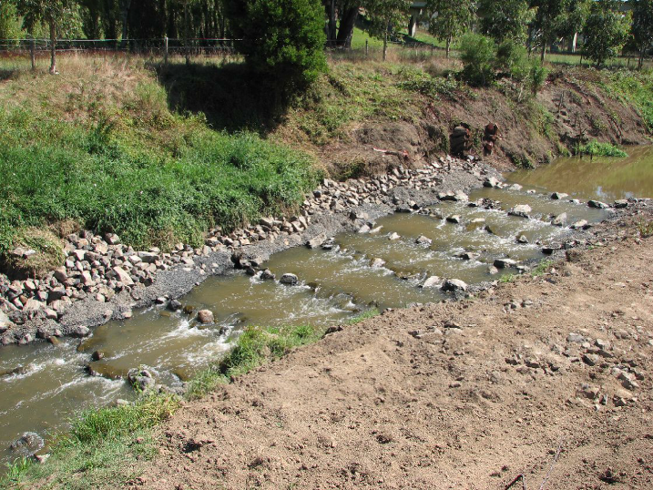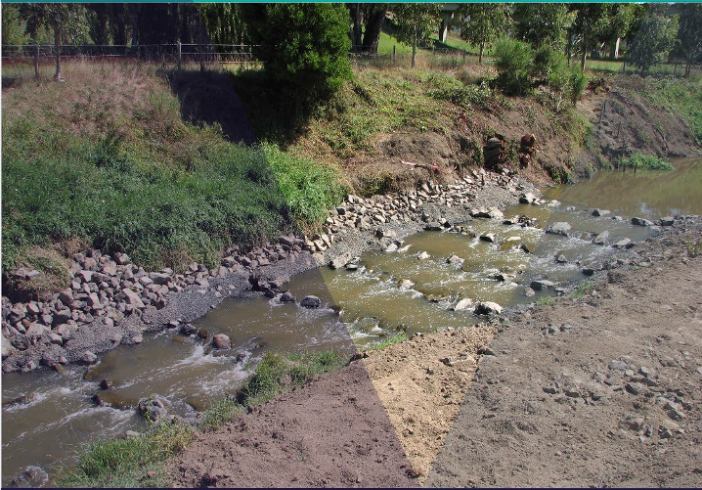
Guidelines for fish passage
at small structures

J. O’Connor, I. Stuart, R. Campbell-Beschorner

November 2017

Arthur Rylah Institute for Environmental Research Technical Report Series Number 276

Acknowledgements
The Water and Catchments Group (Department of Environment, Land, Water and Planning) funded this project. The authors would like to thank Greg Woodward and Joel Rawlinson from the Water and Catchments Group for managing the project and participating in many useful discussions. Thanks also to Dennis Lovric and Mark Turner, who were members of the Steering Committee. Tim Marsden and Joel Rawlinson provided useful comments on an earlier version of this document.

Authors
J. O’Connor, I. Stuart and R. Campbell-Beschorner
Arthur Rylah Institute for Environmental Research, Department of Environment, Land, Water and Planning, 123 Brown Street, Heidelberg, Victoria 3084

Citation
O’Connor, J., Stuart, I. and Campbell-Beschorner, R. (2017). Guidelines for fish passage at small structures. Arthur Rylah Institute for Environmental Research. Technical Report Series No. 276. Department of Environment, Land, Water and Planning, Heidelberg, Victoria.

Photo credit
Front cover: Tarwin River lateral ridge rock-ramp fishway (Justin O’Connor).

© The State of Victoria Department of Environment, Land, Water and Planning, November 2017

This work is licensed under a Creative Commons Attribution 4.0 International licence. You are free to re-use the work under that licence, on the condition that you credit the State of Victoria as author. The licence does not apply to any images, photographs or branding, including the Victorian Coat of Arms, the Victorian Government logo and the Department of Environment, Land, Water and Planning (DELWP) logo and the Arthur Rylah Institute logo. To view a copy of this licence, visit http://creativecommons.org/licenses/by/4.0/
ISSN 978-1-76047-237-5 (print)
ISSN 978-1-76047-238-2 (pdf)
ISBN 1835-3827 (print)
ISBN 1835-3835 (pdf)

Disclaimer
This publication may be of assistance to you but the State of Victoria and its employees do not guarantee that the publication is without flaw of any kind or is wholly appropriate for your particular purposes and therefore disclaims all liability for any error, loss or other consequence which may arise from you relying on any information in this publication.

Accessibility
If you would like to receive this publication in an alternative format, please telephone the DELWP Customer Service Centre on 136186, email customer.service@delwp.vic.gov.au, or via the National Relay Service on 133 677 www.relayservice.com.au. This document is also available on the internet at ari.vic.gov.au.

Contents

Contents i
Summary 1
- Introduction 2
  - Objectives of this document 2
- Categories of small barrier types and their adverse impacts 5
  - Culverts 5
  - Low-level road crossings 7
Causeways and ford crossings 7
  - Gauging weirs 8
- The design process 10
  - Key elements 10
  - Remediation options for culverts 11
  - Remediation options for low-level crossings 23
  - Remediation options for gauging weirs 23
  - Fishway installation 27
  - Combined approaches 28
  - Other considerations 29
References 30

ii Guidelines for fish passage at small structures

Stream barriers have severely affected many native fish species, with fragmented fish populations leading to loss of upstream biodiversity and fish population declines. The Victorian Waterway Management Strategy includes a suite of policies and actions relating to fish passage. This project addresses Action 11.7 of the strategy - Develop a suite of fish passage design guidelines for use at small-scale structures.

Because of their size and tendency to be drowned out during high flow events, small barriers such as culverts, small weirs, gauging stations and road crossings have often been overlooked when assessing the impacts of lost connectivity on fish populations. The high number of road crossings across Victorian streams however has a significant cumulative impact on fish movements throughout the state. The size or height of a barrier will usually play an important part in determining the type of fish passage solutions that may be suitable for that barrier, and in this regard small barriers such as culverts, gauging stations and road crossings share common rehabilitation options that are unique to this group of structures.

The specific objectives of the guidelines are to outline:

- categories of small barrier types and their adverse impacts
- the design process for remediation at small structures, and
- remediation options.

This document describes the impacts of three small barrier types: culverts, road crossings and gauging weirs. Impacts include:

- excessive flow velocities
- excessive turbulence
- debris blockages
- excessive length
- inadequate water depth
- lack of resting places or shelter for fish
- low levels of light
- sharp fall in the water level at the downstream edge, and
- water quality issues from sediment runoff.

The guidelines provide advice on remediation solutions for restoring fish passage at these small structures.
Summary of remediation options for small barrier types

Small barrier type

Culverts Road crossings Gauging weirs

Removal Removal Removal

Modification Modification Modification

Replacement Fishway installation Fishway installation

Adding roughness to culverts (culvert baffles)

Replacement with a bridge

Drowning out existing culverts

Adding extra barrels or upsizing

The impact of instream structures on fish passage has been identified as a major cause of declines in native fish populations in Australia (SAC 1993; MDBC 2008; O’Brien et al. 2010; Humphries and Walker 2013; O’Connor et al. 2015). Connectivity is an important component of healthy rivers and fish populations and allows access to important spawning, dispersal, feeding, refuge, juvenile and adult habitats. Fishways are a major tool in the restoration of fish populations, contributing to stream continuity and connectivity of fish communities worldwide (Northcote 1978; Jungwirth 1998; Mallen-Cooper 1999). In Victoria fish passage is protected by legislation, including the Water Act 1989, Fisheries Act 1995, Flora and Fauna Guarantee Act 1988 and Conservation, Forests and Lands Act 1987, as well as various policies and strategies such as the Catchment Management Authority (CMA) Regional Catchment Strategies (O’Brien et al. 2010). The rehabilitation of fish populations is also an objective of the Victorian Waterway Management Strategy (DEPI 2013).

There is a huge variety of stream barriers within Victoria that block access to habitats, and each of them is unique in regard to rehabilitation; however, a number of these barriers share common attributes, including their physical height. The height of a barrier will usually play an important part in determining the type of fish passage structure that is suitable, and in this regard small barriers (e.g. <1 m high) such as culverts, road crossings and small weirs (e.g. gauging stations) share common rehabilitation options, some of which are unique to this group of structures. Structures such as culverts and road crossings are important public infrastructure, but may act as barriers to the passage of native fish (O’Brien et al. 2010). These structures can produce adverse conditions for upstream fish movement, including hydraulic, physical, behavioural and light barriers.

Because of their size and tendency to be drowned out during high flow events, small barriers have often been overlooked when assessing the impacts of lost connectivity on fish populations. Small structures are often not obvious barriers to fish movement but may act as behavioural (light) or velocity barriers. They are often drowned out and allow fish passage during high flows, so that the upstream impacts of these structures are not always obvious. Nevertheless, even small instream structures can restrict fish passage, resulting in the local extinction of some populations (Lewis and O’Brien 2001). However, the delays to migration and the impending impacts of predation and on the ecology of the impacted species is exacerbated enormously through the sheer number of these small structures in comparison to larger (higher) weirs and dams.

There are a number of shared impacts associated with small barriers, including low flow. Fish and other aquatic organisms need to have sufficient water depths to move through a stream crossing. Furthermore, some of these structures are often made of metal and concrete, which are not always suitable material for fish migration because of the lack of roughness on these surfaces. During high flow events, high water velocities may also scour natural substrates downstream of the structure, creating a large head loss that fish are unable to negotiate upstream. Water velocity is often higher in a constricted crossing or culvert than it is upstream or downstream, further exacerbating the problem. Many of the issues with poorly designed culverts, road crossings and small weirs are heightened during floods, when they may become clogged by woody debris, leaves and other material. This may worsen the impact of floods and make these structures impassable.

1.1 Objectives of this document

The specific objectives of guidelines are to outline:

- categories of small barrier types and their adverse impacts
- the design process for remediation at small structures
- remediation options.
The development of this document is an action of the Victorian Waterway Management Strategy (VWMS) (DEPI 2013). The strategy outlines the Victorian Government’s policy on regional decision-making, investment, management activities and specific management issues for waterways. Policies 11.7 of the VWMS have led to the development of these guidelines which address Action 11.7 of the strategy, which is to ‘Develop a suite of fish passage design guidelines for use at small-scale structures”. (Figure 1.1). This action outlines contemporary design and standards for the remediation of small structures to improve fish passage.

2 Guidelines for fish passage at small structures

The VWMS also outlined a number of other actions specific to fishways, which are addressed in separate but complementary documents and include:

- Action 11.6: Develop Guidelines for Design Approval and Construction of Fishways (O’Connor et al. 2017)
- Action 11.8: Develop and implement a statewide program for monitoring the performance of fishways and fish passage works (Jones and O’Connor 2017).
- Action 11.9: Develop Performance, Operation and Maintenance Guidelines for fishways and fish passage works (O’Connor et al. 2015).

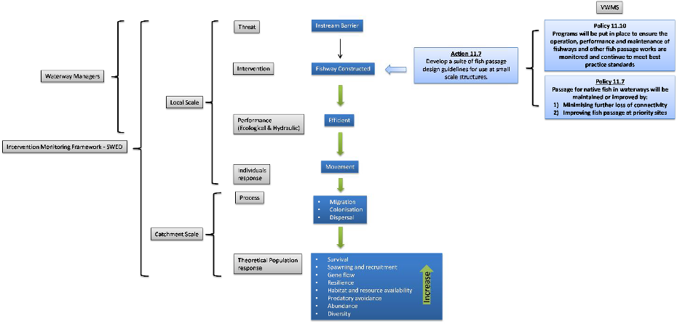

Figure 1.1: The implementation of Action 11.7 and how this fits with Policies 11.7 and 11.10.

Categories of small barrier types and their adverse impacts

There are three main categories of small barrier types in Victoria:

- culverts
- low level road crossings
- gauging weirs.

  - Culverts

A culvert is a hollow structure that allows water to flow under a road, pathway or carriageway. Culverts are usually surrounded by backfilled soil, rock or concrete (Figure 2.1). Poorly designed culverts can cause problems, including hydraulic barriers to the movement of fish. There are many different types of culverts, including pipe, box and arch culverts, and all of these can be perched above the prevailing tailwater (see Figure 2.1) or recessed within the streambed. In general, recessed culverts, which enable a build-up of natural substrate, enable greater fish passage than perched culverts.

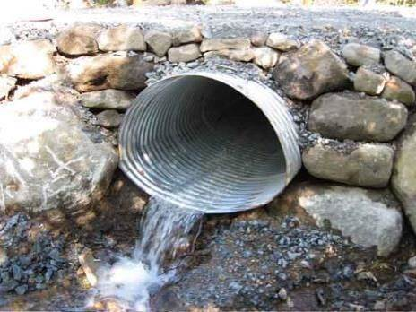

Figure 2.1: Erosion at the downstream end of culverts can result in considerable head loss (i.e. culvert perching) and consequent barriers to fish movement.

One of the problems of fish passage through culverts is the laminar flow of water. Laminar flow is smooth, undisturbed flow with no eddies or turbulence. Laminar flow occurs when water is flowing parallel to the culvert surface and is uninterrupted through the culvert. In this type of flow there is no space for fish to rest and they must swim constantly. The characteristics of culverts that are important in determining the hydraulics and water velocities are the shape, cross-sectional area, slope, length, and roughness of the culvert material (e.g. rough concrete will slow the water velocity more than a smooth stainless steel pipe; Mallen-Cooper 2001). Pipe culverts are usually the greatest impediment to fish passage, especially if the culverts are perched or blocked.

Since 2001 there has been considerable research examining the hydraulics of culverts and the swimming speed of fish (Mallen-Cooper 2001; MacDonald and Davies 2007; Franklin and Bartels 2012). A head loss greater than 100 mm in a culvert produces a water velocity of more than 1.5 m/s, making the culvert impassable for most native fish (Mallen-Cooper 2001). A design standard for South Australian wetlands, for

Guidelines for fish passage at small structures 5

the passage of small fish, specifies water velocities below 0.15 m/s and zero headloss under most operating conditions (Mallen-Cooper 2001).

The impacts that culverts may have on fish passage is outlined in Table 1, noting that these impacts vary across culvert zones (Kapitzke 2010; see Figure 2.2).

Table 2.1: Barrier effects of culverts.

Barrier effect Impact on fish passage

High velocity due to:
    - steep gradient culverts
    - uniform channel with lack of roughness
    - constriction of waterway at the culvert Shallow water depth due to:
    - steep gradient culverts
    - wide culvert bases that disperse flow Lack of resting place or shelter due to:
    - simplified channel form
    - lack of substrate complexity Excess turbulence due to:
    - steep gradient culverts
    - constriction of water at culvert inlet
    - upstream build up
    - low tailwater levels Excessive head loss due to:
    - sudden change in bed profile
Low levels of light due to:
    - long, narrow culverts
Culvert velocities pose a barrier to fish passage when the distance between rest points is greater than the maximum distance fish can swim at burst speeds.

Shallow water can inhibit fish swimming effectively, particularly larger species. Fish may become injured, especially in high flow conditions.

Lack of resting places pose a barrier to upstream fish passage if the length between shelter areas is greater than the maximum distance fish can swim between resting.

Turbulence levels may exceed tolerance of particular fish and therefore present a barrier to upstream movement. Fish lose ability to navigate through the culvert and they are unable to recognise primary flow direction.

Many Australian native fishes have little capacity to jump and are therefore unable to negotiate small water surface drops.

Many Australian native fishes have a tendency to avoid dark areas and may not enter culverts with reduced light levels relative to the stream outside of the culvert.

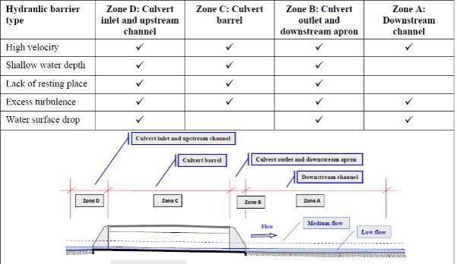

Figure 2.2: The impacts of culverts occur across culvert zones (from Kapitzke 2010).

6 Guidelines for fish passage at small structures

In summary, fish passage at culverts is inhibited by the following:

- excessive velocity flow
- laminar or streaming flows with a lack of resting places or shelter for fish
- excessive culvert length
- excessive turbulence
- inadequate water depth
- low levels of light
- drops at culvert outlet (e.g. additional head loss created by culvert perching)
- lack of physical habitat within the culvert
- debris blockage.

  - Low-level road crossings

Causeways and ford crossings

A causeway is a raised road or track across a river or stream over which the river or stream flows (Figure 2.3). Due to the significant impact of causeways on fish passage during low flow periods, Witheridge (2002) and Fairfull & Witheridge (2003) recommend that fish-friendly low-level culverts (see Section 2.2.1) be used as an alternative to causeways.

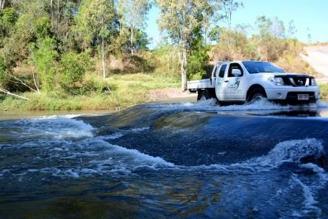

Figure 2.3: Road causeway with shallow depth, high (e.g. 1 m) total head loss and streaming laminar flows that severely impacts on fish migration.

A ford crossing is a shallow place where a river or stream may be crossed in a vehicle or on foot (Figure 2.4). Flow depths across a ford are similar to natural stream conditions, unless the crossing is above the natural bed level and causes a waterfall effect on the downstream edge (Witheridge 2002; Fairfull and Witheridge 2003). Downstream bed scour can migrate up the channel, exacerbating the waterfall effect at the downstream edge. Vehicles travelling across a ford can also disturb sediments, causing water quality issues that affect fish passage (Fairfull and Witheridge 2003).

Guidelines for fish passage at small structures 7

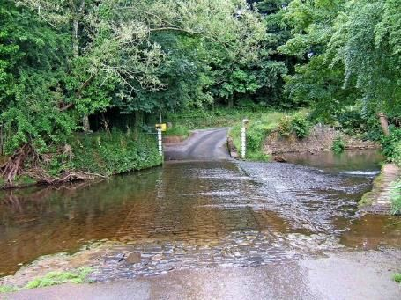

Figure 2.4: Ford crossing with shallow depth and streaming laminar flows that severely affect fish migration.

Most impacts on fish passage from causeways and ford crossings are a result of the broad, shallow flow conditions that exist during low to medium flows (Witheridge 2002). The flow is too shallow to allow large fish to pass, and erosion at the downstream edge of the crossing may also produce head loss and an impassable barrier to small fish (Witheridge 2002). Debris may also accumulate at crossings, leading to excessive head loss or physical barriers (blockage) to movement.

In addition, there may be water quality issues associated with crossings where, during low flow periods, there is usually insufficient flow to effectively flush away sediment runoff from approach roads, creating high concentrations of sediment and turbidity that can be significantly problematic to migrating fish (Witheridge 2002). During high flows, causeways are usually fully submerged under deep water, and fish passage may be facilitated (Witheridge 2002).

In summary, the barriers to fish passage at causeways and ford crossings include:

- excessive flow velocities on the downstream edge of the causeway/ford
- debris blockage
- sharp fall in the water level at the downstream edge of the causeway/ford
- inadequate flow depth over the causeway/ford during low stream flows
- water quality issues from sediment runoff from the approach roads.

  - Gauging weirs

Stream gauging weirs are used to monitor stream attributes, including water temperature and flow discharge (Figure 2.5). The stream gauging instruments do not actually measure the flow of the stream; instead they measure water velocity or water height as a substitute and use a rating curve to calculate the actual stream

8 Guidelines for fish passage at small structures

gauge measurement. The most accurate way to measure discharge is by installing a fixed crest structure (weir) to improve the reliability of using water height as a surrogate for flow discharge (i.e. improving the reliability of the rating table).

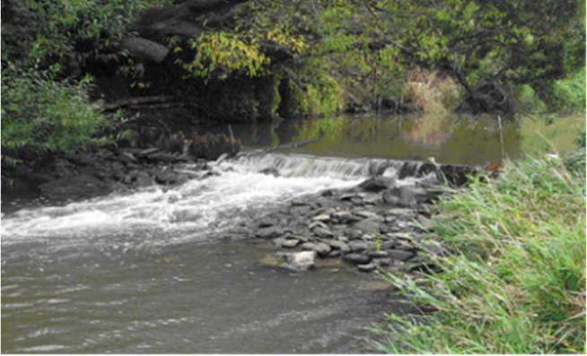

Figure 2.5: A fixed crest sheet pile gauging weir with excessive downstream water velocity, head loss and turbulence, which severely impedes fish migration.

Various forms of weir controls are used to gauge stream attributes, including V-notch, broad-crested, sharp- crested and combination weirs. These low-level weirs can act as complete physical barriers to fish passage at most flows and therefore exclude fish from habitat essential for their life cycle (Lewis and O’Brien 2001). In addition, Lewis and O’Brien (2001) suggest that the difference in water levels across the structure creates increased water velocity and depth that is beyond the swimming ability of many fish species. Drops below the weir can also create turbulent flows (Stevenson and Baker 2009), while debris accumulating at these types of structures can lead to excessive head loss or physical barriers (blockage) to fish movement.

In summary, fish passage at gauging weirs is inhibited by:

- water surface drops at the weir interface (head loss)
- excessive flow velocities, even at low flows
- inadequate depth in the tailwater
- excessive turbulence
- debris blockage.

Guidelines for fish passage at small structures 9

The design process

  - Key elements

When fish passage remediation is to be undertaken at a small structure such as a culvert or gauging weir, a thorough design process will enhance the outcome. The design process for remediation of fish passage at small structures does not vary from the standard fishway design processes set out in O’Connor et al. (2017), but in summary the following elements need to be considered:

- stakeholder engagement
- intervention and fish passage objectives
- budget considerations
- site characteristics
- local fish community.

Stakeholder engagement

A well-planned barrier remediation process should engage all stakeholders from the beginning of the project. Stakeholders include owners of the structure, water authorities, land managers and the public. Stakeholder objectives in the fish passage intervention need to be understood and achievable, and clear communication between stakeholders must be maintained throughout the process. See O’Connor et al. (2017) for more detailed information on stakeholder engagement and communication strategies.

Intervention and fish passage objectives

Realistic and contemporary objectives for remediation of fish passage at small structures need to be determined during the design process and will help to ensure its success. An essential component of design is applying the ecological objectives to set the performance criteria for the remediation. A conceptual model of fish movement and its relationship to river flow can also be useful to summarise biological data, highlight knowledge gaps, enable strategic resource allocation, and clarify and synthesise thinking. A fish migration model is important because the two generic variables that most influence the design (and cost) of a fishway are (i) the target range of flows over which the fishway will be required to operate, and (ii) the fish community (complimentary information on performance criteria can be found in O’Connor et al. 2015). For example, the objectives for a stream-gauging station that requires updating and incorporation of fish passage facilities may include:

- provide accurate stream gauge information over the known range of stream discharges
- achieve fish passage objectives, which may include:
  - pass all fish species present downstream of the structure

  - pass fish of size range 40–700 mm

  - provide passage for fish for the full range of the headwater and tailwater levels and stream discharges within which they migrate

  - provide fish passage in both upstream and downstream directions.

Objectives that are not well documented or thought out may lead to less than optimal functionality. More detailed information on setting intervention and fish passage objectives can be found in O’Connor et al. (2017).

Budget

The primary aim in any fish passage intervention is to design a structure that allows effective fish passage. However, cost is a crucial factor and must be discussed with stakeholders during the design phase. Any compromises around budget and design must be guided by the objectives of the remediation.

Site characteristics

The important starting point in any remediation is an initial site visit to identify the unique site characteristics. These will include the topography and geology of the site, stream depth and width, and discharge and velocity of water over or through the barrier. These site characteristics will influence the type, location and

10 Guidelines for fish passage at small structures

complexity of the remediation’s design. See O’Connor et al. (2017) for more detailed information on site characteristics.

Local fish community

A major factor influencing the design of a remediation at a small structure is the range of fish species it is intended to pass. There are many characteristics specific to individual species of fish that will affect the design, including:

- swimming ability
- size of migratory fishes
- seasonal biomass or abundance of migrating fishes
- life-history traits
- swimming behaviours.

Options analysis

Finally, the appropriate remediation needs to be determined for the barrier, taking into account site characteristics, stakeholder expectations, barrier type, dimensions, function and budget. There are various design options to restore fish passage at small instream barriers, including removal, fishway installation, replacement with a bridge, or modification such as adding roughness to culverts (culvert baffles). These are outlined in more detail below.

  - Remediation options for culverts

There are numerous rehabilitation options for culverts, including:

- removal
- replacement
- modification
- adding roughness to culverts
- drowning out existing culverts
- adding extra culvert barrels or upsizing existing ones.

Removal

Culvert removal involves opening up watercourses and restoring the bed, bank and riparian corridor to more natural conditions. Removal opportunities should always be a first consideration. In some cases this may not involve removing the whole culvert structure, but could involve just removing the obvert or top where light is the primary barrier to fish movement.

Replacement

Replacement with a bridge or U-shaped culverts that maintain stream integrity is also another rehabilitation option for culverts. The advantages of this approach is that the replacement structure:

- spans the stream and banks
- does not change water velocity relative to the surrounding stream
- has a natural streambed
- creates no noticeable change in the stream conditions (e.g. width, substrate or velocity).

Modification

Since 2001, many culvert structures have been constructed which specifically include the fish passage optimisation recommendations of Mallen-Cooper (2001) and others (e.g. Cotterell 1998; Boubee et al. 1999; Fisheries Queensland 2013; Witheridge 2014). Over time these criteria have been refined. Minimum headloss and water velocity specific to fish size are summarised in Table 3.1.

Guidelines for fish passage at small structures 11

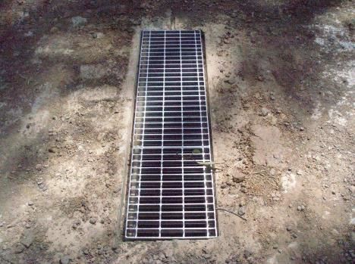Figure 3.1: A light grid in a new wetland culvert to facilitate passage of native fish.

Table 3.1: Headloss, water velocity and minimum fish sizes that might negotiate a culvert (from Mallen-Cooper 2001).

Headloss (mm)

Max. water velocity (m/s)

Fish length (mm)

Comment

2 0.15 < 80 Design standard for wetlands
10 0.3 > 100
20 0.45 > 150
50 0.75 > 250
80 0.93 (> 400)
100 1.05 (> 500)

Generic culvert optimisation design features to improve fish passage should include the following design elements:

- culverts should have a maximum 0.3 m/s water velocity (i.e. < 10 mm headloss) for passage of small fish.
- generally box or arched culverts provide greater fish passage opportunities than pipes.
- Culverts which enable good light penetration and have water ‘freeboard’ are preferred. That is, the obvert of the culvert is usually dry.
- the cross-sectional area should more than match the stream width. Often larger culverts (e.g. minimum culvert size of 1.5 m square) provide a greater cross-sectional area than smaller culverts, and thus a reduced flow velocity that improves fish passage.
- culverts should be installed with no slope (or match the bed gradient where the culvert is counter-sunk).

12 Guidelines for fish passage at small structures

- culverts should maintain the natural stream depth and be 1.25 times the cross-sectional area of the stream
(i.e. install more culverts rather than less).
- avoid water constrictions (and subsequent high water velocities) at the culvert.
- the culvert (including the entrance and exit) should be counter-sunk (c. 30 cm) into the stream bed, thus enabling bed material to build up and avoiding any artificial gradient (Figure 3.2).
- a minimum depth of 0.3 m should be provided for small and medium fish.
- generally culvert length should not exceed 6 m.
- headwalls, tailwalls or wingwalls should not be diagonal, as this produces poor hydraulics for fish passage. Perpendicular walls at 90° to the culvert are preferred.
- scouring and perching at the entrance or exit of the culvert should be avoided.
- a 0.5 m high, downstream sloped (30°) water retention end-sill (usually concrete) can be considered for raising the tailwater, thereby reducing turbulence and providing a refuge/plunge pool. This design feature is especially relevant for wetlands that are regularly dried in perennial systems.
Modifications to culverts can also include light grids (Figure 3.1) to allow sufficient light through the culvert so that sensitive fish species (e.g. bony bream, Australian smelt) are not discouraged by a sudden decrease in light levels.

Water retention end sills to raise tailwater levels and therefore reduce turbulence are also a useful modification that can improve fish passage particularly for small-bodied species. In new culverts it is important to limit water velocity under all hydrological conditions when fish migrate. Hence the culvert design parameters are linked to the fish migration model (see Section 3.1) and site-specific fish passage objectives. Boxes 1 and 2 summarise recent case studies for providing fish passage between wetland and riverine habitats, respectively.

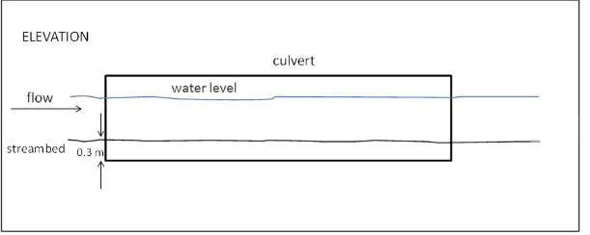

Figure 3.2: A box culvert counter-sunk by 0.3 m to enable stream bed material to accumulate.

Guidelines for fish passage at small structures 13

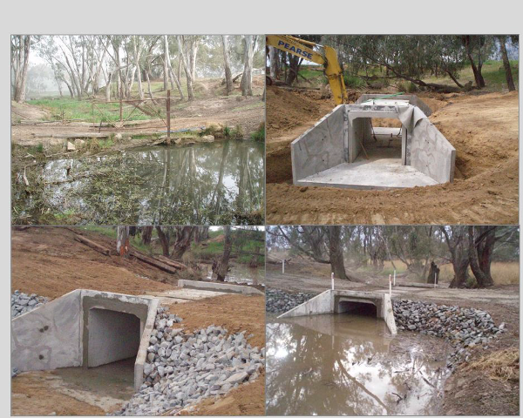

Box 1

Case study 1: An optimised culvert in inland Victoria

At Tahbilk Lagoon, on the Goulburn River in Victoria, several submerged pipe culverts were replaced with optimised box culverts (undertaken by GBCMA) using the generic culvert optimisation design guidelines (Figure B1). The application of the generic fish passage criteria for this culvert did not require substantial site refinement. Freshwater catfish are present in Tahbilk Lagoon, and the optimised culverts are important for their movement ecology.

Figure B1: Replacement of a submerged pipe culvert (top left) with an optimised box culvert (top right and bottom). Note that the upstream and downstream invert of the box culvert is below bed level, there is a flat culvert slope, no water velocity and the high sides of the culvert maximise light penetration. (Photos courtesy of Goulburn Broken CMA.)

14 Guidelines for fish passage at small structures

Box 2

Case study 2: An optimised culvert in coastal Victoria

In 2016, on the Little River within the Western Treatment Plant, Melbourne Water replaced a single narrow perched culvert with a pair of optimised culverts using the generic culvert optimisation design guidelines (Figure B2). The application of the generic fish passage criteria for this culvert did not require substantial changes except for lowering the new culverts (e.g. 0.3 m below bed) and slightly re-contouring the concrete crossing deck. The Little River is tidal below the road crossing and hence the optimised culverts are important for ensuring passage of diadromous fish such as galaxiids.

Figure B2. On the Little River, in coastal Victoria, Melbourne Water replaced a single perched culvert (top left and right) with a paired optimised culvert (bottom right and left). Note that the upstream and downstream invert of the new culverts are 0.3 m below bed level, there is a flat culvert slope and zero water velocity. (Photos courtesy of Melbourne Water.)

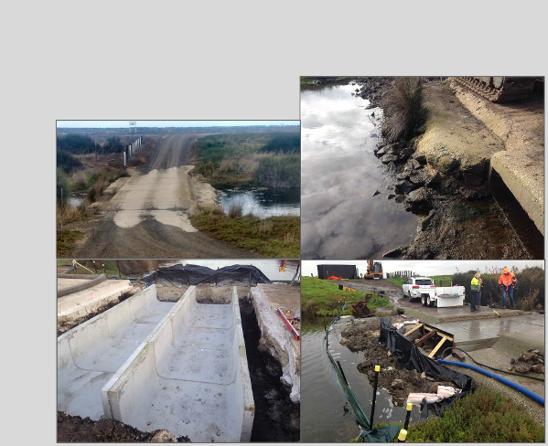Guidelines for fish passage at small structures 15

Adding roughness to culverts

In the case of an existing culvert with a small headloss and high water velocity, there is some potential to retro-fit roughness elements to improve fish passage. Over the last decade there has been increasing interest in adding roughness elements inside the culvert barrel, which break up laminar flow and create hydraulic complexity, and optimise the use of boundary layers (edges of flowing water where water velocity slows adjacent to rough surfaces) that facilitate small and medium-sized fish passage (Doehring et al. 2011; 2012). A variety of materials and configurations have been trialled, including: (1) rocks or timber blocks, (2) side baffles, (3) chains or ropes, (4) pre-cast cones and (5) spoiler baffles e.g. bio-baffles (Table 3.2).

In the main, the addition of roughness elements is limited to sites with long periods of steady-state headwater, or where the total head differential is relatively small. There are several options for retro-fitting roughness units to culverts, and these depend on the fish species and range of flows over which the culvert operates. The major options are:

- retro-fit side culvert baffles or chain droppers, which are advantageous where there is reasonable depth and variable headwater.
- retro-fit rocks, baffles or hard wood blocks, which break up laminar flow and provide resting areas for fish. Importantly, the roughness units must break the water surface. They will be less effective if headwater is variable and the units are submerged.

Table 3.2: Generic comparison of laminar flow reduction options for culverts.

Fishway type Upstream passage of small-bodied fish

Ease of fitting Ongoing maintenance and debris issues

Rock-ramp fishway – drown out excellent no good
In-culvert floor spoiler baffles good fair fair
In-culvert rocks or hardwood blocks fair fair poor
In-culvert pre-cast cones very good fair poor In-culvert side baffles very good very good good In-culvert chains or ropes good very good good

Culvert baffles

Baffles are a useful tool to augment optimal hydraulics. Culvert baffles are designed to assist upstream fish passage by altering the flow of water through culverts and providing areas for fish to rest. Baffles can be fitted prior to the installation of the culvert, or retro-fitted to existing structures.

Existing culverts can be rehabilitated to improve conditions for fish passage (VicRoads 2012). Baffles simulate natural stream elements such as pools, riffles and boulders. They are used in the design or remediation of culvert barrels and apron slabs to increase hydraulic complexity (Kapitzke 2010; VicRoads 2012). Specifically, baffles alter hydraulic conditions such as water depth, velocity and flow patterns, providing resting areas for fish moving through the culvert (Kapitzke 2010).

A variety of baffles have been trialled to provide roughness for fish ascent. Baffles can be fixed to the culvert side walls or floor (Figure 3.3 and 3.4). In Queensland, one design that is used for passing large numbers of small-bodied fish are side angle baffles (Figure 3.3 and 3.5). These are relatively inexpensive (approximately $50 each) and are placed at frequent intervals to enable fish to ascend. An advantage of these baffles over the previous floor fixed spoiler baffles is that they provide roughness over a broader range of water levels within the culvert. In addition, side baffles have fewer debris problems than floor-fixed spoilers, rocks and pre-cast cones. Side baffles can also be fitted before the culverts are moved to site.

Baffle fishway designs have been used extensively throughout North America, and in the past 10 years have become reasonably common in Australia. There are culvert baffles in Victoria, Queensland and South Australia, with baffles also being incorporated into technical fishway channels and onto weir abutments. It should be noted that according to Bates et al. (2003) and Kapitzke (2010), baffle fishways might obstruct the passage of juvenile fish in some flow conditions due to increased turbulence. Moreover, NZ Transport Agency (2013) suggests baffles are not generally suitable for culverts smaller than 0.8 m in diameter due to maintenance and installation concerns.

16 Guidelines for fish passage at small structures

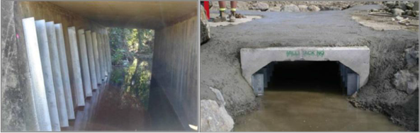

Figure 3.3: (Left) Box culverts with retro-fitted one-side baffles and (right) twin-sided baffles. Baffles help to slow water velocity and create eddies for fish to rest in during their migration. (Photos courtesy Tim Marsden.)

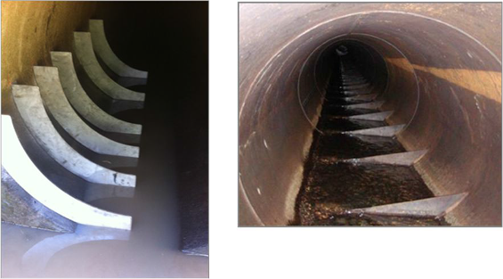

Figure 3.4: Pipe culverts fitted with single sided baffles.

Culvert baffle design criteria

- Baffles usually need only be applied on each river bank; that is, one row of baffles for the culverts to simulate continuation of the bank roughness (Figure 3.5).
- For single culverts, baffles on both side walls are recommended.
- Baffles should be 100 mm wide, i.e. protrude 100 mm into culvert and can be made from galvanised iron, stainless steel or aluminium.
- The gauge of the angle should be 10 mm.
- Each of the angles can be bolted to the culvert before delivery to the site, or attached on-site.
- The baffles should be at least 95% of the full height of the culvert from invert to obvert.
- The baffle spacing should be 400 mm within the culvert (i.e. 4 × baffle width) but at the top and bottom 2 m of the culvert the spacing should be 200 mm (i.e. 2 × baffle width) (Figure 3.6).
- The baffles must continue along any wingwalls, headwalls or tailwalls (at least two baffles).
- Headwalls and tailwalls should be perpendicular to the culvert (not sloping away) to ensure they do not constrict flows.
- There should not be a constriction of flow.
- Downstream aprons must be at the same height as the culvert inverts.
- Culvert baffles typically cost $50–70 per unit.

Guidelines for fish passage at small structures 17

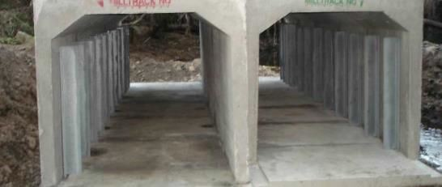

Figure 3.5: Box culverts fitted with single-sided baffles.

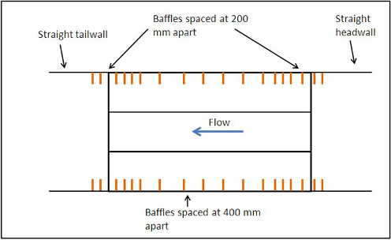

Figure 3.6: Generic concept for side baffle installation on the outside (bank) walls of a three barrel box culvert. Note that the headwalls and tail walls are perpendicular to the culvert.

Pre-cast cones

Pre-cast concrete or plastic cones have been developed by Fisheries Queensland (Department of Agriculture and Fisheries) and James Cook University (Kapitzke 2010). These can be fixed within culverts to improve fish passage, and there has been some biological assessment to demonstrate improvements to fish passage in relatively short culverts (Tim Marsden, pers. comm.). Pre-cast cones may be useful where there is a small headloss (e.g. < 0.5 m) through the culvert, however they may be subjected to build up of debris and require regular maintenance.

Spoiler baffles

Various spoiler baffle arrangements are available for fixing to the base of a pipe culvert to provide surface roughness for improving fish passage (Figure 3.7). The geometry of the baffles needs to take account of the needs of the target fish species. In short sections of pipe (e.g. < 6 m long) there has been encouraging fish

18 Guidelines for fish passage at small structures

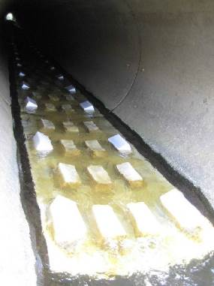passage success (80%) for galaxiids (Macdonald and Davies 2007). One drawback of spoiler baffles is the need for maintenance, as they can trap debris. Spoiler baffles are also unlikely to have strong application in culverts on waterways with variable flow, because they are limited by fluctuating headwater.

Figure 3.7: Spoiler baffles which break up laminar flow and provide roughness for galaxiids to ascend culverts in New Zealand. These have proven successful in short culverts (e.g. 6 m long) but unsuccessful in long culverts (e.g. 70 m long).

In summary, culvert baffles are able to:

- reduce velocity
- increase depth
- interrupt laminar flow
- extend range of flow characteristics by introducing hydraulic complexity
- retain stream bed material
- create high and low flow passage.

Chains and ropes

Some novel solutions to providing low-cost and low-debris solutions for increasing roughness in pipe culverts have recently been trialled. Chain attached to the culvert wall with chain droppers at regular intervals has recently proven successful for small-bodied fish, especially at culverts with moderately variable water levels (Figure 3.8). Because the chain droppers rise with high flows, there is less accumulation of debris.

In addition, mussel spat rope has been used successfully in New Zealand for improving the passage of galaxiids through culverts (David and Hamer 2012). The use of rope installation in culverts is outlined in New Zealand Transport Agency (2013). Ropes are attached to a point inside a culvert and secured to the streambed. Recent research has shown this method has been successful in helping juvenile climbing species through culverts (e.g. eels, climbing galaxiids). The advantages of this method are that rope is quick to install, low cost, durable and has proven effective for passage at long, high gradient culverts. However, this method helps only climbing species overcome barriers.

Guidelines for fish passage at small structures 19

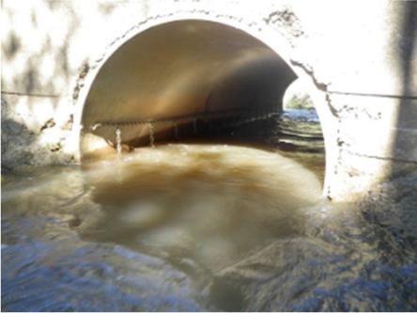

Figure 3.8: Chain with droppers facilitates small-bodied fish migration through pipe culverts in Queensland. Chain droppers and mussel spat ropes can be considered experimental low-cost fish passage options that require further field evaluation. (Photo courtesy Tim Marsden.)

Drown out of existing culverts

For existing culverts an effective option to improve fish passage is to build a fishway downstream which backs up water through the culvert. The aim of the fishway is to reduce water velocity in the culvert. This is achieved by setting the control point of the fishway at least 50 mm above the level of the upstream culvert invert, which causes water to back up through the culvert (Figure 3.9). This type of approach can be expensive but usually results in a cost-effective fish passage outcome. See Box 3 for a case study on culvert drown out in Cardinia Creek, Victoria.

Adding extra culvert barrels or upsizing existing ones

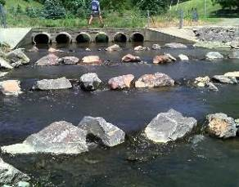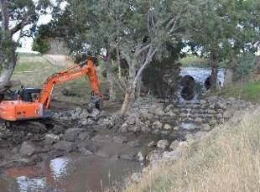Often culverts can be remediated by increasing the width and cross sectional area by adding more barrel culverts or replacing with larger ones that maintain natural stream substrates, widths and velocities.

Figure 3.9: Some recent rock fishways which back up water through culverts to create low water velocity for passage of small-bodied fish. This type of approach can be expensive but is cost- effective at high priority sites for existing culverts.

20 Guidelines for fish passage at small structures

Box 3

Case study 3: Culvert drown out, Cardinia Creek Background
This project was undertaken by Melbourne Water in Cardinia Creek in southern Victoria. The creek flows through a pipe culvert which is 1.5 m in diameter, 70 m long with a total headloss across the length of the culvert of approximately 0.3 m. The existing culvert acted as a barrier to fish movement primarily due to medium/high water velocities over a long length of pipe. Fish passage could potentially be improved by raising the downstream weir pool (tailwater) to decrease water velocity in the culvert. The aim of this study was to investigate the success of a fish passage improvement project by monitoring the passage of migrating, juvenile Galaxias sp. through the culvert.

Methods

A downstream weir-pool was created by installing a 7 m long by 5.8 m wide lateral ridge rock- ramp fishway approximately 15 m downstream of the downstream culvert entrance. The fishway had three ridges, each rising in elevation by 0.105 m. The two pools created within the fishway were 2 m long and nominally 0.35 m deep (Figure B3.1). The ridge rocks were set with 0.15 m gaps between rocks and 0.1 m depth of water through the elevation control point.

The hydraulic objective of the fishway was to drown-out most of the 70 m length of the pipe culvert so that there was negligible velocity at low flows and therefore remove velocity as a barrier to fish migration. At the upstream end of the culvert, where full drown-out did not occur, a series of six stainless steel baffles were installed, each 0.15 m wide by 0.01 m thick and covered from the bottom point of the culvert to halfway up one side (25% of the culvert diameter). The two most downstream baffles were 0.6 m apart and the upstream four baffles 0.3 m apart (Figure B3.2).

The proportion of fish that successfully passed through the culvert increased significantly following remediation.

Figure B3.1: Cardinia Creek lateral ridge rock-ramp fishway

(continued on next page)

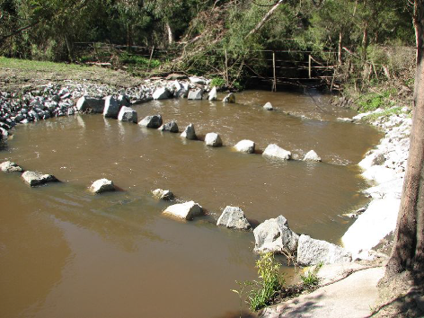

Guidelines for fish passage at small structures 21

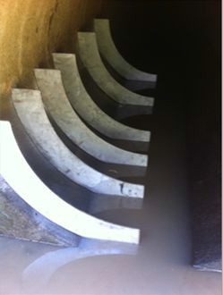Box 3 (continued)

Figure B3.2: Cardinia Creek culvert baffles.

Monitoring

An investigation was undertaken to assess whether fish passage through the pipe-culvert improved following culvert rehabilitation and a mark-recapture technique was used to measure the success of fish passage. A 75 m long control site, located downstream of the culvert test site, was also assessed to account for natural variation in rates of fish movement.

Application of the research

The successful passage of young-of-year Galaxias sp. through the pipe-culvert significantly increased as a result of rehabilitation (Amtstaetter et. al. 2017). Creating a downstream weir pool with water backing up throughout most of the culvert and adding baffles to the upstream end to provide resting areas for fish attempting to move through the culvert, increased passage efficiency by a factor of 16. Furthermore, it appears that the culvert no longer acts as a partial barrier based on fish passage efficiency comparisons to the control site. This research highlights the recovery potential for fish passage at long culverts and provides a restoration model for future projects.

22 Guidelines for fish passage at small structures

  - Remediation options for low-level crossings

There are a variety of ways to minimise the impacts of low-level road crossings (causeways and fords) and each of these is scoped below. The most common issue with road crossings is where the road is elevated or perched above the stream bed.

Natural bottom substrate should be used within the crossing and it should match the upstream and downstream substrates. The design should resist displacement during floods and maintain an appropriate substrate bed during normal flows. At low flows, water depths and water velocities should be the same as they are in natural areas upstream and downstream of the crossing. Bank and riparian corridors should also be stabilised and reflect natural conditions. A good crossing:

- spans the stream and banks
- does not constrict flows by reducing stream width
- does not change water velocity
- does not change water quality
- maintains the depth of the adjacent stream
- has a natural streambed
- does not create a drop in water level across the downstream edge
- creates no noticeable change in the stream conditions.

Effective remediation strategies for road crossings include:

- removal
- replacement with a bridge
- modification
- fishway installation.

Removal

Removal opportunities should be considered as much as possible, particularly at sites where road crossings are no longer required. Removal of obstructions is always the most efficient way of restoring connectivity.

Replacement with a bridge

The next best option to rectify poorly designed road crossings is the installation of a full spanning bridge. A well-designed bridge spans the stream and banks, does not change water velocity, has a natural streambed and creates no noticeable change in the stream conditions.

Modification

Where removal or replacement with a bridge is not an option, simple modifications to a road crossing will often improve conditions for passage, including: creating more depth, maintaining natural stream widths to improve water velocities, and ensuring that downstream erosion and head loss do not occur and therefore create barriers to fish movement. Minimising erosion potential usually means using rock to construct the new causeway and erosion protection. More technical information can be found in Fisheries Queensland (2013) and Witheridge (2014).

Fishway installation

See Section 3.5 Fishway installation on page 27.

  - Remediation options for gauging weirs

Removal

Remediation to provide for fish passage is more difficult for gauging weirs than for culverts (GWRC 2003). Where relevant (e.g. for obsolete weirs), full or partial removal of the structure should be considered because it is the most effective method of providing fish passage. Gauging weir removal involves opening watercourses and restoring the bed, bank and riparian corridor to more natural conditions.

Structure removal is preferable for meeting the requirements of restoration of natural river processes and the free passage of migratory fish both upstream and downstream. Possible negative impacts from an

Guidelines for fish passage at small structures 23

ecological/habitats perspective should also be considered, such as sites where gauging structures control the migration of invasive species (e.g. create barriers to trout colonising threatened barred galaxias habitat (Raadik 2014) or where contaminated sediment could be released, which might have an impact on downstream reaches in the short term and create maintenance requirements after removal. These elements would need to be evaluated prior to any work being carried out. Removal opportunities should be explored as much as possible, particularly at sites where the weir is no longer required for gauging purposes or where a non-barrier gauge (e.g. a Doppler unit) could replace it.

Doppler technology

Horizontal acoustic Doppler current profiling (HADCP) is a relatively new technology that provides for continuous automated monitoring of river discharge (Nihei and Kimizu 2008) and can provide an alternative to gauging weirs. Doppler systems use sound waves to measure the velocity of particles in the water. Some Doppler meters can automatically measure the cross-sectional area or be programmed to determine discharge and provide the required stream gauging data. This technology relies upon permanently mounted horizontal acoustic Doppler units for the collection of continuous velocity and stage data to determine discharge. In some instances the new gauge may require some hard-engineered infrastructure such as concrete revetments and channel narrowing, so this technology is not completely without impact on hydraulics at a site.

In addition, the new measuring station would usually need to be run in parallel with the old site for a number of years to help calibrate the new gauge and to ensure that the two sets of data could be merged together to create a continuous record. However, as this technology does not rely upon the installation of a fixed crest weir, in the long term it would be a more fish-friendly alternative to traditional gauging methods.

Modification

Modifications such as notching or lowering the height of the gauging structure should be considered if the structure cannot be removed or replaced with a non-barrier gauge. However, notching the structure to allow fish to pass upstream and downstream will not remediate all barrier effects. Important considerations include:

- What are the target species and will notching/lowering allow them move up and down the structure?
- Will the structural integrity of the gauge be compromised if it is notched/lowered?
- Will the gauge still be able to record flows accurately enough?
- What work will be required to recalibrate the gauging station?

Fishway installation

If the gauging weir structure cannot be removed or replaced and lowering is not suitable, in some instances installing a vertical slot, rock ramp or natural by-pass fishway may be appropriate (see Section 3.5 Fishway installation on page 27). See also Box 4 for a case study of a rock ramp fishway installation on a gauging weir in the Tarwin River, Victoria.

24 Guidelines for fish passage at small structures

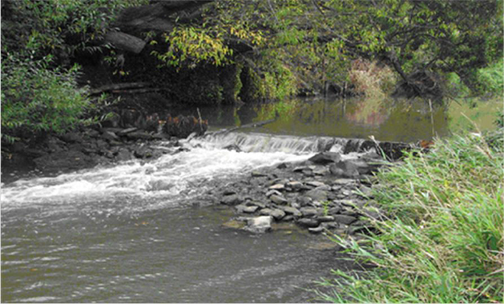
Box 4

Case Study: Installation of a rock-ramp fishway on a stream gauging weir

At low and medium flows a stream gauging station located downstream of the South Gippsland Highway represented a significant barrier to fish movement within the Tarwin River system. The objective of this project was to improve connectivity of the river at the weir by installing a rock-ramp fishway. This component of the study was undertaken in conjunction with the West Gippsland Catchment Management Authority (WGCMA). In conjunction with the fishway construction, the riparian landscape was also fenced and replanted to improve the instream and riparian habitat of the area.

The Tarwin River stream gauging weir is a low-head sheet pile structure approximately 10 m wide and 0.5 m high (Figure B4.1). Incorporated into the weir is a series of steps, each approximately 5 cm higher toward the banks. The lowest notch, which passes most of the flow during low discharge periods, is about 0.4 m high.

Figure B4.1: The Tarwin River Weir showing the stepped sheet pile structure and erosion control rock.

A rock-ramp design was identified as the best fish passage option on the Tarwin River, for the range of flows and native fish fauna present (Kingfisher Research 2007). During construction, a fish biologist was on site directing the excavator driver in the placement of rocks, to ensure that the hydraulic requirements for efficient fish passage were met. The fishway was completed in five days (Figure B4.2). The performance of the fishway was also monitored through a pre- and post- installation assessment, which showed an improvement in fish passage for the target species. The stream gauging station also continued to provide effective stream discharge data.

Site rehabilitation

Following the construction of the fishway the riparian zone adjacent to the fishway was rehabilitated by fencing and revegetation (Figure B4.3) to help stabilise the banks and the fishway by preventing erosion and scouring. The trees and shrubs, once mature, will also provide cover and shade for fish and aquatic insects and are an important component of the local ecosystem.

(continued on next page)

Guidelines for fish passage at small structures 25

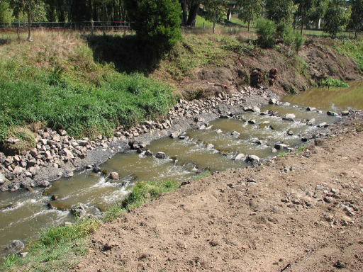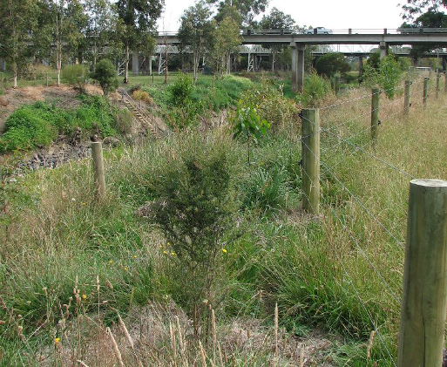Box 4 (continued)

Figure B4.2: The completed fishway.

Figure B4.3: The riparian zone in area adjacent to the fishway approximately two years after fishway installation.

26 Guidelines for fish passage at small structures

  - Fishway installation

There are numerous remediation options specific to culverts, low level road crossings and gauging weirs, however, it is not always possible to design modifications to these small structures to provide fish passage and the installation of a dedicated fishway may be more appropriate (Lewis and O’Brien 2001). Fishways in Victoria are indispensable for effective restoration of many native fish populations (O’Brien et al. 2010). There are three types of fishway typically used to reinstate fish passage at small instream structures in Victoria: vertical-slot (technical structure); and rock-ramp and bypass fishways (close-to-nature structures) with each design having their own advantages and disadvantages (Table 3.3).

An effective fishway is one that:

- Accommodates the whole native fish community that moves through the site
- Is designed to provide year-round passage for fish over the full range of head- and tailwater levels/stream discharges, or at a minimum, ensure passage when fish are migrating
- Is designed to provide both upstream and downstream fish passage
- Is designed so that all infrastructure (including raceways, aprons, plunge pool and baffles) should be designed to minimise fish injury
- Has appropriate lighting and resting habitat provided within the fishway.

These general principles should be used in conjunction with site-specific requirements, including information on the target fish species (swimming ability, size classes), hydraulic conditions and the operational requirements of the structure (O’Connor et al. 2015).

Table 3.3: Small structure fishway types and their advantages and disadvantages.

Fishway type Advantages Disadvantages

Vertical-slot fishways Operate over a wide range of river flow conditions
Pass a broad size range of fish Good calibration for gauging weirs
Expensive

Rock-ramp fishways (random or lateral ridge)
Relatively inexpensive
Operate over a wide range of river levels Fish can easily find the fishway entrance (full width)
Require regular maintenance
Need to be properly engineered and constructed
Operation can be limited by variable headwater

Natural bypass fishways Looks like a natural stream (aesthetic value)
Pass a broad size range of fish
Expensive
Can require large areas to build them
Operation can be limited by variable headwater Require high discharge
Not well tested in Australia

Guidelines for fish passage at small structures 27

  - Combined approaches

There are numerous solutions to overcome barriers at small structures (Table 3.4). While each of these can rehabilitate a site, a combination of approaches may also be used to overcome fish passage barriers, depending on the site, target species and requirements of the structure. For example, a rock-ramp fishway may be used in conjunction with baffles to overcome hydraulic barriers to fish passage at culverts.

Table 3.4: General overview of impacts and solutions suitable for small instream structures.

Impact Solution References

Lack of rest areas for fish
Construct pools at the inlet and outlet to dissipate energy and provide rest areas.
Base the length of the remediation on the maximum distance a fish is able to travel through a culvert without rest.
Witheridge (2014)
Fisheries Queensland (2013) Fairfull and Witheridge (2002)
Boubee et al. (1999)

Bank erosion Align the culvert with the downstream channel to minimise bank erosion. The use of rocks and energy dissipation pool can control erosion at the outlet.
Witheridge (2014)
Fisheries Queensland (2013) Fairfull and Witheridge (2003)

Excessive flow velocities

Debris blockage
Ensure the velocity does not exceed the swimming ability of the target fish.
The cross-sectional area of the culvert array should be at least as wide as the stream, so that flows are minimally constrained prior to overtopping.
The substrate should be as natural as possible and incorporate a wide range of habitats, including large rocks, deep pools and fine gravel.
The deck of the causeway should follow the general shape of the stream cross-section to minimise impacts on fish passage from excessive flow velocities.
Debris deflector walls reduce debris blockages and maintenance costs.
Witheridge (2014)
Fisheries Queensland (2013) Boubee et al. (1999) VicRoads (2012)
Witheridge (2002)

Fairfull and Witheridge (2003)

Inadequate lighting

Excessive variation in water levels

Lack of attraction flows

Complete physical barrier
Include skylights or grated stormwater inlets in design of cells or pipes (for culverts) to maximise light penetration. Maximise natural light by making dimensions of culverts as
large as possible.
As a rule, water depths should be 0.3–0.5 metres to encourage fish passage.
Culverts: Upstream channel modifications to remove issues with steep drops.
Causeways and fords: construct the deck to follow the stream's natural cross section to achieve consistent flow depths.
Road crossings: Minimise the road deck height above the obvert of the culvert or stream bed to minimise the period between culvert full capacity and overtopping.
Weirs: Flow regulation and controlled releases from upstream storages can be designed to inundate low level weirs to allow fish passage.
It is essential that attraction flows be provided at the structure outlet, as still water at the outlet of the structure (downstream) can fail to encourage fish to pass through. Attraction water should be from high-quality surface water.
Consider full or partial removal of the structure if not in use; barrier removal is the most effective method of providing fish passage.
Installation of fishway(s)
Fairfull and Witheridge (2003)
VicRoads (2012)

Witheridge (2014)
Fisheries Queensland (2013) Fairfull and Witheridge (2003)
VicRoads (2012) Fairfull and Witheridge (2003)

Kapitzke (2010) O’Brien et al. (2010)

O’Brien et al. (2010) Greater Wellington Regional Council (2003)

28 Guidelines for fish passage at small structures

  - Other considerations

There is a consensus in the literature that fish passage design solutions require an integrated approach between fish biology, hydraulic and engineering expertise (Katopodis 1992; MDBC 2008; Thorncraft and Harris 2000; Kapitzke 2010; Roscoe and Hinch 2010; O’Brien et al. 2010). In addition, fish passage solutions depend on site-specific information such as species present, topography, flow characteristics and cost effectiveness (Lewis and O’Brien 2001). Therefore, it is important to note that each structure and stream will be different and will need to be assessed on a case-by-case basis.

As Witheridge (2011) suggested, it is also important to consider the variety of issues (besides fish passage) when designing waterway modifications, including aesthetics, terrestrial habitats, connectivity of terrestrial wildlife corridors, human movement corridors, flooding and drainage requirements, maintenance access and safety issues.

Prioritisation of barriers

Given the sheer number of small structures (culverts, road crossings and gauging weirs) present in Victoria, these barriers should be prioritised to focus resources on those that will maximise fish passage (Fairfull and Witheridge 2003). It is essential that barriers to migration be identified and prioritised to ensure that the maximum productive benefit can be derived from future works. In addition, prioritising barriers for future work is a useful mechanism to help agencies determine mechanisms to direct investment funding. O’Brien et al. (2010) suggested that Victoria needs a more consistent approach to the assessment of fish passage priorities and fishway effectiveness (O’Brien et al. 2010).

Guidelines for fish passage at small structures 29

References

Amtstaetter, F., O’Connor, J., Borg D., Stuart I. and Moloney, P. (2017). Remediation of upstream passage for migrating Galaxias (Family: Galaxiidae) through a pipe culvert. Fisheries Management and Ecology 24 (3), 186–192.

Bates, K., Barnard, R., Heiner, B., Klavas, J., and Powers, P. (2003). Design of road culverts for fish passage, Washington Department of Fish and Wildlife, Olympia, WA.

Boubee, J., Jowett, G., Nichols, S. and Williams, E. (1999). Fish Passage at Culverts: a Review with Possible Solutions for New Zealand Indigenous Species. New Zealand Department of Conservation, Wellington, New Zealand.

Cotterell, E. (1998). Fish passage in streams: Fisheries guidelines for design of stream crossings. Department of Primary Industries, Brisbane, Queensland.

David, B.O. and Hamer, M.P. (2012). Remediation of a perched stream culvert with ropes improves fish passage. Marine and Freshwater Research 63, 440–449.

DEPI (2013). Victorian Waterway Management Strategy. Department of Environment and Primary Industries, East Melbourne, Victoria.

Doehring K, Young RG, McIntosh AR. (2011). Factors affecting juvenile galaxiid fish passage at culverts. Marine and Freshwater Research 62, 38–45.

Doehring, K., Young, R.G. and McIntosh, A.R. (2012). Facilitation of upstream passage for juveniles of a weakly swimming migratory galaxiid. New Zealand Journal of Marine and Freshwater Research 46, 303– 313.

Fairfull, S. and Witheridge, G. (2003). Why do fish need to cross the road? Fish Passage Requirements for Waterway Crossings. NSW Fisheries, Cronulla.

Franklin, P.A. and Bartels, B. (2012). Restoring connectivity for migratory native fish in a New Zealand stream: effectiveness of retrofitting a pipe culvert. Aquatic Conservation: Marine and Freshwater Ecosystems 22, 489–497.

Fisheries Queensland (2013). Code for self-assessable development. Minor waterway barrier works. Part 3: Culvert crossings. Code no. WWBW01, April 2013. Fisheries Queensland, Department of Agriculture, Fisheries and Forestry.

Greater Wellington Regional Council (GWRC) (2003). Fish friendly culverts and rock-ramps in small streams. Greater Wellington Regional Council, Wellington New Zealand.
Humphries, P. and Walker, K. (2013). Ecology of freshwater fish. CSIRO Publishing, Collingwood. Jones, M.J. and O’Connor, J.P. (2017). Monitoring the performance of fishways and fish passage works.
Arthur Rylah Institute for Environmental Research Technical report No. 257. Department of Environment,
Land, Water and Planning, Heidelberg, Victoria.

Jungwirth, M. (1998). River continuum and fish migration—going beyond the longitudinal river corridor in understanding ecological integrity, pp. 19–32 in Jungwirth, M., Schmutz, S. and Weiss, S. (eds) Fish Migration and Bypasses. Fishing News Books, Blackwell Science, Oxford, England.

Kapitzke, R. (2010). Culvert fishway planning and design guidelines. James Cook University, Townsville, Australia. Available at www.jcu.edu.au/fishpassagedesign

Katopsis, C. (1992). Introduction to fishway design. Freshwater Institute – Central and Arctic Region Department of Fisheries and Oceans, Winnipeg, Canada.

Kingfisher Research (2007). Fish passage at the Tarwin River weir. Report for Department of Sustainability and Environment.

Lewis, B and O’Brien, T (2001). Providing for fish passage at small instream structures (online). In: 6th Conference on Hydraulics in Civil Engineering: The State of Hydraulic; Proceedings; pages: 429-439. Barton, A.C.T.: Institution of Engineers, Australia.

30 Guidelines for fish passage at small structures

Mallen-Cooper, M. (1999). Developing fishways for non-salmonid fishes: a case study from the Murray River in Australia, pp. 173–195 in Odeh, M. (ed.) Innovations in fish passage technology. American Fisheries Society, Bethesda, Maryland.

Mallen-Cooper, M. (2001). Fish passage on off-channel habitats of the lower River Murray. Report by Fishway Consulting Services to Wetland Care Australia.

Macdonald, J.I. & Davies, P.E. (2007). Improving the upstream passage of two galaxiid fish species through a pipe culvert. Fisheries Management and Ecology 14, 221–230.

MDBC (2008). The sea to Hume Dam: Restoring fish passage in the Murray River. MDBC Publication No. 32/08. Murray–Darling Basin Commission, NSW Department of Primary Industries, Department of Sustainability & Environment, and South Australian Research & Development Institute.

New Zealand Transport Agency (2013). Fish passage guidance for state highways. NZTA, Wellington, New Zealand.

Nihei, Y. and Kimizu, A. (2008). A new monitoring system for river discharge with horizontal acoustic Doppler current profiler measurements and river flow simulation. Water Resources Research 44, W00D20, doi: 10.1029/2008WR006970..

Northcote, G. (1978). Migration strategies and production in freshwater fishes, pp. 326–359 in Gerking, S.D. (ed.), Ecology of freshwater fish production. Blackwell Scientific Publications, Oxford.

O’Brien, T., Ryan, T., Stuart, I. and Saddlier, S. (2010). Review of fishways in Victoria 1996–2009. Arthur Rylah Institute for Environmental Research Technical Report Series No. 216. Department of Sustainability and Environment, Heidelberg, Victoria.

O’Connor, J., Mallen-Cooper, M. and Stuart, I. (2015). Performance, operation and maintenance guidelines for fishways and fish passage works. Arthur Rylah Institute for Environmental Research Technical Report No. 262. Department of Environment, Land, Water and Planning, Heidelberg, Victoria.

O’Connor, J., Stuart, I. and Jones, M. (2017). Guidelines for design, approval and construction of fishways. Arthur Rylah Institute for Environmental Research Technical Report Series No. 274. Department of Environment, Land, Water and Planning, Heidelberg, Victoria.

Raadik, T. (2014). Fifteen from one: a revision of the Galaxias olidus Günther, 1866 complex (Teleostei, Galaxiidae) in south-eastern Australia recognises three previously described taxa and describes 12 new species. Zootaxa 3898 (1): 001–198.

Roscoe, D. and Hinch S. (2010). Effectiveness monitoring of fish passage facilities: historical trends, geographic patterns and future directions. Fish and Fisheries 11, 12–33.

SAC (1993). Final recommendation on a nomination for listing: The prevention of passage of aquatic biota as a result of the presence of instream structures (potentially threatening process). Nomination no. 292. Scientific Advisory Committee, Flora and Fauna Guarantee. Department of Conservation and Natural Resources, Melbourne.

Stevenson, C and Baker, C. (2009). Fish passage in the Auckland region – A synthesis of current research. Prepared by NIWA for Auckland Regional Council. Auckland Regional Council Technical Report 2009/084.

Thorncraft, G. and Harris, JH. (2000). Fish passage and fishways in New South Wales: A status report. Office of Conservation, NSW Fisheries, Sydney.

Witheridge, G. (2014). A field guide to Queensland’s self-assessable codes for fish passage at road crossings. Catchments and Creeks Pty Ltd, Brisbane, Queensland.

Witheridge, G. (2011). Fish friendly waterway culverts: Waterway management practices. Catchment and Creeks Pty Ltd, Brisbane. [http://www.catchmentsandcreeks.com.au/fact-sheets/M-fish-passage.html] accessed 9 February 2015.

Witheridge, G. (2002). Fish passage requirements for Waterway Crossing – Engineering Guidelines. Catchment and Creeks Pty Ltd, Brisbane.

VicRoads (2012). Fauna sensitive road design guidelines. Environmental Sustainability Department, VicRoads, Kew, Victoria.

Guidelines for fish passage at small structures 31

ari.vic.gov.au

