
Cultural conservation of freshwater turtles in Barmah–Millewa Forest, 2010–11

K. Howard, L. Beesley, L. Joachim and A. King

August 2011
Arthur Rylah Institute for Environmental Research
Technical Report Series No. 223

Technical Report Series No. XXX

Technical Report Series No. XXX



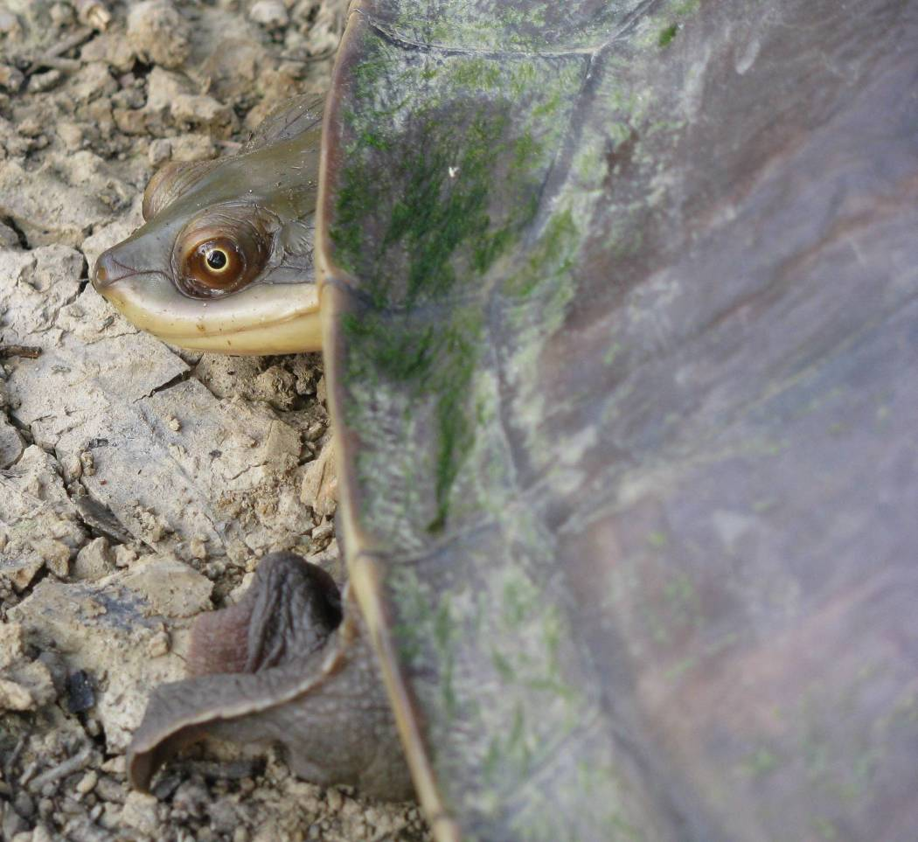
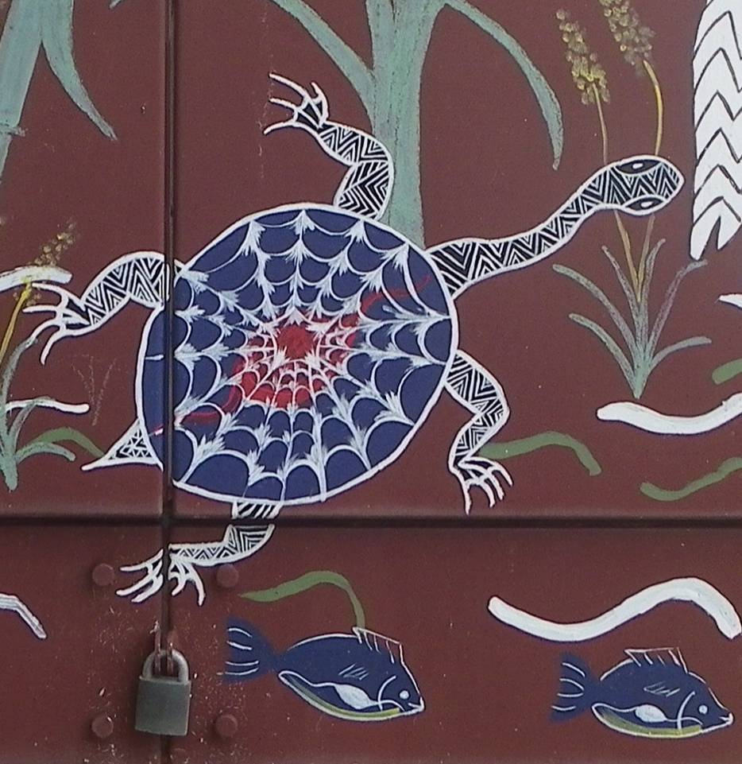



Cultural conservation of freshwater turtles in Barmah–Millewa Forest, 2010–11
Katie Howard¹, Leah Beesley¹, Lee Joachim²
and Alison King¹
¹Arthur Rylah Institute for Environmental Research
123 Brown Street, Heidelberg, Victoria 3084
August 2011
In partnership with:

²Yorta Yorta Aboriginal Corporation
cnr Schier and Maloney Streets, Barmah, Victoria 3639


Arthur Rylah Institute for Environmental Research
Department of Sustainability and Environment
Heidelberg, Victoria

Funded by:

The Murray–Darling Basin Authorities’ Living Murray Program

Report produced by: Arthur Rylah Institute for Environmental Research
Department of Sustainability and Environment
PO Box 137
Heidelberg, Victoria 3084
Phone (03) 9450 8600
Website: www.dse.vic.gov.au/ari
© State of Victoria, Department of Sustainability and Environment 2011
This publication is copyright. Apart from fair dealing for the purposes of private study, research, criticism or review as permitted under the Copyright Act 1968, no part may be reproduced, copied, transmitted in any form or by any means (electronic, mechanical or graphic) without the prior written permission of the State of Victoria, Department of Sustainability and Environment. All requests and enquiries should be directed to the Customer Service Centre, 136 186 or email customer.service@dse.vic.gov.au
Citation: Howard, K. , Beesley, L., Joachim, L. and King, A. (2011) Cultural conservation of freshwater turtles in Barmah-Millewa Forest 2010–11. Arthur Rylah Institute for Environmental Research Technical Report Series No. 223. Department of Sustainability and Environment, Heidelberg, Victoria.

ISSN 1835-3827 (print)
ISSN 1835-3835 (online)
ISBN 978-1-74287-205-6 (print)
ISBN 978-1-74287-206-3 (online)

Disclaimer: This publication may be of assistance to you but the State of Victoria and its employees do not guarantee that the publication is without flaw of any kind or is wholly appropriate for your particular purposes and therefore disclaims all liability for any error, loss or other consequence which may arise from you relying on any information in this publication.
Accessibility:
If you would like to receive this publication in an accessible format, such as large print or audio, please telephone
136 186, or through the National Relay Service (NRS) using a modem or textphone/teletypewriter (TTY) by dialling 1800 555 677, or email customer.service@dse.vic.gov.au
This document is also available in PDF format on the internet at www.dse.vic.gov.au
Front cover photo: Broad-shelled Turtle captured at Yielima Bend (Katie Howard) and a mural in Mathoura painted by Pam Ayton (© Paul Evans)
Authorised by: Victorian Government, Melbourne
Printed by: NMIT Printroom, 77–91 St Georges Road, Preston 3072

Contents
List of tables and figures v
Acknowledgements vi
Acknowledgements vi
Summary 1
1 Introduction 4
Section 1: The current health and status of turtle populations in the Barmah–Millewa Forest 6
2 Methods 6
2.1 Study areas 6
2.2 Water quality and habitat assessment 10
2.3 Collection and processing of live turtles 11
2.3.1 Turtle measurements 12
2.3.2 Marking 12
2.4 Terrestrial surveys 12
2.4.1 Systematic surveys for dead turtles and signs of nesting 12
2.4.2 Spot surveys for signs of nesting 13
2.5 Analyses 16
2.5.1 Abundance and condition 16
2.5.2 Dead turtle survey 16
3 Results 16
3.1 Live turtle survey 16
3.1.1 Abundance and condition 16
3.1.2 Recaptures 17
3.2 Terrestrial surveys 23
3.2.1 Dead turtles 23
3.2.2 Nesting 24
3.2.3 Spot surveys 24
4 Discussion 26
4.1 Relative abundance 26
4.2 Habitat use and body condition 26
4.3 Movement and absolute abundance 28
4.4 Signs of mortality, nesting and recruitment 28
4.5 Conclusions and management recommendations 29
Section 2: Sharing knowledge, ranger training, and capacity-building within Yorta Yorta Nation 31
4.6 Knowledge sharing 31
4.7 Ranger training 31
4.8 Capacity-building 31
4.9 Summary 31
References 33
Appendix 1. Water quality measurements 36

List of tables and figures

List of tables
Table 1. Study sites, their descriptors, water permanence, and habitat grouping. 9
Table 2. Sites surveyed for dead turtles and signs of nesting. 13
Table 3. Effort (hours traps were set) for each site, and the number of each turtle species. 18
Table 4. Water quality measurements taken during February and April 2011 at each site surveyed for live turtles in the Barmah–Millewa Forest. 36

List of figures
Figure 1. River discharge (solid black line) and water temperature (dashed grey line) upstream of Barmah–Millewa Forest (Yarrawonga gauge) for (a) 2010–11 and (b) 2009–10 sampling years. Black triangles show the timing of live turtle surveys. Flows above the solid red line flood the Forest. 7
Figure 2. Location of live turtle survey sites. 8
Figure 3. A selection of the habitat types included in the study: (a) river, Yielima Bend; (b) large lake, Barmah Lake; (c) regulated creek, Tongalong Creek; (d) ephemeral creek, Smiths Creek; (e) ephemeral wetland, Gulpa Track Wetland; (f) ephemeral wetland, Millewa River Road #2. 10
Figure 4. A cathedral trap (a) out of water, and (b) set in Tongalong Creek. (b) Fyke net. 11
Figure 5. Turtle tagging: (a) tag placed between the fourth and fifth digit of the hind foot, (b) notch made in a marginal scute, and (c) notch made in marginal scute F, giving the turtle the unique notch code ‘F’. 12
Figure 6. A selection of the habitat types included in the terrestrial survey: (a) river, Ladgroves Beach; (b) river, Trent Road; (c) ephemeral creek, Ladgroves Track; (d) ephemeral wetland, Gulpa Track wetland. 14
Figure 7. Location of terrestrial survey sites and spot surveys. 15
Figure 8. Location of turtle species captured during the live turtle survey. 19
Figure 9. Size frequency distributions of; (a) Broad-shelled Turtle, (b) Murray River Turtle, and (c) Common Long-necked Turtle. 20
Figure 10. Average catch-per-unit-effort (± SE) per site for the Broad-shelled, Murray River, and Common Long-necked Turtle. 21
Figure 11. Average (± SE) turtle catch-per-unit effort (CPUE) for each site, for (a) Broad-shelled Turtle, (b) Murray River Turtle, (c) Common Long-necked Turtle. Sites are ordered by water permanence. 22
Figure 12. Average (± SE) body condition of Turtles in Barmah–Millewa Forest in 2010 and 2011. Sample size is shown in parentheses, and * = indicates significant difference among years at the alpha 0.05 level. 23
Figure 13. The number of dead turtle shells observed per kilometre of walking effort per person per site. 23
Figure 14. Potential nest at Ladgroves Beach (a), nests and nesting habitats at Millewa River Road Wetland #2 (b–d), and Black Engine Lagoon (e, f). Eggs are indicated with arrows. 25

Acknowledgements
We acknowledge the Yorta Yorta people as the traditional owners of Barmah–Millewa Forest, and thank the community for their invitation to take part in this project. We especially thank Denise Morgan-Bulled for her leadership. The Living Murray section of the Murray–Darling Basin Authority provided financial support. We thank Shar Ramamurthy and Rebecca Curren of the Department of Sustainability and Environment’s Water Group for their management of the project.
Bryan Andy coordinated Yorta Yorta involvement in field work. We thank Greta Morgan, Rochelle Patten, and Bryan for assistance in the field and knowledge sharing. We also thank Paul Evans (Melbourne Water), Nicole Boyd and Graeme Stockfeld for assistance in the field.
Kate Hodges (University of Canberra) and Duncan Limpus (EPA Queensland) kindly provided expert advice on turtle biology.
Field work in New South Wales was authorised under NSW Industry and Investment Fisheries Collection Permit P09/0096-2.0, Forests NSW Special Purposes Permit 48591 and National Parks and Wildlife Services S13052. Sampling in Victorian waters was conducted under ARI fisheries permit RP827, National Parks Flora and Fauna Research Permit 10005451 and DSE Wildlife Permit 1005192. Animal Care and Ethics Approval was granted under ARI AEC09/19.

Summary
This report marks the second year of monitoring the health and status of three freshwater turtle species that inhabit Barmah–Millewa (B–M) Forest. The project commenced in 2009–10 in response to growing concern about turtles, as unusually high numbers of dead turtles were being found in the Forest, which had experienced four years of drought. Turtles are long-lived animals with delayed maturation, low fecundity and low egg and hatchling survival rates — traits that mean they are particularly susceptible to rapid population decline and local extinction.
The Yorta Yorta people were particularly concerned about the longevity of turtle populations because Bayadherra, the Broad-shelled Turtle, is an animal totem associated with their creation stories. This project will assist the Yorta Yorta community to better understand, manage and protect the turtles in Barmah–Millewa Forest, which has recently become a National Park, and is jointly managed by Parks Victoria and Yorta Yorta Nation.
Sampling in B–M Forest in 2009–10, during drought conditions, provided baseline data to assess change in the turtle populations. We found evidence that adult Common Long-necked Turtles occupying ephemeral habitats had experienced significant mortality, and that surviving individuals of this species were occupying refuge habitats (river main channel and permanent wetlands). Sampling in 2010–11 provided an opportunity to examine the effect of large-scale flooding of the forest on the turtle species.
This project, led by Yorta Yorta Nation and funded by The Living Murray Program (Murray–Darling Basin Authority), had four aims in 2010–11:
- Monitor the health and status of turtle populations at B–M Forest.
- Collaborate with the Yorta Yorta people and share knowledge about turtles, and the health of the turtle population in B–M Forest.
- Provide training to an Indigenous Ranger from Yorta Yorta Nation under the Caring for Country program (Parks Victoria), with the aim that future survey work could be conducted by the Yorta Yorta community.
- Support capacity-building within Yorta Yorta community by youth training. The training will teach the process and provide the necessary tools for youths to conduct social science surveys based on informed consent. These surveys will capture Yorta Yorta cultural information and facilitate the transfer of knowledge from elders to youth. This process will assist in the development of Cultural Environmental Management Planning, and the broader management planning for Barmah and Murray Valley National Parks.
To address the first aim, scientific surveys were undertaken to provide information on the distribution of turtles throughout the Forest, their relative abundance, physical condition (body condition), size structure of populations, evidence of nesting and recent mortality. The survey for live turtles commenced in early February 2011, as in the 2010 sampling, but was partly delayed until April 2011 because of flooding. A total of 13 sites were sampled, spanning a range of habitat types, including ephemeral creeks and lakes, regulated creeks, permanent wetlands and the main channel of the Murray River. Terrestrial surveys looking for evidence of turtle mortality and nesting took place at 11 sites in June 2011.
The ‘live turtle’ survey captured 50 turtles, including all three species known to inhabit the area: the Broad-shelled Turtle Chelodina expansa, Murray River Turtle Emydura macquarii and Common Long-necked Turtle Chelodina longicollis. The relative abundance, standardised for effort (catch per unit effort, CPUE), of Broad-shelled and Common Long-necked Turtles was lower in 2011 compared with 2010, but was similar for Murray River Turtles. The reduced relative abundance of two of the three species in 2011 may be the result of flood-facilitated dispersal, negative impacts associated with flood-induced blackwater, or the altered timing of one of the two aquatic surveys in 2011, or a combination of these factors.
Habitat patterns during the flood year were different from those observed during drought, particularly for the Common Long-necked Turtle, which had a higher CPUE in ephemeral habitats compared with river sites. There was preliminary evidence that blackwater conditions during flooding may reduce food availability for carnivorous turtle species and influence habitat choice.
Importantly, the body condition of Common Long-necked and Murray River Turtles was higher in the flood year compared to the drought (by 8.9 and 4.3 % respectively). Body condition could not be compared between years for the Broad-shelled Turtle, because too few individuals were collected in 2011. This finding provides evidence that food availability or production (or both) increases during flooding.
The ‘terrestrial surveys’ found more evidence of nesting activity and fewer signs of turtle mortality, i.e. turtle shells, compared to surveys conducted during drought (2010), suggesting that hydrological conditions within the Forest affect survival and recruitment. The size frequency distribution of turtles captured in B–M Forest during both years of trapping was highly skewed towards adults, i.e. very few juveniles were captured. While this general pattern is typical for long-lived vertebrates such as turtles, long-term studies carried out nearby indicate that the number of juvenile turtles is falling. Measures to protect adults and improve recruitment (for example, nest protection) are warranted, especially for the Common Long-necked Turtle.
This study found that freshwater turtles are patchily distributed in B–M Forest, and that their distribution, body condition, likelihood of mortality and nesting activity changes between years, seemingly in relation to the availability and quality of aquatic habitats. Floods and drought appear to be dominant factors shaping the quality of habitats, but other factors such as predation by foxes, water quality, and landscape factors (including distance between water bodies) are likely to play a role. If the turtles are to be effectively managed, we need a better understanding of how these factors affect turtle populations.
Major management recommendations
Water management — Use environmental or cultural flows (or both) to enhance flooding of the Forest or sustain ephemeral habitats in the Forest during times of drought. This will be particularly important for the Common Long-necked Turtle, which inhabits these areas and whose population has suffered high adult mortality as a result of drought.
Fox control — Conduct fox baiting within B–M Forest. Red Foxes are known to have a considerable impact on turtle populations along the Murray River, preying on both adults and nests. Evidence of predation of nests and has been found within the forest, along with visual sightings of foxes. Reducing the abundance of foxes, and therefore levels of predation, may increase turtle recruitment and help depleted populations to recover.
Nest protection — Protect nesting habitats or localities. This action is hampered at present by a lack of information; see below.
Additional recommendations for scientific research to guide management
Ongoing monitoring — Ongoing monitoring is essential for assessing whether turtle populations are stable, declining or increasing. It is particularly important to assess whether the Common Long-necked Turtle can recover from drought-induced mortality. Ongoing monitoring will also allow an assessment of the effectiveness of the management interventions described above, and will increase our understanding of the effects of flood and drought on turtle population dynamics.
Movement and nesting studies — Understanding the movement patterns and nesting behaviour of turtles is critical to understanding how they behave in response to flood, drought and environmental and cultural flows. A better understanding of refuge locations and dispersal will help managers to protect critical habitat and facilitate recolonisation of the Forest by turtles after drought. It will also provide information on preferred nesting habitats and locations, which is a prerequisite for protecting these areas. An understanding of movement, particularly rates of immigration and emigration in the Forest, is also necessary for mark–recapture studies that estimate absolute turtle abundance, i.e. to determine whether populations are in decline.
Cultural aims
Aims 2 and 3 were addressed by Yorta Yorta participation and engagement in the project, which occurred on several levels. The community was involved in setting project aims, selecting sites, undertaking field work and training, and sharing knowledge about turtles. Aim 4 has been postponed because the youth trainer is based overseas and has not yet arrived in Australia. Surveys by youths and elders will take place in the Forest and so will also depend upon the Forest drying out.
In summary, it is a necessity that Yorta Yorta people are responsible for the development of tools that allow for the enjoyment and ongoing responsibility for country. It is essential for them to cultivate the relationship between themselves and ARI scientists to facilitate the augmentation of cultural knowledge and western science. They support the scientific findings and recommendations, and look forward to an ongoing relationship specific to cultural conservation research.

- Introduction
Barmah–Millewa (B–M) Forest is internationally recognised as an important wetland under the Ramsar Convention, and has received iconic status under the Murray–Darling Basin Commission’s ‘Living Murray Initiative’ (www.mdba.gov.au/programs/tlm). Flood waters run into the Forest along a complex system of anabranches and creek lines. Historically, B–M Forest experienced regular winter and spring floods (Young 2011). However, flow regulation by dams and weirs, together with water extraction for irrigation and other uses, has reduced the frequency and duration of winter-spring floods and the area inundated, and caused a slight increase in the frequency of small summer floods (Bren et al. 1987). The altered flow regime is a major threat to the environmental values of the Forest (Ward 2005) and the Murray River in general (Walker and Thoms 1993).
The Forest is home to three species of freshwater turtle: ‘Bayadherra’, the Broad-shelled Turtle Chelodina expansa; ‘Djirrungana Wanurra Watjerrupna’, the Common Long-necked Turtle C. longicollis; and ‘Dhungalla Watjerrupna’, the Murray River Turtle Emydura macquarii, also known as the Macquarie River Turtle (Wilson and Swan 2008). Although these species have wide-ranging distributions, occurring in South Australia, Victoria, New South Wales and Queensland (Wilson and Swan 2008), the Murray River Turtle and Broad-shelled Turtle are considered to be threatened in Victoria, being listed as ‘data deficient’ and ‘endangered’ respectively (DSE 2007).
Concern for turtles in B–M Forest has increased in recent years following anecdotal reports that unusually high numbers of dead turtles were being found in the Forest. The Yorta Yorta people, the traditional owners of this land, are particularly concerned about the recent turtle mortalities, as Bayadherra is an animal totem associated with their creation stories. Indigenous knowledge suggests that a lack of flooding in the forest is responsible for the turtle’s current plight. Anecdotal evidence also suggests that turtles are suffering from human-induced habitat loss, predation by foxes, damage and death associated with boat strikes and recreational fishing.
South-eastern Australia has experienced below-average rainfall since 2001 (BOM 2008), and until mid 2010 B–M Forest had not received notable watering since spring–summer 2005 (King et al. 2009). After 2005 the Forest experienced four years of severe drought, and most of the creeks and wetlands dried out. Drought has the potential to significantly impact turtle populations, because turtles are long-lived animals with delayed maturation, low fecundity and low egg and hatchling survival (Cann 1998). For example, the Broad-shelled Turtle takes 14 to 15 years to mature (Spencer 2002), and lays between five and 30 eggs per clutch (Cann 1998). Consequently, turtles cannot quickly re-establish their numbers in the wake of a significant mortality event. This makes turtles more susceptible to population decline and local extinction than most other species.
In 2009–10 a program to monitor the health and status of the turtles, strengthen Yorta Yorta connection to country, and facilitate knowledge-sharing between scientists and Indigenous owners was established. The program was led by Yorta Yorta Nation and partnered by scientists from the Arthur Rylah Institute for Environmental Research. Scientific surveys revealed that turtle abundance was greater in ‘refuge’ habitats such as the river and permanent wetlands, and lower in ephemeral habitats. Evidence of dead turtles (i.e. their shells) was greater in ephemeral habitats and lower in permanent habitats. Together, these findings provided evidence that at least one species, the Common Long-necked Turtle, had suffered recent mortality, probably as a result of the drought.
While the first year of data provided a snap-shot of the turtle populations in the Forest, the lack of pre-existing data (baseline data) meant that it was not possible to determine if the mortality observed was normal or unusually high. Ongoing monitoring is necessary to understand the relationship between flooding and drying cycles in the Forest and the survivorship and health of turtle populations. It is also important to determine the extent to which turtle populations are able to recover from drought-associated mortality. The low survival rate of eggs and hatchlings (Thompson 1983, Hamann et al. 2007) means that populations will take a considerable time to build up again. As population recovery relies on successful breeding and recruitment, more understanding is needed regarding nesting habitats and the threats that nests face.
The second year of monitoring (2010–11) provided an opportunity to examine the effects of flooding on turtle populations. It was predicted that flooding would cue the movement of turtles, particularly the Common Long-necked Turtle, away from refuge habitats (e.g. river) and into ephemeral habitats. It was also predicted that turtle body condition would improve, and that evidence of mortality (shells) would decrease. Alongside the scientific inquiry, the program also aimed to focus on transferring technical skills to the Yorta Yorta community. There were four specific aims:
- Monitor the health and status of turtle populations at B–M Forest.
- Collaborate with the Yorta Yorta people and share knowledge about turtles and the health of the turtle population in B–M Forest.
- Provide training to an Indigenous Ranger from Yorta Yorta Nation under the Caring for Country program (Parks Victoria), with the aim that future survey work could be conducted by the Yorta Yorta community.
- Support capacity building within Yorta Yorta community by youth training. The trainer will teach the process and provide the necessary tools for youths to conduct social science surveys based on informed consent. These surveys will capture Yorta Yorta cultural information and facilitate the transfer of knowledge from elders to youth. This process will assist in the development of Cultural Environmental Management Planning, and the broader management planning for Barmah and Murray Valley National Parks.
Aim 1 is covered in Section 1 of this report, and aims 2 to 4 are covered in Section 2.

Section 1: The current health and status of turtle populations in the Barmah–Millewa Forest
The health and status of turtle populations in Barmah–Millewa Forest were assessed during 2010–11 as per the 2009–10 study, which included:
- assessing the distribution, abundance, size-frequency and body condition of live turtles
- conducting terrestrial surveys of turtle shells (dead turtle surveys) and nesting.
In 2010–11 the terrestrial surveys were expanded to include spot surveys of beach habitats along the Murray River.
- Methods
  - Study areas
Live turtle sampling was undertaken over two one-week periods. The first sampling period was in early February (31 January – 4 February 2011), as in 2009–10 sampling. However, the second sampling period was postponed from late February until mid April (18 – 22), because high flows (> 10 000 ML/day) prevented nets being set in the main channel, and restricted access to the Forest (Figure 1).
Sampling occurred at fixed sites, stratified across six habitat types: river, large lake, permanent wetland, regulated creek, ephemeral creek, and ephemeral wetland. Habitat grouping reflected the permanence of the water-body and its flow and habitat type. A total of 13 sites, one fewer than in 2009–10, were sampled. Ten of these sites were sampled in 2009–10 and three sites were new. Widespread flooding increased the amount of ephemeral habitat available in the Forest, allowing new sites that were previously too dry or shallow to be sampled. Four sites were not resampled in 2010–11 because they could not be accessed due to flooding, or because nets could not be set because of high flows. Habitat groupings are described in detail below; a summary is provided in Table 1, and site locations are shown in Figure 2.
River sites were in the main channel of the river, and included three of the five sites sampled in 2009–10: Barmah Choke at Pinchgut Bend, Yielima Bend (Figure 3a) and Ladgroves Beach. Nets were set in low-velocity areas, which were typically adjacent to submerged logs, or among macrophyte beds along the river margins. We also sampled an additional river site, Toupna Creek, which was not sampled in 2009–10. In 2009–10 nets were set on the creek side of the regulator, but because of high flows in 2010 all nets were set on the river side of the regulator (river backwater). River sites always contain water but experience seasonal fluctuations in depth that reflect regulated flow patterns. Water levels are high during summer and low during late autumn and winter. This pattern is the inverse of natural conditions.
Permanent wetlands are oxbow or deflation basin wetlands in the Forest, where water persists for extended periods (decades). These systems are typically deep and have low evaporative demands and large or frequent inputs of water from the river (either overbank or underbank). Only one permanent wetland was surveyed along Millewa River Road. For the purpose of this study, we named this site ‘Millewa River Road Wetland’.
Large lakes are deflation basin systems that exceed 100 ha in area. There are two large lakes in Barmah–Millewa Forest: Barmah Lake and Moira Lake. Moira Lake is disconnected from the main channel and is currently receiving water from environmental water allocations. Barmah Lake has an open connection to the river and experiences the regulated flow regimes of the main channel (Figure 3b).
Figure 1. River discharge (solid black line) and water temperature (dashed grey line) upstream of Barmah–Millewa Forest (Yarrawonga gauge) for (a) 2010–11 and (b) 2009–10 sampling years. Black triangles show the timing of live turtle surveys. Flows above the solid red line flood the Forest.

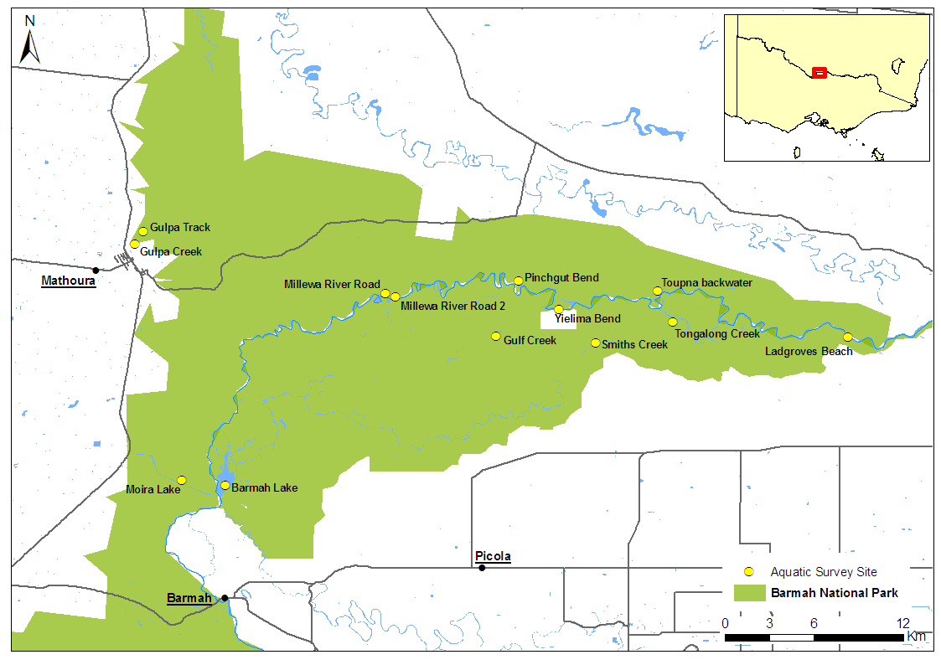
Figure 2. Location of live turtle survey sites.
Regulated creeks have either an open connection to the river channel or are connected by an irrigation-operated regulator. As a consequence they experience the regulated flow regimes of the main channel. Regulated creek sites were on Tongalong Creek, a small anabranch system that lies near Black Engine Swamp in Barmah (Figure 3c), and on Gulpa Creek in Millewa. Gulpa Creek is a natural watercourse used to supply water for irrigation. Water permanence at this site is high. The site at Gulpa Creek – Edwards Junction, sampled in 2009–10, was not sampled in 2010–11 because high flows prevented nets being set.
Ephemeral creeks experience wet–dry regimes. Sites were located at Gulf Creek and Smiths Creek (Figure 3d). These systems have regulators or block-banks that disconnect them from the river and prevent regulated summer flows from unnaturally wetting the system. These systems typically consist of a series of disconnected drying pools. They received considerable water during the protracted flooding of 2010–11. Budgee Creek was sampled in 2009–10, but could not be accessed this year because of flooding. Toupna Creek was sampled behind the regulator in 2009–10, but could not be sampled in 2010–11 because high flows prevented nets being set.
Ephemeral wetlands experience wet–dry regimes. This habitat was not sampled in 2009–10 because sites were dry, but water was abundant in 2010–11 after the flooding. Fewer sites were sampled than anticipated because flooding limited access. Sites studied included a shallow oxbow wetland near Gulpa Creek Track and a deep oxbow wetland adjacent to the Murray River and close to Millewa River Road Wetland #2 (Figure 3e, f).

Table 1. Study sites, their descriptors, water permanence, and habitat grouping.
Site | Water perman-ence | Average depth (m) | Average width (m) | Dominant habitat | Habitat type
Smiths Creek | very low | >2.0 | 25 | WD | ephemeral creek
Gulf Creek | low | 1.0 | 25 | WD | ephemeral creek
Barmah Lake | moderate | >2.0 | > 100 | EM/SM | large lake
Moira Lake* | moderate | 1.5 | > 100 | EM/SM | large lake
Tongalong Creek | moderate | >2.0 | 35 | WD/EM | regulated creek
Gulpa Creek | high | 1.7 | 15 | WD/EM | regulated creek
Millewa River Rd Wetland | high | 1.5 | 100 | WD/EM/FW | permanent wetland
Millewa River Rd Wetland #2* | moderate | 1.5 | 25 | WD/EM/FW | ephemeral wetland
Gulpa Track* | very low | 1.0 | 15 | WD/FW | ephemeral wetland
Toupna Backwater | very high | >2.0 | 20 | EM | Murray River
Ladgroves Beach | very high | >2.0 | 95 | WD/EM | Murray River
Yielima Bend | very high | >2.0 | 90 | EM | Murray River
Pinchgut Bend | very high | >2.0 | 90 | WD/EM | Murray River
WD = woody debris, EM = emergent macrophytes, SM = submerged macrophytes, FW = floating weed.
* Sites not sampled in 2009–10.

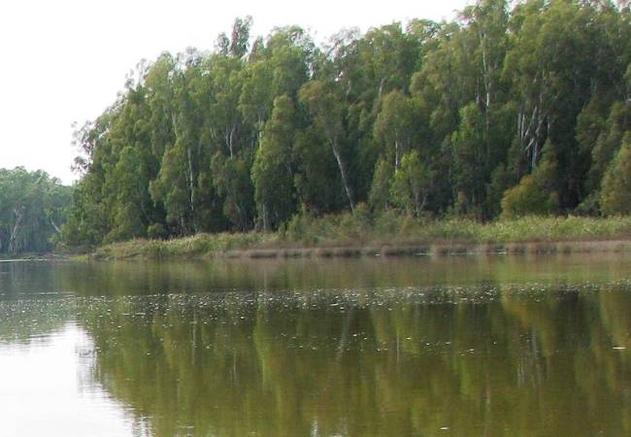  a | 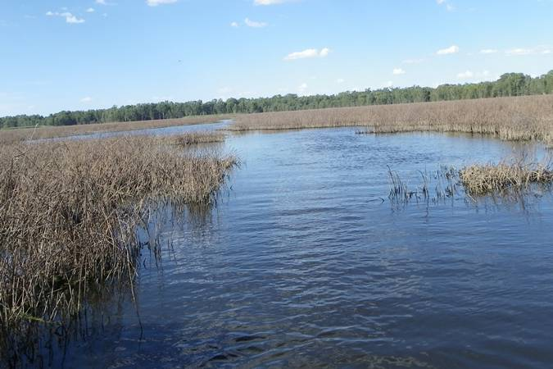  b
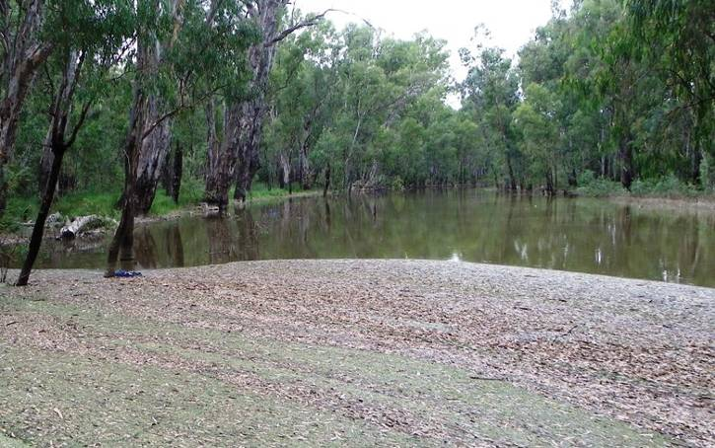  c | 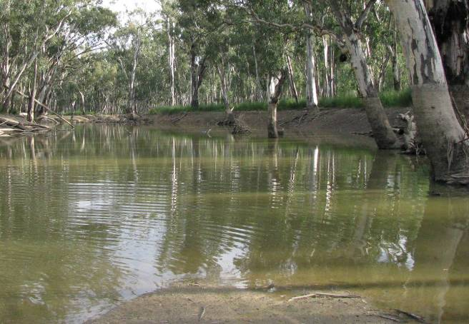  d
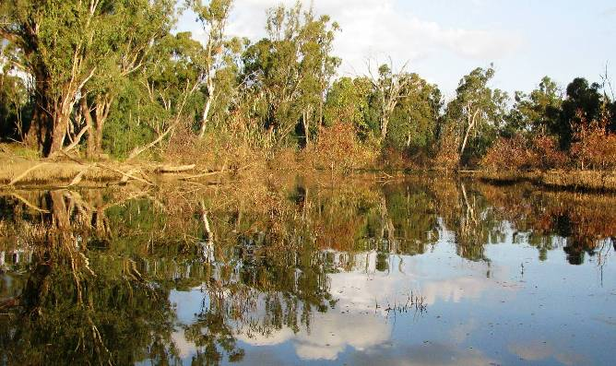  e | 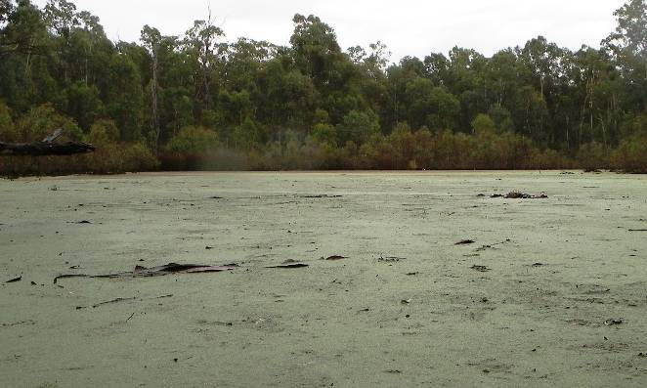  f
Figure 3. A selection of the habitat types included in the study: (a) river, Yielima Bend; (b) large lake, Barmah Lake; (c) regulated creek, Tongalong Creek; (d) ephemeral creek, Smiths Creek; (e) ephemeral wetland, Gulpa Track Wetland; (f) ephemeral wetland, Millewa River Road #2.

  - Water quality and habitat assessment
At each site the water pH, conductivity (μS), turbidity (NTU), temperature (ºC), and dissolved oxygen (ppm) were measured using a TPS meter. A visual assessment was used to rank flow from 1 (still) to 5 (fast). Habitat descriptors, such as average width (m), depth (m) and dominant habitat type, were assessed.
  - Collection and processing of live turtles
Turtles were collected predominantly using ‘cathedral traps’, which are specifically designed for turtles (Figure 4a). These submerged, collapsible traps have a lower chamber for attracting the turtle with bait, and an upper compartment allowing the turtle access to air. The traps have a mesh diameter of 30 mm and a total height exceeding 2 m. Each trap was deployed with a float placed in the top compartment and then tied to overhanging branches and logs where possible (Figure 4b). Beef or lamb heart was placed in the lower chamber of the trap to attract the turtles. Seven to ten cathedral traps were deployed at each site. Nets were set in the late afternoon and retrieved in the early morning, 12–16 hours later. Traps were placed 25–100 m apart in still or slow-flowing areas.
Cathedral traps cannot be set in shallow (< 1.3 m deep) water and were not suitable for sampling in certain ephemeral habitats. To collect turtles in these habitats we used single wing fyke nets with a mixture of small and large mesh sizes, with wings from 5 to 12 m long (Figure 4c). Fyke nets were baited with beef or lamb heart placed at the far end to attract turtles into the net. Fyke nets were set in shallow water, allowing turtles in all funnel compartments access to air, and a float was also placed in the cod end of the net. Eight fyke nets were set 25–100 m apart at each site, in the late afternoon, and retrieved in the early morning.

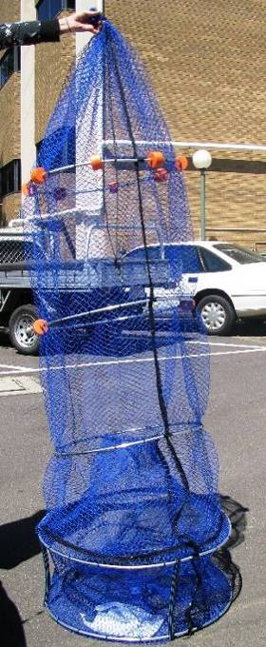  a | 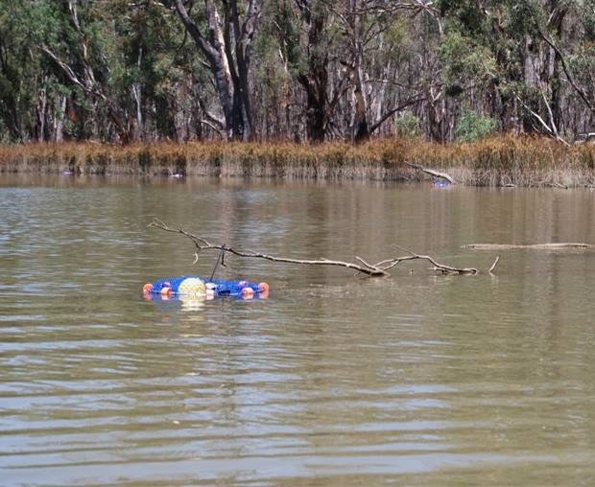  b
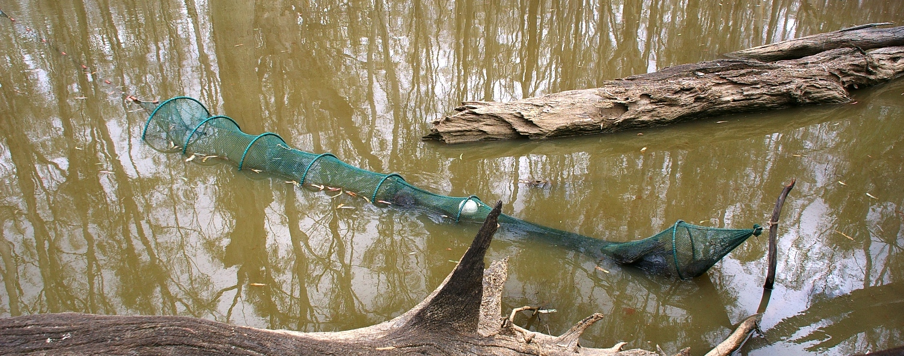
c
Figure 4. A cathedral trap (a) out of water, and (b) set in Tongalong Creek. (b) Fyke net.

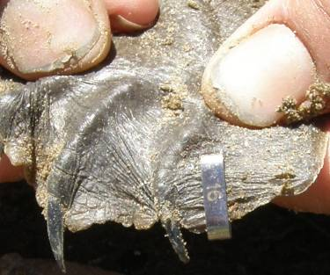  a) | 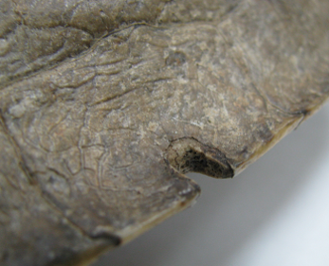  b) | 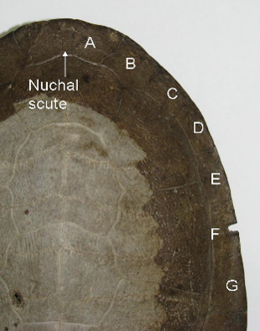  c)
Figure 5. Turtle tagging: (a) tag placed between the fourth and fifth digit of the hind foot, (b) notch made in a marginal scute, and (c) notch made in marginal scute F, giving the turtle the unique notch code ‘F’.

    - Turtle measurements
Turtles were identified to species and sex where possible. For each turtle captured, the following measurements (in cm) were taken using vernier calipers: straight carapace length (SCL), straight carapace width (SCW), plastron length (PL) and body depth. SCL was measured from the middle of the nuchal scute to the middle of rear marginal scutes. SCW was the widest section of the carapace measured perpendicular to the carapace midline. PL was taken from the middle of the anterior and posterior ends of the plastron. Body depth was measured as the widest section between the mid carapace and mid plastron. Turtles were weighed to the nearest gram using a 6 kg or 11 kg balance.
Turtle condition was assessed in two ways: body mass index (K) and physical damage. Body mass index was determined from the following formula (Bjorndal et al. 2000):
$$K=\frac{\text{weight}´\text{100}}{{\text{SCL}}^{3}}$$
    - Marking
Two methods were used to mark turtles: tagging and notching. Each turtle with an SCL greater than 15 cm was tagged with an individually numbered, self-locking and piercing monel tag (National Band and Tag Company, USA). The tag was placed between the webbing of the fourth and fifth toes on one hind foot (Figure 5a). Where possible, turtles were also uniquely notched in the marginal scutes (outside scales) of the carapace. A 10.4 V Model 800 Dremmel battery-powered grinding tool was used to create a notch to a depth one-third the width of the scute (Figure 5b). Each marginal scute was given a letter in a clockwise formation starting from, but not including, the nuchal scute (A, B, C, etc.). One notch was made into individual scutes to create a unique code for that turtle (i.e. A, B, C, … AB, AC, AD, etc.) (Figure 5c).
A small sliver of skin or tissue from the trailing flap on the outside of a hind foot was removed from each turtle with a scalpel and forceps, and preserved in ethanol for any future genetic studies. Once measured and tagged, turtles were released at their site of capture.
  - Terrestrial surveys
    - Systematic surveys for dead turtles and signs of nesting
Eleven sites were surveyed for signs of dead turtles (turtle shells) and signs of nesting. Different sites were surveyed from those visited in 2009–10, to avoid any errors introduced by the removal of shell and egg fragments during the initial survey. A description of the sites surveyed is provided in Table 2, examples of the habitat types surveyed are shown in Figure 6, and the locations of the terrestrial surveys within Barmah–Millewa Forest are displayed in Figure 7.
At each site, two observers walked side by side, 15 m apart, scanning the ground near the waterway for at least 30 minutes. Start and stop locations were recorded using GPS to calculate the total distance walked. Turtle shells, turtle egg fragments, predated nests, diggings from attempted nesting, and potential nesting sites were noted if found. Each turtle shell located was identified to species, and the SCL was measured if the shell was undamaged.

Table 2. Sites surveyed for dead turtles and signs of nesting.
Site | Habitat Type
Cucumber Gully | Ephemeral creek
Tin Hut Bridge | Ephemeral creek
Toupna Creek | Ephemeral creek
Ladgroves Track | Ephemeral creek
Black Engine Lagoon | Ephemeral wetland
Millewa River Road wetland #2 | Ephemeral wetland
Gulpa Track wetland | Ephemeral wetland
Barmah Lake | Large lake
Barmah Town | River
Trent road Murray River | River
Ladgroves Beach | River

    - Spot surveys for signs of nesting
Four sites were opportunistically visited and surveyed when boating on the Murray River (Figure 7). These sites represented potential nesting sites on sandy or clay beaches. At each site four people conducted a visual search along the length of the beach, looking for signs of nesting and dead turtles. These signs included turtle tracks leaving or entering the river, nests and eggs that showed evidence of predation, and holes from attempted nesting.

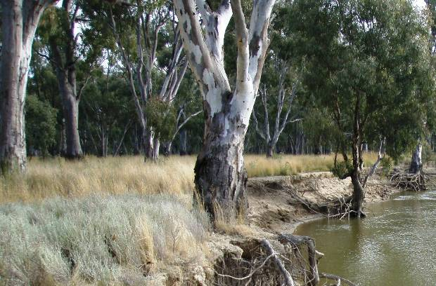  b  a | 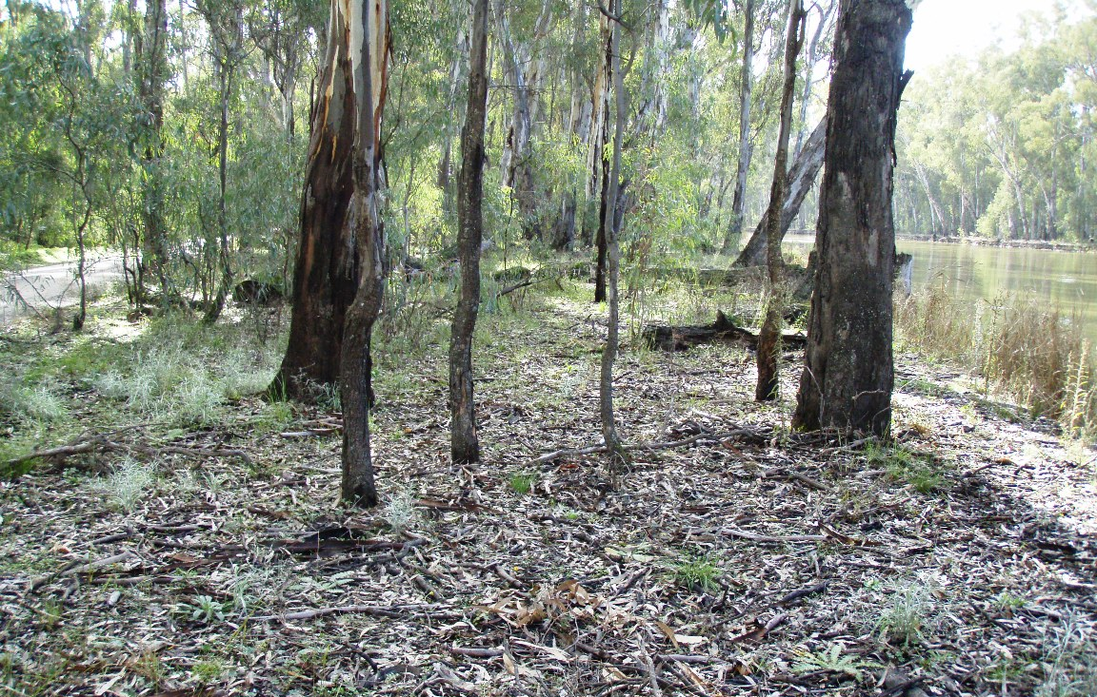
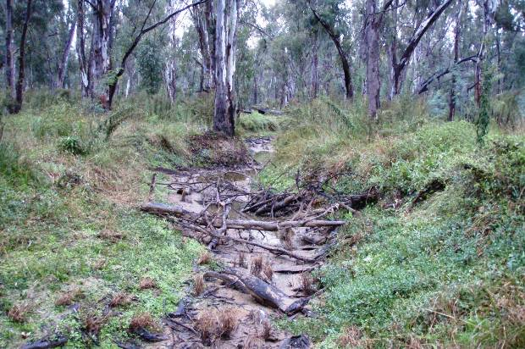  c  a) | 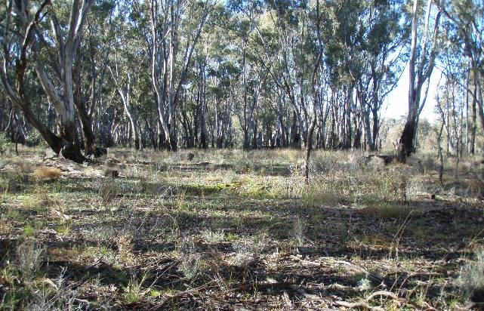  d
Figure 6. A selection of the habitat types included in the terrestrial survey: (a) river, Ladgroves Beach; (b) river, Trent Road; (c) ephemeral creek, Ladgroves Track; (d) ephemeral wetland, Gulpa Track wetland.

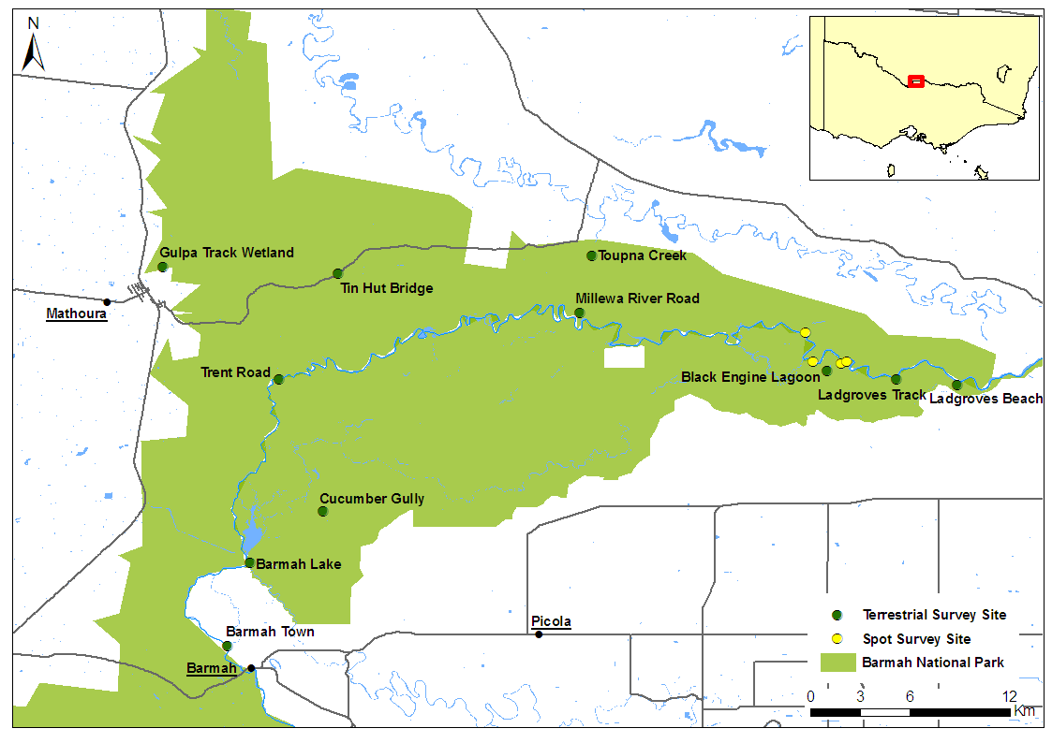
Figure 7. Location of terrestrial survey sites and spot surveys.
  - Analyses
    - Abundance and condition
Abundance data were converted to the number of individuals captured per hour of trapping effort to standardise for the different lengths of time the traps were set. Kruskal–Wallis tests (adjusted for tied ranks) were used to compare CPUE abundance data per site (number of turtles/net/hour) between the two survey years (2010 vs. 2011) for each species. This non-parametric procedure was used because the data were not normally distributed (i.e. it was dominated by zero catches). Comparisons of CPUE data among habitat types for each species were not performed because of low catches. Valid comparisons of CPUE data are based on the assumption that turtle trapping rates were similar for summer and autumn trapping sets. However, a 10 °C reduction in temperature between these two periods is likely to reduce turtle activity, and therefore the capture rate of turtles. Consequently, all CPUE comparisons were interpreted with caution.
The analysis of turtle body condition was restricted to comparisons among years, because too few turtles were caught to make habitat-related comparisons meaningful. Comparisons were conducted using Kruskal–Wallis tests as per CPUE analyses. All statistical analyses were performed using Genstat (version 13.1).
    - Dead turtle survey
To standardise for varying effort (distance walked, number of observers), data were converted to number of turtle shells/km/person.
- Results
  - Live turtle survey
Fifty turtles were collected from the 13 sites sampled: two Broad-shelled Turtles, six Common Long-necked Turtles, and 44 Murray River Turtles (Table 3). The species captured and their locations are shown in Figure 8. Two juvenile Murray River Turtles were collected, but no juvenile Common Long-necked or Broad-shelled Turtles were recorded, which was similar to the findings of 2010 (Figure 9). Water chemistry parameters were generally similar to last year, except for three sites affected by blackwater (see Appendix 1). At these sites (Barmah Lake, Millewa River Road Wetland, and Millewa River Road Wetland #2) oxygen levels were below 1 mg/L (ppm).
    - Abundance and condition
The average abundance of turtles collected per site was 0.030 turtles/trap/hour effort for cathedral traps (range 0 to 0.223), and 0.013 turtles/trap/hour for fyke nets (Table 3). Limiting the analysis to sites sampled using cathedral traps, turtle CPUE per site (abundance/trap/hour) was significantly higher for Murray River Turtles than for the other species (Kruskal–Wallis H_{2, 29} = 8.311,
p = 0.016) (Figure 10). Species comparisons of CPUE across years revealed that there were fewer Broad-shelled and Common Long-necked Turtles caught in 2011 (Kruskal–Wallis Broad-shelled H_{1, 23} = 4.830, p = 0.028; Common Long-necked H_{1, 23} = 4.833, p = 0.028), but a similar number of Murray River Turtles (Kruskal–Wallis H_{1, 23} = 0.546, p = 0.460) (Figure 10). Common Long-necked Turtles were also caught in sites sampled with fyke nets; however, the total number collected was still lower in 2011, even when these turtles were included (14 in 2010, 6 in 2011).
Site-related variation in CPUE was marked for the Murray River Turtle. At most sites CPUE was 0.011 or less (typically less than three turtles for an overnight set). However, at one permanent wetland adjacent to the river (Millewa River Road Wetland) CPUE was as high as 0.223 (34 turtles caught) (Figure 11b). This CPUE was three times as high as that recorded in 2010. No Broad-shelled Turtles were caught at this site in 2011, even though both species were caught in similar numbers in 2010. CPUE was consistently low across sites (and habitats) for the Broad-shelled and Common Long-necked Turtle, and no Common Long-necked Turtles were collected in river sites (Figure 11a, c).
The body condition of Murray River and Common Long-necked Turtles was higher in 2011 than in 2010 (Kruskal–Wallis Murray River H_{1, 82} = 5.274, p = 0.022; Common Long-necked H_{1, 17} = 7.348, p = 0.007) (Figure 12). The condition of Murray River Turtles increased by an average 4.3%, which equates to an average-sized turtle in 2010 putting on an additional 72 g of body weight. The condition of Common Long-necked Turtles increased by an average of 8.9%, which equates to an average-sized turtle in 2010 putting on an additional 83 g of body weight. Too few Broad-shelled Turtles were collected for a meaningful assessment of their condition. Site-related variation in body condition was difficult to assess because of the low numbers of turtles collected at most sites.
    - Recaptures
Two Murray River Turtles marked in 2009–10 were recaptured at the same sites in 2010–11. One was a juvenile trapped at Millewa River Road Wetland. When captured in 2009–10 this turtle was 18.7 cm SCL and weighed 608 g. In 2010–11 the turtle had grown 1.6 cm SCL and gained 211 g in weight. Its body condition score (K) had increased by 5%. The second turtle was an adult female collected at the river site, Pinchgut Bend. In 2009–10 this turtle was 27.7 cm SCL and weighed 2282g. When recaptured in 2010–11 the turtle had grown 0.34 cm SCL and gained 240 g in weight. Its body condition score (K) had increased by 6.5%.

Table 3. Effort (hours traps were set) for each site, and the number of each turtle species.
Captures/trap/h = number of turtles caught per trap per hour set, shown as mean and standard error (SE).
 |  |  |  | Broad-shelled Turtle |  |  | Murray River Turtle |  |  | Common Long-necked Turtle |  |  | All species
 | Effort | Method | Trip | No. | No./trap/h |  | No. | No./trap/h |  | No. | No./trap/h |  | No. | No./trap/h
Site | (hrs set) | (number set) |  | caught | mean | SE | caught | mean | SE | caught | mean | SE | caught | mean
Barmah Lake | 14.25 | cathedral (9) | Feb | 0 | 0.000 | 0.000 | 0 | 0.000 | 0.000 | 0 | 0.000 | 0.000 | 0 | 0.000
Moira Lake | 12.57 | cathedral (10) | Feb | 0 | 0.000 | 0.000 | 0 | 0.000 | 0.000 | 1 | 0.008 | 0.008 | 1 | 0.008
Tongalong Creek | 13.75 | cathedral (9) | Feb | 0 | 0.000 | 0.000 | 1 | 0.008 | 0.008 | 0 | 0.000 | 0.000 | 1 | 0.008
Millewa Rd Wetland | 15.25 | cathedral (10) | Feb | 0 | 0.000 | 0.000 | 34 | 0.223 | 0.060 | 0 | 0.000 | 0.000 | 34 | 0.223
Millewa Rd Wetland #2 | 14.83 | cathedral (9) | Feb | 0 | 0.000 | 0.000 | 3 | 0.022 | 0.011 | 0 | 0.000 | 0.000 | 3 | 0.022
Smiths Creek | 16.50 | cathedral (9) | Apr | 0 | 0.000 | 0.000 | 0 | 0.000 | 0.000 | 0 | 0.000 | 0.000 | 0 | 0.000
Gulf Creek | 18.75 | fyke (8) | Apr | 0 | 0.000 | 0.000 | 0 | 0.000 | 0.000 | 1 | 0.007 | 0.007 | 1 | 0.007
Gulpa Creek | 16.00 | fyke (8) | Apr | 0 | 0.000 | 0.000 | 0 | 0.000 | 0.000 | 3 | 0.023 | 0.011 | 3 | 0.023
Gulpa Track Wetland | 16.00 | fyke (8) | Apr | 0 | 0.000 | 0.000 | 0 | 0.000 | 0.000 | 1 | 0.008 | 0.008 | 1 | 0.008
River: Toupna Regulator | 15.33 | cathedral (10) | Feb | 0 | 0.000 | 0.000 | 1 | 0.007 | 0.007 | 0 | 0.000 | 0.000 | 1 | 0.007
River: Ladgroves Beach | 15:00 | cathedral (7) | Apr | 0 | 0.000 | 0.000 | 0 | 0.000 | 0.000 | 0 | 0.000 | 0.000 | 0 | 0.000
River: Yielima Bend | 15.25 | cathedral (10) | Apr | 2 | 0.014 | 0.009 | 1 | 0.007 | 0.007 | 0 | 0.000 | 0.000 | 3 | 0.020
River: Pinchguy Bend | 16.08 | cathedral (7) | Apr | 0 | 0.000 | 0.000 | 2 | 0.018 | 0.011 | 0 | 0.000 | 0.000 | 2 | 0.018
Total |  |  |  | 2 |  |  | 42 |  |  | 6 |  |  | 50

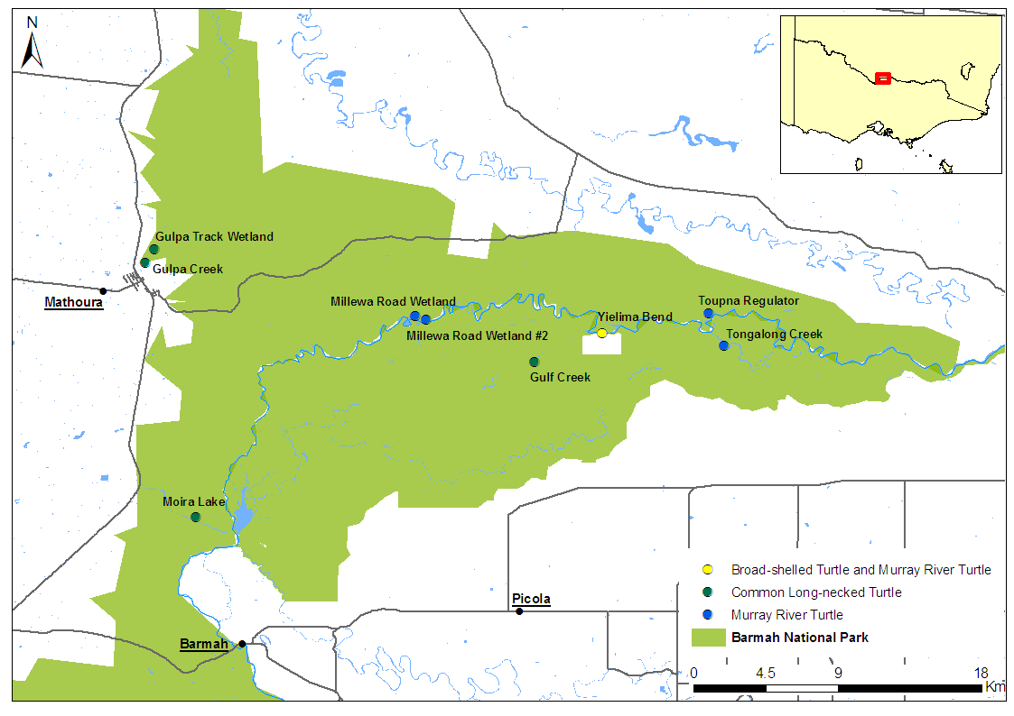
Figure 8. Location of turtle species captured during the live turtle survey.
Figure 9. Size frequency distributions of; (a) Broad-shelled Turtle, (b) Murray River Turtle, and (c) Common Long-necked Turtle. Dashed lines indicate size at maturity (Parmenter 1985, Spencer 2002).

Figure 10. Average catch-per-unit-effort (± SE) per site for the Broad-shelled, Murray River, and Common Long-necked Turtle. Number of sites = 14 in 2010, and 10 in 2011 (fyke net sites excluded), * = indicates significant difference among years at the alpha 0.05 level.
Figure 11. Average (± SE) turtle catch-per-unit effort (CPUE) for each site, for (a) Broad-shelled Turtle, (b) Murray River Turtle, (c) Common Long-necked Turtle. Sites are ordered by water permanence. All sites were sampled with cathedral traps, except for three sites (*) sampled with fyke nets. The number of nets set at each site ranged from 7 to 10 and is provided in Table 3.

Figure 12. Average (± SE) body condition of Turtles in Barmah–Millewa Forest in 2010 and 2011. Sample size is shown in parentheses, and * = indicates significant difference among years at the alpha 0.05 level.

  - Terrestrial surveys
    - Dead turtles
Thirty-seven kilometres were walked looking for evidence of turtles, with an average of 1.7 km walked per site (range 1.3 to 2.3 km). When standardised for effort, there were marginally fewer shells collected in 2011 compared with 2010; Kruskal–Wallis H_{1, 19} = 3.791, p = 0.051 (Figure 13). Only one Common Long-necked Turtle shell was found along the bank of an ephemeral creek (Tin Hut) in 2010–11, compared with 29 during the 2009–10 surveys.

Figure 13. The number of dead turtle shells observed per kilometre of walking effort per person per site. Nine sites were sampled in 2010 and 11 in 2011.
    - Nesting
The terrestrial surveys found turtle eggs at Black Engine Lagoon and Millewa River Road Wetland #2, providing direct evidence of nesting (Figure 14b–f). A digging consistent with turtle nesting was found at Ladgroves Beach (Figure 14a). No egg shells were found within or surrounding the nest, suggesting that the nest was not damaged by predators, but rather that this digging was an unsuccessful nesting attempt. If this nest is included, a total of 17 nests were recorded and marked using GPS. Thirteen of these were located during the terrestrial surveys, and another two nests were found during the aquatic surveys. No signs of nesting were observed during the 2010 terrestrial surveys.
Two nests with evidence of predation were recorded at Black Engine Lagoon (Figure 14e–f). Both nests were in clay soil and within 15 m of the water. Twelve and 11 egg shells were found at each nest respectively. The greatest number of nests (n = 12) were found at Millewa River Road #2 Wetland, where three clusters of nests and one individual nest were found (Figure 14b–d). The three clusters of nests contained four, five and two nests respectively. The nests were laid on small mounds of clay two to six metres from the edge of the wetland, and all were within 30 metres of each other. Not all nests had egg shells associated with them, and because of the clustering of nests it was difficult to ascertain which eggs came from which nest. One isolated nest contained 11 eggs. In addition to these nests, two nests with evidence of predation were located at Millewa River Road Wetland during the aquatic surveys. These were recorded as incidental records, as terrestrial surveys were not conducted at this site. Signs of dogs/foxes, pigs or wild horses were noted at three of the nine sites sampled.
    - Spot surveys
Four sites were opportunistically surveyed along the main river channel, but no turtle tracks, turtle shells or signs of nesting were detected.

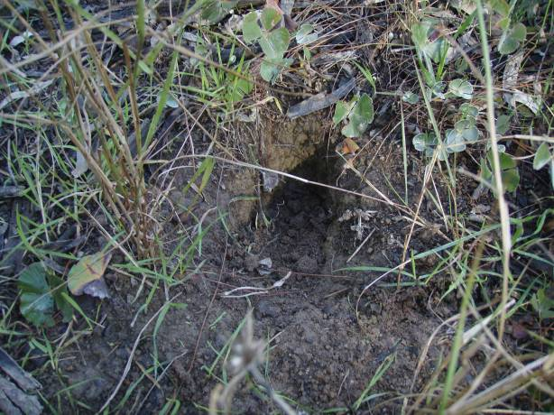  a)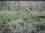) | 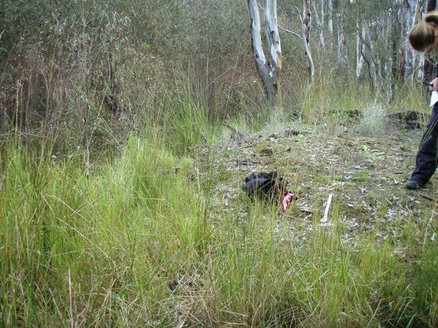  b)
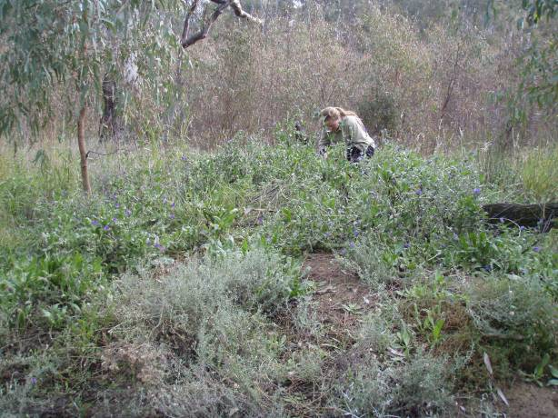  c) | 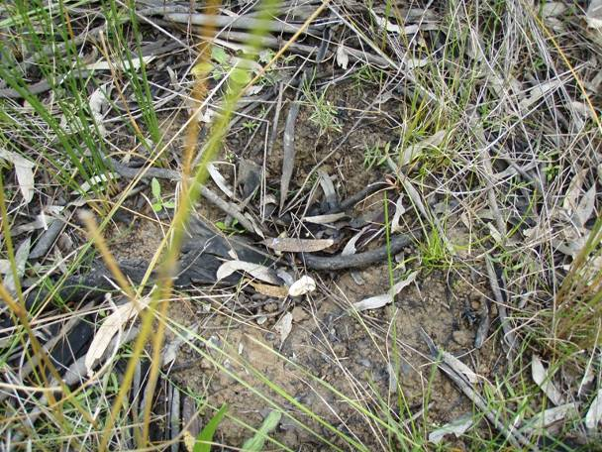  d
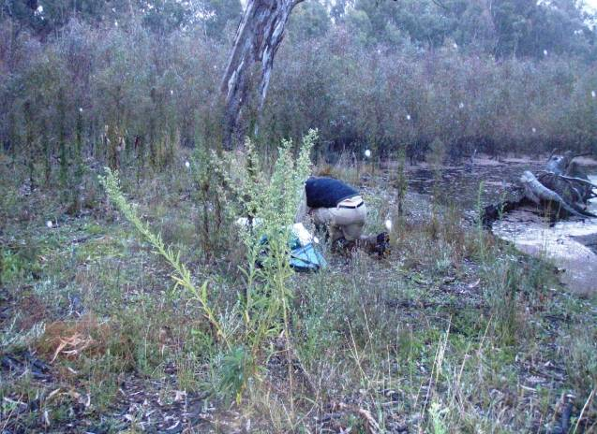  e | 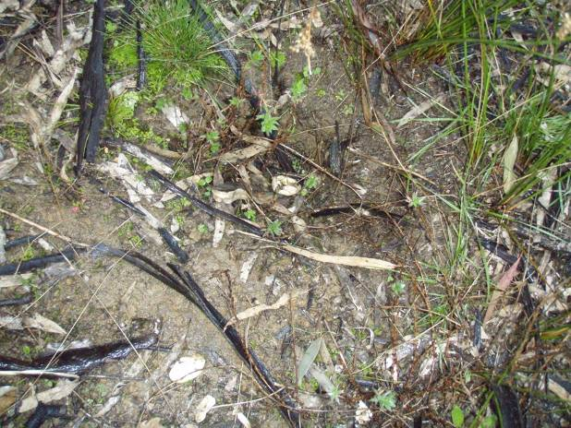  f
Figure 14. Potential nest at Ladgroves Beach (a), nests and nesting habitats at Millewa River Road Wetland #2 (b–d), and Black Engine Lagoon (e, f). Eggs are indicated with arrows.

- Discussion
  - Relative abundance
Turtle relative abundance (catch per unit effort, CPUE) was lower in 2011 than 2010 because fewer individuals of Broad-shelled and Common Long-necked Turtles were caught. This was probably the result of flood-facilitated dispersal, negative impacts associated with flood-induced blackwater, the altered timing of one of the two aquatic surveys in 2011, or a combination of these factors.
Flooding of Barmah–Millewa Forest began in July 2010 and continued through to late March 2011 (www.mdba.gov.au/water/live-river-data). It has been four years since significant flooding of the Forest occurred (2005–06), and 14 years since such a large, protracted event took place (1996). The flood greatly increased the area of aquatic habitat available for turtles, and the dispersion of turtles from drought refuge habitats (i.e. the river and adjacent permanent wetlands) into the ephemeral creeks and wetlands would have reduced the density of turtles in B–M, explaining the reduced CPUE. This scenario is especially likely for the Common Long-necked Turtle, which is the one species known to undertake overland migrations to ephemeral aquatic habitats after rainfall (Roe and Georges 2008).
Flooding in 2011 caused a significant hypoxic blackwater event in B–M Forest (King et al. 2011a). Dissolved oxygen levels were lowest in ephemeral habitats and in the river downstream of the Forest. Values of below 2 mg/L occurred at some sites for several months (November to January) (King et al. 2011b). These extremely low oxygen levels affected invertebrate and fish assemblages – shrimps were observed dying, crayfish were emerging from the water, and many native fish were observed at the waters surface trying to breathe (King et al. 2011a, b). Annual fish condition monitoring undertaken as part of the Living Murray Program reported that the blackwater event had a negative impact on the spawning and / or survival of larvae for many native fish (Raymond et al. 2011). Consequently, there is considerable evidence that blackwater would have affected the availability of food for turtles. This may have forced carnivorous turtle species (i.e. Broad-shelled and Common Long-necked Turtles) to disperse in search of non-blackwater affected habitat, or it may have led to increased mortality of these species, however this study found no evidence of turtle mortality (see ‘Signs of mortality and nesting, section 4.4’).
The high flows within the Murray River during flooding, meant that the sampling of river sites (and some ephemeral sites) was delayed from early February until mid April (seven of the 13 sites), when water temperatures were approximately 10 °C cooler. Although all three species have been trapped, or observed being active, at temperatures similar to those recorded in April (Chessman 1988), temperature can influence the activity rates of turtles, and it is likely that the turtles were less active at this time. Consequently, the reduced CPUE in 2011, particularly at river sites, may be an artefact of sampling time.
  - Habitat use and body condition
The limited results we have (two years only) suggest that flood and drought bring about marked changes in turtle assemblages and habitat use within B–M Forest. Sampling during the drought conditions of 2009–10 showed that all three species were found predominantly in the main channel and adjacent permanent wetlands (Beesley et al. 2010). However, the dead turtle survey found Common Long-necked Turtle shells at drying ephemeral sites, indicating that this species had been utilising these areas and that many had died. These habitat patterns are supported by Chessman’s (1988) study, during which Common Long-necked Turtles were captured in waterbodies that were shallow, ephemeral or remote from the main river channel. He found that the Murray River Turtle dominated the Murray River and its backwaters, and the Broad-shelled Turtle was captured in or near permanent water but not in one particular waterbody type.
Sampling during the flood conditions of 2010–11 revealed differences among the three species. The strongest pattern was the increased CPUE of Common Long-necked Turtles in the ephemeral habitats compared to river sites. This finding supported the assertion made in the 2010 study that this species, while restricted to riverine ‘refuge’ habitats during drought, will preferentially occupy ephemeral habitats when they become available. Ephemeral habitats are likely to benefit this species because they often provide higher densities of food, i.e. aquatic invertebrates, particularly when fish are absent (Chessman 1984a). Common Long-necked Turtles occupying ephemeral habitats are also thought to benefit from reduced competition for food with other species that have a similar diet, such as the Murray River Turtle (Georges et al. 1986, Chessman 1988). In B–M Forest, the increased body condition ( up by 8.9%) of Common Long-necked Turtles collected in ephemeral habitats during the flooding of 2011 when compared with those collected in ‘refuge’ habitats in 2010 supports this theory, and the findings of others. For example, Kennett and Georges (1990) studied Common Long-necked Turtles retreating from drying ephemeral pools to permanent dune lake refuges in New South Wales, and found a decrease in growth and body condition. They also found that the growth of these turtles increased and body condition improved when they returned to the ephemeral habitats. Compared to the other two species, Common Long-necked Turtles are better adapted to take advantage of ephemeral habitats because of their ability to migrate overland, aestivate and withstand desiccation (Chessman 1983, 1984b). Roe and Georges (2007) asserted that the combination of permanent and ephemeral wetlands is the key to a landscape’s ability to support a significant population of Common Long-necked Turtles, and that connectivity between these habitat types is critical.
Flooding also appears to alter the habitat use of the Murray River Turtle and the Broad-shelled Turtle, although the evidence comes from only one site, Millewa River Road Wetland, which was affected by blackwater. In February 2010 all three species of turtle were collected in relatively high numbers in this permanent wetland (average CPUE = 0.174, all species), but in February 2011 only the Murray River Turtle was captured at this site (average CPUE = 0.223). This dramatic shift in the turtle assemblage may be linked to dietary requirements. Murray River Turtles are the only species of the three that are omnivorous, meaning they are not reliant for food on fish, yabbies, or other invertebrates that may have perished or migrated during the protracted blackwater event. Filamentous algae can represent 26% of their diet and are an important food source (Chessman 1986). Broad-shelled turtles are obligate carnivores and are not known to supplement their diet with vegetation (Chessman 1983), and Common Long-necked Turtles are primarily carnivorous, with plant debris forming only 5% of stomach contents (Chessman 1984a). Consequently, Broad-shelled and Common Long-necked Turtles would be more affected by top-order trophic collapses caused by blackwater, and may have migrated to unaffected sections of the Forest to avoid starvation.
Like the Common Long-necked Turtle, the body condition of Murray River Turtles in B–M Forest increased during the flood year, by an average of 4.3%. This species did not disperse to productive ephemeral habitats where turtle density would be lower and food availability higher, indicating that food production across the Forest may have increased during the flood. This is in keeping with studies of energy dynamics of lowland temperate rivers in Australia, which have found that large-scale flooding can contribute large quantities of energy (dissolved organic carbon) entering river systems (Robertson et al. 1999). The study by Gawne et al. (2007), which was focused on the Murray River including Barmah Forest, inferred that flooding of 34 km² would deliver as much energy production as that produced by a river not in flood in a whole year. Flooding of B–M Forest in 2010–11 inundated an area of 640 km² (Keith Ward, Goulburn Broken CMA, pers. comm.), suggesting that this flood event is likely to have injected a significant amount of energy into the system. While the short-term benefits of flooding to turtle condition are evident, the extent to which productivity gains persist into the long-term requires further investigation.
  - Movement and absolute abundance
While habitat patterns suggest that turtles move around the Forest in response to flood and drought, there is relatively little known about the movement biology of these species. Studies conducted in South Australia suggest that female Broad-shelled Turtles have home ranges up to a few kilometres, whereas males can move up to 20 km (Deb Bower, unpubl. data). Common Long-necked Turtles commonly move overland between ephemeral and permanent water sources (Roe and Georges 2007, 2008). There is little published information on the movements of the Murray River Turtle. However, an unpublished masters thesis by Judge (2001), carried out in the Nepean River in New South Wales, found that males of this species were more likely to be recaptured at different locations than females or juveniles.
This study has had limited capacity to build upon this knowledge, because no direct research into turtle movement has been conducted, i.e. radiotracking or GPS tracking studies. The mark-–recapture nature of this study has the potential to provide some indirect evidence, but so far only one adult and one juvenile turtle have been recaptured, and both were trapped at the locations where they were originally tagged. Following flooding the CPUE of turtles in the river declined, presumably as individuals dispersed into ephemeral habitats (assuming this was not driven by a temperature-associated decline in activity). Turtles may also move away from the main-channel of the river to avoid high flows. Future investment in movement research is required to ascertain how flood, drought, and environmental or cultural water flows affect turtle behaviour.
Mark–recapture calculations that allow an estimation of absolute population abundance cannot be utilised until turtle movement throughout the Forest is understood. As the Forest is not a closed system and turtles are not confined to the Forest, it is imperative to understand movement within the system before mark–recapture can be used to describe habitat use and dispersal.
  - Signs of mortality, nesting and recruitment
Signs of turtle mortality, i.e. turtle shells, were greater in ephemeral habitats during the drought (2009–10) than post flood (2010–11). This highlights the impact of protracted drought on the mortality rate of the Common Long-necked Turtle, the one species that predominantly occupies ephemeral habitats.
In contrast to mortality, evidence of nesting activity was greater during the flood year (2010–11) than the drought year (2009–10). Signs of nesting were found in clay substrates, often in small groupings next to permanent and ephemeral wetlands; only one digging was found near the river. As different sites were visited each year for all but one of the terrestrial surveys, it is difficult to ascertain whether the increased activity in 2010–11 was due to the chance discovery of nesting areas in 2010–11, or whether nesting activity is linked to climatic conditions. Nesting in freshwater turtles is often cued by rainfall (Cann 1998), and turtles may abandon nesting sites if soil conditions are inappropriate, e.g. too dry (Goode and Russel 1968). However, improved body condition in 2010–11 may also have contributed to increased reproductive effort. For example, a study in South Carolina, USA, observed the reproductive responses of five species of aquatic turtles during a major drought, and found that certain species emigrated, whereas others stayed at the waterbody yet did not reproduce at levels witnessed in previous years (Gibbons et al. 1983). While the relationship between reproduction and flood/drought is unknown for the three turtle species in Barmah–Millewa Forest, studies in coastal New South Wales by Kennett and Georges (1990) found that the reproductive output of Common Long-necked Turtles declined when they occupied refuge habitats during drought. In this study it is possible that the increased in nesting activity was a direct response to the improved body condition associated with flooding. If so, this suggests that flood and drought can affect reproductive output, hence turtle recruitment. To better understand the relationship between flood and drought and reproduction, there is a need to focus more attention on nesting. Our study was unable to confidently link a particular species with a particular nest. Research conducted in lagoons at Albury in the mid 1990s ( about 150 km upstream of B–M, straight line distance), indicates that the species have different nesting behaviours, beyond those associated with the timing of nesting. For example, Spencer and Thompson (2005) found that Murray River Turtles lay their nests closer to water than Broad-shelled Turtles, which laid their nests approximately 40 m from water. Ercolano (2008), working at two lentic waterbodies attached to the Murray River in South Australia, found that Broad-shelled Turtles chose nesting sites with northerly and westerly aspects and relatively dense vegetation. More work is needed to determine the preferred habitats of the three species of turtle in B–M Forest, and the extent to which nesting occurs in groups and where the nests are located.
The size frequency distribution of turtles captured in Barmah–Millewa Forest during both years of trapping was highly skewed towards adults, i.e. very few juveniles were captured. While this general pattern is typical for long-lived vertebrates such as turtles (Pianka 1970), studies carried out nearby indicate that juvenile numbers are falling. For example, repeat surveys of turtle populations about 60 km upstream of B–M (straight line), from 1976 to 1982 and again in 2009–2011, have found a decline in the proportion of juveniles in the populations; Broad-shelled Turtles declined from 14% to 6%, Common Long-necked Turtles declined from 28% to 0%, and Murray River Turtles declined from 25% to 7% (B. Chessman, unpubl. data). The large declines in recruitment were reflected in severe declines in total abundance for two species, the Common Long-necked and Murray River Turtles (B. Chessman, unpubl. data). It is highly likely that similar declines have occurred in B–M Forest.
Demographic studies of Murray River and Broad-shelled Turtles in Albury in the mid 1990s by Spencer and Thompson (2005) revealed that population size of the Broad-shelled Turtle is more stable than the Murray River Turtle because it contains a higher proportion of juveniles, i.e. that recruitment is replenishing adult mortality. Populations of Murray River Turtles are more vulnerable because they have very few juveniles, so they will be very slow to recover from increased adult mortality (Spencer and Thompson 2005). Red Foxes Vulpes vulpes appear to be the biggest cause of adult and nest mortality (Thompson 1983), and this may be the cause of the population decline seen in this species (Spencer and Thompson 2005). A fox baiting program undertaken by Spencer and Thompson (2005) found that fox control reduced nest predation rates by close to 50% for the Murray River Turtle, increased adult survival from 0.95 to 0.99, and stabilised population growth (i.e. stopped it declining). Fox control did little to alter the survival rate of the Broad-shelled Turtle. This species is thought to be less susceptible to foxes because adults can retract their necks completely, and because they nest further from water in lower densities (Spencer and Thompson 2005). It is important to note that Spencer and Thompson’s (2005) study was conducted during non-drought years, so they could not assess the impact of drought on population size.
  - Conclusions and management recommendations
This study found that freshwater turtles are patchily distributed in B–M Forest, and that their distribution, body condition, likelihood of mortality and nesting activity changes between years, seemingly in response to the availability and quality of aquatic habitats. Floods and drought appear to be dominant factors shaping the quality of habitats, but other factors such as predation by foxes, water quality, and landscape factors including distance between water bodies, are likely to play a role. Effective management of the turtles in Barmah-Millewa Forest requires that we have a better understanding of how these factors affect turtle populations.
A recent survey by Bruce Chessman (NSW OEH, pers. comm.) downstream of Yarrawonga has revealed that turtle abundance and recruitment has declined dramatically since the early 1980s. Drought and predation by foxes of nests and adults appear to be the major factors contributing to this decline; however, the relative importance of these factors are likely to differ among the species. For example, drought is likely to be most important for the Common Long-necked Turtle, and fox predation more important for the Murray River Turtle and the Broad-shelled Turtle. In view of this long-term finding, it appears imperative that we continue to study these turtle species and develop management practices that protect turtle populations and aid their recovery (i.e. through environmental water management, protection of nesting habitat, predator management).
Major management recommendations
Water management – Use environmental or cultural flows (or both) to enhance flooding of the forest or sustain ephemeral habitats in the Forest during times of drought. This will be particularly important for the Common Long-necked Turtle, which inhabits these areas and whose population has suffered high adult mortality as a result of drought.
Fox control – Conduct fox baiting within B–M Forest. Foxes are known to have a considerable impact on turtle populations along the Murray River, preying on both adults and nests. Evidence of predation at nests has been found within the Forest, along with visual sightings of foxes. Reducing the abundance of foxes, and therefore levels of predation, may increase turtle recruitment and help depleted populations to recover.
Nest protection – Protect nesting habitats or localities. This action is hampered at present by a lack of information; see below.
Additional recommendations for scientific research to guide management
Ongoing monitoring – Ongoing monitoring is essential for assessing whether turtle populations are stable, declining or increasing. It is particularly important to assess whether the Common Long-necked Turtle can recover from drought-induced mortality. Ongoing monitoring will also allow an assessment of the effectiveness of management interventions described above, and will increase our understanding of the effects of flood and drought on turtle population dynamics.
Movement and nesting studies – Understanding the movement patterns and nesting behaviour of turtles is critical to understanding how they behave in response to flood, drought and environmental and cultural flows. A better understanding of refuge locations and dispersal will help managers to protect critical habitat and facilitate recolonisation of the Forest by turtles after drought. It will also provide information on preferred nesting habitats and locations, which is a prerequisite for protecting these areas. An understanding of movement, particularly rates of immigration and emigration in the Forest, is also necessary for mark–recapture studies that estimate absolute turtle abundance, i.e. to determine whether populations are in decline.

Section 2: Sharing knowledge, ranger training, and capacity-building within Yorta Yorta Nation
  - Knowledge sharing
Yorta Yorta participation and engagement in this project occurred on several levels. The community was involved in setting project aims, selecting sites, undertaking field work and knowledge sharing about turtles. Information about upcoming work was discussed with representatives of the Yorta Yorta on 3 December 2010. The preliminary findings of the 2011 surveys were shared with Yorta Yorta elders and representatives at a gathering in the Dharnya Centre on 20 April 2011.
  - Ranger training
It was an objective of this study to provide training to an Indigenous ranger from Yorta Yorta Nation employed by parks Victoria under the Caring for Country program, with the aim that future survey work could be conducted by the Yorta Yorta community. Bryan Andy (Yorta Yorta), the program coordinator for Yorta Yorta Parks Victoria rangers, accompanied ARI scientists on two survey occasions and received training in net setting and retrieval, turtle processing and data recording. Greta Morgan (Yorta Yorta, Parks Victoria) and Rochelle Patten (Yorta Yorta) also accompanied scientists in the field.
  - Capacity-building
It was an aim of this study to support capacity-building within the Yorta Yorta community through youth training. Youths were to be trained to conduct social science surveys based on informed consent, which would capture Yorta Yorta cultural information and facilitate the transfer of knowledge from elders to youth. This aim has been postponed because the youth trainer is based overseas and will not arrive in Australia until November 2011. Surveys by youths and elders will take place in the Forest, so the commencement of surveys relies on the Forest drying out.
  - Summary
During surveys of Yorta Yorta people’s cultural activities that are practised today, it became clear that large numbers of turtles were dying because of drought. Concern was also raised for Bayadherra (Totem) which had not been sighted. This brought forward the people’s cultural moral obligation to protect one of their Totems and food resource. Ongoing actions that need to take place include:
Intellectual property protection — To ensure legal safeguards are in place to protect culturally sensitive knowledge from appropriation and commodification by non-Indigenous groups. This will assist in the transfer of knowledge to Yorta Yorta people both young and old. There will also be opportunity to disseminate limited information to wider audiences. This will allow the Yorta Yorta people to drive their initiative of applying deep knowledge of country/culture and use of western science to provide relevant data through ongoing monitoring and protection of species. Rehabilitation of the landscape will also allow for increasing population growth of all species.
Cultural surveying — Ongoing collation of Yorta Yorta knowledge specific to Yorta Yorta country to support the ongoing protection of cultural species. This is significant because it brings together Yorta Yorta epistemologies, protocols and practices towards the development of Yorta Yorta GIS.
Cultural water flows — Development of a framework for the appropriate quantification of cultural water requirements that allow Yorta Yorta to continue cultural activity and obligation, which is essential to Yorta Yorta cultural environmental planning. This will assist governments and their agents in relation to landscape and water management.
Skills development — Ongoing Yorta Yorta – ARI field work arrangement, which will further community capacity and knowledge sharing.
In summary, it is necessary that Yorta Yorta people are responsible for the development of tools that allow for the enjoyment and ongoing responsibility for country. It is essential to cultivate the relationship between the Yorta Yorta people and ARI scientists to facilitate the augmentation of cultural knowledge and western science. The Yorta Yorta people support the findings and recommendations, and look forward to an ongoing relationship specific to cultural conservation research.

References
Beesley, L., Howard, K., Joachim, L., and King, A. (2010) Cultural conservation of freshwater turtles in Barmah–Millewa Forest. Arthur Rylah Institute for Environmental Research Technical Report Series No. 203. Department of Sustainability and Environment, Heidelberg, Victoria.
Bjorndal, K.A., Bolten, A.B. and Chaloupka, M.Y. (2000) Green turtle somatic growth model: evidence for density dependence. Ecological Applications 10: 269–282.
Bren, L.J., O'Neil, I.C. and Gibbs, N.L. (1987) Flooding in the Barmah Forest and its relation to flow in the Murray–Edwards River system. Australian Forestry Research 17: 127–144.
Cann, J. (1998) Australian Freshwater Turtles. Beaumont Publishing, Singapore.
Chessman, B.C. (1983) A note on aestivation in the snake-necked turtle, Chelodina longicollis (Shaw) (Testudines: Chelidae). Herpetofauna 14: 96–97.
Chessman, B.C. (1984a) Food of the snake-necked turtle, Chelodina longicollis (Shaw) (Testudines: Chelidae) in the Murray Valley, Victoria and New South Wales. Australian Wildlife Research 11: 573–578.
Chessman, B.C. (1984b) Evaporative water loss from three south-eastern Australian species of freshwater turtle. Australian Journal of Zoology 32:649–655.
Chessman, B.C. (1986) Diet of the Murray Turtle, Emydura macquarii (Gray) (Testudines: Chelidae). Australian Wildlife Research 13: 65–69.
Chessman, B.C. (1988) Habitat preferences of freshwater turtles in the Murray Valley, Victoria and New South Wales. Australian Wildlife Research 15: 485–491.
DSE (2007) Advisory list of threatened vertebrate fauna in Victoria – 2007. Department of Sustainability and Environement, East Melbourne.
Ercolano, E. (2008) Aquatic and terrestrial habitat use of the Australian freshwater turtle, Chelodina expansa. Submitted in partial fulfilment of the requirements for Australia: Natural and Cultural Ecology, SIT Study Abroad.
Gawne, B., Merrick, C., Williams, D.G., Rees, G., Oliver, R., Bowen, P.M., Treadwell, S., Beattie, G., Ellis, I., Frankenberg, J., and Lorenz, Z. (2007) Patterns of primary and heterotrophic productivity in an arid lowland river. River Research and Applications 23: 1070-1087.
Georges, A., Norris, R.H., and Wensing, L. (1986) Diet of the freshwater turtle, Chelodina longicollis (Testudines: Chelidae) from the coastal dune lakes of the Jervis Bay Territory. Australian Wildlife Research 113: 301-308.
Gibbons, J.W., Greene, J.L. and Congdon, J.D. (1983) Drought-related responses of aquatic turtle populations. Journal of Herpetology 17: 242–246.
Goode, J. and Russel, J. (1968) Incubation of eggs of three species of chelid tortoises, and notes on their embryological development. Australian Journal of Zoology 16: 749–761.
Hamann, M., Schauble, C.S., Limpus, D.J., Emerick, S.P. and Limpus, C.J. (2007). Management plan for the conservation of Elseya sp. (Burnett River) in the Burnett River Catchment. Environment Protection Agency, Queensland.
Heppell, S.S. (1998) Application of life-history theory and population model analysis to turtle conservation. Copeia 1998: 367–375.
Judge, D. (2001) The ecology of the polytypic freshwater turtle species, Emydura macquarii macquarii. Thesis submitted for the degree of Master of Applied Science, University of Canberra, April 2001 (unpublished).
Kennett, R.M. and Georges, A. (1990) Habitat utilization and its relationship to growth and reproduction of the eastern long-necked turtle, Chelodina longicollis (Testudinata: Chelidae), from Australia. Herpetologica 46: 22–33.
King, A.J., Ward, K.A., O'Connor, P., Green, D., Tonkin, Z. and Mahoney, J. (2009) Adaptive management of an environmental watering event to enhance native fish spawning and recruitment. Freshwater Biology 55: 17–31.
King, A. J., Tonkin, Z. and Lieshcke J. (2011a) Short-term impacts of hypoxic blackwater on fish and crustaceans in the Barmah-Millewa Region, 2010/2011. Arthur Rylah Institute for Environmental Research, unpublished client report. Department of Sustainability and Environment, Heidelberg, Victoria.
King, A., Beesley, L., Petrie, R., Nielsen, D., Mahoney J. and Tonkin Z. (2011b) Monitoring fish recruitment, water quality and secondary production in Barmah–Millewa Forest, 2010–11. Arthur Rylah Institute for Environmental Research, Unpublished client report. Department of Sustainability and Environment, Heidelberg, Victoria.
Pianka, E.R. (1970) On r and K selection. The American Naturalist 104: 592–597.
Raymond, S., Rourke, M., and Tonkin, Z. (2011) Barmah–Millewa Fish Condition Monitoring: 2011 Annual Data Summary. Arthur Rylah Institute for Environmental Research. Department of Sustainability and Environment, Heidelberg, Victoria and Department of Trade and Investment NSW, Narrandera Fisheries Centre, Narrandera NSW. Unpublished report submitted to the Murray–Darling Basin Authority.
Robertson, A.I., Bunn, S.E., Boon, P.I., and Walker, K.F. (1999) Sources, sinks and transformations of organic carbon in Australian floodplain rivers. Marine and Freshwater Research 50: 813–829.
Roe, J.H. and Georges, A. (2007) Heterogeneous wetland complexes, buffer zones, and travel corridors: Landscape management for freshwater reptiles. Biological Conservation 135: 67–76.
Roe, J.H. and Georges, A. (2008) Terrestrial activity, movements and spatial ecology of an Australian freshwater turtle, Chelodina longicollis, in a temporally dynamic wetland system. Austral Ecology 33: 1045–1056.
Spencer, R.J. (2002) Experimentally testing nest site selection: Fitness trade-offs and predation risk in turtles. Ecology 83: 2136–2144.
Spencer, R.-J. and Thompson, M.B. (2005) Experimental analysis of the impact of foxes on freshwater turtle populations. Conservation Biology 19: 845–854.
Thompson, M.B. (1983) Populations of the Murray River Tortoise, Emydura (Chelodina): the Effect of Egg Predation by the Red Fox, Vulpes vulpes. Australian Wildlife Research 10: 363–371.
Walker, K.F. and Thoms, M.C. (1993) Environmental effects of flow regulation on the lower River Murray, Australia. Regulated Rivers: Research and Management 8: 103–119.
Ward, K.A. (2005) Water management in the changing Barmah–Millewa wetlands. Proceedings of the Royal Society of Victoria 117: 77–84.
Wilson, S. and Swan, G. (2008) A complete guide to reptiles of Australia, second edition. New Holland Publishers, Sydney, Australia.
Young, W.J., Ed. (2001) Rivers as ecological systems: the Murray–Darling Basin. Canberra, Murray–Darling Basin Commission.
Appendix 1. Water quality measurements
Table 4. Water quality measurements taken during February and April 2011 at each site surveyed for live turtles in the Barmah–Millewa Forest.
Flow was measured using a relative rank score, from 1 (no flow) to 5 (fast flow). * measurement taken from adjacent irrigation channel. NR = not recorded.
Site | pH | Conductivity (μS) | Turbidity (ntu) | Temperature (ºC) | Dissolved Oxygen (ppm) | Flow
River: Pinchgut Bend | 6.7 | 51.7 | 25.6 | 15.7 | 9.60 | 4
River: Yielima Bend | 7.3 | 52.9 | 25.5 | 15.7 | 10.10 | 3
River: Ladgroves Beach | NR | NR | NR | NR | NR | 4
River: Toupna Backwater | 7.2 | 45.0 | 22.9 | 28.3 | 6.44 | 1
Moira Lake* | 5.3 | 53.0 | 39.0 | 31.1 | 6.40 | 2
Barmah Lake | 6.2 | 69.8 | 16.6 | 28.6 | 0.60 | 2
Tongalong Creek | 6.9 | 46.3 | 48.0 | 28.1 | 3.95 | 2
Gulpa Creek | 6.6 | 52.5 | 40.3 | 15.8 | 7.70 | 3
Gulf Creek | 6.8 | 38.0 | 68.1 | 15.8 | 9.93 | 3.5
Smiths Creek | 6.6 | 45.4 | 50 | 17.4 | 10.24 | 1.5
Millewa River Rd Wetland | 6.3 | 87.5 | 8.0 | 27.4 | 0.75 | 1
Millewa River Rd Wetland #2 | 6.0 | 129.6 | 9.8 | 24.9 | 0.58 | 1
Gulpa Track Wetland | 6.5 | 45.6 | 59.0 | 16.9 | 9.50 | 1


ISSN 1835-3827 (print)
ISSN 1835-3835 (online)
ISBN 978-1-74287-205-6 (print)
ISBN 978-1-74287-206-3 (online)

