|  |
| --- |
| Towards a habitat condition assessment method for guiding the management of overabundant Koala populations  D.S.L. Ramsey, A.D. Tolsma and G.W. Brown    June 2016  Arthur Rylah Institute for Environmental Research,  Department of Environment, Land, Water and Planning  Technical Report Series No. 272. |

Towards a habitat condition assessment method for guiding the  
management of overabundant Koala populations

David S.L. Ramsey, Arn D. Tolsma and Geoff W. Brown

June 2016

Report produced by:

Arthur Rylah Institute for Environmental Research

Heidelberg, Victoria

In partnership with:

Barwon South West Region

Department of Environment, Land, Water and Planning

Arthur Rylah Institute for Environmental Research

Department of Environment, Land, Water and Planning

123 Brown Street (PO Box 137),. Heidelberg, Victoria 3084

Phone (03) 9450 8600. Website: [www.delwp.vic.gov.au](http://www.delwp.vic.gov.au)

**Citation:** Ramsey, D.S.L., Tolsma, A.D. and Brown, G.W. (2016). *Towards a habitat condition assessment method for guiding the management of overabundant Koala populations.* Arthur Rylah Institute for Environmental Research Technical Report Series No. 272. Department of Environment, Land, Water and Planning, Heidelberg, Victoria.

**Front cover photo:** Koala in Manna Gum (Arn Tolsma)

© The State of Victoria Department of Environment, Land, Water and Planning 2016



This work is licensed under a Creative Commons Attribution 3.0 Australia licence. You are free to re-use the work under that licence, on the condition that you credit the State of Victoria as author. The licence does not apply to any images, photographs or branding, including the Victorian Coat of Arms, the Victorian Government logo, the Department of Environment, Land, Water and Planning logo and the Arthur Rylah Institute logo. To view a copy of this licence, visit <http://creativecommons.org/licenses/by/3.0/au/deed.en>

Printed by Melbourne Polytechnic, Preston

Edited by Organic Editing

ISSN 1835-3827 (print)

ISSN 1835-3835 (pdf))

ISBN 978-1-76047-182-8 (print)

ISBN 978-1-76047-183-5 (pdf/online)

Accessibility

If you would like to receive this publication in an alternative format, please telephone the DELWP Customer Service Centre on 136 186, email [customer.service@delwp.vic.gov.au](mailto:customer.service@delwp.vic.gov.au) or contact us via the National Relay Service on 133 677 or [www.relayservice.com.au](http://www.relayservice.com.au). This document is also available on the internet at [www.delwp.vic.gov.au](http://www.delwp.vic.gov.au)

Disclaimer

This publication may be of assistance to you but the State of Victoria and its employees do not guarantee that the publication is without flaw of any kind or is wholly appropriate for your particular purposes and therefore disclaims all liability for any error, loss or other consequence which may arise from you relying on any information in this publication.

Contents

Acknowledgements ii

Summary 1

1 Introduction 3

2 Methods 4

2.1 Development of a eucalypt ‘habitat health trigger’ 4

2.1.1 Canopy cover and tree mortality for Manna Gums 4

2.1.2 Canopy defoliation levels and Koala density 5

2.2 Carrying capacity of Koala habitat at Cape Otway 8

3 Results 11

3.1 Development of a eucalypt ‘habitat health trigger’ 11

3.1.1 Canopy cover and tree mortality for Manna Gums 11

3.1.2 Canopy defoliation levels and Koala density 12

3.2 Carrying capacity of Koala habitat at Cape Otway 14

3.3 Towards a habitat health trigger 21

3.3.1 Canopy defoliation and Koala densities 21

3.3.2 Carrying capacity estimates for Koala habitat at Cape Otway 24

4 Discussion 27

5 References 29

Appendix 1 31

Appendix 2 32

Forest canopy condition assessment—field protocol 32

Appendix 3 34

Koala surveys—field protocol 34

Acknowledgements

Garry Peterson and Andrew Pritchard [Department of Environment, Land, Water and Planning (DELWP), Barwon South West Region] were instrumental in initiating and funding this research project, and with Mandy Watson (DELWP, Barwon South West Region) assisted in developing the research protocols and direction. Evelyn Nicholson and David Pitts (DELWP, Barwon South West Region) provided field support for Tyrendarra Flora Reserve, and David Pitts and Andrew Pritchard assisted with data collection at Kurtonitj Indigenous Protected Area. Matt White [Arthur Rylah Institute for Environmental Research (ARI)] produced Koala habitat suitability modelling to assist with site selection, and Peter Menkhorst and Tim O’Brien (ARI) provided valuable advice and logistical support. Jack Pascoe (Conservation Ecology Centre) provided background information on field assessments around Cape Otway. Additional Koala and tree condition data were provided by Australian Ecological Research Services and Biosis Research (via Lorraine Taylor, Parks Victoria), Desley Whisson (Deakin University), Alistair Melzer (Central Queensland University) and Jack Pascoe (Conservation Ecology Centre). Kasey Stamation (ARI) developed the access database.

Summary

**Background**

High densities of Koalas in south-western Victoria have resulted in unsustainable browsing pressure on native trees in many areas on both private and public land. This browsing pressure has led to excessive defoliation of tree canopies, resulting in the death of many trees—which, in turn, has resulted in increased competition for food and the eventual starvation and death of Koalas. This problem was highlighted recently in 2013 at Cape Otway where Koala populations had reached 20 Koalas per hectare in some areas. However, by the time Koalas were observed to be in distress or malnourished, severe canopy defoliation and tree deaths had already occurred in many cases. The main lesson learned from this was that initiating intervention at the time when malnourished and/or distressed Koalas were being observed was too late either to save Koalas or to avoid irreversible canopy decline.

**Aims**

This study addresses two actions proposed in the Cape Otway Koala Management Plan (DELWP 2015a):

* Develop a habitat health trigger for initiating Koala management actions (e.g. welfare intervention, fertility control, or translocation).
* Determine the carrying capacity and population targets for Cape Otway Koala habitats.

**Methods**

*Habitat health trigger*

A habitat health trigger was developed using a relationship between canopy projected foliage cover (PFC) and tree mortality so as to determine a potential ‘foliar cover threshold’. The foliar cover threshold is an estimate of the point at which, if an individual trees PFC drops below the threshold, even a substantial reduction in Koala abundance may be insufficient to reverse continued canopy decline and to avoid subsequent tree death. The relationship between PFC and tree mortality was estimated from 865 tagged Manna Gum trees over a 10-year period from Mount Eccles National Park.

We assessed Koala abundance and canopy PFC for several eucalypt species at 23 sites in the Barwon South West region, including several sites at Cape Otway. At each site, we then determined whether the PFC estimate for individual sampled trees fell below the foliar cover threshold. Trees with a PFC estimate below the threshold were classified as ‘defoliated’. The proportion of defoliated trees for each eucalypt species was used to estimate the ‘canopy defoliation level’. The canopy defoliation level was then estimated for the site as a whole by combining estimates for each eucalypt species using a weighted mean.

*Carry-capacity for Cape Otway Koala habitat*

Data on Koala abundance and canopy PFC for Manna Gum from a long-term (8-year) study at a number of sites on private land at Cape Otway was used to fit a multivariate state–space model of both the population dynamics of Koalas and Manna Gum canopy foliage cover. The equilibrium points from this model were then used to estimate the carrying-capacity of Koalas for Manna Gum woodland at Cape Otway.

**Results**

*Habitat health trigger*

The estimated mortality rate of Manna Gum trees over a 10-year period indicated that mortality was strongly related to PFC. The estimated mortality rate was very low when PFC was >50% , while PFC levels of <10% resulted in mortality rates of between 0.3 and 0.5 trees per annum. Based on this relationship, we selected a PFC of 25% as the ‘foliar cover threshold’.

Canopy defoliation levels (proportion of trees with PFC <25%) at 23 sites sampled in the Barwon South West region showed a strong relationship to Koala density for a number of eucalypt species preferred by Koalas. Canopy defoliation levels for Manna Gum had the strongest relationship with Koala density, increasing to 0.66 at Koala densities of 1.6 Koalas/ha. At a Koala density of 0.90 Koalas/ha, canopy defoliations levels were predicted to be less than 0.4. Canopy defoliation levels for other eucalypt species were generally much lower than for Manna Gum.

*Carry-capacity for Cape Otway Koala habitat*

Data for Koala densities and PFC of Manna Gums from sites on privately owned land at Cape Otway indicated that Koala densities averaged ~10 Koalas/ha from 2008 to 2011, increasing to ~15 Koalas/ha in 2013 before plummeting to ~4 Koalas/ha in 2014. The decline in Koala density was preceded in all cases by a large decline in canopy cover of the Manna Gum forest due to high browsing pressure.

Estimates of the equilibrium points from the population dynamics model for Koalas and Manna Gum PFC at Cape Otway revealed that the likely carrying capacity of the Koala habitat in these areas was 5.3–8.3 Koalas/ha. At these densities, the average canopy foliage cover of Manna Gums would likely be between 19 and 30%. However, these estimates had very low precision due to the short period of the time-series data available for analysis. Although modelling has identified likely maximum Koala densities that are sustainable for Cape Otway Manna Gum woodlands, lower densities than these may be required to enhance recovery of trees exposed to repeated defoliation.

**Recommendations**

* Establish an ‘early warning system’ for risk of unsustainable browsing pressure on eucalypt forests due to Koalas based on an index of canopy ‘health’ rather than on estimates of Koala density.
* A ‘habitat health trigger’ for eucalypt forests subject to Koala browsing be based on the risk of tree mortality due to canopy defoliation, and that a *foliar cover threshold* of <25% be used to classify individual trees as ‘defoliated’.
* The proportion of trees that fall below the foliar cover threshold for each eucalypt species at a site should be used as the estimate of the *canopy defoliation level* for each tree species. Estimates for each species can also be combined to estimate the canopy defoliation level for the site as a whole. The canopy defoliation level for a site or a eucalypt species is proposed as the index of habitat ‘health’.
* The canopy defoliation level for a eucalypt species or for a site should be categorised and used to ‘trigger’ the associated management actions as summarized below.

Summary of suggested management actions corresponding to the recommended canopy health triggers (* based on the proportion of trees in an area with canopy foliage cover less than the recommended threshold of 25%).

|  |  |
| --- | --- |
| Canopy defoliation level* | Suggested action |
| **Green – low defoliation**  (0.0 - 0.2) | Forest condition monitoring at no more than 2 yearly intervals |
| **Yellow – moderate defoliation**  (0.2 - 0.4) | Forest condition monitoring plus Koala monitoring at no more than 2 yearly intervals |
| **Orange – high defoliation**  (0.4 - 0.6) | Intervention recommended if Koala densities are >8 Koalas/ha (Cape Otway Manna Gum) or >1.6 Koalas/ha (elsewhere) |
| **Red - very high defoliation**  (0.6 -1.0) | Intervention required to minimise the risk of severe canopy defoliation. Koala densities should be reduced to <5 Koalas/ha (Cape Otway Manna Gum) or <0.90 Koalas/ha (elsewhere). To enhance the recovery of trees exposed to repeated defoliation, Koala densities should be kept below 0.90 Koalas/ha until recovery of the canopy has occurred. |

**Further research**

* A number of the sites sampled in this study, including those at Cape Otway, should be re-sampled periodically to determine whether the relationship between canopy defoliation level and Koala density is valid long term. The habitat health of other Koala impacted sites in the Barwon South West Region should also be monitored.

1 Introduction

High densities of Koalas in south-western Victoria have resulted in unsustainable browsing pressure on native trees in many areas on both private and public land (DELWP 2015b). This browsing pressure has led to excessive defoliation of tree canopies, resulting in the death of many trees—which, in turn, has resulted in increased competition for food and the eventual starvation and death of Koalas. Many of the areas currently subject to unsustainable browsing pressure by Koalas are near sites of historical translocations. During the 1900s, translocation programs successfully reinstated Koala populations across their estimated pre–European settlement range in Victoria (DELWP 2015b). The release of 75 Koalas at Cape Otway in 1981 was particularly successful due to the abundance of favoured Manna Gum (*Eucalyptus viminalis*) woodland, a high fertility rate, and an absence of predators, disease and wildfires (DELWP 2015b).

However, such was the increase in Koalas at Cape Otway, by 2013 Koala population densities had reached 20 Koalas per hectare in some areas (Whisson et al. 2016). By the time Koalas were observed to be in distress or malnourished, severe canopy defoliation and tree deaths had already occurred in many cases (DELWP 2015a). In addition, it was observed that excessive defoliation of trees occurred quite rapidly, but that Koalas did not lose condition until forest canopies were extremely degraded. Despite the presence of nearby mixed-species eucalypt forest, the majority of Koalas at Cape Otway appeared reluctant to move to relatively unbrowsed trees and subsequently starved to death (DELWP 2015a; Whisson et al. 2016).

The severity of the threat to Cape Otway Koala populations led to emergency welfare interventions by the Department of Primary Industries (DEPI)/Department of Environment, Land, Water and Planning (DELWP) in 2014–2015. Of 960 Koalas assessed, 686 were found to be in sufficiently poor health that they were humanely euthanized by veterinarians (DELWP 2015a). The main lesson learned from this was that initiating intervention at the time when malnourished and/or distressed Koalas were being observed was too late either to save Koalas or to avoid irreversible canopy decline. Hence, the challenge for land managers is to determine when management intervention is required in order to prevent such overbrowsing so that both long-term sustainable Koala populations and forest canopies are maintained. Intervention that is too early can result in a waste of limited resources and unnecessary stress on Koalas. However, intervention that is too late can lead to long-term damage to native forest and subsequent starvation of Koalas.

The Cape Otway Koala Management Plan (DELWP 2015a) identified a range of short- and long-term actions for maintaining a sustainable and healthy population of Koalas at Cape Otway. This study addresses two of the actions proposed in the Management Plan:

* Develop a habitat health trigger for initiating Koala management actions (e.g. welfare intervention, fertility control, or translocation).
* Determine the carrying capacity and population targets for Cape Otway Koala habitats.

The objective of this research was to identify potential habitat condition ‘triggers’ that can be used to determine when forests and their Koala populations are at imminent risk of collapse due to unsustainable browsing pressure so that pre-emptive management intervention can be initiated to mitigate this risk. Here we will develop intervention triggers based on an index of canopy health for eucalypt species preferred by Koalas in order to guide future interventions. Development of these intervention triggers will provide managers with an ‘early warning system’ so that intervention can be implemented soon enough to avoid both excessive defoliation of forest canopies and detrimental effects on Koalas. Use of these intervention triggers should ensure the long-term sustainability of both eucalypt forests and Koala populations in areas at high risk of unsustainable canopy defoliation.

2 Methods

2.1 Development of a eucalypt ‘habitat health trigger’

2.1.1 Canopy cover and tree mortality for Manna Gums

In the majority of cases, Koala overbrowsing is characterised by severe defoliation of the coastal subspecies of Manna Gum (*Eucalyptus viminalis* ssp. *pryoriana* or ssp. *cygnetensis*), leading to death of individual trees (Menkhorst 2008). To develop a habitat health trigger we need to understand the relationship between canopy foliage cover and tree mortality so as to determine a potential ‘foliar cover threshold’. The foliar cover threshold can be described as the amount of foliage on individual trees below which recovery from ongoing browsing may not be possible (Holland 2013). The central idea here is that if the foliar cover drops below the threshold, even a substantial reduction in Koala abundance may be insufficient to reverse continued canopy decline and to avoid subsequent tree death.

Estimates of the relationship between canopy foliage cover and tree mortality require data from individual trees over a long enough period to observe individual tree deaths. Suitable data for estimating a foliar cover threshold for Manna Gum exist for Mount Eccles National Park (MENP), where foliage cover and subsequent tree mortality has been collected biannually for individually tagged Manna Gum trees for over 10 years (2004–2014) (Wood 2008; Ramsey et al. 2010). For each tree, measurements were taken of height, circumference at breast height, canopy area, projected foliage cover (PFC), and an index of defoliation (browsing) was calculated. For a more complete description of the data collected on Manna Gum condition, see Wood (2008).

The PFC is an estimate of the foliar area of the tree canopy and is defined as the proportion of the sky occluded by foliage when looking vertically from beneath the tree. The patterns of foliage cover observed were compared against a series of photographic standards to obtain the PFC estimates, which ranged from 0 to 100%. The defoliation index (DI) measured the level of defoliation of the tree canopy and was an estimate of the percentage of the potential canopy lost. The DI was expressed using a scoring system with six categories (Table 1), and photographic standards were again used to assist with scoring.

Table 1. Classes used to score tree canopy defoliation (modified from Wood 2008).

|  |  |
| --- | --- |
| Score | Defoliation class |
| 1 | 0–12.5% |
| 2 | 12.6–25% |
| 3 | 26–37.5% |
| 4 | 37.5–50% |
| 5 | 50.5–62.5% |
| 6 | 62.5–75% |

In addition to the above measurements, the state of each tree (alive/dead) was also recorded. Trees were classified as ‘dead’ when no live foliage was observed in the canopy and bark was falling off the trunk, and were scored as either ‘0’ if they appeared to have died recently (had dead leaves and/or small branchlets present) or ‘−1’ if they appeared to have been dead for a longer period (had lost all leaves and branchlets) (Wood 2008).

We used observations of the alive/dead status of individual tagged Manna Gums at MENP to model tree mortality as a function of the PFC. A discrete-time survival model was fitted to the data for tree mortality using a proportional hazard representation, which is equivalent to specifying an exponential survival model in continuous time (Allison 1982). Further technical details about tree mortality models are provided in Appendix 1. In addition to PFC, the tree mortality model also included other covariates that could potentially explain the observed mortality rate, including tree Diameter Breast Height Over Bark (DBH) (cm) and annual rainfall (millimetres) falling in the previous 24 months at Portland airport (40 km from Mt Eccles National Park).

Using the relationship between the PFC and tree mortality determined above, we estimated the foliar cover threshold as the point on the resulting mortality curve where the annual mortality probability increased above 10%. A 10% annual mortality rate was considered the best estimate of an ‘elevated’ mortality rate (i.e. significantly higher than the ‘background’ mortality rate) for eucalypts (~3%) (Prior et al. 2009) and, hence, to indicate the point beyond which the tree was considered to have suffered excessive defoliation.

2.1.2 Canopy defoliation levels and Koala density

Estimates of the effects of reduced PFC on the mortality rates of Manna Gum provide an objective basis for classifying individual trees as being at significant risk of death due to browsing pressure. However, the issue still remains of how to classify a forest as being subject to significant levels of defoliation due to Koala browsing. Intuitively, if only a small proportion of trees in a forest are classified as defoliated, then there may not have been any effect on forest integrity (i.e. long-term viability) and overall mortality rates may not be much changed from the background rate. On the other hand, there is likely to be some point at which an increasing proportion of defoliated trees will have a negative impact on forest integrity due to significant changes in forest structure.

Effects of herbivores on the long-term dynamics of forests are notoriously difficult to estimate, requiring careful experimentation using long-term studies (e.g. Forsyth et al. 2015). Alternatively, observations of browsing pressure in a forest undergoing canopy collapse (wide-scale tree death) can provide some indication of the proportion of defoliated trees in a forest both prior to, and following canopy collapse. Here, we attempt to assess levels of defoliation in forests (i.e. proportion of defoliated trees) at a number of sites at which we have measured both eucalypt foliage cover and Koala densities. As all individually measured trees were tagged, the opportunity exists for revisiting these trees over time to assess mortality. Supplementing our data are other survey data obtained using the same methodology (Gibson and Thomas 2012; Wood 2013a). Moreover, we also have data for a number of high-density Koala sites from the Cape Otway region that have undergone, or are on the verge of, high levels of tree mortality (forest collapse) (Whisson et al. 2016).

Site selection—additional sites

Suitable areas for one-off surveys of Koala density and canopy condition were selected using GIS. The aim was to select relatively homogenous landscapes of ~1–2 km2, large enough to contain three or four replicate transects with a minimum separation of ~500 m. This would ensure that transects were independent of one another and unlikely to be utilised regularly by the same Koalas. Various spatial layers were consulted in GIS to ensure that the sites spanned a range of habitats from Lorne to the South Australian border, and that transects within individual sites could be considered reasonable replicates. Spatial layers included:

* Habitat suitability model (Arthur Rylah Institute for Environmental Research, unpubl. data). This model (essentially a continuous ‘surface of suitability’) estimated the suitability of potential Koala habitat across southern Victoria, based mostly on a species distribution model (circa 2014) for Koalas, and species distribution models (circa 2015) for four main food tree species (*Eucalyptus globulus*, *E. viminalis*, *E. camaldulensis* and *E. ovata*). The model also considered the extent of ‘neighbourhood’ native woody vegetation cover, the presence of roads and rail lines, and proximity to Blue Gum (*E. globulus*) plantations. The resultant ‘suitability index’ allowed us to identify some large sites relatively free of influence from transport infrastructure and plantations, ranging from moderate habitat quality (with a low proportion of preferred eucalypt species, but some Koalas nonetheless expected to be present) to high habitat quality (high proportion of preferred eucalypt species and high numbers of Koalas potentially present).
* Public land layer. A number of existing translocation donor sites on private land at Cape Otway were included in the surveys. However, for logistic purposes, additional sites were restricted to public parks and reserves. Freehold land, eucalypt plantations and areas of production forest were avoided.
* Fire mapping. For reasons of safety, and to facilitate future surveys at the same sites if desired, areas within or close to scheduled burns were avoided. Sites that had been burnt within the previous three years were also excluded.
* Ecological Vegetation Class (EVC) layer. Sites were selected such that the four replicate transects at any site would remain within the same mapped EVC.
* Aerial photography. Sites were selected so that the four replicate transects at any site were placed in vegetation that appeared visually homogenous in aerial images.
* Topographic layer. Transects within individual sites were oriented in a way that avoided large between-transect differences in slope and aspect. Individual transects were aligned *a priori* approximately perpendicular to the slope.

Many of the sites initially proposed proved to be unsuitable, with an inappropriate species mix or difficulty of access, and these were discarded. A total of 15 sites were surveyed (Table 2).

Table 2. List of sites surveyed to estimate levels of canopy defoliation and Koala density. SP = State Park, NP = National Park, FR = Flora Reserve, CEC = Conservation Ecology Centre, IPA = Indigenous Protected Area.

|  |  |  |  |
| --- | --- | --- | --- |
| Site ID | Location | EVC No | EVC name |
| 12 | Mount Napier SP | 203 | Stony Rises Woodland |
| 25 | Great Otway NP (Cape Otway) | 30 | Wet Forest |
| 26 | Great Otway NP (Cape Otway) | 45 | Shrubby Foothill Forest |
| 27 | Great Otway NP (Cape Otway) | 45 | Shrubby Foothill Forest |
| 39 | Great Otway NP (Cape Otway) | 45 | Shrubby Foothill Forest |
| 40 | Mt Richmond NP | 3 | Damp Sands Herb-rich Woodland |
| 42 | Tyrendarra FR | 203 | Stony Rises Woodland |
| 50 | CEC private | 3 | Damp Sands Herb-rich Woodland |
| 51 | Woodcock & A Marriner private | 3 | Damp Sands Herb-rich Woodland |
| 52 | Sutton & Suar private | 3 | Damp Sands Herb-rich Woodland |
| 53 | C Marriner private | 45 | Shrubby Foothill Forest |
| 54 | Great Otway NP (Bambra Rd) | 16 | Lowland Forest (in mosaic) |
| 55 | Great Otway NP (Release area) | 45 | Shrubby Foothill Forest |
| 56 | Kurtonitj IPA | 203 | Stony Rises Woodland |
| 57 | Cobboboonee NP | 16 | Lowland Forest (in mosaic) |

Koala surveys—additional sites

Surveys for Koalas followed the double-count method used at Mount Eccles National Park (Wood 2013b) and other locations, to ensure that the resultant data were compatible with previous surveys.

Each transect, 300 m long, was established using the predetermined GPS waypoint and orientation. The centre line was navigated using a compass, and temporarily marked with measuring tapes (3 x 100 m long). Koalas were surveyed (using the double-count technique) by two independent observers commencing 10 min apart (Caughley and Sinclair 1994). Walking along the transect, each observer recorded all Koalas seen within 25 m either side of the transect line (see field data sheet, Appendix 3). If Koalas were scarce, but individuals were seen further from (and perpendicular to) the transect, they were included in the count data. The perpendicular distance from the transect centre line to the tree containing the Koala was confirmed using a laser rangefinder (Bushnell 500 or Bushnell 1000), and notes were made of the distance along the transect, side of transect (left or right), tree species being used, approximate height of Koala in tree, and presence of back-young. When Koalas were further than 25 m from the transect, that was clearly indicated by a ‘Y’ in the appropriate column of the field data sheet.

Upon completion of each survey, the observers compared their data to determine Koalas missed by either observer (noting this on the data sheet), and observations were double-checked as necessary. All data were entered into an Access™ database. The number of Koalas in each replicate plot and the resultant Koala population density were later calculated using the estimator described in Caughley and Sinclair (1994).

Tree condition assessment—additional sites

Surveys for canopy condition were undertaken as per the point centre quarter sampling technique used at Mt Eccles National Park (Wood 2008) and other locations, to ensure that the resultant data were compatible with previous surveys.

At each 50 m interval along the 300 m transect (*n* = 7 survey points, including the start point), the closest mature and live eucalypt (DBH ≥10 cm) within each of the four compass quadrants (north-east, south-east, south-west and north-west) was selected (i.e. 28 trees per transect). For each tree, the observers recorded the species of eucalypt, distance from the transect survey point, DBH of each stem ≥10 cm, and canopy radius (average of four directions) (see field data sheet, Appendix 2). The PFC of the canopy was estimated to the nearest 5% using reference photographs (McDonald et al. 1984), and the defoliation class (nine classes, –1 to 7) was also estimated using reference photographs (Kelly 2000, cited in Wood 2008). For private land sites (translocation trial donor sites), the GPS location (GDA94, Zone 54) of each survey point was recorded to facilitate future monitoring. All data were entered into an Access™ database, and estimates of live tree density and leaf area per hectare for each tree species were later calculated as per Wood (2008).

Other survey data

In addition to the 15 sites surveyed above, we included data from three other sources (collected using similar techniques). These data sources were:

1. Gunditj Mirring Indigenous Protected Areas near Mt Eccles (Wood 2013a) – four freehold properties containing a total of 18 plots, with Koala densities ranging from 0.5 to 3.0 Koalas/ha, monitored by Australian Ecological Services.

2. Cape Otway National Park (Gibson and Thomas 2012) – four sites containing a total of 13 plots, each 1.5 ha, assessed by Biosis Research. Koala densities ranged from 0.5 to 8 Koalas/ha.

3. Cape Otway Private land (Whisson et al. 2016) – data from several sites in two areas (Bimbi Park and Lighthouse) collected by Desley Whisson (Deakin University) and Alistair Melzer (Central Queensland University) with support from the Earthwatch Institute during 2008–2015. Koala densities ranged from 0.0 to 20 Koalas/ha.

4. Cape Otway Private land – data collected in 2015 by the Conservation Ecology Centre (J. Pascoe unpubl. data) from 13 sites in the Manna Gum woodlands that were heavily impacted by Koalas.

Data sources 1 and 2 used the same data collection procedures for canopy measurements and Koala surveys as described above. Data source 3 used slightly different methods; hence, those data are not strictly comparable. However, they are particularly important because they document the status of Koala populations and canopy cover both leading up to and following a collapse in the forest canopy and the subsequent collapse of the Koala population. Data from source 4 was also not used in the analysis because individual trees were not assessed; hence, the data were not comparable with the other data sources used here.

Canopy defoliation levels in coastal forests subject to Koala browsing

We estimated the levels of canopy defoliation for various eucalypt species at the 15 sites sampled in Table 2, as well as from the data in sources 1 & 2 above, by calculating the proportion of trees categorised as below the foliar cover threshold (as determined above). Each site was also classified according to whether it was dominated by Manna Gum, without Manna Gum, or had some Manna Gum as well as other eucalypts. We then attempted to determine relationships between levels of canopy defoliation for the various eucalypt species and Koala density by fitting logistic regressions to the proportion of defoliated trees for each species at each site and to Koala density. We then used these relationships to estimate the levels of canopy defoliation that could be expected at low (or zero) Koala densities, as well as estimating a threshold level of canopy defoliation and Koala density for Manna Gum forests that could be used to define a prototype habitat health trigger.

2.2 Carrying capacity of Koala habitat at Cape Otway

A central challenge in population ecology is to explain the persistence of populations (Murdoch et al. 2003). In the natural world, the extinction of species or populations is usually rare, because most natural populations are subject to regulation over some particular spatial scale. Here we define regulation as factors or mechanisms that act to return a population to its *equilibrium* *density* (also termed *carrying capacity* or *K*). Regulated populations can exhibit a range of dynamics from relative stability (with small fluctuations around equilibrium density) to relative instability (characterised by high fluctuations around equilibrium density). The principle mechanism by which populations are regulated is known as *density dependence*. If either the birth rate or the death rate of individuals in a population changes as the population density changes, then we characterise these changes as being ‘density dependent’, with the underlying causes for the changes being due to density-dependent factors (Caughley and Sinclair 1994). If a population is disturbed from its equilibrium density, then density dependence acts to return the population to *K*. Whether a population actually returns to *K* will depend on the nature of the disturbances affecting it. In some populations, continual disturbances result in the appearance of cycles, sometimes with a high amplitude [e.g. Arctic Voles (*Microtus oeconomus*), Snowshoe Hares (*Lepus americanus*)], and the population may never actually be observed near carrying capacity. Although to all appearances these populations seem unregulated, this is not the case, because regulation is still acting to restrict the population within certain bounds, termed a *stable limit cycle*. Hence, instability does not necessarily lead to extinction of the population.

However, in some cases local populations do go extinct. This occurs due to a breakdown in the regulatory mechanisms in the population, leading to instability that results in eventual extinction (Murdoch et al. 2003). In some cases, instability will lead to changes in the equilibrium density of the species, and the system will undergo a radical shift to an alternative state (new equilibrium). Instability can also be caused by overcompensation, in which the species overshoots its carrying capacity only to then be subject to strong density-dependent regulation, resulting in density overcorrection and reduction to levels far below *K*. Small populations are then at a higher risk of extinction due to factors such as environmental and demographic stochasticity. One mechanism that can lead to overcompensatory dynamics is the phenomenon known as the ‘paradox of enrichment’ (Rosenzweig 1971). Under the paradox of enrichment, increasing resource abundance can destabilise populations by causing them to increase well above carrying capacity, inducing an overcompensatory response.

Qualitatively, the observed trajectories of Koalas and Manna Gum canopy foliage at some sites at Cape Otway appear to be consistent with an overcompensatory, density-dependent response. Avoiding such an overcompensatory response requires the identification of the (stable) equilibrium density of both Koalas, and canopy foliage cover. Hence, one objective of this research was to identify the most likely equilibrium density (carrying capacity) of Koalas in Manna Gum forests at Cape Otway. Identification of the carrying capacity of Koala habitat at Cape Otway would thus represent the best estimate of the management target required to achieve long-term sustainable populations of Koalas. As part of this analysis, we also investigated evidence that Koala dynamics in the study areas are consistent with overcompensatory dynamics.

Estimation of the equilibrium density or ‘carrying capacity’ in a consumer–resource system requires both a suitable model of the population dynamics of the consumer and the resource (i.e. that has carrying capacity as a parameter) as well as suitable data with which to fit the model (i.e. time series of abundance estimates). To our knowledge, there are only two long-term time series data that have measured both Koala abundances and Manna Gum canopy foliage in southern Australia, these being the 10-year study at Mt Eccles National Park and the 15+-year study on Kangaroo Island. Unfortunately, neither of these are suitable for estimating Koala-carrying capacity because both of these populations are subject to ongoing intensive management (i.e. intervention to reduce abundances). As Koalas have been artificially reduced at both these sites, it is not possible to estimate the effect of canopy foliage abundance on the rate of increase of Koalas using these data.

However, suitable data do exist from a long-term study at a number of sites at Cape Otway (Whisson et al. 2016; Whisson and Melzer unpubl. data). Although there are some limitations to these data, we used this source to fit a multivariate state–space model of both the population dynamics of Koalas and Manna Gum canopy foliage cover.

Population dynamics model

The population model consists of a multivariate version of the discrete-time, stochastic, Gompertz model of density-dependent population regulation (Dennis et al. 2006). For a single species, the Gompertz model has the form:

$N_{t}=N_{t-1}\text{ exp}\left(a+b \text{ln}N_{t}+E_{t}\right)$, Eq. 1

where *Nt* is the population abundance at time *t*, *a* is the intrinsic rate of increase, *b* governs the strength of the density dependence, and *Et* is the stochastic process error at time *t*, which is assumed to be normally distributed with variance σ2. On the log scale, Equation 1 can be rewritten as a simple difference equation:

$X_{t}=a+cX_{t-1}+E_{t}$, Eq. 2

where *X*t = log(*N*t) and *c* = *b* + 1. Equation 2 has an equilibrium point (equilibrium density—carrying capacity) given by

$X_{∞}=a/{\left(1-c\right)}$, Eq. 3

Providing $\left|c\right|<1,$ the estimated equilibrium density $X_{∞}$ will be stable. We can generalise this model to *n* interacting species by using a multivariate version of Equation 2:

$X_{t}=A+C{ X}_{t-1}+E_{t}$, Eq. 4

where X and A are now a vector of size *n* of log-transformed abundances and rate of increase, respectively, and C is now a matrix whose elements give the effect of species *j* on the rate of increase of species *i*. Equation 3 thus represents a multivariate autoregressive process of order 1 (Ives et al. 2003). The estimate of the equilibrium density for each species is now given by:

$X_{∞}={\left(I-C\right)}^{-1}A$, Eq. 5

where I is the *n* × *n* identity matrix. We fitted Equation 4 to the time series of Koala densities and average PFC estimates for Manna Gum from five sites around Bimbi Park, Cape Otway, collected in 2008–2015 (Whisson et al. 2016; Whisson and Melzer unpubl. data). These data were used because they are the most comprehensive record of Koala populations covering the period between 2011 and 2015, when populations reached very high densities before subsequently collapsing. Each site was monitored during September of each year, with up to eight observers systematically searching trees in each area for Koalas. Since every tree at each site was subject to searching, the count of the number of Koalas seen divided by the area searched constituted a complete census and was used as the estimate of Koala density. At the same time, the canopies of 20–40 randomly selected Manna Gum trees were assessed, and an estimate was obtained of the PFC as well as an index of canopy defoliation ranging from 1 (complete defoliation) to 5 (little defoliation). A more complete description of the data collection at these sites is given in Whisson et al. (2016). Missing data for canopy PFC for some of these sites in 2010 were imputed by calibrating canopy cover estimates with concurrent estimates of defoliation class (five classes). We predicted the missing data for canopy cover for all individual Manna Gums that had concurrent defoliation class estimates by fitting an ordinal regression to the defoliation classifications using PFC as the single predictor.

We took the natural log of Koala density at each site as the estimate of log abundance used in Equation 4. We also calculated the mean canopy cover from the random sample of trees and made the following transformation:

$LAI= -\ln\left(1-PFC\right)$,

where LAI is the leaf area index (Holland 2013). We took the natural log of LAI as the estimate of the abundance of canopy foliage for use in Equation 3. We also allowed canopy foliage abundance to be influenced by annual rainfall (millimetres) falling in the previous year, as measured by the meteorological station at Cape Otway Lighthouse. These modifications were included by adding an extra term into the linear model in Equation 3. The multivariate state–space model was fitted in JAGS version 4.0 and the resulting estimates of the parameters **A** and **C** used to estimate the equilibrium densities of koalas and Manna Gum PFC using Equation 5.

3 Results

3.1 Development of a eucalypt ‘habitat health trigger’

3.1.1 Canopy cover and tree mortality for Manna Gums

The PFC and status (alive/dead) of 865 tagged Manna Gum trees were used in the analysis of tree survival. Estimates from the discrete-time survival model indicated that tree mortality was strongly related to PFC, but not to either DBH or annual rainfall falling in the previous year (Table 3). The estimated mortality rate of trees showed very low mortality when canopy cover was >50%, and a 10% rate of annual mortality estimated when canopy cover dropped to ~27%. Very low levels of canopy cover (<10%) resulted in annual mortality estimates of between 30 and 50% (Fig. 1).

Table 3. Parameter estimates (complementary log–log scale) from the Bayesian discrete-time survival model fitted to observations of Manna Gum tree deaths between 2004 and 2014. SD = standard deviation, LCL = 2.5% quantile, UCL = 97.5% quantile.

|  |  |  |  |  |
| --- | --- | --- | --- | --- |
| Parameter | Estimate | SD | LCL | UCL |
| Intercept | –0.40 | 0.118 | –0.639 | –0.172 |
| PFC | –15.4 | 1.034 | –17.525 | –13.476 |
| DBH | 0.03 | 0.088 | –0.145 | 0.201 |
| Rainfall | –0.16 | 0.105 | –0.360 | 0.051 |

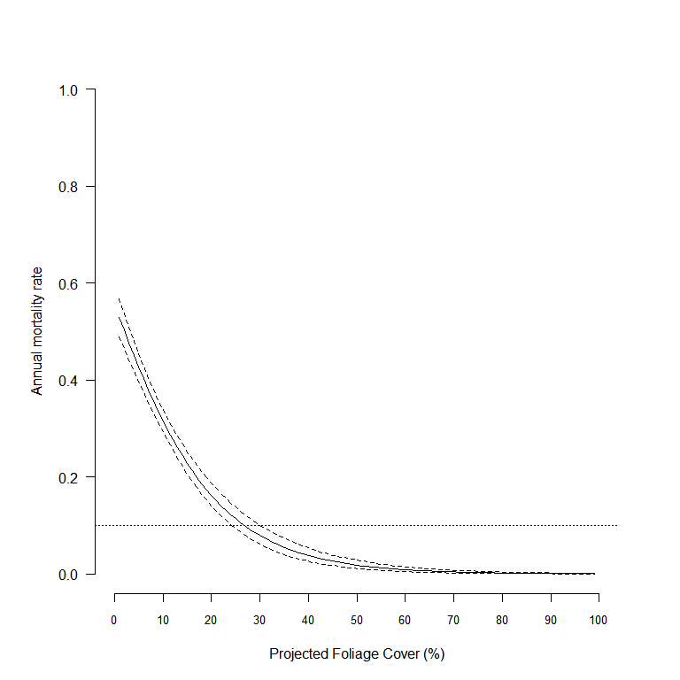

Figure 1. The relationship between annual tree mortality and projected foliage cover (%) of Manna Gums from Mt Eccles National Park. Horizontal dashed line indicates an annual mortality rate of 0.1 (10%).

From the estimated relationship between PFC and tree mortality, we selected a 10% annual mortality rate as our estimate of a ‘significantly elevated mortality’. Thus, trees for which the PFC had dropped to <27% (95% Credible Interval (CI); 25–30) were judged to be at a significantly higher risk of death due to defoliation than trees with a PFC ≥27%. Hence, we used a 25% PFC (i.e. lower CI) as our estimate of the foliar cover threshold in all subsequent analyses.

3.1.2 Canopy defoliation levels and Koala density

A total of 23 eucalypt forest sites that had a one-off assessment of canopy condition and Koala density were used for the analysis of canopy defoliation levels. Of these, 9 sites had no Manna Gum present in the sample, 2 sites were composed of 16% and 29% Manna Gum, and 12 sites were composed of >90% Manna Gum. The levels of total canopy defoliation were dependent on the Manna Gum composition of the forest, with sites having no Manna Gum having a mean defoliation level of 0.19, and sites having >90% Manna Gum composition having an average canopy defoliation level of 0.55. The two site with intermediate Manna Gum composition had a mean canopy defoliation of 0.33 (Fig. 2). Koala density also differed according to the Manna Gum composition of the forest, with a mean density of 2.3 Koalas/ha in forests with no Manna Gum present and a mean density of 4 Koalas/ha in forests with >90% Manna Gum (Fig. 2). However, the range of densities in forests composed of >90% Manna Gum (up to 13 Koalas/ha) varied much more widely than the range of densities in forests with no Manna Gum (Fig. 2)



Figure 2. Boxplots of canopy defoliation levels (proportion of total stems below the foliar cover threshold) and Koala densities for sites containing different percentages of Manna Gums. The box extent indicates the interquartile range, the horizontal black line indicates the median and the whiskers indicate the range.

The relationship between levels of canopy defoliation and Koala densities for individual eucalypt species (or species groups) revealed a different relationship for Manna Gum compared with that for other eucalypt species (Fig. 3). The data on levels of Manna Gum defoliation and Koala densities at each site showed evidence of a highly non-linear relationship in which defoliation levels initially increased rapidly with increasing Koala density up to some threshold density level, after which they increased more steadily with increase in Koala density (Fig. 3). To capture this relationship, we fitted a logistic regression with a ‘threshold’ point (also known as a ‘broken stick’ regression) to the data for Manna Gums. This relationship estimates two slopes for the regression relationship as well as an estimate of the threshold point that separates the two relationships. The threshold model fitted to the Manna Gum data was a much better fit than a single regression relationship (difference in the Deviance Information Criterion (DIC) of 39) and hence was the preferred model for this species.

Estimates of the parameters for each of the logistic regression relationships are given in Table 4. The slope estimates (koalas) indicate that levels of canopy defoliation increase faster for Manna Gum than for other species for a given increase in Koala density, up to a threshold of 1.64 Koalas/ha. The level of canopy defoliation at this density was estimated as 0.66. Thereafter, canopy defoliation increased at a much slower rate, reaching 0.80 at 15 Koalas/ha (Fig. 3). Canopy defoliation levels of less than 0.40 were predicted when Koala densities were less than 0.90 Koalas/ha. The level of canopy defoliation of Manna Gums at zero Koala density was estimated as 0.12. This represents the estimate of likely background levels of defoliation in the absence of Koalas.

Table 4. Parameter estimates (on the logit scale) from logistic regressions (intercept and slope for Koala density) fitted to levels of canopy defoliation for various eucalypt species at a site vs Koala density. The relationship for Manna Gum represents a threshold (TH) regression with different slope estimates when Koala density ≤TH and Koala density >TH, with TH being an estimate of the threshold.

|  |  |  |  |  |  |
| --- | --- | --- | --- | --- | --- |
| Species | Parameter | Estimate | SD | LCL | UCL |
| Manna Gum | Intercept | 0.67 | 0.135 | 0.41 | 0.95 |
|  | Koalas ≤TH | 1.62 | 0.267 | 1.10 | 2.15 |
|  | Koalas >TH | 0.05 | 0.022 | 0.01 | 0.09 |
|  | TH (Koalas/ha) | 1.64 | 0.095 | 1.48 | 1.87 |
| Blue Gum | Intercept | –2.88 | 0.491 | –3.95 | –1.99 |
|  | Koalas | 0.45 | 0.124 | 0.22 | 0.72 |
| Messmate Stringybark | Intercept | –2.54 | 0.293 | –3.13 | –1.98 |
|  | Koalas | 0.37 | 0.091 | 0.19 | 0.55 |
| Mountain Grey Gum (*E. cypellocarpa*) / Swamp Gum (*E. ovata*) | Intercept | –1.95 | 0.364 | –2.70 | –1.26 |
|  | Koalas | 0.42 | 0.162 | 0.11 | 0.75 |

For other eucalypt species, the effect of Koala density on canopy defoliation levels was lower for Messmate Stringybark than for either Blue Gum or Mountain Grey Gum/Swamp Gum (slope estimates of 0.37 vs 0.45 and 0.42, respectively – Table 4). In general, these were much lower than the estimate for Manna Gum below the 1.64 threshold density (slope of 1.62). The levels of canopy defoliation in the absence of Koalas for these species were estimated as 0.05, 0.07 and 0.12 for Blue Gum, Messmate Stringybark and Mountain Grey Gum/Swamp Gum, respectively (Table 4). In general, for these eucalypt species the level of canopy defoliation for a given Koala density is expected to be much lower than for Manna Gum, with levels of defoliation predicted to be between 0.35 and 0.45 at Koala densities of 4–5 Koalas/ha, compared with expected defoliation levels of >0.65 for the same Koala densities for Manna Gum.



Figure 3. Logistic regression relationships between canopy defoliation levels (proportion of stems below the foliar cover threshold) and Koala densities for various eucalypt species. The relationship fitted to Manna Gum represents a threshold or ‘broken stick’ regression to identify a change point (threshold) in the relationship. The solid line is the best-fit regression, and the shaded area indicates the 95% Bayesian credible interval for the regression relationship.

3.2 Carrying capacity of Koala habitat at Cape Otway

The densities of Koalas at sites around Bimbi Park averaged ~10 Koalas/ha between 2008 and 2011, before increasing to an average of 15 Koalas/ha in 2012–2013 (Fig. 4). In the following year, the average Koala density plummeted to <4 Koalas/ha before recovering slightly to be just less than 6 Koalas/ha in 2015. The mean PFC of the Manna Gum canopies was similarly fairly stable at ~35% between 2008 and 2012, before dropping abruptly to ~15% in 2013 then mostly recovering by 2015. The dynamics of Koalas and Manna Gum canopies at Bimbi Park over this period differed from those in some other areas of Manna Gum forest on private land. For example, despite declines in Koala densities, Manna Gum canopies failed to show any recovery at two other sites (Bimbi West and Lighthouse) (Fig. 5). Hence, the Koala populations and Manna Gums in these areas appear to be in the final stages of collapse.

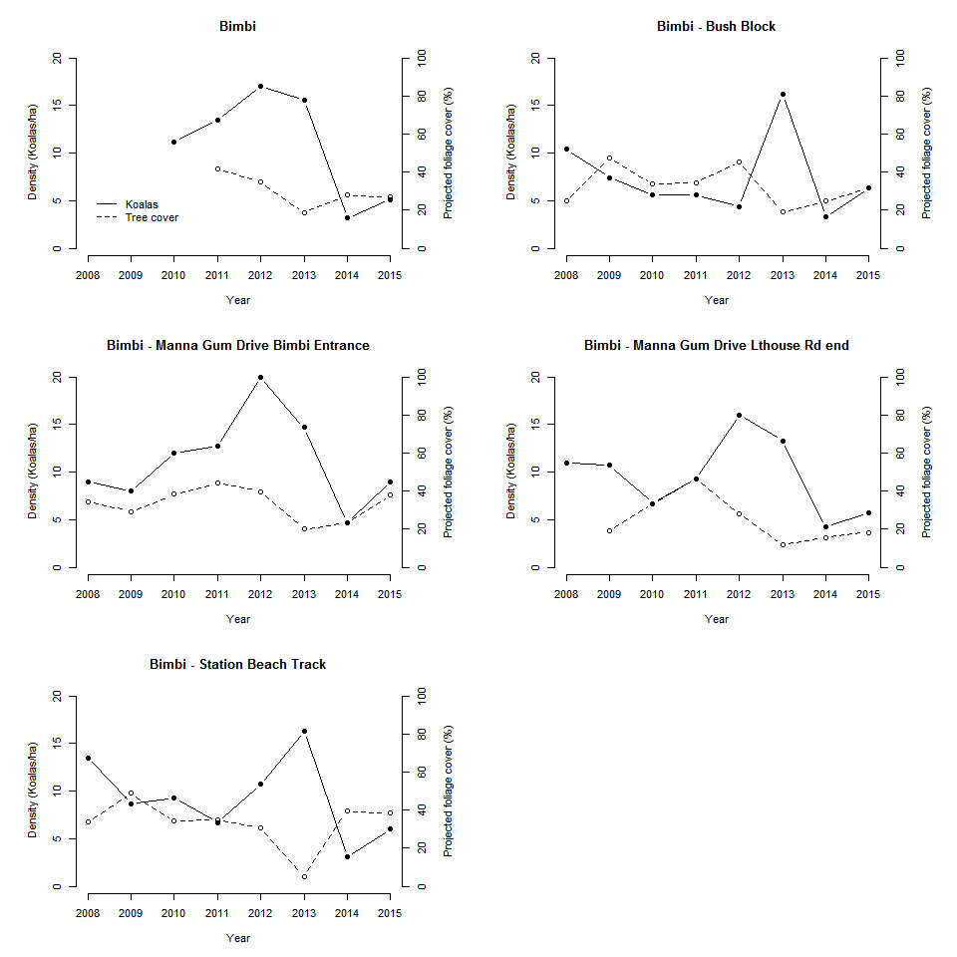

Figure 4. Koala densities (Koalas/ha – solid line) and projected foliage cover (proportion – dashed line) for five sites around Bimbi Park, Cape Otway, between 2008 and 2015. Sites ranged from 1.5 to 7 ha in size.

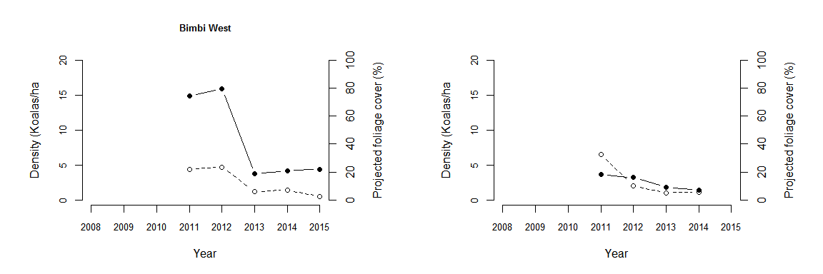

Figure 5. Koala densities (Koalas/ha – solid line) and projected foliage cover (% – dashed line) for two additional sites (Bimbi West and Lighthouse) in Manna Gum forest, Cape Otway, between 2008 and 2015.

After fitting the multivariate state–space model (Equation 4) to the data from Bimbi Park, the equilibrium Koala density (Equation 5) was estimated to be 8.3 Koalas/ha. However, the precision of this estimate was fairly poor (95% credible interval: 2.7–25.7) (Fig. 6). The corresponding estimate of the equilibrium mean PFC was 30% (95% credible interval: 11–67%). The poor precision was a consequence of the small number of points for each time series (eight).

The parameters of the Gompertz model are the intrinsic rate of increase of each variable (parameter **A** in Equation 4) as well as the per-capita effect of a variable on the rate of increase of the other variable (interaction) as well as on themselves (density dependence) (Table 5). The estimate of density dependence for Koalas (parameter **C**; Koalas $→$ Koalas) provided no evidence of overcompensatory dynamics, since the estimate was greater than zero. Koalas had a negative effect on the rate of increase of canopy cover  
(–0.214), but the precision was poor and the credible interval also included zero. However, Manna Gum canopy cover had a significant positive effect on Koala rate of increase (0.64) (Table 5). The intrinsic rate of increase for Koalas was estimated to be 1.96, which is much greater than is biologically plausible (McLean 2003); this indicates that immigration and/or movement must also be contributing to Koala increases at these sites. This is not surprising since these sites were relatively small in area (1.5–7 ha). Rainfall had a positive effect on Manna Gum canopy cover and a negative effect on Koala density; however, neither effect was significant (Table 5).



Figure 6. Estimate of the equilibrium Koala density and corresponding projected foliage cover (red point) from the multivariate Gompertz model fitted to the data from Bimbi Park. The grey envelope represents the equilibrium stationary distribution (95% envelope). The equilibrium point is at [30, 8.3].

Table 5. Parameter estimates from the multivariate Gompertz state–space model fitted to the time series of Koala densities and Manna Gum canopy cover (PFC) from five sites around Bimbi Park, Cape Otway. The parameter C represents the per capita effect of variable *j* (Column) on variable *i* (row). Parameter A represents the intrinsic rate of increase. Values in parentheses are the 95% credible intervals.

|  |  |  |  |
| --- | --- | --- | --- |
| Parameter | Variable | Koalas | PFC |
| C | Koalas | 0.389 [–0.004, 0.774] | 0.640 [0.288, 1.01] |
|  | PFC | –0.214 [–0.696, 0.270] | 0.088 [–0.346, 0.50] |
| A | Koalas | 1.96 [1.10, 2.85] |  |
|  | PFC |  | –0.50 [–1.58, 0.561] |
|  | Rainfall | –0.157 [–0.390, 0.075] | 0.02 [–0.263, 0.298] |

In addition to the above analyses, we also conducted a second analysis by adding the two extra sites (Bimbi West and Lighthouse) to the five Bimbi Park sites. These sites only had five and four years of data, respectively, and Koalas and canopy cover were in the process of decline when monitoring commenced. After fitting the multivariate Gompertz model to the combined data, the estimate of the equilibrium density of Koalas was 5.3 (95% credible interval: 1.2–23) and the estimate of the equilibrium canopy cover was 0.19 (95% credible interval: 0.04–0.67) (Fig. 7). Hence, the addition of these two sites with declining Koala densities and canopy cover revised the equilibrium abundances of both Koalas and Manna Gum canopy cover downwards. The predicted Koala densities and canopy cover from the state–space model fitted to all seven sites are given in Figs 8 and 9.



Figure 7. Estimate of the equilibrium Koala density and corresponding projected foliage cover (red point) from the multivariate Gompertz model fitted to the data from Bimbi Park as well as two additional sites (Bimbi West and Lighthouse). The grey envelope represents the equilibrium stationary distribution (95% envelope). The equilibrium point is at [19, 5.3].

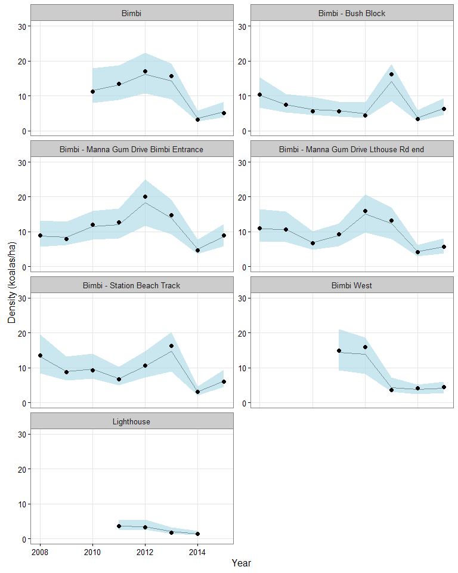

Figure 8. Koala densities predicted from the multivariate Gompertz model (black line) and corresponding 95% credible intervals (blue shading) for seven sites at Cape Otway. Solid circles are the observed densities.

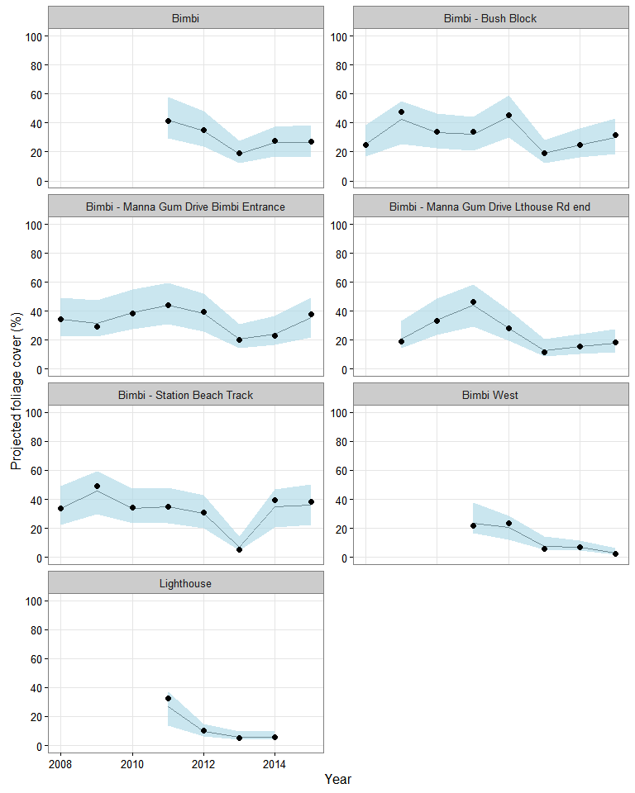Figure 9. Projected foliage cover (%) of Manna Gums predicted from the multivariate Gompertz model (black line) and corresponding 95% credible intervals (blue shading) for seven sites at Cape Otway. Solid circles are the observed values.

3.3 Towards a habitat health trigger

3.3.1 Canopy defoliation and Koala densities

Here, we propose to base the development of a ‘health trigger’ for forests subject to Koala browsing on the risk of tree mortality due to canopy defoliation. Although eucalypts have evolved adaptive strategies to increase their tolerance to herbivory (Moore and Foley 2000), intense browsing pressure can result in tree death, which may be exacerbated if increased browsing coincides with other stress mechanisms such as drought or nutrient enrichment (Jurskis and Turner 2002). Based on the mortality rates of Manna Gums with canopy projected foliage cover (PFC), we propose a *foliar cover threshold* of 25% be used to classify individual trees as ‘defoliated’. The rationale is that when canopy foliage drops below the foliar cover threshold, individual trees are at an increased risk of death due to defoliation or other stressors. Although this level is somewhat arbitrary for use as a threshold for individual trees, it is much greater than the likely ‘background’ level of mortality for eucalypts (~3% per annum – Prior et al. 2009). Here, we assume that the canopy cover/mortality relationship identified for Manna Gums would also apply to other eucalypt species browsed by Koalas.

Given the value for the foliar cover threshold, all adult trees of eucalypt species sampled at a site are then classified as either defoliated (foliage cover ≤ foliar cover threshold) or otherwise (foliage cover > foliar cover threshold). The proportion of defoliated trees in the sample is then used as the estimate of the *canopy defoliation level* for each eucalypt species. We propose the *canopy defoliation level* be used as the habitat health trigger, which can be estimated for an individual eucalypt species or for the site as a whole (i.e. combining over species using a weighted mean). The relationship between levels of canopy defoliation and Koala density differed among eucalypt species. Although only 23 sites were sampled, some patterns to emerge were that defoliation levels for Manna Gum increase much more quickly with increases in Koala density than for other eucalypt species, reaching 0.66 at a Koala density of 1.64 Koala/ha. Sites with defoliation levels above this value were all Manna Gum dominant forests considered to be very degraded by Koala browsing. At the other end of the scale, forests with no Manna Gums rarely had canopy defoliation levels greater than 0.40, and Koala densities did not exceed 5 Koalas/ha. For Manna Gum, canopy defoliation levels of less than 0.40 were predicted when Koala densities were less than 0.90 Koalas/ha. In addition, the relationships suggest that, when Koala densities are low or absent, canopy defoliation levels would be <0.20. These relationships suggest that a useful guide for categorising levels of canopy defoliation should adopt the following classifications (Fig. 10). The actions and levels of intervention recommended for each category are outlined in Table 6.



Figure 10. Proposed habitat condition trigger levels of canopy defoliation for a site or for individual eucalypt species that should be used to guide management interventions for forests affected by Koala browsing.

Table 6. Summary of suggested management actions corresponding to the recommended canopy health triggers (* based on the proportion of trees in an area with canopy foliage cover less than the recommended threshold of 25%).

|  |  |
| --- | --- |
| Canopy defoliation level* | Suggested action |
| **Green – low defoliation**  (0.0 - 0.2) | Forest condition monitoring at no more than 2 yearly intervals |
| **Yellow – moderate defoliation**  (0.2 - 0.4) | Forest condition monitoring plus Koala monitoring at no more than 2 yearly intervals |
| **Orange – high defoliation**  (0.4 - 0.6) | Intervention recommended if Koala densities are >8 Koalas/ha (Cape Otway Manna Gum) or >1.6 Koalas/ha (elsewhere) |
| **Red - very high defoliation**  (0.6 -1.0) | Intervention required to minimise the risk of severe canopy defoliation. Koala densities should be reduced to <5 Koalas/ha (Cape Otway Manna Gum) or <0.90 Koalas/ha (elsewhere). To enhance the recovery of trees exposed to repeated defoliation, Koala densities should be kept below 0.90 Koalas/ha until recovery of the canopy has occurred. |

1. **Green zone**: For forests/eucalypt species in the green zone, no intervention should be required. We suggest that forest condition monitoring be undertaken at sites of interest at a minimum of every 2 years. Forest condition monitoring should follow the protocol used in this report, as outlined in Appendix 2 and described in Wood (2008).
2. **Yellow zone**: For forests/eucalypt species in the yellow zone, no intervention should be required. We suggest that forest condition and also Koala monitoring be undertaken at a minimum of every 2 years. Forest condition and Koala monitoring should follow the protocols outlined in Appendix 2 (Wood 2008, 2013b).
3. **Orange zone**: For forests/eucalypt species in the orange zone, intervention is recommended if koala densities are high in order to reduce the risk of further canopy degradation. Koala populations should be measured, and if densities are found to be >8 Koalas/ha (Cape Otway Manna Gum woodland) or >1.6 Koalas/ha (elsewhere), then intervention is recommended in order to reduce the risk of the forest transitioning to the red zone. Koala densities should be reduced to a maximum of 5 Koalas/ha (Cape Otway Manna Gum woodland) or 0.9 Koalas/ha (elsewhere).
4. **Red** **zone**: For forests/eucalypt species in the red zone, intervention is required in order to reduce the risk of severe canopy defoliation and the subsequent collapse of Koala populations. Koala densities should be reduced to a maximum of 5 Koalas/ha (Cape Otway Manna Gum woodland) or 0.9 Koalas/ha (elsewhere). At Cape Otway where trees have been exposed to repeated heavy defoliation events, Koala densities should be kept below 0.9 Koalas/ha until the canopy has recovered (i.e. recommences flowering).

Retrospective application of the habitat condition trigger outlined above to the Koala population at Bimbi Park indicated that required intervention of Koalas (red zone) would have been triggered at all six sites prior to the collapse of Koala populations in 2014 or in 2013 at Bimbi West. At some sites intervention would have been recommended (code orange) as early as 2008 at Bimbi Bush Block, or 2009 at Bimbi – Manna Gum Drive Lighthouse Rd (Fig. 11). Notably, use of the habitat health trigger developed here appears to be a much more sensitive indicator of unsustainable browsing levels than using the average canopy foliage cover (e.g. Figs 4 and 5).



Figure 11. Retrospective application of the habitat condition triggers applied to Manna Gum canopy defoliation levels for six sites around Bimbi Park. Koala interventions (density reductions) would occur when canopy defoliation levels (green line and points) exceed either the orange (suggested intervention) or red (required intervention) horizontal dashed lines.

3.3.2 Carrying capacity estimates for Koala habitat at Cape Otway

Estimates of equilibrium Koala densities (carrying capacity) for Koalas derived from seven sites at Cape Otway suggest that Manna Gum forests on private land in these areas may support a higher density of Koalas than other areas of Manna Gum forests in south-west Victoria (e.g. Mt Eccles NP). One possible reason for this is that Manna Gum forests in these areas may be exposed to higher soil nitrogen and moisture levels than other areas in south-west Victoria. The carrying capacity for the Bimbi Park/Lighthouse sites was estimated to be between 5.3 and 8.3 Koalas/ha, although these estimates had quite poor precision. Nevertheless, it appears that when Koala populations dropped below these thresholds, both average canopy cover increased (Fig. 4) and canopy defoliation levels decreased (Fig. 10), at least at some sites. Hence, for sites such as Bimbi Park, a carrying capacity estimate of 5 Koalas/ha would appear to be a useful target to guide management interventions of Koalas. Although modelling has identified likely maximum Koala densities that are sustainable for Cape Otway Manna Gum woodlands, lower densities than those identified may be required to enhance recovery of trees exposed to repeated defoliation (i.e. until trees recommence flowering). For Manna Gum forests elsewhere, the critical threshold density at which canopy defoliation levels increased to >0.60 was 1.64 Koalas/ha. Hence, for these areas, a suitable threshold to guide intervention would be 0.90 Koalas/ha in order to reduce canopy defoliation levels to <0.40. Interestingly, retrospective application of these rules of thumb for the Koala population at Mt Eccles National Park would have indicated that no management would have occurred in 2004, at the start of the sterilisation program, because canopy defoliation levels were low (~0.23). Despite intensive management of this population, canopy defoliation levels continued to rise, reaching 0.57 in 2012, when the Koala population was 0.79/ha, before showing signs of recovery in 2014 (Fig. 12). However, canopy defoliation levels never entered the red zone, suggesting the 0.9 Koalas/ha target for Koala populations may be sustainable. Whether this proves to be the case, however, will have to await further monitoring of this population.



Figure 12. Retrospective application of the habitat condition triggers applied to Manna Gum canopy defoliation levels at Mt Eccles National Park. Koala interventions (density reductions) would occur when forest defoliation levels (green line and points) exceed either the orange (suggested intervention) or red (required intervention) horizontal dashed lines.

4 Discussion

An index of ‘habitat health’ for a forest should be based on the potential effects of disturbances on the long-term dynamics of the forest ecosystem (Forsyth et al. 2015). However, the impacts of browsing herbivores on tree dynamics are particularly difficult to predict due to tree longevity and the effects of potential disturbances such as drought, fire, changed nutrient regimes, and disease. The habitat condition trigger classification described here for eucalypt forests subject to overbrowsing by Koalas was developed to provide an ‘early warning system’ for managers in order to avoid severe canopy defoliation and subsequent forest degradation and death of Koalas. This system can be used to assess canopy health at two scales: the individual tree scale (foliar cover threshold) and the tree population (forest) scale (canopy defoliation level). Critical levels for each of these measures were based on an analysis of both historical and newly collected data. While the foliar cover threshold developed for individual trees was based on large sample of tagged trees over a 10-year period, the measures of canopy defoliation levels were based on a single cross-sectional survey of a limited number of sites. The relationship between canopy defoliation levels and Koala density developed from these data is thus based on a number of assumptions. The main assumption is that Koala density and canopy defoliation level have been sampled from the same point in their respective population cycles. An example of where this may not be the case is when Koalas have caused high defoliation levels at one site and subsequently declined in abundance, while at another site high defoliation levels are associated with Koalas still in their increase phase. If Koala densities have already declined in forests that still have high defoliation levels when they are sampled, then this would mean that our one-off survey may have overestimated the slope of the relationship between Manna Gum defoliation levels and Koala densities. This is a weakness of cross-sectional surveys—they do not indicate the stage of the herbivore–resource cycle. Only repeated surveys at the same sites can resolve this. We therefore recommend that a number of these sites be sampled periodically to determine whether the relationships identified in this report hold over the longer term.

The estimation of the carrying capacity of the Koala habitat at Cape Otway was partly based on analysis of data from a small number of sites distributed over a limited area of private land (where most of the canopy degradation problems have occurred). The short duration of the time series of observations for these areas (8 years) means that the estimates of carrying capacity have fairly low precision. In addition, it is possible that the trajectories for the Koala populations and Manna Gums around Bimbi Park may not be representative of other areas of the Manna Gum woodland at Cape Otway. While other areas were sampled, this was not done prior to the collapse of canopy cover and Koala populations; hence, that data was unsuitable for analysis using the methods applied in this study. While some of these areas have subsequently recovered, in other areas there has been local extinction of Koalas and the widespread death of Manna Gum trees. We therefore recommend that a number of sites of extant Manna Gum forest in these areas be subject to ongoing monitoring (using the methods outlined in this report) in order to more accurately determine the future trajectories of both Koala populations and Manna Gum forests.

The analysis of the population dynamics of Koalas at Cape Otway did not reveal any strong evidence of overcompensatory dynamics, even though the large declines in Koala densities observed in 2013 and 2014 are consistent with a strong density-dependent response to decreasing food resources. Why Koala populations appear to have increased to unsustainable levels remains a subject of some debate. The Manna Gum woodlands at Cape Otway do appear to be able to support higher densities of Koalas compared with other Manna Gum forests in south-west Victoria. Why this would be the case is currently unknown. One factor worth investigating is that the Manna Gum woodlands at the Cape may be exposed to higher soil moisture and nitrogen levels than other areas, perhaps due to pasture improvement activities occurring on adjacent private land. Increased nitrogen and soil moisture levels have been implicated in higher defoliation levels for eucalypts by inducing trees to produce foliage that is more palatable to herbivores (Jurskis and Turner 2002; Stalenberg et al. 2014). The increased productivity of Manna Gums may, in turn, have induced increases in the Koala population, leading to unsustainable browsing pressure. This mechanism is consistent with the ‘paradox of enrichment’ (Rosenzweig 1971), whereby productivity increases at one trophic level lead to subsequent instability and overcompensatory responses in the next trophic level. Whether this is actually the case will require further investigation. Although the modelling conducted here has identified likely maximum Koala densities that are sustainable for Cape Otway Manna Gum woodlands, lower densities than those identified may be required for ensuring regeneration and recommencement of flowering after repeated heavy defoliation of trees. Studies in Blue Gum and Jarrah (*Eucalyptus marginata*) have indicated that repeated heavy defoliation events (chronic defoliation) may have consequences for tree recovery by impeding growth rates (Collett and Neumann 2002; Wills et al. 2004). Longer-term monitoring of the populations we have studied will, no doubt, shed further light on the nature of the population dynamics of both Koalas and Manna Gum woodlands at Cape Otway.

5 References

Allison, P.D. (1982). Discrete-time methods for the analysis of event histories. *Sociological Methodology* **13**, 61–98.

Caughley, G. and Sinclair, A.R.E. (1994). *Wildlife Ecology and Management*. Blackwell Scientific Publications, Cambridge, MS, USA.

Collett, N.G. and Neumann, F.G. (2002). Effects of simulated chronic defoliation in summer on growth and survival of blue gum (*Eucalyptus globulus* Labill) within young plantations in northern Victoria. *Australian Forestry* **65**, 99–106. doi:10.1080/00049158.2002.10674860

DELWP. (2015a). *Cape Otway Koala Management Actions*. http://delwp.vic.gov.au/environment-and-wildlife/wildlife/koalas (accessed 20 May 2016).

DELWP. (2015b). *Koalas at Cape Otway*. http://delwp.vic.gov.au/environment-and-wildlife/wildlife/koalas (accessed 20 May 2016).

Dennis, B., Ponciano, J.M., Lele, S.R., Taper, M.L. and Staples, D.F. (2006). Estimating density dependence, process noise, and observation error. *Ecological Monographs* **76**, 323–341.

Forsyth, D.M., Wilson, D.J., Easdale, T.A., Kunstler, G., Canham, C.D., Ruscoe, W.A., Wright, E.F., Murphy, L., Gormley, A.M., Gaxiola, A. and Coomes, D.A. (2015). Century-scale effects of invasive deer and rodents on the dynamics of forests growing on soils of contrasting fertility. *Ecological Monographs* **85**, 157–180. doi:10.1890/14-0389.1

Gibson, M. and Thomas, G. (2012). *Great Otway National Park Pilot Koala and Tree Condition Survey*. Report to Parks Victoria. BIOSIS Research Pty Ltd, Ballarat, Victoria.

Holland, E.P. (2013). Inferring changes in foliar mass and area from foliage cover: a mechanistic model. *Austral Ecology* **38**, 121–130. doi:10.1111/j.1442-9993.2012.02384.x

Ives, A.R., Dennis, B., Cottingham, K.L. and Carpenter, S.R. (2003). Estimating community stability and ecological interactions from time-series data. *Ecological Monographs* **73**, 301–330.

Jurskis, V. and Turner, J. (2002). Eucalypt dieback in eastern Australia: a simple model. *Australian Forestry* **65**, 87–98.

McDonald, R.C., Isbell, R.F., Speight, J.G., Walker, J., and Hopkins, M.S. (1984)*. Australian Soil and Land Survey Field Handbook.* Inkata Press, Melbourne.

McLean, N. (2003). *Ecology and management of overabundant koala (Phascolarctos cinereus) populations*. PhD thesis, University of Melbourne, Victoria.

Menkhorst, P. (2008). Hunted, marooned, re-introduced, contracepted: a history of Koala management in Victoria. In: Lunney, D., Munn, A. and Meikle, W. (Eds) *Too close for comfort: contentious Issues in Human–Wildlife Encounters*. Royal Zoological Society of NSW, Mosman, NSW.

Moore, B.D. and Foley, W.J. (2000). A review of feeding and diet selection in koalas (*Phascolarctos cinereus*). *Australian Journal of Zoology* **48**, 317–333.

Murdoch, W.W., Briggs, C.J. and Nisbet, R.M. (2003). *Consumer–Resource Dynamics*. Princeton University Press, Princeton, NJ, USA.

Prior, L.D., Murphy, B.P. and Russell-Smith, J. (2009). Environmental and demographic correlates of tree recruitment and mortality in north Australian savannas. *Forest Ecology and Management* **257**, 66–74. doi:10.1016/j.foreco.2008.08.015

Ramsey, D.S.L., Todd, C.R. and Forsyth, D.M. (2010). *Population dynamics of koalas at Mt Eccles National Park*. Arthur Rylah Institute for Environmental Research Technical Report Series No. 212. Department of Sustainability and Environment, Heidelberg, Victoria.

Rosenzweig, M. (1971). The paradox of enrichment. *Science* **171**, 385–387.

Stalenberg, E., Wallis, I.R., Cunningham, R.B., Allen, C. and Foley, W.J. (2014). Nutritional correlates of Koala persistence in a low-density population. *PLOS ONE* **9**, e113930. doi:10.1371/journal.pone.0113930

Whisson, D.A., Dixon, V., Taylor, M.L. and Melzer, A. (2016). Failure to respond to food resource decline has catastrophic consequences for Koalas in a high-density population in Southern Australia. *PLOS ONE* **11**, e0144348. doi:10.1371/journal.pone.0144348

Wills, A.J., Burbidge, T.E. and Abbott, I. (2004). Impact of repeated defoliation on jarrah (*Eucalyptus marginata*) saplings. *Australian Forestry* **67**, 194–198.

Wood, M. (2008). *Mount Eccles National Park Manna Gum Condition Assessment August 2008*. Unpublished report to Parks Victoria. Australian Ecological Research Services, Portland, Victoria.

Wood, M. (2013a). *Manna Gum condition and Koala density within Gunditj Mirring Indigenous Protected Areas, South West Victoria*. Report to Gunditj Mirring Traditional Owners Aboriginal Corporation and Parks Victoria. Austalian Ecological Research Services, Portland, Victoria.

Wood, M. (2013b). *Mount Eccles National Park Koala Population Survey August 2013*. Unpublished report to Parks Victoria. Australian Ecological Research Services, Portland, Victoria.

Appendix 1

We used observations of tree death to model tree mortality as a function of the canopy foliage cover using a discrete-time survival model. We used a proportional hazard representation of the form:

, Eq. 1

where  describes the baseline hazard rate,  models the effect of modelled PFC on the hazard rate, and  is a random effect due to individual tree *i*. Equation 1 was fitted using a complementary log–log link, which is equivalent to specifying an exponential survival model in continuous time (Allison 1982).

Appendix 2

Forest canopy condition assessment—field protocol

Surveys for canopy condition were undertaken using the point centre quarter sampling method used at Mt Eccles National Park (Wood 2008) and other locations (to ensure that the resultant data were compatible with previous surveys).

Transects of at least 300 m in length were established at a random starting position at each site, with a minimum of 200 m between start points. At each 50 m along the 300 m transect (*n* = 7 survey points, including the start point), the closest mature and live eucalypt (DBH ≥10 cm) within each of the four compass quadrants (north-east, south-east, south-west and north-west) was selected (i.e. 28 trees per transect). For each tree, the observers recorded the species of eucalypt, distance from the transect survey point, DBH of each stem ≥10 cm, and canopy radius (average of four directions) (see field data sheet, Appendix 2). The PFC of the canopy was estimated to the nearest 5%, using reference photographs (McDonald et al. 1984), and the defoliation class (nine classes, –1 to 7) was also estimated using reference photographs (Kelly 2000, cited in Wood 2008). For private land sites (translocation trial donor sites), the GPS location (GDA94, Zone 54) of each survey point was recorded to facilitate future monitoring. All data were entered into an Access™ database, and estimates of live tree density and leaf area per hectare for each tree species were later calculated, as per Wood (2008).



Appendix 3

Koala surveys—field protocol

Surveys for Koalas are undertaken on the same transects established for assessment of canopy condition. Surveys use the double-count method (Caughley and Sinclair 1994) as used at Mount Eccles National Park (Wood 2013b), and other locations, to ensure that the resultant data are compatible with previous surveys.

The centre line of each 300m transect was navigated using a compass and Koalas surveyed by two independent observers commencing 10 minutes apart. Walking along the transect, each observer recorded all Koalas seen within 25 m either side of the transect line, (see field data sheet, Appendix 3). If Koalas were scarce, but individuals were seen further from (and perpendicular to) the transect, they were included in the count data. The perpendicular distance from the transect centre line to the tree containing the Koala was confirmed using a laser rangefinder (Bushnell 500 or Bushnell 1000), and notes were made of the distance along the transect, side of transect (left or right), tree species being used, approximate height of Koala in tree, and presence of back young. When Koalas were further than 25 m from the transect, they were clearly indicated by a ‘Y’ in the appropriate column of the field data sheet.

Upon completion of the surveys the observers compared their data to determine Koalas missed by either observer (noting this on the data sheet), and observations were double-checked as necessary.





www.delwp.vic.gov.au