**Monitoring the performance of fishways and fish passage works**

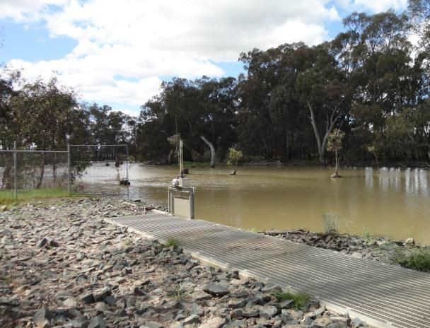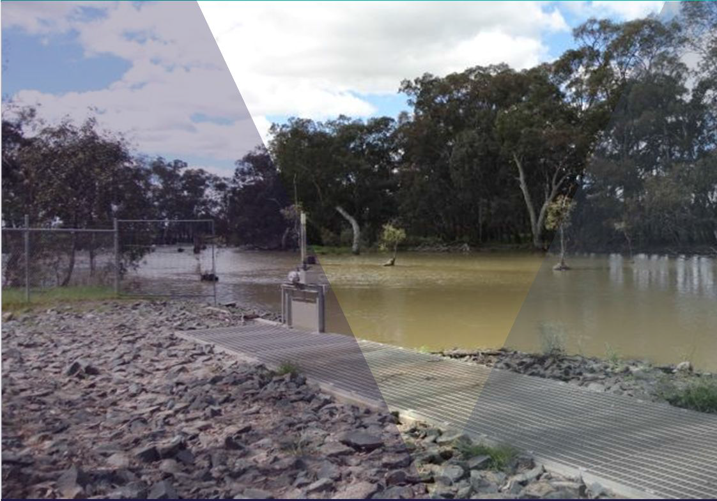

M.J. Jones and J.P. O’Connor

November 2017

Arthur Rylah Institute for Environmental Research Technical Report Series Number 257



**Acknowledgements**

The authors would like to thank Greg Woodward and Joel Rawlinson (DELWP) for assisting with project inception, development and management and many useful discussions regarding the project. We would also like to thank the project steering committee of Denis Lovric (CCMA), Mark Turner (GBCMA) and Duncan Hill (Fisheries Victoria) for their technical support. Ivor Stuart, Paul Reich and Jarod Lyon, Andrew Berghuis, Joel Rawlinson and Tarmo Raadik are thanked for their comments on the document.

**Authors**

M.J. Jones and J.P. O’Connor

Arthur Rylah Institute for Environmental Research, Department of Environment, Land, Water and Planning, 123 Brown Street, Heidelberg, Victoria 3084.

**Citation**

Jones, M.J. and O’Connor, J.P. (2017). Monitoring the performance of fishways and fish passage works. Arthur Rylah Institute for Environmental Research. Technical Report Series No. 257. Department of Environment, Land, Water and Planning, Heidelberg, Victoria.

**Photo credit**

Front cover: Broken Creek, with fishway exit and weir pool. (photo: Matthew Jones)

© The State of Victoria Department of Environment, Land, Water and Planning, November 2017

This work is licensed under a Creative Commons Attribution 4.0 International licence. You are free to re-use the work under that licence, on the condition that you credit the State of Victoria as author. The licence does not apply to any images, photographs or branding, including the Victorian Coat of Arms, the Victorian Government logo and the Department of Environment, Land, Water and Planning (DELWP) logo and the Arthur Rylah Institute logo. To view a copy of this licence, visit<http://creativecommons.org/licenses/by/4.0/>

ISBN 978-1-76047-833-9 (print)

ISBN 978-1-76047-834-6 (pdf)

ISSN 1835-3827 (print)

ISSN 1835-3835 (pdf)

**Disclaimer**

This publication may be of assistance to you but the State of Victoria and its employees do not guarantee that the publication is without flaw of any kind or is wholly appropriate for your particular purposes and therefore disclaims all liability for any error, loss or other consequence which may arise from you relying on any information in this publication.

## Accessibility

If you would like to receive this publication in an alternative format, please telephone the DELWP Customer Service Centre on 136186, email customer[.service@delwp.vi](mailto:service@delwp.vic)c.gov.au, or via the National Relay Service on 133 677 [www.relayservice.com.au](http://www.relayservice.com.au/). This document is also available on the internet at ari.vic.gov.au.

# Contents

Summary 1

1. Introduction 2
   1. Fishway performance 4
   2. Objective of this document 4
2. Background 5
   1. Common Victorian fishway designs 5
      1. Vertical-slot fishway 5
      2. Rock-ramp fishway 5
      3. Fish lock 5
      4. Fish lift 5
      5. Denil fishway 5
      6. Bypass fishways 6
3. Fishway assessment logic 7
   1. Previous fishway assessments 7
   2. Generic fishway assessment principles 7
   3. Generic fishway assessment methods 7
      1. Ecological assessments 8

3.4.1 Hydraulics assessment 22

1. Proposed generic fishway evaluation methods 24
   1. Ecological assessment description 24
      1. Abundance (presence/absence), length-frequency method 24
      2. Presence/absence, length-frequency method 25
   2. Hydraulic assessment description 26
   3. Fishway assessment scoring description 26
   4. Using the proposed evaluation methods 31
      1. Vertical-slot and Denil fishways 31
      2. Rock ramp and bypass fishway 34
      3. Fish lock and fish lift 39
2. Trial of aerial photography and 3D modelling to hydraulically assess a rock-ramp fishway 41
3. Conclusion 47

Appendix 1: Examples of past fishway assessments with details on key attributes 48

Appendix 2: Case study — Ecological and hydraulic assessment methods for monitoring

fish passage facilities 50

References 71

**ii Monitoring the performance of fishways and fish passage works**

The construction of dams, weirs, and regulators has reduced riverine connectivity, fragmented habitats, and impacted the life history of fish and aquatic biota. Reducing the longitudinal and lateral dimension of river-floodplain systems, for example, has adversely affected the migratory behaviour of some fish, with some species unable to complete part of their life-cycle.

Fishways can be used to mitigate some of the adverse impacts of these barriers. They are now being constructed on the longitudinal and lateral dimension of riverine systems, and the technology is being adapted to aid the movement of aquatic biota at road culverts.

The construction of fishways requires significant investment, so it is essential that each fishway design enables fish to pass effectively if these structures are to contribute effectively to programs aimed at restoring connectivity. However, in Victoria, up to 70% of fishways built to date have either not been assessed for passage efficiency or are thought not to pass fish as efficiently as they could.

This document supports a Victorian Government initiative to improve the overall health of native fish populations and instream connectivity of Victoria’s waterways by developing a set of principles and robust methods for assessing Victoria’s fishways on a consistent basis. The document specifically addresses Action 11.8 of the Victorian Waterway Management Strategy (VWMS), which is ‘*Develop and implement a statewide program for monitoring the performance of fishways and fish passage works’*. The document also supports part of Policy 11.10 of the VWMS, ‘*Programs will be put in place to ensure the operation, performance and maintenance of fishways and other fish passage works are monitored and continue to meet best practice standards’,* which also fits with Action 17.3 of the intervention monitoring framework*.*

The methods proposed for monitoring fishway performance use techniques common to fishway assessment in Australia and internationally, and have been refined during a short-term on-ground assessment phase (Appendix 2), in combination with liaison with other fishway researchers. An assessment scoring technique is proposed, which is a unique approach to documenting and summarising the qualitative and quantitative data collected, to determine the overall efficiency of a fishway. A new method of collecting hydraulic information (i.e. headloss, slope) on fishways via aerial photography with three-dimensional modelling was also trialled with promising results, and warrants further investigation.

The methods outlined in this document will ensure that fishway assessments are consistent, enabling fishways to be benchmarked against each other and ensuring the best possible outcomes for fish passage, catchment connectivity and system restoration in Victoria.

**Monitoring the performance of fishways and fish passage works 1**

The development of infrastructure such as dams, weirs, regulators, and culverts has reduced the longitudinal and lateral connectivity of Australia’s river-floodplain systems through the presence of physical barriers and a reduction in the magnitude of flooding (Maheshwari et al. 1995; Gehrke et al. 1995; Jones & Stuart 2008). Such flow alterations, combined with the presence of instream structures, have impacted the ability of native fish to move and migrate, because most instream structures alter the hydraulic (flows) conditions beyond the swimming ability of fish, or completely prevent movement past the barrier (Baumgartner 2006).

Fish need to move in order to obtain food and shelter, and to reproduce (O'Connor et al. 2005; Jones

& Stuart 2009; Koehn et al. 2009). Some fish species can obtain all their requirements within a single reach of a river, but others need to migrate large distances or access seawater in order to complete their life-cycle (Llewellyn 1968; Reynolds 1983, Crook et al. 2006). The most problematic of these are diadromous species, which are required to migrate between the sea and freshwater to complete their life-cycle (Crook et al. 2010), and for which the presence of an instream barrier may represent a major hindrance to population dynamics (Katano et al. 2006). Restricting the movement of native fish may also lead to accumulations downstream of barriers, and consequent elevated levels of predation (Jones & Stuart 2008).

In Australia, fishways are now used to mitigate the adverse impacts of instream barriers on fish movement (Barrett 2004). They are not only being installed on barriers in the longitudinal dimension, but also on the lateral dimension, giving fish access to important floodplain habitats (Baumgartner et al. 2012b). Improving the connectivity of waterways through fishway construction should also reduce habitat fragmentation and help to improve native fish populations (Barrett 2004; Barrett & Lintermans 2008).

Fishway construction can be expensive, but if barrier removal is not practical then fishways become a useful option to mitigate the impacts of the barrier. Once a fishway has been installed, there is a need to ensure that passage efficiency meets the design specifications and fish can pass the barrier effectively. Inefficient or poorly designed fishways may not reduce the adverse impacts of instream barriers on fish movement despite a significant effort and capital outlay. Surprisingly, in Victoria, it is estimated that up to 70% of fishways have either not been assessed, or are not working as efficiently as they could (O'Brien et al. 2010). Therefore, understanding the effectiveness of constructed fishways is a priority if connectivity is to be restored across Victoria’s waterways.

The Victorian Waterway Management Strategy (VWMS) provides a framework for government to improve Victoria’s waterways while meeting its obligations for waterway management and addressing community expectations (Figure 1). The VWMS consists of policies and actions with sets of guiding principles and management approaches for various management areas. Underpinning the management approach is an adaptive management framework aimed at improving our understanding of how the proposed actions contribute to achieving the desired objectives. In practice, some of the VWMS’s policies are aimed at improving connectivity and therefore passage for native fish, and the initial steps are to gather contemporary information on fishway design, operation, maintenance, and performance.

**2 Monitoring the performance of fishways and fish passage works**

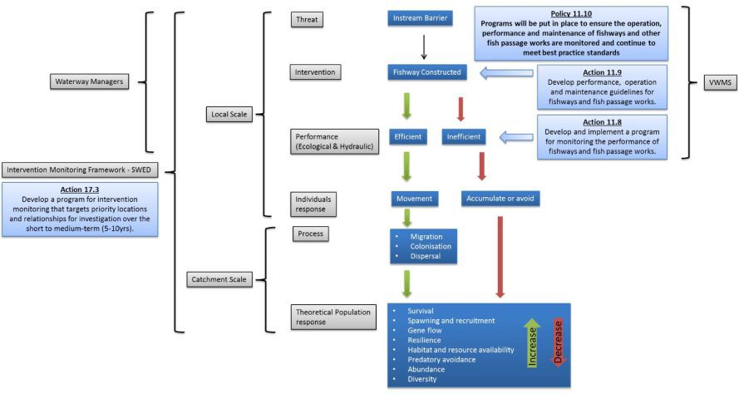

##### Figure 1.1: Role of Action 11.8 of VWMS in assessing fishway efficiency with flow on biological effects and association with Action 17.3 of the Intervention Monitoring Framework.

**Monitoring the performance of fishways and fish passage works 3**

## Fishway performance

Fishway performance can be measured over a number of spatial and temporal scales. At the local

(i.e. fishway) scale, a fishway must meet its ecological performance objectives (e.g. pass all fish the fishway is designed for, over a specified range of river flow conditions), or the objectives used to design the fishway (during the concept and detailed design stage), while performing to design specifications (i.e. internal fishway hydraulics measured after construction must reflect that detailed during the design stage). These may include a number of guiding principles. For example, the fishway may be required to operate at a particular percentage of stream discharge events (e.g. medium to low flows on a receding river), or operate during a high flow event (e.g. up to and including a 1-in-5 year flow event), or across a range of discharge events (e.g. commence to flow up to and including a 1-in-1 year flow event), and be able to pass a particular suite of species and sizes of fish.

At the catchment scale, fishway effectiveness may be evaluated by a number of methods, such as long-term monitoring in the upstream catchment to measure changes in the fish community, including changes in species presence/absence or changes in sizes distribution. An appropriate sampling design must be employed to ensure any changes can be detected and confidently attributed to the fishway construction. Fishway performance may also be measured through a reduction in fish accumulations immediately downstream, although fish accumulations may be seasonal or related to stream discharge or other factors such as predation (O'Connor et al. 2015a).

## Objective of this document

This document provides the rationale and develops guidelines for consistent and robust methodologies to evaluate Victorian fishways. This information should support waterway managers and researchers in gathering the necessary data on changes resulting from fishway construction and to improve their design and operation to ensure that management objectives are achieved.

Specifically, this document addresses Action 11.8 of the Victorian Waterway Management Strategy (VWMS), which is ‘*Develop and implement a statewide program for monitoring the performance of fishways and fish passage works’*. This Action is designed to assess the efficiency of a constructed fishway, to ensure that it functions to design, thereby avoiding the adverse impacts of inefficient fishways (Figure 1). This document also supports part of Policy 11.10 of the VWMS, ‘*Programs will be put in place to ensure the operation, performance and maintenance of fishways and other fish passage works are monitored and continue to meet best practice standards’.*

Specific objectives are as follows:

1. Outline relevant fishway types in Victoria.
2. Outline fishway assessment logic including:
   1. Reviewing previous fishway assessments
   2. Identifying generic fishway assessment principles
   3. Documenting generic fishway assessment methods.
3. Propose and test a set of generic fishway assessment method that can be adapted on a site-by- site basis (Appendix 2).
4. Trial the use of aerial photography with three-dimensional computer modelling as a means of gathering hydraulic information on a rock-ramp fishway.

**4 Monitoring the performance of fishways and fish passage works**

# Background

## Common Victorian fishway designs

Six basic fishway designs are present in Australia, including vertical-slot, rock-ramp, fish lock, fish lift, Denil and fish bypass, however vertical-slot and rock-ramp fishways are most prevalent in Victoria. Barrier height, stream hydrology, species present within a waterway, fish size-class ranges, capital cost, unique site parameters (e.g. substrate type), and internal hydraulics, are the main determinants of which fishway type will be used at a particular barrier. The following section provides a summary of basic fishway types, however refer to O’Connor *et al*. (2015b) for a more detailed description.

##### Vertical-slot fishway

Vertical-slot fishways are typically constructed on barriers up 6 m high. They have a relatively low- gradient concrete channel structure (e.g. 1h : 22 – 32l) connected by a series of vertical slots that divide the fishway into a series of pools. More pools generally indicate a gentler gradient, and long fishways may have resting pools to allow fish to recuperate during their ascent. The vertical slot runs the full depth of each fishway pool (facilitating operation over a range of water levels), and the slot angles the water across the fishway pool, dissipating the energy of the water at the same time. The head loss, or height difference between each pool, determines the water velocity and pool turbulence (along with the pool dimensions), which in turn determine the size and species of fish capable of successfully passing the fishway.

##### Rock-ramp fishway

Rock-ramp fishways are most commonly used for barriers less than 2 m in height, and they typically have gentle slopes (i.e.>1h : 25l). Rock-ramp fishways are typically constructed of strategically placed rocks, but they can be made of an artificial substrate such as concrete blocks. Rocks may be placed semi-randomly in the waterway for a natural aesthetic look, or they may be placed in ridge lines and have associated formalised pools. Rock-ramps may be full or partial width; that is, they may cover the full width of the waterway or only part of the width. Full width rock-ramps allow for greater range of head water variation compared with partial width rock-ramps. The fishway slope, and gap between rocks influence the discharge of the fishway and the internal turbulence and water velocity, which control the species and size-classes of fish able to move through. Rock-ramps also have interstitial spaces capable of passing other aquatic fauna (e.g. turtles and invertebrates).

##### Fish lock

Fish locks are used to move fish over high barriers (i.e. dams), typically 5–15 m high, although in some cases the design may be the most suitable for smaller structures. Fish locks are often used to pass small and large fish in the same fishway or when the capital cost of constructing a vertical-slot fishway is too high. Functionally, fish locks operate in a similar way to a navigation lock designed to move boats past barriers, with gates at the entrance, a holding chamber, and gates at the exit. Fish locks have four basic phases: attraction, filling, exit, and transition. In the attraction phase, the entrance gates are open to allow fish to enter the holding chamber. The entrance gates are then closed during the filling phase, then the exit gates open to allow fish to exit the chamber upstream of the barrier. The system then transitions back to the attraction phase. The filling phase can be achieved via pipework which fills from the bottom (Ardnacrusha design), or top (Borland or open design). The default cycle time of the automated control system (programmable logic controller, PLC) will depend on the species present (O’Connor *et al*. 2015b).

##### Fish lift

Fish lifts are generally used for stream barriers higher than 10 m. Fish lifts transport a single ‘hopper’ of water and fish to the upstream side of the barrier, which contrasts with a fish lock, in which the chamber fills with water to allow fish to passively ascend to the height of the exit location. Like a fish lock, however, fish lifts are usually automated. Entrance into the fish lift can be via an entrance channel or a short section of vertical-slot fishway.

##### Denil fishway

A Denil fishway may be used on barriers less than under 4 m high and is often used in combination with a vertical-slot fishway. Denil fishways may be used as the primary fishway, but their discharge is

**Monitoring the performance of fishways and fish passage works 5**

usually greater than a vertical-slot fishway and they generally target large fish that are capable of negotiating relatively fast water velocities (e.g. 1.8 m/s) and steep slopes (e.g. 1h : 8l). The Denil design consists of a rectangular chute with closely spaced triangular baffles or vanes located along the sides and bottom and set at 45°, causing part of the flow to turn back on itself and thus reducing velocity against which fish must ascend (Clay 1995). The strong flow associated with Denil fishways reduces the deposition of sediment and provides good attraction flows for fishway entrance efficiency.

##### Bypass fishways

A fish bypass may be used for small to medium barriers (e.g. 2–6 m high). Although similar to a rock fishway, bypasses usually have a more conservative slope (i.e. 1v : 50h). Bypass fishways look like a natural stream, with pools, meanders and riffles and an earthen or rocky channel. Unfortunately the application of fish bypasses is limited by variable headwater levels, so they should only be used in situations where headwater variation is limited (e.g. a static weir pool). Bypass fishways can be tailored for individual species or whole fish communities. They can also pass other aquatic fauna including turtles and invertebrates.

**6 Monitoring the performance of fishways and fish passage works**

# Fishway assessment logic

## Previous fishway assessments

To develop the guideline logic, a total of 26 past fishway investigations were reviewed for a range of information, including type of data collected, fishway assessment techniques, and fishway analysis method (Appendix 1). The investigations included a range of scientific papers and unpublished reports. Preference was given to reports with relevance to Australian conditions.

Although this review was not exhaustive it highlighted the common approaches to fishway assessments, and the data obtained has been used to inform an approach suited to Victoria’s fishway assessment objectives. Most of the documents used were published accounts from both Australian and International journals, but a number of unpublished Australian reports were also used.

Because the design of each fishway and target fish species was different, each fishway was assessed slightly differently, in terms of assessment duration, techniques and objectives. Despite this, investigations generally targeted the whole fish community, but some assessments focused on particular target species (Appendix 1). Most of the investigations did not mention the target species or size classes. The range of assessment techniques included, PIT tagging, radio-telemetry, fishway trapping, video recordings, mark–recapture, and electrofishing. Fishways were generally sampled over a 24-hour period, although the duration of some was shorter. The number of fishway trapping replicates ranged from 2 to 100, but was unclear in some investigations. Fishway traps were generally checked up to two times over a 24-hour period, and typical data collected included abundance, length-frequency, behaviour, hydraulics, passage efficiency and attraction efficiency.

The data collected from this review, combined with expert opinion, was used to inform the generic fishway assessment principles and analysis methods proposed in the following sections.

## Generic fishway assessment principles

Despite the breadth of literature reviewed in developing this guideline, all assessments generally conformed to a similar set of assessment principles. These were largely based on ecological data, including ascent success, attraction efficiency, abundance information, length-frequency comparisons, and behavioural information. However, hydraulic information was also provided, albeit less frequently, and included information such as fishway slope, turbulence levels and fishway dimensions.

From this information a set of generic fishway assessment principles were identified to help guide the development of the fishway assessment guidelines, as follows:

* The fishway design, including water depth, water velocity, turbulence and slope, is suitable for all target species.
* All target species sampled at the entrance should also be sampled at the exit.
* The size classes of target fish present at the entrance should also be present at the exit.
* The constructed fishway reflects the design, with minimal variation.
* The fishway operates over the designed range of flow conditions.

## Generic fishway assessment methods

Fishway assessments may be completed using a number of different methods, but some may be more practical than others, depending upon the objectives of the investigation. In Australia, trapping the entrance and exit of a fishway is generally the first method of assessment used, but if this is not possible then electrofishing and trapping, electrofishing only, or mark–recapture may be used. The use of PIT tagging in fishway assessments in Australia is a relatively recent advance (i.e. since 2003), and has been used mainly to provide supplementary information to a trapping assessment method. Radio-tagging has also been used, but mainly for complex fishway assessments where behavioural information can inform the management of a structure (Stuart et al. 2010).

The following section details common assessment designs which may be used to assess fishways in Victoria. Assessing the fishway hydraulics and accumulations downstream of a structure are also discussed.

**Monitoring the performance of fishways and fish passage works 7**

##### 3.3.1 Ecological assessments

**Trapping**

Fish passing through a fishway present researchers with a unique opportunity to sample part of the migratory fish population and thus evaluate the fishway against its ecological and design objectives. To assess vertical-slot fishways, sampling is typically undertaken using tailored traps covered in mesh of a suitable size for the target species (Figure 3.1). Fishway traps may also be used in fish locks and fish lifts, being placed at the entrance or exit.

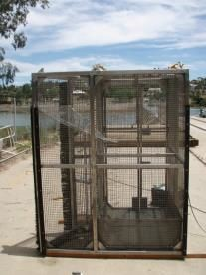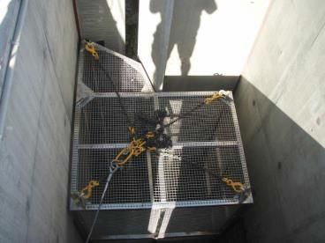

##### Figure 3.1: Fishway trap used to sample vertical-slot fishway (exit), and in position (entrance).

Sampling the entrance and exit of a fishway is similar to a treatment and control experiment for fishway ascent success. The control is the entrance of the fishway, which is typically representative of the fish population downstream of the barrier, while the exit is the treatment, or the test for the fish trying to ascend the fishway. Differences in the fish population (diversity, abundance, size-class) between the entrance and the exit can generally be attributed to the effect of the fishway. (Note that a true control must also involve sampling downstream of the fishway entrance, as small fish may not be able to enter the fishway entrance trap when operating at full discharge. Alternatively, a control sample may be collected by the fishway entrance trap if fishway discharge is reduced by partially closing the fishway exit gates, which in effect reduces water velocity and turbulence at the entrance.)

Trash screens should be used to prevent debris from clogging the mesh on the traps; trash screen are set upstream of the trap to filter the water for debris (Figure 3.2). Debris build-up on the trap may lead to restricted water flow through the fishway, decreasing the water level downstream of the trap substantially. This is referred to as headloss, or the difference between upstream and downstream water levels. Maintaining a consistent headloss throughout the sample period is imperative given that a higher headloss at the trap entrance may prevent small fish (which will be weaker swimmers) from entering. A build-up of debris can also decrease the attraction flow at the entrance of the fishway. Trash screens also need to be cleaned regularly in order to obtain a consistent sample within a fishway trap.

One-way funnels and screens can be used in fishway pools as an alternative when traps are not practical to handle, e.g. where there is no gantry to lift the trap (Figure 3.2). Funnels and screens may be more appropriate to use on pool or Denil fishways, where the pool is used as the holding area for the fish. Unlike fishway traps where the trap can be lifted out to access the fish, flows through the fishway may need to be shut off to enable the fish to be collected by electrofishing or dip-netting.

Biological measurements taken at both the entrance and exit include species presence/absence, individual length and abundance. For each replicate (i.e. entrance and exit sample) sample, a sufficient number of individuals of each species should be measured for length to determine if there is

**8 Monitoring the performance of fishways and fish passage works**

a statistical size difference between the entrance and exit samples. Total abundance may also be recorded, but comparisons between entrance and exit are somewhat confounded by trap design (often entrance and exit traps differ) and trap shyness and therefore abundance data needs to interpreted with this limitation in mind.

If possible, a pilot investigation should be undertaken to determine the appropriate duration to trap

(i.e. 1–24 hours). A one-hour sample may be used and progressively increased until a representative sample is captured (refer to tables below). This may be one hour if large numbers of fish are present, or 24 hours (or longer) if few fish are present. This method can be applied to samples collected during the day or night, depending upon the objective of the investigation. Seasonal and diel effects on fish movement must also be considered, as some fish species or size classes of fish only move during a discrete part of the day or year, or in particular flow conditions.

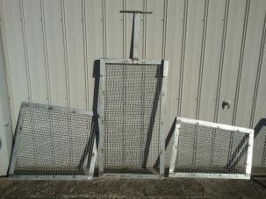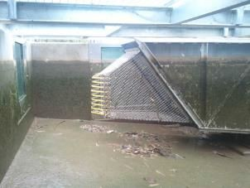

##### Figure 3.2: Left: Funnel on the exit of a Denil fishway in the Murray River, used to prevent fish from making return movements. Right: Screens to prevent fish escaping and trash from reaching the funnel.

Importantly, an appropriate time period must be allowed to pass between top and bottom sampling to enable a representative sample to be collected. For example, enough time should be allowed to pass after entrance sampling to enable fish to successfully redistribute throughout the fishway and reach the exit prior to commencing the exit sample; this will vary with species and fishway length. Similarly, if the fish are diurnal then enough time must be allowed each day for them to ascend the fishway prior to commencing trapping the exit or entrance. This also relies on the assumption that diurnal fish generally do not reside in the fishway overnight. If this assumption is not valid, then implementing a Latin square design (blocking for time) may help to overcome this issue; that is, each sample is to be completed at each of the allocated sample periods throughout the day. For example, the entrance and exit of a fishway is sampled at set periods throughout the day (e.g. 9–11 am, 12–2 pm, 4–6 pm).

One of the limitations of trapping is trap shyness. Fish can repeatedly attempt to enter traps prior to actually entering, or escape traps after entering (Stuart & Mallen-Cooper 1999). Escapement also needs to be considered when designing a trap and when designing the sampling procedure. One method to quantify escapement and trap shyness at each sample location is the use of a DIDSON sonar to count the number of fish entering and exiting the trap prior to completing the sample.

**Monitoring the performance of fishways and fish passage works 9**

**Netting**

For fishways such as rock-ramps and fish bypasses, using appropriately sized nets may be more suitable than a trap (Figure 3.3). However, as with fishway traps or funnels, nets must be maintained to ensure debris does not build up, which can alter the headloss or result in the net being washed downstream.

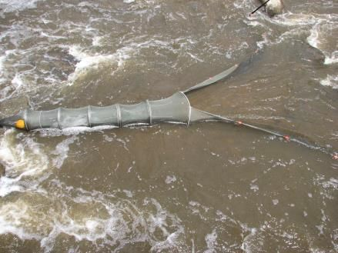

##### Figure 3.3: Fyke net set within a large rock-ramp fishway.

**Electrofishing**

Electrofishing is the preferred sampling method in freshwater locations when the aim is to return fish unharmed to the water. It is the standard sampling technique used by freshwater fisheries research organisations in Australia, New Zealand, Europe and North America.

A number of different electrofishers may be used to collected biological information: backpack, boat- mounted and bank-mounted units are commonly used in a range of waterbodies. Backpack and bank-mounted units are typically used in smaller wadable waterbodies, while boat-mounted units are effective when wadable depth is exceeded (Figure 3.4) or when the waterway is deemed risky to enter. Electrofishing is best undertaken when water turbidity is low and visibility high.

Boat-mounted electrofishing works by passing a pulsed DC current through the water. The hull of the boat or skirt of wire coils acts as a cathode. Anode arrays are hung from booms in the front of the boat. The pulsed current forces fish to swim toward the anode arrays. The effective range of a boat- mounted electrofisher is 3–4 metres.

Backpack electrofishing works in a similar way to boat-mounted electrofishing. A power pack is worn on the back of the operator (wearing rubber waders), who holds an anode ring on a pole in front. A rat’s tail type cathode trails behind the operator. A second person dip-nets any stunned fish missed by the main operator and transfers them to a holding container. Backpacks stun fish in the same way as boat-mounted systems, but their effective range is only about 1 metre. Bank-mounted electrofishing works in a similar fashion, but the power pack unit is located on the bank, typically in a dedicated vehicle, and the operator uses an anode pole with an extension lead to stun the fishway while a dip-netter collects the fish.

Electrofishing is affected by water conductivity, with efficiency decreasing with increasing conductivity. Backpack electrofishing units typically operate in conductivities up to 1000 µS/cm, while bank- mounted 7.5 GPP (generator power pulsator) units are rated to approximately 13 000 µS/cm. A

**10 Monitoring the performance of fishways and fish passage works**

5 GPP boat-mounted unit is rated to 5500 µS/cm. Despite this, electrofishing may be conducted in estuaries, and a new electrofishing unit (Hans Grassl EL65 II GI 1) is being developed to operate up to 35 000 µS/cm.

Electrofishing can be used to assess a number of different fishway types. Rock-ramp fishways and fish bypasses, for example, may be sampled by electrofishing only, while vertical-slot fishways (traditionally sampled by trapping) may be electrofished at the entrance if trapping cannot be undertaken effectively. Electrofishing is also an active technique and therefore may be completed over a much shorter time period compared with trapping.

Fishway assessments involving electrofishing are generally completed by dividing the site into repeatable sampling zones, such as downstream of the fishway, entrance of the fishway, middle of fishway, fishway exit, and upstream of the fishway. Each zone may be electrofished for a consistent period (i.e. electrofishing time on), with the assessment comparing catches between zones. Areas where the relative abundance or size structure of the fish population change may indicate that there may be a competing attraction flow distracting fish from the entrance, or unsuitable hydraulic conditions at the approach or within the fishway preventing fish of particular size classes from moving farther. Statistical analyses of species abundance and length frequency of different sample zones will help to determine this.

One of the limitations of electrofishing is that it is size-selective (Dolan & Miranda 2003); that is, it is more efficient at catching larger fish than smaller fish, and electrofishing efficiency changes with water depth and water clarity, i.e. where the electric field does not reach into fish habitat or where fish can be hard to observe in deep water or are washed away by high discharges. This may be problematic when assessing rock-ramp fishways that are wadable at low or medium discharges but not at higher discharges. Furthermore, some fish may migrate only on high discharges, so that the technique may be exposed to significant bias.

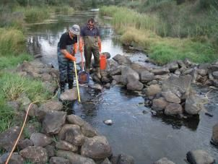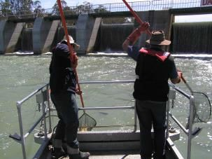

##### Figure 3.4: Boat (left) and bank-mounted (right) electrofishing.

**Mark–recapture**

Mark–recapture studies are used in fishway assessments to determine the movement behaviour of fish, or to measure fishway efficiency or passage success. A mark–recapture investigation involves capturing fish, marking or tagging them, and releasing them at their capture site. The subsequent recapture of these fish allows researchers to calculate distance moved and time since release, and provides data on various behavioural aspects.

When using mark–recapture to assess fish passage efficiency, the fish may be released in the immediate vicinity of the fishway entrance, but they may also be released downstream of the fishway entrance depending upon the objectives of the investigation, e.g. to determine fishway entrance efficiency. Trapping at the fishway exit will help to determine passage success, and sampling riverine habitats upstream of the fishway by electrofishing may also be used to determine passage efficiency.

**Monitoring the performance of fishways and fish passage works 11**

Because a percentage of the marked population may move out of the study area entirely, this method must be validated when determining overall passage efficiency of the tagged population. Furthermore, mark–recapture involves handling the fish prior to beginning the experiment, and handling fish is known to cause adverse side effects or abnormal behaviour (Conte 2004; Wedemeyer 1976). Anaesthesia and surgery in particular can affect behaviour and physiology (Adams et al. 1998; Bridger & Booth 2003), and a percentage of fish can also become infected, shed their tag, or die (Lucas 1989; Summerfelt & Mosier 1984; Ward et al. 2008).

Mark–recapture investigations should therefore recognise the effects of capture, handling and marking methods on fish behaviour prior to interpreting results. Previous research has allowed a minimum waiting period of two weeks during warmer months and four weeks during cooler months for mark–recapture involving anaesthesia and surgery (Jones 2009). If possible, the fishway should not be operational during this period.

*PIT tagging*

A passive integrated transponder (PIT) is an inert tag implanted into an animal to track its movements. PIT tags have been used on mammals, birds, reptiles, amphibians and invertebrates. Data collected from PIT tags provides information on individuals, populations and communities, in addition to behaviour, physiology, management, conservation and commercial harvest.

Because PIT tags come in a range of sizes (Figure 3.5) they can be employed for a range of uses. A 32 mm PIT tag is generally implanted into fish over 180 mm in length. All registered PIT tags have a unique identifier, and they are available as half or full duplex. ‘Full duplex’ refers to a duplex communication mode in which the tag can be energised and transmit its identification code simultaneously. ‘Half duplex’ refers to asynchronous data transfer (similar to a two-way radio), with separate energise and transmit periods. The choice of full or half duplex will depend upon the specific application, but half duplex is most commonly used in Australia.

PIT reader systems installed on fishways typically consist of a number antennas strategically located throughout a fishway, combined with a control box housing the components (Figure 3.5). As a PIT tag is read, the signal passes through the antenna back to the readers and is allocated a date/time stamp. This data is then sent to a database via a telecommunications network or manually downloaded onto a database, for later processing. PIT tags do not have a battery (they are energised by the antenna) so that there is an indefinite tag life-span which is particularly useful for long-lived

(e.g. > 20 years) fish such as Murray Cod.

PIT tagging is a pseudo mark–recapture technique with the added benefit of continuous measurements for the life of the investigation (i.e. if a PIT reader network is present). PIT tagging has frequently been used to assess fish passage overseas (Aarestrup et al. 2003; Calles & Greenberg 2007), and more recently in Australia (Stuart et al. 2008; Baumgartner et al. 2010).

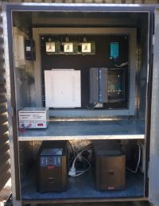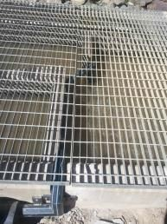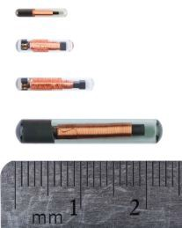

##### Figure 3.5: Left to right: PIT tags, PIT tag antenna within a vertical-slot fishway, PIT reader control box.

**12 Monitoring the performance of fishways and fish passage works**

PIT tag readers are generally placed in the entrance, middle and exit of the fishway, but may also be placed downstream and upstream of the fishway to monitor the movement behaviour of fish. Fish are generally tagged and released immediately downstream of the fishway, but may be released into the entrance of the fishway depending upon the objectives of the investigation. Passage success is calculated as the number of successful ascents versus the number of unsuccessful ascents, however depending on the objectives of the investigation, timing of movement and time taken to ascend may also be important.

Importantly, to assess fishway efficiency with PIT tags effectively, a diverse range of fish species and size classes should be tagged. However, if the fishway is only designed for a limited number of species or a limited size-class, then this may be slightly easier to achieve.

The adverse effects of fish capture, handling and marking fish also apply to the PIT tagging method, and a minimum waiting period (prior to interpreting results) may need to be considered to minimise potential for abnormal behaviour. Similarly, the number of fish moving out of the study area, or being removed by anglers, needs to be considered in the assessment design.

*External tags*

Externally tagging fish is one method for identifying marked fish in a mark–recapture investigation (Figure 3.6). External tagging is also a good method for determining fishway success at the catchment scale, where angling species are tagged across the catchment. Fisheries researchers in Australia have been externally tagging fish since the early 1960s, with amateur anglers playing a significant role in providing data to fisheries researchers. Anglers record the date, capture site, species, length, and weight (if possible), allowing researchers to compare these data to the initial capture information and thereby determine movement pathways, distance travelled and time at large. Tag–recapture may also provide information on the time take for the species to distribute itself across the catchment when movement pathways are restored.

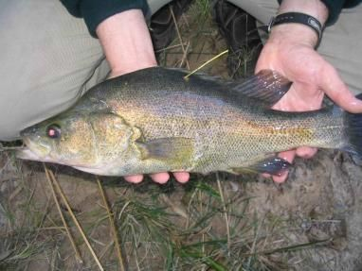

##### Figure 3.6: A golden perch implanted with a dart tag.

**Monitoring the performance of fishways and fish passage works 13**

*Chemical marking*

Chemical marking is another method for identifying marked fish in a mark–recapture investigation. Common chemical marking methods used in fisheries research include the use of calcein and alizarin red (Wilson et al. 1987) (Figure 3.7). The marking method has been used on Golden Perch (Crook et al. 2009) and a number of different galaxiid species (unpubl. data), and the technique has no known adverse side effects outside of the capture and handling procedure. Once marked, researchers can identify marked individuals by illuminating them with a fluorescent light. Researchers wanting to chemically mark fish should refer to the detailed methods outlined in Crook et al*.* (2009).

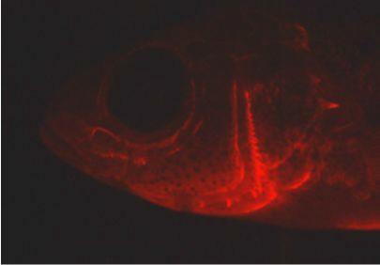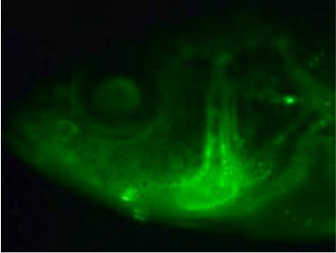

##### Figure 3.7: Example of a chemically marked fish under fluorescent light: calcein (left) and alizarin red (right).

*Radio and acoustic tagging*

In Australia, radio and acoustic tagging have been used for ecological investigations since the early 1990s. Radio and acoustic tagging allow researchers to track or monitor the movement behaviour of individual animals in a range of environments, and the technology is therefore applicable to a wide variety of situations, including fishway assessments.

Both radio and acoustic tagging involve two main components; a transmitter and a receiver. Acoustic tracking can only be used under water, while radio tracking can also be used in terrestrial investigations. The receivers are mounted above water for radio-telemetry (Figure 3.8), while the receivers of acoustic telemetry are generally located underwater (Figure 3.9).

Networks of radio and acoustic tagging equipment have been established along large stretches of riverine systems and migration corridors (Eiler 1995). The restricted nature of most rivers makes them an ideal environment to track the movements of animals due to their natural bottleneck effect on movement pathways and consequent high detection rates.

Radio-tagging has been used to assess a variety of fishways, particularly for fishway attraction efficiency (the ability of fish to find the fishway entrance). Attraction efficiency is very important for fishways because fish first need to find the fishway entrance to successfully ascend, and in environments such as hydro-electric power stations, where noise and turbulence are usually high, locating the entrance of a fishway may prove to be difficult. Flows over a weir or hydroelectric power station, for example, may be manipulated to determine the most suitable fishway attraction flows.

Radio-tagging has been used in a similar manner to PIT tagging, with antennas placed at the entrance and exit (and throughout the fishway) to determine ascent success (i.e. number of unsuccessful ascents versus number of successful ascents). Antennas may also be erected downstream of the fishway or at barriers or fishways farther up the catchment, thereby allowing the overall fate of the fish to be determined.

The adverse effects of fish capture, handling and marking on fish also apply to the radio-tagging method, and a minimum waiting period (prior to interpreting results) may need to be considered to minimise the potential for abnormal behaviour. Similarly, the number of fish moving out of the study area should be considered in the design.

**14 Monitoring the performance of fishways and fish passage works**

##### Figure 3.8: Top left: Golden perch with external dart tag and radio-transmitter implanted. Bottom left: Radio tag. Right: Radio-tracking tower with directional antennas at the junction of a river anabranch to track the movements of fish.

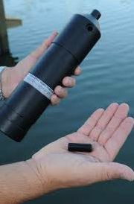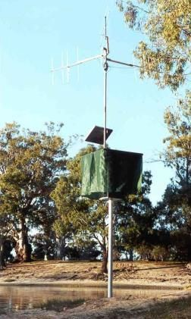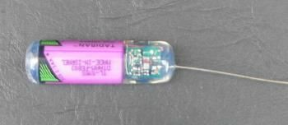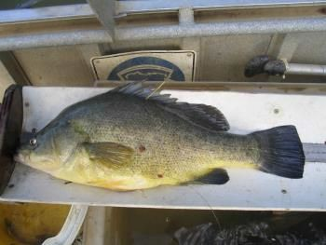

**Figure 3.9: Acoustic receiver and tag.**

**Monitoring the performance of fishways and fish passage works 15**

**Video recording**

Video or digital recording is another tool that can be used to monitor the movements of animals through fishways. Video cameras may be used to observe animal behaviour and therefore collect a diverse range of behavioural information. They can also be used to collect species identification, distributional and abundance information, including within a fishway (Figure 11).

Once a video site is established, the system can collect significant quantities of information without a researcher present. However, the footage obtain also requires significant real time post-processing

(i.e. someone must quantify the visual data manually) unless specific software has been developed to process it. For this reason video recording may be best suited to obtaining behavioural information rather than quantifiable information. Video cameras also require good water clarity to obtain clear images and regular maintenance to minimise algal growth, and can be prone to trapping debris. They can also be difficult to clean safely and effectively without isolating the fishway.

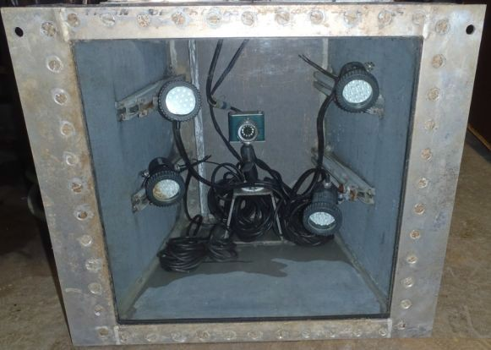

##### Figure 3.10: Underwater video camera installed on the Milwaukee River fishway, Wisconsin, by the US Fish and Wildlife Service for the Ozaukee County Planning and Parks Department.

**Alternative ecological assessment techniques**

A number of alternative and highly technical methods are available to researchers to monitor fishways, including split-beam hydroacoustics, dual-frequency identification sonar (DIDSON), VAKI Riverwatcher, and automatic resistivity counters. However, these methods required specific training, possibly software development for data analyses, and significant post-recording analysis and interpretation of fish behaviour. For these reasons these techniques are not generally recommended for fishway assessments. Despite this, a brief description of each technology is listed below, and links for further information about these technologies are provided.

*Sonar*

Split beam hydroacoustics and DIDSON utilise sonar (sound navigation and ranging). Sonar is the use of sound propagation to communicate with or detect objects in the water, while hydroacoustics is the general term for the application of sound in water. Hydroacoustics can be used to detect water

**16 Monitoring the performance of fishways and fish passage works**

depth, presence/absence, size and behaviour of individual objects, including fish. Split-beam hydroacoustics can be used to locate an individual in three dimensions, allowing target strength, velocity and direction of movement to be calculated (Figure 3.11). Similarly, DIDSON sonar uses sound pulses and converts the returning echoes into digital images (Figure 3.11). The resulting effect is almost like watching an underwater video, even in darkness or in turbid waters. Data collected from either system can be analysed using Echoview (see link below). DIDSON and the split-beam systems have been field-tested in Australian conditions (Baumgartner et al. 2006; Berghuis 2008).

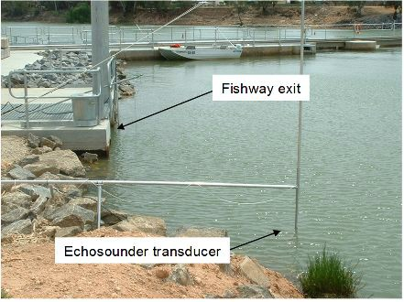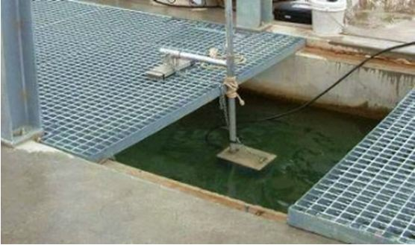

VAKI, a company based in Iceland, produces a range of fish counting and size estimation products for research, monitoring and aquaculture. The VAKI Riverwatcher is an electronic fish counter that measures the shape and size of fish that pass through an infrared scanner (Figure 3.12). The unit can detect movement in an upstream or downstream direction, and an optional photo tunnel containing a video camera (5 seconds recorded per fish) and lights can be added to the scanner to record video during the day or night. Data collected by the unit includes fish size, time and date, swim speed, silhouette images and water temperature. The Riverwatcher uses a Windows operating system, and data collected are analysed using Winari control software (Vaki, Kópavogur, Iceland). The VAKI Riverwatcher technology has been field-tested in Australian conditions (Baumgartner et al. 2012a).

Resistivity counters use electrodes to detect deviations in their electric fields. Fish have a lower resistivity than water, and as such, they induce deviations in the electric field as they pass over the electrodes. Resistivity counters can detect size of a fish and direction of travel. Fish counters are probably best suited to freshwater systems with low electrical conductivity. The components within a fish counter are susceptible to electrical storms, however surge protection devices may minimise potential damage.

Further information on these technologies can be obtained from the following websites:<http://www.soundmetrics.com/Products/DIDSON-Sonars> <http://www.biosonicsinc.com/index.asp>

<http://www.echoview.com/> <http://www.vaki.com/Products/RiverwatcherFishCounter/> <http://www.aquantic.com/>

<http://store.smith-root.com/catalog/fish-counters-c-3.html>

##### Figure 3.11: DIDSON sonar installed on a fishway exit (left), and split-beam hydroacoustics unit installed on the exit of a fishway (right).

**Monitoring the performance of fishways and fish passage works 17**

##### Figure 3.12: VAKI Riverwatcher next to, and within a fishway exit.

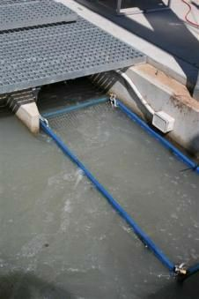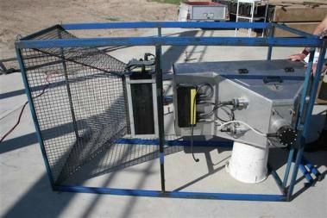

**Fish accumulations**

Monitoring the abundance and composition of fish downstream of a structure may be used to document change following barrier construction or removal, or when the impacts of a barrier are mitigated through the construction of a fishway. Monitoring the downstream accumulation of fish may need to be undertaken over a number of years, given that fish accumulations and species composition can vary with season and year. Each site should also be sampled repeatedly to ensure that robust statistical analyses can be performed.

Monitoring should include sites located close to the barrier (treatment) and downstream outside the area of influence of the barrier, or in a neighbouring catchment (control). Control sites allow researchers to determine the natural temporal dynamics of the fish population unrestricted by a barrier, making it possible to compare the project outcomes with sites located immediately downstream of the barrier. Prior to establishing control sites, researchers should endeavour to undertake a pilot sample of the fish population to ensure that the relative abundance and species composition are representative and that the sites are suitable as controls.

When a fishway commences operation, the composition of the fish population immediately downstream of the barrier should alter by declining in abundance, while the control site located outside the influence area should be more or less unchanged (relative to natural variation). Monitoring should take into account the time of year the fishway is opened and the period when fish accumulations generally occur.

If funding for a longer-term monitoring program is not available, a short-term assessment may target key accumulation periods for the barrier. Along the Murray River, for example, the key accumulation period may be between September–December during a rising river. Thus researchers target this period, aiming to achieve a suitable number of sample replicates at both the control and treatment sites.

*Fishway attraction*

The attraction of fish to the entrance of a fishway is vitally important for passage success. A large barrier such as a weir or regulator can be hundreds of metres wide, while the entrance of a fishway or lock is typically less than 1 m. Fishway attraction flows may be refined by manipulating the weir gate settings to eliminate recirculation or eddies around the entrance, and to ensure that the fishway

**18 Monitoring the performance of fishways and fish passage works**

entrance discharge is not masked by flows from the weir (or elsewhere), so that the integrity of the fishway flow is maintained (O'Connor et al. 2015b).

Appropriate fishway attraction settings may also be determined through monitoring. Radio or acoustic tagging and PIT tagging are the two best two methods for this. The behaviour of fish tagged immediately downstream of the barrier or fishway entrance may be monitored as the weir settings, and hence the attraction conditions, are manipulated. This should also be repeated during low, medium and high flows to determine the nature of movement around the structure over a range of flow conditions. For details of methods to refine fishway attraction flows, refer to O’Connor et al. (2015b, 2017).

**Data analyses**

Fishway assessments generally collect a range of data including species diversity, length-frequency, relative abundance, hydrology, and to a smaller extent, behavioural data (Appendix 1). Non- parametric tests used in fishway data analyses include the Kolmogorov–Smirnov test, Wilcoxon’s rank-sum test (Mann–Whitney *U*-test), Kruskal–Wallis test, chi-square, *t*-test, *G*-test, and descriptive statistics (Appendix 1). Common parametric tests include ANOVA, ANOSIM, regression analysis, MDS ordinations and contingency analysis. Researchers should have a clear understanding of the method of analysis and obtain biometric advice prior to commencing sampling.

Length frequency data is generally analysed using the Kolmogorov–Smirnov test (refer to the case study below), while relative abundance data is generally analysed by ANOVA, MDS ordination and descriptive statistics (Appendix 1). However, this information does not preclude the researchers from using a different method or a more advanced technique.

**Monitoring the performance of fishways and fish passage works 19**

##### Case Study: Kolmogorov-Smirnov test

Generally, researchers use a Kolmogorov–Smirnov (KS) test to determine if the length frequency distributions of two samples are the same. For analyses involving fishways, this test typically compares lengths of fish captured at the entrance (or downstream) and exit (or upstream). A significantly different KS test indicates that the distributions are different, and may indicate a problem within the fishway (e.g. a blockage) or that the fishway design is inappropriate.

To interpret this data correctly, a histogram is typically plotted. Percentage frequency is best used over frequency alone because the KS test adjusts each treatment for the total number of samples, and so the results are easier to interpret, i.e. differences can be readily identified. Descriptive statistics such as mean, minimum, maximum, standard deviation, mode and median are also helpful for documenting differences between the samples.

The following example concerns galaxiids, for which length data was collected from upstream and downstream of a rock-ramp fishway. The raw data is provided in Table 3.1 and plotted in Figure 3.13a. A KS test of this data indicated that the samples were the same; that is, there is no difference in the size-class of fish located upstream and downstream of the fishway. For the purposes of this demonstration, the data was also analysed with fish smaller than 70 mm excluded from the upstream sample, which produced a significant KS result (Figure 3.13b). This result warrants further investigation to determine the cause of the difference. Descriptive statistics can also be used to demonstrate a difference in mean, minimum, standard deviation and median for the two examples (Table 3.1).

##### Table 3.1: Summary data of fish lengths collected upstream and downstream of a rock- ramp fishway.

|  |  |  |  |  |  |  |  |  |
| --- | --- | --- | --- | --- | --- | --- | --- | --- |
|  | **Sample collected from** | **No.** | **Mean** | **Min.** | **Max.** | **SD** | **Mode** | **Median** |

|  |  |  |  |  |  |  |  |  |
| --- | --- | --- | --- | --- | --- | --- | --- | --- |
| All length data | Downstream of fishway | 492 | 88.4 | 46 | 159 | 19.3 | 78 | 84 |
| All length data | Upstream of fishway | 511 | 88.7 | 53 | 180 | 20.1 | 80 | 85 |
| Length data  > 70 mm** | Upstream of fishway | 455 | 91.9 | 70 | 180 | 19 | 80 | 87 |

** denotes KS test significance

**20 Monitoring the performance of fishways and fish passage works**

18

1. n=1003

16 KS test statistic = 0.043

*P*=0.740 14

12

10

8

6

4

2

% Frequency

0

18

1. Fish <70mm omitted from U/S sample 16

n=947

14 KS test statistic = 0.130

*P*=0.001

12

10

8

6

4

2

0

0 20 40 60 80 100 120 140 160 180 200

Length (mm)

##### Figure 3.13: (a) Kolmogorov–Smirnov (KS) test results for a fish species upstream (red) and downstream (black) of a rock-ramp fishway. (b) KS test results with a subset of small fish (< 70 mm long) excluded from the analysis to demonstrate a significant result. Arrow indicates the area that contributed to the significant KS difference.

**Monitoring the performance of fishways and fish passage works 21**

##### 3.4.1 Hydraulics assessment

**Fishway hydraulics**

The construction of a fishway is equally as important as the design, and checking the constructed fishway against design specifications is one of the first steps in assessing a fishway to determine its functional success.

After the fishway is completed, a number of measurements should be made with the fishway filled with water but before it is put into operation. This is known as wet commissioning. During wet commissioning the hydraulic conditions outlined during the detailed design phase should be measured against what has been constructed. Common parameters include headloss, slope, length, width, water depth, slot widths, and entrance location relative to the upstream migration limit such as a weir wall. For example, if a vertical-slot fishway is designed to have 100 mm of head difference between each of the fishway pools, then this should be confirmed during the wet commissioning. Similarly, slot width and other parameters should also be measured against design specifications. A 5% tolerance overall (from entrance to exit) of actual versus constructed slot width is generally acceptable. Water velocity may also be measured, but obtaining consistent and relevant readings can be difficult, particularly in rock-ramp or fish bypasses where natural rocks of different shapes and sizes are used and hydraulic roughness is present.

For rock-ramp and bypass fishways where concrete is generally not used, the commissioning process may allow a tolerance greater than 5% because of the unpredictable or imprecise nature of rock placement and earthworks compared with concrete. However, basic measurements such as headloss, water depth and slope should meet design specifications with the agreed level of tolerance. Following wet commissioning, an assessment of the operational fishway can commence.

For existing fishways, managers of instream structures and researchers may not have access to the design specification against which the fishway can be assessed. When this occurs, researchers and managers should determine the fish species present within the waterway, and develop objectives for the fishway. Once this has been established, hydraulic monitoring can be assessed relative to known hydraulic requirements for the target species.

Rock-ramp and bypass fishways in particular are prone to movements in the crest rocks, the toe rocks and occasionally the foundations. Monitoring the location of each of the rock ridges, in addition to the crest, should be undertaken on a regular basis (O'Connor et al. 2015b) and after major flow events.

In addition, effective attraction flows are a common oversight when fishways are constructed at weirs. A hydraulically correct fishway may not work efficiently if fishway attraction flows are not aligned with the fishway entrance. Flows over a weir for example, can easily overpower fishway attraction flows because they are generally orders of magnitude larger than a fishway out-flow, and fish are generally attracted to the largest flow. Therefore operation of the weir must consider the effect on fishway attraction flows, especially during key migratory periods.

**Contemporary fishway design guidelines**

The guidelines for the design, approval and construction of fishways (O'Connor et al. 2017) set out the contemporary design knowledge for successful fishway design and construction. The essence of the document is summarised in the table below and includes attributes that are important for successful fishway design, including fishway depth, pool volumes, slot widths, turbulence, water velocities, slope and headloss (Table 1). We use the attributes outlined in this table as a foundation for a hydraulics assessment and fish assessment scoring (refer to section 4.3).

**22 Monitoring the performance of fishways and fish passage works**

##### Table 3.2: Contemporary guidelines for the design and construction of fishways (O’Connor et al. 2017).

**Vertical-slot fishway**

Min.

Target

Max. slot

Pool to

Minimum

Maximum water

Entrance and exit

Headloss

Minimum plunge

Fish

Length (mm)

Target

depth (m)

Minimum pool volume (L)

slot width (mm)

Turbulence (W/m3) (*Cd*

=0.7)a

water velocity (m/s)b

Slope

pool headloss (mm)

headloss @ entrance (mm)a

velocity at fishway exit channel (m/s)

flow vectors (deg. from stream centreline)

at trash racks (mm)

pool depth of weir for downstream migrantsc

Weir style for

downstream migrants

Location of entrance and exit respectivelyd

20–99 > 0.5 825 (1.5  1.1 m) 100 < 25 < 1.20 > 1:30 < 75 45 0.05 < 90°, no recirculation < 20 40% of MHD Overshot U/S or D/S migration limit

100–199 > 0.75 2800 (2.5  1.5 m) 150 < 30 < 1.40 > 1:30 < 100 60 0.15 < 90°, no recirculation < 20 40% of MHD Overshot U/S or D/S migration limit

200–699 > 1.0 5000 (2.5  2 m) 250 < 50 < 1.6 > 1:25 < 120 72 0.3 < 90°, no recirculation < 20 40% of MHD Overshot U/S or D/S migration limit

700+ > 1.5 10500 (3.5  2 m) 350 < 50 < 1.8 > 1:20 < 165 100 0.3 < 90°, no recirculation < 20 50% of MHD Overshot U/S or D/S migration limit

## Rock-ramp fishway

Fish Length (mm)

Target depth (m)

Minimum pool volume (litres)

Min slot width (mm)

Target

turbulence (W/m3) (Cd of 0.7)*

Maximum slot water velocity (ms–1) @ *vena contracta*

Slope

Pool to pool Headloss (mm)

Minimum headloss @ entrance (mm)*

Maximum

water velocity @ fishway exit (ms–1)

Entrance and exit flow vectors (degree from stream centreline)

Lateral

ridge slope (Site specific decision)

Minimum plunge

pool depth of weir for downstream migrants (partial width)

Weir style for downstream migrants (partial width)

Location of entrance

20–99 > 0.3 1500 (2.5  2 m) 100 < 25 <1.20 > 1 : 30 < 75 45 0.05 < 90°, no recirculation > 1 : 6 40% of MHD Overshot U/S or D/S migration

U/S migration limit

limit

100–199 > 0.5 2500 (2.5  2 m) 150 < 30 <1.4 > 1 : 30 < 100 60 0.15 < 90°, no recirculation > 1 : 6 40% of MHD Overshot U/S or D/S migration

U/S migration limit

limit

200–699 > 0.6 6000 (4.5  2 m) 250 < 50 <1.6 > 1 : 25 < 120 72 0.3 < 90°, no recirculation > 1 : 6 40% of MHD Overshot U/S or D/S migration

U/S migration limit

limit

700+ > 1.0 10000 (4  2.5 m) 350 < 50 <1.8 > 1 : 20 < 120 90 0.3 < 90°, no recirculation > 1 : 6 50% of MHD Overshot U/S or D/S migration

U/S migration limit

limit

Notes:

a over operational flow range b measured at *vena contracta*

c MHD = maximum head differential d U/S = upstream, D/S = downstream

**Monitoring the performance of fishways and fish passage works 23**

# Proposed generic fishway evaluation methods

The following fishway assessment methods were developed from a review of the literature combined with unpublished data on best practice for fishway assessments. The objective of these methods is to provide waterway managers and fisheries researchers with a consistent approach to assessing the effectiveness of Victorian fishways. Understanding the role of fishway assessment and the adaptive management feedback from research will inevitably lead to improvements in the design and understanding of fishways, and improvements in Victoria’s waterways for instream biota.

As each fishway is unique, the following methods should be used as a guide rather than step-by-step instructions on how to assess all fishways. Fishway types have been grouped according to similarity and assessment methods used: vertical-slot fishway with Denil fishway, fish lock with fish lift, and rock-ramp fishway with fish bypass.

Fishway assessment methods have been divided into hydraulic and ecological assessments, with ecological assessments divided into an abundance/length-frequency method, and a presence/absence, length-frequency method (Figure 4.1). Two options for ecological assessments have been provided to give greater flexibility to waterway managers when undertaking assessments. The presence/absence, length-frequency method is targeted towards short-term assessments where large numbers of fish are present. The hydraulic assessment method is similar regardless of the type of fishway, and is intended to cover most of the measurable hydraulic components of a fishway.

Ecological and hydraulic assessments have an assessment scoring table, which is designed to be used as a method to assess the constructed fishway against the designed fishway. Any significant deviation from design should become evident, and a course of action to rectify issues can then be implemented. This is intended to indicate a general rather than definitive course of action. All outcomes should be referred to a fishway expert to determine the degree of deviation and acceptable limits.

The structure of the assessment and scoring methods is shown in Figure 4.1. This flow diagram is divided into two categories for ease of interpretation: assessment structure, and assessment scoring. Each category of the structure is explained below, and each of the proposed fishway assessment methods is described in the text and accompanying tables. The tables, designed to be read from left to right, are designed to provide the necessary information to undertake a successful fishway assessment. Definitions of the fishway measurements are shown in Table 4.1.

The proposed fishway evaluation methods were tested on two coastal fishways: the Barham River rock-ramp fishway and the Barwon River vertical-sot fishway (Appendix 2). The outcomes of the ecological and hydraulic assessment complemented each other. Specifically, a number of hydraulic anomalies were identified by the methods, and the influence of these anomalies contributed towards the ecological performance and outcomes.

## Ecological assessment description

##### Abundance (presence/absence), length-frequency method

The abundance, length-frequency method can be undertaken using a number of methods, including electrofishing, trapping or mark-recapture. This method of assessment is intended to provide researchers with a replicated design that is suitable for both parametric and non-parametric statistical tests. Because migration of fish is highly variable, migration through the fishway will also be highly variable, and it will alter with season, life-history stage, and diel movement behaviour. For example, some fish such as galaxiids move during the day, while others such as lampreys move during the night. Therefore the number of replicates must be maximised to account for the variations in movement timing (including season), and a minimum of 12 replicates has been suggested to account for such variation, although the literature suggests that the number of replicates can be substantially higher (Appendix 1). Moreover, the timing of these replicates should be targeted towards smaller fish that move early in the migratory season.

**24 Monitoring the performance of fishways and fish passage works**

When assessing fishways, a minimum amount of time between collecting fish from the entrance and the exit is also suggested to account for the time taken for fish to ascend the fishway, as this will vary according to the fish species present, fishway length and number of baffles, and percentage of the waterway to be sampled; this was generally not mentioned in the reviewed literature, but it may have been completed in practice. In the guidelines presented here it is assumed that small fish and long fishways mean additional time for fish to ascend, but if only part of the fishway (i.e. full-width rock- ramp) is sampled then less time is required because fish can continue to ascend even during sampling. Some investigations have randomised the entrance and exit samples as a way of dealing with this issue. However, this only solves part of the bias problem, as sampling the exit during the early morning may not allow enough time for diurnal fish to ascend and become trapped.

The sample duration has not been defined, although the literature suggests that 24 hours is common (Appendix 1). The sample duration typically may be refined through a pilot investigation. Sample duration may also need to take into account variation in behaviour and catchability of the target species, and the abundances encountered. Traps should be checked at least once for a 24 hour sample, to ensure the removal of fish and trash accumulated on the trap, and all individuals should be identified to species level for each sample. Preservation of voucher specimens should be considered for small species such as galaxiids, which are often difficult to identify in the juvenile phase.

All individuals collected during each treatment should be counted, and if possible a minimum of 100 individuals of each species should be measured per replicate. This will allow an appropriate comparison to be made between the length of fish at the fishway entrance and the length of fish at the exit. The total number of fish measured during each treatment (entrance and exit) should be more than 300 to allow a Kolmogorov–Smirnov test to be completed. If possible the entrance samples should include more than 150 individuals of each species at or smaller than the minimum size objective for the fishway; the timing of the assessment should coincide with the movement of small individuals of the target species. Similarly, for mark–recapture a minimum of 300 individuals of various size classes should be tagged to obtain a representative sample. Species that occur in low abundances (e.g. threatened species) can be assessed separately, using whatever data was collected.

Importantly, assessments must be based on sampling undertaken when the fishway is operating within the design specifications. For example, a fishway operating outside its specifications (e.g. during a flood) may be inefficient, so the data collected might not be representative. Refer to Appendix 2 for testing and application of these methods.

##### Presence/absence, length-frequency method

The presence/absence, length-frequency method can be undertaken using a number of methods, including electrofishing, electrofishing and trapping, or trapping alone. This method does not require a replicated design because the analysis compares the presence of species at both the entrance and exit, and via the length-frequency distributions. The presence-absence method, however, relies on all fish being collected downstream (i.e. entrance or river), being present at the exit, with the absence of one common species or more an indication that there may be a problem with the fishway design, operation, or performance.

The sample duration for this method is not predetermined and, like the abundance method, a pilot investigation is suggested to determine the duration for the highest catch rates and greatest species representation.

The minimum sample period for entrance/exit trapping is irrelevant for the presence/absence method, as the aim is to ensure that all species are present and that there is no difference between the length- frequency distribution between entrance and exit for target species and size classes. Species life- history must be considered when assessing the fishway against design objectives, because some fish may only be active during daylight hours, at dawn or dusk, or at night, in addition to seasonal movement behaviour.

The effect of electrofishing on the health of the fish also needs to be considered, and a minimum waiting period of six hours between electrofishing shots has been suggested (with an additional

30 minutes for every five fishway baffles), and different areas of the river can be targeted to minimise any impact. Entrance samples are standardised to five minutes of electrofishing power-on time.

**Monitoring the performance of fishways and fish passage works 25**

Unlike the abundance method, if suitable fish numbers are collected to gain a representative sample (more than 300 individuals of each target species) at all sites (i.e. entrance/exit or upstream/downstream), then the sampling can be completed. This may occur quickly, or sampling may need to continue over an extended period. Importantly, the entrance sample must include more than 150 individuals of each species at or smaller than the minimum size objective for the fishway to ensure that the fishway’s operating limit is tested. The timing of the assessment should coincide with the movement of small size classes of target species. Refer to Appendix 2 for testing and application of these methods.

## Hydraulic assessment description

The hydraulic assessment method can be applied to all fishway types (Table 4.2). It is intended to cover all of the measurable hydraulic components of a fishway, including slope, fishway dimensions, headloss, slot width, upstream migration limit, and debris loads. These are defined in Table 4.2. Any deviation from the proposed fishway design is to be recorded as a percentage departure, with significant departures being highlighted for further investigation (refer to Appendix 2). Importantly, this monitoring document assumes that all fishways, but particularly mechanical fishways (fish lock and lifts), have undergone a thorough dry and wet commissioning process and have had the fishway attraction flows and lock cycles refined. The fishway commissioning process is outlined in the best practice guidelines for design, approval and construction (O’Connor et al. 2017).

## Fishway assessment scoring description

The fishway assessment scoring is divided into two categories: ecological assessments and hydraulic assessments (Table 4.3). The assessment scoring summarises the results and conclusions of the fishway assessment.

The ecological assessment scoring is designed to ensure that:

* the fishway is suitable for the species present
* target species are present at the entrance and exit
* the timing of the assessment coincides with the movement of small size classes of target species
* there is no difference in length-frequency at the entrance and exit.

Relative fish abundance has also been included, but the abundance results should be interpreted with caution because abundances are typically influenced by a range of factors, including season, flow, water temperature and time of day. A replicated sampling design is required to interpret relative abundance data with sufficient certainty.

The hydraulic assessment ensures that the fishway meets the design specifications, or is in accordance with the new guidelines for design, approval and construction of fishways (O’Connor et al. 2017). That is, the fishway parameters, including water depth, pool volume, slot width, water velocity, slope, headloss and auxiliary water accurately reflect the design. The upstream migration limit (i.e. the farthest upstream that a fish can move relative to the instream barrier) is also included to ensure that the fishway entrance is in a suitable position (i.e. within 0.5 m) at all stream discharges. Common tools used to obtain hydraulic information from fishways include tape measures (8 m and 30 m), depth pole, laser level, rangefinder and water velocity meter.

It has been suggested that the researcher or manager should consult a fishway expert to rectify any issues identified. Discussions may also involve the designer of the structure if they are known. Obtaining the original design drawings or design brief is the first step in rectifying fishway performance issues, but if this is not available then the outcomes should be compared with contemporary designs (O'Connor et al. 2017). Refer to Appendix 2 for the application of the assessment scoring.

**26 Monitoring the performance of fishways and fish passage works**

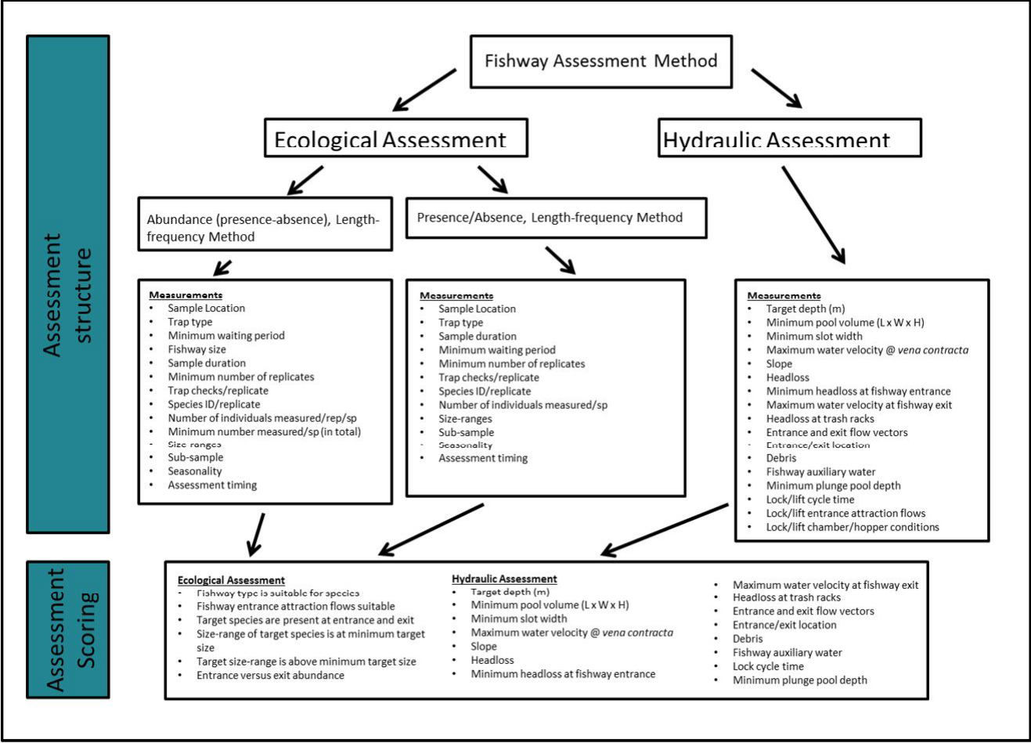

##### Figure 4.1: Structure of the fishway assessment and scoring methods.

**Monitoring the performance of fishways and fish passage works 27**

##### Table 4.1: Fishway assessment parameters with definitions.

|  |  |  |
| --- | --- | --- |
| **Fishway Measurements** | **Ecological Assessment** | **Explanation** |
| Sample Location | Area to be sampled. |
| Trap type | Method of sampling to be used, may include fishway traps, funnel and screens, nets, or electrofishing. When electrofishing, a minimum waiting period of 6 hours between electrofishing shots should be adopted to minimise damage to fish. Electrofishing at the fishway entrance may be used as an alternative to trapping the fishway entrance when traps and funnels/screens are not practical. |
| Minimum waiting period | Length of time required to avoid negative sampling bias between sample locations i.e. entrance or exit. Sampling bias may occur if sampling the  entrance and then the exit, as fish need time to ascend the fishway before reaching the exit. Therefore, an appropriate length of time must be given to allow fish to ascend before beginning the sample. For vertical-slot and Denil fishways, the length of time will vary with fish size and number of fishway baffles, while, for rock-ramp and fish bypasses, the length of time will vary with fishway size and % of waterway to be sampled. |
| Fishway size | The number of baffles within a fishway. |
| Sample duration | Time taken to collect a representative sample – a pilot investigation may need to be completed prior to the experiment. |
| Minimum number of replicates (ent/exit) | Recommended minimum number of replicates required to obtain a statistically viable sample |
| Traps checks/replicate | Number of times the trap may be checked per replicate |
| Species ID/replicate | Number of species that should be identified per replicate |
| Number of individuals measured/rep/sp | Number of individuals (per species) that should be measured for each replicate |
| Minimum number measured/sp (in total) | Minimum number of individuals to be measured per species for the entire experiment |
| Size-ranges | Number of fish required at the minimum design range of the fishway to obtain a representative sample. |
| Sub-sample | Sub-sampling is required to shorten fish processing time when large numbers of fish are captured. A minimum of 5 tubs of fish are used to obtain a sub-sample. This involves counting the total number of tubs taken to account for all fish, then identifying and counting how many fish of each species are present in 5 tubs. This will allow the researcher to extrapolate how many fish of each species were present in the total sample. |
| Seasonality | Seasonal sampling may be required to capture all target species. |
| Assessment timing | The fishway assessment must be conducted when stream discharge is within the target discharge for the fishway. |
| **Hydraulics Assessment** |  |
|  |  |
| Target depth (m) | Water depth of each fishway pool and at the slot |
| Minimum pool volume | Volume of the pool based on minimum target depths (L x W x H) |
| Minimum slot width | Width of the slot at all baffles. |
| Maximum water velocity at *vena contracta* | Maximum water velocity at the vena contracta (i.e. jet of water at the slot) |
| Slope | Slope of the fishway between entrance and exit. |
| Headloss | Difference in water height between fishway pools. |
| Minimum headloss at fishway entrance | Difference between the river height (at entrance) and first pool |
| Maximum water velocity at fishway exit | Maximum water velocity at the exit |
| Headloss at trash racks | Maximum headloss at the fishway trash racks |
| Entrance and exit flow vectors | Angle/direction of flow at the entrance and exit |
| Entrance/exit location | Location of the entrance/exit at the upstream migration limit |
| Debris | Amount of matter (or %) blocking normal fishway operation. |
| Fishway auxiliary water | Additional water supplied to maintain design headloss within pools |
| Minimum plunge pool depth | Minimum depth of the weir/barrier plunge pool. |
| Lock/lift cycle time | Length of time it takes the lock to complete all phases of the cycle i.e. attraction, filling, exiting, transition. |
| Lock/lift entrance attraction flows | Maximum water velocity during attraction phase |
| Lock/lift chamber/hopper conditions | Turbulence conditions within the lock/lift chamber/hopper |

**28 Monitoring the performance of fishways and fish passage works**

##### Table 4.2: Hydraulics assessment.

|  |  |
| --- | --- |
| **Hydraulics Assessment Vertical-slot, Denil, Rock-ramp, fish bypass fishway** |  |
| Target depth | Measure water depth in all pools and baffles, record % difference from contemporary design |
| Minimum pool volume | Measure the length and width and multiply by pool depth, record % difference from contemporary design |
| Minimum slot width | Measure slot-width at all fishway baffles, record % difference from contemporary design |
| Maximum water velocity @ *vena contracts* | Measure the water velocity at the *vena contracta*, record % difference from contemporary design |
| Slope | Measure slope of fishway at regular intervals, record % difference from contemporary design |
| Headloss | Measure headloss between all pools (plot level), record % difference from contemporary design |
| Minimum headloss at fishway entrance | Measure headloss at entrance over a range of operational tail water levels, record % difference from contemporary design |
| **Maximum water velocity at fishway exit channel | Measure water velocity in the fishway exit channel, record % difference from contemporary design |
| **Headloss at trash racks | Measure headloss at trash racks, record % difference from contemporary design |
| **Entrance and exit flow vectors | Draw flow vectors on map of fishway/river, record % difference from contemporary design |
| **Entrance /exit location | Is the entrance/exit location at the upstream/downstream migration limit (<0.5 m), record % difference from contemporary design |
| **Debris | Estimate % of fishway covered in debris |
| **Fishway auxiliary water (if present) | Does it cause excessive turbulence or adverse flow patterns (Yes or No) at the discharge point |
| **Minimum plunge pool depth | Measure weir/barrier headloss, record % difference from contemporary design |
| **Fish Lock or Fish Lift (in addition to ** above)** |  |
| Post-construction commissioning by construction contractors | Check that the commissioning process is complete (if not, refer to O’Connor 2017 for guidance). |
| Lock/lift cycle time | Reflects design phase operation for the current conditions |
| Lock/lift entrance attraction flows | Measure water velocity during entrance attraction phase, record % difference from contemporary design. |
| Lock/lift chamber/hopper conditions | Is turbulence excessive during filling or draining phase |

**Monitoring the performance of fishways and fish passage works 29**

##### Table 4.3: Assessment scoring all fishway types (Note, not all categories are relevant to all fishway types).

|  |  |  |  |  |  |
| --- | --- | --- | --- | --- | --- |
|  | | **Acceptable % deviation from contemporary design** | **Measured deviation%** | **% deviation from contemporary design** | **Course of action when non- conforming** |
| **Ecological Assessment**  Fishway type is suitable for species present | Yes or No Seek expert advice  Yes or No Seek expert advice  Seek expert advice  <2 Seek expert advice  <2 Seek expert advice  Entrance vs exit abundance <30 Seek expert advice  Yes or No Seek expert advice | | | | |
| Fishway hydraulics are suitable for fish species and reflect contemporary deign |
| Target species are present at both fishway entrance and exit Size range of target fish species is at minimum target size at the fishway |
| Target size ranges are present at the entrance and exit of fishway |
| Abundance |
| Entrance and exit location are at migration limit |
|  |
| **Hydraulic Assessment** | 5 Seek expert advice  2 (5) Seek expert advice  2 (5) Seek expert advice  Seek expert advice  2 (5) Seek expert advice  2 (5) Seek expert advice  5 Seek expert advice  10 Seek expert advice  0 Seek expert advice  0 Seek expert advice  10 Seek expert advice  % presence within fishway 5 Seek expert advice  Yes or No Seek expert advice  Yes or No Seek expert advice  Yes or No Seek expert advice  Yes or No Seek expert advice  Yes or No Seek expert advice | | | | |
| Target Depth |
| Minimum pool volume |
| Minimum slot width |
| Maximum water velocity at the *vena contracta* |
| Slope |
| Headloss |
| Minimum headloss at fishway entrance |
| Maximum water velocity at fishway exit channel |
| Headloss at trash racks |
| Entrance and exit flow vectors |
| Entrance/exit location |
| Debris |
| Fishway auxiliary water (if present) causes excessive turbulence |
| Minimum plunge pool depth suitable |
| Lock/lift cycle time (reflects design) |
| Lock/lift entrance attraction flows suitable |
| Lock/lift chamber/hopper turbulence excessive |
| **Comments** |

77 Warrants further investigation – differences in abundance may be related to seasonal influences and/or sample sizes. Relates to trapping and funnel/screen methods only (i.e. excludes electrofishing). () = greater tolerance allowed for rock-ramps and bypass fishways.

**30 Monitoring the performance of fishways and fish passage works**

## Using the proposed evaluation methods

The assessment methods have been formatted into tables to aid interpretation of the method parameters (Tables 4.5–4.9). Each table contains a unique set of assessment methods applicable to each fishway group, and separated into abundance (presence-absence)/length-frequency, and presence-absence/length-frequency method. Application of these methods are also documented in Appendix 2.

All fishway assessments should be completed during the target species migration period, and seasonal sampling may be required to obtain all migratory species. Similarly, assessments must be completed when the fishway is operating within its operational range (i.e. not flooding), and at an appropriate time of the day for the target species.

An important division in evaluation methods can also be made between coastal and inland systems, as coastal species are often diadromous, motivated to move upstream, and an assumption that small size-classes found upstream of fishways during spring are likely to have recently migrated through the fishway. However, for inland fishways and species which are often found, and breed, either side of an instream barrier, no assumptions can be made about passage through a fishway. For this reason, electrofishing upstream and downstream of an inland fishway has been omitted from the collection method (Table 4.4). However, in certain circumstances, such as an inland riverine system being depleted/depauperate of target species or size-classes, then electrofishing may be appropriate, however it should be treated on a case by case basis.

##### Vertical-slot and Denil fishways

Two different evaluation methods are proposed to assess vertical-slot and Denil fishways, entrance and exit trapping only, and exit trapping and entrance electrofishing. Exit trapping has been chosen for both evaluation methods, as exit trapping is the most effective method of collecting fish as they pass through a fishway (i.e. restricted area). Obtaining an entrance sample can either be completed by trapping the fishway entrance to collect fish as they enter, or by electrofishing immediately downstream of the fishway entrance. Entrance samples for both evaluation methods need to obtain a representative sample of the species and size-ranges, and sampling the stream immediately downstream of the fishway should obtain this. However, trapping the fishway entrance for a representative sample must include a reduction in the headloss, velocity and turbulence at the entrance baffle, and this can be achieved by partially shutting the fishway exit gate. By doing this, smaller fish size-classes can enter the entrance trap without being subject to excessive hydraulic conditions.

**Abundance (presence-absence)/length-frequency**

The abundance/length-frequency method of assessment may be completed using traps or funnels and screens (Table 4.5). No minimum waiting period is required if sampling the exit then entrance, however when sampling the exit after the entrance, a minimum waiting period is required. This minimum waiting period depends upon number of baffles (and so fishway length), and the target species.

The sample duration may be determined during a pilot investigation which should aim to capture as many fish as possible and complete as many replicates as possible. A minimum of 12 replicates is suggested and 100 individuals of each species to be measured/identified for each replicate. If limited numbers of fish are present, it is recommended that a minimum number of 300 fish at each treatment

(i.e. upstream/downstream) be collected for analysis. If large numbers are encountered, then sub- sampling may be completed.

**Presence-absence/length-frequency**

The presence-absence/length-frequency method may be completed using trapping (including funnels and screens) at the entrance and exit, or by electrofishing the entrance and trapping the exit (Table 4.5). This procedure is similar to the abundance method, but without the replication. Instead, sampling is repeated until 100% of the target species are obtain at the entrance and the number stabilised at the exit, and at least 300 individuals per species are obtained (at each treatment i.e. entrance/exit) for length analysis. Further, 150 individuals representative of the minimum size objective of the fishway should be collected—the timing of the assessment should therefore, coincide with the movement of small size-classes of target species. If electrofishing at the entrance, then five

**Monitoring the performance of fishways and fish passage works 31**

minutes of electrofishing time on with six hours of rest between each sampling event is suggested to allow fish to recover.

##### Table 4.4: Collection and ecological assessment methods for coastal and inland fishway groups.

|  |  |  |
| --- | --- | --- |
| **Coastal** | **Collection Methods** | **Ecological Assessment Method** |
| Vertical- slot/Denil | Entrance and Exit trapping | Abundance (Presence/Absence), Length-Frequency |
|  | Electrofish immediately downstream and upstream | *Abundance (Presence/Absence), Length-Frequency |
|  | Electrofish immediately downstream and trap exit | Presence/Absence, Length-Frequency |
| Rock- ramp/bypass | Trap immediately downstream of entrance and immediately upstream of exit | Abundance (Presence/Absence), Length-Frequency |
|  | Electrofish immediately downstream and upstream | *Abundance (Presence/Absence), Length-Frequency |
|  | Electrofish immediately downstream and trap immediately upstream | Presence/Absence, Length-Frequency |
| Fish Lock/lift | Entrance and Exit trapping | Abundance (Presence/Absence), Length-Frequency |
|  | Electrofish immediately downstream and upstream | *Abundance (Presence/Absence), Length-Frequency |
|  | Electrofish immediately downstream and trap exit | Presence/Absence, Length-Frequency |
| **Inland** | **Collection Methods** | **Ecological Assessment Method** |
| Vertical- slot/Denil | Entrance and Exit trapping | Abundance (Presence/Absence), Length-Frequency |
|  | Electrofish immediately downstream and trap exit | Presence/Absence, Length-Frequency |
| Rock- ramp/bypass | Trap immediately downstream of entrance and immediately upstream of exit | Abundance (Presence/Absence), Length-Frequency |
|  | Electrofish immediately downstream and trap immediately upstream | Presence/Absence, Length-Frequency |
| Fish Lock/lift | Entrance and Exit trapping | Abundance (Presence/Absence), Length-Frequency |
|  | Electrofish immediately downstream and trap exit | Presence/Absence, Length-Frequency |

*Electrofishing efficiency (and water depth) should be similar either side of the fishway structure—the upstream sample may need to be positioned outside the weir pool

**32 Monitoring the performance of fishways and fish passage works**

##### Table 4.5: Assessment method for a vertical-slot or Denil (/pool) type fishway (trapping exit and entrance only, or trapping exit and electrofishing at entrance).

|  |  |  |
| --- | --- | --- |
| **Ecological Assessment** |  | |
| **Abundance (presence–absence)/length–frequency** | | |
| Sample location  Trap type  Minimum waiting period (hrs) Fishway Size (based on number of baffles within fishway)  Sample duration (hrs) Min. no. replicates (entrance/exit)  Trap checks/set Species ID/rep  No. target individuals measured/rep/sp Minimum number to be measured/sp (in total)  Sub-sample (If >5 tub present)  Seasonality Assessment timing | Entrance and exit Trap or funnel/screen  Sample the exit, then the entrance  Sample the entrance, then the exit (varies with fishway size and target species) Less than 10  10–20  20–30  30–40  40–60 | nil  Small-bodied Large-bodied fishway 1–2 (hr) 30 min  2–5 (hr) 1–2 (hr)  5–7 (hr) 2–5 (hr)  7–10 (h) 5–7 (h)  10–24 (h) 7–10 (h)  1–24  12  ≤2 100%  100  entrance > 300, exit > 300 if possible Y  Y  Y |
| **Presence–absence/length–frequency method**  Sample location  Trap type Sample duration  Minimum waiting period between trap locations  Min. no. sets (ent/exit) Trap checks/set  Species ID/set No. Individuals measured/sp  Size-ranges Sub-sample  Seasonality  Assessment timing |  | |
| Entrance | Exit |
| Trap, funnel/screen, electrofishing | Trap, funnel/screen |
| 1–24 h (trap) (5 min electrofishing time on) | 1–24 h |
| 0 | 0 |
| Repeat until 100% of target species are present | Repeat until the number of species present  stabilises |
| <2 (for 24 h set) | <2 (for 24 h set) |
| 100% | 100% |
| >300 if possible | >300 if possible |
| Must include >150 individuals/sp at or smaller than the minimum size objective for the  fishway | Measure all fish sampled (up to 1000/sp) |
| If >5 tubs present | If >5 tubs present |
| Y | Y |
| Y | Y |

**Monitoring the performance of fishways and fish passage works 33**

##### Rock ramp and bypass fishway

Rock-ramp and bypass fishway designs are highly variable and may include a high degree of bottom roughness from rocks, and are often have rapid moving water, making sampling challenging. Therefore, four different evaluation methods have been proposed to provide greater assessment flexibility, including; entrance and exit trapping; exit trapping and entrance electrofishing; electrofishing only; and mark-recapture (Tables 4.6–4.8).

**Abundance (presence-absence)/length-frequency**

For entrance and exit trapping, the sample duration, minimum number of replicates, number of individuals required and measured is the same as the abundance-length frequency method of assessing a vertical-slot/Denil fishway. However, a rock-ramp or bypass fishway can be sampled with variable levels of trap coverage, reflecting the nature of the structure — full or partial width. Further, no minimum waiting period has been proposed between entrance/exit samples when less than 30% of the fishway/bypass movement pathway is sampled with a trap, however if the trap covers 80-100% of the fishway movement pathway, then minimum waiting periods between samples is being proposed to allow fish to move from the entrance to the exit prior to sampling (Table 4.6).

Assessing a rock-ramp and bypass fishway via electrofishing can be achieved by dividing sampling into reaches such as downstream of entrance, at entrance, middle of fishway and exit — this increases the resolution of the assessment. The minimum number of replicates, number of individuals required and measured, is the same as the abundance-length frequency method of assessing a vertical-slot/Denil fishway, however this method of collection uses electrofishing seconds

(300) as a replicate (Table 4.7). A minimum waiting period of six hours between electrofishing replicates, plus 30 min for every five ridges/baffles (i.e. a five-ridge rock-ramp minimum waiting period is 6.5 hours, a 10 baffle–7 hours, a 20 baffle–8 hours etc.) is suggested to maintain fish health, and to allow fish to continue to move through the fishway.

Mark-recapture may be used to assess the performance of rock-ramp and bypass fishways, provided a representative sample of fish species and size-classes can be obtained and marked, it may also be used as supplementary data for other fishways types (Table 4.8). In this method, fish are caught downstream of the fishway using any gear type, but are either released at their capture site, or may be translocated much closer to the fishway entrance, however, this must be controlled for in the design. A range of marking methods can be applied including external dart tagging, fin clipping, chemical marking, implanting coded or PIT tags, and radio/acoustic tagging.

The exit of the fishway is trapped to collect marked fish and a minimum of 1000 fish/sp (if possible) is recommended for this assessment, given that the exit is to be trapped (monitored) continuously over a short time period (i.e. 7–10 days). Fewer numbers of fish are able to be marked, but they should be trapped (monitored) over a longer duration to increase the return rate. Monitoring a fishway using radio/acoustic tagging should require fewer individuals to be marked, as fish passage behaviour (including fishway attraction) can be taken into account.

**Presence-absence/Length-frequency**

Entrance and exit trapping, or exit trapping and entrance electrofishing may be used to assess rock- ramp fishways and bypass fishways for the presence-absence/length-frequency method (Table 4.6). Sample duration for trapping may be determined during a pilot investigation. If electrofishing, five minutes of electrofishing time on is suggested for the entrance with six hours rest between shots to maintain fish health. Electrofishing and trapping may be repeated until 100% of target species is present at the entrance and the species number stabilises at the exit. Details on individual species collected remain the same as the vertical-slot/Denil presence-absence/Length-Frequency method, and a minimum of 300 individuals per species to be collected at the entrance and exit, and at least 150 individuals per species collected at or smaller than the minimum size objective for the fishway— the timing of the assessment should therefore, coincide with the movement of small size-classes of target species.

Electrofishing only may also be used as a method of collecting data for rock-ramp and bypass fishway (Table 4.7). The presence-absence method of collection is the same as the abundance-length frequency method, however electrofishing downstream of the fishway must continue until all target species are present in the sample, and electrofishing through the fishway and upstream should continue until the number of species stabilises. The details on individual fish collected remain similar

**34 Monitoring the performance of fishways and fish passage works**

to other assessment methods, with a minimum of 300 individuals per species to be collected at the entrance and exit, and at least 150 individuals per species collected at or smaller than the minimum size objective for the fishway—this will be influenced by the timing of the assessment.

**Monitoring the performance of fishways and fish passage works 35**

##### Table 4.6: Assessment method for a rock-ramp and bypass fishway (trapping exit and entrance, or trapping the exit and electrofishing the entrance).

|  |  |  |  |
| --- | --- | --- | --- |
| **Ecological Assessment**  **Abundance (presence–absence)/length–frequency** | | | |
|  | Entrance and exit Trap (trap or nets)  Sample exit, then entrance Sample entrance, then exit No. ridges (baffles) 1–3@ 4–6@  7–9@  10–13@  13+@ | nil  <30% of waterway sampled with 80–100% of waterway sampled with trap (hr) nil 30 min  nil 1–2 (hr)  nil 2–5 (hr)  nil 5–7 (hr)  nil 7–10 (hr)  1–24  12  ≤2 100%  100  Entrance > 300, Exit > 300 if possible Y  Y Y | |
| Sample location |
| Trap type |
| Minimum waiting period (hrs) |
|  |
| Fishway Size (based on number of baffles within |
|  |
|  |
|  |
|  |
| Sample duration (hrs) |
| Min. no. replicates (ent/exit) |
| Trap checks/rep |
| Species ID/rep |
| No. target individuals measured/rep/sp |
| Minimum number to be measured/sp (in total) |
| Sub-sample (If >5 tub present) |
| Seasonality |
| Assessment timing |
|  |
|  | Entrance  Trap, electrofishing  1–24 hours (trap) (5 min electrofishing nil  Repeat until 100% of target species are present  <2 (for 24 hour set)  100%  >300 if possible  Must include >150 individuals/sp at or smaller than the minimum size objective for the If >5 tubs present  Y  Y | | Exit Trap  1–24 hours nil  Repeat until the number of species present stabilises  <2 (for 24 hour set)  100%  >300 if possible  Measure all fish sampled (up to 1000/sp) If >5 tubs present  Y Y |
| **Presence–absence/length–frequency method** |
|  |
| Sample location |
| Trap type |
| Sample duration |
| Minimum waiting period between trap locations |
| Min. no. sets (ent/exit) |
| Trap checks/set |
| Species ID/set |
| No. Individuals measured/sp |
| Size-ranges |
| Sub-sample |
| Seasonality |
| Assessment timing |
|  |

@ Times are based on a fish bypasses less than 150 m long.

**36 Monitoring the performance of fishways and fish passage works**

##### Table 4.7: Assessment method for a rock-ramp and bypass fishway (electrofishing).

|  |  |  |
| --- | --- | --- |
| **Ecological Assessment**  **Abundance (presence–absence)/length–frequency** | | |
|  | Downstream of entrance, through fishway, upstream of fishway |  |
| Sample locations |
| Trap type | Electrofishing |  |
|  | 300 seconds/location |  |
| Sample duration |
| Min. no. replicates (below ent/ent/middle/exit) | 12 |  |
| Species ID/rep | 100% |  |
| No. target individuals measured/rep/sp | 100 |  |
| Minimum number to be measured/sp (in total) | Entrance > 300, Exit > 300 if possible |  |
| Sub-sample (If >5 tub present) | Y |  |
| Seasonality | Y |  |
| Assessment timing | Y |  |
|  | Downstream of entrance, through fishway, upstream of fishway |  |
| **Presence–absence/length–frequency method** |
| Sample location |
| Trap type | Electrofishing |  |
| Sample duration | 300 seconds/location |  |
| Min. No. sets | Downstream of entrance | Through fishway/upstream of fishway |
|  | Repeat until 100% of target species are present at entrance | Repeat until the number of species present |
|  | 100% | 100% |
| Species ID/set |
| No. Individuals measured/sp | > 300 if possible | > 300 if possible |
| Size-ranges | Must include >150 individuals/sp at or smaller than the minimum size objective for the | Measure all fish sampled (up to 1000/sp) |
| Sub-sample | If >5 tubs present | If >5 tubs present |
| Seasonality | Y | Y |
| Assessment timing | Y | Y |
|  |

**Monitoring the performance of fishways and fish passage works 37**

##### Table 4.8: Assessment method for a rock-ramp and bypass fishway (mark-recapture)

|  |  |
| --- | --- |
| **Ecological Assessment**  **Abundance (presence-absence)/Length-frequency** | |
| Sample locations | Downstream of Entrance, Exit |
| Trap type | Electrofishing (downstream ent) and Trapping (exit) |
| No. tagged individuals/sp | Up to 1000 downstream of fishway entrance |
| Size-range of tagged individuals/sp | 100% of fishway target size-ranges |
| Sample duration | 24 hour exit trapping for minimum of 7–10 days |
| Species ID/24 h | 100% |
| No. Individuals measured/sp at exit/24 h | 100% |
| Seasonality | Y |
| Assessment timing | Y |

**38 Monitoring the performance of fishways and fish passage works**

##### Fish lock and fish lift

Two different methods have been proposed to assess fish locks and fish lifts including, entrance and exit trapping only, and exit trapping and entrance electrofishing.

**Abundance (presence-absence)/length-frequency**

The abundance/length-frequency method of assessment can be completed by entrance and exit trapping (Table 4.9). The duration of the sample can be determined during a pilot investigation, however it must relate to the cycles of the lock/lift. A minimum of 12 replicates is suggested for the abundance method. There is no minimum waiting period between sampling the entrance or exit for the abundance method, as the exit sample is essentially fish collected from the entrance of the fishway, which is being constantly replenished from the downstream waterway. Details on individual species collected remain the same as other assessment methods, with a minimum of 300 individuals per species to be collected at the entrance and exit

**Presence-absence/length-frequency**

Like the vertical-slot/Denil assessment, the presence-absence method may include the use of electrofishing to collect a representative sample of fish located at the entrance of the fishway or further downstream. A minimum of 300 seconds of electrofishing time on and 6 hours between shots is suggested to maintain fish health.

Details on individual species collected remain the same as other assessment methods, with a minimum of 300 individuals per species to be collected at the entrance and exit, and at least 150 individuals per species collected at/or smaller than the minimum size objective for the fishway—this will be influenced by the timing of the assessment relatively to key movement periods.

**Monitoring the performance of fishways and fish passage works 39**

##### Table 4.9: Assessment method for a fish lock and fish lift (trapping exit and entrance, or trapping the exit and electrofishing the entrance).

|  |  |  |
| --- | --- | --- |
| **Ecological Assessment** | |  |
| **Abundance (presence–absence)/length–frequency** | | |
| Sample Location | Entrance and exit Trap  1–15 (2 hour) cycles  Sample the exit, then the entrance nil  Sample the entrance, then the exit nil  12  ≤2 100%  100  entrance > 300, exit > 300 if possible Y  Y Y | |
| Trap type |
|  |
| Set duration |
| Minimum waiting period |
|  |
|  |
| Min. no. replicates (ent/exit) |
| Trap checks/set |
| Species ID/rep |
| No. target individuals measured/rep/sp |
| Minimum number to be measured/sp (in total) |
| Sub-sample (If >5 tub present) |
| Seasonality |
| Assessment timing |
|  |
| **Presence–absence/length–frequency method** |  | |
| Entrance Exit  1–15 (2 hour) cycles (5 min electrofishing time on$$) 1–15 (2 hour) cycles  nil nil  Repeat until 100% of target species are present Repeat until the number of species  0–2 (12 cycles) 0–2 (12 cycles)  100% 100%  >300/sp. if possible >300/sp. if possible  Must include >150 individuals/sp at or smaller than the minimum size objective for the Measure all fish sampled (up to If >5 tubs present If >5 tubs present  Y Y  Y Y | |
| Sample location |
| Set duration |
| Minimum waiting period between trap locations |
| Min. No. sets (ent/exit) |
| Trap checks/set |
| Species ID/set |
| No. Individuals measured/sp |
| Size-ranges |
| Sub-sample |
| Seasonality |
| Assessment timing |
|  |

**40 Monitoring the performance of fishways and fish passage works**

# 5 Trial of aerial photography and 3D modelling to hydraulically assess a rock-ramp fishway

Digital mapping specialists (Aerometrex) were commissioned to capture georeferenced data from the rock-ramp fishway at Dights Falls on the Yarra River, Collingwood, to investigate the potential of this technique as a monitoring tool for certain parameters of rock-ramp fishway hydraulics. Specific parameters thought to be measurable from such a technique include fishway dimensions such as length, width, slope, and headloss.

High resolution Digital Photography and ground control survey points were used to capture georeferenced data on 31 May 2016 at 11:00 am (Figure 5.1). Stream discharge at the time was approximately 496 ML/d.

Digital photography was captured with a high resolution (36MP) Canon D810 camera from a locally commissioned Robinson 44 helicopter. A total of 412 high resolution oblique photographs (pixel size at capture was 25 mm GSD) were captured in 15 min of aerial surveying, and a locally commissioned surveyor verified GPS coordinates and height data for six ground survey points. Existing aerial surveys from previous years captured using a large format digital mapping camera (UltraCam-X with IMU, GNSS), with a gyro-stabilised mount on board, were also used to control and check the new survey.

Ground survey points were then used to compose all images into a common relative coordinate system (MGA coordinate system) and 3-dimensional mesh data was extracted using the Aero3Dpro proprietary software. Normally orientated imagery was then placed onto mesh face and manual edits corrected data where automation had not worked.

The three-dimensional image product was viewed with TerraExplorer for desktops (Skyline Software Systems). Horizontal data was presented as Geocentric Datum Australia 1994, while vertical datum was presented as Australian Height Datum (AHD). Map projection was MGA Zone 55. Spatial accuracy of the data (XYZ) was <50 mm on well-defined surfaces.

Georeferenced data from Aerometrex was then uploaded into ArcGis10 for data mining purposes, and digital elevation and near neighbour maps were produced (Figures 5.2, 5.3). The area mapped in ArcGIS was restricted to the rock-ramp fishway immediately downstream of the Dights Falls weir. The digital elevation map displayed the raw data while the near neighbour analysis interrogated the elevation data within a specified radius of each pixel to produce a map of range (min-max) in

elevation over a defined distance (Figures 5.2, 5.3). Near neighbour analysis was completed at 5, 10, 20, and 30 cm radius and elevation categories were grouped into categories of approximately 0.15 m, as this height represents an approximate theoretical threshold for fish passage in a rock-ramp fishway (noting 0.05 m error associated with elevation data).

The 30 cm near neighbour analysis appeared to produce the most useful information, as it more accurately reflected the scale at which elevation change occurred in such a complex rock system. The analysis revealed the presence of potential fish movement pathways (<0.015 m elevation change) throughout the fishway (Figure 4), however these were less obvious from the area leading to the vertical-slot fishway entrances just downstream of the weir wall. A previous investigation into the performance of the Dights Falls rock-ramp and vertical-slot fishways found that fish were unable to ascend the upper reaches of the rock-ramp fishway during high stream discharges (>1000 ML/d) (O'Connor et al. 2015a). Therefore, this method of remotely analysing the elevations at low discharges may be helpful in identifying potential movement pathways and problematic zones, however this requires further investigation.

The length and width of the fishway and the pools between baffles were readily measured using the ArcMap measurement tool. From the entrance baffle to the upstream migration limit of the vertical- slot fishway was approximately 73 m, while the fishway ranged in width from 13.7–45 m. The slope of the fishway and fall between each baffle were readily obtained from the digital elevation map, and the overall slope of the fishway, using the fishway length, was approximately 1:46 (height : length). This sits well within the 1:40 slope suggested for contemporary fishway design.

**Monitoring the performance of fishways and fish passage works 41**

Although analysis of the georeferenced data is preliminary, it does demonstrate that a number of different quantitative assessments on fishways hydraulics can be completed remotely via ArcGIS. Quantitative assessments include length, width, slope, and headloss across the overall fishway and within reaches of the fishway. While the near neighbour analysis identified headloss throughout the fishway allowing for the identification of potential problematic areas, and although not fully explored, the detrending technique could be used to compare reaches within a fishway to ensure consistent design. Another potential benefit of this aerial/modelling technique is that the field data collection can be completed at numerous sites in one surveying trip if they are within close proximity. Furthermore, fishway sites can be monitored over various temporal scales making any alteration to the hydraulic performance easier to detect. The data presented here is a trial of a new technique commonly used in other industries, future researchers should attempt to explore its application to fishway monitoring and assessment.

**42 Monitoring the performance of fishways and fish passage works**

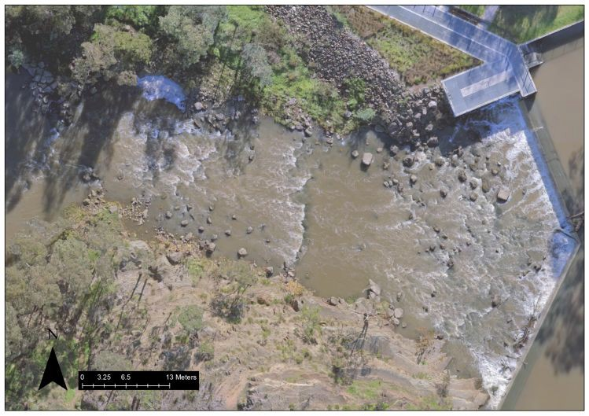

##### Figure 5.1: Digital elevation map of the rock-ramp fishway downstream of Dights Falls weir.

**Monitoring the performance of fishways and fish passage works 43**

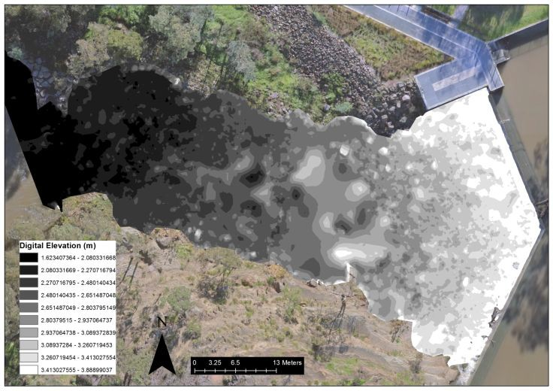

##### Figure 5.2: Digital elevation map of Dights Falls rock-ramp fishway and weir, with elevation classifications (m) shown.

**44 Monitoring the performance of fishways and fish passage works**

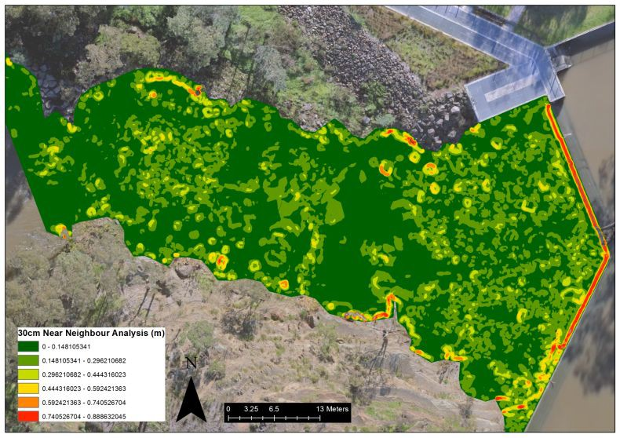

##### Figure 5.3: Thirty centimetre near neighbour analysis of the rock-ramp fishway downstream of Dights Falls weir.

**Monitoring the performance of fishways and fish passage works 45**

##### Figure 5.4: Thirty centimetre near neighbour analysis with potential movement pathways and general areas of larger head losses shown.

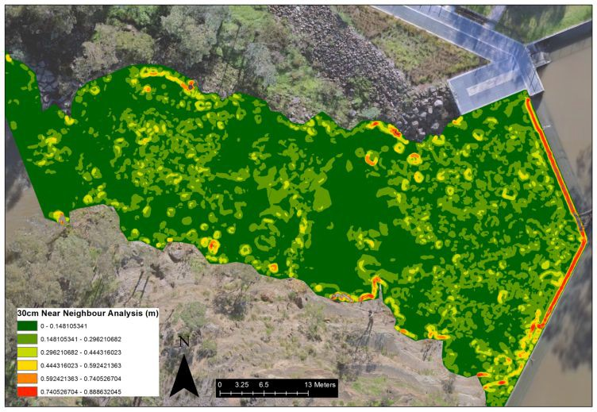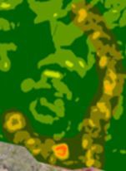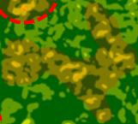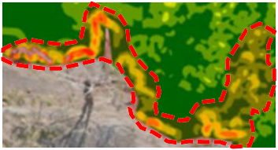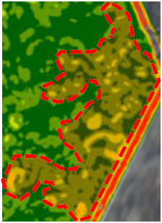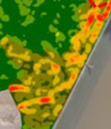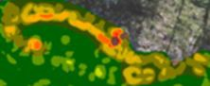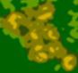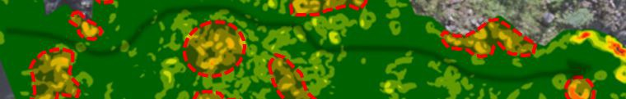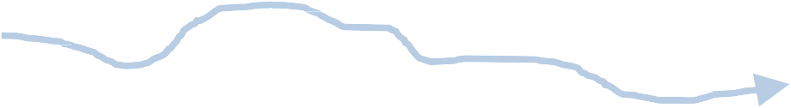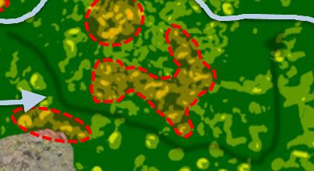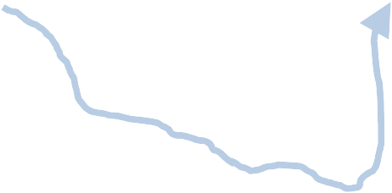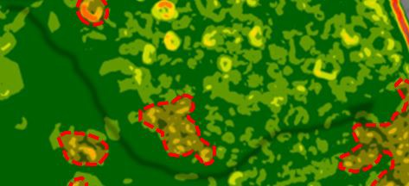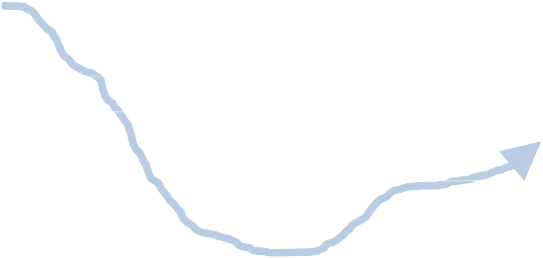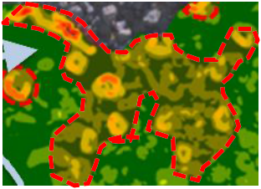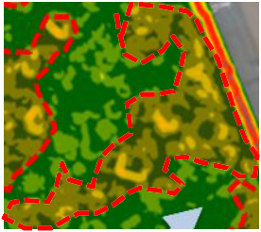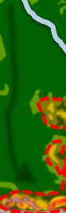

**46 Monitoring the performance of fishways and fish passage works**

# 6 Conclusion

Up to 70% of Victoria’s fishways have either not been assessed for their efficiency in providing unimpeded fish passage, or are not working as efficiently as they could (O'Brien et al. 2010). This presents a range of management issues for Victoria’s waterway authorities, specifically when biodiversity values and restoration efforts are considered.

This document provides a set of guidelines for Victoria’s researchers and waterway managers to assess fishways based on a consistent contemporary approach. The proposed methods use techniques common to fishway assessments in Australia and overseas, and include measurement of both ecological and hydraulic parameters. Reporting of hydraulic performance has not previously been a priority for fishway assessments, yet contemporary researchers consider it vital for assessing ecological functionality against contemporary design. These new guidelines will therefore, ensure the best possible outcomes for fish passage, catchment connectivity, and system restoration in Victoria.

The document addresses Action 11.8 of the Victorian Waterway Management Strategy (VWMS), which is ‘Develop and implement a statewide program for monitoring the performance of fishways and fish passage works’. The document also forms part of Policy 11.1 of the VWMS, ‘Programs will be put in place to ensure the operation, performance and maintenance of fishways and other fish passage works are monitored and continue to meet best practice standards’.

**Monitoring the performance of fishways and fish passage works 47**

# Appendix 1: Examples of past fishway assessments with details on key attributes

|  |  |  |  |  |  |  |  |  |  |  |  |
| --- | --- | --- | --- | --- | --- | --- | --- | --- | --- | --- | --- |
|  | | | | | | | | | | | |
| **Efficiency Assessments** | | | | | | | | | | | |
| **Paper Fishway type** | **Country** | **Site name** | **Fishway gradient (baffle headloss)** | **Target fish** | **Target size-range (mm)** | **Method of assessment** | **Sample duration** | **No. replicates** | **Traps checked** | **Key data collected** | **Analysis method** |
|  | | | | | | | | | | | |

(Stuart et al. 2008) Vertical-slot Australia Murray River, Lock 8 1:32 (0.1 m) Whole fish community 40–1000 Entrance & Exit trapping 24 hours 40 (plus 17 exit

samples)

2 abundance

length–frequency

Wilcoxon’s rank sum test: abundance (ent/exit). Kolmogorov–Smirnov two-tailed test: length–frequency (ent/exit).

PIT tagging - - ascent success descriptive statistics

DIDSON Sonar - - fish behaviour used for observation on trap shyness

Wilcoxon’s rank sum test: abundance (ent/exit).

(Stuart & Mallen-Cooper 1999) Vertical-slot Australia Fitzroy River 1:20 (0.97 m) Whole fish community Unknown Entrance & Exit trapping 24 hours 37 2 abundance

length–frequency

(Stuart & Berghuis 2002) Vertical-slot Australia Burnett River 1:15 (0.1 m) Whole fish community Unknown Entrance & Exit trapping 24 hours 100 2 abundance

length–frequency

(Baumgartner et al. 2010) Vertical-slot Australia Murray River, Lock 9 1:32 (0.1 m) Whole fish community 30–1000 Entrance & Exit trapping 24 hours 16 2 abundance

length-frequency

PIT tagging ascent/descent information

Kolmogorov–Smirnov two-tailed test: length–frequency (ent/exit) descriptive statistics

Wilcoxon’s rank sum test: abundance (ent/exit). Kolmogorov–Smirnov two-tailed test: length–frequency (ent/exit) descriptive statistics

two-way ANOSIM, one-way ANOVA Bray–Curtis similarities

MDS ordination

two-tailed Kolmogorov-Smirnov test descriptive statistics

behavioural descriptive statistics

two-way ANOSIM, one-way ANOVA Bray–Curtis similarities

(Baumgartner et al. 2010) Vertical-slot Australia Murray River, Lock 10 1:32 (0.1 m) Whole fish community 30–1000 Entrance & Exit trapping 24 hours 14 2 abundance

length–frequency

PIT tagging ascent/descent information

MDS ordination

two-tailed Kolmogorov-Smirnov test

descriptive statistics

behavioural descriptive statistics

MDS ordination

(Baumgartner et al. 2010) Vertical-slot Australia Murray River, Lock 7 1:32 (0.1 m) Whole fish community 30–1000 Exit trapping only 24 hours 40? 2 abundance

length–frequency

PIT tagging ascent/descent information

two-tailed Kolmogorov–Smirnov test descriptive statistics

behavioural descriptive statistics

descriptive statistics

(Thiem et al. 2013) Vertical-slot Canada Richelieu River (0.15 m) 5 key species Unclear PIT tagging and trapping (mainly for

capture)

Unclear 492 fish PIT tagged 2/day

ascent/descent information

behavioural passage efficiency abundance/length

T-test

Wilcoxon rank sum test Spearman rank correlation one-way ANOVA

Tukey test

descriptive statistics

(Bryant et al. 1999) Steep pass (Denil) Alaska Margaret Creek 1:4 Whole fish community Exit trapping only 24 hours unclear unclear abundance

length–frequency

T-test regression

(Schmetterling et al. 2002) Denil USA Blackfoot River

tributaries

1:6.3 or 15.8% 3 species Unknown Mark-Recapture 5–7 days 1 - abundance

length–frequency

chi-square test t-test

(Schmetterling et al. 2002) Denil USA 1:10.4 or 9.6% Brown trout Unknown Mark-Recapture (control/translocation) 5–7 days 1 - abundance

length–frequency

(Schmetterling et al. 2002) Denil USA 1:6.1 or 16.4% 2 target species Unknown Mark-Recapture (control/translocation) 5–7 days 1 - abundance

length–frequency

abundance

chi-square test t-test

chi-square test t-test

one-way ANOVA

(Bunt et al. 1999) Denil USA Grand River 1:10 or 10% 2 target species Unknown Exit Trapping, mark-recapture

Radio-telemetry

(Bunt et al. 1999) Denil USA 1:5 or 20% 2 target species Unknown Exit trapping, mark-recapture Radio-telemetry

(Schwalme et al. 1985) Denil USA Lesser Slave River 1:10 or 10% Whole fish community Unknown Exit Trapping

Entrance - Seine net downstream

1:5 or 20% Whole fish community Unknown Exit Trapping

Entrance - Seine net downstream

(Schwalme et al. 1985) Vertical-slot USA Lesser Slave River Whole fish community Unknown Exit Trapping

Entrance - Seine net downstream

640 hours (across the 3 fishways)

640 hours (across the 3 fishways)

640 hours (across the 3 fishways)

Unclear 2/day

unclear 2/day

unclear Exit 2/day

unclear Exit 2/day

unclear Exit 2/day

length–frequency

behavioural fishway hydraulics abundance length–frequency behavioural fishway hydraulics abundance

length fishway hydraulics

blood samples

abundance length

fishway hydraulics

abundance length

fishway hydraulics

behavioural

Chi-square test

contingency analysis for proportions descriptive statistics

one-way ANOVA chi-square test

contingency analysis for proportions descriptive statistics

descriptive statistics G-statistic regression

descriptive statistics G-statistic regression descriptive statistics G-statistic regression descriptive statistics

One-sample Kolmogorov–Smirnov test

(Croze et al. 2008) Fish lift and Fish lock France River Garonne N/A Atlantic salmon Unclear Radio-tagging 2 years (Mar–August) 25 fish -

(Barry & Kynard 1986) Fish lift (2) USA Connecticut River N/A American shad Unclear Radio-tagging 2 years 34 fish

(Sprankle 2005) Fish lift USA Merrimack River N/A American shad Unclear Radio-tagging Unclear 72 fish

ascent success

attraction efficiency

hydraulics

behavioural ascent success

attraction efficiency

hydraulics behavioural ascent success

behavioural

Friedman test (chi-square) linear regression

Mann-Whitney U-test

chi-square Newman-Keuls ANOVA

descriptive statistics descriptive statistics chi-square (Zar) ANOVA

one-way ANOVA

multiple comparisons test (Tukey?)

(Santos et al. 2002) Fish lift Portugal Lima River N/A Whole fish community Unknown Video Camera (On fish lift and exit) 11 Months 1 min video every

4 hour lift cycle

PIT tagging

2218

ascent success

hydraulic

contingency tables – simultaneous test procedure Mann–Whitney rank sum test

stepwise multiple regression

descriptive statistics

(Calles & Greenberg 2007) Nature Like fishway

(2)

Sweden River Eman 2.5% and 1.8% Whole fish community Unknown

Trapping Electrofishing

3.5 years Unclear Unclear ascent success fish length

Monitoring over

Mann–Whitney test Kruskal–Wallis test

chi-square with Yates correction

(Aarestrup et al. 2003) Nature like bypass Denmark Tirsbaek Brook 1.6% Brow sea trout Unknown Electrofishing

PIT tagging

autumn /winter for 2 years

32 fish N/A attraction and passage efficiency behavioural

ANOVA

Kruskal–Wallis

Watson–Williamson two sample

**48 Monitoring the performance of fishways and fish passage works**

**Paper Fishway type Country Site name Fishway gradient**

**(baffle headloss)**

**Target fish**

**Target size-range (mm)**

**Method of assessment Sample duration**

**No. replicates**

**Traps checked**

**Key data collected Analysis method**

(Santos et al. 2005) Nature like bypass Portugal Lima River 3.8% Whole fish community Most size-classes Video Camera (on fish lift and exit)

Electrofishing

Electrofishing downstream (i.e.

117 days - -

hydraulic bypass efficiency

frequency of hours passage

T-test

stepwise multiple regression

Durbin–Watson statistic descriptive statistics

(Schmutz et al. 1998) Nature like bypass Austria Marchfeldkanal – a man

made channel

Rock-ramp Pool and weir

12 pools, 9-22 cm headloss Whole fish community Unclear

1:24 or 4.2%

entrance) Fishway trap (exit)

Radio-tracking

Monitoring between 1993-1995

15 Pike perch (radio-tracking)

- passage efficiency behavioural

descriptive statistics G-test

descriptive statistics

(Franklin et al. 2012)

Step-pass Bypass (rock-ramp) Step-pass

USA

Town brook East River

1:7 or 14.3%

1:10 or 9.6%

1:14 or 7.1%

1: 3.4 or 29.6%

Alewives

Various PIT tagging unclear 793 fish -

passage efficiency behavioural

multiple logistic regression

two-tailed t-test Kaplan–Meier and life tables analysis Cox’s proportional hazards regression

(Litvan et al. 2008)

Grade control structures (rock- ramps)

USA Turkey Creek 5 fishways 1:12.6 -1:18.3

4 target species Unclear

Mark-recapture Electrofishing (Passive gear (nets) Angling)

4 years 3011 fish tagged - passage efficiency behavioural

descriptive statistics

(O'Brien 1997) Rock-ramp Australia Barwon River 1:16 Whole fish community 40–250

Glass eel trap Electrofishing

Fish marking (Bismark brown R)

Approx.. 16 hours (traps)

3 - ascent success fish lengths

descriptive statistics

(Beatty et al. 2007)) Rock-ramp (2) Australia Margaret River 1:20 Whole fish community Unknown Exit trapping (fyke nets) 24 hours unclear - abundance

length–frequency

Electrofishing ? unclear - abundance length–frequency

descriptive statistics

descriptive statistics

(Thorncraft & Harris 1997) Rock-ramp Australia

Macquarie Rivulet Wyong River

Bell River

Macintyre River

1:20 Whole fish community Unknown Entrance and Exit sampling (using nets,

traps)

24 hours 2-4- - abundance length–frequency

descriptive statistics

(Thorncraft & Harris 1997) Fish Lock Australia Murray River N/A Whole fish community Whole fish

community

Electrofishing Entrance and exit trapping

Entrance trapping - Unclear

Exit trapping– approx.

12 hours

2 @ entrances

6 entrance tower

7 at exit - abundance

length–frequency

descriptive statistics

(Stuart et al. 2007) Fish Lock Australia Fitzroy River N/A Whole fish community Whole fish

community

Whole fish community Whole fish

Entrance and exit trapping (incl. lock cycle exp)

Downstream of entrance - Fyke and

24 hours 69 - abundance length–frequency

abundance

Wilcoxon’s rank sum test: abundance (ent/exit). Kolmogorov–Smirnov two-tailed test: length–frequency (ent/exit)

Friedman repeated measured analysis descriptive statistics

generalized linear model Genstat RPAIR

community

Panel nets (accumulation) 6 hours - -

length–frequency

Shannon’s H’

Kolmogorov–Smirnov signed rank test

(McGill 2001) Rock-ramp Australia Thomson River 1:30 (0.1 m) Whole fish community Unknown Entrance and exit fyke netting

Electrofishing

24 hours (netting) Approx.. 8 (netting)

4 (electrofishing)

2 (netting

only)

abundance

length–frequency

Wilcoxon signed rank test descriptive statistics

(Zampatti & Bice 2014) Fish Lock Australia Murray Rover N/A Fish <100 mm Whole fish

community

Vertical-slot Australia Murray River 1:23 Fish >100 mm Whole fish

community

Entrance and exit trapping 24 hours 14 Unknown abundance

length–frequency

Entrance and exit trapping 24 hours 6 (paired samples) Unknown abundance

length–frequency

descriptive statistics Kolmogorov–Smirnov two-tailed test PERMANOVA

descriptive statistics Kolmogorov–Smirnov two-tailed test PERMANOVA

(Mallen-Cooper & Brand 2007) Submerged orifice Australia Murray River 1:9 Whole fish community Unknown Entrance and exit trapping 22 hours 8 (paired samples) Unclear abundance

descriptive statistics

length–frequency Kolmogorov–Smirnov test

**Monitoring the performance of fishways and fish passage works 49**

# Appendix 2:

**Case study — Ecological and hydraulic assessment methods for monitoring fish**

**passage facilities**

## Summary

Fish passage facilities range in size, design and function, and include attributes aimed at the movement needs of the local fish community. Assessing the functionality of a fishway structure against its design is important for reconciling design objectives with passage efficiency. Ecological assessments are typically completed by state or federal agencies and consultant groups, using a range of collection techniques and assessment methods. Little consistency in assessment methods exists between organisations, individuals, or fishway types, leading to a range of outcomes that are often not comparable.

We designed a range of ecological and hydraulic assessment methods for common fishway types (vertical-slot, rock-ramp, fish bypass, fish lift and fish lock) to improve the consistency of fishway assessments across the state of Victoria, Australia. The ecological assessment method consisted of two sub-methods including a replicated and quantifiable design, and an abundance and presence/absence length-frequency design. Assessment methods were applied to a coastal rock- ramp fishway over a two year period to compare outcome consistency. The methods were also applied retrospectively to a coastal vertical-slot fishway to test the applicability of these methods to different fishway types.

Ecological outcomes of the proposed assessment methods were consistent between method type indicating that the range of proposed methods can be used to assess the efficiency of a range of fish passage facilities. Future fishway investigations should aim to utilise the assessment methods as a guide to improve fishway monitoring, and therefore, overall functionality of fishways throughout Victoria.

## Introduction

Fishways are known to provide longitudinal passage for fish at weirs, dams, regulators and road culverts (Stuart & Mallen-Cooper 1999). Fishway structures are now being installed to maintain or improve fish populations for biodiversity values at a local, regional, and state scale (Barrett & Mallen- Cooper 2006; Baumgartner et al. 2014). Understanding the efficiency of a fishway is important for gauging the success of such an intervention at providing passage. Similarly, consistency in functionality is required for achieving passage at a reach, catchment, and basin scale.

Assessing fishway functionality can only be completed via a monitoring program, and monitoring outcomes can improve the design of future fishways. Methods for assessing fishways vary and may include fishway trapping, electrofishing, mark-recapture, radio or acoustic tagging, hydroacoustics, sonar, or PIT tag reader systems (Baumgartner et al. 2010; Bunt et al. 1999). The methods employed may also reflect the availability of funds or the organisation or individuals involved.

Historically, the outcomes of a monitoring program help to gauge the success of the intervention at a local level (i.e. the fishway). However, the scales of restoration efforts are cumulative, and occur over a large spatial and temporal range (Bedford 1999; Neeson et al. 2015), so the intervention success needs to be consistent and contemporary over these broader spatial scales. Our understanding of movement requirements of native fish has progressed significantly in the last 15-20 years, so there is a clear need to ensure that fishway designs, and so assessments, remain contemporary and comparable through time.

We designed a set of methods to assess Victoria’s fishways to gain consistent and comparable outcomes across fishway assessments. The proposed methods take into account ecological and hydraulic aspects of the fishway assessment and target common fishway types occurring in Victoria: rock-ramp, vertical-slot, bypass, fish lock, and fish lift. The methods have been developed to identify fishways not functioning to design/contemporary design. The methods also include an overall

**50 Monitoring the performance of fishways and fish passage works**

assessment scoring designed to enhance the decision making processes around fishway remediation.

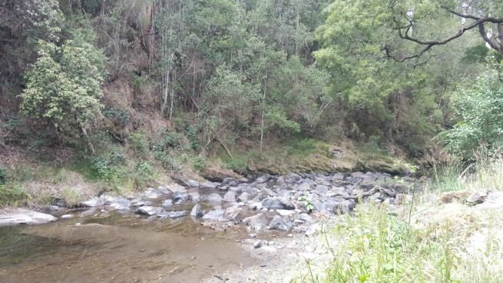

To test the robustness of these assessment methods, two coastal fishways, a rock-ramp and vertical- slot, were assessed. Following this, the proposed methods have been refined and the outcomes are discussed. Future investigations are encouraged to apply these methods to fishway assessments. However, fishway designs and assessment methods are always changing, and a contemporary approach is required to improve the applicability and relevance.

## Site descriptions

##### Barham River rock-ramp fishway

The Barham River rock ramp fishway is located in southern Victoria near Apollo Bay (Figure 5). The Barham River catchment is approximately 75 km2 and the Barham River east branch has an average daily discharge of approximately 54ML/d (ranging from 0-3,843 ML/d) and an annual discharge of approximately 50GL with the majority of flows occurring in the winter-spring period (Victorian Data Warehouse, DELWP). Opening of the Barham River estuary mouth occurs during wetter periods however, artificial openings can occur over the summer months to reduce the inundation of low-lying campgrounds at Apollo Bay.

The Barham River east branch is largely unregulated, however a low-level flow gauging station (concrete apron) exists approximately eight river kilometres upstream of the estuary mouth (Figure 5). The flow gauge has had a rock-ramp fishway constructed downstream to improve movement for native fish. The fishway is a lateral ridge rock-ramp with seven ridges, a slope of 1:25 and headloss of 120 mm at each fishway ridge. This fishway was designed to pass small-medium sized native fish including juvenile diadromous species such as galaxiids and tupong but also adult Australian grayling.

A total of nine fish species are known to occur in the Barham River east branch, eight of which are native species (Table 1). All native fish species are considered diadromous.

##### Figure 5. Rock-ramp fishway downstream of a stream gauging station on the Barham River east branch.

**Monitoring the performance of fishways and fish passage works 51**

Table 1. Species previously recorded in the Barham River each branch post 1985 (Victorian Biodiversity Atlas).

|  |  |  |
| --- | --- | --- |
| **Species** | **Common name** | **Diadromous** |
| **Native**  Galaxias maculatus | Common Galaxias | Yes |
| Galaxias truttaceus | Spotted Galaxias | Yes |
| Galaxias brevipinnis | Climbing Galaxias | Yes |
| Prototroctes maraena | Australian Grayling | Yes |
| Anguilla Australis | Short-finned Eel | Yes |
| Pseudaphritis urvillii | Tupong | Yes |
| Mordacia mordax | Short-headed Lamprey | Yes |
| Geotria australis | Pouched Lamprey | Yes |
| **Introduced**  Salmo trutta | Brown trout |  |

##### Barwon River vertical-slot fishway

The Barwon River fishway is located approximately 15 km downstream of Geelong. The fishway is constructed at a tidal barrage (Figure 6), which was constructed in the late 1930s and is located approximately 1.5 km upstream of Lake Connewarre. The tidal barrage consists of a sheet-pile structure and two floating gates to control upstream water levels to a crest height of 0.85 m AHD (Figure 7). The weir was installed to prevent upstream incursion of salt water, and to maintain upstream levels of freshwater for irrigation and recreation. The barrage forms a barrier between fresh and estuarine water and the fish species associated with these habitats. The tidal range below the barrage is 0 to 0.5 m AHD.

The fishway is a 29 metre long, precast concrete, vertical-slot design, comprising 12 baffles with a 75 mm head loss between each baffle resulting in a total head differential along the entire length of

the fishway of 0.85 m (this will vary depending on head and tail water levels). Turbulence is 18 W/m3 and the slope of the fishway is 1v:30h. Cell dimensions are 1200 mm wide x 2400 mm long, with slot widths tapering (0.18 m tapering to 0.14 m wide slots). A continuous layer of small rocks has been installed in the floor of the fishway to enhance passage of small demersal fish and crustaceans.

The freshwater discharge into the estuary from the fishway is 6.6 ML/d. The fishway operates with a pool depth of 0.4 to 0.6 m which was limited by the upstream invert being set at 0.45 m due to stakeholder concerns relating to the unlikely event of the fishway significantly reducing the weir pool level. The downstream fishway invert was set at –0.40 m AHD which provided a minimum depth of

0.4 m even when the tide was low (0.0 m AHD). To increase fish attraction, an auxiliary flow is introduced at the fishway entrance by a small box culvert.

A total of 41 species have previously been recorded in the Barwon River/estuary complex (Table 2). Twenty of these fish are considered to be estuarine/marine, 14 are considered to be freshwater species, and seven are introduced. A total of eight freshwater species are considered to be diadromous.

**52 Monitoring the performance of fishways and fish passage works**

##### Figure 6. Barwon River vertical-slot fishway with fishway exit trap shown in position.

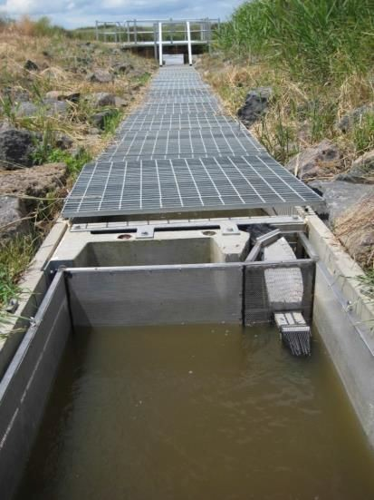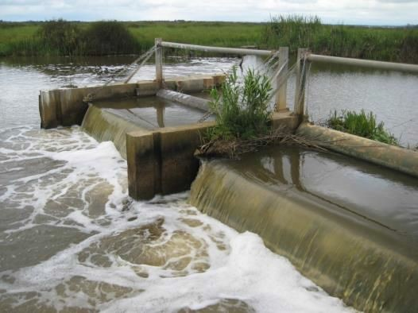

**Figure 7. Tidal barrage gates on the Barwon River**

**Monitoring the performance of fishways and fish passage works 53**

##### Table 2. Species list from the Barwon River including the lower estuary, modified from (Hindell et al. 2008).

Tinca tinca Tench No

|  |  |  |
| --- | --- | --- |
| **Common name** | **Species** | **Diadromous** |
| **Native**  Estuarine/Marine |  |  |
| Arripis georgianus | Australian Herring | No |
| Girella tricuspidata | Luderick | No |
| Rhombosolea tapirina | Greenback Flounder | No |
| Pseudocaranx dentex | Silver Trevally | No |
| Hyperlophus vittatus | Sandy Sprat | No |
| Stigmatopora argus | Spotted Pipefish | No |
| Ammotretis rostratus | Longsnout Flounder | No |
| Tetractenos glaber | Smooth Toadfish | No |
| Sillaginodes punctatus | King George Whiting | No |
| Arripis trutta esper | Australian Salmon | No |
| Aldrichetta fosteri | Yellow-eye Mullet | No |
| Mugil cephalus | Sea Mullet | No |
| Pomatomus saltatrix | Tailor | No |
| Atherinosoma microstoma | Small-mouthed Hardyhead | No |
| Arenigobius bifrenatus | Bridled Goby | No |
| Afurcagobius tamarensis | Tamar Goby | No |
| Tasmanogobius lasti | Scary’s Tasman Goby | No |
| Sciaena Antarctica | Mulloway | No |
| Acanthopagrus butcheri | Black Bream | No |
| Macquaria colonorum | Estuary Perch | No |
| **Freshwater**  Prototroctes maraena | Australian Grayling | Yes |
| Geotria australis | Pouched Lamprey | Yes |
| Mordacia mordax | Short-headed Lamprey | Yes |
| Pseudaphritis urvillii | Tupong | Yes |
| Anguilla australis | Short-finned Eel | Yes |
| Galaxias brevipinnis | Broad-finned Galaxias | Yes |
| Galaxias truttaceus | Spotted Galaxias | Yes |
| Galaxias maculatus | Common Galaxias | Yes |
| Gadopsis marmoratus | River Blackfish | No |
| Edelia obscura | Yarra Pygmy-perch | No |
| Retropinna semoni | Australian Smelt | No |
| Philypnodon grandiceps | Flat-headed Gudgeon | No |
| Nannoperca australis | Southern Pygmy-perch | No |
| Salmo trutta | Brown Trout | No |
| **Introduced**  Oncorhynchus mykiss | Rainbow Trout | No |
| Cyprinus carpio | Carp | No |
| Carassius auratus | Goldfish | No |
| Gambusia holbrooki | Gambusia | No |
| Perca fluviatilis | Redfin | No |
| Rutilus rutilus | Roach | No |

**54 Monitoring the performance of fishways and fish passage works**

## Methods

##### Biological and hydraulic sampling

**Barham River**

Data was collected from the Barham River rock-ramp fishway using fyke netting and back-pack electrofishing, while fish used in the mark-recapture experiment were caught downstream of the fishway using the back-pack electrofisher, and the fish at the exit were trapped using a fyke net. For the mark-recapture experiment, fish were marked with Calcein, which fluoresce under ultraviolet light. The Calcein marking procedure followed those outlined in (Crook et al. 2009). *G. maculatus* was the target species for the Barham River fishway assessment as they were abundant at the time of sampling.

A total of 10, 24-hour entrance/exit fyke netting replicates were completed as part of the abundance (presence-absence)/length-frequency method on the Barham River fishway. Fyke netting occurred over three separate weeks from 1st December 2014 – 4th February 2015. While, 10, five minute electrofishing replicates (upstream/downstream) were also completed for the abundance (presence- absence)/length-frequency method. Each site was then left for six hours to recover from the effects of electrofishing. Back-pack electrofishing samples were completed over two weeks from 4th February 2015 – 26th March 2015. Data used for the presence/absence method for both fyke netting and electrofishing was based on the first 300 fish collected for each treatment site regardless of replicate number.

A total of 744 fish were marked as part of the Calcein marking experiment, with the mark-recapture data collected over two weeks from 12th January 2016 – 19th February 2016. Of the 744 fish marked, 422 were used in the passage experiment, while the remaining 322 fish were held in a holding cage in the Barham River during each week of sampling, in order to gain an estimate mortality associated with the calcein marking procedure — this was less than 8%. At the completion of the mortality experiment, each fish was then measured, and this data was used in the length-frequency analysis, while all fish captured in the fishway exit net were measured before being released.

To prevent fish from moving out of the study area, a fine mesh stop net was placed 50 m downstream of the fishway entrance, and a fine mesh stop net was also used immediately upstream of the fishway to direct fish that successfully ascended the fishway, towards the exit fyke net.

**Barwon River**

The Barwon River vertical-slot fishway was assessed using an entrance and exit trap. A total of 12, 90 min entrance/exit trapping replicates were completed as part of the abundance (presence- absence)/length-frequency method of assessment. The samples were collected over two separate trips twice monthly between from September 2013 — February 2014. Data for the presence- absence/length-frequency analysis was obtained from samples collected in September – November 2013.

Fish captured during both the Barham and Barwon Rivers fishway assessments were counted and identified to the species level, and up to 50 individuals for each replicate were measured for the length-frequency analysis. Descriptive and non-parametric statistics were used to analyse the data collected at both fishways. Specifically, a Mann-Whitney U-test, and a Kolmogorov–Smirnov test were used to analyse abundance and length-frequency data respectively. Parametric statistics (ANOVA) were applied to the abundance data at both fishway sites, however the assumptions for parametric statistics were not met. For more detail on the ecological and hydraulic assessment methods refer to Chapter 4 in the main document.

**Monitoring the performance of fishways and fish passage works 55**

## Results

##### Ecological assessment, Barham River (rock-ramp fishway)

**Electrofishing**

*Abundance / length-frequency method*

A total of seven fish species were captured during electrofishing surveys, one of which was introduced (Table 3). All of these species were captured upstream and downstream of the fishway. *Galaxias maculatus* was the most common species encountered and they occurred in statistically similar abundances upstream and downstream of the fishway (Figure 8). Length-frequency analysis indicated that the size of *G. maculatus* located downstream of the rock-ramp fishway was statistically similar to those located upstream of the fishway (Figure 9).

##### Table 3. Details of fish species collected in the Barham River rock-ramp fishway using the backpack electrofisher only.

|  |  |  |  |  |  |
| --- | --- | --- | --- | --- | --- |
| **Species** | **Common name** | **D/S Entrance** | **Total** | **U/S Exit** | **Total** |
| Native |  |  |  | Yes | 1078 |
| Galaxias maculatus | Common Galaxias | Yes | 1056 |
| Galaxias truttaceus | Spotted Galaxias | Yes | 2 | Yes | 10 |
| Prototroctes maraena | Australian Grayling | Yes | 10 | Yes | 42 |
| Mordacia mordax | Short-headed Lamprey | Yes | 21 | Yes | 23 |
| Anguilla Australis | Short-finned Eel | Yes | 103 | Yes | 78 |
| Pseudaphritis urvillii | Tupong | Yes | 33 | Yes | 39 |
| Introduced  Salmo trutta | Brown Trout | Yes | 38 | Yes | 87 |

20

*Galaxias maculatus*

n=2206

Mann-Whitney U test = 46

15 P =0.762

Mean CPUE (fish/min)

10

5

0

Downstream Upstream

##### Figure 8. Mean catch of *G. maculatus* per minute (±1SE) downstream and upstream of the Barham River fishway. The Mann-Whitney U-test result is indicated.

**56 Monitoring the performance of fishways and fish passage works**

18

16 Downstream Upstream

14

*Galaxias maculatus*

n=1003

KS test statistic = 0.043

P = 0.740

12

10

% Frequency

8

6

4

2

0

0 20 40 60 80 100 120 140 160 180 200

#### Length (mm)

##### Figure 9. Length-frequency plot of *Galaxias maculatus* captured upstream and downstream of the rock-ramp fishway in the Barham River. Kolmogorov–Smirnov test results for each sample location are shown.

*Presence–absence / length-frequency method*

A total of seven fish species were captured during electrofishing surveys, one of which was introduced (Table 4). All seven species were captured upstream and downstream of the fishway.

*G. maculatus* was the most common species encountered. Length-frequency analysis indicated that the size of *G. maculatus* located downstream of the rock-ramp fishway was statistically similar to those located upstream of the fishway (Figure 10).

##### Table 4. Details of fish species collected in the Barham River rock-ramp fishway using the backpack electrofisher only.

|  |  |  |  |  |  |
| --- | --- | --- | --- | --- | --- |
| **Species** | **Common name** | **D/S Entrance** | **Total** | **U/S Exit** | **Total** |
| Native | Common Galaxias | Yes | 578 | Yes | 615 |
| Galaxias maculatus |
| Galaxias truttaceus | Spotted Galaxias | Yes | 1 | Yes | 7 |
| Prototroctes maraena | Australian Grayling | Yes | 10 | Yes | 8 |
| Mordacia mordax | Short-headed Lamprey | Yes | 14 | Yes | 12 |
| Anguilla Australis | Short-finned Eel | Yes | 51 | Yes | 28 |
| Pseudaphritis urvillii | Tupong | Yes | 19 | Yes | 22 |
| Introduced  Salmo trutta | Brown Trout | Yes | 19 | Yes | 29 |

**Monitoring the performance of fishways and fish passage works 57**

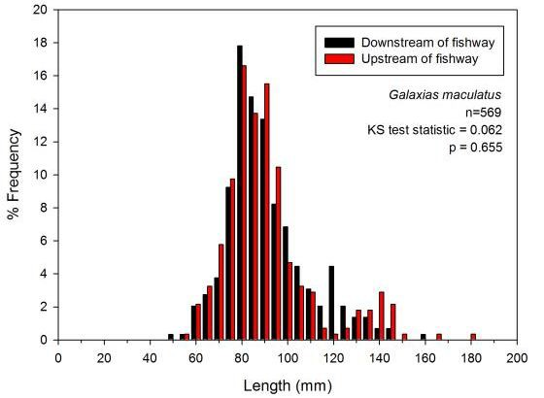

##### Figure 10. Length frequency histogram of fish upstream and downstream of the Barham River fishway. Kolmogorov–Smirnov test results for each sample location are shown.

**Fyke netting**

*Abundance / length-frequency method*

A total of six fish species were captured during fyke netting surveys, one of which was introduced (Table 5). With the exception of Australian grayling, which was only captured upstream of the fishway, all other species were present upstream and downstream of the fishway. *G. maculatus* was the most common species encountered and they occurred in statistically similar abundances upstream and downstream of the fishway (Figure 11). Length-frequency analysis indicated that the size of *G. maculatus* located downstream of the rock-ramp fishway was statistically smaller than those located upstream of the fishway (Figure 12). Additional analysis of the length-frequency data (separate by sample period) indicated that during the December sampling, fish collected downstream of the rock-ramp were statistically smaller than those upstream of the fishway. However, during the late January/early February sample, this statistical difference was absent (Figure 13).

##### Table 5. Details of fish species collected in the Barham River rock-ramp fishway using fyke netting.

|  |  |  |  |  |  |
| --- | --- | --- | --- | --- | --- |
| **Species** | **Common name** | **D/S Entrance** | **Total** | **U/S Exit** | **Total** |
| Native | Common Galaxias | Yes | 1922 | Yes | 234 |
| Galaxias maculatus |
| Prototroctes maraena | Australian Grayling |  | – | Yes | 2 |
| Pseudaphritis urvillii | Tupong | Yes | 7 | Yes | 2 |
| Anguilla Australis | Short-finned Eel | Yes | 35 | Yes | 25 |
| Mordacia mordax | Short-headed Lamprey | Yes | 5 | Yes | 3 |
| Introduced  Salmo trutta | Brown Trout | Yes | 1 | Yes | 1 |

**58 Monitoring the performance of fishways and fish passage works**

550

500

450

400

*Galaxias maculatus*

n=2156

Mann-Whitney U-test statistic = 67.5

P=0.185

350

Mean Catch/24hr

300

250

200

150

100

50

0

Downstream of fishway Upstream of fishway

##### Figure 11. Catch of *G. maculatus* per 24 h (±1SE) using fyke net upstream and downstream of the Barham fishway.

40

Downstream of fishway

35 Upstream of fishway

30 *Galaxias maculatus*

n=499

25 KS test statistic = 0.384

% Frequency

P=0.001

20

15

10

5

0

0 10 20 30 40 50 60 70 80 90 100 110 120 130 140 150 160

### Length (mm)

##### Figure 12. Length frequency of fish upstream and downstream of the Barham River fishway. Note total fish used in the analysis is slightly less than the 300 recommended.

**Monitoring the performance of fishways and fish passage works 59**

% Frequency

55

50 Downstream of fishway

Upstream of fishway 45

December 40

n=231

35 KS test statistic = 0.423

P=0.001 30

25

20

15

10

5

0

0 10 20 30 40 50 60 70 80 90 100 110 120 130 140 150

18

16 Downstream of fishway

Upstream of fishway

14

Late January/early February

12 n=268

KS test statistic = 0.149

P=0.108 10

8

6

4

2

0

0 10 20 30 40 50 60 70 80 90 100 110 120 130 140 150

### Length (mm)

##### Figure 13. Length-frequency plot of *Galaxias maculatus* captured upstream and downstream of rock-ramp fishway in the Barham River. Fish were collected using fyke netting on two separate occasions December and late January/early February. Kolmogorov–Smirnov test results are also shown.

**60 Monitoring the performance of fishways and fish passage works**

**Mark–recapture**

*Abundance/length-frequency method*

Mark–recapture analysis was completed on *G. maculatus*, the most abundant species collected during the Barham River investigation. A total of 764 fish were used in the experiment ranging in size from 47–150 mm (av. 95.04 mm). This analysis was completed over two separate weeks in January and February 2016. Length-frequency analysis completed on fish located downstream of the fishway found no statistical difference between sample weeks (Kolmogorov–Smirnov test statistic = 0.118, P=0.345) and as such, additional analysis was completed using combined data. The length of *G. maculatus* collected downstream and upstream of the Barham River fishway was statistically different (Kolmogorov–Smirnov test statistic = 0.199, P=0.001) (Figure 14). Fish 60–80 mm occurred in high abundance downstream of the fishway compared with upstream of the fishway.

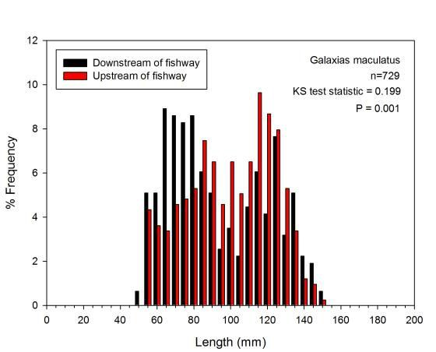

##### Figure 14. Length-frequency graph of Calcein marked *G. maculatus* upstream and downstream of the Barham River fishway. The Kolmogorov–Smirnov test result are shown.

**Monitoring the performance of fishways and fish passage works 61**

##### Hydraulic assessment, Barham River (rock-ramp fishway)

Fishway design details were not available for the Barham River rock-ramp, therefore the constructed design was compared with contemporary design. Water depth throughout the rock-ramp fishway ranged from 10–300 mm, which was substantially less than the 500 mm recommended, and as such, pool volume was also less than recommended (Table 6). Slot width ranged from 10–150 mm across the face of most fishway baffles, despite the minimum width recommended being 150 mm. Slope of the fishway was 1:24.8, less than 1:30 suggested with contemporary design. Headloss at the fishway ranged from 31–164 mm, with the majority of headloss measurements outside the suggested 75 mm suggested with contemporary design (Figure 15). Headloss at the fishway entrance was approximately half the suggested minimum of 60 mm. Entrance and exit flow vectors were excellent and the entrance and exit location was also excellent as the structure is a full width fishway.

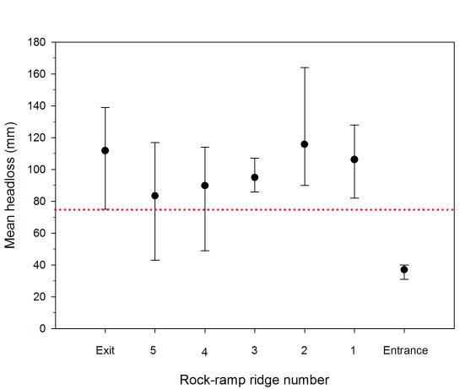

##### Figure 15. Headloss (mean with range) at a number of locations across each rock-ridge at the Barham River fishway. The dotted red line indicates the target headloss range for contemporary design.

**62 Monitoring the performance of fishways and fish passage works**

##### Table 6. Barham River rock-ramp ecological and hydraulic assessment scoring.

|  |  |  |  |  |  |  |
| --- | --- | --- | --- | --- | --- | --- |
| **Measured** | | | **Design details** | **Measured deviation(%) from design** | **Acceptable % deviation from contemporary design** | **Contemporary design** |
| **Hydraulic Assessment** | % presence within fishway | 10–300 mm (av. 80 mm) | N/A | N/A | 5 | 500 mm |
| Depth |
| Pool volume | 1030–2620 L | N/A | N/A | (5) | 2500 L |
| Minimum slot width | 10–150 mm | N/A | N/A | (5) | 150 |
| Maximum water velocity at the *vena contracta* | ** | N/A | N/A |  | 1.2 |
| Slope | 1:24.8 | N/A | N/A | (5) | >1:30 |
| Headloss | (31 mm – 164 mm) | N/A | N/A | (5) | <75 |
| Minimum headloss at fishway entrance | 31 mm | N/A | N/A | 5 | 60 |
| Maximum water velocity at fishway exit channel | ** | N/A | N/A | 10 | 0.05 |
| Headloss at trash racks | N/A | N/A | N/A | 0 | N/A |
| Entrance and exit flow vectors | Excellent | N/A | N/A | 0 | <90o, no recirculation |
| Entrance/exit location | Full width fishway | N/A | N/A | 10 | U/S–D/S migration limit |
| Debris | 5% | N/A | N/A | 5 | ? |
| Fishway auxiliary water (if present) causes excessive turbulence | Yes or No | N/A | N/A | N/A | N/A |
| Lock cycle time (reflects design) | Yes or No | N/A | N/A | N/A | N/A |
| Minimum plunge pool depth suitable | Yes or No | N/A | N/A | N/A | N/A |
| **Ecological Assessment** | Yes or No | Yes |  |  | 0 | |
| Fishway type is suitable for species present |
| Fishway hydraulics are suitable for fish species and reflect  contemporary deign | Yes or No | No (see comment) |
| Target species are present at both fishway entrance and exit | Yes or No | Yes |
| Size range of target fish species is at minimum target size at the fishway | Yes or No | Yes | <2 | |
| Target size ranges are present at the entrance and exit of fishway | Yes or No | Yes | <2 | |
| Abundance77 | Entrance vs exit abundance | EF (<1%), Fyke Net (>800%) | <30 | |
| **Comments** | Average depth is less than required although there was not much water in river. Slot width highly variable and consistently less than 100 mm. Slope is steeper than required. Headloss at baffle 1, 2 and fishway exit appears to be on the higher end of contemporary design – maintenance required. Minimum headloss at entrance is less than recommended. ** water velocity was not measured on site as it was impracticable to measure at the *vena contracta* as they were shallow and narrow | | | | | |

() = greater tolerance allowed for rock-ramps and bypass fishways (with respect to % deviation from contemporary design).

**Monitoring the performance of fishways and fish passage works 63**

##### Ecological Assessment, Barwon River (vertical-slot fishway)

**Presence–absence / length-frequency**

Fifteen fish species were captured during trapping surveys on the Barwon River, two of which were introduced (Table 7). Two species were present at the exit, but absent from the entrance, while three species present at the entrance were absent from the exit. *G. Maculatus* was the most common species encountered and they occurred in statistically similar abundances upstream and downstream of the fishway (Figure 16). Length-frequency analysis indicated that the size of *G. maculatus* downstream of the fishway was statistically different to those located upstream (Figure 17).

##### Table 7. Details of fish species collected in the Barwon River vertical-slot fishway.

|  |  |  |  |  |  |
| --- | --- | --- | --- | --- | --- |
| **Species** | **Common name** | **Entrance** | **Total** | **Exit** | **Total** |
| **Native** | Australian Grayling | Yes | 12 | Yes | 36 |
| Prototroctes maraena |
| Retropinna semoni | Australian Smelt | Yes | 119 | Yes | 76 |
| Galaxias brevipinnis | Broad finned Galaxias | Yes | 1 | No | 0 |
| Galaxias maculatus | Common Galaxias | Yes | 10179 | Yes | 3496 |
| Philypnodon grandiceps | Flathead Gudgeon | Yes | 142 | Yes | 52 |
| Mugil cephalus | Sea Mullet | Yes | 4 | Yes | 2 |
| Anguilla Australis | Short-finned Eel | Yes | 1 | No | 0 |
| Atherinosoma microstoma | Small-mouthed Hardyhead | No | 0 | Yes | 1 |
| Nannoperca australis | Southern Pygmy-perch | Yes | 4 | Yes | 2 |
| Galaxias truttaceus | Spotted Galaxias | Yes | 22 | Yes | 2 |
| Tetractenos glaber | Smooth Toadfish | No | 0 | Yes | 1 |
| Pseudaphritis urvillii | Tupong | Yes | 195 | Yes | 97 |
| Aldrichetta fosteri | Yellow-eye Mullet | Yes | 51 | Yes | 12 |
| **Introduced** | Gambusia | Yes | 3 | No | 0 |
| Gambusia holbrooki |
| Perca fluviatilis | Redfin Perch | Yes | 3 | Yes | 6 |

*Presence–absence / length-frequency*

Eleven fish species were captured during the trapping surveys (Table 8). Two species were absent from the exit sample, namely broad finned galaxias and short finned eel. *G. maculatus* was the most abundant species encountered. The length-frequency of *G. maculatus* collected during the presence- absence method was statistically different to those located upstream of the fishway (Figure 18).

##### Table 8. Details of fish species collected in the Barwon River vertical-slot fishway

|  |  |  |  |  |  |
| --- | --- | --- | --- | --- | --- |
| **Species** | **Common name** | **Entrance** | **Total** | **Exit** | **Total** |
| **Native** | Australian Grayling | Yes | 9 | Yes | 36 |
| Prototroctes maraena |
| Retropinna semoni | Australian Smelt | Yes | 62 | Yes | 72 |
| Galaxias brevipinnis | Broad finned Galaxias | Yes | 1 | No | 0 |
| Galaxias maculatus | Common Galaxias | Yes | 9477 | Yes | 3159 |
| Philypnodon grandiceps | Flathead Gudgeon | Yes | 69 | Yes | 12 |
| Perca fluviatilis | Redfin Perch | Yes | 3 | Yes | 6 |
| Mugil cephalus | Sea Mullet | Yes | 4 | Yes | 2 |
| Anguilla Australis | Short-finned Eel | Yes | 1 | No | 0 |
| Nannoperca australis | Southern Pygmy-perch | Yes | 4 | Yes | 2 |
| Galaxias truttaceus | Spotted Galaxias | Yes | 22 | Yes | 2 |
| Pseudaphritis urvillii | Tupong | Yes | 148 | Yes | 40 |

**64 Monitoring the performance of fishways and fish passage works**

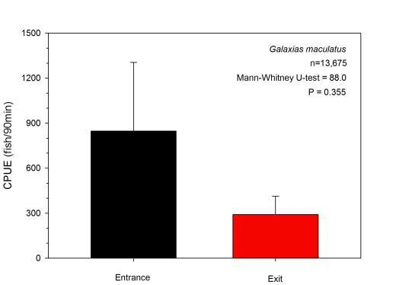

##### Figure 16. Mean catch of *G. maculatus* per 90 min trapping (±1SE) downstream and upstream of the Barham River fishway. The Mann-Whitney U-test result is indicated.

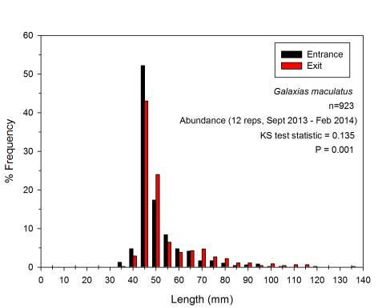

**Figure 17. Length-frequency plot of *G. maculatus* captured upstream and downstream of the vertical-slot fishway in the Barwon River. Kolmogorov–Smirnov test results are also shown.**

**Monitoring the performance of fishways and fish passage works 65**

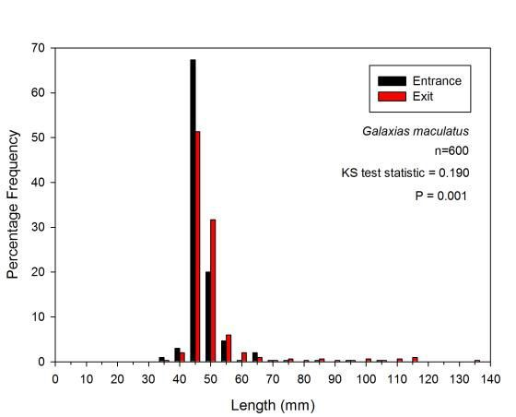

##### Figure 18. Length frequency of fish upstream and downstream of the Barwon River fishway.

**Hydraulic assessment, Barwon River (vertical-slot fishway)**

The design details of the Barwon River vertical-slot fishway have previously been documented (O'Connor et al. 2015a), so measurement taken during this investigation could be compared against the design (Table 9). Pool depth was less than both designed/contemporary design, with the fishway generally being shallower towards the exit. Similarly, pool volume was less than designed/contemporary design. Headloss varied considerable from 0–100% different from both design/contemporary. Entrance location was > 0.5 m from upstream migration limit, while exit location was approximately 26 m upstream of the downstream migration limit for fish. The auxiliary water provided did not cause excessive turbulence at the entrance cell of the fishway. All other parameter measured were in line with the design details

**66 Monitoring the performance of fishways and fish passage works**

##### Table 9. Barwon River vertical-slot fishway assessment scoring.

|  |  |  |  |  |  |  |
| --- | --- | --- | --- | --- | --- | --- |
| **Measured** | | | **Design details** | **Measured deviation (%) from design** | **Acceptable % deviation from contemp. design** | **Contemporary design** |
| **Hydraulic Assessment** | % presence within fishway | 0.15–0.7 m | 0.4–0.6 m | –37.5% – 116.7% | 5 | 0.75 m |
| Depth |
| Pool volume | 400–1850 L | 1056–1584 L | –62.1% – 116.8 | 2 | 2800 L |
| Minimum slot width | 0.18–0.14 | 0.18-0.14 tapering | 0% | 2 | 150 mm |
| Maximum water velocity at the *vena contracta* | 1.2 | 1.21 | <1% |  | 1.2 ms-1 |
| Slope | 1:30 | 1:30 | <2% | 2 | >1:30 |
| Headloss | 0–75 mm | 75 mm | 0–100% | 2 | <75 mm |
| Minimum headloss at fishway entrance | 0 | Unknown | - | 5 | <45 mm |
| Maximum water velocity at fishway exit channel | Not measured | Unknown | - | 10 | 0.05 ms-1 |
| Headloss at trash racks |  | Unknown | - | 0 | <20 mm |
| Entrance and exit flow vectors | <90o | <90o | 0% | 0 | <90o, no recirculation |
| Entrance/exit location | 3 m / 26 m | Unknown |  | 10 | U/S and D/S migration limit |
| Debris |  |  | <5% | 5 | ? |
| Fishway auxiliary water (if present) causes excessive  turbulence | Yes or No | No | Auxiliary Water |  | No |
| Lock cycle time (reflects design) | Yes or No | N/A | N/A | - | N/A |
| Minimum plunge pool depth suitable | Yes or No | N/A | N/A | - | 40% of maximum head  differential |
| **Ecological Assessment** | Yes or No | Yes |  |  | 0 | Yes |
| Fishway type is suitable for species present |
| Fishway hydraulics are suitable for fish species and reflect  contemporary deign | Yes or No | No | Yes |
| Target species are present at both fishway entrance and exit | Yes or No | Yes | Yes |
| Size range of target fish species is at minimum target size at  the fishway | Yes or No | Yes | <2 | Yes |
| Target size ranges are present at the entrance and exit of  fishway | Yes or No | Yes | <2 | Yes |
| Abundance77 | Entrance vs exit  abundance | <35% | <30 | <30% |
| **Comments** | Pool depth < designed/contemporary design. Pool volume is less than designed/contemporary design. Headloss varies considerably: 0–100% different from design. Entrance location is > 0.5 m from upstream migration limit, while exit location is approximately 26 m up of the downstream migration limit. | | | | | |

77 Warrants further investigation – differences in abundance may be related to seasonal influences and/or sample sizes. Relates to trapping and funnel/screen methods only (i.e. excludes electrofishing)

**Monitoring the performance of fishways and fish passage works 67**

## Discussion

The fishway assessment guidelines tested in this document identified hydraulic anomalies associated with two different fishway designs, with outcomes from these anomalies reflected in the ecological assessment findings. Such results are a positive step forward for determining the efficiency of Victoria’s fishways and for identifying areas for improvement.

##### Barham River fishway

The hydraulics assessment on the Barham River rock ramp fishway identified a number of parameters that have the potential to adversely affect fish movement. Headloss appeared highly variable throughout the fishway and generally exceeded the minimum 75 mm suggested for contemporary design for small–medium sized fish. The second, third, and fourth baffle in particular, showed a considerable departure from the recommended maximum headloss, and it indicates that small fish (<50 mm) may have difficulty ascending.

The ecological assessment (both the abundance and presence-absence assessment) complimented the hydraulic results, finding significant length-frequency differences for both fyke netting and mark-recapture collection methods. The significant length-frequency analysis for fyke netting was largely driven by the presence of small sized (<60 mm) *G. maculatus* downstream of the fishway in the December sample, which were unable to ascend. However, separation of this data into the two sample periods, December and late January/early February, reverted the result to a non-significant one. This outcome is likely a reflection of fish cohorts growing to a threshold size for passage as the season progresses.

The length-frequency analysis completed on the mark-recapture method of assessment was also significant. This data was collected in 2016, a year later than the fyke netting data, and was largely driven by the presence of higher abundances of 60-80 mm sized fish in the downstream sample, compared with the upstream sample. Fish ≤60 mm where present at the exit of the fishway despite the significant result, so ecologically, this data indicates that the fishway was functioning for smaller size-classes at the time of sampling, which was January–February 2016.

In contrast to previous collection methods, data collected via electrofishing (both abundance and presence/absence methods) was not significant for either the abundance or presence-absence length/frequency methods. And like the mark-recapture investigation, this data was collected late in the fish migration season, February/March, when fish cohorts had had a chance to grow out, and were therefore capable of passing the fishway. These results reinforce the notion that fishway assessments looking to determine if a fishway is functioning for small size-classes, must sample during the known migratory period for the target species, and account for growth of fish cohorts if the sample periods ranges over a large temporal scale.

Sampling over larger temporal scale has however, demonstrated that the upstream movement of smaller size-classes has been hindered by the hydraulic inefficiencies of the rock-ramp fishway, particularly with reduced water depth and high headloss throughout the fishway. It also demonstrated however, that as the fish cohorts grew, they were able to successfully ascend the fishway albeit after a delay.

Delaying migrating fish suggests that accumulations may be occurring downstream, and although there were no significant differences between the upstream and downstream abundances there was a trend towards more fish being present downstream than upstream. Delaying migrating fish has ecological consequences given that their vulnerability to competition for resources and predation is increased when accumulating downstream of a barrier (Baumgartner 2007).

All species were found upstream and downstream of the rock-ramp fishway, with the exception of *G. truttaceus*, a relatively uncommon species, which was absent from the fyke netting samples (for both abundance and presence/absence methods), and Australian grayling which was only found in the exit sample but not the entrance. While two native fish species previously recorded from the Barham River system, namely *Galaxias brevipinnis* and *Geotria australis*, were absent from the all experimental methods. This result emphasises the importance of sampling over a range of temporal scales, if assessing the fishway is being assessed for passage of previously recorded species.

Managers wanting to improve the functionality of the Barham River east branch rock-ramp fishway should consider implementing a maintenance schedule to regularly remove debris from the fishway to prevent it from adversely affecting passage performance. Removal of sediment build-up near the entrance of the fishway is also recommended. Additional rock-work could also be completed to improve the water depth and headloss throughout the fishway.

Guidelines for fish passage at small structures 68

##### Barwon River vertical slot fishway

The hydraulic assessment completed on the Barwon River fishway identified a number of departures from design, however almost all of the anomalies documented can be attributed to the influence of the tide, and restrictions placed on the fishway design by stakeholders concerns over draining of the weir pool. The invert of the exit, in particular has been set at 0.45 m, which has resulted in shallowing of the fishway towards the exit. Water depths as low as 0.15 m has been found during low tide, and contemporary design for a fishway targeting small-medium sized fish suggests a minimum depth of 0.75 m throughout the fishway. The influence of the entrance and exit inverts levels has also reduced the pool volume and headloss variation ranges from 0–100% of design.

Fishway depth, pool volume and headloss are however, all being influenced by the tide. Pool depth exceeds design (@116%) during high tide, while pool volume also exceeds design (@116%) during high tide. Depths and pool volumes larger than planed can generally be considered a positive, except if the fishway is downed- out and hydraulic conditions are adversely affected. High tail water levels caused by high tides reduced the headloss in the low reaches of the fishway to zero (drown out), as invert of the entrance of the fishway is -

0.45 m. Contemporary design of fishways ensures that there is no less than 45 mm of headloss at the fishway entrance for small-bodied fish species, with no more than 75 mm headloss throughout the fishway. However, zero headloss (and drown-out conditions) was evident at high tide. The presence of auxiliary water during these drown-out periods is a positive addition to the fishway, and will maintain some attraction flows.

The location of the fishway entrance was at the upstream migration limit, however it was at least 3 m from the attraction flows from the barrage gates—a strong attraction flow, and this is likely to reduce fishway attraction efficiency and so fish passage. Similarly, the exit of the fishway was at least 26 m upstream of the downstream migration limit, making it difficult for downstream migrants to find the movement pathway.

Like the Barham River fishway assessment, the abundance and presence-absence/length frequency methods of assessment were consistent for the length-frequency. Entrance and exit samples were significantly different for both methods, and it is possible that the hydraulic parameters that different from design/contemporary design may have contributed to the significant result. However, the statistical variations in size-classes between the entrance and exit samples were not obvious on the length-frequency graphs, but there was a slightly higher abundance of smaller size-classes (<45 mm) at the entrance, while the exit sample had a few large size fish >110 mm. The presence of more small size-classes at the entrance compared with the exit does not however, indicate that there is a major efficiency problem with the fishway, as small-sized fish are passing through. This result highlights the importance of interpreting the data for ecological meaning rather than statistical meaning.

The abundances of *G. Maculatus* trapped at the entrance and exit of the Barwon River fishway were statistically similar, with the large variation in abundances between replicates contributing to the result. This outcome indicates that fish are not accumulating downstream at the entrance. However, the abundance of

*G. maculatus* downstream exceeds the 30% recommended as acceptable in contemporary design. This result however, was only 34% (4% difference), and combined with the non-significant result for abundance, it is not considered a major issue for the fishway. Downstream abundances can change rapidly and are influenced by a range of factors including flow, tide, time of day, and season (Baumgartner 2006). Similarly, two species (broad finned galaxiid and short-finned eel) collected at the fishway entrance were absent from the fishway exit sample. However, both species were recorded in low abundances at the fishway entrance, therefore their absence from the fishway exit should not be considered an unusual result. Further, the species present during the sampling was substantially less than that recorded in historical records (Table 3), however data from this report came from numerous datasets (from the Victorian Biodiversity Atlas) with different aims in the Geelong region (including some marine species since the mid 1900s), rather than being specifically from the Barwon breakwater barrage.

## Conclusion

Testing of the fishway assessment guidelines was applied to two different coastal fishways with promising results for the application of the assessment methods. Fishways located on northern flowing systems may not pass large abundances of fish as observed in coastal systems, particularly medium-large bodied native fish. Small-bodied species such as Australian Smelt, Unspecked Hardyhead, Carp Gudgeon and Flathead Gudgeon can dominate catches in large numbers, however they may not be the target species. Measuring at least 300 fish for each treatment will help to ensure that appropriate length-frequency analysis can be

**Monitoring the performance of fishways and fish passage works 69**

completed with confidence. While, maximising the amount of the data used in the analysis is paramount for a successful outcome.

This document outlines the results of a set of standardised assessment methods aimed at improving outcomes for Victoria’s fishways. The methods take into account ecological and hydraulic aspects of the fishway assessment and target a range of fishway types. The methods developed and tested during this investigation have identified ecological and hydraulic anomalies of underperforming fishways. Having access to assessment methods/guidelines will allow mangers of waterways to have confidence in the methods being used to assess fishway performance. The assessment methods will also allow comparisons against contemporary design, in addition to identifying parameters where fishway performance can be improved.

70 Guidelines for fish passage at small structures

# References

Aarestrup, K., Lucas, M.C. & Hansen, J.A. 2003. Efficiency of a nature-like bypass channel for sea trout (Salmo trutta) ascending a small Danish stream studied by PIT telemetry. Ecology of Freshwater Fish 12: 160-168.

Adams, N.S., Rondorf, D.W., Evans, S.D., Kelly, J.E. & Perry, R.W. 1998. Effects of surgically and gastrically implanted radio transmitters on swimming performance and predator avoidance of juvenile Chinook salmon (*Oncorhynchus tshawytscha*). Canadian Journal of Fisheries and Aquatic Sciences 55: 781-787.

Barrett, J. 2004. Introducing the Murray-Darling Basin Native Fish Strategy and initial steps towards demonstration reaches. Ecological Management & Restoration 5: 15-23.

Barrett, J. & Lintermans, M. 2008. The Sea to Lake Hume: Restoring fish passage in the Murray River. Canberra: Murray-Darling Basin Commission, Canberra.

Barrett, J. & Mallen-Cooper, M. 2006. The Murray River's 'Sea to Hume Dam' fish passage program: Progress to date and lessons learned. Ecological Management and Restoration 7: 173-183.

Barry, T. & Kynard, B. 1986. Attraction of adult American shad to fish lifts at Holyoke Dam, Connecticut River. North American Journal of Fisheries Management 6: 233-241.

Baumgartner, L., Zampatti, B., Jones, M., Stuart, I. & Mallen-Cooper, M. 2014. Fish passage in the Murray- Darling Basin, Australia: Not just an upstream battle. Ecological Management & Restoration 15: 28-39.

Baumgartner, L.J. 2006. Population estimation methods to quantify temporal variation in fish accumulations downstream of a weir. Fisheries Management and Ecology 13: 355-364.

Baumgartner, L.J. 2007. Diet and feeding habits of predatory fishes upstream and downstream of a low-level weir. Journal of Fish Biology 70: 879-894.

Baumgartner, L.J., Bettanin, M., McPherson, J., Jones, M., Zampatti, B. & Beyer, K. 2012a. Influence of turbidity and passage rate on the efficiency of an infrared counter to enumerate and measure riverine fish. Journal of applied Ichthyology 28: 531-536.

Baumgartner, L.J., Boys, C.A., Stuart, I.G. & Zampatti, B.P. 2010. Evaluating migratory fish behaviour and fishway performance: testing a combined assessment methodology. Australian Journal of Zoology 58: 154- 164.

Baumgartner, L.J., Marsden, T., Singhanouvong, D., Phonekhampheng, O., Stuart, I.G. & Thorncraft, G. 2012b. Using an experimental in situ fishway to provide key design criteria for lateral fish passage in tropical rivers: a case study from the Mekong River, central Lao PDR. River Research and Applications 28: 1217- 1229.

Baumgartner, L.J., Reynoldson, N., Cameron, L. & Stanger, J. 2006. Assessment of Dual-frequency Identification Sonar (DIDSON) for application in fish migration studies. No. 84. New South Wales Department of Primary Industries, Narrandera, 33 pp.

Beatty, S.J., Morgan, D.L. & Torre, A. 2007. Restoring ecological connectivity in the Margaret River: Western Australia's first rock-ramp fishways. Ecological Management & Restoration 8: 224-228.

Bedford, B.L. 1999. Cumulative effects on wetland landscapes: Links to wetland restoration in the United States and southern Canada. Wetlands 19: 775-788.

Berghuis, A.P. 2008. Performance of a single frequency split-beam hydroacoustic system: an innovative fish counting technology. No. 177. Heidelberg, Victoria, Australia: Arthur Rylah Institute for Environmental Research, Department of Sustainability and Environment, 19 pp.

Bridger, C.J. & Booth, R.K. 2003. The effects of biotelemetry transmitter presence and attachment procedures on fish physiology and behaviour. Reviews in Fisheries Science 11: 13-34.

Bryant, M.D., Frenette, B.J. & McCurdy, S.J. 1999. Colonization of a watershed by anadromous salmonids following the Installation of a fish ladder in Margaret Creek, southeast Alaska. North American Journal of Fisheries Management 19: 1129-1136.

Bunt, C.M., Katopodis, C. & McKinley, R.S. 1999. Attraction and passage efficiency of white suckers and smallmouth bass by two Denil fishways. North American Journal of Fisheries Management 19: 793-803.

**Monitoring the performance of fishways and fish passage works 71**

Calles, E.O. & Greenberg, L.A. 2007. The use of two nature-like fishways by some fish species in the Swedish River Emån. Ecology of Freshwater Fish 16: 183-190.

Clay, C.H. 1995. Design of Fishways and Other Fish Facilities. Boca Raton, Florida: Lewis Publishers. 248 pp.

Conte, F.S. 2004. Stress and the welfare of cultured fish. Applied Animal Behaviour Science 86: 205-223. Crook, D.A., Koster, W.M., Macdonald, J.I., Nicol, S.J., Belcher, C.A., Dawson, D.R., O'Mahony, D.J., Lovett,

D., Walker, A. & Bannam, L. 2010. Catadromous migrations by female tupong (*Pseudaphritis urvillii*) in

coastal streams in Victoria, Australia. Marine and Freshwater Research 61: 474-483.

Crook, D.A., Macdonald, J.I., O'Connor, J.P. & Barry, B. 2006. Use of otolith chemistry to examine patterns of diadromy in the threatened Australian grayling *Prototroctes maraena*. Journal of Fish Biology 69: 1330- 1344.

Crook, D.A., O’Mahony, D., Sanger, A.C., Munro, A.R., Gillanders, B.M. & Thurstan, S. 2009. Development and evaluation of methods for osmotic induction marking of golden perch (*Macquaria ambigua*) with calcein and alizarin red S. North American Journal of Fisheries Management 29: 279-287.

Croze, O., Bau, F. & Delmouly, L. 2008. Efficiency of a fish lift for returning Atlantic salmon at a large-scale hydroelectric complex in France. Fisheries Management and Ecology 15: 467-476.

Dolan, C.R. & Miranda, L.E. 2003. Immobilization thresholds of electrofishing relative to fish size. Transactions of the American Fisheries Society 132: 969-976.

Eiler, J.H. 1995. A remote satellite-linked tracking system for studying Pacific salmon with radio telemetry. Transactions of the American Fisheries Society 124: 184-193.

Franklin, A.E., Haro, A., Castro-Santos, T. & Noreika, J. 2012. Evaluation of nature-like and technical fishways for the passage of alewives at two coastal streams in New England. Transactions of the American Fisheries Society 141: 624-637.

Gehrke, P.C., Brown, P., Schiller, C.B., Moffatt, D.B. & Bruce, A.M. 1995. River regulation and fish communities in the Murray-Darling river system, Australia. Regulated Rivers: Research & Management 11: 363-375.

Hindell, J.S., Stuart, I. & Jones, M. 2008. Assessment and recommendations on restoring fish passage across the Lower Breakwater Tidal Barrage of the Barwon River.: Arthur Rylah Institute for Environmental Research, 24 pp.

Jones, M. 2009. Fish movements and the impacts of regulators in the Barmah-Millewa Forest. PhD thesis. Melbourne: La Trobe University, Melbourne. 145 pp.

Jones, M.J. & Stuart, I.G. 2008. Regulated floodplains - a trap for unwary fish. Fisheries Management and Ecology 15: 71-79.

Jones, M.J. & Stuart, I.G. 2009. Lateral movement of common carp (*Cyprinus carpio* L.) in a large lowland river and floodplain. Ecology of Freshwater Fish 18: 72-82.

Katano, O., Nakamura, T., Abe, S., Yamamoto, S. & Baba, Y. 2006. Comparison of fish communities between above- and below-dam sections of small streams; barrier effect to diadromous fishes. Journal of Fish Biology 68: 767-782.

Koehn, J.D., McKenzie, J.A., O’Mahony, D.J., Nicol, S.J., O’Connor, J.P. & O’Connor, W.G. 2009. Movements of Murray cod (*Maccullochella peelii peelii*) in a large Australian lowland river. Ecology of Freshwater Fish 18: 594-602.

Litvan, M.E., Pierce, C.L., Stewart, T.W. & Larson, C.J. 2008. Fish Passage in a Western Iowa Stream Modified by Grade Control Structures. North American Journal of Fisheries Management 28: 1384-1397.

Llewellyn, L.C. 1968. Tagging gives answers to fish growth queries. The Fisherman 3: 1-5.

Lucas, M.C. 1989. Effects of implanted dummy transmitters on mortality, growth and tissue reaction in rainbow trout, *Salmo gairdneri* Richardson. Journal of Fish Biology 35: 577-587.

Maheshwari, B.L., Walker, K.F. & McMahon, T.A. 1995. Effects of regulation on the flow regime of the river Murray, Australia. Regulated Rivers: Research & Management 10: 15-38.

Mallen-Cooper, M. & Brand, D.A. 2007. Non-salmonids in a salmonid fishway: what do 50 years of data tell us about past and future fish passage? Fisheries Management and Ecology 14: 319-332.

72 Guidelines for fish passage at small structures

McGill, D.A. 2001. Fairmont weir rock-ramp fishway assessment. Third Australian Technical Workshop on Fishways. Sunshine Coast: Monash University, 63-75 pp.

Neeson, T.M., Ferris, M.C., Diebel, M.W., Doran, P.J., O’Hanley, J.R. & McIntyre, P.B. 2015. Enhancing ecosystem restoration efficiency through spatial and temporal coordination. Proceedings of the National Academy of Sciences 112: 6236-6241.

O'Brien, T. 1997. Rock Fishways in Victoria. Second National Fishway Technical Workshop. Rockhampton: Queensland Department of Primary Industries, 193-202 pp.

O'Brien, T., Ryan, T.J., Stuart, I. & Saddlier, S. 2010. Review of fishways in Victoria 1996-2009. No. 216. Heidelberg, Victoria: Arthur Rylah Institute for Environmental Research, 35 pp.

O'Connor, J.P., Jones, M. & Pickworth, A. 2015a. Assessment of the Dights Falls fishway complex. Unpublished report, Arthur Rylah Institute for Environmental Research. Department of Environment, Land, Water and Planning, Heidelberg, 49 pp.

O’Connor, J., Mallen-Cooper, M. and Stuart, I. 2015b. Performance, operation and maintenance guidelines for fishways and fish passage works. Arthur Rylah Institute for Environmental Research Technical Report No. 262 for the Water and Catchments Group, Department of Environment, Land, Water and Planning. Arthur Rylah Institute for Environmental Research, Department of Environment, Land, Water and Planning, Heidelberg, Victoria.

O'Connor, J.P., O'Mahony, D.J. & O'Mahony, J.M. 2005. Movements of *Macquaria ambigua*, in the Murray River, south eastern Australia. Journal of Fish Biology 66: 392-403.

O’Connor, J., Stuart, I. and Jones, M. 2017. Guidelines for the design, approval and construction of fishways. Arthur Rylah Institute for Environmental Research. Technical Report Series No. 274. Department of Environment, Land, Water and Planning, Heidelberg, Victoria.

Reynolds, L.F. 1983. Migration patterns of five fish species in the Murray-Darling River system. Marine and Freshwater Research 34: 857-871.

Santos, J.M., Ferreira, M.T., Godinho, F.N. & Bochechas, J. 2002. Performance of fish lift recently built at the Touvedo Dam on the Lima River, Portugal. Journal of applied Ichthyology 18: 118-123.

Santos, J.M., Ferreira, M.T., Godinho, F.N. & Bochechas, J. 2005. Efficacy of a nature-like bypass channel in a Portuguese lowland river. Journal of applied Ichthyology 21: 381-388.

Schmetterling, D.A., Pierce, R.W. & Liermann, B.W. 2002. Efficacy of three Denil fish ladders for low-flow fish passage in two tributaries to the Blackfoot River, Montana. North American Journal of Fisheries Management 22: 929-933.

Schmutz, S., Giefing, C. & Wiesner, C. 1998. The efficiency of a nature-like bypass channel for pike-perch (*Stizostedion lucioperca*) in the Marchfeldkanal system. Hydrobiologia 371-372: 355-360.

Schwalme, K., Mackay, W.C. & Lindner, D. 1985. Suitability of vertical slot and Denil fishways for passing north-temperate, non-salmonid fish. Canadian Journal of Fisheries and Aquatic Sciences 42: 1815-1822.

Sprankle, K. 2005. Interdam movements and passage attraction of American shad in the lower Merrimack River main stem. North American Journal of Fisheries Management 25: 1456-1466.

Stuart, I.G. & Berghuis, A.P. 2002. Upstream passage of fish through a vertical-slot fishway in an Australian subtropical river. Fisheries Management and Ecology 9: 111-122.

Stuart, I.G., Berghuis, A.P., Long, P.E. & Mallen-Cooper, M. 2007. Do fish locks have potential in tropical rivers? River Research and Applications 23: 269-286.

Stuart, I.G., Koehn, J.D., O'Brien, T.A., McKenzie, J.A. & Quinn, G.P. 2010. Too close for comfort: a fishway exit and a hydro-power station inlet. Marine and Freshwater Research 61: 23-33.

Stuart, I.G. & Mallen-Cooper, M. 1999. An assessment of the effectiveness of a vertical-slot fishway for non- salmonid fish at a tidal barrier on a large tropical/subtropical river. Regulated Rivers: Research & Management 15: 575-590.

Stuart, I.G., Zampatti, B.P. & Baumgartner, L.J. 2008. Can a low-gradient vertical-slot fishway provide passage for a lowland river fish community? Marine and Freshwater Research 59: 332-346.

Summerfelt, R.C. & Mosier, D. 1984. Transintestinal expulsion of surgically implanted dummy transmitters by channel catfish. Transactions of the American Fisheries Society 113: 760-766.

**Monitoring the performance of fishways and fish passage works 73**

Thiem, J.D., Binder, T.R., Dumont, P., Hatin, D., Hatry, C., Katopodis, C., Stamplecoskie, K.M. & Cooke, S.J. 2013. Multispecies fish passage behaviour in a vertical slot fishway on the Richeliew River, Quebec, Canada. River Research and Applications 29: 582-592.

Thorncraft, G. & Harris, J.H. 1997. Rock-ramp and lock fishways as tools for solving fish passage problems in New South Wales, Australia. Second National Fishway Technical Workshop. Rockhampton: Queensland Department of Primary Industries, 203-215 pp.

Ward, D.L., Childs, M.R. & Persons, W.R. 2008. PIT tag retention and tag induced mortality in juvenile bonytail and Gila chub. Fisheries Management and Ecology 15: 159-161.

Wedemeyer, G.A. 1976. Physiological response of juvenile coho salmon (*Oncorhynchus kisutch*) and rainbow trout (*Salmo gairdneri*) to handling and crowding stress in intensive fish culture. Journal of the Fisheries Research Board of Canada 33: 2699-2702.

Wilson, C.A., Beckman, D.W. & Dean, J.M. 1987. Calcein as a fluorescent marker of otoliths of larval and juvenile fish. Transactions of the American Fisheries Society 116: 668-670.

Zampatti, B. & Bice, C. 2014. Assessment of a high gradient vertical slot fishway and an automated fishlock at Lock 3 for providing passage of whole fish community. Unpublished report, South Australian Research and Development Institute, Adelaide, Australia, pp. 178-193.

74 Guidelines for fish passage at small structures

ari.vic.gov.au