|  |
| --- |
| Riparian Intervention Monitoring Program  (RIMP) |
| Early signs of improved riparian condition following management |

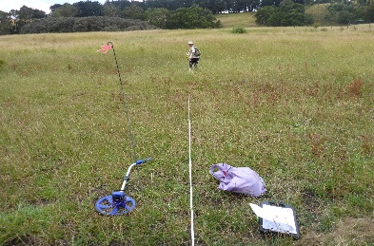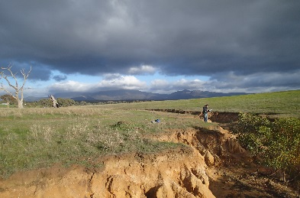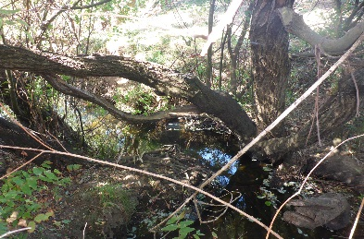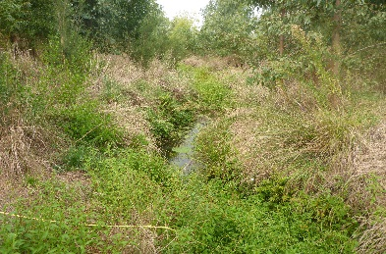

## Background

In Victoria, the Department of Environment Land Water and Planning (DELWP), Catchment Management Authorities (CMAs) and Melbourne Water invest significant resources in riparian management interventions along waterways including stock management fencing, revegetation and weed management. These interventions aim to improve vegetation condition, manage bank erosion, and contribute to long-term improvements in waterway condition. Further evidence, however, is needed to quantify the effectiveness of these management interventions.

## What is RIMP?

The Riparian Intervention Monitoring Program (RIMP) is a state-wide, long-term program developed by DELWP in 2014. The program works with CMAs and landholders to establish long-term monitoring sites to assess the impact and effectiveness of riparian management.

RIMP contributes to demonstrating outcomes of the *Regional Riparian Action Plan* which delivers an accelerated riparian works program across regional Victoria as part of the Victorian Government’s Water Plan, *Water for Victoria,* to improve the health of waterways and catchments.

## Project objectives

The key objectives of program are to:

* provide rigorous evidence of responses of riparian vegetation condition and bank stability to common management interventions (i.e. weed control, revegetation and livestock exclusion)
* understand how long it takes for condition attributes to change
* understand sources of variability in responses to management interventions
* improve conceptual models of expected outcomes of riparian management.

## Types of sites

Several approaches are being used to gather evidence of riparian responses to management:

* **Standard paired sites**: well matched intervention and control (unmanaged) site pairs that are monitored before and multiple times after intervention works are implemented.
* **Past intervention paired sites:** well matched past intervention and control (unmanaged) site pairs that are monitored multiple times after intervention works.
* **Before and after works**: these single sites are monitored before and after the intervention when a well-matched control (unmanaged) site is not available. They inform progress towards a target but are less robust in evaluating the effectiveness of interventions according to scientific principles.

The most rigorous is the standard paired sites which represent the core component of RIMP.

## What is being monitored?

Monitoring measures the following riparian attributes:

* invasive vegetation cover and stem density
* native vegetation cover and composition
* bare ground and litter cover
* vegetation structure
* recruitment of native trees and shrubs
* native vegetation extent and continuity
* bank stability

## Types of sites

RIMP sites were established across nine regional CMAs between 2014 and 2017.

**Table 1. Total number of sites assessed using each approach and the number of sites scheduled to be resurveyed three years following management to 2020.**

|  |  |  |  |  |  |  |  |  |
| --- | --- | --- | --- | --- | --- | --- | --- | --- |
| **Approach** |  | **Total** | **17/18** | **18/19** | **19/20** |  |  |  |
| Standard Pairs |  | **31** | 12 | 9 | 10 |  |  |  |
| Past Intervention Pairs |  | **5** |  | 2 | 3 |  |  |  |
| Before and After |  | **1** |  |  | 1 |  |  |  |

The percentage of RIMP sites that received each type of management intervention is show below.

* Livestock exclusion, revegetation and weed management = **62%**
* Livestock exclusion and revegetation = **24%**
* Livestock exclusion only = **14%**

## Early responses to management

## The first set of 12 RIMP sites were resurveyed in 2017/18, three years after management, and allow us to:

* assess early responses to management
* evaluate if the approach is able meet the program’s objectives.

*What were riparian sites like before management?*

Riparian vegetation condition was generally low prior to management and had the following attributes:

* high cover of bare ground cover
* low native vegetation cover
* low native species richness
* poor vegetation structure, with almost all vegetation occurring in the understorey (< 1.5 m height)
* few native trees and shrubs
* few native tree and shrub recruits
* variable levels of woody weed invasion.

*How did sites change without management?*

Without management intervention – bare ground tended to increase, and litter cover and total vegetation cover tended to decrease.

*How did sites change with management?*

Where management interventions were applied, the following changes in vegetation condition attributes were found:

* total native vegetation cover increased ~2-fold
* native species richness increased ~1.5-fold
* planted and natural woody recruits increased ~ 9-fold
* woody weed abundance decreased to almost zero at most sites.
* bare ground cover did not increase as found in unmanaged sites.

*Results are based on data pooled across all 12 resurveyed sites.

## Conclusion

These early results provide encouraging evidence of the benefits of riparian management. After only three years following management and with only a third of sites resurveyed, the RIMP has demonstrated statistically significant changes in many riparian vegetation attributes. As such, the RIMP program appears to be a suitable approach to evaluating responses of riparian vegetation to management.

## What’s next?

Although the results clearly show that the management intervention improved vegetation condition, responses were variable among individual sites. As more sites are resurveyed, future analyses will examine if this variability is due to the type of management intervention, initial site condition, or different site and landscape variables.

Ongoing monitoring in the medium (5-8 years) and long term (> 10 years) is needed to determine whether the early gains observed at intervention sites are maintained over time or are lost through emerging threats such as weed invasion.

**For more information:**

Contact: [Kaylene.Morris@delwp.vic.gov.au](mailto:Kaylene.Morris@delwp.vic.gov.au)

|  |  |
| --- | --- |
| © The State of Victoria Department of Environment, Land, Water and Planning 2018  LogoThis work is licensed under a Creative Commons Attribution 4.0 International licence. You are free to re-use the work under that licence, on the condition that you credit the State of Victoria as author. The licence does not apply to any images, photographs or branding, including the Victorian Coat of Arms, the Victorian Government logo and the Department of Environment, Land, Water and Planning (DELWP) logo. To view a copy of this licence, visit http://creativecommons.org/licenses/by/4.0/  ISBN 978-1-76077-266-6 (print), 978-1-76077-267-3 (pdf/online/MS word)  Disclaimer  This publication may be of assistance to you but the State of Victoria and its employees do not guarantee that the publication is without flaw of any kind or is wholly appropriate for your particular purposes and therefore disclaims all liability for any error, loss or other consequence which may arise from you relying on any information in this publication. | Accessibility  If you would like to receive this publication in an alternative format, please telephone the DELWP Customer Service Centre on 136186, email [customer.service@delwp.vic.gov.au](mailto:customer.service@delwp.vic.gov.au) or via the National Relay Service on 133 677 [www.relayservice.com.au](http://www.relayservice.com.au). This document is also available on the internet at <https://www.ari.vic.gov.au/research/rivers-and-estuaries/riparian-intervention-monitoring-program> |

For more information visit the ARI website at: <https://www.ari.vic.gov.au/research/rivers-and-estuaries/riparian-intervention-monitoring-program>