About Us
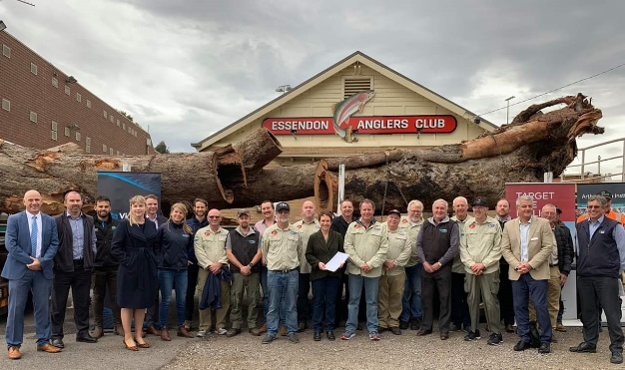
The Applied Aquatic Ecology group aims to generate and share knowledge, through world-class, applied, ecological research, which supports and guides sustainable ecosystem policy and
management to ensure healthy, resilient ecosystems. We work collaboratively with national, state and local agencies, research institutes, universities, interest groups and the community.

Highlights
- A landmark statewide partnership has commenced to reuse trees cleared during road construction as new habitat in waterways. The partnership involves DELWP, VicRoads, Major Road Projects Victoria, the Victorian Fisheries Authority, Catchment Management Authorities and Melbourne Water. Other important steps in this partnership involve identifying sites to store the trees as well as sites to reinstate instream woody habitat (IWH) (funded by DELWP Water and Catchments).
- Recent surveys of Round Lake, and nearby Lake Elizabeth, checked how Murray Hardyhead were faring. Hundreds of these small-sized, critically endangered, fish were successfully bred and then released in Round Lake last spring to build up the existing population. It’s encouraging to see that the species is thriving, with the greatest numbers of fish recorded in over ten years! The fish were bred as part of a salinity tolerance trial. The monitoring is part of WetMAP (Wetland Monitoring and Assessment Program for environmental water (funded by DELWP Water and Catchments).
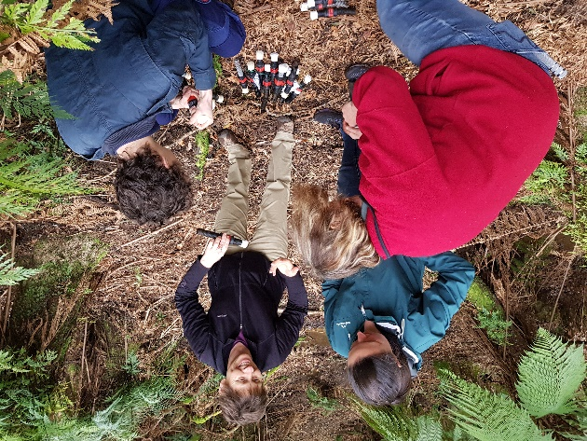
- Environmental DNA (eDNA) monitoring represents a revolutionary new survey method, taking advantage of animal DNA present in waterways to detect species presence/absence and estimate their relative abundance. This method has great potential to detect rare, cryptic species (e.g. galaxiids, crayfish and freshwater mussels) in remote areas as well as pest species. ARI recently purchased equipment which will provide us with the capacity to conduct eDNA detection and monitoring of freshwater species. A new staff member James Shelley has a strong background in genetics and eDNA sampling procedures. Robust methods and procedures will be developed within ARI to expand eDNA sampling across monitoring programs (funded by DELWP ARI).

Output highlights
- Lyon et al. (2019) Increased population size of fish in a lowland river following restoration of structural habitat. Ecological Applications 29(4): e01882.
- O’Connor et al. (2019) Assessment of a vertical slot fishway in south-eastern Australia designed to pass numerous species and size classes of fish. Ecological Management and Restoration 20(2): 151-155.
- Tonkin et al. (2019) Hydrology and water temperature influence recruitment dynamics of the threatened Silver Perch Bidyanus bidyanus in a regulated lowland river. Marine and Freshwater Research.
- Lieschke (2019) Angling pressure impedes a three-year telemetry study on Mulloway. Cogent Environmental Science 5 (1): 1602101.
- Dandenong Burrowing Crayfish video – about a collaborative citizen science project to survey this threatened species (DELWP, Yarra Ranges Council and community groups).

Influencing change
Photos (from top): Celebrating the statewide partnership to reuse trees cleared during road construction works; A Murray Hardyhead; Di Crowther ARI guiding volunteers on a unique method of surveying burrowing crayfish; collecting an eDNA sample.
- The aquatic fauna component of the Forest Protection Survey Program and RFA Landscape Scale Survey Program (Year 1) has been completed. This work will support management by improving our knowledge of the distribution of key threatened fish and crayfish in forested catchments and improving their protection in forested reserves and state forest areas permitted for harvesting (funded by DELWP Forest, Fire and Regions).
- A new project has commenced to set targets and response trajectories of fish populations to instream habitat interventions across Victoria. This work builds on an earlier pilot project trialled in Hughes and Seven creeks. It includes: collation of data to quantify past investment and monitoring outcomes of IWH restoration across Victoria; setting targets and refining objectives for IWH restoration works across priority waterways; assessing fish population responses to habitat interventions across priority sites; quantifying progress towards achieving targets; generating long-term projections of fish populations and producing guidance resources for managers (funded by DELWP Water and Catchments).
- A population model for Estuary Perch in the Snowy River is being developed. This will test environmental flow regimes to determine their likely benefits on recruitment and identify the ideal environmental flow regime needed to support the fish (funded by East Gippsland Catchment Management Authority).
- The threatened galaxiid Biodiversity Response Plan Projects (Year 1) have been completed. This work involved predator (trout) detection and removal to protect remaining populations, and assessment of the condition of instream barriers below each population to ensure they are functioning as predator barriers (funded by DELWP Biodiversity).

Knowledge transfer and engagement
Presentations and participation:
- ARI seminars - Measuring ecological responses to the restoration of water regimes in wetlands (Papas), Barriers benefitting biodiversity (Raadik).
- Climate change and reduced river flows: what can be done to protect native fish populations? (Stuart) at Biodiversity across Borders Conference (Federation Uni); A proposed method and case study for detection of change in waterway health due to flows (Sparrow) at DELWP Water and Catchments; Salinity tolerance of Murray Hardyhead to guide environmental watering (Stoessel) and Flatheaded Galaxias (Raadik) at the Floodplain Specialist Fish Forum (Tri-State Murray NRM Regional Alliance); Campaspe and West Gippsland Environmental Water Advisory Groups – VEFMAP (Jones, Tonkin); Dispersal of Silver Perch (Koster) at MDBA workshop; Freshwater Catfish ecology (Ayres) at Wangaratta Sustainability Network and Victorian Fisheries Authority meeting; Native fish surveys (Sharley) at Natural Research in the Strathbogie Ranges GBCMA forum.

