|  |
| --- |
| Victorian Environmental Flows Monitoring and Assessment Program (VEFMAP) Stage 6 |
| Vegetation Project Update – 2019  Monitoring of Aquatic and River Bank Vegetation:  **Yarra and Watts Rivers** |

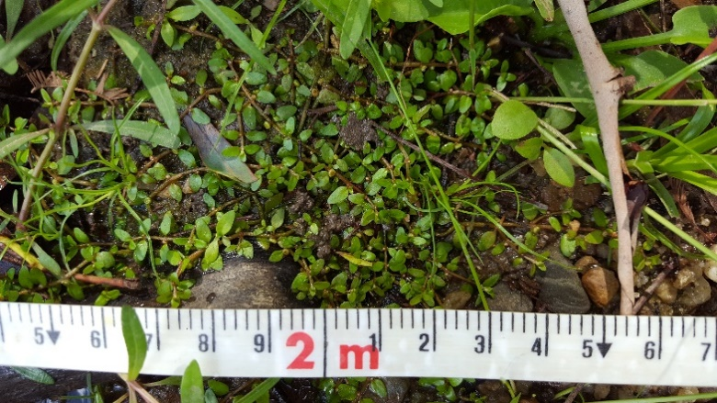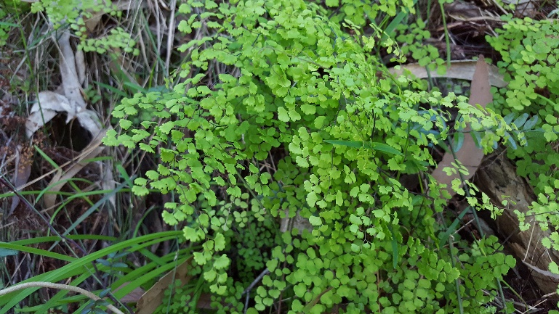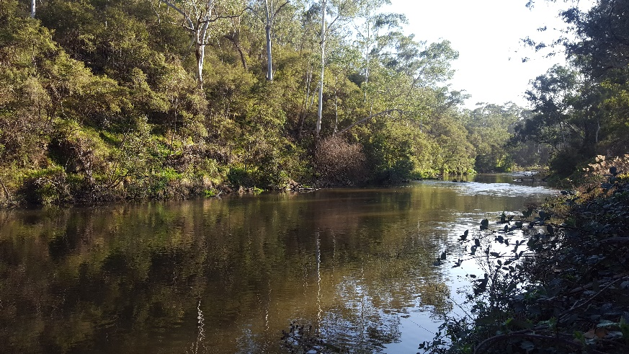

* 1. **VEFMAP Stage 6**

The Victorian Environmental Flows Monitoring and Assessment Program (VEFMAP) is now in its sixth stage of delivery. VEFMAP Stage 6 focusses on ‘intervention’ or ‘event-based’ monitoring of fish and vegetation responses to flows. The program is funded through the Victorian government’s $222 million investment in waterway and catchment health.

## Stage 6 – Vegetation Objectives

Stage 6 vegetation objectives aim to identify vegetation responses to environmental flows. The monitoring approach has been substantially modified from previous stages of the program and is focussed on individual flow events in waterways to detect short-term responses of native and exotic plant species to environmental water delivery. A longer-term understanding will be gained from repeated short-term assessments and by using data from previous stages of VEFMAP to create longer-term datasets. Importantly, these responses will be considered in relation to other factors that may influence flow responses, such as grazing, rainfall, soil properties and season (see program overview for details, DELWP 2017a).

## 2018/19 Monitoring on the Yarra River

Monitoring in the Yarra River system commenced in 2018/2019 and was funded by Melbourne Water. Four sites were selected for surveying: three on the Yarra River and one on Watts River, a tributary of the Yarra River (Figure 1).

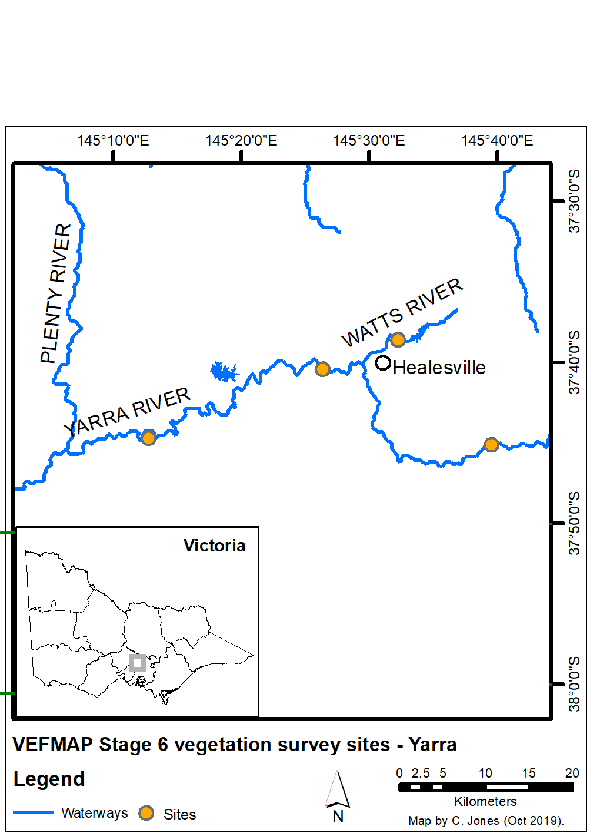

**Figure 1: Map of survey sites on the Yarra and Watts rivers.**

## Survey timing and hydrology

Timing for the VEFMAP surveys considers rainfall and managed flow deliveries. The sampling design recommends surveys occur before a planned flow delivery and two to 12 weeks after the event, depending on the flow regime, to provide adequate time for vegetation to respond and for germinants to emerge. Timing is altered if rainfall increases the flow prior to a planned survey.

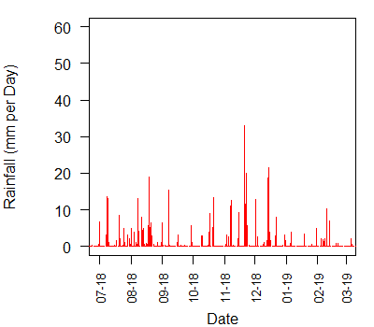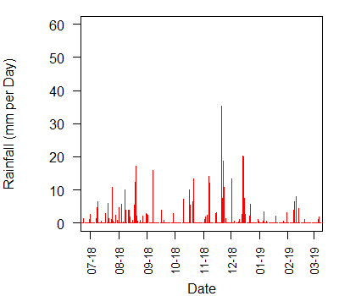

**Figure 2: Daily rainfall at Healesville (top) and Warrandyte (bottom) in 2018/19.**

#### Watts River

Rainfall data near Watts River, measured at Healesville, indicated relatively consistent rainfall in late winter 2018 and a relatively large rainfall period in late November 2018 (Figure 2). Both of these particular rainfall events had a noticeable influence on the flow discharge in the Watts River in 2018/19, causing flow peaks in August and November (Figure 3). River discharge varied considerably throughout the year, with a relatively large flow period in late winter/early spring, followed by two spring pulses and one summer pulse. The August rainfall-induced peak was followed by the August environmental flow release, which resulted in elevated flow levels for several weeks. The November rainfall-induced peak occurred just over a month after the October environmental flow release.

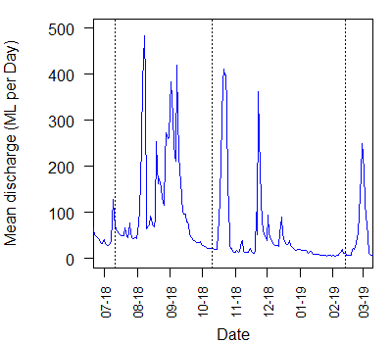

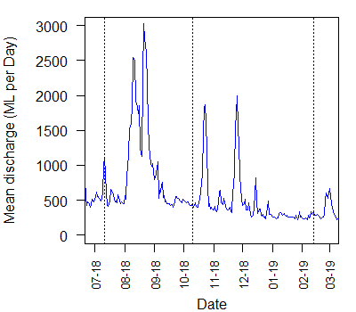

**Figure 3: River flow discharge for Watts River (top) and the Yarra River at Warrandyte (bottom) in 2018/19. Dotted lines indicate VEFMAP vegetation survey timing.**

#### Yarra River

Given the close spatial proximity, rainfall on the Yarra River was very similar to that near Watts River (Figure 2), indicating relatively consistent rainfall in late winter 2018 and a relatively large rainfall period in late November 2018. As with the Watts River, the rainfall events were reflected in the flow discharge, which is considerably greater in the Yarra than the Watts River (Figure 3). Flow discharge was very similar for the three reaches with survey sites (flow at Warrandyte shown in Figure 3) and was similar to the flow regime on the Watts River with events in winter, spring and summer. While the two spring flow pulses were isolated within the flow regime, the late winter event was a composite of multiple flow peaks, which was more varied on the Watts River than the Yarra River.

Surveys on both rivers were conducted prior to the large late winter flows, prior to the spring flows, and prior to the summer fresh to evaluate the impacts/responses of vegetation to the winter and spring flows.

## Methods

Survey methods are outlined in detail in VEFMAP Stage 6 Part B: Monitoring design and sampling methods (DELWP 2017b). The surveys include a wide range of methods: fine-scale vegetation measurements, broad-scale mapping, tree canopy assessments and hydrology assessments.

## Survey observations

**Submerged instream vegetation** was present only at one of the four sites, at Warrandyte on the Yarra River. It is likely that instream vegetation persists at this site because the channel is wide and not too fast flowing or deep for instream species colonisation (Figure 4). Given the various challenges for instream vegetation colonisation and occupancy, due to high turbidity and large flow volumes, small alterations to the flow regime within the Yarra River are unlikely to result in broad-scale colonisation and growth of instream plant species.

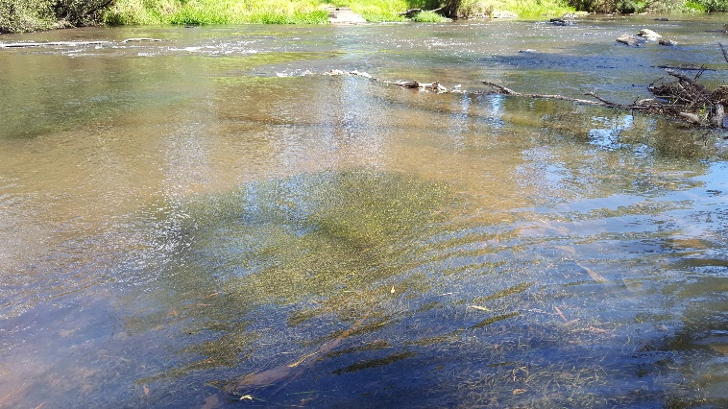

**Figure 4: Instream vegetation at Warrandyte where the channel is wide and shallow.**

The cover of **emergent vegetation** was generally low across all sites (Figure 5), with the most extensive patches at Warrandyte as per instream species. Emergent species tend to occur in greater abundance where the flow depth and velocity are not too great; however, both the Yarra and Watts Rivers have relatively large flow volumes and velocities. Observations during 2018/19 indicated relatively little influence of environmental flows on emergent vegetation cover and extent because of other limiting factors, such as grazing, other flow components, channel form and substrate.

At higher bank elevations, observations during 2018/19 indicated that both exotic and native inundation-tolerant **fringing species** responded positively to the spring flows. Perennial inundation-tolerant exotic species occurred at all sites and occasionally in very high abundance. These species are difficult to manage using flows because they benefit from the same regimes designed to benefit native riparian species. As such, these species will require additional active management to prevent their spread and impacts.

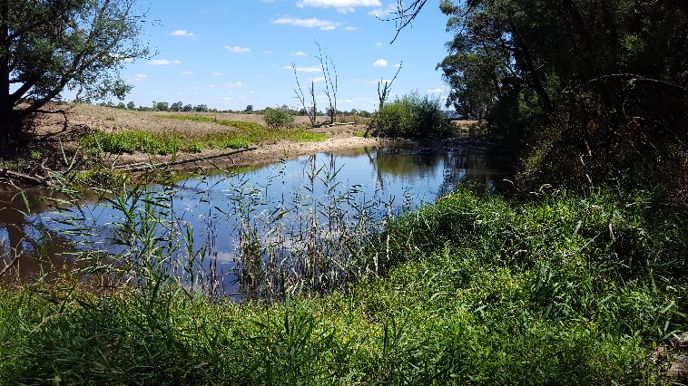**Figure 5: Emergent vegetation (*Phragmites australis*) extending into the channel.**

Flows are being delivered at a suitable time, magnitude and duration to restrict terrestrial inundation-intolerant species encroachment to the lower bank (Figure 6) and to support the growth of riparian (inundation-tolerant) species.

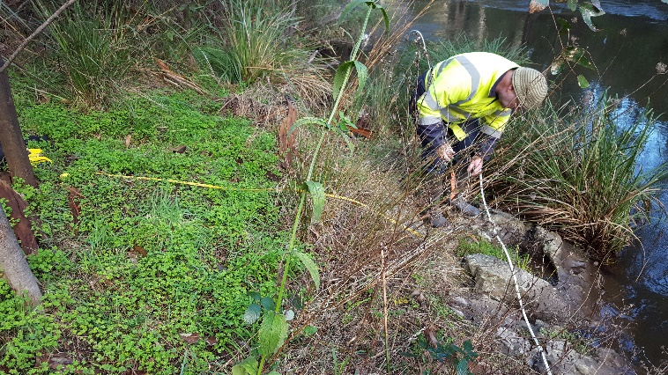 **Figure 6: Inundation-intolerant species such as the exotic *Oxalis incarnata* (Pale Wood-sorrel) cannot tolerate the most regularly and extensively inundated parts of the lower bank.**

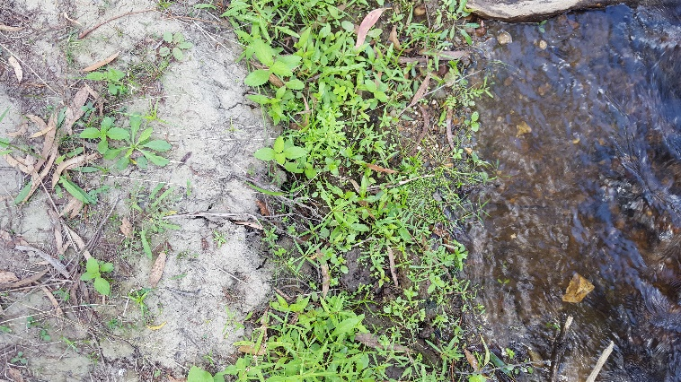**Recruitment** of riparian and terrestrial plants on the river banks was observed at all four survey sites.

**Figure 7: Fringing vegetation recruitment shows the clear impact of water availability on the growth and abundance of recruits from a wet to drier gradient up the bank in February 2019.**

Most of the successful vegetation recruitment occurred in bare soil close to the water margin, with a small apparent window of optimal recruitment conditions for fringing species between too wet and too dry (Figure 7). Recruitment was observed for all broad groups: grasses, sedges/rushes, forbs, shrubs and trees.

## Livestock grazing

Current grazing by cattle occurs at one of the four sites. Two grazing exclosures were installed in late 2018, each paired with an adjacent control transect. Sites were surveyed in December 2018 and February 2019. Initial results suggest that some differences in plant growth, cover, leaf litter and plant recruitment are already evident (Figure 8). In particular, increased plant growth (and cover), leaf litter and recruitment were recorded within the exclosures compared to the adjacent controls (Jones et al. 2019). The exclosures will continued to be surveyed in 2019/20.

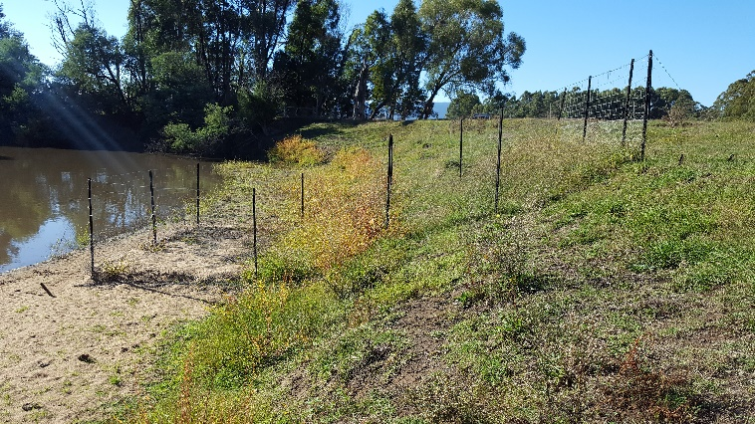

**Figure 8: Grazing exclosures installed on the Yarra River.**

## Summary

Environmental flows are being delivered on the Yarra and Watts Rivers to deliver benefits to vegetation and fauna. Waterway managers are working closely with researchers, waterway authorities and a range of other stakeholders to manage flow deliveries as effectively as possible for the environment and other users.

The observations summarised here form part of a larger story relating to vegetation responses to environmental water. Further information on the other systems surveyed and research projects is also available.

## Key Outcomes

* Spring freshes encouraged the growth of exotic and native fringing and emergent species at sites on both the Yarra and Watts rivers. Inundation-tolerant exotic species are a significant problem that will require additional management actions for removal.
* Recruitment of native riparian species was observed at most sites but was limited at sites where the bank was dominated by perennial species (often exotic).
* Extent and diversity of instream and emergent vegetation was low at all sites but highest at the site with a wider, shallower channel.
* Grazing at low bank elevations is highly damaging to the river bank, resulting in the loss of vegetation and reduced soil stability. With high rainfall, vegetation cover can increase rapidly following grazing removal, but exotic species need to be monitored.

## Next Steps

In the final year of VEFMAP Stage 6 (2019/20), the data collected during the first three years of the program will be processed and analysed, and the findings reported in a series of reports and publications.

## References

DELWP (2017a and b) VEFMAP Stage 6 Part A: Program context and rationale and VEFMAP Stage 6 Part B: Program design and monitoring methods. Reports by Arthur Rylah Institute for Environmental Research and Integrated Water and Catchments Division, Department of Environment, Land, Water and Planning.

Jones, C. S., L. Vivian, and B. Mole. 2019. VEFMAP Stage 6: Monitoring vegetation response to environmental flow delivery in the Yarra and Watts Rivers 2018/19. Arthur Rylah Institute report to Melbourne Water, Melbourne.

## Contact [Chris.Jones@delwp.vic.gov.au](mailto:Chris.Jones@delwp.vic.gov.au)

## Cheryl.Edwards@melbournewater.com.au

|  |  |
| --- | --- |
| © The State of Victoria Department of Environment, Land, Water and Planning 2020  LogoThis work is licensed under a Creative Commons Attribution 4.0 International licence. You are free to re-use the work under that licence, on the condition that you credit the State of Victoria as author. The licence does not apply to any images, photographs or branding, including the Victorian Coat of Arms, the Victorian Government logo and the Department of Environment, Land, Water and Planning (DELWP) logo. To view a copy of this licence, visit http://creativecommons.org/licenses/by/4.0/  ISBN 978-1-76077-158-4 (pdf/online/MS word)  Disclaimer  This publication may be of assistance to you but the State of Victoria and its employees do not guarantee that the publication is without flaw of any kind or is wholly appropriate for your particular purposes and therefore disclaims all liability for any error, loss or other consequence which may arise from you relying on any information in this publication. | Accessibility  If you would like to receive this publication in an alternative format, please telephone the DELWP Customer Service Centre on 136186, email [customer.service@delwp.vic.gov.au](mailto:customer.service@delwp.vic.gov.au), or via the National Relay Service on 133 677 [www.relayservice.com.au](http://www.relayservice.com.au). This document is also available on the internet at https://www.ari.vic.gov.au/research/rivers-and-estuaries/assessing-benefits-of-environmental-watering |