|  |
| --- |
| The effects of interaction between planned burning and foxes on the presence of native mammals  A. Robley, P. Moloney, C. Moxham, G. Neave, G. Friend and I. Fraser  August 2016  Arthur Rylah Institute for Environmental Research, Department of Environment, Land, Water and Planning  Technical Report Series No. 273  Lighting Ops E to F (6) |

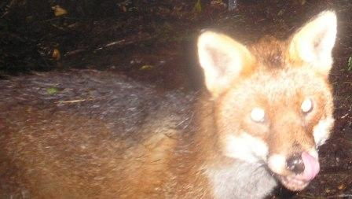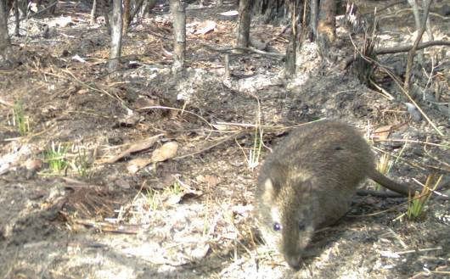

The effects of interaction between  
planned burning and foxes on the presence of native mammals

Alan Robley1, Paul Moloney1,  
Claire Moxham1, Georgie Neave2, Gordon Friend3  
and Imogen Fraser3

1Arthur Rylah Institute for Environmental Research  
123 Brown Street, Heidelberg, Victoria 3084

2Department of Environment, Land, Water and Planning  
Barwon South West Region, Heywood, Victoria 3304

3Fire and Emergency Management Division  
Department of Environment, Land, Water and Planning  
Level 3, 8 Nicholson Street, East Melbourne, Victoria 3002

August 2016

Arthur Rylah Institute for Environmental Research  
Department of Environment, Land, Water and Planning  
Heidelberg, Victoria

**Report produced by:** Arthur Rylah Institute for Environmental Research  
Department of Environment, Land, Water and Planning  
PO Box 137  
Heidelberg, Victoria 3084  
Phone (03) 9450 8600  
Website: [www.delwp.vic.gov.au](http://www.delwp.vic.gov.au)

**Citation:** Robley, A., Moloney, P., Moxham, C., Neave, G., Friend, G. and Fraser, I. (2016). *The effects of interaction between planned burning and foxes on the presence of native mammals*. Arthur Rylah Institute for Environmental Research Technical Report Series No. 273. Department of Environment, Land, Water and Planning, Heidelberg, Victoria.

**Front cover photo:** Planned burn lighting operations (photographer: Georgie Neave). Inset photos: Red Fox (*Vulpes vulpes*); Long-nosed Potoroo (*Potorous tridactylus*) (photographer: Alan Robley)

© The State of Victoria Department of Environment, Land, Water and Planning 2016



This work is licensed under a Creative Commons Attribution 3.0 Australia licence. You are free to re-use the work under that licence, on the condition that you credit the State of Victoria as author. The licence does not apply to any images, photographs or branding, including the Victorian Coat of Arms, the Victorian Government logo, the Department of Environment, Land, Water and Planning logo and the Arthur Rylah Institute logo. To view a copy of this licence, visit <http://creativecommons.org/licenses/by/3.0/au/deed.en>

Printed by Print Room, Preston Victoria

Edited by Organic Editing

ISSN 1835-3827 (print)

ISSN 1835-3835 (pdf))

ISBN 978-1-76047-204-7 (Print)

ISBN 978-1-76047-205-4 (pdf/online)

**Accessibility**

If you would like to receive this publication in an alternative format, please telephone the DELWP Customer Service Centre on 136 186, email [customer.service@delwp.vic.gov.au](mailto:customer.service@delwp.vic.gov.au) or contact us via the National Relay Service on 133 677 or [www.relayservice.com.au](http://www.relayservice.com.au). This document is also available on the internet at [www.delwp.vic.gov.au](http://www.delwp.vic.gov.au)

**Disclaimer**

This publication may be of assistance to you but the State of Victoria and its employees do not guarantee that the publication is without flaw of any kind or is wholly appropriate for your particular purposes and therefore disclaims all liability for any error, loss or other consequence which may arise from you relying on any information in this publication.

Contents

Acknowledgements 1

Summary 2

Key findings 2

Floristic and habitat attributes 2

Mammal responses to planned burning 2

Fox response to planned burning 3

Management implications 3

Further areas of investigation 3

1 Introduction 5

1.1 Policy context 5

1.2 Planned burning 5

1.3 Introduced predators in Australia 6

1.4 Top-down and bottom-up ecological processes 7

1.5 Project approach 7

1.6 Inclusions/exclusions 8

1.6.1 Inclusions 8

1.6.2 Exclusions 8

2 Methods 9

2.1 Study location and sampling design 9

2.2 Burn severity 11

2.3 Habitat attributes 11

2.4 Presence of native mammals and predators 14

2.4.1 Changes in native species and introduced predators 14

2.4.2 Fox activity 15

2.5 Fox capture and movement 15

2.5.1 Hotspur and Mt Clay 2013 15

2.5.2 Annya 2014–2015 16

2.6 Pre- and post-burn fox diet 16

3 Results 17

3.1 The planned burns 17

3.1.1 Burn severity 18

3.2 Floristic diversity and richness 20

3.3 Floristic life forms and habitat structure 22

3.3.1 Reponses of structural features 22

3.3.2 Cluster analysis 23

3.4 Mammal response to planned burning 23

3.4.1 Red Fox activity 23

3.4.2 Southern Brown Bandicoot 23

3.4.3 Long-nosed Potoroo 24

3.4.4 Common Brushtail Possum 25

3.4.5 Common Ringtail Possum 25

3.4.6 Short-beaked Echidna 26

3.4.7 The role of unburnt patches of vegetation 27

3.5 Movement of foxes 28

3.5.1 Mt Clay and Hotspur 2013 28

3.5.2 Annya 2014/15 29

3.5.3 Fox territory pre- and post-planned burn 29

3.6 Changes in fox diet 31

4 Discussion 33

Management implications and recommendations 37

Future areas of investigation 37

References 41

Appendices 45

Appendix 1: Changes in species diversity and richness 45

Appendix 2: Changes in vegetation characteristics 46

Appendix 3: Parameter estimates for species occupancy models 47

Appendix 4. Details of foxes captured and tracked at Annya in August–November 2014 50

Figures

Figure 1. Study locations 9

Figure 2. Layout of the sampling design for vegetation structure data collection in the pre- and immediate post-burn period. Red dotes are the sampling points. 13

Figure 3. Y-shaped design for vegetation structure data collection in one year (2014) and two years (2015) post-burn. Red dots are the approximate location of sampling sites along each transect. 13

Figure 4. Location and number of unburnt patches within (a) Annya, (b) Hotspur and (c) Mt Clay. Red dots indicate the locations of camera survey points. Green – unburnt patches, Grey – burnt area, Red square – study location 17

Figure 5. Difference in ranked scores for multiple comparison of burn scores between locations. Comparisons not including zero indicates a significant difference between locations 18

Figure 6. Difference in ranked scores for non-parametric multiple comparison results for each vegetation layer. Bars are 95% confidence limits. Pairs not containing zero are significantly different 19

Figure 7. Changes in vegetation at Hotspur (a) pre-burn, (b) post-burn 2013 (burn score of 2 for ground cover, mid-storey, tall shrub, and canopy), (c) 2014 and (d) 2015 19

Figure 8. Changes in vegetation at Annya (a) pre-burn, (b) post-burn 2013 (burn score of 5 for ground cover, mid-storey, tall shrub, and canopy), (c) 2014 and (d) 2015 20

Figure 9. Change in species diversity at a) Annya, b) Hotspur, and c) Mt Clay pre and post-burn and in the following 2 years, except for Mt Clay. Non-overlapping notches provide ‘strong evidence’ of a significant difference (Chambers et al. 1983) 21

Figure 10. Change in the number of species at a) Annya, b) Hotspur, and c )Mt Clay pre and post-burn and in the following 2 years, except for Mt Clay. Non-overlapping notches provide ‘strong evidence’ of a significant difference (Chambers et al. 1983) 21

Figure 11. Changes in habitat characteristics pooled across Annya and Hotspur: a) vertical vegetation cover, b) coarse woody debris, (CWD), and c) logs 22

Figure 12. Activity estimates for foxes at Annya and Hotspur, pre-burn, post-burn, 2014 and 2015. Bars are 95% credible limits. 23

Figure 13. Occupancy estimates for Southern Brown Bandicoots at Hotspur during the four monitoring periods. Solid dots indicate the overall occupancy estimates; vertical lines indicate the 95% confidence limits 24

Figure 14. Occupancy estimates for Common Brushtail Possums during the four monitoring periods 25

Figure 15. Occupancy estimates for Common Ringtail Possums during the four monitoring periods 26

Figure 16. Short-beaked Echidna occupancy rates for sites categorised as unburnt and burnt areas 27

Figure 17. Naïve Short-beaked Echidna occupancy rates for sites categorised by the detection or non-detection of Red Foxes 27

Figure 18. Fox fitted with GPS tracking collar 28

Figure 19. Territories of foxes pre- (blue) and post-burn (green) at Annya State Forest in 2015 30

Figure 20. Percentage of identified food items from fox scats combined across Hotspur and Annya pre- (blue bar), post-burn 2013 (red bar) and in 2014 (green bar) 32

Tables

Table 1. Categorical scores assigned to burn severity for each of four structural layers at each monitoring site. Adapted from Pollet and Omi (2002). 11

Table 2. Habitat attributes collected to assess their influence on mammal species occurrence 12

Table 3. Number and size (ha) of unburnt patches at Annya, Hotspur and Mt Clay 17

Table 4. Results of fox trapping and the fate of each fox at Mt Clay and Hotspur 2013 29

Table 5. The number of GPS location fixes pre- and post-burn and the estimated 95% Kernel Density Estimate for fox territories in this study 30

Table 6. Location and number of fox scats collected pre- and post-burn in 2013 and 2014 31

Acknowledgements

This project was funded by the Fire and Emergency Management Division, Department of Environment, Land, Water and Planning (DELWP) and the HawkEye project (DELWP).

A large number of people made valuable contributions to the project. Special thanks go to the works crews of the Heywood and Dartmoor Depots (DELWP), and their Work Centre Coordinators.

Allan Duffield, Rhys Evans, Mitchell Haker, Chris Hatfield, Tim Hiscock, Robert McDonald, Tom McKinnon, Kane Millard, Chris Rowe, Aileen Smith, Leesa Thomas and Irene Whennen (Heywood and Dartmoor, DELWP); Michael Basson, Matt Bruce, Ruth Lennie, John Mahoney, Luke Woodford and Heidi Zimmer (ARI, DELWP); and Dave Caldwell, Rena Gabarov, Tim Gentles, Tamara Leitch and Claire McCall (Wildlife Unlimited) undertook mammal and fox trapping, camera deployment and retrieval, and fox scat collection. Barbara Triggs undertook the identification of species in fox scats.

Stephen Balharrie, Wesley Burns, Troy Jenkins and Don Pratt (Barwon South West Region, DELWP) assisted with project management.

Judy Downe, Mike Duncan, Brad Farmilo, Sally Kenny, Michelle Kohout, Geoff Sutter and Liz Wemyss (ARI, DELWP), Alison Oates (contractor) and Garry Cheers (contractor) collected floristic and habitat data.

The Fire Management Team at Heywood undertook site preparation and implementation of the planned burns. Without their cooperation and support, this project would not have been possible.

The Project Control Board - Gordon Friend, Fiona Hamilton and Stephen Platt (DELWP) and John Wright (Parks Victoria) - assisted with project development and guidance throughout. David Ramsey and Lindy Lumsden provided valuable comments that improved earlier versions of this report.

This research was conducted under Animal Ethics Committee Permit No. 11/22, Pest Animal Research Permit No. RE84 and DELWP Scientific Research Permit No. 10007449.

Summary

The 2009 Black Saturday bushfires had significant social, environmental and economic impacts. The subsequent Victorian Bushfire Royal Commission resulted in the Department of Environment, Land, Water and Planning (‘the Department’) revising its Code of Practice for Bushfire Management on Public Land (‘the Code’). The revised Code outlined clear objectives for bushfire management activities, established a risk-based framework for bushfire management, and established how the Department would use monitoring, evaluation and reporting (MER) to assess the effectiveness of bushfire management activities against the Code objectives. As part of the MER approach, the Department developed and implemented the Bushfire Science Strategy, designed to deliver evidence that informs strategic policy and operational decisions. This project forms part of the Department’s Bushfire Science Strategy, and was developed in partnership with the Fire and Emergency Division, and HawkEye (a long-term biodiversity monitoring project established in 2011).

Following planned burning and bushfire events, land managers sometimes undertake activities to control introduced predators. This is based on the assumption that the risk these predators pose to native wildlife increases post fire. However, there is limited quantitative evidence available for informing land managers about the interactive effects of planned burning and Red Fox (*Vulpes vulpes*; ‘fox’) predation on the survival and recovery of native species, about what to do and when to act, and about the impact of such actions on species’ resilience across the landscape. The objective of this project was to provide information about the interactions between planned burning, predation and habitat refuges. This information will inform land management decisions about the application of planned burning and the mitigation of predator impacts on native mammals.

We undertook this research in south-west Victoria at four sites scheduled to be burnt as part of the Barwon South West fire management strategy. At each site we assessed changes in floristic and habitat structure, the movement and activity of foxes, changes in fox diet, and changes in the occurrence of native mammals. Monitoring occurred 3 months prior to the planned burns, 3 weeks following the planned burns, and 12 and 24 months after the planned burns.

Key findings

Floristic and habitat attributes

* Floristic life forms and habitat structural attributes important to native mammals were significantly reduced by the planned burns.
* Ground- and mid-storey vegetation layers were those most affected.
* Plant species richness and diversity were significantly reduced for up to 24 months following the burns.

Mammal responses to planned burning

* Southern Brown Bandicoots (*Isoodon obesulus*) declined following the burns and showed no signs of recovery within 24 months.
* Long-nosed Potoroos (*Potorous tridactylus*) became locally extinct due to a combination of planned burns and the presence of foxes.
* Common Brushtail Possums (*Trichosurus vulpecula*) were unaffected by either the planned burns or the presence of foxes.
* Common Ringtail Possums (*Pseudocheirus peregrinus*) declined initially post-burn, but recovered within 12 months.
* Short-beaked Echidnas (*Tachyglossus aculeatus*) declined post-burn, but were detected more often at sites without foxes and in unburnt patches for up to 12 months following the burns.

Fox response to planned burning

* Fox activity in the burn area increased immediately post-burn, had decreased by 12 months post-burn, but had then increased again by 24 months post-burn.
* Following the burn, foxes with home ranges overlapping the burn area contracted their range and increased their use of the burn area.
* Foxes not resident within the burn area did not alter their territorial boundaries or make short-term movements into or towards the burn area.
* Common Ringtail Possums were the fox’s main prey item pre-burn. The occurrence of Southern Brown Bandicoots in fox scats increased post-burn, then decreased 12 months later. Long-nosed Potoroos were absent in the fox scats in the immediate post-burn period, but were present by 12 months after the burn.

Management implications

The effects of the interaction between predation and the reduction in habitat complexity (resulting from the fuel management strategy) led to a decline in Southern Brown Bandicoot occurrence and the complete loss of Long-nosed Potoroos at the burn sites. The fuel management strategy also resulted in a significant loss of habitat attributes recognised as important to the occurrence of native species, although signs of habitat recovery were evident at 24 months post-burn.

For locations with native species at risk from fox predation, the instigation of a broad-scale fox reduction program would be advisable. This program should commence 2–3 months before the planned burn is scheduled, because it takes time to reduce the local fox population. Fox control should continue for at least 2 years post-burn or until the habitat and floristic attributes of the site have returned to pre-burn levels, thereby affording native animal populations some protection from predation.

The spatial scale of fox control operations should be sufficient to supress fox numbers over an area double the size of a fox home range. This would allow for a relatively fox free buffer around a burn site, thereby reducing the likelihood of non-resident foxes moving into the site. Once fox control ceased foxes would quickly re-establish in the vacant habitat.

Within a given area, the spatial scale of any fox control program should be taken into account when determining the spatial arrangement of burns. It may be more cost-effective if the fox control program is linked to a number of proposed planned burns, even if the burns have not been scheduled for the same year.

An understanding of the following factors would help guide management decisions regarding the timing and location of fox control operations: the spatial connectedness of populations of native species at risk from fox predation, the location and timing of planned burns, and the burn history of an area.

Further areas of investigation

The preliminary results from this project provide insights into the effects planned burning has on habitat, foxes and native fauna, and on the ways in which they interact. Future research should consider increasing our understanding of the response of foxes to planned burns, including changes in territory and diet. In addition, increased understanding of home range size in forested environments should allow better planning of fox control. This study indicated that at a local level some native fauna declined significantly post-burn, possibly to local extinction. Improved understanding of how planned burning at the landscape level impacts the metapopulations of native species at risk would enable managers to better plan the timing and locations of both planned burning and predator control.

Other introduced predators are also of concern. There is currently very little knowledge of the interactive effects of planned burning and predation by feral Cats (*Felis catus*), or the interaction between fox control and feral Cats in mesic environments across Australia. Research is required into the home range and diet of feral Cats, control strategies for feral Cats in relation to planned burning, and the various impacts on native fauna.

1 Introduction

1.1 Policy context

Fire is a complex phenomenon that can have positive and negative effects on the functioning of ecosystems around the world (Bond and Keeley 2005), but it can also present a serious threat to human life and property when uncontrolled. Managing the ambiguity of fire has been a long-term and significant challenge for land managers (Bond et al. 2005). Increasingly, land managers are recognising that fire can be used to manage biodiversity assets and promote ecological processes (Bradstock et al. 2012), and that interactions between the disturbance created by fire and other processes (e.g. predation, variations in climate, habitat fragmentation) can act in concert to shape ecosystem responses (Dale et al. 2001; Beschta and Ripple 2009).

In Victoria, the 2009 Black Saturday bushfires and the subsequent Victorian Bushfire Royal Commission resulted in the Department of Environment, Land, Water and Planning (DELWP; ‘the Department’) revising its Code of Practice for Bushfire Management on Public Land (‘the Code’, DSE 2012). The revised Code outlines clear objectives for bushfire management activities, established a risk-based framework to bushfire management, and established how the Department should use monitoring, evaluation and reporting (MER) to assess the effectiveness of bushfire management activities against the Code objectives. The Code sets out two key objectives for bushfire management:

1. To minimise the impact of major bushfires on human life, communities, essential and community infrastructure, industries, the economy and the environment. Human life will be afforded priority over all other considerations.

2. To maintain or improve the resilience of natural ecosystems and their ability to deliver services such as biodiversity, water, carbon storage and forest products.

To help achieve its fire management responsibilities, DELWP implemented a research and monitoring program to obtain data to inform strategic policy and operational decision-making (DEPI 2013). This current project, which investigated the interaction between planned burning and predation and its subsequent influence on the presence of native mammals, is part of DELWP’s Science Strategy. The knowledge gained from this project will inform key DELWP policy initiatives and programs within the Forests, Fire and Regions Division:

* Bushfire Risk Landscape Planning and the Monitoring, Evaluation and Reporting Framework for Bushfire Management on Public Land (Policy and Planning Branch and Knowledge and Engagement Branch, Fire and Emergency Management Division)
* Strategic Management Prospects project (Knowledge and Decision Systems Branch)
* Weeds and Pests on Public Land Initiative (Catchment and Community Programs)
* Biodiversity Strategy and Threatened Species Management (Knowledge and Decision Support Branch).

1.2 Planned burning

The deliberate and repeated application of fire to the landscape (i.e. planned burning) can have significant ecological impacts through altering the composition and structure of the vegetation (Burgess et al. 2015).

Planned burning can reduce vegetation cover, nesting sites and the protection of individuals from predation (Radford 2012; Lentic et al. 2013). This is because the presence of physically complex habitat (e.g. dense vegetation or woody debris) can impede the ability of predators to detect and chase prey, thereby increasing the probability that the prey will evade the predator (e.g. Mandelik et al. 2003).

Planned burning can also have either positive and negative impacts on food availability. The simplified habitat structures that can be created by planned burning can be important for foraging, e.g. by Long-nosed Potoroos (*Potorous tridactylus*) exploiting hypogeal fungi following fire (Bennett 1993; Vernes et al. 2004; Norton et al. 2015), in some cases, despite the increased risk of fox predation (Norton et al. 2015). Planned burning can also decrease the availability of food resources for some species, through reducing the composition and structure of the vegetation (Woinarski et al. 2004). When foraging for food, small- to medium-sized ground-dwelling mammals, such as antechinus, potoroos and bandicoots, require a complex understorey with a diverse shrub layer and a ground cover of logs, leaf litter and woody debris (Paull and Date 1999).

1.3 Introduced predators in Australia

The introduced Red Fox (*Vulpes vulpes*; ‘the fox’) spread rapidly across Australia following its introduction in 1870 (Saunders et al. 1995). Currently, foxes are present on most public land in Victoria, although their level of abundance is unknown across most of the landscape. Fox habitat ranges from forest to open plains, farmlands and deserts. There are few environmental factors that limit its distribution, and there is some evidence that time-since-fire has no relationship with habitat use by foxes (Payne et al. 2012). During the 1980s and early 1990s, a body of evidence was generated relating to the impacts of foxes on native species (e.g. Burbidge and McKenzie 1989; Kinnear et al. 2002). The evidence indicated that foxes are omnivorous hunters that generally prey on small (<5 kg) mammals. They have also been recorded as eating birds, reptiles, amphibians, insects and fruits (Triggs et al. 1984). Impacts on native fauna are the major concern in relation to foxes, and the fox is thought to have caused a severe reduction in the populations of many threatened species, the majority of these being small-weight-range mammals and ground-nesting bird species (Dickman 1996a).

Cats (*Felis catus*) probably first became established in Australia as pets of European settlers during the 18th century, and they were later deliberately introduced in an attempt to control rabbits and rodents (Dickman 1996a). Feral cats now occupy 99% of Australia. They are exceptional hunters and pose a significant threat to the survival of many native species, including small mammals, birds and reptiles (Dickman 1996a). Feral cats have been implicated in the extinctions of Australian native animals and have contributed to the failure of a number of endangered species reintroduction programs (e.g. Numbat, *Myrmecobius fasciatus*, Greater Bilby, *Macrotis lagotis*; Dickman 1996b). Approximately 80 endangered and threatened species are at risk from feral Cat predation in Australia, according to Australia’s *Environment Protection and Biodiversity Conservation Act 1999* and Threat Abatement Plan (Commonwealth of Australia 2015).

Land managers sometimes undertake introduced predator control post fire, under the assumption that the risk to native wildlife has increased. However, there is limited quantitative evidence for informing managers about the impacts of the interactions between planned burning and fox predation on the survival and recovery of native species, about what to do and when to act, and about the impact such actions might have on species resilience across the landscape. One study found that half of the Brush-tailed Bettongs (*Bettongia penicillata*) that survived a bushfire in south-west Western Australia were subsequently killed by introduced predators (Christensen 1980). Radford (2012) showed that predation by native predators on their prey increased in recently burnt areas compared with in long-unburnt areas, and suggested that this may provide evidence of predators regulating the abundance of prey after the removal of the ground vegetation layer by fire.

The role of unburnt habitat (within and adjacent to planned burn areas) as a refuge and source of recolonisation has not been thoroughly explored for native species, nor has the use of post-burn habitats by predators. There is some evidence that native mammals (e.g. Long-nosed Potoroos) use unburnt patches as a refuge (Smith 2013). It is largely unknown how predators use the range of fire-structured habitats created post-burn within mesic environments in south-eastern Australia. The influence of these altered habitats on predation efficacy and native species survival also remains unclear.

1.4 Top-down and bottom-up ecological processes

Two key types of ecological processes that can interact to influence the presence/absence of native species are: (i) top-down regulation (when predators keep prey populations below the size that would be observed in the absence of predators) and (ii) bottom-up regulation (when nutrient/food availability are the main drivers explaining population fluctuations).

The aim of this project was to investigate how planned burning and predation interact, and the consequences of those interactions on the occurrence of native species.

We investigated two alternative general hypotheses that relate to the impact of planned burning and predation on native species:

1. Responses to planned burning by native mammals are primarily driven by the top-down process of predation by introduced predators (i.e. foxes), and reduction in habitat attributes mediate increased predation rates; or
2. Post-burn responses by native species are driven by the immediate reduction in habitat attributes, and post-fire recovery will be facilitated by increases in these attributes over time, regardless of predation pressure, i.e. a bottom-up response.

If top-down processes are important, then predator numbers/activity should increase post-burn, the predator diet should reflect this change, and native species should decline and show little or no sign of recovery. If bottom-up processes are the key influence on mammal response to planned burns, then recovery of key habitat attributes should be accompanied by increases in mammal occupancy post-burn, assuming that recruitment can occur via a source population in an adjacent refuge or via reproduction of survivors.

1.5 Project approach

We undertook this research in south-west Victoria at four sites scheduled to be burnt as part of the Barwon South West Fire Operations Plan. At each site we collected data on habitat attributes that provided food or shelter/structure for avoiding predators, the presence of native and introduced mammals, and burn severity. Data on the movement of foxes was gathered using GPS collars. Across the broader study area, we collected fox scats to assess changes in their pre- and post-burn diet. All sampling was undertaken once prior to the planned burns, within 3 weeks following the planned burns, and 12 and 24 months post the planned burn.

The original aim was to undertake this project at burns located in areas with foxes and also in areas where foxes have been significantly reduced by monthly baiting from 2005 to 2013. However, two events occurred that resulted in changes to the project design. The first was the failure of one planned burn to ignite in April 2013 due to wetter-than-expected conditions. A replacement location was identified in the Fire Operations Plan (DEPI 2013) and was to be burnt in autumn 2014.

The second event occurred in 2014, when an escaped planned burn burnt 1375 ha of the Mt Clay State Forest and adjoining Narrawong Flora/Fauna Reserve. This bushfire had two impacts on the study. First, it burnt a large area immediately adjacent to one of the study areas, which had been burnt the year before as part of this study, significantly confounding any comparison with species recovery at other locations. Second, the scheduled planned burn at the replacement site was delayed, and it then became too wet to ignite. This resulted in the replacement site being dropped from the study, and the site adjacent to the escaped planned burn being discontinued after April 2014 (Figure 1).

The two abandoned sites were fox treatment sites, both having received fortnightly poison baiting for fox control over the previous 8 years. As a result of losing the treatment sites, the focus of the study was shifted. The new foci of the study were as follows: (i) investigating the impact of planned burning on native mammals in the presence of foxes (representing current management practice); (ii) investigating changes in key habitat attributes post–planned burn and the subsequent response of both native species and their habitat; and (iii) fox movement following a planned burn.

This project provides empirical data to help inform policy development for monitoring and reporting the outcomes of fire management (DELWP 2015), including the key evaluation question: How have fuel management strategies changed the occupancy of fire-sensitive species within their preferred habitat? We also provide recommendations for future research in order to fill knowledge gaps in relation to the role of predation, planned burning and species resilience.

1.6 Inclusions/exclusions

This project has a set of inclusions and exclusions as identified in the implementation plan and described below.

*List any components that have been included in the project. The purpose of this is to make it very clear what is, and what is not in the project so as to clearly define the boundaries of the project scope.*

* + 1. Inclusions

1. Improved understanding (via field work, data, analysis and interpretation) of the relationships between planned fire, presence of predators and diversity of animal communities in fire-prone landscapes.
2. Understanding of the relative value of unburnt and less severely burnt refuges to predators and native species resulting from planned burns.
3. Quantitative data and improved understanding of the effects on biodiversity of fire severity, frequency and interval, and the role of predation.
4. Scientific peer-reviewed research findings (conferences, workshops and publications) and ‘ready-to-print’ project reporting.
5. Contribution to formulation of policy and planning guidelines and manuals, and integration with fire operations and planning; on-ground advice.
6. Communicating results at workshops and training sessions.
7. Data curation during the life of the project and database management.

List any components that have been excluded from the project. The purpose of this is to make it very clear what is, and what is not in the project so as to clearly define the boundaries of the project scope.

1.6.2 Exclusions

1. Impacts of various fire mosaics on human life and property (built assets)
2. Impacts of various fire mosaics on levels of carbon storage.
3. Relationships between fire regimes/mosaics and social and economic drivers/systems.
4. Impacts of climate change on fire regimes/mosaics.
5. Impacts of predator control post fire in areas without current predator control.

2 Methods

2.1 Study location and sampling design

The study was located within National Park and State Forest in south-western Victoria (38° 07' 39" S, 141° 15' 39" E) (Figure 1). The two blocks of public land that formed the core of the study, Annya State Forest (4703 ha) and Hotspur State Forest (6940 ha), have never had fox control. An additional and separate site within Annya State Forest was used in 2015 as part of the investigation into fox movement.

Within each of the two forest blocks, two to three planned burns were scheduled for the 2013–2015 burning period (DEPI 2013). We selected one planned burn from each of the two forest blocks that was scheduled for autumn 2013 for the main comparative study, and a second planned burn in Annya for the 2015 fox movement study (Figure 1).

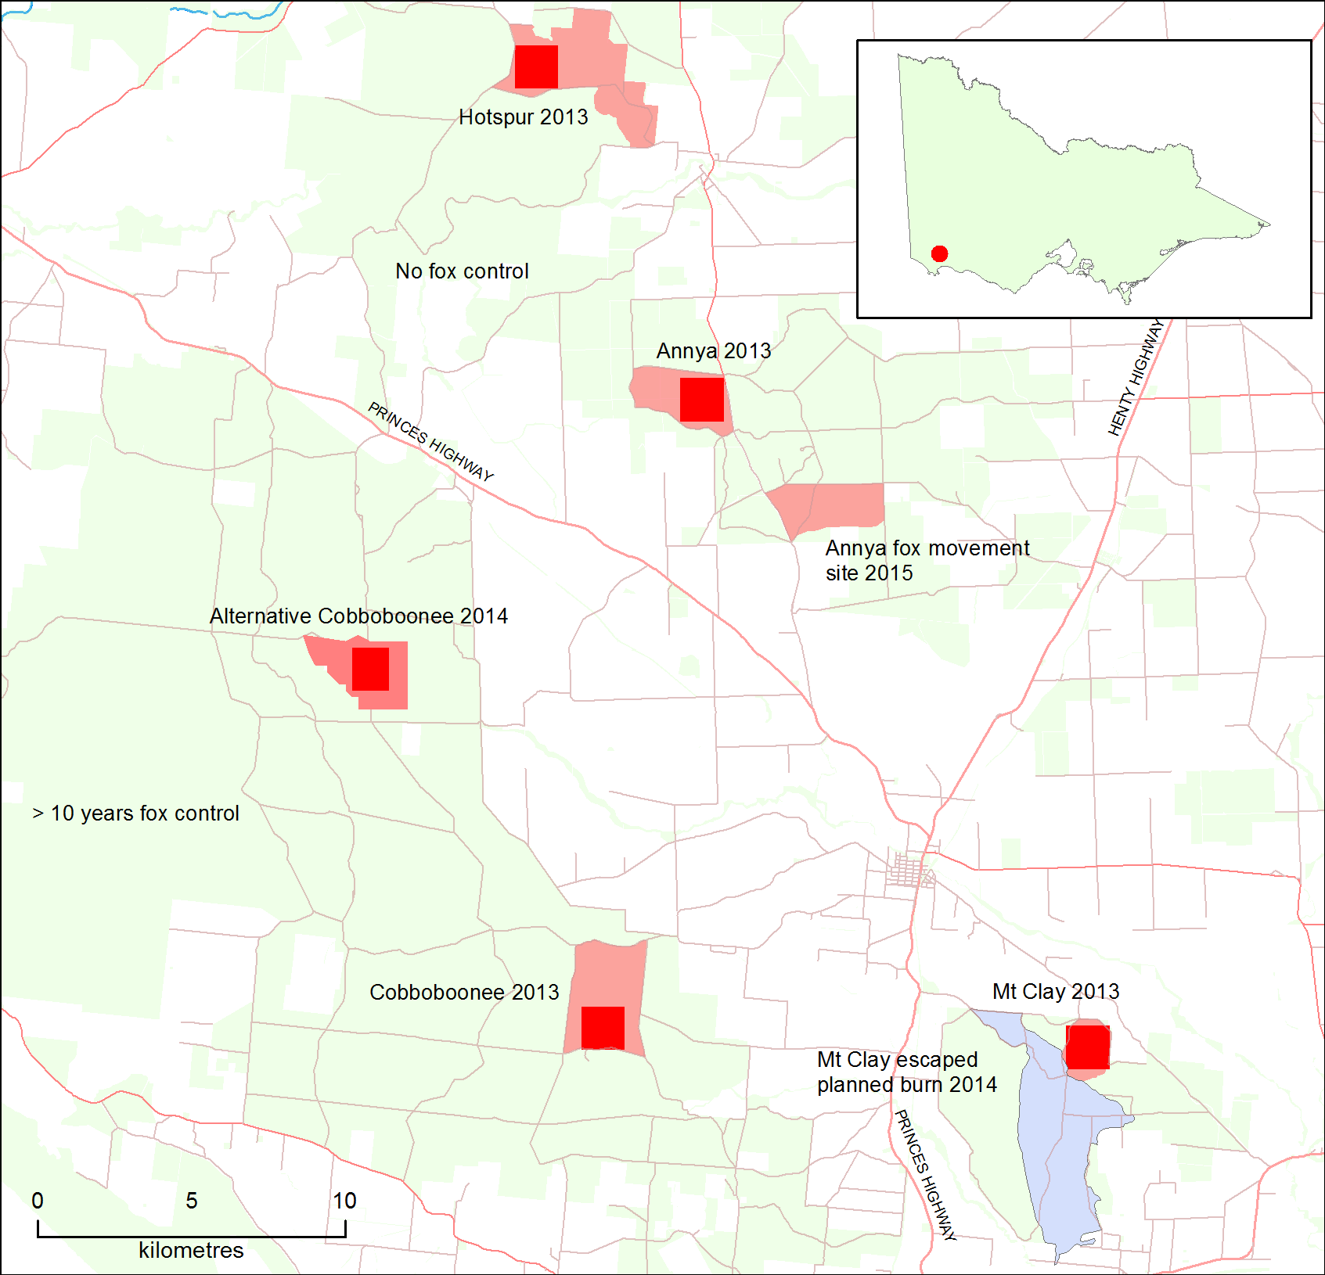

Figure 1. Study locations

Red squares = 200 ha study locations. Pink areas = extent of planned burns. Blue area = escaped Mt Clay planned burn. Continuous fox control has been implemented south of the diagonal black line on public land since 2005. No fox control has ever occurred north of the black line.

The minimum area for the planned burns was 200 ha, and this was used to define the size of each of the two main study location. Each study location was divided into 2 ha plots, resulting in 100 potential sampling sites in each location. We then randomly selected 35 sites within each study location.

The vegetation communities over all study areas were comprised primarily of two Ecological Vegetation Divisions (EVDs; as first described in Long et al. 2003), and all areas were dominated by Tall Mixed Forest (EVD-7; Long et al. 2003). This forest type frequently occurs on infertile soils (often duplex) in areas with moderate and reliable rainfall throughout the year. They are characteristically tall, open, many-layered forests with species-rich lower strata, have low rates of decomposition, and are flammable for much of the year (although barely so in winter). Fire severity, coverage, and whether or not a crown fire occurs in this EVD is dependent (more or less) on season of burn. Typically, plant species composition and structure in this EVD can be changed by too-frequent fire or long-term fire absence (Cheal 2010).

Grassy/Heathy Dry Forest (EVD-3) was less common within the study areas. This EVD is characterised by low open forests on infertile sandy soils, low growth and decomposition rates (except after fires), sclerophyllous shrubs, and/or bracken dominating the lower strata. It has high species richness, and grasses may be rare on sandy soils and/or not forming continuous swards. Sedges and sclerophyllous monocots are common throughout. The natural fire regime for this EVD takes the form of high-frequency very-high-severity fires, and it is flammable for most of the year (with the possible exception of winter), displaying rapid recovery post fire, with much of the regeneration fire cued.

Fauna species that were known to occur in the study areas are: Long-nosed Potoroo (*Potorous tridactylus*), Southern Brown Bandicoot (*Isoodon obesulus*), Common Brushtail Possum (*Trichosurus vulpecula*), Short-beaked Echidna (*Tachyglossus aculeatus*), Common Ringtail Possum (*Pseudocheirus peregrinus*), Red Fox and feral Cat. The listed native species are considered to be at risk from fox predation [based on a statewide assessment of predation risk (Robley and Choquenot 2002)] or to be potentially affected by the loss of habitat associated with planned burning (Norton et al. 2015), and their response to fire has been estimated from expert elicitation (MacHunter et al. 2009).

At each site we collected data on habitat attributes that provided food or shelter/structure for avoiding predators, the presence of native and introduced mammals (via digital cameras), and burn severity. Data on the movement and survival of both native mammals and foxes was gathered using a combination of live trapping and GPS tracking data. Across the broader study area, we collected fox scats to assess changes in the pre- and post-burn diet of foxes. All sampling was undertaken once prior to the planned burns, within 3 weeks following the planned burns, and 12 and 24 months post-burn.

2.2 Burn severity

A burn severity score for each of four structural layers (ground, mid-storey, tall shrub, and canopy) was determined based on the five categories (described in Table 1).

Table 1. Categorical scores assigned to burn severity for each of four structural layers at each monitoring site. Adapted from Pollet and Omi (2002).

|  |  |
| --- | --- |
| Burn severity score | Burn severity description |
| 1 | Unburnt |
| 2 | Light surface burn, without crown or foliage scorch |
| 3 | Patchy, irregular crown or foliage scorch |
| 4 | Moderate, intense burn, with complete crown or foliage scorch |
| 5 | Severe, high-intensity burn, with crown or foliage totally consumed |

Following each planned burn, vegetation was assessed along east–west transects spaced at 200 m intervals. The perimeters of any unburnt patches (>5 m2) were mapped with a hand-held GPS unit (Garmin 60, Garmin Ltd, Olathe, USA).

To assess if burn severity was different between the two blocks we used the non-parametric Wilcoxon rank sum test to assess the differences in burn severity score at ground level, mid-storey, tall shrub, and canopy between Hotspur and Annya. Significant results were further investigated using the non-parametric multiple-contrast test in the package *nparcomp* (Konietschke et al. 2015) in the statistical software *R* version 3.2.1 (R Core Team 2015).

2.3 Habitat attributes

We selected a set of basic attributes that characterise the habitat of ground-dwelling medium-sized mammals (McElhinny 2002; Arthur et al. 2012). These were (i) vertical vegetation cover, (ii) floristic species diversity and richness, (iii) volume of fallen logs, and (iv) volume of coarse woody debris. We also used a set of life-history attributes that describe the functional form of floristic species. These were derived from the Victorian Flora Attributes Database (Matt White pers. comm.) (Table 2). These attributes were used to cluster sites; these clusters were then used in the later analysis as explanatory variables for native mammal response to burning and predation.

Table 2. Habitat attributes collected to assess their influence on mammal species occurrence

CWD = coarse woody debris.

|  |  |
| --- | --- |
| Attribute name | Description |
| Vertical vegetation cover | The number of vegetation contacts in each of six height categories: 0–20 cm, 20–40 cm, 40–60 cm, 60–80 cm, 80–100 cm and 100–120 cm |
| Log-metres3 | Estimate of total volume of logs >10 cm diameter within a 10 m radius at each of the 35 sampling sites (L x W = cubic metres) |
| CWD-metres3 | As above, but for small branches 2–10 cm in diameter, within a 10 m radius at each of the 35 sampling sites |
| Floristic species abundance | The number of individuals of species within a 10 m radius at each of the 35 sampling sites |
| Species diversity | Shannon–Wiener index. Defined as H = –sum pi log(b) pi, where pi is the proportional abundance of species i and b is the base of the natural logarithms |
| Patches | A binary variable to indicate if the sampling site was unburnt habitat that remained intact within the burn footprint following the burn: 0 = burnt patch, 1 = unburnt patch |
| Life-form attribute code | Description |
| PS | Prostrate shrubs |
| F | Forbs (generally between 5 cm and 50 cm in width) |
| SS | Shrubs between 20 cm and 1 m in height |
| TS | Shrubs >1 m in height |
| T | Trees 5 - 20 m in height. |
| LT | Large trees (>20 m in height) |
| Fire_K | Bushfire tolerance category: typical adult plant (including underground parts) killed by a moderately intense fire |
| Fire_NK | Bushfire tolerance category: typical adult plant not killed by a moderately intense fire |

In the pre-burn and immediate post-burn sampling period, habitat attribute data were collected from the four cardinal points at 5 m from the central sampling point. Floristic abundance and overall vegetation data (e.g. ground layer cover, coarse woody debris) were collected from an area within a 10 m radius centred on the central sampling point (Figure 2). The same data were also collected from within unburnt patches in the immediate post-burn period.

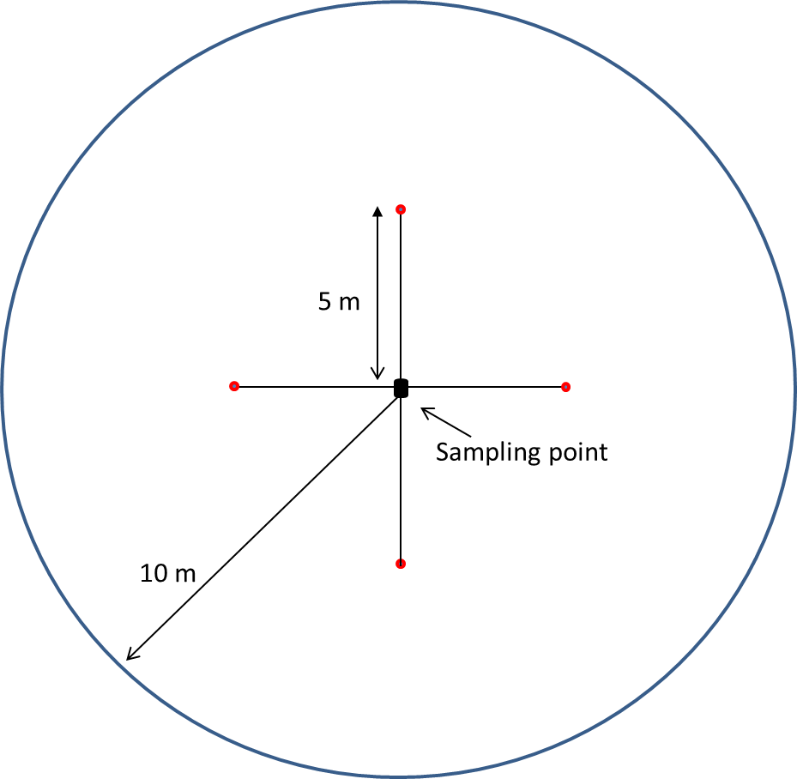

Figure 2. Layout of the sampling design for vegetation structure data collection in the pre- and immediate post-burn period. Red dotes are the sampling points.

In 2014 and 2015, floristic and habitat data were collected from five points located along each of three 10 m transects radiating out from a central point, forming a Y-shape (Figure 3). This change was made after analysis of the pre- and immediate post-burn data, which indicated a high degree of variability in the data. The central point of the Y-shape was located at the central sampling point described above. Habitat attribute and floristic abundance data were collected from an area within a 10 m radius centred on the central sampling point. Data were also collected from within unburnt patches in 2014 and 2015.

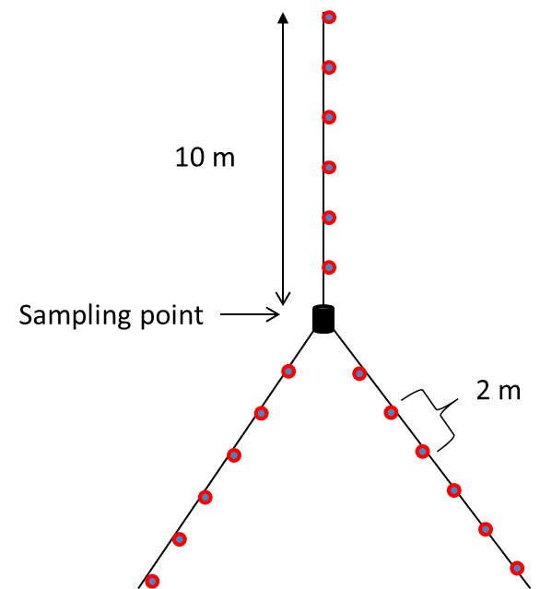

Figure 3. Y-shaped design for vegetation structure data collection in one year (2014) and two years (2015) post-burn. Red dots are the approximate location of sampling sites along each transect.

To investigate the effects of planned burning on the composition of the floristic communities in which native species and introduced predators occurred, we used the Shannon–Wiener index of diversity. We also calculated plant species richness (Magurran 1988) at each location pre- and post-burn, in 2014 and 2015. Species richness and species diversity were calculated for all sites using the ‘specnumber’ and ‘diversity’ functions in the ‘*vegan*’ package (Oksanen et al. 2015) of the statistical software *R*, version 3.2.1 (R Core Team 2015). Differences in diversity and richness were tested using analysis of variance (ANOVA), followed by Tukey’s honestly significant difference multiple comparisons test. Divergence from normality and homogeneity of variance were examined using Q-Q plots and the Shapiro-Wilk test and Bartlett’s test (performed in *R*).

To investigate changes in habitat attributes, we first multiplied the abundance of each plant species by the presence of the attribute for that species. We used this data and the data for coarse woody debris, volume of logs, and total vertical cover up to 1.2 m to explore the structure of the vegetation communities at each location over time.

We used similarity profile analysis (Clarke et al. 2008) in the *R* package ‘*Clustsig*’ (Whitaker and Christman 2015) to explore which (if any) clusters of habitat attributes differed significantly when comparing our two sites. A similarity profile was constructed from the species abundance data by first creating a similarity matrix. We carried out a hierarchical agglomerative cluster analysis with a Bray–Curtis metric using Ward’s cluster method (Whitaker and Christman 2015). The lower tridiagonal of the Bray–Curtis matrix was converted to a vector and sorted by magnitude. The sorted list of similarities provided a profile of the structure underlying the observed data. An iterative permutation procedure, based on randomly shuffling the original raw data, was then used to generate a mean permuted similarity profile, which represented the profile expected under the null model. The similarity between the observed profile and the null model was measured, using the pi statistic, as the sum of the absolute differences between corresponding elements of the two profiles. The pi statistic was then assessed by a permutation test; if it was statistically significant, the null hypothesis (that no multivariate structure exists within the data) was rejected at the appropriate alpha level (*P* = 0.05). The resulting clusters were used as explanatory variables in occupancy modelling exploring the influence of habitat and fox presence on native species occurrence (section 2.4).

2.4 Presence of native mammals and predators

Digital cameras were used to assess the presence of native mammals, foxes and feral Cats at Annya and Hotspur. Data was collected in autumn 2013, 1 month pre-burn, three weeks immediately post-burn and in autumn 2014 and autumn 2015. Cameras were deployed for between 35 and 56 nights at each site in each sampling session. We deployed 36 cameras at Hotspur, 34 at Annya and 33 at Mt Clay. Mt Clay was not included in the species response modelling due to the confounding effect of the bushfire in 2014 (see Introduction for details). Following the planned burns, we established additional camera points in unburnt patches within the burnt areas at Annya and Hotspur.

A single Reconyx HC500 or PC900 infrared flash camera (Reconyx Inc., Wisconsin, USA) was attached to the nearest suitable tree to the sampling point and positioned 20 cm above and parallel to the ground and 2 m from a sampling point. Vegetation was cleared adjacent to the trap and sampling point to improve visibility. Cameras were set to take photos 24 h per day, with three shots per trigger, at 1-s interval between photos, and a 15-s interval between triggers. Cameras are triggered by passive infra-red sensors which detect a difference between the background ambient temperature and the temperature of a moving object.

2.4.1 Changes in native species and introduced predators

The presence or absence of species at sites derived from the camera data was then used to assess the influence of habitat, planned burn and predator presence on the occurrence of native mammals. We combined the presence/absence data for native mammals with: the habitat attribute clusters derived from the floristic and structural traits of the sites; the presence of foxes at the site; and whether the site was part of Annya or Hotspur in an occupancy model (MacKenzie et al. 2002, 2006, and references therein).

The pre-burn analysis was conducted as a separate single-season model, whereas analysis of the results for the immediate post-burn and the following years was conducted using a multiseason model. There are two reasons for using separate models. First, the time interval between ‘seasons’ should be consistent, and this was not the case for all four surveys. Second, the change from the pre-burn surveys to the post-burn surveys was so great that including this period in the model outcome would have resulted in very large confidence intervals.

Occupancy models explicitly recognise that given a species occurs in an area, the probability of detecting it on a single survey is often less than one. This potential source of bias is addressed by using repeat sampling across multiple sites, enabling the detection probability to be calculated and incorporated into the occupancy estimate (MacKenzie et al. 2002, 2006).

We also derived estimates of colonisation and extinction for each sampling point. Colonisation is analogous to the reproduction rate of a population, and is the probability that a site that was not occupied becomes occupied at the next time-step (MacKenzie et al. 2003). Persistence is analogous to survival and is the probability that sites that were occupied remain occupied in the following period. Colonisation and extinction are important because they are the processes that drive occupancy.

Depending on the distribution of the species, some parameters may be poorly estimated. For example, if all sites within a location were occupied, then an estimate of colonisation for the following interval will not be possible because there were no unoccupied sites to colonise. Similarly, if all sites were unoccupied, then estimates of persistence will not be possible. The result is that occupancy models using a classical approach are unable to predict meaningful estimates of occupancy; using a Bayesian modelling approach can overcome this issue (Ntzoufras 2009).

In general, strong evidence of a positive treatment effect is indicated by the entire 95% CI being above zero. Similarly, strong evidence of a negative treatment effect is indicated when the 95% CI is below zero. Where the 95% CI includes 0, there will be either weak or no evidence for a treatment effect. Strong, moderate or weak evidence of a positive effect on native species occurrence were indicated by values of ≥0.99, 0.95–0.99 or 0.9–0.95, respectively. Correspondingly, strong, moderate or weak evidence of a negative effect were indicated by small probabilities (e.g. 0.01, 0.05 or 0.1, respectively). These probabilities correspond to the credible intervals (CIs).

2.4.2 Fox activity

To evaluate the effect of planned burning on foxes we used a relative abundance index to assess differences in fox activity before and after the planned burns. We were not able to undertaken an assessment of occupancy rate as camera sites were not spatially independent for foxes. The activity index was determined from the number of independent images (images separated by 24 hours) for all camera traps at a sampling point. To evaluate the effect of the planned burn on overall fox activity we used a Bayesian linear mixed model to test differences in activity at Annya and Hotspur through time. The number of camera days per site varied, we used this as the offset in the model to account for the difference in sampling effort. Significant differences are indicated by the 95% credible intervals not containing zero. Analysis was undertake in the “brms” package (Buerkner 2016) in the statistical software *R* version 3.2.4 (R Core Team 2015).

2.5 Fox capture and movement

2.5.1 Hotspur and Mt Clay 2013

We set 33 Victor No. 1.5 soft-jaw traps (Victor Softcatch No. 1.5, Western Trapping Supplies, Drayton North, Queensland) along tracks and trails between 7 and 17 January 2013 at Mt Clay, and 25 traps between 7 and 22 January 2013 at Hotspur, ~3 months prior to planned burning. Captured foxes were sedated by an intramuscular injection of 50 g/kg of medetomidine hydrochloride (Domitor, Zoetis, Australia), revived by an intramuscular injection of 250 mg/kg atipamezole (Antisedan, Zoetis, Australia) and released at the point of capture. All traps were checked and reset, if needed, each morning. Individual animals were sexed, weighed and fitted with a GPS data logger (Sirtrack, Havelock, NZ) attached to a collar. Only foxes >4 kg were fitted with collars.

Each collar also contained a VHF beacon and a timed-release mechanism to facilitate recovery of the collar. The date of release for fox collars was 1 October 2013, ~7 months post-burn. Fox collars were programmed to collect a location every hour.

2.5.2 Annya 2014–2015

In 2014, we assessed fox movement pre- and post-burn at a second site in Annya State Forest. Capture and collaring of foxes followed the same method as outlined above, with the following differences: (i) trapping was undertaken over two sessions, 1) mid-August 2014 and 2) Novemebr 2014, (ii) the drop-off date was set to 31June 2015, and (iii) collars were programmed to take a single fix once a week from mid-August to mid-February, then hourly until drop-off. This schedule allowed us to assess home range, movement, and habitat use immediately pre- and immediately post-burn. It also allowed us to capture foxes at a time of year when juveniles were least likely to be in the population, which would later disperse from the study area.

We used the GPS data to assess changes in territory size pre- and post-burn. Prior to any analysis, we filtered out unrealistic data, i.e. indicating movements between two point locations that would be greater than that physically possible for foxes (e.g. >20 km/h) and imprecise locations. These anomalies can occur when satellite geometry is distorted, or when the number of satellites used is less than three (Bjorneraas et al. 2010).

We calculated the area in which foxes spent 95% of their time (i.e. the 95% utilisation distribution isopleths) for individual foxes, using the kernel density estimator function in *ArcMet* (Wall 2014). This *ArcGis* extension implements a bivariate Gaussian kernel with a fixed smoothing parameter. The h_ref function calculates the optimum value of the smoothing parameter, based on the spatial variance of the input points (Worton 1989). As a measure of the shift in individual fox territories in response to the planned burn, we measured the percentage overlap between the 95% isopleths (depicting areas of use in a format similar to contour lines) before and after the burn for individual foxes.

2.6 Pre- and post-burn fox diet

We collected fox scats from each study area 1 month pre- and 1 month post-burn. Two collectors spent ~3.25 h walking 8 km of tracks and trails at each site pre- and post-burn.

The importance of each prey type in the fox’s diet was quantified by the frequency of occurrence (determined as the number of scats containing each prey type x 100/total number of scats). We grouped prey items into four categories: insect and plant material; small mammals (e.g. *Antechinus* species), medium-sized mammals (e.g. possums and bandicoots); and large mammals (e.g. macropods). Shannon’s index of diversity was calculated for diet items for each burn period, with H’ = pi*(log pi), where pi represents the proportion of each species in the sample (Shannon and Weaver 1949). A Student’s *t*-test was used to test whether the diversity indices differed between burn periods (Hutcheson 1970).

3 Results

3.1 The planned burns

Hotspur, Annya and Mt Clay were burnt in April 2013, and Annya (fox movement) was burnt in April 2015. The stated burn objectives (high intensity burn over 50% of the area, reducing fuel loads to less than ‘very high’) for all three locations were achieved, with the total area treated at each site being as follows: Annya 513 ha; Annya (fox movement) 509 ha; Hotspur 1080 ha; and Mt Clay 258 ha. Some vegetation patches remained unburnt within the perimeter of each burn (Table 3). Figure 4 shows the size, number and location of unburnt patches within Annya, Hotspur and Mt Clay. Burn scores and mapping were not undertaken for Annya (fox movement) due to limitations on available resources. Fire severity mapping was completed for Annya (fox movement) by the Barwon South West Region.

Table 3. Number and size (ha) of unburnt patches at Annya, Hotspur and Mt Clay

|  |  |  |  |
| --- | --- | --- | --- |
| Patch characteristics | Annya | Hotspur | Mt Clay |
| Number of patches | 21 | 23 | 39 |
| Average patch size (ha) | 4.1 | 3.1 | 8.4 |
| Median patch size (ha) | 1.7 | 1.0 | 2.0 |
| Maximum patch size (ha) | 27.5 | 30.3 | 88.7 |

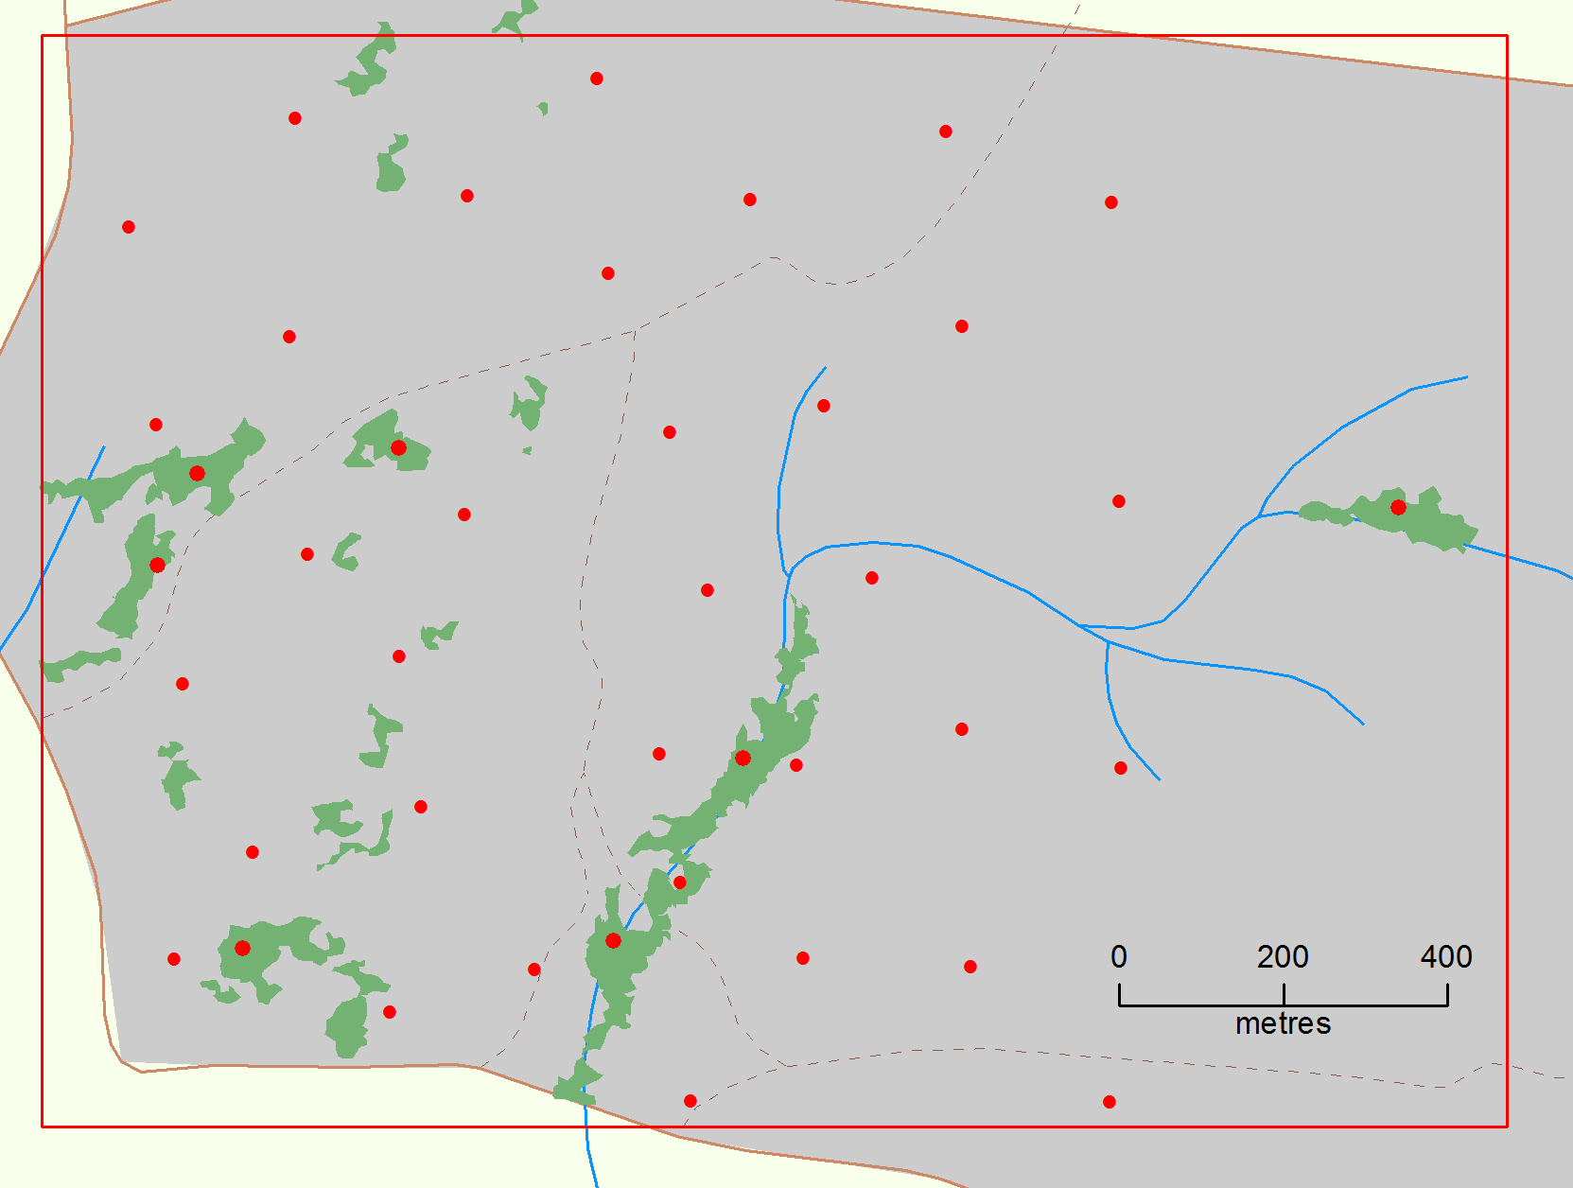

a)

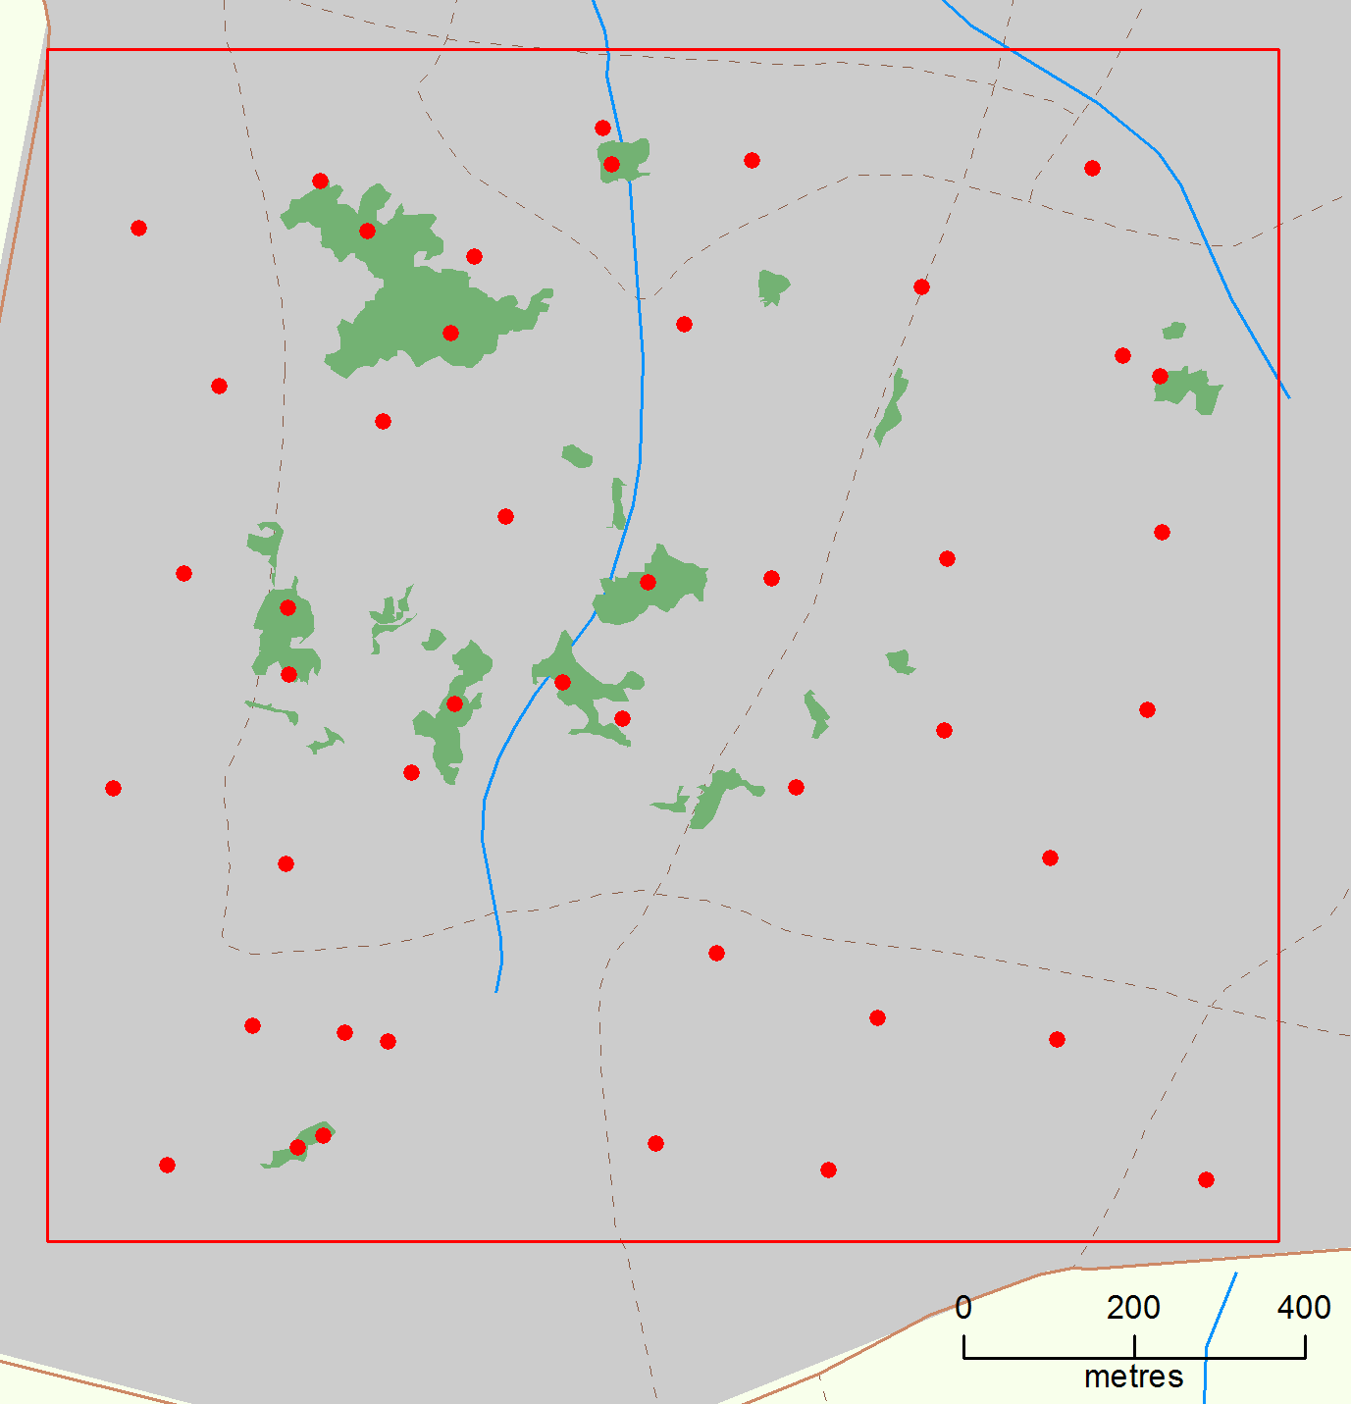

b)

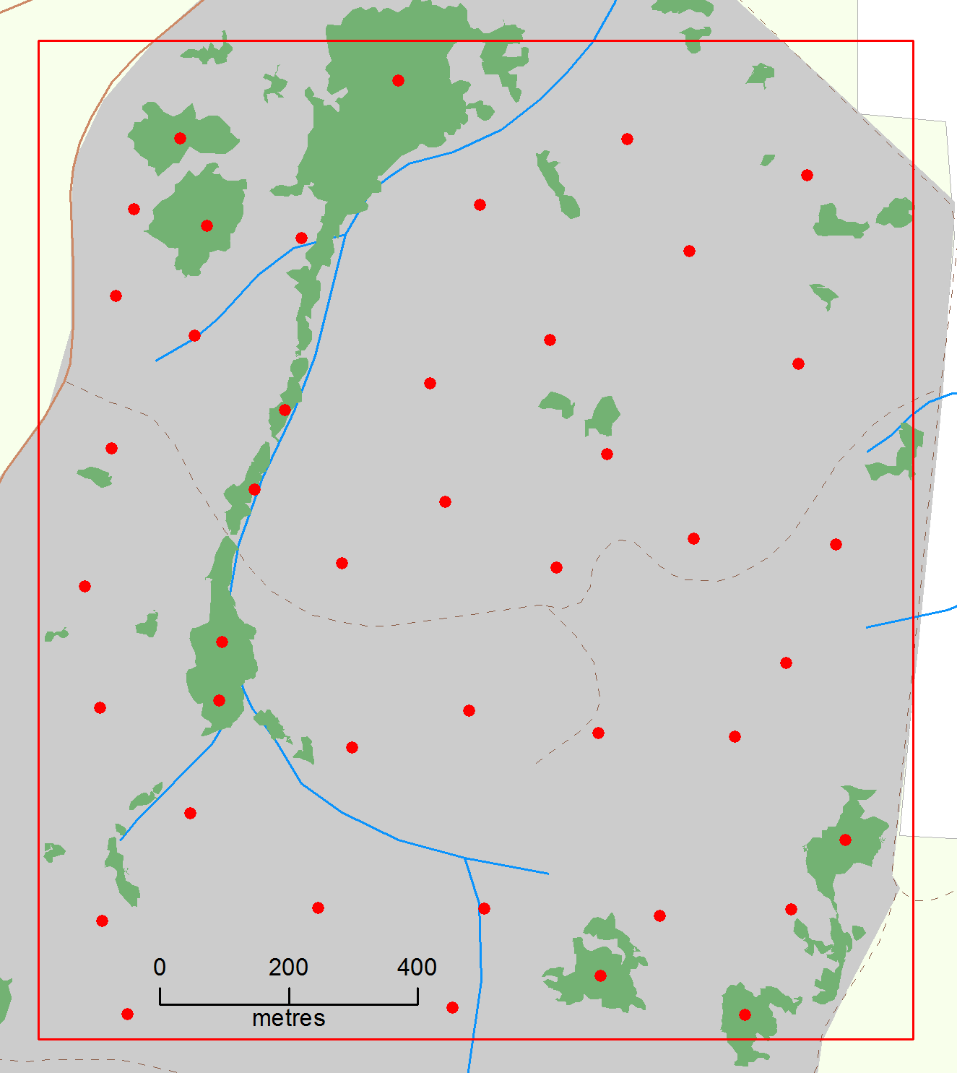

c)

Figure 4. Location and number of unburnt patches within (a) Annya, (b) Hotspur and (c) Mt Clay. Red dots indicate the locations of camera survey points. Green – unburnt patches, Grey – burnt area, Red square – study location

3.1.1 Burn severity

There was a significant difference in the overall impacts of the planned burns between locations (Kruskal-Wallis Χ2 = 18.7, df=2, p >0.05), with Annya being more severely burnt than Hotspur (difference = -0.139, 95%CL -0.215 to -0.063, *p* = >0.001) and Mt Clay (Difference = -0.108, 95% CL -0.184 to -0.031, *p* = >0.001); no overall difference was detected between Hotspur and Mt Clay (Figure 5).

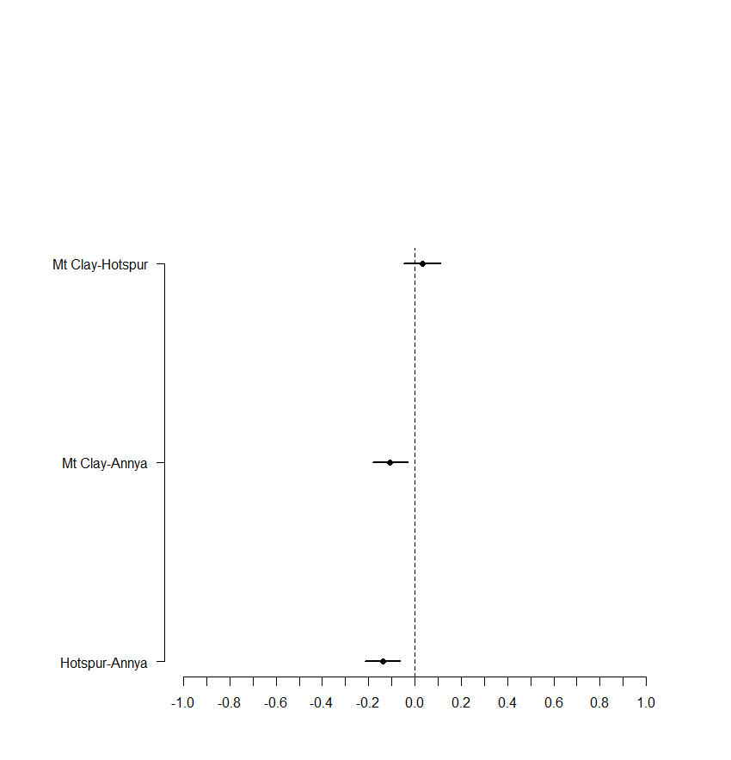

Figure 5. Difference in ranked scores for multiple comparison of burn scores between locations. Comparisons not including zero indicates a significant difference between locations

There was a significant difference in the severity of the burn across vegetation layers (Kruskal-Wallis Χ2squared = 93.522, df = 3, p >0.05). Non-parametric Tukey’s honestly significant difference multiple comparison tests indicated a significant difference between the severity of the burn at the ground layer, mid-storey and tall shrub layer compared to the canopy layer (Figure 6), with the canopy being subject to less severe high-intensity burning.

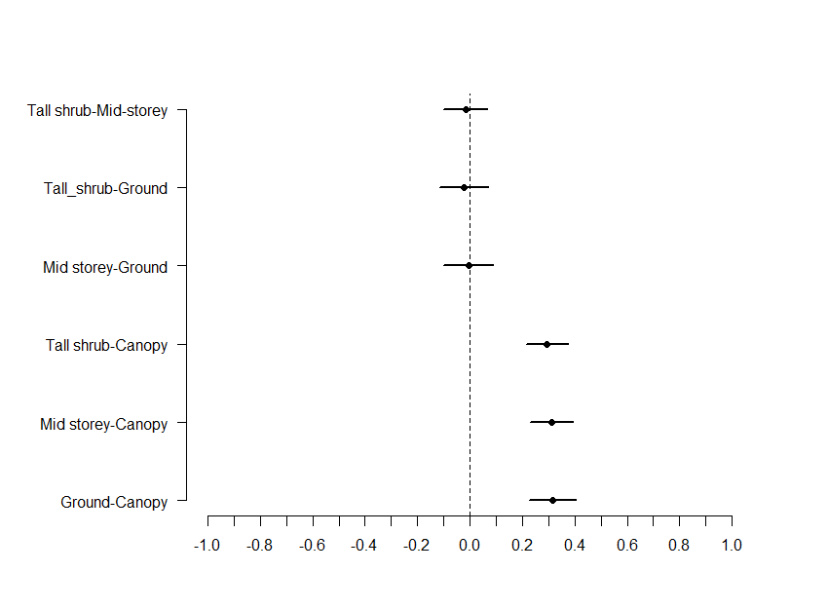

Figure 6. Difference in ranked scores for non-parametric multiple comparison results for each vegetation layer. Bars are 95% confidence limits. Pairs not containing zero are significantly different

Figures 7 and 8 illustrate the difference between pre- and post-burn vegetation for various levels of burn severity and the level of recovery in the vegetation 2 years post-burn.

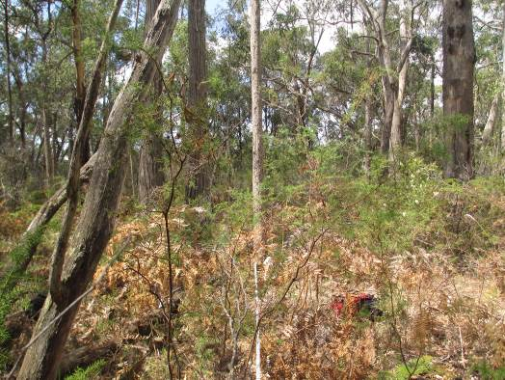

**(a)**

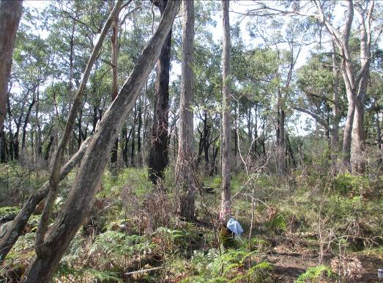

**(c)**

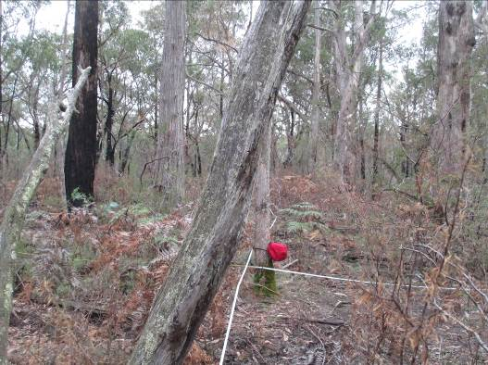

**(b)**

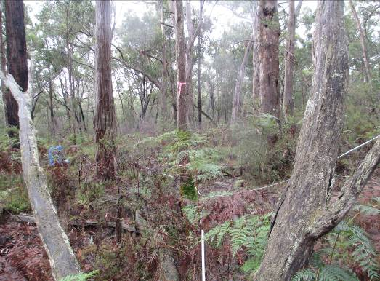

**(d)**

Figure 7. Changes in vegetation at Hotspur (a) pre-burn, (b) post-burn 2013 (burn score of 2 for ground cover, mid-storey, tall shrub, and canopy), (c) 2014 and (d) 2015

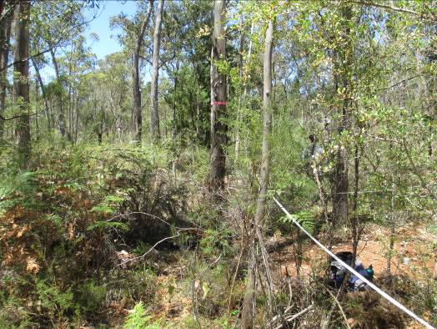 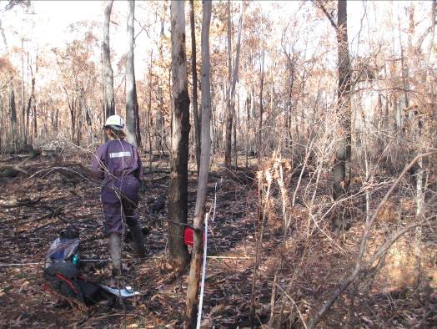

**(b)**

**(a)**

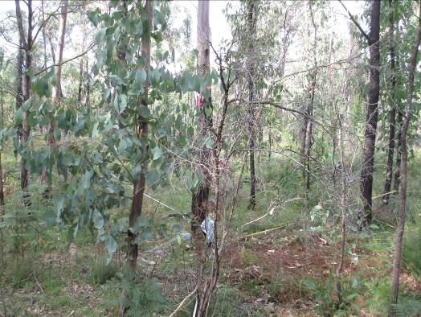

**(d)**

**(d)**

**(c)**

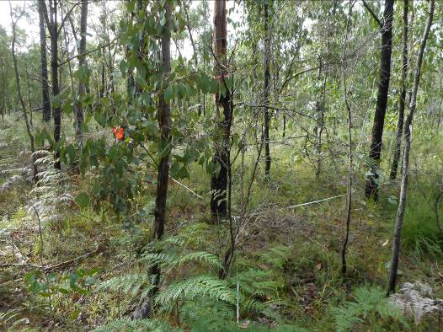Figure 8. Changes in vegetation at Annya (a) pre-burn, (b) post-burn 2013 (burn score of 5 for ground cover, mid-storey, tall shrub, and canopy), (c) 2014 and (d) 2015

3.2 Floristic diversity and richness

Pre-burn, a total of 49 species of vascular plants were recorded across the three areas. While there was little difference in the total number of species between Mt Clay (33) and Hotspur (38), there were fewer species recorded at Annya-2013 (26).

Figures 9 shows that there was a significant change in species diversity at each site over time (Annya-2013 df = 3, F = 34.72, P ≥ 0.001; Hotspur df = 3, F = 9.83, P ≥ 0.001; and Mt Clay df = 2, F = 22.5, P ≥ 0.001). There was also a significant change in the number of species over time (Annya-2013 df = 3, F = 65.15, P ≥ 0.001; Hotspur df = 3, F = 12.77, P ≥ 0.001; and Mt Clay df = 2, F = 39.67, P ≥ 0.001). (Figure 10).

a)

b)

c)

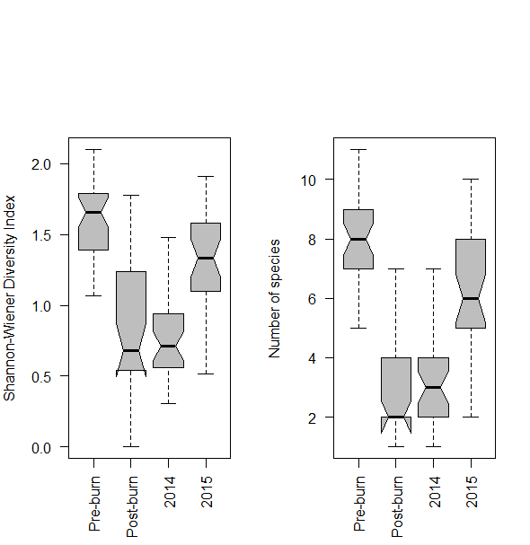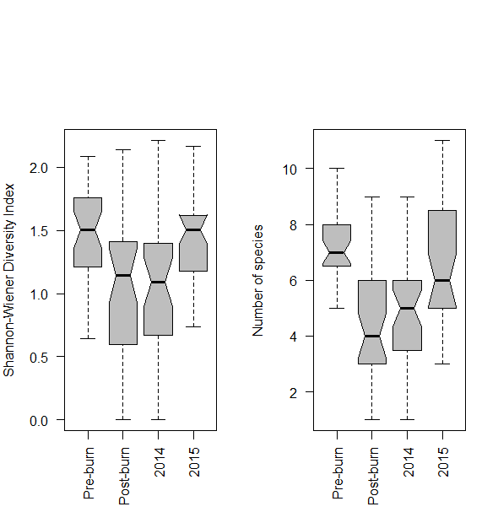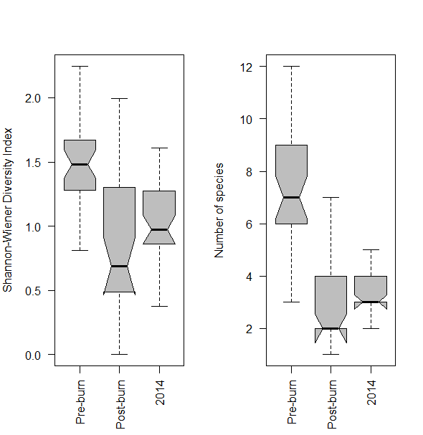

Figure 9. Change in species diversity at a) Annya, b) Hotspur, and c) Mt Clay pre and post-burn and in the following 2 years, except for Mt Clay. Non-overlapping notches provide ‘strong evidence’ of a significant difference (Chambers et al. 1983)

a)

b)

c)



Figure 10. Change in the number of species at a) Annya, b) Hotspur, and c )Mt Clay pre and post-burn and in the following 2 years, except for Mt Clay. Non-overlapping notches provide ‘strong evidence’ of a significant difference (Chambers et al. 1983)

Changes in species richness and diversity reflect the intensity of the burns with reductions both greater and lasting longer at Annya compared to Hotspur. At Annya, post-hoc pairwise multiple comparison showed that species diversity and richness were significantly reduced from the immediate post-burn period through to 2015 compared to pre-burn levels, with a significant increase from 2014 to 2015 (Appendix 1). At Hotspur, reductions in species diversity and richness occurred from the immediate post-burn period to 2014 compared to the pre-burn levels (Appendix 1). At Mt Clay, richness and diversity was lower in the immediate post-burn period and 2014 compared to the pre-burn levels (Appendix 1).

3.3 Floristic life forms and habitat structure

3.3.1 Reponses of structural features

There were significant changes in vertical vegetation cover, coarse woody debris and logs in the immediate post-burn period compared with the pre-burn and 2014 and 2015 periods (Figure 11 a–c, Appendix 2); however, there were no significant differences in structural features between the pre-burn and 2015.

a)

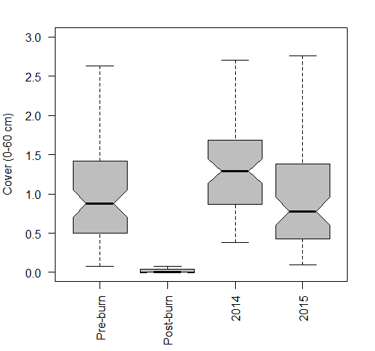

c)

b)

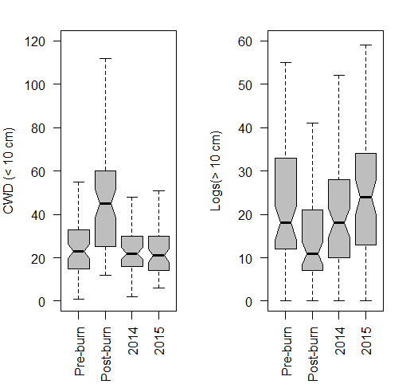

Figure 11. Changes in habitat characteristics pooled across Annya and Hotspur: a) vertical vegetation cover, b) coarse woody debris, (CWD), and c) logs

3.3.2 Cluster analysis

We used an unweighted pair group average (UPGMA) hierarchical cluster analysis to group sites within Annya and Hotspur in each sampling period (i.e., Pre-burn, post-burn, 2014, and 2015) according to increasing similarity based on a set a pre-defined habitat attributes (Table 2). This reduced the large volume of habitat characteristic data into descriptive groups (clusters) to be included in the multiseason occupancy modelling as possible explanatory variables for the change in occupancy by native species. Analysis was undertaken using the package ‘cluster’ in R statistical software (R Core Team 2016).

Cluster analysis of floristic and habitat attributes resulted in four groups—pre-burn and unburnt patches, immediate post-burn, 2014, and 2015—reflecting time-since-burn. Details of which sites from Annya and Hotspur comprised each cluster and their attribute values are available on request from the senior author. There was some mixing of sites from other periods, for example some immediate post-burn sites were included in the pre-burn cluster, reflecting the low level of burn severity at these sites.

3.4 Mammal response to planned burning

3.4.1 Red Fox activity

Fox activity increased significantly at Annya post-burn and remained higher for the following 2 years. The point estimates suggest that activity at this site was on the decline from 2014. Activity at Hotspur also increased significantly post-burn, but not to the same extent as at Annya. Activity at Hotspur steadily declined over the following 2 years to return to pre-burn levels in 2015. (Figure 12).

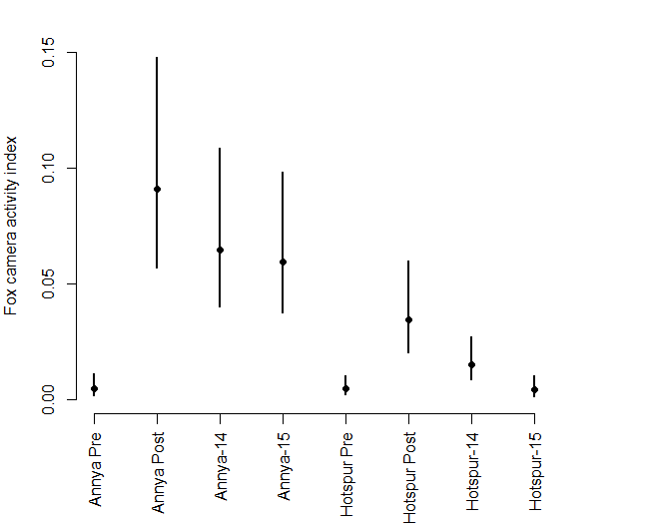

Figure 12. Activity estimates for foxes at Annya and Hotspur, pre-burn, post-burn, 2014 and 2015. Bars are 95% credible limits.

3.4.2 Southern Brown Bandicoot

No Southern Brown Bandicoots were detected at Annya pre-burn or any time post-burn. Therefore, the models discussed here deal with Hotspur only.

The pre-burn occupancy rate was 38% (95% CL 23.4–55.1%; Figure 14), and given Southern Brown Bandicoots were present at a site, the chance of detecting them on any given day was 9.5% (95% CL 7.2–12.5%). The immediate post-burn occupancy was 9.3% (95% CL 3.5–22.3%), and detection rates were 13.3% (95% CL 11.0–16.1%). This represents a significant decline in Southern Brown Bandicoots in the post-burn period.

There was insufficient evidence to suggest an impact on Southern Brown Bandicoot occupancy by fox presence, habitat, or time from the immediate post-burn period to 2015.The best occupancy model for the post-burn period was the null model (i.e. constant detection, colonisation and extinction). While the post-burn occupancy growth rates were slightly positive, this relationship was not significant (Figure 13). The occupancy of Southern Brown Bandicoots at individual camera sites was variable, with a post-burn turnover rate of 81.4% (95% CL 48.1–99.9%) in 2014 and 72.9% (95% CL 49.7–99.9%) in 2015. This means that around three-quarters of sites where Southern Brown Bandicoots were detected in 2014 and 2015 were the result of local colonisation. Parameter estimates for the occupancy models are given in Appendix 3.

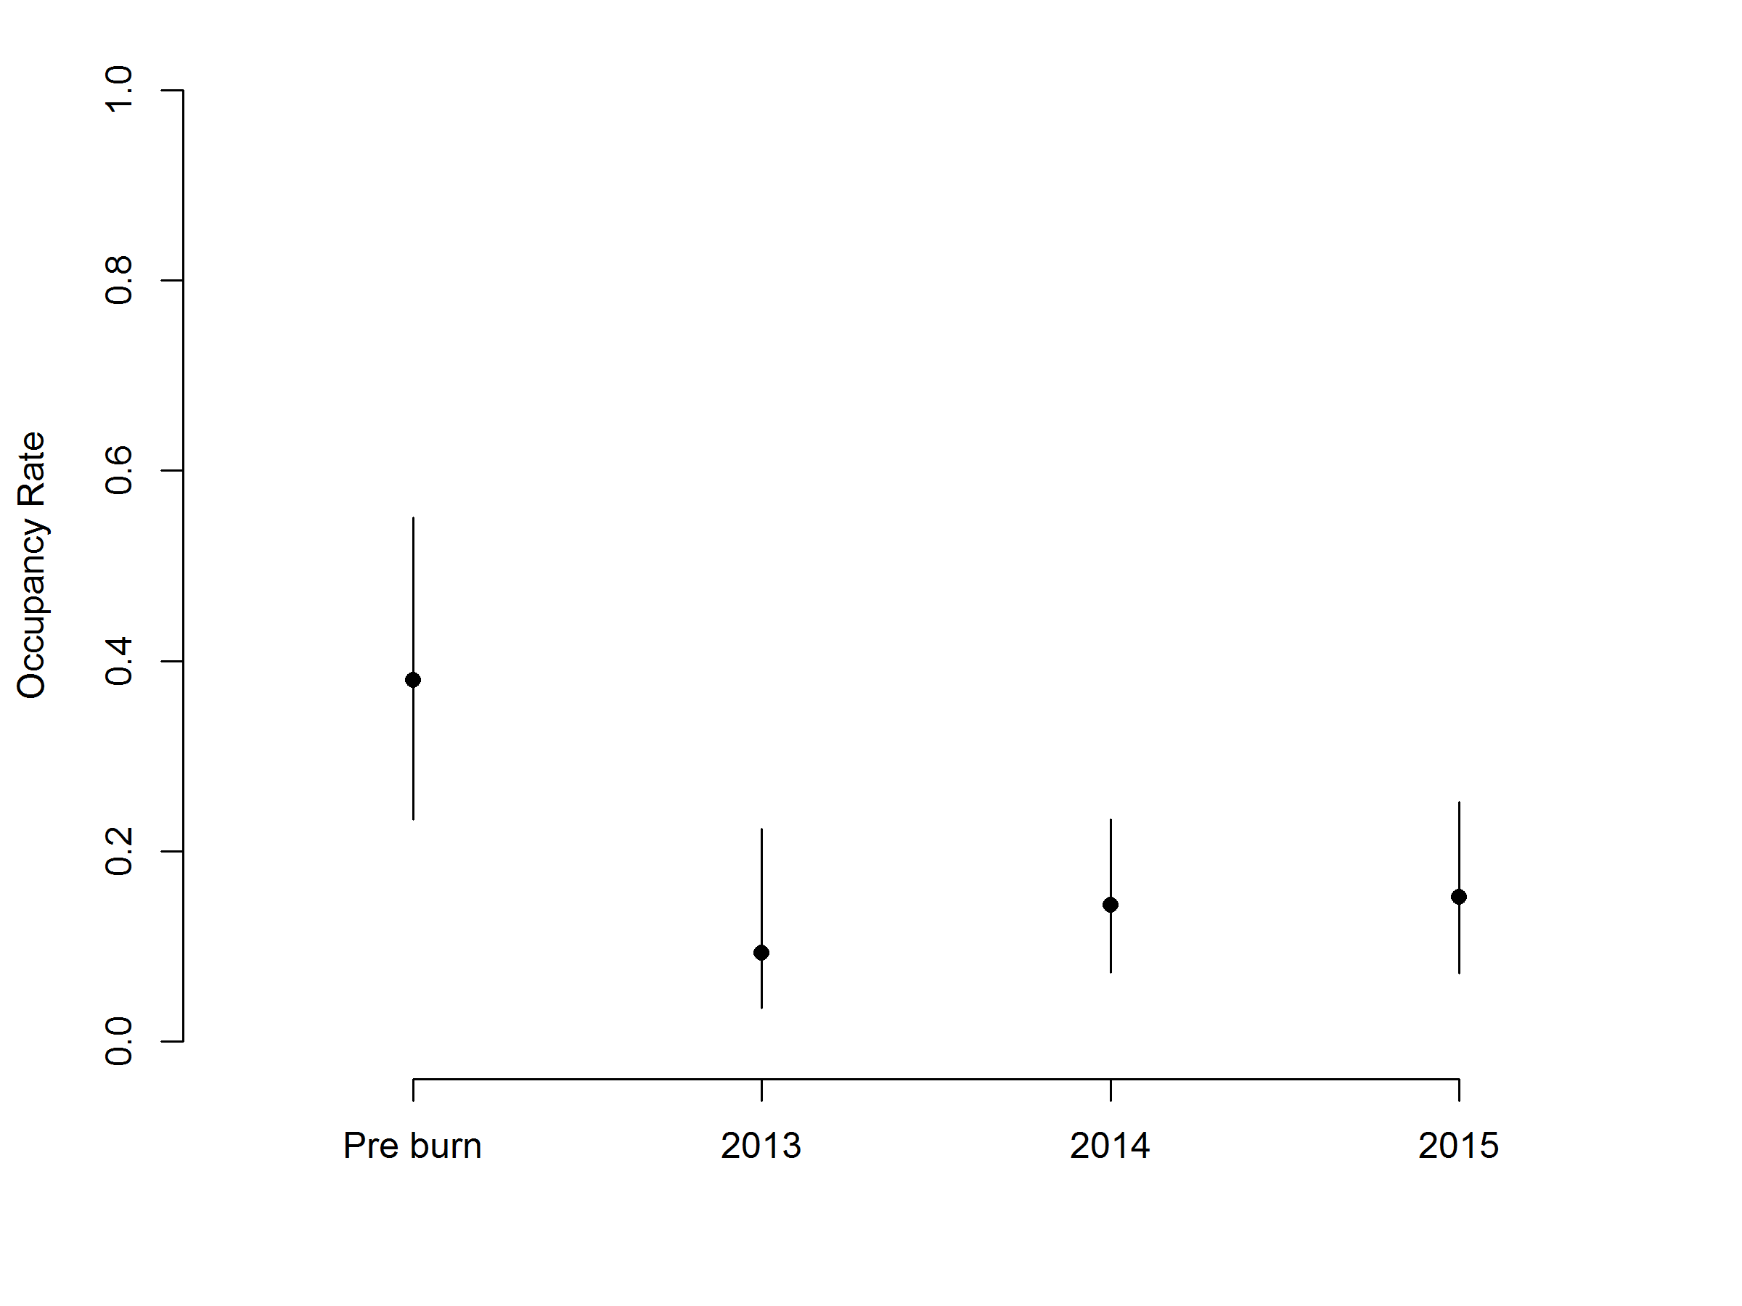Figure 13. Occupancy estimates for Southern Brown Bandicoots at Hotspur during the four monitoring periods. Solid dots indicate the overall occupancy estimates; vertical lines indicate the 95% confidence limits

3.4.3 Long-nosed Potoroo

There were several numerical difficulties encountered when developing the pre-burn single-season model of Long-nosed Potoroo occupancy. These difficulties arose due to the large number of non-detections. Therefore, the model was run in a Bayesian modelling framework.

The planned burns led to the local extinction of Long-nosed Potoroos at both Annya and Hotspur. Prior to the burn, Long-nosed Potoroos were detected at seven sites, six of which were at Hotspur. Foxes had not been detected at any of the seven sites. Post burn, a Long-nosed Potoroo was detected only once at Hotspur. The solitary post-burn detection was on the second day of monitoring (immediately post-burn). Four days later, a fox was detected at that site. Following this, no Long-nosed Potoroos were captured on camera at either location.

There is moderate evidence that fox presence at sites decreased the occupancy rate for Long-nosed Potoroos. The occupancy rate for sites with no fox detections was 16.5% (95% CL 7.2–27.3%). If foxes were detected, the rate dropped to 4.2% (95% CL 0.0–12.4%). The daily detection rates for Long-nosed Potoroo were 13.7% (95% CL 9.8–18.0%). Parameter estimates for the pre-burn occupancy models are given in Appendix 3.

3.4.4 Common Brushtail Possum

Common Brushtail Possums were unaffected by the planned burn or the presence of foxes. The occupancy rates of Common Brushtail Possum differed between the locations prior to the planned burns, with Annya having nearly double the occupancy rate of Hotspur. The pre-burn occupancy model with the most support had estimated occupancy rates of 50.5% (95% CL 33.0–67.9%; Figure 14) at Annya and 24.5% (95% CL 12.6–42.1%) at Hotspur. This model had estimated detection rates of 6.8% per day (95% CL 5.2–8.7%), and this was consistent across sampling sites.

The ‘best’ post-burn model was similar, with initial occupancy dependent on location, and detection consistent across sites (5.7% per day; 95% CL 4.9–6.6%). Colonisation rates changed between years, whereas the local extinction rate remained consistent. Occupancy rates at Hotspur increased between the immediate post-burn period (2013) and 2014, with growth estimated to be 121% (95CL 33–438%). In contrast, occupancy rates at Annya decreased between 2014 and 2015, with growth estimated to be –18% (95% CL –32% to –1%). Turnover rates were relatively low for Common Brushtail Possums, with the highest being 30.8% (95% CL 18.6–43.0%) for sites immediately post-burn (2013) at Annya. Colonisation and extinction rates were ~13–14% on average. Parameter estimates for the occupancy models are given in Appendix 3.

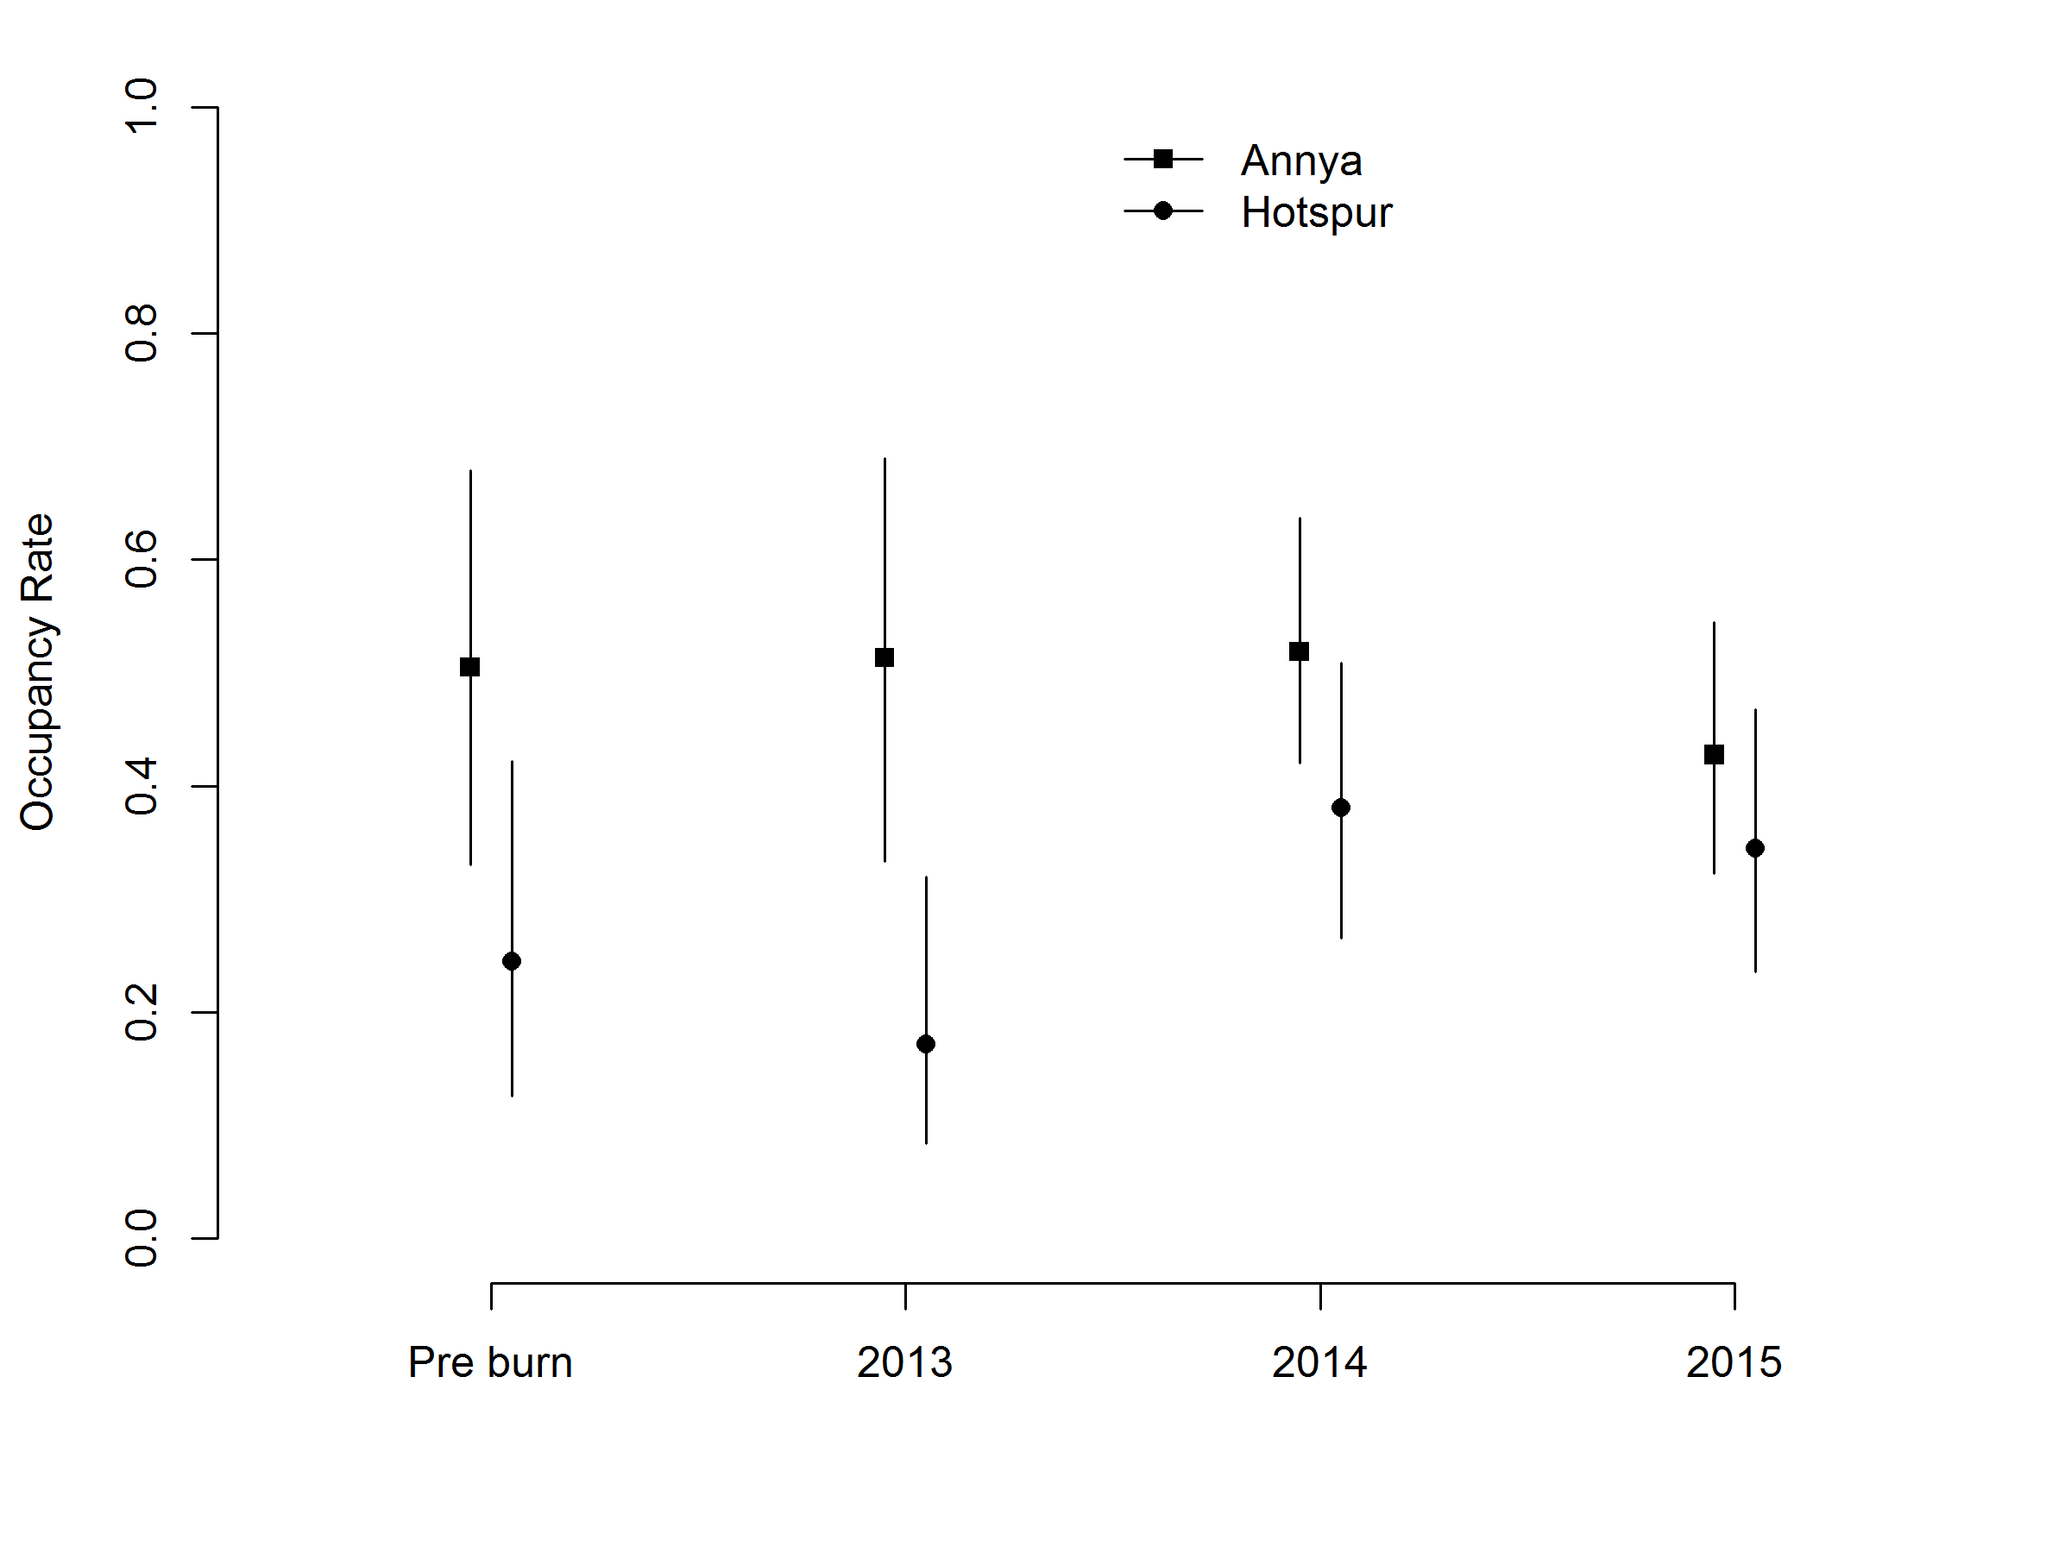

Figure 14. Occupancy estimates for Common Brushtail Possums during the four monitoring periods

Solid points indicate the occupancy estimates; vertical lines indicate the 95% confidence limits.

3.4.5 Common Ringtail Possum

The pre-burn model for Common Ringtail Possums with the most support had possum occupancy differing by location (Annya 38.9%, 95% CL 23.1–57.5%; Hotspur 68.5%, 95% CL 50.2–82.4%; Figure 15). Daily detection rates were estimated at 8.0% (95% CL 6.3–10.0%) where foxes were not detected, and fell to 4.8% (95% CL 3.1–7.5%) where foxes were detected.

In the post-burn period, occupancy was dependent on whether foxes were detected or not. Where foxes were not detected, occupancy was 13.7% (95% CL 5.1–32.0%), increasing to 45.9% (95% CL 28.8–64.0%) with fox detection. Colonisation and extinction rates were constant, with daily detection rates of 3.6% (95% CL 3.0–4.4%). Common Ringtail Possum occupancy rates at sites where foxes were not detected increased between 2013 and 2014, with growth estimated to be 229% (95% CL 64–1466%), and were constant between 2014 and 2015. Parameter estimates for the occupancy models are given in Appendix 3.

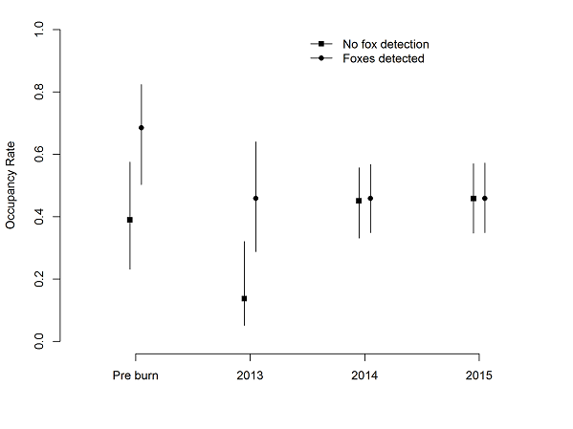

Figure 15. Occupancy estimates for Common Ringtail Possums during the four monitoring periods

Solid points indicate the occupancy estimates; vertical lines represent the 95% confidence limits.

3.4.6 Short-beaked Echidna

The ‘best’ model of Short-beaked Echidna occupancy in the pre-burn period was the null model, with no difference between sites based on fox detection or location. Pre-burn occupancy was estimated to be 86.6% (27.7–99.1%), and detection was estimated to be 2.2% (1.4–3.4%).

The ‘best’ post-burn model estimated greater occupancy rates at unburnt sites than burnt sites (Figure 16), with greater local colonisation at Annya and consistent extinction rates across both sites. The occupancy rates for burnt sites increased in 2015, but not significantly so. For this model, detection rates were higher where foxes had not been detected (3.3%, 95% CL 2.2–4.9%) compared with sites where foxes had been detected (1.2%, 95% CL 0.5–2.9%) (Figure 17). Parameter estimates for the occupancy models are given in Appendix 3.

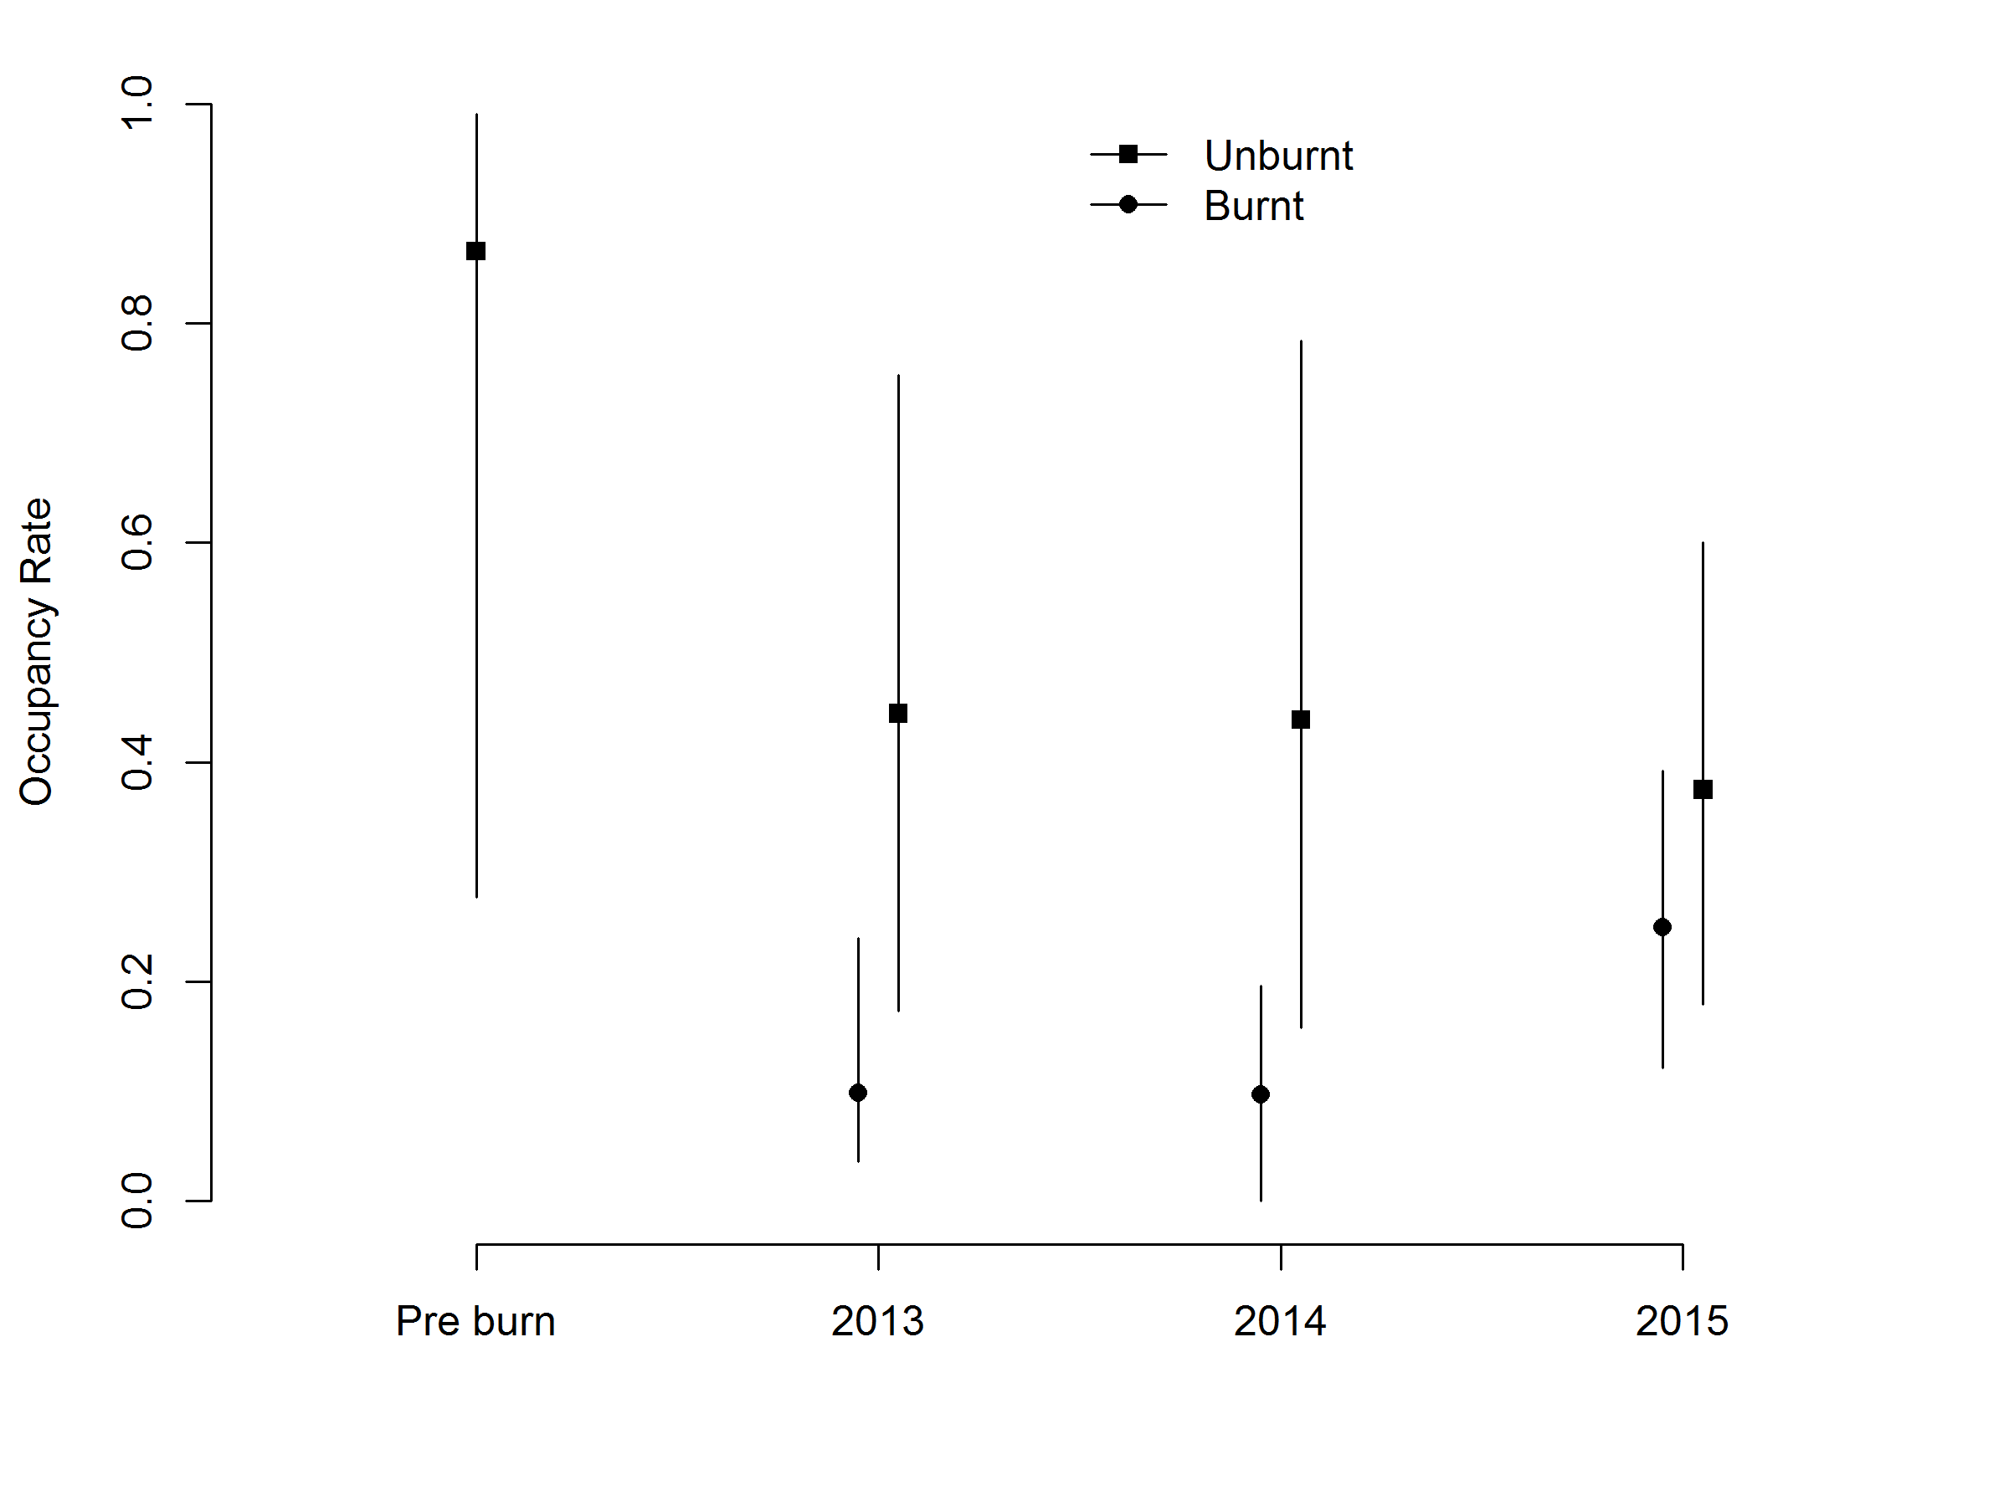

Figure 16. Short-beaked Echidna occupancy rates for sites categorised as unburnt and burnt areas

Vertical lines represent the 95% confidence limits.

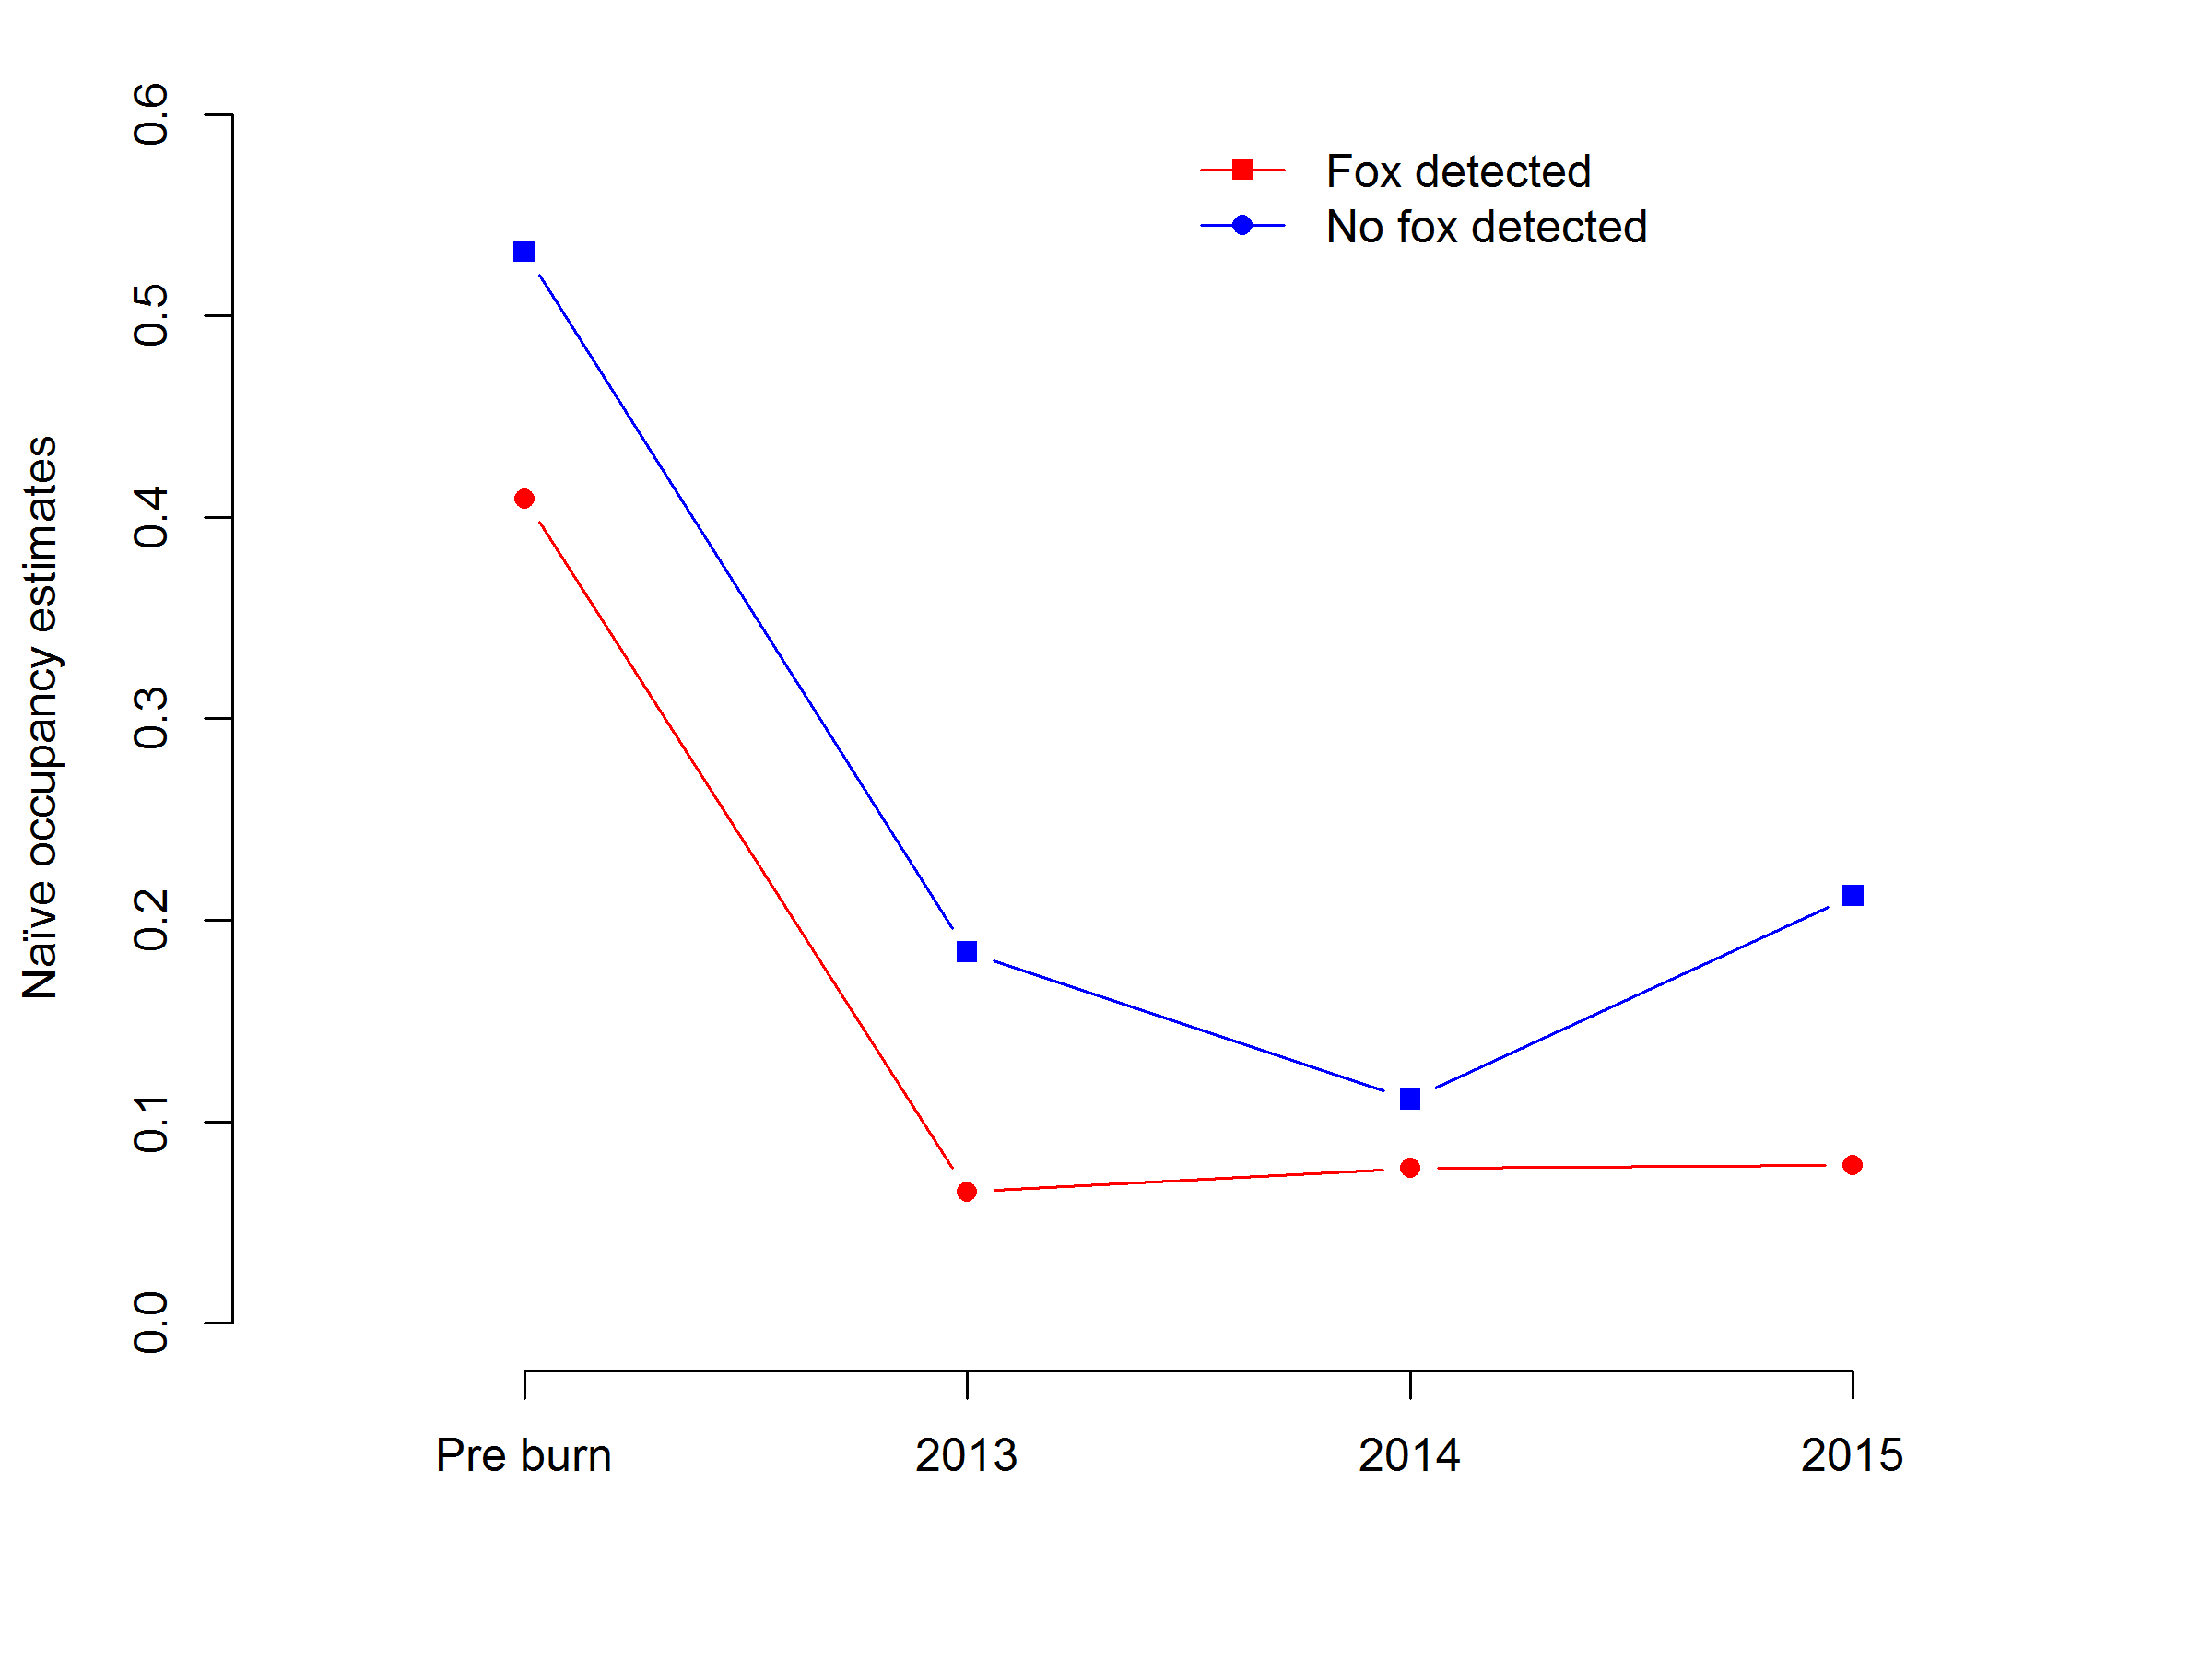

Figure 17. Naïve Short-beaked Echidna occupancy rates for sites categorised by the detection or non-detection of Red Foxes

3.4.7 The role of unburnt patches of vegetation

The presence of unburnt vegetation patches was only a significant explanatory variable for Short-beaked Echidna occupancy. For the remaining species, small numbers of detection resulted in large standard errors (clouding the interpretation of the results).

Southern Brown Bandicoots and Long-nosed Potoroos did make use of unburnt patches; however, this varied between sites and with time. At Mt Clay, Southern Brown Bandicoots used unburnt patches just over four times more often than burnt patches in the immediate post-burn period, but this declined by nearly half in 2014. While at Hotspur, they used one unburnt patch in 2014, compared with 12 burnt sites between the immediate post-burn period and 2015. Long-nosed Potoroos were detected once in the immediate post-burn period in an unburnt patch. No species were recorded using unburnt patches at Annya.

Foxes’ use of unburnt patches also varied between locations and over time. At Annya, foxes were detected at 91% of unburnt sites compared with 100% of burnt patches from the immediate post-burn period to 2015. At Hotspur, foxes were generally detected more often in 2015, and proportionally more in unburnt patches than not. At Mt Clay, fox detection generally increased across the site in 2013, with unburnt patch use in 2014 decreasing to below the levels in burnt areas.

3.5 Movement of foxes

3.5.1 Mt Clay and Hotspur 2013

We fitted GPS data logger collars to four foxes (two males and two females) at Mt Clay and six foxes (three males and three females) at Hotspur in January 2013 (Figure 18), 2 months prior to the ignition of the planned burns at these sites.

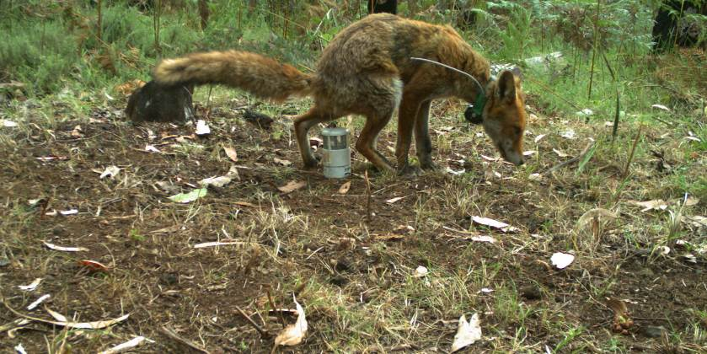

Figure 18. Fox fitted with GPS tracking collar

Two foxes were shot by landholders: one on private property to the north of Mt Clay ~1 month after it was attached and before the planned burn, the other was shot before the planned burn near Mt Richmond, ~20 km to the south-west of Mt Clay. Both collars were returned by the landholders. The remaining 2 collars from Mt Clay were retrieved but only 1 of the 6 from Hotspur could be found despite extensive searching of the location and surrounding area. The location data enabled territory size to be estimated (Table 4). It is unknown whether the loss of the remaining collars was related to the failure of the collars to operate correctly or to foxes dispersing from the site.

All retrieved collars failed to record locations as programmed, due to an error in the software supplied by the manufacturer. Later investigations by the manufacturer determined that an automated software update incorrectly set the internal clock date to 2017, forcing the collars to shut down. Hence, no post-burn data is available for these foxes.

Table 4. Results of fox trapping and the fate of each fox at Mt Clay and Hotspur 2013

The fate of the collars and the number of days GPS data was recorded.

|  |  |  |  |  |  |  |
| --- | --- | --- | --- | --- | --- | --- |
| Site | Species | Sex | Weight | Fate | Days | 100% MCP (km2) |
| Mt Clay | Fox | M | 3.25 | aShot/Retrieved | – | – |
|  | Fox | F | 3.5 | Retrieved | 57 | 3.24 |
|  | Fox | F | 4.0 | Shot/Retrieved | 22 | 0.92 |
|  | Fox | M | ~4.0 | Lost | – | – |
| Hotspur | Fox | F | 2.5 | Retrieved | 1 | NA |
|  | Fox | M | 2.5 | Retrieved | 98 | 1.40 |
|  | Fox | F | 5.0 | Lost | – | – |
|  | Fox | F | 2.5 | Lost | – | – |
|  | Fox | M | 3.25 | Lost | – | – |
|  | Fox | M | 3.0 | Lost | – | – |

a fox shot near Mt Richmond

3.5.2 Annya 2014/15

Overall, we captured 18 foxes (13 females, 5 males) and collared 11 in close proximity to the location of the burn planned for autumn 2015 (Appendix 4).

We retrieved eight collars; however, one of these had its GPS antenna chewed off (resulting in no usable fixes being recorded), two collars could not be retrieved despite extensive searching and a third collar failed to release as scheduled and could not be retrieved.

3.5.3 Fox territory pre- and post-planned burn

Of the seven collars, five had sufficient GPS location data spanning the pre- and post-burn period to assess changes in territory size following the burn (Table 5). One of these collars (4160) stopped operating 12 days post-burn, obtaining 163 fixes. This fox was included in the pre- and post-burn movement analysis; however, results for this individual should be interpreted with caution. Two collars (5590 and 6010) failed to record data until after the planned burn, and the manufacturer was able to explain why the programming failed on these collars.

The territory sizes of two foxes (4160 and 6410) that overlapped the burn area changed post-burn, increasing by 13.3% and decreasing by –65.1% respectively. The territory size of two other foxes (4590, and 4780) with pre- and post-burn data remained similar and a third collar (4400) contracted its area of use by --30.4% (Figure 19).

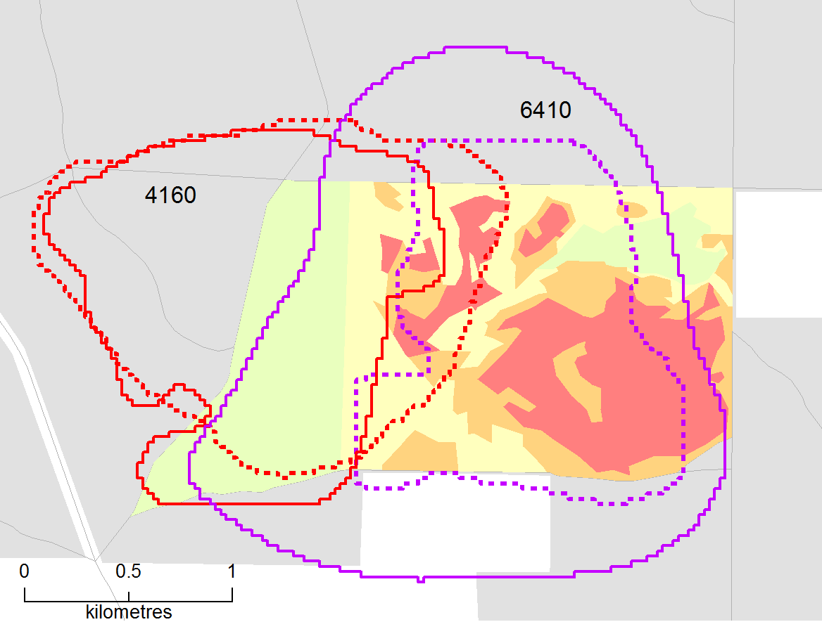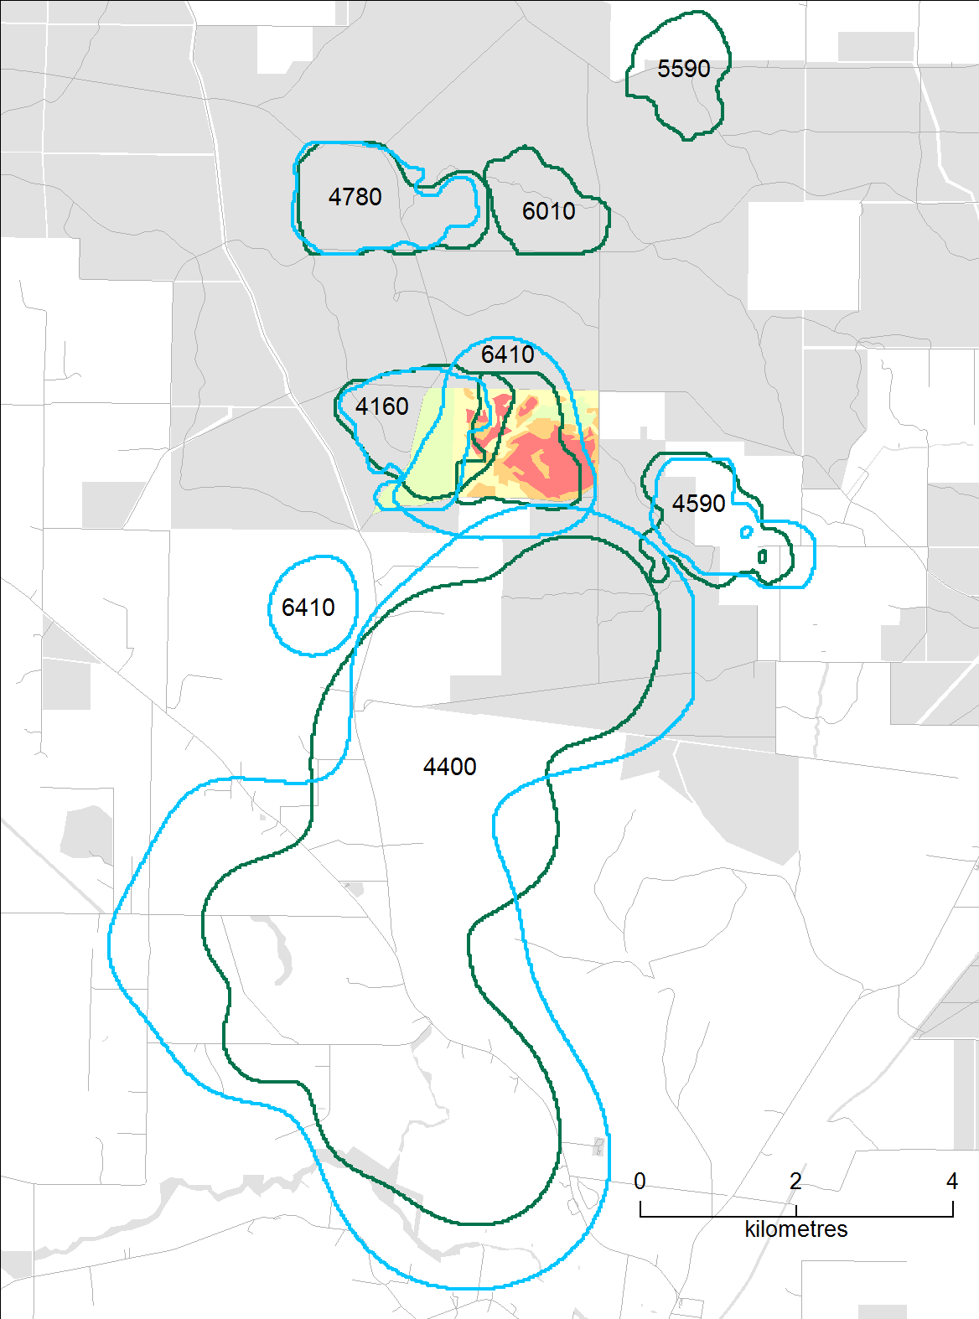

Figure 19. Territories of foxes pre- (blue) and post-burn (green) at Annya State Forest in 2015

Exploded view: Fox 6410 – purple solid line pre-burn, dashed line post-burn; Fox 4160 – red solid line pre-burn, dashed line post-burn. Collars failed to record the GPS locations for Foxes 6010 and 5590 pre-burn.

Table 5. The number of GPS location fixes pre- and post-burn and the estimated 95% Kernel Density Estimate for fox territories in this study

|  |  |  |  |  |  |  |  |  |  |  |
| --- | --- | --- | --- | --- | --- | --- | --- | --- | --- | --- |
| Fox ID | Sex | Weight | # fixes pre-burn | # fixes post-burn | Total # fixes | # of days pre-burn | # of days post-burn | Pre-burn 95% KDE (km2) | Post burn 95% KDE (km2) | % change |
| 4160 | F | 4.0 | 1160 | 663 | 1823 | 88 | 35 | 2.4 | 2.72 | 13.3 |
| 4400 | F | 5.0 | 1401 | 1831 | 3232 | 88 | 47 | 40.5 | 28.18 | -30.4 |
| 4590 | M | 4.0 | 1528 | 2789 | 4317 | 88 | 58 | 2.13 | 2.23 | 4.7 |
| 4780 | F | 3.0 | 1379 | 891 | 2270 | 88 | 38 | 2.46 | 2.71 | 10.2 |
| 5590 | F | 3.0 | 0 | 985 | 985 | 0 | 66 | – | 1.49 |  |
| 6010 | M | 4.5 | 0 | 428 | 428 | 0 | 40 | – | 1.48 |  |
| 6410 | F | 4.1 | 1469 | 163 | 1632 | 88 | 12 | 5.82 | 2.03 | -65.1 |

The planned burn area included 39% of 6410’s territory pre-burn; following the fire, this fox contracted its territory and concentrated its territory use within the burn area, so 84% of its post-burn territory was within the burnt area. Although only 163 locations were recorded post-burn for 4610, 158 were within the burnt area. Of these, 30% were in the medium burn severity areas, 27% in the high burn severity areas, and 22% in each of the patchy and unburnt areas. This fox tended to use the unburnt area more frequently (22% of all locations) than the availability of this habitat (6% of the available habitat within the burnt area). The GPS points in the unburnt area were spatially clustered, suggesting a den or feeding site. Fox 6410 consistently travelled to open farmland at night every 2–3 days pre-fire, with the last farmland visit occurring 9–10 April (3 days before the fire); she did not leave the forest again during the tracking period (B. Hradsky pers. comm.). F440 decreased its territory size by 30.4% in the post-burn period, however; this fox never overlapped with the burn area. The contraction of this foxes territory may be related to changes in resources, as most of its territory was on cleared, private agricultural land.

3.6 Changes in fox diet

Scats were collected from the Annya and Hotspur study areas (sites with no fox control) and Mt Clay (fox control site) prior to the autumn 2013 planned burn and post-burn, and from at Annya and Hotspur in 2014 (Table 6).

Table 6. Location and number of fox scats collected pre- and post-burn in 2013 and 2014

|  |  |  |  |
| --- | --- | --- | --- |
| Site | Pre-burn | Post burn | 2014 |
| Annya | 34 | 30 | 40 |
| Hotspur | 48 | 28 | 39 |
| Mt Clay | 28 | 6 | – |
| Total | 110 | 64 | 79 |

Altogether, we walked 35.4 km over 24 h, collecting 110 scats prior to the burn. Post burn and in 2014, we collected scats opportunistically while setting fox traps and driving tracks and roads.

There was a significant reduction in prey diversity in the diet of foxes from the pre-burn (H’ = 2.44) to the post-burn period (H’ = 1.67; *t* = 2.13, *P* = 0.0002), and an increase from the post-burn to the 2014 period (H’ = 2.35; *t* = 2.13, *P* = 0.0003). There were some large differences in the prey items consumed between pre- and post-burn periods and between the post-burn and the 2014 periods (Figure 20). Western Grey Kangaroos (*Macropus fuliginosus*) and Common Ringtail Possums were the two main prey items pre-burn; kangaroos declined by 50% from pre-burn to post-burn and by 76% from post-burn to 2014, while possums increased by 57% and then declined by 38%, respectively. Black Wallabies (*Wallabia bicolor*) were a significant component also in the pre-burn diet comprising 11% of the pre-burn food item. The proportion of wallabies declined by 84% in the immediate post-burn period before increasing by 55%. The occurrence of Southern Brown Bandicoots in fox scats showed a similar pattern, with a 82% increase post-burn, then a 63% decrease in 2014. Long-nosed Potoroos were absent in the diet samples in the post-burn period, but increased by 56% from the pre-burn period to 2014. Common Brushtail Possums showed an increase (12.5%) between the pre-burn and post-burn periods, also followed by a decrease (22%) in 2014.

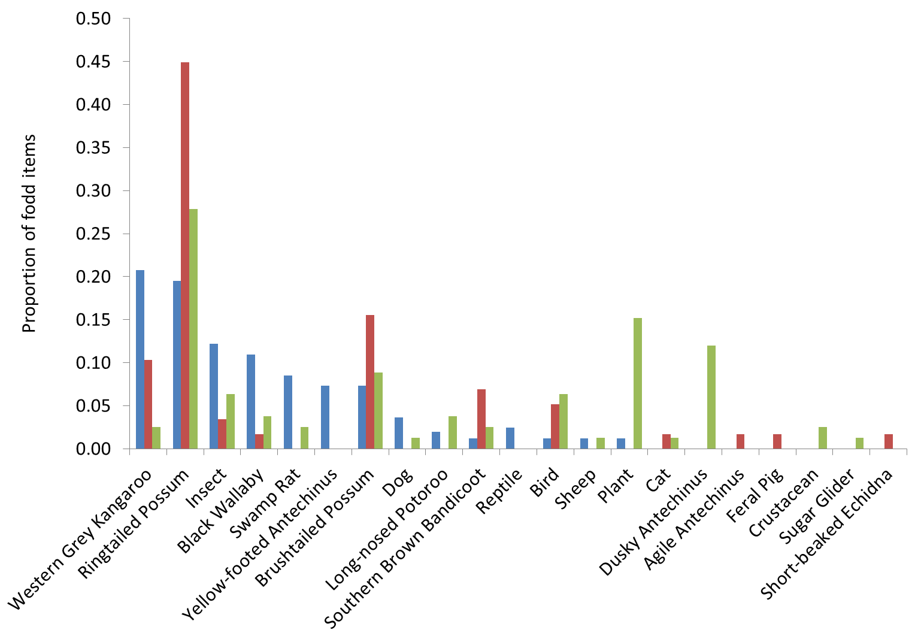

Figure 20. Percentage of identified food items from fox scats combined across Hotspur and Annya pre- (blue bar), post-burn 2013 (red bar) and in 2014 (green bar)

Agile Antechinus (*Antechinus agilis),* Dusky Antechinus (*Antechinus swainsonii*), Dog (*Canis lupus*), Feral Pig (*Sus scrofa*), Sheep (*Ovis aries*), Swamp Rat (*Rattus lutreolus*), Sugar Glider (*Petaurus breviceps*),Yellow-footed Antechinus (*Antechinus flavipes*).

4 Discussion

Predation and fire shape the structure and function of ecosystems globally (Pastro et al. 2014). However, few studies have explored the interactions between these two processes, and large-scale experimental manipulations of these processes have been very rare. Lack of knowledge about these interactions is significant, not only for ecological theory, but also in an applied context, because it limits the ability of land managers to predict the outcomes of manipulating fire and predators.

This project set out to investigate the combined impact of planned burning and predation by the Red Fox on the survival and persistence of native mammals in tall mixed forest in south-west Victoria. The original plan was to compare the effects of planned burns in areas of high and low fox abundance in order to investigate the relative importance of burning and predation. However, due to the loss of the two low-fox-abundance sites as a result of the escaped planned burn at Mt Clay, and the resultant diversion of resources away from carrying out the planned burn at the Cobboboonee site, we were unable to make this comparison. We were, however, able to investigate the current management practice of planned burning in the presence of foxes, thus providing quantitative data on (i) changes in habitat attributes important to native mammals, (ii) native species survival, (iii) differences in fox movement and activity pre-burn and post-burn, and (iv) differences in fox diet pre-burn and post-burn.

The outcomes of this project provide information addressing a number of Key Evaluation Questions set out in the Monitoring, Evaluation and Reporting Framework (DELWP 2015), chiefly:

(i) How have fuel management strategies changed the occupancy of fire-sensitive species within their preferred habitat? and

(ii) How has the abundance of key habitat attributes changed as a result of fuel management?

We note that our project was limited by lack of (i) a treatment site with lowered levels of fox abundance and (ii) a site with no fox control and no burning. Inclusion of such sites was planned for, but due to circumstances mentioned above, these sites were removed from the project. Also the inclusion of a set of sites with no burning and no fox control would have been prohibitively expensive. These limitations mean we need to be cautious about making broad generalisations about the impact of planned burning and predation across the broader landscape. Despite this limitation, our results provide information for land managers on a number of key findings regarding planned burning and fox interactions and the resultant impact on native mammals.

Floristic and habitat attributes

* For 2 years after the burn, habitat structural attributes important for native mammal survival were significantly reduced by the planned burns. Ground- and mid-storey vegetation layers were the most affected.
* Unburnt patches within the burn area played no detectable role in the post-burn survival or recovery of Southern Brown Bandicoots or Long-nosed Potoroos; neither species was detected in unburnt patches post-burn at either location.

Mammal responses to planned burns

* Planned burning reduced the occupancy of Southern Brown Bandicoots for at least 2 years.
* Long-nosed Potoroos became locally extinct primarily due to the impact of the planned burns, with some evidence of fox presence also being a factor.
* Common Ringtail Possums declined after the burn, with fox presence affecting their occurrence.
* Short-beaked Echidnas declined post-burn, and were detected more often at sites without foxes and in unburnt patches.
* Common Brushtail Possum occupancy was not significantly altered, either by the planned burn or the presence of foxes.

Fox response to planned burns

* Of the two foxes whose home ranges overlapped with the burnt area, one contracted its territory and the other expanded its territory to spend more time in the burnt area post-burn.
* Southern Brown Bandicoots increased in the diet of foxes post-burn. Long-nosed Potoroos were absent in the diet in the immediate post-burn period, but were present 12 months after the burn, despite not being detected by digital camera surveys in the same period.

Native mammal response to planned burning was not uniformly related to either the effect of the burn or the presence of foxes, and varied by location. Our data indicated that habitat attributes providing escape advantage (vegetation cover, woody debris, logs) and possibly food (plant species diversity and abundance) were significantly reduced immediately post fire, but that these attributes had recovered to near pre-burn levels after 2 years. Importantly, despite habitat recovery, Southern Brown Bandicoots and Long-nosed Potoroos showed no sign of recovery within the 2 years following the planned burns and may have been rendered locally extinct. A significant driver for the decline and local loss of Long-nosed Potoroos was the presence of foxes. Also of importance was the observation that unburnt patches within the burn area played no detectable role in the post-burn protection or the recovery of Southern Brown Bandicoots or Long-nosed Potoroos. Ringtail Possums were affected by the burn, and Common Ringtail Possum presence was positively related to the presence of foxes. Short-beaked Echidnas were more common on sites with fewer foxes and in unburnt patches for up to 12 months post-burn, whereas Common Brushtail Possums were unaffected by the fire or by the presence of foxes. This study has added knowledge concerning the role of predation and its interactive effects in limiting recovery and in contributing significantly to local extinctions of native mammal species.

**Native mammal response to fire and predators**

Our results, which explicitly account for the role of foxes in the system, suggest a more complex mechanism for species response to the impact of planned burning than reported elsewhere. For example, Monamy and Fox (2000) showed that post-fire colonisation was related to the rate of vegetation density recovery rather than time since fire for small mammals. Similarly, Swan (2014) showed that small mammal diversity was not directly related to either time since fire or vegetation type, but that habitat structure drove beta diversity (multi-site or regional-scale species richness). These and other studies (e.g. Lindenmayer et al 2008; Griffiths and Brooks 2014; Pastro et al. 2014) have not attempted to incorporate the role of fox predation, hence possibly excluding an important driver for native mammal response to burning. The longer-term responses of native mammals to fire have been shown to interact in a complex manner. Arthur et al. (2012) showed that while Southern Brown Bandicoots recovered following bushfires in parallel with increasing shrub cover, they later declined faster at locations with senescing cover; they suggest a possible link between the concurrent increase in feral Cats and the decline in cover with the decline in bandicoots in their study area.

In this study we demonstrated a significant decline in and local loss of Southern Brown Bandicoots and Long-nosed Potoroos that was related to planned burning and the presence of foxes. The results of this study are consistent with other studies. Smith (2013) reported that Southern Brown Bandicoots were undetectable following a planned burn for up to 18 months post-burn. Smith’s study area had been subject to 8 years of continuous fox control, but was known to have feral Cats present (A. Robley pers. obs.). A study in South Australia in 2009, which assessed Southern Brown Bandicoot survival for 6 months post-burn, recorded fatalities due to predation both during the burn and after the burn (K. Abley pers. comm.). In New South Wales (NSW), Southern Brown Bandicoots were regularly detected at a long-term monitoring site (Wilson 2004). However, following a fuel reduction burn, this species was not detected during the 7-year post-fire monitoring period (NSW National Parks and Wildlife Service, Fox Threat Abatement Plan, unpubl. data). Pardon et al. (2003) investigated the survival of Northern Brown Bandicoots (*Isoodon macrourus*) under four experimental fire regimes and found that the species declined under all treatment conditions. Non-native predators were either known or presumed to occur at these sites. Notably, this decline in bandicoots in response to planned burning is not universal. Catling et al. (2001) found no relationship between bandicoot survival and time-since fire over 25 years, but reported an increase in the species with increasing habitat complexity. In addition, in NSW heathland vegetation, Hope (2012) found that Southern Brown Bandicoots survived a low-intensity burn for up to 5 months post-burn (after which monitoring ceased).

A number of studies have investigated the association of Long-nosed Potoroos with time since fire (Claridge and Barry 2000), and the pattern of their occurrence with respect to successional stages following fire (Catling et al. 2001). Direct observational or experimental data on post-fire survival and use of habitat by Long-nosed Potoroos is limited to the present study and that of Smith (2013). Long-nosed Potoroos were rare in the landscape of our study locations and appeared not to survive the combined impacts of fire and predation, despite evidence of broader habitat recovery 2 years post-burn. This is in contrast to Smith (2013), who reported that Long-nosed Potoroos survived the immediate impact of the fire at Mt Clay, and persisted at the site for 18 months (monitoring ceased at that point). One explanation for this difference is that the Annya and Hotspur populations were small prior to the burn, and that the combined effect of the burn and the subsequent apparent increase in predation resulted in the local extinction of the population—a classic example of the small population paradigm (Caughley and Gunn 1996).

The remaining three species for which we had sufficient camera detections for analysis showed varied responses to the burn and the presence of foxes. Common Brushtail Possums appeared unaffected by either the burn or the presence of foxes, which is similar to the findings of Lindenmayer et al. (2008) and Isaac et al. (2008), who both found that Common Brushtail Possums were unaffected by fire. Post burn occupancy by Common Ringtail Possums declined, but occupancy rates return to pre-burn levels 2 years post-burn. What the longer-term trajectory for these populations might be is hard to predict.

Short-beaked Echidnas are known to be preyed upon by foxes (Mitchell and Banks 2005), and there was evidence that echidnas were more detectable by cameras at sites without foxes. Echidnas were the only species in this study for which unburnt patches were a significant explanatory variable associated with post-burn occupancy.

**Changes in fox diet following planned burning**

There are few examples in the literature that demonstrate increased rates of predation by foxes on native species following bushfire or planned burning. While our results were limited to two sites with a small sample size, they do show an increased occurrence of both Southern Brown Bandicoots and Long-nosed Potoroos in fox scats post-burn. Similarly, predator scat analysis showed an increase in the predation rate on Southern Brown Bandicoots in the months following a fire in South Australia (K. Abley pers. comm.)

The occurrence of Common Ringtail Possums in the diet of foxes increased substantially post-burn, and the presence of foxes at sites with higher rates of Common Ringtail Possum occupancy may be a result of foxes seeking out sites with this food source. Common Ringtail Possums are a common food item for foxes in forested habitats (Triggs et al. 1984; Mitchell and Banks 2005), and in our study area they may have supported foxes following the burn. Following a major bushfire in the Ku-ring-gai Chase National Park, Common Ringtail Possums became locally extinct; they were reintroduced into the burnt area 4 years post fire. The reintroduction ultimately failed as a result of predation by both native and introduced predators (Russell et al. 2003).

There is similar evidence for Common Brushtail Possums, in that while this species did not decline as a result of the planned burning, the proportion of Common Brushtail Possums increased in the fox diet in the immediate post-burn period. Isaac et al. (2008) recorded an influx of new Common Brushtail Possums into burnt areas and suggested that this was related to the resprouting of vegetation. Similarly, Newsome et al. (1983) suggested that post-fire predation on Common Brushtail Possums by Dingoes (*Canis dingo*) was disproportionately high relative to their abundance. An influx in Common Brushtail Possums may explain the seemingly contradictory evidence in our study of no decrease in occupancy but an increase in fox diet, with the influx of new individuals balancing out the off-take by fox predation. This assumption requires further investigation.

Radford (2012) showed that predation by native mammals on their prey increased in recently burnt areas compared with in long-unburnt areas. Radford suggested that this may be evidence of predators regulating the abundance of prey after the removal of the ground-layer vegetation by fire.

**The use of unburnt areas within planned burns**

The presence of unburnt habitat patches can have an important ecological function as refuges for fauna in fire-prone environments (Robinson et al. 2013). Refuge from predation is often positively associated with habitat structure (Huffaker 1958), and it can stabilise predator–prey interactions by providing habitat patches within which the efficiency of predator hunting is reduced. It is assumed that a combination of reduced predator pressure and unburnt patches within burn sites could provide the best opportunity for native species at risk from both fire and predation to (i) survive the immediate burn, (ii) have access to the habitat structure necessary for avoiding or reducing the impact of post-burn predation and (iii) to have possible sources of local recolonisation. The areas of unburnt habitat in our study had the potential to provide refuge for Long-nosed Potoroos and Southern Brown Bandicoots (a number of unburnt patches were large enough to accommodate several home ranges and were structurally intact). However, there was no evidence that these species made use of this habitat. In contrast, in South Australia, those Southern Brown Bandicoots that survived the immediate post-fire period shifted their home ranges into unburnt habitat within their pre-fire home ranges (K. Abley pers. comm.), and in her study at Mt Clay, Smith (2013) found that Long-nosed Potoroos made use of unburnt patches, allowing them to persist for at least 18 months post-burn.

In our study, Short-beaked Echidnas tended to use unburnt patches immediately following the burn. However, by 2015 (2 years post-burn), there was no difference in occupancy between burnt and unburnt patches. This indicated that, at least for echidnas, the habitat had sufficiently returned to pre-burn levels to allow recolonisation of the burnt area.

Patch creation within burns and across the landscape can have counterintuitive impacts. Creating unburnt patches can create edges in addition to the edges created by other processes (e.g. fragmentation resulting from land clearing for agriculture and forestry). Creating too many edges (both within burn areas and across the landscape) can lead to increased rates of predation by predators. Foxes have been shown to predate upon avian nests up to 4 km into forest patches from forest edges (Storch et al. 2005). Salek et al. (2010) demonstrated that edges can be also associated with higher levels of prey abundances, which in turn can lead to higher abundances of predators, including Red Foxes.

**Fox response to planned burning**

The Red Fox response to the planned burn appeared to be localised, with territory use by foxes outside the immediate planned burn area remaining unchanged immediately post-burn. In contrast, the two foxes that had territories encompassing the burn intensified their use of the burnt area. While it may be tempting to consider fox control at the scale of the planned burn to remove the immediate post-burn risk, foxes are well adapted to compensate for any form of population reduction and rapidly colonise vacant territories from both short and long distances (Coman et al. 1991), hence fox control needs to be at a spatial scale that suppresses foxes over a larger area and that control needs to be maintained for at least 2 years to allow habitat to recover to pre-burn levels.

We have shown the potential for foxes to increase their use of burnt areas within their territories and to increase predation rates following burning. Meek and Saunders (2000) also reported foxes using recently burnt heathlands in NSW, with several foxes increasing their use of recently burnt areas, and one making burnt areas an important part of its home range. However, this may not be a universal response or a long-lasting one. Payne et al. (2012) and B. Hradsky (pers. comm.) demonstrated that, at a broader landscape scale, fire history did not affect the distribution of foxes in the landscape, with foxes found in all vegetation age classes of time-since-fire.

Management implications and recommendations

The fuel management strategy implemented at our study locations aimed to reduce fuel loads by 80% across the burn area. The interaction between predation and the reduction in habitat complexity (resulting from the fuel management strategy) led to a decline in Southern Brown Bandicoot occurrence and the complete loss of Long-nosed Potoroos at the burn sites. The fuel management strategy also resulted in a significant loss of habitat attributes important to the occurrence of native species; however, there were signs of recovery 2 years post-burn. We recommend that in order for predator control to be effective, it should be implemented at sites with species known to be at risk from predation, and commenced at least 2–3 months prior to the implementation of planned burning. It should continue for at least 2 years or until the habitat attributes upon which the target native species depend have returned to pre-burn levels.

The small fragmented populations of some native species that can result from planned burning have an increased risk of going extinct due to stochastic events (Caughley and Gunn 1996). The results of this study, and similar studies across the country, indicate that reducing predation pressure post-burn would limit the likelihood of planned burns impacting negatively on the occurrence of native species.

Broad-scale, long-term and continuous control of foxes (e.g. in the Glenelg, Grampians, Central Highlands, and Southern Ark programs) that cover areas >100,000 ha may already be benefiting biodiversity in locations where planned burns have been implemented. The role of feral Cats remains unknown in these landscapes. Integrating planned burning with fox and feral Cat control measures as part of the design of these adaptive management programs is a critical next step in their continued improvement.

The specifics of such predator control programs (e.g. short-term versus continuous baiting, baiting versus trapping, inclusion of shooting, type of bait, etc.) will vary depending on local conditions, the underlying densities of the predators and the life-history strategy of the target native species. The general approach for predator management strategies, however, should include clearly stated objectives, thoughtful planning, adequate resourcing, and robust monitoring and evaluation—leading to continued improvement.

The scale at which monitoring occurs is an important consideration when assessing the impact of fuel management strategies and predator control programs on at-risk species. The spatial scale at which fauna communities are studied affects our ability to detect relationships between changes in habitat characteristics, patterns of species diversity, and species composition, and it may obscure differences in how species perceive the scale of environmental variation (Pearman 2002). By only considering landscape-scale biodiversity impacts, and monitoring across broad areas, we may miss important relationships between species survival, habitats affected by fire, and predation. A multiscale monitoring, evaluation and reporting approach would overcome this shortfall, with monitoring at specific case study locations (i.e. at the scale of individual burns, assessing how species and habitats respond specifically to fuel reduction strategies) and also at the broader landscape scale.

Future areas of investigation

We present a list of possible research/monitoring activities aimed at filling specific knowledge gaps in relation to the application of fuel management and its associated impacts on the ecological condition or resilience of the landscape over time. The activities outlined below focus primarily on knowledge gaps regarding fire-mediated impacts of non-native predators on biodiversity.

Post burn population trajectory of species at risk from fox predation

The predator–fire project in south-west Victoria has demonstrated that 2 years post-burn, Long-nosed Potoroos and Southern Brown Bandicoots have shown no signs of recovery, despite indications that habitat attributes have returned to near pre-burn levels. Continuation of the monitoring program through integration with the Glenelg Ark project would provide longer-term data for informing management about the relationship between post-fire mammal recovery, vegetation growth stage structure and predation.

Monitoring, evaluation and reporting key evaluation questions (MER KEQs) (DELWP 2015) addressed by this proposal are;

* How have fuel management strategies changed the occupancy of fire-sensitive species within their preferred habitat?
* How has the abundance of key habitat attributes changed as a result of fuel management?

Do patchy burns increase predation risk for surviving native mammals at risk from fox predation?

Spatially heterogeneous habitats (i.e. habitats with structural complexity) are thought to play a role in mediating predator–prey dynamics by reducing the efficiency with which predators can search for, encounter and kill prey. However, planned burns simplify habitat complexity in the short to medium term, potentially increasing predation risk. Unburnt areas within planned burns are considered to benefit native wildlife by providing immediate refuge from the effects of the burn, by providing possible sources of intraburn recolonisation, and by retaining the required structural complexity to mediate increased predation. Considerable variation is likely to occur in unburnt patch quality, resulting in native species being energetically stressed and leading to prey species using areas in which predation risk is high, which may lead to increased search efficiency by predators. Thus, planned burning can create islands of habitat of variable quality surrounded by a sea of high predation risk. Increased use of this risky habitat increases the probability of encounter by predators. It would be useful to test this assertion by quantifying the habitat complexity, landscape context, size, and shape of unburnt patches immediately following burns, matched across a range of planned burns, and contrasting the use of unburnt patches by native species and predators with use of the surrounding burnt habitat in areas with and without a long history of fox control.

Do unburnt habitat patches within planned burns provide sites of refuge from predation in the medium term across growth stages?

It is widely considered that refuge habitat is critical to post-planned burn survival and recolonisation of fire-sensitive native fauna; however, the empirical data to support this assertion is limited (Robinson et al. 2013). Little information is available to inform land managers regarding the importance of refuges to native species at risk from predation (fire-sensitive or not), or regarding the best size, number, structure or configuration of refuges, or their spatial arrangement in the landscape. Across the 100,000 ha of the Glenelg Ark project area a number of planned burns occur each year, within and outside the fox control areas. This management operation could be used to characterise the unburnt habitat and its use by native mammals, and assess this use over time in areas with and without fox control. Biophysical attributes would be considered within the unburnt patch, as well as the landscape context of unburnt areas across the landscape. Information gained from this project would be used to develop guidelines for the creation of unburnt patches for the management of species at risk from fox predation.

MER KEQs addressed by this proposal:

* How have fuel management strategies changed the occupancy of fire-sensitive species within their preferred habitat?

Unintended cascading effects of planned burning and predator reduction—can increased herbivory retard ground-dwelling native mammal recovery?

Ecosystems are complex, with bottom-up and top-down process acting to shape their structure. Management interventions in ecosystem processes can have unintended outcomes. Substantial and sustained reduction of foxes (as the only apex predator) can result in overbrowsing or grazing of canopies and mid-storey vegetation by possums and wallabies (which respond numerically to less predation pressure). This could prevent regeneration of rare ground-layer species (e.g. orchids), eliminating them by digging herbivores, e.g. Swamp Rats (*Rattus lutreolus*). The resulting alteration of the habitat structure and floristic composition could exacerbate the impacts of predation on native mammals by foxes (and feral Cats). Changes to habitat attributes also have implications for the role of refuge habitat as locations for native animal persistence post-burn, because habitat quality in refuges may decrease rapidly post-burn due to intensified use in the medium term. It would be useful to investigate these issues by contrasting a set of replicated growth stage structures inside and outsider the Glenelg Ark fox control areas and measuring plant species abundance, floristic composition and habitat structure, then relating this to the occurrence of browser and grazer abundance and the occurrence of native mammals at risk from fox predation. This could include the use of herbivore enclosures within burnt and unburnt patches following planned burns. Information from this project would guide the development of planned burning and predator control prescriptions for bushfire management planning.

MER KEQs addressed by this proposal:

* How appropriate are the current thresholds of management action for avoiding fundamental change in each Ecological Vegetation Division?
* How have fuel management strategies changed the occupancy of fire-sensitive species within their preferred habitats?
* How has the abundance of key habitat attributes changed as a result of fuel management?

Predicting areas in the landscape where native species are most at risk from predation due to changes in habitat created by planned burning

GIS-based techniques could be used for modelling the distribution of predator and selected native species populations spatially, and for defining habitat structure. To determine the spatial predictors of predation in areas of planned burning (possibly covering a range of Growth Stage Structures), inductive–spatial modelling could be used. Predation risk could be interpolated across regions using a linear regression model for spatio-temporal predictors of predation risk, with a predation risk surface and surfaces representing predator abundance, prey abundance, and habitat structure. These measures would augment traditional ecological approaches and assist land managers by identifying where in the landscape predator control should be targeted, and the importance of predator, prey and habitat measures as spatial determinants of predation. This would require a staged approach, collating existing datasets and determining the feasibility of creating the predictive risk layers; if successful, a full analysis across a test region would be carried out.

MER KEQ addressed by this proposal:

* How have fuel management strategies changed the occupancy of fire-sensitive species within their preferred habitat?

Differences in animal population densities/abundance are predicted by spatial changes in habitat structures and not by temporal changes resulting from growth stage structure

Proposed fire management strategies to meet the Department’s responsibilities under the second objective of the Code of Bushfire Management assume that animal population density or abundance alters in response to averaged vegetation condition across a large habitat, i.e. a Growth Stage, and that it should be possible to optimise the spatial arrangement of Growth Stages in the landscape to benefit a broad range of biodiversity. This assumption may not be true—spatial ecological approaches consider that population density/abundance changes in response to the local conditions experienced by individuals, which may be at a scale independent of Growth Stage Structures. The Glenelg Ark project has implemented large-scale continuous fox control over 100,000 ha since 2005 and has in place 240 monitoring sites with recorded presence/absence of native species over the past 10 years. It should be possible to investigate the spatial occurrence of native species at risk from fox predation (in areas with and without fox control), to characterise the habitats occupied, and to compare this with occurrence based on Growth Stages across the landscape. This could be done using existing datasets.

MER KEQ addressed by this proposal:

* How have fuel management strategies changed the occupancy of fire-sensitive species within their preferred habitat?
* How has the abundance of key habitat attributes changed as a result of fuel management?

How do feral cats respond to planned burning?

There is very limited data on how feral Cats respond to habitat changes resulting from planned burning, and the data that is available is associated with very large burns undertaken in northern Australia. There is a critical need to better understand how feral Cats respond to planned burring in mesic habitats in south-eastern Australia. Using the Glenelg Ark ongoing management initiative, it would be possible to undertake targeted camera surveys to assess differences in feral Cat activity (possibly abundance) pre- and post-burn across a replicated series of planned burns.

MER KEQ addressed by this proposal:

* How have fuel management strategies changed the occupancy of fire-sensitive species within their preferred habitat?

Regional scale population dynamics, predation and fuel management strategies

Further work is required to improve our understanding of how planned burning at the regional level impacts upon the survival of metapopulations of native species at risk from disturbances such as planned burning and predation by introduced carnivores. This would enable managers to better plan the timing and location of both planned burning and predator control.

Development of models is required for predicting the impact of bushfire and planned burns on the regional population dynamics of fire-sensitive native fauna. By integrating metapopulation models and fire behaviour modelling, it would be possible to assess the likely outcomes of a range of regional scale burning scenarios regarding the persistence of native species. This is of importance for land managers aiming to proactively use fire to manage for biodiversity values.

MER KEQ addressed by this proposal:

* How have fuel management strategies changed the occupancy of fire-sensitive species within their preferred habitat?

References

Arthur, A.D., Catling, P.C. and Ried, A. (2012). Relative influence of habitat structure, species interactions and rainfall on the post-fire population dynamics of ground-dwelling vertebrates. *Austral Ecology* **37,** 958–970.

Bennett, A.F. (1993). Microhabitat use by the Long-nosed Potoroo, *Potorous tridactylus*, and other small mammals in remnant forest vegetation of south-western Victoria. *Wildlife Research* **20**, 267–285.

Beschta, R.L. and Ripple, W.J. (2009). Large predators and trophic cascades in terrestrial ecosystems of the western United States. *Biological Conservation* **142**, 2401–2414.

Bjorneraas, K., Van Moorter, B., Rolandsen, C.M. and Herfindal, I. (2010). Screening global positioning system location data for errors using animal movement characteristics. *Journal of Wildlife Management* **74**, 1361–1366.

Bond, W.J. and Keeley, J.E. (2005). Fire as a global ‘herbivore’: the ecology and evolution of flammable ecosystems. *Trends in Ecology and Evolution* **20**, 387–394.

Bond, W.J., Woodward, F.I. and Midgley, G.F. (2005). The global distribution of ecosystems in a world without fire. *New Phytologist* **165**, 525–537.

Bradstock, R.A., Williams, J.E. and Gill, A.M. (2012). *Flammable Australia: the Fire Regimes and Biodiversity of a Continent*. Cambridge University Press, Cambridge, UK.

Buerkner, P-C. (2016). brms: Bayesian Regression Models using Stan. R package version 0.10.0. <https://CRAN.R-project.org/package=brms>. (accessed 15 January 2016).

Burbidge, A.A. and McKenzie, N.L. (1989). Patterns in the modern decline of Western Australia’s vertebrate fauna: causes and conservation implications. *Biological Conservation* **50**, 143–189.

Burgess, E.E., Moss, P., Haseler, M. and Maron M. (2015). The influence of a variable fire regime on woodland structure and composition. *International Journal of Wildland Fire* **24**, 59–69.

Catling, P.C., Coops, N.C. and Burt, R.J. (2001). The distribution and abundance of ground-dwelling mammals in relation to time since wildfire and vegetation structure in south-eastern Australia. *Wildlife Research* **28**, 555–564.

Caughley, G. and Gunn, A. (1996). *Conservation Biology in Theory and Practice*. Blackwell Science, Oxford, UK.

Chambers, J.M., Cleveland, W.S., Kleiner, B. and Tukey, P.A. (1983). *Graphical Methods for Data Analysis*. Wadsworth and Brooks/Cole.

Cheal, D. (2010). *Growth stages and tolerable fire intervals for Victoria’s native vegetation data sets*. Fire and Adaptive Management Report No. 84. Arthur Rylah Institute for Environmental Research, Department of Sustainability and Environment, East Melbourne, Victoria.

Christensen, P. (1980). *The biology of* Bettongia penicillata *(Gray, 1837) and* Macropus eugenii *(Desmarest, 1834) in relation to fire*. Bulletin No. 91. Western Australian Department of Forestry, Perth, WA.

Claridge, A.W. and Barry, S.C. (2000). Factors influencing the distribution of medium-sized ground-dwelling mammals in south-eastern mainland Australia. *Austral Ecology* **25**, 676–688.

Clarke, K.R., Somerfield, P.J. and Gorley, R.N. (2008). Testing null hypotheses in exploratory community analyses: similarity profiles and biota–environmental linkage. *Journal of Experimental Marine Biology and Ecology* **366**, 56–69.

Coman, B.J., Robinson, J. and Beaumont, C. (1991). Home range, dispersal and density of Red Foxes (*Vulpes vulpes* L.) in central Victoria. *Wildlife Research* **18**, 215–223.

Commonwealth of Australia. (2015). *Background document for the threat abatement plan for predation by feral cats*. Department of the Environment, Commonwealth of Australia, Canberra, ACT.

Dale, V.H., Joyce, L.A., McNulty, S., Neilson, R.P., Ayres, M.P., Flannigan, M.D., Hanson, P.J., Irland, L.C., Lugo, A.E., Peterson, C.J., Simberloff, D., Swanson, F.J., Stocks, B.J. and Wotton, M.B. (2001). Climate change and forest disturbances. *BioScience* **51**, 723–734.

DELWP. (2015). *Monitoring, evaluation and reporting framework for bushfire management on public land*. Department of Environment, Land, Water and Planning, Melbourne, Victoria,

DEPI. (2013). *Fire Operations Plan 2013/14 – 2015/16 Barwon South West Region*. Department of Environment and Primary Industries, Melbourne, Victoria.

Dickman, C. (1996a). Impact of exotic generalist predators on the native fauna of Australia. *Wildlife Biology* **2**, 185–195.

Dickman, C. (1996b). *Overview of the impacts of feral Cats on Australian native fauna*. Australian Nature Conservation Agency, Canberra, ACT.

DSE. (2012). *Code of practice for bushfire management on public land*. Department of Sustainability and Environment, Melbourne, Victoria.

Griffiths, A.D. and Brook, B.W. (2014). Effects of fire on small mammals: a systematic review. *International Journal of Wildland Fire* **23**, 1034–1043.

Hope, B. (2012). Short-term response of the Long-nosed Bandicoot, *Perameles nasuta*, and the Southern Brown Bandicoot, *Isoodon obesulus*, to low-intensity prescribed fire in heathland vegetation. *Wildlife Research* **39**, 731–744.

Huffaker, C.B. (1958). Experimental studies on predation: dispersion factors and predator–prey oscillations. *Hilgardia* **27**, 343–383.

Hutcheson, K. (1970). A test for comparing diversities based on the Shannon formula. *Journal of Theoretical Biology* **29**, 151–154.

Isaac, J.I., Valentine, L.E., and Goodman, B.A. (2008). Demographic responses of an arboreal marsupial, the common brushtail possum (*Trichosurus vulpecula*), to a prescribed fire. *Population Ecology* DOI 10.1007/s10144-007-0057-1 (accessed 12 November 2015).

Kinnear, J., Sumner, N.R. and Onus, M.L. (2002). The Red Fox in Australia—an exotic predator turned biocontrol agent. *Biological Conservation* **108**, 335–359.

Konietschke, F., Placzek, M., Schaarschmidt, F. and Hothorn, L.A. (2015). nparcomp: an R software package for nonparametric multiple comparisons and simultaneous confidence intervals. *Journal of Statistical Software* **64**, 1–17.

Lentic, M., Tischler, M. and Gordon, C. (2013). Desert small mammal responses to wildfire and predation in the aftermath of a La Niña driven resource pulse. *Austral Ecology* **38**, 841–849.

Lindenmayer, D.B., MacGregor, C., Welsh, A., Donnelly, C., Crane, M., Michael, D., Montague-Drake, R., Cunningham, R.B., Brown, D., Fortescue, M., Dexter, N., Hudson, M. and Gill, A.M. (2008). Contrasting mammal responses to vegetation type and fire. *Wildlife Research* **35**, 395–408.

Long, K., Robley, A., Cheal, D., White, M., Carter, O., Tolsma, A. and Oates, A. (2003). *Prioritisation of rabbit control within the Parks Victoria’s estate; reducing risks to environmental values*. Report to Parks Victoria, Arthur Rylah Institute for Environmental Research, Department of Sustainability and Environment, Melbourne, Victoria.

MacHunter, J., Menkhorst, P. and Loyn, R. (2009). *Towards a process for integrating vertebrate fauna into fire management planning*. Arthur Rylah Institute for Environmental Research Technical Report Series No. 192. Department of Sustainability and Environment, Heidelberg, Victoria.

MacKenzie, D.I., Nichols, J.D., Hines, J.E., Knutson, M.G. and Franklin, A.B. (2003). Estimating site occupancy, colonization, and local extinction when a species is detected imperfectly. *Ecology* **84,** 2200–2207.

MacKenzie, D.I., Nichols, J.D., Lachman, G., Droege, S., Royle, A. and Langtimm, C.A. (2002). Estimating site occupancy rates when detection probabilities are less than one. *Ecology* **83**, 2248–2255.

MacKenzie, D.I., Nichols, J.D., Royle, J., Pollock, K., Bailey, L. and Hines, J. (2006). *Occupancy Estimation and Modeling*. Elsevier, San Diego, California, USA.

Magurran, A.E. (1988). *Ecological Diversity and its Measurement*. Croom Helm, London, UK.

Mandelik, Y., Jones, M. and Dayan, T. (2003). Structurally complex habitat and sensory adaptations mediate the behavioural responses of a desert rodent to an indirect cue for increased predation risk. *Evolutionary Ecology Research* **5**, 501–515.

McElhinny, C. (2002). *Forest and woodland structure as an index of biodiversity: a review*. Department of Forestry, Australian National University, Canberra, ACT.

McGregor, H. (2015). *Density, movements and hunting of feral cats in relation to fire and grazing in northern Australia*. PhD thesis, University of Tasmania, Hobart, Tasmania.

Meek, P.D. and Saunders, G. (2000). Home range and movement of foxes (*Vulpes vulpes*) in coastal New South Wales, Australia. *Wildlife Research* **27**, 663–668.

Mitchell, B.D. and Banks, P.B. (2005). Do wild dogs exclude foxes? Evidence for competition from dietary and spatial overlap. *Austral Ecology* **30**, 581–591.

Monamy, V. and Fox, B.J. (2000). Small mammal succession is determined by vegetation density rather than time elapsed since disturbance. *Austral Ecology* **25**, 580–587.

Newsome, A.E., Catling, P.C. and Corbertt, L.K. (1983). The diet of the dingo. II. Dietary and numerical relationships with fluctuating populations of prey in south-eastern Australia. *Australian Journal of Ecology* **8**, 345–366.

Norton, M.A., Prentice, A., Dingle, J., French, K. and Claridge, A. (2015). Population characteristics and management of Long-nosed Potoroo (*Potorous tridactylus*) in high-quality habitat in the southern highlands of New South Wales. *Australian Mammalogy* **37**, 67–74.

Ntzoufras, I. (2009). *Bayesian Modeling Using WinBUGS*. John Wiley and Sons, New Jersey, USA.

Oksanen, J., Blanchet, F.G., Friendly, M., Kindt, R., Legendre, P., McGlinn, D., Minchin, P.R., O’Hara, R.B., Simpson, G.L., Solymos, P., Henery, M., Stevens, H. Szoecs, E., and Wagner, H. (2015). *vegan: Community Ecology Package. R package version 2.0-3*. <https://cran.r-project.org/web/packages/vegan/vegan.pdf> (accessed 5 August 2015).

Pardon, G.L., Brook, B.W., Griffiths, A.D. and Braithwaite, R.W. (2003). Determinants of survival for the Northern Brown Bandicoot under a landscape-scale fire experiment. *Journal of Animal Ecology* **72**, 106–115.

Pastro, L.A., Dickman, C.R. and Lentic, M. (2014). Fire type and hemisphere determine the effects of fire on the alpha and beta diversity of vertebrates: a global meta-analysis. *Global Ecology and Biogeography* **23**, 181–190.

Paull, D. and Date, E. (1999). Patterns of decline in the native mammal fauna of the north-west slopes of New South Wales. *Australian Zoologist* 31, 210–224.

Payne, C.J., Ritchie, E.G., Kelly, L.T. and Nimmo, D.G. (2012). Does fire influence the landscape-scale distribution of an invasive mesopredator? *PLoS ONE* **9**: e107862.

Pearman, P.B. (2002). The scale of community structure: habitat variation and avian guilds in tropical forest understory. *Ecological Monographs* **72**, 19–39.

Pollet, J. and Omi, P.N. (2002). Effect of thinning and prescribed burning on crown fire severity in ponderosa pine forests. *International Journal of Wildland Fire* **11**, 1–10.

R Core Team. (2015). *R: a Language and Environment for Statistical Computing*. R Foundation for Statistical Computing, Vienna, Austria.

Radford, I.J. (2012). Threatened mammals become more predatory after small-scale prescribed fires in a high-rainfall rocky savannah. *Austral Ecology* **37**, 926–935.

Robinson, N.M., Leonard, S.W., Ritchie, E.G., Bassett, M., Chia, E.K., Buckingham, S., Gibb, H., Bennett, A.F. and Clarke, M.F. (2013). Refuges for fauna in fire-prone landscapes: their ecological function and importance. *Journal of Applied Ecology* **50**, 1321–1329.

Robley, A. and Choquenot, D. (2002). *Assessing the alignment of Parks Victoria’s fox control program with priorities for reducing risk to native species*. Report to Parks Victoria, Arthur Rylah Institute, Department of Sustainability and Environment, Melbourne, Victoria.

Russell, B.G., Smith, B. and Augee, M.L. (2003). Changes to a population of Common Ringtail Possums (*Pseudocheirus peregrinus*) after bushfire. *Wildlife Research* **30**, 389–396.

Salek, M., Kreisinger, J., Sedlacek, F. and Albrecht, T. (2010). Do prey densities determine preferences of mammalian predators for habitat edges in an agricultural landscape? *Landscape and Urban Planning* **98**, 86–91.

Saunders, G., Coman, B., Kinnera, J. and Braysher, M. (1995). *Managing vertebrate pests: foxes*. Bureau of Resource Science, Australian Government Publishing, Canberra.

Shannon, C.E. and Weaver, W. (1949). *The Mathematical Theory of Communication*. University of Illinois Press, Urbana, IL, USA.

Smith, J.K. (2013). *Fire, foxes and foliage: conservation management of the Southern Brown Bandicoot and Long-nosed Potoroo*. PhD thesis, The University of Melbourne, Parkville, Victoria.

Storch, I., Woitke, E. and Krieger, S. (2005). Landscape-scale edge effects in predation risk in forest–farmland mosaics of central Europe. *Landscape Ecology* **20**, 927–940.

Swan, M. (2014). *Interactions between fire, environmental heterogeneity and ground-dwelling mammals*. PhD thesis, The University of Melbourne, Parkville, Victoria.

Triggs, B., Brunner, H. and Cullen, J.M. (1984). The food of fox, dog and cat in Croajingalong National Park, south-eastern Victoria. *Australian Wildlife Research* **11**, 491–499.

Vernes, K., Johnson, C.N. and Castellano, M.A. (2004). Fire-related changes in biomass of hypogeous sporocarps at foraging points used by a tropical mycophagus marsupial. *Mycological Research* **108**, 1438–1446.

Wall, J. (2014). *Movement Ecology Tools for ArcGIS (ArcMET) 10.2.2*. <http://www.movementecology.net> (accessed 10 August 2015).

Whitaker, D. and Christman, M. (2015). *clustsig: Significant Cluster Analysis. R package version 3.0.2*. <https://cran.r-project.org/web/packages/clustsig/index.html>. (accessed 15 september 2015)

Wilson, R. (2004). *Habitat selection and demography of the endangered Southern Brown Bandicoot (Isoodon obesulus) in northern Sydney*. MSc thesis, University of New South Wales, Sydney, NSW.

Woinarski, J., Riseler, J. and Kean, L. (2004). Response of vegetation and vertebrate fauna to 23 years of fire exclusion in a tropical Eucalyptus open forest, Northern Territory, Australia. *Austral Ecology* **29**, 156–176.

Worton, B.J. (1989). Kernel methods for estimating the utilization distribution in home-range studies. *Ecology* **70**, 164–168.

Appendices

Appendix 1: Changes in species diversity and richness

Table A1.1. Differences in scores of species diversity and richness from post-hoc multiple comparisons test of changes at Annya

|  |  |  |  |  |  |  |  |  |  |  |  |  |
| --- | --- | --- | --- | --- | --- | --- | --- | --- | --- | --- | --- | --- |
| Comparisons | Species diversity | | |  | | | | Species richness | | | | |
| Difference | LCL | UCL | | *P* (adj) |  | Difference | | LCL | UCL | *P* (adj) |
| Pre-burn - Post burn | 0.77 | 0.52 | 1.02 | | 0.00 |  | 4.97 | | 3.84 | 6.10 | 0.00 |
| Pre-burn - 2014 | 0.83 | 0.58 | 1.07 | | 0.00 |  | 5.09 | | 3.96 | 6.22 | 0.00 |
| 2014 - 2015 | 0.54 | 0.30 | 0.79 | | 0.00 |  | 3.21 | | 2.07 | 4.34 | 0.00 |
| Pre-burn - 2015 | 0.28 | 0.03 | 0.53 | | 0.02 |  | 1.88 | | 0.75 | 3.01 | 0.00 |
| Post burn - 2014 | 0.05 | –0.19 | 0.30 | | 0.94 |  | 0.12 | | –1.01 | 1.25 | 0.99 |
| Post burn - 2015 | –0.49 | –0.74 | –0.24 | | 0.00 |  | –3.09 | | –4.22 | –1.96 | 0.00 |

Table A1.2. Differences in scores of species diversity and richness from post-hoc multiple comparisons test of changes at Hotspur

|  |  |  |  |  |  |  |  |  |  |  |  |
| --- | --- | --- | --- | --- | --- | --- | --- | --- | --- | --- | --- |
| Comparisons | Species diversity | | | |  | Species richness | | | | | |
| Difference | LCL | UCL | *P* (adj) | | |  | Difference | LCL | UCL | *P* (adj) | |
| Pre-burn - Post burn | 0.45 | 0.17 | 0.74 | 0.00 | | |  | 2.97 | 1.47 | 4.47 | 0.00 | |
| Pre-burn - 2014 | 0.43 | 0.15 | 0.72 | 0.001 | | |  | 2.60 | 1.10 | 4.10 | 0.00 | |
| 2014 - 2015 | 0.37 | 0.09 | 0.66 | 0.004 | | |  | 1.90 | 0.47 | 3.47 | 0.005 | |
| Pre-burn - 2015 | 0.06 | –0.22 | 0.34 | 0.95 | | |  | 0.63 | –0.87 | 2.13 | 0.70 | |
| Post burn - 2014 | –0.02 | –0.30 | 0.26 | 0.99 | | |  | –0.37 | –1.87 | 1.13 | 0.92 | |
| Post burn - 2015 | –0.39 | –0.68 | –0.11 | 0.002 | | |  | –2.34 | –3.84 | –0.84 | 0.00 | |

Table A1.3. Differences in scores of species diversity and richness from post-hoc multiple comparisons test of changes at Mt Clay. Sampling at Mt Clay was discontinued as a result of the 2014 fire.

|  |  |  |  |  |  |  |  |  |  |
| --- | --- | --- | --- | --- | --- | --- | --- | --- | --- |
| Comparisons | Species diversity | | | |  | Species richness | | | |
| Difference | LCL | UCL | *P* (adj) |  | Difference | LCL | UCL | *P* (adj) |
| Pre-burn - Post burn | 0.63 | 0.39 | 0.86 | 0.00 |  | 3.88 | 2.65 | 5.10 | 0.00 |
| Post burn - 2014 | –0.12 | –0.35 | 0.12 | 0.46 |  | 0.18 | –1.04 | 1.41 | 0.93 |
| Pre-burn - 2014 | 0.51 | 0.27 | 0.74 | 0.00 |  | 4.06 | 2.83 | 5.29 | 0.00 |

Appendix 2: Changes in vegetation characteristics

Table A2.1. Differences in mean vertical vegetation cover scores from multiple comparison test pooled across Annya and Hotspur using a subset of data (0-60 cm)

|  |  |  |  |  |  |
| --- | --- | --- | --- | --- | --- |
| Comparisons | Difference | Lower | Upper | Statistic | *P value* |
| Pre-burn - Post burn | 0.03 | 0.01 | 0.08 | –8.35 | >0.001 |
| Pre-burn - 2014 | 0.67 | 0.54 | 0.77 | 3.28 | 0.012 |
| Pre-burn - 2015 | 0.50 | 0.38 | 0.63 | 0.05 | 1.00 |
| Post burn - 2014 | 0.99 | 0.96 | 0.10 | 7.23 | >0.001 |
| 2014 - 2015 | 0.97 | 0.91 | 0.10 | 8.10 | >0.001 |

Table 2.2. Differences in the scores of coarse woody debris pooled across Annya and Hotspur from the multiple comparison test

|  |  |  |  |  |  |
| --- | --- | --- | --- | --- | --- |
| Comparisons | Difference | Lower | Upper | Statistic | *P value* |
| Pre-burn - 2014 | 0.48 | 0.36 | 0.61 | –0.33 | 0.101 |
| Pre-burn - 2015 | 0.45 | 0.33 | 0.58 | –0.93 | 0.124 |
| Post burn - 2014 | 0.24 | 0.15 | 0.37 | –4.92 | 0.004 |
| Post burn - 2015 | 0.19 | 0.11 | 0.30 | –5.97 | 0.002 |
| 2014 - 2015 | 0.47 | 0.351 | 0.60 | –0.54 | 0.104 |

Table 2.3. Differences in the scores for logs pooled across Annya and Hotspur from the multiple comparison test

|  |  |  |  |  |  |  |
| --- | --- | --- | --- | --- | --- | --- |
| Comparisons | Difference | Lower | | Upper | Statistic | *P value* |
| Pre-burn - Post burn | 0.35 | | 0.24 | 0.48 | –3.01 | 0.01 |
| Pre-burn - 2014 | 0.47 | | 0.36 | 0.61 | –0.29 | 0.99 |
| Pre-burn - 2015 | 0.53 | | 0.41 | 0.66 | 0.66 | 0.92 |
| Post burn - 2014 | 0.62 | | 0.49 | 0.74 | 2.44 | 0.07 |
| 2014 - 2015 | 0.68 | | 0.55 | 0.78 | 3.63 | 0.001 |

Appendix 3: Parameter estimates for species occupancy models

Table A1.1. Parameter estimates for the Southern Brown Bandicoot (*Isoodon obesulus*) pre-burn single-season model

Estimates in logit scale.

|  |  |  |  |
| --- | --- | --- | --- |
| Parameter | Estimate | s.e. | *P-value* |
| Occupancy | –0.49 | 0.355 | 0.166 |
| Detection | –2.25 | 0.157 | <0.001 |

Table A1.2. Parameter estimates for the Southern Brown Bandicoot (Isoodon obesulus) post-burn multiseason model

Estimates in logit scale.

|  |  |  |  |
| --- | --- | --- | --- |
| Parameter | Estimate | s.e. | *P-value* |
| Initial occupancy | –2.28 | 0.525 | <0.001 |
| Local colonisation | –1.91 | 0.339 | <0.001 |
| Local extinction | 0.91 | 0.837 | 0.269 |
| Detection | –1.87 | 0.114 | <0.001 |

Table A1.3. Parameter estimates for the Long-nosed Potoroo (Potorous tridactylus) pre-burn single-season model

These results are from the Bayesian model.

|  |  |  |  |
| --- | --- | --- | --- |
| **Parameter** | Estimate | s.e. | *P-value* |
| Occupancy (no foxes detected) | 0.165 | 0.071 | 0.273 |
| Occupancy (foxes detected) | 0.042 | 0.000 | 0.124 |
| Detection | 0.137 | 0.099 | 0.180 |

Table A1.4. Parameter estimates for the Common Brushtail Possum (Trichosurus vulpecula) pre-burn single-season model

Estimates in logit scale.

|  |  |  |  |
| --- | --- | --- | --- |
| Parameter | Estimate | s.e. | *P-value* |
| Occupancy (intercept) | 0.02 | 0.372 | 0.956 |
| Occupancy (add if Hotspur) | –1.15 | 0.552 | 0.038 |
| Detection | –2.62 | 0.142 | <0.001 |

Table A1.5. Parameter estimates for the Common Brushtail Possum (Trichosurus vulpecula) post-burn multiseason model

Estimates in logit scale.

|  |  |  |  |
| --- | --- | --- | --- |
| Parameter | Estimate | s.e. | *P-value* |
| Initial occupancy (intercept) | 0.05 | 0.380 | 0.889 |
| Initial occupancy (add if Hotspur) | –1.63 | 0.563 | 0.004 |
| Local colonisation (intercept) | –0.79 | 0.325 | 0.014 |
| Local colonisation (add if 2014) | –1.22 | 0.670 | 0.068 |
| Local extinction | –0.922 | 0.345 | 0.007 |
| Detection | –2.80 | 0.079 | <0.001 |

Table A1.6. Parameter estimates for the Common Ringtail Possum (*Pseudocheirus peregrinus*) pre-burn single-season model

Estimates in logit scale.

|  |  |  |  |
| --- | --- | --- | --- |
| Parameter | Estimate | s.e. | *P-value* |
| Occupancy (intercept) | 0.02 | 0.372 | 0.956 |
| Occupancy (add if Hotspur) | –1.15 | 0.552 | 0.038 |
| Detection | –2.62 | 0.142 | <0.001 |

Table A1.7. Parameter estimates for the Common Ringtail Possum (Pseudocheirus peregrinus) post-burn multiseason model

Estimates in logit scale.

|  |  |  |  |
| --- | --- | --- | --- |
| Parameter | Estimate | s.e. | *P-value* |
| Initial occupancy (intercept) | –1.84 | 0.554 | <0.001 |
| Initial occupancy (if foxes detected) | 1.67 | 0.666 | 0.012 |
| Local colonisation | –0.21 | 0.287 | 0.461 |
| Local extinction | 0.115 | 0.357 | 0.747 |
| Detection | –3.28 | 0.106 | <0.001 |

Table A1.8. Parameter estimates for the Short-beaked Echidna (Tachyglossus aculeatus) pre-burn single-season model

Estimates in logit scale.

|  |  |  |  |
| --- | --- | --- | --- |
| Parameter | Estimate | s.e. | *P-value* |
| Occupancy | 1.86 | 1.44 | 0.196 |
| Detection | –3.81 | 0.24 | <0.001 |

Table A1.9. Parameter estimates for the Short-beaked Echidna (Tachyglossus aculeatus) post-burn multiseason model

Estimates in logit scale.

|  |  |  |  |
| --- | --- | --- | --- |
| Parameter | Estimate | s.e. | *P-value* |
| Initial occupancy (intercept) | –2.23 | 0.547 | <0.001 |
| Initial occupancy (add if unburnt) | 1.99 | 0.844 | 0.019 |
| Local colonisation (intercept) | –1.30 | 0.433 | 0.003 |
| Local colonisation (add if Hotspur) | –1.52 | 0.800 | 0.061 |
| Local extinction | –0.33 | 0.700 | 0.637 |
| Detection (intercept) | –3.31 | 0.220 | <0.001 |
| Detection (add if fox detected) | –1.14 | 0.436 | 0.009 |

Appendix 4. Details of foxes captured and tracked at Annya in August–November 2014

Table A2.1. Details of foxes captured at Annya in August–November 2014

|  |  |  |  |  |
| --- | --- | --- | --- | --- |
| Fox ID | Date captured | Sex | Weight (kg) | Notes |
| 4160 | 22/08/2014 | F | 4.0 | Retrieved |
| 4400 | 18/09/2014 | F | 5.0 | Retrieved |
| 4590 | 16/09/2014 | M | 4.0 | Retrieved |
| 4780 | 5/09/2014 | F | 3.0 | Retrieved |
| 5000 | 26/11/2014 | F | 4.0 | Not retrieved |
| 5400 | 27/11/2014 | F | 4.0 | Not retrieved, failed to release |
| 5590 | 24/11/2014 | F | 3.0 | Retrieved |
| 5800 | 27/11/2014 | F | 3.0 | Retrieved, GPS antenna lost |
| 6010 | 25/11/2014 | M | 4.5 | Retrieved |
| 6200 | 19/09/2014 | F | 5.0 | Not retrieved |
| 6410 | 22/08/2014 | F | 4.1 | Retrieved |
| 5800 | 10/09/2014 | M | 5.0 | Dead, unknown cause, collar redeployed |
| 5590 | 19/09/2014 | F | 4.5 | Shot October, collar redeployed |
| 5400 | 11/09/2014 | M | 5.0 | Dead, unknown cause, collar redeployed |
| 5200 | 12/09/2014 | F | 5.0 | Dead, unknown cause |
| – | 25/11/2014 | M | <2.0 | Cub |
| – | 25/11/2014 | F | <2.0 | Cub |
| – | 28/11/2014 | F | <2.0 | Cub |

# Untitled-4

www.delwp.vic.gov.au