ARI Aquatic Quarterly Update – Influence Summer 2022

About Us
The Applied Aquatic Ecology section aims to generate and share knowledge, through world-class, applied, ecological research. This research supports and guides sustainable ecosystem policy and management to ensure healthy, resilient ecosystems. We work collaboratively with national, state and local agencies, research institutes, universities, interest groups and the community.
Our focus:
- To undertake high quality, relevant ecological research.
- To interpret research outcomes and communicate these effectively to key stakeholders.
- To guide and support sustainable ecosystem policy and management.

This update provides three examples of projects which help managers.

They provide:
- A synthesis of IWH (instream woody habitat) interventions carried out over 15 years which showed the value of deriving benchmarks to help set clear realistic management targets and allow evaluation of progress.
- An assessment of the sensitivity of Murray Cod larvae and Macquarie Perch larvae to pulses of cold water. It showed that impacts of CWP (cold-water pollution) can vary among critical early life stages and fish species.
- A method to progress the development of a targeted monitoring program, using a pre-existing state-and-transition model for the grassy woodland communities of central Victoria.

www.ari.vic.gov.au Subscribe to any of ARI’s communications at www.tiny.cc/ARIsubscribe
A synthesis of how fish respond to the addition of instream woody habitat
Issue: Substantial investment is made in rehabilitation actions within freshwater environments, including the addition of instream woody habitat (IWH) to enhance native fish populations. There’s a need to determine if these actions meet their intended ecological outcomes. Setting benchmarks and rigorous monitoring of ecological responses to actions are essential but rarely undertaken.

Action: We synthesised data from IWH interventions carried out over a 15-year period across Victoria, making use of previous work which had developed benchmarks for Victorian rivers. There were three aims associated with this work: (1) Examine how current IWH levels deviate from benchmarks; (2) Quantify progress towards achieving IWH benchmarks and (3) Assess fish responses to IWH.

Data was collated on past IWH densities within 275 rivers (using benchmarks set previously). We then examined how the current IWH levels deviated from benchmarks, to assess where IWH is degraded relative to estimated natural levels. This comparison also enabled an assessment of the progress towards achieving IWH benchmarks. Data from 25 intervention projects was used to assess fish responses to IWH additions, in an analysis which explored the role of two predictors (time since intervention and baseline habitat density) on the magnitude of these responses.

Results: Many rivers had lower IWH densities than their benchmarks. The density of IWH had increased by less than 20% in many waterways where IWH had been added. However, at some locations, IWH additions had led to density increases of more than 40%. Fish responses to IWH additions were mixed overall but there was evidence that positive effects are more likely at locations older than eight years post-intervention, and in areas with higher IWH density prior to additions.

Outcome: This work highlighted: (1) deriving benchmarks can help set clear realistic management targets and enable meaningful evaluation of progress; and (2) fish responses to IWH additions may take several years (at least) to occur, and response trajectories can be non-linear, including the potential for short-term negative outcomes. Therefore, a long-term commitment to monitoring and evaluation is needed. Consideration of these points will help river managers decide where to focus their efforts to maximise ecological responses to IWH additions and other restoration actions more broadly.

Funder: DELWP Water and Catchments
ARI contact: Dr Rob Hale
Hale et al. (2022). A synthesis of 15 years of instream woody habitat management: Progress towards benchmarks and assessing fish responses. Freshwater Biology
Figure 1. Predictions from linear mixed effects models showing the relationship between effect size (response ratio) of native fish and:
- time since intervention and
- baseline instream woody habitat (IWH) density at the reach scale.
The mean estimate (black line) and 95% confidence interval are shown, along with the p-value and conditional r². Positive response ratios represent increased numbers of fish following interventions whereas negative response ratios represent decreased numbers of fish following intervention. Sample sizes for models are n = 37 (a) and n = 27 (b).

Testing the sensitivity of larval fish to pulses of cold water

Issue: In some impoundments which are thermally stratified, a non-circulating layer of water lies below the thermocline which is always cold (known as a hypolimnetic zone). When this cold water is released from impoundments, it sharply reduces riverine water temperatures downstream. Known as cold water pollution (CWP), it can unfortunately extend for hundreds of kilometres, severely challenging the physiological ability of aquatic fauna. Fish, being cold-blooded animals (ectotherms), are at particularly risk from CWP, which can influence essential processes such as metabolism, development and growth and survival. The impact of CWP on native fish, especially early life stages, is poorly known.
Action: We investigated the effect of a 24-hour pulse exposure to a range of water temperatures (8, 10, 12, 14, 16, 18 and 20⁰C) on three age-classes (<24-hours-old, 7-days old and 14-days-old larvae) of two nationally threatened species of native fish: Murray Cod (Maccullochella peelii) and Macquarie Perch (Macquaria australasica). This 24-hour pulse exposure imitated short-term cold-water releases from impoundments. The temperatures selected replicate those reported from river reaches during the November-December period when these larvae are present. The three age-classes were chosen to reflect times where critical physiological processes occur. Loss of equilibrium was used as a surrogate for fish mortality.

Results: Overall, Murray Cod larvae were more sensitive to lower water temperatures and hence CWP than Macquarie Perch larvae, indicated by higher rates of equilibrium loss. Murray Cod larvae were most sensitive to exposure at 7-days old whereas Macquarie Perch larvae were most sensitive at <24-hours-old. Using our results, we then modelled pre- and post-impoundment temperature scenarios and estimated the downstream impact of CWP for both species in an Australian river reach. Murray Cod larvae were predicted to be absent from the first 26 km of river downstream of the impoundment compared with no estimated impact on the distribution of Macquarie Perch larvae.

Outcome: Managing riverine water temperature below impoundments is fundamental to promoting positive outcomes for endemic fish on not only a local, but global basis. This study emphasises the differential impact of CWP among the critical early life stages and fish species and highlights the urgent need to better manage hypolimnetic water releases to improve downstream river ecosystems.
Funder: Goulburn-Broken Catchment Management Authority
ARI contact: Dr Scott Raymond
Raymond et al. (2022) Larval fish sensitivity to a simulated cold-water pulse varies between species and age. Journal of Limnology
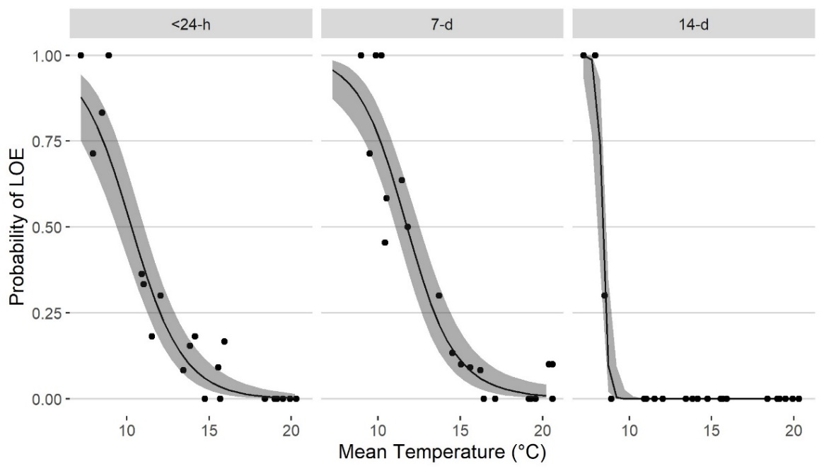
Figure 2. Model predictions for the relationship between 24-hour exposure to various temperatures and the probability of Murray Cod larvae exhibiting LOE (loss of equilibrium) for three ages (<24-hours-old, 7-days-old and 14-days-old). The black line represents the model fit with 95% CI (shaded grey). Black dots are the observed proportion of larvae entering LOE for each treatment replicate.
Targeted monitoring to detect transitions in vegetation restoration projects

Issue: Monitoring vegetation restoration is costly, time consuming, requires long-term funding, and involves examining many vegetation variables which often may not link directly to assessing progress toward objectives. To address these issues, there is a clear need to develop targeted monitoring programs that focus on a reduced set of variables that are tied to specific restoration objectives.

Action: We developed a method to progress a targeted monitoring program, using a pre-existing state-and-transition model for the grassy woodland communities of central Victoria. State-and-transition models (STMs) are a common form of system model used in vegetation management, outlining the knowledge and beliefs about multiple, distinct states of vegetation in a landscape, with various pathways of change (i.e. transitions) between them. They provide a useful framework for modelling vegetation condition evaluating progress towards objectives, as well as help formulate more targeted monitoring strategies.
Our approach involved three steps:
- field data was used to validate an expert-derived classification of woodland vegetation states (a state-and-transition model) (Figure 3)
- this data was then used to identify which vegetation variable(s) help differentiate woodland states and
- the target thresholds for each variable were identified to signify the desired transition has been achieved (Figure 4)
Seven states were identified (Reference, Simplified, Oldfield, Thicket, Native Pasture, Exotic Pasture and Derived) and validated by experts. Each state was considered to be likely to transition to one or more alternative states, as described in the STM conceptual model.
One hundred and twenty-five sites were identified, visited and assessed. Data analysis involved the use of decision tree models and logistic regression.
Results: The measured vegetation variables from each site in this study were good predictors of the different states. We show that by measuring only a few of these variables, it is possible to assign the vegetation state for a collection of sites and monitor if, and when, a transition to another state has occurred. For this ecosystem and STM, out of nine vegetation variables considered, the density of immature trees and percentage of exotic understorey vegetation cover were the variables most frequently specified as effective to define a threshold or transition.

Outcome: This study provides good justification for, and demonstrates the value of, developing targeted monitoring strategies for woodland vegetation. The findings are synthesised and presented in a decision tree for practical guidance for managers.

Funder: ARC grant and the NESP Threatened Species Recovery Hub.
ARI contact: Dr Chris Jones
Jones et al. (2022) What state of the world are we in? Targeted monitoring to detect transitions in vegetation restoration projects. Ecological Applications

Figure 3. State and Transition model for non-riparian woodlands and a brief
description of the woodland states shown to experts, modified from Rumpff et al. (2011).
Figure 4. An example of a transition between Derived (DER) and Simplified (SIMP) states that is effectively indicated by the Richness of Native Understorey – one of the top three ranked vegetation variables (identified by the classification tree analysis) that would be most useful for monitoring these transitions. Solid black lines are the likelihood of a site being in one of two states given the value of a vegetation variable. Black circles indicate measured values at a site (one circle per site). The dashed black line occurs at the 0.5 probability which indicates the transition threshold, and shaded areas represent 95% CI or uncertainty around threshold values.

Rumpff et al. (2011). State-and-transition modelling for Adaptive Management of native woodlands. Biological Conservation. https://doi.org/10.1016/j.biocon.2010.10.026

