|  |
| --- |
| Filling critical knowledge gaps  for Murray Hardyhead |
| The salinity tolerance of  early life stages of Murray Hardyhead |

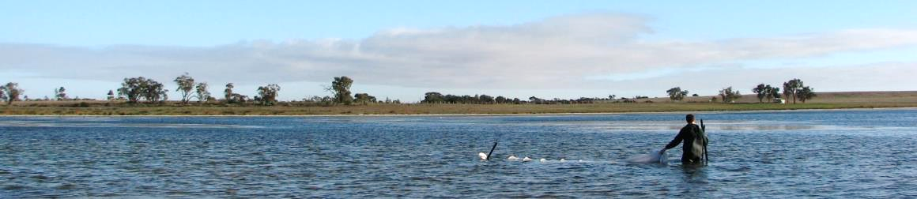

## Background

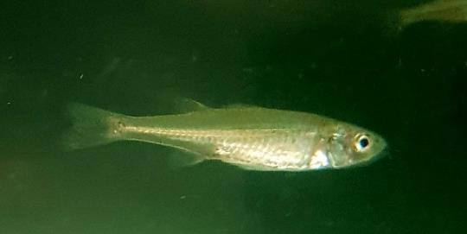Murray Hardyhead (*Craterocephalus fluviatilis*) is a small (<100 mm) freshwater fish, endemic to the lower Murray-Darling River Basin in South Australia, Victoria and New South Wales. It is an annual species, living for a maximum of 18 months. Historically the species was recorded as far upstream as Narrandera on the Murrumbidgee River, Wentworth on the lower Darling River in New South Wales (NSW), in multiple wetlands near Swan Hill and Mildura in Victoria, and sections of the Murray River and its tributaries near Renmark, Swan Reach and the Lower Lakes near the Murray River mouth in South Australia. In Victoria, remnant populations of Murray Hardyhead are in saline habitats, however, the species has been recorded in freshwater wetlands in South Australia.

**Decline of Murray Hardyhead**

Over the past 50 years, the species has suffered a severe decline in range and abundance. In Victoria, surveys of remnant and translocated populations demonstrate the species is on the verge of extinction, with Murray Hardyhead most recently captured at only two out of six known sites in the State. The last confirmed capture of Murray Hardyhead in NSW was from the Murray River in 2005, and the species is now likely to be extremely rare within the State. In South Australia, only four core, isolated, populations may remain.

Due to its decline, Murray Hardyhead are now one of the most threatened fish species in Australia, being

listed nationally as Endangered under the Environment Protection and Biodiversity Conservation Act 1999 (EPBC Act), and the International Union for the Conservation of Nature (IUCN) Red List 2017. It is also classified as Critically Endangered in Victoria, New South Wales and South Australia.

**Figure 1 – An adult Murray Hardyhead**

As individuals of the species only live for a maximum of 18 months, and perish soon after spawning, any perturbation which disrupts successful spawning and recruitment may result in the rapid local extinction of populations. Critical to ensuring the long-term recovery of the species is information which will guide future environmental watering of remnant sites to improve survivorship and recruitment of individuals to populations.

## Project Aims

This project aims to:

* Determine the tolerance of eggs, larvae and juvenile Murray Hardyhead to varying levels of salinity.
* Use the knowledge gained to make recommendations regarding how best to use environmental water in saline wetlands to promote egg, larvae and juvenile survivorship.
* Release the juvenile Murray Hardyhead reared back to the wild to bolster existing populations.

## Approach

To determine the salinity tolerance of early life stages (i.e. eggs, larvae and juvenile) of Murray Hardyhead, adults will be captured from the wild, and brought to aquarium facilities at the Arthur Rylah Institute (ARI). Once the adult fish are acclimatised, water temperature and artificial lighting in ARI's aquarium facilities will be manipulated to bring adults up to a stage of reproductive maturity. The adults will then be induced to spawn.

Eggs will be monitored to determine hatching success at salinities previously observed in saline wetlands that the species is present in the wild. Once hatched, larvae will remain in treatment aquaria, and grown-out to a juvenile stage (~15mm). At the completion of the trials, remnant adults and juveniles will be released back to the wild to assist in the re-establishment of the species.

## Who is involved?

The project is funded under the Biodiversity On-ground Actions Regional Partnerships and Targeted Actions program, DELWP. Scientists from ARI are responsible for developing and undertaking the project.

This project will run until the end of August 2018.

## For further details contact

Daniel.j.stoessel@delwp.vic.gov.au

|  |  |
| --- | --- |
| © The State of Victoria Department of Environment, Land, Water and Planning 2018  LogoThis work is licensed under a Creative Commons Attribution 4.0 International licence. You are free to re-use the work under that licence, on the condition that you credit the State of Victoria as author. The licence does not apply to any images, photographs or branding, including the Victorian Coat of Arms, the Victorian Government logo and the Department of Environment, Land, Water and Planning (DELWP) logo. To view a copy of this licence, visit http://creativecommons.org/licenses/by/4.0/  ISBN 978-1-76077-113-3 (Print) ISBN 978-1-76077-114-0 (pdf/online/MS word)  Disclaimer  This publication may be of assistance to you but the State of Victoria and its employees do not guarantee that the publication is without flaw of any kind or is wholly appropriate for your particular purposes and therefore disclaims all liability for any error, loss or other consequence which may arise from you relying on any information in this publication. | Accessibility  If you would like to receive this publication in an alternative format, please telephone the DELWP Customer Service Centre on 136186, email [customer.service@delwp.vic.gov.au](mailto:customer.service@delwp.vic.gov.au) or via the National Relay Service on 133 677 [www.relayservice.com.au](http://www.relayservice.com.au). This document is also available on the internet at [www.delwp.vic.gov.au](http://www.delwp.vic.gov.au). |

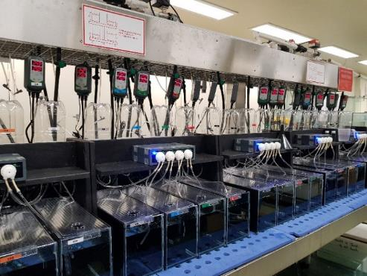

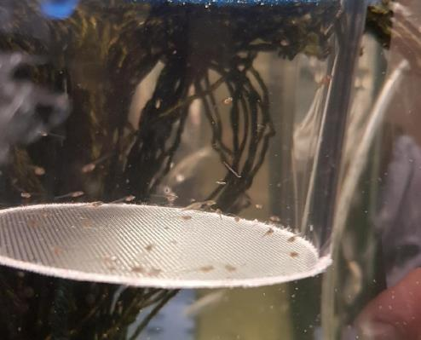**Figure 2 – Aquarium facilities at ARI**

**Figure 3 – Murray Hardyhead larvae**