|  |
| --- |
| Recovering Trout Cod in the Ovens River |
| A threatened species success story |

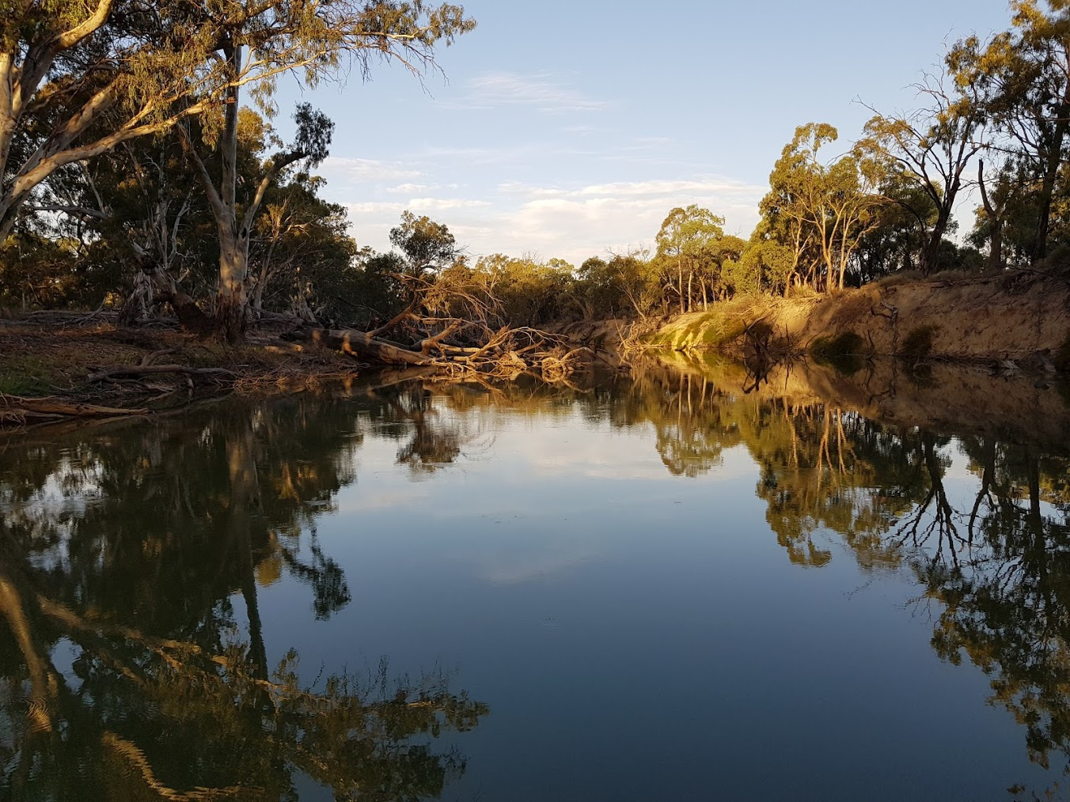

## Background

Trout Cod (*Maccullochella macquariensis*) is a large-sized (up to 850mm length, 16kg weight) riverine fish native to the mid reaches of the Murray-Darling Basin (MDB). Once widespread and abundant, the species has suffered a major decline in its distribution and abundance, particularly in the 1970s and 1980s due to threatening processes including the removal of woody debris, flow regulation and dam construction. By the late 1980s, only a single, naturally occurring population was known to exist, in the Murray River between Yarrawonga to Cobram.

A national recovery plan for Trout Cod (DSE 2008) outlines a range of objectives and actions for this critically endangered species. An Ovens River Trout Cod Recovery program (DCNR 1994) has also been developed, which includes the following broad objectives:

* Develop suitable breeding techniques
* Develop a translocation strategy
* Educate anglers to tell the difference between Murray Cod and Trout Cod.
* Monitor the Trout Cod population
* Undertake research into the biology/ecology of the species.

The Murray-Darling Basin Authority (MDBA), Victorian Fisheries Authority (VFA) and the Arthur Rylah Institute (ARI) have collaborated to reintroduce Trout Cod back into waterways where they previously existed. Consequently, Trout Cod were re-introduced into a number of locations within the MDB (and elsewhere), including the lower-mid reaches of the Ovens River.

## Ecology and Life-history

Trout Cod have a preference for faster-flowing deep waters with abundant instream woody habitat. They are a lie-in-wait apex predator, show strong site fidelity and are renowned for their aggression and fighting qualities as a sport fish. Trout Cod sexually mature at 3-5 years, and adults undertake a spawning migration in spring (October and November) over 10’s of km’s. The species lays adhesive eggs in nests, which are guarded by the male until they hatch. Larvae drift downstream for four to five days. Survival of larvae and juveniles is correlated with years of higher flow variability in summer and autumn.

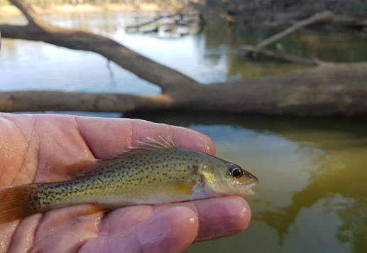

**Figure 1: A juvenile Trout Cod caught in the Ovens River (Photo: ARI)**

## Ovens River

The mid-reaches of the Ovens River (Bundalong to Myrtleford) were home to Trout Cod until the early 1980s. The species’ disappearance from this river has been attributed to a range of threats including over-fishing, river regulation (including altered river flows and loss of connectivity) and the loss of preferred Instream Woody Habitat (IWH).

## Recovery program

Following the development of suitable hatchery techniques in the early-mid 1980s, Trout Cod were stocked into the upper (1989-1995, n=15,790) and lower (1996-2006, n=281,440) reaches of the Ovens River by VFA and its predecessors. The Ovens River Demonstration Reach project (2008-2016) subsequently undertook an integrated approach to river rehabilitation through reinstating instream habitat, improving river connectivity through construction of fishways, restoring riparian vegetation through replanting and fencing and undertaking angler awareness. Monitoring of the Trout Cod population during this program through electrofishing, recorded Young-of-the-year (YOY) Trout Cod in seven of 10 years, indicating that the population was successfully breeding and recruiting.

## A success story

Successful breeding and recruitment, the presence of a broad range of fish size classes and increasing catch rates all point to a sustainable Trout Cod population in the Ovens River. An integrated approach to the management of this species in the Ovens River, through habitat restoration, reducing impacts of threats, fish stocking and education have all contributed to its recovery.

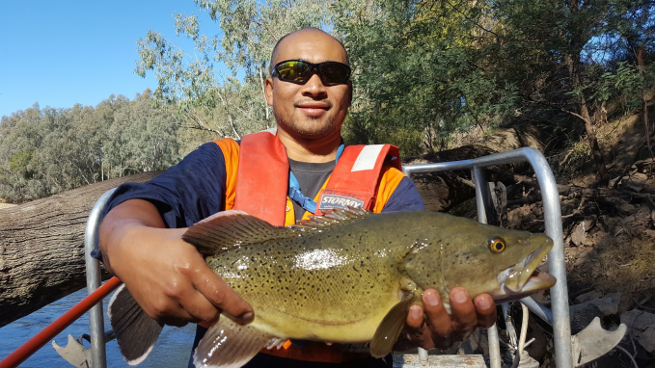**Figure 2: A healthy Trout Cod caught in the Ovens River (Photo: Scott Raymond)**

## Project partners

Partnering with relevant stakeholders was essential to foster ownership in the recovery of Trout Cod in the Ovens River.

Project partners

* Murray-Darling Basin Authority
* Department of Environment, Land, Water and Planning (DELWP)
* DELWP Arthur Rylah Institute
* VFA Snobs Creek Fish Hatchery
* North East Catchment Management Authority
* Wangaratta Sustainability Network
* Nutrisoil, and
* many landowners and interested community members who participated in field work, provided assistance with river access and continue to advocate for a healthy Ovens River

|  |  |
| --- | --- |
| © The State of Victoria Department of Environment, Land, Water and Planning 2018  LogoThis work is licensed under a Creative Commons Attribution 4.0 International licence. You are free to re-use the work under that licence, on the condition that you credit the State of Victoria as author. The licence does not apply to any images, photographs or branding, including the Victorian Coat of Arms, the Victorian Government logo and the Department of Environment, Land, Water and Planning (DELWP) logo. To view a copy of this licence, visit http://creativecommons.org/licenses/by/4.0/  ISBN 978-1-76077-107-2 (Print) 978-1-76077-108-9 (pdf/online)  Disclaimer  This publication may be of assistance to you but the State of Victoria and its employees do not guarantee that the publication is without flaw of any kind or is wholly appropriate for your particular purposes and therefore disclaims all liability for any error, loss or other consequence which may arise from you relying on any information in this publication. | Accessibility  If you would like to receive this publication in an alternative format, please telephone the DELWP Customer Service Centre on 136186, email [customer.service@delwp.vic.gov.au](mailto:customer.service@delwp.vic.gov.au), or via the National Relay Service on 133 677 [www.relayservice.com.au](http://www.relayservice.com.au). This document is also available on the internet at [www.delwp.vic.gov.au](http://www.delwp.vic.gov.au). |

## Contact:

[Scott.raymond@delwp.vic.gov.au](mailto:Scott.raymond@delwp.vic.gov.au)