|  |
| --- |
| Plant responses to environmental watering at Hattah Lakes |
| Native water-dependent plants benefit from environmental watering |

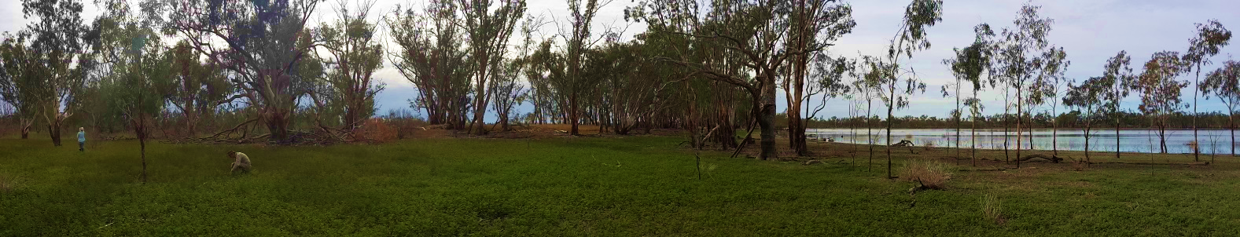

# Key points:

* **Native water-dependent plants benefited from environmental watering at Hattah Lakes.**
* **Native plants and plant communities differ in their responses to environmental watering.**
* **Environmental watering is important for the survival of water-dependent plants and the maintainance of semi-arid floodplains.**

## Hattah Lakes

Hattah Lakes is a complex of semi-arid lake systems and floodplains in north-west Victoria that forms part of the Hattah-Kulkyne National Park and the Murray-Kulkyne Park. Hattah Lakes is one of six ‘Icon Sites’ located along the Murray River and has significant ecological, cultural, recreational, heritage and economic values.

The lack of connectivity between the Hattah Lakes and the Murray River, together with river regulation and water extraction, has negatively impacted the overall environmental health of the system, and habitat value for fauna has declined.

**Environmental watering (managed flooding) is implemented to mitigate the effects of the reduced frequency of natural flooding and improve ecosystem health.**

Accordingly, environmental water deliveries are being undertaken as part of The Living Murray (TLM) initiative, a river restoration program designed to improve the environmental health of the Murray River and its floodplain.

## Determining environmental watering benefits

To effectively deliver environmental water in a way that maintains or improves ecosystem health, we need to know about the target riparian system. In addition, we need to monitor how plants and animals respond to watering events and use this information to refine future watering events. Monitoring the benefits of environmental watering is particularly important in drying climates where there is insufficient rainfall to maintain semi-arid floodplain ecosystems.

At Hattah Lakes a long-term monitoring program is evaluating the effects of environmental watering on the semi-arid floodplain lake-side plant community, capturing an environmental gradient from the lakebed to the lower and higher floodplain (Figure 1).

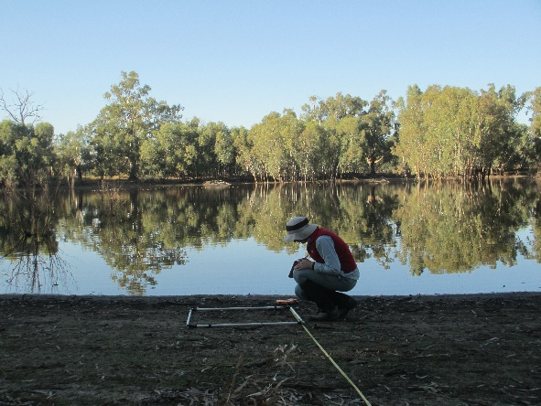

Figure 1: Scientist monitoring vegetation responses to environmental watering at Hattah Lakes. (Credit C.Moxham)

.

## Plant communities of Hattah Lakes

Around the lakes, waterways and floodplains of the Hattah Lakes system, three main plant communities occurr in a mosaic, reflecting environmental gradients in elevation, soil moisture and flooding history (Figure 2).

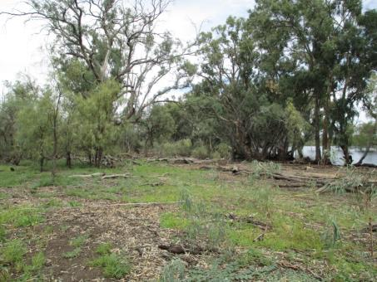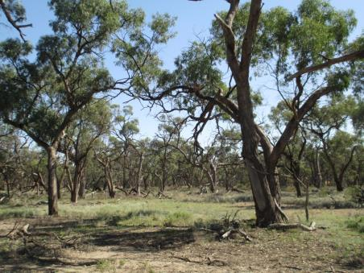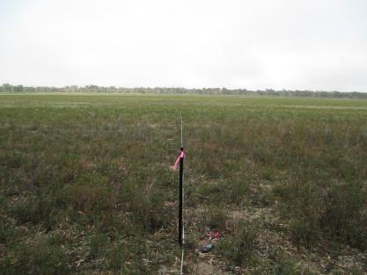



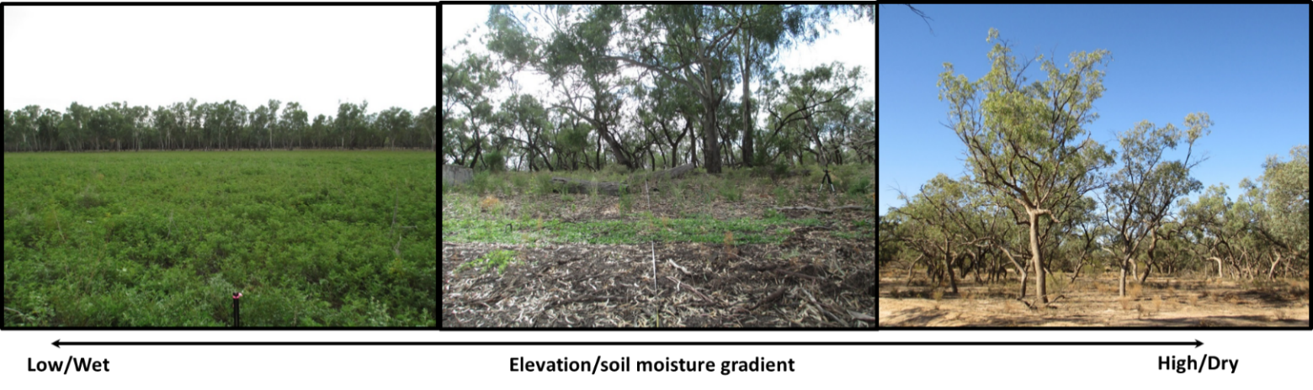

|  |  |  |
| --- | --- | --- |
| **Lake Bed Herbland** | **Intermittent Swampy Woodland** | **Riverine Chenopod Woodland** |
| **< 41.71 m elevation lake bed** | **< 43.17 m elevation lower floodplain** | **> 43.72 m elevation higher floodplain** |
| Frequently flooded | Intermittently flooded | Rarely flooded |
| Water dependent plants | Water tolerant plants | Dryland plants |
| **Common species**   * Southern Liquorice *(Glycyrrhiza acanthocarpa)* * Clammy Goosefoot (*Dysphania pumilio*) * Mallee Cucumber (*Austrobryonia micrantha;* **pictured**) * Southern Hollyhock (*Malva weinmanniana*) | **Common species**   * River Red Gum (*Eucalyptus camaldulensis)* * Black Box *(Eucalyptus largiflorens)* * River Coobah (*Acacia stenophylla*) * Tangled Lignum (*Duma florulenta*) * Blue Rod (*Stemodia florulenta;* **pictured**) * Common Sneezeweed (*Centipeda cunninghamii*) * Spreading Nut-heads (*Sphaeromorphaea littoralis*) * Spring Flat-sedge (*Cyperus gymnocaulos*) | **Common species**   * Black Box (*Eucalyptus largiflorens*) * Ruby Saltbush (*Enchylaena tomentose*; **pictured**) * Streaked Copperburr (*Sclerolaena tricuspis*) * Flat-top Saltbush (*Atriplex lindleyi*) * Hedge Saltbush (*Rhagodia spinescens*) * Nodding Saltbush (*Einadia nutans*) |

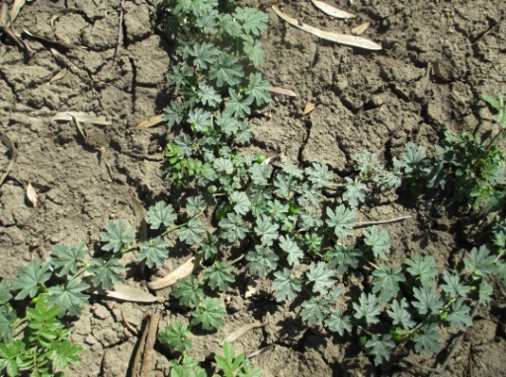

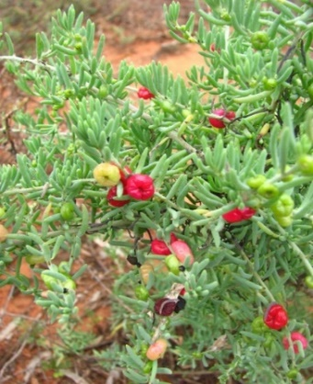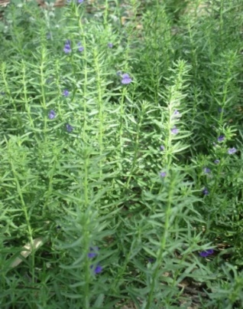

Figure 2: The three main plant communitites of the Hattah Lakes floodplain system and their defining characteristics.

## Short-term plant responses to environmental watering

* Plants fell into two main groups favouring either: (1) the lake edge and lower floodplain, or (2) the higher floodplain.
* Of the 100 plants evaluated, 46 responded to environmental watering. However, plant responses did not necessarily align with expected plant functional group responses (e.g. with all terrestrial plants favouring dryland habitats).
* Lake bed/edge species generally responded positively to watering. In contrast, dryland or higher floodplain species may have had positive or negative responses. For example:
  + Southern Liquorice (*Glycyrrhiza acanthocarpa*) is a water responder which is dominant on the lake bed/edge. Modelling indicated it responded positively to watering. However, Plains Joyweed (*Alternanthera* sp. 1), also a putative water responder, had a negative response.
  + On the higher floodplain, Dissected New Holland Daisy (*Vittadinia dissecta*) had a positive response, whereas the dominant Ruby Saltbush (*Enchylaena tomentosa*) had a more negative response, particularly close to the waters edge.
* 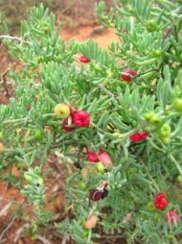Individual plant models were more useful than plant functional group models. Although the plant functional groups illustrated overall trends, models were disproportionately influenced by several abundant taxa and did not provide information about the many species-specific responses.

**------**  post watering abundance

**____** pre watering abundance



**Positive responses**

**Negative responses**

**Favouring lake edge**

**Favouring higher floodplain**



Ruby Saltbush

Southern Liquorice

Distance from water’s edge (m)

Plains Joyweed

Dissected New Holland Daisy

Abundance

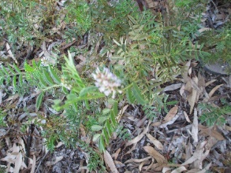

***Plants had a mix of responses to environmental watering***

## How long does the effect of one enviromental watering event last?

The positive response of many plants to environmental watering was short-lived:

* 27 out of 67 responding plants increased in the six months after the environmental watering event; and
* 22 out of these 27 plants returned to near pre-watering levels by 18 months post watering event.

It is likely that hot temperatures and the rapid loss of soil moisture in this semi-arid environment limits the duration of the response to environmental watering.

Negative plant responses to an environmental watering event can be considered a natural step to restoring water-dependent floodplain plants. For example, 20 plants declined in abundance by six months after the environmental watering event and remained low in abundance 18 months later. These dryland plants occur on the higher floodplain and are not flood tolerant. They are associated with the terrestrialisation of the floodplain vegetation in the Hattah Lakes system due to long ‘dry’ phases and the adverse response of dryland plants to prolonged inundation.

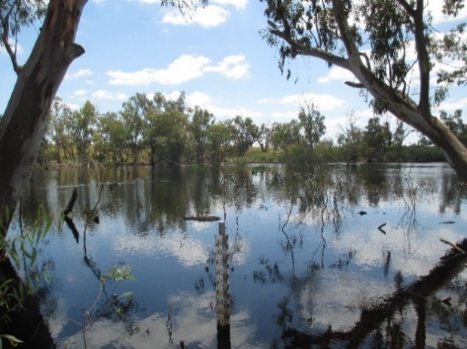

## Acknowledgements

This project was funded by the Mallee Catchment Management Authority through The Living Murray initiative. The Living Murray is a joint initiative funded by the New South Wales, Victorian, South Australian, Australian Capital Territory and Commonwealth governments, coordinated by the Murray-Darling Basin Authority.

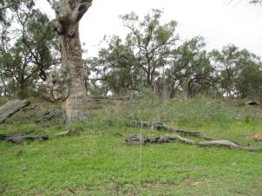

|  |  |
| --- | --- |
| © The State of Victoria Department of Environment, Land, Water and Planning 2021  LogoThis work is licensed under a Creative Commons Attribution 4.0 International licence. You are free to re-use the work under that licence, on the condition that you credit the State of Victoria as author. The licence does not apply to any images, photographs or branding, including the Victorian Coat of Arms, the Victorian Government logo and the Department of Environment, Land, Water and Planning (DELWP) logo. To view a copy of this licence, visit http://creativecommons.org/licenses/by/4.0/  ISBN 978-1-76105-437-2 (pdf/online/MS word) Disclaimer  This publication may be of assistance to you but the State of Victoria and its employees do not guarantee that the publication is without flaw of any kind or is wholly appropriate for your particular purposes and therefore disclaims all liability for any error, loss or other consequence which may arise from you relying on any information in this publication. | Accessibility  If you would like to receive this publication in an alternative format, please telephone the DELWP Customer Service Centre on 136186, email [customer.service@delwp.vic.gov.au](mailto:customer.service@delwp.vic.gov.au), or via the National Relay Service on 133 677 [www.relayservice.com.au](http://www.relayservice.com.au). This document is also available on the internet at [www.delwp.vic.gov.au](http://www.delwp.vic.gov.au). |

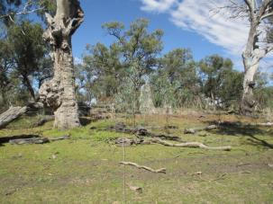

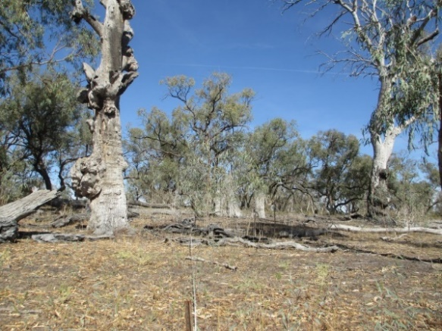

Figure 3: Lake edge water-respondent plant community immediately after environmental watering (top), 12 months (middle) and two years (bottom) post flooding. (Credit C. Moxham)

## Further information

[research.ari@delwp.vic.gov.au](mailto:research.ari@delwp.vic.gov.au)

[ari.vic.gov.au](https://www.ari.vic.gov.au/)