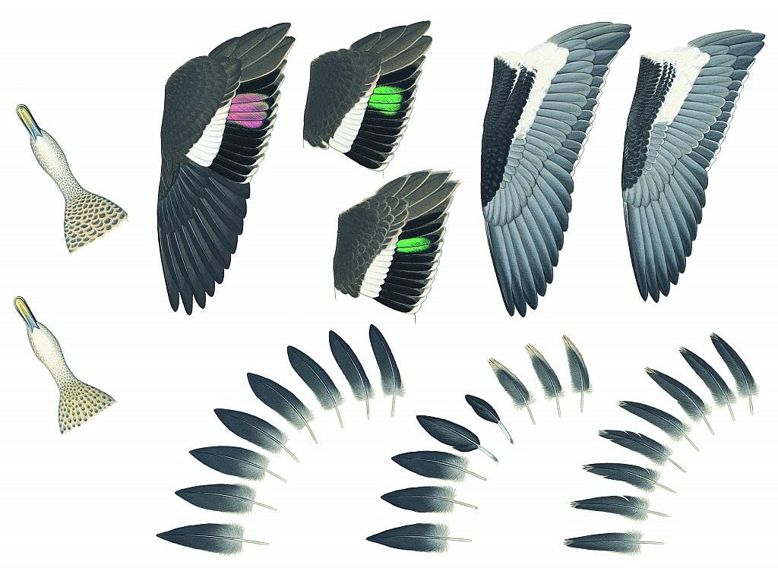

Ageing and sexing Victorian native game birds using plumage characters

D. Rogers, P. Menkhorst and J. Davies

March 2019

Arthur Rylah Institute for Environmental Research

Technical Report Series No. 294

Arthur Rylah Institute for Environmental Research Department of Environment, Land, Water and Planning PO Box 137
Heidelberg, Victoria 3084
Phone (03) 9450 8600
Website: www.ari.vic.gov.au

Citation: Rogers, D., Menkhorst, P. and Davies, J. (2019). Ageing and sexing Victorian native game birds using plumage characters. Arthur Rylah Institute for Environmental Research Technical Report Series No.294. Department of Environment, Land, Water and Planning, Heidelberg, Victoria.

Front cover image: Plumage characters used to determine sex and age of Chestnut Teal (see Appendix 7) (Painting by Jeff Davies).

© The State of Victoria Department of Environment, Land, Water and Planning 2019

This work is licensed under a Creative Commons Attribution 3.0 Australia licence. You are free to re-use the work under that licence, on the condition that you credit the State of Victoria as author. The licence does not apply to any images, photographs or branding, including the Victorian Coat of Arms, the Victorian Government logo, the Department of Environment, Land, Water and Planning logo and the Arthur Rylah Institute logo. To view a copy of this licence, visit http://creativecommons.org/licenses/by/3.0/au/deed.en
Edited by Organic Editing

ISSN 1835-3827 (print)
ISSN 1835-3835 (pdf))
ISBN 978-1-76077-306-9 (print)
ISBN 978-1-76077-307-6 (pdf)

Disclaimer
This publication may be of assistance to you, but the State of Victoria and its employees do not guarantee that the publication is without flaw of any kind or is wholly appropriate for your particular purposes and therefore disclaims all liability for any error, loss or other consequence which may arise from you relying on any information in this publication.

Accessibility

If you would like to receive this publication in an alternative format, please telephone the DELWP Customer Service Centre on 136 186, email customer.service@delwp.vic.gov.au or contact us via the National Relay Service on 133 677 or www.relayservice.com.au. This document is also available on the internet at www.delwp.vic.gov.au

Ageing and sexing Victorian native game birds using plumage characters

Danny Rogers1, Peter Menkhorst1 and Jeff Davies2

1Arthur Rylah Institute for Environmental Research 123 Brown Street, Heidelberg, Victoria 3084
226 Dresden St, Heidelberg Heights, Victoria 3084

Arthur Rylah Institute for Environmental Research

Technical Report Series No. 294

Arthur Rylah Institute for Environmental Research Department of Environment, Land, Water and Planning Heidelberg, Victoria

Acknowledgements

This study was commissioned and funded by the Game Management Authority (GMA) for which we are most grateful. We wish to thank GMA staff who facilitated our examination of collected wings and tails: Heath Dunstan, Zach Powell and Simon Toop. The opportunity to join GMA staff in the laboratory at Sebastapol was especially helpful, as it gave us a better understanding of the operational conditions under which staff assess the age and sex of collected duck wings.
At the Arthur Rylah Institute we thank Di Crowther for providing laboratory access, and Steve Werner, Luke Woodford and George Naidos for facilitating freezer storage of the specimens we worked on. We are also grateful to collection managers Karen Roberts, Katie Date, Ricki-Lee Erickson and Laura Cook at Museums Victoria; Leo Joseph, Alex Drew, Margaret Cawsey and Clare Holleley at the Australian National
Wildlife Collection (CSIRO); and Sandy Ingleby and Leah Tsang at the Australian Museum for access to their collections.
We thank Jeanette Birtles, Andrew Geschke and Dr David Ramsey for helpful comments on previous drafts

i Ageing and sexing Victorian game birds using plumage characters

Contents

Acknowledgements i

Summary 1
Introduction 2
  - Principles of ageing ducks on plumage characters 3
    - Detecting juvenile plumage 3
    - Ageing using tail feathers 3
    - Ageing using wing feathers 4
    - Moults, ageing and sexing of adults 5
    - Moults and ageing of first-year ducks 7
  - Principles of ageing quail on plumage characters 8
  - Using wing measurements to estimate sex ratios 8
  - Report layout 9
- Methods 10
  - Wing length 10
- Results 14
  - Pink-eared Duck Malacorhynchus membranaceus 14
    - Ageing characters 14
    - Sexing characters 17
  - Australian Shelduck Tadorna tadornoides 17
    - Ageing characters 17
    - Sexing characters 18
  - Hardhead Aythya australis 21
    - Ageing characters 21
    - Sexing characters 25
  - Australasian Shoveler Spatula rhynchotis 25
    - Ageing characters 26
    - Sexing characters 29
  - Pacific Black Duck Anas superciliosa 29
    - Ageing characters 30
    - Sexing characters 30
  - Grey Teal Anas gracilis 34
    - Identification 34
    - Ageing characters 34
    - Sexing characters 35
  - Chestnut Teal Anas castanea 38
    - Identification 38
    - Ageing characters 39
    - Sexing characters 42
  - Australian Wood Duck Chenonetta jubata 42
ii Ageing and sexing Victorian game birds using plumage characters
    - Ageing characters 43
    - Sexing characters 46
  - Stubble Quail Coturnix pectoralis 47
    - Ageing characters 47
    - Sexing characters 48
- Discussion 52
  - Reliability of sexing characters 52
  - Reliability of ageing characters 53
  - Recommendations for future data collection and further research 55
    - Collection of specimens 55
    - Laboratory procedures 55
References 57
Appendices 60
Appendix 1: Pink-eared Duck 61
Appendix 2: Australian Shelduck 63
Appendix 3: Hardhead 65
Appendix 4: Australasian Shoveler 67
Appendix 5: Pacific Black Duck 69
Appendix 6: Grey Teal 71
Appendix 7: Chestnut Teal 73
Appendix 8: Australian Wood Duck 75
Appendix 9: Stubble Quail 77

Tables
Table 1. Commonly used moult and plumage nomenclatures for ducks 7
Table 2. Shrinkage of wing length in study skins, estimated by comparing the mean wing length of skins with that of freshly dead samples 12
Table 3. Differences between adult and juvenile Pink-eared Ducks, and between males and females 15
Table 4. Number of Pink-eared Ducks examined with attributes of male, female and first-year plumages 16
Table 5. Sexing criteria for Pink-eared Ducks according to wing lengths of undried wings, and their reliability in classifying the known-sex specimens measured in this study 17
Table 6. Differences between adult and juvenile Australian Shelducks, and between males and females 19
Table 7. Number of Australian Shelduck examined with attributes of male, female and first-year plumages 20 Table 8. Sexing criteria for Australian Shelduck according to wing lengths of undried wings, and their
reliability in classifying the known-sex specimens measured in this study 21
Table 9. Differences between adult and juvenile Hardheads, and between males and females 23
Table 10. Number of Hardheads examined with attributes of male, female and first-year plumages 24
Table 11. Sexing criteria for Hardheads according to wing lengths of undried wings, and their reliability in classifying the known-sex specimens measured in this study 25
Table 12. Differences between adult and juvenile Australasian Shoveler, and between males and females 27
Table 13. Number of Australasian Shovelers examined with attributes of male, female and first-year plumages 28
Table 14. Sexing criteria for Australasian Shoveler according to wing lengths of undried wings, and their reliability in classifying the known-sex specimens measured in this study 29
Table 15. Differences between adult and juvenile Pacific Black Duck, and between males and females 32
Table 16. Number of Pacific Black Ducks examined with attributes of male, female and first-year plumages33 Table 17. Sexing criteria for Pacific Black Duck according to wing lengths of undried wings, and their
reliability in classifying the known-sex specimens measured in this study 34
Table 18. Differences between adult and juvenile Grey Teal, and between males and females 36
Table 19. Number of Grey Teal examined with attributes of male, female and first-year plumages 37
Table 20. Sexing criteria for Grey Teal according to wing lengths of undried wings, and their reliability in classifying the known-sex specimens measured in this study 38
Table 21. Differences between adult and juvenile Chestnut Teal, and between males and females 40
Table 22. Number of Chestnut Teal examined with attributes of male, female and first-year plumages 41

Table 23. Sexing criteria for Chestnut Teal according to wing lengths of undried wings, and their reliability in classifying the known-sex specimens measured in this study 42
Table 24. Differences between adult and juvenile Australian Wood Ducks, and between males and females
............................................................................................................................................................ 44
Table 25. Number of Australian Wood Ducks examined with attributes of male, female and first-year plumages 45
Table 26. Sexing criteria for Australian Wood Duck according to wing lengths of undried wings, and their reliability in classifying the known-sex specimens measured in this study 46
Table 27. Differences between adult, immature and juvenile Stubble Quail, and between males and females
............................................................................................................................................................ 49
Table 28. Number of Stubble Quail examined with attributes of male, female and first-year plumages 51
Table 29. Overview of reliability and ease of use of sexing characters described in this study 52
Table 30. Overview of reliability and ease of use of ageing characters described in this study 54

Figures

Figure 1. Distinguishing adult and juvenile tail feathers of ducks, using Pink-eared Duck as a model 4

Figure 2. Wing topography of ducks, using the immature Australian Shelduck as a model 5
Figure 3. Measurement of maximum chord wing length 11
Figure 4. Sexing criteria calculated in this report 13

Summary

Context:
The Victorian Government proposes to adopt a Waterfowl Conservation Harvest Model to guide the management of Victorian game ducks. Using this approach, decisions about aspects of the hunting season, such as its duration and bag limits, are informed annually by demographic statistical models. Variables required by this approach include annual estimates of sex ratios and age ratios. In theory, the data required to calculate these ratios can be obtained using samples from birds harvested by hunters during the duck hunting season, provided individual birds can be aged and sexed correctly.

Aims:
This report describes ageing and sexing characters of the Victorian game birds (eight species of duck, and Stubble Quail Coturnix pectoralis), focusing on attributes that can be recorded from wings and tails detached from birds collected from hunters.

Methods:
The study was based largely on examination of museum skins, and on wing and tail specimens obtained from hunters during opening weekend of the 2017 and 2018 duck hunting seasons. We consider the reliability of ageing and sexing characters, including some that were previously unknown, and make recommendations for future data collection. The report is accompanied by commissioned paintings illustrating differences between males and females, and between adults and juveniles for each game bird species. These illustrations are annotated and set out as double-sided sheets designed so that they can be printed, laminated, and used as ‘stand-alone’ ageing and sexing guides under field conditions.

Results:
The reliability and ease of use of ageing and sexing characters varied from species to species. Three game bird species (Hardhead Aythya australis, Australasian Shoveler Spatula rhynchotis and Australian Wood Duck Chenonetta jubata) can be sexed reliably using unambiguous plumage characters of the wing; two others (Australian Shelduck Tadorna tadornoides and Stubble Quail) can be sexed reliably and easily on plumage characters if the head and body plumage are examined.
Sexing criteria based on wing measurements are presented: In all duck species, the wing length of males was significantly longer than that of females. In Stubble Quail, however, females had longer wings than males. In Australian Shelduck and Australasian Shoveler, wing length can be used to sex almost every individual. In other species there was more overlap in size between the sexes, and many individuals could not be sexed based on wing measurement. However, given a sufficient number of samples, analysis of wing length could be used to make annual estimates of sex ratio for all species.
A large proportion of immature ducks retain juvenile tail feathers, an obvious and easily interpreted ageing character diagnostic of first-year birds when present. However, we show that, at the beginning of duck hunting season (mid-March), approximately 20% of first-year ducks retain no juvenile tail feathers, and they can only be distinguished from adults by checking for retained juvenile wing feathers. In two species (Australian Shelduck and Australasian Shoveler), retained juvenile wing feathers are reliable and easily detected ageing characters. In the remaining species, retained juvenile plumage in the wing was difficult to identify, though in most species (except Hardhead) it could be distinguished from adult wing plumage when given careful examination by experienced workers. Less intensive examination of wing plumage would probably result in underestimates of the proportion of immature birds in the population.

Conclusions and implications:
Recommendations for future recording of age and sex ratios are made. Most importantly, we recommend collection of additional information when complete specimens are briefly available while collecting wings from hunters. Body plumage should be recorded, especially in species that are difficult or impossible to sex on visual inspection when only wings are available [Australian Shelduck, Chestnut Teal (Anas castanea) and Stubble Quail]. We also recommend cloacal examination; when carried out by experienced observers, it provides ageing and sexing information that would be a valuable supplement to the plumage and measurement characters described in this report.

Introduction

The Victorian Government proposes to adopt a Waterfowl Conservation Harvest Model to guide the management of Victorian game ducks (DEDJTR 2016). Using this approach, decisions about aspects of the hunting season, such as its duration and bag limits, are informed annually by demographic statistical models (Ramsey et al. 2010, 2017). Variables required by this modelling approach include annual estimates of sex ratios and age ratios. In theory, the data required to calculate these ratios can be obtained using samples from the birds harvested annually by hunters, provided individual birds can be aged and sexed correctly.
Most of Victoria’s native game bird species are ducks: Pink-eared Duck Malacorhynchus membranaceus, Australian Shelduck Tadorna tadornoides, Hardhead Aythya australis, Australasian Shoveler Spatula rhynchotis, Pacific Black Duck Anas superciliosa, Grey Teal Anas gracilis, Chestnut Teal Anas castanea and Australian Wood Duck Chenonetta jubata. There is also one native quail species available to hunt, the Stubble Quail Coturnix pectoralis. Plumage studies in Australia (e.g.
Marchant and Higgins 1990, 1993) suggest that age-diagnostic and sex-diagnostic morphological characters exist in most of these species. However, the existing literature on these criteria is specialised and not fully illustrated and was not prepared with estimation of demographic ratios for population management in mind. For example, it makes little or no assessment of the probability of incorrect ageing or sexing. Most literature also assumes that the observer can examine the entire bird. However, in Victoria, a recent change in field practice, aimed at improving efficiency and increasing sample size, has been to remove a wing and the tail feathers from birds shot by hunters for later examination in the laboratory. Therefore, this study focusses on ageing and sexing using wing and tail characters.
Ageing of ducks and true quail for the purposes of game bird management has been studied intensively in the Northern Hemisphere (e.g. Boyd et al. 1975; Krapu et al. 1979; Carney et al. 1992; Pearse et al. 2014; ONCFS 2017). Helpful general principles for ageing and sexing game bird species have emerged from this work, however, they cannot be applied uncritically to all Australian game bird species because:
- A different suite of species occurs in Australia, and although many are congeneric with intensively studied species overseas, they differ in specific plumage markings.
- Some Australian game bird species (such as Pink-eared Duck) are not closely related to any extralimital species, so there is no comparable frame of reference.
- Ageing criteria are influenced by the timing of moult, and this is in turn influenced by climate patterns. In North America and northern Europe, where the most intensive plumage studies of game birds have been made, the annual cycle of game birds is predictable because it has evolved in a climate of severe winters and short breeding seasons. In Australia, the breeding season is more extended, especially in inland Australia; multiple nesting attempts may be carried out in good breeding seasons, and little or no nesting may occur in poor breeding seasons. Moreover, birds shot during the Victorian duck hunting season are not necessarily from Victorian breeding grounds; some may originate from central or northern Australia, where breeding peaks at different times of year. The timing of moults of Australian game birds is thus less predictable than in Europe or North America, resulting in more variation in plumage wear and appearance at any one time.
There is, therefore, a need for an ageing and sexing guide for Victorian game bird species, based and tested on Australian specimens, and presented in a manner that is suitable for guiding the government agency staff who examine hunters’ bags and collect the data used in harvest models.
In this study, we used samples from the opening weekend of the 2017 and 2018 duck hunting seasons (the third weekend in March), and examination of museum skins, to describe plumage and morphological attributes of Victorian game bird species that can be used to age or sex individuals when only wings and tails are available. We consider the reliability of these ageing and sexing characters and make recommendations for future data collection. The report is accompanied by commissioned paintings illustrating the differences between males and females, and between adults and juveniles for each species. These illustrations are annotated on single sheets for each species;

the sheets are designed so that they can be printed, laminated and used as ageing and sexing guides in the field. We anticipate that these sheets will be the main information source used by agency staff to age and sex ducks, but strongly recommend that staff first read this report for more complete information on the principles of ageing and sexing, methods, recommended workflow, and the limitations and strengths of the ageing and sexing criteria we recommend.

Principles of ageing ducks on plumage characters

Detecting juvenile plumage
Detection of juvenile plumage, or remnant juvenile plumage, is usually the key to ageing ducks. Juvenile plumage is the first coat of contour feathers (i.e. real, non-downy feathers) worn by a bird, and its appearance varies considerably from one avian family to another. Feather texture ranges from the relatively weak and fluffy juvenile plumage of many passerines, to the durable, adult-like juvenile plumage of some seabirds and birds of prey. It takes birds longer to grow durable, adult-like feathers than it takes to grow fluffy feathers. The appearance and texture of juvenile feathers is probably a trade-off between selection for rapid development (needed by species at high risk of predation before they are old enough to fly) and selection for durable plumage (needed by species that are relatively secure at the nest, but retain their juvenile plumage for up to a year).
In ducks, juvenile plumage replaces the down of ducklings before they are fully grown, and it is retained for the first few weeks or months after fledging, i.e. through a period when young ducks can fly strongly, mix in flocks with adults, and may disperse hundreds of kilometres from where they were born. The juvenile plumage, therefore, has attributes enabling young ducks to thermoregulate and start flying before they have reached full size, while still being durable enough to withstand the forces of extended flight.
At fledging, the wings and feet of young ducks are close to adult size, but the body and (to a lesser extent) the head are still growing. Their juvenile plumage can, therefore, be envisaged as a set of ‘clothing’ intended for a smaller bird than an adult, and it appears relatively ‘tight’ as a result. Juvenile body feathers of ducks are smaller than those of adults, being both shorter and narrower. In field views, this creates a characteristically neat appearance, perhaps most obvious on the flanks. In adults, the flank feathers are relatively long, and they conceal most of the folded wings of swimming birds. In juveniles, the flank feathers are shorter, and the flight feathers (especially the secondaries) are partially exposed when the wings are folded.

Ageing using tail feathers
When examined in the hand, more objective identification of the juvenile plumage of ducks can be achieved through examining the rectrices: the 12–20 stiff feathers of the tail. The number of tail feathers differs between species (e.g. 12 in Pink-eared Duck, 14 in Hardhead, and 16–20 in Pacific Black Duck), but in all duck species the juvenile tail feathers are very distinctive. They differ structurally from adult tail feathers, being slightly shorter and obviously narrower, and they have a characteristic pattern of wear at the tip (Figure 1). When still growing or very fresh, juvenile tail feathers have weak and filamentous tips, initially attached to the natal down that forms the stubby tail of ducklings. The natal down breaks off when ducks are no more than a few weeks old, leaving a distinctive notch at the tip of most juvenile tail feathers. Usually the tip of the feather shaft remains, but it is surrounded by a bare segment where the flimsy feather web has worn away. Juvenile tail feathers of ducks wear and fade more quickly than adult tail feathers. The Victorian duck hunting season starts on the third Saturday in March (when samples are usually collected) and concludes in winter, usually in early-June. Throughout this period, the tails of juvenile ducks typically appear paler brown and more abraded than those of adults. Most adults have fresh tails during the duck hunting season, but a few individuals may be encountered that are still moulting and retain some worn tail feathers. Worn adult tail feathers can sometimes have broken tips which may resemble the notch seen at the tip of juvenile tail feathers, but the feather shafts seldom project beyond the webs of the feathers; moreover, adult tail feathers are clearly broader than those of juveniles (Figure 1).

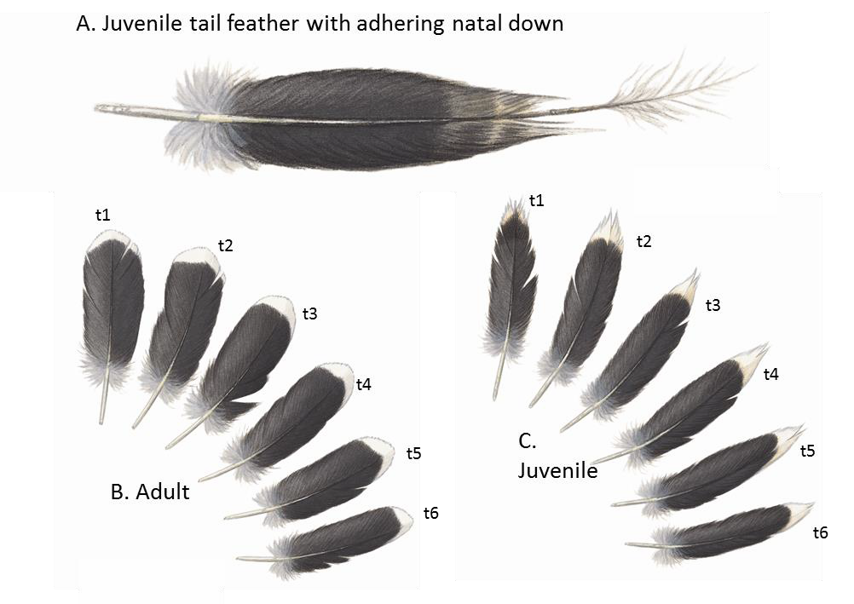
Figure 1. Distinguishing adult and juvenile tail feathers of ducks, using Pink-eared Duck as a model A: a fresh juvenile tail feather showing the natal down still attached to the tip. B: Adult tail feathers (dorsal view of feathers on right half of tail). C: Juvenile tail feathers (dorsal view of feathers on right half of tail). Juvenile feathers are narrower and more worn than those of adults; small notches form at their tips where the natal down has broken away. Tail feathers are numbered from the centre outwards: the central pair is t1, the next pair t2, etc.

Ageing using wing feathers
Juvenile wing coverts of ducks also differ in shape from those of adults: details vary by species, but in general juvenile coverts are shorter and narrower, with weaker and narrower tips. Juvenile tertials differ in a similar way, and often have small points at their tips where natal down was once attached. However, as is the case with tail feathers, many or all juvenile wing coverts and tertials can be replaced before the opening of the duck hunting season (see next section), and this limits their usefulness as an ageing character during the hunting season. In contrast, juvenile flight feathers (the primaries and the secondaries, Figure 2) are retained until birds are a year old. In theory, this makes them desirable characters to use for ageing ducks. In practice, however, the differences between juvenile and adult flight feathers are not always obvious. The flight feathers of juvenile ducks (notably the outer primaries) are narrower, with slightly narrower tips, than those of adults. These differences are subtle, and the tips of the outer primaries become narrower when worn in both juveniles and adults. Distinguishing these differences in shape becomes easier with observer experience, but it is difficult to avoid some subjectivity, and in some species the shape of juvenile and adult primaries overlaps too much for this to be considered a reliable ageing character.

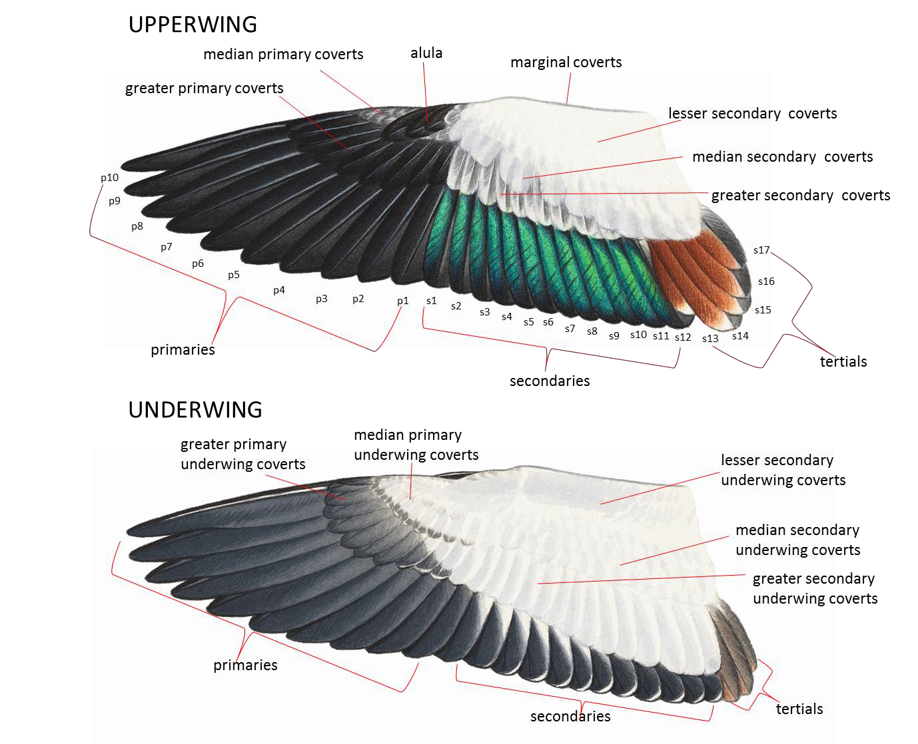

Figure 2. Wing topography of ducks, using the immature Australian Shelduck as a model
Note the glossy green speculum in the secondaries. We refer to secondaries and tertials separately in this report, but strictly speaking the tertials are modified secondaries and are numbered accordingly.

Moults, ageing and sexing of adults
Moults have been studied quite thoroughly in many species of duck, mainly outside Australia. The following overview is based largely on Cramp and Simmons (1977), Marchant and Higgins (1990), Howell (2010), Pyle (2013) and Reeber (2015). Ducks have the ‘complex alternate’ moult strategy defined by Howell et al. (2003), which involves two moults every year in adults. In one of these moults, all plumage is replaced, including the flight feathers; the moult of the head and body plumage is gradual, but the flight feathers are shed simultaneously, leaving ducks flightless for approximately 3–5 weeks until the new wing feathers have grown long enough to support flight. In southern Australia, this moult typically occurs in summer, and the Victorian duck hunting season is timed to occur after wing moult is completed, to avoid exposing ducks with reduced flight capacity to hunting. Accordingly, most adult ducks have fresh, fully grown flight feathers during the Victorian duck hunting season. However, a small proportion of adult ducks may delay wing moult and may still have growing or worn flight feathers in March–April.
The moult of the flight feathers is followed by replacement of all the head and body feathers. In some species, this body moult overlaps with the final stages of wing moult; in others, it may occur after the ducks have completed wing moult and dispersed away from breeding areas. Either way, the moult is considered to be a continuation of a complete moult in which the flight feathers were replaced, and replacement of the head and body feathers is typically complete, or near-complete, by the onset of the Victorian duck hunting season. The resultant plumage is brightly coloured (at least in males) and is retained for much of the year, being held through the non-breeding season and into the mating period.

Most or all adult ducks carry out a second moult each year, which involves replacement of some to many of the head and body feathers, and sometimes tail feathers and a few wing coverts. The resultant plumage is referred to as ‘eclipse’ plumage, and it is often relatively drab in appearance. In species with brightly coloured males, the eclipse plumage can resemble female plumage. In many duck species in the temperate Northern Hemisphere, the timing of this moult differs between males and females. Females tend to moult earlier, holding their most drab and cryptic plumage during incubation, chick-rearing and the flightless wing-moult period. Males tend to moult later and are only in ‘eclipse’ plumage briefly during the flightless moult period. It is likely that similar sexual differences in timing of moult occur in Australian ducks (though their body moults have not been studied intensively). In Victoria, most adult males replace eclipse plumage before the duck hunting season; however, a few individuals may still have eclipse plumage when the season opens. The eclipse plumage of males is quite short-lived in most Australian duck species and therefore seldom causes incorrect sexing; males with eclipse plumage typically also have some remnant or incoming ‘bright’ plumage that obviously differs from that of females. When they are in eclipse, the head and body plumage of a few individual males of some species (notably Australian Wood Duck and Hardhead) can look very similar to that of females. Such individuals can, however, be sexed reliably, as their wing plumage does not change in appearance seasonally.
The evolutionary basis for the complex moult strategies of adult ducks has been debated. The traditional interpretation is that the most brightly coloured plumage is the breeding plumage, and the eclipse plumage is a non-breeding plumage. This view has recently been challenged by workers who argue that, in ducks, the more brightly coloured plumage (which is attained in a complete moult and held for most of the year) is a basic plumage, homologous with the non-breeding plumage found in other avian groups (Pyle 2005, 2013; Howell 2010; Reeber 2015). Under this scenario it is suggested that the drabber plumage (attained in a partial moult and held rather briefly) is the alternate plumage, evolved so that ducks are in relatively cryptic plumage at times when there is a higher risk of predation, such as during the flightless moult period, and, in females, during the incubation period.
For a conflicting interpretation, see Hawkins (2011).
We treat eclipse as an alternate plumage in this report when we need to refer to a precise plumage or moult. We use some additional terms for convenience:
- Adult (Ad.): a bird that is a year or more old and indistinguishable from older birds.
- Juvenile (Juv.): a bird in its first non-downy plumage.
- Immature (Imm.): a bird that has moulted some juvenile plumage but is still in its first year.
- First-year birds: a collective term for juvenile and immature ducks.
From the practical view of ageing and sexing ducks, the nomenclatural considerations are unimportant, provided one scheme is used consistently. However, the variety of nomenclatures used in previous literature can be confusing, so we include a summary in Table 1. During the Victorian duck hunting season, in those duck species with a distinct seasonal change in appearance (especially Australian Shelduck, Australasian Shoveler and Chestnut Teal), most adult males will be in ‘bright’ plumage. Males with relatively drab plumage may be laggards with remnant eclipse plumage, but should be examined carefully in case they are first-year birds.

Table 1. Commonly used moult and plumage nomenclatures for ducks

Year of life | Humphrey and Parkes1 | Common terms in older literature | Shorthand in this report
1 | Juvenile (= Basic 1) | Juvenile | Juvenile
 | Pre-formative | Post-juvenile | Immature
 | Formative | 1st immature (also variously referred to as ‘immature non-breeding’ or ‘first winter’)
 | Pre-alternate 1 | 1st pre-breeding
 | Alternate 1 | 2nd Immature (also variously referred to as ‘immature breeding’ or ‘first summer’)
 | Pre-basic 2 | 1st post-breeding
2 | Basic 2 | Adult (confusingly referred to as ‘adult breeding’ or ‘adult non-breeding’ in different literature) | Adult
 | Pre-alternate 2 | 2nd pre-breeding (though moult often follows nesting)
 | Alternate 2 | Adult eclipse (most often called ‘adult non-breeding’)
3 | Pre-basic 3 | Post-breeding (though moult often precedes breeding)
 | Basic 3 | Adult (confusingly referred to as ‘adult breeding’ or ‘adult non-breeding’ in different literature)
1Based on the moult and plumage nomenclatural scheme described by Humphrey and Parkes (1959), but including the important modifications of Howell et al. (2003).

Moults and ageing of first-year ducks
After fledging, ducks undergo two partial moults in their first year of life. The first of these moults (the ‘post-juvenile’ or ‘pre-formative’ moult) occurs in the first summer, autumn or winter; it involves replacement of most feathers in the head, neck, breast, flanks, mantle and scapulars; a smaller proportion of the feathers of the back, belly and undertail coverts are also replaced. In addition, a varying number of tertials, smaller wing coverts and tail feathers are replaced, though the primaries and secondaries are retained. The resultant plumage is similar to that of adults. The timing of the pre- formative moult has not been studied in detail in Australian ducks, but analogy with North American and European species suggests the moult is probably protracted, can be spread over several months, and may be suspended at times (i.e. ducks may interrupt the pre-formative moult for some time, thus going through a period when no active moult can be detected).
The replacement of tail feathers in the pre-formative moult is of particular relevance to workers attempting to age ducks. Juvenile tail feathers are the most easily identified juvenile remnants in many first-year ducks during the Victorian duck hunting season. However, many of the first-year ducks collected at this time of year have active, or recently completed, pre-formative tail moult. Most often, the tails of first-year birds have a mixture of retained juvenile feathers and growing or fully grown formative feathers that resemble those of adults (but are distinctly narrower in some species). In some first-year individuals, all juvenile tail feathers are replaced in a pre-formative moult, and such birds can only be distinguished from adults using the plumage characters in the wing.
The first pre-alternate moult also occurs in the later part of the first year of life, shortly before the first breeding attempt when about one year old. In southern Australia, this usually occurs in spring or early summer (after the Victorian duck hunting season is complete). The timing and extent of this moult is similar to that of the pre-alternate moult of adults; it involves replacement of many of the head, neck

and body feathers attained in the pre-formative moult, and additional feathers may be replaced in the wing coverts and tail. The juvenile primaries and secondaries are retained, but they are replaced soon afterwards in a complete moult of all feathers; thereafter, the ducks are in fully adult plumage, indistinguishable from older birds.
The above description of first-year moult cycles in ducks is simplified, and detailed studies in ducks of the Northern Hemisphere show that the pre-formative moult varies considerably between species and individuals. With these and other complications, workers in the Northern Hemisphere have had considerable difficulty working out which body feathers are replaced in which moult (e.g. Howell 2010). In Australia, first-year moults of ducks have received considerably less study, so it is quite likely that there are complexities in first-year moults that are yet to be revealed. From the practical viewpoint of ageing individuals, it is perhaps sufficient to be aware that:
- During the Victorian duck hunting season, ducks in their first year will include juveniles, birds undergoing pre-formative moult, and birds that are in formative plumage.
- If present, retained juvenile tail feathers are a reliable indication that an individual is in its first year. However, many first-year birds will have replaced some of their tail feathers, meaning that only some tail feathers will be juvenile.
- Some first-year birds replace all their juvenile tail feathers before the duck hunting season and can only be distinguished from adults through examination of wing plumage (which is often difficult to distinguish from that of adults).
- Moults of head and body feathers continue through the duck hunting season, so detection of age- diagnostic juvenile remnants is easiest early in the season and more difficult later in the season.

Principles of ageing quail on plumage characters
The Stubble Quail is a member of the family Phasianidae, and the moults and ageing characteristics of this family have been studied intensively in many North American species (e.g. Leopold 1939, Lyon 1962, Watson 1962, 1963, Ohmart 1967, Summers 1972). Disney (1969) and Marchant and Higgins (1993) confirmed that the Stubble Quail has a similar moult strategy to that of these North American species, including a peculiarity in the moult of juvenile primaries and primary coverts that can be used to age immatures.
Juvenile quail are characterised by very rapid development. Chicks hatch in a downy plumage and begin to grow juvenile plumage almost as soon as they are hatched. This plumage is sufficiently grown to enable flight at around 2 weeks of age, well before the birds are fully grown (Crome 1981). Growth of the longest flight feathers is completed by approximately 46–48 days, and by this stage young quail have already begun to replace their juvenile body plumage with immature body plumage; moreover, they have also started to replace their juvenile inner primaries in a pre-formative moult (while the juvenile outer primaries are still growing). By the age of around 3 months, young quail look similar to adults, but they can be distinguished from adults by wing characteristics until they are about one year old.
The pre-formative (post-juvenile) moult of quail is an almost complete moult, with nearly all juvenile feathers being replaced. However, the nine juvenile greater primary coverts are retained, as are some of the outer primaries. These retained juvenile feathers differ in wear, and often differ slightly in pattern, from adult plumage.

Using wing measurements to estimate sex ratios
In most of Victoria’s game bird species, males are slightly larger than females (in the Stubble Quail the female is the larger sex). The difference is not absolute (there is overlap in size between the smallest males and the largest females and vice versa in the Stubble Quail), but measurements can be used to establish the probability that an individual is male or female. With sufficient samples, it is possible to estimate sex ratios by using measurements (e.g. Nebel et al. 2013).

Report layout
The methods and pitfalls of sexing and ageing each game bird species using plumage characters are presented and discussed in the Results section. A synthesis and explicit recommendations are presented in the Discussion. Annotated illustrations of ageing and sexing characters (and in some species, identification characters) are provided in a series of appendices, one for each game bird species. These appendices are designed to be ‘stand-alone’ so they can be printed, laminated and used in the field or in the laboratory when ageing and sexing game birds.

Methods

Some of the information on ageing and sexing ducks in this report was obtained through literature review, but much of the information provided is new, derived from examination of museum skins and from detached wings and tails obtained from hunters’ bags on the opening weekend of the 2017 Victorian duck hunting season, 18–19 March 2017. A smaller subsample of wings from the opening weekend of the 2018 hunting season (17–18 March 2018) was also examined.
Access to the wing and tail specimens was provided by the Game Management Authority (GMA). For most species, our approach was to examine a sample of ~50 individuals, spread out on a large bench so we could compare them all carefully. We initially separated juveniles (those birds with a complete set of juvenile tail feathers) and immatures (birds with some adult and some juvenile tail feathers) from probable adults (birds with only adult tail feathers). We then measured the wing length of each specimen and sorted the specimens within each age category from longest-winged (probable males) to shortest-winged (probable females). Comparisons of these cohorts enabled us to identify the plumage characters of potential value for ageing or sexing. We recorded the presence or strength of these plumage characters systematically on every individual. While examining them, we carefully compared the shapes of the wing feathers (especially the outer primaries) of known juveniles with those of all apparent adults in the sample, an approach that enabled us to identify some immatures that had moulted all their juvenile tail feathers but still had juvenile wings.
In some species, our sexing of fresh specimens was tentative, based only on measurements (which overlap slightly between males and females). Later in the study, one of us (DR) recorded the same plumage characters systematically in museum skins at Museums Victoria in Melbourne, the Australian National Wildlife Collection in Canberra and the Australian Museum in Sydney. Most but not all museum skins had previously been sexed by dissection, and many were accompanied by other information (e.g. head and body plumage, gonad measurements, descriptions of oviduct convolution and skull ossification) that helped to confirm age and sex.

Wing length
Wing length can be measured for the wings obtained from hunters. In this report, we present maximum chord measurements, taken using a butted ruler, from the carpal joint to the tip of the longest primary (Figure 3); this section of the wing is pressed flat against the ruler, and the primaries are straightened so that the longest possible measurement is taken. Other wing measurement methods have been described (e.g. the natural chord, in which the outer wing is not straightened or flattened), but these approaches are considered less repeatable (Marchant and Higgins 1990). We checked the condition of the primaries before measuring wing length, and did not measure specimens in which the longest primaries were still growing (i.e. the longest primaries still had wax on the feather sheaths) or specimens in which the primary tips were broken.

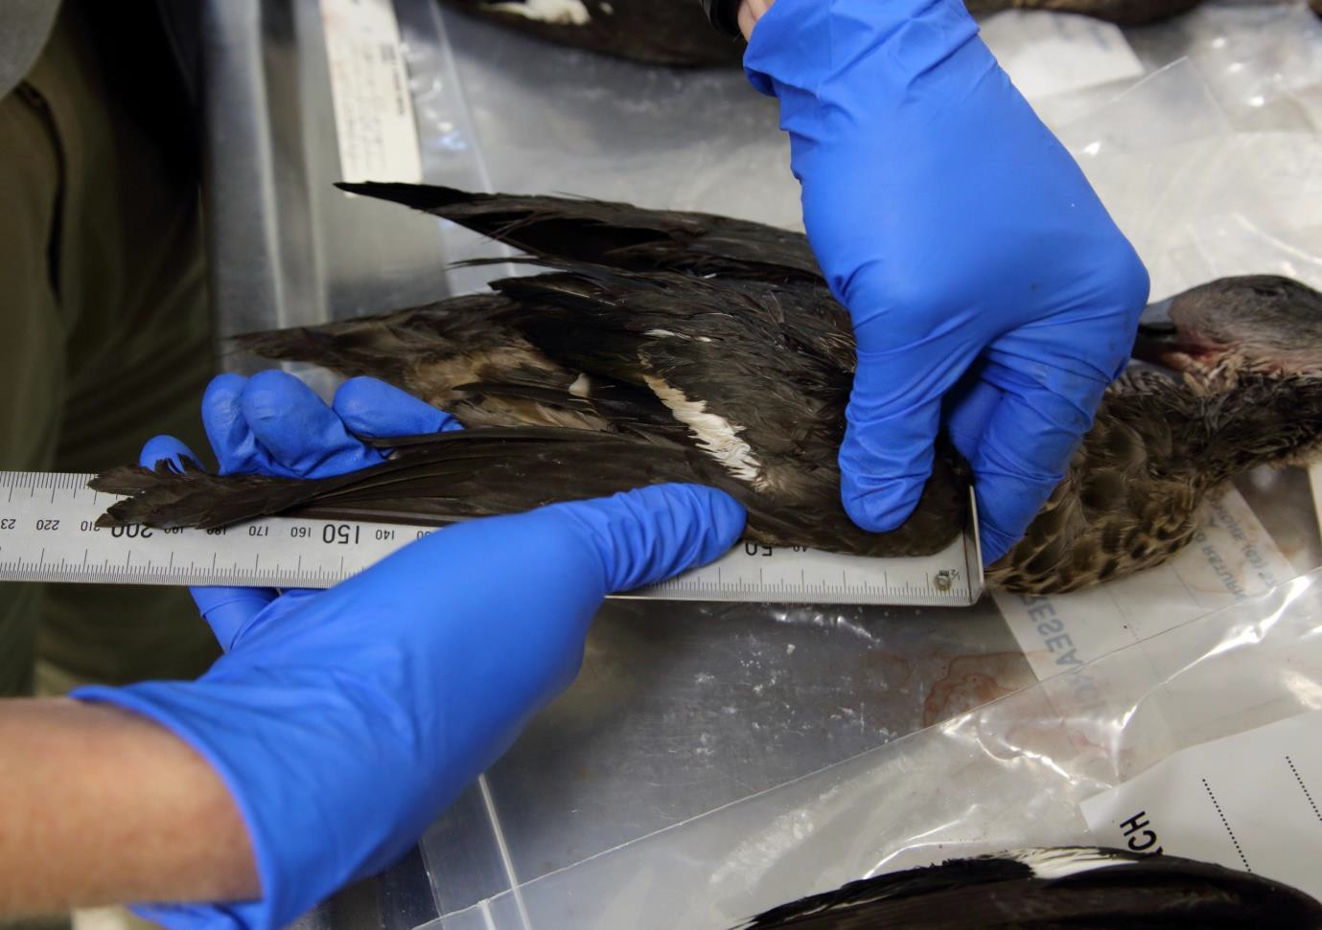

Figure 3. Measurement of maximum chord wing length
The carpal joint is pressed against the butt of the rule by the forward hand (the left hand in this image), with the thumb pressing the wing flat against the ruler. The thumb and fingers of the rear hand (the right hand in this image) are used to straighten the primaries so the longest possible measurement is taken.

The wing measurements taken from museum skins, and those of ducks from hunters’ bags in 2017 and 2018, are presented separately. The wings from hunters’ bags had been frozen, and they were measured when defrosted sufficiently to be spread and closed. In contrast, study skins are dried, and this process causes shrinkage. The extent of shrinkage ranges from 0.39% to 4% in the various families of birds (Herremans 1985; Winker 1993). We could find no published information on the extent of shrinkage of duck wings. Winker (1993) suggested that in the absence of taxon-specific shrinkage data, an average shrinkage correction factor of bird wings of 1.7% could be used—but he emphasised that this correction factor is crude, and that family-specific information is preferable if available. Measuring individual fresh wings, waiting 2–5 months until they dried, and then remeasuring them was beyond the scope of this study. However, we were able to compare the mean wing lengths of freshly dead specimens with those of museum skins for five species (Table 2). The wings of museum skins were shorter than those of freshly dead birds, and the scale of the difference was consistent with that found in previous studies of wing shrinkage in museum skins. The average shrinkage found in 15 comparisons was 1.6%, similar to the generic correction of 1.7% suggested by Winker (1993). When basing sexing criteria on measurements of wing length of museum skins, we assumed the wings had shrunk in preparation, and applied a shrinkage correction so measurements could be compared with the undried wings collected from hunters. Using the information in Table 2, we applied a shrinkage factor of 1.2% for Chestnut Teal and the morphologically similar Grey Teal, of 1.8% for Hardhead, and of 2.4% for Australian Wood Duck. We applied the generic shrinkage factor of 1.6% for the remaining species, because the sample sizes of sexed fresh wings were too small for us to be confident in our estimates of species-specific shrinkage.

Table 2. Shrinkage of wing length in study skins, estimated by comparing the mean wing length of skins with that of freshly dead samples
(See elsewhere in this report for further details about these samples; f = female; m = male.)

Species | Sex | Age | No. of freshly dead samples | No. of skins | Shrinkage of skins | Average shrinkage by species
Chestnut Teal | f | Ad. | 10 | 8 | 1.4% | 1.2%
 | m | Ad. | 12 | 21 | 1.0%
Hardhead | f | Ad. | 7 | 16 | 0.0% | 1.8%
 | m | Ad. | 13 | 24 | 2.5%
 | m | Imm. | 7 | 6 | 3.0%
Pacific Black Duck | f | Ad. | 9 | 24 | 3.4% | 2.7%
 | f | Imm. | 4 | 7 | 2.3%
 | m | Ad. | 22 | 29 | 3.0%
 | m | Imm. | 5 | 9 | 2.2%
Australian Shelduck | f | Ad. | 4 | 12 | –0.3% | 0.0%
 | m | Ad. | 9 | 14 | 0.3%
Australian Wood Duck | f | Ad. | 24 | 18 | 2.2% | 2.4%
 | f | Imm. | 13 | 15 | 2.5%
 | m | Ad. | 31 | 35 | 1.2%
 | m | Imm. | 6 | 11 | 3.8%

Sexing criteria were calculated using measurements from birds that had been reliably sexed according to plumage characters or by dissection. After calculating the mean, standard deviation and 95% confidence intervals for each sex and age cohort, normal distribution theory (we used the NORM.DIST function in Excel) was used to calculate the following (also explained in Figure 4, and by Rogers and Rogers 1995):
    - the threshold values at which 95% of birds were correctly sexed as male and 95% were correctly sexed as female
    - the threshold value at which 50% of birds are male, and 50% are female
    - the proportion of birds in our measured samples that were correctly sexed, incorrectly sexed, or not sexed at all by these criteria (Figure 4).
The level of confidence required for sexing can be selected by the analyst in accordance with the purposes of the study. The use of a minimum probability of correct sexing of 95% in this report follows typical conventions and reduces the chances of incorrectly sexing individual birds. The higher the minimum probability of incorrect sexing selected, the higher the proportion of individuals that will need to be treated as unsexed. If a minimum probability of correct sexing of 50% is selected, a sex can be assigned to every individual. This approach will, in species in which the sexes overlap in size, result in many individuals being incorrectly sexed. This is not necessarily important if the sole purpose of the analysis is to estimate the sex ratio. However, a 50% threshold is not our preferred option, as the error associated with the estimate of the percentage threshold value is difficult to estimate and could be influenced by skewed sex ratios, or by small numbers of outliers (e.g. incorrectly sexed museum specimens). For most species, we considered it more realistic to accept that there is so much overlap between the size of males and females that not all individuals can be correctly sexed.

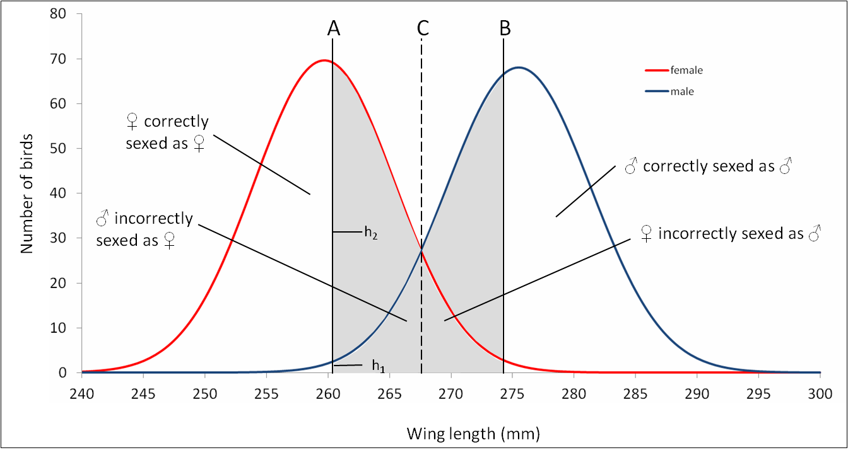

Figure 4. Sexing criteria calculated in this report (after Rogers and Rogers 1995)
Wing length distributions are shown for adult Pacific Black Duck; the y-axis shows the number of birds in a simulated population of 500 males and 500 females. Birds in the grey zone cannot be sexed with
≥95% confidence. A: Value at which 95% of birds are female [calculated with the formula h1/(h1+h2)]. B: Value at which 95% of the population is male. C: Value at which 50% of birds are male, and 50% are female.

Results

  - Pink-eared Duck Malacorhynchus membranaceus
Pink-eared Ducks breed largely in temporary shallow water bodies following flooding or rainfall. Their breeding season is therefore rather unpredictable, but breeding in south-eastern Australia usually occurs in August–February, following winter or spring rains (Crome 1986; Marchant and Higgins 1990), and moult occurs soon afterwards. During the duck hunting season, most adults would therefore be expected to have fresh, recently moulted flight feathers, but it is possible that the proportion of birds that are yet to complete moult varies annually, being especially higher in years with extensive late summer rainfall.
Male and female Pink-eared Ducks have similar plumage, and the existing literature states that the sexes are indistinguishable on plumage characters alone. Similarly, no wing plumage differences between juveniles and adults have been described (e.g. Marchant and Higgins 1990). However, our examination of wings collected by hunters in the 2017 duck hunting season revealed clear differences between the wing markings of juveniles and adults, and also suggested some subtle plumage differences between larger adults (presumably males) and smaller adults (presumably females). The differences are summarised in Table 3. These characters were recorded systematically for museum specimens sexed by dissection to assess whether they were of practical use as sexing characters, and to assess their reliability as ageing characters (Table 4). We also recorded ear-spot colour (said to be pink in adults, white in juveniles) and the presence of a white patch on the belly (said to be present in juveniles but not adults). A summary of ageing and sexing criteria for practical field and laboratory purposes is provided in Appendix 1.

Ageing characters
First-year Pink-eared Ducks can often be picked out immediately based on retained juvenile tail feathers. However, approximately 60% of first-year Pink-eared Ducks collected during the 2017 opening weekend had begun to moult tail feathers, and a further approximately 15% of first-year Pink- eared Ducks had replaced all juvenile tail feathers (Table 4). It is therefore unsatisfactory to assume that all birds lacking juvenile tail feathers are adults; the wings of such individuals should be checked for retained juvenile features.
We consider the shape of the primary tips a particularly helpful character for ageing those first-year Pink-eared Ducks that have replaced all their juvenile tail feathers. The juvenile primaries are retained until one year old, and they have narrower and more pointed tips than adults. There is some subjectivity in judging primary shape, but in Pink-eared Ducks we found the distinction easier to make than in most other Victorian duck species. In the samples examined, we only encountered one adult female and one immature male for which we were unable to classify the primary tips as either ‘broad’ or ‘narrow’.
In some cases, observers may be unable to judge whether the primary shape is juvenile or adult (e.g. through inexperience or lack of comparative material, or because the primary tips are wet or damaged). In such cases, it is helpful to look for retained juvenile wing coverts with the following attributes: smaller white tips to the greater upperwing coverts and greater and median underwing coverts, more buff vermiculation on the marginal and lesser upperwing coverts, and finer black markings on the lesser underwing coverts. Note, however, that these feathers are not retained in all first-year Pink-eared Ducks in the duck hunting season. We consider the underwing coverts the most helpful coverts for ageing, because they are often retained through the first year, being present in approximately 80% of first-year Pink-eared Ducks during the Victorian duck hunting season.

Table 3. Differences between adult and juvenile Pink-eared Ducks, and between males and females.
Measurements are presented in the format mean (standard deviation; minimum – maximum; sample size)

Plumage attribute | Adult male | Adult female | Juvenile male | Juvenile female
Pink ear-spot | Present |  | Absent
Belly | Barred |  | White
Body feathers | Longer and broader than in juveniles |  | Shorter and narrower than in adults
Tail feathers | Broad with rounded white tips; usually fresh during duck hunting season |  | Narrower and usually more worn than those of adults in duck hunting season; tips notched with bare tip to shaft
Greater secondary coverts | Sharply defined white tips to both inner and outer webs when fresh; they can be lost with wear | Narrow white tips when fresh, that are restricted to or mainly occurring on the outer web; they can be lost with wear | Lack white tips, but have some buff vermiculation near tip of feather
Marginal and lesser upperwing coverts | Near-black with faint buff vermiculation that is more obvious when worn | Subtly browner ground colour than males? | Look browner (less black) than adults because they have heavier buff vermiculation
Greater underwing coverts | Sharply defined, broad white tips | Broad white tips, often have grey mottling within | Narrower white tips than adults, often sullied by grey mottling; also have white subterminal spots
Median underwing coverts | Sharply defined, broad white tips | Broad white tips; often also have small white subterminal markings | Narrower white tips than adults, often sullied by grey mottling; also have white subterminal spots
Lesser underwing coverts | Continuous black barring | Patchier black barring than males | Finer dark markings than adults, looking like lines of blackish dots rather than continuous barring
Wing length (skins, mm) | 195.9 (3.02; 192–200; 7) | 187.2 (5.23; 180–193; 6) | 195.0 (3.37; 193–200; 4) | 180.6 (6.45; 171–191; 11)
Wing length (undried specimens, mm) | 197.3 (6.22; 190–214; 16) | 186.2 (5.48; 180–198; 15) | 198.3 (5.85; 190–211; 15) | 182.4 (6.96; 171–194; 19)

Table 4. Number of Pink-eared Ducks examined with attributes of male, female and first-year plumages
Plumage characters were scored as ‘adult’ (Ad.) or ‘juvenile’ (Juv.) if they corresponded with the descriptions in Table 3 and illustrations in Appendix 1. They were scored as ‘Intermediate’ (Int.) if: (1) their appearance was intermediate between ‘adult’ and ‘juvenile’ and it was not possible to judge which was the most apt description; (2) if the feather tract was moulting (had a mixture of juvenile and adult feathers). First-year birds included juveniles, birds in formative plumage, and birds in various stages of pre-formative moult.

Plumage character |  |  | Adults |  |  | First-year birds
 |  | Total (%) | Males (%) | Females (%) | Total (%) | Males (%) | Females (%)
Number of juvenile tail feathers  n = 42 Ad. (18 ♂, 17 ♀), 34 Imm. (10 ♂, 14  ♀) | None | 100 | 100 | 100 | 14.7 | 10 | 12.5
 | 1–13 | 0 | 0 | 0 | 58.8 | 70 | 50.0
 | 14 (all) | 0 | 0 | 0 | 35.3 | 20 | 37.5
Pink ear-spot  n = 20 Ad. (9 ♂, 11 ♀), 9 Imm. (5 ♂, 4 ♀) | Present | 95 | 100 | 90.9 | 44.4 | 20.0 | 100
 | Absent | 5 | 0 | 9.1 | 55.6 | 80.0 | 0
Belly  n = 40 Ad. (16 ♂, 17 ♀), 32 Imm. (9 ♂, 13  ♀) | Ad. | 82.5 | 100 | 58.8 | 18.8 | 55.6 | 0
 | Int. | 15.0 | 0 | 35.3 | 18.8 | 22.2 | 15.4
 | Juv. | 2.5 | 0 | 5.9 | 62.5 | 22.2 | 84.6
Greater secondary coverts  n = 40 Ad. (18 ♂, 16 ♀), 35 Imm. (9 ♂, 16  ♀) | Ad. | 72.5 | 100 | 43.8 | 17.1 | 0 | 0
 | Int. | 27.5 | 0 | 56.2 | 11.4 | 33.3 | 25.0
 | Juv. | 0 | 0 | 0 | 71.4 | 66.7 | 75.0
Marginal and lesser upperwing coverts  n = 37 Ad. (19 ♂, 11 ♀), 23 Imm. (7 ♂, 8 ♀) | Ad. | 73.0 | 100 | 72.7 | 4.4 | 0 | 12.5
 | Int. | 27.0 | 0 | 23.3 | 13.0 | 28.6 | 0
Juv. |  | 0 | 0 | 0 | 82.6 | 71.4 | 87.5
Greater underwing coverts  n = 41 Ad. (18 ♂, 16 ♀), 35 Imm. (9 ♂, 16  ♀) | Ad. | 51.2 | 77.8 | 25.0 | 11.4 | 11.1 | 6.2
 | Int. | 48.8 | 22.2 | 75.0 | 8.6 | 22.2 | 0
 | Juv. | 0 | 0 | 0 | 80.0 | 67.7 | 93.8
Median underwing coverts  n = 20 Ad. (8 ♂, 6 ♀), 23 Imm. (5 ♂, 9 ♀) | Ad. | 75 | 100 | 33.3 | 8.6 | 0 | 0
 | Int. | 20 | 0 | 50 | 4.3 | 0 | 0
Juv. |  | 5 | 0 | 16.7 | 87.0 | 100 | 100
Lesser underwing coverts  n = 22 Ad. (9 ♂, 6 ♀), 26 Imm. (5 ♂, 11 ♀) | Ad. | 90.9 | 100 | 83.3 | 26.9 | 40 | 18.2
 | Int. | 9.1 | 0 | 16.7 | 3.9 | 0 | 9.1
Juv. |  | 0 | 0 | 0 | 69.2 | 60 | 72.7
Shape of primary tips  n = 40 Ad. (16 ♂, 17 ♀), 36 Imm. (10 ♂, 16  ♀) | Ad. | 97.5 | 100 | 93.8 | 5.6 | 0 | 0
 | Int. | 2.5 | 0 | 6.2 | 5.6 | 10 | 0
 | Juv. | 0 | 0 | 0 | 88.8 | 90 | 100

Sexing characters
There are some plumage differences between male and female Pink-eared Ducks, but the differences are quite subtle and variable. Females are more likely than males to have grey mottling within the white tips of the greater and median underwing coverts, narrower white tips to the greater secondary upperwing coverts, and patchier black barring on the lesser underwing coverts. Females are also more likely to have sparsely barred or white bellies, and when adult they are more likely to lack a pink ear-spot than males. These plumage characters are all intermediate in appearance between adult male and juvenile, but are considerably more like the former. Only a small proportion of female Pink- eared Ducks can be sexed reliably using these features.
Wing measurements are a more objective basis for estimating sex ratios in Pink-eared Duck. On average, the wings of female Pink-eared Ducks are 92–94% the length of the wings of male Pink- eared Ducks, with negligible differences between the size of juveniles and adults (Table 3). Sexing criteria are provided in Table 5. Note that there is overlap between the sizes of males and females; in the samples examined, the wing length of 67% of adults and 47% of first-year birds lay in the ‘grey zone’, in which wing length cannot be used to sex individuals.

Table 5. Sexing criteria for Pink-eared Ducks according to wing lengths of undried wings, and their reliability in classifying the known-sex specimens measured in this study

Wing length | Adult | First-year | Adult | First-year
Confidence level | 95% | 95% | 50% | 50%
Female if ≤ (mm) | 183 | 183 | 191 | 189
Male if ≥ (mm) | 203 | 203 | 192 | 190
Percentage correctly sexed | 32.3% | 52.9% | 83.9% | 94.1%
Percentage wrongly sexed | 0% | 3.3% | 16.1% | 5.9%
Percentage unsexed | 67.4% | 47.1% | 0% | 0%

  - Australian Shelduck Tadorna tadornoides
Australian Shelducks breed in temperate south-eastern and south-western Australia, and have a rather regular breeding season from mid-winter through spring. They are widely dispersed when breeding, but like several extralimital species of shelduck, they have a moult migration. After breeding, many birds migrate, often several hundreds of kilometres, to moulting sites at large water bodies. Numbers at the moulting sites peak in about February and return to breeding-season levels by about May. Because of this migration, it is possible that samples obtained from any one site during the opening of the duck hunting season may comprise birds from a variety of breeding locations, potentially differing slightly in timing of moult. There is little information on the return migration of shelducks to their breeding areas, and it is not known whether some cohorts (e.g. males or immatures) return earlier than others. It is therefore probably prudent to only use samples collected on opening weekend when assessing age and sex ratios in Australian Shelduck.
The head and body plumage of adult male and female Australian Shelduck differ markedly (Table 6; Appendix 2). Adult males are larger than adult females, with a completely black hood, a white collar and a broad cinnamon-brown breast-band. Adult females are smaller, have a white base to the bill and a white ring around the eye, and their breast-band is darker and more chestnut than that of males. Juveniles are like adult females in general appearance, but they can be reliably distinguished from adults using the wing characters originally reported by Riggert (1977); these characters are described in more detail below and illustrated for the first time in Appendix 2.

Ageing characters
In most cases, Australian Shelducks can be most easily and reliably aged by examining the greater secondary coverts (Riggert 1977). Juvenile greater secondary coverts are retained throughout their first year (Table 7); these feathers are extensively grey and are readily distinguished from the predominantly white greater secondary coverts of older birds. Extensively grey greater secondary

coverts have also been found to be the most reliable ageing features in the shelduck species occurring in Europe (Reeber 2015 ONCFS 2017): Ruddy Shelduck Tadorna ferruginea and Common Shelduck Tadorna tadorna.
Several other feather tracts are also helpful in ageing Australian Shelducks. Like the greater coverts, the median secondary coverts are retained through the first year; initially, they differ obviously from those of adults in having greyish tips, but the tips often bleach to white before they are moulted when a year old. Juvenile median primary coverts are also distinctive (being much greyer than those of adults) and were present in the majority of immatures examined in this study (Table 7); however, samples were rather small. Finally, retained juvenile tail feathers are readily identified in Australian Shelduck, being clearly narrower and more pointed than those of adults, with the notched tips typical of juvenile ducks. However, 20–40% of individuals replace all their juvenile tail feathers before the onset of the Victorian duck hunting season.

Sexing characters
When complete specimens are available, adult Australian Shelducks are most readily sexed using head and body plumage. The white eye-ring is considered the most reliable sexing character (Frith 1982): it is broad and conspicuous in females, absent in males. Females have a broad ring of white feathering at the base of the bill; this was absent in all adult males encountered in this study (Table 7), but present in approximately 20% of males examined by Frith (1982). The colour of breast and mantle is also a reliable difference: chestnut in females, and distinctly more cinnamon or yellowish-rufous in adult males. The white collar of males is a little broader than that of females, and it is usually complete (unbroken around the hindneck); in all females examined in this study, it was incomplete around the hindneck.
Juveniles of both sexes are superficially like adult females, though with obviously smaller body feathers and paler vent. Males tend to have a yellower tinge to the breast and smaller white markings at the base of the bill (foreshadowing the sexing characters of adults), but there is considerable variation, and reliable sexing on these characters may not be possible. Juvenile plumage begins to moult at the age of around 90 days (Riggert 1977), and the resultant plumage is readily sexed using ‘adult’ characters. Birds with complete juvenile plumage that are difficult to sex are therefore likely to be rare in samples collected during the duck hunting season.
When only wings are available, male and female Australian Shelduck differ most obviously in size. On average, the wing length of females is only 90% that of males, and there is little overlap (Table 8).
Birds with a wing length of 350–363 mm (adults) or 349–360 mm (immatures) can be only sexed with less than 95% confidence, but such individuals form a small proportion of the population; in the samples we examined, all males had a wing length of >355 mm, and all females had a wing length of
<354 mm.

Table 6. Differences between adult and juvenile Australian Shelducks, and between males and females.
Measurements are presented in the format mean (standard deviation; minimum – maximum; sample size)

Plumage attribute | Adult male | Adult female | Juvenile male | Juvenile female
Collar | Broad, white, sharply defined | Narrower than male, incomplete round hindneck, mottled brown | Off-white, narrow, sometimes absent or concealed in females
Feathers at base of bill | Usually all black; a few individuals have a few white feathers | White | Off-white, narrow
White eye-ring | Absent | White, extensive | Present, off-white
Breast colour | Yellowish chestnut | Rufous brown | Reddish brown, slightly yellower than juvenile female | Reddish brown
Median upperwing coverts | White (with concealed grey bases to inner webs) |  | Obvious grey markings at feather tips
Greater secondary coverts | White (with small, concealed grey areas on inner webs) |  | Largely medium grey, with white outer edges and pale-grey inner edges
Underside of secondaries | Black tips (white restricted to base of inner webs) | Black tips (white restricted to base of inner webs) | Distinct white tips, at least when fresh
Speculum | Bright green | Darker green than adult male | Duller green than adults; doesn’t extend so close to feather tips
Width from speculum to trailing edge (mm) | 2.0 (1.19; 1–4; 15) | 3.0 (1.62; 1–5; 12) | 6.3 (2.75; 3–10; 7) | 9.75 (3.86; 6–15; 4)
Tertials | Outer webs rufous, merging to buff-yellow at tips | Outer webs red-brown, sometimes with yellow-brown traces on edges | Same as adult female (?)
Wing length (skins) | 372.7 (10.25; 355–389; 14) | 337.3 (7.86; 323–348; 12) | 362.0 (8.34; 353–375;  6) | 335.8 (7.09; 331–346; 4)
Wing length (undried) | 373.9 (10.96; 358–395; 9) | 336.3 (7.18; 327–344; 4) | 371, 374 | –

Table 7. Number of Australian Shelduck examined with attributes of male, female and first-year plumages
Plumage characters were scored as ‘adult’ (Ad.) or ‘juvenile’ (Juv.) if they corresponded with the descriptions in Table 6 and illustrations in Appendix 2. They were scored as ‘Intermediate’ (Int.) if: (1) their appearance was intermediate between ‘adult’ and ‘juvenile’ and it was not possible to judge which was the most apt description; (2) if the feather tract was moulting (had a mixture of juvenile and adult feathers). First-year birds included juveniles, birds in formative plumage, and birds in various stages of pre-formative moult.
Plumage character |  |  | Adults |  |  | First-year bird | s
 |  | Total (%) | Males (%) | Females (%) | Total (%) | Males (%) | Females (%)
Number of juvenile tail feathers  n = 29 Ad. (16 ♂, 13 ♀), 18 Imm. (9 ♂, 7 ♀) | None | 100 | 100 | 100 | 27.8 | 22.2 | 42.9
 | 1–13 | 0 | 0 | 0 | 22.2 | 33.3 | 14.2
14 (all) |  | 0 | 0 | 0 | 50.0 | 44.4 | 42.9
Collar  n = 28 Ad. (15 ♂, 13 ♀), 10 Imm. (7 ♂, 3 ♀) | Male | 50.0 | 93.3 | 0 | 40 | 57 | 0
 | Female | 50 | 6.7 | 100 | 30 | 0 | 100
Juv. |  | 0 | 0 | 0 | 30 | 42.9 | 0
Base of bill  n = 28 Ad. (15 ♂, 13 ♀), 10 Imm. (7 ♂, 3 ♀) | Male | 53.7 | 100 | 0 | 60 | 85.7 | 0
 | Female | 46.4 | 0 | 100 | 30 | 0 | 100
Juv. |  | 0 | 0 | 0 | 10 | 14.3 | 0
Eye-ring  n = 28 Ad. (15 ♂, 13 ♀), 10 Imm. (7 ♂, 3 ♀) | Male | 53.7 | 100 | 0 | 70 | 100 | 0
 | Female | 46.4 | 0 | 100 | 30 | 0 | 100
Breast colour  n = 28 Ad. (15 ♂, 13 ♀), 10 Imm. (7 ♂, 3 ♀) | Male | 50.0 | 100 | 0 | 50 | 71.4 | 0
 | Female | 50.0 | 0 | 100 | 50 | 28.6 | 100
Median secondary upperwing coverts  n = 30 Ad. (18 ♂, 12 ♀), 21 Imm. (10 ♂, 8 ♀) | Ad. | 100 | 100 | 100 | 14.3 | 0 | 37.5
 | Juv. | 0 | 0 | 0 | 85.7 | 100 | 62.5
Greater secondary upperwing coverts  n = 30 Ad. (18 ♂, 12 ♀), 22 Imm. (10 ♂, 7 ♀) | Ad. | 100 | 100 | 100 | 0 | 0 | 0
 | Juv. | 0 | 0 | 0 | 100 | 100 | 100
Median primary coverts  n = 29 Ad. (17♂, 12 ♀), 21 Imm. (10 ♂, 8 ♀) | Ad. | 100 | 100 | 100 | 9.5 | 0 | 25
 | Juv. | 0 | 0 | 0 | 90.5 | 100 | 75
Speculum colour  n = 28 Ad. (15 ♂, 13 ♀), 11 Imm. (7 ♂, 4 ♀) | Bright | 66.7 | 93.3 | 33.3 | 9.0 | 14.3 | 0
 | Int. | 0 | 0 | 0 | 18.1 | 28.6 | 0
Dull |  | 33.3 | 6.7 | 66.7 | 72.7 | 57.1 | 100
Tertials  n = 28 Ad. (15 ♂, 13 ♀), 12 Imm. (7 ♂, 5 ♀) | Male | 53.6 | 80 | 23.1 | 33.3 | 42.9 | 20
 | Female | 46.4 | 20 | 76.9 | 66.7 | 57.1 | 80

Table 8. Sexing criteria for Australian Shelduck according to wing lengths of undried wings, and their reliability in classifying the known-sex specimens measured in this study

Undried Wing length | Adult | First-year | Adult | First-year
Confidence level | 95% | 95% | 50% | 50%
Female if ≤ (mm) | 349 | 348 | 357 | 354
Male if ≥ (mm) | 364 | 361 | 358 | 355
Percentage correctly sexed | 61.8% | 88.2% | 100% | 100%
Percentage wrongly sexed | 0% | 0% | 0% | 0
Percentage unsexed | 38.2% | 11.8% | 0% | 0

If only wings are available, and it is not possible to take a wing measurement, there are other sexing clues. The speculum of males is usually brighter green than that of females. In addition, the tertials of males are rufous, usually grading to buff-yellow at the feather tips and shaft; the tertials of females are duller red-brown, rarely with yellow-brown tinges at the edges. Both plumage characters vary, and there is some overlap between the sexes (Table 7), so we regard wing length as a superior method of separating the sexes.

  - Hardhead Aythya australis
Hardheads have a broad breeding distribution, and the timing of breeding varies geographically according to time of annual rainfall: largely between September and December in inland NSW, and south-western and south-eastern Australia; in January and February in northern NSW; and probably in April–May in parts of northern Australia that have monsoonal summer rains (Marchant and Higgins 1990). The origin of the birds found in Victoria during the duck hunting season is unclear, so they may comprise birds from several different regions. Moreover, Hardhead numbers in southern Victoria often peak at slightly different times to those of other waterfowl. For example, at the Western Treatment Plant, large post-breeding aggregations of Hardheads often occur in early summer, which is earlier than the aggregations of other species (Arthur Rylah Institute unpublished data). Their moult timing may therefore be earlier than in other Victorian game bird species.
Adult male and female Hardheads are usually readily separable when the entire specimen can be examined (Tables 9 and 10). Males have a white iris, dark brown head, sharply defined white bill-nail, and usually (but not always) a sharply demarcated white belly-patch. Females have a paler brown head and body plumage, some white feathering on the throat, a brown iris, a less boldly demarcated pale bill-nail, and usually (but not always) a less clearly demarcated white belly-patch (sullied by irregular brown barring). Juveniles of both sexes appear to be similar to adult females, but they are drabber, the smaller and less boldly demarcated white belly-patch has more brownish mottling, and the bill-nail is initially black. Male and female juveniles appear to be similar to one another, but can be distinguished on wing characters (see below); in addition, juvenile males tend to have less white on the throat than juvenile females do.
No wing or tail plumage characters diagnostic of sex or age have previously been described for Hardhead (Marchant and Higgins 1990), but in several congeneric pochards from New Zealand and the Holarctic, males have slightly glossier upperwing plumage than females and juveniles, with less freckling on the tertials and lesser wing coverts. These potential age and sex characters were sought and recorded systematically when examining museum specimens sexed by dissection, but proved to be similar in male and female Hardheads. We did, however, find consistent differences in the wing- bar of male and female Hardheads, and also some differences in the patterning on the primary underwing coverts (Table 10, Appendix 3).

Ageing characters
The juvenile tail feathers of Hardheads are distinctive, and if retained provide a reliable ageing character. Compared with the other duck species examined in this study, the retained juvenile tail feathers of Hardheads were often exceptionally worn, with the tips (up to the distal third) bleached to pale brown. In part this may be because the tail feathers wear especially readily: often the tail feathers

are worn when hardly any wear can be detected in wing feathers of the same age. Moreover, Hardheads may have an earlier moult than most other Victorian duck species (correlated with their early arrival post-breeding), so the tail feathers of juveniles are probably older on average than those of juveniles of other species of the same age.
After the last juvenile tail feathers are moulted, Hardheads are very difficult to age. We could find no difference in primary shape between the wings of juveniles and those of presumed adults. Features that can be helpful include:
      - Some may retain juvenile marginal coverts at the leading edge of the wing; these feathers have more complete white fringes than those of adult females, have some white internal markings inside the carpal joint, and are distinctly smaller than adult feathers (Appendix 3).
      - Due to their early breeding schedule, some first-year birds have obviously worn flight feathers during the Victorian duck hunting season, which are distinctly more faded and abraded than those of adults.
      - If the head and body plumage resemble that of the adult female and the iris is brown but the wing-bar pattern resembles that of the adult male, the bird is a male in its first year.
The distinctive head and body plumage of males develops during the first year, with the bill-nail starting to become white and the iris starting to become pale while still in juvenile plumage (and probably less than 2 months old). It is possible that some individuals moult all juvenile head and body feathers, all juvenile tail feathers and all juvenile underwing coverts before the onset of the Victorian duck hunting season. Individuals in a plumage condition of this kind would probably be indistinguishable from adults.

Table 9. Differences between adult and juvenile Hardheads, and between males and females.
Measurements are presented in the format mean (standard deviation; minimum – maximum; sample size)

Plumage attribute | Adult male | Adult female | Juvenile male | Juvenile female
Iris | White | Brown | Initially brown; starts to whiten in first year | Brown
Head | Dark brown (medium brown in eclipse) | Medium brown with white mottling on chin and throat | Medium brown with white patch on chin and throat
Bill-nail | Clean white with sharply demarcated edges | Tinged light grey, less boldly defined | Initially black; starts to whiten in first year | Initially black
Belly-patch | Clean white, sharply defined; looks more female-like in eclipse | Less clearly demarcated than in males; sullied by brown barring | Like adult female with denser, more streaky-brown mottling
Wing-bar | Clean white with trace of cloudiness on outer primaries | Brown smudging throughout wing-bar, especially on outer primaries | Like adult male | Like adult female
Outermost primary with distinct white patch on outer web | p7 or p8, rarely p6 | p4 to p6, rarely p7 | p7 or p8, rarely p6 | p4 to p6, rarely p7
Greater primary underwing coverts | Clean white except for small grey-brown smudges on outer webs and tips of outermost feathers | Extensively washed grey- brown, this tinge strongest on outer feathers | Like adult male | Like adult female
Marginal underwing coverts | White tips to some feathers, especially outside carpal joint | White tips wrapping round onto edges of many feathers | Complete white fringes to most feathers; some white internal markings inside carpal; feathers smaller than in adult | As juvenile male
Wing (fresh) | 222.4 (5.19; 215–230; 13) | 212.1 (5.79; 205–221; 7) | 219 (7.16; 206–229; 7) | 209 (n = 1)
Wing (skins) | 216.9 (4.48; 210–226; 24) | 212.2 (4.72; 205–222; 16) | 212.3 (8.11; 198–220; 6) | 207.9 (6.66; 200–221; 9)

Table 10. Number of Hardheads examined with attributes of male, female and first-year plumages
Plumage characters were scored as ‘adult’ (Ad.) or ‘juvenile’ (Juv.) if they corresponded with the descriptions in Table 9 and illustrations in Appendix 3. They were scored as ‘Intermediate’ (Int.) if: (1) their appearance was intermediate between ‘adult’ and ‘juvenile’ and it was not possible to judge which was the most apt description; (2) if the feather tract was moulting (had a mixture of juvenile and adult feathers). First- year birds included juveniles, birds in formative plumage and birds in various stages of pre-formative moult.

Plumage character |  |  | Adults |  |  | First-year birds
 |  | Total (%) | Males (%) | Females (%) | Total (%) | Males (%) | Females (%)
Number of juvenile tail feathers  n = 61 Ad. (39 ♂, 22 ♀), 25 Imm. (14 ♂, 11 ♀) | None | 100 | 100 | 100 | 4 | 0 | 9.1
 | 1–13 | 0 | 0 | 0 | 48 | 57.1 | 54.5
14 (all) |  | 0 | 0 | 0 | 48 | 42.9 | 36.4
Head  n = 41 Ad. (25 ♂, 16 ♀), 15 Imm. (6 ♂, 9 ♀) | Male-like | 63.4 | 100 | 6.2 | 26.7 | 0 | 0
 | Female-like | 36.6 | 0 | 93.8 | 33.3 | 66.7 | 55.5
Juv.-like |  | 0 | 0 | 0 | 40 | 33.3 | 44.5
Belly-patch  n = 41 Ad. (25 ♂, 16 ♀), 15 Imm. (6 ♂, 9 ♀) | Male-like | 46.3 | 68.0 | 87.5 | 6.7 | 16.7 | 0
 | Female-like | 53.7 | 32.0 | 12.5 | 53.3 | 50.0 | 55.6
Juv.-like |  | 0 | 0 | 0 | 0 | 33.3 | 44.4
Wing-bar  n = 63 Ad. (40 ♂, 23 ♀), 27 Imm. (14 ♂, 13 ♀) | Male-like | 63.5 | 100 | 0 | 51.9 | 100 | 0
 | Int. | 1.6 | 0 | 4.3 | 0 | 0 | 0
Female-like |  | 34.9 | 0 | 95.7 | 48.1 | 0 | 100
Outermost primary with distinct white patch on outer web  n = 63 Ad. (40 ♂, 23 ♀), 27 Imm. (14 ♂, 13 ♀) | p9 | 4.8 | 7.5 | 0.0 | 0.0 | 0.0 | 0.0
 | p8 | 34.9 | 55.0 | 0.0 | 14.8 | 28.6 | 0.0
 | p7 | 36.5 | 35.0 | 39.1 | 37.0 | 57.1 | 15.4
p6 |  | 17.5 | 2.5 | 43.5 | 18.5 | 14.3 | 23.1
p5 |  | 4.8 | 0.0 | 13.0 | 11.1 | 0.0 | 23.1
p4 |  | 1.6 | 0.0 | 4.3 | 14.8 | 0.0 | 30.8
P3 |  | 0.0 | 0.0 | 0.0 | 3.7 | 0.0 | 7.7
Primary underwing coverts  n = 41 Ad. (25 ♂, 16 ♀), 16 Imm. (6 ♂, 10 ♀) | Male-like | 65.9 | 100 | 2.4 | 31.3 | 83.3 | 0
 | Int. | 2.4 | 0 | 2.4 | 0 | 0 | 0
Female-like |  | 31.7 | 0 | 34.1 | 68.8 | 16.7 | 100
Marginal underwing coverts  n = 41 Ad. (25 ♂, 16 ♀), 16 Imm. (6 ♂, 10 ♀) | Adult-like | 92.7 | 92.0 | 93.8 | 50.0 | 50.0 | 50.0
 | Int. | 4.9 | 4.0 | 6.3 | 0.0 | 0.0 | 0.0
Juv.-like |  | 2.4 | 4.0 | 0.0 | 50.0 | 50.0 | 50.0

Sexing characters
Hardheads can be sexed reliably using the wing-bar character discovered in this study (Tables 9 and 10, Appendix 3). In both adults and juveniles, males have a cleaner white wing-bar than females. In the 90 specimens we examined, only one specimen (an adult female) had a wing pattern that was difficult to classify as either ‘clean’ or ‘smudged’. The wing-bar of males is also slightly longer. We tried to document this systematically by recording the outermost primary that had a clear white spot on the outer web. This differed between males (usually p6–p8) and females (usually p4–p7), but there was some overlap.
We consider the clean white of the male wing-bar, versus the cloudy brown wash over much of the female wing-bar, to be a reliable sexing character, albeit one that is most easily discerned with experience or comparative material. This sexing character is also applicable to juveniles, in which the male and female head and body plumage is similar. In contrast, in some congeneric species in the Holarctic (Tufted Duck Aythya fuligula and Greater Scaup Aythya marila), similar variation in the wing- bar pattern is related to age rather than sex, with juvenile wing-bars being a little shorter and having a stronger grey-brown wash (Reeber et al. 2015).
If entire specimens are available, Hardheads are most reliably sexed on iris colour (always brown in females, and white or whitish in all but the youngest juvenile males). Although the differences in the head patterns of males and females are usually obvious, we encountered one adult female with a head as dark as typical males. The difference in the underparts patterns of males and females is usually striking during the duck hunting season, but males in eclipse plumage can have quite female- like underparts, with brown mottling within the white belly-patch, and the contrast between the white belly and dark brown breast being reduced because of white tips to the breast feathers. Hardhead males in eclipse plumage are encountered more often than in other Victorian game bird species, suggesting that the plumage can be held for several months. We therefore consider the wing-bar to be a more reliable sexing character.
The size differences between male and female Hardheads are modest; wing length of females is approximately 95–98% that of males. Only the very smallest females and very largest males can be sexed reliably using wing length (Table 11).

Table 11. Sexing criteria for Hardheads according to wing lengths of undried wings, and their reliability in classifying the known-sex specimens measured in this study

Undried Wing length | Adult | First-year | Adult | First-year
Confidence level | 95% | 95% | 50% | 50%
Female if ≤ (mm) | 207 | 206 | 217 | 215
Male if ≥ (mm) | 227 | 221 | 218 | 216
Percentage correctly sexed | 1.6% | 22.2% | 46.2% | 41.7%
Percentage wrongly sexed | 0% | 22.2% | 53.8% | 58.3%
Percentage unsexed | 98.4% | 55.6% | 0% | 0%

  - Australasian Shoveler Spatula rhynchotis
Australasian Shovelers breed mainly in temperate regions of southern Australia between August and November (Marchant and Higgins 1990). In eastern Australia, they nest mainly in Victoria, south- western New South Wales and south-eastern South Australia: they may have a broader breeding distribution in wet years, and there is probably some fluctuation in time of breeding, driven by rainfall conditions. Moult of the flight feathers occurs soon after breeding and is usually completed in early to mid-summer, though a few birds (especially females) are still moulting at the onset of the duck hunting season in March.
Sexual dimorphism in Australasian Shovelers is striking (Table 12; Appendix 4). Males have boldly coloured breeding plumage, including blue-grey head with white crescent in front of the eye, and

chestnut underparts with a white flank-spot. The eclipse plumage of males is more subdued and female-like, but nevertheless can easily be distinguished from female plumage. Juveniles look like drabber versions of the adult female, and the sexes are quite similar, but they can be sexed reliably on wing plumage characters.
The wing markings, moult and plumage cycles of Australasian Shovelers appear to be very similar to those of the Northern Shoveler Spatula clypeata, a species that has been studied intensively in North America and Europe (Palmer 1976; Cramp and Simmons 1977; Pyle 2005, 2008; Reeber 2015, ONCFS 2017). Male Northern Shovelers are suspected to have a third (pre-supplemental) moult in each annual cycle; this has some effect on the appearance of the head plumage, but does not influence key ageing or sexing characters. It is not known whether a homologous plumage occurs in the Australasian Shoveler.

Ageing characters
Juvenile tail feathers of Australasian Shovelers differ obviously from those of adults. The sample of first-year birds we examined was rather small, but included birds that were actively moulting juvenile tail feathers, and one individual that had completed tail moult (Table 13). We therefore suspect that a proportion of first-year Australasian Shovelers have no remnant juvenile tail feathers during the Victorian duck hunting season, as was the case in the other species considered in this study.
It is thus important to examine the wing of Australasian Shovelers to confirm the age of those birds that lack juvenile tail feathers. Available data suggest that first-year Australasian Shovelers retain their juvenile flight feathers and wing coverts throughout the first year (Table 13), as is the case in the Northern Shoveler (Cramp and Simmons 1977). These retained juvenile feathers are readily identified, but it is important to sex this species before ageing it on wing characters, as there are similarities between the wings of first-year males and adult females. First-year males differ from adult males in having more pointed primaries, a smaller speculum, a duskier wing-panel, and partly exposed dark bases to the greater secondary coverts. First-year females differ from adult females in their drabber appearance and narrower primary tips; importantly, the outer greater secondary coverts have simple narrow white fringes to the tips and outer webs. In adult females, the outer greater secondary coverts have more extensive and complex white patterning, often with a white patch encircling a black spot (Appendix 4).

Table 12. Differences between adult and juvenile Australasian Shoveler, and between males and females.
Measurements are presented in the format mean (standard deviation; minimum – maximum; sample size)

Plumage attribute | Adult male | Adult female | Juvenile male | Juvenile female
Primary tips | Broad primaries with rounded tips |  | Narrow primaries with more pointed tips
Head pattern | Grey-blue with white crescent in front of eye. Subdued version of same pattern in most or all with eclipse plumage. | Brown flecked whitish, paler at base of bill, with distinct dark eye-stripe under whitish supercilium | Few data; available specimens had subdued ‘male’ pattern, similar to typical eclipse | Brown flecked whitish, paler at base of bill, with distinct dark eye-stripe under whitish supercilium
Underparts | Mainly chestnut with black scalloping. Eclipse duller but tinged redder than female; has smaller white patch in rear-flanks and lacks black undertail coverts | Brown with blackish feather centres from breast to undertail coverts; no white patch in rear-flanks | Like juvenile female, but at least some have more reddish ground colour on underparts | Brown with blackish feather centres from breast to undertail coverts; feathers obviously smaller than those of adult female
Wing-panel formed by lesser and median secondary upperwing coverts | Uniform light greyish blue | Mottled by dusky feather centres | Mottled by dusky feather centres, only slightly brighter than adult female | Mainly dark brown with grey- blue fringes to feathers that can be lost with wear
Greater secondary upperwing coverts | Clean white, forming broad continuous wing-bar | Lacks bold wing-bar; most feathers blackish brown with white fringes, complex blackish and white patterning on outermost feathers | Like adult male, but dark brown bases partly exposed | Lacks bold wing-bar; like adult female but outer feathers only have narrow white fringes
Speculum | Large and bright; green gloss extends to outermost 1–3 secondaries, and to within  1 cm of trailing edge | Smaller than adult male; green gloss peters out on about s5 and falls ~2 cm short of trailing edge | Size intermediate between speculum of adult male and adult female | Speculum small and dull; bright-green patches usually confined to 3–5 feathers
Tertials | Black with pointed tips and white shaft-streaks. Female- like in eclipse plumage. | Dark brown, tips less pointed than adult male; narrow white fringes but no white streaks | Smaller and narrower than adult; pattern similar to adult female, tips more rounded | Smaller and narrower than adult; pattern similar to adult female, tips more rounded
Wing length (skins) | 250.5 (4.29; 242–258; 13) | 229.6 (6.64; 219–240; 20) | 240.7 (3.21; 237–243; 3) | 222.7 (4.93; 217–226; 3)

Table 13. Number of Australasian Shovelers examined with attributes of male, female and first-year plumages
Plumage characters were scored as ‘adult’ (Ad.) or ‘juvenile’ (Juv.) if they corresponded with the descriptions in Table 12 and illustrations in Appendix 4. They were scored as ‘Intermediate’ (Int.) if: (1) their appearance was intermediate between ‘adult’ and ‘juvenile’ and it was not possible to judge which was the most apt description; (2) if the feather tract was moulting (had a mixture of juvenile and adult feathers). First- year birds included juveniles, birds in formative plumage, and birds in various stages of pre-formative moult.

Plumage character |  |  | Adults |  |  | First-year birds
 |  | Total (%) | Males (%) | Females (%) | Total (%) | Males (%) | Females (%)
None |  | 100 | 100 | 100 | 16.7 | 33.3 | 0
Number of juvenile tail feathers
n = 26 Ad. (16 ♂, 10 ♀), 6 Imm. (3 ♂, 3 ♀)
 | 1–13 | 0 | 0 | 0 | 50.0 | 66.7 | 33.3
All juv. |  | 0 | 0 | 0 | 33.3 | 0 | 66.7
Ad. |  | 96.0 | 93.3 | 100 | 0 | 33.3 | 16.7
Primary shape
n = 26 Ad. (16 ♂, 10 ♀), 6 Imm. (3 ♂, 3 ♀)
 | Int. | 4.01 | 6.7 | 0 | 33.3 | 0 | 16.7
Juv. |  | 0 | 0 | 0 | 66.7 | 66.7 | 66.7
Bold |  | 12.0 | 0 | 30.0 | 0 | 0 | 0
White shaft-streaks on leading edge of wing
n = 26 Ad. (16 ♂, 10 ♀), 6 Imm. (3 ♂, 3 ♀)
 | Faint | 40.0 | 26.7 | 60.0 | 100 | 100 | 100
Absent |  | 48.0 | 73.3 | 10.0 | 0 | 0 | 0
White |  | 37.5 | 100 | 0 | 50 | 100 | 0
Distal half of outer greater secondary coverts
n = 8 Ad. (3 ♂, 5 ♀), 4 Imm. (2 ♂, 2 ♀)
 | Patterned | 50 | 0 | 80 | 0 | 0 | 0
Narrow fringe |  | 12.5 | 0 | 20 | 50 | 0 | 100
Speculum appearance  n = 26 Ad. (56 ♂, 7 ♀), 6 Imm. (3 ♂, 3 ♀) | Large | 68.2 | 100 | 0 | 33.3 | 66.7 | 0
 | Small | 31.8 | 0 | 100 | 66.7 | 33.3 | 100
Present |  | 24.0 | 40.0 | 0 | 33.3 | 66.7 | 0
White bases to under-primary coverts
n = 26 Ad. (16 ♂, 10 ♀), 6 Imm. (3 ♂, 3 ♀)
 | Small, hidden | 48.0 | 46.7 | 50.0 | 50.0 | 33.3 | 66.7
Absent |  | 28.0 | 50.0 | 13.3 | 16.7 | 0 | 33.3
None |  | 41.2 | 58.3 | 0 | 0 | 0 | 0
Mottling on median under-primary coverts
n = 17 Ad. (12 ♂, 5 ♀), 2 Imm. (1 ♂, 1 ♀)
 | Inner web | 17.6 | 25.0 | 0 | 50 | 100 | 0
Both webs |  | 41.2 | 16.7 | 100 | 50 | 0 | 100

Sexing characters
Both adult and juvenile Australasian Shovelers can be sexed reliably by plumage characters. Head and body plumage characters are summarised in Tables 12 and 13, and Appendix 4.
Within the tail and wings, we consider the greater secondary coverts to be the most easily interpreted of several sexing clues (Table 13). At all ages, males have a broad white wing-bar formed by predominantly white greater secondary upperwing coverts. The white markings are slightly less extensive in juvenile males than in adult males (see Ageing characters), but they are nevertheless readily separable from the greater secondary upperwing coverts of both juvenile and adult females, in which the greater secondary coverts are predominantly blackish, with only narrow white fringes at the tips of most feathers; at best they form a narrow white wing-bar, and often the wing-bar is barely noticeable on casual glance.
Adult male Australasian Shovelers are also readily sexed by the clear blue-grey wing-panel formed by the median and lesser upperwing coverts, extensive bright-green speculum, more pointed tertials with white streaks, white bases to the greater underwing primary coverts, and predominantly white median and lesser underwing primary coverts. In adult females, the wing-panel appears more dusky or grey because of the partially exposed dusky feather centres, the speculum is smaller and less bright, the tertials have rounded tips and no clear white patches, the greater underwing primary coverts are entirely dark grey, and the median and lesser underwing coverts have extensive dark centres. The wing pattern of juveniles is drabber than that of adults, and differs between the sexes (Appendix 4).
The upperwing of juvenile males has dusky mottling in the wing-panel, rounded tertial tips, a reduced speculum and (in some individuals) dark bases to the median primary underwing coverts; it can therefore look superficially like that of an adult female, but the white wing-bar provides a reliable distinction. The upperwing of juvenile females is very drab and, when worn, the retained juvenile wing of some immature females shows no blue-grey gloss in the wing-panel or green gloss in the speculum.
It is likely that Australasian Shovelers can also be sexed reliably based on wing measurements. In the adult samples measured, the average wing length of females was 92% of the average male wing length. Immatures had shorter wings than adults (96% of the length of the adult wing) and, as in adults, the average wing length of immature females was 92% of that of immature males (the latter result was perhaps fortuitous, as the sample of first-year birds was very small). There was almost no overlap in wing measurements of males and females (Table 14). However, in view of the small samples, we consider the plumage differences between male and female wings to be a safer sexing method.

Table 14. Sexing criteria for Australasian Shoveler according to wing lengths of undried wings, and their reliability in classifying the known-sex specimens measured in this study

Undried Wing length | Adult | First year | Adult | Immature
Confidence level | 95% | 95% | 50% | 50%
Female if ≤ (mm) | 246 | 234 | 245 | 236
Male if ≥ (mm) | 247 | 240 | 246 | 237
Percentage correctly sexed | 87.0% | 100% | 83.9% | 100%
Percentage wrongly sexed | 0% | 0% | 16.1% | 0%
Percentage unsexed | 13.0% | 0% | 0% | 0%

3.5 Pacific Black Duck Anas superciliosa
Pacific Black Ducks breed throughout much of Australia, but the largest numbers occur in the Murray– Darling Basin, eastern coastal districts and south-western Australia. Although they have been recorded making long-distance movements, the bulk of the population is relatively sedentary (Frith 1982). Most Pacific Black Duck shot in Victoria are probably from south-east Australian breeding populations, which nest largely from about July to October, though birds nesting at high altitudes in

the southern Tablelands nest later, about October to January. The breeding season is restricted in dry years and extended in wet years, so there is likely to be variation in feather wear and timing of breeding both within and between years.
Male and female Pacific Black Ducks are quite difficult to distinguish. When mated pairs are observed together, it is usually apparent that males are larger. In breeding plumage, females have buff crescent-shaped markings within the tertials, whereas the centres of the tertials of most males are entirely black (Table 15; Appendix 5). Juveniles are patterned like adults, but their smaller body feathers are distinctive.

Ageing characters
The juvenile tail feathers of Pacific Black Ducks are distinctive (Appendix 5), being smaller than those of adults and having notched tips. If retained, they provide a reliable ageing character. However, over 20% of first-year birds from the duck hunting season examined in this study had moulted some juvenile tail feathers, and over 10% had replaced all their tail feathers. First-year birds that had replaced all tail feathers could sometimes be aged with careful examination of moult contrasts in the wing (see below). However, the distinction was difficult, and it is possible that some first-year birds were overlooked.
Variation in feather pattern in several of the feather tracts on the wing was recorded systematically (Table 16). None of these characters proved particularly helpful for ageing. There was a tendency for first-year birds to have a smaller speculum and weaker dark shaft-streaks on the primary underwing coverts, but the full range of variation in these plumage characters was observed in both immatures and adults.
Primary shape was helpful in ageing (Table 16). In adults, the primaries were usually relatively broad and had rounded tips, whereas juvenile primaries were typically narrower and had more pointed tips. However, approximately 8% of adults and 30% of first-year birds had primary shapes that we could only classify as ‘intermediate’, as we were unable to decide whether they were closer in shape to ‘classic’ adults or juveniles. Furthermore, 6% of first-year birds had primaries that were indistinguishable in shape from those of adults.
The Pacific Black Duck is closely related to the Mallard (Anas platyrhynchos), a species that has been studied intensively overseas. Mallards are difficult to age after their pre-formative moult, but immature birds can be distinguished from adults based on retained juvenile coverts (especially tertial coverts) in the upperwing, which are similar in pattern to those of adults but differ subtly in shape, and contrast in wear with newer immature coverts (Cramp and Simmons 1977; Pyle 2008; Reeber et al. 2015). We sought similar ageing characters in Pacific Black Duck, and in some cases we were able to pick out immatures on the basis of retained juvenile coverts. The patterning of juvenile and adult coverts was identical, and the feather generations could only be distinguished by differences in shape or wear.
Some individuals were relatively easy to age because they had both formative and retained juvenile secondary upperwing coverts, which could be compared directly in size (the retained juvenile coverts being clearly more worn and faded, and slightly smaller with narrower tips). Some retained nearly all their juvenile coverts, and the relatively small size of the coverts could be discerned when compared with those on the wings of adults. In a few immatures, there was a faint contrast in wear between the greater primary coverts (retained from the juvenile plumage) and the newer secondary upperwing coverts. However, this distinction was difficult to make, and in many birds we were unable to decide whether or not there was a moult contrast, despite having more time and comparative material than is likely to be available to GMA staff examining hunters’ bags. Overall, identifying first-year Pacific Black Ducks on retained wing coverts was more difficult than we had anticipated, having read the literature on Mallards. We suspect that this is related to the relatively extended breeding season of the Pacific Black Duck, contributing to variation in shape and pattern that we were unable to interpret.

Sexing characters
Female Pacific Black Ducks tend to have slightly broader buff fringes to the head and body feathers than males (Frith 1982). Although we could see this average difference when examining large museum collections of sexed birds, we found the distinction too subtle and inconsistent for reliable sexing of individual birds.
Peter Fullagar’s studies of captive Pacific Black Duck (summarised in Marchant and Higgins 1990) drew attention to the importance of the tertials in sexing Pacific Black Duck. According to that study, non-breeding females have blackish-brown tertials with buff fringes, and one or two tertials have

distinctive (though variable) buff crescent-shaped markings within the outer webs; males and breeding females have blackish-brown tertials with dull buff fringes, but without the buff interior feather markings of non-breeding females. Our study was broadly consistent with these findings, but it was not a wholly reliable sexing method. Almost 30% of the duck hunting season females that we examined lacked buff markings in the tertials, perhaps suggesting that some retain breeding plumage into the duck hunting season; more unexpectedly, about 15% of males had traces of buff markings in the tertials (Table 16).
Some other plumage characters in the wing differed subtly between males and females. Females tended to have a smaller speculum: we could not find a systematic way to record the distinction, but it was apparent when comparing sexed museum skins and is illustrated in Appendix 5. Females had a buff streak at the tip of each secondary, most noticeable on s1; the marking was usually smaller in males, and often wholly absent.
Male Pacific Black Ducks are larger than females. The average wing length of females was 94% of that of males; in the samples examined, 67% of adults and 89% of first-year birds could be sexed on wing length with >95% confidence (Table 17).

Table 15. Differences between adult and juvenile Pacific Black Duck, and between males and females.
Measurements are presented in the format mean (standard deviation; minimum – maximum; sample size)

Primary tips | Broad primaries with rounded tips |  | Narrow primaries with more pointed tips
Tertials | Blackish brown with dull buff fringes | Blackish brown; outer webs have buff, crescent- shaped markings in non- breeding plumage; fringes buff, often broader than male | Blackish brown with dull buff fringes; shorter and narrower than adults | Like juvenile male; can have traces of buff crescent-shaped markings within outer webs of some feathers
Tip of outermost secondary (S1) | Cream streak through tip of outer web usually faint or absent | Cream streak through tip of outer web usually bold, sometimes faint, seldom absent | Cream streak through tip of outer web usually faint or absent | Cream streak through tip of outer web usually bold, sometimes faint, seldom absent
Greater secondary coverts | Large with rounded tips. Variation in width of buff subterminal band not related to sex |  | Narrower and slightly smaller than in adults, no consistent difference in pattern
Marginal coverts on leading edge of wing | Narrow buff fringes to feathers, becoming narrower when worn |  | When fresh, fringes of feathers broader and whiter than in adult; difficult to detect difference when worn
Greater primary underwing coverts | Dark shaft-streaks faint to strong, usually present |  | Dark shaft-streaks faint or absent, rarely strong
White fringes to greater secondary underwing coverts | Variably broad white fringes at tip of greater secondary coverts, not obviously related to age or sex
Wing length (skins) | 267.8 (6.90; 254–280; 29) | 252.3 (5.62; 241–267; 24) | 261.3 (4.16; 256–267; 9) | 244.3 (8.10; 235–255; 7)
Wing length (fresh) | 276.1 (3.73; 268–283; 22) | 261.3 (5.63; 254–273; 9) | 267.4 (5.13; 261–275; 5) | 253.3 (3.86; 251–259; 4)

Table 16. Number of Pacific Black Ducks examined with attributes of male, female and first-year plumages
Plumage characters were scored as ‘adult’ (Ad.) or ‘juvenile’ (Juv.) if they corresponded with the descriptions in Table 15 and illustrations in Appendix 5. They were scored as ‘Intermediate’ (Int.) if: (1) their appearance was intermediate between ‘adult’ and ‘juvenile’ and it was not possible to judge which was the most apt description; (2) if the feather tract was moulting (had a mixture of juvenile and adult feathers). First- year birds included juveniles, birds in formative plumage, and birds in various stages of pre-formative moult.

Plumage character |  |  | Adults |  |  | First-year birds
 |  | Total (%) | Males (%) | Females (%) | Total (%) | Males (%) | Females (%)
Number of juvenile tail feathers  n = 85 Ad. (35 ♂, 29 ♀), 46 Imm. (17 ♂, 13 ♀) | None | 100 | 100 | 100 | 10.9 | 17.6 | 14.3
 | 1–17 | 0 | 0 | 0 | 21.7 | 5.9 | 28.6
18 (all) |  | 0 | 0 | 0 | 67.4 | 76.5 | 42.9
Primary shape  n = 87 Ad. (36 ♂, 27 ♀), 47 Imm. (16 ♂, 13 ♀) | Ad. | 92.0 | 97.2 | 92.6 | 6.4 | 6.3 | 7.7
 | Int. | 8.0 | 2.8 | 7.4 | 29.8 | 6.3 | 53.8
Juv. |  | 0 | 0 | 0 | 63.8 | 87.5 | 38.5
Buff interior markings in tertials  n = 59 Ad. (34 ♂, 25 ♀), 27 Imm. (13 ♂, 13 ♀) | Present | 28.8 | 2.9 | 64.0 | 14.8 | 7.7 | 23.1
 | Faint | 10.2 | 11.8 | 8.0 | 3.7 | 0 | 7.7
Absent |  | 61.0 | 85.3 | 28.0 | 81.5 | 92.3 | 69.2
Cream streak on s1  n = 85 Ad. (34 ♂, 20 ♀), 42 Imm. (13 ♂, 9 ♀) | Present | 36.5 | 8.8 | 65.0 | 46.7 | 15.4 | 55.6
 | Faint | 43.5 | 55.9 | 35.0 | 45.2 | 61.5 | 44.4
Absent |  | 20.0 | 35.3 | 0 | 7.1 | 23.1 | 0
Buff bar on greater secondary coverts  n = 87 Ad. (35 ♂, 20♀), 43 Imm. (13 ♂, 9 ♀) | Present | 72.4 | 68.6 | 80.0 | 67.4 | 46.2 | 77.8
 | Faint | 23.0 | 20.0 | 20.0 | 27.9 | 38.5 | 22.2
Absent |  | 4.6 | 11.4 | 0 | 4.7 | 15.4 | 0
Shaft-streak on greater primary underwing coverts  n = 86 Ad. (35 ♂, 20 ♀), 43 Imm. (12 ♂, 9 ♀) | Present | 40.7 | 34.3 | 50 | 17.1 | 16.7 | 0
 | Faint | 44.2 | 48.5 | 30 | 48.8 | 41.7 | 22.2
Absent |  | 15.1 | 17.1 | 20 | 34.1 | 41.7 | 77.8
White fringes to greater sec underwing coverts  n = 42 Ad., 24 Imm. | Present | 42.9 |  |  | 20.8
 | Faint | 38.1 |  |  | 45.8
Absent |  | 19.0 |  |  | 33.3
Outermost speculum feather  n = 101 Ad. (41 ♂, 28 ♀), 49 Imm. (17 ♂, 13 ♀) | s1 | 37.6 | 46.3 | 28.6 | 26.5 | 47.1 | 15.4
 | s2 | 57.4 | 51.2 | 57.1 | 65.3 | 52.9 | 76.9
s3 |  | 5.0 | 2.4 | 14.3 | 8.2 | 0 | 7.7

Table 17. Sexing criteria for Pacific Black Duck according to wing lengths of undried wings, and their reliability in classifying the known-sex specimens measured in this study

Undried Wing length | Adult | First-year | Adult | First-year
Confidence level | 95% | 95% | 50% | 50%
Female if ≤ (mm) | 261 | 260 | 267 | 260
Male if ≥ (mm) | 274 | 264 | 268 | 261
Percentage correctly sexed | 66.7% | 89.3% | 91.9% | 95.1
Percentage wrongly sexed | 2.4% | 3.5% | 8.1% | 4.9
Percentage unsexed | 1.6% | 7.1% | 0 | 0

  - Grey Teal Anas gracilis
Grey Teal are widespread and highly dispersive. Their breeding stronghold is in inland Australia, and they are renowned for their long-distance movements and their ability to breed opportunistically to exploit flood events. Although they have been recorded throughout much of the continent, most breeding occurs in the southern half of Australia and is somewhat seasonal, mainly occurring between June and February, though breeding can occur after this period when there are exceptional late summer rain events. Given that the breeding period is lengthy, it is likely that during the Victorian duck hunting season first-year birds will include both birds in full juvenile plumage, and immatures with few or no remaining traces of juvenile head or body plumage.
Male and female Grey Teal have very similar plumage. Females may be slightly paler than males on average (Frith 1982), but the difference is subtle, difficult to judge and unreliable. Juveniles are similar to adults in appearance: they barely differ in pigmentation or patterning, but the smaller body feathers of juvenile Grey Teal cause them to have a neater general appearance, with finer breast markings than adults. The post-juvenile moult occurs in the first few months of life, and during the Victorian duck hunting season, many first-year birds can only be aged by careful examination for traces of retained juvenile feathering. Fully adult plumage is attained when one year old.

Identification
Grey Teal have similar plumage to that of female Chestnut Teal. When viewed in the field in reasonable light conditions, it is usually obvious that Grey Teal have a paler, greyer ground colour than female Chestnut Teal, and a more extensively white throat. A common cause of misidentifications is ferrous staining of the underparts of Grey Teal; the resultant colour can be similar to the typical colouration of female Chestnut Teal.
When in the hand, dead Grey Teal can be surprisingly difficult to distinguish from female or juvenile Chestnut Teal, especially when wet or blood-stained. In such cases, look for the larger and cleaner white throat patch of Grey Teal (Appendix 6), which runs from the base of the underside of the bill to the lower foreneck. For individuals on which this character cannot be examined, there are some other identification characters to look for: wing length (shorter on average in Grey Teal); colour of speculum (green with reduced magenta gloss in Grey Teal) and colour of upperwing coverts (more uneven and ‘dappled’ in Grey Teal). These characters are described in more detail in the identification section for Chestnut Teal.

Ageing characters
Retained juvenile tail feathers are readily identified in Grey Teal (Table 18; Appendix 6) and are diagnostic of first-year birds if present. However, most of the immatures collected during the duck hunting season that were examined in this study had started post-juvenile tail moult, and approximately 30% of first-year birds examined in this study had replaced all their juvenile tail feathers (Table 19). Of first-year birds collected in March (when opening day samples are collected), 11 of 44 specimens (25%) had replaced all their juvenile tail feathers.
Immature Grey Teal that have replaced all their juvenile tail feathers are difficult to age. Some can be aged reliably if they retain juvenile tertials (with more pointed tips than adults). Retained juvenile

lesser, median and greater secondary coverts are also slightly narrower than the equivalent feathers in adults, a distinction most easily made in birds in active moult, in which the two feather generations can be compared directly. In some individuals, it is possible to detect an age-diagnostic contrast between the wear of primary coverts (retained from the juvenile plumage) and fresher innerwing coverts (attained in a post-juvenile moult), though this difference is quite subtle and is most easily picked up by experienced observers with access to comparative material.
Some first-year birds replace all their juvenile tail feathers and tertials, and cannot be aged on retained juvenile upperwing coverts (either because they have been moulted, or because observers are not confident about assigning their shape or wear to a category). Such individuals do, however, retain all their juvenile primaries and secondaries. We originally suspected that the speculum was larger in adults than in juveniles. Systematic recording of speculum extent demonstrated that this is true on average, but that there is so much overlap that it is of little practical use in ageing most individuals. However, the speculum of some 20% of first-year birds is reduced to a small glossy patch that does not meet the tips of the greater secondary coverts. We did not find any adults with such small speculum markings.
There was a reasonably consistent difference between the shape of the tips of adult and juvenile primaries. Over 80% of adults had relatively broad primaries with rounded tips; over 80% of immatures had relatively narrow primaries with more pointed tips. We were unable to decide whether the primaries of approximately 15% of individuals were ‘broad and rounded’ or ‘narrow and pointed’; such individuals proved to include both immature and adult birds. These data suggest that primary shape is a reasonably effective ageing character, but we should emphasise that the feature was difficult to judge, the shape differences were subtle, and there was a tendency for primaries to become narrower when worn. With the museum collections, we had time to make careful comparisons of known adult and juvenile wings when classifying primary shape as broad or narrow. Such opportunities may not always be available to agency staff when assessing age ratios.

Sexing characters
Grey Teal are difficult to sex when only wings are available for examination. We could find no reliable plumage differences between males and females, though females tended to have a smaller speculum usually restricted to two or three secondaries (it usually occurs on three or four secondaries in males; Table 19).
The size difference between the sexes is modest. The average wing length of females is 95% of that of males; the difference is statistically significant, but there is considerable overlap and only 60% of adults and 48% of first-year birds can be sexed with 95% confidence (Table 20). Moreover, immatures (with retained juvenile flight feathers) have slightly shorter wings than adults, so different sexing criteria need to be applied to adults and immatures—and the two age categories can be difficult to distinguish. If immatures are misclassified as adults, then estimates of sex ratio based on measurements will be biased towards females.

Table 18. Differences between adult and juvenile Grey Teal, and between males and females.
Measurements are presented in the format mean (standard deviation; minimum – maximum; sample size)

Plumage attribute | Adult male | Adult female | Juvenile male | Juvenile female
Primary tips | Broad primaries with rounded tips |  | Narrow primaries with more pointed tips
Tertials | Dull buff fringes, rounded tips |  | Buff fringes; tips of feathers taper to fine point (most obvious when fresh); feathers narrower and slightly  shorter than in adults
Marginal coverts on leading edge of wing | Narrow buff fringes to feathers, lost when worn |  | When fresh, fringes of feathers broader and whiter than in adult; difficult to detect difference when worn
Number of speculum feathers (i.e. secondaries with a glossy green patch) | 2–4 secondaries, usually 3 or  4 | 2–4 secondaries, usually 2 or  3 | 2–4 secondaries, usually 3 or  4 | 2–4 secondaries, usually 2 or  3
Number of speculum feathers with large glossy patch meeting tips of greater secondary coverts | 1–3 secondaries, usually 2 | 0–3 secondaries, usually 1 or  2 | 0–3 secondaries, usually 2 | 0–3 secondaries, usually 1 or  2
Wing length (skins) | 207.6 (5.13; 198–217; 41) | 196.7 (6.00; 181–208; 35) | 202.4 (6.11; 189–211; 2) | 193.3 (3.54; 190–200; 8)
Wing length (fresh) | 209.6 (5.13; 200–219; 41) | 198.7 (6.00; 183–210; 35) | 204.4 (6.11; 189–211; 2) | 195.3 (3.54; 190–200; 8)

Table 19. Number of Grey Teal examined with attributes of male, female and first-year plumages
Plumage characters were scored as ‘adult’ (Ad.) or ‘juvenile’ (Juv.) if they corresponded with the descriptions in Table 18 and illustrations in Appendix 6. They were scored as ‘Intermediate’ (Int.) if: (1) their appearance was intermediate between ‘adult’ and ‘juvenile’ and it was not possible to judge which was the most apt description; (2) if the feather tract was moulting (had a mixture of juvenile and adult feathers). First-year birds included juveniles, birds in formative plumage, and birds in various stages of pre-formative moult.

Plumage character |  |  | Adults |  | First-year birds
 |  | Total (%) | Males (%) | Females (%) | Total (%) | Males (%) | Females (%)
None |  | 100 | 100 | 100 | 32.7 | 16.7 | 36.4
Number of juvenile tail feathers
n = 90 Ad. (43 ♂, 34 ♀), 52 Imm. (18 ♂, 11 ♀)
 | 1–13 | 0 | 0 | 0 | 25.0 | 16.7 | 18.2
14–16 (all) |  | 0 | 0 | 0 | 42.3 | 66.7 | 45.5
Primary shape  n = 103 Ad. (44 ♂, 40 ♀), 74 Imm. (21 ♂, 12  ♀) | Ad. | 88.3 | 81.8 | 92.5 | 2.7 | 2 | 16.7
 | Int. | 11.7 | 18.2 | 7.5 | 12.2 | 23.8 | 25.0
 | Juv. | 0 | 0 | 0 | 85.1 | 76.2 | 58.3
Leading edge of wing  n = 101 Ad. (43 ♂, 40♀), 71 Imm. (19 ♂, 12 ♀) | Unfringed | 7.9 | 9.3 | 2.5 | 4.2 | 0 | 8.3
 | Fringed | 92.1 | 90.7 | 97.5 | 95.8 | 100 | 91.7
Ad. |  | 1.0 | 2.3 | 0 | 0 | 0 | 0
Underwing coverts
n = 102 Ad. (43 ♂, 40♀), 71 Imm. (19 ♂, 12 ♀)
 | Int. | 79.6 | 79.1 | 65.0 | 38.0 | 26.3 | 50
Juv. |  | 28.4 | 18.6 | 35.0 | 62.0 | 73.7 | 50
Speculum colour  n = 101 Ad. (42 ♂, 40♀), 63 Imm. (19 ♂, 11 ♀) | Green | 77.2 | 73.8 | 90.0 | 63.5 | 84.2 | 81.8
 | Magenta tinge | 22.8 | 26.2 | 10.0 | 36.5 | 15.8 | 18.2
5 |  | 0 | 0 | 0 | 0 | 0 | 0
Number of glossy feathers in speculum  n = 77 Ad. (25 ♂, 33♀), 52 Imm. (10 ♂, 11 ♀) | 4 | 16.9 | 28.0 | 6.1 | 19.2 | 30.0 | 18.2
 | 3 | 55.8 | 56.0 | 51.5 | 55.8 | 50.0 | 45.5
2 |  | 27.3 | 16.0 | 42.4 | 25.0 | 20.0 | 36.4
Number of large specula feathers  n = 77 Ad. (25 ♂, 33♀), 52 Imm. (10 ♂, 11 ♀) | 4 | 0 | 0 | 0 | 1.9 | 0 | 0
 | 3 | 14.3 | 12.0 | 15.2 | 7.7 | 10.0 | 9.1
 | 2 | 55.8 | 76.0 | 42.4 | 46.2 | 60.0 | 45.5
 | 1 | 23.4 | 12.0 | 36.4 | 17.3 | 10.0 | 18.2

Table 20. Sexing criteria for Grey Teal according to wing lengths of undried wings, and their reliability in classifying the known-sex specimens measured in this study

Undried Wing length | Adult | First-year | Adult | First-year
Confidence level | 95% | 95% | 50% | 50%
Female if ≤ (mm) | 194 | 195 | 202 | 199
Male if ≥ (mm) | 212 | 201 | 203 | 200
Percentage correctly sexed | 60.0% | 0% | 80.3% | 89.5%
Percentage wrongly sexed | 4.4% | 0% | 19.7% | 10.5%
Percentage unsexed | 35.5% | 100% | 0% | 0%

  - Chestnut Teal Anas castanea
Chestnut Teals breed mainly in coastal and near-coastal regions of south-eastern and south-western Australia. Despite their limited breeding distribution in temperate regions, they have an extended breeding season, beginning as early as June and completing as late as April, although breeding peaks in spring and summer. During the Victorian duck hunting season, it is likely that first-year birds will therefore include both birds in full juvenile plumage, and immatures with few or no remaining traces of juvenile head or body plumage.
In adults, the head and body plumage of male and female Chestnut Teal are very different (Table 21; Appendix 7). Adult males are brightly coloured with largely chestnut underparts and a glossy green head. They have an eclipse plumage, held briefly during the summer, which is usually a little duller than the breeding male plumage; a few individuals become female-like in appearance, though this plumage is mainly known from captives and it is not clear whether it occurs often in wild birds. Adult females are plain in colouration.
Juveniles of both sexes are similar to the adult female, differing in having smaller feathers (most noticeable on the breast and flanks); they tend to have cleaner white throats than adults and are the plumage most likely to be confused with Grey Teal (see below). It is possible that juvenile male Chestnut Teal have a warmer brown tinge to the underparts than juvenile females, but the difference is slight. Juvenile males begin to develop recognisably male plumage soon after fledging, and most juvenile plumage is replaced by 4 months of age (Frith 1982). Adult plumage is attained when a year old.

Identification
Adult female Chestnut Teal can be difficult to distinguish from Grey Teal. When viewed in the field in reasonable light conditions, it is usually obvious that female Chestnut Teals have a darker, browner ground colour than Grey Teal and a less extensively white throat. However, dead Grey and Chestnut Teal can be surprisingly difficult to distinguish when wet or blood-stained, with the ground colour of the head and body plumage becoming difficult to judge. In such cases, identification is most reliably based on throat colour. Grey Teal have a large clear white patch on the throat, extending from the base of the underside of the bill to the lower foreneck. The throat of female and juvenile Chestnut Teal, although also whitish, is mottled and finely streaked dark brown at the margins and on the foreneck, with clear white being restricted to a small patch on the upper throat. About 70% of adult females have a diagnostic dark smudge on the lower chin (Appendix 7); this marking is never present in Grey Teal. The dark smudge on the chin is usually absent in juvenile Chestnut Teal. Juvenile Chestnut Teal are therefore more difficult to identify than adult females, but both can nevertheless be distinguished reliably from Grey Teal by examining the streaking on the foreneck and at the margins of the pale throat patch (see Appendices 6 and 7).
Identification of Grey and Chestnut Teal is more problematic when only wings are available. With experience, it should usually be possible to base identification on:
- Wing measurement. Chestnut Teal are larger than Grey Teal. The size of the two species overlaps, but individuals with a wing length of >215 mm are very likely to be Chestnut Teal, and

individuals with a wing length of <195 mm are very likely to be Grey Teal. Wing length varies slightly by age and sex, so refer to Tables 18, 20, 21 and 23 for more detail on the sizes of these cohorts.
- The speculum is iridescent in both species, with the apparent colour varying depending on feather orientation. In Grey Teal, the speculum usually appears glossy green; in Chestnut Teal a distinct magenta gloss is usually obvious. This identification character needs to be used with caution, because when the angle of viewing is changed, it is often possible to detect some magenta in the speculum of Grey Teal, and some green in the speculum of Chestnut Teal. Moving the wing around should give careful observers an impression of whether the speculum looks mainly green or mainly magenta; such impressions are inevitably somewhat subjective, but they are usually reliable. Moreover, the speculum of Chestnut Teal is often larger than that of Grey Teal, occurring on more secondary feathers (Tables 19 and 22).
- The lesser, median and greater secondary upperwing coverts of Chestnut Teal (especially males) typically appear more evenly dark brown than those of Grey Teal, in which the feathers show stronger contrast between the dark centres and pale fringes.

Ageing characters
Retained juvenile tail feathers are readily identified in Chestnut Teal, and are diagnostic of age if present. However, most of the immatures collected in mid-March that were examined in this study had started post-juvenile tail moult, and 4 of the 25 immatures (16%) had replaced all their juvenile tail feathers (Table 22).
It is possible that this is an underestimate of the proportion of immatures that replace all their juvenile tail feathers, because these individuals are difficult to distinguish from adults. Some can be aged reliably when they retain a small number of juvenile tertials (with more pointed tips than adults). In known males, individuals with white fringing on all lesser underwing coverts usually prove to be first- year birds. As with Grey Teal, retained juvenile upperwing coverts can also be a helpful ageing character, but overall, we found it more difficult to judge relative wear and shape of coverts in Chestnut Teal than in Grey Teal. Often all juvenile tertials and recognisable juvenile coverts are moulted, with only the primaries and secondaries being retained from the juvenile plumage. On the secondaries, we originally suspected that the speculum was larger on average in adults than in juveniles. This proved to be incorrect, with no consistent difference between speculum extent being apparent when the number of feathers with a glossy speculum patch was recorded systematically.
There was a reasonably consistent difference between the shape of the tips of the adult primaries and the juvenile primaries. Over 95% of adults had relatively broad primaries with rounded tips; approximately 90% of immatures had relatively narrow primaries with more pointed tips. We were unable to decide whether the primaries of approximately 15% of individuals were ‘broad and rounded’ or ‘narrow and pointed’; most such individuals proved to be immatures. These data suggest that primary shape is a reasonably effective ageing character, but we should emphasise that the feature was difficult to judge: the shape differences were subtle, and there was a tendency for primaries to become narrower when worn. With the museum collections, we had time to make careful comparisons of known adult and juvenile wings when classifying the primary shape as broad or narrow. Such opportunities may not always be available to agency staff when assessing age ratios.

Table 21. Differences between adult and juvenile Chestnut Teal, and between males and females. Measurements are presented in the format mean (standard deviation; minimum – maximum; sample size)

Plumage attribute | Adult male | Adult female | Juvenile male | Juvenile female
Primary tips | Broad primaries with rounded tips |  | Narrow primaries with more pointed tips
Tertials | Dull buff fringes, rounded tips |  | Buff fringes; tips of feathers taper to fine point (most obvious when fresh); feathers narrower and slightly  shorter than in adults
Marginal coverts on leading edge of wing | Usually but not always lacking pale fringes | Pale fringes when fresh, lost with wear | Pale fringes when fresh, lost with wear
Lesser underwing coverts | White fringes absent or restricted to longest secondary lesser underwing coverts | White fringes usually present, either on all feathers or restricted to longest secondary lesser underwing coverts | White fringes usually present but restricted to longer lesser underwing coverts | Usually has white fringes to most lesser underwing coverts
Number of speculum feathers (i.e. secondaries with a glossy green patch) | 2–5 secondaries, usually 3 |  | 2–5 secondaries, usually 3 or  4 | 2–4 secondaries, usually 3
Number of speculum feathers with large glossy patch meeting tips of greater secondary coverts | 0–4 secondaries, usually 2 or  3 | 0–3 secondaries, usually 2 or  3 | 0–3 secondaries, usually 2 or  3 | 0–3 secondaries
Wing length (skins) | 220.7 (8.62; 203–234; 21) | 209 (3.85; 204–214; 8) | 216.5 (3.54; 214–219; 2) | 208 (9.85; 197–216; 3)
Wing length (fresh) | 223 (7.08; 209–232; 12) | 212 (4.85; 204–223; 10) | 218.7 (4.68; 213–226; 6) | 205.6 (7.71; 190–216;11)

Table 22. Number of Chestnut Teal examined with attributes of male, female and first-year plumages
Plumage characters were scored as ‘adult’ (Ad.) or ‘juvenile’ (Juv.) if they corresponded with the descriptions in Table 21 and illustrations in Appendix 7. They were scored as ‘Intermediate’ (Int.) if: (1) their appearance was intermediate between ‘adult’ and ‘juvenile’ and it was not possible to judge which was the most apt description; (2) if the feather tract was moulting (had a mixture of juvenile and adult feathers). First-year birds included juveniles, birds in formative plumage, and birds in various stages of pre-formative moult.

Plumage character |  |  | Adults |  | First-year birds
 |  | Total (%) | Males (%) | Females (%) | Total (%) | Males (%) | Females (%)
Number of juvenile tail feathers  n = 50 Ad. (30 ♂, 17 ♀), 29 Imm. (10 ♂, 14 ♀) | None | 100 | 100 | 100 | 17.2 | 20 | 21.4
 | 1–13 | 0 | 0 | 0 | 72.4 | 70 | 64.3
14–16 (all) |  | 0 | 0 | 0 | 10.3 | 10 | 14.3
Primary shape  n = 56 Ad. (33 ♂, 18 ♀), 29 Imm. (9 ♂, 15 ♀) | Ad. | 98.2 | 97 | 100 | 0 | 0 | 0
 | Int. | 1.8 | 3 | 0 | 10.3 | 11.1 | 13.3
Juv. |  | 0 | 0 | 0 | 89.7 | 88.9 | 86.7
Leading edge of wing  n = 56 Ad. (33 ♂, 18 ♀), 30 Imm. (10 ♂, 15 ♀) | Unfringed | 69.6 | 84.8 | 44.4 | 26.7 | 40 | 26.7
 | Fringed | 30.4 | 15.1 | 55.6 | 73.3 | 60 | 73.3
Lesser underwing coverts  n = 56 Ad. (33 ♂, 18 ♀), 30 Imm. (10 ♂, 15 ♀) | Unfringed | 36.7 | 51.5 | 11.1 | 3.3 | 10 | 0.0
 | Int. | 48.2 | 45.5 | 44.4 | 43.3 | 80 | 26.7
Fringed |  | 16.1 | 3.0 | 44.4 | 53.3 | 10 | 73.3
Speculum colour  n = 54 Ad. (32 ♂, 17 ♀), 30 Imm. (10 ♂, 15 ♀) | Male | 55.6 | 75.0 | 82.4 | 60 | 80 | 46.7
 | Female | 44.4 | 25.0 | 17.6 | 40 | 20 | 53.5
5 |  | 1.9 | 3.2 | 0 | 3.3 | 10.0 | 0
Number of glossy feathers in speculum  n = 54 Ad. (31 ♂, 18 ♀), 30 Imm. (10 ♂, 15 ♀) | 4 | 16.7 | 16.1 | 16.7 | 33.3 | 40.0 | 26.7
 | 3 | 74.1 | 71.0 | 77.8 | 50.0 | 50.0 | 46.7
2 |  | 7.4 | 9.7 | 5.6 | 6.7 | 0 | 26.7
4 |  | 1.9 | 3.2 | 0 | 0 | 0 | 0
Number of large specula feathers  n = 54 Ad. (31 ♂, 18 ♀), 30 Imm. (10 ♂, 15 ♀) | 3 | 33.3 | 25.8 | 44.4 | 26.7 | 30.0 | 26.7
 | 2 | 44.4 | 54.8 | 27.8 | 30.0 | 40.0 | 26.7
1 |  | 13 | 12.9 | 16.7 | 10.0 | 0 | 6.7
0 |  | 7.4 | 3.2 | 11.1 | 33.3 | 20.0 | 40.0

Sexing characters
Chestnut Teal are most reliably sexed by examination of the head and body plumage of complete specimens, and should ideally be sexed on that basis while wing samples are being collected. Adult males have chestnut underparts and a glossy green head; females lack these bright colours and have a white throat patch. In full juveniles, the sexes appear similar; birds at this plumage stage will retain a complete set of juvenile tail feathers. The sex-diagnostic plumage of males starts to emerge in the post-juvenile moult (when probably only a few weeks old), and varying extents of male colouration will be apparent in most first-year males during the duck hunting season.
Eclipse males are usually a drabber version of typical male plumage, with distinctly more chestnut underparts than females; although the head is less glossy than in breeding males, it is still essentially dark without a pale throat patch. There are reports of captive males entering a full eclipse plumage that is similar to the plumage of adult females. This has not been confirmed in wild birds, and no such individuals were encountered in this study, or by Frith (1982). While we cannot rule out the possibility that some eclipse males can be briefly identical to adult females in appearance, such individuals are so rare that they will not have a substantial effect on assessments of sex ratio during the duck hunting season.
Assessment of sex ratios of Chestnut Teal is more difficult when only wings are available for examination. Differences between the wing plumage of males and females are subtle; males have more evenly dark brown upperwing coverts than females, and are less likely to have white fringes to the smaller underwing coverts and coverts on the leading edge of the wing (Table 22). We initially suspected that males had a larger, brighter speculum than females, but systematic scoring of size and brightness of the speculum on sexed specimens confirmed that sex cannot be determined on this character.
Male Chestnut Teal have significantly longer wings than females, but there is considerable overlap between the sexes; only approximately 50% of individuals can be sexed with >95% confidence based on wing measurements (Table 23). Moreover, immatures (with retained juvenile flight feathers) have slightly shorter wings than adults, so different sexing criteria need to be applied to adults and immatures—and the two age categories can be difficult to distinguish.

Table 23. Sexing criteria for Chestnut Teal according to wing lengths of undried wings, and their reliability in classifying the known-sex specimens measured in this study

Undried Wing length | Adult | First-year | Adult | Immature
Confidence level | 95% | 95% | 50% | 50%
Female if ≤ (mm) | 191 | 207 | 217 | 212
Male if ≥ (mm) | 224 | 224 | 218 | 213
Percentage correctly sexed | 30.3% | 54.0% | 36.4% | 81.2%
Percentage wrongly sexed | 0% | 4.0% | 0% | 81.8%
Percentage unsexed | 66.7% | 41.9% | 63.6% | 0%

  - Australian Wood Duck Chenonetta jubata
Australian Wood Ducks are widespread. They are a grazing species and breeding is probably timed so that newly hatched broods can graze on growing pasture. In the more southerly and well-watered parts of their range they nest from about July to December. Breeding occurs later in more northerly parts of their range, where pasture growth is associated with monsoonal rain. The timing is erratic in inland Australian regions with unpredictable rainfall (though breeding probably largely occurs in spring). Movements of Australian Wood Duck appear to be rather localised in better-watered parts of their range, suggesting that Victorian samples of this species are likely to come from nearby breeding areas with relatively little variability in moult timing.

A study by Kingsford (1986) revealed most of the relevant ageing and sexing characters for Australian Wood Duck, and we found an additional difference between juvenile and adult flight feathers during this study. The species can be aged and sexed quite reliably, both in field views or when only spread wings and tail are available. Adult Australian Wood Duck are readily sexed when complete specimens are available (Table 24; Appendix 8). Adult males briefly hold an eclipse plumage, with some female- like feathers on the face, flanks and belly. A small proportion of eclipse males look very like females, but this extreme is most likely to occur before the duck hunting season. It is unlikely to cause sexing errors, as even full eclipse males can be sexed reliably on wing plumage.
Juvenile Australian Wood Duck are superficially similar to adult females (though readily distinguished on details of breast and flank pattern). Birds in full juvenile plumage can be encountered during the Victorian duck hunting season (especially on opening day) and may be difficult to sex on the basis of head and body plumage, but they can be sexed reliably on wing plumage. Young males start to develop obviously male flank feathers when around 3 months old.

Ageing characters
Retained juvenile tail feathers are readily identified in Australian Wood Ducks, being clearly narrower and more pointed than those of adults, with the notched tips typical of juvenile ducks. Approximately 20% of first-year Australian Wood Ducks examined had replaced all their juvenile tail feathers (Table 25), though it is possible that this proportion is smaller during the duck hunting season (only one of 12 immatures collected on opening day in March had replaced all tail feathers). Nevertheless, it is clear that additional ageing characters are needed to confirm the age of birds with no juvenile tail feathers.
We initially thought that white tips to the median coverts may be a helpful character, because they tend to be broader in juveniles, but this character proved to be ineffective; both adults and juveniles can lose the white tips from these feathers when worn (Table 25). A more effective character is white bases to the inner edges of the primaries, most readily viewed from the underside of the wing; these markings are retained throughout the first year. In at least 75% of adults, these markings are small. In at least 80% of juveniles, the white basal inner edges of the primaries are usually much more extensive, especially on the inner primaries; on the innermost primary p1, the white edge extends to the feather tip. In approximately15% of individuals, the extent of the white bases was considered intermediate between these two extremes, perhaps to some extent reflecting the difficulty of examining inner primaries in museum skins with closed wings. Nevertheless, we confirmed that 5–8% of apparent adults had extensive white bases that were like those of first-year birds, and a similar proportion of first-year birds had restricted white bases that were similar to those of adults. The character is therefore not a perfect character, but if greater than 80% of immatures are aged accurately on tail feathers, and approximately 80% of the remainder are aged accurately on primary pattern, then the great majority of immatures will be aged correctly.

Table 24. Differences between adult and juvenile Australian Wood Ducks, and between males and females.
Measurements are presented in the format mean (standard deviation; minimum – maximum; sample size)

Plumage attribute | Adult male | Adult female | Juvenile male | Juvenile female
Head pattern | Rufous head except for short mane of blackish feathers down hindneck | Stripes through and below eye, white flecks on chin and throat; small brown mane | Similar to female but slightly paler; more white flecking on chin and throat; no mane
Flanks | Feathers finely barred (vermiculated) dark grey and white | Brown with large white spots | Brown streaks on whitish background
Belly | Large black patch from belly to undertail | White from belly to undertail | White from belly to undertail
Breast | Grey-white with black spots and bars | Browner than male, with white spots and black mottling | Looks brown-streaked rather than spotted
Speculum | Bright green, extensive; innermost speculum feather, s11, has mainly green outer web | Less extensive than male; innermost speculum feather, s10, has small glossy green patch and big white edge to feather tip | Bright green, extensive; innermost speculum feather, s11, has mainly green outer web | Less extensive than male; innermost speculum feather, s10, has small glossy green patch and big white edge to feather tip
Speculum extent | Large bright-green panels on 3–8 secondaries, usually 4–5 | Large bright-green panels on 2–6 secondaries, usually 2–3 | Large bright-green panels on 1–7 secondaries, usually 4–5 | Large bright-green panels on 1–4 secondaries, usually 2–3
Outer tertials | Two all-grey tertials between black tertial streaks and speculum | Three all-grey tertials between inner black-streaked tertials and speculum | Two all-grey tertials between inner black-streaked tertials and speculum | Three all-grey tertials between black tertial streaks and speculum
White tips to median secondary coverts | White tips narrow, can be lost with wear |  | White tips broader than in adults when fresh, but can be lost with wear
White bases of primaries | Small white bases to inner webs, not reaching to tip of innermost primary p1 | Similar to male but slightly larger on average | White bases to inner webs usually much bigger than adult, often visible from upperwing as well as underwing; white inner edge of p1 often extends to tip of feather
Wing length (skins) | 275.7 (7.31; 246–285; 35) | 268.4 (6.37; 257–284; 18) | 269.7 (6.44; 258–278; 11) | 268.3 (6.61; 255–276; 15)
Wing length (undried) | 279.1 (6.49; 266–291; 31) | 274.6 (7.92; 259–287; 24) | 280.5 (5.47; 273–287; 6) | 275.2 (4.41; 267–280; 13)

Table 25. Number of Australian Wood Ducks examined with attributes of male, female and first-year plumages
Plumage characters were scored as ‘adult’ (Ad.) or ‘juvenile’ (Juv.) if they corresponded with the descriptions in Table 24 and illustrations in Appendix 8. They were scored as ‘Intermediate’ (Int.) if: (1) their appearance was intermediate between ‘adult’ and ‘juvenile’ and it was not possible to judge which was the most apt description; (2) if the feather tract was moulting (had a mixture of juvenile and adult feathers). First- year birds included juveniles, immatures, and birds in various stages of pre-formative moult.

Plumage character |  |  | Adults |  | First-year birds
 |  | Total (%) | Males (%) | Females (%) | Total (%) | Males (%) | Females (%)
Number of juvenile tail feathers  n = 81 Ad. (51 ♂, 30 ♀), 37 Imm. (12 ♂, 30 ♀) | None | 100 | 100 | 100 | 18.9 | 14.3 | 33.3
 | 1–13 | 0 | 0 | 0 | 56.8 | 66.7 | 61.9
14 (all) |  | 0 | 0 | 0 | 24.3 | 8.3 | 19.0
Face pattern  n = 56 Ad. (37 ♂, 19 ♀), 31 Imm. (11 ♂, 17 ♀) | Male | 64.3 | 97.3 | 0 | 48.4 | 63.6 | 0
 | Female | 35.7 | 2.7 | 100 | 48.4 | 0 | 88.2
Juv. |  | 0 | 0 | 0 | 22.6 | 36.4 | 11.8
Flanks  n = 56 Ad. (37 ♂, 19 ♀), 31 Imm. (11 ♂, 17 ♀) | Male | 64.3 | 97.3 | 0 | 22.6 | 63.6 | 0
 | Female | 35.7 | 2.7 | 100 | 54.8 | 27.3 | 82.4
Juv. |  | 0 | 0 | 0 | 22.6 | 9.1 | 17.6
Belly pattern  n = 56 Ad. (37 ♂, 19 ♀), 31 Imm. (11 ♂, 17 ♀) | Male | 64.3 | 97.3 | 0 | 22.6 | 63.6 | 0
 | Fem. or Juv. | 35.7 | 2.7 | 100 | 77.4 | 37.4 | 100
Breast pattern  n = 56 Ad. (37 ♂, 19 ♀), 31 Imm. (11 ♂, 17 ♀) | Male | 64.3 | 97.3 | 0 | 22.6 | 63.6 | 0
 | Female | 35.7 | 2.7 | 100 | 54.8 | 27.3 | 82.4
Juv. |  | 0 | 0 | 0 | 22.6 | 9.1 | 17.6
White tips to median secondary upperwing coverts  n = 56 Ad. (37 ♂, 19 ♀), 31 Imm. (11 ♂, 17 ♀) | Large | 32.1 | 29.7 | 36.8 | 54.8 | 64.7 | 54.5
 | Small | 41.1 | 37.8 | 47.4 | 29.0 | 18.2 | 23.5
 | None | 26.8 | 32.4 | 15.8 | 29.0 | 45.5 | 23.5
Speculum colour  n = 59 Ad. (38 ♂, 21 ♀), 33 Imm. (13 ♂, 19 ♀) | Bright | 64.4 | 97.4 | 4.8 | 48.5 | 100 | 10.5
 | Int. | 0 | 0 | 0 | 3.0 | 0 | 7.7
Dull |  | 35.6 | 2.6 | 95.2 | 48.5 | 0 | 84.2
Number of all-grey tertials  n = 50 Ad. (32 ♂, 18 ♀), 21 Imm. (10 ♂, 88♀) | 2 | 68.1 | 100 | 0 | 35.5 | 100 | 0
 | 3 | 31.9 | 0 | 100 | 64/5 | 0 | 100
White bases to primaries  n = 58 Ad. (38 ♂, 20 ♀), 32 Imm. (13 ♂, 19 ♀) | Small | 77.6 | 78.9 | 75.0 | 6.3 | 7.7 | 5.3
 | Int. | 15.5 | 13.2 | 20.0 | 12.5 | 0 | 21.1
Large |  | 6.9 | 7.9 | 5.0 | 81.3 | 92.3 | 73.7

Sexing characters
Adult male Australian Wood Ducks usually have an entirely chestnut head with a narrow dark brown ‘mane’ down the back of the neck, a black belly-patch, and flanks that appear evenly light grey at first glance (though on close examination this appearance is caused by very fine blackish and white vermiculation). Females have duller head colour, with fine white stripes through and below the eyes; they do not have a black belly-patch, and their flanks are brownish with bold white markings. The eclipse plumage of males is usually restricted to some female-like feathers in the face, flanks and belly. However, a small proportion of eclipse males have very similar head and body plumage to that of females (Kingsford 1986; this study), so sexing based solely on body plumage is not wholly reliable. Moreover, before post-juvenile moult begins, the head and body plumage of juvenile males and juvenile females cannot be distinguished.
Examination of spread wings is a reliable method for sexing Australian Wood Duck in all plumages, including juveniles and eclipse males. Males have a brighter speculum than females, and this is usually apparent on cursory inspection (Table 25), though a few exceptions were found; most were males in very worn plumage, in which the speculum became less glossy. If in doubt, the shape of the inner speculum is wholly reliable. In males, the speculum broadens considerably at the base of the wing, and on the innermost speculum feather, the outer web is almost entirely glossy green; two all- grey tertials separate the speculum from the black-streaked inner tertials. In females, the innermost feather of the speculum has a glossy green panel in the basal half, but the distal half has a broad white outer edge; three all-grey tertials separate the speculum from the black-streaked inner tertials (Tables 24 and 25; Appendix 8).
Wing measurements are of little value in sexing Australian Wood Ducks. Males were slightly larger than females, but there was so much overlap that it was impossible to develop sexing criteria with 95% confidence levels (Table 26).

Table 26. Sexing criteria for Australian Wood Duck according to wing lengths of undried wings, and their reliability in classifying the known-sex specimens measured in this study

Undried Wing length | Adult | First-year | Adult | Immature
Confidence level | 95% | 95% | 50% | 50%
Female if ≤ (mm) | 257 | 257 | 274 | 278
Male if ≥ (mm) | 288 | 318 | 275 | 279
Percentage correctly sexed | 0% | 0% | 72.8% | 59.6%
Percentage wrongly sexed | 0% | 0% | 27.2% | 40.4%
Percentage unsexed | 100% | 100% | 0 | 0

3.9 Stubble Quail Coturnix pectoralis
Stubble Quails in south-eastern Australia breed in spring and early summer, and if rainfall patterns are suitable they often have a second peak of breeding in late summer and autumn (Frith and Carpenter 1980; Marchant and Higgins 1993). Their moult strategy in the first year enables rapid development, and they can breed at 4–5 months of age (Disney 1978). First-year birds collected in the hunting season (May–July) may therefore include some birds that have already started breeding.
In the hunting season (May–July), the following age cohorts can be seen:
- Juvenile (aged 4–13 weeks). A briefly held plumage in Stubble Quail; post-juvenile moult begins at approximately 27 days of age and is completed when no more than 100 days of age (Crome 1981). The presence of full juveniles in game samples would therefore be indicative of birds that fledged in the second peak of breeding in late summer and autumn. Juveniles are capable of flight, but it is possible that younger individuals fly reluctantly and may therefore be underrepresented in game samples.
- Immature (formative and first alternate plumages; aged 11–64 weeks). This plumage is attained within 100 days of fledging. It can be recognised (with some difficulty) until approximately one year old; identification of this plumage is therefore essential for estimation of age ratios. Immatures resemble the respective sexes of adults but differ in retaining the 3 (rarely 4 or 5) outermost juvenile primaries, and nearly all the juvenile primary coverts. Immature males also have smaller black breast markings than adult males.
- Adult (aged >72 weeks). Seasonal variation in appearance is negligible. Most adults carry out a complete moult of the primaries at the end of the breeding season—a gradual flight feather moult, starting at the innermost primary and progressing outwards. There is some variation in the timing of moult, probably related to rainfall conditions and breeding. During the quail hunting season, most would be expected to have completed wing moult and to therefore have fresh or only slightly worn flight feathers. However, approximately 25% of adults arrest their primary moult before it is completed, retaining the 1–3 outermost primaries. Such individuals are difficult to distinguish from immatures.

Ageing characters
Full juvenile Stubble Quails are easily recognised, even if only wings are available: they are far from fully sized and most primaries are still growing. If it is possible to examine the body feathers, the spotted breast of juveniles is even more easily detected (Table 27).
Careful examination is required to distinguish adult and immature Stubble Quail. It is best to begin by examining the condition of the primaries, as the primary moult strategies of adults and immatures differ in important respects, resulting in different patterns of wear. Detailed studies of known-age captive birds by Crome (1981) were consistent with independent studies by Disney (1969, 1978) and by Marchant and Higgins (1993), showing that:
      - First-year Stubble Quails begin the post-juvenile (pre-formative) moult of their inner primaries when less than 90 days old, while the outermost (juvenile) primaries are still growing. The post-juvenile moult wave is arrested before reaching the outermost primaries, with the outer 3 (occasionally 4 or 5) primaries remaining unmoulted. The outermost primaries of immatures are therefore 2–3 months older than their inner primaries, and appear contrastingly more worn. If this wear contrast cannot be detected, the bird is probably an adult.
      - Approximately 75% of adult Stubble Quails have patterns of primary wear that clearly differ from immatures. Usually they replace all their primaries (~60% of adults examined in this study; Table 28) and thus have no distinct moult contrasts in the wing: each primary looks to be the same age. Some adults (~20% of the wild-caught individuals examined by Crome 1981) have eccentric patterns of primary wear, with moult waves beginning at more than one point in the wing, resulting in a block of one or more old primaries being surrounded by older feathers. Neither complete primary moults nor eccentric patterns of primary wear occur in immatures.

      - Approximately 25% of adult Stubble Quails arrest their primary moult, resulting in a moult contrast that is easily confused with that observed in immatures. Previous studies by Disney (1969), Crome (1981) and Marchant and Higgins (1993) reported that adults could retain the outermost 1, 2 or 3 primaries, while immatures retain the outermost 3–5 primaries. This was consistent with most specimens examined in this study (Table 28), though we examined several immatures (aged reliably on the basis of retained juvenile breast feathers) in which we could not detect a contrast in wear between the inner and outer primaries, despite close examination. This may indicate that there is more variation in the extent of primary replacement in immatures than previous workers have recognised, and that a small proportion of first-year birds replace all their juvenile primaries in the pre-formative moult. Alternatively, it may reflect the difficulty in recognising moult contrasts in some individuals, especially while juvenile outermost primaries are still fresh.
The age difference between the old outer and new inner primaries of adults is almost a year, so we expected the primary moult contrast to be more striking in adults than in immatures (in which the retained outer primaries are only 2–3 months older than the inner primaries). In practice, however, wear proved to be too subtle and variable to distinguish adults and immatures on this basis.
In those individuals in which primary wear and moult contrasts are not diagnostic of age, it is helpful to examine the greater primary coverts; in immatures these are retained from the juvenile plumage.
Juvenile primary coverts tend to be more extensively cream than those of adults, with broader shaft- streaks, and broader cream tips wrapping onto the edges of the feathers. There was overlap in the appearance of adult and immature primary coverts (Table 28), and often our final ageing was based on assessments of feather age and shape. Some immatures had moulted a few inner greater primary coverts; this revealed a distinct contrast between the two feather generations. Many individuals had no such moult contrast within the greater primary coverts, but the primary coverts appeared relatively narrow at the tips when worn, and they appeared slightly more worn than the adjacent primaries. We found these distinctions subtle and difficult to make, even in museum conditions with plentiful comparative material. In field assessments, we suspect that many Stubble Quail will be listed as ‘unaged’.

Sexing characters
The head and body plumage of male and female Stubble Quail differs markedly: males have orange- buff throat and face markings, and a large black patch on the breast; females have white throat and face markings and lack a black breast-patch. The wing and tail plumage of males and females is identical.
When only wings are available for examination, it is very difficult to distinguish male and female Stubble Quail. We could find no consistent differences in plumage pattern, and while females had significantly longer wings than males (Table 27), the average difference was small (<2 mm), with so much overlap between the sexes that it was not possible to develop effective sexing criteria. There were no significant differences between the wing lengths of adults and immatures.

Table 27. Differences between adult, immature and juvenile Stubble Quail, and between males and females.
Measurements are presented in the format mean (standard deviation; minimum – maximum; sample size)

Plumage attribute | Adult male | Adult female | Immature male | Immature female | Juvenile
Face and throat | Orange- buff | Cream- white | Orange- buff (slightly paler than adult but not consistently so) | Cream- white | Cream-white
Breast | Solid black patch in centre includes some all-black feathers | Evenly streaked black and white with no central patch | Heavy patch of black streaking in breast, but not entirely black; no feathers entirely black; some retain a few juvenile feathers | Evenly streaked black and white with no central patch; some retain a few juvenile feathers | Distinctly spotted rather than streaked black
Primary moult | Most moult all primaries in post- breeding moult, and thus lack moult contrasts. About 25% retain  1–3 outer primaries and are readily confused with immatures. |  | Retains outer 3 (or 4 or  5) primaries from juvenile plumage. These outer primaries are narrower than those of adults when fresh, but the difference is negligible when outer primaries are worn. |  | Active primary moult in inner wing; it begins while outermost juvenile primaries are still growing

Ageing and sexing Victorian game birds using plumage characters 49

 | Tips of outer primaries blunt and rounded when fresh, taper to a point when worn.
Primaries 1–7 | Narrow cream fringes restricted to feather tips; a little or no buff mottling near base of outer webs |  | Retained juvenile primaries are present in all juveniles, and in some but not all immatures. (1) They have narrower tips than adult, though difference is hard to discern when feathers worn; (2) narrow cream fringes extend well onto feather edges; (3) more buff mottling at base of outer webs than adult.
Primary coverts | Narrow cream shaft-streak, tip and edges; when fresh ground colour slightly darker and browner than in juvenile. Tips broad and rounded. |  | Retained from juvenile: broad cream shaft-streaks; broad cream tip and edges; when fresh they have greyer ground colour than adult. Tips rounded when fresh but narrower than in adult when worn.
Wing length (skins) | 102.7  (2.32;  98–109;  46) | 104.3  (2.82;  100–  112; 40) | 103.0  (1.79; 100–  107; 29) | 104.4  (2.47; 99–  108; 27) | Not fully grown
Wing length (undried) | 104.4  (2.36;  100–  111; 46) | 106.2  (2.87;  102–  114; 40) | 104.8  (1.82; 102–  109; 29) | 106.1  (2.51;  101–110;  27) | Not fully grown

50 Ageing and sexing Victorian game birds using plumage characters

Table 28. Number of Stubble Quail examined with attributes of male, female and first-year plumages
Plumage characters were scored as ‘adult’ (Ad.) or ‘juvenile’ (Juv.) if they corresponded with the descriptions in Table 27 and illustrations in Appendix 9. They were scored as ‘Intermediate’ (Int.) if: (1) their appearance was intermediate between ‘adult’ and ‘juvenile’ and it was not possible to judge which was the
most apt description; (2) if the feather tract was moulting (had a mixture of juvenile and adult feathers). First-year birds included immatures, and birds in various stages of pre-formative moult; full juveniles do not pose ageing problems and are not included in this table.
Plumage character |  |  | Adults |  |  | First-year birds
 |  | Total (%) | Males (%) | Females (%) | Total (%) | Males (%) | Females (%)
Face pattern  n = 90 Ad. (48 ♂, 42 ♀), 57 Imm. (29 ♂, 27 ♀) | Male | 53.5 | 100 | 0 | 51.8 | 100 | 0
 | Female | 47.7 | 0 | 100 | 48.2 | 0 | 100
Breast pattern  n = 90 Ad. (48 ♂, 42 ♀), 57 Imm. (29 ♂, 27 ♀) | Ad. male | 41.1 | 77.1 | 0 | 12.7 | 24.1 | 0
 | Imm. male | 12.2 | 22.9 | 0 | 40.0 | 75.9 | 0
Ad. female |  | 43.3 | 0 | 92.9 | 30.9 | 0 | 65.4
Imm. female |  | 3.3 | 0 | 7.1 | 16.4 | 0 | 34.6
Retained outer primaries in birds without growing primaries  n = 86 Ad. (45 ♂, 40 ♀), 57 Imm. (29 ♂, 27 ♀) | 0 | 61.8 | 59.3 | 64.3 | 9.3 | 12.0 | 5.3
 | 1 | 9.1 | 11.1 | 7.1 | 0 | 0 | 0
 | 2 | 7.3 | 11.1 | 3.6 | 0 | 0 | 0
3 |  | 21.8 | 18.5 | 25.0 | 69.8 | 60.0 | 78.9
4 |  | 0 | 0 | 0 | 16.3 | 24.0 | 5.3
5 |  | 0 | 0 | 0 | 4.7 | 4.0 | 5.3
6 |  | 0 | 0 | 0 | 0 | 0 | 5.3
Inner primaries p1–p7: pale fringes  n = 86 Ad. (45 ♂, 40 ♀), 57 Imm. (29 ♂, 27 ♀) | None | 9.9 | 16.7 | 2.3 | 1.8 | 3.4 | 0
 | Narrow, only at tip | 89.0 | 83.3 | 95.3 | 83.9 | 82.8 | 85.2
Spreads onto |  | 1.1 | 0 | 2.3 | 14.3 | 13.8 | 14.8
Inner primaries p1–p7:  Mottling at base of outer webs  n = 86 Ad. (45 ♂, 40 ♀), 57 Imm. (29 ♂, 27 ♀) | None | 9.9 | 16.7 | 2.3 | 2.8 | 3.4 | 0
 | Present | 89.0 | 83.3 | 95.3 | 75.0 | 82.8 | 85.2
 |  | 1.1 | 0 | 2.3 | 22.2 | 13.8 | 14.8
Primary coverts: cream fringes  n = 86 Ad. (45 ♂, 40 ♀), 57 Imm. (29 ♂, 27 ♀) | None | 17.8 | 20.8 | 14.3 | 0 | 0 | 0
 | Narrow, only at tip | 77.8 | 79.2 | 76.2 | 37.5 | 55.2 | 18.5
Spreads onto |  | 4.4 | 0 | 9.5 | 62.5 | 44.8 | 81.5
Primary coverts: cream shaft-streaks  n = 86 Ad. (45 ♂, 40 ♀), 57 Imm. (29 ♂, 27 ♀) | Absent | 76.7 | 68.1 | 86.0 | 5.5 | 0 | 11.1
 | Narrow | 23.3 | 31.9 | 14.0 | 67.3 | 67.9 | 66.7
Broad |  | 0 | 0 | 0 | 27.3 | 32.1 | 22.2

Ageing and sexing Victorian game birds using plumage characters 51

Discussion

Reliability of sexing characters
Some native game bird species in Victoria are easier to sex than others (Table 29). Only three of the nine species considered in this study (Hardhead, Australasian Shoveler and Australian Wood Duck) can be sexed reliably based on quick examination of wing plumage. Three additional species can be sexed reliably if it is also possible to examine the head and body plumage (Australian Shelduck, Chestnut Teal and Stubble Quail). Three species (Pink-eared Duck, Pacific Black Duck and Grey Teal) cannot be sexed reliably by plumage examination.
In all the duck species considered in this study, the mean wing length of males and females differed significantly (males being larger than females). However, there was some overlap in the wing measurements of males and females of all species. Overlap was negligible in Australian Shelduck, Pacific Black Duck and Australasian Shoveler. In these three species, almost all individuals can be sexed by wing length. In other duck species, there was substantial overlap in size between males and females, with 29–84% of individuals having a wing length lying within the confidence limits of both males and females. In Stubble Quail, although there was a statistically significant difference between mean wing length of males and females, there was so much overlap in wing length of males and females that it was not possible to develop sexing criteria based on that parameter.

Table 29. Overview of reliability and ease of use of sexing characters described in this study
Species highlighted in bold can be sexed reliably when wings are the only source of information.

Species | Reliability of sexing on head and body plumage characters | Reliability of sexing on plumage characters if only wing is available | Proportion that can be sexed on wing length
 |  |  | Adult | Imm
Pink-eared Duck | Some, subjective | Some, subjective | 32.3% | 52.9%
Australian Shelduck | 100% | Some | 62% | 100%
Hardhead | 100% | 100% | 2% | 22%
Australasian Shoveler | 100% | 100% | 87% | 100%
Pacific Black Duck | Some, subjective | Some | 67% | 89%
Grey Teal | 0% | 0% | 60% | 0%
Chestnut Teal | 100% | Some, subjective | 33% | 54.0%
Australian Wood Duck | 100% | 100% | 0% | 0%
Stubble Quail | 100% | 0% | 0% | 0%

In this report, we present sexing criteria for correct sexing of an individual with a minimum of 95% accuracy, based on the specimens we have examined (e.g. male if wing >215 mm, female if wing <205 mm, unsexed if wing between these values). Assigning a sex to every individual examined using these criteria will provide an approximate sex ratio, though that ratio will probably be based on small samples for those species in which many individuals cannot be sexed on wing measurements. Some caveats should be made about this approach to estimating sex ratios. First, it assumes that birds are consistent in size from year to year. While this is probably a reasonable assumption over the time scale used by harvest models, there is an increasing body of literature demonstrating that some bird species are becoming longer-winged over time, probably in response to global warming (e.g. Gardner et al. 2014; Lank et al. 2017; Naya et al. 2017). Second, if sex ratios are strongly skewed, then sexing by these criteria will underestimate the abundance of the least numerous sex. This is not an implausible scenario; male-biased sex ratios have been documented in several North American duck species (Bellrose et al. 1961), and in Europe there is evidence for sex ratios of some duck species changing over time (Fox and Cristensen 2018).
In theory, it would be more robust to estimate an annual sex ratio from the samples obtained within each season, assuming that the data represent a mixture of two normal distributions, with analytical approaches

52 Ageing and sexing Victorian game birds using plumage characters

being used to separate them. Statistical approaches and software packages to do this exist (e.g. Rogers 1995). Even when there is substantial overlap in size between the sexes, this approach could be used to estimate sex ratios (and the associated error) annually. This approach may be particularly helpful for species for which plumage pattern is not a reliable sexing character (Pink-eared Duck, Pacific Black Duck and Grey Teal). However, the greater the overlap in size between the sexes, the larger the samples required for estimating the sex ratio based on wing length. We did not model the required sample size, but we suspect that, in practice, samples of at least 100 wing measurements would be required to estimate the annual adult sex ratios of species in which the sexes overlap considerably in size. If annual estimates of sex ratios in immatures are required, the required sample sizes will be larger still; the wing length of first-year birds is slightly shorter than that of adults, and the two age cohorts should not be pooled in the same wing-length analysis.
There are potentially alternative approaches to sexing Victorian game birds:
- Some of the species considered in this report (notably Chestnut Teal and Stubble Quail) are difficult to sex when only wings are available, but readily sexed if the plumage of the complete specimen can be examined. Staff collecting wing samples from hunters should be encouraged to sex birds according to body plumage, provided they have appropriate training. If in doubt they should leave sex unassigned.
- Ducks can be sexed with cloacal examination; the penis of males and oviduct of females can be inspected by external examination of the cloaca, without the need for dissection. Training is required to use this method; helpful information on the technique is provided by Hochbaum (1942), Hanson (1953), Pyle (2008), ONCFS (2017) and on the GMA website, http://www.gma.vic.gov.au/education/better- hunting/know-your-waterfowl/game-waterfowl-guide (accessed 26 August 2018).
- Genetic sexing of most avian species is now possible; it is highly reliable, requires only small samples of tissue (e.g. blood), and a number of commercial laboratories will perform the service. We have not investigated the potential costs, which would include the costs of extraction and storage of samples, in addition to laboratory costs.

Reliability of ageing characters
Juvenile tail feathers of ducks are distinctive, being small and narrow compared with those of adults, and having distinctive notched tips. They are readily recognised, even by inexperienced observers, and are therefore a popular ageing tool. However, in all the duck species examined in this study, some first-year ducks had replaced all their juvenile tail feathers before or during the duck hunting season. In the samples we examined, the proportion of first-year ducks that had completed tail moult by the beginning of the duck hunting season ranged from 11% in Pacific Black Duck to 33% in Grey Teal (Table 30). First-year birds with retained juvenile tail feathers included birds that had yet to begin tail moult, birds that were in active tail moult, and birds that had arrested tail moult before all juvenile feathers had been moulted, meaning that they had a mixture of old juvenile feathers and fully grown, new adult feathers. Ageing by this method alone, therefore, underestimates the proportion of immature ducks in the population. A similar conclusion was drawn in studies of tail moult in North American ducks (Siwarski 2006). Siwarski (2006) found that the proportion of first-year North American ducks with retained juvenile tail feathers declines during the winter.
We expect this applies in south-eastern Australia too, as a large proportion of the first-year ducks we examined were in active tail moult. Moreover, in Australia it is probably not valid to assume the percentage of first-year birds retaining juvenile tail feathers would be consistent from year to year, as the timing of breeding (and therefore timing of fledging) can fluctuate in response to rainfall conditions.
Given that some first-year ducks do not retain juvenile tail feathers, it is important to look for additional ageing clues. All species considered in this report retain some juvenile plumage in the wings through the first year of life. This retained juvenile plumage is easy to recognise in some species, and we consider ageing of Australian Shelduck and Australasian Shoveler to be reliable and straightforward (Table 30). Retained juvenile wing plumage of Pink-eared Duck and Australian Wood Duck is also relatively easy to recognise, though with slightly lower reliability. In all these species there are distinct differences in pattern between retained juvenile feathers and the plumage pattern of adults. In Pink-eared Duck and Australian Wood Duck, there is a little overlap in the feather patterning of juvenile feathers and adult feathers, and only a small proportion of birds will be incorrectly aged using these characters. However, as this small proportion of inaccurately aged birds is a subset of the relatively small proportion of birds that cannot be aged on tail feathers, the overall proportion of inaccurately aged Pink-eared Ducks and Australian Wood Ducks will be modest and will probably have a negligible effect on the assessment of age ratios.

Ageing and sexing Victorian game birds using plumage characters 53

Table 30. Overview of reliability and ease of use of ageing characters described in this study Species highlighted in bold can be aged reliably when only wings are available. A ? indicates that that data are inadequate to make a judgement with confidence.

Species | Proportion of first-year birds in duck hunting season with no retained juvenile tail feathers | Retained juvenile wing coverts or tertials |  | Retained juvenile primaries and secondaries
 |  | Proportion of birds with retained feathers | Ease of recognition | Proportion of birds with retained feathers | Proportion of first-year birds that can be picked out
Pink-eared Duck | 15% | 80% | Moderate | 100% | 89%
Australian Shelduck | 28% | 100% | Easy | 100% | 100%
Hardhead | >4% | ? | Difficult | 100% | 0%
Australasian Shoveler | 17% | 100% | Easy | 100% | >67%
Pacific Black Duck | 11% | 100% | Difficult | 100% | >64%
Grey Teal | 33% | >50% | Difficult | 100% | >76%
Chestnut Teal | 17% | >50% | Difficult | 100% | 90%
Australian Wood Duck | 19% | ? | Difficult | 100% | >80%
Stubble Quail | – | 100% | Moderate | 100% | 100%

In the remaining four duck species, recognition of retained juvenile plumage is more difficult because there are no obvious differences in feather pattern to guide detection of retained juvenile feathers (Table 30). In Pacific Black Duck, Grey Teal and Chestnut Teal, retained juvenile feathers differ slightly from adult feathers in their relative size and in the shape of their feather tips; retained juvenile feathers can also differ slightly from subsequent generations of feathers in being more worn. Moult contrasts of similarly patterned feathers are also key to ageing Stubble Quail.
These distinctions are subtle. We were at least sometimes able to detect them in this study, but we were working under different conditions to those likely to be experienced by agency staff when assessing age ratios. The museum skins we worked from were clean and dry; this is often not the case when examining bag samples, either in the field or when using specimens from a freezer. As plumages were the focus of this study, we also had the luxury of extensive comparative material (photographs and museum skins), and time to examine it, while trying to assess the age of difficult individuals. Moreover, we have a long-standing interest in plumages and moults, and have considerable experience in detecting moult contrasts. Even with these advantages, we were not confident in our ageing of every specimen and found it difficult to avoid a certain degree of subjectivity in, for example, classifying feather tips as rounded or pointed. We found Hardhead a particularly difficult species to age after it had moulted its juvenile tail feathers, and suspect that the proportion of immatures in bag samples is likely to be systematically underestimated.
Given these difficulties, we recommend:
    - Ageing should be carried out by experienced staff who can take the time to examine wing plumage as well as tail feathers, and who have a working space in which to compare subtle plumage characters (e.g. shape of primary tips) against a temporary reference collection of specimens of known age.
    - Cloacal examination of ducks should be carried out when wing specimens are collected. Characteristics of the cloaca of immature ducks include an opening to the bursa of Fabricius (in both sexes), a closed oviduct (in females) and an unsheathed penis (in males). As with cloacal sexing, use of this technique requires specialised training. Cloacal ageing would best be used as a complement to ageing by plumage characters (not as a replacement), as there is limited information on when ‘adult’ cloacal attributes are attained by Australian ducks.

54 Ageing and sexing Victorian game birds using plumage characters

Recommendations for future data collection and further research

Collection of specimens
In this study, we have considered the reliability of the ageing and sexing of the specimens obtained from hunters at the beginning of the Victorian duck hunting season (3rd weekend in March). Our study did not extend to the question of whether or not these samples are representative of the population, but this is an issue that should be addressed in the age and sex ratios used in game harvesting models. For example, Riggert (1977) demonstrated that the proportion of juvenile Australian Shelducks shot by hunters in Rottnest Island was significantly higher than the proportion of juveniles observed in the population; similarly, juveniles have been found to be overrepresented in hunted wing samples of several European duck species (Fox et al. 2016). Riggert’s (1977) shelduck study found no significant differences between the sex ratios obtained from hunters and those obtained from a systematic trapping survey, but it did demonstrate some local patchiness in the distribution of the sexes, e.g. flocks dominated by females formed at certain times of year. Studies comparing age and sex ratios on wetlands just before duck hunting season begins could help clarify whether the ratios in hunters’ samples are representative of the age and sex ratios actually present. Sex ratio could be assessed from field views for several Victorian duck species, and one of Victoria’s game bird species, Australian Shelduck, could also be aged from field views.
When wing and tail samples are collected from hunters or other sources, the samples are placed in A4 envelopes on which key details such as date, location and species are recorded. The envelopes are custom- printed with fields in which key data are recorded. Our impression was that this system worked well, but that the fields ‘Male’ and ‘Female’ were often left blank, even for species for which the differences between male and female body plumage are very striking (e.g. Chestnut Teal). We suspect that sometimes sex was not recorded in the field because staff did not have time to examine specimens closely, and therefore were worried about the risk of confusing juveniles with adult females.
We suggest that when wing and tail are taken from birds in hunters’ bags, staff have a brief opportunity to examine the entire specimen and should specifically record the general appearance of the head and body plumage: male, female or unknown. In many game bird species (except Pink-eared Duck, Pacific Black Duck and Grey Teal), this can be appraised at a glance, enabling more rapid and reliable sexing of males than can be achieved through subsequent detailed examination of wings. Moreover, information on the general appearance of head and body plumage often proves helpful in the final age and sex determination made when subsequently examining wing and tail plumage more closely in the laboratory.
To clarify (especially for new staff) that this is the intention of the Male/Female fields on the collection envelopes, we suggest that the wording on the envelopes is changed slightly, to:

Plumage appearance: Male Female Juvenile Unknown

As discussed previously, we also recommend examination of the cloaca by experienced staff whenever possible. Characters that would be worth documenting systematically include:
      - penis (adult, immature or not seen)
      - oviduct (closed, open or not seen)
      - bursal opening (present, absent or not seen).

Finally, when detaching wings and tails, collectors should remember the following guidelines:
- All tail feathers should be collected. Many first-year ducks have replaced some but not all their juvenile tail feathers by the start of the Victorian duck hunting season, so it is important to examine every tail feather.
- Ideally, the wing should be cut off at the base, specifically at the distal end of the humerus, so that the collected wing includes the tertials and tertial coverts. These feathers are helpful in ageing and sexing some species (e.g. Australian Wood Duck, Appendix 8).
- If it is not possible to cut off the wing at the base, it should at least be cut off between the carpal joint and the tertials, so that a wing measurement can be made. Wings cut off outside the carpal joint are not worth retaining (at least in ducks), because they are usually inadequate for ageing or sexing.

Ageing and sexing Victorian game birds using plumage characters 55

Laboratory procedures
In 2017, GMA staff held a workshop in Sebastopol to work through the duck wings and tails obtained during the 2017 duck hunting season. We consider such workshops to be the ideal setting for ageing and sexing duck wings, because many of the ageing and sexing criteria outlined in this report are quite difficult to apply, requiring observer experience, judgement and comparative study. When staff meet in a workshop, relatively inexperienced staff can learn from the more experienced staff, and the more subjective criteria can be discussed within the group, helping to ensure that all team members use them consistently. Another important advantage of examining all Victorian specimens in a central location (with adequate bench space and lighting) is that it is easier to assemble a temporary reference collection, setting out confidently aged specimens so they can be compared with birds that are proving difficult to age and sex.
When attempting to age a duck, we recommend starting by looking at the tail. Retained juvenile tail feathers are easily identified, and they are only present in birds in their first year. The remaining specimens that lack juvenile tail feathers, will mainly be adults. However, some first-year ducks moult all their juvenile tail feathers before the Victorian duck hunting season begins. We therefore recommend examination of the wings of all specimens with ‘adult’ tails to assess whether or not they have any retained juvenile feathers, especially in the primaries.
Ageing and sexing data were entered directly into a database during the Sebastopol workshop. We recommend that this database should have two columns for Age:
- ‘Age by Tail’
- ‘Age by Wing’
Age ratios based on ‘Age by Tail’ are likely to underestimate the proportion of immature ducks in the population, because those first-year ducks that have moulted all their tail feathers will be misclassified as adults. Despite being an underestimate, the age ratios obtained by examining the tail only are probably strongly correlated with true age ratios. Ageing by tail could therefore be used to differentiate years of high, low and moderate breeding success. However, harvest models require estimates of the absolute age ratio, so ageing by tail alone is not ideal.
In theory, age ratios based on ‘Age by Wing’ should be an accurate measure of a population age ratio, because all first-year individuals retain juvenile flight feathers. In practice, distinguishing juvenile flight feathers from adult flight feathers is difficult, as it requires observer experience and some judgement calls (e.g. is this feather closer in shape to the adults or the juveniles in the reference collection?). We therefore recommend recording ‘Age by Tail’ and ‘Age by Wing’ in separate fields. When sufficient data has accumulated, it should be analysed to assess whether different observers are consistent in their application of the ageing criteria, whether there is a consistent relationship between ‘tail’ and ‘wing’ over time, and whether there is evidence for tail moult to be more extensive in some years than in others.
We also recommend adding a column for wing length. In Pacific Black Duck, Grey Teal, Chestnut Teal and Pink-eared Duck, we recommend measuring a wing of every bird; analysis can then be undertaken to estimate sex ratio in a rigorous manner.

56 Ageing and sexing Victorian game birds using plumage characters

References

Bellrose, F.C., Scott, T.G., Hawkins, A.S. and Low, J.B. (1961). Sex ratios and age ratios in North American ducks. Illinois Natural History Survey Bulletin 26, 391–474.
Boyd, H., Harrison, J. and Allison, A. (1975). Duck wings. A study of duck production. WAGBI Conservation, Harrison Zoological Museum, Rossett, UK. 112 pp.
Carney, S. M. (1992). Species, age and sex identification of ducks using wing plumage. U.S. Fish and Wildlife Service (Ed.), Washington D.C. 144 p.
Cramp, S. and Simmons, K.E.L. (1977). Handbook of the Birds of Europe, the Middle East, and North Africa.
Volume 1. Oxford University Press, Oxford, UK.
Crome, F.J.H. (1981). Ageing Stubble Quail, Coturnix pectoralis Gould, by using measurements of lengths and the moulting stages of the primaries. Australian Wildlife Research 8, 163–179.
Crome, F.J.H. (1986). Australian waterfowl do not necessarily breed on a rising water level. Australian Wildlife Research 13, 461–480.
DEDJTR. (2016). Sustainable Hunting Action Plan. Department of Economic Development, Jobs, Transport and Resources, Victorian Government, Melbourne.
Disney, H.J. de S. (1969). Bird in the hand: Stubble Quail. Australian Bird Bander 7, 89–91.
Disney, H.J. de S. (1978). The age of breeding in the Stubble Quail and Japanese Quail. Corella 2, 81–84.
Fox, A.D. and Cristensen, T.K. (2018). Could falling female sex ratios among first-winter northwest European duck populations contribute to skewed adult sex ratios and overall population declines? Ibis, in press. doi: 10.1111/ibi.12649.
Fox, A.D., Clausen, K.K., Dalby, L., Cristensen, T.K. and Sunde, P. (2016). Between-year variation in sex/age ratio bias in hunter wings of Eurasian Wigeon Anas penelope compared to field samples. Ornis Fennica 93, 26–30.
Frith, H.J. (1982). Waterfowl in Australia. Angus and Robertson, Sydney.
Frith, H.J. and Carpenter, S.M. (1980). Breeding of the Stubble Quail, Coturnix pectoralis, in south-eastern Australia. Australian Wildlife Research 7, 117–137.
Gardner, J.L., Amano, T., Backwell, P.R.Y., Ikin, K., Sutherland, W.J. and Peters, A. (2014). Temporal patterns of avian body size reflect linear size responses to broadscale environmental change over the last 50 years. Journal of Avian Biology 45, 529–535.
Hanson, H.C. (1953). Aids for the exploration of the avian cloaca for characters of age and sex. Journal of Wildlife Management 17, 89–90.
Hawkins, G. (2011). Molts and plumages of ducks (Anatinae): an evaluation of Pyle (2005). Waterbirds 34, 481–494.
Herremans, M. (1985). Post-mortem changes in morphology and its relevance to biometrical studies. Bull.
Brit. Orn. Club 105, 89-91.
Hochbaum, H.A. (1942). Sex and age determination of waterfowl by cloacal examination. Transactions of North American Wildlife Conference 7, 299–307.
Howell, S.F., C. Corben, C., Pyle, P. and Rogers, D.I. 2003. The first basic problem: A review of molt and plumage homologies. Condor 105, 635-653.
Howell, S.N.G. (2010). Molt in North American Birds. Houghton Mifflin, New York NY, USA.
Humphrey, P.S. and Parkes, K.C. (1959). An approach to the study of molts and plumages. Auk 76, 1-31.
Kingsford, R.T. (1986). The moults and plumages of the Maned Duck Chenonetta jubata on the southern tablelands of New South Wales. Corella 10, 108–113.
Krapu, G.L., Johnson, D.H. and Dane, C.W. (1979). Age determination of mallards. Journal of Wildlife Management 43, 384-393.
Lank, D.B., Xu, C., Harrington, B.A., Morrison, R.I.G., Gratto‐Trevor, C.L., Hicklin, P.W., Sandercock, B.K.,
Smith, P.A., Kwon, E., Rausch, J., Pirie Dominix, L.D., Hamilton, D.J., Paquet, J., Bliss, S.E.,

Ageing and sexing Victorian game birds using plumage characters 57

Neima, S.G., Friis, C., Flemming, S.A., Anderson, A.M. and Ydenberg, R.C. (2017). Long‐term continental changes in wing length, but not bill length, of a long‐distance migratory shorebird.
Ecology and Evolution 7, 3243–3256.
Leopold, A.S. (1939). Age determination in quail. Journal of Wildlife Management 3, 261–265.
Lyon, D.L. (1962). Comparative growth and plumage development in Coturnix and bobwhite. Wilson Bulletin
74, 28–42.
Marchant, S. and Higgins, P. (1990). Handbook of Australian, New Zealand and Antarctic Birds. Volume 1.
Ratites to Ducks. Oxford University Press, Melbourne.
Marchant, S. and Higgins, P. (1993). Handbook of Australian, New Zealand and Antarctic Birds. Volume 2.
Raptors to Lapwings. Oxford University Press, Melbourne.
Naya, D.E., Naya, H., Cook, J. and Navas, C.A. (2017). Climate change and body size trends in aquatic and terrestrial endotherms: Does habitat matter? PLoS ONE 12, e0183051.
Nebel, S., Rogers, K.G., Minton, C.D.T. and Rogers, D.I. (2013). Is geographic variation in the size of Australian shorebirds consistent with hypotheses on differential migration? Emu 13, 99–111.
Ohmart, R.D. (1967). Comparitive moult and pterylography in the quail genera Callipepla and Lophortyx.
Condor 69, 535–548.
ONCFS. (2017). Guide to the age and sex of European Ducks. Office National de la Chasse et de la Faune Sauvage. http://www.oncfs.gouv.fr/IMG/pdf/Guide-age-sex-european-ducks.pdf (accessed 12 June 2018).
Palmer, R.S. (1976). Handbook of North American Birds. Volume 2. Waterfowl (Part 1). Yale University Press, New Haven CT, USA. 521 pp.
Pearce, A.T., Johnson, D.H., Rohwer, F.C. and Cox, R.R.Jr. (2014). Accuracy of Aging Ducks in the U.S. Fish and Wildlife Service Waterfowl Parts Collection Survey. USGS Northern Prairie Wildlife Research Center. Paper 295. http://digitalcommons.unl.edu/usgsnpwrc/295
Pyle, P. (2005). Molts and plumages of ducks. Waterbirds 28, 208–219.
Pyle, P. (2008). Identification Guide to North American Birds, Part II: Anatidae to Alcidae. Slate Creek Press, Point Reyes Station CA, USA.
Pyle, P. (2013). Molt homologies in ducks and other birds: a response to Hawkins (2011) and further thoughts on molt terminology in ducks. Waterbirds 36, 77–81.
Ramsey, D.H.L., Forsyth, D.M., Conroy, M.J., Hall, G.P., Kingsford, R.T., Mitchell, G., Rosheir, D.A., Veltman, C.J., Webb, G. and Wintle, B.A. (2010). Developing a sustainable harvest model for Victorian waterfowl. Arthur Rylah Institute for Environmental Research Technical Report Series Number 195. Department of Sustainability and Environment, Heidelberg, Victoria.
Ramsey, D., Pacioni, C., McLeod, S. and Dundas, S. (2017). Towards the implementation of adaptive harvest management of waterfowl in south eastern Australia. Arthur Rylah Institute for Environmental Research Technical Report Series Number 284. Department of Environment, Land, Water and Planning, Heidelberg, Victoria.
Reeber, S. (2015). Wildfowl of Europe, Asia and North America. Helm, London, UK.
Riggert, T.L. (1977). The biology of the Mountain Duck on Rottnest Island, Western Australia. Wildlife Monographs 51, 3-67
Rogers, D.I. and Rogers, K.G. (1995). Commentary: estimating sexes of honeyeaters from head–bill measurements. Corella 19, 12–17.
Rogers, K.G. (1995). SHEBA: computer programs for sexing birds on measurements using univariate data.
Corella 19: 25–34.
Siwarski, T. (2006). Reliability of determining adults from juvenile ducks by presence or absence of notched tail feathers in various species of North American ducks. MSc Thesis, University of Wisconsin.
Summers, D.D.B. (1972). Pterylography, plumage development and moult of Japanese quail Coturnix c.
japonica in captivity. Ibis 114, 79–88.
Thompson, D.R. and Kabat, C. (1950). The wing molt of the bobwhite. Wilson Bulletin 62, 20–31.
Watson, G.E. (1962). Molt, age determination and annual cycle in the Cuban bobwhite. Wilson Bulletin 74, 28–42.

58 Ageing and sexing Victorian game birds using plumage characters

Watson, G.E. (1963). Incomplete first prebasic moult in the chukar partridge. Auk 80, 80–81.
Winker, K. (1993). Specimen shrinkage in Tennessee Warblers and “Traill’s” Flycatchers. Journal of Field Ornithology 64, 331–336.

Ageing and sexing Victorian game birds using plumage characters 59

Appendices

Ageing and sexing criteria for each of the nine Victorian native game bird species are summarised in annotated illustrations in the following appendices. Each appendix is designed so that it can be printed, laminated, and used as a two-page, ageing and sexing guide under field conditions.
The illustrations were prepared by Jeff Davies based on examination of numerous museum specimens and on wing and tail samples obtained from duck hunters.

60 Ageing and sexing Victorian game birds using plumage characters

Appendix 1: Pink-eared Duck Malacorhynchus membranaceus

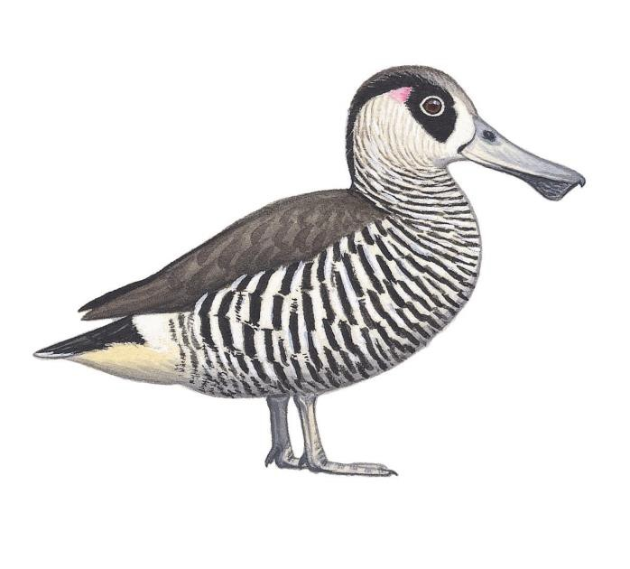Juvenile
Adult
Pink ear-spot
Coarser barring than
juvenile, extends onto belly
Wing (95% CI): ♂ 190–208 mm, ♀ 178–201 mm
Adult tail feathers
Rounded tips
Broad feathers

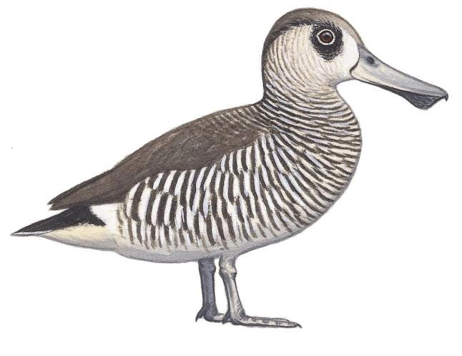
Lacks pink ear-spot
White belly patch

Wing: ♂ 191–205 mm, ♀ 171–197 mm

Juvenile tail feathers

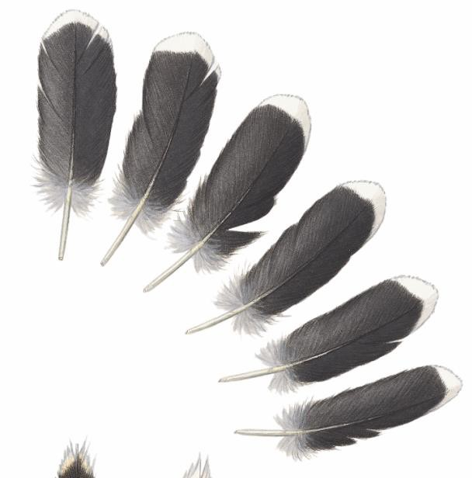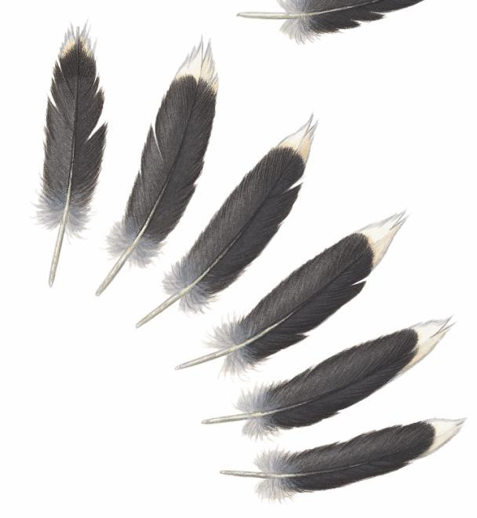
Notched tips
Narrow feathers

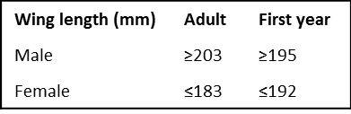
Recommended workflow
Ageing
- Look for juvenile tail feathers; if any are present, the bird is in its first year.
- Examine wings of birds that lack juvenile tail feathers, seeking retained juvenile coverts (especially in underwing) and narrow primary tips. If either is present, the bird is in its first year; if absent, the bird is probably adult.
Sexing
1. Measure wing length; ~32% of adults can be sexed:

Pink-eared Duck

Adult male

Blackish marginal and lesser coverts with faint buff freckling

Broad primary tips
Narrow white wing-bar, except when very worn

Continuous black barring on lesser underwing coverts

Clean white tips to median and greater underwing coverts

Juvenile
Browner marginal and lesser coverts with heavier buff freckling

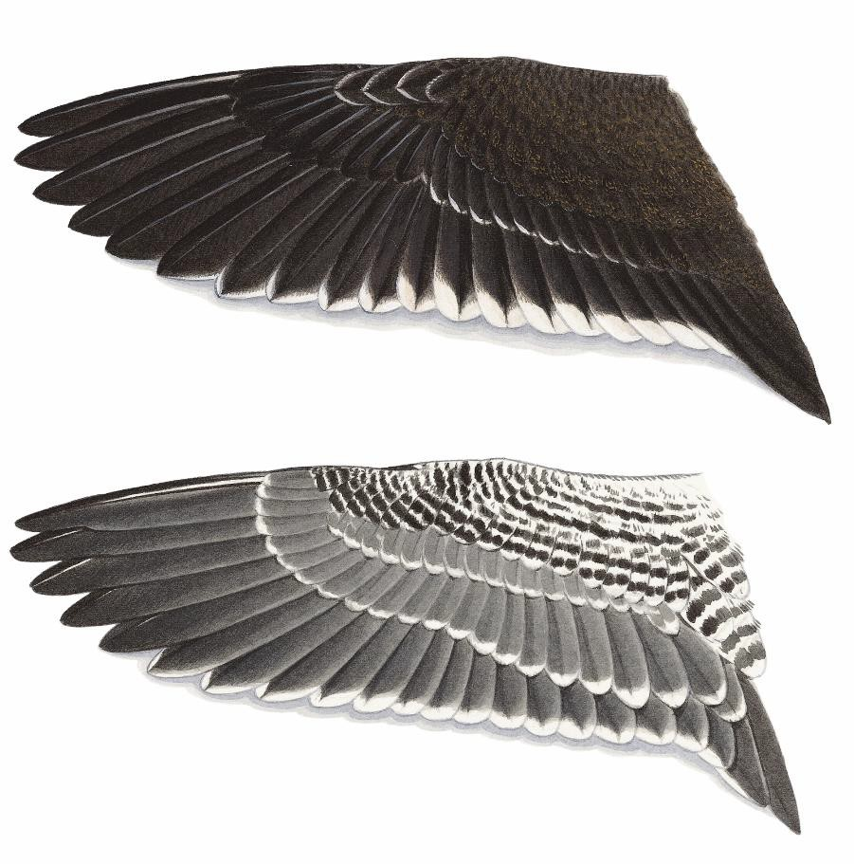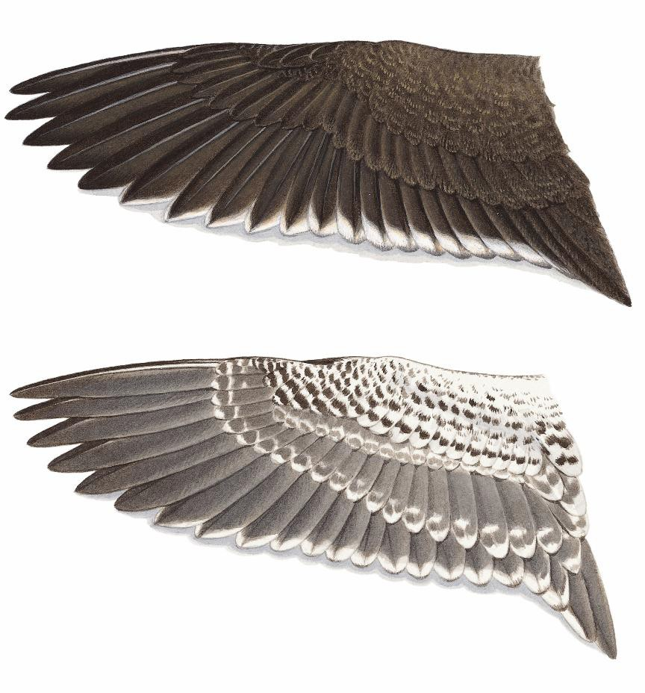

Narrower primary tips

Broken black barring on lesser underwing coverts: looks like a row of dots

Grey and white mottling at tips of median and greater underwing coverts

Note that a few first-year birds replace some or all their wing coverts before the onset of the duck hunting season—but they all retain their narrow juvenile primaries

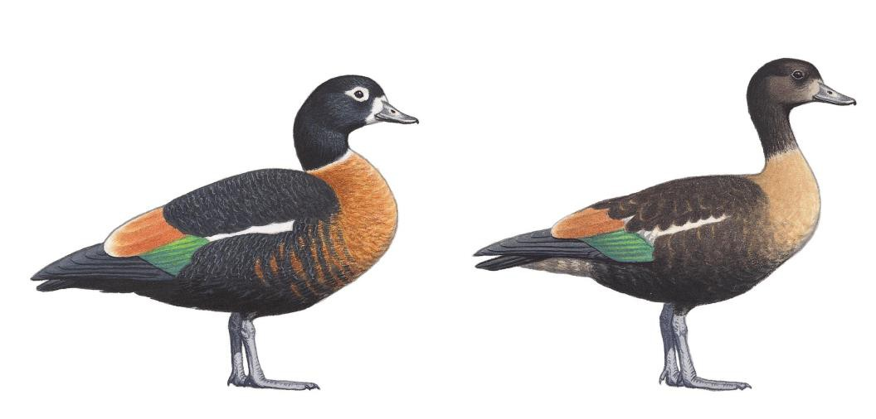Appendix 2: Australian
Shelduck Tadorna tadornoides
Adult female
Juvenile female

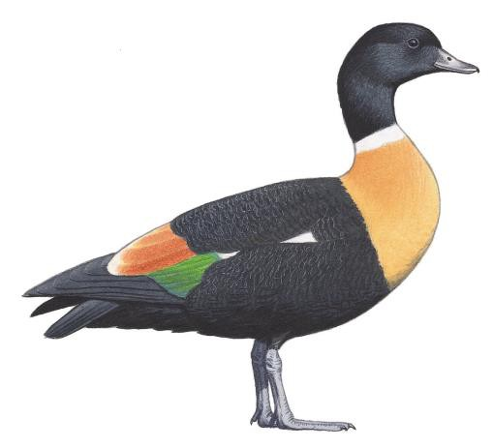
Adult male

  - black head
  - yellower breast than ♀
  - bigger than ♀

Wing (95% CI): 356–397 mm

- white eye-ring and front of face
- chestnut breast
- smaller than ♂

Wing: 325–357 mm

- ♀-like plumage with smaller body feathers, paler vent
- breast foreshadows adult colour—a bit yellower in ♂

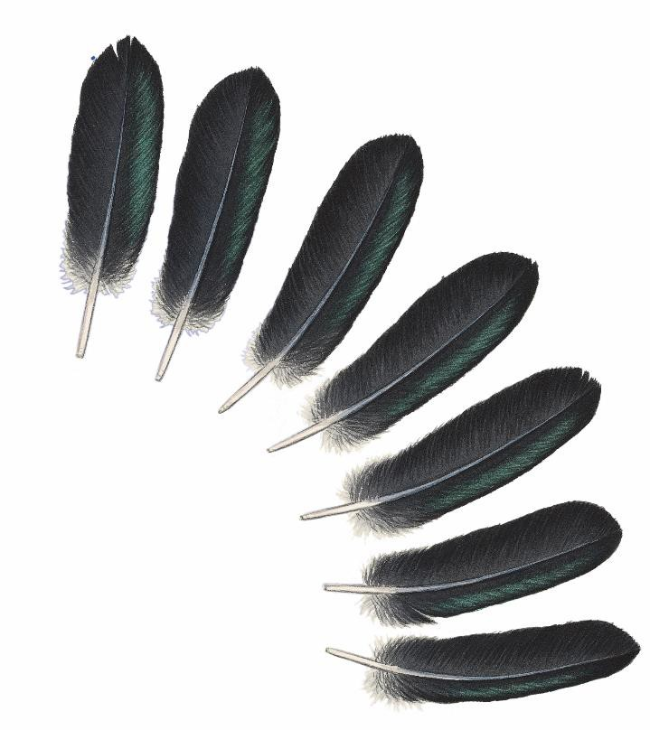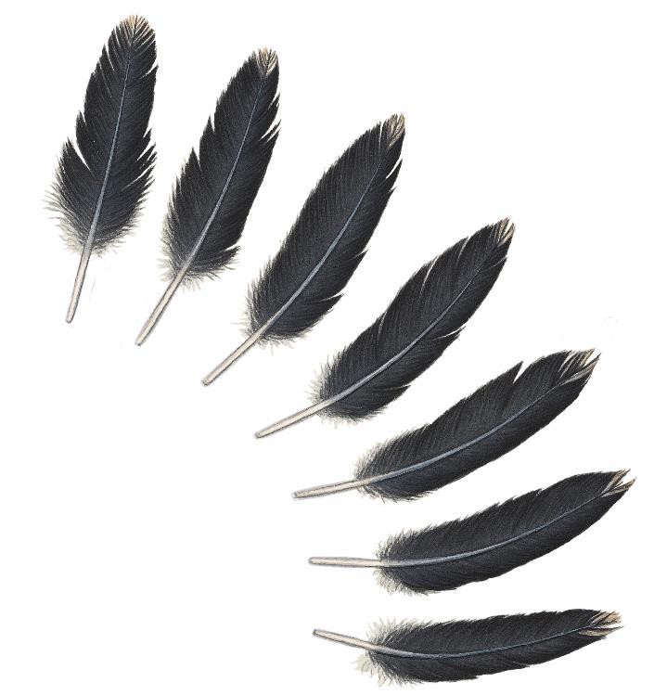
Adult male tail feathers
Rounded tips
Broad feathers
Juvenile tail feathers
Notched tips
Narrow feathers

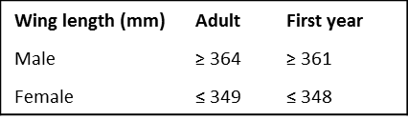
Recommended workflow
Ageing
1. Look for juvenile greater secondary coverts: if present, the bird is in its first year.

Sexing
1. Measure wing length; ~90% can be sexed:

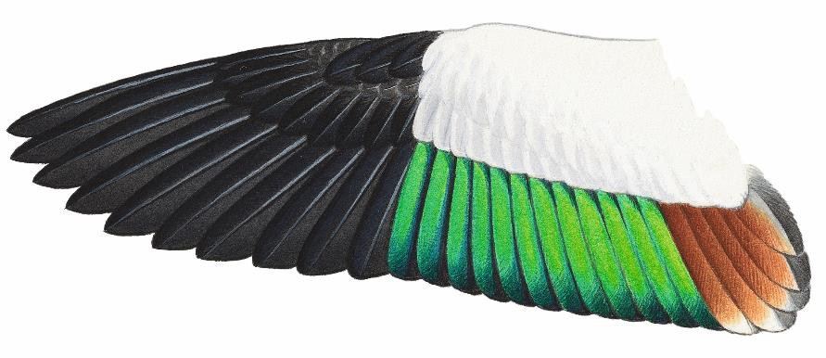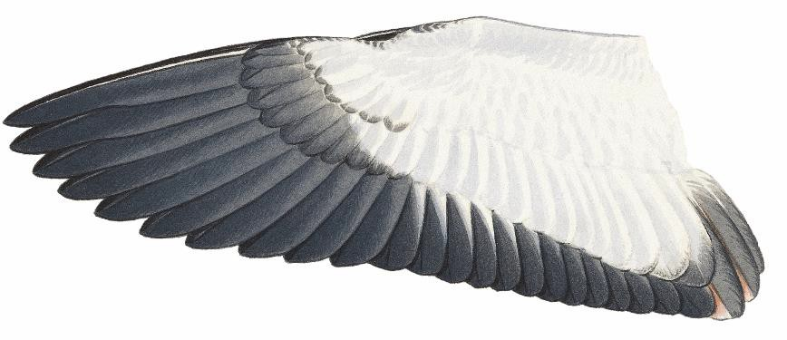Australian Shelduck

Adult male

White wing panel except for faint grey on outermost greater secondary coverts

Tips of primaries tend to be broader in adults

Bold emerald speculum almost reaches feather tips

Faint ochre tinge to tertials

Secondaries mainly black below, with white bases to inner edges

Immature female Grey juvenile lesser primary coverts often retained
Juvenile greater secondary coverts retained through first year

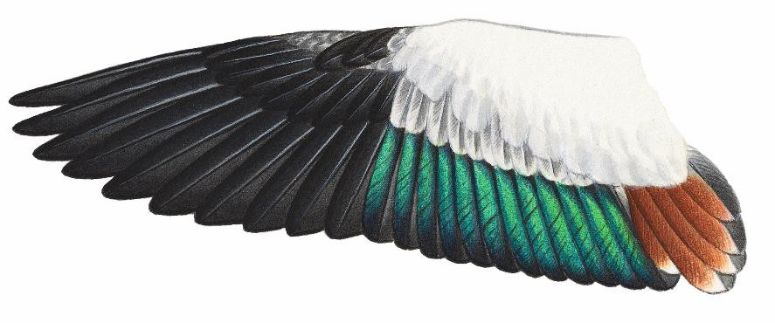Example of a first-year bird with a mixture of juvenile and adult feathers in wing
Juvenile primaries, secondaries, primary coverts and greater secondary coverts
Other coverts and tertials replaced, as in adult female

Slightly narrower primary tips than in adult

Speculum of adult and immature females is duller than that of adult males

Replaced (adult) tertials duller than those of adult male

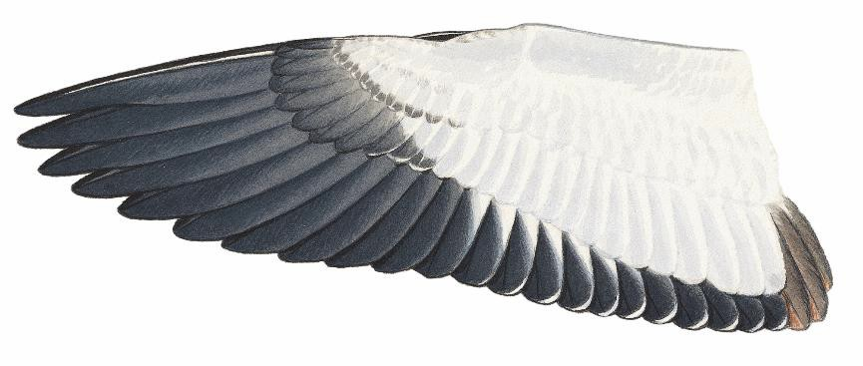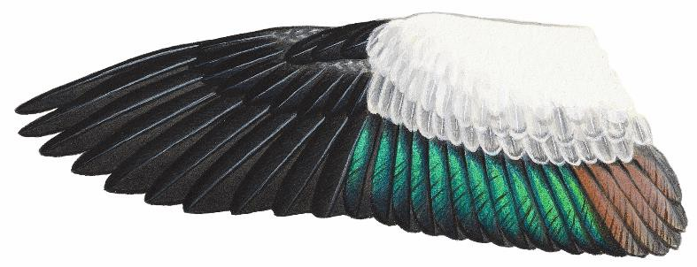Juvenile

Examples of first-year birds retaining all juvenile plumage
Note difference in size between female (right) and male (below)
Grey markings in most secondary coverts

Speculum and tertials duller than in adults

Narrow primary tips
On underside of secondaries, extensive white bases to inner edges extend to feather tip

Appendix 3: Hardhead

Aythya australis

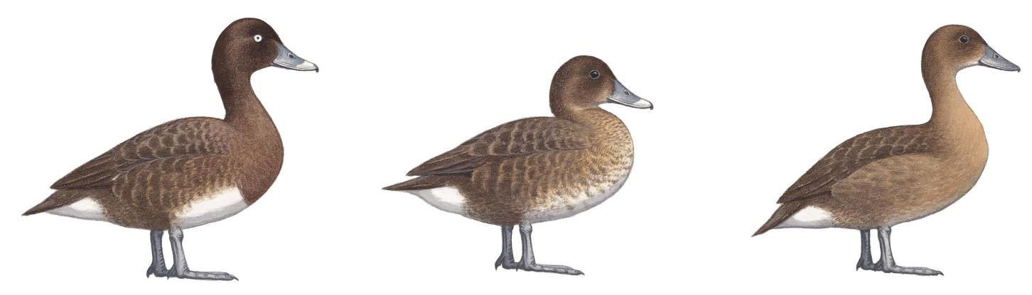Adult male Adult female Juvenile

  - white eye
  - evenly dark head
  - clearly demarcated white belly-patch

Wing (95% CI): 212–231 mm
- brown eye
- brown head, paler at base of bill
- mottled white belly-patch Wing: 205–225 mm
- brown eye; in males, it starts getting pale during first year
- paler head than adult female
- mainly brown underparts

Wing: ♂ 203–233 mm
♀ 199–224 mm

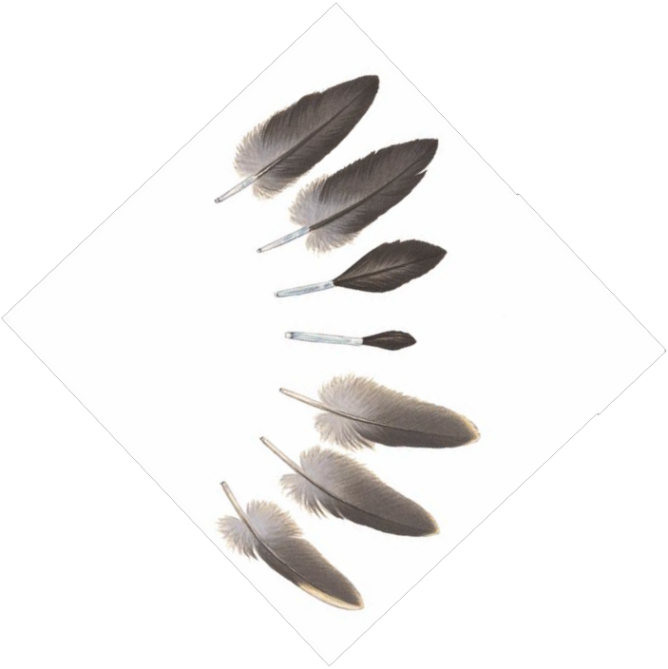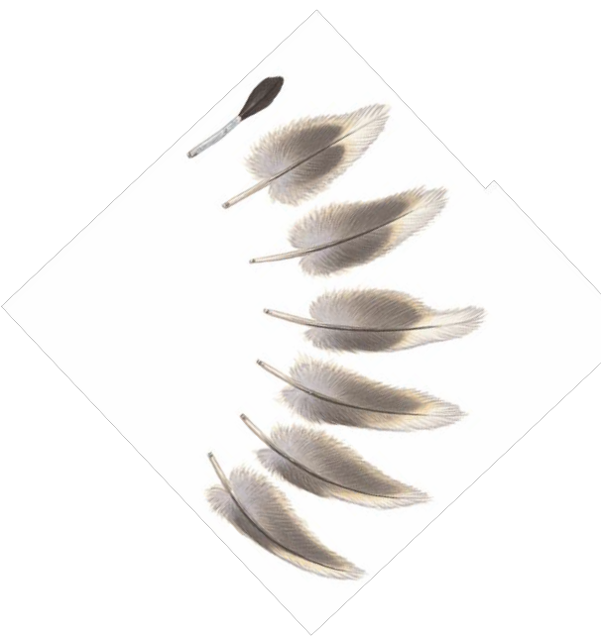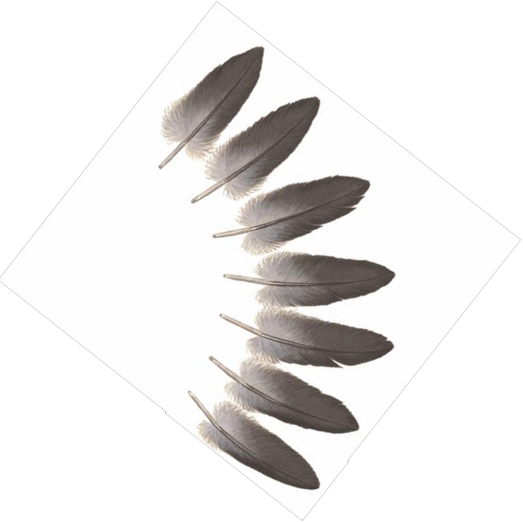(in post-juvenile moult)
Tail feathers
Adult
Immature
Juvenile

Recommended workflow
Sexing
1.
Ageing
1.
2.
Sex according to wing-bar (clean white in males, cloudy in females).
Look for juvenile tail feathers; if present, the bird is in its first year.
First-year birds that have moulted all tail feathers are very difficult to distinguish from adults. Look for retained juvenile lesser underwing coverts at bend of wing.

Hardhead

Adult male

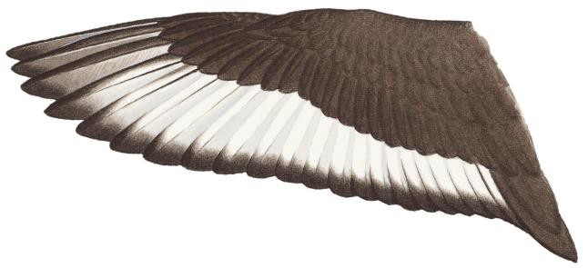White patch on outer webs extends to p7 or beyond

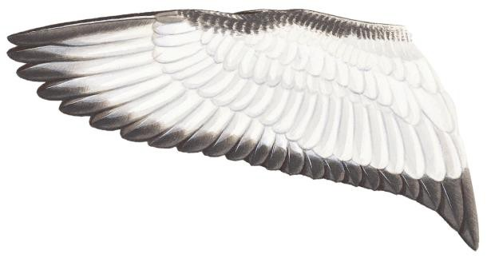Wing-bar mainly clean white

White primary underwing coverts

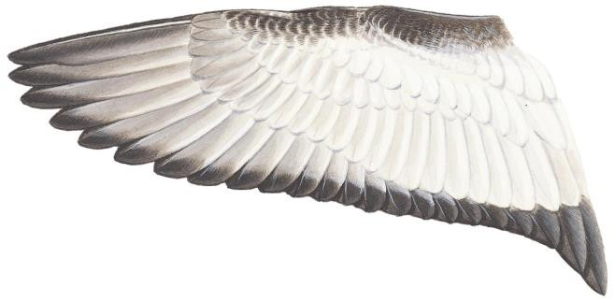Adult female

Grey-brown wash on primary underwing coverts

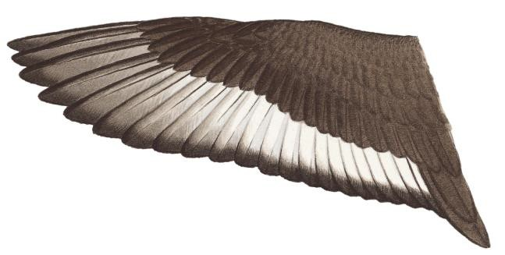White patch on outer webs rarely extends beyond p6

Brown wash over white wing-bar on most primaries

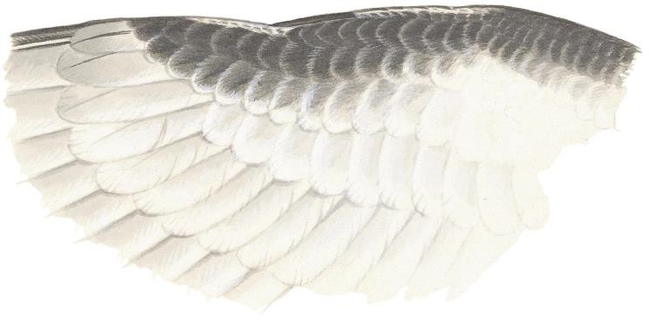Narrow white fringes on coverts near bend of wing (narrower still in males)

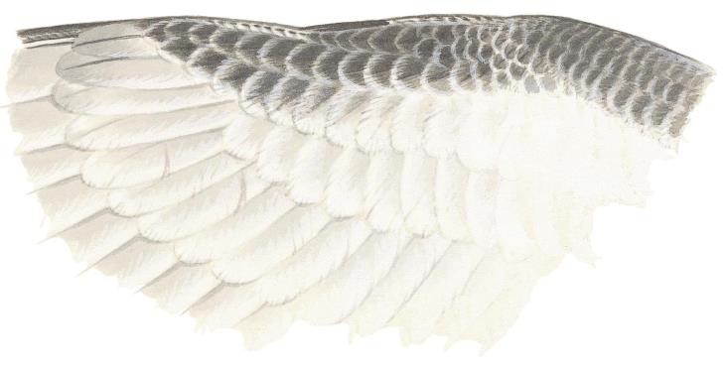Juvenile male

Juvenile wing patterns almost identical to wing patterns in respective sexes of adult

Some (not all) first-year birds can be distinguished from adults because they retain small juvenile coverts at the bend of the underwing, with complete white fringes
Only first-year males combine male wing-bar pattern with brown iris and female-like head and body plumage

Appendix 4: Australasian Shoveler

Spatula rhynchotis

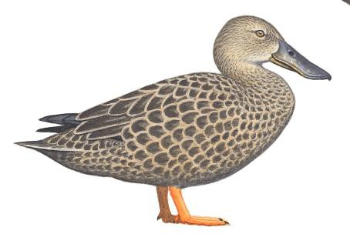
Adult female
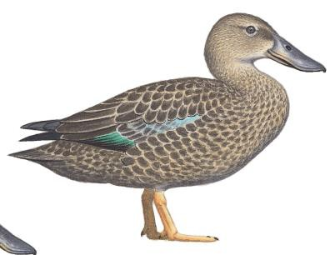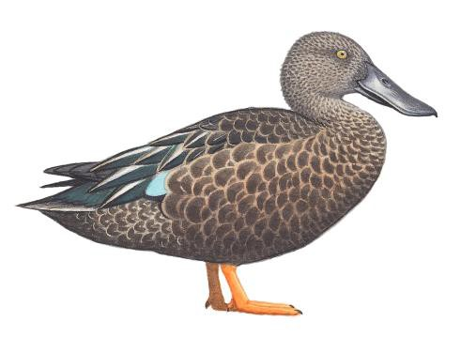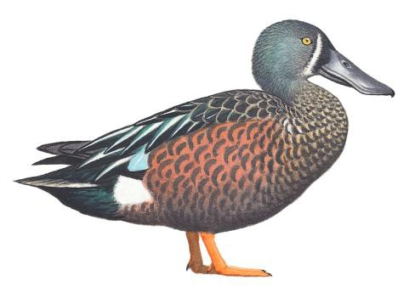Wing: 220–247 mm
Adult male
Wing (95% CI): 246–263 mm

Adult male eclipse Juvenile female

Juvenile wing:
♂ 238–251 mm
♀: 216–236 mm

Tail feathers

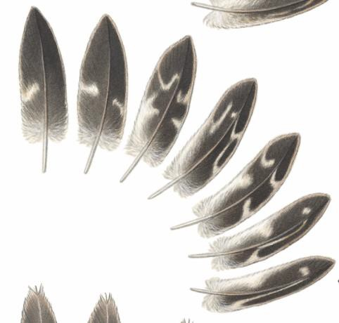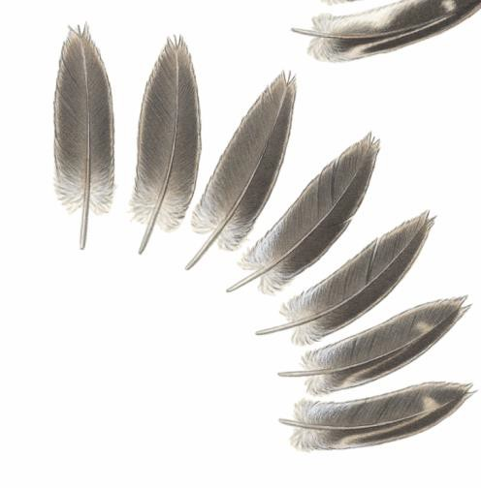Notched tips
Rounded tips
Adult female

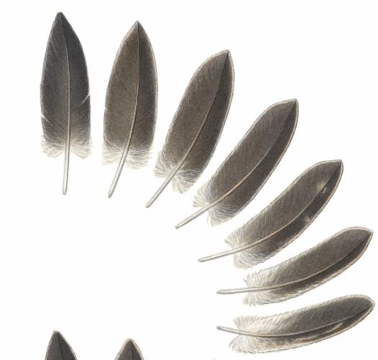Most tail feathers have buff internal markings
Rounded tips
Adult male
Tail feathers largely dark brown

Juvenile
Tail feathers smaller and narrower than in adult

Limited buff internal markings in Juv. male (above); extensive buff internal markings in juvenile female

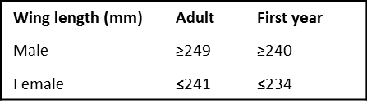
Recommended workflow
Sexing
- Examine greater secondary coverts; bold white wing-bar in males only.
- Measure wing length; ~90% of adults can be sexed:

Ageing
- Look for juvenile tail feathers; if any are present, the bird is in its first year.
- Examine wings of birds that lack juvenile tail feathers, seeking
- juvenile greater coverts (obvious blackish bases in males; narrow white fringes to outer feathers in females)
- first-year birds also have a small speculum, relatively dull wing panel and pointed primaries.

Australasian Shoveler

Adult male
Adult female

White bases to greater under- primary coverts

Median and lesser under- primary coverts mainly white
Greater under- primary coverts uniformly dark

Median and lesser under- primary coverts blackish with white fringes

Adult male Adult female

Light-blue median and lesser coverts
Grey-blue median and lesser coverts mottled by dark bases

Greater secondary coverts form broad, white wing-bar

Extensive bright- green speculum
Black greater secondary coverts; white tips only broad on outermost feathers

Smaller, duller green speculum

Juvenile male
Juvenile female

Grey-blue median and lesser coverts like adult female
Brown median and lesser coverts with grey-blue fringes

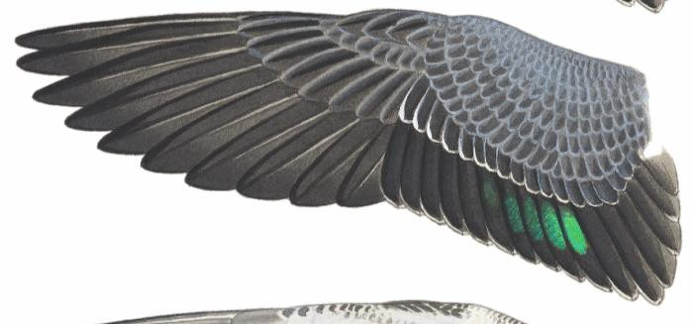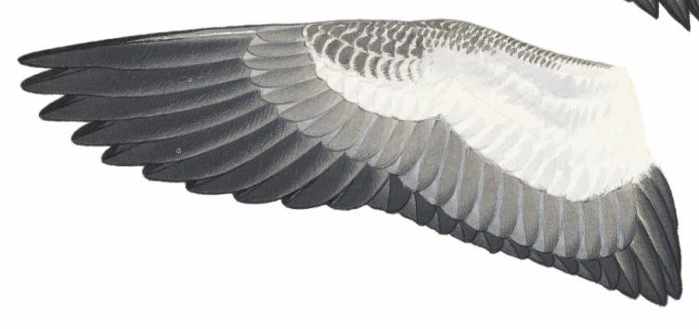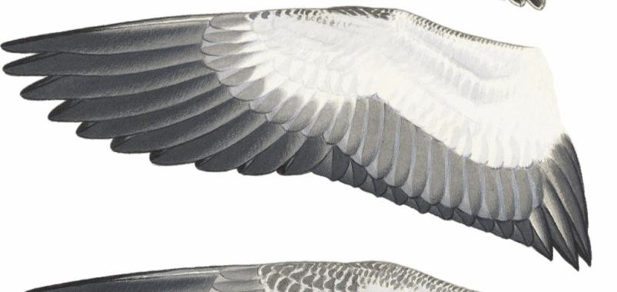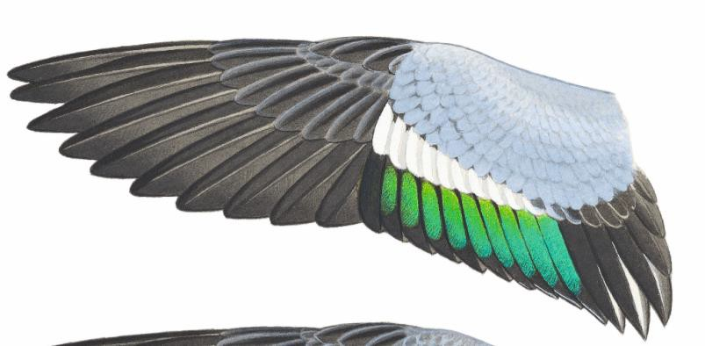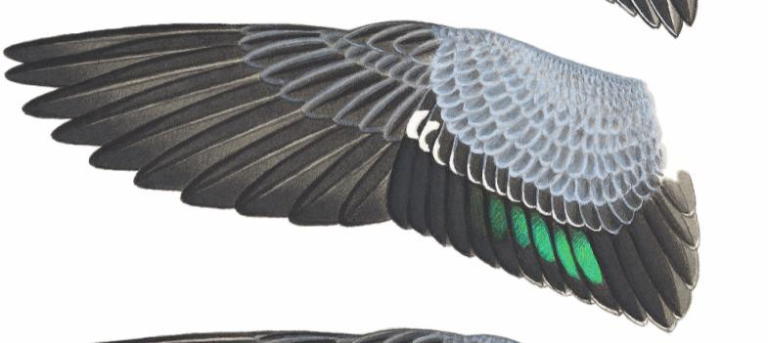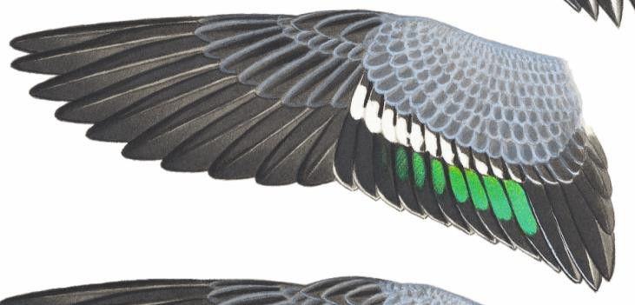
Broad white tips to greater secondary coverts form wing-bar that is narrower than in the adult male

Speculum narrower than in adult male, but bigger than in adult female

Outer greater secondary coverts have narrower white tips than those of adult female

Speculum narrower and duller than in adult female

Appendix 5: Pacific Black Duck

Anas superciliosa

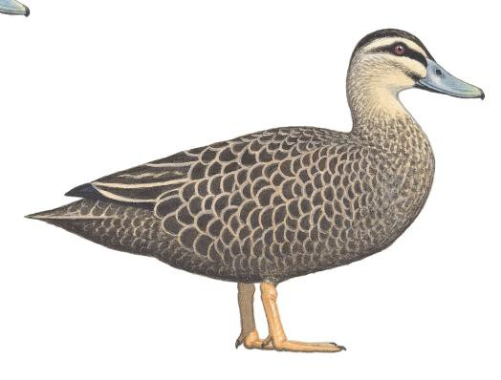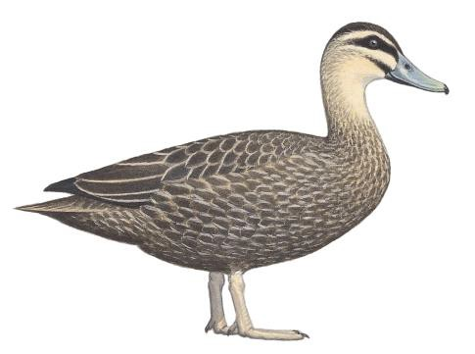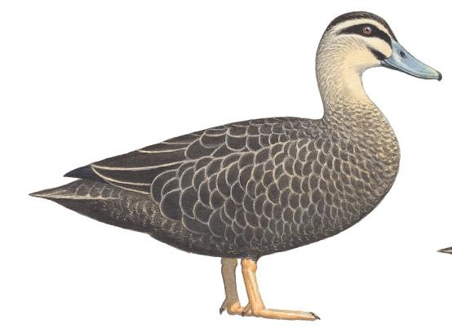Adult male
Adult female
females often have buff markings within tertials
Most males have black- centred tertials

Juvenile

Wing: 248–271 mm Wing: ♂ 259–277 mm

Wing (95% CI): 264–287 mm
  - broader buff fringes to body feathers than males
  - smaller than ♂
♀ 238–265 mm
Small body feathers contribute to more streaked appearance

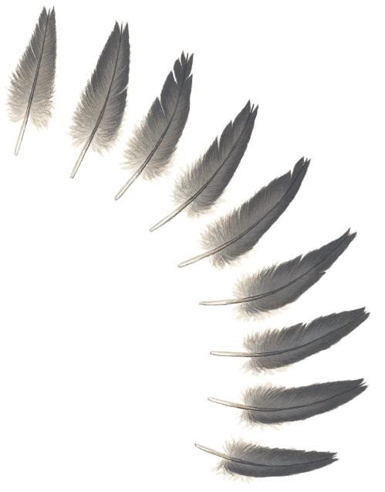Tail feathers

Juvenile
Feathers narrow with notched tips

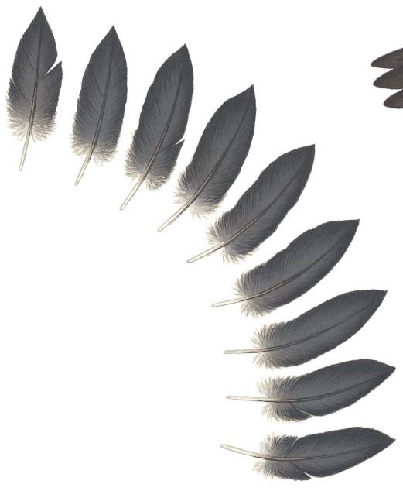

Adult
Feathers broad with pointed tips

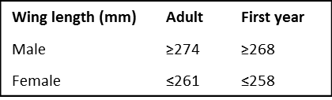
Recommended workflow
Ageing
- Look for juvenile tail feathers; if any are present, the bird is in its first year.
- Examine wings of birds that lack juvenile tail feathers, seeking relatively narrow primary tips, and retained juvenile coverts (narrower than in adults – a difficult distinction best made with comparative material). If either is present, the bird is in its first year; if absent, the bird is probably adult.

Sexing
- Sexing: look for female tertials.
- Measure wing length; ~60% can be sexed:

Pacific Black Duck

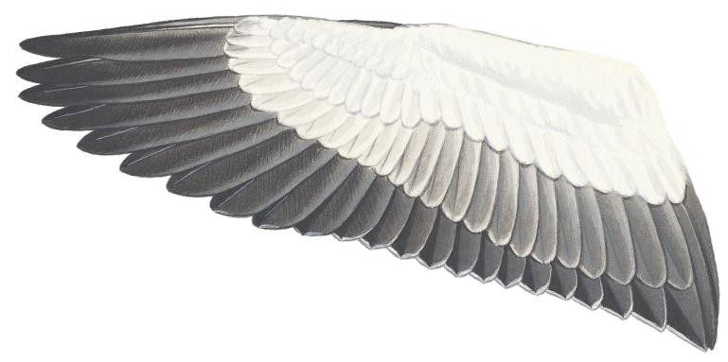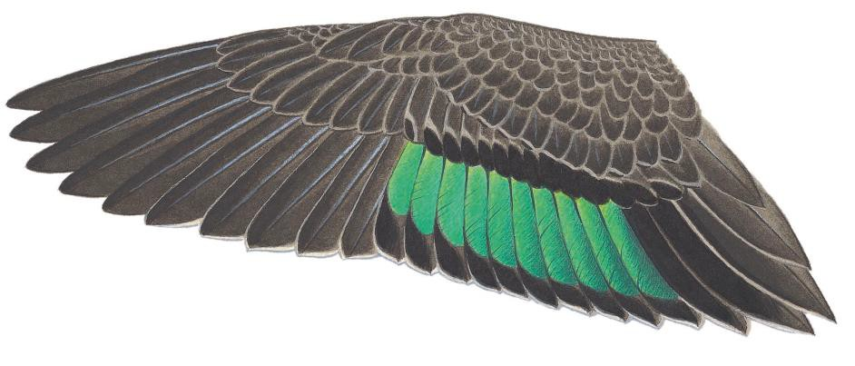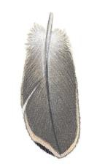Adult male underwing

Primaries of adult usually broad with rounded tips
Dark shaft-streaks on primary underwing coverts tend to be bigger in adults than in first-year birds, but there is considerable overlap

Adult male upperwing

In some males, gloss of speculum extends onto tips of inner median coverts (seemingly absent in females)

Cream streak on outermost secondary often small or absent in males

Adult female upperwing
Males have a larger speculum than females, and it extends onto the outermost secondary

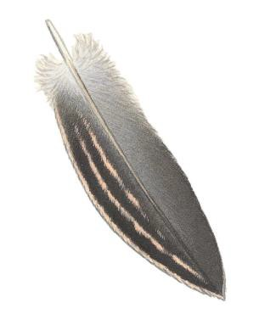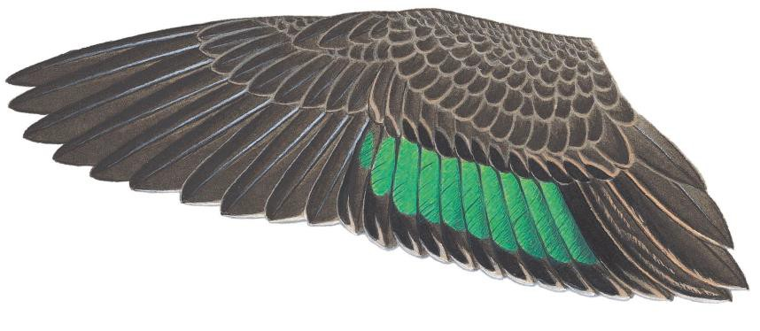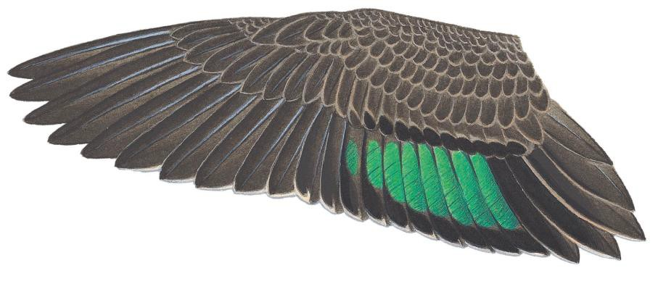Females have a slightly smaller speculum that starts petering out on outer secondaries

Cream streak on outermost secondary is usually bolder in females

About 65% of adult females and 25% of immature females have sex-diagnostic buff internal markings on tertials

Juvenile female upperwing

Coverts and tertials are narrower than in adults, with less rounded tips

Primaries of juveniles usually narrower and more pointed than in adults

rs.

Juvenile speculum a little narrower than in adults, not much obscured by greater secondary coverts

Appendix 6: Grey Teal

Identification
Easily confused with ♀ Chestnut Teal
Anas gracilis

Grey Teal Chestnut Teal

Slightly smaller, paler and greyer than ♀ Chestnut Teal
Colour differences difficult to assess if wet or bloodstained, in which case throat pattern is best ID feature:

Grey Teal:
Entire throat white, including lower throat

Chestnut Teal:
White throat patch smaller than in Grey Teal, with more dark streaking at sides, especially in lower throat

Juvenile Adult

Adult

Juvenile
Juvenile
Dark patch on chin diagnostic of Chestnut Teal; present in ~70% of adults, but absent in most juveniles

Adult

Wing: ♂ 200–220 mm, ♀ 187–210 mm Wing: ♂ 192–216 mm, ♀ 188–202 mm Finer flank and breast
markings than in adult

Broad tail feathers with rounded tips in adults

Narrow, notched tail feathers in juveniles

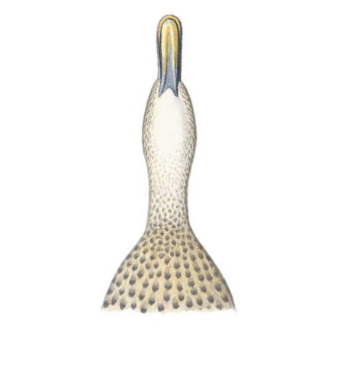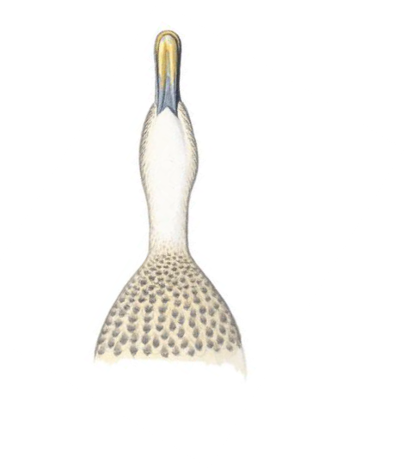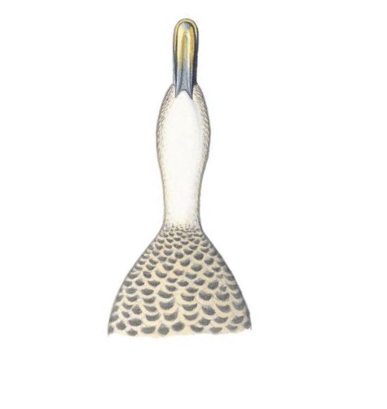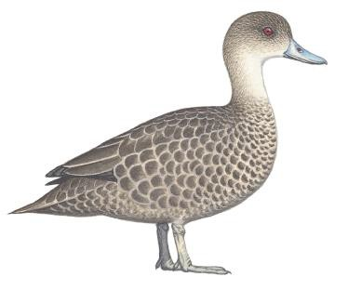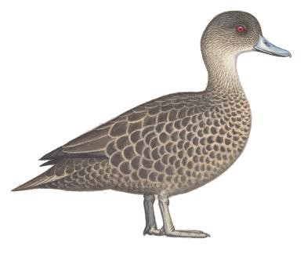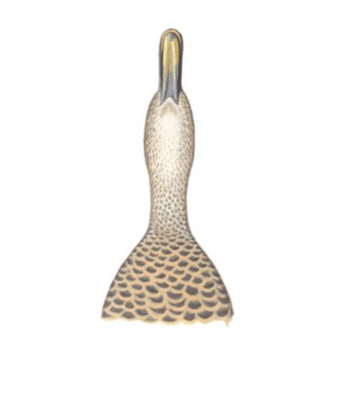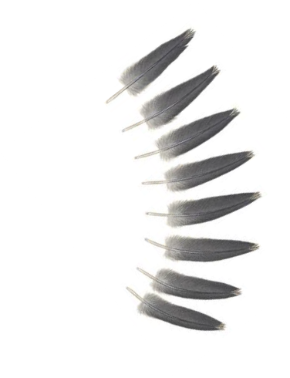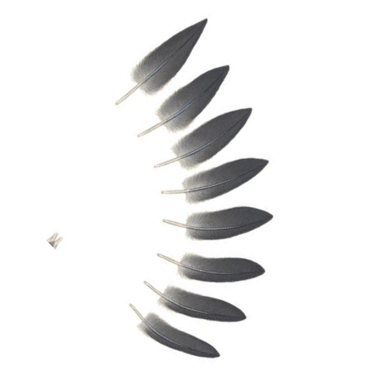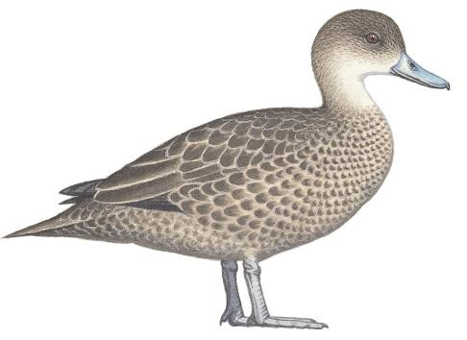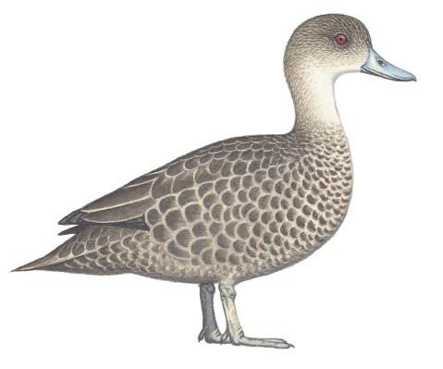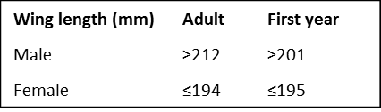

Recommended workflow

Ageing
- Look for juvenile tail feathers; if any are present, the bird is in its first year.
- Examine wings of birds that lack juvenile tail feathers, seeking
- retained juvenile tertials
- retained juvenile coverts
- retained juvenile primaries with relatively narrow tips (a difficult distinction best made with comparative material).
If any of the above are present, the bird is in its first year; if absent, the bird is probably adult.

Sexing
1. Measure wing length; ~60% can be sexed:

Grey Teal

Adult

Upperwing coverts look slightly lighter than those of Chestnut Teal. Stronger contrast between dark feather centres and paler fringes make Grey Teal look more dappled.

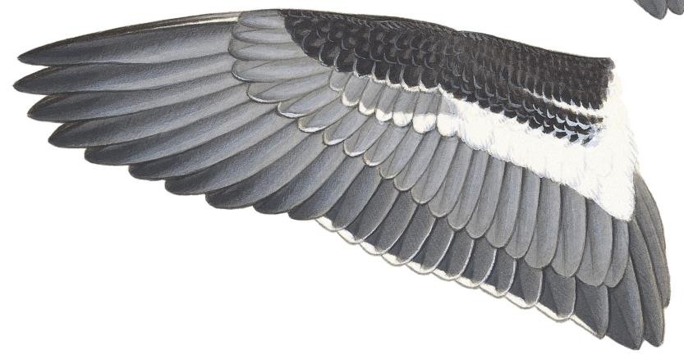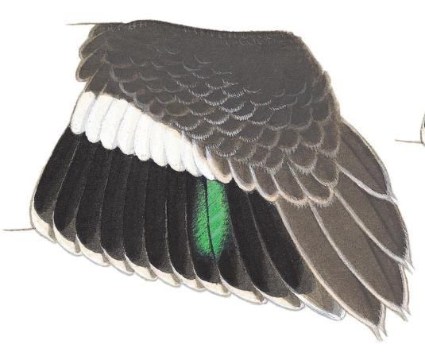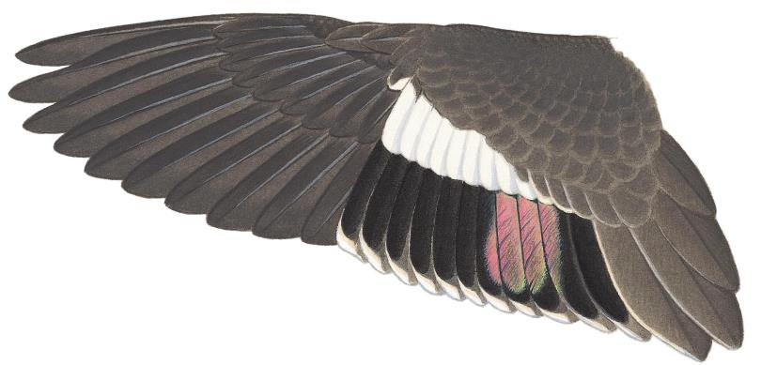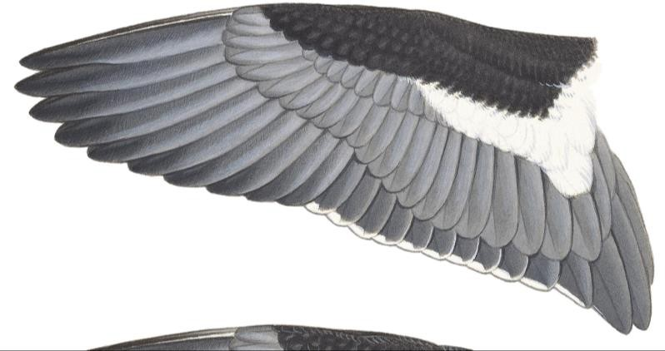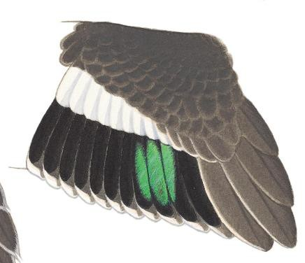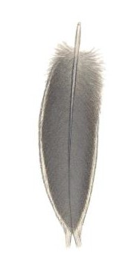Glossy magenta tinge to speculum when it is tilted at the right angle

In other orientations, or when viewed in shade, speculum looks green

Broad primaries with rounded tips in most adults
Only traces of white
fringing on the lesser underwing coverts

Fringing more extensive in very fresh juveniles

Juvenile Juveniles usually
have a smaller speculum than

Slightly narrower primaries with more pointed tips in most juveniles
adults

Juvenile tertials have buff fringes and tapered tips

Juveniles tend to have broader fringing on lesser
underwing coverts, but these feathers can be moulted before one year of age

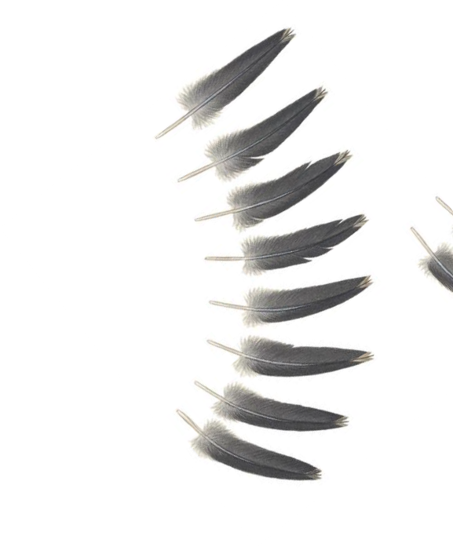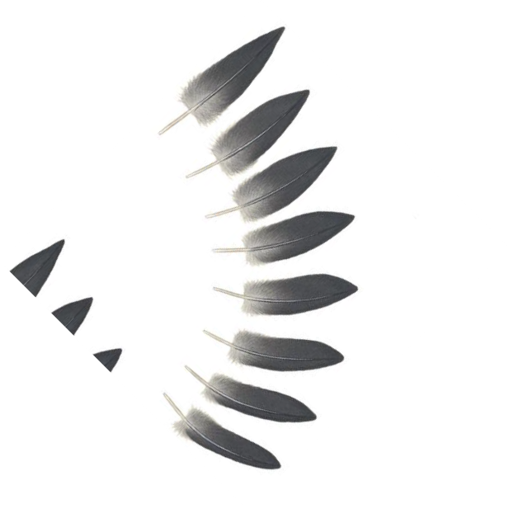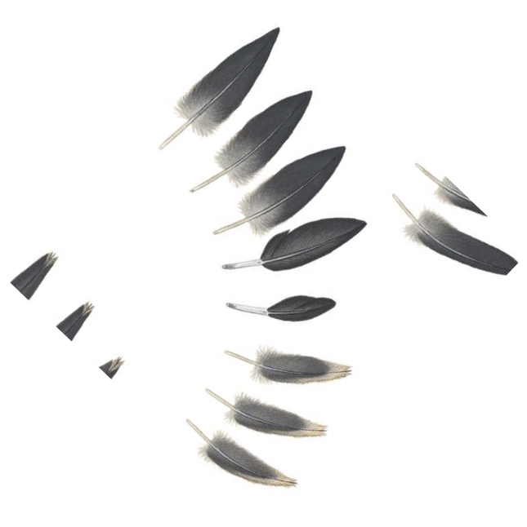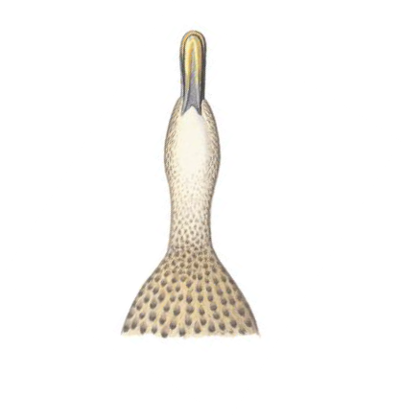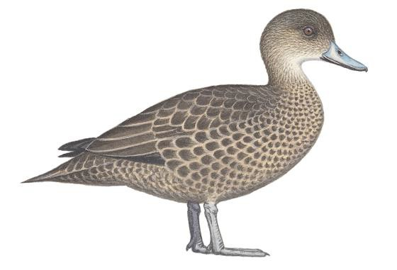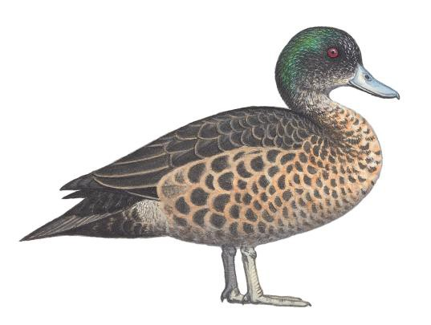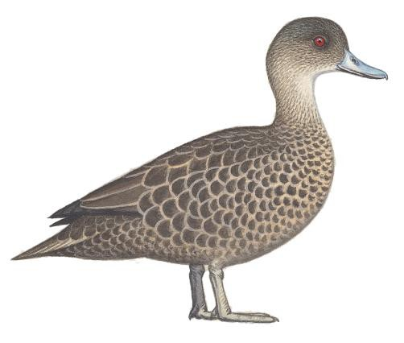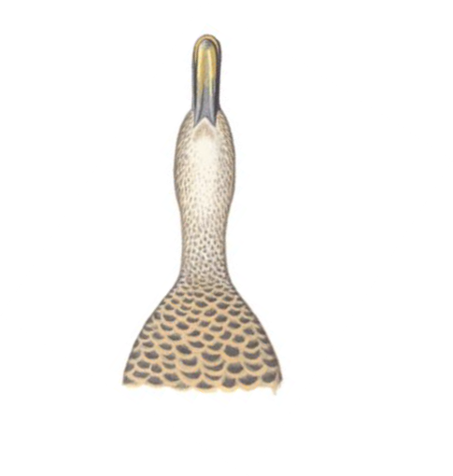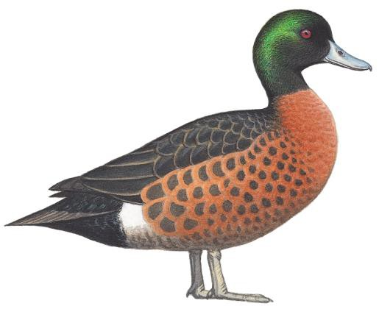Appendix 7: Chestnut Teal

Anas castanea
Diagnostic dark smudge on chin

Adult male Adult female
of most adults and some

Wing (95% CI): 207–238 mm
Wing: 203–220 mm
Warmer brown body plumage than Grey Teal
juveniles

Sides and base of throat streaked (cleaner white in Grey Teal)

Adult male eclipse
Varies, but usually a drabber version of breeding male

Juvenile
Wing: ♂ 210–227 mm,
♀ 191–222 mm
Juvenile has whiter throat: more likely to be confused with Grey Teal

Juvenile has
smaller body feathers than ♀

Tail feathers

Adult
Broad, pointed tail feathers

Immature
In post-juvenile moult

Juvenile
Small, narrow tail feathers with notched tips

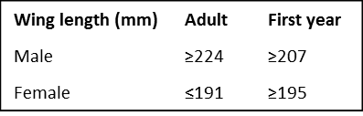
Recommended workflow
Ageing
- Look for juvenile tail feathers; if any are present, the bird is in its first year.
- Examine wings of birds that lack juvenile tail feathers, seeking retained juvenile tertials and narrow primary tips. If either is present, the bird is in its first year; if absent, the bird is probably adult.
Sexing
- Sex bird according to head and body plumage if full specimen available. Otherwise …
- Check white fringing of lesser underwing coverts: male if absent, unsexed if present.
- ~30% of adults and ~50% of immatures can be sexed on wing measurement:

Adult male
Chestnut
Teal

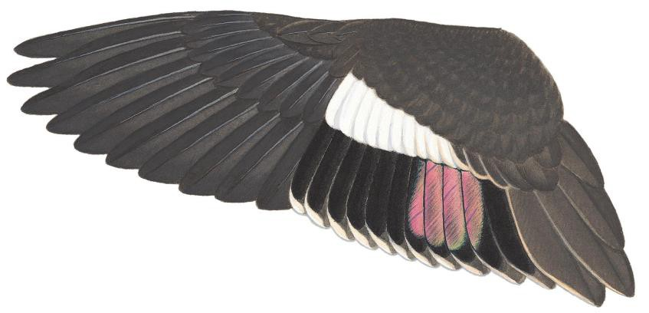Upperwing coverts look more evenly dark brown than those of Grey Teal, especially in males

Glossy magenta tinge to speculum when viewed from most angles – more obvious than in Grey Teal

Adult female
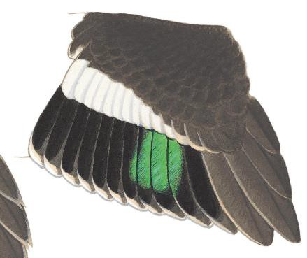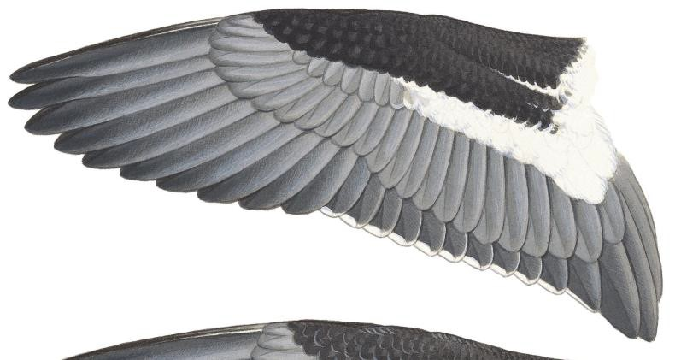Only traces of white fringing on lesser underwing coverts of most males and some females

In some orientations or in dull light, speculum can look green in both sexes

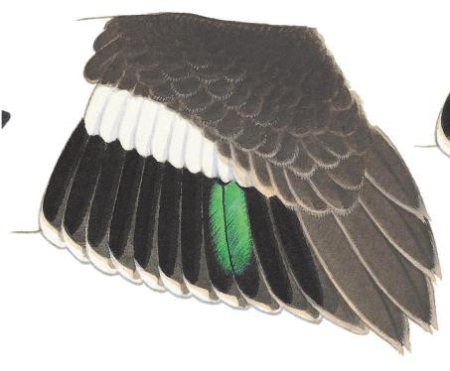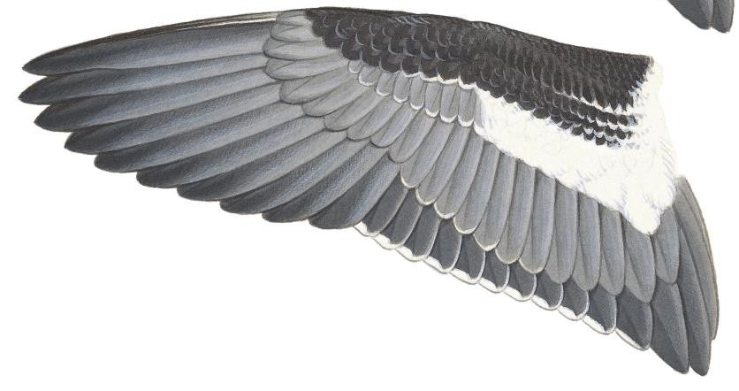Broad primaries with rounded tips in most adults

Juvenile
Slightly narrower primaries with more pointed tips in most juveniles

Relatively small speculum can occur in both adults and juveniles
Fringing more extensive in very fresh juveniles

Juveniles tend to have broader fringing on lesser underwing coverts, but these feathers can be moulted before birds are one year old
Pointed tips to retained juvenile tertials: age-diagnostic if present, but not retained in all immatures

Appendix 8: Australian Wood Duck Chenonetta jubata

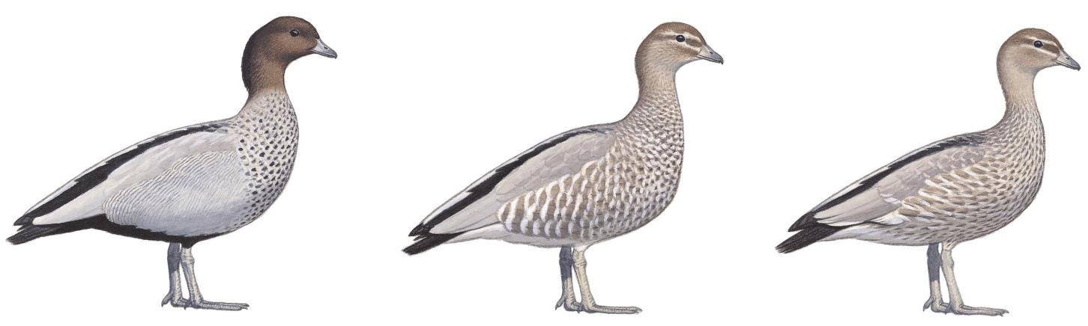

Wing (95% CI): 266–292 mm
Wing: 259–290 mm
Wing: ♂ 270–291 mm
♀ 267–283 mm

Adult male
Adult female Juvenile

Adult male tail feathers Juvenile tail feathers
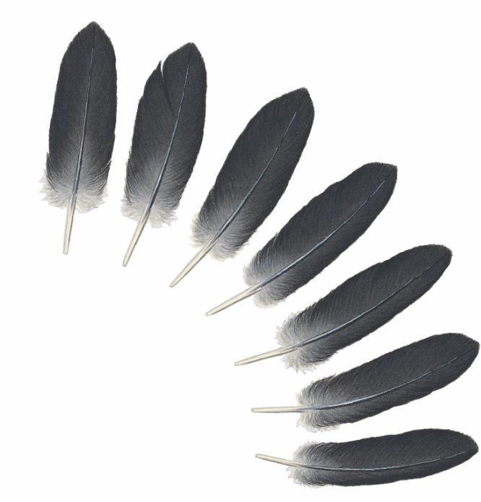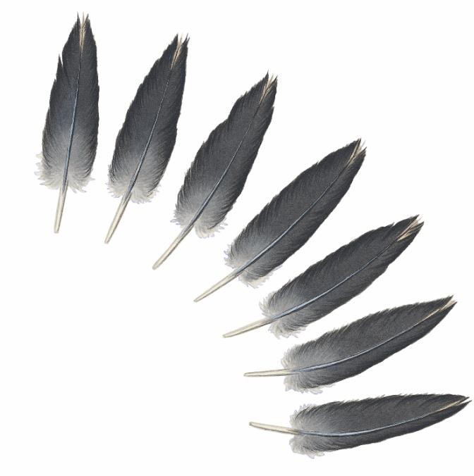
Rounded tips
Broad feathers
Notched tips
Narrow feathers

Recommended workflow
Sexing
- Sex according to head plumage and flanks if full specimen available.
- If only wing available, sex on speculum (see overleaf).

Ageing
- Look for juvenile tail feathers; if any are present, the bird is in its first year.
- Examine underside of inner primaries of birds that lack juvenile tail feathers; white bases are small in adult, large in first year.

Australian Wood Duck

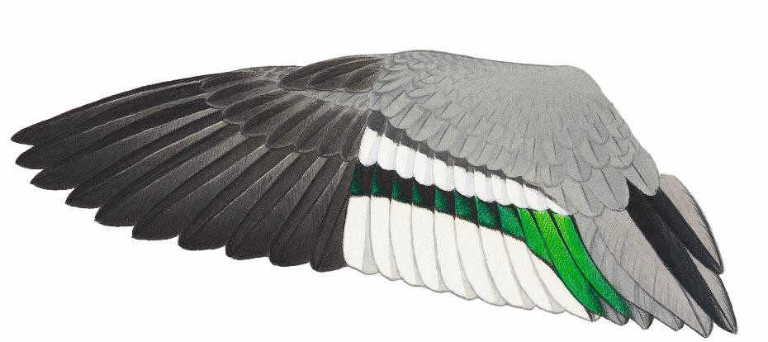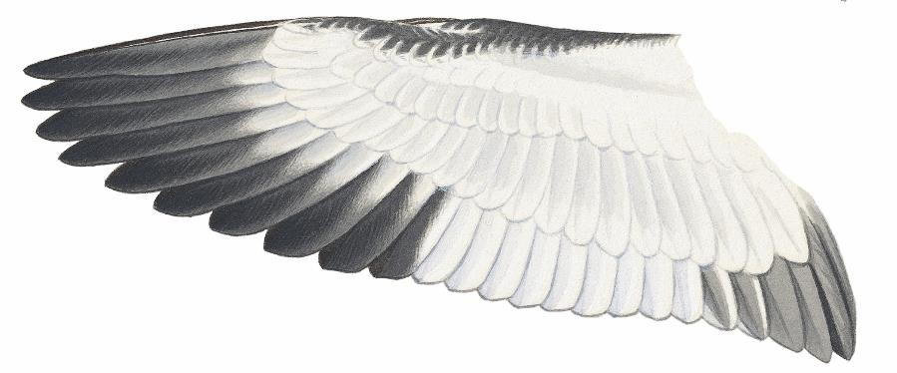Adult male

White tips to median coverts lost with wear

Innermost speculum feather has glossy green
outer web

Bright-green speculum; green iridescence on most or all secondaries

Two all-grey tertials between black tertial streaks and speculum

Small white bases to inner webs of primaries cf. juvenile

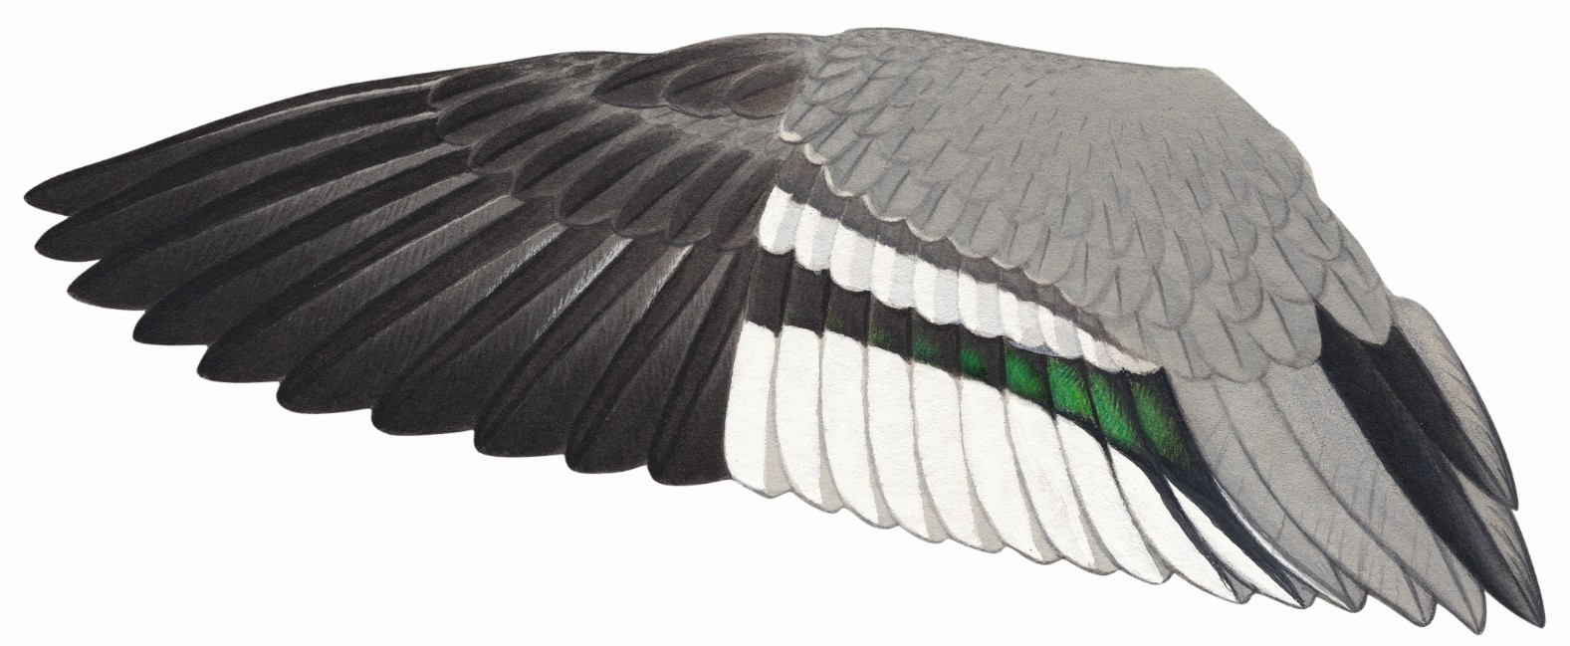Adult female

Primaries slightly broader than in juvenile, but considerable overlap

Outer median secondary coverts have fine white tips when fresh

Innermost speculum feather has restricted glossy green panel, white outer edge

Duller speculum than in male; iridescence peters out short of outer secondaries

Three all-grey tertials between black tertial streaks and speculum

Juvenile male

Primary tips slightly narrower than in adult
Median secondary coverts have broader white tips than
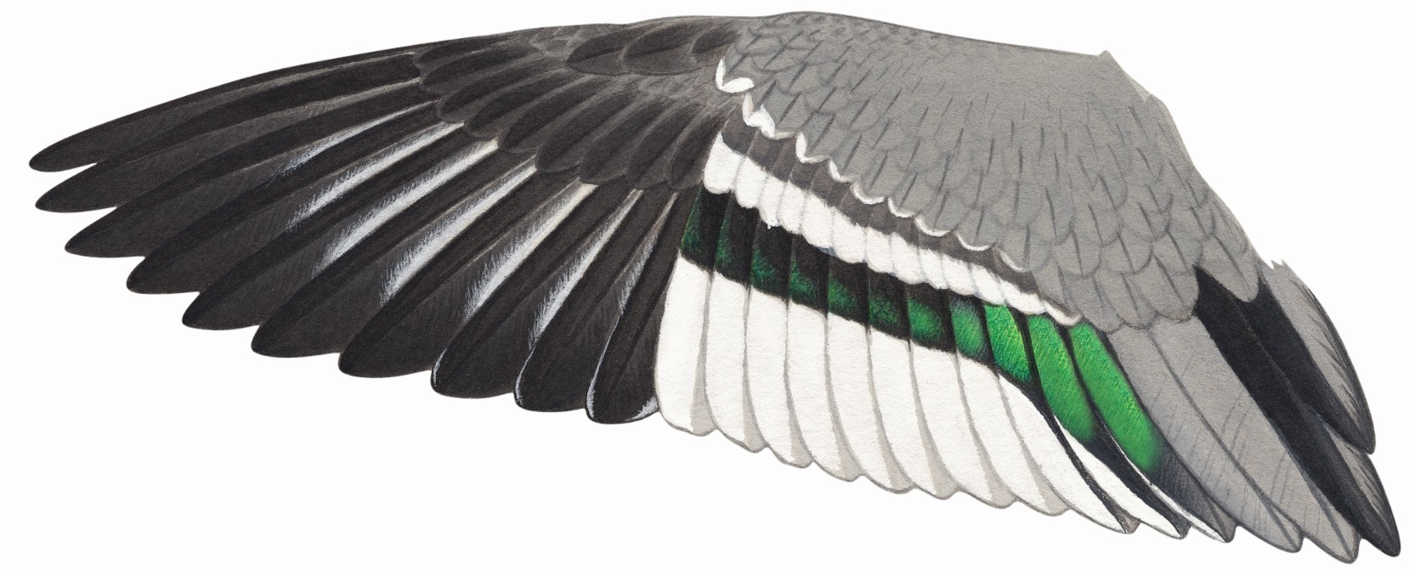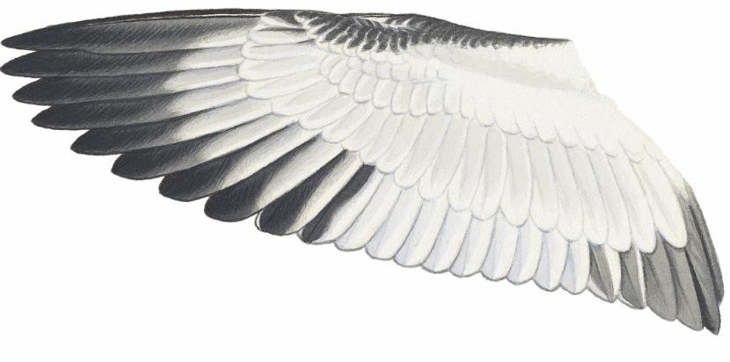in adult when fresh

Dark outer edge to outer primary coverts

White bases of inner webs often slightly exposed when viewed from above

Big white bases to inner webs of primaries, especially on inner feathers

Speculum differs between males and females, as in adults. Inner speculum pattern shows this is a male

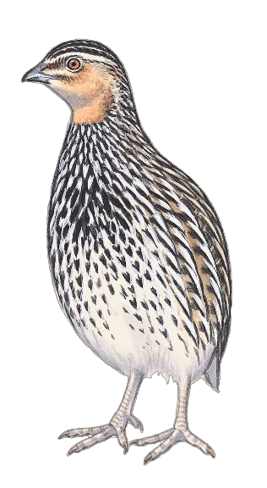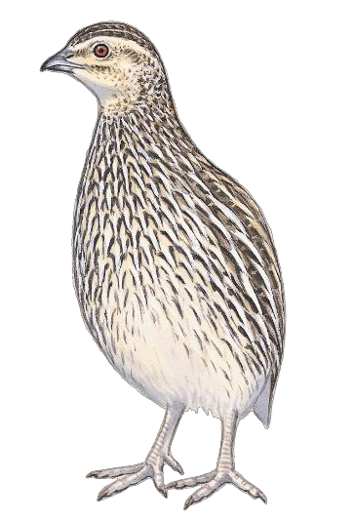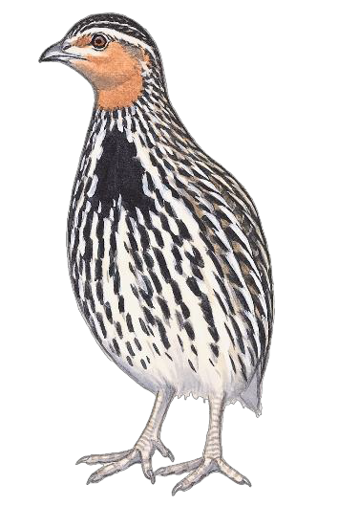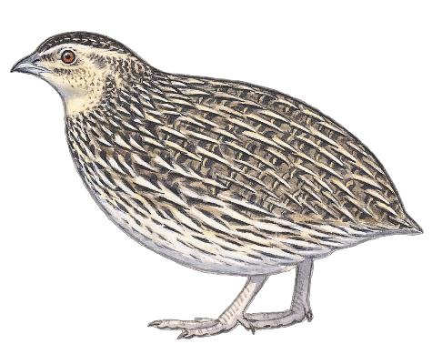
Appendix 9: Stubble Quail
Coturnix pectoralis
Adult male
Wing (95% CI) 100-111 mm
Orange face and throat
Black patch in breast includes some entirely black feathers
Adult Female
Wing 102-114 mm
Cream-white face and throat; no black central patch in breast
Immature
Wing ♂ 102–109 mm, ♀ 101–110 mm

Immature male
Similar to adult ♂ but black breast patch has white streaking on all feathers
Immature female (not illustrated)
Very similar to adult female, only differs in wing pattern (see facing page)
Both sexes can retain some juvenile feathers in underparts
(spotted rather than streaked black)

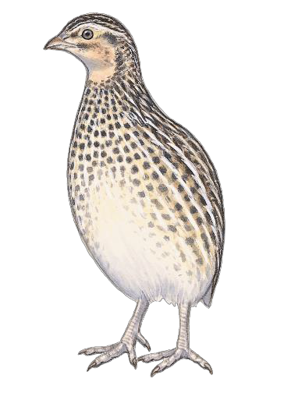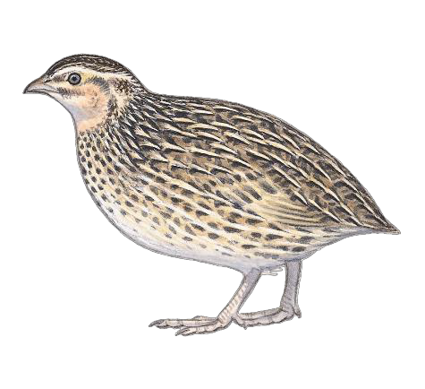
Recommended workflow
Sexing
1. Sex on head and breast plumage, only possible if full specimen available.

Ageing
- If wing is not fully grown, bird is Juvenile
- In fully grown birds, look for moult contrast in primaries. If lacking, bird is adult
- If moult contrast is present, examine primary coverts: only Imm retains Juv primary coverts, with broad buff shaft-streaks and fringes.
Juvenile
Smaller than Adult or Immature. Can fly before
fully grown
Underparts feathers spotted, not streaked; extensively white belly
Face and throat patterned like adult ♀
In most or all ♂, faint rufous tinge in face foreshadows orange face and throat of adult
Juvenile
male
Page 2/2 Rogers, D., Menkhorst, P. and Davies, J. (2018). Ageing and sexing Victorian game birds using plumage characters.

Stubble Quail

Adult
Usually moults all primaries, so all have similar wear. About 25% have wear pattern similar to Imm (below)

“Classic” adult primary coverts have very narrow cream shaft-streaks and fringes

Immature

The outer 3, 4
or 5 primaries are more worn (slightly older and browner) than inner
primaries

Weakly marked Juv covert very similar to
some Ads

Immatures retain juvenile primary coverts that usually have obvious cream shaft- streaks and fringes

Juvenile
“Classic” Juv covert

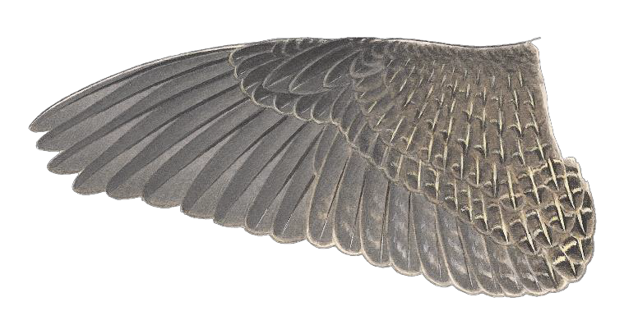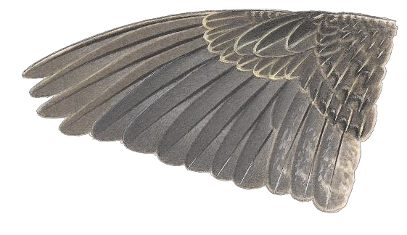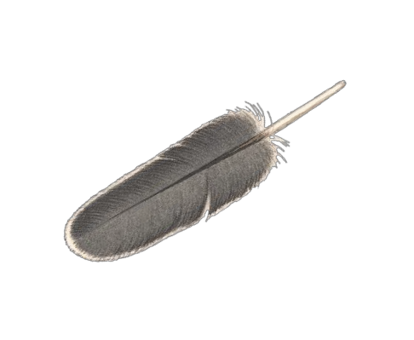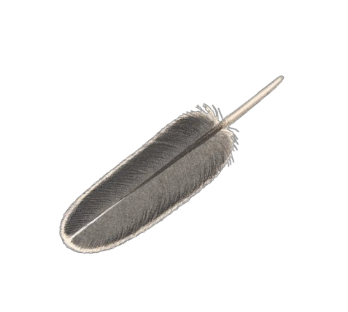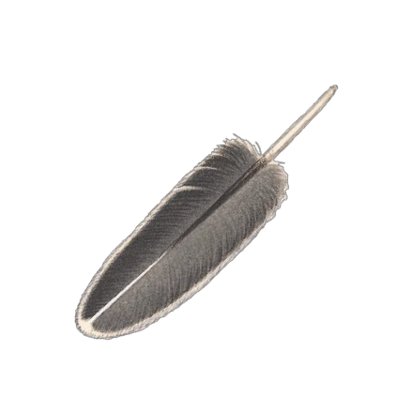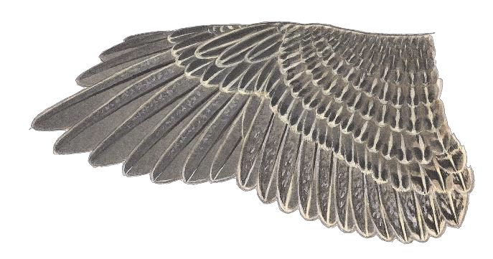
Most are obviously smaller than Ad or Imm, with most wing feathers still growing More clear buff streaking on all coverts than older birds Inner Juv primaries have more buff speckling than older birds.

Page 1/2 Rogers, D., Menkhorst, P. and Davies, J. (2018). Ageing and sexing Victorian game birds using plumage characters.

www.delwp.vic.gov.au www.ari.vic.gov.au

