|  |
| --- |
| Victorian Environmental Flows Monitoring and Assessment Program (VEFMAP) Stage 6 |
| Project Update – 2017  Pilot Monitoring of Aquatic and River Bank Vegetation |

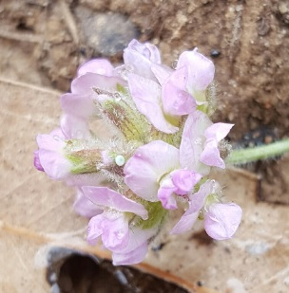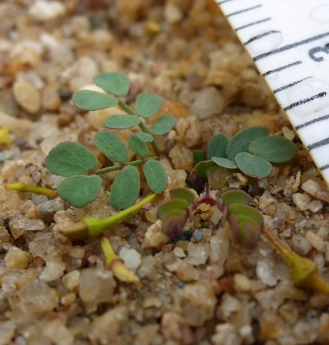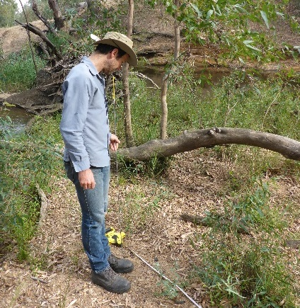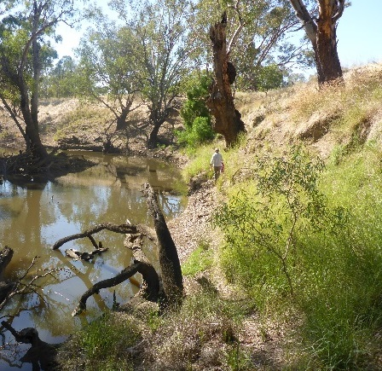

## Background

The Victorian Environmental Flows Monitoring and Assessment Program (VEFMAP) was established by the Victorian Government in 2005 to monitor and assess ecosystem responses to environmental watering in priority rivers across Victoria. The program’s results help inform decisions for environmental watering by Victoria’s Catchment Management Authorities (CMAs) and the Victorian Environmental Water Holder (VEWH). Over the past 12 years, the information collected through VEFMAP has provided valuable data and informed significant changes to the program. VEFMAP is now in its sixth stage of delivery and includes a strong focus on monitoring fish and vegetation responses to “interventions” or “flow events”. This document summarises the outcomes of a pilot study of the updated vegetation monitoring approach on the Campaspe River (North Central CMA) in 2016/17.

## Vegetation Monitoring

The core objectives for vegetation monitoring in VEFMAP Stage 6 are to:

* + - evaluate the effectiveness of flow delivery plans (Environmental Water Management Plans – EWMPs, Seasonal Watering Plans – SWPs, and Long-Term Watering Plans - LTWPs) in achieving their specific vegetation objectives from 2017-20.
    - address knowledge gaps in our understanding of ecosystem and population responses to environmental flows.
    - enable adaptive management to inform operational watering decisions.

Additional VEFMAP Stage 6 objectives are to:

* + - identify whether vegetation responses to flow management vary within or among, rivers or regions.
    - assess whether vegetation responses to flow management are dependent on or enhanced by complimentary management interventions (e.g. livestock exclusion).
    - contribute monitoring data and outcomes to Murray-Darling Basin Plan reporting.

These objectives for vegetation were developed by ARI and DELWP in collaboration with CMAs.

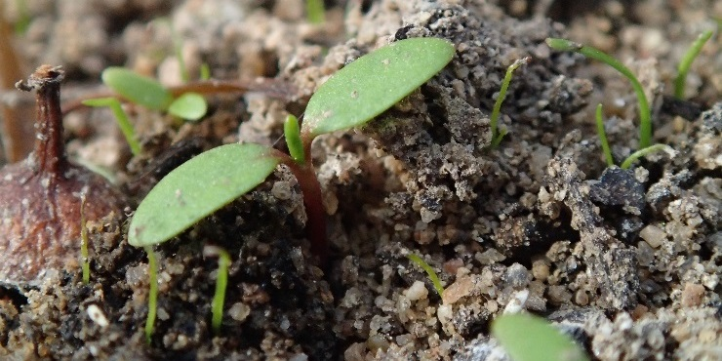

**Figure 1 – Monitoring evidence of recruitment.**

## Key evaluation questions

Five key evaluation questions are used to clearly articulate the monitoring questions being addressed in the program. They focus on the influence that environmental flow discharge has on the spatial distribution, foliage cover, species diversity, recruitment (Figure 1) and establishment of in-stream, fringing and woody vegetation at a sub-reach scale. They also focus on how additional factors (grazing, rainfall, soil properties and season) influence the response of vegetation to environmental flow discharge (see program overview for details, DELWP 2017a).

## 2016/17 Monitoring

Surveys were conducted at six sites on the Campaspe River that were used in previous VEFMAP surveys. Site inspections for planning of future monitoring were also conducted on the Thomson River, Moorabool River and Wimmera River tributaries (Mackenzie River, Burnt Creek and Mount William Creek).

## Timing

The sampling design recommends surveys to occur before a planned flow delivery and a minimum of 8 weeks after the event (to provide adequate time for vegetation to respond and for germinants to emerge). However, high rainfall resulted in high flow levels in the Campaspe River in August-October 2016. The planned flow was therefore not delivered and the first survey occurred in November 2016 once the water level receded. The same sites were re-surveyed 10 weeks later in January-February 2017. A set of six small flows (including four environmental flows) was delivered in February-May 2017, and then the same sites were re-surveyed a third time in May 2017.

## Methods

Survey methods included the following:

* + - *broad-scale surveys* to measure spatial distribution patterns of vegetation:
      * aerial imagery (UAV or drone flown above tree canopy for 1.5 km along the river at each site)
      * onground surveys (350-550 m on each side of the river),
    - *fine-scale transect and quadrat surveys* to measure expansion/contraction of existing plant stands and recruitment of new plants (10 transects at six sites),
    - *photograph assessment of tree canopy cover* to inform how the canopy cover might be influencing understorey vegetation responses to flows, as well as how the canopy itself changes through time (first survey each year), and
    - *photo-point photograph* establishment and assessment (up to 10 points at each site).

Supplementary approaches included establishment of:

* *grazing exclosures* to prevent grazing, comprising a tall fence around an area of up to 10x10 m each (two quadrats at two sites with transects within and immediately adjacent to each exclosure) (established December 2016 at Doaks Reserve (Figure 2) and Strathallan Road),
* *instream hydrology loggers* to measure flow height and duration of height change (installed at six sites, Figure 3),
* *soil moisture loggers* (six probes divided across three sites with two positions along the river bank, Figure 2). Also, four probes were installed at two Long-term Intervention Monitoring (LTIM) sites, Loch Garry and McCoy’s Bridge, Goulburn River (all loggers installed December 2016).

Methods were refined and updated after each sampling period to ensure the most effective and efficient approach was used.

Experiments on the effects of depth and duration of inundation on young and mature vegetation will occur in 2017/18.

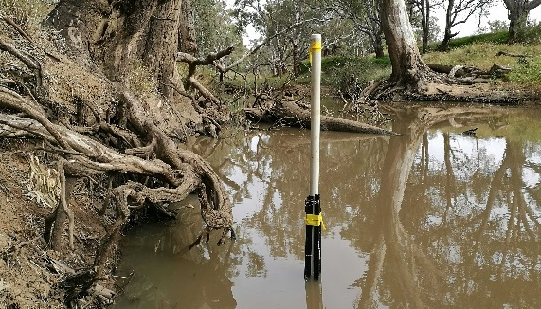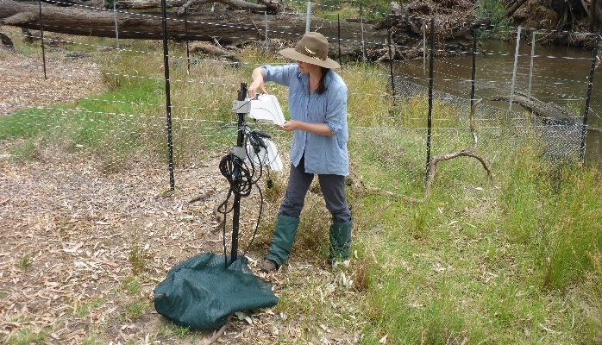

**Figures 2 and 3 – A soil moisture logger and an instream hydrology logger.**

## Results

* 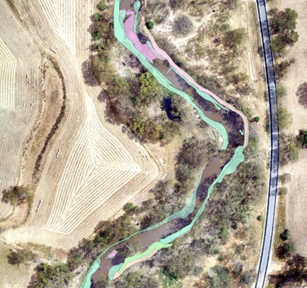*Broad-scale surveys* – have provided a useful overview of vegetation within each site and allow data collection over a much larger spatial area than fine-scale surveys. Combined data from on-ground surveys overlaid onto high-quality aerial images provides the most accurate data and highest quality images for communications and reporting (Figure 4).

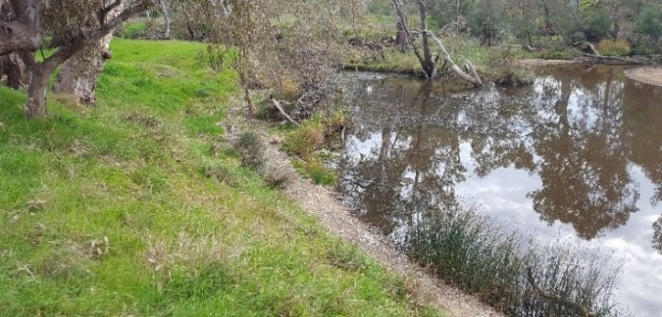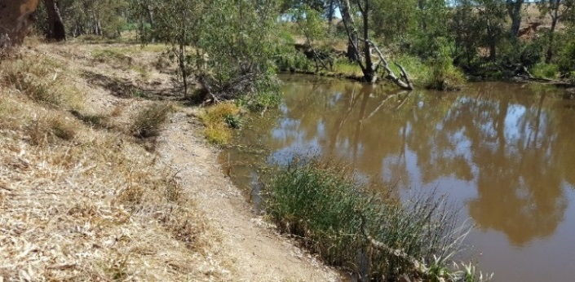

**Figure 4 – Vegetation mapping on the river bank in 2016.**

* 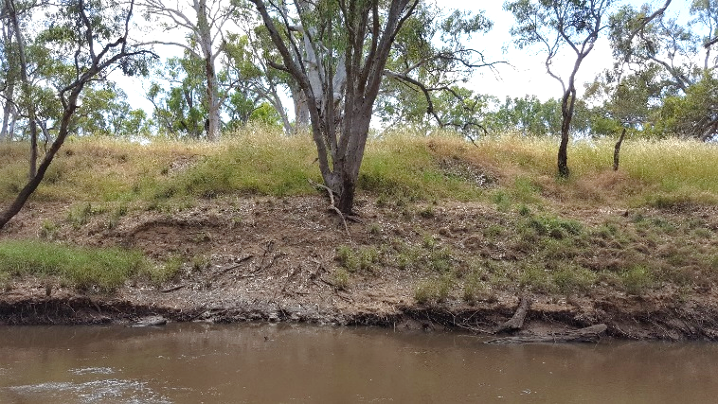*Fine-scale surveys* – >20,000 point transect samples were recorded in each of the three survey periods on the Campaspe River. There was clear evidence for vegetation changes resulting from inundation of the bank during the natural flow events in 2016. Exotic annual species (mostly pasture grasses) were killed up to the inundation line, while more flood-tolerant species persisted (Figure 5). Recruitment of native and introduced plant species occurred with some species recruiting continuously and others only after seasonal or flow events. The six consecutive smaller flows in early 2017 caused frequent inundation of mature fringing plants on the lower parts of the bank, and a subsequent reduction in leaf biomass, although no apparent mortality.

**Figure 5 –Flow inundation line visible on the river bank in 2016 after large natural flow events killed exotic species.**

* *Photo-point assessment* – photo points across the six sites show changes in vegetation through the season, as well as changes resulting from inundation (Figure 6).

**Figure 6 – Photo-points can show vegetation changes over time.**

Supplementary actions

* *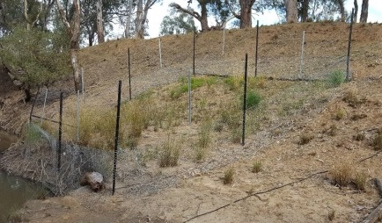Grazing exclosures* – At Strathallan Road, high grazing pressure led to a dramatic increase in vegetation cover inside the exclosures compared to outside (Figure 7). At Doaks Reserve, there were marginal differences in vegetation cover inside and outside exclosures due to low grazing pressure

**Figure 7 – A grazing exclosure at Strathallan Road.**

* *Hydrology* – The 2016/17 water year started very wet, with high rainfall in the first few months leading to high flow levels in August, and particularly September and October (discharge levels > 10,000 ML/day). This corresponded with increases in river height from a base level of <2 m to a peak of >7 m at the gauging station in Rochester. Flow levels remained relatively stable from November to the start of February, followed by delivery of a series of short environmental and operational flow events from Lake Eppalock, resulting in changes in river height of up to 50 cm in Rochester.
* *Soil moisture* – All four environmental flows in early 2017 were recorded and detected in the soil moisture profile. At the Bryants Lane site on the Campaspe River, these flows corresponded with soil wetting in the shallow soil profiles (<20 cm deep), and moisture levels returned to pre-flow conditions rapidly after the event. Further up the bank, where the flow didn’t reach, the soil moisture levels were unchanged and only the shallowest profile changed in response to larger rain events. Soil moisture in the deeper profiles (>20 cm) was largely unaffected. Additional soil moisture monitoring was conducted on the Goulburn River for comparison, where two flow events occurred in early 2017 (inter-valley transfer in January 2017, environmental flow event in March 2017). The soil profile lower on the bank was wet down to 50 cm, and took longer to return to pre-flow conditions.

## Conclusions

Using multiple methods to directly address the key components of the VEFMAP Stage 6 monitoring objectives has so far proven to be successful (see DELWP (2017b) for further details). The methods summarised here, were approved for continued use in Stage 6 by an Independent Review Panel (Feb-May 2017).

## Highlights

A highlight so far is the strong collaboration between program managers and key stakeholders, including regular active communication. It is recognised that the Pilot Study has only involved monitoring with one CMA however future surveys throughout Stage 6 will be conducted across multiple CMAs, and this active and close communication will extend further to meet communication objectives for all relevant stakeholders.

## Collaboration

It is intended to continue to pursue options for key collaborations with researchers including academics (internal and external) and students. This includes through ARC linkages, University of Melbourne student projects, and other opportunities where available.

## References

DELWP (2017a) VEFMAP Stage 6 Part A: Program context and rationale. Department of Environment, Land, Water and Planning. In prep.

DELWP (2017b) VEFMAP Stage 6 - Monitoring vegetation response to environmental flow delivery in Victoria 2016/17 – Pilot study. A report to Water and Catchments, Department of Environment, Land, Water and Planning.

## Contact [Chris.Jones@delwp.vic.gov.au](mailto:Chris.Jones@delwp.vic.gov.au)

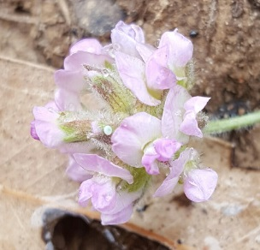

**Figure 8 – The threatened Small Scurf-pea found in a grazing exclosure plot on the Campaspe River.**

|  |  |
| --- | --- |
| © The State of Victoria Department of Environment, Land, Water and Planning 2017  LogoThis work is licensed under a Creative Commons Attribution 4.0 International licence. You are free to re-use the work under that licence, on the condition that you credit the State of Victoria as author. The licence does not apply to any images, photographs or branding, including the Victorian Coat of Arms, the Victorian Government logo and the Department of Environment, Land, Water and Planning (DELWP) logo. To view a copy of this licence, visit http://creativecommons.org/licenses/by/4.0/  ISBN 978-1-76047-799-8 (print), 978-1-76047-800-1 (pdf/online)  Disclaimer  This publication may be of assistance to you but the State of Victoria and its employees do not guarantee that the publication is without flaw of any kind or is wholly appropriate for your particular purposes and therefore disclaims all liability for any error, loss or other consequence which may arise from you relying on any information in this publication. | Accessibility  If you would like to receive this publication in an alternative format, please telephone the DELWP Customer Service Centre on 136186, email [customer.service@delwp.vic.gov.au](mailto:customer.service@delwp.vic.gov.au), or via the National Relay Service on 133 677 [www.relayservice.com.au](http://www.relayservice.com.au). This document is also available on the internet at [www.delwp.vic.gov.au](http://www.delwp.vic.gov.au). |