***ARI Aquatic Quarterly Update – Influence Summer 2019/20***

**About Us**

The Applied Aquatic Ecology section aims to generate and share knowledge, through world-class, applied, ecological research, which supports and guides sustainable ecosystem policy and management to ensure healthy, resilient ecosystems. We work collaboratively with national, state and local agencies, research institutes, universities, interest groups and the community.

**Our focus:**

* To undertake high quality, relevant ecological research.
* To interpret research outcomes and communicate these effectively to key stakeholders.
* To guide and support sustainable ecosystem policy and management.

**This update provides three examples of projects which help managers:**

They provide:

* a case study demonstrating the need for a system-scale approach to flow management to conserve riverine fish such as Golden Perch.
* evidence of the effects of different durations and frequencies of unseasonal flows on plants in riparian areas. The project can help inform management decisions about how unseasonal peak flows can be delivered to minimise negative impacts on plants in riparian zones.
* evidence of how flow regulation can potentially affect the behaviour of Golden Perch and Murray Cod.

[www.ari.vic.gov.au](http://www.ari.vic.gov.au) Subscribe to any of ARI’s communications at [www.tiny.cc/ARIsubscribe](http://www.tiny.cc/ARIsubscribe)

***A system-scale approach to conserving Golden Perch***

**Issue:**Riverine fish such as Golden Perch spawn in free-flowing rivers with downstream drift of eggs and larvae.  The spatial scale of downstream drift is largely unknown. For river managers, information on downstream movement of young Golden Perch is important for environmental water to be applied at appropriate spatial scales.

**Action:**On the Darling River, in late 2016,larval nets were set at 15 sites, from Wentworth to Walgett (1900 km), as a flood pulse travelled down from the upper Queensland/NSW tributaries.  Fish surveys were also conducted in the Menindee Lakes and in the Great Darling Anabranch to determine movement of young fish.

**Results:**Golden Perch spawned in the unregulated flowing tributaries of Qld and northern NSW, on the flow pulse, with larvae and fingerlings drifting/dispersing up to >1600 km downstream. While they moved downstream, larvae transitioned into fingerlings and fish that entered the floodplain habitats of the Menindee Lakes found excellent productive conditions for fast growth.

A collaborative agency team then developed an environmental flow regime for the lower Darling River, which cued further spawning and enabled fingerlings to disperse downstream into the lower Darling River, the Great Darling Anabranch, and the Murray River.  Some fish potentially completed an active migration of >2100 km by age 1 year.

**Outcome:**The Darling River case studyhighlights the need for a system-scale approach to conservation of some riverine fish by: (i) protecting flows at large spatial scales, (ii) enhancing hydrological connectivity of small and medium tributary flows into main rivers, (iii) linking productive floodplains, and (iv) developing multi-year flow strategies.

**Partners & funder**:

NSW Department of Primary industries (Fisheries), NSW Office of Environment and Heritage, Commonwealth Environmental Water Office

**ARI contact:** Ivor Stuart. **NSW Parks and Wildlife contact:**Clayton Sharpe

[Stuart and Sharpe](https://onlinelibrary.wiley.com/doi/abs/10.1002/aqc.3311) (2020) Riverine spawning, long distance larval drift, and floodplain recruitment of a pelagophilic fish: A case study of golden perch (*Macquaria ambigua*) in the arid Darling River, Australia. Aquatic Conserv: Mar Freshw Ecosyst. DOI: 10.1002/aqc.3311

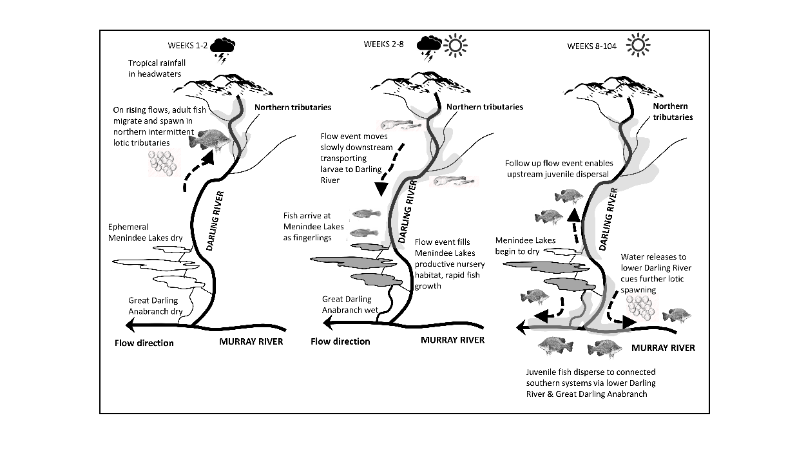

Fig 3. Conceptual illustration of a Darling River flow pulse moving from the tropical uplands across the arid drylands to Menindee Lakes and then to the southern Murray River system.

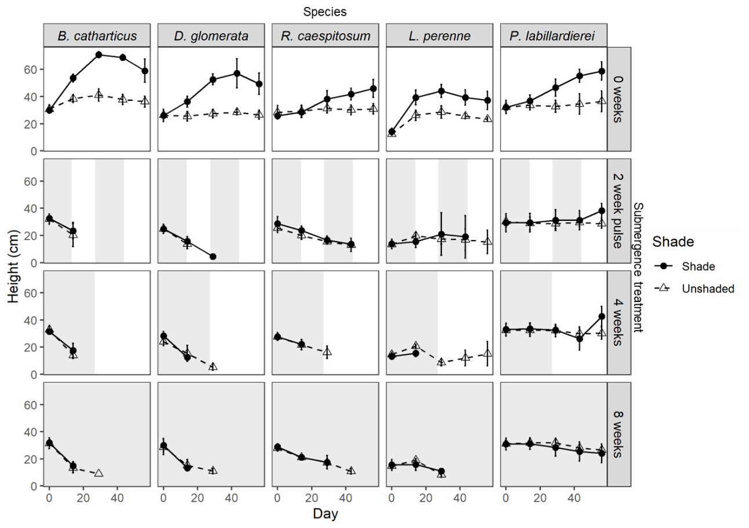

***How grasses in riparian zones respond to unseasonal flows in summer and autumn***

**Issue:** River regulation has altered the seasonal timing of flows in many rivers in south-eastern Australia, affecting the survival and growth of riparian plants. Releases of irrigation water in summer often cause high river flows during a season that would naturally experience low flows. The tolerance of vegetation to such unseasonal high summer flows is poorly known.

**Action**: The responses of five common grass species (three exotic, two native) to differing durations of summer flows were investigated using outdoor experimental tanks. There were four submergence treatments (eight weeks, four weeks, two-week pulses and no submergence), and two levels of shading (no shading and 80% light reduction), over eight weeks in summer and early autumn

**Results:** All submergence treatments, including the two-week pulse, resulted in the death of three species (*Bromus catharticus*, *Dactylis glomerata* and *Rytidosperma caespitosum*) by the end of the eight-week period. *Lolium perenne* showed moderate survival rates in the shorter-duration unshaded submergence treatments, while *Poa labillardierei* largely survived all treatments. Similar responses across species were observed for plant height (see Fig 2) and biomass, although height generally increased and biomass growth was reduced by shading.

These results show that even two-week periods of summer submergence can reduce growth and cause the death of some grass species. While some species may survive longer submergence durations, the impacts on their long-term survival are unknown.

**Outcome:** This research has increased our understanding of the effects of different durations and frequencies of unseasonal flows on plants in riparian areas. It can help inform management decisions about how unseasonal peak flows can be delivered to minimise negative impacts on plants in riparian zones.

**Funder:** DELWP Water and Catchments – This work is part of VEFMAP (Victorian Environmental Flow Monitoring and Assessment Program).

**Collaborator:** Joe Greet (University of Melbourne) **ARI contact:** Lyndsey Vivian

Fig 2. Heights of plants assessed as alive (measured as the height of the longest section of green leaf) during the experiment; values are means (excluding dead plants) + 95% confidence intervals. Grey shading indicates periods of submergence.

Fig 3. Examples of movement patterns of a) Murray Cod and b) Golden Perch tagged in Broken Creek. Grey circles show detections of tagged fish on the listening stations.

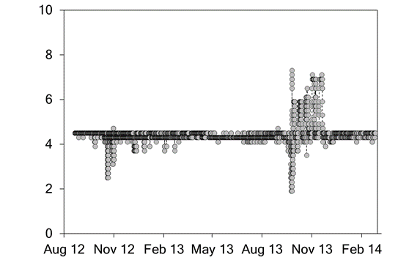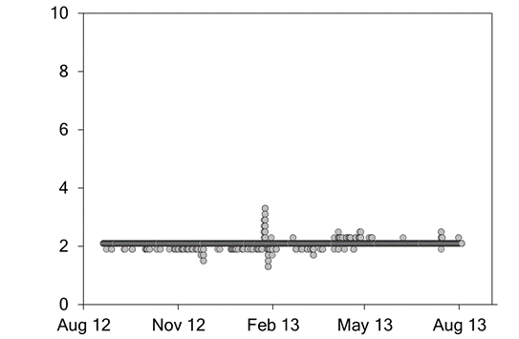

Distance upstream from Rices Weir (km)

a)

b)

Date

***Understanding how fish respond to flow regulation***

**Issue:** The construction of dams and weirs and the associated changes to hydrological and hydraulic (e.g. water level and velocity) characteristics of rivers represents a threat to fish, affecting their movement, habitat use and activity. There is a need to better understand how and why fish are affected by these changes to their environment so that management efforts can focus on reducing their impacts on fish.

**Action:** Murray Cod and Golden Perch in the lower Broken Creek were collected and tagged with acoustic transmitters and listening stations were deployed to monitor their movements between the River Murray junction and Nathalia. This creek represents a series of low-level weir pools. The habitat use, longitudinal movement and activity of the tagged fish was investigated and compared to results from published studies on riverine populations.

**Results:** Fish showed some similar behaviours to riverine populations, such as strong site fidelity and use of woody habitat by Golden Perch. Other behaviours, such as large scale (10s to 100s of km) movements known in riverine populations, were rarely recorded. These differences may reflect flow regulation characteristics such as stable water levels and loss of hydraulic cues in the weir pools. The two species showed differing responses to dissolved oxygen conditions in the weir pool, with Golden Perch more active during times of decreased oxygen compared to Murray Cod.

**Outcome:** These results highlight the potential effect of flow regulation on fish behaviours, and whether knowledge can be directly transferable among populations from different environments. Management actions may need to be targeted to different habitats, and different species.

Further investigations of fish behaviour and life history will help determine and manage the ecological consequences of river regulation.

**Funder:** Goulburn-Broken Catchment Management Authority

**ARI contact:** Wayne Koster

[Koster et al.](https://onlinelibrary.wiley.com/doi/abs/10.1111/jfb.14275?af=R) (2020) Habitat use, movement and activity of two large-bodied native riverine fishes in a regulated lowland weir pool. Journal of Fish Biology. DOI: 10.1111/jfb.14275.