|  |
| --- |
| Water for the environment benefits rare plants at Hattah Lakes |
|  |

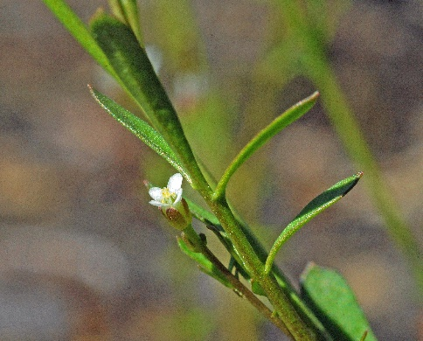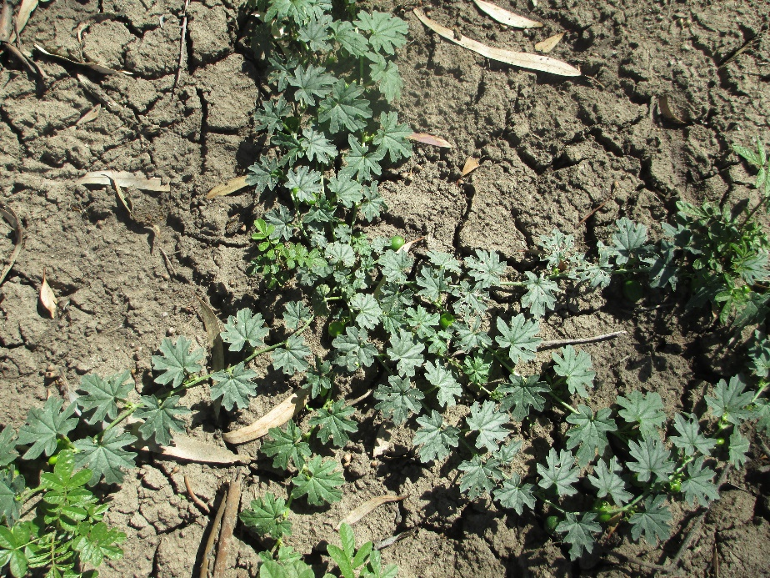

# Key points:

* **A long-term research program evaluating the effects of water for the environment has greatly increased our knowledge of rare plants at Hattah Lakes.**
* **37 rare plant species have been recorded, including two new species for Victoria.**
* **Environmental watering is important for maintaining the habitat in which these rare plants survive.**

## Environmental watering benefits rare plants

Environmental watering (managed flooding) is designed to improve river and floodplain ecosystem health, and this requires monitoring to ensure that river and floodplain communities are managed most effectively.

The Living Murray intervention vegetation monitoring program investigates ground layer plant responses to environmental watering, including by rare plants. Information about rare plant populations is often limited, hindering our ability to implement effective conservation actions. Thus, additional knowledge is needed to inform decision making and ensure the effective management of rare plants.

The discovery of rare or threatened plants during this program has reinforced the value of environmental watering for maintaining vegetation on these floodplains and provides important additional information to land managers.

## Highlights

Between 2014 and 2020, the research program at Hattah Lakes has discovered:

* Thirty-seven rare or threatened plant species.
* Two new species for Victoria: Winged Plains-bush (*Pluchea rubelliflora*) and Fruit Salad Plant (*Pterocaulon sphacelatum*).
* One species not seen in Victoria since the 1980s: Slender Spurge (*Sauropus trachyspermus*).
* Three new populations of Curly Flat-sedge (*Cyperus rigidellus*), which is listed as threatened under the Victorian *Flora and Fauna Guarantee Amendment Act* *2019*.
* Six rare species recorded for the first time in the Hattah Lakes: Riverina Bitter-cress (*Cardamine moirensis*), Bearded Flat-sedge (*Cyperus squarrosus*), Dwarf Brooklime (*Gratiola pumilio*; Figure 1), Winged Plains-bush (*P. rubelliflora*), Fruit Salad Plant (*P. sphacelatum*) and Slender Spurge (*Sauropus trachyspermus*).

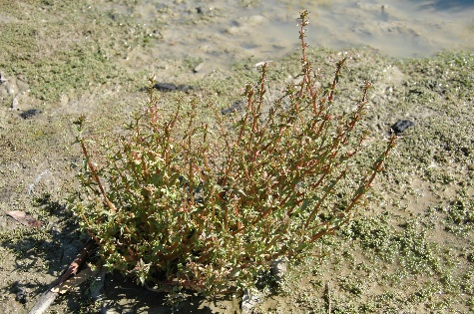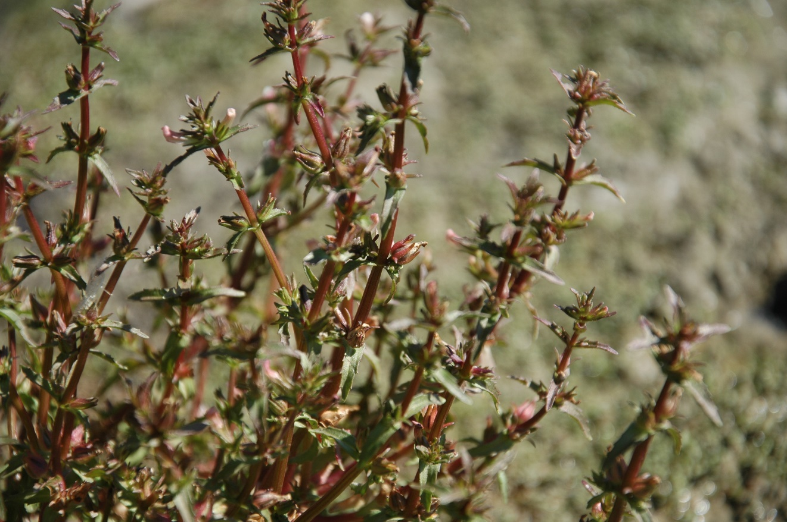

Figure 1. Dwarf Brooklime (Photo credit I. Sluiter).

## Winged Plains-bush (*Pluchea rubelliflora*)

***Two new plant species for Victoria***

ARI has discovered the first *Pluchea* species for Victoria. Until now Victoria has been the only mainland state in which *Pluchea* species has not been recorded. A population of 10 plants was discovered at Hattah Lakes, leading to a large range extension for the species. Winged Plains-bush is a perennial herb (to 50 cm high) listed as critically endangered in Victoria (Figure 2). It inhabits seasonally wet areas, swamps, claypans, dry rivers and floodplains.

The population was discovered following a large environmental watering event that inundated the site. Of three recent flood events, this was the only one to reach the higher floodplain. It is likely that flooding from the 2017/18 environmental watering event stimulated seed germination from the soil seed bank.

 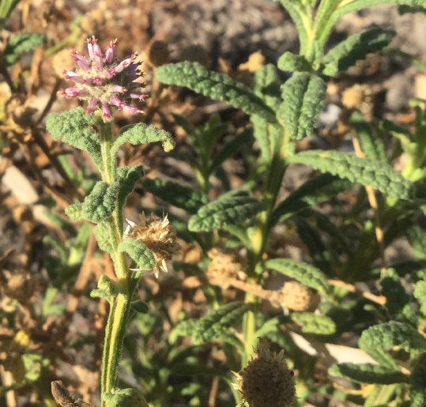

Figure 2. Left Winged Plains-bush (Photo credit C. Moxham) and right Fruit Salad Plant (Photo credit K. Bennetts).

## Fruit Salad Plant (*Pterocaulon sphacelatum*)

The Fruit Salad Plant is a short-lived, strongly aromatic, perennial herb that is listed as critically endangered in Victoria (Figure 2). In 2018 one plant was discovered on a river terrace (lower floodplain) in a recently flooded area at Hattah Lakes. This individual may be a result of a colonisation event following recent flooding. However, it could also be related to increased monitoring in the area.

## Slender Spurge (*Sauropus trachyspermus*)

Slender spurge is an annual herb to 40 cm high and had not been recorded in Victoria since 1981. A large population of over 200 plants was discovered on the lower floodplain at Hattah Lakes. The species is classified as endangered in Victoria (Figure 3).

Slender Spurge typically occurs only after substantial floods, highlighting the importance of environmental watering in maintaining plant species’ lifecycles and habitat in this semi-arid floodplain.

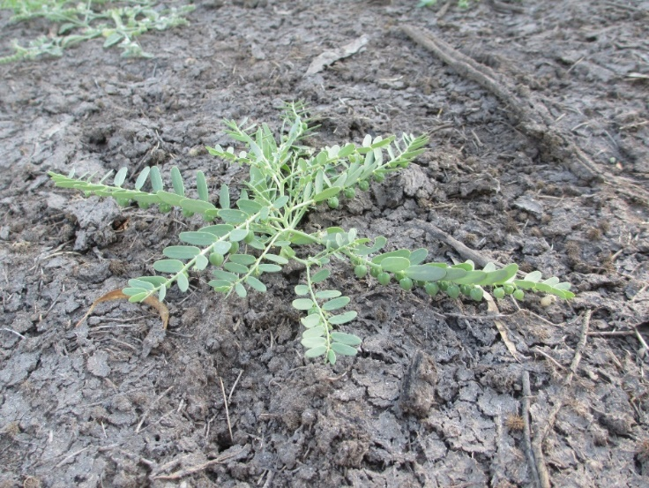

Figure 3. Slender Spurge (Photo credit C. Moxham).

***New plants for Hattah Lakes***

Three additional plant species were recorded for the first time at Hattah Lakes: Riverina Bitter-cress (*Cardamine moirensis*), Bearded Flat-sedge (*Cyperus squarrosus*), and Dwarf Brooklime (*Gratiola pumilio*; Figure 1). All were found in low numbers around lake edges, following flood events.

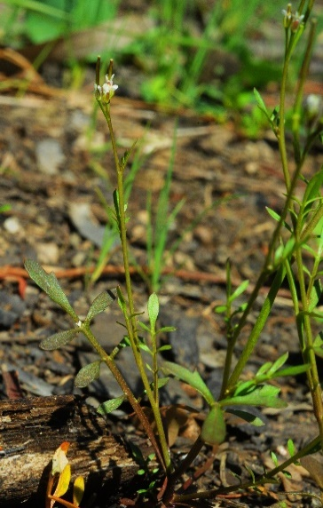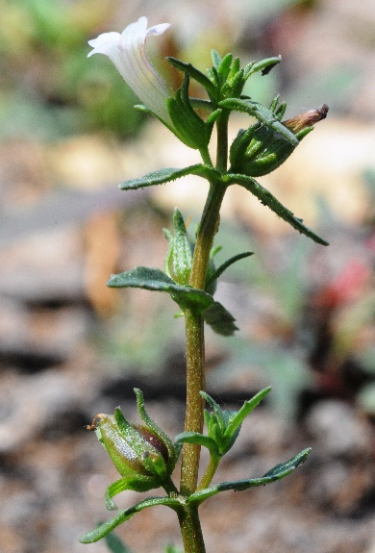

Figure 4. Left Dwarf Brooklime and right Riverina Bitter-cress (Photo credit D. Osler).

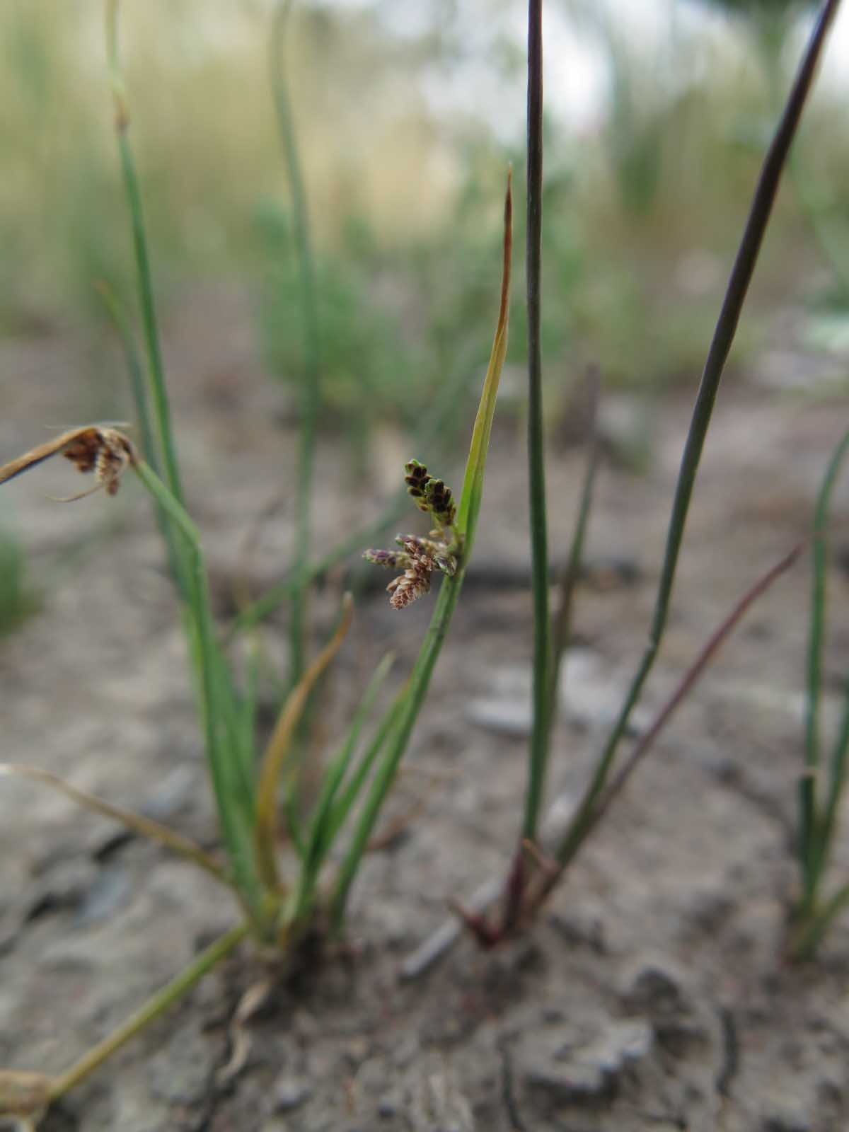Curly Flat-sedge (*Cyperus rigidellus*) is a small annual or perennial sedge to 25 cm high that inhabits ephemerally wet areas such as waterways and lake beds. Although common elsewhere in Australia it is rare in Victoria, known from only four locations, hence is listed under the Victorian *Flora and Fauna Guarantee Amendment Act* *2019*. Three new populations of Curly Flat-sedge were found at lake side monitoring sites.

***Curly Flat-sedge***

Figure 5. Curly Flat-sedge (Photo credit D. Osler).

## Summary

These plant species naturally occur in riparian environments, and therefore can respond to increased water availability from rainfall or environmental watering events. The two new plant species records for Victoria and the additional records for multiple rare or threatened species (Table 1) are important as they increase our knowledge of these species, their distribution and their habitat requirements. This information can also be used to inform future environmental watering events.

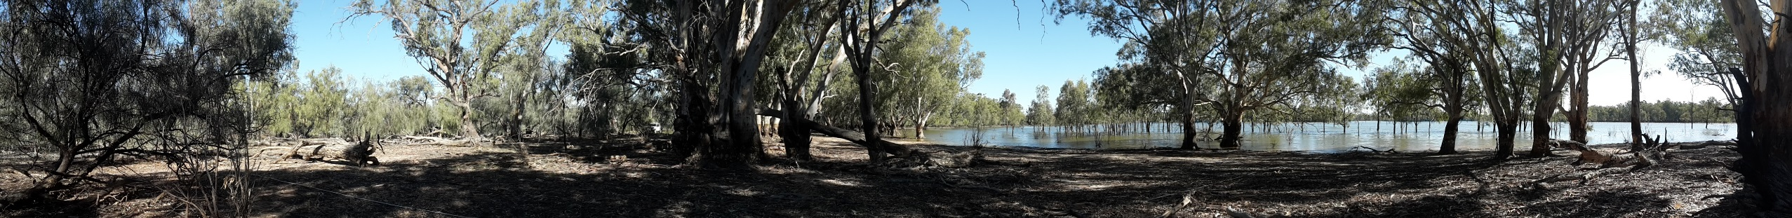

## Plant species recorded

Table 1. Rare or threatened plant species recorded at the Hattah Lakes Icon Site between 2014 and 2020. For ‘Status’, ‘v’ = vulnerable, ‘r’ = rare, ‘e’ = endangered, ‘k’ = poorly known (DEPI 2014) and ‘L’ = listed under the Flora and Fauna Guarantee Amendment Act 2019.

|  |  |
| --- | --- |
| **Small shrubs (Common/Scientific name)** | **Status** |
| Flat-top Saltbush (Atriplex lindleyi subsp. *l*indleyi) | k |
| Spiny Lignum (*Duma horrida subsp. horrida*) | r |
| Spear-fruit Copperburr (*Sclerolaena patenticuspis*) | v |
| Pin Sida (*Sida fibulifera*) | v |

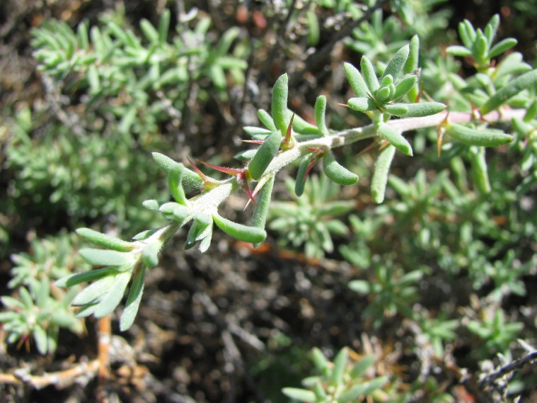

Figure 6. Spear-fruit Copperburr (Photo credit K. Bennetts).

|  |  |
| --- | --- |
| **Grasses/Sedges (Common/Scientific name)** | **Status** |
| Native Couch (Cynodon dactylon var. pulchellus) | k |
| Dwarf Flat-sedge *(Cyperus pygmaeus)* | v |
| Curly Flat-sedge *(Cyperus rigidellus)* | e, L |
| Bearded Flat-sedge *(Cyperus squarrosus)* | v |
| Purple Love-grass *(Eragrostis lacunaria)* | v |
| Inland Club-sedge *(Isolepis australiensis)* | k |
| Button Rush *(Lipocarpha microcephala)* | v |
| Needle Grass *(Triraphis mollis)* | r |

|  |  |
| --- | --- |
| **Herbs (Common/Scientific name)** | **Status** |
| Common Joyweed (Alternanthera nodiflora) | k |
| Joyweed (Alternanthera sp. 1) | k |
| Jerry-jerry (*Ammannia multiflora*) | v |
| Mallee Cucumber (*Austrobryonia micrantha*) | r |
| Small Water-fire (*Bergia trimera*) | v |
| Yellow Garland-lily (*Calostemma luteum*) | v |
| Blue Burr-daisy (*Calotis cuneifolia*) | r |
| Riverina Bitter-cress (*Cardamine moirensis*) | r |
| Cotton Sneezeweed (*Centipeda nidiformis*) | r |
| Frosted Goosefoot (Chenopodium desertorum subsp. Desertorum) | r |
| Dwarf Brooklime (*Gratiola pumilo*) | r |
| Austral Trefoil (Lotus australis var. australis) | k |
| Fruit Salad Plant *(Pterocaulon sphacelatum)* | e |
| Lagoon Spurge (*Phyllanthus lacunarius*) | v |
| Sandhill Spurge (*Phyllanthus lacunellus*) | r |
| Winged Plains-bush (*Pluchea rubelliflora*) | e |

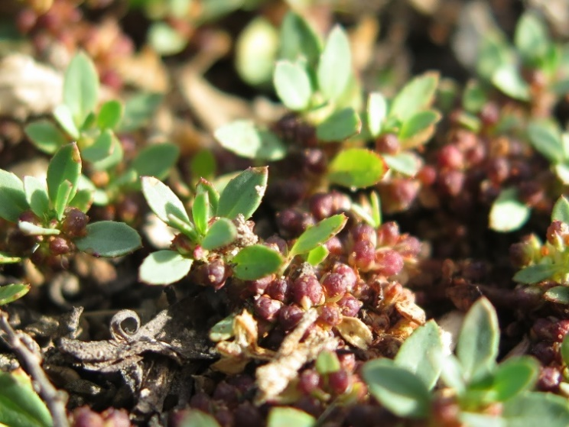

Figure 7. Small Water-fire (Photo credit D. Osler).

## Further information

[research.ari@delwp.vic.gov.au](mailto:research.ari@delwp.vic.gov.au)

[ari.vic.gov.au](https://www.ari.vic.gov.au/)

|  |  |
| --- | --- |
| **Herbs (Common/Scientific name)** | **Status** |
| Dwarf Bitter-cress (Rorippa eustylis) | r |
| Glistening Dock (Rumex crystallinus s.s.) | v |
| Slender Spurge *(Sauropus trachyspermus)* | e |
| Hairy Nightshade (*Solanum eremophilum*) | k |
| Small-leaf Swainson-pea (*Swainsona microphylla*) | r |
| Inland Verbena (Verbena officinalis var. Africana) | k |
| Native Verbena (Verbena officinalis var. gaudichaudii) | k |
| Mallee Annual-bluebell (*Wahlenbergia tumidifructa*) | r |
| Riverine Flax-lily (*Dianella porracea*) | v |

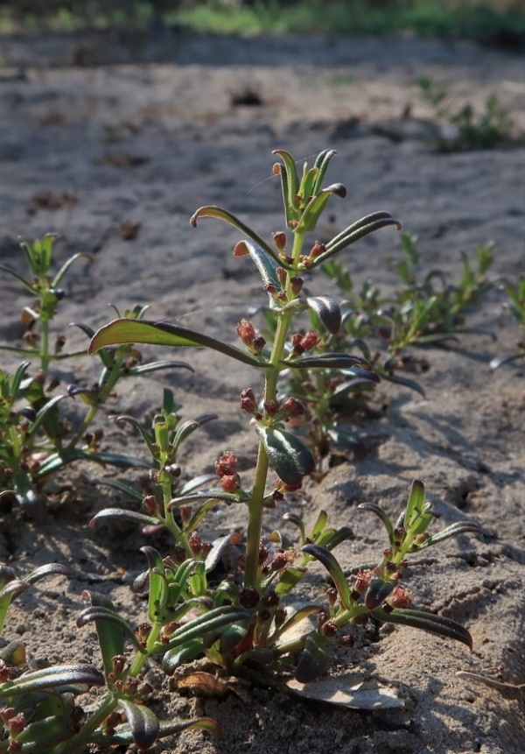

Figure 8. Jerry-jerry (Photo credit D. Osler).

## Acknowledgements

This project was funded by DELWP and the Mallee Catchment Management Authority through The Living Murray initiative. The Living Murray is a joint initiative funded by the New South Wales, Victorian, South Australian, Australian Capital Territory and Commonwealth governments, coordinated by the Murray-Darling Basin Authority.

|  |  |
| --- | --- |
| © The State of Victoria Department of Environment, Land, Water and Planning 2021  LogoThis work is licensed under a Creative Commons Attribution 4.0 International licence. You are free to re-use the work under that licence, on the condition that you credit the State of Victoria as author. The licence does not apply to any images, photographs or branding, including the Victorian Coat of Arms, the Victorian Government logo and the Department of Environment, Land, Water and Planning (DELWP) logo. To view a copy of this licence, visit http://creativecommons.org/licenses/by/4.0/  ISBN 978-1-76105-436-5 (pdf/online/MS word) Disclaimer  This publication may be of assistance to you but the State of Victoria and its employees do not guarantee that the publication is without flaw of any kind or is wholly appropriate for your particular purposes and therefore disclaims all liability for any error, loss or other consequence which may arise from you relying on any information in this publication. | Accessibility  If you would like to receive this publication in an alternative format, please telephone the DELWP Customer Service Centre on 136186, email [customer.service@delwp.vic.gov.au](mailto:customer.service@delwp.vic.gov.au), or via the National Relay Service on 133 677 [www.relayservice.com.au](http://www.relayservice.com.au). This document is also available on the internet at [www.delwp.vic.gov.au](http://www.delwp.vic.gov.au). |