janet

**The feasibility of**

**wetland vegetation recovery:**

Decision Support Tool, Version 1.0

November 2017

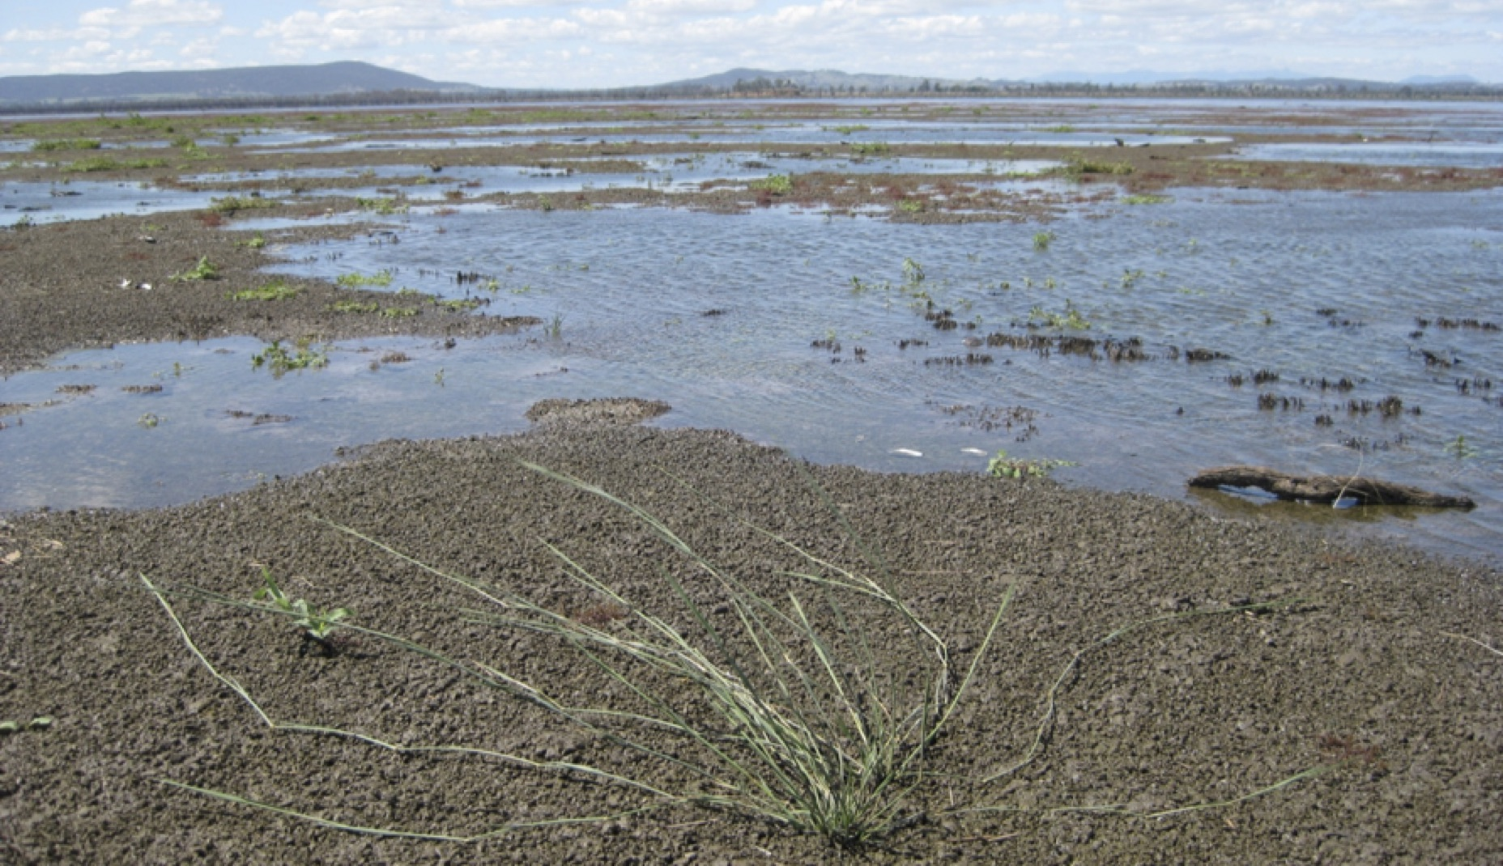

Arthur Rylah Institute for Environmental Research Technical Report Series No. 283

Photo credit

Southern Canegrass Eragrostis infecunda establishing on the exposed bed of former Lake Mokoan (at Winton Wetlands) in October 2016. (Dylan Osler, via Jane Roberts)

|  |
| --- |
| © The State of Victoria Department of Environment, Land, Water and Planning 2017 |
| LogoThis work is licensed under a Creative Commons Attribution 4.0 International licence. You are free to re-use the work under that licence, on the condition that you credit the State of Victoria as author. The licence does not apply to any images, photographs or branding, including the Victorian Coat of Arms, the Victorian Government logo and the Department of Environment, Land, Water and Planning (DELWP) logo. To view a copy of this licence, visit  <http://creativecommons.org/licenses/by/4.0/>  ISSN **1835-3827** (print)  ISSN **1835-3835** (pdf)  ISBN **978-1-76047-817-9** (print)  ISBN **978-1-76047-818-6** (pdf/online)  Disclaimer  This publication may be of assistance to you but the State of Victoria and its employees do not guarantee that the publication is without flaw of any kind or is wholly appropriate for your particular purposes and therefore disclaims all liability for any error, loss or other consequence which may arise from you relying on any information in this publication.  Accessibility  If you would like to receive this publication in an alternative format, please telephone the DELWP Customer Service Centre on 136186, email [customer.service@delwp.vic.gov.au](mailto:customer.service@delwp.vic.gov.au), or via the National Relay Service on 133 677 [www.relayservice.com.au](http://www.relayservice.com.au). This document is also available on the internet at [www.delwp.vic.gov.au](http://www.delwp.vic.gov.au). |

**The feasibility of**

**wetland vegetation recovery:**

Decision Support Tool, version 1.0

J. Roberts, M.T. Casanova, K. Morris and P. Papas

Arthur Rylah Institute for Environmental Research

Department of Environment, Land, Water and Planning

Heidelberg, Victoria

|  |
| --- |
| November 2017  Technical Report Series No. 283 |

Acknowledgements

|  |  |  |  |
| --- | --- | --- | --- |
|  |  |  |  |

This project was funded by the Water and Catchments Group (WCG) and the Arthur Rylah Institute for Environmental Research (ARI) of the Department of Environment, Land, Water and Planning, Victoria (DELWP). The following people are thanked for reviewing drafts and providing valuable feedback: Tamara van Polanen Petel and Janet Holmes (WCG, DELWP), Steve Sinclair (ARI, DELWP), Tein McDonald (Board Member, Society for Ecological Restoration Australasia), Jacinta Hendriks (Glenelg Hopkins Catchment Management Authority) and Damien Cook (Rakali Ecological Consulting).

Authors

Jane Roberts1, Michelle Casanova2, Kay Morris3 and Phil Papas3

* 1 Ecological Consultant, PO Box 6191, O’Connor, Australian Capital Territory 2602
* 2 Charophyte Services, PO Lake Bolac, Victoria 3351
* 3 Arthur Rylah Institute for Environmental Research, 123 Brown Street, Heidelberg, Victoria 3084

Editor

Organic Editing

|  |
| --- |
| Report produced by:  Arthur Rylah Institute for Environmental Research  Department of Environment, Land, Water and Planning  PO Box 137  Heidelberg, Victoria 3084  Phone (03) 9450 8600  Website: www.delwp.vic.gov.au  Citation  Roberts, J., Casanova, M.T., Morris, K. and Papas, P. (2017). Feasibility of wetland recovery: Decision Support Tool, version 1.0.  Arthur Rylah Institute for Environmental Research Technical Report Series No. 283, Department of Environment, Land, Water and Planning, Heidelberg, Victoria. |

**Contents**

Introduction to the Decision Support Tool 1

Section 1: Getting started with the DST 4

Section 2: Describing your Vegetation Recovery Plan 6

Step P1: Plan details 6

Step P2: Long-term goal for the wetland 6

Step P3: Future wetland vegetation types (EVCs) 8

Step P4: Identifying the Target EVCs 9

Step P5: Plans for Works and Activities and approach to revegetation 10

Step P6: Future water regime and salinity of the wetland 10

Section 3: Collecting wetland ecological information 12

Step F1: EVC details and context 12

Step F2: Characteristics of current vegetation 12

Step F3: Document characteristics of the Target Area, wetland and nearby catchment 14

Step F4: Complete information about the Target EVC 17

Section 4: Working through the DST questions 19

Step E1: Fill in the Target EVC information 20

Step E2: Answer DST Question 1 (Habitat Suitability) 20

Step E3: Answer DST Question 2 (Habitat Suitability) 22

Step E4: Answer DST Question 3 (Regeneration Potential) 25

Step E5: Answer DST Question 4 (Regeneration Potential) 30

Step E6: Answer DST Question 5 (Establishment Potential) 32

Step E7: Answer DST Question 6 (Establishment Potential) 40

Step E8: Answer DST Question 7 (Establishment Potential) 41

Section 5: Resources and ancillary information 43

5a Resources 43

5b Downloading a wetland base map 43

5c Describing wetland hydrology 44

5d Map of Wetland Landscapes 45

5e Changes in water regime 47

5f Ecological traits of wetland EVCs (based on Indicator Species) 48

5g Indicator Species and Water Plant Functional Group classification 53

5h Indicator Species and Water Plant Functional Group classification 54

Section 6: Glossary and references 62

Glossary 62

References 63

Section 7: Worksheets 64

Plan Worksheet 64

Field Worksheet 67

Evaluation Worksheet 74

# Introduction to the Decision Support Tool

## Purpose and scope of the Decision Support Tool

The Decision Support Tool (DST) can be used to objectively determine whether a Plan for the initial stages of wetland vegetation recovery (first 1–5 years) is likely to be successful. It uses the wetland Ecological Vegetation Classes (EVCs) described for Victoria to set a vegetation target and evaluate a recovery Plan. It is in the form of a decision tree comprised of seven core questions that evaluate three key constraints on the success of the vegetation recovery: (i) Habitat Suitability, (ii) Regeneration Potential and (iii) Establishment Potential (see schematic below). Ecological information about the wetland—some of which is collected in the field—is used to answer the questions in the DST.

It is designed to help make sensible decisions but should not be treated as a predictive tool.

***Overview of the DST process with feedback loops to the draft Plan***

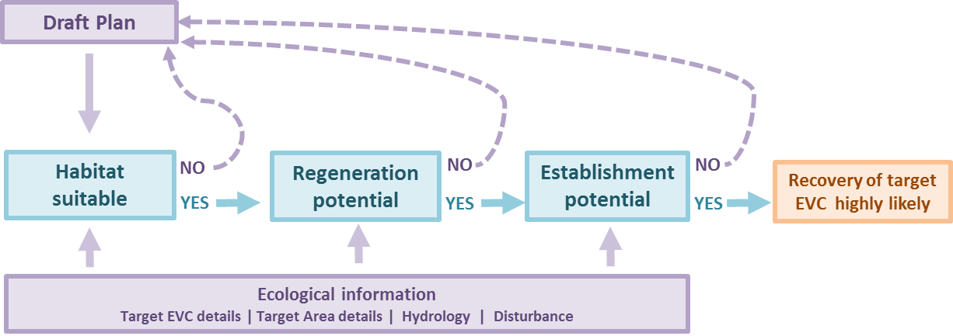

**Habitat Suitability**

**Regeneration Potential**

**Establishment Potential**

**Recovery of Target EVC highly likely**

In the DST, the following terms are defined:

* ‘Successful’ means achieving a previously specified outcome.
* ‘Recovery’ means restoration or rehabilitation.
* ‘Plan’ means a plan, an idea or a written application.

The DST is:

* only for vegetation of inland wetlands (wetlands not under any tidal influence)
* only for vegetation in the wetland, not for the terrestrial vegetation surrounding it
* only used for one vegetation type (wetland EVC) at a time
* only used for the initial stages of vegetation recovery.

This DST does not:

* consider the whole wetland at once
* evaluate whether the EVC chosen for the wetland Goal ‘*Provide wetland habitat*’ is the best choice for that fauna (wetland goals are in Section 2 on page 6)
* explicitly evaluate the effectiveness of the proposed Works and Activities (although the list of Works and Activities may be revised because of feedback provided by the DST)
* consider plans or strategies for long-term maintenance
* evaluate whether the expected outcome is better or worse than what is currently there.

## Assumptions

The DST assumes that:

* the User wants wetland vegetation that is self-sustaining and resilient
* the User is already familiar with the site
* Works and Activities will be implemented, applying best practice, with minimum negative effects (such as soil disturbance, or damage to existing vegetation or the seed bank)
* a vegetation regeneration opportunity (such as drawdown) is scheduled—the DST does not specifically check this as part of the Planned Works and Activities—also, see the notes on natural regeneration below
* Works and Activities will be effective in achieving their purpose.

### Notes on natural regeneration

* Vegetation recovery starts with regeneration. Natural regeneration occurs when conditions in the wetland trigger seeds to germinate and seedlings to establish. For most wetland plants, germination conditions are provided by a drawdown of water that results in exposed moist mud.
* Natural regeneration is not a mandate to cease caring for the site.
* It is unrealistic to establish the site, return in 5 years, and expect to find the Target EVC has established. Routine maintenance such as weeding will still be needed.

## Applications of the DST

The DST can be used in two ways: (i) for assessing the likelihood of success (feasibility) of a draft Plan, or (ii) for providing feedback on a draft Plan, which can then be used to improve it. Whichever approach is taken, both the Plan Worksheet and the Field Worksheet must be completed.

1. **Assessing a Plan**: The User moves through the DST, either to the end, or until directed back to the start. If the User reaches the end, the draft Plan is considered feasible and highly likely to be successful. However, if the User is directed back to the start before reaching the end, the draft Plan is unlikely to be feasible.
2. **Improving a Plan:** The User moves through all components of the DST (without exiting, even if reaching an exit arrow) in order to understand all potential constraints on the success of the Plan. The user then notes the feedback and comments provided by the Evaluation and Guidance as each question is answered. The feedback and comments include advice on what to change in the Plan in order to improve its likelihood of success. This feedback can be used to refine the Plan, typically by changing (i) a management action, (ii) the objective, (iii) the Target EVC, or all three.

The refined Plan may then be taken through the decision tree again, and the evaluation repeated.

The process of evaluation, feedback and refinement can be repeated until it has been established that the Plan is highly likely to be successful.

## Who is the DST for and what experience is needed to use it?

The DST is designed for anyone with a need to identify the feasibility of a wetland vegetation recovery Plan or to improve such a Plan—this could be any of the following people:

* a program manager who needs to know whether a proposal for restoring a wetland is properly thought through, feasible, and worthy of investment
* proponents of a wetland restoration project or people preparing a Business Case for a major wetland project, who need to be confident they have thought through all aspects
* wetland managers who are planning a project
* community groups wanting to develop a wetland project or a proposal for funding, and who are needing to review and check their ideas
* traditional owners wanting a wetland to support particular cultural values
* shire councillors or landholders wanting to do something with a wetland, who are not necessarily well versed in wetland ecology, and who need some help in thinking through various aspects.

Groups, officials and individuals should consider engaging a wetland plant ecologist to help with completing the DST. The parts of the DST where expert advice will be particularly useful are: setting the objective; and completing the field sheets. For the objective, ideas about species need to be translated into an EVC (Ecological Vegetation Class) for the wetland. For the field sheets, skills in wetland plant identification, familiarity with wetland EVCs, and experience in the ecology of wetlands are needed.

Landholders or other local persons knowledgeable about the wetland and how it has been used should be consulted to help complete the field sheets. This may not be necessary for wetlands that are already well-documented.

## Future of the DST

We plan to have the DST available as a software application (app) for portable devices. This will make it quicker and easier for Users to look up information and to fill in the Worksheets. It will also mean that answers to questions and information in Worksheets will be transferred automatically to other parts of the DST as needed, rather than having to be copied forward manually, as currently happens; tallies and ratings for combinations of answers will be carried out automatically.

## 

# Section 1: Getting started with the DST

## Become familiar with the DST and print off the Worksheets

Reading this document through before you begin an appraisal will help you understand what is involved and how much effort is likely to be required. Become familiar with the structure, the questions that are asked and the resources available. It will be easier to follow the instructions and enter the corresponding information on the Worksheets if they are printed off separately. The Worksheets are provided in Section 7 (page 64).

Throughout the DST, you will see the following symbols:

* + indicates guidance, references to supporting material, and tips for using the DST.
  + indicates an instruction to enter information in the worksheets supplied. The information must be entered either before starting or during use of the DST.

## Useful resources and materials

The DST is intended to be a stand-alone resource for use in Victoria. It contains most of the information needed to fill in the Worksheets. Titles of technical resources that will be helpful when filling in the Worksheets required in the DST are as follows:

* *Index of Wetland Condition assessment procedure* (DELWP 2016b)
* *Benchmarks for wetland Ecological Vegetation Classes in Victoria* (DELWP 2016c)
* *A guide to water regime, salinity ranges and bioregional conservation status of Victorian wetland Ecological Vegetation Classes* (henceforward referred to as ‘*The EVC water regime and salinity guide*’) (Frood and Pappas 2016)
* *Vegetation recovery in inland wetlands: an Australian perspective* (Roberts et al. 2017).
* ***These resources are all available online, and details are provided in Section 5a on page 43.***

Access to people knowledgeable about the wetland and its past, and about wetland vegetation, plant propagation and planting out (such as people from local nurseries and plant-growing groups) will be needed. An aerial photograph or satellite image (or another map) of the wetland is required for use as a base map for the Plan Worksheets—this is covered in Section 2.

## Describing your Vegetation Recovery Plan (Section 2)

The DST uses specific information about what is planned for the wetland and its vegetation. This information must be compiled into the Plan Worksheets. Information should be drawn from your provisional Vegetation Plan for the wetland of interest. This could be anything from a set of ideas with sketch maps, a written agreement, a budget proposal, an existing management plan or a major report that is supported by investigations. This information is compiled into the Plan Worksheets and forms your draft Plan. Information required for the Plan Worksheets and DST includes:

* the long-term goal for the wetland
* consideration of climate change
* the target vegetation type
* the Works and Activities that are being proposed, including revegetation approaches
* a map of the intended future vegetation
* the future water regime for the wetland.

The form of the draft Plan is not important. However, the planning details contained in it are, and completing the Plan Worksheets is required.

The effort required in completing the Plan Worksheets depends very much on the quality of the draft Plan and the availability of the information. For wetlands that are small and/or not well known, or ones that do not have documented information, it may only take an hour or so to fill in the Plan Worksheets. Large, high-profile or well-researched wetlands with a lot of reports to consider and public consultations to include will probably take much longer.

* ***Allow an hour to a full day for filling in the Plan Worksheets.***

## Collecting and compiling wetland ecological information (Section 3)

Ecological information about the wetland Target EVC and about the wetland itself is required to answer the questions in the DST. This information includes the following:

1. *Wetland EVC details*: inundation phase, Indicator Species, evidence of herbivory and evidence of competition.
2. *Current hydrology*: water regime, water source, water quality.
3. *Disturbance history of the Target EVC area*: activities and land use in and around the wetland, both past and present.
4. *Current disturbance of wetland sediment/soil in the Target EVC area by mud foragers:* feral animals (carp, pigs, deer, goats) and waterfowl.
5. *Target EVC regeneration:* proximity to propagule sources, availability of tubestock/seedlings or seeds.

Information can be collected in a Field Survey of the wetland and the Target Area and by discussions with landholders, neighbours, wetland experts, field naturalists and bird observers. Information is compiled into the corresponding Field Worksheets. The Target Area is the location of the Target EVC(s) in the wetland that is(are) to be evaluated using the DST.

A recent assessment of wetland condition [as defined by the Index of Wetland Condition (IWC) (DELWP 2016a)] may make it slightly easier to complete parts of the Field Worksheet, but is not essential. Only a small part of the IWC condition assessment is directly transferable to the Field Worksheets.

* ***Allow a day to complete the Field Worksheets if the information is already documented for the wetland/Target EVC area. Allow an extra 1–2 days for the Field Survey and consultation (if this information is not already documented) for a small- to medium-sized wetland.***

## Working through the DST (Section 4)

With the details of your Plan now documented, and ecological information collated, you are now ready to start working through the DST questions and completing the Evaluation Worksheets.

* ***Allow up to two hours to work through the DST questions and fill in the Evaluation Worksheets.***

# Section 2: Describing your Vegetation Recovery Plan

The Plan is a record of the long-term goal for the wetland, the type of wetland vegetation that is aimed for (the ‘target vegetation’), as well as any activities planned for the wetland (Works and Activities).

Filling in the Plan Worksheet requires a decision to be made (if it has not already been made) about which of the wetland EVCs are to be evaluated in the DST. This choice is important because it affects the amount of field information needed. If you want to plan a wetland recovery project that takes climate change into account, consider the information provided in the box on the following page. If the necessary field information is not already available (e.g. through vegetation maps and existing reports and assessments), the number of EVCs to be evaluated will affect the amount of field work that must be completed.

## Step P1: Plan details

Record basic details about the Plan: specifically, which wetland, the contact person for the Plan (including contact details) and the date and/or number of the project. Some of these details are necessary only if the Plan includes an application for resources. The date and number (or version) of the Plan may be useful in tracking improvements.

* ***Enter Plan details in Table P1 on the Plan Worksheet.***

## Step P2: Long-term goal for the wetland

Record what the long-term goal is for the wetland. This is essential for the DST because it frames some of the feedback. This goal guides Works and Activities in the wetland, and helps determine when those Works and Activities are needed. Once a long-term goal is in place, it is much easier to decide on the objective for the wetland vegetation.

Goals can be expressed in simple language or with lots of detail. All that is required for the Plan Worksheet and the DST is to set out the long-term goal in simple but broad terms. This is done by choosing which of the three long-term goals listed below best describes the User’s intentions for the wetland.

The first is *RETURN*, which is often referred to as restoration. The second is *REHABILITATE*: this is more open-ended and can involve working towards creating a wetland quite different from what it currently is. The third is *PROVIDE FAUNA HABITAT*. This is a special case for Users who have a strong interest in a particular faunal group, rather than wetland ecology in general.

These long-term goals are overarching goals that may embrace any site-specific goals already in place in existing management plans.

### Considering climate change in your plan (also see Section 5, page 43 for technical resources)

Projections for southern Australia (including Victoria) are for a warmer and drier climate, with less winter rainfall. If you want to be ‘climate ready’, you will need to:

* understand the likely future site conditions (with respect to both the water regime and the weather) and how these are predicted to differ from the present conditions.
* be prepared to modify parts of the Recovery Plan, such as the goal, objective and Target EVC, if it looks like the future conditions for the wetland are going to be very different, or only marginally suitable for the EVC initially chosen.

If you want to plan a wetland recovery project that is consistent with climate change, you should consider the following:

1. *Goal setting:* Take a long-term perspective—plan for decades, not just the next 5–10 years.
2. *Water regime and connectivity:* Determine whether the water regime and hydrological connectivity for the wetland are likely to change and, if possible, what these changes are likely to be. Even if this is only a crude projection, it will shape your thinking and may set planning in the right direction. It can be refined later if necessary.
3. *Natural regeneration:* Think about whether propagule dispersal patterns are likely to change.
4. *Assisted regeneration:*
5. Source planting material (seeds, tubestock/seedlings) from sites that are warmer and drier than the study wetland.
6. Select species and target communities from sites that are similar to but warmer and drier than the study site.
7. Try to build in genetic diversity by sourcing plant material from several sites.

***Wetland water regime under climate change***

A shift to a drier regime means the future water regime is likely to be drier than the contemporary one, even if it is not known by how much, and we need to interpret this in terms of EVC vulnerability (see below). Changes between the water regime categories used by Frood and Papas (2016) have been used in the example below, as these are at the level of precision used in the tool. This appraisal needs to consider the wetland’s water source(s), noting that: rainfall reduction is expected to have a disproportionate effect on run-off, that evaporation rates will be higher, and that the degree of climate change will likely not be uniform across Victoria.

***EVC vulnerability to future water regime***

The vulnerability of a wetland EVC to climate change can be explored by:

1. assessing how the components of the water regime will be altered by climate change
2. mapping the predicted future water regime against the water regime tolerances provided by *The EVC water regime and salinity guide* (Frood and Papas 2016).

An example of this for *EVC 819 Spike-sedge Wetland* is as follows.

This Target EVC occurs in wetlands with a broad range of water regimes—as indicated by the blue shading in the table below. Darker-shaded cells represent the commonly occurring range for the EVC, and lighter-shaded cells represent the range over which the EVC occasionally occurs. The EVC does not occur in the water regime categories that are unshaded. As EVC 819 does not occur in wetlands where the duration of inundation is <1 month, this EVC will be vulnerable in wetlands that are currently inundated for 1–6 months. This risk, however, is reduced if the depth of inundation is close to the maximum sustained depth tolerated by this EVC within this category (i.e. 100 cm), as the system is more likely to remain inundated for >1 month than in wetlands where the depth of inundation is close to the lower limit of 30 cm. Shallower inundation would not present a risk to this EVC.

***Occurrence of EVC 819 across a range of water regimes***

|  |  |  |  |
| --- | --- | --- | --- |
| **Frequency of inundation** | | | |
| Permanent | Seasonal | Intermittent | Episodic |
| Constant, annual | Annual or near-annual:  8–10 years in every 10 | 3–7 years in every 10 | <3 years in every 10 |
| **Duration of inundation** | | | |
| Permanent | >6 months | 1–6 months | <1 month |
| **Depth of inundation (maximum of regular or sustained)** | | | |
| Deep | Medium to deep | Shallow to medium | Very shallow |
| >200 cm | >100 to 200 cm | 30–100 cm | <30 cm |

The long-term goal shapes what type (or types) of wetland vegetation is (are) wanted in the long term, and hence which EVCs will be evaluated in the DST.

* If the long-term goal is *RETURN*, the future wetland vegetation types or EVCs will be determined by what the vegetation used to be.
* If the long-term goal is *REHABILITATE*, the future wetland vegetation types or EVCs can be vegetation that is currently there or a different vegetation type altogether.
* If the long-term goal is *PROVIDE FAUNA HABITAT*, the future wetland vegetation types or EVCs are strongly influenced by what fauna habitat is required (particularly in terms of the structural characteristics of the vegetation), what Works are planned (if any) and the future hydrology of the wetland. Thus, for this goal, the future vegetation types and EVCs could be what is already there, what used to be there, or something quite different.

| **Long-term goal for wetland** | **Interpretation from the User’s perspective** |
| --- | --- |
| RETURN  Return the wetland to what it was. | * You want the wetland to be like what it used to be. * You know or have some evidence of what the wetland used to be like and what sort of wetland vegetation used to be there. |
| REHABILITATE  Change the wetland from what it is now. | * You want the wetland to be a healthy native ecosystem that is used by wildlife (but not by any fauna group or species in particular). * You are not concerned about what the wetland was in the past. * You want to plan for climate change. |
| PROVIDE FAUNA HABITAT  Make habitat for a particular species or group of species. | * You want the wetland to be a place that will attract and/or be suitable for native wetland fauna, and have a particular group or species in mind. * You know or have some idea of what sort of vegetation is needed, but not necessarily which EVC. |

* ***Select the goal that best applies to this Plan in Table P2 on the Plan Worksheet.***

## Step P3: Future wetland vegetation types (EVCs)

Record the wetland EVC(s) that you are aiming for or expecting after the Works and Activities have been completed, and after the vegetation has recovered.

* ***Enter the name and number of future wetland EVC(s) into Table P3 on the Plan Worksheet.***

**Map:** A base map of the wetland is needed to delineate the wetland boundary, future vegetation types (known as Target EVCs in the DST) and other features. It is also used in the Field Survey. The map may be an aerial photograph, satellite image (e.g. from Google Earth) or a map downloaded from the DELWP interactive mapping website. As the map will be used in the Field Survey, include landmarks for orientation. Alternatively, space is also provided in the Plan Worksheet for drawing the map (Map P4).

* ***Guidance for generating and downloading a base map from the DELWP or IWC website is given in Section 5 on page 44.***
* ***Make two copies of this map: attach one to the Plan Worksheet and one to the Field Worksheet.***
* ***Alternatively, space is also provided in the Plan Worksheet for drawing your own map (Map P4).***

**Future Vegetation (Target EVCs):** On the map, sketch the vegetation/wetland EVCs that you are aiming for or expecting after the Works and Activities have been completed, and after the vegetation has recovered. These may be vegetation types already there, types like those already there, or quite different types. Make notes about the desired structure or about species [e.g. short sedges, patchy lignum, diverse herbs and forbs, a patch of Black Box (*Eucalyptus largiflorens*) woodland]. The distribution of these vegetation types should be as ecologically realistic as possible, without being too concerned about accurate boundaries. For example, take care not to map a deep-water vegetation type onto a part of the wetland that is shallow.

Label each EVC number and name on the map. Discussion with a wetland ecologist with knowledge of wetland EVCs may be useful for this. This is a now a rough map of the future vegetation after recovery.

## *Annotate the base map with the Target EVC(s).*

## Step P4: Identifying the Target EVCs

From the EVCs recorded in Step 3, identify the Target EVC(s) that you will evaluate with the DST.

### Number of wetland EVCs to be evaluated

Some individual wetlands can support several wetland EVCs, and these can vary both spatially and temporally. The DST evaluates one EVC at a time—this is known as the Target EVC. If there is more than one Target EVC, the DST evaluates each one individually. Each of these will be supported by its own ecological information and corresponding Field Worksheets. The decision on how many wetland EVCs to evaluate using the DST needs to be made *after* some initial planning (such as preparing the target map on the Plan Worksheets and inspecting the wetland), but *before* doing or commissioning any other field work activities required by the DST.

Where more than one Target EVC has been identified in the plan and there are resource constraints on evaluating all future EVCs, it will be necessary to select which future EVC(s) to evaluate with the DST.

The following guidance will help you decide on the minimum number of EVCs to evaluate at the wetland.

A. It may be appropriate to evaluate only one EVC in the DST if one or more of the following apply.

* One of the Target EVCs is expected to cover most of the wetland.
* One of the Target EVCs is particularly significant for its conservation value.

B. Two or more Target EVCs should be evaluated in the DST if one or more of these apply.

* There has been some uncertainty or disagreement in setting the goal and/or vegetation objectives for the wetland, resulting in more than one candidate Target EVC.
* The Target EVC requires different management interventions that may influence the likelihood of success of the other EVCs.
* The wetland is diverse in its physical and chemical attributes, and this may result in the management response differing according to the Target EVC.
* The Target EVCs are particularly important or have conservation significance.

C. Select all the EVCs for evaluation if:

* the wetland is of high value and/or profile and/or is attracting considerable investment.

### Interpreting the DST advice for more than one EVC

Understanding and acting on the advice from the DST is straightforward when only one EVC is evaluated. It is potentially more complicated when more than one EVC has been selected. It is quite possible that the DST will result in different evaluations for different EVCs. For example, there could be different contributions to the seed bank (and therefore different likelihoods of natural regeneration), EVCs might differ in proximity to potential sources of dispersal, and EVCs could have different water regime requirements. If the DST returns differing evaluations for EVCs planned for the same wetland, the following is recommended:

* Check that no errors have been made when completing the Plan, Field or Evaluation worksheets (such as errors of transcription or interpretation).
* Identify points of uncertainty in compiling the Worksheets, and check whether these should have been entered differently.
* Compare the worksheets to see why the EVCs have differing evaluations for each DST component (Habitat Suitability, Regeneration Potential, Establishment Potential).

### Target EVC(s)

This is (These are) the EVC (EVCs) that is (are) to be evaluated using the DST. Only one Target EVC can be evaluated at a time in the DST.

### Target Area

This is the location of the Target EVC. Only one Target Area can be considered at a time.

The Target Area is the location for the Field Survey for the corresponding Target EVC. When another EVC is the target, the Target Area changes, and the Field Survey is repeated.

* ***Delineate the boundary of the Target Area using a GPS to help ensure the Field Survey remains in the designated area. Mark this area on Map P4 of the Plan Worksheet. This will also help in tracking progress once recovery has begun.***
* ***Select which of the wetland EVCs on the target map (Map P4) will be evaluated using the DST, and record this in Table P3 of the Plan Worksheet.***

## Step P5: Plans for Works and Activities and approach to revegetation

### Works and Activities

These are the various Works and Activities that are planned (or that may be required) in or around the wetland or nearby that will affect the wetland in some way. They include the approaches to revegetation that are to be used.

Vegetation recovery may be achieved by natural or assisted regeneration (see Glossary on page 62), or by a mix of both of these approaches. The intention for revegetation needs to be recorded as part of the Project Plan. No details of the revegetation approach are required at this point (this is done as part of the Field Survey and is recorded in the Field Worksheet); it is only necessary to give the general approach, whether natural regeneration or assisted, and if assisted, whether by planting, propagating or using donor sites. One or more approaches can be selected.

* ***Enter a list of all Works and Activities, (using the checklist) or enter others as required in Table P5 on the Plan Worksheet.***
* ***Mark which revegetation approaches apply in Table P6 on the Plan Worksheet.***

## Step P6: Future water regime and salinity of the wetland

The final step for the Plan is to record the expected (future) water regime and salinity of the wetland, after the planned Works and Activities (if any) are in place and effective. Water regime and salinity is described by the categories used in *The EVC water regime and salinity guide* (reproduced on page 11). If no change is expected in the future (after taking climate change into account), the current hydrology should be entered as the Future Hydrology. No change may apply to wetlands with groundwater as the main water source, or those that have a water entitlement.

***Water regime categories and codes (reproduced from The EVC water regime and salinity guide)***

|  |  |  |
| --- | --- | --- |
| **Frequency of Inundation** | | |
| **Category** | **Description** | **Code** |
| Permanent | Constant, annual or less frequently (but always holding water) | F3 |
| Seasonal | Annual or near-annual inundation (8–10 years in every 10) | F4 |
| Intermittent | Inundated 3–7 years in every 10 | F5 |
| Episodic | Inundated less than 3 years in every 10 | F6 |
| Bog | Constant waterlogging, inundation mostly superficial | F7 |
| **Duration of waterlogging and inundation** | | |
| **Duration of waterlogging** | **Duration of inundation** | **Code** |
| 1–6 months | <1 month | D2 |
| >6 months | <1 month | D3 |
| 1–6 months | 1–6 months | D4 |
| >6 months | 1–6 months | D5 |
|  | >6 months (but not permanent) | D6 |
|  | permanent | D7 |
| **Maximum depth of regular or sustained inundation** | | |
| **Category** | **Depth range (cm)** | **Code** |
| Very shallow | <30 cm | WD1 |
| Shallow to medium | 30–100 cm | WD2 |
| Medium to deep | >100 to 200 cm | WD3 |
| Deep | >200 cm | WD4 |

***Salinity categories and codes (reproduced from The EVC water regime and salinity guide)***

|  |  |  |  |
| --- | --- | --- | --- |
| **Salinity** | | | |
| **Category** | **Range (mg/L)** | **Range (S/cm)** | **Code** |
| Fresh | 0–3000 | 0–4690 | F |
| Hyposaline (brackish) | >3000 to 10,000 | >4690 to 15,600 | B (for brackish) |
| Mesosaline | >10,000 to 50,000 | >15,600 to 78,100 | S (for saline) |
| Hypersaline | >50,000 to 350,000 | >78,100 to 547,000 | H |
| Calcareous | n/a | n/a | C |

n/a = not applicable

* ***Enter the Future water regime and salinity for the wetland in Table P7 on the Plan Worksheet.***

# Section 3: Collecting wetland ecological information

To inform the DST, ecological information on the Target Area and Target EVC is required and needs to be recorded on the Field Worksheet. The area adjacent to the Target Area is also considered. This information is collected in the field or by drawing on work already completed and reported in existing documents. The Field Survey requires skills in wetland plant identification, familiarity with wetland EVCs, and an understanding of the ecology of wetlands. Consultation and discussion with the landholder(s) and/or other local people who have knowledge of the wetland is recommended, but not essential.

Almost all the information recorded in the Field Worksheet relates to the Target EVC. The exception is the availability of Indicator Species for planting or propagating. This can be established any time *after* deciding on the Target EVCs but *before* using the DST. It is included in the Field Worksheet to keep all information on the Target EVC together.

If taking more than one Target EVC through the DST, a separate Field Worksheet (one for each Target EVC) must be completed.

## Step F1: EVC details and context

Record the date of the field work, the name and number of the Target and Current EVC(s), the preferred inundation phase of the EVC(s) and the inundation phase at the time of the survey.

There are three inundation phases:

* ***Continuous***, when the EVC is expressed (present) in all inundation phases.
* ***Inundated***, when the EVC is expressed when the wetland is inundated.
* ***Drying***, when the EVC is expressed during or extending into the drying phase.

Inundation phase definitions and the preferred inundation phase for each wetland EVC are contained in Table 2 in *The EVC water regime and salinity guide*. Most wetland EVCs occur in both inundated and drying phases, allowing some flexibility with the timing of the survey. The preferred inundation phase for the EVC is the most appropriate time to be doing the field work.

* ***Record details about the Target and Current EVC(s) and the field work in Table F1 of the Field Worksheet.***

## Step F2: Characteristics of current vegetation

Record characteristics of the current vegetation in the Target Area in three tables [Indicator Species (Table F2), Herbivory (Table F3) and Competition (Table F4)].

### Indicator Species table (Table F2)

The DST uses the Indicator Species for each Target EVC as a short list of species indicative of that wetland EVC (see Glossary on page 62). The Indicator Species table is a record of which Indicator Species in the Target EVC are currently present in the Target Area. The most efficient way of completing this table is to fill in the names of all Indicator Species for that EVC before going out into the field—this will streamline the search. The names of all Indicator Species for each EVC or EVC complex can be found in *Benchmarks for wetland Ecological Vegetation Classes in Victoria* (see Technical Resources in Section 5 on page 43).

The Indicator Species table can accommodate 30 species names—which is the highest number of Indicator Species for an EVC (808 Lignum Shrubland). In contrast, Cane Grass Wetland (EVC 291) has only one Indicator Species. Most EVCS (60%) have 6–16 Indicator Species.

There are three columns in the table to be completed for each Indicator Species:

* **Present:** means that the Indicator Species was present in the Target Area at the time of the survey.
* **Good condition:** means that the Indicator Species looks vigorous enough to produce seed or propagules over the first 1–5 years of the project. Deciding whether a species is in Good Condition in the Target Area requires familiarity and judgement. For example, a tree or shrub that looks ailing because it has dead branches and sparse foliage, or is diseased, or has lots of mistletoe, should not be marked as being in Good Condition. It may survive for several years, but its current condition suggests it is unlikely to contribute many seeds or propagules. A grass or sedge with all leaves dead may look like it is in poor condition, but if the Field Survey is in autumn–winter (not a recommended time), it could be seasonally senescent rather than dead, in which case it would be expected to regrow in warmer months. A grass or sedge or shrub that is stunted due to being browsed may be healthy but unlikely to contribute seeds or propagules in the near future, especially if browsing is likely to continue; in that case, it is not in Good Condition as defined here.
* **Abundant:** means an Indicator Species is present in most of or all of the Target Area.

***Instructions for completing Table F2***

Search the Target Area. For each Target EVC, tick if the species is Present in column [P], tick column [GC] if it is in Good Condition, and tick column [AB] if it is Abundant **(only do this for EVCs with 1–5 Indicator Species)**. Tally the Indicator Species in the table as follows: the total number of species present is the number of marks in column [P]. The total number of species in Good Condition is the number of ticks in column [GC] (except for a Target EVC with only 1–5 Indicator Species, in which case the total number of species in good condition is the number of Indicator Species that are in Good Condition and Abundant). The totals for [P] and [GC] are used in the DST.

* ***Using the instructions above, enter these details in Table F2.***

### Herbivory Table (Table F3)

This table is structured as a set of eight observations on vegetation attributes, faecal matter and fencing in the Target Area and adjacent area. These observations are:

* extent of ground cover
* abundance of unpalatable species in the ground cover
* height characteristics of the ground cover
* recruitment status for trees and shrubs
* condition of tree trunks
* status of canopy of low trees and shrubs
* abundance of animal droppings evident
* wetland protection from livestock.

***Instructions for completing Table F3***

* ***The Herbivory assessment should also consider herbivores in adjacent and nearby areas because they are mobile.***

For each attribute, choose one description (in column A, B or C) that best matches the field observations, and place a mark in the cell beneath the observation. Column A represents observations that indicate some grazing pressure, column C represents observations that indicate virtually no grazing pressure, and column B is intermediate. If the area has been cleared of trees, or if it is naturally without trees, mark column D for rows 4, 5 and 6. Choose column D for the other observations if any of the following apply:

* There is a high degree of uncertainty in the observations.
* You lack the relevant knowledge to interpret the observations.
* Circumstances mean that it is not possible to make reliable observations (e.g. the Target Area is unexpectedly flooded or recently burnt, or there is poor light).
* You are relying on existing documents and reports and not collecting field observations.

When all eight rows have been marked, tally the marks for rows 1–6 only. This tally and the marks for row 7 and row 8 are used to evaluate Establishment Potential in the DST.

* ***Ensure that one observation for each row is marked in Table F3 and that rows 1–6 are tallied.***

### Competition Table (Table F4)

This table is structured as a set of observations of plants in the Target Area in the following five areas:

* extent of ground cover plants
* amount of cover from canopy plants
* cover of plants expressed following drawdown
* presence of problem plants
* cover of plants expressed while inundated.

***Instructions for completing Table F4***

For each row in the table, choose one description in column A, B or C that best matches your field observations, and place a mark in the cell beneath it.

Column A represents observations that indicate a high potential of plant competition for establishing plants, column C represents observations that indicate a low potential for competition, and column B is intermediate. Choose column D if any of the following apply:

* There is a high degree of uncertainty in the observations.
* You lack the relevant knowledge to interpret the observations.
* Circumstances mean that it is not possible to make reliable observations (e.g. the Target Area is unexpectedly flooded or recently burnt, or there is poor light).
* You are relying on existing documents and reports and not collecting field observations.

Complete all rows in the table, including row 5 on canopy shading (regardless of whether the area has been cleared of trees or is naturally treeless), then tally the marks for each column. These tallies are used to evaluate the likelihood of plant competition that will adversely affect establishment of Indicator Species in the DST.

* ***Landholder and local knowledge will be helpful for rows 6, 7 and 8.***
* ***Ensure that one observation for each row is marked in Table F4 and that all rows are tallied.***

## Step F3: Document characteristics of the Target Area, wetland and nearby catchment

This step assesses the following three characteristics:

* current hydrology
* disturbance history
* perturbations in the Target Area.
* ***Completing this step will require more information than provided by the Field Survey. Other sources will be needed, particularly local knowledge held by landholders, field naturalists, bird observers or anyone that has visited the wetland. Spatial information (maps, satellite imagery, photographs) and reports or newsletters may also be useful.***

### Current hydrology (Table F5)

***Water regime***

This is measured at the time of the Field Survey (before any Works or Activities) and includes water regime, salinity and likelihood of nutrient enrichment of the Target Area.

The frequency of inundation, duration of waterlogging and inundation, and depth categories for the wetland will apply to the Target Area if the Target Area spans the range of depths in the wetland. However, if the Target Area occupies only a part of the depth range in the wetland, the depth and duration will need to be adjusted to suit the Target Area.

Water regime is described by the categories used in *The EVC water regime and salinity guide* (see also page 11).

* ***Record the water regime categories and codes for the Target Area in Table F5.***

***Water source***

Some wetlands receive water from multiple sources; however, one is usually dominant. For example, a floodplain wetland that fills by river flooding may be maintained by groundwater between floods; a depression wetland that fills by local run-off may be prevented from drying out by inflows of irrigation drainage. The water source for the Target Area will nearly always be the same as that of the wetland.

Water source is described by the categories used in the *Victorian Wetland Classification* (reproduced below).

Both the dominant and minor water source (if applicable) are to be documented. If you are uncertain whether there is a minor water source, enter ‘Not known’. If you are confident that there is no minor water source (or that any minor water source makes only a very small contribution to the wetland’s water regime), enter ‘None’.

***Water source categories and their description (reproduced from the Victorian Wetland Classification)***

|  |  |
| --- | --- |
| **Water source** | **Description** |
| River or stream inflow | Water reaches the wetland by overbank flows, or by channels. |
| Local run-off | Water reaches the wetland after local rain produces surface and subsurface run-off; or directly falls into the wetland. |
| Groundwater | Water reaches the wetland from aquifers or groundwater. |
| Artificial | Discharge from agricultural or industrial enterprises, urban or residential areas that is pumped into the wetland or supplied through channels and regulating structures. |

* ***Record the water source(s) for the Target Area in Table F5.***

***Salinity***

Most wetlands in Victoria are fresh water or low to moderately saline. Only a few are hypersaline (salinity concentration greater than seawater) or calcareous.

For the DST, salinity is described by the categories used in *The EVC water regime and salinity guide* (reproduced on page 11) and is best determined by measurement when the wetland is >75% full. A calcareous wetland can be inferred if it has limestone and calcareous substrates and soils, and it may have a distinctive flora.

If the wetland is documented on the DELWP wetland inventory (see Section 5b on page 44 re accessing the inventory via an online mapping application), its salinity category can be obtained. It is still advised that you measure the actual salinity wherever possible.

* ***Record salinity in the Water Quality Table (Table F5).***

***Likelihood of nutrient enrichment***

In the DST, nutrient enrichment means that a wetland has become nutrient enriched over the last 50 years. This is important when considering Establishment Potential, because nutrient enrichment gives an advantage to competitive and invasive plant species.

Nutrient enrichment is normally established by laboratory analysis of the water and sediments—this is expensive and is not required for the DST. As there are no predefined categories for nutrient status, the DST uses wetland practices and field observations to infer the likelihood of nutrient enrichment. A list of these practices and observations is provided on page 16.

***Practices that could lead to nutrient enrichment and signs of nutrient enrichment***

|  |
| --- |
| **Practices that could lead to nutrient enrichment** |
| Nutrient-rich water is / has been discharged directly into the wetland (e.g. sewage, irrigation water, urban run-off, farm run-off, aquaculture) or into a feeder stream. |
| Fertiliser or manure is / has been applied to the land around the wetland. |
| Livestock (cattle) graze or have grazed the wetland extensively and for a long period. |
| The wetland is / has been used for aquaculture. |
| The wetland is / has been fertilised (e.g. associated with cropping). |
| The wetland is / has been used to store drums of nutrient-rich liquids (such as oil). |
| The wetland is / has been used to dispose of wastes, especially organic wastes. |
| **Signs of nutrient enrichment** |
| The wetland has algal blooms. |
| Plants in the wetland are species typically associated with high nutrient levels (e.g. invasive plants such as *Egeria* and *Elodea*). |

* ***Local knowledge, spatial information (e.g. aerial photos, land use data) and on-site observations are all relevant in recognising these practices and signs of nutrient enrichment.***
* ***Record the practices that could lead to nutrient enrichment and the signs of nutrient enrichment in Table F6.***

Once the practices and observations have been systematically checked for relevance, the likelihood of nutrient enrichment is determined using the categories and criteria as follows:

1. ***PROBABLY NUTRIENT ENRICHED***, if one or more practices have occurred and observations of nutrient enrichment (algal blooms, abundant filamentous algae) have been made in the past few years
2. ***POSSIBLY NUTRIENT ENRICHED***, if one or more practices have occurred but there have been no observations of nutrient enrichment in the past few years
3. ***UNLIKELY TO BE NUTRIENT ENRICHED***, if none of the practices has occurred, or if livestock grazing in wetland has occurred, it has been at a low stocking rate, and there has been no evidence of algal blooms or filamentous algal growth.

* ***Using the criteria above, determine the ‘likelihood of nutrient enrichment category’ and record this in Table F5.***

### Disturbance history (Tables F7 and F8)

Disturbance history is inferred from a description of the activity or land use in the wetland, currently and in the past, and in areas adjoining the wetland. Both can affect the condition of the soil seed bank, and hence influence vegetation recovery. The ‘condition’ of the seed bank refers to both the abundance (sometimes referred to as the density) and the composition of the seeds. With regard to composition, the presence of non-native species (either environmental weeds or agricultural seeds) and the possible depletion without replenishment of native species is a concern.

In small wetlands, the disturbance history of the Target Area is likely to be the same as that for the entire wetland. This is not likely to be true for large wetlands or for wetlands with fences or property boundaries across them. Disturbance history in the Target Area (or wetland) and the area adjacent to the wetland are considered separately because they may have different disturbance histories.

* ***Advice from landholders, aerial imagery, and photographs of the wetlands through time—as well as the field observations—will help establish a reliable disturbance history.***

For use in the DST, activities and land uses in and near the wetland are classified into five categories that infer the magnitude of the effect on the condition of the soil seed bank (from very high to very low).

* ***Mark activities and land uses in and near the wetland (past and present) in Table F7. If more than one land use is recorded, enter the most severe effect.***
* ***Transfer codes from Table F7 to Table F8.***

### Perturbation (Tables F9 and F10)

Perturbation in the DST refers to the disturbance of wetland sediment by vertebrate animals foraging in soft sediment—which can indicate whether seedlings and small plants are at risk of being uprooted or damaged. The DST has two measures for perturbation: (i) evidence of soil disturbance and (ii) presence of mud foragers. If perturbation is severe and widespread, vegetation recovery will not be successful.

***Soil disturbance (Table F9)***

Look for evidence of soil disturbance in the Target Area and determine its extent. Disturbance may include livestock pugging, carp mumbling, pig diggings, deer wallows and/or trampling effects. For the DST, the extent is classified into three levels: high, medium and low.

* ***Record the level of soil disturbance in the Target Area in Table F9.***

***Mud foragers (Table F10)***

A diversity of fauna forage in wet mud. The DST considers the presence and abundance of animals in the Target Area and local area that are known to be particularly troublesome for seedling establishment through their dislodging and uprooting of plants. These fauna include:

* Common Carp (*Cyprinus carpio*)
* Black Swans (*Cygnus atratus*)
* herbivorous waterfowl [specifically, Purple Swamphens (*Porphyrio porphyria*), Eurasian Coots (*Fulica atra*), Australian Wood Duck (*Chenonetta jubata*)]
* feral animals [specifically, pigs (*Sus scrofa*), goats (*Capra hircus*) and deer species].
* ***Livestock are considered elsewhere in the DST.***

***Instructions for completing Table F10***

For wetlands that are small, observations about the Target Area and the wetland will be effectively the same.

For each row in the table, select one Abundance description (column A, B or C) that best matches local knowledge. Descriptions of Abundance range from persistently present and more than a few individuals (column A) to rarely present and only a few individuals (column C), with column B being an intermediate category. Mark column D when there is no reliable information. Complete all eight rows in the table and tally rows 1–6 and rows 7–8.

* ***Information about mud foragers requires local knowledge, drawing on landholders, field naturalists, wetland practitioners, websites or reports—in addition to the Field Survey.***
* ***Using the instructions above, complete Table F10.***

## Step F4: Complete information about the Target EVC

* ***The Field Survey does not contribute to this—instead a mix of local knowledge, mapping, imagery and other sources will be needed.***

### Proximity of Target EVC to other patches of the Target EVC (Table F11)

The potential for other patches of the Target EVC to contribute propagules or vegetative fragments to the wetland is influenced by hydrological connectivity (whether the patches are on a stream or channel that normally can flow into the wetland) and distance. Precise distances from such patches to the wetland are not required, but a landscape perspective is. The distribution of the Target EVC in the local area and catchment can be determined using a mix of EVC mapping, local knowledge and expert advice, and hydrological connectivity to the wetland can be determined using maps or relevant imagery.

* ***Determine the locations of patches of the Target EVC in the local area, and hydrological connectivity from these patches to the wetland (if any), and record this in Table F11.***

### Availability of tubestock/seedlings and seed for the Target EVC (Table F12)

The availability of tubestock/seedlings for planting and of seed for propagating is a practical aspect of assisted regeneration of the Target EVC. The DST needs to check availability because not all species are readily available through commercial outlets.

You will need to contact at least one source, and preferably three sources (e.g. nurseries, volunteer planters/propagators and contract growers) and provide them with a list of all Indicator Species for the Target EVC. Establish how many of these can be readily obtained as tubestock/seedlings and/or seed, and calculate the percentages of the Indicator Species that are available as tubestock/seedlings and as seed.

* ***Record the availability of tubestock/seedlings and seed for the Indicator Species in the Target EVC (number and percentage available) in Table F12.***

### Donor sites

A donor site is one where plant material, such as cuttings, rhizome parts, or soil seed banks of the Target EVC, can be sourced for transplanting/stocking to the recovery site. Donor sites should be large enough to have material removed without damaging or destroying them. Locating potential donor sites can be done at the same time as addressing the proximity of the Target EVC to other patches of the EVC. More than one donor site should be identified (the Field Worksheet allows for up to six).

Using a donor site **is not needed or suitable** if any of the following apply:

* The Target EVC at the donor site has high ecological value and should not be disturbed.
* The donor site is a significant cultural site.
* The donor site harbours diseases [such as chytrid fungus (*Batrachochytrium dendrobatidis*) and *Phytophthora*] that affect wetland fauna and flora.
* ***Identify one to six donor sites and record site details in Table F13.***

# Section 4: Working through the DST questions

The Plan is evaluated by considering the seven Core Questions (shown below). Some have subsidiary questions that are about the wetland, its physical and ecological characteristics, the wetland vegetation on the site, and Indicator Species, as well as about the general characteristics of the Target Area. Sometimes the subsidiary questions are complex, in which case they are broken down into further questions. Each question is answered using the information in the completed Plan Worksheets and Field Worksheets, and the answer is entered on the Evaluation Worksheet in the corresponding cell of the Outcome Table relevant to that question.

***The seven Core Questions in the DST and feedback loops***

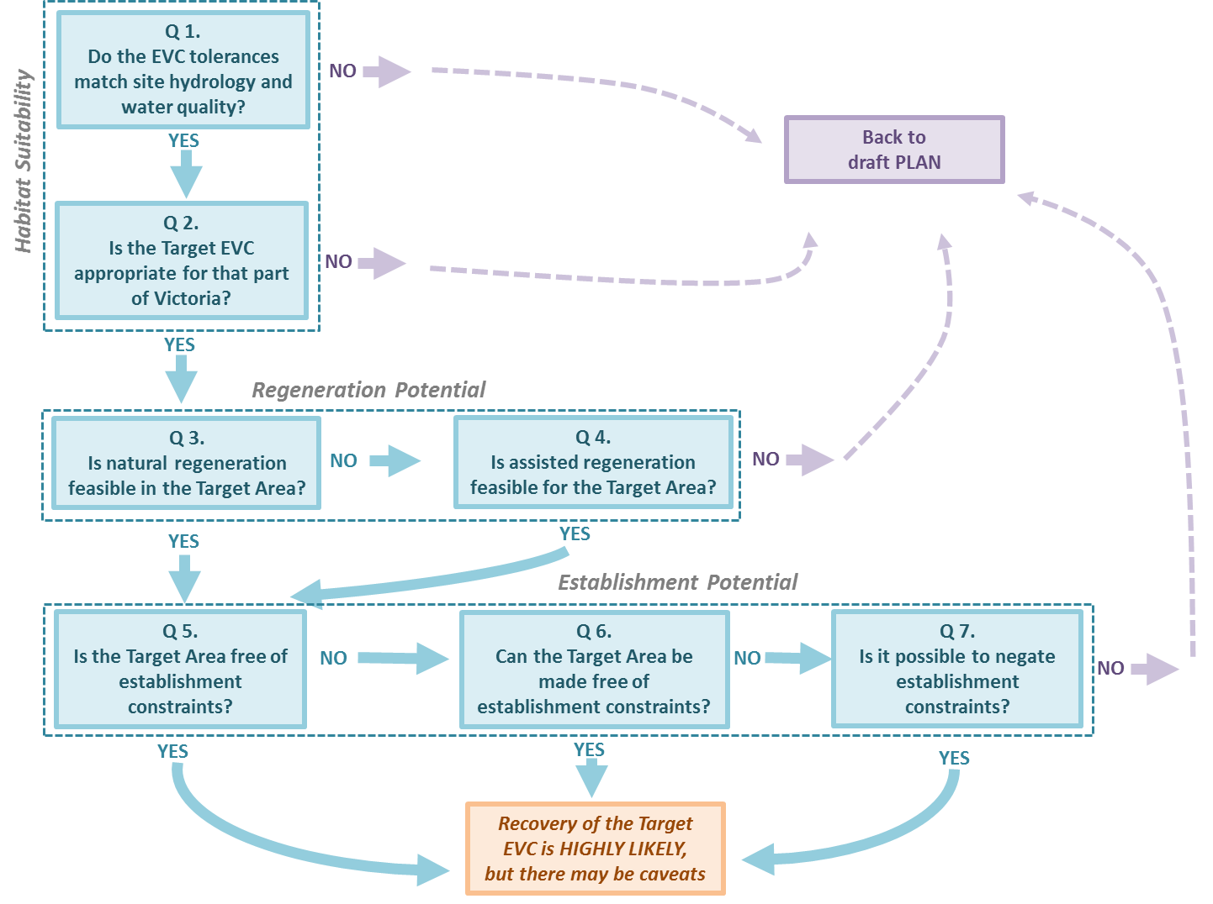

The answers to the subsidiary questions are combined to give an answer to each Core Question, which is also entered on the Evaluation Worksheet in the corresponding cell of the Outcome Table relevant to that question. The response can be *YES*, *NO* or *MAYBE*.

* If the Outcome is *YES*, it is unlikely that a particular ecological issue will restrict vegetation recovery. The User then continues through the decision tree.
* If the Outcome is *NO* or *MAYBE*, vegetation recovery is unlikely to be successful.

The DST briefly interprets the outcome for each ecological issue, and advises on options for increasing recovery success.

* In general, if the outcome is *NO*, there are few or no options for increasing the likelihood of vegetation recovery. In this case, the advice is generally to re-think or re-design the Recovery Plan.
* If the outcome is *MAYBE*, it may be straightforward to increase the likelihood of success.

The effect of a *NO* or *MAYBE* outcome depends on how the DST is being used. If the aim is to assess a Plan, a *NO* or *MAYBE* outcome indicates a low to negligible likelihood of the draft Plan achieving its stated objective and there is no point in continuing. However, if the aim is to get feedback and develop a better Plan, you should continue to the end.

Guidance on filling in the Evaluation Worksheet is detailed below. There are 22 tables in the Evaluation Worksheet, numbered E1 to E22.

## Step E1: Fill in the Target EVC information

In this step, the Target EVC name and number and the wetland goal are copied across from the Plan Worksheet to the Evaluation Worksheet.

* ***The wetlands goal keywords are RETURN, REHABILITATE and PROVIDE FAUNA HABITAT.***
* ***Copy the information from Tables P2 and P3 on the Plan Worksheet to Table E1 on the Evaluation Worksheet.***

## Step E2: Answer DST Question 1 (Habitat Suitability)

Habitat in the DST is from a plant or an EVC perspective and is evaluated in two ways, so there are two questions to answer. Question 1 is from a wetland perspective and Question 2 is from a landscape perspective.

#### Question 1: Do the tolerances of the Target EVC match the future hydrological characteristics of the Target Area?

* ***Have Tables E2, P7 and E3 handy.***

This requires a comparison of the water regime tolerances of the Target EVC with the future hydrological conditions of the Target Area—using information in *The EVC water regime and salinity guide* (frequency of inundation, duration of waterlogging and inundation, maximum sustained depth and salinity). An example of the hydrology information for EVC 819 from *The EVC water regime and salinity guide* is provided below.

***Water regime and salinity information for EVC 819***

|  |  |  |  |
| --- | --- | --- | --- |
| **EVC 819 Spike-sedge Wetland**  (*Note: brackets in the Code column indicate that the EVC occurs only occasionally in this range.*) | | | |
| **Frequency of inundation** | **Category** | **Description** | **Code** |
| Seasonal | Annual or near-annual inundation (e.g. 8–10 years in every 10) | F4 |
| Intermittent | Inundated 3–7 years in every 10 | F5 |
| Episodic | Inundated less than 3 years in every 10 | F6 |
| **Duration of waterlogging and inundation** | **Waterlogging maximum** | **Inundation maximum** |  |
| 1–6 months | 1–6 months | D4 |
|  | >6 months (but not permanent) | D6 |
| **Maximum sustained depth of inundation** | **Category** | **Depth range (cm)** |  |
| Very shallow | <30 | WD1 |
| Shallow to medium | 30–100 | WD2 |
| Medium to deep | >100 to 200 | (WD3) |
| **Salinity** | **Category** | **Salinity range (mg/L)** |  |
| Fresh | 0–3000 | F |
| Hyposaline | >3000 to 10,000 | (B) |

Only the typical conditions for the EVC are used in the comparison. In the example, this means that the Medium-to-deep category (100–200 cm) and the Hyposaline category (3000–10,000 mg/L) are not included in the comparison because they are not typical ranges for this EVC (this is indicated by the brackets around their code).

***Steps for answering Question 1***

* ***Enter the tolerances of the Target EVC into Table E2 (taking care not to include any categories that are not in the typical range).***
* ***Copy the future water regime and salinity of the Target Area from Table P7 in the Field Worksheet to Table E2 in the Evaluation Worksheet.***

Compare each of the four hydrological attributes (frequency of inundation, duration of waterlogging and inundation, maximum sustained depth, and salinity) for the Target Area (in the future) with those of the Target EVC, using the water regime change matrices (in Section 5e on page 46). The matrices identify the probable size of the hydrological change for each attribute: *COMPLETE, MAJOR, PARTIAL, MINOR* or *NO CHANGE.*

* ***Record the size of the hydrological change for each component in Table E2.***

Use the following criteria to determine how well the tolerances of the Target EVC match the future hydrological characteristics of the Target Area:

* If all four characteristics are *NO CHANGE*, thematch =***GOOD.***
* If the four characteristics are a mix of *NO CHANGE*, *MINOR* and *PARTIAL*, the match = ***POOR.***
* If one or more of the four hydrological characteristics is *MAJOR* or *COMPLETE*, the match = ***INCOMPATIBLE.***

Examples of these answers, using the example of EVC 819 are as follows:

* The match is ***GOOD*** between EVC819 and a hypothetical Target Area with an F5 + D4 + WD1–WD2 water regime and an F water quality.
* The match is ***POOR*** between EVC 819 and a hypothetical Target Area with an F4 + D5 + WD1–WD2 water regime and an F water quality. The categories match except for duration (D4 and D6 for EVC819, and D5 for Target Area). According to the water regime change matrices, the difference in duration between EVC819 and the hypothetical Target Area is *MINOR* (D4 vs D5) or *PARTIAL* (D6 vs D5).
* The match is ***INCOMPATIBLE*** between EVC 819 and a hypothetical Target Area with an F5 + D4 + WD2 water regime and an S water quality. The difference in water quality from S to F is *COMPLETE*, making this an *INCOMPATIBLE* match (the assumption is that species in EVC 819 are not adapted to grow and reproduce in mesosaline conditions).
* ***Using the criteria above, record the level of match in Table E2.***
* ***The DST does not specifically consider acid sulphate soils. If there is a risk of the presence of acid sulphate soils in the Target Area, specialist expert advice should be obtained because this presents a serious environmental risk.***

The answer to Question 1 (*‘Do the tolerances of the Target EVC match the future hydrological characteristics of the Target Area?’)* is:

* ***YES***, if the match is *GOOD*
* ***MAYBE***, if the match is *POOR*
* ***NO***, if the match is *INCOMPATIBLE*.
* ***Record the answer to Question 1 in Table E3 and proceed to the Evaluation below.***

#### Evaluation

**If the answer to Question 1 is *YES*** (a *good* match), the Target Area is suitable as a habitat for the Target EVC.

Outcome:

* This part of the project Plan is viable.
* Proceed to Question 2 (Habitat Suitability).

**If the answer is *NO*** (an *incompatible* match), the Target Area is not suitable for the Target EVC. Indicator Species in the Target EVC are highly unlikely to establish; if they do establish, or are planted, they are unlikely to persist: if they are already present, their condition may deteriorate in the long term. There is no point in continuing without revising parts of the Recovery Plan (see Guidance below).

Outcome:

* The Plan is not viable and the Target Area is unsuitable for the Target EVC.
* Do not proceed to the next Question.

**If the answer is *MAYBE*** (a *poor* match), the hydrological characteristics of the Target Area are not well suited to the Target EVC. You may proceed to the next Question, but it would be worthwhile reviewing the Plan details (see Guidance below).

Outcome:

* This part of the project plan is risky.
* You may proceed to Question 2 (Habitat Suitability).

***Guidance (if the answer to Question 1 is MAYBE)***

The match between the future hydrological characteristics and the Target EVC needs to be improved. Check for errors in compiling the Plan and Field Worksheets, and consider the following three options:

1. **Make the water regime suitable for the Target EVC.** Works may help to make the future water regime of the Target Area more suitable. Works can reduce the amount of water reaching the wetland, which may be an option if the frequency of inundation is too frequent, maximum sustained depth of inundation is too deep, or duration of inundation lasts too long. Environmental watering or Works such as diversions, sills, barriers, etc. can increase frequency, depth or duration, but the latter may require more water. Works will increase cost and/or effort: if Works are undertaken, damage to the seed bank and to existing vegetation needs be avoided. This option places a high priority on establishing this particular EVC.
2. **Make salinity suitable for the Target EVC.** Generally, this is not a feasible option. Large volumes of water would be needed to dilute the water from saline or brackish to fresh. Increasing salinity is difficult without also modifying other hydrological characteristics.
3. **Change the Target EVC**. A Target EVC can be chosen that matches the future hydrological conditions of the Target Area. This may mean changing the long-term goal. This is a pragmatic option that attempts to work within the constraints of the project and the wetland.

* ***Also refer to the Wetland conceptual models (associations between wetland values, threats and management interventions; Section 5a page 43) to help identify management options for a changed water regime.***

## Step E3: Answer DST Question 2 (Habitat Suitability)

#### Question 2: Does the Target EVC match the Wetland Landscape and Component for that part of Victoria?

***Have Tables E4 and E5 handy.***

This question evaluates Habitat Suitability for the Target EVC from a landscape and biogeographic perspective, using Wetland Landscape Profiles and their Components—originally developed to assist with the identification of wetland EVCs for the Victorian IWC.

Each Wetland Landscape Profile is named in a way that conveys its character and location and includes a brief description (of its geomorphological setting and location) and a diagram that shows the broad types of wetlands that occur in each landscape (known as *Components*). Wetland EVCs that could occur in each Component are identified. One wetland Landscape Profile is provided below (Landscape Profile #9, *Lowland Grassy Plains—coastal/southern plains*). It is described as having wetland systems associated with relatively fertile (mostly clay) sedimentary plains south of the Great Dividing Range. This landscape has four Components: 9.1 Seasonal drainage lines and associated swamps; 9.2 Closed catchments or spring/seepage-fed wetlands; 9.3 Calcareous (karst); 9.4 Wet flats.

A map showing the distribution of the wetland landscapes is provided in the ancillary information in this document (Section 5d on page 46). Spatial data for the map can also be downloaded from <https://www.data.vic.gov.au/data/dataset/wetland-landscape-profiles>.

***Landscape Profile Diagram #9: Lowland Grassy Plains—lowland southern plains***

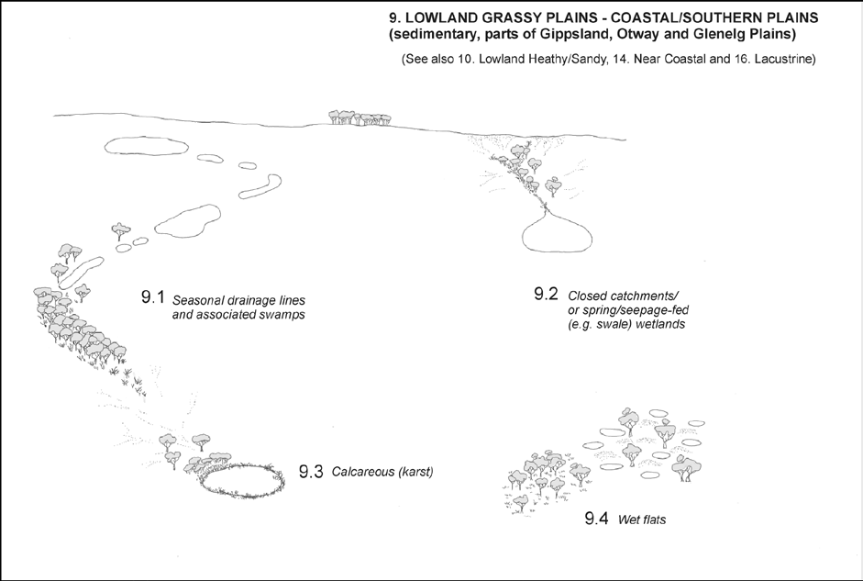

*Components*

**Steps for answering Question 2**

Using the Wetland Landscape Profiles and map, determine the Landscape Profile that best represents your project location. Then determine the Component that best describes your project wetland.

* ***Enter the Landscape number and name, Component number and name, and the EVCs associated with the Component in Table E4.***

Next, determine the suitability of the Target EVC by checking to see whether it is in the list of EVCs for this particular Landscape and Component. Use the criteria below to determine the level of match:

* The Target EVC is one that is listed for this Landscape and Component combination = ***PERFECT MATCH.***
* The Target EVC is not listed for this Landscape and Component but is listed for other Components in this Landscape = ***ADEQUATE MATCH.***
* The Target EVC is not listed for this Landscape but is listed in an adjacent Landscape = ***ADJACENT MATCH.***
* The Target EVC is not listed for this Landscape or for adjacent Landscapes = ***DISTANT MATCH.***
* ***Record the level of match in Table E5.***

The answer to Question 2 (Does the Target EVC match the Wetland Landscape and Component for that part of Victoria?) is:

* ***YES***, if the match is *PERFECT*
* ***MAYBE***, if the match is *ADEQUATE*
* ***NO***, if the match is *ADJACENT* or *DISTANT*.
* ***Record the answer to Question 2 in Table E5 and proceed to the Evaluation below.***

#### Evaluation

The long-term goal influences this evaluation.

**If your answer to Question 2 is *YES***, the Target EVC is consistent with the Wetland Landscape and Component combination. A *YES* answer is essential if the long-term goal is *RETURN*; a *YES* answer is desirable if the long-term goal is *REHABILITATE* or *PROVIDE FAUNA HABITAT*.

Outcome:

* This part of the plan is appropriate. Proceed to Question 3 (Regeneration Potential).

**If your answer to Question 2 is *MAYBE***, this means that the Target EVC is not normally associated with this particular type of wetland (i.e. is not listed as an EVC for this Wetland Landscape and Component combination), although it does occur in this Wetland Landscape. A *MAYBE* answer is not desirable if the long-term goal is *RETURN*; some part of the project Plan needs to be revised (see the Guidance below). A *MAYBE* answer is acceptable if the long-term goal is *REHABILITATE* or *PROVIDE FAUNA HABITAT*.

Outcome:

* This part of the plan is appropriate, unless the long-term goal is *RETURN*.
* Proceed to Question 3, unless the long-term goal is *RETURN*.
* If the long-term goal is *RETURN*, review and revise your Plan.

**If your answer to Question 2 is *NO***, the Target EVC is not consistent with the Wetland Landscape and Component combination and does not occur in this part of Victoria. A *NO* answer is only acceptable if the long-term goal is *REHABILITATE* or *PROVIDE FAUNA HABITAT* and if the match between Wetland Landscape and Component and Target EVC is *ADJACENT*. A *NO* answer may be acceptable if the long-term goal is *PROVIDE FAUNA HABITAT* and the match is *DISTANT*, but see the Guidance below. A *NO* answer is not acceptable if the long-term goal is *RETURN*; in that case the Plan must be revised.

Outcome:

* This part of the plan is appropriate only if the long-term goal is *REHABILITATE* or *PROVIDE FAUNA HABITAT* and if the match in Table E5 is adjacent. If this is the case, proceed to Question 3.
* If the long-term goal is *RETURN*, review and revise your Plan.
* If the long-term goal is *PROVIDE FAUNA HABITAT* and the match is distant, proceed to Question 3, but check Guidance and consider reviewing and revising the Plan.

**Guidance**

The DST requires a *PERFECT* match when the long-term goal is *RETURN*: this is to maintain the distinctive ecological character for this part of Victoria. If the long-term goal is *RETURN* and the match is not *PERFECT*, it is worthwhile trying to understand why by reviewing the Plan. A project can be made ecologically consistent by implementing one or more of the following options:

Options:

* Revise the Target EVC. This means reviewing the reasons for choosing this EVC, and revisiting the historical evidence for misinterpretations or alternative interpretations.
* Review the future water regime. This means reviewing the design of any Works that might be planned.
* Revise the goal. The site may have changed since pre-disturbance in ways that cannot be easily reinstated.

If your long-term goal is *REHABILITATE* and the match is *ADJACENT* or *DISTANT*, this means the Target EVC does not occur in this Wetland Landscape. Establishing this Target EVC when it does not currently occur should be done only if you are seeking to work with climate change. In that case, the Target EVC will be one that is associated with drier hydrological conditions or is from a Wetland Landscape that is warmer than where the project wetland is.

If your long-term goal is *PROVIDE FAUNA HABITAT*, and the match is *ADJACENT or DISTANT*, this means the Target EVC does not occur in this Wetland Landscape. Establishing this Target EVC when it does not occur naturally in this part of Victoria should be done only if the Target EVC is known to grow in the local climate (i.e. does not have any temperature tolerances or limitations).

Option:

* Review the reasons for choosing the Target EVC. There may be other EVCs that occur in this Wetland Landscape that provide the habitat characteristics needed.

## Step E4: Answer DST Question 3 (Regeneration Potential)

Here the decision tree considers Regeneration Potential, and determines whether natural regeneration can be relied upon to achieve vegetation recovery, and whether assisted regeneration is logistically feasible. Natural regeneration means plants self-establish without interventions such as planting or seeding. Assisted regeneration involves doing interventions such as planting or seeding (see Glossary). Regeneration Potential is evaluated by asking two questions about Indicator Species in the Target EVC and the approach to regeneration. Question 3 considers natural regeneration and Question 4 considers assisted regeneration.

#### Question 3: Is natural regeneration of Indicator Species feasible in the Target Area?

Several factors affect the feasibility of natural regeneration, and Question 3 contains subsidiary questions to consider.

**The first factor is Current Vegetation**. Q3.1 considers whether the current vegetation contains Indicator Species of the Target EVC, and if plants that are present are likely to contribute to the development of the Target EVC through the provision of seeds or propagules. It does this by treating the presence and condition of Indicator Species for the Target EVC in the Target Area (entered in Table F2: Indicator species present) as a surrogate for reproductive capacity over the first five years of vegetation recovery. The DST also considers whether changing hydrological conditions (*recorded on the Plan Worksheet*) could affect those Indicator Species that are present.

**The second factor is Seed bank**. In the DST, this always refers to all types of propagules (including seeds, spores and tubers) in the soil. It does not refer to the aerial seed bank. Q3.2 considers whether the seed bank is likely to make a significant contribution to the development of the Target EVC. This is quite an intricate question that needs to consider several points such as: similarity between the current and the Target EVC vegetation attributes, and whether a viable seed bank is present at all. It does this by considering information already recorded on the Field Worksheets.

**The third factor is Dispersal**. Q3.3 considers whether dispersal of propagules of Indicator Species from beyond the wetland is likely to contribute to the development of the Target EVC. It does this by using distance and hydrological connectivity as approximate indicators of the likelihood of propagules from elsewhere arriving in the Target Area.

#### Question 3.1: Are Indicator Species present? Are they likely to contribute to regeneration of the Target EVC?

* ***Have Tables F2, F5, P7, E6, E7, E8 and E12 handy.***

#### Steps for answering Question 3.1

First, compile the total number of Indicator Species for the Target EVC [T] from its respective EVC benchmark *(refer to Benchmarks for wetland Ecological Vegetation Classes in Victoria – see Section 5a*), then copy the number of Indicator Species present in the wetland [P] and in good condition [GC] from Table F2.

* ***Enter this information in Table E6.***

Second, calculate the number of Indicator Species present in the wetland, expressed as a percentage of the total number of Indicator Species for the Target EVC [P%], followed by the number in good condition expressed as a percentage of the number present [GC%].

* ***Enter this information in Table E6.***

Third, the percentage present [P%] and percentage in good condition [GC%] are used together in a likelihood matrix (shown below). This determines the likelihood of current vegetation making a significant contribution to natural regeneration of the Target EVC. For this, the two values for P% and GC% are used to navigate into the matrix. It is essential to start with P% (*select relevant column*) and then move down to GC% (*select relevant row*). For example, if P% = 62% and GC% = 38%, the likelihood is *LOW.* This likelihood has not considered changes, if any, in water regime, so is referred to as *unadjusted.*

|  |  |  |  |  |  |  |
| --- | --- | --- | --- | --- | --- | --- |
|  |  | **P% (number of IS present as a % of IS in the EVC Benchmark** | | | | |
|  |  | 100–80 | 79–60 | 59–40 | 39–20 | <20 |
| **GC% (number of IS in good condition as a % of IS present)** | 100–80 | high | good | low | very low | very low |
| 79–60 | high | good | low | very low | very low |
| 59–40 | good | low | low | very low | very low |
| 39–20 | low | low | low | very low | very low |
| <20 | very low | very low | very low | very low | very low |

* ***Determine the unadjusted likelihood of current vegetation contributing to the seed bank, using the matrix (above).***
* ***Enter the likely contribution into the Unadjusted column in Table E6.***

The *unadjusted potential* for natural regeneration of the Target EVC must now be adjusted to be relevant to future hydrological conditions. The size of this adjustment depends on how different future hydrological conditions are from those current, and this is determined by comparing the current and future hydrology. For this comparison, it is easier to use the codes rather than the categories. The codes are taken from the Current Hydrology (in Table F5) and Future Hydrology (in Table P7). The size of the hydrological change from Current to Future is determined for each water regime characteristic, using the comparison matrices (Section 5e on page 47). The size of this change can range from *NO CHANGE* (*n.c*) to *COMPLETE*.

* ***Enter codes for current and future water regime and water quality from Tables F5 and P7, respectively, in Table E7.***

Compare the Current and Future codes for each of the hydrological variables in Table E7, using the water changes matrices and the procedure described in Section 5e on pages 47 and 48. The size of change for each comparison is recorded in the relevant column in the *Change in water regime* table (Table E7)*.*

* ***Record the size of change for all four hydrological variables in Table E7.***

The unadjusted potential can now be corrected as follows:

* If the change for all of the hydrological characteristics is *NO CHANGE* or *MINOR*, the adjusted potential is the same as the unadjusted potential.
* If the change to any of the four characteristics is rated as *PARTIAL*, *MAJOR* or *COMPLETE*, the adjusted potential is *LOW*.
* ***Record the adjusted Indicator Species potential in Table E8 and Table E12.***

The answer to Question 3.1 (“*Are Indicator Species present? Are they likely to contribute to the regeneration of the Target EVC*?”)is:

* ***YES***, if the adjusted potential is *HIGH* or *GOOD*
* ***NO****,* if the adjusted potential is *LOW* or *VERY LOW*.
* ***Record the answer in Table E8 under Answer to Q3.1.***

#### Question 3.2: Could the seed bank contribute to the development of the Target EVC?

This question is broken into three subsidiary questions (3.2a, 3.2b and 3.2c—shown below). The first subsidiary question considers the similarity, or overlap, in Indicator Species between the current and the future EVCs, the second considers what percentage of Indicator Species per EVC form a seed bank, and the third considers the condition of the seed bank. All subsidiary questions must be answered to answer Q3.2.

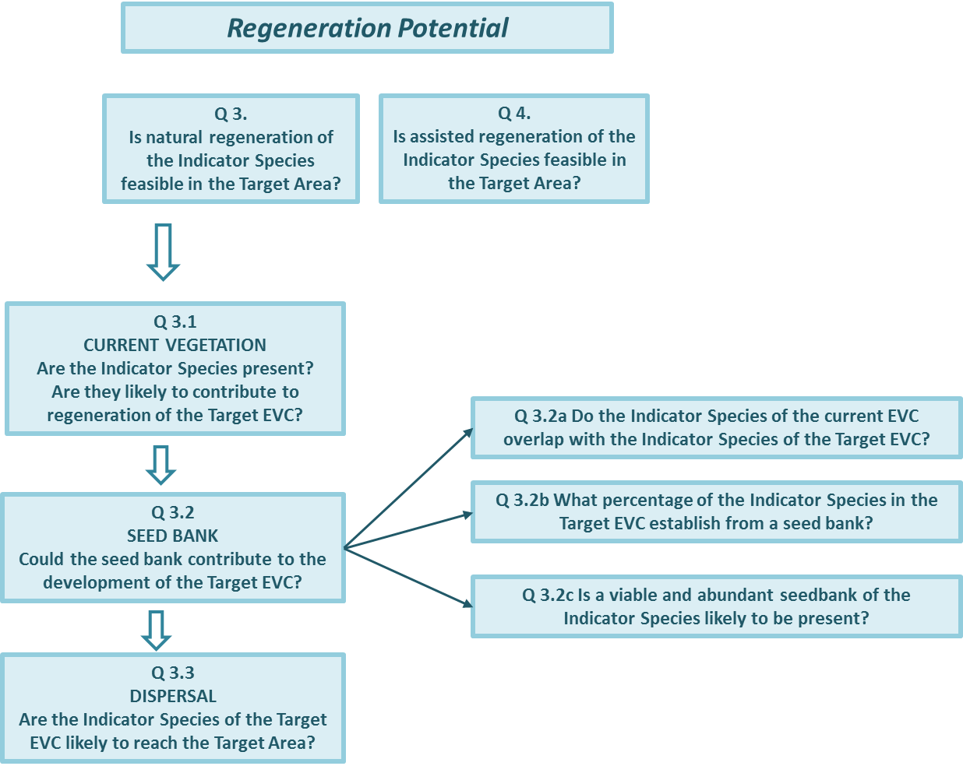

#### Q3.2a: Do the Indicator Species of the current EVC overlap with the Indicator Species of the Target EVC?

* ***Have Table E9 handy.***

This question is answered by comparing the list of Indicator Species for the current EVC with the list of Indicator Species for the Target EVC. The names and numbers of the Target EVC and the current EVC were recorded in Table F1 on the Field Worksheet. The Indicator Species for each wetland EVC are provided in *Benchmarks for wetland Ecological Vegetation Classes in Victoria.* This comparison is at the level of EVC, unlike in Q3.1, which considers the species present at a particular point in time, i.e. during the Field Survey.

* If 40% or more of the Indicator Species occur in both the current and future EVCs (i.e. are ‘shared’), the seed bank could contribute to the Target EVC, and the answer is ***YES***.
* If less than 40% but more than 0% of the Indicator Species occur in both the current and future EVCs, the answer is ***SOME***.
* If no Indicator species are shared, the answer is ***NONE***.

Check the name and number of the future and current EVCs in the Target Area, and compare their respective lists of Indicator Species (using *Benchmarks for wetland Ecological Vegetation Classes in Victoria*) to determine whether any Indicator Species are shared.

* ***Record the answer in Table E9 at Q3.2a.***

#### Q3.2b: What percentage of Indicator Species in the Target EVC can establish from a seed bank?

* ***Have Table E9 handy.***

Wetland plant species have three different regeneration strategies. One strategy is dispersal whereby regeneration is dependent on propagules dispersing into the wetland – these species do not form a persistent seed bank. Another strategy is regeneration by seed bank whereby these species establish only from a seed bank. The third (and the most common) strategy is a combination of both seed bank and dispersal. This question is answered by consulting the table of ecological traits of wetland EVCs (Section 5f on pages 48–52). This table lists all EVCs (sorted by number) and gives an estimate of what percentage of Indicator Species per EVC are ‘not dispersal dependent’ (which is equivalent to the percentage that ‘form a seed bank’, but is easier to determine).

* ***Enter % Indicator Species that are not dispersal dependent (i.e. percentage that establish from a seed bank) in Table E9 at Q3.2b.***

#### Q3.2c: Is a viable and abundant seed bank of Indicator Species likely to be present?

* ***Have Tables F8 and E9 handy.***

The viability and abundance of seeds in the sediment seed bank can be boosted or depleted by many factors. The DST focuses on land use practices within and adjacent to the wetland that are likely to deplete the seed bank. It uses disturbance history recorded in Table F8 along with the matrix below to determine the likely seed bank viability and abundance.

The matrix relates the intensity of disturbance history of the area adjacent to the wetland and of the Target Area in the wetland recorded in Table F8 to seed bank viability as follows: if the area adjacent to the wetland has a disturbance history categorised as *LOW* (*L*), but the wetland itself has a disturbance history categorised as *HIGH* (*H*), the likelihood of the soil seed bank being abundant and viable is *MEDIUM*.

There are four possible outcomes for the likelihood of the seed bank being viable and abundant: *VERY LOW, LOW, MEDIUM* and *HIGH*.

Observe the categories of disturbance history for the Target Area and for the adjacent area from Table F8 in the Field Worksheet. Use this matrix to determine the *Likelihood of the seed bank being viable and abundant*.

|  |  |  |  |  |  |  |
| --- | --- | --- | --- | --- | --- | --- |
|  |  | **Adjacent to the wetland** | | | | |
|  |  | VH | H | M | L | VL |
| **Within the wetland** | VH | very low | low | medium | medium | medium |
| H | low | low | medium | medium | medium |
| M | medium | medium | medium | high | high |
| L | medium | medium | high | high | high |
| VL | medium | medium | high | high | high |

* ***Enter the likelihood of the seed bank being viable and abundant in Table E9 at Q3.2c.***

#### Answering Question 3.2

* ***Have Tables E9, E10 and E12 handy.***

The question “*Could the seed bank contribute to the development of the Target EVC?*” can now be answered by combining the answers to the three subsidiary questions recorded in Table E9. The likelihood of the seed bank contributing to the development of the Target EVC is:

* ***HIGH***, if the Indicator Species overlap is *YES* or *SOME*, the percentage of the Indicator Species that form a seed bank is 50% or more, and the likelihood of there being a viable and abundant seed bank of Indicator Species is *HIGH* or *MEDIUM*
* ***MEDIUM***, if the Indicator Species overlap is *YES* or *SOME*, the percentage of the Indicator Species that form a seed bank is 1–50%, and the likelihood of there being a viable and abundant seed bank of Indicator Species is *HIGH* or *MEDIUM*
* ***LOW***, if the Indicator Species overlap is *NONE*, if the percentage of the Indicator Species that form a seed bank is zero, or if the likelihood of there being a viable and abundant seed bank of Indicator Species is *LOW* or *VERY LOW*.

Check the entries in the *Seed bank contribution table* (Table E9 in the Evaluation Worksheet) and follow the guidance above to determine the likelihood of the seed bank contributing to the development of the Target EVC.

* ***Enter HIGH, MEDIUM or LOW in Tables E10 and E12 in the Answer to Q3.2.***

#### Question 3.3: Are Indicator Species of the Target EVC likely to disperse into the Target Area?

* ***Have Tables F11, E11 and E12 handy.***

This question is answered by considering the occurrence, if any, of the Target EVC in the local area, the catchment and the regional Wetland Landscape. The dispersal of propagules of the Indicator Species of the Target EVC into the Target Area depends on the distance between the propagule source and the wetland, and whether there is hydrological (surface water) connectivity between the Target EVC and the Target Area. The likelihood of arrival is determined by these factors. **This information was previously recorded in Table F11.**

* ***Copy the information from Table F11 to E10.***
* ***Record the likelihood of propagules reaching the Target Area in Table E11 and E12 in the Answer to Q3.3. (NB: When there is more than one likelihood, record only the highest.)***

#### Answering Question 3

Question 3 (“*Is natural regeneration feasible in the Target Area?*”) can now be answered based on answers to the subsidiary questions on Current Vegetation (Q3.1), Seed Bank (Q3.2) and Dispersal (Q3.3). The answer to Question 3 is:

* ***YES***,if Q3.1 is *YES*, Q3.2 is *HIGH* and Q3.3 is *HIGH* or *VERY HIGH*
* ***MAYBE***,if Q3.1 is *YES*, Q3.2 is *MEDIUM* and Q3.3 is *MODERATE* or better
* ***NO***,if Q3.1 is *NO*, Q3.2 is *LOW* or Q3.3 is *LOW* to *VERY LOW*.
* ***Record the Answer in Table E12 under Answer to Q3 and proceed to the evaluation below.***

#### Evaluation

**If the answer to Question 3 is *YES***, natural regeneration is certainly a feasible way of revegetating the Target EVC in this part of the wetland. Not only are Indicator Species present, and the seed bank is likely to be viable and abundant, but species can readily disperse into the Target Area. This answer is essential when natural regeneration is the only approach for revegetation in the Plan (Table P6: Planned approach to revegetation).

Note, however, that being feasible is not a guarantee of recovery: other factors still need to be considered.

Outcome:

* This part of the Plan is feasible.
* Proceed to Question 5 (Establishment Potential).

**If the answer is *MAYBE***, relying on natural regeneration is potentially risky. The actual level of risk is not easy to determine, but the field observations indicate that propagule viability and abundance in the wetland (or likelihood of propagules reaching it from elsewhere) may not be high. Just how important this is depends very much on which revegetation approach is to be used (Table P6: Planned approach to revegetation). It could be risky to proceed with the Plan if natural regeneration is the only approach, but less so if the Plan is to combine natural and assisted regeneration. See options below.

Outcome:

* This part of the Plan is potentially risky.
* If the Plan is to revegetate by natural regeneration only, proceed to Question 5 (Regeneration Potential); however, you are advised to revise the revegetation approach to include assisted regeneration, so revise your Plan.
* If the Plan is to revegetate using a combination of natural and assisted regeneration, proceed to Question 4 (assisted regeneration).

Option:

* Review the evaluation of condition. Explore the Field Worksheet and consider whether this is due to the condition of the Indicator Species (GC in Question 3.1); if so, consider whether their condition can be improved. Indicator Species may have been evaluated as unlikely to regenerate when plants at the wetland were suffering from insect infestation, were being repeatedly grazed, or were being impacted by drought. If so, you may be able to rectify this problem. The required vegetation management should be included in Table P5: Planned Works and Activities, and the Plan should be revised.

**If the answer is *NO***, natural regeneration of the Target EVC is highly unlikely to be feasible and the approach to revegetation must be revised. Assisted regeneration techniques will be essential for establishing the Target EVC. The feasibility of this is explored in Q4, and the Establishment Potential is explored in Q5.

Outcome:

* Natural regeneration is not feasible; assisted regeneration will be essential for recovery.
* An assessment that is *LOW* or *VERY LOW,* but which has 60% or more of the Indicator Species, is of interest.
* It may be possible to improve the likelihood of natural regeneration by some on-site Activities.
* You should note that Regeneration Potential could be higher, record a likely reason (if possible) for the low regeneration potential, and flag this as a way to improve the Plan.
* If the Plan is to revegetate using assisted regeneration, proceed to Question 4 (assisted regeneration).

Option:

* It may be worthwhile returning to the Plan and reconsidering the long-term goal and/or the Target EVC.

## Step E5: Answer DST Question 4 (Regeneration Potential)

#### Question 4: Is assisted regeneration of Indicator Species feasible in the Target Area?

The feasibility of assisted regeneration is evaluated by considering the availability of plant material from (i) plants such as tubestock/seedlings or seeds for propagating and (ii) donor material (from a donor site). Two subsidiary questions cover these aspects (below and on page 31).

#### Q4.1. Are Indicator Species of the Target EVC likely to be available?

* ***Have Tables F12 and E14 handy.***

This question is answered using the information about tubestock/seedlings and seed of Indicator Species (previously recorded in Table F12).

Using the percentage of Indicator Species available as tubestock/seedlings (%ST) or as seed (%sd), the availability of Indicator Species is categorised as follows:

* ***HIGH***, if more than 50% if Indicator Species is readily available
* ***MEDIUM***, if 10–50% of Indicator Species is readily available
* ***LOW****,* if less than 10% of Indicator Species is readily available.

No distinction is made between the availability of Indicator Species tubestock/seedlings and that of seed for the Target EVC. Use the highest value of these estimates.

* ***Select the highest percentage estimate from Table F12 and record ‘Seed’ or ‘Planting’ or ‘Both’ in Table E13 in Q4.1.***
* ***Using the categories above, record HIGH, MEDIUM or LOW in Table E13 in the Answer to Q4.1.***

#### Q4.2. Are there any stands or patches of the Target EVC suitable for use as donor sites?

* ***Have Tables F13 and E14 handy.***

Donor sites need to be chosen carefully because of the potential for damage to the donor site and for unwanted ecological effects at the receiving site, and because the site may have cultural significance. The suitability of donor sites can be categorised as follows:

* ***HIGH***, if the Target EVC at the donor site is healthy and abundant (having no / very few weed species and the site is known to be free of chytrid and phytophthora)
* ***MEDIUM***, if the Target EVC at the donor site is healthy, but not abundant (having no / very few weed species and the site is known to be free of the chytrid fungus and phytophthora)
* ***LOW***, if the Target EVC at the donor site is healthy, but weed species are abundant; or if the Target EVC is healthy but is locally and regionally rare; or if the Target EVC is not vigorous and is in poor condition
* ***NOT SUITABLE***, if the Target EVC at the donor site is present and healthy, but the donor site has high ecological value or is a significant cultural site and permission to take soil/plants is not obtainable; if the donor site is known to harbour diseases, such as the chytrid fungus or phytophthora, that affect wetland fauna and flora
* ***NOT ABLE TO BE DETERMINED***, if you are not able to find out anything about the donor site’s status, disease or condition.
* ***Evaluate the suitability of each of the donor sites listed in Table F13 on the Field Worksheet using the criteria above, and record the suitability category in Table E14 and E13 in the Answer to Q4.2.***

#### Answering Question 4 (using answers to Q4.1 and Q4.2)

The answer to Question 4 (“*Is assisted regeneration of Indicator Species feasible in the Target Area?*”) is:

* ***YES***, if the availability of Indicator Species is *HIGH* or if more than one donor site has *HIGH* suitability
* ***MAYBE***, if the availability of Indicator Species is *MEDIUM*, or if some donor sites have *MEDIUM* or better suitability
* ***NO***, if the availability of Indicator Species is *LOW*, or if donor sites are categorised as being of *LOW* suitability, *NOT SUITABLE* because of the reasons above, or *NOT ABLE TO BE DETERMINED*.
* ***Based on your answers to Q4.1 and Q4.2 and the criteria above, enter the answer in Table E13 in the Answer to Q4 and proceed to the Evaluation below.***

#### Evaluation

**If the answer to Question 4 is *YES***, assisted regeneration is feasible. A YES answer is essential if assisted regeneration is the only revegetation approach in the Plan (Table P6: Planned approach to revegetation). Note, however, that being feasible is not a guarantee of vegetation recovery.

Outcome:

* This part of the project is feasible.
* Proceed to Question 5 (Establishment Potential).

**If the answer is *MAYBE***, assisted regeneration may be feasible. It could be risky to proceed if assisted regeneration is the only approach to revegetation. It could also be risky to proceed if assisted regeneration is to be used in combination with natural regeneration (Table P6), but the feasibility of natural regeneration does not rate high (Table E13).

Outcome:

* This part of the Plan is potentially risky.
* The Plan needs to be revised if Table P6 shows that assisted regeneration is the only approach to revegetation.
* The plan needs to be revised if Table P6 shows revegetation is a mix of natural and assisted regeneration and Table E13 shows natural regeneration to be risky.

**If the answer is *NO***, assisted regeneration is highly unlikely to be effective. If assisted regeneration is part of the revegetation approach, the Plan needs to be revised. See the Guidance below.

Outcome:

* This part of the project is not feasible.
* The plan needs to be revised if Table P6 shows that assisted regeneration is part of the approach to revegetation.

**Guidance**

*NO* and *MAYBE* answers to Questions 3 and 4 indicate that little to no Regeneration Potential for the Target EVC in the Plan is likely. This is a real constraint to recovery.

It is worthwhile reviewing why this EVC goal was chosen for the wetland, together with the information used to answer Questions 3 and 4. This means reconsidering the long-term goal. If the long-term goal is:

* ***RETURN***, the Target EVC is presumed to have been there before. Information used in developing the Plan should be reviewed, such as: historical information used to identify which EVC was present, and field information used when answering questions about natural and assisted regeneration. If all of these are as correct and reliable as possible, the only options are to change the long-term goal from *RETURN* to *REHABILITATE* and to select an alternative (somewhat similar) EVC, or to only restore selected characteristics of the EVC.
* ***REHABILITATE***, there is some flexibility in what EVC to aim for across the wetland.
* ***PROVIDE FAUNA HABITAT***, it is worth reviewing the process that resulted in choosing this EVC, because other EVCs may provide the necessary structure and food plants needed by the fauna in question.

## Step E6: Answer DST Question 5 (Establishment Potential)

This part of the DST considers Establishment Potential of the Target EVC, and refers only to the first few years of recovery. It determines whether there are biotic constraints that may prevent the Target EVC from establishing in the Target Area.

Establishment Potential is evaluated by asking core Questions 5, 6 and 7. Question 5 determines whether establishment, whether by natural or assisted regeneration, is likely to be constrained by biota without any intervention; Question 6 determines whether the constraints can be managed and if the Plan includes these management Activities; and Question 7 determines what can be done to encourage establishment if the constraints cannot be managed.

#### Question 5: Is the Target Area free of biotic constraints on establishing the Target EVC?

The three main biotic constraints on regeneration considered in the DST are: (i) herbivory, (ii) perturbation caused by vertebrate animals (damage caused by insects is not considered), and (iii) competition among plants. These are all natural processes that can be intense enough or frequent enough to negatively affect vegetation, especially establishing vegetation.

This part of the evaluation aims to determine which (if any) of these processes is, or could, limit plant establishment. There is no easy way to measure any of these processes, or to determine whether they are (or will be) at levels that would jeopardise the recovery Plan, so the DST makes inferences about them. These are based on field observations and therefore must be considered as advice, not as a prediction. The relevant time frame is the first few years of recovery, while Indicator Species are establishing. (Notionally, this is about 1–5 years after providing the Regeneration Opportunity).

**Herbivory:** Herbivory in the DST means eating seedlings and established plants, and specifically refers to vertebrate herbivores. Vertebrate herbivores may be native animals, livestock or feral animals and can be aquatic, terrestrial or avian fauna.

**Competition:** Competition between plants, for example for light or resources in the soil, can result in less growth, reduced vigour, or death, especially in smaller plants such as seedlings. Plants such as rhizomatous perennials, and scrambling plants and creepers are particularly effective at excluding other plants. Seedlings generally have a low establishment rate among existing vegetation, particularly if the existing vegetation is dense or has a well-developed canopy.

**Perturbation:** Perturbation in this context means any disturbance to the upper layer of the soil (where plants grow) that damages, breaks or uproots seedlings and establishing plants. Perturbations are caused by hoofed fauna (most non-native animals) that move around in a wetland, and by wetland fauna that forage for food items in submerged or exposed muds (certain waterbirds and fish). The DST focuses on two mud foragers that are both widespread and the most damaging for wetland plants: Common Carp (*Cyprinus carpio*) and Black Swan (*Cygnus atratus*).

The likely intensity of each process is evaluated using two to four subsidiary questions.

#### Question 5.1: Are herbivores present at levels likely to prevent establishment of the Target EVC?

The presence of mammal and waterbird herbivores in sufficient numbers to reduce establishment is inferred from a mix of field observations and local knowledge. Question 5.1 has three subsidiary questions (pages 34–40) about grazing pressure, herbivore abundance and the ease with which livestock move into the wetland.

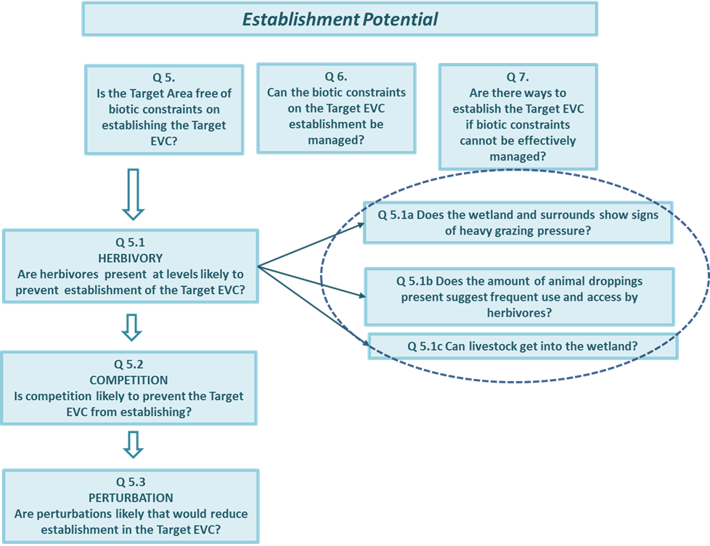

* ***Have Tables F3 and E15 handy.***

#### Q5.1a: Does the wetland and surrounds show signs of heavy grazing pressure?

Grazing pressure is inferred from field observations of herbivory in the Target Area and nearby. This information was previously recorded in the Herbivory Table (Table F3 in the Field Worksheet). In this table, the tally of the marks in columns A to D for Ground Cover and Trees and Shrubs (i.e. rows #1 to #6) determine the intensity of grazing pressure using the following criteria:

* ***HEAVY***, if there are two marks or more in column A for Ground Cover and either two marks or more in column A for Trees and Shrubs or two marks or more in column D
* ***MODERATE***, if there are two marks or more in column B for Ground Cover and either two marks or more in column B for Trees and Shrubs or two marks or more in column D
* ***LIGHT***, for any other combinations that are not *HEAVY*, *MODERATE* or *NOT DETERMINED*
* ***NOT DETERMINED***, if there are four or more marks in column D.
* ***Using the criteria above, determine the level of grazing pressure (HEAVY, MODERATE, LIGHT or NOT DETERMINED) and enter this in Table E15 at Q5.1a Level.***

Determine the answer to Question 5.1a using the following criteria:

* ***YES***, if the level is *HEAVY*
* ***MAYBE***, if the level is *MODERATE* or *NOT* *DETERMINED*
* ***NO***, if the answer is *LIGHT*.
* ***Record the answer in Table E15 at Q5.1a Answer.***

#### Q5.1b: Does the amount of animal droppings suggest frequent use and access by herbivores?

Animal abundance is inferred from observations of animal droppings recorded in row #7 (Faecal Matter) in the Herbivory table (Table F3 in the Field Worksheet). The DST assumes that animal droppings at a wetland are contributed by herbivores such as rabbits, cattle, sheep, goats, kangaroos or wallabies. The marks in columns A to D are used to infer herbivore abundance using the criteria below:

* ***HIGH***, if column A is marked
* ***MEDIUM***, if column B is marked
* ***LOW***, if column C is marked
* ***NOT DETERMINED***, if column D is marked.
* ***Using the criteria above, determine the herbivore abundance (HIGH, MEDIUM, LOW or NOT DETERMINED) and enter this in Table E15 at Q5.1b Level.***

Determine the answer to Question 5.1b using the following criteria:

* ***YES***,if the abundance level is *HIGH*
* ***MAYBE***,if the level is *MEDIUM* or *NOT DETERMINED*
* ***NO***,if the answer is *LOW*.
* ***Record the answer in Table E15 at Q5.1b Answer.***

#### Q5.1c: Can livestock get into the wetland?

Observations of how effectively the wetland is protected from livestock are recorded in row #8 of the Fencing in the Herbivory table (Table F3 in the Field Worksheet). The likelihood of livestock getting into the wetland is:

* ***HIGH***, if column A is marked
* ***MEDIUM***, if column B is marked
* ***LOW***, if column C is marked
* ***NOT DETERMINED***, if column D is marked.
* ***Using the criteria above, determine the herbivore abundance (HIGH, MEDIUM, LOW or NOT DETERMINED) and enter this in Table E15 at Q5.1c Level.***

Determine the answer to Question 5.1b using the following criteria:

* ***YES***, if the likelihood is *HIGH*
* ***MAYBE***,if the likelihood is *MEDIUM* or *NOT DETERMINED*
* **NO**, if the answer is *LOW*.
* ***Record the answer in Table E15 at Q5.1c Answer.***

#### Answering Question 5.1

The answer to Question 5.1 (“*Is the Target Area free of biotic constraints on establishing the Target EVC?*”) is:

* ***YES***,if the answers to all three subsidiary questions is *NO*
* ***MAYBE***, if the answers to subsidiary questions are a mix of *No or MAYBE*
* ***NO***, if the answer to any subsidiary questions is *YES* or all are *MAYBE*.
* ***Record the answer in Table E15 under Answer to Q5.1.***

#### Question 5.2: Is competition likely to prevent the Target EVC from establishing?

Competition is a process, so cannot be readily observed in a Field Survey. This question is answered by evaluating the potential for competition (based on observations indicative of future competition and past competition) and by considering the nutrient status of the site—therefore, there are two subsidiary questions (page 36).

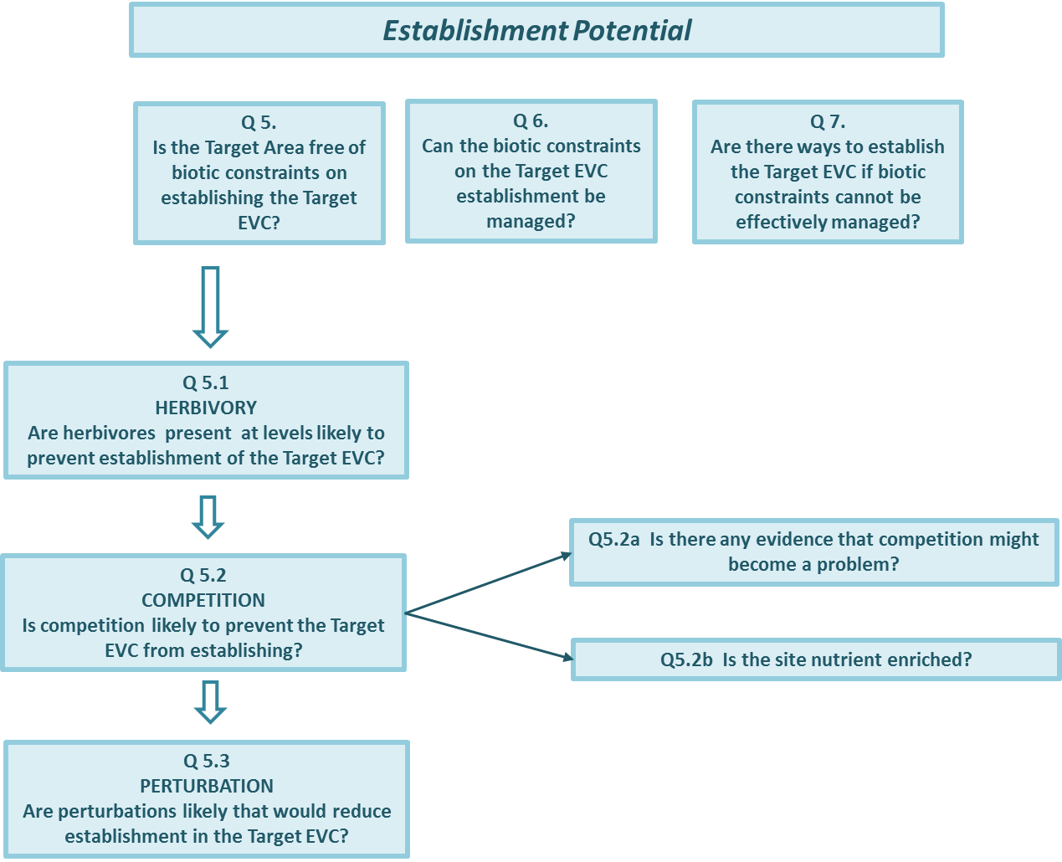

* ***Have Tables F4 and E16 handy.***

#### Q5.2a: Is there any evidence that competition might become a problem?

Use the tally at the bottom of the Competition Table (F4) in the Field Worksheet to determine the potential for competition, whereby potential for competition is:

* ***HIGH***,if column A has a tally of 5 or more
* ***MEDIUM***,if column A and B have a combined tally of 5 or more
* ***LOW***,if column C has a tally of 5 and column A has a tally of 0
* ***NOT DETERMINED***, if column D has a tally of 5 or more.
* ***Using the criteria above, determine the potential for competition (HIGH, MEDIUM, LOW or NOT DETERMINED) and enter this in Table E16 at Q5.2a Level/Likelihood.***

Determine the answer to Question 5.2a using the following criteria. The answer is:

* ***YES***, if the level of competition is *HIGH*
* ***MAYBE,*** *if the level of competition is MEDIUM or NOT DETERMINED*
* ***NO,*** *if the level of competition is LOW.*
* ***Record the answer in Table E16 Q5.2a Answer.***

#### Q5.2b: Is the site nutrient enriched?

Nutrient enrichment means plants grow vigorously, and this could favour species with competitive traits (such as weed species) and limit the diversity of native plants. This question is answered using the Likelihood of Nutrient Enrichment category previously recorded for Water Quality in the Field Worksheet (Table F5).

* ***Record the likelihood of nutrient enrichment in Table E16 at Q5.2b Level/Likelihood.***

Determine the answer to Question 5.2b using the following criteria. The answer is:

* ***YES***,if the category is probably nutrient enriched
* ***MAYBE***, if the category is possibly nutrient enriched
* ***NO***, if the category is unlikely to be nutrient enriched.
* ***Record the answer in Table E16 at Q5.2b Answer.***

#### Answering Question 5.2

The answer to Question 5.2 (“*Is competition likely to prevent the Target EVC from establishing*?”) is:

* ***YES***, if the potential for competition is *YE*S or the potential for competition is *MAYBE* (provided this potential is based on *MEDIUM* potential and is not *NOT DETERMINED* and the likelihood of nutrient enrichment is *YES*.
* ***MAYBE***,if the potential for competition is *MAYBE* (provided this potential is based on *NOT DETERMINED* only) or if potential competition is NO and the likelihood of nutrient enrichment is *YES*.
* ***NO***,if the answer to both subsidiary questions is *NO*.
* ***Record the answer in Table E16 under Answer to Q5.2.***

#### Question 5.3: Are perturbations likely that would reduce establishment in the Target Area?

Sediment disturbance (perturbation) can be caused by animals foraging in the mud, or moving through the wetland. Question 5.3 aims to establish whether perturbations are likely to adversely affect establishment. It does this by using field observations and local knowledge about a range of animals, and considers how well future hydrology will suit these animals. There are four subsidiary questions (pages 37–39). All four must be answered to answer Question 5.3.

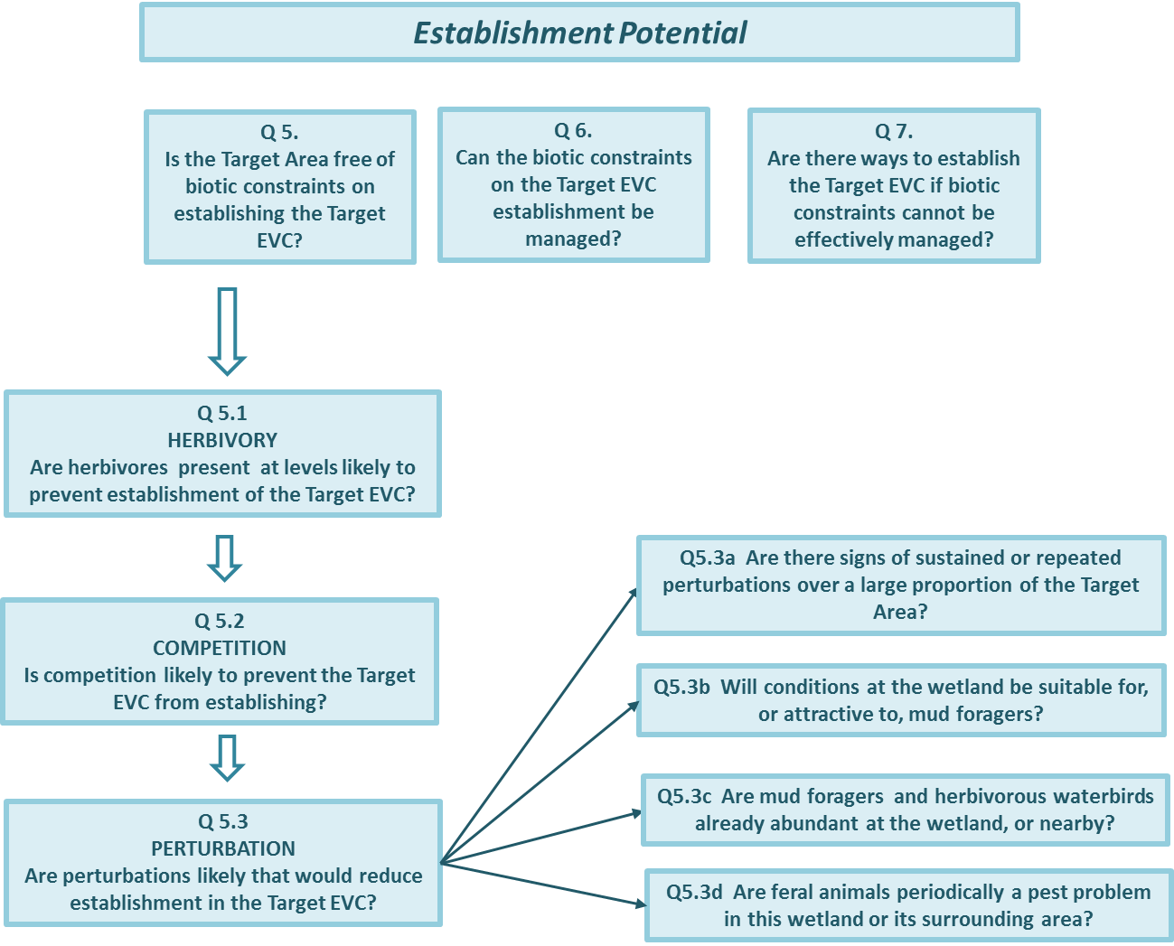

#### Q5.3a: Are there signs of sustained or repeated perturbations over a large proportion of the Target Area?

* ***Have Tables F9 and E17 handy.***

The current level of soil/sediment disturbance is answered based on observations recorded in the Perturbation Table in the Field Worksheet (Table F9). The current level of soil/sediment disturbance is:

* ***HIGH***, if column A is marked
* ***MODERATE***, if column B is marked
* ***NEGLIGIBLE***, if column C is marked
* ***NOT DETERMINED***, if column is marked.
* ***Record the level of soil/sediment disturbance in Table E17 at Q5.3a Level.***

Determine the answer to Question 5.3a using the following criteria. The answer is:

* ***YES***,if the level of soil perturbation is *HIGH*
* ***MAYBE***,if the level of soil perturbation is *MODERATE*; or is *NOT DETERMINED*
* ***NO***,if the level of soil perturbation is *NEGLIGIBLE*.
* ***Record the answer in Table E17 at Q5.3a Answer.***

#### Q5.3b: Will conditions at the wetland be suitable for mud foragers?

* ***Have Tables P7, F5, E18 and E19 handy.***

This question focuses on two of the mud foragers (Common Carp and Black Swan) that can have a potentially high impact on wetland plants. Characteristics of wetlands suitable for these mud foragers include:

* They rarely dry out.
* They are at least 50 cm deep.
* They have water quality that is fresh to brackish (for Common Carp) or fresh to saline (for Black Swan).
* They are productive, with deep-water or submerged macrophytes (for Black Swan), especially if tuberous species such as Water Ribbons (*Triglochin* spp.) are present.

Answering this question means comparing the future hydrology (water regime and water quality) of the wetland with the hydrology preferences of the Common Carp and Black Swan. Future hydrology (water regime and salinity) was previously recorded in the Plan Worksheet, and the nutrient status was recorded in the Field Worksheet (Table F5). Note that the DST assumes that the current description of the nutrient status is a good guide to the nutrient status at least in the near future.

* ***Transfer the water regime and water quality categories and codes from Table P7 and F5 into Table E18.***
* ***Determine whether the conditions are suitable for Common Carp and Black Swan (i.e. the future hydrological variable is the same as, or included in, the reference hydrological description).***
* ***Record YES (if suitable) or NO (if not suitable) in each column of Table E18 for Common Carp and Black Swan.***

#### Answering Question 5.3b

The answer to Question 5.3b (“*Will conditions at the wetland be suitable for mud forager*s?”) is answered by considering all the hydrological variables recorded as suitable for Common Carp and Black Swan, as follows:

Conditions suitable for Common Carp will be:

* ***YES***, if Frequency and Duration and Depth and Salinity are all *YES*.
* ***MAYBE***, if Frequency and Duration and Salinity are all *YES* but Depth is *NO*.
* ***NO***,if Frequency or Duration or Salinity are *NO*.

Conditions suitable for Black Swan will be:

* ***YES***, if all five hydrological conditions are *YES*.
* ***MAYBE***, if four hydrological conditions are *YES* and Nutrient Status is *NO*.
* ***NO***, if Frequency, Duration, Depth or Salinity is *NO*.
* ***Record the overall suitability for Common Carp and Black Swan at the bottom of Table E18.***

Determine the answer to Question 5.3b using the following criteria. The answer is:

* ***YES***, if the conditions are suitable for Common Carp or Black Swan
* ***MAYBE***, if the conditions may be suitable for both Common Carp and Black Swan
* ***NO***, if the conditions are a mix of *MAYBE* and *NO*.
* ***Record the answer in Table E19 at Q5.3b Answer.***

#### Q5.3c: Are mud foragers and herbivorous waterbirds already abundant at the wetland or nearby?

* ***Have Tables F10 and E19 handy.***

Establishment will be difficult if mud foragers and herbivorous waterbirds are already abundant at the wetland or in the local area. This question uses observations and local knowledge for the wetland and local area that were recorded in the *Mud foragers and herbivores* Table in the Field Worksheet (Table F10). In the DST, mud foragers are Common Carp and Black Swan, and waterbird herbivores are Australasian Coots, Purple Swamphen and Australian Wood Duck.

Check the tally of rows #1 to #6 of Table F10 and determine the level of abundance using the criteria below:

* ***HIGH***, if column A has three or more marks
* ***MEDIUM***, if column B has three or more marks
* ***LOW***, if column C has three or more marks and column D has no marks
* ***NOT DETERMINED***, if column D has three or more marks and column A has no marks.
* ***Record the level of abundance (HIGH, MEDIUM, LOW or NOT DETERMINED) in Table E19 at Q5.3c Level.***

Determine the answer to Question 5.3c using the following criteria. The answer is:

* ***YES***,if the level of abundance is *HIGH*
* ***MAYBE***,if the level of abundance is *MEDIUM* or is *NOT DETERMINED*
* ***NO***, if the level of abundance is *LOW*.
* ***Record the answer in Table E19 at Q5.3c Answer.***

#### Q5.3d: Are feral pigs, goats or deer periodically a pest problem in the area?

* ***Have Tables F10 and E19 handy.***

The abundance of feral pigs, goats and deer is inferred from the observations and local knowledge for the wetland and local area that were recorded in the *Mud foragers and herbivores* Table in the Field Worksheet (Table F10).

Check the tally for pigs, goats and deer (given after rows #7 and #8 in Table F10) and determine the level of abundance using the criteria below:

* ***HIGH***, if column A has one or more marks
* ***MEDIUM***, if column B one or more marks
* ***LOW***, if column C has one or more marks
* ***NOT DETERMINED***, if column D has two marks.
* ***Record the level of abundance (HIGH, MEDIUM, LOW or NOT DETERMINED) in Table E19 at Q5.3d Level.***

Determine the answer to Question 5.3d using the following criteria. The answer is:

* ***YES***, if the level of abundance is *HIGH*
* ***MAYBE***, if the level of abundance is *MEDIUM* or is *NOT DETERMINED*
* ***NO***, if the level of abundance is *LOW*.
* ***Record the answer in Table E19 at Q5.3d Answer.***

#### Answering Question 5.3

The answer to Question 5.3 (“*Are perturbations likely that would reduce establishment in the Target Area*?”) is:

* ***YES***, if one or more of the subsidiary questions has a *YES* answer
* ***MAYBE***, if answers to the subsidiary questions are a mix of *MAYBE* and *NO*
* ***NO***, if all the subsidiary questions have a *NO* answer.
* ***Record the answer in Table E19 under Answer to Q5.3.***

#### Answering Question 5 (using answers to Q5.1, Q5.2 and Q5.3)

* ***Have Tables E15, E16, E19 and E20 handy.***
* ***Transfer the answers to Questions 5.1, 5.2 and 5.3 from Tables E15, E16 and E19 to Table E20.***

The Answer to Question 5 (“*Is the Target Area free of biotic constraints on establishing the Target EVC*?”) is:

* ***YES***, if answers to all the subsidiary questions are *NO*
* ***MAYBE***, if answers to any of the subsidiary questions are *MAYBE*
* ***NO***, if answers to any of the subsidiary questions are *YES.*
* ***Record the answer in Table E20 under Answer to Question 5 and proceed to the Evaluation below.***

#### Evaluation

**If the Answer to Question 5 is *YES***, there is a high likelihood that the Target EVC will establish without biotic interference; hence, there is little to no need for special or major management interventions.

Outcome:

* The recovery Plan is likely to be successful.
* Special management interventions to facilitate EVC establishment are not necessary.

**If the answer is *MAYBE***, there is some uncertainty as to whether the Target Area is free of biotic constraints; hence, it is not certain whether special management interventions are necessary or what they should be. This uncertainty needs to be resolved. Either it is because information recorded in the Field Worksheet was incomplete, or it is because biotic constraints are present but at a low level. It could be risky to continue with the Plan without resolving the cause of this uncertainty. This is best done by reviewing the relevant sections in the Field Worksheet.

Outcome:

* This part of the project may not be feasible.
* It is uncertain whether special management interventions will be needed.
* Proceed to Question 6 (Establishment Potential).
* Review the Field Worksheet and if changes are needed, revise the Plan.

**If the Answer is *NO***, the Target EVC is unlikely to establish without management interventions or Activities.

Outcome:

* This part of the Plan is not feasible.
* Special management interventions are necessary.
* Proceed to Question 6 (Establishment Potential).

**Guidance**

The answer to Question 5 makes it possible to review the management Activities proposed in the Plan Description (Table P5: *Planned Works and Activities*) and to consider whether these are relevant or needed, and whether all the appropriate management Activities have been included in the project Plan. This is done as part of Question 6.

## Step E7: Answer DST Question 6 (Establishment Potential)

#### Question 6: Can the biotic constraints on establishment be managed?

* ***Have Tables P5 and E21 handy.***

Some biotic constraints are more readily managed than others. Question 6 asks whether the biotic constraints identified in Question 5 can be managed, and whether control measures have been identified in the Plan Worksheets in the Plan Description.

#### Answering Question 6

* ***To assist with this question, consult wetland managers and practitioners, share experiences with neighbours, and refer to online resources (some are listed in Section 5).***
* ***Identify the biotic constraints present in the Target Area by entering PRESENT or ABSENT in the ‘In Target Area’ column in Table E21.***
* ***Based on the consultation, enter YES or NO in the ‘Readily controlled’ column.***
* ***Copy management activities from the Project Plan (Table P5: Planned Works and Activities) that are relevant to each Biotic Constraint into the ‘Management Actions Listed’ column in Table E21—if there are no relevant management activities, enter NONE.***

The Outcome is determined by specific combinations of answers given in these three columns in Table E21 (In Target Area, Readily controllable, and Management Activities Listed), as shown in the table below. There are five possible scenarios, coded A to H for ease of reference.

***Assessment of outcome for Question 6***

|  |  |  |  |  |  |
| --- | --- | --- | --- | --- | --- |
| **Code** | **In Target Area** | **Readily controllable** | **Management Activities Listed** | **Outcome** | **Note** |
| A | Present | Yes | Yes | Appropriate |  |
| B | Present | Yes | No | Not appropriate | Revise Plan Description |
| C | Present | No | Yes | Not appropriate | Revise Plan Description |
| D | Present | No | No | Appropriate |  |
| E | Absent | Not applicable | Not applicable | Appropriate |  |

* ***For each row in Table E21, record the Outcome and Code using the table above.***

#### Evaluation

**If the Outcome for a Biotic Constraint in Table E21 is *APPROPRIATE***, this means that the management action listed in the Plan Worksheet is a suitable response to that Biotic Constraint.

‘*APPROPRIATE*’ refers to management planning, and this can be because a planned Activity is suitable (code A), or because no activity is planned (codes D, F and H).

**If the Outcome is *NOT APPROPRIATE***, this can mean two things. One possibility is that there is no planned Activity when there should be one (Code B); this means an Activity is missing, and to rectify this, the Plan Description needs to be changed. The other possibility is that there is a planned Activity when one is not merited (Codes C, E and G): this means unnecessary effort and expenditure, and to rectify this, the Plan Description needs to be changed.

Changes to the Plan Description will incur a change to budget and resources. They may also require changes to other parts of the Plan Worksheet or Field Worksheet if there is any disturbance to the seed bank, or damage to existing vegetation, or alteration to the physical characteristics of the wetland.

The DST does not evaluate the proposed Actions: it expects that the most appropriate and most effective activities will be planned for the circumstances.

**If the Answer to Question 6 (“*Can the biotic constraints on establishment be managed*?”) is*****YES***, it is likely that your Plan is viable.

Outcome:

* The recovery Plan is likely to be successful.

**If the Answer is *NO***, indicating that it is not possible to remove or reduce the (biotic) constraints, the goal of establishing the Target EVC is only likely to be achieved through some other way of facilitating establishment. This last possibility is explored in Question 7.

Outcome:

* Establishing the Target EVC is only likely through some other way of facilitating establishment.
* Proceed to Question 7.

## Step E8: Answer DST Question 7 (Establishment Potential)

#### Question 7: Are there ways to establish the Target EVC if biotic constraints cannot be effectively managed?

* ***Have Table E22 handy.***

This final question (“*Are there ways to establish the Target EVC if biotic constraints cannot be effectively managed*”) is addressed as follows. In some cases it may be possible to establish the Target EVC, even in the presence of biotic constraints, if vulnerability to the constraint is only expressed during early life stages. For example, sensitivity to livestock grazing will be greater at germination and seedling stages compared with at more mature life stages (at least for some plants). For these species, planting more mature stages may enable re-establishment at sites where grazing constraints cannot be fully controlled.

* ***Record your answer in Table E22.***

#### Evaluation

### If the answer is *YES*, indicating that it is possible to get Indicator Species established, despite not being able to remove or reduce the biotic constraints, this needs to be in the Plan Worksheet. Record the biotic constraints, how Indicator Species will be established, and whether this is a one-off or repeated intervention. This will require resourcing, so will add to the overall cost, and it may need follow-up maintenance.

Outcome:

* Recovery will require specific or novel interventions for establishment to be successful.

**If the answer is *NO***, indicating that it is not possible to deal with the (biotic) constraints in any other way, most of the Indicator Species are highly unlikely to establish, and there will be little likelihood of the Target EVC recovering.

Outcome:

* The Plan is not viable.

The stumbling block in this Plan is the on-site (biotic) conditions, which are unfavourable for Indicator Species to establish, and which are difficult to eradicate or minimise. The Target EVC may also be a stumbling block if its Indicator Species are particularly difficult to establish. You will need to reconsider decisions in the Plan, such as why the EVC was chosen, what the vegetation objective is, and what the habitat conditions for plants are likely to be in the future.

Option:

Revise the Plan and review the decisions in the Plan.

# Section 5: Resources and ancillary information

## 5a Resources

|  |  |
| --- | --- |
| **Essential technical resources** | **Website location** |
| *Benchmarks for wetland Ecological Vegetation Classes in Victoria – June 2016* (DELWP 2016c) | [iwc.vic.gov.au/resources](http://iwc.vic.gov.au/resources) |
| *A guide to water regime, salinity ranges and bioregional conservation status of Victorian wetland Ecological Vegetation Classes* (Frood and Papas 2016) | https://www.ari.vic.gov.au/__data/assets/pdf_file/0017/40265/ARI-Technical-Report-266-Guide-to-water-regime,-salinity-ranges-and-bioreg-cons-status-of-Vic-wetland-EVCs.pdf |
| *Wetland Landscape Profiles spatial data* (DELWP 2016e) | [www.data.vic.gov.au/data/dataset/wetland-landscape-profiles](http://www.data.vic.gov.au/data/dataset/wetland-landscape-profiles) |

|  |  |
| --- | --- |
| **Advisory resources** | **Website location** |
| *Index of Wetland Condition assessment procedure – June 2016* (DELWP 2016b) | iwc.vic.gov.au/resources |
| *The Victorian wetland classification framework* (DEWLP 2016d) | <https://www.water.vic.gov.au/__data/assets/pdf_file/0023/52763/Final-for-publicatn-Wetland-Classification-Report-8Mar16.pdf> |
| *Wetland conceptual models: associations between wetland values, threats and management interventions. Version One*.  (Morris and Papas 2012) | https://www.ari.vic.gov.au/__data/assets/pdf_file/0027/35892/ARI-Technical-Report-237-Wetland-conceptual-models.pdf_ |
| *A guide to managing livestock grazing in Victoria’s wetlands. Decision Framework and Guidelines – Version 1.0.* (Peters et al. 2015) | <https://www.water.vic.gov.au/__data/assets/pdf_file/0023/52781/ARI-Technical-Report-265-Guide-to-managing-livestock-grazing-in-wetlands-decision-framework-V1.0.pdf> |
| *PestSmart* website (information for managing Goats, Pigs, Rabbits, Horses and Deer) | [www.pestsmart.org.au](http://www.pestsmart.org.au) |
| *Impacts of carp in wetlands – Fact Sheet 4* (DELWP 2017) | <http://www.ari.vic.gov.au/__data/assets/pdf_file/0037/66898/Impact-of-Carp-on-Wetlands-Fact-Sheet-4.pdf> |
| *Atlas of Australian Acid Sulfate Soils* (ASRIS 2013) | <http://www.asris.csiro.au/themes/AcidSulfateSoils.html> |

|  |  |
| --- | --- |
| **Technical and advisory resources on climate change** | **Website location** |
| *Vegetation recovery in inland wetlands: an Australian perspective* (Roberts et al. 2017) | [www.ari.vic.gov.au/__data/assets/pdf_file/0029/66953/ARI-Technical-Report-270-Vegetation-recovery-in-inland-wetlands-an-Australian-perspective.pdf](http://www.ari.vic.gov.au/__data/assets/pdf_file/0029/66953/ARI-Technical-Report-270-Vegetation-recovery-in-inland-wetlands-an-Australian-perspective.pdf) |
| *Climate-ready restoration. Some practical guidelines for plant restoration in an uncertain future* (Broadhurst et al. 2016) | <http://www.terranova.org.au/repository/murray-basin-nrm-collection/murray-basin-nrm-climate-ready-practical-restoration-guidelines-powerpoint-presentation/murray-basin-nrm-climate-ready-restoration.pdf/at_download/file> |
| *Indicative assessment of climate change vulnerability for wetlands in Victoria* (DSE 2013) | <http://www.water.vic.gov.au/__data/assets/pdf_file/0024/66336/Wetland-vulnerability-to-climate-change-Victoria.pdf> |
| Victorian government climate change resources | <https://www.climatechange.vic.gov.au/information-and-resources> |
| Australian government climate change resources | <http://www.environment.gov.au/climate-change/publications> |

## 5b Downloading a wetland base map

Instructions on downloading a wetland base map from the DELWP website are as follows:

1. Navigate to the interactive mapping website at the following URL:

<http://mapshare.maps.vic.gov.au/MapShareVic/index.html?viewer=MapShareVic.PublicSite&locale=en-AU>

1. Select Wetland on the toolbar (circled below).
2. Select IWC Map on the toolbar (circled below).
3. In the resultant window that appears:

select the type of map: ***Base Map*** (blank map of the wetland with roads and hydrology delineated) or ***Imagery Map*** (aerial photo of the wetland)

enter the name of the wetland (if known) or its wetland number (from the DELWP wetland inventory).

1. When the map is generated (in one to two minutes), a link will appear on the left-hand side of the screen, labelled IWC map (Figure 20, *circled below*).
2. Select the link to download the map.

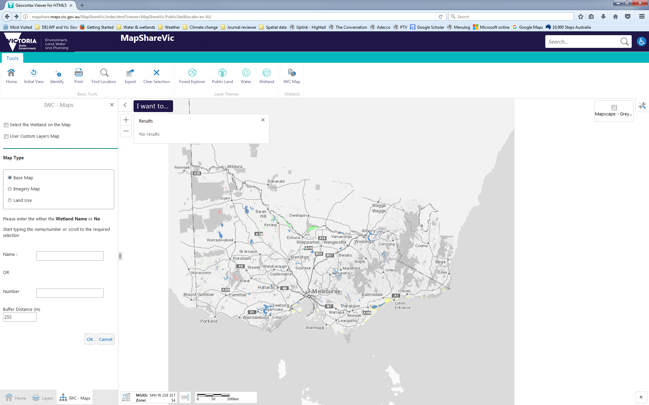

## 5c Describing wetland hydrology

A standardised way of describing water regime, water source and water quality (salinity) has been developed in Victoria for use in wetland classification. A table showing the various categories and codes are given in Section 2 of *The EVC water regime and salinity guide*. Background on these is available in the *Index of Wetland Condition assessment procedure* (DELWP 2016b).

The categories and codes given below are for inland wetlands. Categories and codes specific to wetlands under tidal influence are not included.

**Terminology:** The DST uses the term *brackish*, rather than *hyposaline* as given below, as being closer to general usage and easier to understand. The DST abbreviates *maximum depth of regular or sustained inundation* (see below) to *maximum sustained depth*, for convenience.

***Terms and categories used to describe water regime and salinity***

|  |  |  |  |  |
| --- | --- | --- | --- | --- |
| **Frequency of Inundation** | | | | |
| **Category** | **Description** | | | **Code** |
| Permanent | Constant, annual or less frequently, but before wetland dries | | | F3 |
| Seasonal | Annual or near-annual inundation, 8–10 years in every 10 | | | F4 |
| Intermittent | Inundated 3–7 years in every 10 | | | F5 |
| Episodic | Inundated less than 3 years in every 10 | | | F6 |
| Bog | Constant waterlogging, inundation mostly superficial | | | F7 |
| **Duration of inundation and waterlogging** | | | | |
| **Waterlogging maximum** | **Inundation maximum** | | | **Code** |
| 1–6 months | <1 month | | | D2 |
| >6 months | <1 month | | | D3 |
| 1–6 months | 1–6 months | | | D4 |
| >6 months | 1–6 months | | | D5 |
|  | >6 months (but not permanent) | | | D6 |
|  | permanent | | | D7 |
| **Maximum depth of regular or sustained inundation** | | | | |
| **Category** | **Depth range (cm)** | | | **Code** |
| Very shallow | <30 cm | | | WD1 |
| Shallow to medium | 30–100 cm | | | WD2 |
| Medium to deep | >100 to 200 cm | | | WD3 |
| Deep | >200 cm | | | WD4 |
| **Salinity** | | | | |
| **Category** | **Range (mg/L)** | **Range (uS/cm)** | **Code** | |
| Fresh | 0–3000 | 0–4690 | F | |
| Hyposaline (brackish) | >3000 to 10,000 | >4690 to 15,600 | B (for brackish) | |
| Mesosaline | >10,000 to 50,000 | >15,600 to 78,100 | S (for saline) | |
| Hypersaline | >50,000 to 350,000 | >78,1000 to 547,000 | H | |
| Calcareous | n/a | n/a | C | |

n/a = not applicable

***Terms used to describe water source***

|  |  |
| --- | --- |
| **Source** | **Description** |
| River or stream inflow | Water reaches the wetland by overbank flows, or by channels. |
| Local run-off | Water reaches the wetland after local rain produces surface and subsurface run-off; or directly falls into the wetland. |
| Groundwater | Water reaches the wetland from aquifers or groundwater. |
| Artificial | Discharge from agricultural or industrial enterprises, urban or residential areas that is pumped into the wetland or supplied through channels and regulating structures. |

## 5d Map of Wetland Landscapes

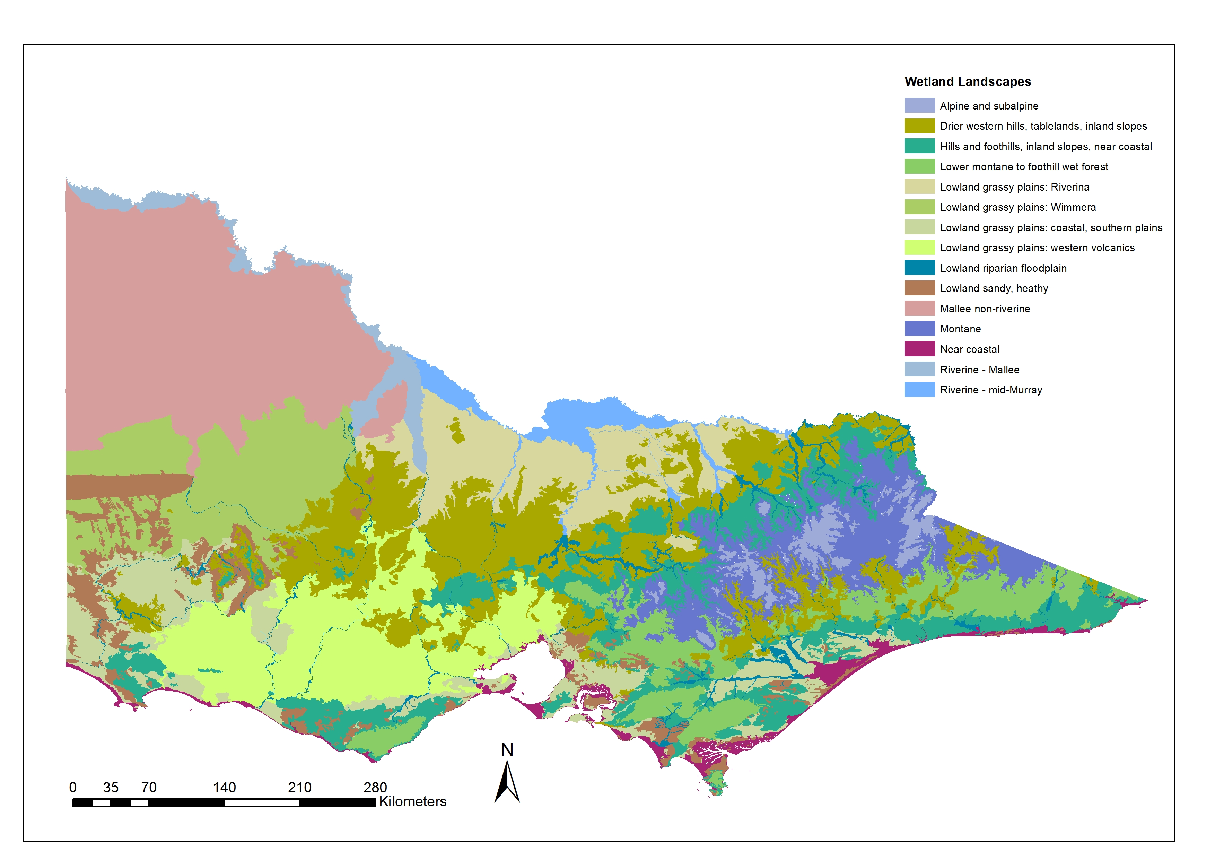

## 5e Changes in water regime

**Background**

Changing the water regime, or changing the water quality, means changing the habitat where wetland plants grow and complete their life cycle. A change may be tolerated by some Indicator Species, but not by others. The bigger the change, the more Indicator Species will be affected.

This section provides a rule-of-thumb approach to determining the effects of water regime change and water quality on Indicator Species. It was developed specifically for this DST. It is based on the expert judgement of two wetland plant ecologists with considerable experience in plant responses to water regimes.

**Matrix Approach**

The matrix approach considers water regime variables individually [frequency, duration and depth (referring to maximum sustained depth)]. It uses the water regime categories developed to describe EVC tolerances in *A guide to water regime, salinity ranges and bioregional conservation status of Victorian wetland Ecological Vegetation Classes*. Change from one category to another is shown as a matrix, with one matrix for each water regime variable (*see below and next page*). Each matrix shows both code and category for each water regime variable. The categories are arranged in a hydrological gradient and are not necessarily in numerical order.

The matrix shows the size of the hydrological change, using five levels. These range from *no change* (shown as n.c) to *complete.* Complete means that the water regime change is such that none of the Indicator Species currently present will tolerate the new conditions. A key to all five levels of the size of the hydrological change is provided below.

|  |  |
| --- | --- |
| **Complete** | None of the current Indicator Species are expected to tolerate the change. |
| **Major** | Very few of the current Indicator Species are expected to tolerate the change. |
| **Partial** | Many (notionally 50–80%) of the current Indicator Species are expected to tolerate the change. |
| **Minor** | Majority (notionally >80%) of the current Indicator Species are expected to tolerate the change. |
| **no change (n.c.)** | All or almost all the current Indicator Species are expected to tolerate the change. |

**Navigating through each Matrix**

It is essential that each matrix is navigated correctly. The User starts with FROM (*select relevant column*) and moves down until TO (*select relevant row*).

For example: it is proposed to build an earthen bund, about 1.2 m high, on the downslope side of a shallow (20 cm deep) wetland, thus retaining water for longer and resulting in a deeper wetland. The depth will increase to over 1 m, and water is likely to remain for about 8–10 months, instead of 2–3 months. The matrix shows that increasing maximum sustained depth from WD1 to WD3 is expected to *completely* change Indicator Species; and increasing duration from D4 to D6 is expected to cause a *major* change.

***A. Matrix of water regime change: Frequency***

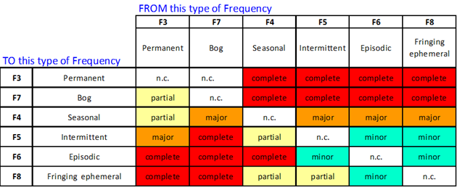

***B. Matrix of water regime change: Waterlogging and Duration***

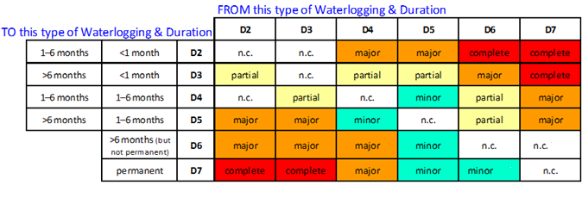

***C. Matrix of water regime change: Depth***

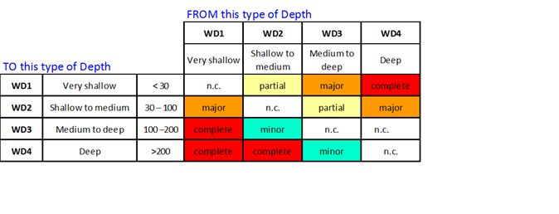

***D. Matrix of water quality change: Salinity***

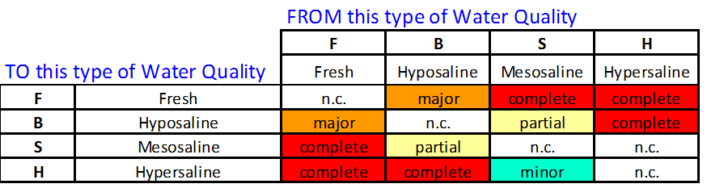

## 5f Ecological traits of wetland EVCs (based on Indicator Species)

The table below gives characteristics and ecological traits for wetland EVCs, based on the traits of the Indicator Species for that EVC. The EVC traits are:

* ***Number of IS****,*meaning the number of Indicator Species recognised for that EVC.
* ***% IS that form a seed bank***, defined as those species that are not dispersal dependent (DD).
* ***% Perennials***, or perenniality, meaning the percentage of Indicator Species that are perennial, as opposed to being annual or biennial. The table also shows the number of Indicator Species per EVC.

Data for % IS that are not DD was compiled by Michelle Casanova, drawing on a personal database. Number of IS and % perennials were derived from EVC and Species information held by the Victorian Government (DELWP 2016c).

| **EVC name** | **EVC number** | **Number of IS** | **% IS that are not DD** | **% perennials** |
| --- | --- | --- | --- | --- |
| Wet Heathland | 8 | 10 | 40.0 | 90.0 |
| Coastal Saltmarsh Aggregate | 9 | 10 | 50.0 | 90.0 |
| Estuarine Wetland | 10 | 18 | 66.7 | 83.3 |
| Wet Swale Herbland | 12 | 4 | 100.0 | 75.0 |
| Brackish Sedgeland | 13 | 5 | 20.0 | 100.0 |
| Montane Riparian Woodland | 40 | 18 | 61.1 | 77.8 |
| Montane Riparian Thicket | 41 | 16 | 50.0 | 93.7 |
| Swamp Heathland Aggregate | 49 | 8 | 12.5 | 100.0 |
| Swamp Scrub | 53 | 5 | 60.0 | 40.0 |
| Floodplain Riparian Woodland | 56 | 7 | 28.6 | 100.0 |
| Riparian Thicket | 59 | 11 | 72.7 | 90.9 |
| Spring Soak Woodland | 80 | 12 | 83.3 | 50.0 |
| Swampy Riparian Woodland | 83 | 10 | 40.0 | 90.0 |
| Samphire Shrubland | 101 | 7 | 71.4 | 28.6 |
| Riverine Chenopod Woodland | 103 | 11 | 45.4 | 63.6 |
| Lignum Swamp | 104 | 10 | 90.0 | 50.0 |
| Grassy Riverine Forest | 106 | 9 | 88.9 | 44.4 |
| Lake Bed Herbland | 107 | 8 | 75.0 | 50.0 |
| Grey Clay Drainage-line Aggregate | 124 | 13 | 100.0 | 69.2 |
| Plains Grassy Wetland | 125 | 17 | 88.2 | 82.4 |
| Sedge Wetland | 136 | 6 | 50.0 | 66.7 |
| Montane Sedgeland | 148 | 21 | 85.7 | 80.9 |
| Alpine Fen | 171 | 3 | 100.0 | 66.7 |
| Perched Boggy Shrubland Aggregate | 185 | 11 | 36.4 | 81.8 |
| Riparian Scrub | 191 | 7 | 14.3 | 100.0 |
| Seasonally Inundated Shrubby Woodland | 195 | 3 | 0.0 | 100.0 |
| Seasonally Inundated Sub-saline Herbland | 196 | 2 | 0.0 | 100.0 |
| Sub-alpine Wet Heathland | 210 | 6 | 16.7 | 100.0 |
| Alpine Creekline Herbland | 239 | 12 | 83.3 | 75.0 |
| Floodplain Thicket | 280 | 9 | 11.1 | 100.0 |
| Sedge-rich Wetland | 281 | 11 | 90.9 | 27.3 |
| Plains Sedgy Woodland | 283 | 8 | 62.5 | 75.0 |
| Claypan Ephemeral Wetland | 284 | 10 | 80.0 | 50.0 |
| Alpine Heath Peatland | 288 | 9 | 66.7 | 88.9 |
| Cane Grass Wetland | 291 | 1 | 100.0 | 100.0 |
| Red Gum Swamp | 292 | 5 | 60.0 | 80.0 |
| Aquatic Grassy Wetland | 306 | 8 | 100.0 | 87.5 |
| Aquatic Sedgeland | 308 | 5 | 20.0 | 100.0 |
| Montane Swamp | 318 | 4 | 100.0 | 75.0 |
| Black Box Wetland | 369 | 10 | 80.0 | 70.0 |
| Brackish Aquatic Herbland | 537 | 10 | 100.0 | 50.0 |
| Brackish Herbland | 538 | 11 | 90.9 | 54.6 |
| Brackish Lake Bed Herbland | 539 | 10 | 80.0 | 60.0 |
| Calcareous Wet Herbland | 591 | 13 | 92.3 | 38.5 |
| Cane Grass Wetland/Aquatic Herbland Complex | 602 | 14 | 100.0 | 57.1 |
| Cane Grass Wetland/Brackish Herbland Complex | 606 | 15 | 93.3 | 60.0 |
| Plains Sedgy Wetland | 647 | 11 | 63.6 | 90.9 |
| Plains Swampy Woodland | 651 | 11 | 54.6 | 81.8 |
| Aquatic Herbland | 653 | 6 | 100.0 | 50.0 |
| Freshwater Lignum Shrubland | 657 | 8 | 75.0 | 62.5 |
| Dune Soak Woodland | 673 | 3 | 33.3 | 100.0 |
| Salt Paperbark Woodland | 676 | 6 | 50.0 | 83.3 |
| Ephemeral Drainage-line Grassy Wetland | 678 | 16 | 87.5 | 75.0 |
| Sedgy Swamp Woodland | 707 | 7 | 85.7 | 57.1 |
| Hypersaline Inland Saltmarsh Aggregate | 708 | 3 | 66.7 | 66.7 |
| Fern Swamp | 721 | 24 | 54.2 | 91.7 |
| Forest Bog | 723 | 14 | 78.6 | 71.4 |
| Forest Creekline Sedge Swamp | 728 | 17 | 58.8 | 82.4 |
| Plains Grassy Wetland/Aquatic Herbland Complex | 755 | 6 | 100.0 | 83.3 |
| Plains Grassy Wetland/Brackish Herbland Complex | 767 | 12 | 91.7 | 66.7 |
| Plains Swampy Woodland/Lignum Swamp Complex | 784 | 10 | 80.0 | 80.0 |
| Rushy Riverine Swamp | 804 | 13 | 92.3 | 69.2 |
| Alluvial Plains Semi-arid Grassland | 806 | 5 | 80.0 | 40.0 |
| Lignum Shrubland | 808 | 30 | 80.0 | 50.0 |
| Floodplain Grassy Wetland | 809 | 14 | 100.0 | 64.3 |
| Floodway Pond Herbland | 810 | 15 | 93.3 | 33.3 |
| Grassy Riverine Forest/Floodway Pond Herbland Complex | 811 | 14 | 85.7 | 42.9 |
| Grassy Riverine Forest/Riverine Swamp Forest Complex | 812 | 13 | 92.3 | 38.5 |
| Intermittent Swampy Woodland | 813 | 14 | 64.3 | 57.1 |
| Riverine Swamp Forest | 814 | 9 | 88.9 | 44.4 |
| Riverine Swampy Woodland | 815 | 26 | 80.8 | 53.9 |
| Sedgy Riverine Forest | 816 | 23 | 82.6 | 65.2 |
| Sedgy Riverine Forest/Riverine Swamp Forest Complex | 817 | 12 | 66.7 | 75.0 |
| Spike-sedge Wetland | 819 | 2 | 100.0 | 50.0 |
| Sub-saline Depression Shrubland | 820 | 7 | 42.9 | 85.7 |
| Tall Marsh | 821 | 19 | 78.9 | 63.2 |
| Intermittent Swampy Woodland/Riverine Grassy Woodland | 822 | 10 | 90.0 | 80.0 |
| Lignum Swampy Woodland | 823 | 4 | 0.0 | 100.0 |
| Saline Aquatic Meadow | 842 | 4 | 100.0 | 50.0 |
| Sea-grass Meadow | 845 | 4 | 50.0 | 75.0 |
| Stony Rises Pond Aggregate | 857 | 9 | 88.9 | 44.4 |
| Blocked Coastal Stream Swamp | 875 | 3 | 0.0 | 100.0 |
| Sedge Wetland/Calcareous Wet Herbland Complex | 883 | 15 | 86.7 | 66.7 |
| Plains Saltmarsh | 888 | 4 | 75.0 | 75.0 |
| Alpine Short Herbland | 905 | 9 | 55.6 | 77.8 |
| Sink-hole Wetland | 908 | 8 | 37.5 | 75.0 |
| Estuarine Flats Grassland | 914 | 8 | 75.0 | 87.5 |
| Sub-alpine Wet Sedgeland | 917 | 6 | 66.7 | 100.0 |
| Submerged Aquatic Herbland | 918 | 2 | 100.0 | 100.0 |
| Sweet Grass Wetland | 920 | 6 | 100.0 | 83.3 |
| Wet Heathland/Sedge Wetland Complex | 931 | 11 | 72.7 | 72.7 |
| Wet Verge Sedgeland | 932 | 21 | 95.2 | 57.1 |
| Brackish Grassland | 934 | 10 | 90.0 | 80.0 |
| Swampy Woodland | 937 | 16 | 18.8 | 93.8 |
| Floodway Pond Herbland/Riverine Swamp Forest Complex | 945 | 16 | 93.8 | 31.3 |
| Brackish Lignum Swamp | 947 | 14 | 78.6 | 71.4 |
| Dwarf Floating Aquatic Herbland | 949 | 5 | 100.0 | 0.0 |
| Estuarine Reedbed | 952 | 8 | 62.5 | 87.5 |
| Estuarine Scrub | 953 | 19 | 52.6 | 94.7 |
| Freshwater Lignum – Cane Grass Swamp | 954 | 20 | 85.0 | 65.0 |
| Herb-rich Gilgai Wetland | 956 | 10 | 90.0 | 70.0 |
| Plains Grassy Wetland/Calcareous Wet Herbland Complex | 958 | 9 | 100.0 | 44.4 |
| Plains Grassy Wetland/Sedge-rich Wetland Complex | 959 | 16 | 87.5 | 75.0 |
| Plains Grassy Wetland/Spike-sedge Wetland Complex | 960 | 7 | 100.0 | 71.4 |
| Plains Rushy Wetland | 961 | 4 | 100.0 | 75.0 |
| Sedge Wetland/Aquatic Sedgeland Complex | 963 | 8 | 62.5 | 62.5 |
| Shell-beach Herbland | 964 | 5 | 60.0 | 80.0 |
| Montane Bog | 966 | 28 | 53.6 | 85.7 |
| Gahnia Sedgeland | 968 | 5 | 40.0 | 80.0 |
| Brackish Shrubland | 973 | 20 | 75.0 | 55.0 |
| Lava Plain Ephemeral Wetland | 974 | 18 | 100.0 | 44.4 |
| Riverine Ephemeral Wetland | 975 | 4 | 50.0 | 50.0 |
| Coastal Ephemeral Wetland | 976 | 21 | 71.4 | 71.4 |
| Unvegetated (open water/bare soil/mud) | 990 | 1 | 0.0 | 100.0 |
| Plains Sedgy Wetland/Sedge Wetland Complex | 1010 | 8 | 75.0 | 87.5 |
| Alpine Hummock Peatland | 1011 | 13 | 53.9 | 69.2 |
| Alkaline Basaltic Wetland Aggregate | 1111 | 29 | 93.1 | 51.7 |
| Granite Rock-pool Wetland | 1112 | 15 | 100.0 | 26.7 |
| Sedge Wetland/Brackish Herbland Complex | 1113 | 9 | 77.8 | 88.9 |
| Brackish Sedgy Shrubland | 1114 | 20 | 75.0 | 60.0 |
| Swamp Scrub/Gahnia Sedgeland Complex | 2004 | 18 | 33.3 | 83.3 |
| Plains Grassy Wetland/Lignum Swamp Complex | A101 | 12 | 91.7 | 75.0 |
| Sedge Wetland/Aquatic Herbland Complex | A102 | 4 | 75.0 | 50.00 |
| Wet Heathland/Plains Grassy Wetland Complex | A104 | 6 | 66.7 | 83.3 |
| Wet Heathland/Plains Sedgy Wetland Complex | A105 | 6 | 66.7 | 66.7 |
| Calcareous Sedgy Shrubland | A106 | 13 | 46.2 | 84.6 |
| Wet Saltmarsh Herbland | A107 | 6 | 83.3 | 66.7 |
| Wet Saltmarsh Shrubland | A108 | 6 | 66.7 | 100.0 |
| Coastal Saline Grassland | A109 | 5 | 100.0 | 80.0 |
| Coastal Dry Saltmarsh | A110 | 5 | 20.0 | 60.0 |
| Coastal Hypersaline Saltmarsh | A111 | 5 | 40.0 | 100.0 |
| Coastal Tussock Saltmarsh | A112 | 6 | 66.7 | 100.0 |
| Saltmarsh-grass Swamp | A113 | 8 | 50.0 | 75.0 |
| Red Gum Swamp/Cane Grass Wetland Complex | A114 | 10 | 90.0 | 70.0 |
| Red Gum Swamp/Plains Rushy Wetland Complex | A115 | 11 | 90.9 | 63.6 |

## 5g Indicator Species and Water Plant Functional Group classification

Water Plant Functional Group (WPFG) classification can provide information about the water regime that the species requires in relation to germination, establishment, growth and reproduction. There are 10 such groups (Table 1). EVCs often contain Indicator Species from more than one group. Although water level ranges are given for EVCs, individual plant species can require particular water levels, or transitions (drying down, flooding) for specific life-history events (germination, reproduction). The allocation of a WPFG can provide information about those water level requirements for different life-history phases of individual species.

These definitions are based on WPFGs developed by Brock and Casanova (1997) with the addition of ATw, Se, Sr and Sk groups (Casanova 2011).

***Plant characteristics for each Water Plant Functional Group***

| **Functional Group code** | **Definition** |
| --- | --- |
| **Tdr**  **Terrestrial dry** | The species in this group do not require flooding and will persist in damper parts of the landscape due to localised high rainfall. Species in this group can invade or persist in riparian zones and the edges of wetlands, but are essentially terrestrial. |
| **Tda**  **Terrestrial damp** | These species germinate and establish on saturated or damp ground, but cannot tolerate flooding in the vegetative state. As such, they can persist throughout the environment in dry puddles and drains. They grow on bare ground following flooding or in places where floodwater has spread out over the landscape long enough to saturate the soil profile. They require the soil profile to remain damp for c. 3 months. |
| **ATl**  **Amphibious fluctuation tolerator – low-growing** | These species can germinate either on saturated soil or underwater, and grow totally submerged, as long as they are exposed to air by the time they start to flower and set seed. They require shallow flooding for c. 3 months. |
| **ATe**  **Amphibious fluctuation tolerator – emergent** | This species group consists of emergent monocots and dicots that survive in saturated soil or shallow water but require most of their photosynthetic parts to remain above the water (emergent). They tolerate fluctuations in the depth of water, as well as in water presence/absence. They need water to be present for c. 8–10 months of the year and the dry time to be in the cooler times of the year. |
| **ATw**  **Amphibious fluctuation tolerator – woody** | This species group consists of woody perennial species that hold their seeds on their branches, require water to be present in the root zone all year round, but will germinate in shallow water or on a drying profile. If they grow on floodplains, they require flooding and/or refreshing of the groundwater levels on a regular basis. They do not tolerate continuous flooding. |
| **ARp**  **Amphibious fluctuation responder – plastic** | This species group occupies a similar zone to the ATl group, except that they have a morphological response to water level changes, such as rapid shoot elongation or a change in leaf type. They can persist on damp and drying ground because of their morphological flexibility, but can flower even if the site does not dry out. They occupy a deeper/wet-for-longer site than the ATl group. |
| **ARf**  **Amphibious fluctuation responder – floating** | This group consists of species that grow underwater, float on the surface of the water, or have floating leaves. They require the year-round presence of free water. Many of these can survive and complete their life cycle stranded on the mud, but they reach maximum biomass growing in ‘open’ water all year round. |
| **Se**  **Perennial – emergent** | This category refers to woody and monocotyledonous species that require permanent water in the root zone, but remain emergent. They thrive where water levels do not fluctuate or fluctuate little (e.g. weir pools, dams). They are tolerant of continuous flooding. |
| **Sk**  **Submerged – perennial** | These species require that a site be flooded to >10 cm for at least 6 months for them to either germinate or reach sufficient biomass to start reproducing sexually. Many have asexual reproduction (fragmentation, rhizomes, turions). Completely water-dependent, true aquatic species. |
| **Sr**  **Submerged – annual** | These species colonise recently flooded areas. Many require drying to stimulate high germination percentages, they frequently complete their life cycle quickly and die off naturally. They persist via a dormant, long-lived bank of seeds or spores in the soil. Their habitats can be flooded from once a year to once a decade, to a depth >10cm. |

## 5h Indicator Species and Water Plant Functional Group classification

| **Indicator Species** | **Water Plant Functional Group** |
| --- | --- |
| *Acacia dealbata* | Tdr |
| *Acacia farinosa* | Tdr |
| *Acacia mearnsii* | Tdr |
| *Acacia melanoxylon* | Tda |
| *Acacia provincialis* | Tdr |
| *Acacia stenophylla* | ATw |
| *Acacia verticillata* | Tda |
| *Acaena novae-zelandiae* | Tdr |
| *Agrostis* spp. agg. aff. *hiemalis* | Tda |
| *Allittia cardiocarpa* | Ate |
| *Allocasuarina luehmannii* | Tdr |
| *Allocasuarina paludosa* | ATw |
| *Alternanthera denticulata* s.l. | Tda |
| *Alternanthera* sp. 1 (Plains) | Tda |
| *Alternanthera* spp. | Tda |
| *Amphibromus archeri* | Tda |
| *Amphibromus fluitans* | Arp |
| *Amphibromus neesii* | Ate |
| *Amphibromus nervosus* | Tda |
| *Amphibromus recurvatus* | Ate |
| *Amphibromus sinuatus* | Ate |
| *Angianthus preissianus* | Tda |
| *Anthosachne scabra* s.l. | Tdr |
| *Aphelia gracilis* | Tda |
| *Aphelia* spp. | Tda |
| *Apium annuum* | Tdr |
| *Apium prostratum* | Tda |
| *Apium* spp. | Tda |
| *Apodasmia brownii* | Ate |
| *Asperula conferta* | Tdr |
| *Asperula gemella* | Tda |
| *Asperula subsimplex* | Tda |
| *Astelia alpina* | Se |
| *Astelia alpina* var. *novae-hollandiae* | Se |
| *Astelia australiana* | Ate |
| *Atherosperma moschatum* | Tdr |
| *Atriplex australasica* | Tdr |
| *Atriplex cinerea* | Tdr |
| *Atriplex leptocarpa* | Tdr |
| *Atriplex paludosa* | ATe |
| *Atriplex suberecta* | Tdr |
| *Austrobryonia micrantha* | Tda |
| *Austrocynoglossum latifolium* | Tdr |
| *Austrostipa scabra* | Tdr |
| *Austrostipa stipoides* | Tdr |
| *Avicennia marina* | ATw |
| *Azolla filiculoides* | ARf |
| *Azolla* spp. | ARf |
| *Baeckea* spp. | Tdr |
| *Baeckea utilis* s.l. | Tdr |
| *Baeckea utilis* s.s | Tdr |
| *Baloskion australe* | Se |
| *Baloskion tetraphyllum* | ATe |
| *Baumea arthrophylla* | ATe |
| *Baumea articulata* | ATe |
| *Baumea gunnii* | ATe |
| *Baumea juncea* | ATe |
| *Baumea rubiginosa* | ATe |
| *Baumea tetragona* | ATe |
| *Blechnum minus* | Tda |
| *Blechnum nudum* | ATe |
| *Blechnum penna-marina* subsp. *alpina* | ATe |
| *Blechnum* spp. | ATe |
| *Blechnum wattsii* | Se |
| *Bolboschoenus caldwellii* | Se |
| *Bolboschoenus medianus* | ATl |
| *Bolboschoenus* spp. | Se |
| *Brachyscome basaltica* var. *gracilis* | Tda |
| *Brachyscome ciliaris* | Tdr |
| *Brachyscome dentata* | Tdr |
| *Brachyscome lineariloba* | Tdr |
| *Brachyscome perpusilla* | Tda |
| *Brachyscome* spp. | Tdr |
| *Bulbine semibarbata* | Tdr |
| *Callistemon citrinus* | ATw |
| *Callistemon pityoides* | ATw |
| C*allistemon rugulosus* | Tdr |
| *Callitriche umbonata* | ATl |
| *Calocephalus citreus* | Tdr |
| *Calocephalus lacteus* | Tda |
| *Calocephalus sonderi* | Tda |
| *Calotis hispidula* | Tda |
| *Calotis scapigera* | Tdr |
| *Calotis* spp. | Tdr |
| *Calystegia sepium* | Tdr |
| *Calystegia sepium* subsp. *roseata* | Tdr |
| *Cardamine moirensis* | Ate |
| *Carex alsophila* | Ate |
| *Carex appressa* | Ate |
| *Carex breviculmis* | Ate |
| *Carex fascicularis* | Ate |
| *Carex gaudichaudiana* | Ate |
| *Carex inversa* | Tda |
| *Carex* spp. | Ate |
| *Carex tasmanica* | Ate |
| *Carex tereticaulis* | Ate |
| *Carpha* spp. | Tda |
| *Cassytha glabella* | Tdr |
| *Cassytha melantha* | Tdr |
| *Casuarina cunninghamii* | ATw |
| *Celmisia sericophylla* | Tda |
| *Centella cordifolia* | Tda |
| *Centipeda cunninghamii* | ATl |
| *Centipeda minima* s.l. | ATl |
| *Centipeda* spp. | Tda |
| *Centrolepis polygyna* | Tdr |
| *Centrolepis* spp. | Tdr |
| *Centrolepis strigosa* subsp. *strigosa* | Tdr |
| *Chaerophyllum eriopodum* | Tdr |
| *Chaerophyllum pulvinificum* | Ate |
| *Chaerophyllum* spp. | Tda |
| *Chamaesyce drummondii* | Tdr |
| *Chenopodium glaucum* | Tdr |
| *Chenopodium nitrariaceum* | Tdr |
| *Chiloglottis* spp. | Tda |
| *Chloris truncata* | Tdr |
| *Chorizandra australis* | ATe |
| *Chorizandra cymbaria* | ATe |
| *Chorizandra enodis* | Tdr |
| *Cladium procerum* | ATe |
| *Clematis microphylla* s.l. | Tdr |
| *Comesperma volubile* | Tdr |
| *Convolvulus* spp. | Tdr |
| *Coprosma quadrifida* | Tdr |
| *Coronidium gunnianum* | Tda |
| *Craspedia paludicola* | Tda |
| *Crassula closiana* | Tdr |
| *Crassula decumbens* | ATl |
| *Crassula helmsii* | ARp |
| *Crassula peduncularis* | ARp |
| *Crassula sieberiana* s.l. | Tdr |
| *Cressa australis* | ATe |
| *Cullen cinereum* | Tda |
| *Cullen parvum* | Tda |
| *Cullen* spp. | Tda |
| *Cuscuta* spp. | Tdr |
| *Cyathea australis* | Tda |
| *Cycnogeton microtuberosum* | ATe |
| *Cycnogeton procerum* | Se |
| *Cymbonotus lawsonianus* | ATe |
| *Cynodon dactylon* var*. pulchellus* | Tdr |
| *Cyperus gunnii* | ATe |
| *Cyperus gymnocaulos* | ATe |
| *Cyperus lucidus* | ATe |
| *Daucus glochidiatus* | Tdr |
| *Deyeuxia affinis* | Tdr |
| *Deyeuxia densa* | Tdr |
| *Deyeuxia innominata* | Tda |
| *Deyeuxia quadriseta* | ATe |
| *Dianella tasmanica* | Tdr |
| *Dichelachne crinita* | Tda |
| *Dichondra repens* | Tdr |
| *Dicksonia antarctica* | Tda |
| *Disphyma crassifolium* subsp. *clavellatum* | Tdr |
| *Distichlis distichophylla* | Tda |
| *Drosera binata* | Tda |
| *Drosera peltata* s.s. | Tda |
| *Drosera pygmaea* | Tda |
| *Duma florulenta* | ATw |
| *Duma horrida* subsp*. horrida* | Tdr |
| *Dysphania glomulifera* subsp*. glomulifera* | Tdr |
| *Dysphania pumilio* | Tdr |
| *Eclipta platyglossa* | Tda |
| *Elatine gratioloides* | ATl |
| *Eleocharis acuta* | Ate |
| *Eleocharis gracilis* | Ate |
| *Eleocharis pallens* | Ate |
| *Eleocharis pusilla* | Ate |
| *Eleocharis sphacelata* | Ate |
| *Empodisma minus* | Ate |
| *Epacris breviflora* | Tdr |
| *Epacris glacialis* | ATw |
| *Epacris lanuginosa* | ATw |
| *Epacris microphylla* s.l. | Tdr |
| *Epacris paludosa* | Tdr |
| *Epilobium billardierianum* | Tda |
| *Epilobium gunnianum* | Tda |
| *Epilobium hirtigerum* | Tda |
| *Epilobium pallidiflorum* | Tda |
| *Epilobium* spp. | Tda |
| *Eragrostis australasica* | Ate |
| *Eragrostis brownii* | Tdr |
| *Eragrostis infecunda* | Ate |
| *Eragrostis* spp. | Tdr |
| *Eremophila* spp. | Tdr |
| *Eriocaulon scariosum* | Tda |
| *Eryngium ovinum* | Tda |
| *Eryngium vesiculosum* | Tda |
| *Eucalyptus blakelyi* | Tdr |
| *Eucalyptus cadens* | ATw |
| *Eucalyptus camaldulensis* | ATw |
| *Eucalyptus camphora* | ATw |
| *Eucalyptus camphora* s.l. | ATw |
| *Eucalyptus camphora* subsp. *humeana* | ATw |
| *Eucalyptus cephalocarpa* | Tdr |
| *Eucalyptus fulgens* | Tdr |
| *Eucalyptus goniocalyx* | Tdr |
| *Eucalyptus ignorabilis* s.l. | Tdr |
| *Eucalyptus largiflorens* | ATw |
| *Eucalyptus leucoxylon* | Tdr |
| *Eucalyptus melliodora* | Tdr |
| *Eucalyptus microcarpa* | Tdr |
| *Eucalyptus nortonii* | Tdr |
| *Eucalyptus obliqua* | Tdr |
| *Eucalyptus ovata* | Tdr |
| *Eucalyptus radiata* | Tdr |
| *Eucalyptus radiata* s.l. | Tdr |
| *Eucalyptus rubida* | Tdr |
| *Eucalyptus stellulata* | Tdr |
| *Eucalyptus tereticornis* subsp*. mediana* | Tda |
| *Eucalyptus viminalis* | Tdr |
| *Eucalyptus yarraensis* | Tda |
| *Euchiton sphaericus* | Tdr |
| *Euphrasia collina* subsp. *collina* | Tdr |
| *Exocarpos aphyllus* | Tdr |
| *Festuca asperula* | Tdr |
| *Ficinia nodosa* | ATe |
| *Fimbristylis* spp. | Tda |
| *Frankenia pauciflora* | Tda |
| *Frankenia* spp. | Tda |
| *Gahnia clarkei* | ATe |
| *Gahnia filum* | ATe |
| *Gahnia sieberiana* | ATe |
| *Gahnia* spp. | ATe |
| *Gahnia trifida* | ATe |
| *Gaultheria appressa* | Tda |
| *Geranium potentilloides* | Tdr |
| *Geranium retrorsum* s.l. | Tda |
| *Geranium* spp. | Tda |
| *Gleichenia microphylla* | ATw |
| *Gleichenia* spp. | ATw |
| *Glinus* spp. | Tda |
| *Glossostigma cleistanthum* | Arp |
| *Glossostigma elatinoides* | ATl |
| *Glossostigma* spp. | ATl |
| *Glyceria australis* | Ate |
| *Glycyrrhiza acanthocarpa* | Tda |
| *Gnaphalium polycaulon* | Tda |
| *Gonocarpus micranthus* | ATl |
| *Goodenia heteromera* | Tda |
| *Goodenia humilis* | Tda |
| *Goodenia macbarronii* | Tda |
| *Goodenia ovata* | Tda |
| *Goodenia* spp. | Tda |
| *Gratiola peruviana* | Ate |
| *Gratiola pubescens* | Ate |
| *Gratiola pumilo* | Tda |
| *Gratiola* spp. | Tda |
| *Gymnoschoenus sphaerocephalus* | Ate |
| *Hakea microcarpa* | ATw |
| *Hakea nodosa* | Tdr |
| *Haloragis aspera* | Tda |
| *Haloragis heterophylla* | Tda |
| *Haloragis* spp. | Tdr |
| *Helichrysum luteoalbum* | Tdr |
| *Heliotropium curassavicum* | Tda |
| *Heliotropium* spp. | Tda |
| *Hemarthria uncinata* var. *uncinata* | Tda |
| *Hemichroa pentandra* | Ate |
| *Heterozostera* spp. | Sk |
| *Hierochloe redolens* | Tda |
| *Histiopteris incisa* | Ate |
| *Hookerochloa hookeriana* | Tda |
| *Hornungia procumbens* | Tda |
| *Hydrocotyle hirta* | Tda |
| *Hydrocotyle muscosa* | ARp |
| *Hydrocotyle pterocarpa* | ATl |
| *Hydrocotyle sibthorpioides* | Tda |
| *Hydrocotyle* spp. | Tda |
| *Hydrocotyle tripartita* | ATl |
| *Hypericum japonicum* | Tda |
| *Hypolaena fastigiata* | Tda |
| *Hypolepis rugosula* | Tda |
| *Hypolepis* spp. | Tdr |
| *Hypoxis vaginata* | Tda |
| *Imperata cylindrica* | Tdr |
| *Isoetes muelleri* | Sk |
| *Isoetopsis graminifolia* | Tda |
| *Isolepis cernua* | ATl |
| *Isolepis cernua* var*. platycarpa* | ATl |
| *Isolepis crassiuscula* | ATe |
| *Isolepis fluitans* | Sk |
| *Isolepis inundata* | ATl |
| *Isolepis producta* | ATl |
| *Isolepis* spp. | ATe |
| *Isolepis subtilissima* | Tda |
| *Isotoma axillaris* | Tdr |
| *Isotoma fluviatilis* subsp. *australis* | ATl |
| *Juncus alexandri* | Tda |
| *Juncus amabilis* | ATe |
| *Juncus antarcticus* | Tda |
| *Juncus bufonius* | Tda |
| *Juncus falcatus* | ATe |
| *Juncus flavidus* | ATe |
| *Juncus gregiflorus* | Tda |
| *Juncus holoschoenus* | ATe |
| *Juncus ingens* | ATe |
| *Juncus kraussii* subsp. *australiensis* | ATe |
| *Juncus pallidus* | ATe |
| *Juncus planifolius* | ATe |
| *Juncus procerus* | Tda |
| *Juncus semisolidus* | ATe |
| *Juncus* spp. | Tda |
| *Juncus subsecundus* | Tda |
| *Kunzea ericoides* s.l. | ATw |
| *Lachnagrostis adamsonii* s.l. | Tda |
| *Lachnagrostis aemula* s.l. | Tda |
| *Lachnagrostis filiformis* s.l. | Ate |
| *Lachnagrostis filiformis* s.s | Ate |
| *Lachnagrostis filiformis* var. 1 | Ate |
| *Lachnagrostis filiformis* var. 2 | Ate |
| *Lachnagrostis scabra* | Tda |
| *Lachnagrostis* spp. | Ate |
| *Lamprothamnium* spp. | Sk |
| *Landoltia punctata* | ARf |
| *Lawrencia squamata* | Tda |
| *Lemna disperma* | ARf |
| *Lemna* spp. | ARf |
| *Lemna trisulca* | ARf |
| *Lepidium* spp. | Tdr |
| *Lepidosperma congestum* | Ate |
| *Lepidosperma elatius* | Tda |
| *Lepidosperma lineare* | Tda |
| *Lepidosperma longitudinale* | Ate |
| *Lepidosperma neesii* | Ate |
| *Lepidosperma* spp. | Tdr |
| *Lepidosperma viscidum* | Tdr |
| *Lepilaena bilocularis* | Sr |
| *Lepilaena cylindrocarpa* | Sr |
| *Lepilaena marina* | Sk |
| *Lepilaena preissii* | Sr |
| *Lepilaena* spp. | Sr |
| *Leptinella filicula* | Tda |
| *Leptinella reptans* s.s. | ATl |
| *Leptinella* spp. | ATl |
| *Leptocarpus* spp. s.l. | Tda |
| *Leptospermum continentale* | Tdr |
| *Leptospermum grandifolium* | ATw |
| *Leptospermum lanigerum* | ATw |
| *Leptospermum myrtifolium* | Tda |
| *Leptospermum obovatum* | ATw |
| *Leptospermum scoparium* | Tda |
| *Lepyrodia muelleri* | Tda |
| *Lepyrodia* spp. | Tda |
| *Leucopogon* sp. aff. *parviflorus* | Tdr |
| *Lilaeopsis polyantha* | ATl |
| *Limosella australis* | ATl |
| *Linum marginale* | Tdr |
| *Lobelia anceps* | Tda |
| *Lobelia beaugleholei* | Tda |
| *Lobelia concolor* | ATl |
| *Lobelia irrigua* | Tda |
| *Lobelia pedunculata* s.l. | Tdr |
| *Lobelia pratioides* | ATl |
| *Lobelia* spp. | Tda |
| *Lobelia surrepens* | Tda |
| *Logania ovata* | Tdr |
| *Ludwigia peploides* subsp. *montevidensis* | ARp |
| *Luzula atrata* | ATe |
| *Luzula modesta* | ATe |
| *Lythrum hyssopifolia* | Tda |
| *Lythrum salicaria* | ATe |
| *Maireana pentagona* | Tda |
| *Malacocera tricornis* | Tdr |
| *Malva* aff*. preissiana* | Tdr |
| *Malva preissiana* s.l. | Tdr |
| *Marsilea costulifera* | ARp |
| *Marsilea drummondii* | ARp |
| *Marsilea* spp. | ARp |
| *Mazus pumilio* | Tda |
| *Melaleuca armillaris* | Tdr |
| *Melaleuca brevifolia* | Tdr |
| *Melaleuca decussata* | Tdr |
| *Melaleuca ericifolia* | ATw |
| *Melaleuca gibbosa* | ATw |
| *Melaleuca halmaturorum* | ATw |
| *Melaleuca lanceolata* | Tdr |
| *Melaleuca parvistaminea* | Tdr |
| *Melaleuca squamea* | ATw |
| *Melaleuca squarrosa* | Tda |
| *Mentha diemenica* s.l. | Tda |
| *Mentha laxiflora* | Tda |
| *Microseris scapigera* s.s | Tdr |
| *Millotia muelleri* | Tdr |
| *Mimulus repens* | ATl |
| *Minuria leptophylla* | Tda |
| *Montia australasica* | Ate |
| *Montia fontana* | Tda |
| *Myoporum insulare* | ATl |
| *Myriocephalus rhizocephalus* | Tda |
| *Myriophyllum crispatum* | Arp |
| *Myriophyllum integrifolium* | Arp |
| *Myriophyllum muelleri* | ATl |
| *Myriophyllum pedunculatum* | ATl |
| *Myriophyllum porcatum* | Arp |
| *Myriophyllum salsugineum* | Arp |
| *Myriophyllum simulans* | Arp |
| *Myriophyllum striatum* | Arp |
| *Myriophyllum variifolium* | Arp |
| *Myriophyllum verrucosum* | Arp |
| *Neopaxia australasica* | Arp |
| *Nicotiana goodspeedii* | Tdr |
| *Nitella* spp. | Sr |
| *Nothofagus cunninghamii* | Tdr |
| *Nymphoides crenata* | ARf |
| *Nymphoides* spp. | ARf |
| *Oreobolus distichus* | Tda |
| *Oreobolus pumilio* subsp. *pumilio* | Tda |
| *Ottelia ovalifolia* | ARf |
| *Ottelia ovalifolia* subsp. *ovalifolia* | ARf |
| *Oxalis exilis* | Tda |
| *Oxalis magellanica* | Tdr |
| *Oxalis* sp. aff. *exilis* (glabrescent) | Tda |
| *Ozothamnus ferrugineus* | Tda |
| *Paquerina graminea* | ATl |
| *Parantennaria uniceps* | Tda |
| *Parsonsia brownii* | Tdr |
| *Paspalidium jubiflorum* | Tda |
| *Patersonia* spp. | Tda |
| *Pentapogon quadrifidus* var*. quadrifidus* | Ate |
| *Persicaria decipiens* | ATe |
| *Persicaria hydropiper* | ATe |
| *Persicaria lapathifolia* | ATe |
| *Persicaria praetermissa* | ATe |
| *Persicaria prostrata* | ATl |
| *Persicaria* spp. | ATe |
| *Phragmites australis* | ATe |
| *Pittosporum angustifolium* | Tdr |
| *Plantago cunninghamii* | Tdr |
| *Plantago muelleri* | Tda |
| *Plantago* spp. | Tdr |
| *Poa clelandii* | Tdr |
| *Poa costiniana* | Tda |
| *Poa ensiformis* | Tdr |
| *Poa fordeana* | Tda |
| *Poa helmsii* | Tda |
| *Poa labillardierei* | Tda |
| *Poa poiformis* | Tda |
| *Poa* spp. | Tda |
| *Poa tenera* | Tdr |
| *Pogonolepis muelleriana* | Tda |
| *Polygonum plebeium* | Tda |
| *Polystichum proliferum* | Tdr |
| *Potamogeton cheesemanii* | ARf |
| *Potamogeton sulcatus* | ARp |
| *Potamogeton tricarinatus* s.l. | ARf |
| *Prasophyllum frenchii* | Tda |
| *Pseudoraphis paradoxa* | Tdr |
| *Pseudoraphis spinescens* | ARp |
| *Psychrophila introloba* | Tda |
| *Pteridium esculentum* | Tda |
| *Pteris tremula* | Tdr |
| *Puccinellia perlaxa* | Tda |
| *Puccinellia stricta* | Tda |
| *Pultenaea weindorferi* | ATw |
| *Pycnosorus globosus* | Tda |
| *Ranunculus pimpinellifolius* | Tda |
| *Ranunculus amphitrichus* | ARf |
| *Ranunculus diminutus* | ATl |
| *Ranunculus gunnianus* | Tda |
| *Ranunculus inundatus* | ATl |
| *Ranunculus lappaceus* | Tda |
| *Ranunculus pumilio* | Tda |
| *Ranunculus* spp. | Tda |
| *Rhagodia candolleana* | Tdr |
| *Rhodanthe corymbiflora* | Tdr |
| *Ricciocarpus natans* | ARf |
| *Richea continentis* | Ate |
| *Richea victoriana* | Tda |
| *Rubus parviflorus* | Tdr |
| *Rumex bidens* | Arp |
| *Rumex brownii* | Tda |
| *Rumex* spp. | Tda |
| *Rumex tenax* | Tda |
| *Ruppia maritima* s.s. | Sk |
| *Ruppia megacarpa* | Sk |
| *Ruppia polycarpa* | Sr |
| *Ruppia tuberosa* | Sr |
| *Rytidosperma caespitosum* | Tdr |
| *Rytidosperma duttonianum* | Tdr |
| *Rytidosperma geniculatum* | Tdr |
| *Rytidosperma semiannulare* | Tdr |
| *Rytidosperma setaceum* | Tdr |
| *Rytidosperma* spp. | Tdr |
| *Samolus repens* | Tda |
| *Sarcocornia blackiana* | Ate |
| *Sarcocornia quinqueflora* | Ate |
| *Sarcocornia* spp. | Ate |
| *Schoenoplectus pungens* | Ate |
| *Schoenoplectus tabernaemontani* | Se |
| *Schoenus apogon* | Ate |
| *Schoenus brevifolius* | Ate |
| *Schoenus carsei* | Ate |
| *Schoenus latelaminatus* | Ate |
| *Schoenus maschalinus* | Ate |
| *Schoenus nitens* | Ate |
| *Schoenus* spp. | Ate |
| *Schoenus tesquorum* | ATe |
| *Scleroblitum atriplicinum* | Tdr |
| *Sclerochlamys brachyptera* | Tda |
| *Sclerolaena tricuspis* | Tdr |
| *Sebaea albidiflora* | Tda |
| *Sebaea ovata* | Tda |
| *Sebaea* spp. | Tda |
| *Selaginella uliginosa* | Tda |
| *Selliera radicans* | ATl |
| *Senecio glomeratus* | Tda |
| *Senecio glossanthus* | Tdr |
| *Senecio halophilus* | Tda |
| *Senecio pinnatifolius* | Tdr |
| *Senecio pinnatifolius* var*. pinnatifolius* | Tdr |
| *Senecio psilocarpus* | ATe |
| *Senecio quadridentatus* | Tdr |
| *Senecio runcinifolius* | Tda |
| *Senecio* spp. | Tdr |
| *Senecio squarrosus* | Tda |
| *Solanum simile* | Tdr |
| *Sphaeromorphaea australis* | Tda |
| *Sphagnum cristatum* | Se |
| *Sphagnum* spp. | Se |
| *Sporobolus mitchellii* | Tda |
| *Sporobolus virginicus* | ATe |
| *Sprengelia incarnata* | ATw |
| *Stellaria angustifolia* | ATe |
| *Stellaria caespitosa* | ATl |
| *Stellaria flaccida* | Tda |
| *Stellaria* spp. | Tda |
| *Stemodia florulenta* | Tda |
| *Stuckenia pectinata* | Sk |
| *Stylidium montanum* | Tda |
| *Stylidium* spp. | Tda |
| *Suaeda australis* | ATe |
| *Swainsona procumbens* | Tda |
| *Tasmannia lanceolata* | Tdr |
| *Tecticornia arbuscula* | ATe |
| *Tecticornia halocnemoides* | Ate |
| *Tecticornia pergranulata* | Ate |
| *Tecticornia* spp. | Ate |
| *Tetragonia eremaea* s.l. | Tdr |
| *Tetragonia implexicoma* | Tdr |
| *Tetrarrhena juncea* | Tda |
| *Teucrium racemosum* s.l. | Tdr |
| *Themeda triandra* | Tdr |
| *Thysanotus patersonii* | Tdr |
| *Todea barbara* | Tda |
| *Triglochin alcockiae* | Ate |
| *Triglochin* spp. | Tda |
| *Triglochin striata* | Ate |
| *Trigonella suavissima* | Tda |
| *Typha domingensis* | Se |
| *Typha* spp. | Se |
| *Urtica incisa* | Tda |
| *Utricularia australis* | Arp |
| *Vallisneria americana* var. *americana* | Sk |
| *Vallisneria australis* | Sk |
| *Veronica calycina* | Tdr |
| *Veronica gracilis* s.l. | Tda |
| *Villarsia exaltata* | ARf |
| *Villarsia reniformis* | ARf |
| *Villarsia* spp. | ARf |
| *Viminaria juncea* | ATw |
| *Viola hederacea* | Tda |
| *Vittadinia* spp. | Tdr |
| *Wahlenbergia fluminalis* | Tda |
| *Wahlenbergia gracilenta* s.l. | Tdr |
| *Walwhalleya proluta* | Tdr |
| *Wilsonia backhousei* | Tda |
| *Wilsonia humilis* | Tda |
| *Wilsonia rotundifolia* | Tda |
| *Wittsteinia vacciniacea* | Tdr |
| *Wolffia australiana* | ARf |
| *Wolffia* spp. | ARf |
| *Xanthorrhoea* spp. | Tdr |
| *Xerochrysum palustre* | ATe |
| *Zostera muelleri* s.l. | Sk |

# Section 6: Glossary and references

## Glossary

| **Word/Term** | **Meaning in the DST** |
| --- | --- |
| **Assisted regeneration** | Assisted regeneration means deliberately revegetating an area, whether by planting, re-seeding or any other technique. Also referred to as active regeneration or active revegetation. The contrast is natural regeneration. |
| **Decision Support Tool** | An information system to assist or guide decision-making; typically involves a computer-based simulation model, but also a decision tree. |
| **Decision tree** | A hierarchical arrangement of questions that guides a user to an outcome, based on responses to the questions. |
| **Donor site** | Wetland or patch of vegetation where plant material (cuttings, rhizome parts, soil seed banks) is sourced. |
| **EVC** | Ecological Vegetation Classes (EVCs) are groupings of vegetation communities based on floristic, structural and ecological features. |
| **Establishment** | Establishment means the successful transition from seedling to reproductively mature plant. |
| **Indicator Species** | Species that are typical to a particular EVC and which define that EVC. The presence of Indicator Species helps to identify an EVC in the field. The same EVC in different landscapes can have slightly different Indicator Species; many species are Indicator Species for more than one EVC. |
| **Natural regeneration** | Natural regeneration is when plants establish without being planted or being otherwise deliberately introduced. Also known as passive or spontaneous regeneration. In contrast, assisted regeneration involves planting or other deliberate introduction. |
| **Overarching goal** | An aspirational and generalised statement of intent, usually quite simply expressed. It can act as an umbrella for a number of more specific goals or objectives. The words goal, objective and target tend to be used in a hierarchy of increasingly more specific statements of intent. |
| **Propagule** | Seed, spore, or vegetative part that enables a new plant to grow. |
| **Recovery** | Recovery means arriving at a predetermined state of vegetation type, sometimes after management Works or Activities. |
| **Seed bank** | The population of dormant seeds and spores in the soil. |
| **Success** | Achievement of a previously specified outcome (such as meeting a goal or target). |
| **Vulnerable** | Having little or no capacity to resist or respond, or having low resistance (for example to a threat or an impact). |
| **Water regime** | The pattern of changes in depth, duration and frequency of inundation within the wetland. In the DST, water regime does not include the timing or duration of the critical dry phase, although both are important and are widely used elsewhere. |

## References

Broadhurst, L., Wilson, J., Skinner, A., Dwyer, S., Brunt, K., Day, P., Baker, T., Doerr, V. and Rogers, D. (2016). *Climate-ready Restoration: Some practical guidelines for plant restoration in an uncertain future*. CSIRO Australia.

Brock, M.A. and Casanova, M.T. (1997). Plant life at the edge of wetlands: ecological responses to wetting and drying patterns. In: Klomp, N. and Lunt, I. (Eds) *Frontiers in Ecology: Building the Links*. Elsevier Science.

Casanova, M.T. (2011). Using water plant functional groups to investigate environmental water requirements. *Freshwater Biology* **56**, 2637–2652.

DELWP. (2016a). *Index of Wetland Condition – assessment of wetland vegetation*. Department of Environment, Land, Water and Planning, East Melbourne, Victoria.

DELWP. (2016b). *Index of Wetland Condition assessment procedure*. ARI Technical Report No. 265. Department of Environment, Land, Water and Planning, Heidelberg, Victoria.

DELWP. (2016c). *Benchmarks for wetland Ecological Vegetation Classes in Victoria – June 2016*. Department of Environment, Land, Water and Planning, East Melbourne, Victoria.

DEWLP. (2016d). *The Victorian wetland classification framework 2014*. Department of Environment, Land, Water and Planning, East Melbourne.

DELWP. (2016e). *Wetland Landscape Profiles spatial data*. Department of Environment, Land, Water and Planning, East Melbourne.

DELWP. (2017). *Impacts of Carp in Wetlands – Fact Sheet 4*. Department of Environment, Land, Water and Planning, Heidelberg, Victoria.

DSE. (2013). *Indicative assessment of climate change vulnerability for wetlands in Victoria*. Department of Sustainability and Environment, East Melbourne, Victoria.

Frood, D. and Papas, P. (2016). *A guide to water regime, salinity ranges and bioregional conservation status of Victorian wetland Ecological Vegetation Classes*. Arthur Rylah Institute for Environmental Research Technical Report Series No. 266. Department of Environment, Land, Water and Planning, Heidelberg, Victoria.

Morris, K. and Papas, P. (2012). *Wetland conceptual models: associations between wetland values, threats and management interventions. Version 1*. Arthur Rylah Institute for Environmental Research Technical Report Series No. 237, Department of Environment, Land, Water and Planning, Heidelberg, Victoria.

Peters, G., Morris, K., Frood, D., Papas, P. and Roberts, J. (2015). *A guide to managing livestock grazing in Victoria’s wetlands. Decision framework and guidelines — Version 1.0*. Arthur Rylah Institute for Environmental Research Technical Report Series No. 265. Department of Environment, Land, Water and Planning, Heidelberg, Victoria.

Roberts, J., Casanova, M.T., Morris, K. and Papas, P. (2017). *Vegetation recovery in inland wetlands: an Australian perspective*. Arthur Rylah Institute for Environmental Research. Technical Report Series No. 270. Department of Environment, Land, Water and Planning, Heidelberg, Victoria.

# Section 7: Worksheets

# Plan Worksheet

**Table P1: Plan details**

|  |  |  |  |  |
| --- | --- | --- | --- | --- |
| **Plan date** |  | **Plan number** |  | **Wetland location coordinates** |
| **Plan version** |  | Zone |
| **Wetland name** |  | **Wetland number**  [from DELWP wetland inventory] |  | Easting |
| **Proponent organisation** |  | **Proponent name** |  | Northing |
| **Proponent phone number** |  | **Proponent  email address** |  |  |

**Table P2: Long-term goal for wetland**

***Tick which goal applies to your plan***

|  |  |  |
| --- | --- | --- |
| **RETURN** | **REHABILITATE** | **FAUNA HABITAT** |
|  |  |  |

**Table P3: Future and Target wetland EVCs**

|  |  |  |
| --- | --- | --- |
| **Future  Wetland EVC name** | **Future Wetland EVC number** | **Tick if this is a target** |
|  |  |  |
|  |  |  |
|  |  |  |
|  |  |  |

**Map P4: Future wetland vegetation types**

|  |
| --- |
|  |

**Table P5: Planned Works and Activities**

***Wetland hydrology***

|  |  |  |  |
| --- | --- | --- | --- |
|  | **Mark** | **Other** | **Mark** |
| **Lower/Raise sill level** |  |  |  |
| **Install regulator** |  |  |  |
| **Add/Remove internal banks** |  |  |  |
| **Add/Block outlets** |  |  |  |
| **Add/Remove barriers or dykes** |  |  |  |
| **Add/Divert inflows** |  |  |  |
| **Add/Divert discharge** |  |  |  |

***Wetland shape or wetland bed***

|  |  |  |  |
| --- | --- | --- | --- |
| **Undertake earthworks inside wetland** |  |  |  |
| **Excavation** |  |  |  |
| **Infilling** |  |  |  |
| **Rock-ramping** |  |  |  |

***Water quality***

|  |  |  |  |
| --- | --- | --- | --- |
| **Treat discharge before it reaches the wetland** |  |  |  |
| **Minimise upstream channel erosion** |  |  |  |
| **Remove rubbish** |  |  |  |
| **Reduce velocity of inflows** |  |  |  |
| **Install carp screen** |  |  |  |

***Management and land use***

|  |  |  |  |
| --- | --- | --- | --- |
| **Cease cultivation** |  |  |  |
| **Add livestock** |  |  |  |
| **Remove livestock** |  |  |  |

***Vegetation management***

|  |  |  |  |
| --- | --- | --- | --- |
| **Control/Remove weeds** |  |  |  |
| **Selective removal of woody dominants** |  |  |  |

**Table P6: Planned approach to revegetation**

|  |  |  |  |
| --- | --- | --- | --- |
| **Mark approach to be used** | **Natural regeneration** | **Assisted regeneration**  **Planting** | **Assisted regeneration**  **Donor sites** |
|  |  |  |

**Table P7: Future water regime and salinity of the wetland**

|  |  |  |  |  |  |
| --- | --- | --- | --- | --- | --- |
|  | **Frequency** | **Waterlogging and duration** | | **Maximum sustained depth** | **Salinity** |
| **Category** |  |  |  |  |  |
| **Code** |  |  |  |  |  |

# Field Worksheet

**Table F1: EVC details**

|  |  |  |  |  |  |
| --- | --- | --- | --- | --- | --- |
| **Date of field work** | **EVC** | | | **Inundation phase** | |
|  | **Name** | **Number** | **EVC preferred** | **Actual at time of survey** |
|  | **Target** |  |  |  |  |
|  | **Current** |  |  |  |  |

**Table F2: Indicator Species present**

|  |  |  |  |  |
| --- | --- | --- | --- | --- |
|  | **Indicator Species** | **[P]** | **[GC]** | **[AB]** |
| **1** |  |  |  |  |
| **2** |  |  |  |  |
| **3** |  |  |  |  |
| **4** |  |  |  |  |
| **5** |  |  |  |  |
| **6** |  |  |  |  |
| **7** |  |  |  |  |
| **8** |  |  |  |  |
| **9** |  |  |  |  |
| **10** |  |  |  |  |
| **11** |  |  |  |  |
| **12** |  |  |  |  |
| **13** |  |  |  |  |
| **14** |  |  |  |  |
| **15** |  |  |  |  |
| **16** |  |  |  |  |
| **17** |  |  |  |  |
| **18** |  |  |  |  |
| **19** |  |  |  |  |
| **20** |  |  |  |  |
| **21** |  |  |  |  |
| **22** |  |  |  |  |
| **23** |  |  |  |  |
| **24** |  |  |  |  |
| **25** |  |  |  |  |
| **26** |  |  |  |  |
| **27** |  |  |  |  |
| **28** |  |  |  |  |
| **29** |  |  |  |  |
| **30** |  |  |  |  |
|  | **TOTAL =** |  |  |  |

**Table F3: Herbivory**

|  |  |  |  |  |  |
| --- | --- | --- | --- | --- | --- |
| **ATTRIBUTE** | | **Column A** | **Column B** | **Column C** | **Column D** |
| **GROUND COVER** | | | |
| **1** | **Extent of ground cover** | very little to no ground cover | ground cover exceeds bare area | ground cover vigorous, abundant | not able to be determined |
| **Mark for #1** | |  |  |  |  |
| **2** | **Abundance of unpalatable species in the ground cover** | abundant, dominant | some present, not abundant | not at all abundant: none or sparse | not able to be determined |
| **Mark for #2** | |  |  |  |  |
| **3** | **Height characteristics of the ground cover** | short to very short (<5 cm), just about everywhere; taller clumps possible of unpalatable species | medium to short, and variable | variable heights evident | not able to be determined |
| **Mark for #3** |  |  |  |  |
|  | | **TREES AND SHRUBS** | | | |
| **4** | **Recruitment status for trees and shrubs** | no tree or shrub recruits (seedlings, saplings or suckers) present | a few recruits (seedlings, saplings or suckers) evident | recruits of trees or shrubs (seedlings, saplings or suckers) present in Target Area or nearby | there are no trees or shrubs in Target Area or nearby |
| **Mark for #4** |  |  |  |  |
| **5** | **Condition of tree trunks** | bark is stripped off trunks on some trees in Target Area or nearby | bark is stripped off, but rarely, in Target area or nearby | none of the trees in Target Area or nearby show signs of having bark stripped | there are no trees in Target Area or nearby |
| **Mark for #5** |  |  |  |  |
| **6** | **Status of canopy of low trees and shrubs** | a browse line is evident on low trees; shrubs are trimmed | a browse line is evident on only a few low trees; shrubs not shaped by grazing pressure | the canopy of trees and shrubs shows no sign of being shaped by grazing (e.g. no browse line) | there are no trees or shrubs in the Target Area or nearby |
| **Mark for #6** |  |  |  |  |
| **TALLY for #1 to #6** |  |  |  |  |
|  | | **FAECAL MATTER** | | | |
| **7** | **Abundance of animal droppings evident** | animal droppings evident and common in target area and nearby | animal droppings present but sparse or old | almost no animal droppings evident in the target area or nearby | not able to be determined |
| **Mark for #7** |  |  |  |  |
|  | | **FENCING** | | | |
| **8** | **Wetland protection from livestock** | the wetland is not protected by fencing. | the wetland is fenced, but gates and fences are not in good repair | the wetland is fenced; gates and fences are in good repair | not able to be determined |
| **Mark for #8** |  |  |  |  |
| **Tally for #7 to #8** | |  |  |  |  |

**Table F4: Competition**

|  |  |  |  |  |  |
| --- | --- | --- | --- | --- | --- |
| **TYPES OF PLANTS** | | **Column A** | **Column B** | **Column C** | **Column D** |
| **GROUND COVER** | | | |
| **1** | **Extent of ground cover** | extensive; with only a few to no bare areas | mix of ground cover and bare areas | sparse to no ground cover | not able to be determined |
| **Mark for #1** |  |  |  |  |
| **2** | **Indicator Species for target EVC as a proportion of ground cover** | few to none of the plant species present are Indicator Species | some of the plant species present are Indicator Species. | most or all the plant species present are Indicator Species. | not able to be determined |
| **Mark for #2** |  |  |  |  |
| **3** | **Tufted or mat-forming rhizomatous perennials as a part of ground cover** | high proportion | medium proportion | low to no proportion | not able to be determined |
| **Mark for #3** |  |  |  |  |
| **4** | **Indicator Species for target EVC as a proportion of cover of perennials in #3** | low to none | medium proportion | high proportion | not able to be determined |
| **Mark for #4** |  |  |  |  |
|  | | **CANOPY** | | | |
| **5** | **Canopy shading and overhanging trees** | affects most of Target Area | affects some of Target Area | affects little to none of Target Area | not able to be determined |
| **Mark for #5** |  |  |  |  |
|  | | **AFTER DRAWDOWN** | | | |
| **6** | **Characteristics of vegetation that develops in Target Area after drawdown** | dense stands of medium–tall herbs, in near-monospecific bands | stands of herbs, but not dense and not monospecific | herbs are diverse, scattered or patchy | not able to be determined |
| **Mark for #6** |  |  |  |  |
|  | | **PROBLEM PLANTS** | | | |
| **7** | **Nuisance scramblers, twiners or creepers in Target Area** | are currently present | have been present in the past; currently absent or very sparse | no history and not currently present | not able to be determined |
| **Mark for #7** |  |  |  |  |
|  |  | **WHILE INUNDATED** | | | |
| **8** | **Characteristics of vegetation that develops on the water surface** | extensive patches of dense interlocking or overlapping leaves or plants, of mostly one species | patches that may be extensive but are not dense and are a mix of species | negligible to no cover develops on the water surface. | not able to be determined |
| **Mark for #8** |  |  |  |  |
| **TALLY per column** | |  |  |  |  |

**Table F5: Current hydrology**

|  |  |  |  |  |
| --- | --- | --- | --- | --- |
|  | **Water regime** | | | |
| **Frequency** | **Duration of waterlogging and inundation** | | **Maximum sustained depth** |
| **Category** |  |  |  |  |
| **Code** |  |  |  |  |

|  |  |
| --- | --- |
| **Water source** | |
| **Dominant** | **Minor** |
|  |  |

|  |  |  |
| --- | --- | --- |
|  | **Water quality** | |
| **Salinity** | **Likelihood of nutrient enrichment** |
| **Category** |  |  |
| **Code** |  | **n/a** |

**n/a = not applicable**

**Table F6: Nutrient enrichment**

|  |  |
| --- | --- |
| **Practices that can lead to nutrient enrichment** | **Mark all that apply** |
| Nutrient-rich water is / has been discharged directly into the wetland (e.g. sewage, irrigation water, urban run-off, farm run-off, aquaculture) or into a feeder stream. |  |
| Fertiliser or manure is / has been applied to the land around the wetland. |  |
| Livestock (cattle) graze or have grazed the wetland. |  |
| The wetland is / has been used for aquaculture. |  |
| The wetland is / has been cropped and fertilised. |  |
| The wetland is / has been used to store drums of nutrient-rich liquids (such as oil). |  |
| The wetland is / has been used to dispose of wastes, especially organic wastes. |  |
| **Signs of nutrient enrichment** |  |
| The wetland has algal blooms. |  |
| Plants in the wetland are species typically associated with high nutrient levels. |  |

**Table F7: Activities and land uses in and near the wetland**

| **Effect rating and code** | **Activity/use in wetland** | **Activity/use adjacent to the wetland** |
| --- | --- | --- |
| **Very High**  **[VH]** | * excavation or damming for water storage * refuse tip including dumped spoil and chemical contamination * severe nutrient enrichment | * built urban or industrial use * refuse tip, including dumped spoil and chemical contamination * intensive animal production |
| **Mark** |  |  |
| **High**  **[H]** | * vehicle tracks in peatland wetlands * broadacre cropping (with chemical and fertiliser application and soil amelioration, for 2 years or more) * irrigated agriculture with regular herbicide | * multiple lane road * land cleared for urban development or golf-course or playing fields * sealed roads |
| **Mark** |  |  |
| **Medium**  **[M]** | * broadacre cropping (with chemical and fertiliser application and soil amelioration, but only once) * removal of tree and shrub species * vehicle tracks (any wetland) | * high- to medium-intensity grazing * forestry activities * broadacre cropping (with chemical and fertiliser application and soil amelioration, for 2 years or more) |
| **Mark** |  |  |
| **Low**  **[L]** | * dam or tank excavated within the wetland * light continuous grazing * grazing only when the wetland is dry * broadacre cropping with no chemical or fertiliser application | * no active land use with weed infestation * broadacre cropping (with just one year of chemical and fertiliser application and soil amelioration), with buffer at least 10 m wide * off-road vehicle use and tracks (except in peatland) * broadacre cropping with no chemical or fertiliser application |
| **Mark** |  |  |
| **Very Low**  **[VL]** | * nature conservation with little recreation | * nature conservation with little recreation |
| **Mark** |  |  |

**Table F8: Disturbance history**

|  |  |  |
| --- | --- | --- |
| **Disturbance History** | **Target area within wetland** | **Adjacent to wetland** |
| **Category** |  |  |
| **Code** |  |  |

**Table F9: Soil disturbance**

|  |  |  |  |  |
| --- | --- | --- | --- | --- |
|  | **Column A** | **Column B** | **Column C** | **Column D** |
| **Level of soil disturbance in the Target area** | pugmarks, trampling, wallows or carp mumbling evident over most of the area that is poorly or unvegetated  [High] | some evidence of wallows, pugmarks, trampling or carp mumbling in the wetland sediment  [Medium] | almost no evidence of wallows, pugmarks, trampling or carp mumbling in the wetland sediment  [Low] | not able to be determined |
| **Mark** |  |  |  |  |

**Table F10: Presence of mud foragers and herbivores**

|  |  |  |  |  |  |
| --- | --- | --- | --- | --- | --- |
|  |  | **Column A** | **Column B** | **Column C** | **Column D** |
| **In the wetland** | |  | | | |
| **1** | **Mature Common Carp** | are abundant, or nearly always evident | are likely to be present, and not abundant | are not evident here | not able to determine |
| **Mark for #1** |  |  |  |  |
| **2** | **Black Swans** | are frequently present | are sometimes present | are rare or not known here | not able to determine |
| **Mark for #2** |  |  |  |  |
| **3** | **Herbivorous waterfowl** | are often or always present | are sometimes present | are rare or not known here | not able to determine |
| **Mark for #3** |  |  |  |  |
| **In the local area** | |  |  |  |  |
| **4** | **Mature Common Carp** | are abundant, or nearly always evident | are likely to be present, and not abundant | are not evident here | not able to determine |
| **Mark for #4** |  |  |  |  |
| **5** | **Black Swans** | are frequently present | are sometimes present | are rare or not known here | not able to determine |
| **Mark for #5** |  |  |  |  |
| **6** | **Herbivorous waterfowl** | are often or always present | are sometimes present | are rare or not known here | not able to determine |
| **Mark for #6** |  |  |  |  |
|  | **Tally** |  |  |  |  |
| **In the wetland** | |  |  |  |  |
| **7** | **Feral pigs, goats, deer** | are frequently present | are sometimes present | are rare or not known here | not able to be determined |
| **Mark for #7** |  |  |  |  |
| **In the local area** | |  |  |  |  |
| **8** | **Feral pigs, goats, deer** | are often or always present | are sometimes present | are rare or not known here | not able to be determined |
| **Mark for #8** |  |  |  |  |
|  | **Tally** |  |  |  |  |

**Table F11: Proximity to patches of the Target EVC**

|  |  |
| --- | --- |
| **Target EVC occurs:** | **Mark which apply** |
| **in an area that is hydrologically connected to the wetland** |  |
| **in a nearby wetland (but not connected by water)** |  |
| **in a wetland in the same catchment** |  |
| **in the region** |  |
| **Target EVC is not known for this Wetland Landscape** |  |

**Table F12: Availability of tubestock/seedlings and seed for the Target EVC**

|  |  |  |  |  |  |
| --- | --- | --- | --- | --- | --- |
|  | | **Tubestock/seedlings** | | **Seed** | |
| **Target EVC** | **Number of Indicator Species in Target EVC** | **Number of Indicator Species available**  **[ST]** | **Percentage of Indicator Species available**  **[%ST]** | **Number of Indicator Species available**  **[sd]** | **Percentage of Indicator Species available**  **[%sd]** |
| **1.** |  |  |  |  |  |
| **2.** |  |  |  |  |  |
| **3.** |  |  |  |  |  |

**Table F13: Availability of donor sites for the Target EVC**

|  |  |  |
| --- | --- | --- |
| **Wetland or site name (if known)** | **Wetland number**  (from DELWP wetland inventory) | **Location (GPS coordinates)** |
| **1.** |  |  |
| **2.** |  |  |
| **3.** |  |  |
| **4.** |  |  |
| **5.** |  |  |
| **6.** |  |  |

# Evaluation Worksheet

**Table E1: Target EVC**

|  |  |  |
| --- | --- | --- |
| **Name of Target EVC** | **EVC number for Target EVC** | **Wetland goal (keyword)** |
|  |  |  |

**Table E2: Hydrological comparison**

|  |  |  |  |  |  |  |
| --- | --- | --- | --- | --- | --- | --- |
|  | | **Water regime** | | | | **Water quality** |
|  | | **Frequency** | **Waterlogging and duration** | | **Maximum sustained depth** | **Salinity** |
| **Target Area** | **Category** |  | |  |  |  |
| **Code** |  | |  |  |  |
| **Target EVC** | **Category** |  | |  |  |  |
| **Code(s)** |  | |  |  |  |
| **Severity of change** | |  |  | |  |  |

|  |
| --- |
| **Level of match** |
|  |

**Table E3: Outcome for Question 1**

|  |
| --- |
| **Answer to Q1**  Target EVC tolerance a match for future hydrological characteristics of the Target Area? |
|  |

**Table E4: Wetland Landscape and Component**

|  |  |  |
| --- | --- | --- |
| **Wetland Landscape Number and Name** | **Wetland Component Number and Name** | **EVC associated with Wetland Component (numbers only)** |
|  |  |  |

**Table E5: Outcome for Question 2**

|  |  |
| --- | --- |
| **Type of match** | **Answer to Q2**  Target EVC matches Wetland Landscape profile and Component? |
|  |  |

**Table E6: Indicator Species (IS) contribution**

|  |  |  |  |  |  |
| --- | --- | --- | --- | --- | --- |
| **Number Indicator Species for target EVC  [T]** | **Number Indicator Species present  [P]** | **Number Indicator Species in good condition  [GC]** | **Calculate P/T × 100 [P%]** | **Calculate GC/P × 100 [GC%]** | **Likely Indicator Species contribution (unadjusted)** |
|  |  |  |  |  |  |

**Table E7: Change in water regime**

|  |  |  |  |  |  |
| --- | --- | --- | --- | --- | --- |
|  | | **Water regime** | | | **Water quality** |
|  | | **Frequency** | **Waterlogging and duration** | **Maximum sustained depth** | **Salinity** |
| **Current** | **Code** |  |  |  |  |
| **Future** | **Code** |  |  |  |  |
| **Size of change** | |  |  |  |  |

**Table E8: Outcome for Question 3.1**

|  |  |
| --- | --- |
| **Likely Indicator Species contribution**  **(adjusted)** | **Answer to Q3.1**  Current vegetation |
|  |  |

**Table E9: Outcome for Question 3.2**

|  |  |  |  |
| --- | --- | --- | --- |
| **Answer to Q3.2a**  Overlap of Indicator Species: current and target | **Answer to Q3.2b**  Proportion of Indicator Species establishing from seed bank | **Answer to Q3.2c**  Viability and abundance of seed bank | **Answer to Q3.2** |
|  |  |  |  |

**Table E10: Target EVC dispersal**

|  |  |  |
| --- | --- | --- |
| **Target EVC occurs:** | **Mark which apply** | **Likelihood of reaching Target Area** |
| **in an area that is hydrologically connected to the wetland** |  | **very high** |
| **in a nearby wetland (but not connected by water)** |  | **high** |
| **in a wetland in the same catchment** |  | **moderate** |
| **in the region** |  | **low** |
| **Target EVC is not known for this Wetland Landscape** |  | **very low** |

**Table E11: Outcome for Question 3.3**

|  |
| --- |
| **Answer to Q3.3** |
|  |

**Table E12: Outcome for Question 3**

|  |  |  |  |
| --- | --- | --- | --- |
| **Answer to Q3.1**  Current vegetation | **Answer to Q3.2**  Seed bank | **Answer to Q3.3**  Dispersal | **Answer to Q3** |
|  |  |  |  |

**Table E13: Outcome for Question 4**

|  |  |  |  |
| --- | --- | --- | --- |
| **Q4.1**  Source of Indicator Species | **Answer to Q4.1**  Availability of Indicator Species | **Answer to Q4.2**  Donor sites | **Answer to Q4** |
|  |  |  |  |

**Table E14: Donor site suitability**

|  |  |  |
| --- | --- | --- |
| **Name or number** | **Location (or Grid Ref.)** | **Suitability** |
| **1.** |  |  |
| **2.** |  |  |
| **3.** |  |  |
| **4.** |  |  |
| **5.** |  |  |
| **6.** |  |  |

**Table E15: Outcome for Question 5.1**

|  |  |  |  |  |
| --- | --- | --- | --- | --- |
|  | **Q5.1a**  Grazing pressure | **Q5.1b**  Abundance | **Q5.1c**  Ease of access | **Answer to Q5.1** |
| **Level** |  |  |  |
| **Answer** |  |  |  |  |

**Table E16: Outcome for Question 5.2**

|  |  |  |  |
| --- | --- | --- | --- |
|  | **Q5.2a**  Competition potential | **Q5.2b**  Nutrient enrichment | **Answer to Q5.2** |
| **Level/Likelihood** |  |  |
| **Answer** |  |  |  |

**Table E17: Outcome for Question 5.3a**

|  |  |
| --- | --- |
|  | **Q5.3a**  Soil/sediment disturbance |
| **Level** |  |
| **Answer** |  |

**Table E18: Suitability for mud foragers—used to answer Q5.3b below**

|  |  |  |  |  |  |
| --- | --- | --- | --- | --- | --- |
|  | **Frequency** | **Duration** | **Maximum sustained depth** | **Salinity** | **Nutrient status** |
| **Future hydrology** |  |  |  |  |  |
| **Common Carp** | **Permanent (F3)** | **Permanent (D7)** | **Shallow to Medium (WD2)**  **Medium to Deep (WD3)**  **Deep (WD4)** | **Fresh (F)**  **Hyposaline (B)** |  |
| **Suitable for Common Carp** |  |  |  |  |  |
| **Black Swan** | **Permanent (F3)**  **Seasonal (F4)** | **Permanent (D7)**  **>6 months (D5)** | **Shallow to Medium**  **(WD2)**  **Medium to Deep (WD3)**  **Deep (WD4)** | **Fresh (F)**  **Hyposaline (B)**  **Mesosaline (S)** | **Probable**  **Possible** |
| **Suitable for Black Swan** |  |  |  |  |  |
|  |  |  |  |  |  |
|  | **Overall suitability** |  |  |  |  |
| **Common Carp** |  |  |  |  |  |
| **Black Swan** |  |  |  |  |  |

**Table E19: Outcome for Question 5.3**

|  |  |  |  |  |
| --- | --- | --- | --- | --- |
|  | **Q5.3b**  Suitability for mud foragers | **Q5.3c**  Abundance of mud foragers | **Q5.3d**  Feral animals | **Answer to Q5.3** |
| **Level** | **N/A** |  |  |
| **Answer** |  |  |  |  |

**Table E20: Outcome for Q5**

|  |  |  |  |
| --- | --- | --- | --- |
| **Q5.1** | **Q5.2** | **Q5.3** | **Answer to Q5** |
|  |  |  |  |

**Table E21: Outcome for Question 6**

|  |  |  |  |  |  |
| --- | --- | --- | --- | --- | --- |
| **Ecological Process** | **Biotic constraint** | **In Target Area** | **Readily controllable** | **Management Actions listed** | **Outcome** |
| **Herbivory** | **Livestock** |  |  |  |  |
| **Competition** | **Overhanging canopy** |  |  |  |  |
| **Rhizomatous perennial grasses** |  |  |  |  |
| **Nuisance scramblers** |  |  |  |  |
| **Disturbance** | **Common Carp** |  |  |  |  |
| **Black Swan** |  |  |  |  |
| **Herbivorous waterfowl** |  |  |  |  |
| **Feral animals** |  |  |  |  |

**Table E22: Outcome for Question 7**

|  |
| --- |
| **Answer to Q7** |
|  |