|  |
| --- |
| Translocation of River Blackfish – Tarwin River pilot study |
| Project Overview |

## Background

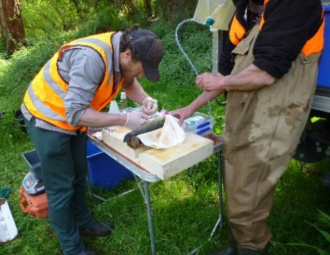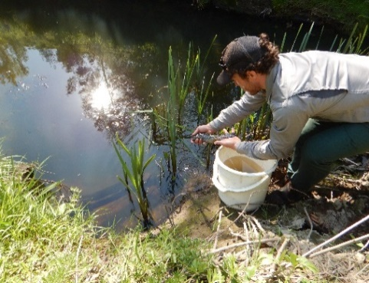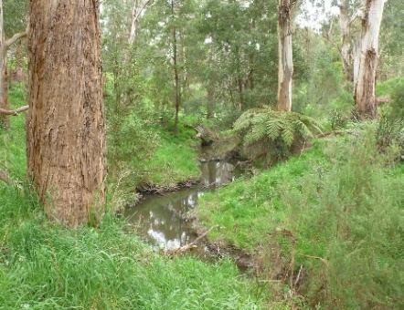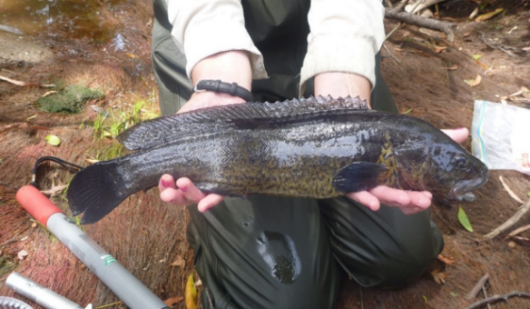

River Blackfish (*Gadopsis marmoratus*), also known as Greasys, Slimys and Marbled Cod, are a medium sized freshwater fish, native to south-eastern Australia. While River Blackfish live in a range of habitats, adults prefer pools and woody structures. They typically have a small home range of about 25-30m, although some fish will move over 100m. They breed in spring and summer, when water temperatures are about 14-20°C. Females lay large, adhesive eggs in hollow logs and cavities of rocks. Relatively few eggs are laid (generally between 30 – 500 eggs) and larger females produce more eggs.

River Blackfish are a popular angling species and were historically widespread and abundant, including in west Gippsland. Leongatha, in the Tarwin River Catchment, was once one of the best River Blackfish locations in Victoria. Now, there are fewer in the Tarwin River catchment and their distribution is patchy (they’re more often found in upper tributaries). Local anglers note their catches have steadily declined in recent decades.

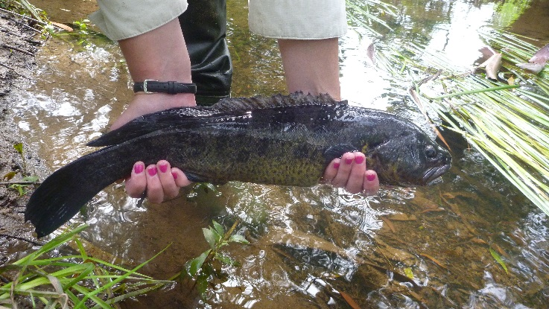Over the last 25 years, West Gippsland Catchment Management Authority have been working with landholders and community groups to improve the health of the Tarwin River catchment and habitat for River Blackfish and other fish species. Actions include removing weeds, planting native trees, fencing, stabilising riverbanks and installing fishways. Since River Blackfish don’t tend to migrate, and breed locally, they haven’t however naturally recolonised rehabilitated areas. Translocating fish into rehabilitated areas may therefore be a valuable way to support recolonisation and population recovery in the Tarwin River and other waterways throughout the species’ range.

## Project Objectives

## A pilot project commenced in 2015 to:

## translocate River Blackfish into rehabilitated reaches within their former range in the Tarwin River catchment.

## assess whether fish remain in the translocated areas.

## assess if recruitment occurs.

## Approach

Twenty-seven adult River Blackfish were collected from upland areas of the Tarwin River west branch using backpack electrofishing in October 2015. Fish were translocated into rehabilitated reaches of Coalition Creek, a tributary further downstream, where they previously occurred. To monitor whether River Blackfish stayed at the translocation sites, fish were tagged with acoustic transmitters and acoustic receivers were placed at about 90m intervals along the translocated reach and at the junction of the Coalition Creek and Tarwin River. Electrofishing and fyke netting surveys were subsequently carried out in autumn 2016, 2017 and 2018 to also monitor for fish survival, establishment of new home ranges, and recruitment.

**Fig 1: A River Blackfish ready for release (Photo: ARI)**

## Results

Acoustic monitoring over the first eight months showed that twenty-two of the translocated River Blackfish survived and remained within the translocated reaches. Five River Blackfish were not recorded after being translocated. These fish may have not moved past a receiver, rejected their tags, died or their tags failed.

Of the River Blackfish that were tracked, most fish moved less than 100m, with two fish moving more than 1km. When stream flows increased, some fish moved more frequently or over larger distances. One fish even moved over 1.6 km – the longest distance recorded for River Blackfish!

A few adult fish and no young fish were collected during the electrofishing and fyke netting surveys in autumn 2016, while no adult or young fish were collected in 2017 and 2018, suggesting that the River Blackfish failed to establish permanent, new home ranges and reproduce. Factors which may explain results include:

## Adult fish stayed in the translocation reaches and recruited, but adult and juvenile fish have not been detected in surveys.

## The effect of stress related to translocation close to the species’ spawning period, resulted in fish not breeding.

## Not enough fish were translocated to obtain a viable breeding population.

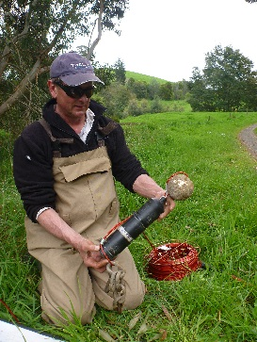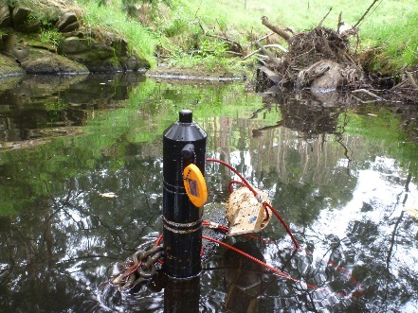

## Adult fish moved from the site when conditions become unfavourable.

A severe drought in Coalition Creek about six months after translocation resulted in the creek ceasing to flow, with subsequent decreased dissolved oxygen and increased water temperature. This poor water quality may have caused translocated fish to leave the reaches, and reiterates the need to carefully select translocation sites with good instream and riparian habitat in catchments not impacted by potential water quality issues.

## Key findings and next steps

This pilot study indicates that River Blackfish can be translocated and will remain in translocated areas for at least eight months. Translocation may represent one tool that can contribute to restoration of River Blackfish within their former range. Future remediation approaches should consider using a larger number of translocated fish and more suitable rehabilitation areas that are resilient to drought. It would also be worthwhile investigating the feasibility of a captive breeding and stocking program for River Blackfish in Victoria.

## A Partnership

This work was funded through the Recreational Fishing Grants Program. West Gippsland CMA managed the project, ARI undertook the fish research and monitoring, and the Leongatha Angling Club contributed to site selection and project support.

## Contact

Justin.O’Connor@delwp.vic.gov.au

## References

O’Connor, J., Amtstaetter, F., Ayres, R., Koster, W. and Bowler, M (2016) Translocation of River Blackfish – Tarwin River pilot study. An unpublished client report for West Gippsland Catchment Management Authority. ARI

|  |  |
| --- | --- |
| © The State of Victoria Department of Environment, Land, Water and Planning 2018  LogoThis work is licensed under a Creative Commons Attribution 4.0 International licence. You are free to re-use the work under that licence, on the condition that you credit the State of Victoria as author. The licence does not apply to any images, photographs or branding, including the Victorian Coat of Arms, the Victorian Government logo and the Department of Environment, Land, Water and Planning (DELWP) logo. To view a copy of this licence, visit http://creativecommons.org/licenses/by/4.0/  ISBN 978-1-76077-105-8 (print), 978-1-76077-106-5 (pdf/online)  Disclaimer  This publication may be of assistance to you but the State of Victoria and its employees do not guarantee that the publication is without flaw of any kind or is wholly appropriate for your particular purposes and therefore disclaims all liability for any error, loss or other consequence which may arise from you relying on any information in this publication. | Accessibility  If you would like to receive this publication in an alternative format, please telephone the DELWP Customer Service Centre on 136186, email [customer.service@delwp.vic.gov.au](mailto:customer.service@delwp.vic.gov.au), or via the National Relay Service on 133 677 [www.relayservice.com.au](http://www.relayservice.com.au). This document is also available on the internet at [www.delwp.vic.gov.au](http://www.delwp.vic.gov.au). |

**Fig 2: Acoustic receivers placed instream (Photo: ARI)**