|  |
| --- |
| A Guide to Managing Livestock Grazing in Victoria’s Wetlands. Decision Framework and Guidelines — Version 1.0  G. Peters, K. Morris, D. Frood, P. Papas and J. Roberts  **September 2015**  Arthur Rylah Institute for Environmental Research Technical Report Series No. 265 |

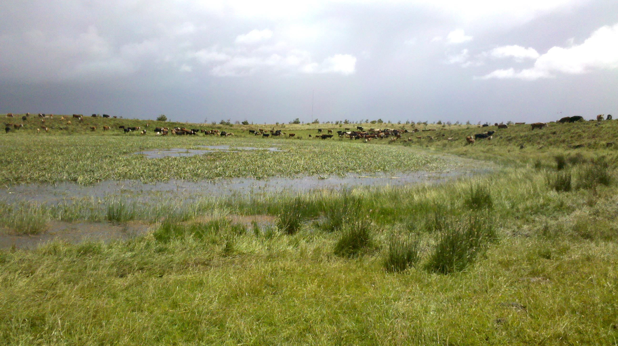

A guide to managing livestock grazing in Victoria’s wetlands. Decision framework and guidelines — Version 1.0

Greg Peters1, Kay Morris2, Doug Frood3,  
Phil Papas2 and Jane Roberts4

1Riverness 1b/51 Little Fyans Street, Geelong, Victoria 3220

2Arthur Rylah Institute for Environmental Research  
123 Brown Street, Heidelberg, Victoria 3084

3Pathways Bushland P.O. Box 360, Greensborough, Victoria 3088

4P.O. Box 6191, O’Connor, Australian Capital territory 2602

September 2015

Arthur Rylah Institute for Environmental Research  
Department of Environment, Land, Water and Planning  
Heidelberg, Victoria

|  |
| --- |
| **Report produced by:** Arthur Rylah Institute for Environmental Research Department of Environment, Land, Water and Planning PO Box 137 Heidelberg, Victoria 3084 Phone (03) 9450 8600 Website: [www.delwp.vic.gov.au](http://www.delwp.vic.gov.au)  **Citation:** Peters, G., Morris, K., Frood, D., Papas, P. and Roberts, J. (2015). A guide to managing livestock grazing in Victoria’s wetlands. Decision framework and guidelines — Version 1.0. Arthur Rylah Institute for Environmental Research Technical Report Series No. 265. Department of Environment, Land, Water and Planning, Heidelberg, Victoria.  ISSN 1835-3827 (print)  ISSN 1835-3835 (pdf)  ISBN 978-1-74146-780-2 (print)  ISBN 978-1-74146-781-9 (pdf)  © The State of Victoria Department of Environment, Land, Water and Planning 2015  Logo This work is licensed under a Creative Commons Attribution 3.0 Australia licence. You are free to re-use the work under that licence, on the condition that you credit the State of Victoria as author. The licence does not apply to any images, photographs or branding, including the Victorian Coat of Arms, the Victorian Government logo, the Department of Environment, Land, Water and Planning logo and the Arthur Rylah Institute logo. To view a copy of this licence, visit <http://creativecommons.org/licenses/by/3.0/au/deed.en>  **Disclaimer:** This publication may be of assistance to you but the State of Victoria and its employees do not guarantee that the publication is without flaw of any kind or is wholly appropriate for your particular purposes and therefore disclaims all liability for any error, loss or other consequence which may arise from you relying on any information in this publication.  **Accessibility:** If you would like to receive this publication in an alternative format, please telephone the DELWP Customer Service Centre on 136 186, email [customer.service@delwp.vic.gov.au](mailto:customer.service@delwp.vic.gov.au) or contact us via the National Relay Service on 133 677 or [www.relayservice.com.au](http://www.relayservice.com.au). This document is also available on the internet at [www.delwp.vic.gov.au](http://www.delwp.vic.gov.au)  **Front cover photo:** Livestock in a wetland (Aggie Stevenson, Glenelg Hopkins Catchment Management Authority).  **Edited by:** Organic Editing. |

Contents

Acknowledgements 4

Acronyms 5

Glossary 5

About the guide 7

Why is grazing guidance needed for wetlands? 7

Who should use the guide and what are the prerequisites for its use? 8

Structure of the guide 9

Section 1: Livestock grazing decision framework 10

Stage 1: Is the framework applicable? 11

Stage 2: Describing the historic and current livestock grazing practices 11

Stage 3: Assessing wetland values and wetland EVC condition 12

Stage 3a: Identifying wetland EVCs 12

Stage 3b: Assessing wetland vegetation condition 12

Stage 3c: Identifying significant flora/fauna species and habitats 16

Stage 3d: Producing a map of the wetland site 17

Stage 4: Setting management objectives and outcomes for each wetland EVC 19

Stage 4a: Setting vegetation condition management objectives 19

Stage 4b: Setting management outcome targets 21

Stage 5: Identifying livestock grazing options for each wetland EVC 22

Stage 5a: Using the decision trees 24

Decision tree guidance 26

Grazing Decision Tree A 31

Grazing Decision Tree B 35

Grazing Decision Tree C 39

Grazing Decision Tree D 44

Grazing Decision Tree E 48

Grazing Decision Tree F 51

Stage 6: Selecting a final livestock grazing option for the whole wetland 55

Stage 6a: Assess if the different grazing options for the EVCs present in the wetland can be implemented 55

Stage 6b: Identify the livestock grazing option that achieves the best ecological benefit for the wetland 56

Section 2: Principles for best practice controlled livestock grazing in wetlands 57

Timing of grazing 58

Grazing stocking rate 59

Type of grazing animal 59

Supplementary feeding and managing livestock access in the wetland 59

Section 3: Monitoring, evaluating and revising the grazing options 60

Design 60

Evaluation questions and indicators 60

Monitoring schedule 61

Data management 61

Evaluation 61

Quality assurance and quality control 61

Adaptive management 62

References 63

Appendix A – Field assessment sheet 65

Appendix B – Environmental, social, cultural and economic values identified in the VWMS 68

Appendix C – Rationale applied in the decision trees for selecting livestock grazing options 70

Tables

Table 1. Botanic skill level required for an IWC assessment of wetland vegetation (DEPI 2013b). 13

Table 2. Condition classes, equivalent IWC wetland vegetation assessment scores and categories, and descriptions for the condition classes. 14

Table 3. Method to determine whether the wetland site contains significant species or suitable habitat 17

Table 4. Acceptability of predicted outcomes of each of the three vegetation condition objectives for each EVC condition class. 20

Table 5. Livestock grazing practices to avoid and those that will minimise impacts to the wetland 57

Table 6. Example evaluation questions and monitoring indicators. 61

Table A1. Historic and current livestock grazing practices. 65

Table A2. Wetland EVCs occurring on the wetland site 65

Table A3. Significant flora and fauna species or suitable fauna habitats occurring on the wetland site. 66

Table A4. Other wetland values for the wetland site. 66

Table A5. Vegetation condition objective. 66

Table A6. Management outcome targets. 66

Table A7. Key criteria for selecting a final livestock grazing option. 67

Table A8. Recommended livestock grazing regime for the wetland 67

Table B1. Environmental, social, cultural and economic values identified in the VWMS. 68

Table C1. Hierarchy and rationale for selecting a *preliminary livestock grazing option* when the options for controlling competitive grasses and preventing vegetation closure differ. 70

Table C2. Process and logic for selecting the preferred livestock grazing option for the EVC when the *preliminary* grazing options and the assessment of potential impacts of grazing differ. 70

Figures

Figure 1. The impacts and potential benefits of livestock grazing in wetlands. 7

Figure 2. The three sections of the guide. 9

Figure 3. The six stages of the livestock grazing decision framework. 10

Figure 4. Expert wetland vegetation condition assessment method. 15

Figure 5. Structure of the livestock grazing decision trees. 23

Figure 6. Selecting the appropriate livestock grazing decision tree. 25

Figure 7. Schematic representation of a concentric arrangement of wetland EVCs and/or condition. 55

Acknowledgements

This project was funded by the Water and Catchments Group (WCG) of the Victorian Department of Environment, Land, Water and Planning (DELWP). Janet Holmes and Andrea White (WCG, DELWP) provided management support and comments on drafts of this guide. Valuable comments on drafts were also provided by Sally Kenny (Arthur Rylah Institute for Environmental Research – ARI, DELWP) and Arn Tolsma (ARI, DELWP).

Workshop participants provided valuable input into the development of the guidelines. Participants were: Michelle Casanova (Research Fellow, Water Research Network, Federation University Australia), Bruce McInnes (Wimmera Catchment Management Authority – CMA), Donna Smithyman (Corangamite CMA), Aggie Stevenson (Glenelg Hopkins CMA) and Nick Layne (North Central CMA). Respondents to an online survey seeking information on livestock grazing practices in Victorian wetlands are thanked for the provision of information that informed the development of the guidelines and decision framework.

Field testing of the logic behind the decision trees at three wetlands on private land in the Wimmera CMA region was coordinated by Bruce McInnes, Glenn Dixon and Jack Purcell (Wimmera CMA). Wimmera landholders Sue Close and Andrew Cormack are thanked for allowing the project to access their wetlands and for the valuable information they provided about land use, vegetation and grazing history. A second round of field-testing, in the Corangamite CMA region to obtain feedback on the guidelines and decision framework, was coordinated by Donna Smithyman (Corangamite CMA). Sandy McBean is thanked for allowing the project to access wetlands on his property for this testing.

Acronyms

ARI Arthur Rylah Institute for Environmental Research

CMA Catchment Management Authority

DELWP Department of Environment, Land, Water and Planning

DEPI Department of Environment and Primary Industries (now DELWP)

DSE Department of Sustainability and Environment (now DELWP)

EPBC Environment Protection and Biodiversity Conservation Act

EVC Ecological Vegetation Class

FFG Flora and Fauna Guarantee Act

IWC Index of Wetland Condition

NRM Natural Resource Management

VWMS Victorian Waterway Management Strategy

WCG Water and Catchments Group

Glossary

|  |  |
| --- | --- |
| **Continuous grazing** | Where livestock graze the site all year, with no significant regular spell periods. |
| **Controlled livestock grazing regime** | Where livestock grazing is restricted to particular time(s) of the year, duration, type(s) of livestock and/or stocking rate. |
| **Ecological Vegetation Class (EVC)** | A type of native vegetation classification that is described through a combination of its floristic, life form, and ecological characteristics, and through an inferred fidelity to particular environmental attributes. Each EVC includes a collection of floristic communities (i.e. a lower level in the classification that is based solely on groups of the same species) that occur across a biogeographic range and, although differing in species, have similar habitat and ecological processes operating. |
| **Exclude livestock grazing** | Permanent exclusion of livestock from the site, usually achieved by fencing the site. |
| **Maintain current livestock grazing practice** | The livestock grazing practice that is currently applied by the landholder is maintained. This can be:   * uncontrolled grazing i.e. set stocking * some form of controlled grazing (as initiated by the landholder) e.g. low-intensity grazing at particular times of the year * permanent exclusion of all livestock, usually achieved by fencing the site. |
| **Management objectives** | Long-term goals (>8 years) for maintaining or improving the environmental condition of an asset. |
| **Management outcome targets** | The assumed outcomes of regional work programs that indicate progress towards improving the condition of waterways over a 1–8 year time frame. |
| **Regional Waterway Strategy** | The regional waterway strategies are planning frameworks for river, estuary and wetland management in each of the 10 catchment management regions across Victoria that support the Victorian Waterway Management Strategy. |
| **Rotational grazing** | Multiple paddock systems in which some paddocks are grazed until a desired residual dry matter level of the pasture is reached, while other paddocks are ungrazed to allow maximum growth and reproduction of plants. |
| **Seasonal tracking** | A form of controlled grazing, in which livestock are restricted, reduced or excluded from a site in accordance with seasonal conditions, forage availability and/or growth period of native plants. |
| **Threats** | Activities that lead to impacts on wetland values. |
| **Vegetation closure** | A process by which a particular species outcompetes other plant species for space, light, nutrients and/or water, resulting in the exclusion of the less competitive species and the dominance of the more competitive species. |
| **Wetland** | Wetlands, for the purpose of this framework, are defined as surface waters, whether natural, modified or artificial, subject to permanent, periodic or intermittent inundation, which hold static or very slow-moving water and support biota adapted to inundation and the aquatic environment. |
| **Wetland buffer** | The native vegetation adjacent to the wetland (from the maximum inundation level outwards). Native vegetation is vegetation in which the overstorey (if present) is native and where native species make up more than 25% of the total understorey cover. Areas of revegetation are classed as native vegetation if they simulate the natural EVC and meet the above criteria. |
| **Wetland component** | Term used in the Victorian Index of Wetland Condition (IWC) to describe wetland features. Examples include soil physical properties, wetland vegetation, salinity, and nutrients. |
| **Wetland condition** | The state of the biological, physical and chemical components of the wetland and their interactions (DSE 2005a). |
| **Wetland EVC** | An EVC is regarded as relevant to wetlands if the ecological effects of at least intermittent inundation or extreme waterlogging are expressed in the floristic composition. This determination has been based on the ecological attributes and habitat preferences of the component species. Presently, 143 wetland EVCs have been described (DEPI 2013a). |
| **Wetland values** | Environmental, cultural, social and economic benefits to communities provided by wetlands. |
| **Victorian Waterway Management Strategy (VWMS)** | The VWMS provides the policy direction for managing Victoria’s waterways over an 8-year period. The strategy aims to improve the condition of Victoria’s waterways so they can support the environmental, social, cultural and economic values that are important to communities. |

About the guide

Why is grazing guidance needed for wetlands?

Livestock grazing in wetlands is common and widespread in Victoria. While it occurs most often on private land, it can also be licensed on public land. It usually degrades the condition of wetlands and threatens wetland values, but in certain cases grazing can be beneficial to wetland values if carefully managed (Morris and Reich 2013, Figure 1).

Despite the prevalence of livestock grazing, and the variable responses of wetlands to it, guidance on identifying appropriate livestock grazing options has not been available in Victoria. This guide uses an understanding of the potential benefits and impacts of grazing in wetlands to assist wetland managers in identifying grazing options that meet the following management objectives:

* maintain the vegetation condition of high-quality wetlands
* improve the vegetation condition of poorer quality wetlands
* manage the vegetation condition for significant fauna.

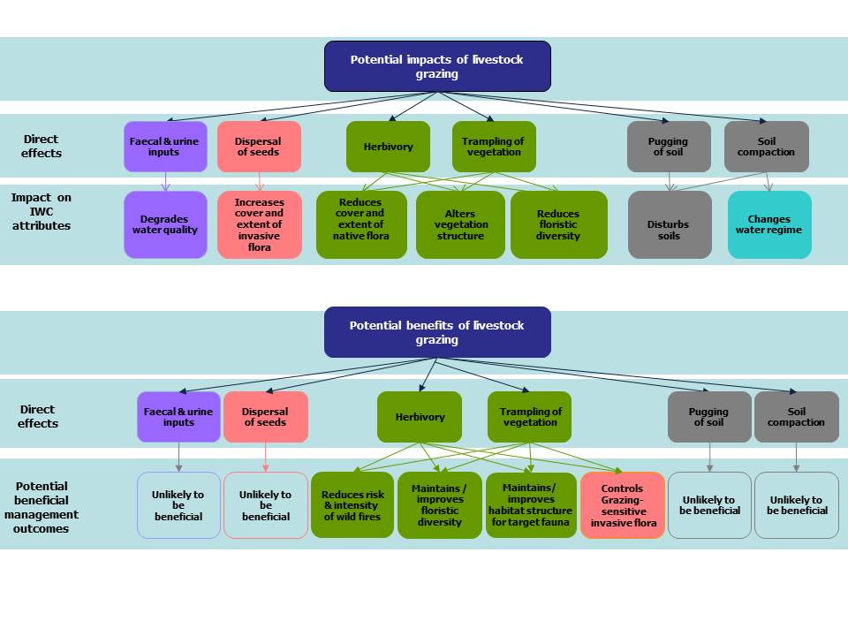

Figure . The impacts and potential benefits of livestock grazing in wetlands. Colours indicate variables associated with wetland components measured by the Index of Wetland Condition (IWC): purple = water properties; pink = invasive flora; green = vegetation condition; grey = soil properties; blue = water regime (adapted from Morris and Reich 2013).

These management objectives are consistent with the objectives of the Victorian Waterway Management Strategy (VWMS) for maintaining or improving the environmental condition of waterways to support environmental, social, cultural and economic values (DEPI 2013a). The grazing guidelines provided here principally support two environmental values identified in the VWMS[1] – naturalness, and rare or threatened species.

In most instances, management activities for maintaining or improving environmental condition will support all wetland values, but in some instances the environmental conditions required to support a particular value(s) can present conflicts for management. If values in the VWMS are identified at the wetland site that could present management conflicts, then the Regional Waterway Strategy should be consulted to inform regional decision-making about which values will be managed for (with reference to the regional goals and consultation with stakeholders) (DEPI 2013b).

Who should use the guide and what are the prerequisites for its use?

This guide is designed for use by natural resource management (NRM) practitioners, environmental consultants, and researchers with expertise in NRM to inform livestock grazing management practices in wetlands on private and public land.

Users should have skills (including botanic expertise) in assessing wetland vegetation condition, threats and values. Users should also have an understanding of the Index of Wetland Condition (IWC). The IWC provides a standardised approach for assessing the condition of Victoria’s wetlands and also documents threats and impacts.

IWC assessments can provide key prerequisite information for this guide, and thus it is recommended that where possible an IWC assessment be done prior to using the guide. Details on the IWC can be found at the Index of Condition System website: <http://ics.water.vic.gov.au/ics/>.

Agencies that may find this guide helpful include:

* Catchment Management Authorities (CMAs)
* Parks Victoria
* Department of Environment, Land, Water and Planning (DELWP)
* Department of Economic Development, Jobs, Transport and Resources
* non-government organisations, including Greening Australia and Trust for Nature
* water authorities
* local government.

Landowners or land managers who do not have specialist knowledge of wetlands, or lack the required botanic skills, should seek assistance from their local CMA wetland officer before using the guide.

Structure of the guide

This guide contains three sections shown in Figure 2 and outlined below that aim to support livestock grazing management decisions in wetlands. .

**2. Best grazing practice guidelines**

**3. Monitoring and evaluation**

**1. Livestock grazing decision framework**

Figure 2. The three sections of the guide.

1. Livestock grazing decision framework

This section contains a decision framework for identifying a livestock grazing option that will: (i) maintain the vegetation condition of high-quality wetlands, (ii) improve the vegetation condition of poorer quality wetlands, or (iii) manage the vegetation condition for significant fauna.

The framework focuses on vegetation condition because:

* vegetation reflects the direct impacts of livestock through trampling, herbivory and the dispersal of invasive plant seeds, as well as through changes in water quality, soil disturbance (pugging and soil compaction) and potential changes in water regime; and
* vegetation closure by native or exotic plants, and the invasion of competitive introduced grasses are the only two impacts for which grazing may be used to protect or improve wetland values.

2. Best livestock grazing practice guidelines

This section provides best practice guidance to assist in developing a controlled livestock grazing management plan. This guidance covers the timing and duration of livestock access, the type of livestock, stocking rate and supplementary feeding.

3. Monitoring and evaluation recommendations to support adaptive management

This section provides recommendations for developing a monitoring and evaluation plan to support adaptive management. It is recommended that an adaptive management plan is adopted at all sites where livestock grazing management is implemented. This requires that a monitoring and evaluation program be developed to assess whether the vegetation management objectives for the site are being achieved and whether any impacts are being adequately controlled. The data collected through monitoring should be evaluated and used to revise the livestock management plan.

Section 1: Livestock grazing decision framework

The livestock grazing decision framework is designed to be used at an individual wetland. Its six stages are illustrated in Figure 3 and described following the figure. Information collected throughout each stage should be recorded on the field assessment sheets provided in Appendix A. Instructions for recording information on the field sheets are indicated in blue boxes throughout the guide.

**Livestock grazing decision framework**

**Stage 1**

Assess whether the decision framework is applicable

**Stage 2**

Describe historic and current grazing practices

**Stage 3**

Assess wetland values and the condition of ecological vegetation classes (EVCs)

**Stage 4**

Set vegetation condition objectives and management outcomes for each EVC

**Stage 5**

Use decision trees to identify a preferred grazing option for each EVC

**Stage 6**

Select a final grazing option for the whole wetland

Figure 3. The six stages of the livestock grazing decision framework.

Stage 1: Is the framework applicable?

Wetlands that can be assessed using the framework

Any wetland that has vegetation described by a wetland EVC benchmark can be assessed using this guide. This includes: lakes, swamps, marshes, meadows and intertidal wetlands. Wetlands may be fresh or saline and permanently or intermittently inundated.

This guide does not provide grazing guidance for the wetland buffer. However, the risk that grazing may present to the condition of the wetland buffer is considered in determining the appropriate grazing option for the wetland EVC. For further guidance on managing grazing in the wetland buffer, refer to *Managing grazing on riparian land. Decision support tool and guidelines* (DEPI 2013c).

The decision framework is not applicable for wetland sites where nutrient enrichment has been identified as a significant threat to the wetland and reducing nutrient levels is a management goal. In this case, livestock should be excluded because the impacts of livestock will override any potential benefit grazing may have.

Guidance on evaluating the risk of nutrient enrichment at the wetland site is provided by the IWC. Where an IWC assessment rates the risk as high, further investigation or professional guidance is recommended for assessing the nutrient status of the wetland site. Water quality guidelines developed for lakes by the Environment Protection Authority (EPA 2010) may also assist, but similar guidelines are not available for other wetland types.

If nutrient issues do not present a problem or are not a high risk at the site, the decision framework will assist in identifying an appropriate grazing regime. Continue to Stage 2.

Stage 2: Describing the historic and current livestock grazing practices

An understanding of the current and historic livestock grazing practices is required in order to:

* evaluate the trajectory of the wetland condition at the wetland site
* inform responses to questions presented in the decision trees
* inform livestock grazing management plans.

Where possible, the characteristics of the historic and current grazing regimes should be obtained through discussions with the land manager and documented on the field assessment sheet in Appendix A. Such characteristics include:

* the number of years over which grazing has occurred at the wetland, and the number of years the current grazing practice has been in place
* the livestock grazing practice (e.g. continuous grazing, controlled grazing, seasonal tracking, rotational grazing or complete exclusion)
* the timing of livestock grazing (i.e. when the grazing occurs)
* the length of time that animals are allowed to graze the site on an annual basis
* the type of grazing animals that access the site (e.g. livestock, native or exotic wild animals)
* the stocking rate (i.e. number of livestock accessing the wetland)
* any adjustment to typical grazing practices (e.g. timing, duration, type of animal and stocking rates) due to drought conditions, fire, flooding or other reasons
* the reason for grazing the wetland (e.g. provide fodder and/or water, control weeds, maintain diversity of native flora, avoid costs of fencing off the wetland)
* supplementary feeding (i.e. when livestock are provided with additional feed in the wetland)
* managing livestock access in and around the wetland (e.g. providing pastures, licks and watering points away from the wetland, purging stock before entering the wetland)
* site factors (e.g. susceptibility of soils to erosion).

Record on field assessment sheet

Once the historic and current livestock grazing practices for the wetland site have been identified, record this information in Table A1 of the field assessment sheet (Appendix A).

Stage 3: Assessing wetland values and wetland EVC condition

In this stage you will collect the information required for selecting the vegetation condition objectives for each wetland EVC (Stage 4) and for informing responses to the questions presented in the decision trees (Stage 5).

By the end of this stage, you will have:

* identified and assessed the condition of the EVCs occurring at the wetland site
* identified whether any rare, threatened or locally significant flora and/or fauna species have been observed in the wetland or if the wetland provides suitable habitat
* identified other wetland values (Appendix B)
* recorded this information in the field assessment sheet (Appendix A)
* produced a map of the wetland site and wetland EVCs where possible.

Stage 3a: Identifying wetland EVCs

To identify which EVCs occur at the wetland site, use the procedure outlined in the *Index of Wetland Condition* [*Assessment of Wetland Vegetation*](http://ics.water.vic.gov.au/ics/files/IWC_Assessment-of-Wetland-Vegetation-Update_December_2012.pdf) (DSE 2012)[2].

The key steps in this procedure are:

1. identify the relevant landscape profile that fits the wetland site(there are 16 landscape profiles defined for Victoria)
2. use the wetland landscape profile relevant to the wetland site to identify a list of possible wetland EVCs
3. use defining characteristics and indicator species of the EVCs to confirm the identification of EVC(s) present at the wetland site. These are described in EVC benchmarks (DEPI 2013a).

Stage 3b: Assessing wetland vegetation condition

The condition of the wetland vegetation at the EVC scale is used as the primary basis for selecting the appropriate decision tree. Five condition classes are identified, varying from unmodified or excellent condition through to largely modified or very poor condition.

Depending on your botanic skills and experience, the condition of each wetland EVC can be assessed using one of two methods – an *IWC assessment of wetland vegetation method* or an *Expert wetland vegetation assessment method*. A similar condition outcome is reached by both methods.

The *IWC assessment of wetland vegetation method* is a quantitative assessment of the wetland EVC, supported by benchmarks. This approach is recommended for people who have a good knowledge of wetland vegetation (see Table 1 for required botanic skills). It is likely that this method will be suited to most assessors.

Assessors with a very high level of wetland vegetation knowledge and botanic expertise can use the qualitative *Expert wetland vegetation condition assessment method* outlined below and in Figure 4. For these assessors, this method may be quicker than the IWC approach.

Table 1. Botanic skill level required for an IWC assessment of wetland vegetation (DEPI 2013b).

|  |  |
| --- | --- |
| Botanic skill | Expected skill level |
| Recognition of plant species | * Can distinguish between all the individual native species present * Can identify the native species that are required to discriminate between wetland EVCs * Can identify life forms that are characteristic of wetland EVCs * Can identify weed species |
| Recognition of vegetation types | * Can identify wetland EVCs using reference material, and recognise any major floristic community variants that occur within these |
| Recognition of condition attributes | * Can consistently estimate cover values for life forms and weeds * Can identify biological invasions due to altered processes |

IWC assessment of wetland vegetation method (most assessors)

This is a quantitative method for assessing wetland EVC condition based on the following attributes:

* critical life forms
* presence of weeds
* indicators of altered processes
* vegetation structure and health.

An explanation of these attributes and how to assess them is provided in the *Index of Wetland Condition Assessment Procedure* (DEPI 2013d)[3]. If the wetland site has already been assessed using the IWC assessment procedure, and the assessment is believed to be still valid (i.e. nothing at the wetland site has changed), then use the existing scores.

Once an EVC has been assessed, its IWC wetland vegetation assessment score is translated to a condition class (refer to Table2).

Expert wetland vegetation condition assessment method (high level of expertise required)

This is a qualitative method for assessing wetland EVC condition based on the following attributes:

* loss of plant diversity
* weediness (the presence and extent of non-indigenous or invasive species)
* vegetation structure (number of strata, density of cover)
* modification of ecological processes, as reflected in the vegetation.

Assessors with a very high level of wetland vegetation knowledge and botanic expertise can use this method to identify the condition class for each wetland EVC. Figure 4 provides a flow chart for working through the method.

Record on field assessment sheet

Once the EVCs occurring in the wetland have been identified and their condition class determined, record this information in Table A2 of the field assessment sheet (refer to Appendix A).

Table 2. Condition classes, equivalent IWC wetland vegetation assessment scores and categories, and descriptions for the condition classes.

|  |  |  |
| --- | --- | --- |
| Condition class | Condition class description | IWC wetland vegetation assessment score/category |
| **1** Severely modified | * Indigenous ground-layer flora absent, except for at most a very minor component of the most resilient species, and largely replaced by introduced species | 0–5 Very poor |
| **2** Substantially modified | * EVC degraded, with only a minor component of relatively resilient species of the original understorey/ground flora persisting * Structure of the vegetation substantially altered * Serious environmental weeds typically prevalent within at least part of the wetland site or significant ecological invasions are advanced | >5–9 Poor |
| **3** Moderately modified | * Vegetation disturbed, but still readily identifiable as a particular EVC * Extinction-prone species mostly displaced, but a substantial component of the indigenous understorey/ground flora persisting (at least as a range of species at low levels, or if only a few species, then at higher cover) * Serious environmental weeds often present or otherwise significant plant invasions occurring (native or introduced) | >9–14.5 Moderate |
| **4** Slightly modified | * Some floral diversity losses within the vegetation presumed, but at most minor * Weed invasions relatively minor * System apparently remaining ecologically stable | >14.5–18.5 Good |
| **5** Largely unmodified | * No major identifiable impacts on vegetation condition (structure or floristics) * Vegetation apparently still relatively intact and ecologically stable (temporal and spatial variation remaining within the spectrum of possibilities anticipated for unmodified examples of the relevant system) * Floral diversity losses minimal if any * Serious environmental weeds absent | >18.5–20 Excellent |

**Floral diversity losses presumed minimal,**

**if any**

**Weeds negligible, serious environmental weeds absent**

**No indication of modified ecological processes**

**Vegetation structure largely intact**

**Floral diversity losses substantial, but a range of species persist at low cover or a few species persist at high cover**

**Indications of modified ecological processes at most minor**

**Alteration of vegetation structure at most minor**

**Serious environmental weeds at most very minor**

**Presumed floral diversity losses at most minor**

**Indications of modified ecological processes at most moderate**

**Vegetation structure modified, but key components of at least one stratum conspicuous**

**If serious environmental weeds established, not dominant**

**Vegetation structure substantially altered, but key species of at least one strata persisting**

**At least minor component of relatively resilient ground-layer species persisting**

**Condition Class 5**

**Condition Class 2**

**Condition Class 3**

**Condition Class 4**

**Condition Class 1**

Yes

Yes

Yes

No

Yes

Yes

Yes

Yes

No

No

No

No

No

No

No

No

No

No

No

No

No

Yes

Yes

Yes

Yes

Yes

Yes

Yes

Figure 4. Expert wetland vegetation condition assessment method.

Stage 3c: Identifying significant flora/fauna species and habitats

Wetlands are important environments for flora and fauna. The Millennium Ecosystem Assessment (2003) recognised that wetlands:

* support locally or regionally significant flora and/or fauna species
* support an abundance of individuals of particular species or groups
* support a high diversity of species
* are important as habitat for animal taxa at a vulnerable stage of their life cycle or as a refuge during adverse conditions
* maintain bioregional biodiversity.

Some Victorian wetlands are habitat for rare or threatened flora or fauna that are listed on international, national or state advisories and legislation. These include the International Union for the Conservation of Nature (IUCN) Red List of Threatened Species,the *Environment Protection and Biodiversity Conservation* (EPBC) *Act 1999*, the *Flora and Fauna Guarantee (FFG) Act 1988*, the Advisory List of Threatened Invertebrate Fauna in Victoria (DSE 2009), the Advisory List of Threatened Vertebrate Fauna in Victoria (DEPI 2013e) and the Advisory List of Rare or Threatened Plants in Victoria (DEPI 2014).

Generally it is assumed that largely unmodified vegetation (condition class 5) will provide the best quality habitat for the fauna species that occur at the wetland. However, there may be cases when modified vegetation provides important habitat for a particular species or group of species which would be lost if the vegetation condition was improved. In these cases, maintaining vegetation condition may be a preferred management objective to improving vegetation condition.

To identify the species present at the wetland site, you can use field observations during the site assessment and consult one or more of the following sources of information:

* previous flora and fauna studies undertaken at the site or locally
* local knowledge (of landholders or local field naturalists)
* the Victorian Biodiversity Atlas (state database of flora and fauna location records) (<https://vba.dse.vic.gov.au/vba/>).

For the species identified as likely to be present (or for any species you identify while on site), use the methods outlined in Table 3 to determine whether the wetland site still contains suitable habitat. You could also refer to the relevant action statements or to the recovery plans (if they exist), or seek expert advice from DELWP.

Table 3. Method to determine whether the wetland site contains significant species or suitable habitat (sourced from DEPI 2013f).

|  |  |  |
| --- | --- | --- |
| Determine whether the wetland contains suitable habitat for significant flora species  *Undertake these steps for each significant flora species* | | |
| A | Was the species observed during the course of the assessment? | Yes – record as species observed  No – go to B |
| B | Has the species been recorded at the wetland site in the last 20 years and is the wetland site still suitable habitat for the species? | Yes – record as likely habitat |
| Determine whether the wetland contains suitable habitat for significant fauna species  *Undertake these steps for each significant fauna species* | | |
| A | Was the species sighted within the last 2 years (e.g. during the course of the assessment, as part of the IWC assessment) or recorded at the wetland site in the last 20 years? | Yes – record as species observed  No – go to B |
| B | Has the species been recorded within a 5-km radius of the wetland site in the last 20 years? | Yes – go to C  No –species is not present locally |
| C | Does the habitat occurring at the wetland site clearly meet the habitat requirements of the species? Is it reasonable to expect that the species is present or would make use of the site in the medium term (e.g. within the next 10 years). | Yes – record as potential habitat  No – not potential habitat |

The information gathered through the use of Table 3 will be used to determine suitable management objectives for vegetation condition, presented in Stage 4 of the guidelines. If a species has been sighted recently, but the habitat is no longer suitable, then consider basing a target around the re-establishment of that habitat and improved recruitment or breeding.

Record on field assessment sheet

Once the flora and fauna species or potential habitats occurring at the wetland site have been identified, record this information in Table A3 of the field assessment sheet (Appendix A).

Stage 3d: Producing a map of the wetland site

It is recommended that a map of the wetland site is developed and annotated with the following:

* the boundaries of each EVC (this may already have been completed if the site was part of an IWC assessment of wetland vegetation quality)
* patches of abutting remnant vegetation (native vegetation outside the wetland that may be impacted by livestock grazing)
* other site values such as flora or fauna habitat
* wetland infrastructure such as fences and access points.

This map will assist you to:

* keep track of spatial information gathered for the wetland site
* visualise how fence lines (existing or proposed) may impact livestock movement
* develop a monitoring program.

Note

It will not always be possible to map EVC boundaries. This may occur when access to the site is difficult, where there are complex vegetation patterns and/or where the vegetation is highly dynamic (e.g. floating vegetation that moves with the prevailing wind). In these cases, a description of the EVC is adequate.

Instructions for generating maps of the wetland site

Wetland maps and aerial images can be automatically generated and downloaded from the IWC wetland mapping tool located at the following URL: <http://www.depi.vic.gov.au/forestry-and-land-use/forest-management/maps/interactive-maps>. On this page, select the IWC wetland mapping tool link.

Maps can be generated in one of three ways: (i) by selecting a wetland from the Victorian Wetlands Inventory spatial layer (WETLAND_CURRENT), (ii) uploading a wetland polygon or point location or (iii) navigating to the approximate wetland location on the map. Instructions for these methods are provided below.

1. Finding a wetland on the WETLAND_CURRENT spatial inventory
2. Click on the Select Wetland tab at the top of the screen, and on the right-hand side of the screen enter either the wetland number (the ID in the WETLAND_CURRENT spatial inventory), the Corrick Wetland ID[4] or the name of the wetland, or select the name of the wetland from the drop-down list.
3. Ensure the correct wetland is selected in the table of results.
4. Select the desired map products using the check boxes and click the ‘Go’ button.
5. Generating a wetland shapefile or point coordinate
6. Select the File tab at the top of the screen. On the right-hand side of the screen, select the desired format of the file to upload.
7. Choose the files to upload (for a shapefile both the .shp file and .dbf file must be uploaded); select the projection, the title for the wetland uploaded and the symbology. Leave the layer position at the default setting. Select the ‘OK’ button.
8. On the right-hand side of the screen, select the appropriate drop-down option.
9. Select the desired map product(s) using the check boxes and click the ‘Go’ button.
10. Generating a map template
11. Select the Print Map tab at the top of the screen and click the ‘Go’ button on the right-hand side of the screen.

Append to field assessment sheet

Append the map to the field assessment sheet (Appendix A).

Stage 4: Setting management objectives and outcomes for each wetland EVC

Management objectives are long-term goals (>8 years) for maintaining or improving the environmental condition of an asset. Management outcomes are specific, measurable, short- to medium-term objectives (1–8 years) that demonstrate progress towards achieving vegetation condition objectives.

Setting objectives and reporting management outcomes are widely accepted key tools for natural resource management because they can:

* help focus resources on priorities
* communicate expectations and promote transparency
* promote continuous improvement through the lessons learnt
* demonstrate progress and accountability.

At the end of this stage you will have:

* set vegetation condition objectives for each wetland EVC, based on vegetation condition and the habitat value of the EVC for significant fauna
* set management outcome targets to assess progress towards the selected vegetation condition objective
* recorded this information on the field assessment sheet (Appendix A).

Stage 4a: Setting vegetation condition management objectives

Management objectives in this guide focus on vegetation condition, based on the assumption that good vegetation condition is necessary to support the values present at the wetland site, or that a specific aspect of the vegetation condition is required in order to support a particular value that is of overriding importance to the community (e.g. the presence of a significant species).

Vegetation condition objectives are set for each wetland EVC and are informed by:

* the current extent and condition of the EVC (that you have recorded in the field assessment sheet)
* the trajectory of the EVC extent and condition or of the fauna habitat condition, under the current grazing regime.

The following questions will assist in identifying these trajectories**:**

* Is the extent of the wetland EVC decreasing, stable or increasing over time?
* Is the condition of the wetland EVC improving, declining or being maintained over time?
* Are significant fauna species decreasing, stable or increasing in prevalence over time?

Consult with the land manager to answer these questions.

For each EVC, following an assessment of condition and condition trajectories, select one of the following possible vegetation condition objectives:

* maintain vegetation condition
* improve vegetation condition
* manage vegetation condition for significant fauna habitat.

The acceptability (desirable, acceptable, unacceptable) of each vegetation condition objective will vary with the condition class of the EVC. Table 4 ranks these for each of the five possible EVC condition classes and provides a rationale for the assigned ranking.

Realistic and appropriate time frames should be set for achieving these objectives. Time frames can be between 8 and 20 years, depending on the condition of the site, the level of management intervention possible with available resources, and the likely form of measurement.

Table 4. Acceptability of predicted outcomes of each of the three vegetation condition objectives for each EVC condition class.

|  |  |  |  |
| --- | --- | --- | --- |
|  | Acceptability rankings | | |
| EVC condition class | Maintain vegetation condition | Improve vegetation condition | Manage vegetation condition for significant fauna habitat |
| 5 | **Desirable**  Predicted outcome: wetland vegetation remains in condition class 5. | **Not applicable**  This is the highest condition class, inferring a mostly intact system. As such, improvement is unnecessary and unlikely. | **Unacceptable**  Due to the low number of wetland EVCs in these classes, priority is given to maintaining/improving vegetation condition. It is assumed that significant fauna present will benefit from maintaining or improving vegetation condition.  In contrast, managing vegetation for significant fauna habitat may have impacts on vegetation condition. |
| 4 | **Acceptable**  Predicted outcome: wetland vegetation remains in condition class 4.  Factors such as landscape-scale threats or funding limitations may limit the ability to improve vegetation condition. | **Desirable**  Predicted outcome: wetland vegetation either:   * improves to a better condition within condition class 4, or * transitions to condition class 5. |
| 3 | **Unacceptable**  As the purpose of the decision framework is to identify grazing options that will protect and improve wetland condition, maintaining vegetation in a severely or substantially modified condition is not considered acceptable unless this is required to support significant fauna habitat. | **Desirable**  Predicted outcome: wetland vegetation either:   * improves to a better condition within condition class 3, or * transitions to a higher condition class. | **Desirable**  Predicted outcome: wetland vegetation improves.  **Acceptable**  Predicted outcome: wetland vegetation remains in the same condition class but provides suitable habitat for significant fauna.  Maintenance of wetland vegetation to support fauna is only acceptable where:   * the vegetation is moderately to severely modified; and * the target fauna are significant. |
| 1 or 2 | **Desirable**  Predicted outcome: wetland vegetation either:   * improves to a better condition within its current condition class, or * transitions to a higher condition class. |

Stage 4b: Setting management outcome targets

Management outcome targets serve two purposes:

1. They provide a framework for evaluating whether the selected grazing option is achieving the vegetation condition objectives (see *Section 3: Monitoring, evaluating and revising the grazing options*).
2. They inform responses to questions presented in the Grazing Decision Trees.

In this stage, management outcome targets are identified and recorded on the field assessment sheet (Appendix A).

Some examples of management outcome targets include:

* reduce the cover of competitive introduced grasses
* reduce vegetation closure by native or introduced plants
* maintain or increase the number of grazing-sensitive native flora species
* maintain or increase the cover of grazing-sensitive native flora species
* maintain or increase the abundance of grazing-sensitive native fauna species
* increase recruitment of native herbaceous species
* reduce cover of weeds
* improve vegetation structure
* maintain or increase cover of life form groups representative of the EVC
* increase cover of native flora species
* increase or maintain diversity of native flora species
* protect breeding habitat for fauna species ‘x’
* maintain food resources for fauna species ‘x’.

Notes

If targets are to be set for a significant species, these may be based on a long-term outcome from an existing Action Statement (or similar) for that species or on expert opinion.

The response time of these targets should be considered and documented. These times will vary – some targets may be reached within weeks; others may take several years to be reached.

Record on field assessment sheet

Once vegetation condition objectives and management outcome targets have been set for each wetland EVC on the wetland site, record this information in Tables A5 and A6 of the field assessment sheet (Appendix A).

Stage 5: Identifying livestock grazing options for each wetland EVC

At the end of this stage, the potential benefits and possible impacts of livestock grazing will have been considered and a final livestock grazing option for each wetland EVC will have been identified for your wetland site.

The process of identifying livestock grazing options for a wetland EVC uses decision trees and is supported by the guidance provided on pages 23–27. Six grazing decision trees are provided to assist in determining the most appropriate livestock grazing option for a wetland EVC .

Each decision tree asks a series of questions that lead to one of the three possible livestock grazing options: (i) maintain the current livestock grazing practice, (ii) control the livestock grazing regime or (iii) exclude livestock grazing. Each of these grazing options is described in detail in Box 1.

Box 1. Description of livestock grazing options considered in this guide.

1. Maintain the current livestock grazing practice

The grazing practice that is currently applied by the landholder is maintained. This could be:

* uncontrolled grazing, i.e. set stocking or continuous grazing
* a form of controlled grazing (as initiated by the landholder), e.g. low-intensity grazing at particular times of the year, or
* complete exclusion of livestock (where the site has been fenced and stock removed permanently).

Where livestock grazing currently occurs, maintaining the grazing regime is considered only for sites that meet the following criteria:

* the vegetation is in good or excellent condition (condition classes 4 and 5) and the current grazing regime has been in place for 10 or more years and there is high confidence of the trajectories of change in condition under the current management, or
* the vegetation is in moderate condition (condition class 3) and the wetland is being managed for maintenance of significant fauna habitat.

The characteristics of the wetland vegetation in condition class 4 and 5 include:

* no major identifiable impacts on vegetation condition (structure and floristics)
* the vegetation is still relatively intact and ecologically stable (the temporal and spatial variation is within anticipated range for unmodified examples of the relevant system)
* floral diversity losses are minimal if any
* serious environmental weeds are absent (relatively unmodified in terms of ecological processes).

In most cases wetlands in good or excellent condition will have a history of either no grazing or low-intensity grazing with minimal soil disturbance. Continuing low intensity grazing is likely to result in little or no change to the structure and composition of the vegetation. However, any grazing needs to be carefully and continuously managed, to ensure it does not impact on sensitive species.

1. Control the livestock grazing regime

For this option, controlled means permitting a set number of a certain type of livestock to graze in a defined area, at a specified time, for a specified duration. To implement a controlled livestock grazing regime, both the historic and current grazing regime for the wetland site should be assessed.

1. Exclude livestock grazing

This option requires the complete exclusion of livestock from the site. Typically, this is done by installing a livestock-proof fence around the wetland.

In some instances, removing livestock grazing may require implementation of other forms of vegetation management at the site, e.g. controlling weeds, establishing native vegetation (by allowing for natural regeneration and/or direct seeding and/or seedling planting).

In identifying a suitable livestock grazing option, the decision trees consider the potential benefits and impacts of livestock grazing. These are illustrated in Figure 5 and described following the figure.

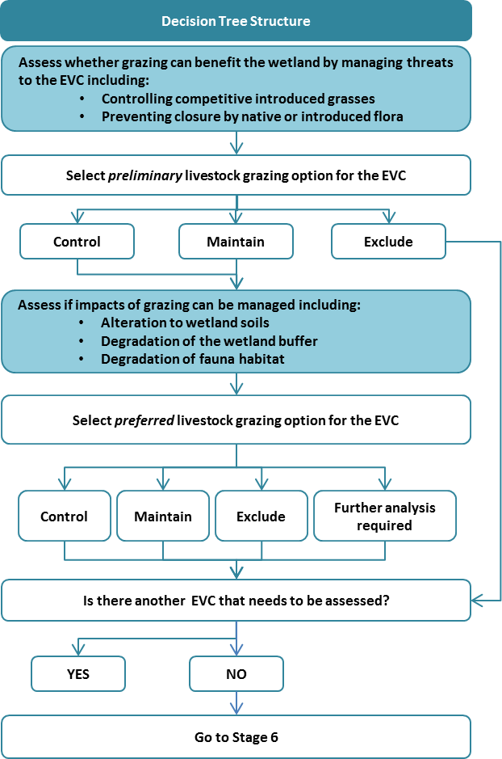

Figure 5. Structure of the livestock grazing decision trees.

The potential benefits of livestock grazing are assessed first; this provides a *preliminary livestock grazing option*. Livestock grazing is only considered beneficial if it can be used to control competitive invasive grasses and/or prevent closure by native or introduced flora.

Where the grazing options for controlling competitive grasses and preventing vegetation closure differ, the decision trees guide you to the appropriate *preliminary livestock grazing option* based on the rationale described in Appendix C (Table C1).

Where the *preliminary livestock grazing option* selected is either ‘maintain’ or ‘control’, the potential impacts of the grazing option must then be evaluated to assess whether the possible impacts from grazing to other wetland values are not present or can be managed, including one or more of the following:

* alteration to wetland soils
* degradation of the wetland buffer (native vegetation)
* degradation of fauna habitats
* impacts on grazing-sensitive species.

Where the *preliminary livestock grazing option* and subsequent grazing options that consider potential impacts differ, the decision trees will guide you to the *preferred livestock grazing option*, based on the logic described in Appendix C (Table C2).

Where *further analysis required* is selected, there are both benefits and impacts associated with livestock grazing. To determine which option to select, re-evaluate the preliminary livestock grazing option to check that other options for managing the threat cannot be applied, check responses to all questions, and weigh up benefits against impacts.

Stage 5a: Using the decision trees

1. Using Figure 6. overleaf, select the appropriate decision tree for the condition class of the EVC and the selected vegetation condition objective that were determined in Stage 4. It is important that the appropriate decision tree is selected as the information provided in the decision trees is specific to a particular wetland condition class and vegetation condition objective.
2. Follow the steps in the decision tree to identify the appropriate livestock regime for the wetland EVC. The guidance provided on pages 23–27 will assist in answering the questions in the decision trees.
3. If the preferred livestock grazing option for the EVC is *further analysis required*, then this indicates that the preliminary livestock grazing option may put other wetland values at risk. To determine which option to select, re-evaluate:
4. The *preliminary livestock management option*. Is the option the only appropriate strategy? Are alternative options acceptable?
5. The risks to other wetland values. Are the risks acceptable? Do the benefits outweigh the risks?

Based on these considerations, decide whether to retain your preliminary livestock grazing option or to select exclude livestock grazing as your preferred livestock grazing option for the wetland EVC.

1. Once you have decided on a preferred livestock management option for the EVCs, record the information on the field assessment sheet and assess the next EVC in the wetland.
2. If you have assessed all the EVCs in the wetland, go to Stage 6 to identify a grazing regime for the whole wetland.

**Vegetation Condition Objective**

**EVC Vegetation Condition Class**

**Decision Tree**

**Vegetation Condition Class 3**

**Vegetation Condition Class 4**

**Vegetation Condition Class 5**

**Maintain vegetation condition**

**A**

**Maintain vegetation condition**

**A**

**Improve vegetation condition**

**B**

**Manage vegetation for significant fauna habitat**

**C**

**D**

**Improve vegetation condition**

**Vegetation Condition Classes 2 or 1**

**Manage vegetation for significant fauna habitat**

**E**

**F**

**Improve vegetation condition**

Figure 6. Selecting the appropriate livestock grazing decision tree.

Decision tree guidance

Questions on grazing and competitive introduced grasses

There are situations where livestock grazing may be justified in controlling potentially dominant, grazing-sensitive palatable exotic plants (notably a small range of grasses, particularly closer to the wetland boundary). These situations are where either:

* a wetland is being invaded by introduced grasses
* a wetland is under immediate threat of invasion by introduced grasses.

Is the EVC dominated or partly dominated by introduced grasses?

Introduced grasses will typically only be a problem if they are able to withstand periods of wetting.

Is the EVC prone to invasion by competitive introduced grasses?

The term *prone to invasion* means either:

* the wetland has only isolated or patchy occurrences of competitive introduced grasses present
* the wetland is relatively free of weeds, but there is a source of propagules on adjacent land (such as a paddock or other areas with *Phalaris* or Tall Wheat-grass) that can reasonably be anticipated to be a source of future invasions.

Is there a risk to habitat from competitive introduced grasses?

In other words, will the dominance or partial dominance of the EVC by introduced grasses displace plant species that provide important habitat or food resources for significant fauna?

Can competitive introduced grasses be controlled without grazing the EVC?

For wetlands where introduced grasses currently dominate or partly dominate a site, a number of management activities (in addition to grazing) may assist in the control of competitive introduced grasses (Morris and Papas 2012). It is important to acknowledge that ‘control’ in the above context refers to limiting the competitive influence of the relevant species, and not its elimination (at least not in the short to medium term). The most common control methods for wetlands are listed below.

1. *Chemical control*  
   Only a few herbicides are registered for use in aquatic areas in Australia, and these include several glyphosate-based products that do not contain toxic surfactants that are harmful to aquatic organisms. The use of herbicides in Victorian waterways is tightly regulated and permits must be obtained prior to their application near a waterway. Guidance should be obtained in selecting the best herbicide, application technique, and appropriate timing of application to best manage a particular invasive species. All herbicides must be used with care and measures taken to minimise both adverse effects on non-target organisms and risks to public health and safety.
2. *Mechanical control*  
   This is most commonly slashing, but may also include hoeing, use of harvesting machines and bulldozing. These measures may be problematic in sites with Acid Sulfate Soils (ASSs) or potential ASSs, or when there is a risk of penetrating a saline groundwater table. They can also disturb or remove the native seed bank, so care must be taken to re-establish native vegetation following mechanical works to prevent the establishment of opportunistic weed species. Interventions that involve excavation have the potential to cause significant damage to native vegetation in the wetland or the buffer and may also initiate or worsen soil erosion and/or degrade water quality. These control measures also have the potential to increase the weed species present at a site through poor machinery hygiene so machinery hygiene should be strictly enforced.

**Decision tree guidance (continued)**

Questions on grazing and competitive introduced grasses (continued)

Can competitive introduced grasses be controlled without grazing the EVC? (continued)

1. *Manual control*  
   Includes hand removal and slashing or cutting. These methods are suited to managing small populations.
2. *Modifying the water regime*  
   Where growth and/or reproduction of an invasive wetland plant species is reduced by a specific water regime, decreasing or increasing the period of inundation, where feasible, may help eliminate or reduce the size of populations of invasive species. Risks to native species and wetland function associated with these changes must be evaluated prior to changing the wetland water regime.
3. *Preventing seed set/release*  
   Seeds and vegetative fragments of invasive wetland flora that have established in a wetland may disperse to other parts of the wetland via wind, water or animal vectors. Measures to limit dispersal (such as burning or slashing) can help contain the spread of invasive species. Harvesting invasive plants prior to seed set or release can help limit both the expansion of the population within the wetland and dispersal to new sites.

When deciding whether competitive introduced grasses can be controlled by methods other than grazing, the suitability of the other control methods should be tested by considering the following questions:

* Will they be as effective as grazing in treating the problem?
* Are they practical in treating the problem? For example, chemical control is often cost-prohibitive on large sites and can be excessively destructive when used by people without bushland regeneration skills.
* Will they create risks to other values (either on site or off site)? In some cases, the management activity to reduce the level of a threat may not be beneficial to all values. For example, chemical control is not without risks to the aquatic ecosystem.
* Will they present risks to public health and safety, domestic animals, or livestock? Management activities that are hazardous to the public, domestic animals, or livestock are unsuitable, unless specific and stringent precautions can be put in place.

Wetlands at risk of invasion from introduced grasses may be protected by preventing competitive introduced grasses from invading. Options include:

1. *Creating or improving the wetland buffer*  
   Intact native vegetation around the perimeter of the wetland will reduce opportunities for invasive species to establish and enhance competitive exclusion by native species.
2. *Restoring wetland vegetation*  
   There is a higher likelihood of incursions of invasive flora species where the native wetland vegetation has been removed or is highly degraded. Re-establishing native vegetation can assist in minimising the impact of invasive flora by out-competing the invasive species and reducing sites for establishment or changing the conditions needed for establishment or growth (e.g. reducing bare ground and increasing shading).

**Decision tree guidance (continued)**

Questions on grazing and canopy closure

Is there a risk to plant diversity from closure by native or exotic wetland plants?

Closure by native or introduced grasses may be a threat if the wetland supports significant flora that is/are disturbance specialist(s) or require gaps in vegetation cover to germinate, establish or survive.

Is there a risk to habitat from closure by native or exotic wetland plants?

Closure by native or introduced grasses may be a threat if the wetland supports significant fauna and gaps in vegetation cover are considered an important habitat features for these fauna.

Can the closure be controlled without grazing the EVC?

Alternatives to grazing include any other method of biomass reduction such as burning or suitably timed slashing. See *Can competitive introduced grasses be controlled without grazing the EVC*? (see pages 263 and 24 for details regarding alternatives).

Questions on grazing impacts on wetland soils

Is the EVC vulnerable to hydrological change and/or severe pugging from grazing?

Although livestock grazing has the potential to cause hydrological changes in all wetlands, the most pronounced changes will occur in alpine peatlands that are dominated by sphagnum moss. Moss and underlying peat are easily damaged and killed by trampling and wallowing. These activities cause channels to form that have the effect of draining the wetland (DEWHA 2009). In non-alpine wetlands, grazing can cause soil erosion, bank compaction and pugging. Severe pugging may damage seed and invertebrate egg banks.

Is there a grazing regime that will not cause hydrological change and/or severe pugging?

In some circumstances, these potential impacts can be managed by fencing, installation of off-stream watering points, seasonal spelling and/or managing actual grazing pressure. To prevent pugging, grazing must only be allowed when the wetland soil is dry.

Questions on grazing impacts on wetland buffer vegetation

Does the EVC abut less modified wetland buffer vegetation?

Assess the wetland site to determine whether remnant vegetation abuts the area being considered for grazing, and whether this may be accessible to livestock if grazing is implemented. In particular, look for vegetation that may be particularly threatened due to its proximity to places where livestock may congregate, such as areas of shade, access points or paths. Aerial imagery may assist with this.

Could grazing negatively affect the condition of the wetland buffer vegetation?

The wetland buffer is both an important determinant of wetland condition and important as terrestrial habitat. Potential impacts associated with livestock grazing include:

* loss of palatable plant species
* trampling and browsing of understorey vegetation
* introducing weeds and encouraging their growth
* preventing natural recruitment
* elevating soil nutrient levels.

Is there a grazing regime that will not impair the condition of the wetland buffer vegetation?

This could include the utilisation of fencing, where this is effective in exclusion, or other regulation of grazing within the adjacent remnant vegetation. It is recommended that assessors refer to *Managing grazing on riparian land. Decision support tool and guidelines* (DEPI 2013c) for guidance on selecting a preferred grazing strategy for wetland buffer vegetation.

**Decision tree guidance (continued)**

Questions on grazing impacts on fauna habitat

Does the EVC support any significant fauna species?

These are identified in Stage 3 (Gathering information needed to use the grazing decision trees).

Could grazing negatively impact the fauna habitat condition within the EVC?

Is there a grazing regime that will not impact the fauna habitat condition?

To answer these questions you will need a good understanding of the habitat requirements and threats to any significant fauna species that may utilise the wetland. National recovery plans and/or Action Statements for threatened species prepared by DELWP[5] provide information on the distribution, threats and conservation measures for some threatened species. Where Action Statements exist, they should be used to inform the risks to habitat that livestock grazing may present. Where Action Statements are not available and the habitat requirements of the species are not known, a fauna specialist should be consulted.

Dense cover of plants may assist in the suppression of weeds by closing gaps in vegetation and reducing opportunities for disturbance specialists (often weeds) to establish and spread. Closure may also provide habitat for fauna species by providing cover for nesting or protection from predators. Check specific habitat requirements for significant species at your wetland site, especially for ground-nesting birds.

Questions on grazing-sensitive species

Are grazing-sensitive species present and at risk from grazing?

In general, any relatively soft-tissued or palatable herbaceous species (including a range of sedges) are potentially vulnerable to certain grazing regimes, particularly if they have conspicuous flowering heads.

Particularly sensitive species include, but are certainly not limited to:

* Yam Daisy (*Microseris* spp.)
* Swamp Everlasting (*Xerochrysum palustre*)
* Swamp Lily (*Philydrum lanuginosum*)
* Swamp or Smooth-fruited Groundsel (*Senecio psilocarpus*)
* Stiff Groundsel (*Senecio behrianus*)
* Leek-orchids (*Prasophyllum* spp.)
* Swamp Onion-orchid (*Hydrorchis orbicularis*)
* Austral Ladies Tresses (*Spiranthes australis*)
* Swamp Daisy (*Allittia cardiocarpa*)
* Water Parsnip (*Berula erecta*).

Other species that are particularly vulnerable to sustained or heavy grazing include:

* Pale Swamp Everlasting (*Coronidium* sp., previously *Helichrysum* sp. aff. *rutidolepis*)
* Billy Buttons (*Craspedia* spp.)
* Swainson Peas (*Swainsona* spp.)
* Some of the bitter-cresses (*Rorippa* and *Cardamine* spp.)
* Basalt or Swamp Daisy (*Brachyscome basaltica*).

Highly palatable species can be under severe grazing pressure, even when there is a substantial cover of vegetation and the appearance of abundant feed.

**Decision tree guidance (continued)**

Questions on grazing-sensitive species (continued)

Are grazing-sensitive species present and at risk from grazing? (continued)

Grazing-sensitive fauna are species that may be impacted by livestock, through trampling, competition for resources or disturbance. This includes waterbirds that are particularly flighty or nest on the ground and frogs, reptiles and other species that would be impacted by a decline in vegetation condition.

Is there a desire to re-establish grazing-sensitive flora or fauna?

Consider whether the wetland site is currently suitable for the reintroduction of grazing-sensitive species, and whether there is a desire to undertake reintroduction in the short to medium term. Check whether local, regional or state strategies for the reintroduction of sensitive flora or fauna to suitable sites exist and would apply at this site.

Is there a grazing regime that will accommodate grazing-sensitive species?

In general, continuous or high-intensity grazing pressure will reduce the cover of palatable species, leading to a wider range of species being eaten. This, in turn, will result in reduced plant diversity, particularly on the wetland verges. However, in some cases, relatively palatable species that would be likely to be severely reduced or eliminated under continuous grazing may tolerate pulse or short-season grazing, particularly if they are rhizomatous and if the soils are relatively dry over the period of grazing.

Grazing Decision Tree A

* **EVC condition class: 5 or 4**
* **Vegetation condition objective: Maintain vegetation condition**

**Overview**

EVCs in condition class 5 are largely unmodified or in excellent condition (see Table 2). These EVCs are of high value and uncommon. The vegetation condition objective for these sites should be to maintain their condition

EVCs in condition class 4 are slightly modified or in good condition (see Table 2). The most desirable management objective for this condition class is to improve vegetation condition. For these sites Grazing Decision Tree B, page 35 should be used). However, in cases where landscape-scale threats or funding limit the ability to improve the vegetation condition, maintaining vegetation condition is an acceptable management objective. For these sites Grazing Decision Tree A overleaf should be used.

**Grazing management considerations**

These EVCs should be protected from potentially damaging activities, including livestock grazing There are a few instances however when livestock grazing may be a means of supporting these vegetation values. These include when potentially dominant, introduced grazing-palatable plants are established nearby and have started to invade the wetland, and when control through other means is unrealistic, or when biomass reduction is required and other means such as mechanical removal are not suitable.

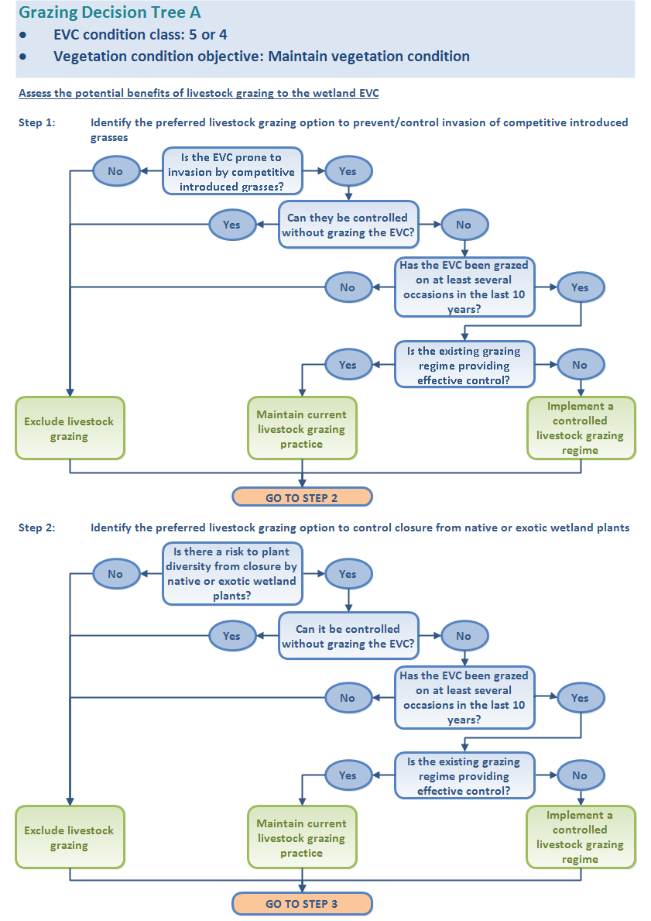

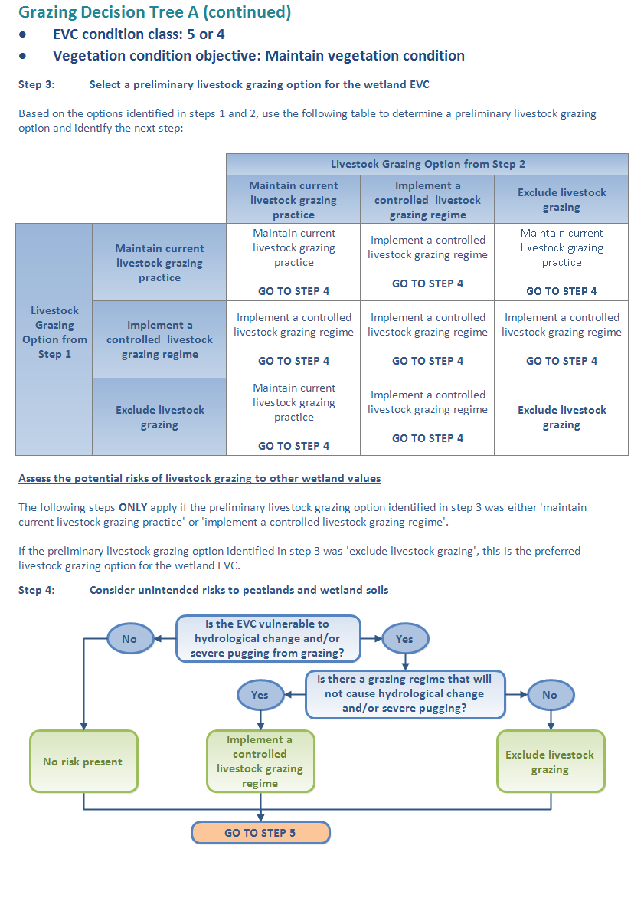

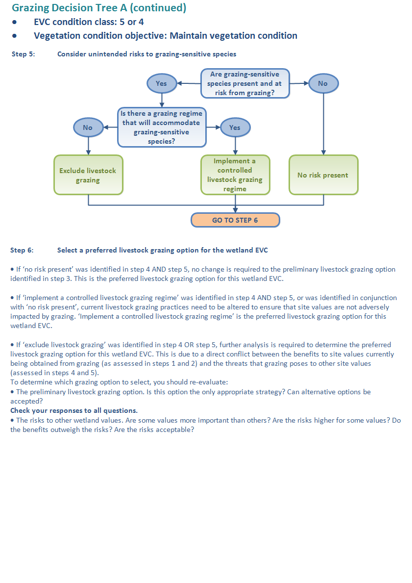

Grazing Decision Tree B

* **EVC condition class: 4**
* **Vegetation condition objective: Improve vegetation condition**

**Overview**

EVCs in condition class 4 are slightly modified or in good condition (see Table 2). The most desirable management objective for this condition class is to improve vegetation condition. For these sites Grazing Decision Tree B overleaf should be used. In cases where landscape-scale threats or funding limit the ability to improve the vegetation condition, maintaining vegetation condition is an acceptable management objective. In these cases Grazing Decision Tree A on page 31 should be used.

**Grazing management considerations**

EVCs in this condition class are of high value and should be protected from potentially damaging activities, including livestock grazing. There are a few instances however when livestock grazing may be a means of supporting these vegetation values. These include when potentially dominant, introduced grazing-palatable plants are established nearby and have started to invade the wetland, and when control through other means is unrealistic, or when biomass reduction is required and other means such as mechanical removal are not suitable.

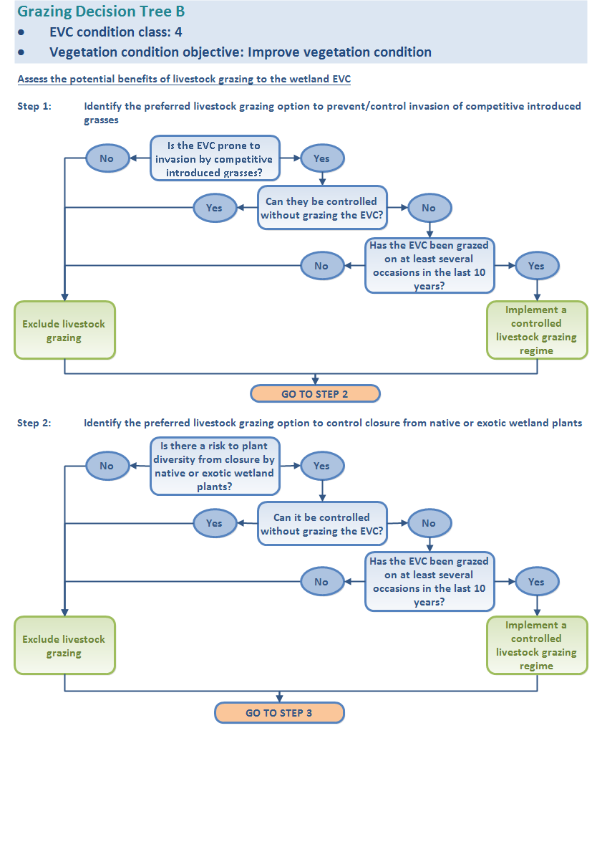

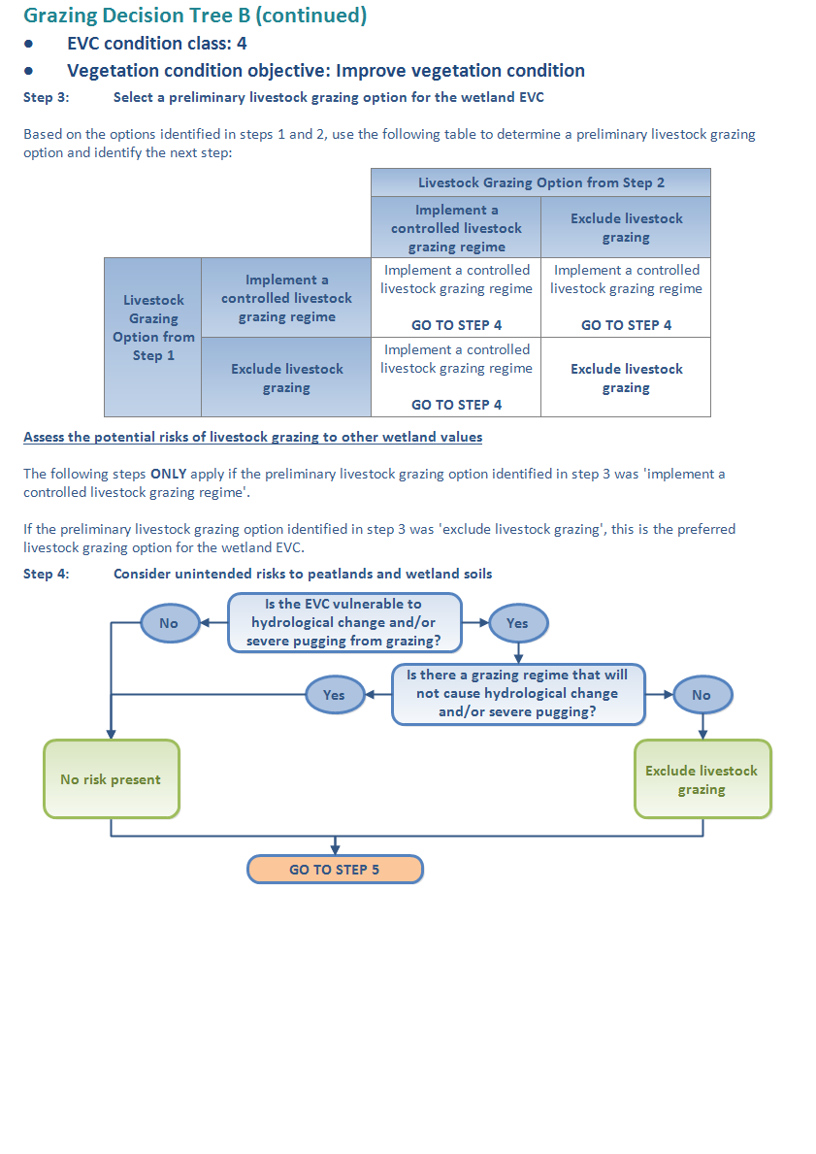

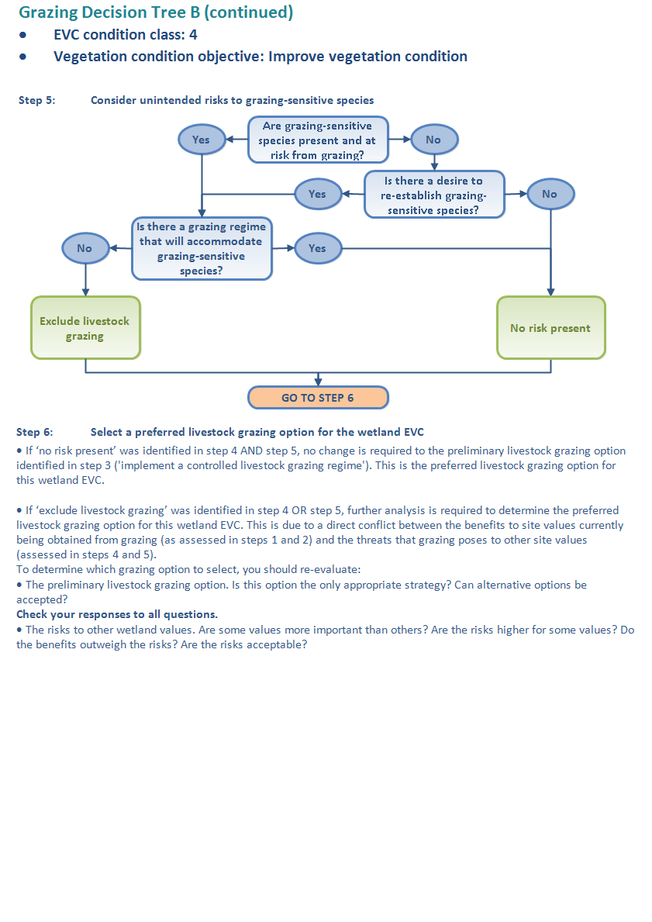

Grazing Decision Tree C

* **EVC condition class: 3**
* **Vegetation condition objective: Improve vegetation condition**

**Overview**

EVCs in condition class 3 are moderately modified or in moderate condition (see Table 2). As the purpose of the decision framework is to identify grazing options that will protect and improve wetland condition, maintaining vegetation in a substantially modified condition is not considered acceptable unless this is required to support significant fauna habitat.

If significant fauna or significant fauna habitat is not present at the wetland, it is desirable to improve the condition of the vegetation and Grazing Decision Tree C overleaf should be used. If significant fauna or significant fauna habitat is present, then managing vegetation condition for fauna habitat is considered acceptable. For these sites Grazing Decision Tree D on page 44 should be used.

**Grazing management considerations**

Vegetation that has been moderately modified presents a challenge for decision-making. For example, grazing-sensitive species may co-occur with serious environmental weeds, in which case successful improvement of condition and values may require very high-level skills in ecological management.

Where a highly invasive palatable grass is present, a grazing regime may be far better than none, even if it also compromises some of the remnant species, because the invasion may pose a greater threat. If it is not realistic to treat the weed invasion using physical or chemical methods, then the optimal management action may be to use a controlled livestock-grazing regime to manage these weeds and prevent a further decline in diversity. Where it is realistic to selectively treat weed invasions with physical or chemical methods, then removing stock will generally favour any potential recovery of the vegetation, even if in the short term this may result in increased abundance of the less serious weed species. Ongoing monitoring of vegetation responses to the selected grazing management option (i.e. outcomes) will best guide adjustments to the implemented grazing regime.

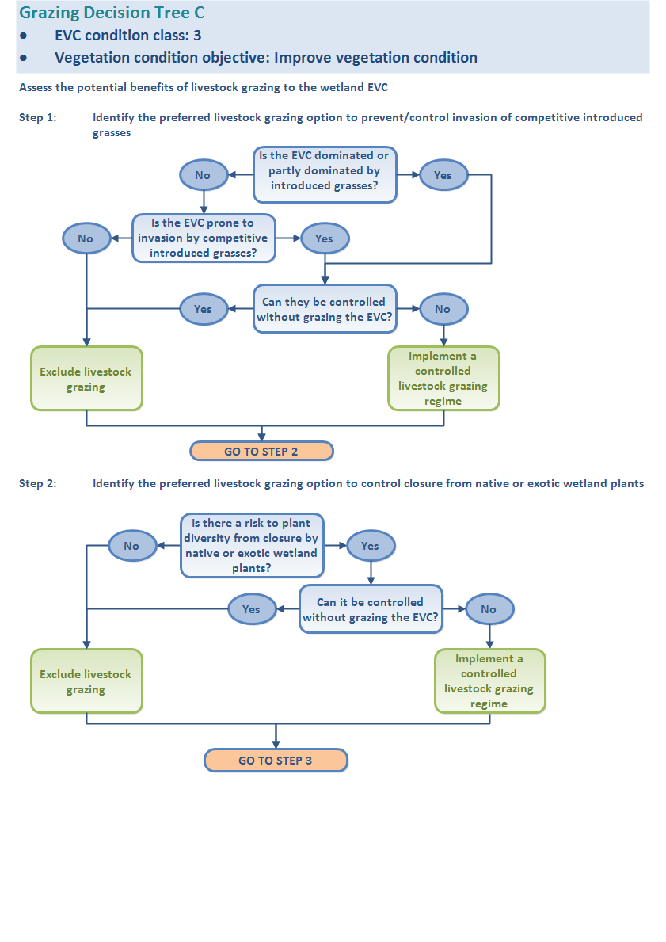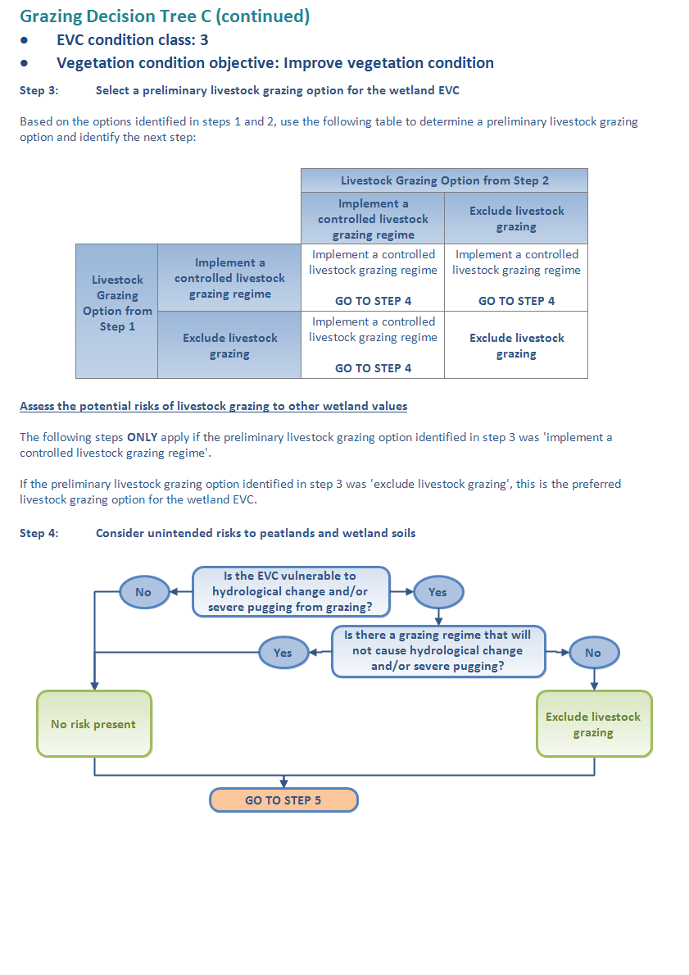

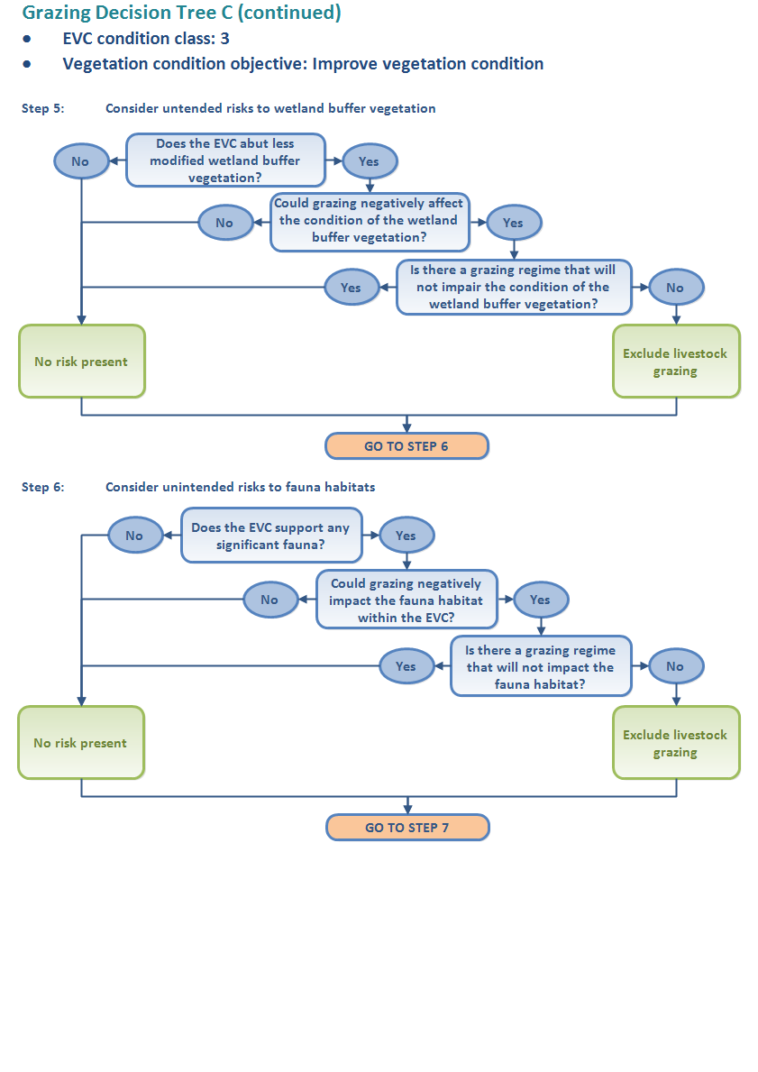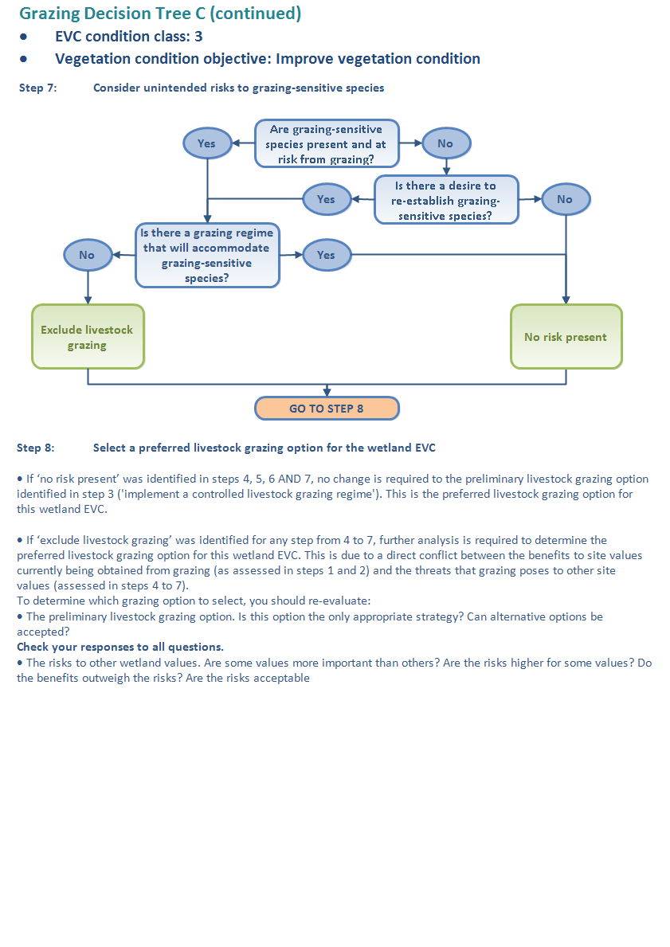

Grazing Decision Tree D

* **EVC condition class: 3**
* **Vegetation condition objective: Manage vegetation for significant fauna habitat**

**Overview**

EVCs in condition class 3 are moderately modified or in moderate condition (see Table 2). As the purpose of the decision framework is to identify grazing options that will protect and improve wetland condition, maintaining vegetation in a substantially modified condition is not considered acceptable unless this is required to support significant fauna habitat.

If significant fauna or significant fauna habitat is present, then managing vegetation condition for fauna habitat is considered acceptable and Grazing Decision Tree D overleaf should be used. If significant fauna or significant fauna habitat is not present at the wetland, it is desirable to improve the condition of the vegetation and Grazing Decision Tree C on page39 should be used.

**Grazing management considerations**

Vegetation that has been moderately modified presents a challenge for decision-making. For example, grazing-sensitive species may co-occur with serious environmental weeds, in which case successful maintenance or improvement of vegetation condition and fauna habitat values may require very high-level skills in ecological management.

Where a highly invasive palatable grass is present that presents a risk to fauna habitat, a grazing regime may be far better than none, even if it also compromises some of the remnant species, because the invasion may pose a greater threat. If it is not realistic to treat the weed invasion using physical or chemical methods, then the optimal management action may be to use a controlled livestock-grazing regime to manage these weeds to protect fauna habitat. Where it is realistic to selectively treat weed invasions with physical or chemical methods, then removing stock will generally favour any potential recovery of the vegetation, even if in the short term this may result in increased abundance of the less serious weed species. Ongoing monitoring of fauna habitat responses to the selected grazing management option (i.e. outcomes) will best guide adjustments to the implemented grazing regime.

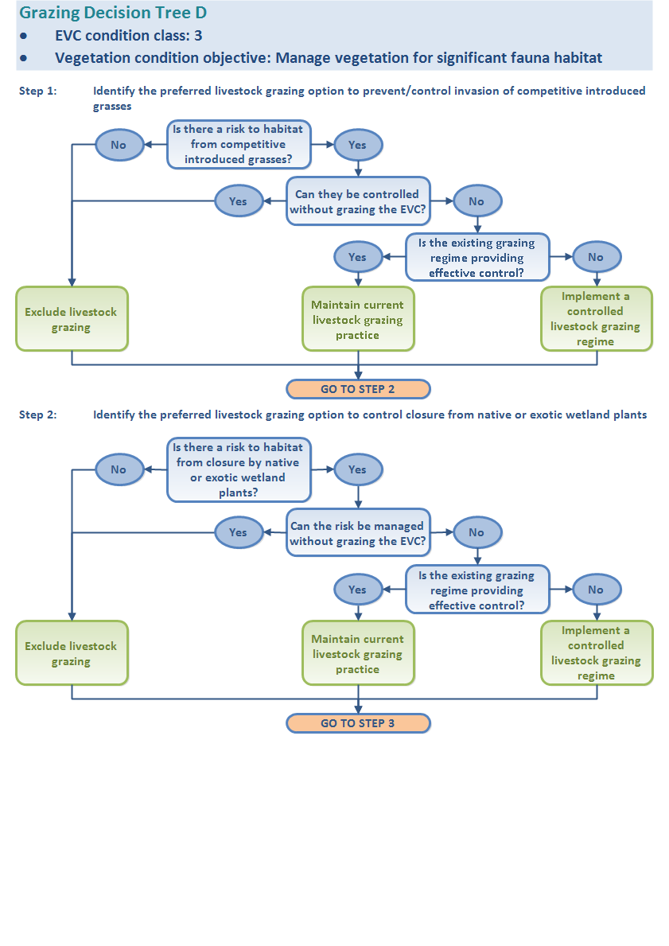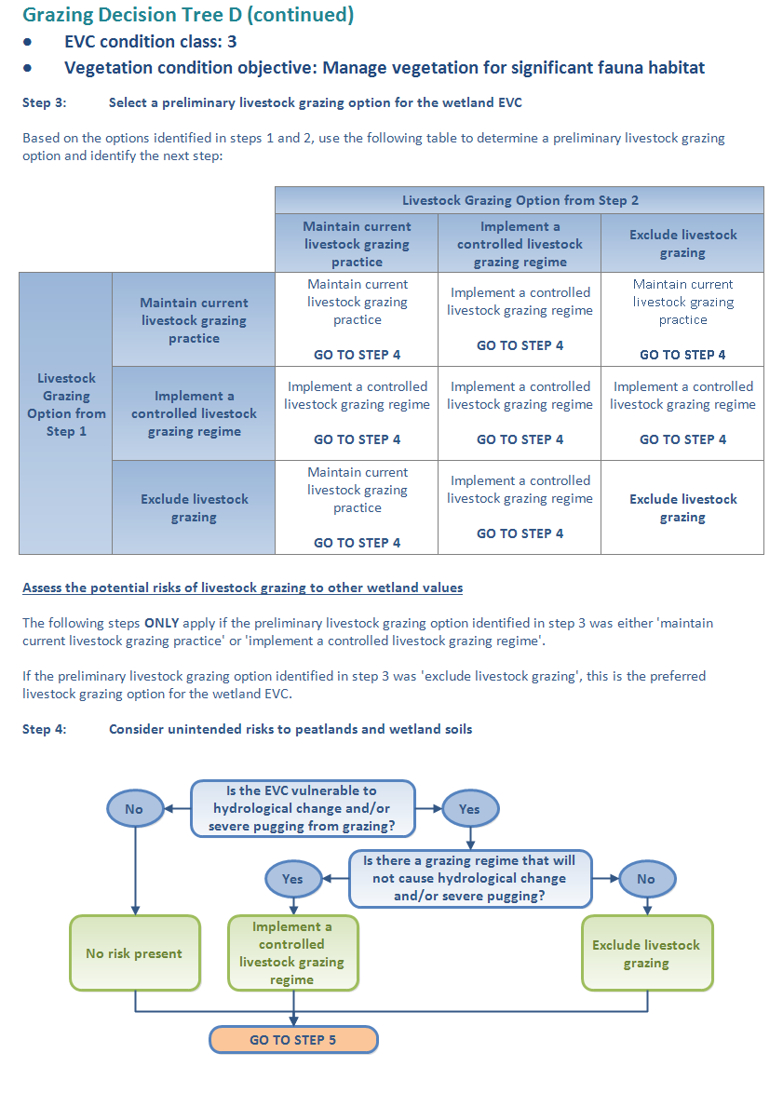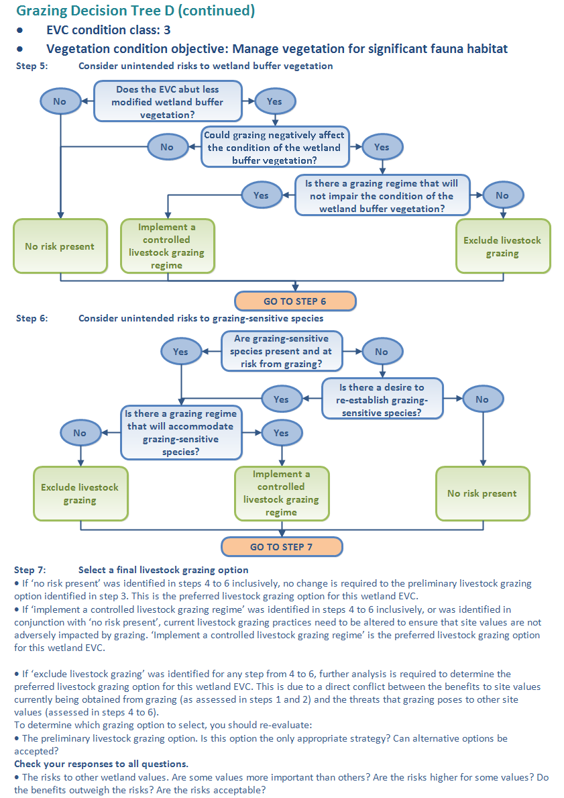

**Grazing Decision Tree D**

* **EVC condition Class: 3**
* **Vegetation condition objective: Manage vegetation for significant fauna habitat**

**Grazing Decision Tree D (continued)**

* **EVC condition Class: 3**
* **Vegetation condition objective: Manage vegetation for significant fauna habitat**

Grazing Decision Tree E

* **EVC condition classes: 2 or 1**
* **Vegetation condition objective: Improve vegetation condition**

**Overview**

EVCs in condition class 2 are substantially modified or in poor condition. EVCs in condition class 1 are severely modified or in very poor condition. As the purpose of the decision framework is to identify grazing options that will protect and improve wetland condition, maintaining vegetation in a substantially modified condition is not considered acceptable unless this is required to support significant fauna habitat.

If significant fauna or significant fauna habitat is not present at the wetland, it is desirable to improve the condition of the vegetation and Grazing Decision Tree E overleaf should be used. If significant fauna or significant fauna habitat is present, then managing vegetation condition for fauna habitat is considered acceptable and Grazing Decision Tree F on page 51 should be used.

**Grazing management considerations**

In general, vegetation in these classes is so modified that grazing is generally unlikely to lead to further rapid deterioration in values. While many plant species are grazing-sensitive under sufficient grazing pressure, highly sensitive species are generally absent from vegetation in these condition classes. Grazing decisions for wetland vegetation in these classes relate to the objective of improving the existing condition or habitat.

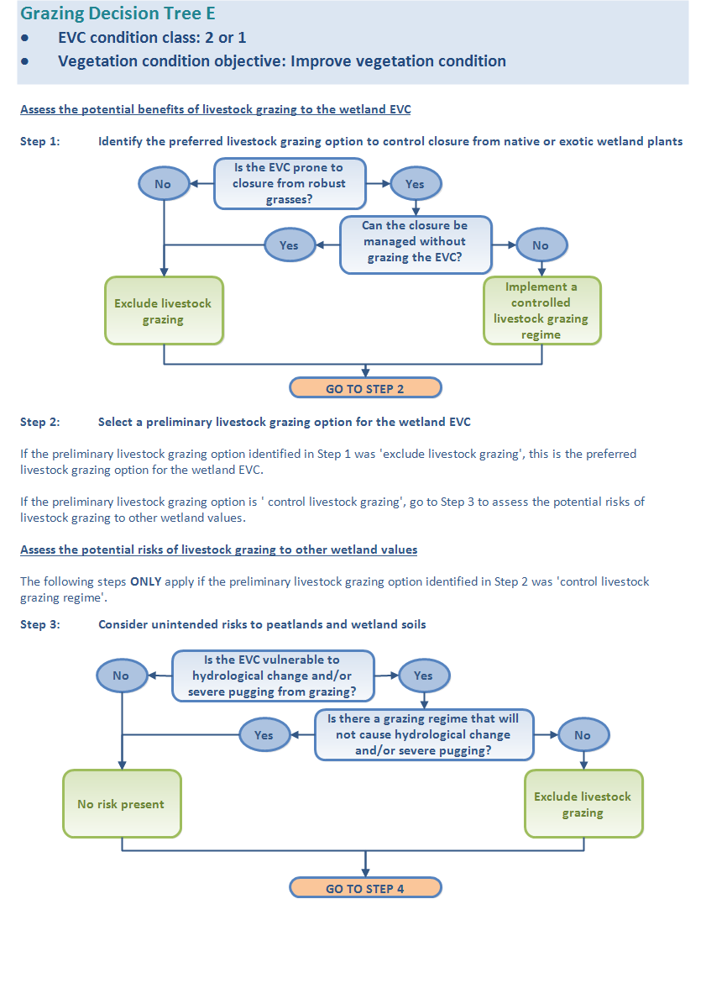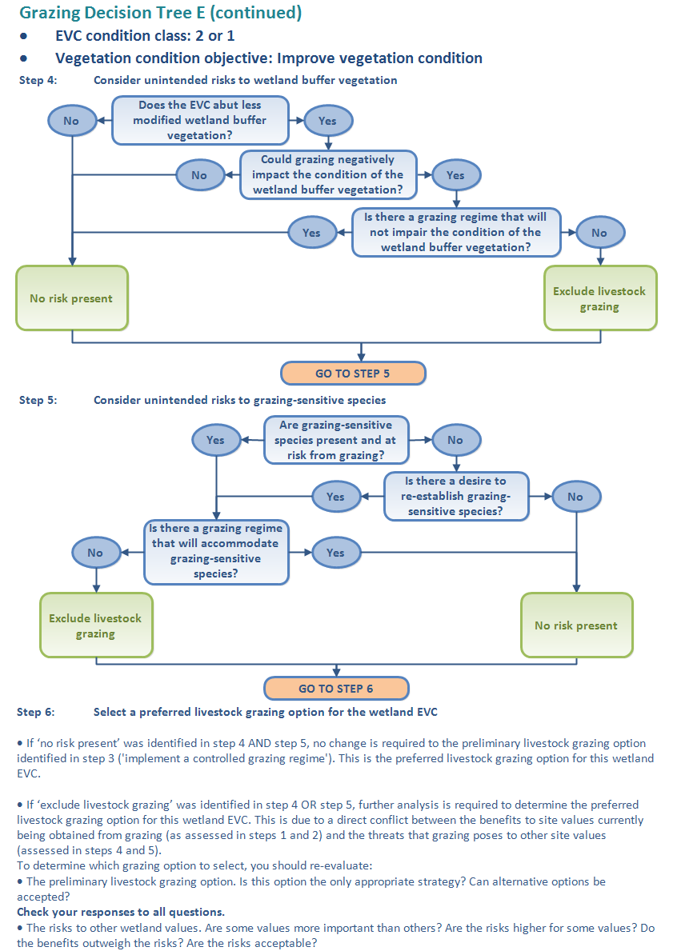

Grazing Decision Tree F

* **EVC condition classes: 2 or 1**
* **Vegetation condition objective: Manage vegetation condition for significant fauna habitat**

**Overview**

EVCs in condition class 2 are substantially modified or in poor condition. EVCs in condition class 1 are severely modified or in very poor condition. As the purpose of the decision framework is to identify grazing options that will protect and improve wetland condition, maintaining vegetation in a substantially modified condition is not considered acceptable unless this is required to support significant fauna habitat.

If significant fauna or significant fauna habitat is present, then managing vegetation condition for fauna habitat is considered acceptable and Grazing Decision Tree F overleaf should be used. If significant fauna or significant fauna habitat is not present at the wetland, it is desirable to improve the condition of the vegetation and Grazing Decision Tree E on page 48 should be used.

**Grazing management considerations**

In general, vegetation in these classes is so modified that grazing is generally unlikely to lead to further rapid deterioration in values. While many plant species are grazing sensitive under sufficient grazing pressure, highly sensitive species are generally absent from vegetation in these condition classes. Grazing decisions for wetland vegetation in these classes relate to the objective of improving the existing condition or existing habitat.

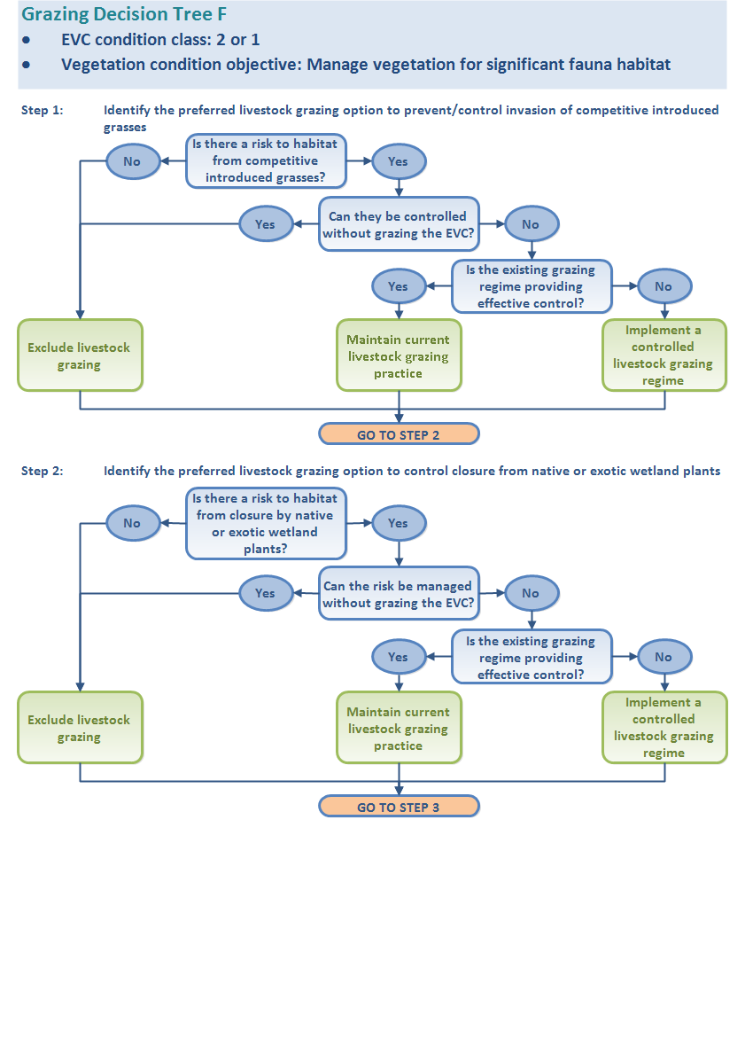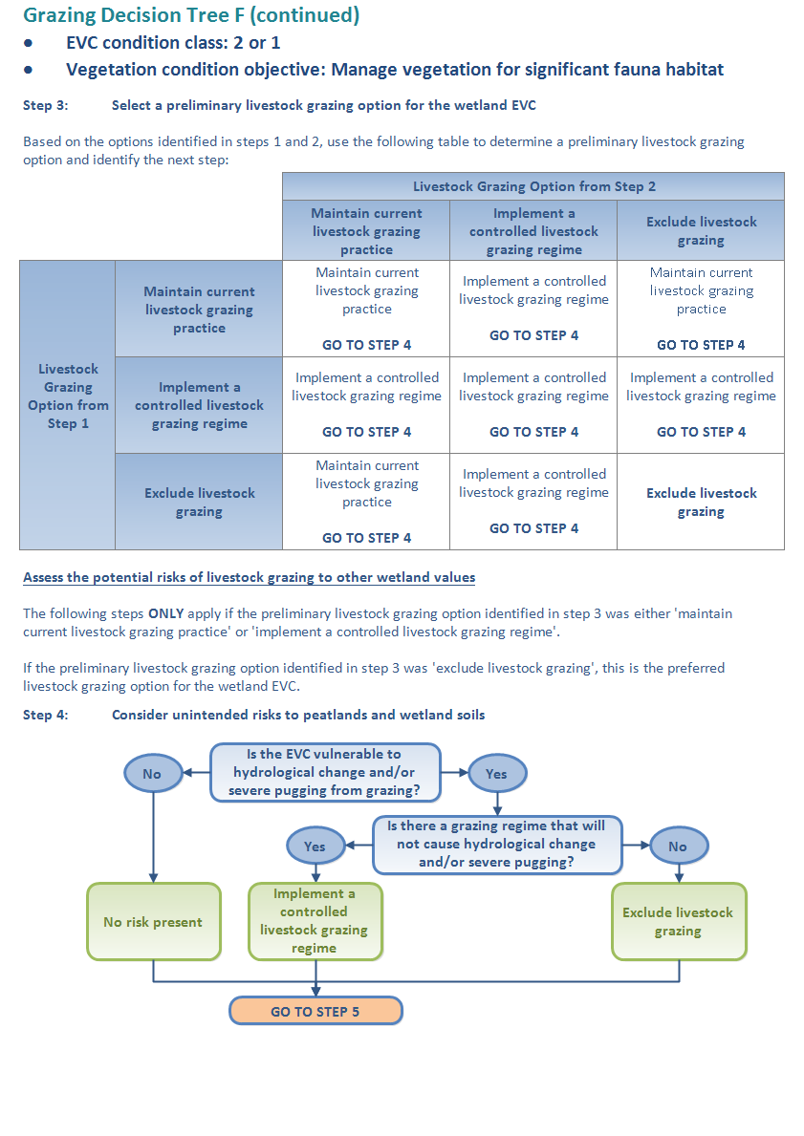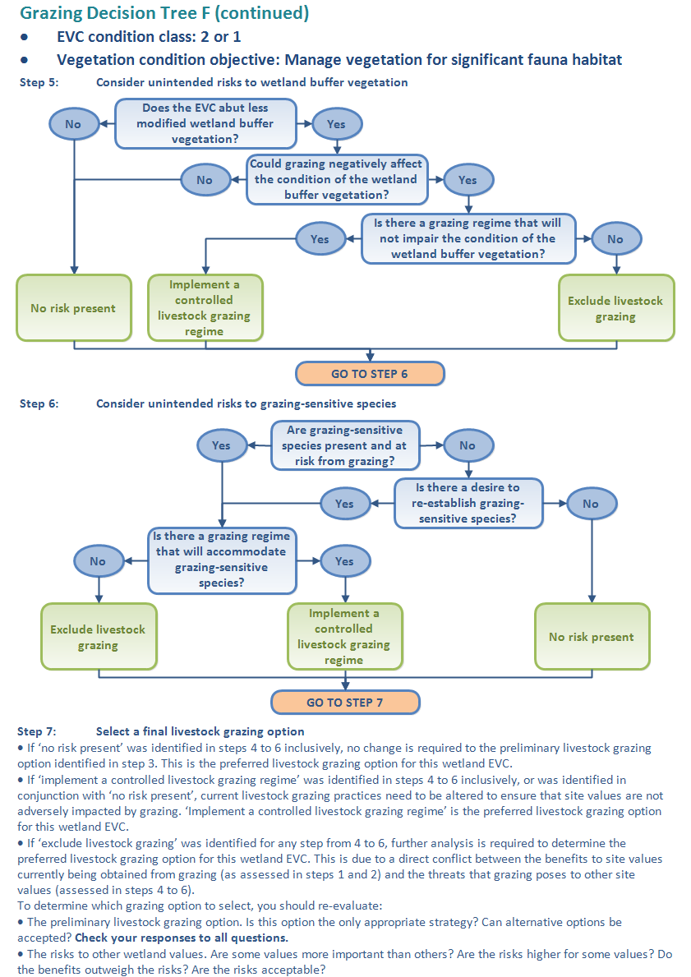

Stage 6: Selecting a final livestock grazing option for the whole wetland

As many wetlands are likely to include more than one EVC and condition class, it is possible that the final *preferred livestock grazing option* selected for each EVC will differ. For example, the decision trees may recommend a controlled grazing regime in one EVC and livestock exclusion in another. If this occurs, the guidance provided below with help determine the best grazing option for the whole wetland.

The first step is to identify if the different livestock grazing options can be implemented (Stage 6a). If this is not possible, then the EVCs are assessed against criteria to identify the grazing option that achieves the most ecological benefit for the wetland (Stage 6b).

If grazing recommendations are the same for all EVCs, this will be the final livestock grazing option for the whole wetland.

Stage 6a: Assess if the different grazing options for the EVCs present in the wetland can be implemented

In some cases the spatial arrangement of the EVCs and/or condition classes that have different grazing management options may allow both options to be applied without compromising the management objectives of either EVC.

To assess if this is possible, the spatial arrangement of areas within the wetland that contain the EVCs and/or condition classes that have different grazing options should be assessed using the mapping that was done in Stage 3. If the EVC or condition classes have a concentric arrangement, as illustrated in Figure 7, it may be possible to manage the inner core and the outer zone differently. For example, where the *controlled grazing* area applies to EVCs in the outer zone of the wetland, and *exclude grazing* applies to EVCs in the inner core, both preferred grazing options may be possible under the following conditions: (i) the outer zone is only grazed with sheep and (ii) sheep only have access to the outer zone when the inner core is wet. This is based on the expectation that sheep will not enter the inner core when it is wet.

If the EVCs and/or condition classes that have different grazing options do not have this spatial arrangement in the wetland, it is unlikely that both options can be implemented. In that case, the final grazing option for the whole wetland should be the one that will deliver the greatest ecological benefit. The criteria in Stage 6b will assist in identifying this option.

EVC 1

*controlled grazing*

Figure 7. Schematic representation of a concentric arrangement of wetland EVCs and/or condition classes within a wetland. In this example, EVC2 (with a preferred grazing option of *exclude grazing*) is enclosed by EVC1 (with a preferred grazing option of *controlled grazing*). In this case, implementing a controlled grazing regime, where sheep only access the wetland when the inner core containing EVC2 is wet will allow both grazing options to be implemented.

Stage 6b: Identify the livestock grazing option that achieves the best ecological benefit for the wetland

The criteria below, in order of priority, provide a prioritisation sequence to guide decision-making where two or more EVCs and/or condition classes are present and the proposed grazing recommendations differ for each of them. Assess each EVC against each criterion, starting at 1. The final livestock grazing option for the wetland will be that of the EVC that rates highest for the first criterion. If two or more EVCs rate equal highest for this criterion, go to the results for the second criterion (and so on, until a clear priority is identified).

1. **EPBC-listed communities or rare or threatened species of flora and/or fauna**Identify whether an EPBC-listed community or rare or threatened species of flora and/or fauna is present in the EVC. These may be grazing-sensitive, closure-sensitive, or requiring structural characteristics related to grazing or exclusion. If competing values occur in the various EVCs, assess the relative value of each EVC for each of the relevant species, considering its overall threatened status and extent of utilisation, or population size and viability. In other words, maximise for the most highly threatened species, allowing for the value of the habitat and level of utilisation.
2. **EVC significance**Compare the Bioregional Conservation Status (BCS) of each wetland EVC[6].
3. **Species diversity**Rank the EVCs to identify which ones support the highest diversity. This is generally based on flora diversity, but could also consider the diversity of fauna that may be associated with a particular EVC.
4. **Condition**Rank each wetland EVC based on vegetation condition.
5. **Area**Approximate the percentage area covered by each wetland EVC relative to the wetland area (to maximise the project area receiving optimum management).

Record on field assessment sheet

Once the criteria for each wetland EVC occurring on the wetland site have been applied, record this information in Table A7 of the field assessment sheet (refer to Appendix A).

Section 2: Principles for best practice controlled livestock grazing in wetlands

In this section, principles for best practice controlled livestock grazing in wetlands are provided. These cover all aspects of the grazing regime, including livestock type, stocking rate and the timing and duration of livestock access in the wetland, as well as supplementary feeding. These principles will assist the development of a livestock grazing management plan. A summary of these principles is provided in Table 5, followed by more detail following the table. Much of this information is contained in reviews such as Morris and Reich (2013) and DEPI (2013c, f). Refer to these publications for additional resources.

Table 5. Livestock grazing practices to avoid (unshaded) and those that will minimise impacts to the wetland (shaded in light blue).

|  |  |
| --- | --- |
| Grazing regime component | Best practice principles |
| Timing of grazing | * Do not graze when soils are saturated or surface water is present (usually winter and spring in most of Victoria, but may also be at other times of the year). * Do not graze during drought periods, when plant growth is reduced and there are large areas of bare ground. * Do not graze during or immediately following events that trigger germination of native species (e.g. heavy rain, fire, floods). * Do not graze when native species that are sensitive to grazing are releasing seed. * Do not graze repeatedly (e.g. annually) when species are setting seed. * Do not graze when replanting has occurred. * Do not graze when native plants are establishing. * Do not graze when fauna (e.g. turtles, waterbirds, frogs) are breeding. |
| * Consider grazing for short periods when weed abundance is high and prior to them setting seed. * Consider grazing when native plants are likely to be dormant – in Victoria this is usually from late summer to early winter. |
| Stocking rate | * Do not graze when there is a large amount of bare ground and evidence of soil erosion. * Do not graze at medium-to high-density stocking rates, unless for very short periods when the soils are not waterlogged or flooded. |
| * Consider the total grazing pressure exerted by livestock, native herbivores and feral animals when determining stocking rates. * Regularly reassess the stocking rate based on vegetation responses. |
| Type of grazing animal | * Do not allow cattle to access waterlogged or flooded areas. * Do not graze with cattle where there are grazing-sensitive shrubs and trees. |
| * Consider using sheep instead of cattle in sites that have waterlogged or flooded areas. * Consider using smaller stock (e.g. weaners instead of cows) to reduce impacts on wetland soils, provided the higher pathogen load associated with weaners is not a consideration. |

Table 5. Livestock grazing practices to avoid (unshaded) and those that will minimise impacts to the wetland (shaded in light blue). (continued).

|  |  |
| --- | --- |
| Grazing regime component | Best practice principles |
| Supplementary feeding/managing livestock access in the wetland | * Do not store or use supplementary feed (e.g. hay) at a wetland site. * Do not allow sheep that have not been recently shorn to access a wetland. * Do not allow livestock to graze on the site before weed seeds they may have ingested in the paddocks have passed through their systems. |
| * Consider creating watering points >100 m from the wetland. * Consider establishing shady areas >100 m from the wetland. * Consider locating stock crossings >100 m away from the wetland. * Consider creating watered pastures >100 m away from the wetland. * Consider providing supplements/licks >100 m away from the wetland. |

Timing of grazing

Controlled grazing may involve excluding grazing at particular times of the year. The optimum time for controlled grazing is when the wetland soil moisture is relatively low (to avoid or minimise soil impacts) and native plants are likely to be dormant (i.e. growth rates are low and they are not flowering or setting seed). This is usually from late summer to early winter. There are several instances when grazing should be excluded. These are:

Excluding grazing during the growth phase of native plants or when setting seed

* When native plants are entering their annual growth phase, heavy grazing can make them less able to send out new growth and develop healthy root systems. Healthy root systems increase the resilience of plants in times of drought stress and are important in protecting the condition of the wetland by binding the soil and recycling nutrients.
* Grazing should be avoided when native plants sensitive to grazing are in flower or setting seed. This is usually in spring and early summer, but it is important to understand the life-cycle characteristics of the particular wetland plant species at the wetland site (and especially the life cycles of important functional groups and endangered species), and plan accordingly. It is also important not to repeatedly graze (e.g. annually) when plants are setting seed.

Excluding grazing where there are juvenile plants

* If there has been natural regeneration or replanting of trees and shrubs, do not graze until plants are beyond browsing height (normally after 3–5 years).
* Do not graze if there are short-statured understorey species regenerating on the site: livestock are likely to trample and kill them.

Excluding grazing to minimise soil impacts

Flexibility is an important consideration when grazing, because seasonal conditions will vary from year to year and affect the species composition and vegetation structure in a wetland. Irrespective of the time of year, controlled grazing should not be used:

* When the soil is very moist (typically in winter, although possibly at any time of year, including after heavy rain): bringing livestock into a wetland when the soil is very moist will result in pugging and soil compaction; and
* When the soil is very dry (such as during a drought): when the soil is very dry, the vegetation at ground level may be very sparse, leading to overgrazing and soil erosion.

Grazing stocking rate

The stocking rate and duration of grazing should be set according to the characteristics of the site and adjusted according to the current conditions. To determine the optimum regime, consider the sensitivity of species present at the site to grazing and the overall species composition of the wetland site. Highly palatable species can be under severe grazing pressure, even when there is a substantial cover of vegetation and the appearance of abundant feed.

The grazing preferences of livestock and the growth phases of plants should be used to inform the grazing regime applied at the site. A list of some species that are particularly sensitive to grazing is provided on page 26.

Type of grazing animal

Controlled grazing may include using a particular type of grazing animal. Most grazing animals tend to graze selectively, preferring some species and avoiding others. This is often detrimental to the most palatable, accessible and actively growing plant species. There are substantial and well-known differences between how cattle and sheep graze, and the pressure they put on vegetation. However, rather than be prescriptive about the type of grazing that is best for a wetland site, be aware of the differences in the grazing pressures likely to be exerted by sheep and cattle and plan accordingly. For example:

* the grazing pressure, represented by the dry mass of vegetation consumed per animal per day, of one cow is equivalent to that of eight sheep, 11 goats, 12 kangaroos or 133 rabbits (Lu 1988; Burritt and Frost 2006)
* sheep are more selective grazers than cattle
* sheep prefer to graze and bed on elevated areas, whereas cattle will enter wet low-lying areas
* sheep graze closer to the ground than cattle, which inhibits recruitment of trees and shrubs
* sheep tend to pug the soil less than cattle
* fencing costs will be cheaper for cattle if electric fencing is an option.

The decision framework does not prescribe one type of grazing animal over another: it is important to know the particular impacts of the grazing animals you have in mind, and address these when considering options.

It is also important to take into account the grazing pressure exerted by wild herbivores. These include feral animals such as goats, rabbits, deer and horses, as well as native animals such as kangaroos and waterbirds (e.g. swans). Where there is significant grazing by these animals, the level of livestock grazing that can be sustained will be greatly reduced (Morris and Reich 2013). An understanding of total grazing pressure, along with the productivity of the land is needed to determine livestock grazing densities that are sustainable.

Supplementary feeding and managing livestock access in the wetland

Grazing must consider measures to minimise the risk of weed seed dispersal in and out of the wetland. Follow these principles:

1. Do not use, or allow to be stored, supplementary feed sources (such as hay bales) in the wetland. There is a risk that the seeds from these will establish in the wetland.
2. Remember that there may be viable weed seeds in the gut of livestock. Where there are weeds in paddocks, but not in the wetland, ensure that livestock do not graze in the wetland until any weed seeds they ingested in the paddocks have passed through their digestive system.
3. Do not use sheep for controlled grazing in the wetland until after they are shorn to ensure they do not bring weed seeds into the wetland. Sheep carry many kinds of weed seeds in their wool.
4. When moving livestock from a wetland following grazing, it is best to keep them in a controlled area (e.g. a stock containment area) until they have passed any weed seeds they ingested, to prevent them introducing weeds to other locations.

Section 3: Monitoring, evaluating and revising the grazing options

Before implementing a livestock grazing plan, developing a monitoring plan is highly recommended. This will be used to assess the extent to which the grazing achieves the project’s management outcome targets and to detect any adverse responses to grazing. A monitoring plan should include consideration of the following elements:

* design
* evaluation questions and indicators
* monitoring schedule
* data management
* quality assurance and quality control
* evaluation.

This guide does not provide a framework for monitoring grazing, however some guiding principles are outlined below.

Design

The monitoring design, measurements and frequency of monitoring should be guided by the vegetation condition objectives and the initial vegetation condition classes of the EVCs in the wetland.

In general, wetlands that contain EVCs in good condition, or that have populations of threatened species, will require a more rigorous monitoring program than poorer-quality sites. This is because these sites are more likely to degrade if the grazing regime is wrong. Also, the consequences of degradation are higher (due to their higher quality). Therefore, early warning and good detection are necessary.

For high-quality sites, a rigorous monitoring program should be developed that includes monitoring of control sites that may be in the same wetland. Control sites are sites where the current grazing regime and initial vegetation condition are comparable with those of the wetland site, but where the grazing regime is not changed. Monitoring both the control and the management sites should be done before and after the new grazing regime is implemented at the management site. The value of this approach is that it allows strong inferences to be made on the effectiveness of the selected grazing regime as it accounts for natural variation.

Evaluation questions and indicators

The monitoring program should aim to assess whether the vegetation condition objectives for the site have been achieved, and if any adverse responses to the grazing regime have occurred. Evaluation questions should align with the management outcome targets identified in Stage 4 and recorded on the field assessment sheets (Appendix A). Evaluation questions should be used to guide the selection of appropriate and sensitive indicators. Some examples of evaluation questions and indicators are provided in Table 6.

In some instances it may be possible to develop evaluation questions that include quantitative targets or action criteria. A target is typically a quantitative change in an indicator, for example a 20% increase in the cover of native vegetation. Action criteria are values of an indicator that trigger a management action. For example, when the cover of bare ground increases above a certain level, such as 30%, livestock must be removed.

For each indicator, best practice methods should be identified and documented and data sheets provided to allow the methods to be consistently applied and documented by assessors.

Table 6. Example evaluation questions and monitoring indicators.

|  |  |
| --- | --- |
| Evaluation questions | Indicators |
| Did the applied grazing regime increase the cover of grazing-sensitive wetland species? | Percentage cover of grazing-sensitive species |
| Did the applied grazing regime reduce the cover of competitive introduced grasses? | Percentage cover of competitive introduced grasses |
| Did the applied grazing regime increase the cover of indigenous species? | Percentage cover of each indigenous species |
| Did the applied grazing regime maintain the diversity of indigenous species? | Number of indigenous species per unit area |
| Did the applied grazing regime maintain the cover of the key structural plant species required by the target significant fauna species? | Percentage cover of key structural plant species |
| Did the applied grazing regime maintain or increase the abundance of the target significant fauna species? | Increased number of sightings of target fauna species |

Monitoring schedule

The frequency of monitoring should be based on the expected response times of the selected indicators. As many components of the wetland will respond quickly to changes in grazing regime, it is recommended that sites are monitored before the selected grazing regime is applied and no longer than one year after it has been implemented. Components of the wetland that are present at a site and considered very sensitive to grazing (i.e. sensitive flora species) may need to be monitored earlier (i.e. within weeks/months) to ensure that the grazing regime can be adjusted before any significant adverse effects occur.

Data management

Clear protocols for collating, storing and checking the monitoring data (including appropriate metadata[7]) should be developed and followed.

Evaluation

In the evaluation phase, the data collected from monitoring is analysed and used to:

1. answer the evaluation questions identified for a management site
2. assess whether the grazing regime is heading towards the achievement of the vegetation condition target(s) for the site.

Quality assurance and quality control

Monitoring programs require data of high quality and consistency. Quality assurance and quality control measures (QA QC) are designed to assure and test, respectively, that a set standard of quality is achieved. The following considerations should be part of a QA QC plan:

1. Ensure assessor competence in the assessment procedures and data entry.
2. Perform audits to assess accuracy of monitoring.
3. Obtain stakeholder feedback.

Adaptive management

The evaluation process will provide evidence that will help assess whether the applied grazing regime is achieving your management targets and whether the grazing regime requires adjustment. Over time the condition of wetland vegetation will change in response to the applied grazing regime, and it will be necessary to reassess the site to ensure the grazing management option you selected still suits the site’s vegetation condition.

Knowledge from the evaluation process not only informs the ongoing management of grazing in a wetland, but can be used to inform an evaluation of the grazing decision trees. Where the evaluation supports the relationships in the grazing decision trees, there will be greater confidence in the tool. Where the evaluation suggests that grazing produces a different response to that represented in the grazing decision trees, then this knowledge should be used to refine the decision tool to better represent the possible range of responses.

As data is gathered from robust monitoring programs throughout the state, this will improve the understanding of which grazing regimes are most effective in achieving vegetation condition objectives and how variation in vegetation condition or landscape context (e.g. climate or adjacent land use) influence the success of grazing management.

References

Burritt, E. and Frost, R. (2006). Animal behaviour, principles and practices. Pages 10–21 *in* Launchbaugh, K. (ed.) *Targeted Grazing: a Natural Approach to Vegetation Management and Landscape Enhancement.* American Sheep Industry Association (ASI), Centennial, CO, USA.

DELWP. *Victorian Biodiversity Atlas*. Department of Environment, Land, Water and Planning, East Melbourne, Victoria. <https://vba.dse.vic.gov.au/vba/>

DELWP. *Index of Condition System*. Department of Environment, Land, Water and Planning, East Melbourne, Victoria. <http://ics.water.vic.gov.au/ics/>

DEPI. (2013a). *Benchmarks for wetland ecological vegetation classes in Victoria*. Department of Environment and Primary Industries, East Melbourne, Victoria.

DEPI. (2013b). *Improving our waterways. Victorian Waterway Management Strategy.* Department of Environment and Primary Industries, East Melbourne, Victoria.

DEPI. (2013c). *Managing grazing on riparian land. Decision support tool and guidelines*. Department of Environment and Primary Industries, East Melbourne, Victoria.

DEPI. (2013d). *Index of Wetland Condition assessment procedure September 2013*. Department of Environment and Primary Industries, East Melbourne, Victoria.

DEPI. (2013e). *Advisory list of threatened vertebrate fauna.* Department of Environment and Primary Industries, East Melbourne, Victoria.

DEPI. (2013f). Wetland Tender: Field Officer Manual. State of Victoria, Department of Environment and Primary Industries, East Melbourne, Victoria (unpublished).

DEPI. (2014). *Advisory list of rare or threatened plants in Victoria.* Department of Environment and Primary Industries, East Melbourne, Victoria.

DEWHA. (2009). *Alpine sphagnum bogs and associated fens. A nationally threatened ecological community. Environment Protection and Biodiversity Conservation Act 1999. Policy Statement 3.16*. Department of the Environment, Water, Heritage and the Arts, Australian Government.  
<http://www.environment.gov.au/system/files/resources/b08acec6-6a27-4e71-8636-498719b253b4/files/alpine-sphagnum-bogs.pdf>

DSE. (2005a). *Index of Wetland Condition. Conceptual framework and selection of measures*. Department of Sustainability and Environment, East Melbourne, Victoria  
<http://www.depi.vic.gov.au/__data/assets/pdf_file/0017/204083/IWC_Conceptual_Framework_and_Selection_of_Measures_2005.pdf>

DSE. (2005b). *Advisory list of rare or threatened plants in Victoria – 2005*. Department of Sustainability and Environment, East Melbourne, Victoria.

DSE. (2009). *Advisory list of environmental weeds of the aquatic habitats of Victoria.* Department of Sustainability and Environment, East Melbourne, Victoria.

DSE. (2012). *Index of Wetland Condition assessment of wetland vegetation update – December 2012.* Department of Sustainability and Environment, East Melbourne, Victoria.

EPA. (2010). Environmental quality guidelines for Victorian lakes. Environment Protection Authority. Melbourne, Victoria.

Lu, C.D. (1988). Grazing behavior and diet selection of goats. *Small Ruminant Research* **1**, 205–216.

Millennium Ecosystem Assessment. (2003). Ecosystems and Human Well-being*.* A Framework for Assessment. World Resources Institute, Washington, DC.

Morris, K. and Papas, P. (2012). *Wetland conceptual models: associations between wetland values, threats and management interventions. Version one.* Arthur Rylah Institute for Environmental Research Technical Report Series No. 237. Department of Sustainability and Environment, Heidelberg, Victoria.

Morris, K. and Reich, P. (2013). *Understanding the relationship between livestock grazing and wetland condition.* Arthur Rylah Institute for Environmental Research Technical Report Series No. 252. Department of Environment and Primary Industries, Heidelberg, Victoria.

Appendix A – Field assessment sheet

**Background information**

|  |  |  |  |  |
| --- | --- | --- | --- | --- |
| **Landholder** | **Name:** |  | **Phone No:** |  |
| **Address:** |  | | |

|  |  |  |  |  |
| --- | --- | --- | --- | --- |
| **Assessor** | **Name** |  | **Date:** |  |

|  |  |  |  |  |
| --- | --- | --- | --- | --- |
| **Site location** | **Bioregion** |  | **Easting** |  |
| **Nearest town** |  | **Northing** |  |

|  |  |  |
| --- | --- | --- |
| **Grazing history** | **Number of years over which grazing has occurred at the wetland** |  |
| **Number of years the current grazing practice has been in place** |  |

Table A1. Historic and current livestock grazing practices.

|  |  |  |
| --- | --- | --- |
|  | **Historic (up to the past 20 years)** | **Current** |
| **Livestock grazing practice** |  |  |
| **Type of grazing animal** |  |  |
| **Timing of grazing e.g. summer** |  |  |
| **Timing variations** |  |  |
| **Duration e.g. two weeks** |  |  |
| **Stocking rate** |  |  |
| **Reasons for grazing practice** |  |  |
| **Supplementary feeding (yes/no)** |  |  |
| **Managing livestock access to and away from the wetland** |  |  |

Enter *unknown* where applicable.

Table A2. Wetland EVCs occurring on the wetland site.

|  |  |  |  |  |  |  |  |
| --- | --- | --- | --- | --- | --- | --- | --- |
| **Wetland Vegetation** | | | | | | | |
| **Ecological Vegetation Class** | | | **Condition class** | | | | |
| **No.** | **Name** | **% cover of wetland area** | **5** | **4** | **3** | **2** | **1** |
|  |  |  |  |  |  |  |  |
|  |  |  |  |  |  |  |  |
|  |  |  |  |  |  |  |  |
|  |  |  |  |  |  |  |  |
|  |  |  |  |  |  |  |  |

Table A3. Significant flora and fauna species or suitable fauna habitats occurring on the wetland site.

|  |  |  |
| --- | --- | --- |
| **Species** | **Species observed on site** | **Potential habitat on site** |
|  | 🞏 | 🞏 |
|  | 🞏 | 🞏 |
|  | 🞏 | 🞏 |
|  | 🞏 | 🞏 |
|  | 🞏 | 🞏 |
|  | 🞏 | 🞏 |

Table A4. Other wetland values for the wetland site.

|  |
| --- |
| **Other wetland values (social, cultural and/or economic)** |
|  |

Table A5. Vegetation condition objective.

|  |  |  |  |  |  |  |  |
| --- | --- | --- | --- | --- | --- | --- | --- |
| **EVC name and number** | **Vegetation condition** | | | **Vegetation condition for significant fauna** | | | |
| **Maintain** | **Improve** | **Timeframe** | | **Maintain** | **N/a** | **Timeframe** |
|  | 🞏 | 🞏 |  | | 🞏 | 🞏 |  |
|  | 🞏 | 🞏 |  | | 🞏 | 🞏 |  |
|  | 🞏 | 🞏 |  | | 🞏 | 🞏 |  |
|  | 🞏 | 🞏 |  | | 🞏 | 🞏 |  |
|  | 🞏 | 🞏 |  | | 🞏 | 🞏 |  |
|  | 🞏 | 🞏 |  | | 🞏 | 🞏 |  |

Table A6. Management outcome targets.

|  |  |  |
| --- | --- | --- |
| **EVC name and number** | **Management outcome targets** | **Expected response time** |
|  |  |  |
|  |  |  |
|  |  |  |
|  |  |  |
|  |  |  |
|  |  |  |

Table A7. Key criteria for selecting a final livestock grazing option.

|  |  |  |  |  |  |  |
| --- | --- | --- | --- | --- | --- | --- |
| **EVC name and number** | **Preferred grazing option** | **Criteria** | | | | |
| **1** | **2** | **3** | **4** | **5** |
|  |  |  |  |  |  |  |
|  |  |  |  |  |  |  |
|  |  |  |  |  |  |  |
|  |  |  |  |  |  |  |
|  |  |  |  |  |  |  |
|  |  |  |  |  |  |  |

Criterion 1: Rare or threatened flora/fauna. Rank each EVC (**high, med, low**) based on its function in supporting identified species.

Criterion 2: EVC significance. List the Bioregional Conservation Status of each EVC i.e. **endangered, vulnerable, rare**.

Criterion 3: Species diversity. Rank each EVC (**high, med, low**) based on its function in supporting diversity.

Criterion 4: Condition. List the vegetation class for each EVC (**5, 4, 3, 2, 1**), as determined in Phase 2.

Criterion 5: Area. Approximate percentage area covered by each wetland EVC relative to the wetland site area.

**Final grazing option for the wetland (tick one):**

|  |  |
| --- | --- |
| Maintain current livestock grazing practice | 🞏 |
| Implement a controlled livestock grazing regime | 🞏 |
| Exclude livestock grazing | 🞏 |

Table A8. Recommended livestock grazing regime for the wetland.

|  |  |
| --- | --- |
|  | **Recommendation** |
| **Livestock grazing practice** |  |
| **Type of grazing animal** |  |
| **Timing of grazing, e.g. summer** |  |
| **Timing variations** |  |
| **Duration, e.g. 2 weeks** |  |
| **Stocking rate** |  |
| **Reasons for grazing practice** |  |
| **Supplementary feeding (yes/no)** |  |
| **Managing livestock access to and away from the wetland** |  |

|  |  |
| --- | --- |
| **Date the new livestock grazing regime is to be commenced** |  |
| **Date the new livestock grazing regime is to be reassessed** |  |

Appendix B – Environmental, social, cultural and economic values identified in the VWMS[8]

Table B1. Environmental, social, cultural and economic values identified in the VWMS.

|  |  |
| --- | --- |
| **Environmental values category** | **Specific value** |
| Formally recognised significance | * International Significance   + Ramsar Sites   + East Asian–Australasian Flyway Sites |
| * National Significance   + Nationally Important Wetlands   + Living Murray Icon Sites   + National Heritage Sites |
| * State Significance   + Heritage Rivers   + Essentially Natural Catchments   + Victorian Parks and Reserves   + Victorian Heritage Sites |
| Representativeness | * Representative Wetlands (to be determined) |
| Rare or threatened species/communities | * Significant fish * Significant birds * Significant amphibians * Significant invertebrates * Significant reptiles (aquatic) * Significant reptiles (riparian) * Significant mammals * Significant flora * Significant wetland Ecological Vegetation Communities |
| Naturalness | * Aquatic invertebrate community condition (to be determined) * Native fish (to be determined) * Wetland vegetation condition |
| Landscape features | * Drought refuges * Important bird habitats * Biosphere reserves |

(*Continued on next page)*

Table B1. Environmental, social, cultural and economic values identified in the VWMS (continued).

|  |  |
| --- | --- |
| **Social value category** | **Specific social value** |
| Activity | * Recreational fishing * Non-motor boating * Motor boating * Camping * Swimming * Beside water activities * Game hunting |
| Place | * Landscape |
| People | * Community groups * Use of flagship species |
| **Cultural value category** | **Specific cultural value** |
| Heritage | * Aboriginal cultural heritage * Post-European cultural heritage |
| **Economic value category** | **Specific economic value** |
| Water | * Urban/Rural township water sources * Rural water sources for production * Water storages * Water carriers * Wastewater discharges |
| Power generation | * Hydroelectricity |
| Other resources | * Commercial fishing * Extractive industries * Timber harvesting and firewood collection |

Appendix C – Rationale applied in the decision trees for selecting livestock grazing options

Table C1. Hierarchy and rationale for selecting a *preliminary livestock grazing option* when the options for controlling competitive grasses and preventing vegetation closure differ.

|  |  |
| --- | --- |
| Hierarchy for selecting a preliminary grazing option | Rationale |
| *Control* is selected over *Maintain* | *Control* is selected over *Maintain* because the grazing regime can be designed so that it provides the same/similar benefits to the current grazing practice, as well as managing the other threat.  In contrast, *Maintain* would mean that a threat is not adequately managed. |
| *Control* is selected over *Exclude* | *Control* is selected over *Exclude* because a carefully managed grazing regime is required to manage one of the threats. In contrast, *Exclude* will mean that one of the threats is not adequately managed. The other threat is either not present, or can be managed without grazing. |
| *Maintain* is selected over *Exclude* | *Maintain* current livestock grazing practice is selected over *Exclude* because it is required to manage one of the threats. The other threat is either not present, or can be managed without grazing. |

Table C2. Process and logic for selecting the preferred livestock grazing option for the EVC when the *preliminary* grazing options and the assessment of potential impacts of grazing differ.

|  |  |  |
| --- | --- | --- |
| Preliminary grazing option | Assessment of impacts | Preferred livestock grazing option for the wetland EVC |
| Control | *No risks present* selected for all responses | Controlled livestock grazing regime |
| Maintain | *No risks present* selected for all responses | Maintain the current grazing practice |
| Control | *Control* selected for all responses or in conjunction with a *No risks present* response | The controlled grazing regime needs to be modified to manage the identified risks |
| Maintain | *Control* selected for all responses or in conjunction with a *No risks present* response | The current grazing practice needs to be changed to a controlled livestock grazing regime that manages the impacts identified |
| Maintain | *Exclude* selected for any response | Further analysis required |
| Control | *Exclude* selected for any response | Further analysis required |



www.delwp.vic.gov.au

1. Refer to Appendix B for a list of environmental, social, cultural and economic values identified in the VWMS.
2. <http://ics.water.vic.gov.au/ics/files/IWC_Assessment-of-Wetland-Vegetation-Update_December_2012.pdf>
3. <http://ics.water.vic.gov.au/ics/files/IWC_Assessment_Procedure.pdf>
4. The Corrick wetland ID is the wetland ID in the former WETLAND_1994 geospatial layer, which uses the former Victorian wetland classification system (also known as the Corrick system). It is a 10-digit number based on the location coordinates of the wetland (in AGD 66 datum), this being the four-digit 1:100,000 topographic mapsheet number and the six-figure easting and northing.
5. Actions statements can be located by searching ‘Action Statements’ on the DELWP website: www.delwp.vic.gov.au
6. The BCS wetland EVC database will be made available to CMAs.
7. Metadata describes the data: including who, where, how and why the data were collected.
8. Victorian Waterway Management Strategy (DEPI 2013b).