|  |
| --- |
| Native Fish Report Cards |
| Project Overview |

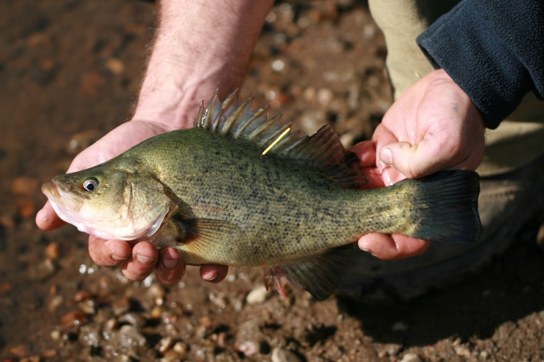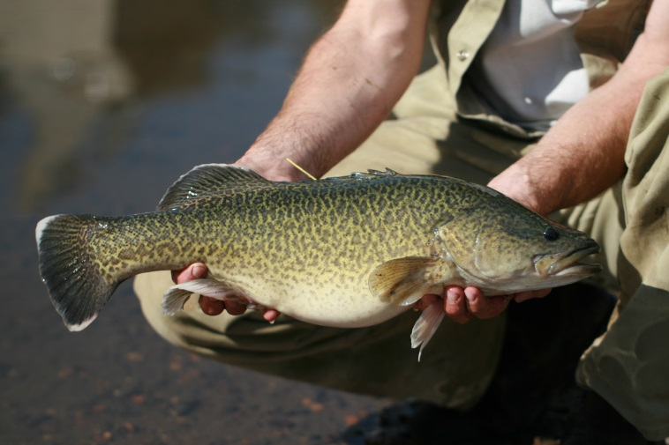

## Native Fish Report Cards give us a snapshot of the state of native fish in priority waterways in Victoria.

**Background – A partnership**

In Victoria, many agencies invest significant resources in river and water management, including in native fish. DELWP, Catchment Management Authorities (CMAs), Melbourne Water and the Victorian Environmental Water Holder carry out extensive river and streamside rehabilitation activities and research within our waterways. The Victorian Fisheries Authority (VFA) undertakes regular stocking programs and enforcement activities for native fish each year.

These agencies require information on the status of native fish to help inform management and policy. Information about our native fish also helps these agencies engage with recreational fishers and local communities. Currently, only limited data are collected to specifically evaluate the condition of recreational species across Victoria. To address this knowledge gap, DELWP and VFA developed a collaborative project to monitor the status of native fish species including important recreational species. The information gathered will also support the implementation of DELWP’s Victorian Waterway Management Program and the VFA’s Inland Freshwater Fisheries Management Plan.

**Native Fish Report Cards**

The project commenced in 2016, to develop regular report cards for important native fish species in selected priority rivers. Report cards have been used in a similar program undertaken by VFA which assesses the health of trout populations in Victorian rivers. Positive feedback has been received from recreational fishers about these report cards, and they voiced their interest in extending the program to include native recreational fish species.

The Native Fish Report Cards are brief overviews of the health of populations of targeted fish species. They report on recent fish data collected through scientific surveys. These data are used to indicate of the status of target fish species in priority rivers, by reporting:

* The number of fish that were caught
* The number of fish per 1 km of waterway
* The length and weight of the largest fish caught
* The number of legal size fish caught (if it is a recreational species that can be taken)
* The percentage of the catch that is legal size (if it is a recreational species that can be taken)

Species that are caught but not targeted by the survey methods (i.e. non-target species) are also reported for each waterway.

**Key Health Indicators**

There are key questions about fish populations that help indicate the health of the fishery and its recreational fishing potential. We want to understand how abundant the target species in the fishery are, whether there is recruitment, and how the fishery is performing in terms of providing fishing opportunities.

The three Key Health Indicators are:

1. **Recent recruitment** – were small fish (presumed less than 1 year old) present, indicating fish are breeding (or being stocked)
2. **Multiple size classes** – were there fish from a variety of sizes, an indicator of a healthy population
3. **Mature fish present** – were mature fish (capable of reproduction) caught

**Scope of the Report Cards**

This project is not specifically designed to assess the effectiveness of management interventions, such as fish stocking, or habitat rehabilitation such as provision of environmental flows, instream or streamside restoration actions. It will, however, provide valuable information on the status and trends of priority fish species for managers and will contribute to the identification of issues that are worthy of more intensive investigation and targeted research.

**Table 1: Selected priority rivers and species**

|  |  |  |  |
| --- | --- | --- | --- |
| CMA region | Priority river | Recreational species | Threatened non-recreational species |
| East Gippsland | Mitchell River | Australian Bass | Australian Grayling |
| West Gippsland | Thomson River (including Macalister River downstream of Lake Glenmaggie) | Australian Bass | Australian Grayling |
| Corangamite | Gellibrand River | River Blackfish | Australian Grayling |
| Glenelg Hopkins | Glenelg River | Estuary Perch |  |
| Goulburn Broken | Lower Goulburn River | Golden Perch, Murray Cod | Silver Perch, Trout Cod |
| Mallee | Lindsay River/Mullaroo Creek | Golden Perch, Murray Cod | Silver Perch |
| North Central | Gunbower Creek | Golden Perch, Murray Cod | Silver Perch, Trout Cod |
| North East | Ovens River | Golden Perch, Murray Cod, | Macquarie Perch, Trout Cod |
| Wimmera | Wimmera River | Freshwater Catfish, Golden Perch |  |
| Melbourne Water | Yarra River | Macquarie Perch, Murray Cod | Australian Grayling |

**Priority rivers and priority species**

It is not feasible to survey all rivers and all fish species, so priority rivers and selected species have been selected from each CMA and Melbourne Water region.

Representatives from DELWP, VFA, CMAs, VRfish, and Melbourne Water were consulted to select sites and species to ensure the needs of partners are met, and to maximise the value of the Native Fish Report Cards (Table 1). These sites represent rivers that have already been recognised as priorities by DELWP, CMAs and recreational fishers.

**Site selection**

The selection of sites within each river system considered:

* Past distributional data of target species
* Abundance of target species caught historically
* Habitat availability
* Access for boats and vehicles
* Past stocking locations

A review was undertaken of the past and current fish surveys within each priority river. This information, combined with expert knowledge, has greatly supported the selection of the most suitable sites for surveys.

Monitoring design and methods

Deciding on the most appropriate monitoring design and methods considered key questions relating to the health of the fishery. Using a consistent design and method means results can be compared from year to year to help identify trends.

**Survey methods**

Survey methods have been selected to address the key questions. These will vary between different species and will involve:

* targeting appropriate habitats (e.g. snags) for each species (Figure 1)
* using the most effective gear specific to each species.

A variety of sampling equipment may be used during surveys, including boat, backpack or bank-mounted electrofishing and fyke netting (Figure 2). Fyke netting is used, in particular, to survey River Blackfish and Freshwater Catfish since these species live on the bottom of the river and can be cryptic, so they are difficult to catch using electrofishing.

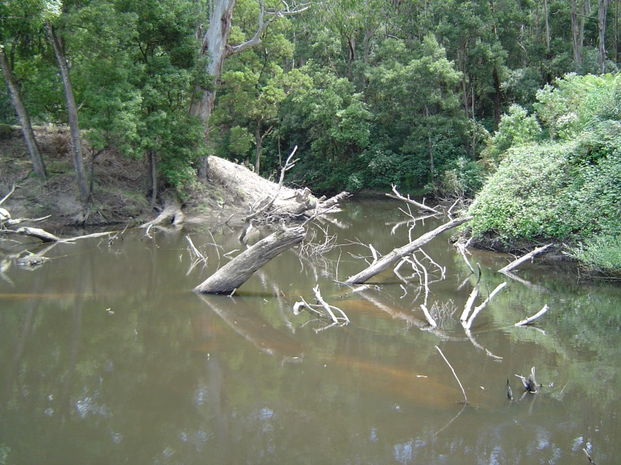

**Figure 1: Snags provide important habitat for many recreational fish species, which can be targeted during surveys (Photo: ARI)**

**Survey timing**

Surveys are carried out once a year in autumn, to avoid the spring periods of peak migration when some native fish undertake long distance movements.

The timing of fish surveys is based on life-history traits and sampling efficiency to maximise the number of fish to be collected. For example, sampling is more efficient during low to moderate flows when river visibility is greatest and target habitats are accessible.

Figure 2: Fish surveys include boat electrofishing, bank-mounted electrofishing and fyke netting. (Photos: ARI).

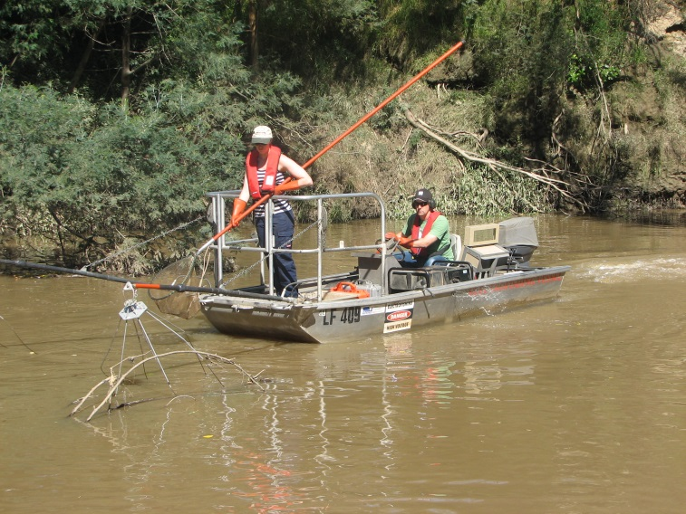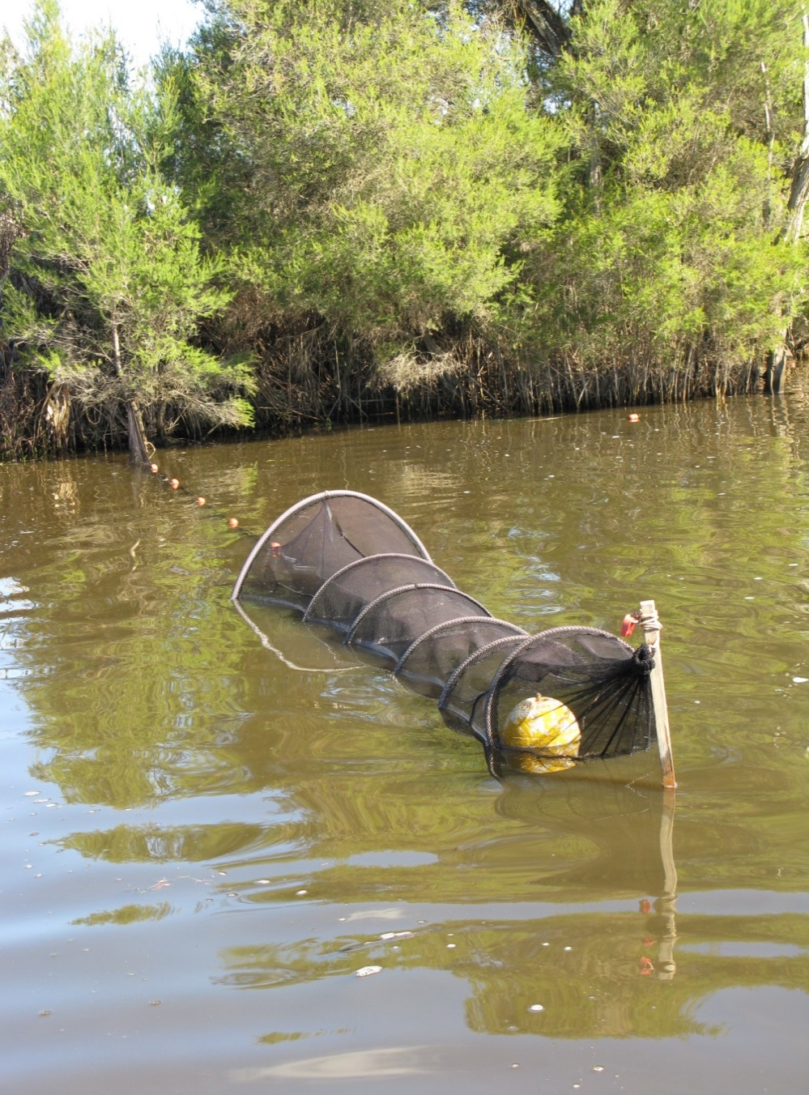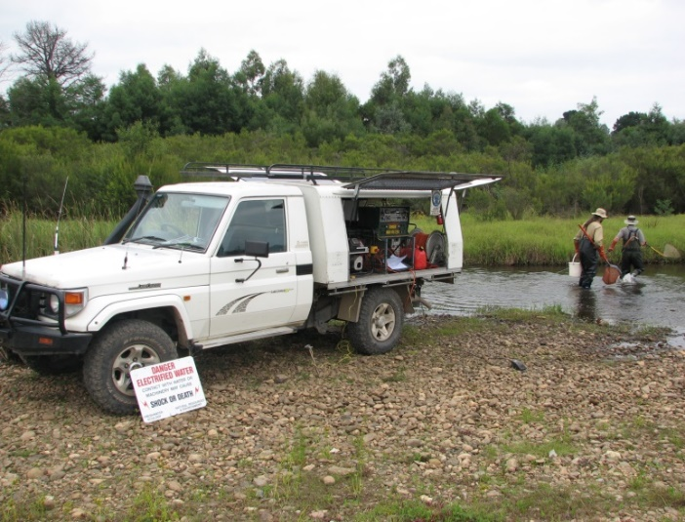

**Data limitations**

Electrofishing and fyke netting are sampling methods used to provide a snapshot of the presence and abundance of fish in waterways at the time of sampling. However, no method is perfect and able to catch all the fish present in a waterway. Therefore, the numbers of fish presented in the Native Fish Report Cards should be considered a sample only. There are likely to be many more fish in the waterways than just those recorded. Fish may also move about and populations will fluctuate due to natural variation in the environment.

**Project outputs**

Field sampling has been completed for 2017 and 2018, and a series of metrics selected to include in the Native Fish Report Cards.

The [Native Fish Report Card](https://www.nativefishreportcard.org.au/) website has also been developed, to enable easy access to results. This website provides:

* A mapping portal which allows you to view information about each of the target fish species in the priority rivers across Victoria.
* A downloadable summary of the results for each species for each priority river.

The website also provides other resources about waterway health and recreational fishing.

**Other opportunities**

There may also be opportunities to gather additional valuable information during this project. For example, there is scope to:

* collect fin clip samples for genetic analysis to gather additional information about the genetic diversity of populations of target species.
* tag fish with individual identification tags to gather additional information about fish movement and angler recapture rates.

**A Collaboration**

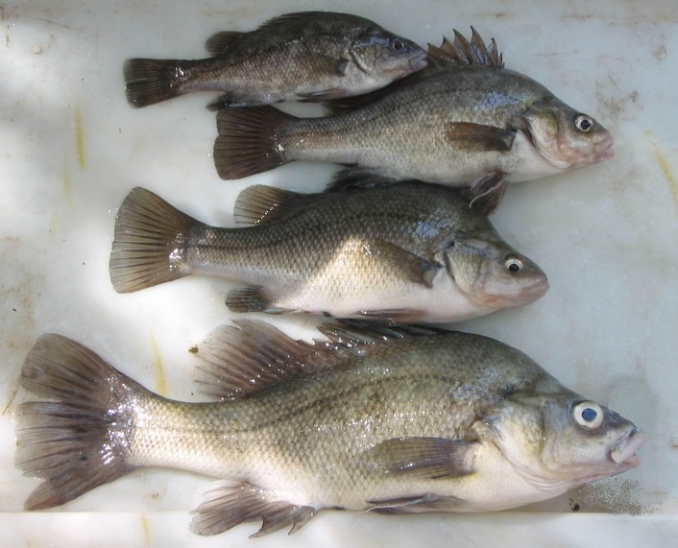This project represents a partnership between the DELWP, VFA and Recreational Fishing License Holders (through Recreational Fishing License Trust Recreational Fishing Grants Program).

Figure 3: Evidence of a range of size classes can be an encouraging sign for the health of a fishery (Photo: ARI)

|  |  |
| --- | --- |
| © The State of Victoria Department of Environment, Land, Water and Planning 2018  LogoThis work is licensed under a Creative Commons Attribution 4.0 International licence. You are free to re-use the work under that licence, on the condition that you credit the State of Victoria as author. The licence does not apply to any images, photographs or branding, including the Victorian Coat of Arms, the Victorian Government logo and the Department of Environment, Land, Water and Planning (DELWP) logo. To view a copy of this licence, visit http://creativecommons.org/licenses/by/4.0/  ISBN 978-1-76077-413-4 (print) 978-1-76077-414-1 (pdf/online/MS word)  Disclaimer  This publication may be of assistance to you but the State of Victoria and its employees do not guarantee that the publication is without flaw of any kind or is wholly appropriate for your particular purposes and therefore disclaims all liability for any error, loss or other consequence which may arise from you relying on any information in this publication. | Accessibility  If you would like to receive this publication in an alternative format, please telephone the DELWP Customer Service Centre on 136186, email [customer.service@delwp.vic.gov.au](mailto:customer.service@delwp.vic.gov.au), or via the National Relay Service on 133 677 [www.relayservice.com.au](http://www.relayservice.com.au). This document is also available on the internet at [www.ari.vic.gov.au](http://www.ari.vic.gov.au). |