|  |
| --- |
| Re-establishing Macquarie Perch in the Ovens River |
| Project Overview - 2018 |

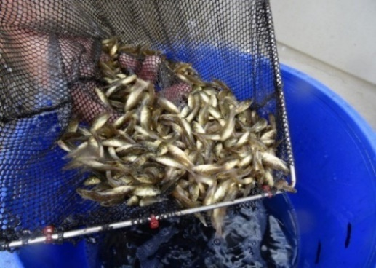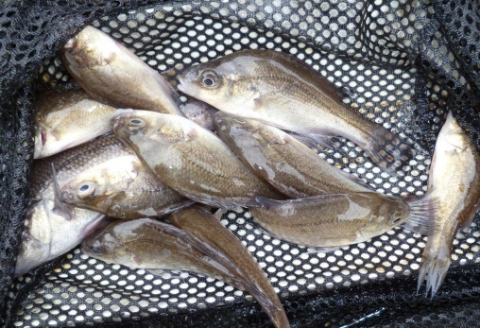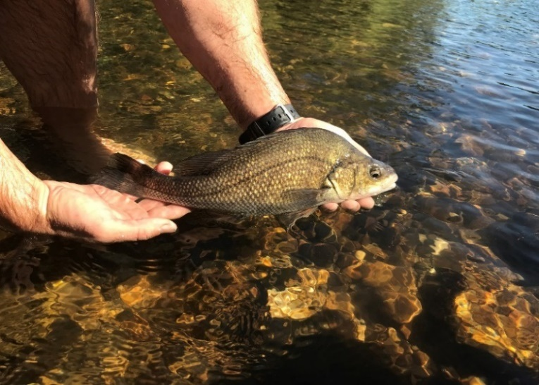

**Background**

The Macquarie Perch *Macquaria australasica* was historically abundant in the lower and mid-Ovens River. The species declined dramatically in range and abundance until it was considered locally extinct in this river. It is also recognised as endangered nationally.

Many rehabilitation actions have been undertaken to improve the health of the Ovens River and its suite of large-bodied native fish species including Murray Cod *Maccullochella peelii* and Trout Cod *M. macquariensis*. A coordinated effort commenced in 2008 with multiple government agencies and community support and engagement to protect and plant streamside vegetation, install instream woody habitat and fishways to improve fish passage, and remove Carp.

Actions specific to re-estabishing Macquarie Perch include a five-year stocking program which began in 2013/14 using both fingerlings produced by the Victorian Fisheries Authority (Snobs Creek hatchery) and direct translocations of sub-adult fish from the healthy Lake Dartmouth population. Since 2011, a total of 94,020 fingerlings have been released and 2258 fish translocated (from early juvenile–adult stage) across 15 sites, spanning 66 km of the Ovens River between Myrtleford and Wangaratta. Hatchery produced fingerlings have been released across 10 sites in total, which included between 2–5 sites each year.

This combination of stocking and translocations aims to provide the foundations for a sustainable, re-established population of Macquarie Perch in the Ovens River in what is now a robust and healthy habitat. This will ultimately reduce the risk of loss of genetic diversity of the species, due to the potential threat of localised extinction of the population in Lake Dartmouth.

**Project Aims**

A project was initiated to assess the effectiveness of the stocking and translocation program in re-establishing a self-sustaining Macquarie Perch population in the Ovens River.

**Methods**

Three evaluation methods were used in the program.

1. *Electrofishing surveys*: to monitor the abundance and distribution of Macquarie Perch. Surveys were conducted in March-April 2018, at 32 sites spanning 190 km of the Ovens River and five sites of the lower Buffalo River. Electrofishing data from 2016 and 2017 were also used in the project.
2. *A genetic assessment:* to determine survival rates of offspring of the Snobs Creek broodstock, of translocated fish and to determine whether there is evidence for natural recruitment at this stage of the program. Genetic samples were collected from all fish captured, then compared with samples collected from all broodfish and translocated individuals using parentage and identity analysis.
3. *Population modelling*: to estimate future population trajectories and likely success of the program. The numbers of fish released into the Ovens River (including their estimated ages) was examined in relation to an age-structured population model (adapted from [Todd and Lintermans 2015](https://www.sciencedirect.com/science/article/pii/S0304380015001970)), which incorporated a 20-year time series of past flow and temperature records in the Ovens River.

**Results**

*Electrofishing survey*

A total of 167 Macquarie Perch were recorded, at 23 of the 32 Ovens River sites. The species was absent from just one site between Wangaratta and Myrtleford (the reach in which all fish were released). Macquarie Perch were detected in the Ovens River and Buffalo River 19 km and 22 km upstream of the nearest release point, with this upstream dispersal encompassing movement through several high velocity rapids.

Fish were recorded from a wide range of sizes, ranging from 45–384 mm in length and 2–950 g in weight. Most fish were juveniles, with two size classes dominating the catch, specifically, fish between 100–150mm TL (most likely 1+ year old fish), and 190–250 mm TL (most likely 2+ and 3+ year old fish). Several fish <70mm TL represented individuals several months old (spawned the previous spring).

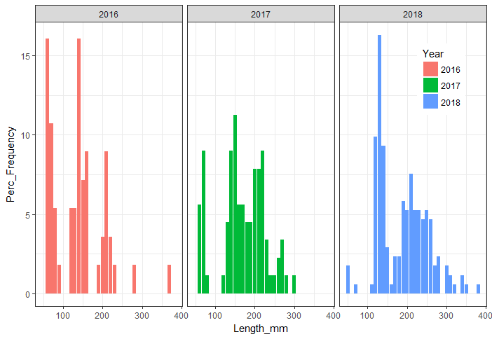

Natural recruitment

*Genetic assessment*

The parentage analysis of fish captured in the Ovens River indicates the contribution of stocking was 23% in 2018 (and has reduced from 25% in 2017 and 53% in 2016). All remaining fish were either translocated, or naturally spawned by translocated fish. Indeed, a large proportion of the juvenile fish captured were not assigned to any of the broodfish pairs, with further analysis underway to identify the specific parents of these locally bred individuals.

*Population modelling*

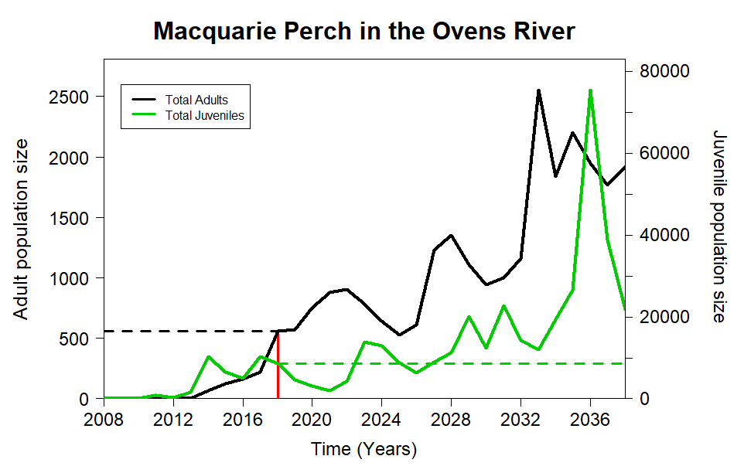The model predicted the average number of adults (>5 years of age) was 560 (a range of 134–1236) and juveniles as 8611 (range of 5540–19,208). Encoragingly, the model predicted an upward trend and self-sustaining population (Figure 1).

**Figure 1: Predicted adult and juvenile population size of Macquarie Perch in the Ovens River, Victoria.**

**Key Findings**

Monitoring has indicated Macquarie Perch were present at over 70% of the sites monitored in the Ovens River, with strong evidence of local recruitment. These provide encouraging signs of the return of this species to its former stronghold. While the genetic assessment is still underway, it indicates that both stocked and translocated fish are contributing to the re-establishment of a self-sustaining population.

**Figure 2: Size frequency (%) of Macquarie Perch captured in Ovens River electrofishing surveys in 2018 (N = 167), 2017 (N = 89) and 2016 (N = 56).**

|  |  |
| --- | --- |
| © The State of Victoria Department of Environment, Land, Water and Planning 2018  LogoThis work is licensed under a Creative Commons Attribution 4.0 International licence. You are free to re-use the work under that licence, on the condition that you credit the State of Victoria as author. The licence does not apply to any images, photographs or branding, including the Victorian Coat of Arms, the Victorian Government logo and the Department of Environment, Land, Water and Planning (DELWP) logo. To view a copy of this licence, visit http://creativecommons.org/licenses/by/4.0/  ISBN 978-1-76077-319-9 (print), 978-1-76077-320-5 (pdf/online)  Disclaimer  This publication may be of assistance to you but the State of Victoria and its employees do not guarantee that the publication is without flaw of any kind or is wholly appropriate for your particular purposes and therefore disclaims all liability for any error, loss or other consequence which may arise from you relying on any information in this publication. | Accessibility  If you would like to receive this publication in an alternative format, please telephone the DELWP Customer Service Centre on 136186, email [customer.service@delwp.vic.gov.au](mailto:customer.service@delwp.vic.gov.au), or via the National Relay Service on 133 677 [www.relayservice.com.au](http://www.relayservice.com.au). This document is also available on the internet at https://www.ari.vic.gov.au/research/ |

**What’s Next?**

* Continue to monitor the population status of Macquarie Perch in the Ovens River and Lake Dartmouth. The latter to ensure that existing fish collection for translocation and broodstock is sustainable.
* Continue to engage with the local community, anglers, schools, Landcare and other groups to increase awareness and participation in such programs.
* Use this program to help guide the expansion of actions to other waterways.

**Acknowledgements**

This project was funded the Biodiversity On-ground Actions Regional Partnerships and Targeted Actions program, DELWP; and ARC Linkage Grant LP160100482.

**Contact:** Zeb.Tonkin@delwp.vic.gov.au