|  |
| --- |
| Improving our knowledge of threatened fish and crayfish in eastern Victoria |
| Landscape Scale Surveys  2018–2020 |

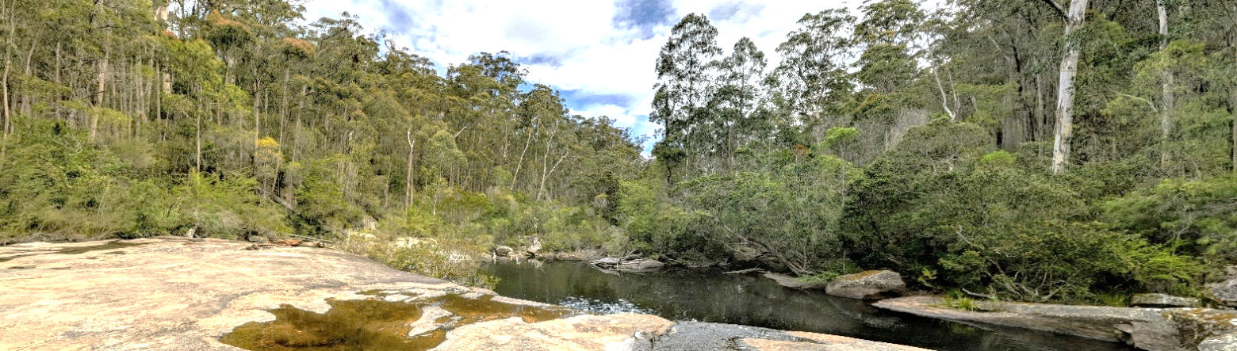

## Background

To improve the management of Victorian forests for the benefit of the community and environment, the Department of Environment, Land, Water and Planning (DELWP) is modernising Victoria’s Regional Forest Agreement (RFA), which is due for renewal in 2020. An important component is the consideraytion of Traditional Owner rights, and community and environmental values, since changes have occurred in the last 20 years since the RFA commenced.

Another key focus of the process is to undertake surveys for threatened species at a broad landscape scale across Victoria’s forested regions to provide updated location information. This information is highly relevant to local-scale integrated planning. It also supports improvements in Habitat Distribution Models (HDMs) that use species location data to provide species-specific representation of potential habitat across Victoria. Conservation measures can then be focused on this critical habitat.

To progress this process, the Landscape Scale Survey Project was established in 2019 to study a range of high priority, forest dependent species in eastern Victoria over two years. Besides a range of terrestrial plants and animals, aquatic fauna, residing in temporary or permanently flowing stream networks in forested catchments, are also being targeted. The Arthur Rylah Research Institute for Environmental Research (DELWP) is focussing on a group of small, highly threatened, native freshwater fishes known as galaxiids, and threatened freshwater crayfish.

## Aquatic species

**Fish**. Many species of galaxiids are endemic to forested mountain streams in Victoria, with 11 threatened species known from eastern Victoria, north and south of the Great Dividing Range. Unfortunately, these species, such as Barred Galaxias (*Galaxias fuscus*) and Dargo Galaxias (*Galaxias mungadhgan*), have declined dramatically in number and distribution, primarily due to predation by exotic Brown Trout (*Salmo trutta*) and Rainbow Trout (*Oncohrhynchus mykiss*): where trout are present these species cannot exist. Most of the threatened galaxiid species now exist in small, isolated populations above barriers to trout movement, such as waterfalls, in some of the most remote areas of Victoria. Consequently, they are very difficult to find, and current distribution information is limited.

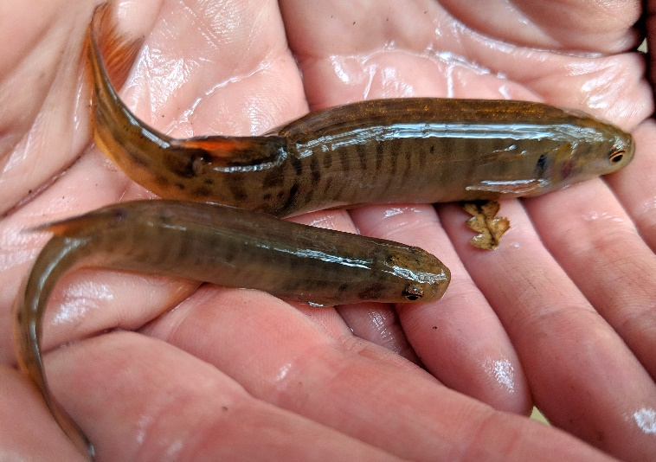

Fig 1. Native galaxiids (Photo credit: Michael Nicol DELWP).

**Crayfish.** Eleven species of freshwater spiny crayfish (genus *Euastacus*) and 22 species of burrowing crayfish (genus *Engaeus*) also occur in Victoria’s forested streams. They can be impacted by timber harvesting operations that may cause heightened sediment runoff into streams, smothering crayfish habitat. Many, such as the Orbost Spiny Crayfish (*Euastacus diversus*), are under threat as a result.

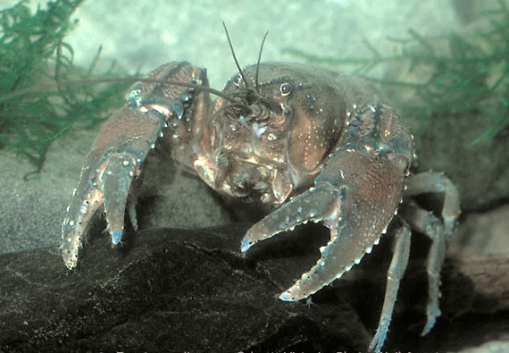

Fig 2. An Orbost Spiny Crayfish (Photo credit: Neil Armstrong).

## Key objective

* To improve understanding of the distribution of the target, high priority, forest-dependent fish and crayfish species in forested catchments.

## Approach

The key tasks to be undertaken include the following:

* Undertake a distributional gap analysis for target species to inform site selection, by overlaying the location of previously sampled areas on available presence/absence data to identify sampling gaps.
* Undertake surveys of target aquatic fauna at selected sites.
* Accurately identify aquatic species, including potentially new species of fish and crayfish in poorly known species complexes.
* Contribute results to the development of species Habitat Distribution Models, to improve our ability to predict species distributions.

Site selection will be based on sampling areas that will provide the greatest information gain. Sites will also be spread across all land tenures and will include areas outside the current known distribution of species, or in suspected marginal habitats.

Aquatic surveys will involve electrofishing, in which a pulsed electrical current is applied through the water that momentarily stuns fish and crayfish so they can be collected, identified, weighed, measured and returned alive to the water. This method allows relatively rapid sampling, is portable, and is efficient in the smaller streams in forested catchments. Survey data will also be entered into the Victorian Biodiversity Atlas database so that they are publicly available.

|  |  |
| --- | --- |
| Michael D. Nicol & Tarmo A. Raadik © The State of Victoria Department of Environment, Land, Water and Planning 2019  LogoThis work is licensed under a Creative Commons Attribution 4.0 International licence. You are free to re-use the work under that licence, on the condition that you credit the State of Victoria as author. The licence does not apply to any images, photographs or branding, including the Victorian Coat of Arms, the Victorian Government logo and the Department of Environment, Land, Water and Planning (DELWP) logo. To view a copy of this licence, visit http://creativecommons.org/licenses/by/4.0/  **ISBN** 978-1-76077-830-9 **(pdf/online/MS word)**  Disclaimer  This publication may be of assistance to you but the State of Victoria and its employees do not guarantee that the publication is without flaw of any kind or is wholly appropriate for your particular purposes and therefore disclaims all liability for any error, loss or other consequence which may arise from you relying on any information in this publication. | Accessibility  If you would like to receive this publication in an alternative format, please telephone the DELWP Customer Service Centre on 136186, email [customer.service@delwp.vic.gov.au](mailto:customer.service@delwp.vic.gov.au) or via the National Relay Service on 133 677 [www.relayservice.com.au](http://www.relayservice.com.au). This document is also available on the internet at [www.delwp.vic.gov.au](http://www.delwp.vic.gov.au). |

## Project benefits

This project will also benefit broader biodiversity knowledge and management, including river health, particularly in relatively remote and mid to higher elevation forested catchments. Significantly, it also has the potential to resolve outstanding biodiversity issues related to fish and crayfish in these poorly known catchments, possibly even discovering new species.

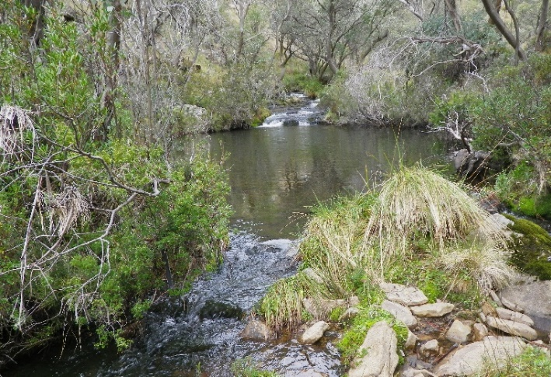

Fig 3. A forested stream in central Gippsland (Photo credit: Tarmo A. Raadik).

## Contact

michael.nicol@delwp.vic.gov.au