Our focus
How do these project outputs help managers? They provide:
- evidence of how a regulated river can be managed to support irrigation and the needs of Murray Cod to spawn.
- strategies for managers to target fish species for recovery, given the species-specific responses to restoration actions.
- the first Victorian example of monitoring a fishway on a tidal barrier and evidence to support further fishways on the Barwon River.
- To undertake high quality, relevant ecological research.
- To interpret research outcomes and communicate these effectively to key stakeholders.
- To guide and support sustainable ecosystem policy and management.

From irrigation system to an ecological asset
Issue: Gunbower Creek has historically been operated for irrigation efficiency. There is a growing focus on managing flow regimes in regulated rivers to support the needs of irrigation and native fish. Murray Cod has not thrived in this creek for many years and stocking has occurred since 2001.
Action: The creek operated for irrigation efficiency until 2012, with rapidly fluctuating water levels in spring followed by winter drying. Since then a specific environmental flow was implemented within the existing irrigation regime in the Cohuna-Koondrook reach where high-quality snag, and 20 km of continuous complex fast water, habitats exist. The annual flow regime included: (i) a steady spring rise to support Murray Cod nesting and spawning, (ii) a slow summer/autumn recession to maximise inundated habitats for improved feeding and survival of locally spawned and stocked juveniles, and (iii) a winter connection baseflow (no drying the creek into pools). Boat electrofishing surveys five years before and five years after this changed water management measured the relative abundance and size distribution of Murray Cod. Larval sampling also occurred in 2013.
Result: The post-environmental flow average of 4.3 Murray Cod/site/year was significantly higher than the pre-environmental flow average of 0.7 Murray Cod/site/year. Stuart et al. (2019)
Outcome: In river reaches which retain complex fast water (i.e. hydrodynamic complexity) and good snag habitats, managers can permanently implement the Murray Cod flow regime to support natural and stocked populations. Monitoring continues and lessons are now being applied in other working rivers.
Fig 1. Mean (+/-95% confidence intervals) number of Murray cod collected by boat electrofishing in Gunbower Creek between 2008 and 2018 for all fish. The dark and light column bars are before and after the environmental flow respectively.
Funder: North Central CMA
ARI contact: Ivor Stuart

Similar fish, different responses
Issue: River restoration programs now commonly include multiple actions such as reinstating instream woody habitat, riparian revegetation, removing barriers to fish passage, fencing out livestock and controlling weeds. How different native fish respond to restoration approaches, including at segment- (0.3km) and reach-scales (20km) is not well understood.
Action: Five complementary restoration actions occurred along the Ovens River (2008-2012). Annual fish monitoring (2009-2015) occurred at 10 sites along the Ovens River with restoration actions (intervention) and four sites along the King River without restoration actions (control).
Result: Murray Cod and Trout Cod increased in the restored segments of river, compared with the control segments of river. At the reach scale, only Murray Cod abundance significantly increased in reaches supplemented with wood.
Outcome: An improved understanding of species-specific responses to restoration actions allows prediction of fish outcomes based on ecological preferences. Restoration actions can be tailored to provide positive outcomes for selected species; particularly beneficial for threatened species and popular recreational species. This approach enables more cost-effective use of resources for restoring rivers. Raymond et al. (2019)
Funder: Murray-Darling Basin Authority ARI contact: Scott Raymond
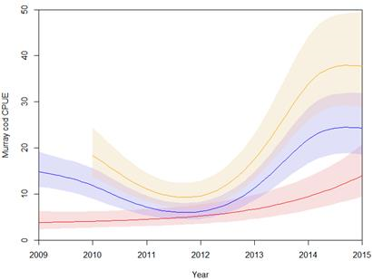
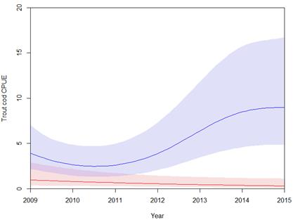
Fig 2. Estimated CPUE for Murray Cod (a) and Trout Cod (b) in the intervention (blue) and control (red) reaches and for Murray cod (brown, 6a) in sites supplemented with IWH. Shaded areas represent 95% confidence intervals.
a)
b)

A Victorian first - monitoring a tidal barrier
Issue: A tidal barrage on the Barwon River formed a barrier between fresh and estuarine water, and so a vertical slot fishway was installed in 2013. Assessment of the effectiveness of fishways on tidal barriers is rare.
Action: Trapping of fish at the fishway entrance and exit recorded species’ composition, abundance and length of fish using the fishway. Sampling occurred 12 times (Apr 2013-Dec 2015). A section of river downstream of the fishway was also sampled to ensure fishway trapping reflected the species composition seeking to use the fishway to move upstream.
Result: Eighteen species and 69,246 individual fish were caught in the fishway traps, including six species of juvenile fish returning to freshwater following their obligate marine larval phase. This showed the fishway successfully provides connectivity for obligate marine/freshwater fish with migratory life history traits, and the indirect benefits of increased productivity made available to upstream areas.
Outcome: Evidence of the effectiveness of the fishway provides support for managers to build on this success. This includes opportunities to establish more fishways on associated sites.
Funder: Corangamite CMA, Vic Recreational Fishing Grants Program
ARI contact: Justin O’Connor O’Connor et al. (2019)
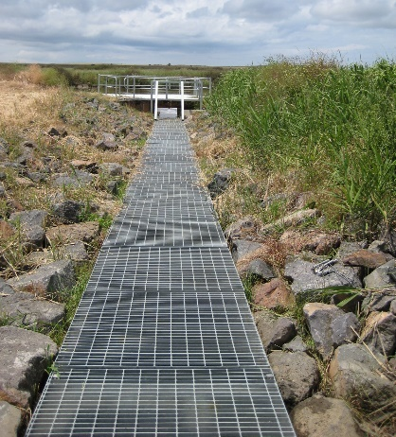
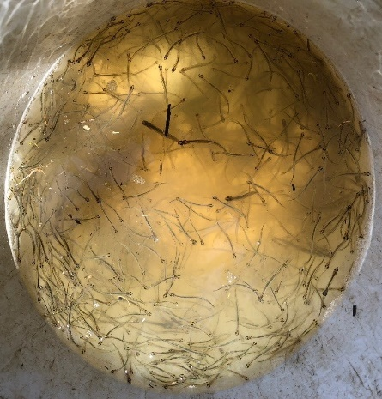
Fig 3. a) The vertical slot fishway on the Barwon River, b) Common Galaxias was the most abundant species, representing 97% of the fish caught.
b)
a)

