Timber for fish:
repurposing timber (removed from road projects) for waterway rehabilitation
Guidelines
The purpose of these guidelines
These guidelines aim to support VicRoads and Major Roads Project Victoria staff when giving management advice to road contractors. They provide key relevant information about:
- why timber in waterways is important for waterway health and fish
- the history of timber removal from waterways
- the benefits of organisations working together to reinstate timber in waterways
- the 2019 Memorandum of Understanding for repurposing timber felled during road projects for waterway rehabilitation
- timber requirements for waterway rehabilitation
- the steps to follow when timber is reinstated into waterways.

Many photos are also provided to showcase this information and the steps involved.

Wood in waterways
Trees and branches that fall or are washed into rivers, creeks and wetlands are called instream woody habitat (IWH), also known as large woody debris, snags, structural woody habitat, and log jams. IWH is important for waterway condition and ecosystem function. It provides substrate for microbes, algae and other aquatic plants (supporting carbon and nutrient processing), and by interacting with water flows it plays a key role in creating important physical attributes of streams, such as deep pools, riffles, and benches. These attributes and the complex nature of wood itself provide the diversity of habitat required to support a rich fauna of fish and other animals, such as platypus, water rats, and insects. IWH is found from the riverbank to mid-channel, and from within the water column to above the water surface, providing vital habitat structure and substrate at the whole range of water levels and conditions preferred by different fish species.
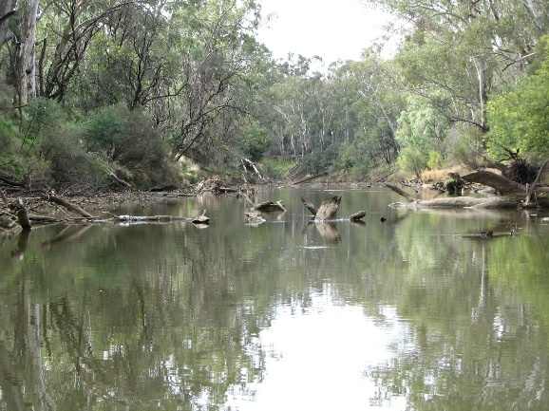
Caption: Natural IWH in the Goulburn River. (Photograph: Adrian Kitchingman, ARI)

Fish need woody habitat
In waterways, IWH supports healthy, self-sustaining fish populations. Fish use IWH for shelter, food sources, breeding areas, and territorial markers – which are what fish need to survive, grow, breed and migrate. Some fish species have very strong associations with IWH. Murray Cod and River Blackfish, for example, lay their eggs on hard substrates, usually on logs or in log hollows. Freshwater Catfish use IWH and aquatic plants for cover. Macquarie Perch tend to be found around IWH and boulders. IWH positioned at different locations within the waterway channel benefits different fish species: for example, Trout Cod utilise snags positioned in faster water flows, whereas Murray Cod prefer snags in slower water flows.
Since many fish species rely on IWH, changes in IWH can affect the distribution and abundance of fish populations. Loss of IWH is a factor in the decline of many threatened fish species. ‘Removal of woody debris from Victorian rivers and streams’ is listed as a potentially threatening process under the Victorian Flora and Fauna Guarantee Act 1988.
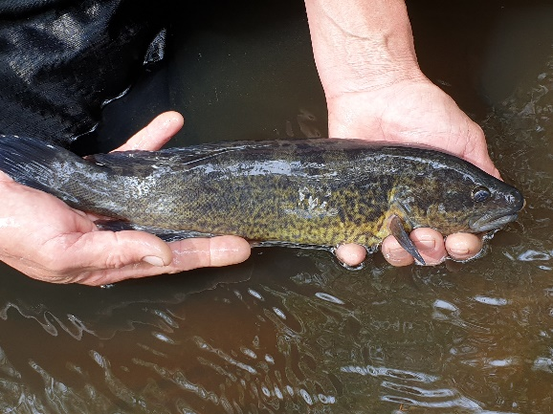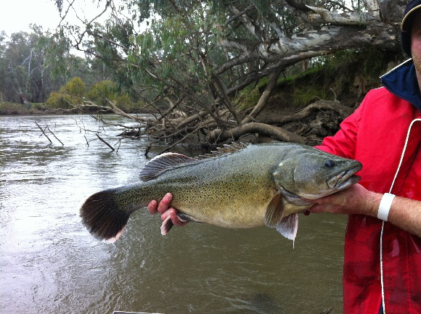
River Blackfish Trout Cod
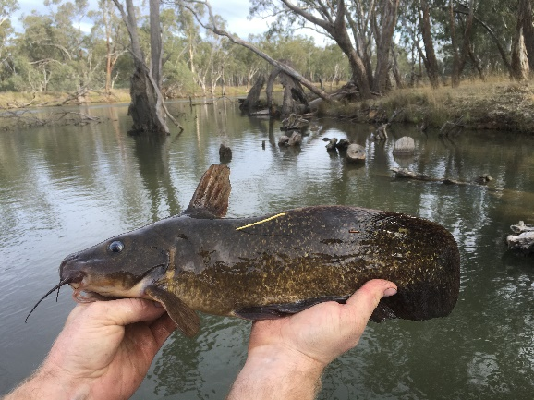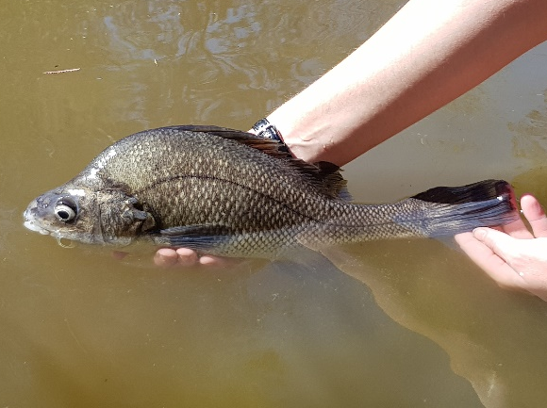
Freshwater Catfish Macquarie Perch
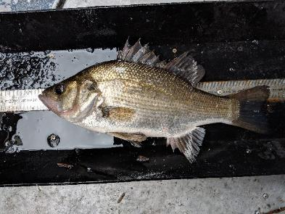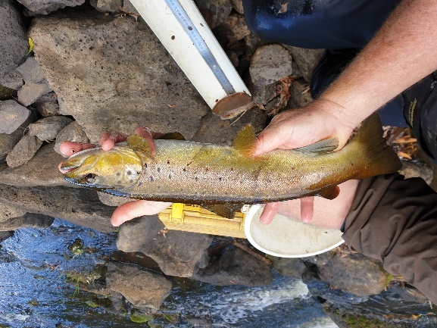
Estuary Perch Brown Trout
Caption: Various fish species use instream woody habitat for shelter, food sources, breeding areas and territorial markers. (Photographs: ARI)

History of instream woody habitat removal
From the 1880s to the late 1990s, wood was commonly removed from waterways in south-eastern Australia as part of the old river management practices. For example, 129 km of the Latrobe River in Gippsland was desnagged between 1940 and 1980. Similarly, over 25,000 snags were removed from the Murray River between Lake Hume and Lake Mulwala in the 1970s and 1980s. Wood was removed to improve boat passage for transport of people and goods along waterways, to reduce the severity of flooding (it was then thought that IWH blocked river channels and slowed water transfer), and to protect infrastructure (such as roads and bridges) from damage.
IWH removal was widespread in Victoria. Overall, there has been an average 41% loss of IWH density in Victorian waterways compared with before European settlement. Regions in the south-west, south-central, south-east, north-west, and north-central Victoria are particularly impacted and have up to 95% reductions in IWH densities.
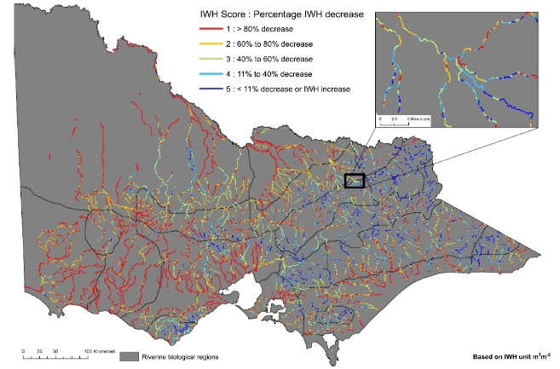
Caption: Predicted baseline (2011) condition of instream woody habitat (IWH) as percentage decrease from predicted reference (pre disturbance) levels in waterways in Victoria (Tonkin et al. 2016)
Research has since shown that the removal of IWH has minimal impact on flood mitigation and actually impairs waterway health and biodiversity. Many native trees along riverbanks have also been cleared, which limits the natural input of IWH. The negative outcomes of wood removal have triggered a groundswell within government and community, over the last ~20 years, to help repair our rivers by reinstating IWH and replanting riverbanks with native vegetation.

Working together to reinstate instream woody habitat
Reinstating IWH is an integral component of rehabilitating waterways. In the long term, replanting native vegetation along riverbanks will allow tree limbs and trees to eventually fall naturally into waterways. Unfortunately for some regions, it may take hundreds of years before natural IWH loads recover by this process. So, there is a need to manually put woody habitat back into waterways.
Sourcing and transporting timber are a barrier to reinstating IWH. The larger pieces of wood ideal for waterway rehabilitation projects are in relatively limited supply, so they have to be used in the highest priority waterways. Wood needs to be obtained from approved clearing sites, which can often be long distances from the waterways where the timber is needed. Sourcing timber from trees cleared during road projects can be an excellent opportunity for overcoming the barriers of sourcing and transportation.
Road projects often involve vegetation clearing, with the timber having traditionally been seen as a waste product. More recently, the timber has been reused productively, wherever practicable, including for nest-boxes, habitat for ground-dwelling animals, sculptures, and park benches. The state authorities that manage roads, catchments, waterways, biodiversity and fisheries have now partnered to enable a new high-value reuse of timber removed through road projects – for waterway rehabilitation.

A new Memorandum of Understanding for repurposing timber felled during road projects for waterway rehabilitation
In May 2019, Minister Pulford (then Minister for Roads and Minister for Fishing and Boating) launched a new Memorandum of Understand (MOU) for repurposing timber felled during road projects for waterway rehabilitation. There are 14 Parties to the MOU, namely the Roads Corporation (trading as VicRoads), Major Road Projects Victoria, the Department of Environment, Land, Water and Planning, the Victorian Fisheries Authority, North East CMA, Goulburn Broken CMA, North Central CMA, Mallee CMA, Wimmera CMA, Glenelg Hopkins CMA, Corangamite CMA, West Gippsland CMA, East Gippsland CMA and Melbourne Water.
The MOU sets out the common understanding between the Parties, which reflects the principles, voluntary commitment and duration of the MOU in relation to documenting how the Parties will voluntarily work to repurpose timber felled during road projects for waterway rehabilitation, where practicable. Activities include provision of a schedule of upcoming road projects; identifying priority waterway rehabilitation sites and storage locations; permits and approvals; engagement and communication; the removal, selection, and transportation of timber from road projects to waterway rehabilitation sites; installation; and safety.

Timber requirements
Each waterway rehabilitation project needs to consider its specific timber requirements. Wood sought for waterway rehabilitation projects varies depending on several factors, including the project’s objectives, the site’s characteristics, the size of the waterway channel, targets for IWH density, stream energy, budget, and timber availability.
Green timber from native hardwood species (such as red gum and box eucalypts) is preferable because of its higher density. The size and cut of the timber needed depends on the design of the structures to be created. Timber can be arranged in the waterway in numerous ways, and the design is tailored to consider the circumstances at each site. Some designs can have multiple functions – e.g. fish habitat, riverbank erosion control, and promotion or stabilising of sediment scour. Each design specifies the main timber pieces, plus the timber pieces and other materials needed to anchor and stabilise the structure, which can include timber piles, rock, concrete, cables and anchors. The minimum diameter of timber used is generally 30 cm; however, smaller diameter pieces can be combined to form a larger structure or used in stabilising and anchoring structures. The relevant CMAs will be able to provide more guidance on their timber requirements.
Knowledge of the designs planned for structures will help guide how timber is removed at a road project site. Retaining larger branches, hollows, the main trunk, and the rootball increases the complexity of the IWH. Where possible, keeping larger branches connected to the trunk, and retaining the part of the trunk connected to the rootball, helps in locking pieces together, making stabilising and anchoring of structures easier. Larger and heavier pieces are more likely to withstand high water flows, require less anchoring, and have greater longevity, because they take longer to decompose. The length and width of each timber piece is also governed by the removal and transportation logistics. Timber pieces need to be of a manageable size for machinery and truck transport. Timber pieces may be cleaned prior to transportation to remove dirt and to reduce any biosecurity risk. Ideally, the waterway project manager, the road project manager and an arborist will be onsite together when timber is being felled to provide input regarding each of these points.

The process of repurposing timber from road projects for waterway rehabilitation
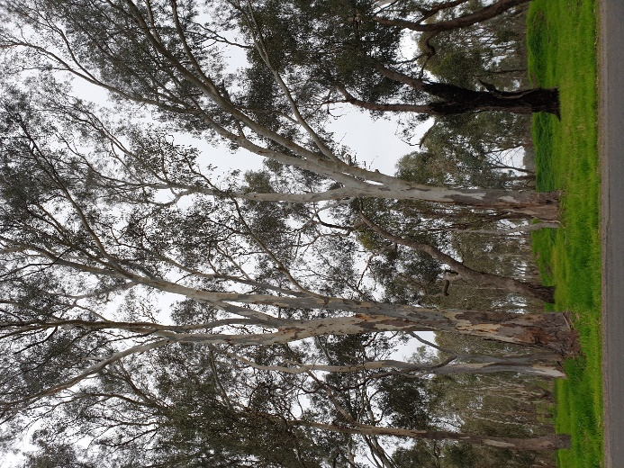
Caption: There are multiple ways in which trees can be cut and removed to create the timber pieces needed for instream woody habitat. Options include (1) keeping the whole tree intact; (2) removing the crown but keeping the key branches, trunk, and rootball intact; (3) retaining the rootball with at least 1 m of trunk; (4) removing the crown and rootball, but keeping the trunk and key branches. Large trees can be cut into multiple timber pieces. The blue lines represent potential cuts for creating different timber pieces. (Photograph: ARI)
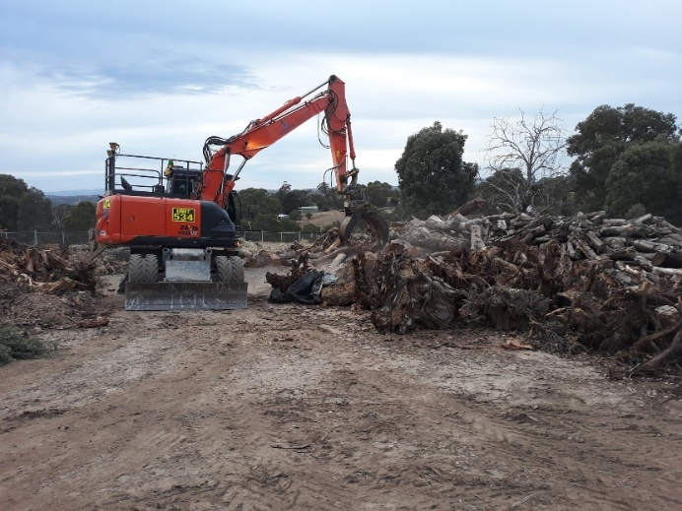
Caption: Loading timber onto trucks for transportation. (Photograph: Major Road Projects Victoria)
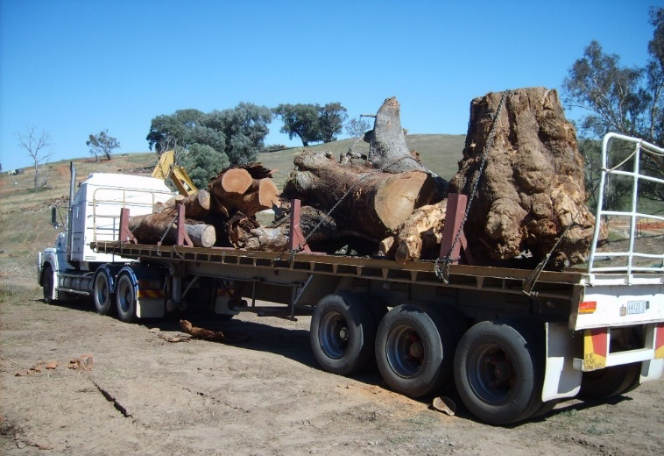
Caption: The gross load limit, width, and length of trucks limits the size and number of timber pieces that can be carted in a single trip. (Photograph: Martin Casey)
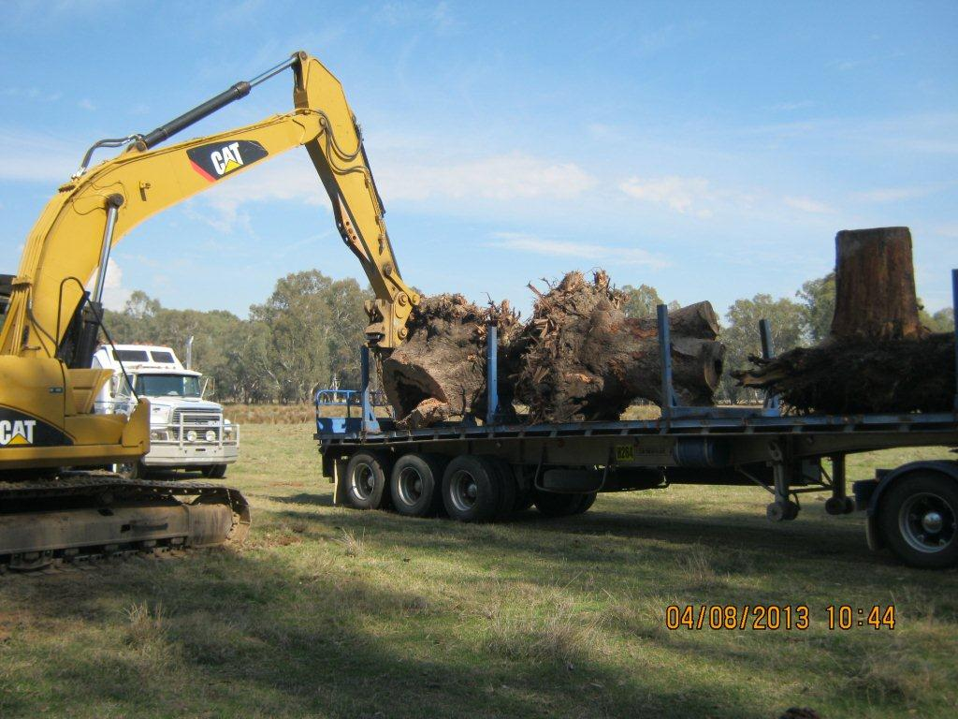
Caption: Machinery needs to be ready for off-loading timber pieces at the waterway rehabilitation or storage site. (Photograph: North East CMA)

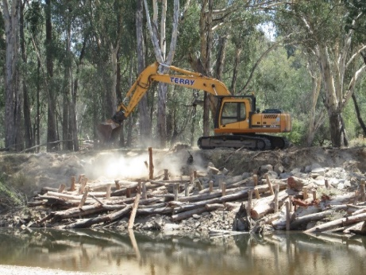
Ovens River (Photograph: North East CMA)
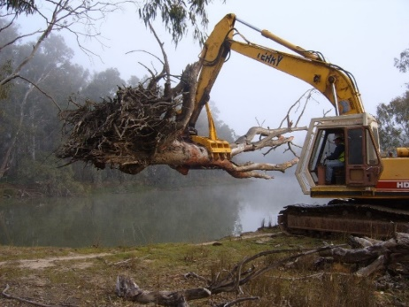
Murray River (Photograph: ARI)
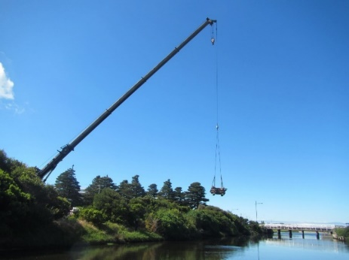
Merri Estuary (Photograph: Glenelg Hopkins CMA)
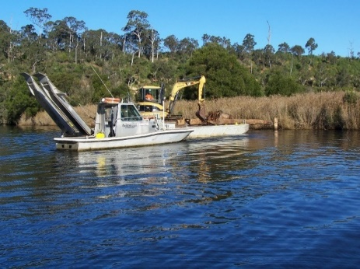
Nicholson River (Photograph: East Gippsland CMA)
Caption: Machinery is used to install instream woody habitat structures from the riverbank or via barge.

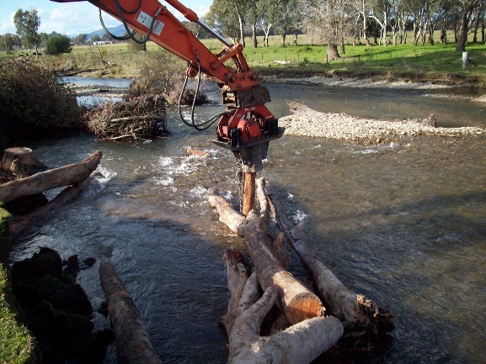
Caption: Timber structures may be anchored and stabilised using materials such as timber piles, cables, rocks, anchors and concrete. (Photograph: Goulburn Broken CMA)

Examples of instream woody habitat structures
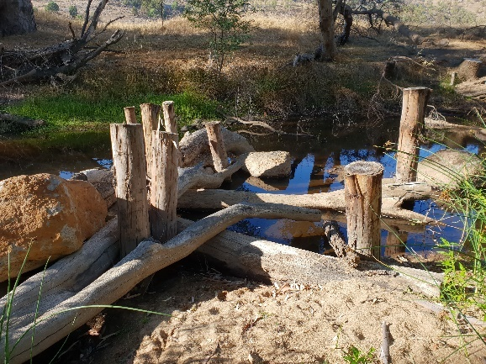
Caption: Hughes Creek instream woody habitat structure: timber pieces are keyed into the riverbank, locked into one another, and secured using piles and rocks. (Photograph: Renae Ayres, ARI)
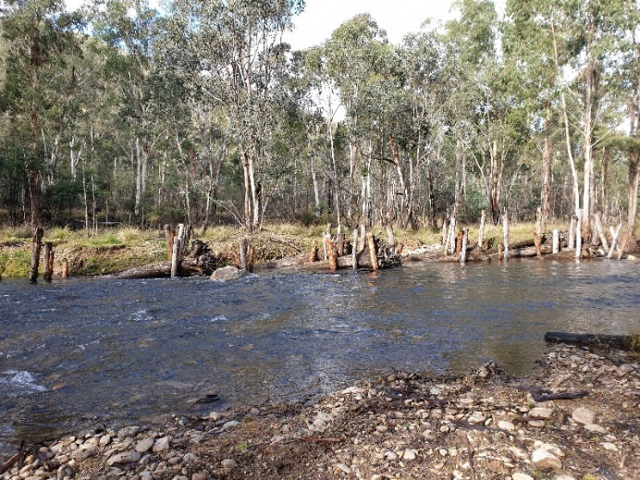
Caption: Macalister River instream woody habitat structures involving a series of rootballs with tree trunks, pinned together and anchored by timber piles. (Photograph: Renae Ayres, ARI)
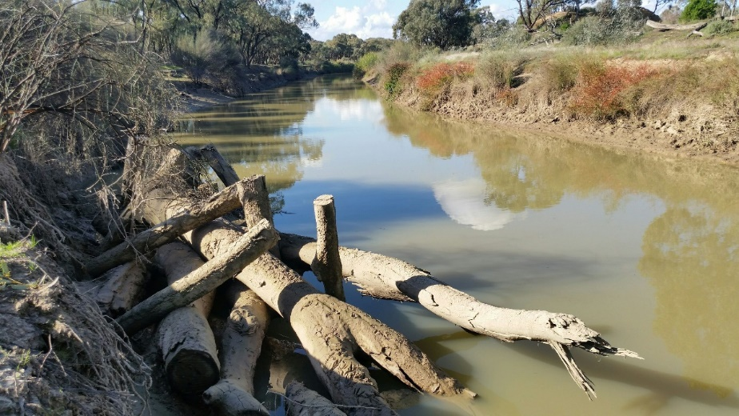
Caption: Timber structure installed in Pyramid Creek, consisting of two rootballs and four lengths of timber, pinned to the substrate with 8–10 timber piles. (Photograph: North Central CMA)

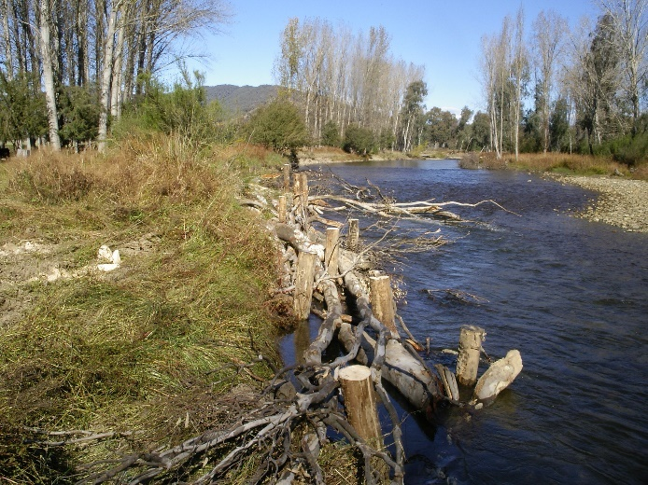
Caption: Tree trunks and branches are pinned together to create instream woody habitat structures in Nariel Creek (Photograph: North East CMA)
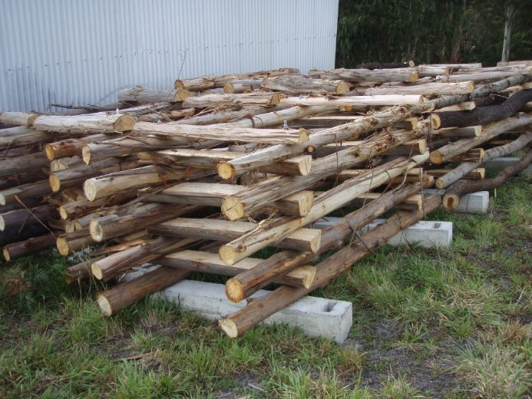
Caption: ‘Fish havens’ or ‘fish hotels’ consist of many relatively small branches arranged in a square or rectangular shape. They are connected by metal rods, and sometimes weighted with concrete and pinned with piles. (Photograph: Corangamite CMA)

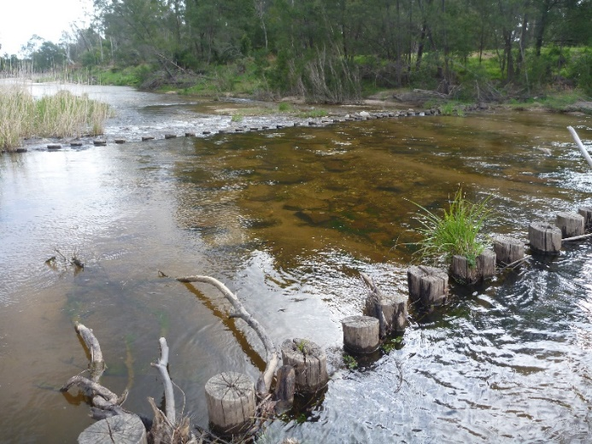
Caption: In the Cann River, multiple timber piles are embedded across the waterway channel to slow the movement of the sandy substrate. (Photograph: Renae Ayres, ARI)
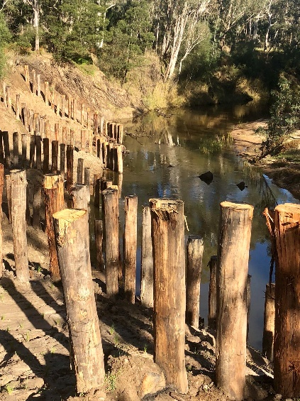
Caption: Timber piles are pinned vertically into the edge of the river channel to mitigate erosion. (Photograph: Glenelg Hopkins CMA)

Catchment management authorities (CMAs) and Melbourne Water (MW) identify priority waterways and locations for instream woody habitat rehabilitation in respective regions, in consultation with researchers, and relevant community and stakeholder organisations. For each location, they identify the quantity, size and type of timber preferred.
For upcoming road projects, VicRoads and Major Road Projects Victoria (MRPV) develop a schedule for any timber considered necessary for removal, including information about the road project location, and the types and quantities of timber associated with specific road projects.

They share this information with the Department of Environment, Land, Water and Planning (DELWP), VicRoads, MRPV and the Victorian Fisheries Authority (VFA).
They share this information with DELWP, CMAs, MW and VFA.

VicRoads and MRPV connect with local CMAs and MW during the planning of specific road projects to discuss opportunities for timber reuse for waterway rehabilitation, including timber availability, timber needs, time frames, and transportation and installation costs.

CMAs and MW obtain permits and approvals (including cultural heritage approval), complete hydrological modelling, and engineer log designs, etc., as required for undertaking works on waterways, accessing waterway rehabilitation sites and storing timber at storage sites.

VicRoads and MRPV engage with local CMAs during timber clearing to ensure trees are removed and cut in the desired manner.

VicRoads, MRPV, CMAs and MW plan timber transportation and installation, including schedules, contractors, resources, access and safety.

Timber is transported.
Timber is installed in waterways.
VicRoads, MRPV, CMAs and MW document any project-specific learnings and opportunities for improvement and share outcomes with DELWP and VFA.

DELWP, CMAs and MW monitor the integrity of the timber structures and the environmental benefits.
Caption: Flow diagram of the steps to repurpose timber from road projects for waterway rehabilitation as per MOU
Caption: Flow diagram of the steps in repurposing timber from road projects for waterway rehabilitation, as per MOU
Take-home messages
- IWH is the trees and logs in waterways. It is important for the health of waterways and biodiversity.
- IWH helps sustain fish populations. It provides fish with shelter, food resources, breeding areas, and territorial markers.
- Many waterways in Victoria are highly modified. Timber was removed from waterways from the 1880s until the late 1990s.
- Government and community are working together to return wood to waterways across Victoria, to recreate habitat for fish and to improve the health of waterways and fisheries.
- Reusing timber removed during road construction will boost opportunities for IWH rehabilitation projects.
- Different waterway rehabilitation projects will have different timber requirements.
- Green, native hardwood timber is best.
- The size and cut of the timber needed will depend on the design of the IWH structures to be created, as well as plant and logistics.
- Road project managers and catchment managers should work together from the early planning stages of projects in order to get the best outcomes possible.

Timber requirement checklist
Road project name:

VicRoads or MRPV contact person and number:

Waterway destination:

CMA or MW contact person and number:

Timber specifications
Native ☐
Hardwood ☐
Green ☐
Cleaned (pressure-washed, dirt removed) ☐

Description | Quantity | Length | Diameter
Whole tree (rootball, trunk, branches, crown)
Rootball, trunk, main branches (crown removed)
Rootball, trunk |  | 8 m maximum | 1.5 m minimum
Trunk, main branches |  | 6–9 m | 0.5 m minimum
Rootball (+ 1 m of trunk) |  | – | 1.5 m minimum
Straight logs |  | 6–9 m | 0.2 m

Consider plant capacity for loading and transportation
Vehicle capacity, maximum length:
Vehicle capacity, maximum width:
Vehicle capacity, gross load limit:

Resources
Beesley, L.S., Middleton, J., Gwinn, D.C., Pettit, N., Quinton, B. and Davies, P.M. (2017). Riparian design guidelines to inform the ecological repair of urban waterways. Cooperative Research Centre for Water Sensitive Cities, Melbourne, Victoria.
Brooks, A.P. (2006). Design guideline for the reintroduction of wood into Australian streams. Land and Water Australia, Canberra, ACT.
Bureau of Reclamation and U.S. Army Engineer Research and Development Center. (2016). National Large Wood Manual: Assessment, Planning, Design, and Maintenance of Large Wood in Fluvial Ecosystems: Restoring Process, Function, and Structure. Available: www.usbr.gov
Jackson, P. and Clunie, P. (2014). A demonstration reach toolbox. Arthur Rylah Institute for Environmental Research, Technical Report No. 259. Report for Murray–Darling Basin Authority. Department of Environment and Primary Industries, Heidelberg, Victoria.
Kitchingman, A. (2015). Riverine rehabilitation decision support tool – helping managers rehabilitate instream habitat (ArcGIS add-in). Available by emailing adrian.kitchingman@delwp.vic.gov.au
Rutherfurd, I.D., Jerie, K. and Marsh, N. (2000). A rehabilitation manual for Australian streams, Volumes 1 and 2. Land and Water Resources Research and Development Corporation, Canberra, ACT and the Cooperative Research Centre for Catchment Hydrology, Clayton, Victoria.
Saddlier, S. (2008). Techniques for reinstating instream habitat. Arthur Rylah Institute for Environmental Research. Department of Sustainability and Environment, Heidelberg, Victoria.
Tonkin, Z., Kitchingman, A., Ayres, R.M., Lyon, J., Rutherfurd, I.D., Stout, J.C and Wilson, P. (2016). Assessing the distribution and changes of instream woody habitat in south-eastern Australian rivers. River Research and Applications 32 (7), 1576–1586.

