Lindsay River/Mullaroo Creek (Lindsay River system) 2021
Mallee region

This report card summarises the 2021 Native Fish Report Card (NFRC) survey in the Lindsay River system
Sites 10, MCMA, Electrofishing

Fish found in Lindsay River system for NFRC
Target species
Golden Perch
Murray Cod
Silver Perch

Non-target species captured since 2017*
Large-bodied native species
Bony Bream
Freshwater Catfish

Small-bodied native species
Australian Smelt
Carp Gudgeon
Flatheaded Gudgeon
Murray-Darling Rainbowfish
Unspecked Hardyhead

Exotic species
Common Carp
Eastern Gambusia
Goldfish
Redfin

* These non-target species were incidentally captured during NFRC surveys since 2017 but not measured as for target species

LOGOS – ARI, DELWP

Lindsay River system 2021
Fish Community

NFRC target species
The NFRC Program began in 2017 with a focus on targeting the monitoring of population dynamics of key iconic fish species that have high recreational and/or conservation values, in large rivers across Victoria. In the Lindsay River system, the target species are Golden Perch, Murray Cod and Silver Perch. Surveys occur in March each year, at 10 sites from the Mullaroo offtake with the Murray River upstream of weir seven to the junction of the Lindsay and Murray rivers. The equipment and habitats surveyed are focused on these species, which are measured to determine population structures. Other fish species that are incidentally captured are recorded, but not measured to determine their population structures, except Freshwater Catfish which are also captured, measured and weighed.

Species | Key Health Indicators
 | Recent recruitment | Multiple size classes | Mature fish present
Golden Perch | No | Yes | Yes
Murray Cod | Yes | Yes | Yes
Silver Perch | - | - | -

Recent recruitment means young-of-year fish
*- cannot be determined due to low abundances
Silver Perch were historically abundant throughout the Lindsay River system but have experienced dramatic declines across their range. Silver Perch are present in low densities. Overall, the Lindsay River system appears to be maintaining healthy populations of Golden Perch with the Murray Cod population recovering following the 2016 blackwater event.

Non-target species
The non-target fish species that have been incidentally recorded in the Lindsay River system during NFRC surveys since 2017 are:

Large-bodied native species
Other large-bodied species recorded in surveys are Bony Bream and Freshwater Catfish. Bony Bream which are cold water intolerant are common in the lower Murray-Darling Basin, including the Lindsay River system. The species is often in higher abundances in slower flowing habitats. Freshwater Catfish are a lowland species, generally found at altitudes below 200 metres. This species has suffered a decline in distribution and abundance across Victoria. Low abundances of Freshwater Catfish have been recorded from 2018 onwards. In 2021, young-of-year were collected for the first time during NFRC surveys.

Small-bodied native species
The small-bodied species Australian Smelt, Carp Gudgeon, Flatheaded Gudgeon and Unspecked Hardyhead are common and are expected to be widespread throughout the Lindsay River system and more broadly within the Murray-Darling Basin. Murray-Darling Rainbowfish are common throughout the Lindsay River system. This species was once widespread in the Murray-Darling Basin, and now has a patchy distribution and a restricted range and is considered threatened in Victoria.

Exotic fish species
Common Carp and Goldfish are widely distributed across sampling sites. Eastern Gambusia are not as widely distributed and are more likely to be collected in the slower flowing waters. Redfin are also distributed throughout, but in low abundances.

Other native species known from the Lindsay River system
There is a range of other species historically known from this system, although they have not been detected for many decades.

Other notable species
Surveys have also recorded Yabbies and Turtle species.

LOGOS – ARI, DELWP, NFRC

Lindsay River system 2021
Environmental and Management Context

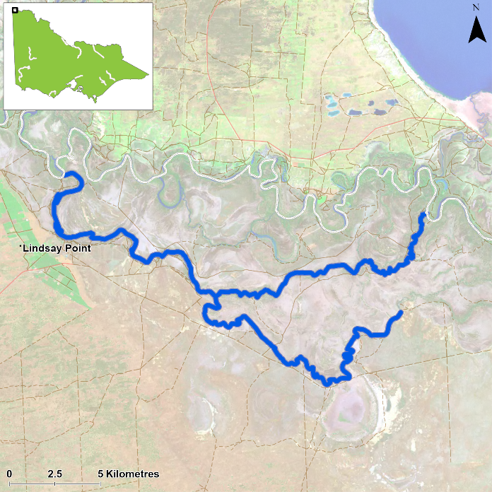
Figure 1. Map showing the section of Lindsay River and Mullaroo Creek where NFRC sampling occurs

Environment
A blackwater event impacted the fish population in late 2016. Generally, stream flows were similar during the autumn sampling periods in 2017 to 2021. The Murray River has not connected with the upper Lindsay River since the 2016 flood. Therefore the upstream reaches of the Lindsay River (above the Mullaroo Creek junction) have experienced lower flows and water levels since 2017. Ten sites were surveyed by an electrofishing boat, between 16 and 18 March 2021.

River rehabilitation efforts in the Lindsay River
A range of rehabilitation actions to improve the health of the Lyndsey River system and its fish community, have been identified within the Mallee Waterway Strategy 2014-2022. The core current focus involves allocation of water for the environment and improving fish passage. Since 2006, fish monitoring has occurred for the Lindsay, Mulcra, Wallpolla Islands, as part of The Living Murray Program. The Mallee Catchment Management Authority, DELWP and VFA support rehabilitation and management of the Lindsay River and its fish community.

PHOTOS
LOGOS – ARI, DELWP, NFRC

Golden Perch

Lindsay River system, Mallee region

Key Health Indicators
Recent recruitment No
Multiple size classes Yes
Mature fish present Yes

Monitoring Results
Total number of fish caught 36
Fish per 1km of waterway 2.98
Largest fish by length (cm) 47.0
Largest fish by weight (kg) 1.61
% of the catch that is legal size 97.2

The abundance of Golden Perch (Macquaria ambigua) appears to decrease after higher abundances were recorded in 2017 and 2018 (Figure 2). It is likely that the 2016 floods attracted Golden Perch into the system, with abundances in the upper Lindsay system (above the Mullaroo Creek junction) being highest in 2017 and decreasing as this part of the system has reduced flows. In addition, the higher proportion of juveniles in 2017 were also in the upper Lindsay River. A large proportion of Golden Perch collected are adults (Figure 2) with 97% adults in 2021 (Figure 3). Overall, there is a consistently productive Golden Perch population. Recruits of this species are difficult to catch using this sampling methodology. The juveniles in 2017 are now approaching adult size, with all fish in 2021 above 25 centimetres (Figure 3).

Stocking
No stocking has occurred.

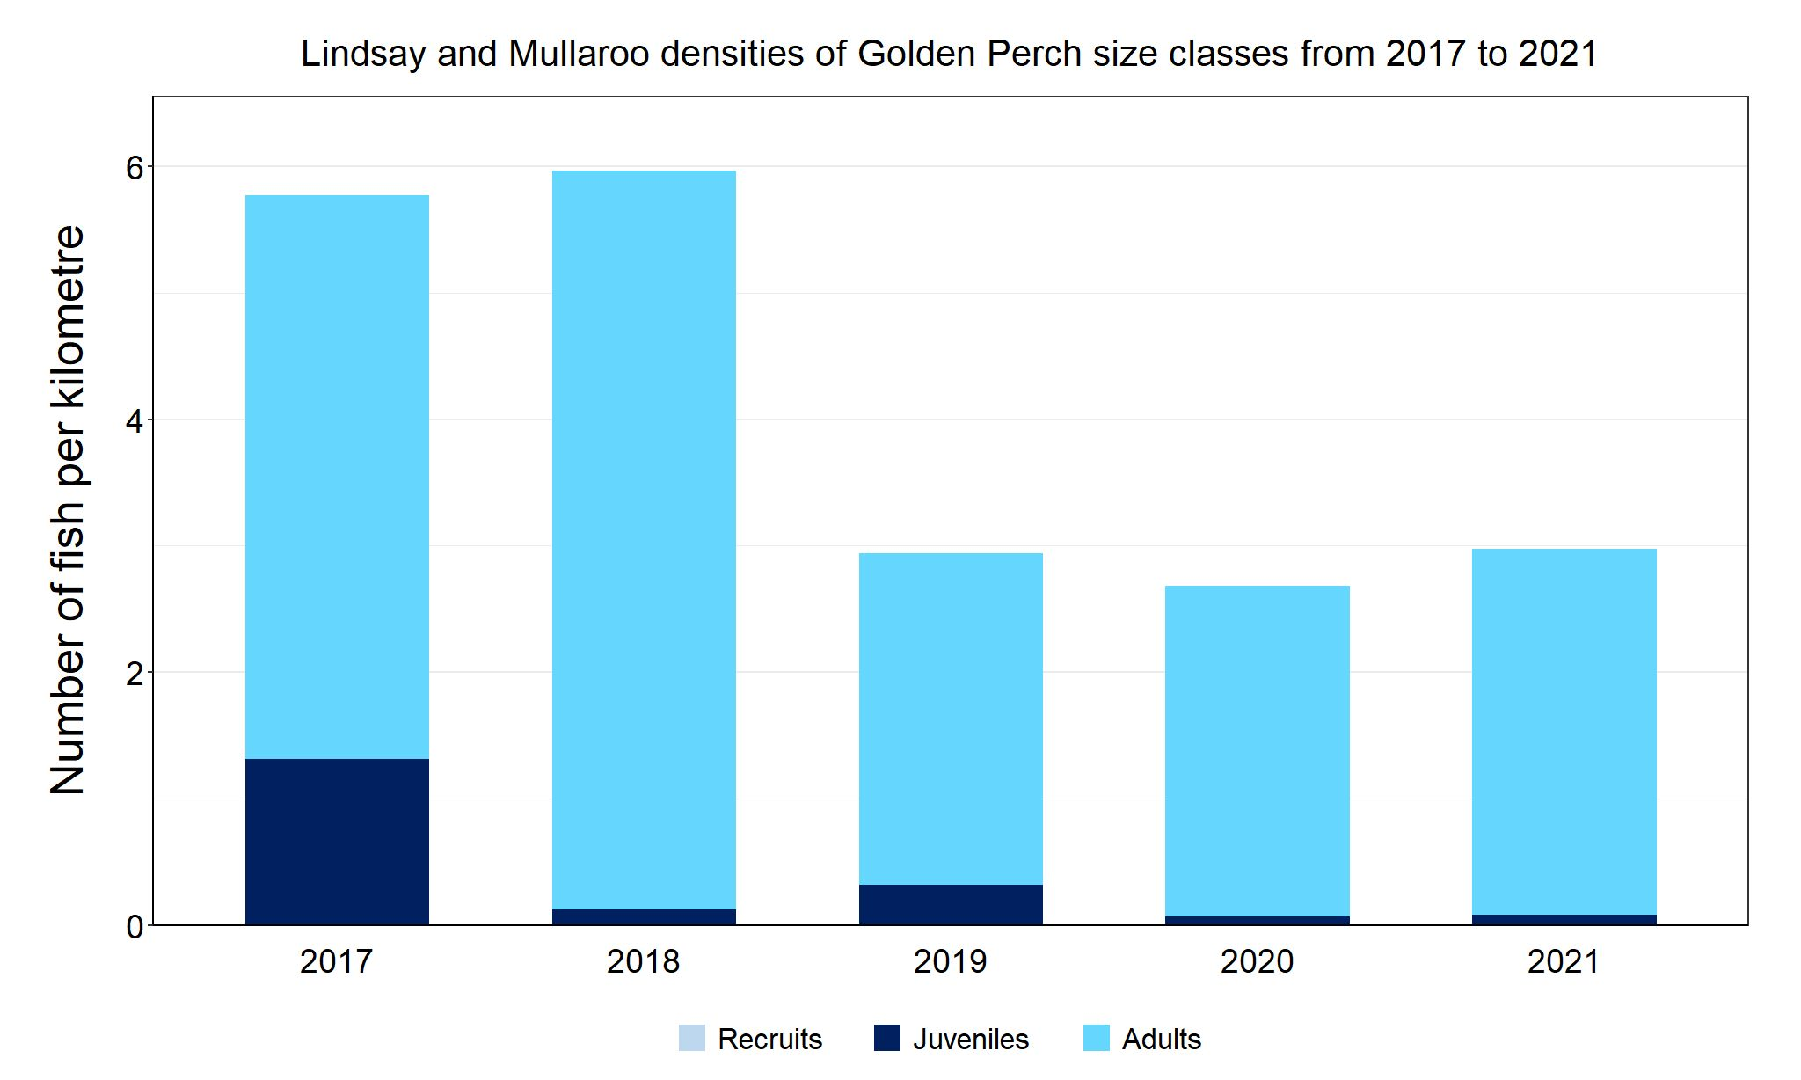
Figure 2. The densities of recruits, juveniles and adult Golden Perch in the Lindsay River system from 2017 to 2021

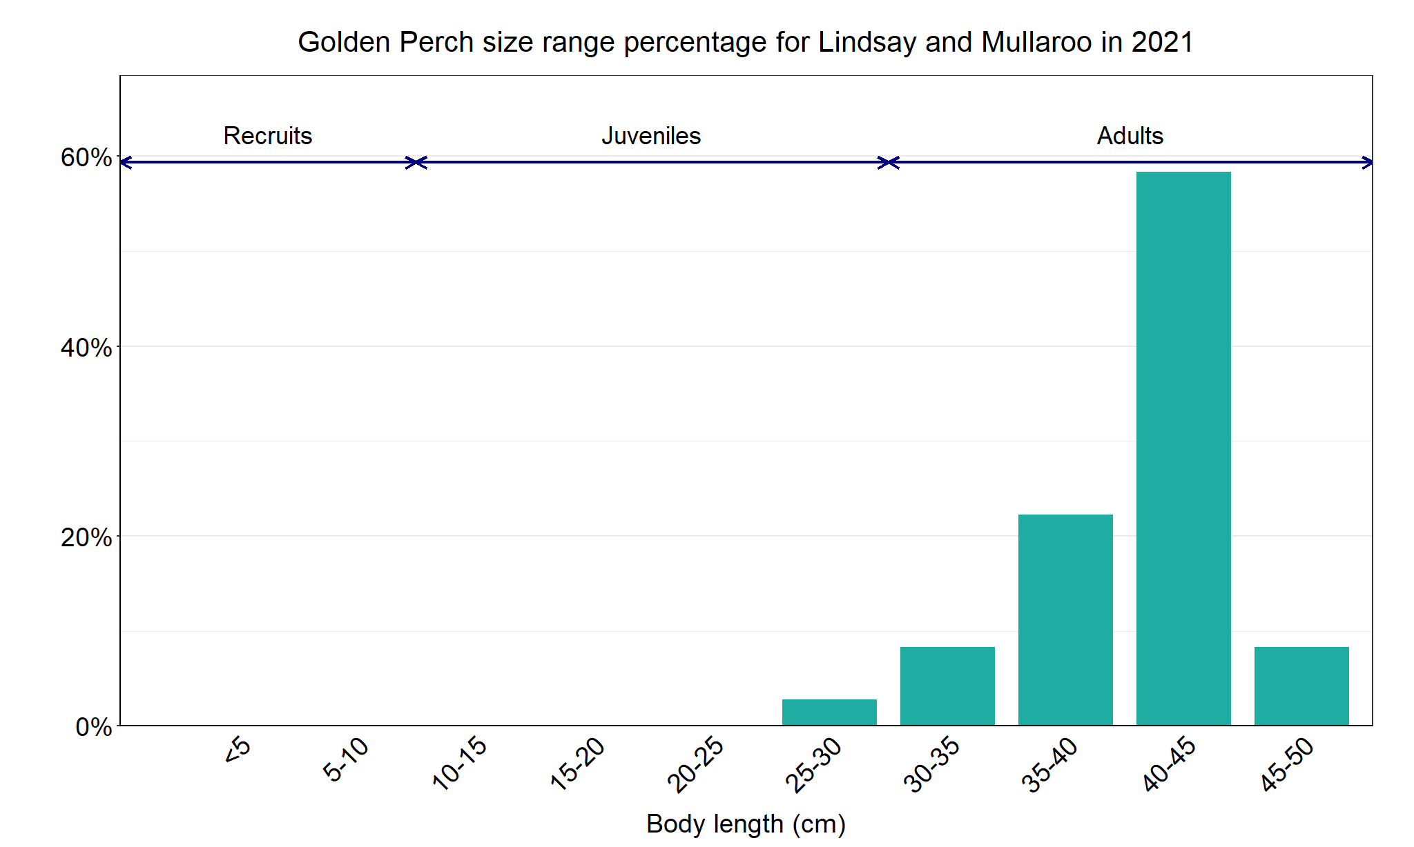
Figure 3. The size range percentage of Golden Perch in the Lindsay River system in 2021.

Murray Cod

Lindsay River system, Mallee region

Key Health Indicators
Recent recruitment Yes
Multiple size classes Yes
Mature fish present Yes

Monitoring Results
Total number of fish caught 75
Fish per 1km of waterway 6.2
Largest fish by length (cm) 118.0
Largest fish by weight (kg) 28.5
% of the catch that is legal size 14.7

The abundance of Murray Cod (Maccullochella peelii) in the Lindsay River system declined dramatically following the 2016 blackwater event either through emigration or mortality¹. Murray Cod have subsequently increased from 2017 (where no Murray Cod were captured at NFRC sites, although one juvenile was captured during The Living Murray survey (unpublished data) (Figure 4). Murray Cod have only been recorded from the Mullaroo Creek and never in Lindsay River itself in all five years. From 2018 to 2021 multiple size classes including mature and young-of-year fish have been recorded with the number of adults highest in 2021 (Figure 4). As no stocking has occurred prior to the 2021 surveys, these are all likely to be wild spawnings. The NFRC has set recruits for Murray Cod across all priority rivers as 10 cm (based on previous research). In the Lindsay River system in 2018 approximately 71% of fish captured were 90 – 150 mm TL, representative of young-of-year fish spawned in spring 2017 (a subsample was aged by otoliths*), indicating a faster growth rate following the blackwater event². As a result, the abundance of recruits is most likely under-represented in Figures 4 and 5. For example, the 10-15 cm fish in 2021 (Figure 5) are likely recruits from 2020 spawnings. In 2020, where Murray Cod were aged, the 2017 spawning made up approximately 50 % of Murray Cod in the system². Overall, the Murray Cod is showing a strong recovery.

Stocking
Twenty-seven thousand Murray Cod were stocked into the Lindsay River in March 2021. Note this stocking occurred after the 2021 surveys.

*Otoliths are fish earbones

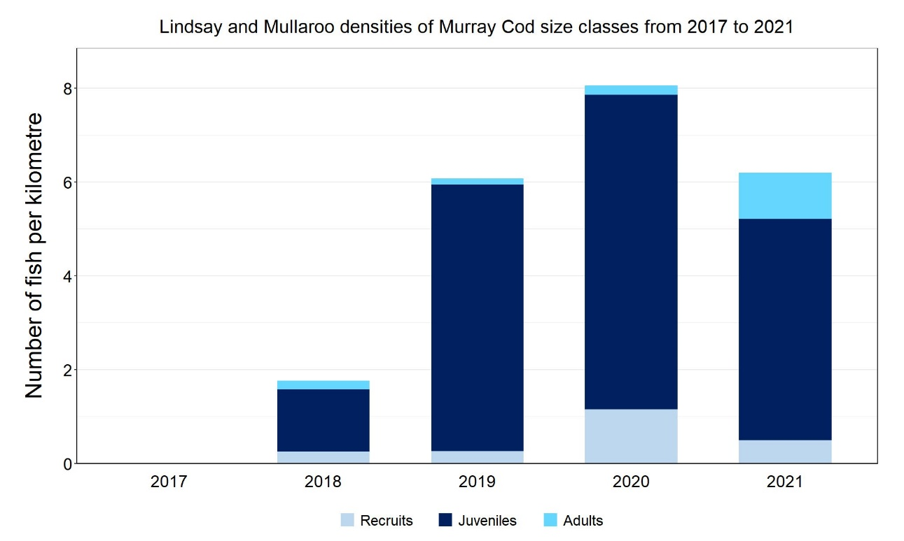
Figure 4. The densities of recruits, juveniles and adult Murray Cod in the Lindsay River system from 2017 to 2021.
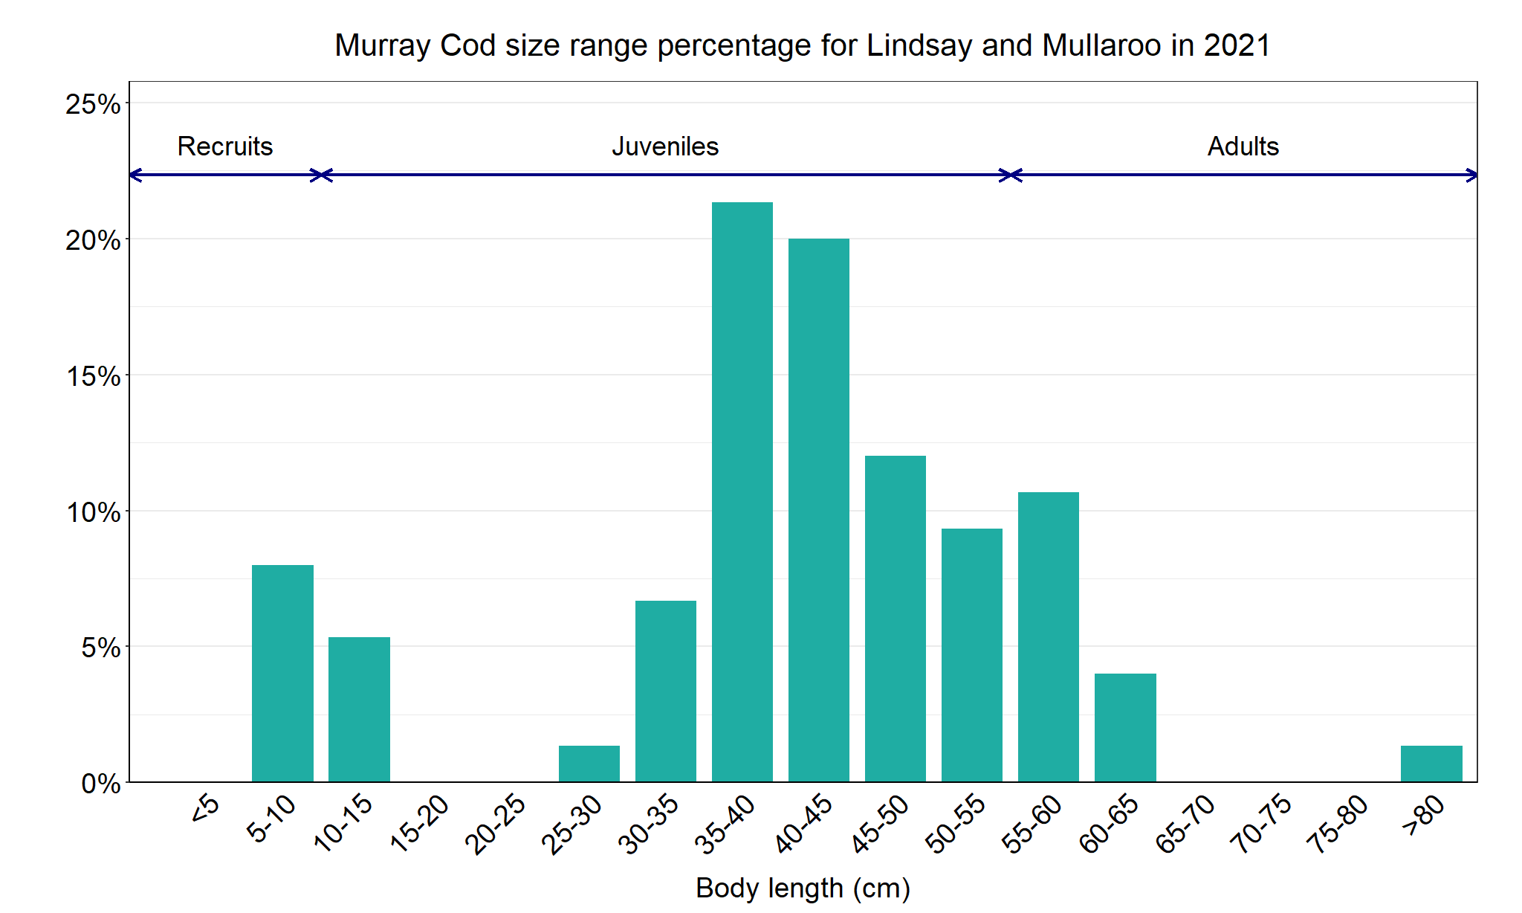
Figure 5. The size range percentage of Murray Cod in the Lindsay River system in 2021.

1. Tonkin, Z., O’Mahony, J., McMaster, D., Raymond, S., Moloney, P. and Lyon, J. (2017). Fish movement in the Lindsay and Mulcra Island anabranch systems: 2017 Progress report. Unpublished Client Report for the Mallee Catchment Management Authority. Arthur Rylah Institute for Environmental Research. Department of Environment, Energy, Environment and Climate Change Group, Heidelberg, Victoria.

2. Tonkin, Z., O’Mahony, J., Kitchingman, A., Moloney, P., Raymond, S., Hackett, G., and J. Lyon (2020). Murray cod movement and population structure in the Lindsay Island anabranch system: 2020 Report. Unpublished Client Report for the Mallee Catchment Management Authority. Arthur Rylah Institute for Environmental Research, Department of Environment, Land, Water and Planning, Heidelberg, Victoria.

Silver Perch

Lindsay River system, Mallee region

Key Health Indicators
Recent recruitment Cannot be determined
Multiple size classes Cannot be determined
Mature fish present Cannot be determined

Monitoring Results
Total number of fish caught 4
Fish per 1km of waterway 0.33
Largest fish by length (cm) 39.8
Largest fish by weight (kg) 792
% of the catch that is legal size NA

The natural range of Silver Perch (Bidyanus bidyanus) includes most of the Murray-Darling Basin, excluding the cool, higher altitude upper reaches of streams. River regulation and barriers have been listed as factors impacting Silver Perch populations, with these relevant to the Lindsay River system. While the NFRC only expects to capture low numbers of this species, the monitoring can provide a greater understanding of the current status of the populations which is essential to inform management of these species. Due to the low abundances of Silver Perch collected during NFRC the key health indicators cannot be measured. Low abundances of Silver Perch have been detected in all five years (Figure 6). The Silver Perch detected are a mixture of recruits (2020), juveniles (2017, 2019 and 2021) and adults (2018, 2019 and 2021 (Figures 6 and 7)). Recruits of this species are difficult to catch using this sampling methodology, with recruits only detected in 2020, indicative of spawning success in 2019.

Stocking
No stocking has occurred.

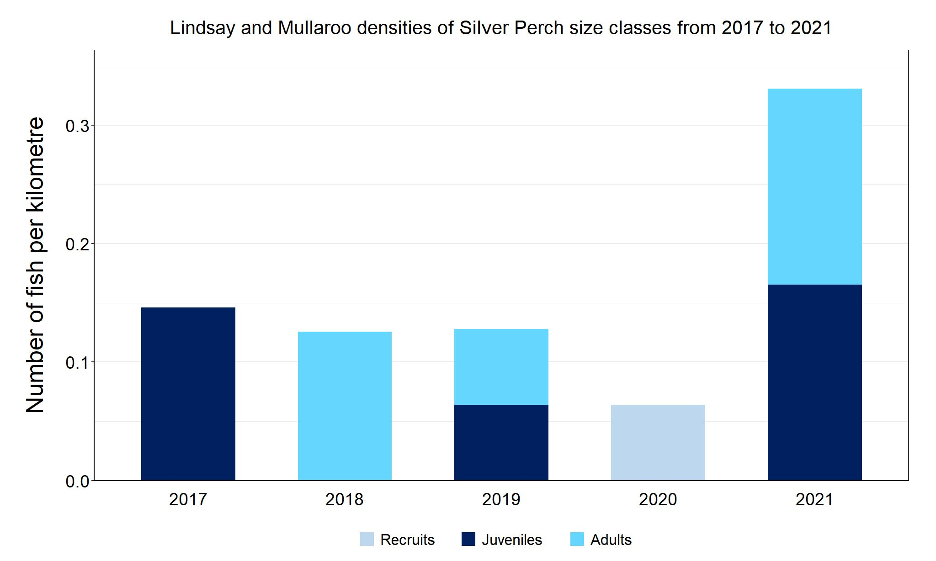
Figure 6. The densities of recruits, juveniles and adult Silver Perch in the Lindsay River system from 2017 to 2021.

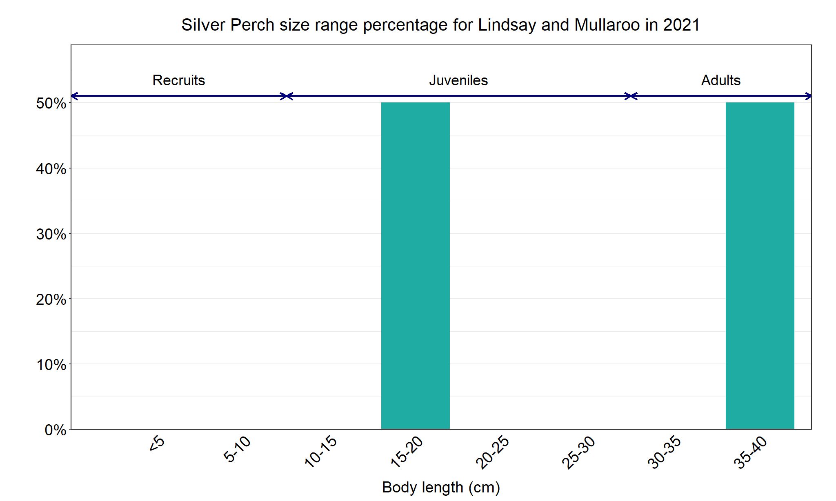
Figure 7. The size range percentage of Silver Perch in the Lindsay River system in 2021.

