distna

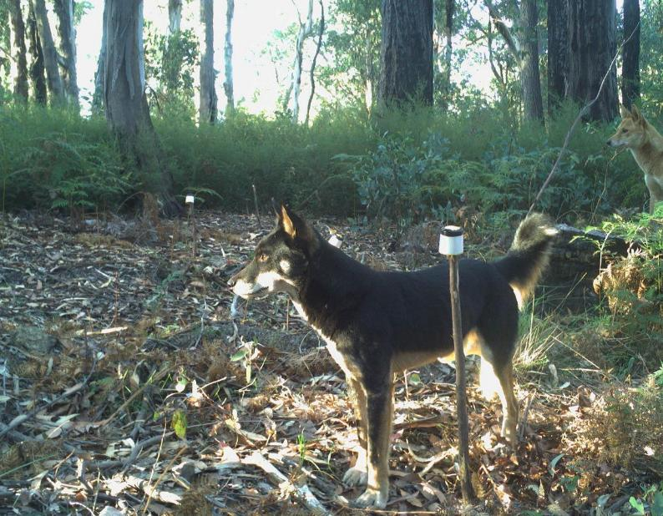

Arthur Rylah Institute for Environmental Research Technical Report Series No. 382
The abundance of dingoes Canis familiaris (Dingo) in Victoria
Results from a statewide survey
D.S.L. Ramsey and J.G. Cally
June 2024



Arthur Rylah Institute for Environmental Research
Department of Energy, Environment and Climate Action
PO Box 137, Heidelberg, Victoria 3084
Phone (03) 9450 8600
Website: www.ari.vic.gov.au
Citation: Ramsey, D.S.L. and Cally, J.G. (2024). The abundance of dingoes Canis familiaris (Dingo) in Victoria: Results from a statewide survey. Arthur Rylah Institute for Environmental Research Technical Report Series No. 382. Department of Energy, Environment and Climate Action, Heidelberg, Victoria.
Front cover photo: Dingo in the eastern Victorian highlands (Arthur Rylah Institute).

Edited by Fox Writing Services
ISSN 1835-3835 (pdf))
ISBN 978-1-76136-759-5 (pdf/online/MS word)

We acknowledge and respect Victorian Traditional Owners as the original custodians of Victoria’s land and waters, their unique ability to care for Country and deep spiritual connection to it.
We honour Elders past and present whose knowledge and wisdom
has ensured the continuation of culture and traditional practices.
DEECA is committed to genuinely partnering with Victorian Traditional Owners and Victoria’s Aboriginal community to progress their aspirations.
© The State of Victoria Department of Energy, Environment and Climate Action June 2024.
Creative Commons
This work is licensed under a Creative Commons Attribution 4.0 International licence, visit the Creative Commons website (http://creativecommons.org/licenses/by/4.0/).
You are free to re-use the work under that licence, on the condition that you credit the State of Victoria as author. The licence does not apply to any images, photographs or branding, including the Victorian Coat of Arms, and the Victorian Government, the Department and the ARI logos.
Disclaimer
This publication may be of assistance to you but the State of Victoria and its employees do not guarantee that the publication is without flaw of any kind or is wholly appropriate for your particular purposes and therefore disclaims all liability for any error, loss or other consequence which may arise from you relying on any information in this publication.
Accessibility
To receive this document in an alternative format, phone the Customer Service Centre on 136 186, email customer.service@delwp.vic.gov.au, or contact National Relay Service on 133 677. Available at DEECA website (www.deeca.vic.gov.au).

The abundance of dingoes Canis familiaris (Dingo) in Victoria

Results from a statewide survey

David S.L. Ramsey and Justin G. Cally

¹Arthur Rylah Institute for Environmental Research
Department of Energy, Environment and Climate Action
123 Brown Street, Heidelberg, Victoria 3084

Date

Arthur Rylah Institute for Environmental Research

Technical Report Series No. 382

Acknowledgements
This project was funded by the Biodiversity Division, Department of Energy, Environment and Climate Action (DEECA). We thank Luke Woodford and Tom Schneider for the additional camera trap surveys in the Big Desert Wilderness Park and Wyperfeld National Park, and for subsequent image analysis. The previous work on the statewide deer abundance project that underpins the current work was funded by DEECA under the Victorian Deer Control Strategy, and we thank Stefan Kaiser, Michelle Hanslow and Daryl Clune for facilitating that project. We also thank the Game Management Authority, particularly Simon Toop, for providing the funding for the targeted Hog Deer survey, which was also used as part of this project. We would like to thank Wildlife Unlimited, Brad Farmilo, Declan Leevers, Thomas Schneider, Luke Woodford, Dave Bryant, Emily Jordan, Rob Dabal, Khorloo Batpurev, Ellie Tsiamis and Celsey Adams for their contributions to fieldwork.

Contents
Acknowledgements ii
Summary 1
1 Introduction 2
1.1 Aims 2
2 Methods 4
2.1 Sampling design 4
2.2 Analysis of camera trap data 6
2.2.1 Dingo density estimates 7
2.2.2 Prediction of Dingo abundance 9
2.2.3 Estimating occupied area 9
3 Results 10
3.1 Detection of dingoes 10
3.1.1 Distance sampling 10
3.2 Dingo activity 11
3.3 Dingo abundance 12
3.3.1 Site-level estimates 12
3.3.2 Statewide estimates 13
4 Discussion 17
4.1 Conclusions and recommendations 18
5 References 19
Appendix 22

Tables
Table 1. Descriptions of the covariates used to model Dingo density. 8
Table 2. Model selection table for distance detection functions fitted to the distance data from Dingo images in cameras. 11
Table 3. Parameter estimates for the fixed-effect covariates for Dingo abundance ($λi$) in the Bayesian model fitted to the distance data and image counts in cameras. LCL and UCL represent the lower and upper 90% confidence limits, respectively. 13
Table 4. Parameter estimates for the fixed-effect covariates for the zero-inflation parameter ($ϕi$) (i.e. probability of presence) in the Bayesian model fitted to the distance data and image counts in cameras. LCL and UCL represent the lower and upper 90% confidence limits, respectively. 13
Table 5. Abundance estimates for the Dingo on public land in Victoria. Predictions are provided for Eastern Victoria and the BD/WNP, areas known to be occupied by dingoes (Figure 8). SD – standard deviation, CV – coefficient of variation, LCI – lower 90% credible limit, UCL – upper 90% credible limit, Area – area of public land used for prediction (km²), Density – average density (dingoes/km²) with values in brackets representing the 90% credible interval for the density estimate. 15

Figures
Figure 1. Location of the 317 camera trap sites (yellow circles) sampled as part of the statewide deer monitoring project during 2021–2022. 5
Figure 2. Locations of camera trap sites within the Big Desert Wilderness Park and Wyperfeld National Park (BD/WNP) region of northwest Victoria. Yellow circles indicate the camera trap sites sampled during 2021–2022 and the red circles indicate the locations sampled during 2023, with two cameras placed at each site. The vertical black line indicates the Victorian/South Australian border. 5
Figure 3. A Dingo detected on a camera in eastern Victoria. The image shows the locations of the four distance markers set at 2.5, 5, 7.5 and 10 m from the camera (yellow capped stakes). 6
Figure 4. Locations of remote cameras (blue circles) set across public land in Victoria (green shading). Red circles show cameras that detected dingoes. Polygons show the regions within the west and east of the state where Dingo abundance was estimated. 10
Figure 5. Distance-sampling detection process for dingoes (group size = 1). Bars indicate the frequency distribution of expected distances, and the line indicates the fitted detection function (half-normal with second- and third-order cosine adjustment terms). 11
Figure 6. Relative activity of dingoes throughout a 24-hour day. Bars are the observed frequencies of active times and the solid blue line is the mean kernel density estimate. 12
Figure 7. Marginal response plots of the relationship between environmental covariates and Dingo abundance. These marginal effects consider the effect of zero-inflation (occupancy) on each parameter and are generated for the East Gippsland Uplands bioregion; an area with high Dingo occupancy. Valley bottom flatness and Precipitation seasonality are unitless. 14
Figure 8. Spatial variation in Dingo density predicted across public land in Victoria for the two regions (Eastern Victoria and the BD/WNP), known to be occupied by dingoes. Focused views of each region are provided in Figures 9 and 10. 15
Figure 9. Focused view of the spatial variation in Dingo density predicted across public land in the BD/WNP. 16
Figure 10. Focused view of the spatial variation in Dingo density predicted across public land in eastern Victoria. 16
Figure 11. Estimates of the area of public land occupied by dingoes in the eastern and BD/WNP regions of Victoria. 17

Summary
Context:
In Victoria in 2021, the Dingo (Canis lupus dingo) was listed as “Vulnerable in Victoria” under the Flora and Fauna Guarantee Act 1988 and therefore, is protected under the Wildlife Act 1975. Dingoes are an ancient lineage of wild canid closely related to domestic dogs (Jackson et al. 2021). In 2024, Dingoes were recognised as Canis familiaris and this report adopts that taxonomic nomenclature. While there is debate about Dingo taxonomy, it is broadly recognised that the Dingo has been present in Victoria for thousands of years and is considered native wildlife. Recent genetic investigations have suggested that the level of hybridisation between free-ranging dingoes and feral or domestic dogs in Victoria is very low, challenging previous understanding (Weeks et al. 2022; Cairns et al. 2023). This work subsequently prompted a review of the current policy and regulatory framework around Dingo conservation and management in Victoria. To inform an assessment of the current conservation status of the Dingo in Victoria, an estimate of the statewide abundance of dingoes is required.
Aims:
The aims of this study were to:
- use existing monitoring data from an array of 317 remote infrared cameras set across public land in Victoria to estimate the abundance of dingoes in eastern Victoria
- estimate the abundance of dingoes in western Victoria using monitoring data from (1) in conjunction with data supplemented from an additional 40 remote infrared cameras set within the Big Desert Wilderness Park and State Forest and Wyperfeld National Park region (BD/WNP).
Methods:
The statewide abundance of dingoes was assessed using remote infrared cameras (camera traps) set at 357 sites across public land in Victoria using a spatially balanced, random sampling design. To enable estimation of Dingo density, images with dingoes were tagged with their distance from the camera. The encounter rates of dingoes in camera images were used along with the distance category for each image to estimate Dingo density at the camera location using camera trap distance sampling (CTDS) (Howe et al. 2017). A hierarchical Bayesian model was then used to model Dingo density as a function of covariates describing spatial variation in density, accounting for Dingo group size, camera detection probability, survey effort (camera deployment period) and relative Dingo activity. Results from this model were then used to derive abundance estimates for the Dingo population on public land in eastern Victoria (40,909 km²) as well as the Dingo population in the BD/WNP (6,864 km²).
Results:
Images of dingoes were obtained from 32 of the 357 monitored sites with dingoes detected at 30 sites in eastern Victoria and two sites in the BD/WNP. Based on image capture times, the estimate of the relative amount of a 24 h day that dingoes were active was 44% (90% CL: 24–65%), with activity peaking in the early morning and evening.
Dingo density at monitored sites estimated from the Bayesian model ranged from 0–1.9 dingoes/km², with a mean overall density of 0.08 dingoes/km². Dingo densities were lower at sites with higher percentage bare soil, higher amounts of forest edge habitat per km² and longer distances to water while densities were higher at sites with higher precipitation seasonality and higher valley bottom flatness. Dingo abundance in eastern Victoria was estimated to be 4,900 (90% CL: 2,640–8,880) individuals, while in the BD/WNP Dingo abundance was estimated to be 110 (90% CL: 40–230) individuals.
Conclusions and implications:
An extensive and intensive statewide survey using camera traps estimated the total population of dingoes in Victoria to be 5,010 (90% CL: 2,710–9,050), with the majority of the state’s Dingo population resident in the Gippsland and Hume regions. Due to the apparent very low population abundance of dingoes estimated in the BD/WNP, it is recommended that further periodic monitoring of this population be prioritised to determine the response to threats and management. Similarly, continued monitoring of the eastern population should be undertaken to determine how the population responds to management.
- Introduction
In Victoria in 2021, the Dingo (Canis lupus dingo) was listed as “Vulnerable in Victoria” under the Flora and Fauna Guarantee Act 1988. In 2024, Dingoes were recognised as Canis familiaris and this report adopts that taxonomic nomenclature. While there is debate about dingo taxonomy, it is broadly recognised that dingoes have been present in Australia for thousands of years prior to European settlement and are considered native wildlife and therefore, protected under the Wildlife Act 1975 in Victoria. However, dingoes are also a significant threat to Victoria’s livestock and have been estimated to cost the industry around $13–18 million per year in lost productivity (DEPI 2013). The Victorian Government currently manages the impacts of dingoes on agricultural properties to meet its land manager responsibilities under the Catchment and Land Protection Act (CaLP) (Victorian/Government 1994). This is facilitated by a Governor in Council order, which declares dingoes to be unprotected wildlife on most private land and public land within 3 km of private land boundaries. Until recently, the unprotection order on public land was limited to certain areas in the Hume and Gippsland regions, and to the Mallee region in northwest Victoria.
Occurrences of dingoes in the Victorian Biodiversity Atlas (VBA – accessed 4/6/2024) since 1990 are largely confined to eastern Victoria, with a single record located in northwest Victoria in the Big Desert Wilderness Park and State Forest and Wyperfeld National Park (hereafter – BD/WNP). However, a revision of the canid records in the VBA has recently been undertaken, which uses updated knowledge on the occurrence of wild canids in Victoria and will increase the number of published Dingo records currently in the VBA, including northwest Victoria. Dingoes are an ancient lineage of wild canid closely related to domestic dogs (Jackson et al. 2021). However, recent genetic investigations have suggested that the level of hybridisation between free-ranging dingoes and feral or domestic dogs in Victoria is very low (Weeks et al. 2022; Cairns et al. 2023). This recent work has challenged previous understanding about the level of hybridisation between dingoes and domestic dogs (Stephens et al. 2015). Both studies also suggested that the Dingo population in the BD/WNP is a genetically distinct and geographically isolated subpopulation that is in danger of extinction due to very high levels of inbreeding. The level of threat to the BD/WNP Dingo population has recently led to a revision of the unprotection order to protect dingoes in the northwest of the state on both private and public land. The recent genetic evidence has also prompted a review of the current policy and regulatory framework around Dingo conservation and management in Victoria. This review will also include a comprehensive assessment of the conservation status of the Dingo, including an assessment of Dingo population and distribution across Victoria.
To inform an assessment of the current conservation status of the Dingo in Victoria, a current estimate of the statewide abundance of dingoes is required. Despite numerous investigations into the ecological role of the Dingo in Australia (e.g. Johnson and Vanderwal 2009; Allen et al. 2013), there are very few examples of robust estimates of Dingo abundance in the peer-reviewed scientific literature (Forsyth et al. 2019b and references therein). The most robust estimates of Dingo abundance were made by intensive long-term observation of packs supplemented with radio telemetry (Thomson et al. 1992), a method that has been commonly used to estimate Gray Wolf (Canis lupus) densities in North America (Latham et al. 2011). However, that method is labour-intensive and expensive, and more cost-effective methods are needed to estimate the abundance of cryptic carnivores (Forsyth et al. 2019b). The advent of affordable and reliable remote infrared trail cameras (hereafter ‘camera traps’) has revolutionised many aspects of the study of wild mammals, and has proven particularly cost-effective for detecting cryptic carnivores that occur at low densities (Karanth et al. 2006; Jiménez et al. 2017). Here we use camera trap data to undertake distance sampling (Howe et al. 2017) of Dingo detections and combine this with a spatially comprehensive sampling design to estimate the abundance of dingoes across public land in Victoria.

Aims
The aims of this study were to:
- use existing monitoring data from an array of 317 remote infrared cameras to estimate the abundance of dingoes in eastern Victoria
- estimate the abundance of dingoes in western Victoria using monitoring data from (1) in conjunction with data supplemented from an additional 40 remote infrared cameras set within the Big Desert Wilderness Park and State Forest and Wyperfeld National Park (BD/WNP).

- Methods

Sampling design
The statewide abundance of dingoes was assessed on public land in Victoria using a sampling design that was originally constructed for the purposes of assessing deer abundance (Cally and Ramsey 2023) (Figure 1). However, as the principal monitoring method utilised remote infrared cameras, all images of vertebrate taxa that were detected, including dingoes, were tagged and collated for future analyses. We summarise the sampling design and monitoring methods relevant for dingoes here with further details given in Cally and Ramsey (2023).
The sampling frame consisted of all crown land on the mainland of Victoria, including Phillip and French islands (e.g. national parks, state forests, state game reserves, conservation reserves etc.). The total area of public land available for sampling was 74,570 km². To facilitate sampling, a hexagonal sampling grid was overlaid on the total area of public land, with each grid cell consisting of a nominal area of 4 km² (approximately 2 km in maximal diameter). The grid cell size was arbitrary but was selected to minimise spatial correlation among neighbouring cells. Any grid cell that had 50% of its area (at least 2 km²) overlapping public land was included in the sampling frame, which resulted in a total of 57,944 available grid cells. From this pool, a master list of 600 cells were randomly selected using a balanced accepted sampling approach (Lisic and Cruze 2016; van Dam-Bates et al. 2018). This approach ensured that cells were randomly sampled in such a way as to be representative of several ecological gradients including:
- spatial location (latitude, longitude): a broad proxy for bioclimatic variation
- tree density: reflecting various ecological vegetation groups and habitats
- bushfire impacts: reflecting recent disturbance due to 2019/20 megafires
- strategic biodiversity values: a proxy for many biodiversity assets and ecosystems.
Values for these variables were extracted for each grid cell and then used to calculate sampling probabilities (i.e. unequal probability sampling) such that any random sample would reflect the heterogeneity of values across each of the ecological gradients. From this master list, a total of 253 cells were then sampled between September 2021 and May 2023. In addition to these cells, a further 64 grid cells were also sampled between September and December 2022 as part of a related project targeting coastal Gippsland between Lower Tarwin and Point Hicks for the purposes of sampling Hog Deer (Axis porcinus) (Ramsey et al. 2023). Therefore, a total of 317 grid cells were sampled as part of those projects (Figure 1).
The number of sampled grid cells that fell in the range of the northwest Dingo population in the BD/WNP was only five. Consequently, to increase the likelihood of Dingo detections for this important subpopulation, we randomly selected an additional 20 grid cells within the BD/WNP area for sampling, which occurred during October – December 2023 (Figure 2). Sampling in these grid cells consisted of two cameras being placed between 93 and 202 metres apart (mean = 130 m) to improve detection rates. Therefore, in total, an additional 40 cameras were deployed, bringing the total number of camera sites available across the state to 357.

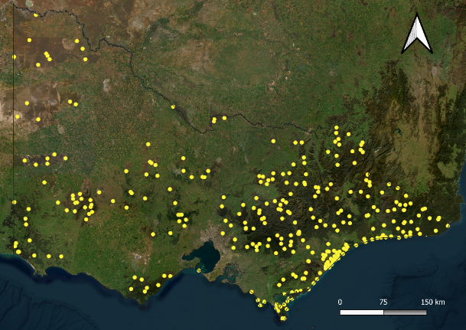
Figure 1. Location of the 317 camera trap sites (yellow circles) sampled as part of the statewide deer monitoring project during 2021–2022.

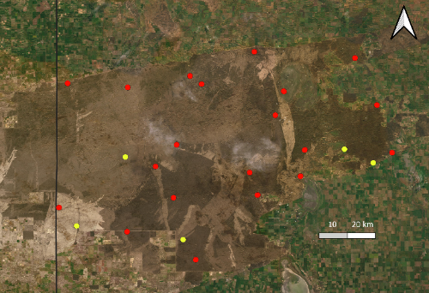
Figure 2. Locations of camera trap sites within the Big Desert Wilderness Park and Wyperfeld National Park (BD/WNP) region of northwest Victoria. Yellow circles indicate the camera trap sites sampled during 2021–2022 and the red circles indicate the locations sampled during 2023, with two cameras placed at each site. The vertical black line indicates the Victorian/South Australian border.

For each sampled grid cell, a site was selected for monitoring located as near to the centroid of the cell as was practicable given road or track access. Sites were then located at least 150 m away from the nearest road or track in the direction of the cell centroid. At each site, a remote infrared camera (Reconyx Hyperfire HF2X – hereafter, camera trap) was attached to the nearest tree at a height of 1 m above ground and facing in a southerly direction. Trees were selected that gave a clear field of view for the camera avoiding any obvious tracks or game trails. To enable estimation of animal density, four distance markers were set at 2.5 m, 5 m, 7.5 m and 10 m from the camera near the midpoint of the field of view. Hence, for each Dingo detection, a distance category or ‘bin’ was recorded (i.e., 2.5 m – 5.0 m). Reflective tape attached to the distance markers enabled them to be visible in both day and night-time images (Figure 3). Cameras were left in place for approximately 6 weeks. The exception to the above was that for the 20 additional grid cells (40 cameras) that were sampled in the BD/WNP, a total of two cameras were placed in each cell, without distance markers. To estimate distances of dingoes from these cameras, we took reference images during the set-up of the camera. In these reference photos, one person would trigger the camera by standing in front of the camera with a sign indicating their distance from the camera. Images of dingoes could then be compared against these reference images to determine the distance of the Dingo from the camera. The use of reference images instead of distance markers was used to avoid dingoes interacting (e.g. smelling or chewing) the distance markers; behaviour that may bias density estimates when not accounted for (Henrich et al. 2022).

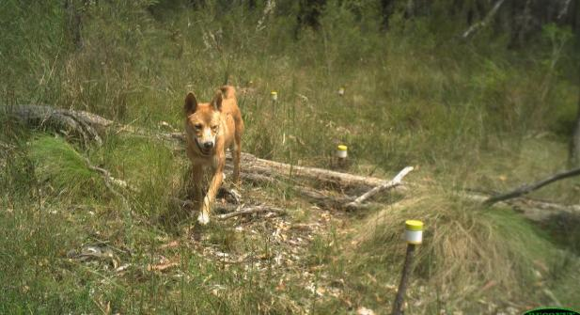
Figure 3. A Dingo detected on a camera in eastern Victoria. The image shows the locations of the four distance markers set at 2.5, 5, 7.5 and 10 m from the camera (yellow capped stakes).

Analysis of camera trap data
The encounters of dingoes on cameras along with the distance category for each image can be used to estimate Dingo density at the camera location using camera trap distance sampling (CTDS) (Howe et al. 2017). CTDS is a modified form of distance sampling, which allows us to infer the probability that a given individual will be detected within the survey area (area in front of the camera). This detection probability is a function of the distance of the individual from the camera, whereby detection of individuals declines with increasing distance from the camera (Howe et al. 2017). Briefly, this method assumes that cameras are deployed independently of animal locations at a site ($i$) for a period of time ($T_{i}$) and capture images for as long as an individual is present to trigger the camera. Images are then obtained at a predetermined set of instants, $t$ units of time apart (snapshot instants). Temporal effort at each camera is then calculated as $T_{i}⁄t$. Howe et al. (2017) suggested that a useful range for $t$ is 0.25 to 3 seconds, with values at the lower end being more suitable for fast-moving or rarer species. For the analysis here, we set the snapshot instants ($t)$ to 1 second intervals. If the camera covers a horizontal angle of view of $θ$ radians, then the fraction of the circle observed by the camera field of view is $θ⁄2π$. Therefore, the data consist of a series of snapshot instants taken $t$ units of time apart, with an overall sampling effort at each site $i$ equal to $(θT_{i})/2πt$. Estimates of density (${\hat{D}}_{i}$) follow standard point transect methods (Equation 1) (Buckland et al. 2006).
$$\begin{aligned}\begin{aligned}{\hat{D}}_{i}=\frac{C_{i}}{πw^{2} e_{i}p_{i}A}\end{aligned}\#1\end{aligned}$$
Where $C_{i}$ are the counts of the total number of dingoes in snapshot moments at site $i$, $w$ is the maximum observation distance from the camera (truncation distance – here set to 12.5 m for all dingoes observed beyond the 10 m marker), $p_{i}$ is the probability of detecting an individual that is within $w$ distance from the camera, $A$ is an estimate of relative Dingo activity and $e_{i}$ is the overall sampling effort $(θT_{i})/2πt$.
An underlying assumption of CTDS is that cameras and distance markers do not influence the behaviour of individuals so encounters with cameras depend only on natural movement rates. Individuals who show behavioural interactions with cameras or distance markers are likely to spend more time in the camera field of view than they otherwise would, which could bias density estimates (Henrich et al. 2022). To remove this source of bias, we removed snapshot moments where dingoes exhibited interactions with camera or distance markers, which occurred in 23% of snapshot moments.
Following on from the above, a further assumption about CTDS is that the probability a Dingo will encounter a particular distance bin within the camera field of view is proportional to the total area of each distance bin, which increases at further distance bins (Buckland et al. 2006). However, for images containing multiple individuals, only the distance to the closest individual was recorded. Consequently, we implemented a novel method that considers the group size of detected individuals in the calculation for the probability of encounter (i.e. availability). The rationale here was that the camera was more likely to be triggered by the closest individual of a group: individuals at further distances are recorded following the triggering of the camera by the closest individual. Therefore, for groups, CTDS should account for the availability of the closest individual rather than the availability of all individuals. It follows that as group size increases, the distance between the camera and the closest individual is likely to decrease. If we assume that the triggering of the camera is dependent upon the closest individual within a group, then we must adjust our estimated availability to account for variable group sizes. If we do not adjust for group size and only use the distance to the closest individual for our distance sampling models, then we will likely underestimate the detection rate. Alternatively, if we record distances to multiple individuals in the same photo and take an average or model them independently, we will likely overestimate detection probability because individuals at further distances are only recorded in response to a closer individual triggering the camera trap.
In this study, we investigated two possible detection functions (half-normal and hazard rate) that may explain how detection rates decline with increasing distances from the camera (Buckland et al. 1993). We also allowed the inclusion of cosine adjustment terms in the detection functions (up to order 3) to potentially improve model fit. We compared the relative fit of detection functions using AIC (Burnham and Anderson 2002) in the ‘Distance’ R package (Thomas et al. 2010) and used the detection function most supported by the data in our Bayesian hierarchical model of Dingo density and abundance (see below).
- Dingo density estimates
The count of the number of snapshot moments of Dingo images at a site was modelled as a function of explanatory variables describing spatial variation in density, relative frequency of group sizes, distance-sampling detection probability, survey effort (area in front of camera multiplied by the total snapshot moments the camera was deployed for) and proportion of time within a 24-hour cycle that dingoes were active (Equation 2). We accounted for noticeable zero-inflation in the counts of dingoes by adopting a zero-inflated Poisson (ZIP) model with a zero-inflation probability parameter $ϕ_{i}$. Therefore, our model for the image counts ($C$) at site ($i$), and group size ($j$) was:
$$\begin{aligned}C_{ij} \sim ZIP\left(λ_{i}∙p_{i}∙A∙g_{ij}∙e_{i}, ϕ_{i}\right)\#2\end{aligned}$$
where $λ_{i}$ is the true mean density at a site (dependent on covariates). This mean density parameter was modelled using a fixed-effects formulation while the zero-inflation probability $ϕ_{i}$ was modelled using both fixed and random effects:
$$\begin{aligned}\log\left(λ_{i}\right)=X_{i}β\#3\end{aligned}$$
$$logit\left(ϕ_{i}\right)=X_{i}α+ ε_{b(i)}$$
where $X_{i}$ were the covariates describing spatial variation in density, derived from climatic, environmental, topographic, and soil-based variables (Table 1) with $β$ representing the parameter estimates. These variables were chosen as they describe resources that may be relevant to Dingo spatial variation. The same covariates were also used to model the zero-inflation probability $ϕ_{i}$ with parameter estimates $α$ but with the addition of spatial random effects $ε_{b\left(i\right)}$, which were dependent on the bioregion $b$ at site $i$. The values for the covariates at a camera site were estimated as the mean of the values extracted from the camera location including a 1 km buffer.
Table 1. Descriptions of the covariates used to model Dingo density.
Covariate | Description
Bioregion | A landscape-scale classification of areas in Victoria based on their climate, geomorphology, geology, soils, and vegetation (Department of Energy Environment and Climate Action 2019).
Bare soil (%) | Fractional cover of bare soil estimated from remote sensing (MODIS Nadir BRDF-Adjusted Reflectance product: MCD43A4). The combined sum of bare soil, photosynthetic vegetation and non-photosynthetic vegetation is 100% (Guerschman 2014).
Nitrogen (%) | Mass fraction of nitrogen in the topsoil (0–15 cm) by weight (O’Brien 2021).
Distance to pastural land (m) | Distance to nearest area of land that is classed as being under pastural use. Catchment scale land use data for Australia (CLUM) using The Australian Land Use and Management (ALUM) classification system was used to classify pastural areas (ABARES 2021). The following land use classes were considered as pasture:  2.1.0 Grazing native vegetation  3.2.0 Grazing modified pastures  3.2.1 Native/exotic pasture mosaic  3.2.2 Woody fodder plants  3.2.3 Pasture legumes  3.2.4 Pasture legume/grass mixtures  3.2.5 Sown grasses  4.2.0 Grazing irrigated modified pastures  4.2.1 Irrigated woody fodder plants  4.2.2 Irrigated pasture legumes  4.2.3 Irrigated legume/grass mixtures  4.2.4 Irrigated sown grasses.
Precipitation seasonality | The coefficient of variation of precipitation across the year (BIO15 in WorldClim variables). That is, the standard deviation of the monthly precipitation estimates expressed as a percentage of the mean of those estimates (i.e. the annual mean). This broadly reflects how much rainfall varies throughout the year (Karger et al. 2017).
Forest edge per km² (m) | Length of forest edge within a 1 km² area. Forest cover is estimated from structural vegetation data (DEECA 2021). With forest classed as a type of open forest or woodland vegetation form.
Distance to water (m) | Distance from the centroid of each 1-km grid cell to the nearest permanent surface water (e.g. river, lake, wetland or stream).
Non-photosynthetic vegetation (%) | Fractional cover of non-photosynthetic vegetation estimated from remote sensing (MODIS Nadir BRDF-Adjusted Reflectance product: MCD43A4). The combined sum of bare soil, photosynthetic vegetation and non-photosynthetic vegetation is 100% (Guerschman 2014).
Valley-bottom flatness | Multi-resolution valley-bottom flatness (MrVBF) is a topographic index that identifies valley bottoms and calculates their relative elevation and flatness to their surroundings (Gallant et al. 2012).

The $g_{ij}$ (Equation 2) are the estimated proportions for each of the $J$ group sizes ($j=1…J$) at a site, where $\sum_{j=1}^{J}{g_{ij}}=1.$We assumed that group size proportions could vary between sites, and accounted for this by modelling group size with a group level intercept ($ζ_{j}$) and site-group-size level random effect (${ϵsite}_{ij}$):
$$\begin{aligned}{ϵpsi}_{ij}=exp\left(ζ_{j}+{ϵsite}_{ij}\right) \#4\end{aligned}$$
proportional group size $j$at a given site $i$ was therefore given by:
$$\begin{aligned}g_{ij}= \frac{{ϵpsi}_{ij}}{sum\left({ϵpsi}_{ij}\right)}\#5\end{aligned}$$
The parameter $A$ was the estimate of Dingo activity, defined as the proportion of a 24-hour day that animals were active. Estimation of this parameter was required to account for availability bias, where individuals may temporarily be unavailable for detection due to changes in animal behaviour (e.g. resting) (Corlatti et al. 2020). We estimated the proportion of a 24-hour day that individual dingoes were active by fitting a kernel density estimate to the image capture times from each Dingo image (in radians). The area under the kernel density estimate was used as the estimate of $A$ (Rowcliffe et al. 2014), and was included in the Bayesian hierarchical model using an informative beta prior. The other parameters appearing in Equation 2 ($p_{i}$ and $e_{i}$) were defined previously (Equation 1).
The above model defined by equation’s 1–5 was fitted in a Bayesian framework using Hamiltonian Markov chain Monte Carlo (MCMC) methods in Stan (version 2.34.1) with CmdStanR in R (Gabry and Češnovar 2022). Weakly informative prior distributions were used for all parameters in the model specified as $N\left(0, 5\right)$. A total of 500 MCMC iterations were run for the model, using eight chains, with the first 250 iterations considered to be ‘warmup’ (tuning) iterations and discarded. This left a total of 2,000 samples for each parameter to form the inference. Convergence of the MCMC chains was confirmed by visual inspection of traceplots and calculation of the convergence statistic $\hat{R}$ (Brooks and Gelman 1998).
- Prediction of Dingo abundance
Our model-based approach allowed us to generate estimates of Dingo abundance across unsampled areas (1-km grid cells), by applying the model to any unsampled areas that had the appropriate covariate values. We restricted our predictions to public land (excluding water bodies and publicly tenured land used for services and utilities) within two distinct regions representing the known distribution of dingoes in Victoria. These were the region subject to the unprotection order in eastern Victoria (40,909 km²) and the BD/WNP region in the west (6,864 km²). Predictions used covariate data at a 1 km² spatial resolution and were offset by the amount of public land in the grid cell, and therefore reflected the estimated abundance of dingoes on public land within that grid cell. Grid cell predictions were then summed to estimate Dingo abundance for each region. Each grid cell prediction was calculated as the trimmed mean from the posterior distribution (highest and lowest 2.5% of draws were trimmed). The trimmed mean was used as it is considered to be a more robust measure of central tendency when outliers are present. Average density estimates for these regions were calculated by dividing the total abundance within the region by the area of public land in the region.
The combined effects of the covariates fitted to the zero-inflation and abundance components of the model were interpreted by calculating expected values for the marginal responses of each covariate, which for the ZIP model were given by:
$$\begin{aligned}E\left(C_{i}\right)= π_{i}λ_{i}\#6\end{aligned}$$
where $π_{i}= {\text{exp}\left(ϕ_{i}\right)}/{\left(1+\text{exp}\left(ϕ_{i}\right)\right)}$. Visual presentation of relationships between Dingo abundance and covariates was undertaken within a bioregion known to have high levels of Dingo occupancy (e.g. East Gippsland Uplands).
- Estimating occupied area
We created a binary prediction of occupied and unoccupied areas within each of the two regions used to predict Dingo abundance using the model predictions for each grid cell. This was undertaken by calculating an abundance threshold, which was closest to perfect sensitivity and specificity (Perkins and Schisterman 2006; Robin et al. 2011). Uncertainty in the estimated threshold was obtained using 2,000 bootstrapped iterations to calculate 90% confidence limits (Robin et al. 2011). From these values, we assigned areas across public land in the two regions as being occupied/unoccupied according to the median thresholds and lower/upper confidence bounds.

- Results

Detection of dingoes
After filtering images to exclude behavioural interactions with cameras and/or distance markers, a total of 326 snapshot moments of dingoes were obtained from 32 of the 357 cameras set across public land in Victoria (Figure 4). The majority of dingoes were detected in the eastern region of the state, with dingoes only detected at two locations in the BD/WNP region (Figure 4). No dingoes were detected outside these two regions (Figure 4).

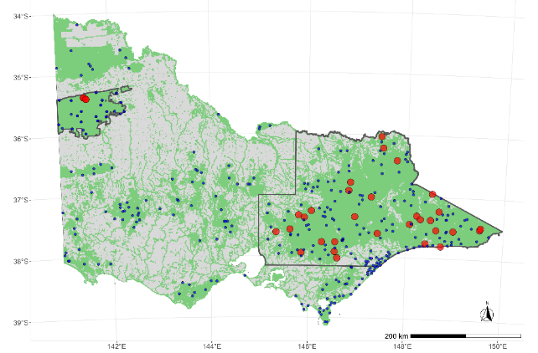
Figure 4. Locations of remote cameras (blue circles) set across public land in Victoria (green shading). Red circles show cameras that detected dingoes. Polygons show the regions within the west and east of the state where Dingo abundance was estimated.

Distance sampling
Following fitting of the detection functions to the distance data derived from the snapshot images of dingoes, the top model (as chosen by AIC) from this selection was the half-normal including second- and third-order cosine adjustment terms (Table 2). The average detection rate from this model (out to a maximum distance of 12.5 m) was 0.212 (Table 2; Figure 5). For group sizes of two, three and four dingoes, the detection probabilities increased to an average of 0.31, 0.37 and 0.41, respectively. This model was an adequate fit to the distance data as judged by a $χ^{2}$ goodness-of-fit test, which did not indicate any evidence of lack-of-fit (p = 0.196). Therefore, this detection function was subsequently used in the Bayesian model of Dingo abundance.

Table 2. Model selection table for distance detection functions fitted to the distance data from Dingo images in cameras.
Model | $χ^{2}$ p-value | $$\hat{p}$$ | se($\hat{p}$) | AIC | $Δ$AIC
Half-normal (2,3) | 0.196 | 0.212 | 0.039 | 804.2 | 0
Half-normal (2) | 0.044 | 0.269 | 0.041 | 806.6 | 2.34
Hazard-rate | 0.007 | 0.266 | 0.075 | 809.9 | 5.66
Half-normal | 0.005 | 0.401 | 0.033 | 811.1 | 6.81
Hazard rate (2) | 0.002 | 0.266 | 0.089 | 811.9 | 7.66

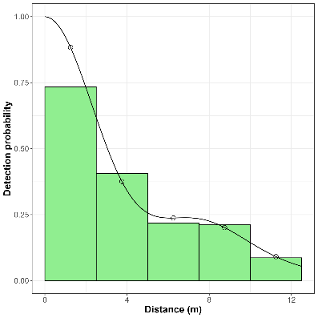
Figure 5. Distance-sampling detection process for dingoes (group size = 1). Bars indicate the frequency distribution of expected distances, and the line indicates the fitted detection function (half-normal with second- and third-order cosine adjustment terms).

Dingo activity
Following fitting of the kernel density estimate to the image capture times from each snapshot image, the estimate of the relative amount of a 24-h day that dingoes were active was 47% (SE: 4.1%) (Figure 6). Dingo activity was predominately crepuscular, exhibiting higher activity in the early morning and late afternoon/early evening (Figure 6). The estimate of relative activity of dingoes was incorporated into the Bayesian model of Dingo abundance using an informative beta prior specified as $β\left(16.9, 19.1\right)$. After fitting the Bayesian model, the posterior estimate of Dingo activity was 44% (90% CL: 24–65%).
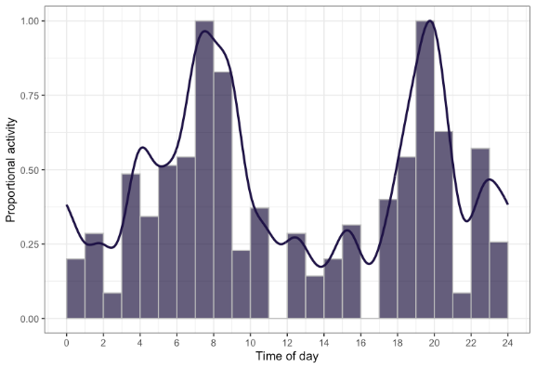
Figure 6. Relative activity of dingoes throughout a 24-hour day. Bars are the observed frequencies of active times and the solid blue line is the mean kernel density estimate.

Dingo abundance
Following fitting of the Bayesian hierarchical model (equation’s 1–5) in Stan, convergence was observed to be achieved as judged by $\hat{R}$ values < 1.05 (Brooks and Gelman 1998) and by visual inspection of traceplots for the main parameters. Posterior predictive checks showed good correspondence between observed count statistics and statistics of the posterior-predictive values (Appendix 1). The main discrepancy observed was that the model slightly underestimated the proportion of locations with zero image counts (Appendix 1).
- Site-level estimates
Dingo density at monitored sites ($λ_{i}$) estimated from the Bayesian model ranged from 0–1.9 dingoes/km² with a mean overall density of 0.08 dingoes/km² (SE = 0.17). From the eight covariates that were used for the fixed effects in the model, Dingo abundance was found to be significantly negatively related to the percentage bare soil, the amount of forest edge habitat per km² and distance to water. Abundance was also positively related to precipitation seasonality and valley-bottom flatness (Table 3). The zero-inflation parameter (an estimate of habitat suitability) was largely dependent on the bioregion spatial random effect, which had an estimated standard deviation (for the logit scale parameter) of 5.39 (90% CI: 3.59–7.38). Zero-inflation was also affected by bare soil, nitrogen, precipitation seasonality and forest edge (Table 4). The marginal effects of each covariate on Dingo abundance within an occupied bioregion (East Gippsland Uplands) due to the combined effects of the zero-inflation and abundance components of the model are given in Figure 7.

Table 3. Parameter estimates for the fixed-effect covariates for Dingo abundance ($λ_{i}$) in the Bayesian model fitted to the distance data and image counts in cameras. LCL and UCL represent the lower and upper 90% confidence limits, respectively.
Covariate | Estimate | SD | LCL | UCL
(Intercept) | -1.91 | 0.41 | -2.56 | -1.20
Bare soil (%) | -1.99 | 0.32 | -2.48 | -1.42
Nitrogen (%) | -0.01 | 0.39 | -0.69 | 0.61
Distance to pastural land (m) | -0.67 | 0.51 | -1.60 | 0.14
Precipitation seasonality | 0.70 | 0.15 | 0.45 | 0.94
Forest edge per km² (m) | -1.32 | 0.44 | -2.08 | -0.56
Valley-bottom flatness | 2.31 | 0.42 | 1.60 | 2.98
Non-photosynthetic vegetation (%) | -0.26 | 0.59 | -1.28 | 0.74
Distance to water (m) | -1.27 | 0.49 | -1.99 | -0.41

Table 4. Parameter estimates for the fixed-effect covariates for the zero-inflation parameter ($ϕ_{i}$) (i.e. probability of presence) in the Bayesian model fitted to the distance data and image counts in cameras. LCL and UCL represent the lower and upper 90% confidence limits, respectively.
Covariate | Estimate | SD | LCL | UCL
(Intercept) | -3.08 | 1.41 | -5.36 | -0.84
Bare soil (%) | 3.97 | 1.30 | 1.84 | 6.17
Nitrogen (%) | -1.53 | 0.89 | -3.03 | -0.04
Distance to pastural land (m) | 0.48 | 1.31 | -1.48 | 2.89
Precipitation seasonality | -0.98 | 0.63 | -2.15 | -0.11
Forest edge per km² (m) | 1.92 | 1.06 | 0.56 | 3.88
Valley-bottom flatness | -1.76 | 1.10 | -3.61 | 0.02
Non-photosynthetic vegetation (%) | -1.43 | 1.95 | -4.74 | 2.09
Distance to water (m) | 1.46 | 1.03 | -0.16 | 3.15

- Statewide estimates
Dingo abundance in eastern Victoria was estimated to be 4,900 (90% CL: 2,640–8,880), while in the BD/WNP Dingo abundance was estimated to be 110 (90% CL: 40–230) (Table 5; Figures 8 – 10). The total abundance of dingoes in these two areas combined was estimated to be 5,010 (90% CL: 2,710–9,050). Our range estimates suggest dingoes occupied an area of 628 km² (90% CI: 85, 887) of public land in the BD/WNP region and 27,366 km² (90% CI: 15,284, 29,627) of public land in the eastern region of Victoria (Figure 11).

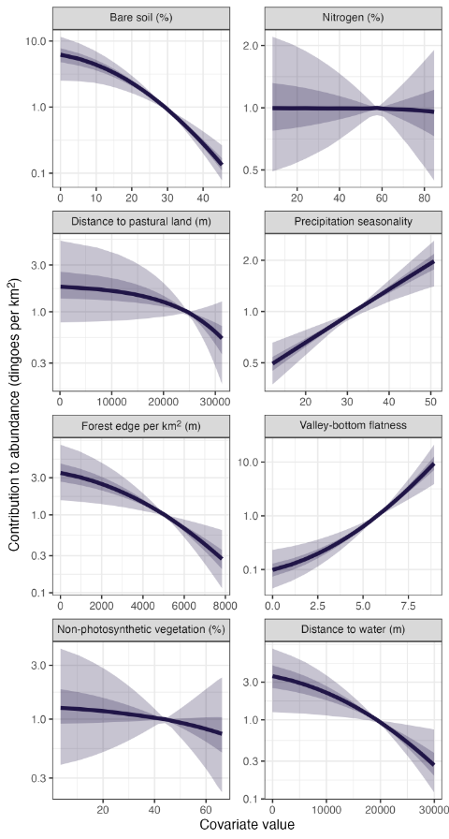
Figure 7. Marginal response plots of the relationship between environmental covariates and Dingo abundance. These marginal effects consider the effect of zero-inflation (occupancy) on each parameter and are generated for the East Gippsland Uplands bioregion; an area with high Dingo occupancy. Valley bottom flatness and Precipitation seasonality are unitless.
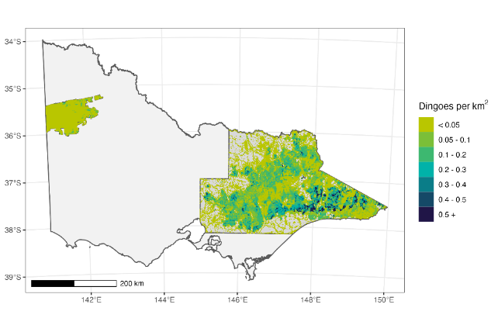
Figure 8. Spatial variation in Dingo density predicted across public land in Victoria for the two regions (Eastern Victoria and the BD/WNP), known to be occupied by dingoes. Focused views of each region are provided in Figures 9 and 10.

Table 5. Abundance estimates for the Dingo on public land in Victoria. Predictions are provided for Eastern Victoria and the BD/WNP, areas known to be occupied by dingoes (Figure 8). SD – standard deviation, CV – coefficient of variation, LCI – lower 90% credible limit, UCL – upper 90% credible limit, Area – area of public land used for prediction (km²), Density – average density (dingoes/km²) with values in brackets representing the 90% credible interval for the density estimate.
Region | Estimate | SD | CV | LCI | UCI | Area | Density
Eastern Victoria | 4900 | 2095 | 0.43 | 2640 | 8880 | 40,909 | 0.12 (0.06–0.22)
BD/WNP | 110 | 66 | 0.61 | 40 | 230 | 6,864 | 0.02 (0.01–0.03)

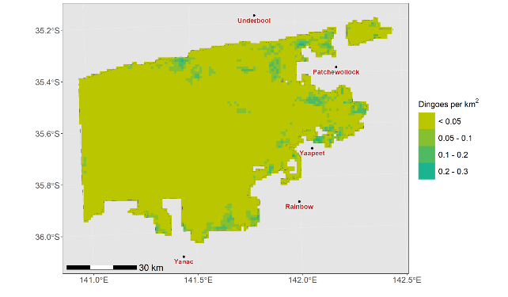
Figure 9. Focused view of the spatial variation in Dingo density predicted across public land in the BD/WNP.

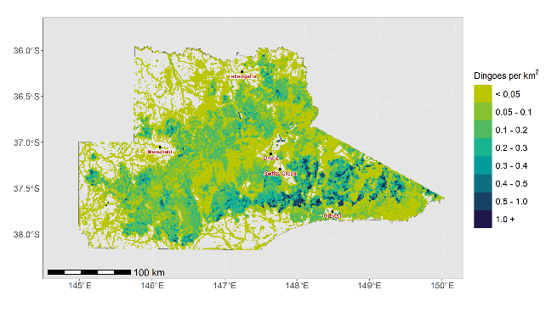
Figure 10. Focused view of the spatial variation in Dingo density predicted across public land in eastern Victoria.
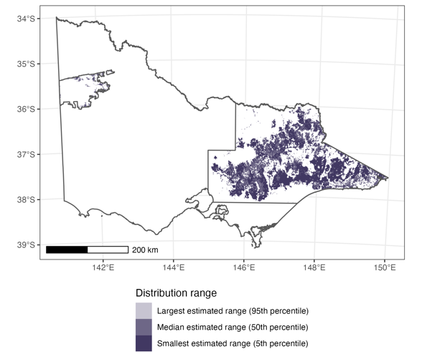
Figure 11. Estimates of the area of public land occupied by dingoes in the eastern and BD/WNP regions of Victoria.

- Discussion
This study represents the first rigorous attempt at estimating the abundance of dingoes at a statewide scale. The majority of investigations involving dingoes to date have mainly utilised indices of relative abundance using either camera traps (e.g. Fancourt et al. 2019; Forsyth et al. 2019a) or abundance of tracks or other signs (e.g. Allen et al. 1996; Johnson and Vanderwal 2009). Previous estimates of Dingo abundance have been confined to relatively small areas (~100 km²) (e.g. Forsyth et al. 2019b) or have used relatively labour intensive methods based on radiotelemetry of a sample of individuals (Thomson et al. 1992).
The present study was based on a comprehensive, spatially balanced, random sampling design that sampled 357 sites across the state and modelled the abundance of dingoes across 47,773 km² of public land. Results confirm the knowledge that the stronghold of dingoes in Victoria is the forested public land occurring in the Gippsland and Hume regions of eastern Victoria. Average Dingo density in this area was 0.12 dingoes/km², which is broadly comparable with Dingo density estimates obtained from other published studies in temperate woodland habitat, which ranged from 0.1 to 0.3 dingoes/km² (McIlroy et al. 1986; Fleming 1996). Outside this eastern region, dingoes were only detected in the BD/WNP, where the estimated density was only 0.02 dingoes/km². This density is much lower than has been estimated in other, similar semi-arid habitat. For example, Thomson et al. (1992) estimated a density of 0.22 dingoes/km² in arid pastoral land in Western Australia, which was reduced to 0.06 dingoes/km² following poison baiting (Fleming et al. 2001).
We constrained our abundance estimates to the two regions in Victoria that are known to be occupied by dingoes. Although dingoes were likely distributed over much of Victoria before European settlement, there are no confirmed Dingo populations occurring outside eastern Victoria and the BD/WNP regions. Our extensive camera trap sampling across the state also did not detect dingoes outside these two regions. While our model could theoretically make predictions to other areas of public land, they would be heavily reliant on extrapolation and therefore, would be highly uncertain. Consequently, we consider that predictions to other areas of public land represent the potential distribution (i.e. habitat suitability) rather than the current distribution of dingoes (e.g. Gormley et al. 2011). Hence, we do not consider that predictions to public land outside the two regions used here contribute to the current occupied range of dingoes in Victoria.
The spatial distribution of dingoes in Victoria was revealed to be related to several environmental and climatic variables. In occupied areas dingoes were less abundant at sites with a relatively high proportion of bare soil, which may reflect avoidance of open habitat. Conversely, higher Dingo abundance in areas with a relatively low proportion of bare soil may reflect higher occurrence of their primary prey (e.g. small- and medium-sized mammals), which are likely to prefer areas with higher vegetative ground cover. Dingoes also preferred areas with a relatively high valley bottom flatness index, as well as areas with more seasonal distribution of rainfall, which again, may primarily reflect the distribution of prey. Other studies have also found that Dingo occurrence declined with increasing terrain ruggedness (i.e. low valley bottom flatness) (Stobo-Wilson et al. 2020). Dingoes were also less likely to occur further from permanent water, which may be a driving factor governing their distribution in the BD/WNP. However, it is also acknowledged that other sources of water or other variables not captured by our study may also be driving the spatial distribution of dingoes in the BD/WNP. The confluence of all these relationships meant that the highest densities of dingoes were predicted to occur in the forested areas of east Gippsland.
There is a growing literature on statistical methods for deriving animal density from encounter rates by unmarked individuals with camera traps (e.g. Rowcliffe et al. 2008; Chandler and Royle 2013; Ramsey et al. 2015; Howe et al. 2017; Nakashima et al. 2018; Moeller et al. 2018). Compared with other methods for estimating absolute abundance (e.g. mark-recapture), camera trapping is relatively low cost and has the advantage of being able to generate data for multiple species (Palencia et al. 2021). However, methods for estimating animal density from camera traps when there is no individual identification rely on several model assumptions (Gilbert et al. 2021; Palencia et al. 2021). The two critical assumptions most likely to be violated in studies using CTDS are that cameras are placed independently of animal locations and that animal movement and behaviour are not affected by camera traps or distance markers. Our random sampling design ensured that cameras were placed independently of the locations of dingoes. For each randomly selected site, we attempted to place cameras as close to the site centroid as possible. Cameras were also orientated in a southerly direction, and we were careful not to place cameras facing any obvious animal tracks. Behavioural interactions of animals with camera traps or distance markers may also cause bias in density estimates because animals spend more time in front of cameras than would otherwise occur during random encounters, consequently inflating density estimates (Houa et al. 2022). We minimised the influence of this source of bias by tagging any images showing dingoes reacting to the presence of the camera or distance markers, resulting in the removal of 23% of Dingo images from our analyses. Additionally, later surveys conducted in BD/WNP used reference images instead of distance markers to prevent Dingo interaction with markers in front of the camera. Consequently, we believe that the camera trap encounters of dingoes recorded during this study conform to the assumptions underlying the use of the CTDS model we used to estimate Dingo densities.
In addition, recent studies have shown that CTDS estimates need to account for variation in activity levels (i.e. the proportion of a 24-h day when animals are active) because encounter rates with cameras are likely to vary with animal activity (Rowcliffe et al. 2014). Failure to account for activity using CTDS will result in underestimates of population abundance (Corlatti et al. 2020). Analysis of relative activity levels of dingoes revealed that activity peaked in the early morning and evening, presumably periods when their primary prey was also the most active. Overall, dingoes were active for 44% of a typical 24-hour period. This estimate falls within the range of activity time estimated from GPS tracking of dingoes in arid areas, with daily activity rates estimated at 9% in Summer and 54% in Winter (Tatler et al. 2021).

Conclusions and recommendations
An extensive and intensive statewide survey using camera traps has estimated the total population of dingoes in Victoria to be 5,010 (90% CL: 2,710–9,050), with the majority of the state’s Dingo population resident in the Gippsland and Hume regions. Due to the apparent very low population abundance of dingoes estimated in the BD/WNP, it is recommended that further periodic monitoring of this population be prioritised to determine the response to threats and management. Similarly, continued monitoring of the eastern population is recommended to determine how the population responds to management activities.

- References
ABARES (2021). Catchment Scale Land Use of Australia – Update December 2020, Australian Bureau of Agricultural and Resource Economics and Sciences.
Allen BL, Fleming PJS, Allen LR, Engeman RM, Ballard G, Leung LKP (2013). As clear as mud: A critical review of evidence for the ecological roles of Australian dingoes. Biological Conservation 159, 158–174. doi:10.1016/j.biocon.2012.12.004
Allen L, Engeman RM, Krupa H (1996). Evaluation of three relative abundance indices for assessing dingo populations. Wildlife Research 23, 197–206.
Brooks S, Gelman A (1998). General methods for monitoring convergence of iterative simulations. Journal of Computational and Graphical Statistics 7, 434–455.
Buckland ST, Anderson DR, Burnham KP, Laake J (1993). ‘Distance sampling: estimating abundance of biological populations’. (Chapman & Hall: London)
Buckland ST, Summers RW, Borchers DL, Thomas L (2006). Point transect sampling with traps or lures. Journal of Applied Ecology 43, 377–384.
Cairns KM, Crowther MS, Parker HG, Ostrander EA, Letnic M (2023). Genome-wide variant analyses reveal new patterns of admixture and population structure in Australian dingoes. Molecular Ecology 32, 4133–4150. doi:10.1111/mec.16998
Cally JG, Ramsey DSL (2023). Abundance of deer in Victoria: Regional and statewide estimates of deer density and their impact on vegetation. Arthur Rylah Institute for Environmental Research Technical Report Series No. 368. Department of Energy, Environment and Climate Action, Heidelberg, Victoria.
Chandler RB, Royle JA (2013). Spatially explicit models for inference about density in unmarked or partially marked populations. The Annals of Applied Statistics 7, 936–954. doi:10.1214/12-AOAS610
Corlatti L, Sivieri S, Sudolska B, Giacomelli S, Pedrotti L (2020). A field test of unconventional camera trap distance sampling to estimate abundance of marmot populations. Wildlife Biology 2020, 1–11. doi:10.2981/wlb.00652
van Dam-Bates P, Gansell O, Robertson B (2018). Using balanced acceptance sampling as a master sample for environmental surveys. Methods in Ecology and Evolution 9, 1718–1726. doi:10.1111/2041-210X.13003
DEPI (2013). Action plan for managing wild dogs in Victoria. Department of Environment and Primary Industries, Victoria.
Fancourt BA, Cremasco P, Wilson C, Gentle MN (2019). Do introduced apex predators suppress introduced mesopredators? A multiscale spatiotemporal study of dingoes and feral cats in Australia suggests not Ed M Hayward. Journal of Applied Ecology 56, 2584–2595. doi:10.1111/1365-2664.13514
Fleming PJS (1996). Aspects of the management of wild dogs (Canis familiaris) in north-eastern New South Wales. University of New England, Armidale, New South Wales, Australia.
Fleming PJS, Corbett L, Harden R, Thomson P, Bomford M (2001). ‘Managing the impacts of dingoes and other wild dogs’. (Bureau of Rural Sciences: Canberra)
Forsyth DM, Pople A, Woodford L, Brennan M, Amos M, Moloney PD, Fanson B, Story G (2019a). Landscape-scale effects of homesteads, water, and dingoes on invading chital deer in Australia’s dry tropics Ed J Goheen. Journal of Mammalogy, gyz139. doi:10.1093/jmammal/gyz139
Forsyth DM, Ramsey DSL, Woodford LP (2019b). Estimating abundances, densities, and interspecific associations in a carnivore community. Journal of Wildlife Management 83. doi:10.1002/jwmg.21675
Gabry J, Češnovar R (2022). cmdstanr: R Interface to ‘CmdStan’. Available at: https://mc-stan.org/cmdstanr/ [accessed 18 August 2023]
Gilbert NA, Clare JDJ, Stenglein JL, Zuckerberg B (2021). Abundance estimation of unmarked animals based on camera-trap data. Conservation Biology 35, 88–100. doi:10.1111/cobi.13517
Gormley AM, Forsyth DM, Griffioen P, Lindeman M, Ramsey DSL, Scroggie MP, Woodford L (2011). Using presence‐only and presence–absence data to estimate the current and potential distributions of established invasive species. Journal of Applied Ecology 48, 25–34.
Henrich M, Hartig F, Dormann CF, Kühl HS, Peters W, Murray D (2022). Deer Behavior Affects Density Estimates With Camera Traps , but Is Deer Behavior Affects Density Estimates With Camera Traps , but Is Outweighed by Spatial Variability Edited by : Frontiers in Ecology and Evolution 10:881502. doi:10.3389/fevo.2022.881502
Houa NA, Cappelle N, Bitty EA, Normand E, Kablan YA, Boesch C (2022). Animal reactivity to camera traps and its effects on abundance estimate using distance sampling in the Taï National Park, Côte d’Ivoire. PeerJ. doi:10.7717/peerj.13510
Howe EJ, Buckland ST, Després-Einspenner M-L, Kühl HS (2017). Distance sampling with camera traps. Methods in Ecology and Evolution 8, 1558–1565.
Jackson SM, Fleming PJS, Eldridge MDB, Archer M, Ingleby S, Johnson RN, Helgen KM (2021). Taxonomy of the Dingo: It’s an ancient dog. Australian Zoologist 41, 347–357. doi:10.7882/AZ.2020.049
Jiménez J, Nuñez-Arjona JC, Rueda C, González LM, García-Domínguez F, Muñoz-Igualada J, López-Bao JV (2017). Estimating carnivore community structures. Scientific Reports 7, 41036. doi:10.1038/srep41036
Johnson CN, Vanderwal J (2009). Evidence that dingoes limit abundance of a mesopredator in eastern Australian forests. Journal of Applied Ecology 46, 641–646. doi:10.1111/j.1365-2664.2009.01650.x
Karanth KU, Nichols JD, Kumar NS, Hines JE (2006). Assessing tiger population dynamics using photographic capture-recapture sampling. Ecology 87, 2925–2937. doi:10.1890/0012-9658(2006)87[2925:ATPDUP]2.0.CO;2
Latham ADM, Latham MC, McCutchen NA, Boutin S (2011). Invading white-tailed deer change wolf-caribou dynamics in northeastern Alberta. Journal of Wildlife Management 75, 204–212. doi:10.1002/jwmg.28
Lisic J, Cruze N (2016). Local pivotal methods for large surveys. In ‘Proceedings of the Fifth International Conference on Establishment Surveys’.
McIlroy JC, Cooper RJ, Gifford EJ, Green BF, Newgrain KW (1986). The Effect on Wild Dogs, Canis f. familiaris, of 1080 Poisoning Campaigns in Kosciusko National Park, N.S.W. Wildlife Research 13, 535. doi:10.1071/WR9860535
Moeller AK, Lukacs PM, Horne JS (2018). Three novel methods to estimate abundance of unmarked animals using remote cameras. Ecosphere 9, e02331.
Nakashima Y, Fukasawa K, Samejima H (2018). Estimating animal density without individual recognition using information derivable exclusively from camera traps. Journal of Applied Ecology 55, 735–744. doi:10.1111/1365-2664.13059
Palencia P, Rowcliffe JM, Vicente J, Acevedo P (2021). Assessing the camera trap methodologies used to estimate density of unmarked populations. Journal of Applied Ecology 58, 1583–1592. doi:10.1111/1365-2664.13913
Ramsey DSL, Caley PA, Robley A (2015). Estimating population density from presence–absence data using a spatially explicit model. The Journal of Wildlife Management 79, 491–499. doi:10.1002/jwmg.851
Ramsey DSL, Pacioni C, White L, Hill E, Murphy N, Cally J (2023). Abundance and population genetics of Hog deer (Axis porcinus) in Victoria. Arthur Rylah Institute for Environmental Research Technical Report Series No. 372. Department of Energy, Environment and Climate Action, Heidelberg, Victoria.
Rowcliffe JM, Field J, Turvey ST, Carbone C (2008). Estimating animal density using camera traps without the need for individual recognition. Journal of Applied Ecology 45, 1228–1236. doi:10.1111/j.1365-2664.2008.01473.x
Rowcliffe JM, Kays R, Kranstauber B, Carbone C, Jansen PA (2014). Quantifying levels of animal activity using camera trap data. Methods in Ecology and Evolution 5, 1170–1179. doi:10.1111/2041-210x.12278
Stephens D, Wilton AN, Fleming PJS, Berry O (2015). Death by sex in an Australian icon: a continent‐wide survey reveals extensive hybridization between dingoes and domestic dogs. Molecular Ecology 24, 5643–5656.
Stobo-Wilson AM, Stokeld D, Einoder LD, Davies HF, Fisher A, Hill BM, Mahney T, Murphy BP, Stevens A, Woinarski JCZ, Rangers B, Rangers W, Gillespie GR (2020). Habitat structural complexity explains patterns of feral cat and dingo occurrence in monsoonal Australia. Diversity and Distributions 26, 832–842. doi:10.1111/ddi.13065
Thomas L, Buckland ST, Rexstad EA, Laake JL, Strindberg S, Hedley SL, Bishop JRB, Marques TA, Burnham KP (2010). Distance software: Design and analysis of distance sampling surveys for estimating population size. Journal of Applied Ecology 47, 5–14. doi:10.1111/j.1365-2664.2009.01737.x
Thomson PC, Rose K, Kok NE (1992). The behavioural ecology of dingoes in north-western Australia. V. Population dynamics and variation in the social system. Wildlife Research 19, 565–583.
Victorian/Government (1994). ‘Catchment and Land Protection Act’. (Victorian Government: Melbourne, Australia)
Weeks AR, Kriesner P, Bartonicek N, van Rooyen A (2022). Genomic SNP analyses of free-ranging canids from Victoria and other parts of Australia. A report by Cesar Australia for the Department of Environment, Land, Water and Planning.

Appendix
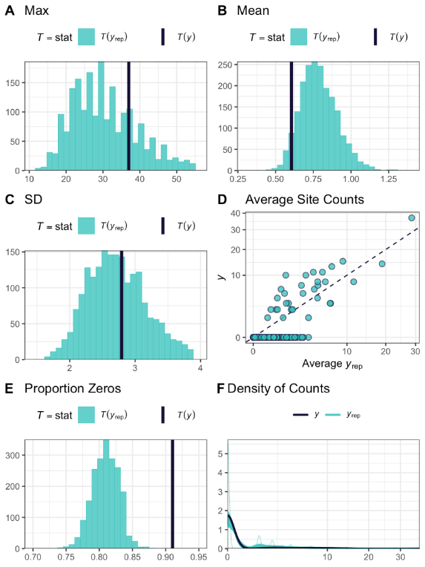
Figure A1. Posterior predictive checks for modelled versus observed estimates relating to Dingo abundance and occupancy. Observed statistics that are compared to the posterior distributions are (A) maximum observed counts (snapshot moments with dingoes), (B) mean counts (snapshot moments) of dingoes, (C) standard deviation of counts and (D) comparison of mean estimated site counts against the modelled site counts, (E) proportion of sites with a zero count for dingoes, and (F) the density of modelled and observed counts.

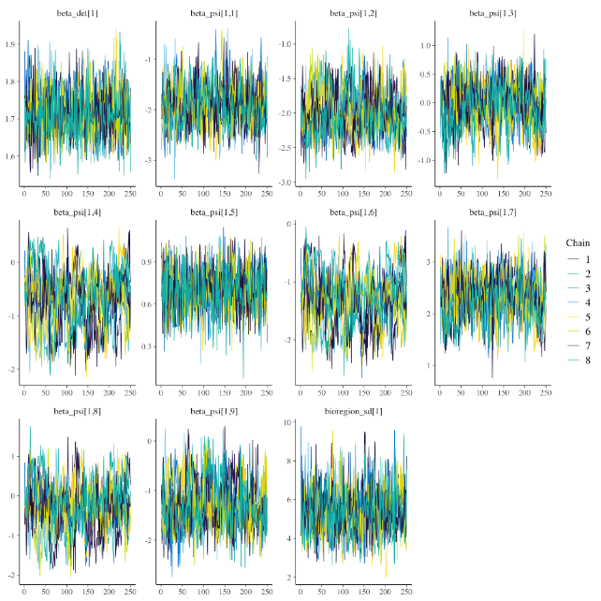
Figure A2. Traceplots showing model convergence of key parameters related to the detection (beta_det) and abundance (beta_psi) of dingoes.

www.deeca.vic.gov.au

www.ari.vic.gov.au

A revision to the Dingo unprotection order came into place on the 14 March 2024 (https://www.wildlife.vic.gov.au/our-wildlife/dingoes).
Abundance estimates are rounded to the nearest 10.

