Southern Pygmy Perch in farm dams
Saving a threatened species from extinction
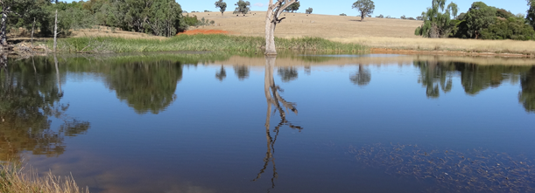

Background
Southern Pygmy Perch (Nannoperca australis) is a threatened small-bodied (up to 85 mm length) perch-like fish endemic to south-eastern Australia. The species has a southern and northern genetic form, separated by the Great Dividing Range. Once widespread and abundant, the species’ northern form has suffered dramatic declines in distribution and abundance, particularly since the 1980s. At the end of the Millennium drought, only four naturally occurring populations were known to exist in Victoria. These fragmented populations are restricted to the granite-creeks region of the Strathbogie Ranges and the upper Avoca River.

Ecology and Life-history
The Southern Pygmy Perch is short-lived (3-5 years) and inhabits still or slow-flowing waters in streams, lakes and wetlands. The species occurs almost exclusively in aquatic vegetation, and dense macrophytes appear critical to their survival. Both sexes reach sexual maturity at the end of their first year. Spawning occurs from September to January, with rising water temperatures (15-18⁰C) and flow pulses acting as cues. Females scatter 100s to 1000s of non-adhesive eggs over aquatic vegetation, rocks and bottom of waterbodies. Survival of larvae and juveniles is correlated with years of higher flow variability in summer and autumn. The diet includes a mixture of micro- and macro-invertebrates.

Threats
The remaining small and fragmented populations of Southern Pygmy Perch are susceptible to a range of threats including: a lack of seasonal flooding and modification of natural flows that reduce their ability to recolonise new habitats; and habitat degradation and loss from farming, urbanisation and wetland drainage. Livestock access to waterways and the feeding habitats of Common Carp (Cyprinus carpio) also damage aquatic vegetation and water quality. This species is also preyed upon by introduced fish species: Redfin (Perca fluviatilis), trout (mainly Brown Trout Salmo trutta) and Eastern Gambusia (Gambusia holbrooki).

The Fish in Supplementary Habitats program
The ‘Fish in Supplementary Habitats (FISH), funded by the Victorian government, was established in 2018 to conserve threatened Southern Pygmy Perch. The project aims to reduce Southern Pygmy Perch’s risk from extinction.
This involves:
- Identification of private dams with suitable habitats in north-eastern Victoria.
- Collection of some fish from existing populations and their translocation to these sites.
- The use of these populations for future translocations into areas of suitable habitat within their former range.

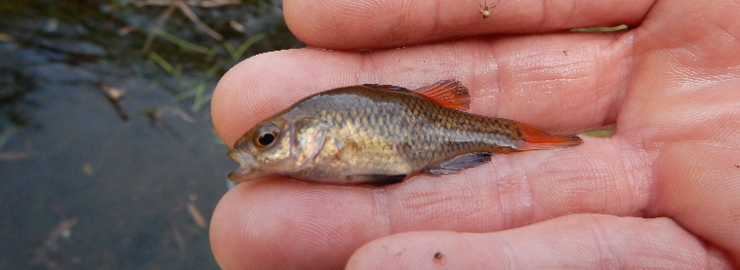
Establishment of refuge populations can reduce the potential and immediate threat from catastrophic state-wide loss (e.g. bushfires), and also provide source populations for further translocations in the future.
Figure 1: A Southern Pygmy Perch (Photo: ARI).

Progress
To date, about 500 adult Southern Pygmy Perch have been collected from Castle, Hughes and Seven Creeks, and from a private property at Edi in northern Victoria. Four private farm dams were chosen as refuge sites based on the habitat requirements of Southern Pygmy Perch which include abundant fringing, submergent and emergent vegetation, a permanent water supply, restricted stock access and riparian shading. Fish were successfully translocated into the farm dams in March 2018.
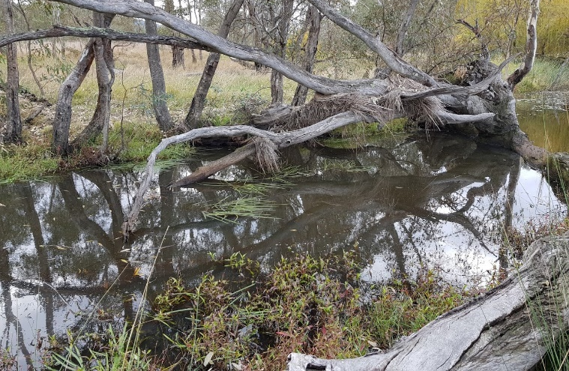

Figure 2: Ideal Southern Pygmy Perch habitat in Castle Creek, Victoria (Photo: Scott Raymond)

What’s Next?
In March 2019, research scientists from ARI will survey the four farm dams containing translocated Southern Pygmy Perch. Survey data will determine if the species has survived and if they have successfully recruited individuals into their populations. Sustainable Southern Pygmy Perch populations will be used to further reduce their risk from extinction.

Project partners
This project involves strong collaboration across a range of partners including:
- Department of Environment, Land, Water and Planning (DELWP) and Arthur Rylah Institute
- Murray-Darling Basin Authority
- Goulburn-Broken Catchment Management Authority
- Greta Valley Landcare Group
- Wangaratta Sustainability Network
- Small Green Steps ©
- VFA, and
- Landowners and interested community members who participated in field work, aided with creek and farm dam access and continue to advocate for healthy and diverse native fish communities across Victoria

Partnering with relevant stakeholders has been essential to foster ownership in the recovery of Southern Pygmy Perch in north-eastern Victoria. We extend our gratitude to Greta Landcare and WSN for their help with selecting sites, organising field days, community meetings and collecting and collating fish data.

DELWP kindly provided funding for the FISH project, through the Biodiversity Onground Actions program.
© The State of Victoria Department of Environment, Land, Water and Planning 2019    This work is licensed under a Creative Commons Attribution 4.0 International licence. You are free to re-use the work under that licence, on the condition that you credit the State of Victoria as author. The licence does not apply to any images, photographs or branding, including the Victorian Coat of Arms, the Victorian Government logo and the Department of Environment, Land, Water and Planning (DELWP) logo. To view a copy of this licence, visit http://creativecommons.org/licenses/by/4.0/  ISBN 978-1-76077-490-5 (Print)  ISBN 978-1-76077-491-2 (pdf/online/MS word)  Disclaimer  This publication may be of assistance to you but the State of Victoria and its employees do not guarantee that the publication is without flaw of any kind or is wholly appropriate for your particular purposes and therefore disclaims all liability for any error, loss or other consequence which may arise from you relying on any information in this publication. | Accessibility  If you would like to receive this publication in an alternative format, please telephone the DELWP Customer Service Centre on 136186, email customer.service@delwp.vic.gov.au, or via the National Relay Service on 133 677 www.relayservice.com.au. This document is also available on the internet at www.delwp.vic.gov.au.

Contact:

Scott.raymond@delwp.vic.gov.au

