**Managing stream gauging stations across Victoria to maximise gauging performance and environmental outcomes**

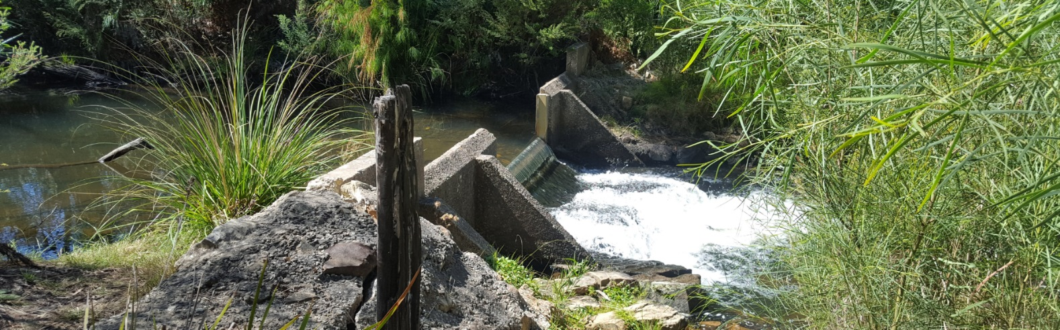

## Fish Friendly Stream Gauging Station Program

The Department of Environment, Land, Water and Planning (DELWP) is reviewing the status of stream gauging stations across Victoria that are used by the Regional Water Monitoring Partnership (RWMP) (approx. 820 stations). The Fish Friendly Stream Gauging Station Program will assess their integrity and functionality to inform their management. Fish friendliness will also be assessed as most stream gauging stations present a barrier to native fish movement, which is detrimental for healthy native fish populations.

This program will gather and analyse information from each site such as the location of instream barriers, stream hydrology, presence and migratory status of fish species and catchment condition. The data will be used to set priorities for possible upgrades of stream gauges and fish passage works.

## What are stream gauges?

Managing Victoria’s water resources requires the collection of stream flow data. Stream gauging stations collect data on streamflows, as well as dissolved oxygen and various nutrients, all of which are collated and processed in a publically available centralised database, the [Water Measurement Information System](http://data.water.vic.gov.au/). Flow data are used by Emergency Victoria (i.e. State Emergency Service), the [Bureau of Meteorology](http://www.bom.gov.au/vic/flood/index.shtml?ref=hdr) and [DELWP’s](https://www.water.vic.gov.au/managing-floodplains/flood-warning-and-mapping) flood warning and mapping systems.

Stream gauging stations (Figure 1) typically consist of an instream control (concrete weir) that provides a smooth surface for highly accurate flow gauging. Automated sensing equipment then detects the water level upstream of the instream control, from which stream discharge (ML/d) can be calculated.

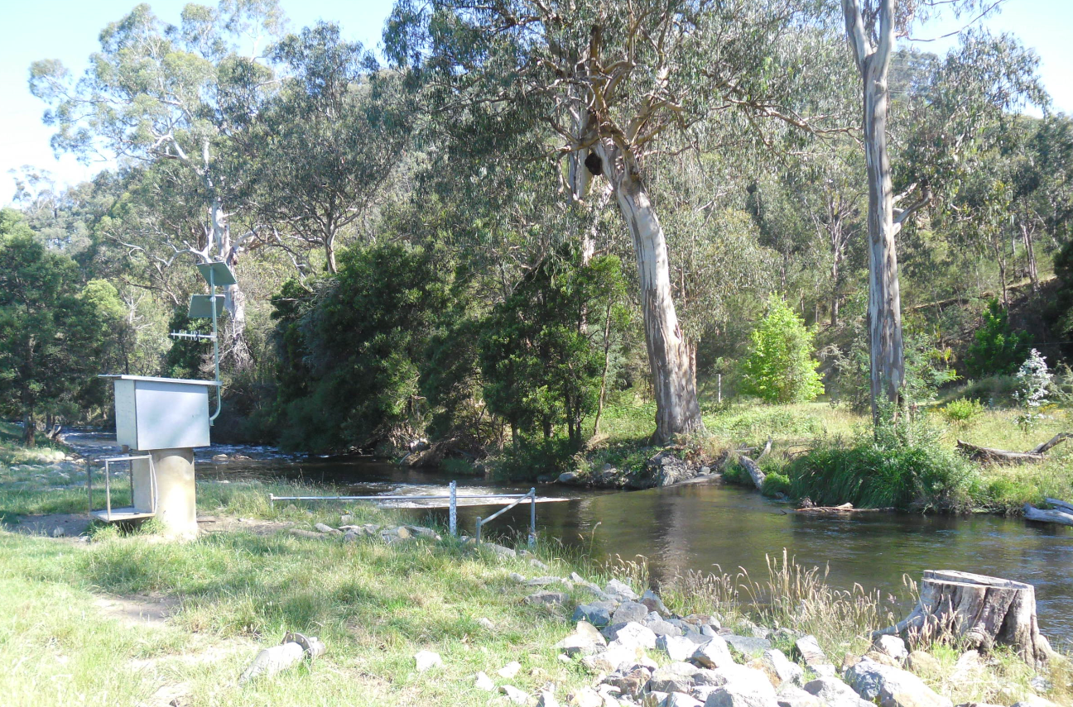**Figure 1: A typical stream gauging station (Photo: DELWP)**

Stream gauging stations are monitored and maintained by a third-party service provider, Australian Laboratory Services (ALS) on behalf of DELWP.

## Program objectives

1. Identify and collate all datasets relevant to instream control structures.
2. Identify modern stream gauging techniques/technologies or alternative gauging solutions for fish friendliness.
3. Identify and collate all datasets relevant to native fish passage at gauging stations.
4. Identify stream gauging stations that require maintenance/upgrade works.
5. Identify those instream control structures which would benefit from improved fish passage.
6. Prioritise both stream gauge maintenance/ upgrade and fish passage works at stream gauging stations.

## Program outcomes

* Develop a prioritisation tool for gauging stations to identify where works are required to improve fish passage.
* Identify instream barriers for future removal.
* Identify obsolete stream gauge controls for removal.
* Replace deteriating stream gauging controls with modern, fish friendly gauging technology and/or fishways.

## The status of instream control structures

The control structures associated with Victoria’s stream gauging stations are ageing; some were built in the 1950s and most have had little or no maintenance (Figure 2). A separate process to assess the condition of all control structures is currently underway which will inform this program. Any repairs to these structures or installation of fishways (Figure 3) is likely to incur significant costs.

## Regional Water Monitoring Partnership

The RWMP is a voluntary collaboration of 41 separate organisations that are required to collect water data from the environment and hence represent key stakeholders for the program. Organisations include the Bureau of Meteorology, Murray-Darling Basin Authority, Victoria’s catchment management authorities, water corporations, and local government councils.

## Working with stakeholders

Strong engagement with stakeholders is a priority for the program to:

* regularly share plans, progress and results.
* enable collaboration and inclusion of advice.
* support changes in stream gauge design and function.

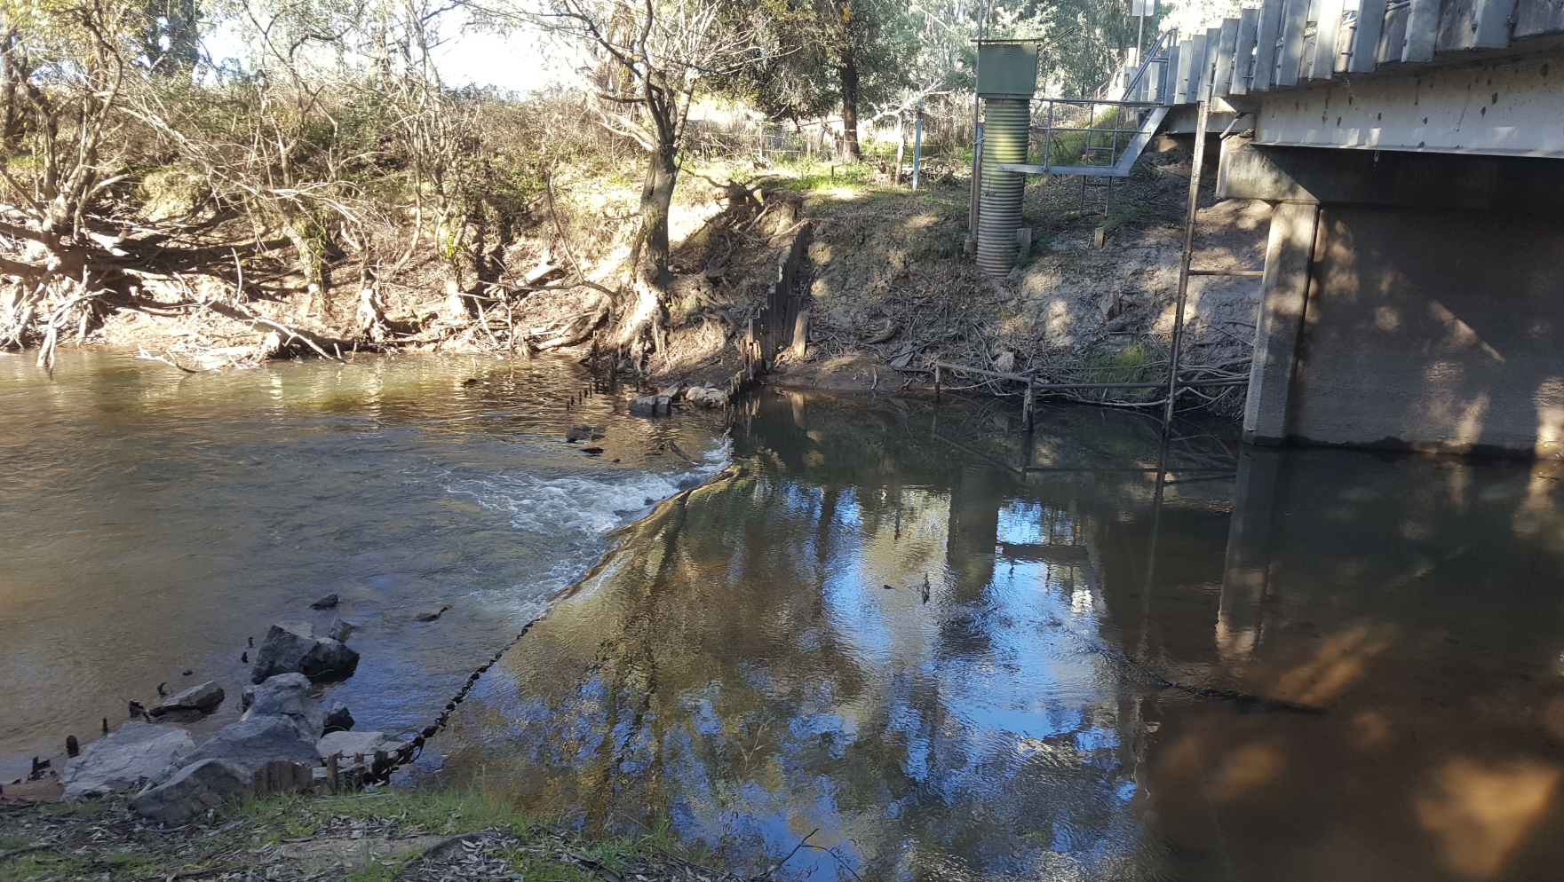

**Figure 2: An ageing control structure requiring upgrade works (Photo: ARI)**

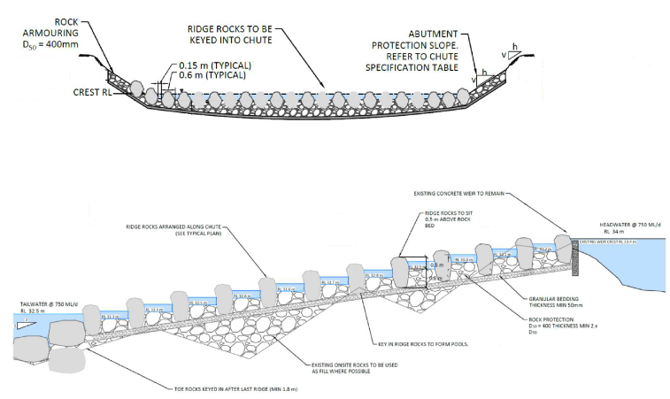

**Figure 3: Design of a modern stream gauge control incorporating a fishway for fish passage (Supplied by DELWP)**

## Contacts:

## [matthew.jones@delwp.vic.gov.au](mailto:Matthew.Jones@delwp.vic.gov.au) (Fish Ecologist)

## p[aul.wilson@delwp.vic.gov.au](mailto:aul.wilson@delwp.vic.gov.au) (Senior Manager, Water Monitoring and Data)

## david.mcphee[@delwp.vic.gov.au](mailto:Zeb.Tonkin@delwp.vic.gov.au) (Northern Regional Coordinator RWMP)

## j[anice.taylor@delwp.vic.gov.au](mailto:anice.taylor@delwp.vic.gov.au) (Sourthern Regional Coordinator RWMP)

|  |  |
| --- | --- |
| © The State of Victoria Department of Environment, Land, Water and Planning 2019  LogoThis work is licensed under a Creative Commons Attribution 4.0 International licence. You are free to re-use the work under that licence, on the condition that you credit the State of Victoria as author. The licence does not apply to any images, photographs or branding, including the Victorian Coat of Arms, the Victorian Government logo and the Department of Environment, Land, Water and Planning (DELWP) logo. To view a copy of this licence, visit http://creativecommons.org/licenses/by/4.0/  ISBN 978-1-76077-488-2 (Print) 978-1-76077-489-9 (pdf/online/MS word)  Disclaimer  This publication may be of assistance to you but the State of Victoria and its employees do not guarantee that the publication is without flaw of any kind or is wholly appropriate for your particular purposes and therefore disclaims all liability for any error, loss or other consequence which may arise from you relying on any information in this publication. | Accessibility  If you would like to receive this publication in an alternative format, please telephone the DELWP Customer Service Centre on 136186, email [customer.service@delwp.vic.gov.au](mailto:customer.service@delwp.vic.gov.au), or via the National Relay Service on 133 677 [www.relayservice.com.au](http://www.relayservice.com.au). This document is also available on the internet at [www.delwp.vic.gov.au](http://www.delwp.vic.gov.au). |