|  |
| --- |
| WetMAP – Victoria’s Wetland Monitoring and Assessment Program for environmental water |
| Project Update – 2018-19  Bird Theme |

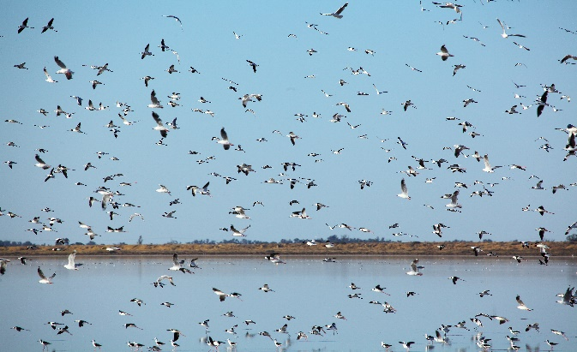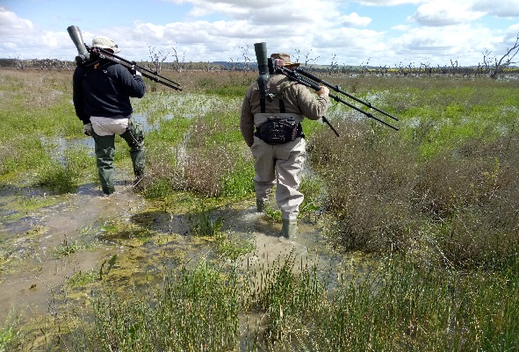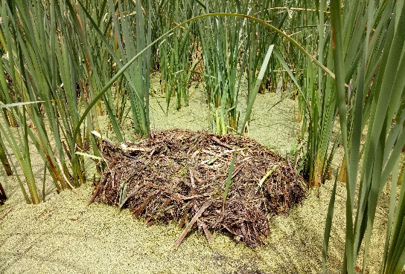

## Background

WetMAP is a state-wide monitoring program designed to assess ecological responses of vegetation, birds, frogs and fish to the delivery of water for the environment in Victorian wetlands. Monitoring for the current stage of WetMAP (2016–2020) is coordinated by Arthur Rylah Institute (ARI) and funded through the Victorian government’s $222 million investment over four years to improve catchment and waterway health. The WetMAP bird monitoring theme is delivered through a collaboration between ARI and BirdLife Australia.

## Program Objectives

WetMAP aims to:

* enable DELWP (Department of Environment, Land, Water and Planning) and its water delivery partners to clearly demonstrate ecological outcomes of environmental water management to the community and water industry stakeholders.
* fill knowledge gaps to enable adaptive management – improving planning, delivery and evaluation of environmental water management in rivers and wetlands across Victoria.
* identify ecosystem outcomes from environmental water to help meet Victoria’s obligations under the Murray-Darling Basin Plan.
  1. Ultimately, WetMAP seeks to inform the development of a planning tool for Catchment Management Authorities (CMAs) and the Victorian Environmental Water Holder.

## Program Design

WetMAP’s design is based on:

* conceptual models of wetland responses to environmental water delivery and natural flooding,
* watering objectives defined in state and regional water management plans, and
* Key Evaluation Questions (KEQs) and indicators.

## Factors that influence the response of birds to environmental water

* 1. Key drivers affecting the response of birds to water regimes include factors and processes that operate at the local and continental scale. An improved understanding is required of the relationship between bird species distribution, diversity and abundance and wetland water regimes (particularly the timing and duration of inundation and drawdown). There are also knowledge gaps about the use of wetland habitat and food resources by birds, including lag times between wetland watering and a response in food availability, and the influence this has on bird numbers.

## Bird Monitoring

This component of WetMAP incorporates three elements:

1. **Local response monitoring** – specific wetland monitoring program.
2. **Investigation of long-term datasets** - to better understand relationships between waterbird numbers (highly variable) and wetland availability in central and eastern Australia.
3. **Citizen science linkage** – a collaboration to fill gaps in existing monitoring.

This flyer focuses on the **local response monitoring** element.

The bird theme is addressing four key evaluation questions (KEQs) during 2017-20 (Table 1). Supplementary questions have also been developed to investigate the specific, underlying processes that drive bird responses to environmental watering (Table 2).

**Table 1 – Key Evaluation Questions and monitoring indicators**

|  |  |
| --- | --- |
| **KEQs** | **Indicator(s)** |
| 1. Do environmental water events increase the abundance and species richness of birds in wetlands? | Abundance of each species and total individuals present; species richness |
| 1. Do environmental water events result in waterbird breeding at wetlands? | Number of species breeding; number of clutches or broods |
| 1. Do environmental water events increase suitable habitat for foraging, roosting and breeding of waterbirds in wetlands? | Extend of each structural habitat category by wetland; proportionate use of each habitat category by species |
| 1. Do environmental water events increase abundance and species richness of woodland birds adjacent to the wetland? | Abundance of each species and total individuals present; species richness |

**Table 2 – Supplementary Questions**

|  |
| --- |
| **SQs** |
| 1. How does waterbird abundance and species richness change with water level in watered wetlands? |
| 1. How does waterbird abundance and species richness change with spatial extent of wetland inundation? |
| 1. How does waterbird abundance and species richness change with duration of flooding in watered wetlands? |
| 1. Are waterbird abundance and species richness at wetlands affected by availability of alternative habitats in the same region? |
| 1. Are waterbird abundance and species richness at wetlands affected by continental rainfall patterns, and water availability in the Australian landscape? |
| 1. Do waterbirds that use WetMAP bird monitoring sites breed elsewhere (local, regional, continental)? |
| 1. What are the habitat characteristics of wetlands where waterbirds are breeding? |
| 1. Do select waterbird species show site fidelity to wetlands? |
| 1. How often do Victorian waterbird species breed? |
| 1. Was suitable breeding habitat available at watered wetlands? |
| 1. Was the wetland flooded long enough for a breeding attempt? |
| 1. What is the expected lag time between water delivery, zooplankton abundance and waterbird response in watered wetlands? |
| 1. What are the water regime requirements (timing and duration) for different waterbird species? |
| 1. What are the local wetland habitat preferences for select species of waterbirds for feeding, resting and breeding? |
| 1. How does woodland bird abundance and species richness change with water extent? |

**Survey Methods**

Twenty-one wetlands were assessed in 2018/19:

* 12 temporary wetlands that received environmental water during the survey period;
* six wetlands that were not watered (including four that still held water from previous watering events); and
* three permanently watered sewage farms (used as counterfactuals).

Each wetland was surveyed monthly while wet and at two-monthly intervals when completely dry. Data recorded during whole wetland surveys included wetland habitat extent, water extent, count of all waterbird species and the proportion of each species in each habitat type. During each visit to wetlands that received environmental water, water quality and zooplankton samples were collected at two or more sites within the wetland. Multiple 10-min 1 ha woodland bird counts were also conducted in the fringing woodland habitats (where applicable) during each visit.

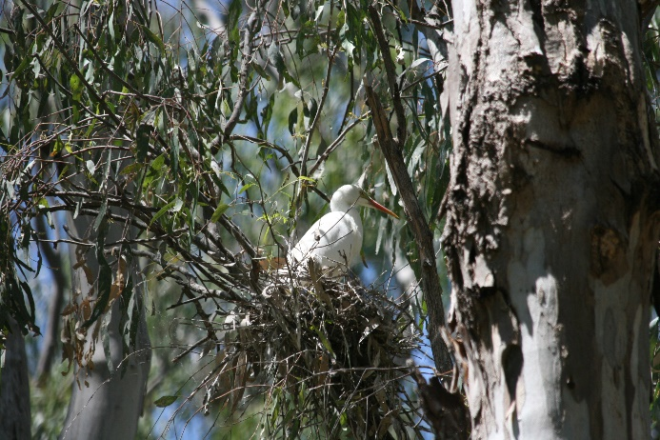**Results and Key Observations**

A total of 252,538 waterbirds were recorded during surveys, representing 65 waterbird species and including 28 species listed as threatened or near-threatened. Waterbirds from all foraging guilds were found to only occupy wetlands when they held water, abandoning the sites when they were dry.

*Waterbird abundance and diversity*

Results to date provide strong evidence that both the abundance and diversity of waterbirds increase in response to environmental water delivery to wetlands.

Preferred water levels differed by species: diving waterfowl and swimming piscivores tended to peak in numbers at wetlands with high water levels, while shorebirds preferred wetlands with low water levels.

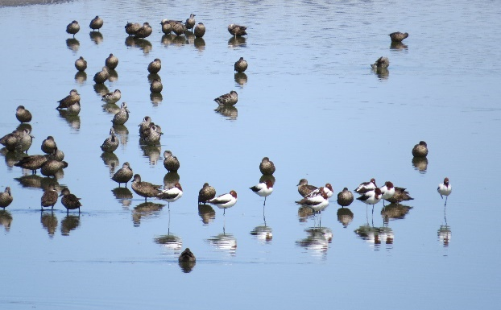Waterbird abundance and diversity in wetlands that receive environmental water was also influenced by other external factors. The seasonal patterns of occurrence suggest many waterbird species recorded are migratory. How waterbird numbers in wetlands are influenced by the broader Victorian and Australian landscape requires further investigation.

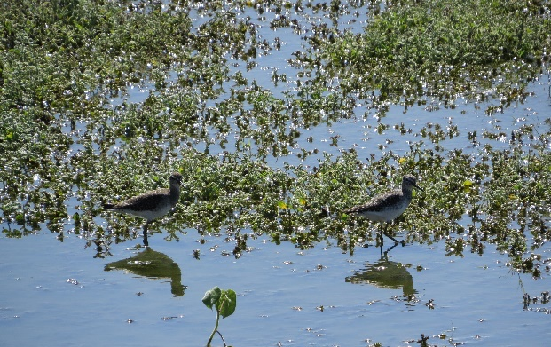**Fig 1 – Red-necked Avocets, Grey Teal and Pink-eared Ducks (Photo: ARI)**

*Waterbird breeding*

Although there was some evidence of waterbird breeding in wetlands that received environmental water, there were only 43 confirmed records of breeding for nine species, which represented only 0.01% of all waterbirds recorded. This included 10 breeding records from a permanently watered sewage farm.

**Fig 2 – Eastern Great Egret (Photo: ARI)**

*Waterbird habitat*

Most waterbird species had clear preferences for microhabitats with surface water. Addition of environmental water, therefore, increased waterbird habitat quality at WetMAP sites.

Waterbird species differed in their microhabitat preferences within wetlands. Vegetation structure was particularly important, with some species preferring open water or mudflats; this affords them good views of approaching danger, enabling them to take flight before predators get too close. Other species, which avoid danger by concealment, preferred microhabitats with emergent vegetation. Submerged aquatic plants were important to some waterbirds, either because they feed on the aquatic plants directly, or on the invertebrates living in the vegetation. Vegetation structure within wetlands is influenced by watering regime, with density of some vegetation in shallow waters increasing with duration of flooding. Water management and its resultant effects on vegetation structure are likely to have important effects on the number and diversity of waterbirds that use the wetland.

**Fig 3 – Wood Sandpipers (Photo: ARI)**

Direct observations of surface water extent by observers correlated well with data obtained from satellite imagery (other than in wetlands with thick vegetation). This indicates that satellite imagery can be used to a) compare historical waterbird count data with water levels of the wetlands they were using, and b) estimate water availability in the broader landscape at times when watered wetlands are surveyed or when decisions are made about where to allocate environmental water.

*Woodland birds*

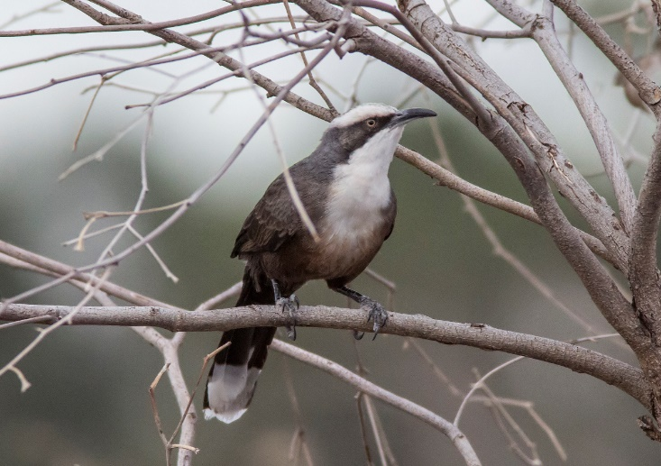Woodland bird data was collected on the fringes of 12 wetlands (where the woodland fringe was broad enough to sample). A total of 99 species were recorded, including four species listed as threatened or near threatened. Exploratory analysis was carried out on data from five wetlands that had been sampled repeatedly when the wetlands were both dry and wet. This analysis showed no difference in woodland bird abundance or species richness when the adjacent wetland was dry or wet.

**Fig 4 – Grey-crowed Babbler (Photo: ARI)**

**What’s Next?**

While preliminary evidence has been collected to answer the key evaluation questions, further sampling in 2019-2020 will inform more detailed analysis.

To better understand the mobility and habitat preferences of birds, and the potential influence of water availability throughout the landscape, satellite tracking of particular species of birds is proposed for inclusion in the 2020/21 monitoring program.

This information in conjunction with hydrology and long-term waterbird datasets will help us to understand the effects of seasonality, annual variations, and availability of alternate wetlands (at local and Australia-wide scales) on waterbird numbers at wetlands that receive environmental water.

**Acknowledgements**

This work was funded by DELWP Water and Catchments, as part of the Victorian Government’s $222 million investment to improve catchment and waterway health across regional Victoria.

**Further information**

See [www.ari.vic.gov.au](http://www.ari.vic.gov.au) for further information on WetMAP

**Contact** [Danny.Rogers@delwp.vic.gov.au](mailto:Danny.Rogers@delwp.vic.gov.au) (bird monitoring methods)

[Jacqueline.Brooks@delwp.vic.gov.au](mailto:Jacqueline.Brooks@delwp.vic.gov.au) (program leader),

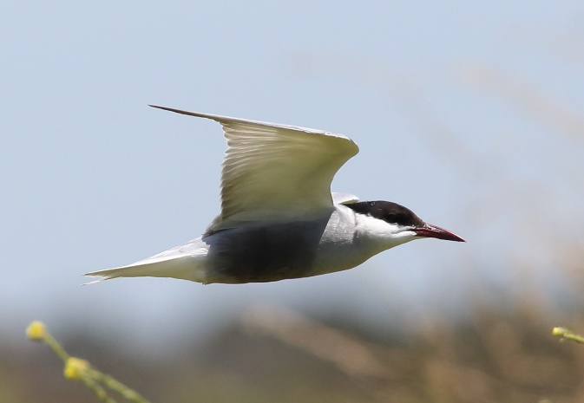

**Fig 5 - Whiskered Tern (Photo: ARI)**

|  |  |
| --- | --- |
| © The State of Victoria Department of Environment, Land, Water and Planning 2020  LogoThis work is licensed under a Creative Commons Attribution 4.0 International licence. You are free to re-use the work under that licence, on the condition that you credit the State of Victoria as author. The licence does not apply to any images, photographs or branding, including the Victorian Coat of Arms, the Victorian Government logo and the Department of Environment, Land, Water and Planning (DELWP) logo. To view a copy of this licence, visit http://creativecommons.org/licenses/by/4.0/  ISBN 978-1-76105-030-5 (pdf/online/MS word)  Disclaimer  This publication may be of assistance to you but the State of Victoria and its employees do not guarantee that the publication is without flaw of any kind or is wholly appropriate for your particular purposes and therefore disclaims all liability for any error, loss or other consequence which may arise from you relying on any information in this publication. | Accessibility  If you would like to receive this publication in an alternative format, please telephone the DELWP Customer Service Centre on 136186, email [customer.service@delwp.vic.gov.au](mailto:customer.service@delwp.vic.gov.au), or via the National Relay Service on 133 677 [www.relayservice.com.au](http://www.relayservice.com.au). This document is also available on the internet at <https://www.ari.vic.gov.au/research/wetlands-and-floodplains/assessing-wetland-response-to-environmental-water> |