|  |
| --- |
| VEFMAP Stage 6  Murray Cod, Flows and Recruitment |
| Linking flow attributes to Murray Cod recruitment dynamics to inform flow management |

**The Victorian Environmental Flows Monitoring and Assessment Program (VEFMAP) Stage 6**

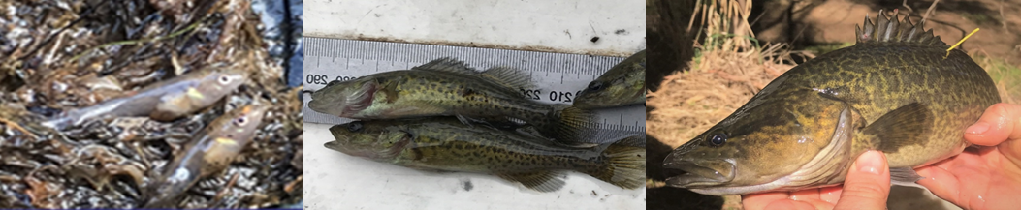

Northern Victorian Rivers

The northern rivers fish component of VEFMAP Stage 6 examined links between flows (including environmental, irrigation and natural events), life history processes (dispersal, survival and recruitment) and population outcomes (distribution and abundance) for several native fish species in the lower reaches of the Campaspe, Loddon, Goulburn and Broken river systems. This fact sheet focusses on flows and Murray Cod.

Background and Approach

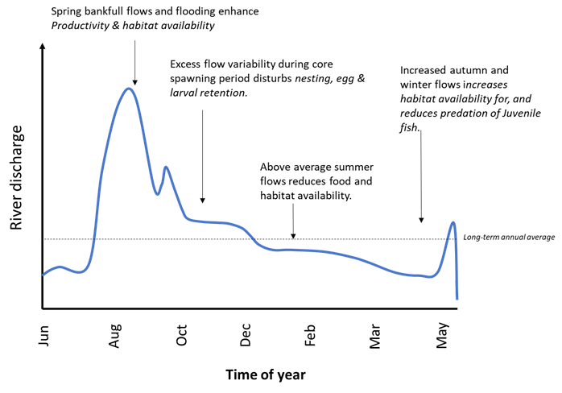There are gaps in our understanding of how best to manage river flows to benefit recruitment of Murray Cod. This project developed hypotheses about the links between recruitment and key components of the flow regime, such as flow during spring spawning period or during the summer juvenile stage. Twenty years of annual fish survey data from five rivers in the southern MDB (Murray, Goulburn, Broken, Ovens and King rivers) were then analysed to test these hypotheses. While these rivers varied in their size and habitat characteristics, all have healthy populations of Murray Cod.

Key Findings

Spring flows and their variation during spawning, as well as summer and winter flow conditions during the early juvenile period were all found to be influential on Murray Cod recruitment. As such, providing suitable flow regimes across the whole year for Murray Cod is vital. For example, ideal spring flow conditions may lead to successful spawning, but if the summer or winter flow conditions which follow are not suitable, these new juveniles may not survive or thrive. These findings provided evidence to confirm the initial hypotheses (see Fig 1).

**Fig 1. Conceptual model of the key flow attributes which influence Murray Cod recruitment**

|  |
| --- |
| Providing suitable flow regimes across the whole year for Murray Cod is vital. |

Relationships between river discharge and the strength of Murray Cod recruitment varied across rivers, which likely reflects the differences in the river characteristics (e.g. their flows, habitats and geomorphology) and available data. For example, in all regulated systems, the higher the flow in summer, the lower the recruitment of Murray Cod.  Yet in the unregulated Ovens River, there was a moderate positive link between higher flows in summer and higher recruitment of Murray Cod. For regulated rivers, flows during summer often exceed levels experienced in winter and spring (something that rarely occurs in natural flowing rivers), and this may reduce critical rearing habitats for juvenile fish and the prey they eat.

Careful consideration is needed when transferring the recruitment response of Murray Cod from one river system to another, particularly where systems are diverse. Further data collection and analysis to identify common processes across rivers, will continue to improve the potential for transferability.

While Murray Cod are long-lived and the impact of a single year of poor recruitment may be limited, the cumulative impacts over multiple years could be significant.

Specific Flow Recommendations

Aim to provide flows that align with the general shape of the natural flow regime. Specifically, flows should be:

* + above the long-term annual average in winter and spring
  + move gradually to below the annual average levels through summer and autumn, while also maintaining suitable water quality
  + avoid excess variability in rates of change in flows during the core spawning period (late October – early December).

Building a Strong Scientific Foundation

|  |  |
| --- | --- |
| © The State of Victoria Department of Environment, Land, Water and Planning 2020  LogoThis work is licensed under a Creative Commons Attribution 4.0 International licence. You are free to re-use the work under that licence, on the condition that you credit the State of Victoria as author. The licence does not apply to any images, photographs or branding, including the Victorian Coat of Arms, the Victorian Government logo and the Department of Environment, Land, Water and Planning (DELWP) logo. To view a copy of this licence, visit http://creativecommons.org/licenses/by/4.0/  ISBN 978-1-76105-149-4 (pdf/online/MS word)  Disclaimer  This publication may be of assistance to you but the State of Victoria and its employees do not guarantee that the publication is without flaw of any kind or is wholly appropriate for your particular purposes and therefore disclaims all liability for any error, loss or other consequence which may arise from you relying on any information in this publication. | Accessibility  If you would like to receive this publication in an alternative format, please telephone the DELWP Customer Service Centre on 136186, email [customer.service@delwp.vic.gov.au](mailto:customer.service@delwp.vic.gov.au), or via the National Relay Service on 133 677 [www.relayservice.com.au](http://www.relayservice.com.au). This document is also available on the internet at https://www.ari.vic.gov.au/publications |

This work has greatly improved our knowledge of how the breeding success of Murray Cod is influenced by river flows. It provides a strong scientific basis to implement flow management to directly achieve recruitment success for Murray Cod, as well as other species with similar breeding strategies such as Trout Cod and River Blackfish. Population models, a key tool used to predict long-term population outcomes from a range of flow scenarios, have also been improved.

What’s Next?

VEFMAP Stage 7 will continue to focus on filling knowledge gaps to support and inform improved water management and demonstrate the ecological value of water for the environment.