|  |
| --- |
| Stock Exclusion Fencing:  Monitoring native vegetation improvements |
| What outcomes for native vegetation can we expect to see through monitoring? |

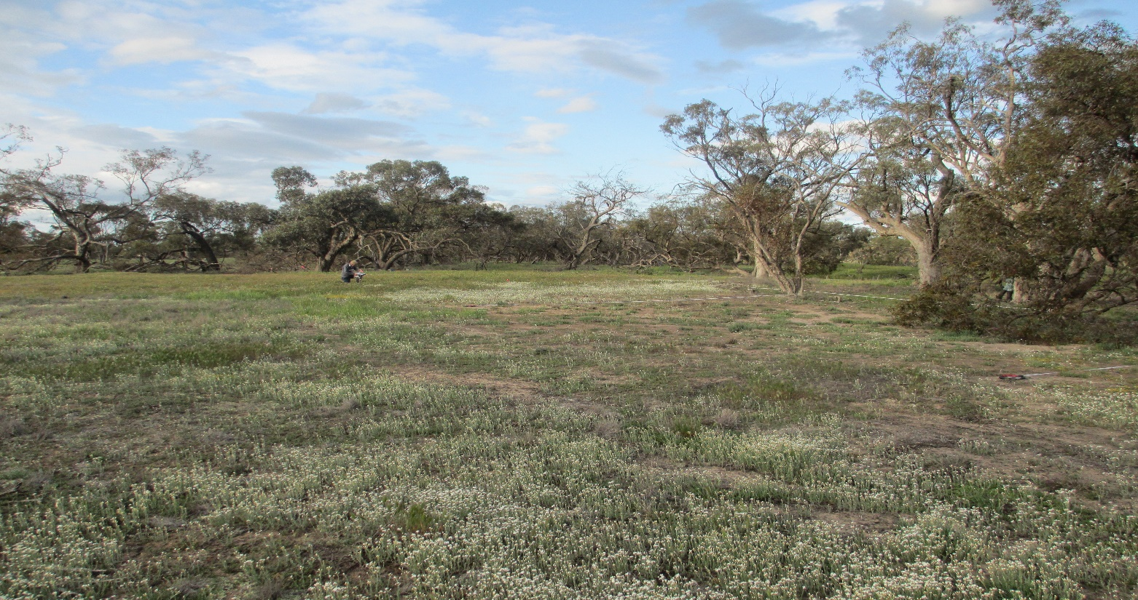

# Background



## Key points

* Stock exclusion fencing is an effective mangament action that can improve or maintain native vegetation
* Many factors drive the recovery of native vegetaion in stock excluded areas (rainfall, region, land shape)
* Only through long term monitoring can we better understand how we can best manage native vegetation on private land



Native vegetation supports ecosystem services such as erosion control, nutrient cycling and habitat for threatened species. With almost one third of Victoria’s remaining native vegetation existing on private land, landholders are often supported by a range of incentive and extension schemes to maintain and improve the health of their native vegeation.

On private land, a major threat to native vegetation is livestock grazing.

|  |
| --- |
| Stock exclusion fencing is one of the most effective management actions to protect native vegetation and wildlife habitat. |

Stock exclusion fencing is an effective management option that can protect native vegetation from the negative impacts of livestock grazing to either maintain or improve the overall condition.

# What monitoring can tell us?

Monitoring involves surveying vegetation over time, identifying how it changes and what the implications of those changes are. For stock exclusion fencing investments, monitoring can:

* Inform when, where and how to undertake management actions.
* Document actions and outcomes.
* Capture and build knowledge to inform future actions.

# What stock exclusion fencing can do?

Recently, a review of monitoring programs has evaluated the effectiveness of stock exclusion fencing in maintaining or improving native vegetation condition.

The review found that expected vegetation responses over time in relation to stock exclusion included:

* Increased native vegetation cover
* Increased number of native plant species
* Decreased bare ground
* Decreased weed cover

|  |
| --- |
| Stock exclusion fencing has, in most instances, maintained or improved native vegetation condition. |

## Drivers of vegetation health

Other factors may also influence vegetation response to stock exclusion:

* + **Vegetation type** – different plant communities respond in different ways to stock exclusion.
  + **Remnant shape** – remnants with high edge effects (e.g. small or linear remnants) are often in poor condition and may take longer to recover.
  + **Landscape context (nativeness)** – remnants more connected to others in the landscape often have higher vegetation condition and probability of recovery.
  + **Annual rainfall** – influences vegetation recovery and rates of change.
  + 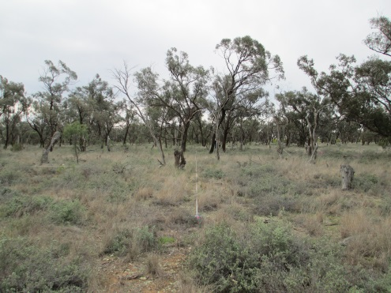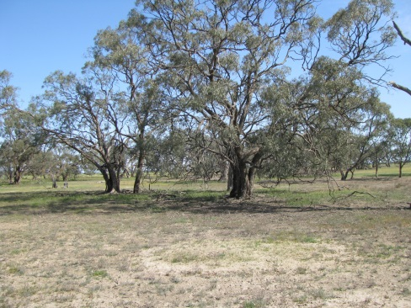**Vegetation starting condition** – low condition sites that are recently fenced (< 10 years) may take longer to recover than high condition sites.

## Detecting short-term vegetation responses

Remnants where stock have been excluded for less than ten years are often of low to medium condition.

What five-year monitoring programs can tell us about these sites?

* Some vegetation responses can be detected over a five-year period (but not all).
* Weed cover may decrease, but this response is also be influenced by vegetation condition and annual rainfall.
* Minimal vegetation change is expected in high condition sites over a five-year period, as these sites are already in a stable condition.
* Further management actions (e.g. weed control) may be required to improve vegetation condition within a five-year period.

## Natural tree regeneration after stock exclusion

* The degree of natural tree regeneration is highly variable and dependant on a range of factors (e.g. tree health, site condition).
* To improve the regeneration of trees, site-specific management actions may be required (e.g. planting tubestock, direct seeding).

## Stock exclusion program considerations:

* Most investment sites are in relatively good condition.
  + - Vegetation responses at a state-wide scale can differ at a regional and site scale, representing climate and soil productivity gradients.
* The starting condition of vegetation will influence the recovery observed and is an important consideration in low to medium condition sites.

|  |  |
| --- | --- |
| © The State of Victoria Department of Environment, Land, Water and Planning 2020  LogoThis work is licensed under a Creative Commons Attribution 4.0 International licence. You are free to re-use the work under that licence, on the condition that you credit the State of Victoria as author. The licence does not apply to any images, photographs or branding, including the Victorian Coat of Arms, the Victorian Government logo and the Department of Environment, Land, Water and Planning (DELWP) logo. To view a copy of this licence, visit http://creativecommons.org/licenses/by/4.0/  ISBN 978-1-76105-187-6 (Print)  ISBN 978-1-76105-188-3 (pdf/online/MS word)  Disclaimer  This publication may be of assistance to you but the State of Victoria and its employees do not guarantee that the publication is without flaw of any kind or is wholly appropriate for your particular purposes and therefore disclaims all liability for any error, loss or other consequence which may arise from you relying on any information in this publication. | Accessibility  If you would like to receive this publication in an alternative format, please telephone the DELWP Customer Service Centre on 136186, email [customer.service@delwp.vic.gov.au](mailto:customer.service@delwp.vic.gov.au), or via the National Relay Service on 133 677 [www.relayservice.com.au](http://www.relayservice.com.au). This document is also available on the internet at [www.delwp.vic.gov.au](http://www.delwp.vic.gov.au). |

## Acknowledgements

This project was funded with support of the Victorian Government as part of the Biodiversity On-ground Action initiative’s Adaptive Learning project.