Native Fish Report Card Program

Data collection and interpretation

## Key Messages

* Native Fish Report Cards provide a snapshot of the state of native fish, of high conservation and recreational value, in priority waterways in Victoria.
* Over time the data collected during the annual surveys will allow trends in target fish populations to be studied.
* Understanding how survey data is collected and can be interpreted is an important element of this program.

## The Native Fish Report Card Program

In Victoria, many agencies invest significant resources in river and riparian rehabilitation activities and research, as well as fish stocking and enforcement. These agencies need information on the status of native fish populations to inform management, policy and strategic research. However, until recently, relevant data on key species has not been collected and/or shared in a way that agencies, recreational fishers and others interested in fish can easily obtain.

The Native Fish Report Card Program began in 2017. Report cards are produced for selected target species to provide more accessible information on the current status of native fish in priority rivers (Table 1). These target species include those of high conservation and/or recreational value.

## What do report cards include?

The Native Fish Report Cards are brief overviews of the health of target fish populations. They are prepared when new data becomes available.

For each target species the following information is collected:

* Total number of fish caught
* Fish per 1km of waterway
* Largest fish by length (cm)
* Largest fish by weight (kg)
* % of the catch that is legal size

Three Key Health Indicators are also included for each target species:

1. **Recent recruitment** – were small fish (presumed less than 1 year old) present, indicating fish are breeding (or being stocked)
2. **Multiple size classes** – were there fish from a variety of sizes, one indicator of healthy populations
3. **Mature fish present** – were mature fish, capable of breeding present

For some threatened species, the NFRC is unlikely to capture enough fish to measure key health indicators. Collecting data on these species, however, allows a greater understanding of the current status of the populations, providing essential information for their management.

Each report card also provides brief information regarding the fish community within the river. This includes the non-target fish species incidentally recorded during surveys, the suite of native and non-native species known from each river, as well as environmental conditions during surveys and relevant river rehabilitation efforts.

## Fish Survey - Methods

Fish surveys for this program began in 2017 and are conducted in autumn. Sampling is done in autumn to avoid the spring periods of peak migration when some native fish undertake long distance movements into or out of rivers.

Fish are sampled from multiple sites in each priority waterway, predominantly using electrofishing. Fyke netting is used to target River Blackfish in the Gellibrand River. This species lives on the bottom of the river and can be cryptic, so they are difficult to catch using electrofishing.

**How to interpret the results**

Using a consistent design and method means results can be compared from year to year to help identify trends.

Electrofishing and fyke netting are scientific sampling methods used to provide a snapshot of the presence and abundance of fish present in waterways at the time of sampling. However, no method is perfect and able to catch all the fish present in a waterway. Therefore, the numbers of fish presented in the Native Fish Report Cards should be considered a sample only. There are likely to be many more fish in the waterways than just those recorded. Fish may also move about and populations will fluctuate due to natural variations in the environment.

## A Collaboration

This project is a collaboration between DELWP, ARI, and the Victorian Fisheries Authority, in partnership with recreational fishing license holders. The Victorian Fisheries Authority also presents Native Fish Report Card results at their annual Murray Codferences.

**Table 1 – Selected species**

|  |  |  |  |
| --- | --- | --- | --- |
| **CMA region** | **Priority river** | **Recreational species** | **Threatened non-recreational species** |
| East Gippsland | Mitchell River | Australian Bass | Australian Grayling |
| West Gippsland | Thomson River (including Macalister River downstream of Lake Glenmaggie) | Australian Bass | Australian Grayling |
| Corangamite | Gellibrand River | River Blackfish |  |
| Glenelg Hopkins | Glenelg River | Estuary Perch |  |
| Goulburn Broken | Lower Goulburn River | Golden Perch, Murray Cod | Silver Perch, Trout Cod |
| Mallee | Lindsay River/Mullaroo Creek | Golden Perch, Murray Cod | Silver Perch |
| North Central | Gunbower Creek | Golden Perch, Murray Cod | Silver Perch, Trout Cod |
| North East | Ovens River | Golden Perch, Murray Cod, | Macquarie Perch, Trout Cod |
| Wimmera | Wimmera River | Freshwater Catfish, Golden Perch |  |
| Melbourne Water | Yarra River | Macquarie Perch, Murray Cod | Australian Grayling |

## Contact details

For more information contact [Jason.Lieschke@delwp.vic.gov.au](mailto:Jason.Lieschke@delwp.vic.gov.au) or Waterway Monitoring (DELWP) [Waterway.Monitoring@delwp.vic.gov.au](mailto:Waterway.Monitoring@delwp.vic.gov.au)

See ARI website to access [Native Fish Report Cards](https://www.ari.vic.gov.au/research/field-techniques-and-monitoring/native-fish-report-card-program).

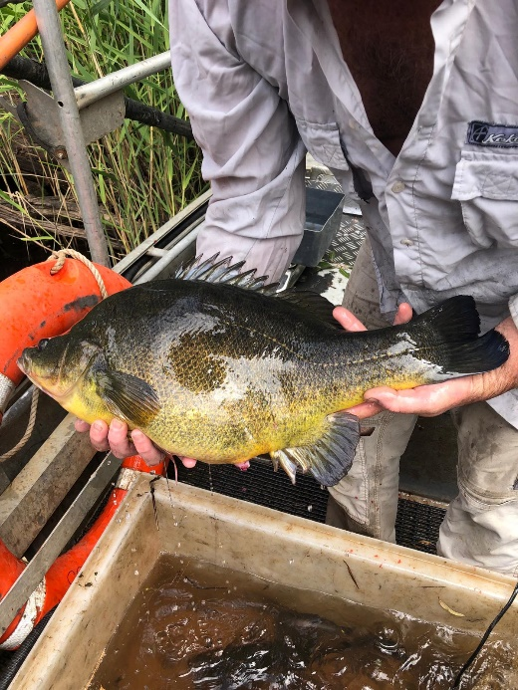**Figure 1 – A Golden Perch caught during a survey**

|  |  |
| --- | --- |
| © The State of Victoria Department of Environment, Land, Water and Planning 2021  Printed by (insert printing company name, suburb).  ISBN 978-1-76105-843-1 (pdf/online/MS word) | LogoThis work is licensed under a Creative Commons Attribution 4.0 International licence. To view a copy of this licence, visit creativecommons.org/licenses/by/4.0/ |