|  |
| --- |
| Impacts of Foxes in Wetlands |
| Fact Sheet 2 |

## Victorian distribution and habitat

The European Red Fox (*Vulpes vulpes*) naturally occurs in Europe, Asia and North America. The species was introduced to Australia for recreational hunting in 1855 and became established in the wild in the early 1870s. Within 100 years the Fox had spread across most of Australia, with the exception of the tropics1.

The Fox is a highly elusive and adaptive species, and is present across most of Victoria. The species occurs within a broad range of habitats, from forest to open plains, farmlands, deserts and wetlands. There are few environmental factors that limit their distribution. Foxes can survive in dry conditions because they are predominantly nocturnal and can meet water intake requirements through their prey without reliance on a supply of free water.

Predation by the Fox is listed as a Key Threatening Process under the federal *Environment Protection and Biodiversity Conservation Act* 1999 as well as the Victorian *Flora and Fauna Guarantee Act* 1988.

## Biology

The Fox is a medium-sized mammal with a body length of about 50 to 90 cm, and a weight range commonly between 4 and 6 kg. The typical colouration ranges from pale, yellowish-red to deep, reddish-brown on the upper body with white, ash, or slate colourings on the underbody. The lower part of the legs is usually black, and the tail is generally tipped with white or black.

Foxes typically live for three to six years, although some individuals may live up to ten years. Most Foxes in a population tend to be less than two years old2. Mortality rates of adult Foxes are high (50-60%), due to human intervention (e.g. shooting, baiting) and natural deaths through lack of food, drought, aging and disease3.

The species has a high reproductive rate and high rate of cub survival4. Females breed once a year, over a 3-7 week period from mid-June to the end of July3. Gestation is 51-53 days with most cubs (or ‘kits’) born in August to September. The mean litter size is four with up to ten cubs possible in areas where there is an abundant food supply. Foxes raise their litters in dens, which are usually enlarged Rabbit or Wombat burrows. A female may excavate several dens. Cubs are weaned by about one month and are sexually mature by ten months. About 85% of young females will breed in their first year3.

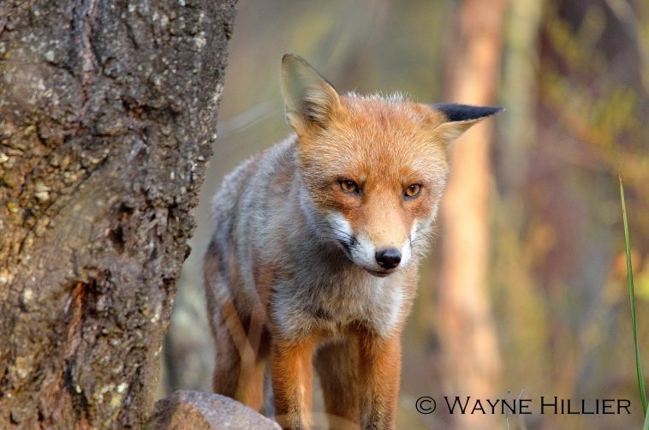

Figure 1: The Fox has contributed to the decline of many native species (Photo: Wayne Hillier).

## 

## Diet

Foxes are omnivorous predators and scavengers that generally prey on small (< 5.0 kg) mammals. They also eat birds, reptiles, amphibians, insects and fruits. In Australia’s agricultural regions, young Rabbits form the majority of their diet but they will prey on lambs, goat kids and poultry. In areas where Rabbits are scarce, Foxes prey largely on native animals. Foxes can cache excess food, burying it in shallow holes2. There are some anecdotal and contemporary examples of surplus killings5.

## Territories

Foxes are generally solitary animals, although demonstrate a strong social structure during breeding activity3. They tend to have only one mate, although social groups of one male and several females can occur. Family groups usually have well-defined territories, with borders delineated by scent markings, aggressive and non-aggressive interactions and vocalisations3. There is some evidence that territorial boundaries are elastic (Alan Robley, ARI, pers.comm.). Boundaries are also sometimes defined by linear features in the landscape such as roads, tracks, watercourses and fence lines3.

The size of territories can vary widely and is likely influenced by food availability, reproductive status, population density, habitat type and habitat availability6. For example, territory estimates vary from <30 ha in urban Melbourne7 to >3300 ha in arid South Australia8. Territory estimates in agricultural landscapes range from 300-700 ha, although data is limited9. Territories can also be unstable, changing in size and location3. It is unknown whether the territories of itinerate Foxes differ from those that are resident in an area3. There are no detailed studies comparing territories within wetland habitats to other habitats.

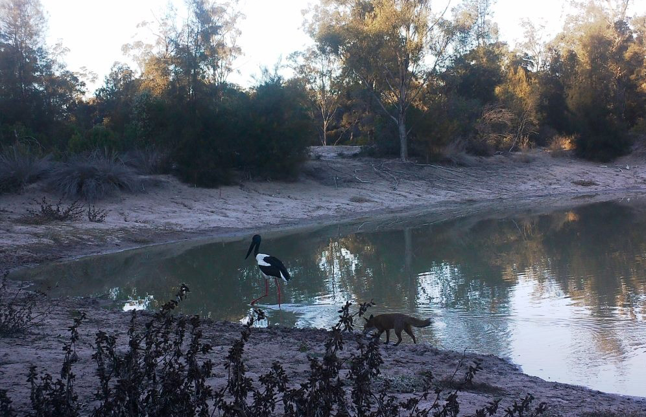

Figure 2: A Fox near a Black-necked Stalk in a wetland (Photo: Warren Venaglia).

Foxes are largely nocturnal hunters, with peaks in activity in the evening and early morning (crepuscular)3. During the day they may use several sites within their home range to rest, including dense vegetation and large Rabbit burrows.

Foxes can travel rapidly between foraging areas, and use particular routes regularly9. They commonly make use of cleared areas with easy access such as tracks and roads. Greater hunting success of Foxes has been observed along linear habitats such as roadsides and creek lines, compared to remnant vegetation and open paddocks2.

## Fox abundance

Estimating Fox population densities is difficult due to their secretive and nocturnal nature2. When food may be abundant, such as in urban areas, densities of 16-30 Foxes/km2 have been recorded 7,10. Common densities in temperate agricultural areas of Australia range between 4-8 Foxes/km2 (3).

The number of Foxes within a landscape is often underestimated3. When young Foxes disperse in late summer/early autumn, this causes a large floating population, although the percentage of the total population this represents is unknown. Itinerate Foxes can rapidly fill gaps in established territories once other Foxes die3. There are no detailed studies comparing Fox abundance in wetland habitats to other habitats.

## Impacts

The Fox is thought to have caused a severe reduction in populations of many threatened species, primarily through predation. Those most at risk are terrestrial mammals within the ‘critical weight range’(i.e. 35 g-5.5 kg)and ground-nesting birds4. There is a body of evidence relating to the significant impacts of Foxes on native species, particularly from the 1980s onwards. This includes:

* anecdotal and historical accounts of major declines in species, particularly in the critical weight range, coinciding with the establishment of Foxes.
* many native species which are extinct or highly threatened on mainland Australia, which thrive in Fox-free areas such as islands.
* significant losses of animals through predation during reintroduction programs for threatened species.
* significant improvements in population status of native species when intensive Fox control programs occur2.

There has been some work to estimate the impact of Foxes in Australia, using different methods. One study11 estimated a total annual impact of Foxes in Australia of $227.5 million, comprising:

* $37.5 million economic impact (via sheep production loss, and management costs, research costs)
* $190 million environmental impact (via predation of native fauna)
* an unquantified social impact (e.g. impacts on employment, commercial harvest of pelts).

Another study undertook an assessment of impact, incorporating consideration of how removal of pest species would improve economic surplus12. This study estimated the impact to agriculture by Foxes to be $21.2 million/year. There are no detailed studies that measure the environmental impacts of Foxes on wetland environments.

Wetlands may be particularly sensitive to Fox impacts due to their inherent high fauna biodiversity values and potential edge effects, where higher predation rates may occur along the water’s edge.

## Impacts to fauna

Under the federal *Environment Protection and Biodiversity Conservation Act* 1999, predation by Foxes is identified as a threat to 103 species1 (see [The Species Profiles and Threats database](http://www.environment.gov.au/cgi-bin/sprat/public/sprat.pl)).

In Victoria, a recent project used a range of species’ life history traits to evaluate their relative vulnerability to predation by Foxes and Cats13. A predation vulnerability rating (PVR) between ‘0’ (negligible) and ‘4’ (high) was assigned to group species in their overall vulnerability to both species. Of 893 species, the breakdown of ranking for vulnerability to Fox predation was:

* High 26%
* Moderate 10%
* Low 29%
* Negligible 31%
* Not applicable 3%

Of the 232 species which scored a ‘high’, this included the following subset of extant, native species which specifically occur in Victoria wetlands (or are widespread and could occur in wetlands and associated habitats):

* 30 wetland bird species, and 27 wader/coastal species
* 7 mammals
* 2 reptiles
* 12 amphibians

This list may require some revision, based on further expert feedback and research, particularly regarding impacts to turtle species.

## Impacts on turtles

The impact of Foxes on turtles has been the focus of research in Australia. Foxes can prey on adults, juveniles and eggs. One study found Foxes responsible for up to 93% of nest predation of the Murray River Tortoise *Emydura macquarii*14. Impacts may have been exacerbated by river regulation and reductions in floodplain inundations, as natural flood events may have prevented access to, and predation of, many turtle nests (Katie Howard, ARI, pers. comm.). High predation rates can cause adult-biased populations shifts, which can be difficult to detect because of turtle longevity15. In surveys in the mid upper Murray, three turtle species displayed this shift16 although declines cannot be attributed entirely to Fox predation.

Impacts of Fox predation can vary between turtle species according to their life history traits. Murray River Tortoises nest close to water, with aggregated nests, and experience high egg predation rates, and low female adult predation rate. Alternately, the Broad-shelled Long-neck Turtle *Chelodina expansa* which nests further from the water’s edge, buries nests that are spread apart and has lower nest predation rates and higher juvenile recruitment17.

The presence of Foxes at a nesting site can also influence nest site selection by female turtles. Although nest predation rates increase closer to water for Murray River Tortoise, in high risk areas the species nests 10-15 m closer to the water to reduce the chances of their own mortality18.

Short-necked species (e.g. *Emydura* and *Elseya* spp.) are particularly vulnerable to predation due to their inability to retract their head and limbs fully17.

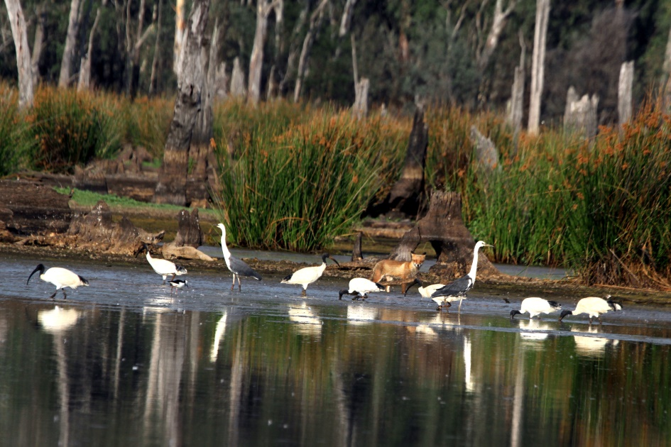

Figure 3: A Fox stalking waterbirds in a wetland (Photo: B. Enders)

## Vectors of spread and growth of weeds

The diet of Foxes includes fruit and berries from both native and introduced plants (e.g. Blackberries, Boxthorn, Sweet Briar)3. There has only been limited investigation of the role Foxes play in the spread of weeds. The species can contribute to dispersal of introduced plants via their scats19 and when attached to their fur. A study in the 1970s at two sites in Victoria found Blackberry seeds were dispersed extensively by Foxes, and recorded germination rates of seeds from Fox scats between 22-35%20. Their large territories in some environments and tendency to follow tracks also represents a risk of spread of introduced plant species.

## Disease

Foxes are susceptible to a range of diseases and parasites, which are transmissible to dogs3. They may play a role in maintaining reservoirs of harmful diseases and would be a prime vector of rabies if it were ever introduced to Australia7,21.

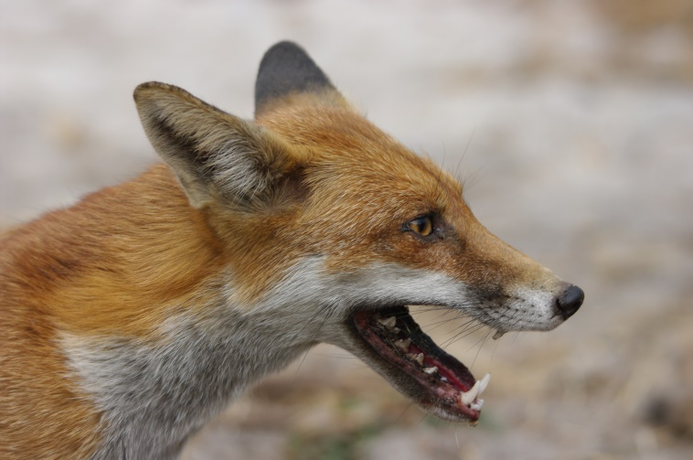

Figure 4: A Fox (Photo: Gary Tate)

## Density thresholds and impacts

An important component of Integrated Pest Management is managing a species below a predetermined density threshold below which its impacts on environmental values are acceptable22. For some species however, such as Foxes, identifying such a density threshold is problematic. Fox densities can be difficult to estimate and can vary widely across habitats and times of year. The specific impact of Foxes on different species of fauna is also likely to vary across landscapes and may be influenced by many factors.

Understanding whether Fox predation acts to limit or regulate a population of a particular species can be hard to determine, although can be important for management23.

Despite the recognised difficulties in managing Foxes, it is important to aim for more effective evidence-based management. There is value in monitoring prey and predator abundance and actual predation, to clearly show causal links.

Even for threatened species which have been the subject of extensive past investment and monitoring such as the Malleefowl, there is limited quantitative evidence for the benefit of management actions such as Fox baiting24. Reliable scientific studies of the ecological effects of pest control are needed to justify these actions in terms of costs and animal welfare25. Improving our understanding of the effectiveness of alternative management actions such as habitat manipulation is also important24.

Some modelling has been undertaken to predict the effects of predation on persistence ability of declining extant populations and reintroduced populations of threatened species26. Recent population analyses for Murray River Turtles suggest that an increase in nest survival to 30% every 5-7 years can maintain populations (Spencer unpubl. data, cited by Katie Howard, ARI).

A recent study assessed the effectiveness of short-term Fox control to protect a seasonally vulnerable species, the Eastern Long-nected Turtle27. While estimates of Fox occupancy declined following a control program within a lake system, there was no significant change in survival rates of nests. This highlighted the importance of managers assessing both the operational performance of a pest control program as well as whether the asset performance against clear objectives (i.e. a significant increase in survival rates of turtles nests) 27.

## References

1. Department of Environment (2013). Threat abatement plan for predation by the European red fox (2008) – Five yearly review 2013.

2. Carter, A. (2010). Improving Red Fox (*Vulpes vulpes*) management for Bush Stone-curlew (*Burhinus grallarius*) conservation in south-eastern Australia. PhD. School of Environmental Sciences, Charles Sturt University.

3. DPI (2012). Established Invasive Animals Training Manual. Department of Primary Industries, Victoria.

4. DEWHA (2008). *Background document for the threat abatement plan for predation by the European red fox*. Department of the Environment, Water, Heritage and the Arts Canberra.

5. Short, J. et al. (2002). Surplus killing by introduced predators in Australia – evidence for ineffective anti-predator adaptations in native prey species? *Biological Conservation* **103,** 283-301.

6. Carter, A. et al. (2012). Ecology of the red fox (*Vulpes vulpes*) in an agricultural landscape 2. Home range and movements. *Australian Mammalogy* **34,** 175-187.

7. Marks, C. A. and Bloomfield, T. E. (2006). Home-range size and selection of natal den and diurnal shelter sites by urban red foxes (*Vulpes vulpes*) in Melbourne. *Wildlife Research* **33,** 339–347

8. Moseby, K. E. et al. (2009). Movement patterns of feral predators in an arid environment – implications for control through poison baiting. *Wildlife Research* **36**, 422-435.

9. Carter, A. et al. (2012). Ecology of the red fox (*Vulpes vulpes*) in an agricultural landscape. 2. Home range and movements. *Australian Mammalogy* **34**, 175–187.

10. Harris, S. and Rayner, J. M. V. (1986). Urban fox *Vulpes vulpes* population estimates and habitat requirements in several British cities. *Journal of Animal Ecology* **55**: 575-591.

11. McLeod, R. (2004). Counting the Cost: Impact of Invasive Animals in Australia 2004. Cooperative Research Centre for Pest Animal Control. Canberra.

12. Gong, W. et al. (2009). The economic impacts of vertebrate pests in Australia. Invasive Animals Cooperative Research Centre, Canberra.

13. Kennedy, S. and Ferns. L. (2015). Predation vulnerability ratings (PVR) for Victoria’s mainland vertebrate fauna. Version 1: September 2015. Unpublished report, Department of Environment, Land, Water and Planning, Knowledge and Decision Systems Branch.

14. Thompson, M. B. (1983). Populations of the Murray River Tortoise, Emydura (Chelodina): the Effect of Egg Predation by the Red Fox*, Vulpes vulpes*. *Australian Wildlife Research* **10,** 363-71.

15. Brown, C. L. and Hecnar, S. J. (2007). Species loss and shifting population structure of freshwater turtles despite habitat protection. *Biological Conservation* **138,** 421-429.

16. Chessman, B. (2011). Declines in freshwater turtles associated with climatic drying in Australia’s Murray-Darling Basin. *Wildlife Research* **38,** 664-671.

17. Spencer, R-J. and Thompson, M. B. (2005). Experimental analysis of the impact of foxes on freshwater turtle populations. *Conservation Biology* **19(3),** 845-854.

18. Spencer, R-J. and Thomson, M. B. (2003). The significance of predation in nest site selection of turtles: an experimental consideration of macro- and mictrohabitat preferences. *Oikos* **102,** 592-600.

19. Bustmante, R. O. et al. (1992). Are foxes legitimate and efficient seed dispersers – a field test. *ACTA Oecologica – International Journal of Ecology* **13(2),** 203-208.

20. Brunner, H. et al. (1976). A note on the dispersal of seeds of blackberry (Rubus procerus P J Muell.) by foxes and emus. *Weed Research* **16,** 171-173.

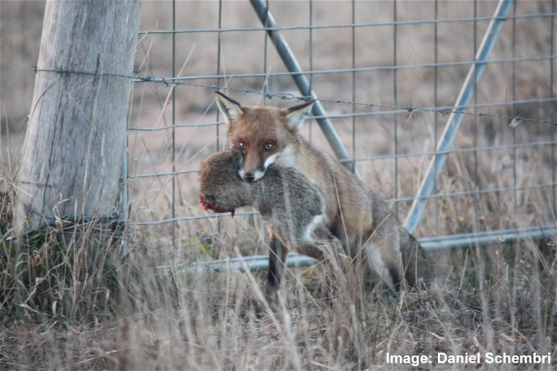

**Figure 5**: Foxes can prey on native and introduced fauna (Photos: Maryann Addington, Daniel Schembri)

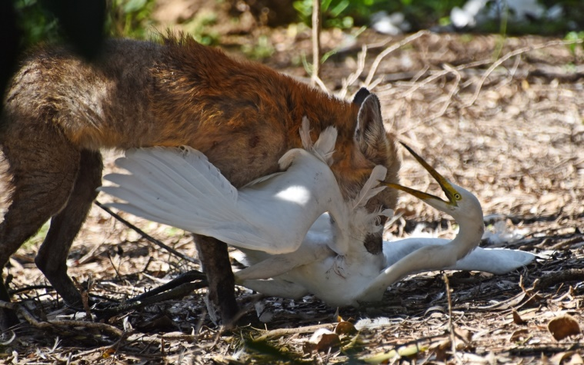

21. Saunders, G. et al. (1995). Managing Vertebrate Pests: Foxes. Bureau of Resource Sciences, Canberra.

22. Braysher, M. and Saunders, G. (2003). PESTPLAN – a guide to setting priorities and developing a management plan for pest animals. Bureau of Rural Sciences and the National Heritage Trust, Canberra, ACT.

23. Sharp, A. et al. (2014). Population recovery of the yellow-footed rock-wallaby following fox control in New South Wales and South Australia. *Wildlife Research* **41,** 560-570.

24. Walsh, J. C. et al. (2012). Unexpected outcomes of invasive predator control: the importance of evaluating conservation management actions. *Animal Conservation* **15,** 319-328.

25. Reddiex, B. and Forsyth, D. (2006), Control of pest mammals for biodiversity protection in Australia. II Reliability of knowledge. *Wildlife Research* **33,** 711-717.

26. Sinclair, A. R. E et al. (1998). Predicting effects of predation on conservation of endangered prey. *Conservation Biology* **12,** 564-575.

27. Robley, A. et al. (2016). The effectiveness of short-term fox control in protecting a seasonally vulnerable species, the Eastern Long-necked Turtle (*Chelodina longicollis*). *Ecological Management and Restoration* **17(1)**, 63-69.

Websites

Department of Economic Development, Jobs, Transport and Resources - <http://agriculture.vic.gov.au/agriculture/pests-diseases-and-weeds/pest-animals/a-z-of-pest-animals/red-fox>

Invasive Animal CRC - <http://www.pestsmart.org.au/pest-animal-species/european-fox/>

|  |  |
| --- | --- |
| © The State of Victoria Department of Environment, Land, Water and Planning 2017  LogoThis work is licensed under a Creative Commons Attribution 4.0 International licence. You are free to re-use the work under that licence, on the condition that you credit the State of Victoria as author. The licence does not apply to any images, photographs or branding, including the Victorian Coat of Arms, the Victorian Government logo and the Department of Environment, Land, Water and Planning (DELWP) logo. To view a copy of this licence, visit http://creativecommons.org/licenses/by/4.0/  ISBN 978-1-76047-420-1 (print)  ISBN 978-1-76047-421-8 (pdf)  Disclaimer  This publication may be of assistance to you but the State of Victoria and its employees do not guarantee that the publication is without flaw of any kind or is wholly appropriate for your particular purposes and therefore disclaims all liability for any error, loss or other consequence which may arise from you relying on any information in this publication. | Accessibility  If you would like to receive this publication in an alternative format, please telephone the DELWP Customer Service Centre on 136186, email [customer.service@delwp.vic.gov.au](mailto:customer.service@delwp.vic.gov.au) or via the National Relay Service on 133 677 [www.relayservice.com.au](http://www.relayservice.com.au). This document is also available on the internet at [www.delwp.vic.gov.au](http://www.delwp.vic.gov.au). |