https://www.stylemanual.gov.au/grammar-punctuation-and-conventions/numbers-and-measurementsLammer

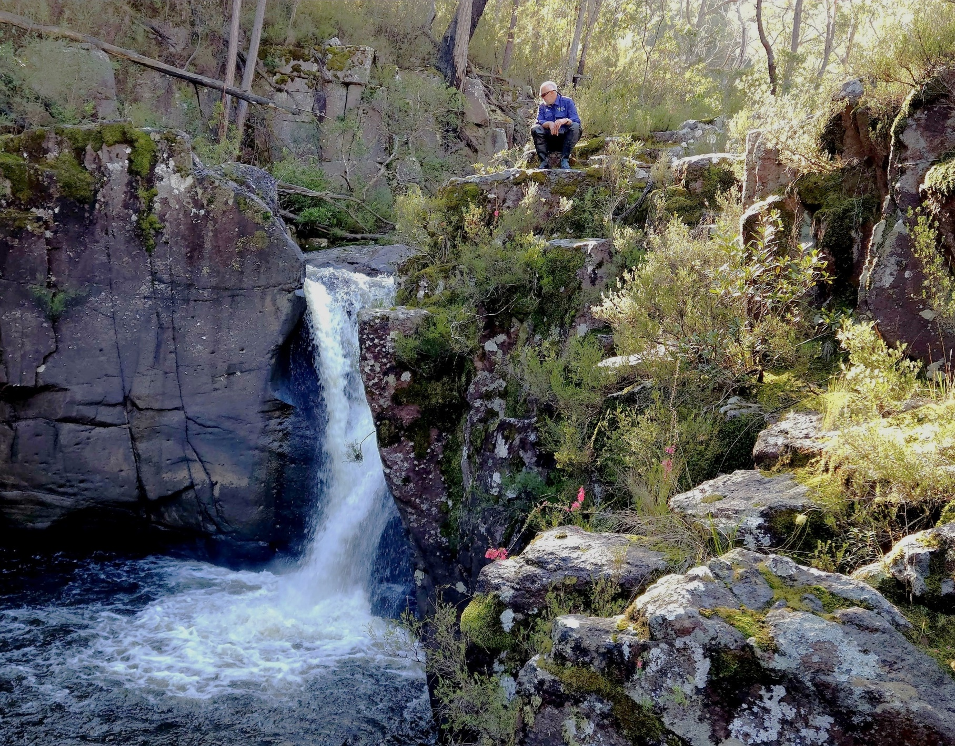


Arthur Rylah Institute for Environmental Research

Technical Report Series No. 408
Identifying translocation stream reaches for nationally threatened species of Galaxias in eastern Victoria

T.A. Raadik and M.D. Nicol
July 2026




Arthur Rylah Institute for Environmental Research
Department of Energy, Environment and Climate Action
PO Box 137, Heidelberg, Victoria 3084
Phone (03) 9450 8600
Website: www.ari.vic.gov.au
Citation: Raadik, T.A. and Nicol, M.D. (2026). Identifying translocation stream reaches for nationally threatened species of Galaxias in eastern Victoria. Arthur Rylah Institute for Environmental Research Technical Report Series No. 408. Department of Energy, Environment and Climate Action, Heidelberg, Victoria.
Front cover photo: Rodger Falls, Roger River, Snowy River National Park, Victoria (Michael D. Nicol).
Edited by Jeanette Birtles (Organic Editing)
ISSN 1835-3835 (pdf)
ISBN 978-1-76176-954-2 (pdf)


We acknowledge and respect Victorian Traditional Owners as the original custodians of Victoria’s land and waters, their unique ability to care for Country and deep spiritual connection to it.
We honour Elders past and present whose knowledge and wisdom
has ensured the continuation of culture and traditional practices.
DEECA is committed to genuinely partnering with Victorian Traditional Owners and Victoria’s Aboriginal community to progress their aspirations.
© The State of Victoria Department of Energy, Environment and Climate Action July 2026.
Creative Commons
This work is licensed under a Creative Commons Attribution 4.0 International licence, visit the Creative Commons website (http://creativecommons.org/licenses/by/4.0/).
You are free to re-use the work under that licence, on the condition that you credit the State of Victoria as author. The licence does not apply to any images, photographs or branding, including the Victorian Coat of Arms, and the Victorian Government, the Department and the ARI logos.
Disclaimer
This publication may be of assistance to you, but the State of Victoria and its employees do not guarantee that the publication is without flaw of any kind or is wholly appropriate for your particular purposes and therefore disclaims all liability for any error, loss or other consequence which may arise from you relying on any information in this publication.
Accessibility
To receive this document in an alternative format, phone the Customer Service Centre on 136 186, email customer.service@deeca.vic.gov.au, or contact the National Relay Service on 133 677. Available at DEECA website (www.deeca.vic.gov.au).

Identifying translocation stream reaches for nationally threatened species of Galaxias in eastern Victoria
Tarmo A. Raadik and Michael D. Nicol
Arthur Rylah Institute for Environmental Research
Department of Energy, Environment and Climate Action
123 Brown Street, Heidelberg, Victoria 3084
Arthur Rylah Institute for Environmental Research
Technical Report Series No. 408

Acknowledgements
This project was funded by the Australian Government’s Saving Native Species program as Project ATM_2024_3000 ‘Emergency action to benefit five threatened galaxiid species’. We thank Sarah Lenarduzzi (Saving Native Species Section, Biodiversity Division, Department of Climate Change, Energy, the Environment and Water) for project and contract management, Chris Nicol (Groundwater Logic), Hugh Allan (University of Canberra) and Adrian Kitchingman [Arthur Rylah Institute for Environmental Research (ARI)] for assistance with digital elevation model (DEM) development and analysis, and Rick Frisner and Jian Yang (Vicmap Spatial Services) for providing access to 1-m DEM data.
We also thank the following staff for information on track conditions and assistance with, and permissions for, access to field locations: Parks Victoria—Gary Bellesini, Dave Burton, David Butterworth, Susie Cutlack, Michael Dower, Mike Irvine, Jenny Lawrence, Sam Sunderland and Michael Treanor; Department of Energy, Environment and Climate Action, Gippsland Region—Lucas Bluff, Peter Brick, Nicole Chapman, Emily Cordy, Glen Digby, Marc Perri, and Kylie Singleton; Melbourne Water—Josh Chesterton, Kate Hill, Renelle Verkes.
The success of this project relied on the commitment of field staff, who happily ventured off track, down steep gradients through thick forest regrowth to access remote, often very wet locations. For their valuable field assistance, we thank Ben Iscaro, Annique Harris, Liam Hogan, and Ben Woolcock (all ARI).
Sampling was conducted under Victorian Fisheries Authority Research Permit RP827, National Parks Permit No. 10009828 and Flora and Fauna Guarantee Act 1988 Permit No. 10010854, on Wurundjeri, Bunurong, Gunaikurnai, Jaitmatang, Ngarigo Monero and Bidawal country.

Contents
Acknowledgements ii
Executive summary 1
1 Introduction 3
1.1 Translocation considerations 4
1.1.1 Previous recovery actions 4
1.1.2 Opportunities for translocation 4
1.1.3 Criteria for suitable translocation reaches 5
1.1.4 Challenges in identifying translocation reaches 5
1.1.5 Project objective 5
1.2 Project area 6
2 Methods 7
2.1 Desktop stream and site selection 7
2.1.1 Initial barrier identification (map-based assessment) 7
2.1.2 Digital elevation model analysis 7
2.2 Selection of stream reaches and sites for field assessment 10
2.2.1 Species-specific treatment for Yalmy Galaxias 10
2.2.2 Exclusion criteria 11
2.2.3 Field-assessment prioritisation criteria 11
2.3 Field site assessment process 19
2.3.1 Fish sampling 19
2.3.2 Fish processing 19
2.3.3 Site characteristics and water quality 19
2.4 Post-assessment site filtering 20
3 Results 22
3.1 Field assessment 22
3.2 Post-assessment site filtering 29
4 Discussion 53
4.1 Conservation significance 53
4.2 Performance of the reach selection framework 54
4.3 Limitations and uncertainty 54
4.4 Management implications and future work 55
5 Conclusions and recommendations 56
5.1.1 Recommendations 56
6 References 57
Appendices 60
Appendix 1. Python packages and scripts used for DEM analysis utilising WhiteboxTools 60
Appendix 2. Location data for field assessment sites 78
Appendix 3. Results of field sampling at each assessment site, including date of sampling, gear type used, and species names and numbers collected for sampled fauna 117
Appendix 4. Selected site images 132
Snowy River Basin 132
Tambo River Basin 146
Mitchell River Basin 147
Thomson River Basin 148
Latrobe River Basin 151
South Gippsland River Basin 155

Tables
Table 1. Numbers of streams and survey sites in the project area, grouped by river basin and mainstream catchments. 12
Table 2. Number of sites assessed in each river basin grouped by fish community observed (fishless, native fish only, or trout) and by sites that were dry or only trickling at the time of assessment. 22
Table 3. Catchment, waterbody reach name, and site codes for the additional 29 stream reaches (34 sites) identified for exclusion during prioritisation, based on trout access, small upstream catchment area, or water permanency concerns. 32
Table 4. Selection criteria for the 61 candidate reaches (93 site–reach codes) identified in this project. 40
Table 5. Coordinates of the downstream-most barrier for each of the 61 candidate reaches identified in this project, including barrier confirmation status (confirmed or requiring verification) (see Figures 24–29). 43
Table 6. Water quality parameters for the 61 candidate stream reaches identified in this project. 45

Figures
Figure 1. The six coastal river basins forming the project area in eastern Victoria. 6
Figure 2. Previous fish survey records, and verified trout streams above 150 m in elevation, across the six river basins in the project area. 8
Figure 3. Example output of a 1-m-DEM—based in-stream barrier analysis. 10
Figure 4. Location of the 124 assessment sites in the Snowy River Basin, including site codes. 13
Figure 5. Location of the 23 assessment sites in the Tambo River Basin, including site codes. 14
Figure 6. Location of the 29 assessment sites in the Mitchell River Basin, including site codes. 15
Figure 7. Location of the 21 assessment sites in the Thomson River Basin, including site codes. 16
Figure 8. Location of the 32 assessment sites in the Latrobe River Basin, including site codes. 17
Figure 9. Location of the 24 assessment sites in the South Gippsland Basin, including site codes. 18
Figure 10. Filtering and prioritisation process used to identify candidate translocation reaches for upland galaxiids following field assessment. 21
Figure 11. Results of field assessment of sampling sites in the Snowy River Basin. 23
Figure 12. Results of field assessment of sampling sites in the Tambo River Basin. 24
Figure 13. Results of field assessment of sampling sites in the Mitchell River Basin. 25
Figure 14. Results of field assessment of sampling sites in the Thomson River Basin. 26
Figure 15. Results of field assessment of sampling sites in the Latrobe River Basin. 27
Figure 16. Results of field assessment of sampling sites in the South Gippsland Basin. 28
Figure 17. Examples of fauna collected during sampling, and of backpack electrofishing. 29
Figure 18. Candidate sites remaining in the Snowy River Basin (green circles, white circles and yellow squares) following removal of trout-inhabited and dry sites, highlighting 17 additional sites identified for exclusion based on trout access (no effective downstream trout barrier; red circles) or potential water permanency issues (orange circles). 33
Figure 19. Candidate sites remaining in the Tambo River Basin (white circle, yellow square) following removal of trout-inhabited and dry sites, highlighting three additional sites identified for exclusion based on trout access (no effective downstream trout barrier; red circle), very small upstream (U/S) catchment area (<2 km²; mauve circle), or potential water permanency issues (orange circle). 34
Figure 20. Candidate sites remaining in the Mitchell River Basin (green circles and white circles) following removal of trout-inhabited and dry sites, highlighting seven additional sites identified for exclusion based on trout access (no effective downstream trout barrier; red circles) or potential water permanency issues (orange circles). 35
Figure 21. Candidate sites remaining in the Thomson River Basin (green circles and white circles) following removal of trout-inhabited and dry sites, highlighting five additional sites identified for exclusion based on trout access (no effective downstream trout barrier; red circle, very small upstream (U/S) catchment area (<2 km²; mauve circle), or potential water permanency issues (orange circles). 36
Figure 22. Candidate sites remaining in the Latrobe River Basin (white circles, yellow square) following removal of trout-inhabited and dry sites, highlighting three additional sites identified for exclusion based on trout access (no effective downstream trout barrier; red circles). 37
Figure 23. Candidate sites remaining in the South Gippsland Basin (green circles, white circles, yellow squares) following removal of trout-inhabited and dry sites, highlighting one additional site identified for exclusion based on trout access (no effective downstream trout barrier; red circle). 38
Figure 24. Final 34 candidate reaches, including barrier confirmation status (confirmed or requiring verification), remaining in the Snowy River Basin following additional exclusion filtering. 47
Figure 25. Final two candidate reaches, including barrier confirmation status (confirmed or requiring verification), remaining in the Tambo River Basin following additional exclusion filtering. 48
Figure 26. Final six candidate reaches, including barrier confirmation status (confirmed or requiring verification), remaining in the Mitchell River Basin following additional exclusion filtering. 49
Figure 27. Final three candidate reaches, including barrier confirmation status (confirmed or requiring verification), remaining in the Thomson River Basin following additional exclusion filtering. 50
Figure 28. Final 10 candidate reaches, including barrier confirmation status (confirmed or requiring verification), remaining in the Latrobe River Basin following additional exclusion filtering. 51
Figure 29. Final six candidate reaches, including barrier confirmation status (confirmed or requiring verification), remaining in the South Gippsland River Basin following additional exclusion filtering. 52

Executive summary
Context:
Four of the five nationally Critically Endangered galaxiid fishes in Gippsland, eastern Victoria, that are considered to be at imminent risk of extinction are now each restricted to a single, isolated headwater population upstream of natural barriers that exclude introduced Brown Trout (Salmo trutta) and Rainbow Trout (Oncorhynchus mykiss). The fifth species, Yalmy Galaxias (Galaxias sp. nov. ‘Yalmy’), is restricted to a single population at a lower elevation reach where trout occupancy appears to be limited by warmer water temperatures. These galaxiids face a high risk of extinction due to trout invasion, their small population size, declining genetic diversity and the increasing impacts of drought, fire and other stochastic events.
Although captive breeding to support the establishment of additional populations is now available through the Snobs Creek Conservation Hatchery, a major constraint to recovery has been the lack of identified translocation sites. This project addresses that critical gap.
Aims:
This project aimed to identify stream reaches suitable for future translocations of the five nationally threatened galaxiid species by:
- Identifying potential trout-free stream reaches across six Gippsland river basins
- Field-assessing candidate reaches for trout presence, native fish presence, habitat condition, and water permanence
- Producing an inventory of potentially suitable stream reaches to support future translocation planning.
Methods:
Potential trout-free reaches were initially identified using existing fish distribution records and high-resolution Light Detection And Ranging (LiDAR)-derived digital elevation models (DEMs) to locate likely in-stream barriers. For most target species, candidate reaches were selected upstream of barriers likely to prevent trout incursion, but potential translocation sites for Yalmy Galaxias were assessed using a species-specific framework that also sought to identify trout-free reaches lacking a downstream barrier but where thermal conditions were likely to limit trout occupancy. The candidate reaches were then assessed in the field between February 2025 and May 2026.
A total of 253 sites within 122 streams were surveyed by backpack electrofishing for the presence of native fish and introduced trout in the Snowy, Tambo, Mitchell, Thomson, Latrobe and South Gippsland river basins. Habitat characteristics, water permanence indicators, and water quality were also recorded. Sites were subsequently filtered using ecological criteria based on trout presence, presence of galaxiid fishes, downstream barrier effectiveness in preventing trout access, upstream catchment area, and likely water permanence, to identify potentially suitable translocation reaches.
Results:
The survey represents one of the largest landscape-scale assessments undertaken, in terms of area of potential translocation habitat for threatened upland galaxiids in south-eastern Australia. The key outcomes were:
- A total of 253 sites across 122 streams were surveyed.
- The surveys recorded 12 fish species (10 native, 2 introduced) and 8 native crayfish species.
- Five previously undocumented Mountain Galaxias complex populations were identified that potentially represent three species, including one likely undescribed taxon.
- No new populations of the five target threatened galaxiid species were detected.

Following site filtering and reach-level exclusion:
- Sixty-one stream reaches, represented by 93 survey sites, were identified as candidate translocation habitat, distributed across all six river basins.
- Most of the candidate reaches were in the Snowy River Basin (34 reaches).
- Twenty-seven of the reaches have confirmed effective downstream trout barriers.
- Twenty-six of the reaches require barrier verification prior to further prioritisation and translocation consideration.
- The remaining eight reaches were identified as candidate translocation habitat for Yalmy Galaxias using a species-specific assessment framework, under which downstream physical barriers were considered desirable but not essential where trout absence and habitat suitability could be demonstrated.
- The water quality across all of the candidate reaches was within suitable ranges for upland galaxiid persistence.
Conclusions and recommendations:
This project provides a comprehensive landscape-scale assessment of potential translocation reaches for five threatened upland galaxiids in eastern Victoria. By combining existing biological records, LiDAR-derived stream channel analyses, and field verification surveys, 61 candidate stream reaches were identified across six Gippsland river basins. These reaches provide the first strategically developed network of potential recipient habitats for establishing additional populations of five nationally Critically Endangered galaxiid species.
The project achieved its objective of identifying potentially suitable translocation habitats, addressing a key constraint in species recovery. This approach, including the incorporation of species-specific ecological requirements in assessments where appropriate, offers an efficient and transferable method for identifying trout-free habitats, with broader application to other trout-sensitive freshwater species.
Given the continued decline of these species and their restriction to single wild populations, establishing additional self-sustaining populations remains a high conservation priority. The findings provide critical knowledge for this next phase of conservation management.
Prior to any conservation translocations, further assessment and prioritisation of the 61 candidate reaches is required. Recommended actions include:
- Confirm trout barriers at candidate stream reaches by field verification.
- Undertake pre-translocation surveys across the broader catchment (not just the stream containing the proposed translocation reach) to identify any resident galaxiid taxa. This will reduce the risk of hybridisation, genetic swamping, or impacts on relict populations.
- Complete the species-specific prioritisation of the 61 candidate reaches based on habitat suitability, barrier integrity, presence of existing galaxiid populations, conservation value, and translocation feasibility.
- Undertake further detailed assessments of the highest-priority candidate reaches, where required.
- Re-survey priority reaches to verify the continued absence of trout and to detect any recent incursions.
- For candidate Yalmy Galaxias reaches lacking downstream barriers, undertake multiseason monitoring of trout occurrence and stream temperature before translocation.
- Implement staged conservation translocations using a combination of hatchery-bred and wild-sourced fish.
- Introduction
The Galaxiidae is a moderately diverse family of Southern Hemisphere freshwater fishes (McDowall 2006; Burridge et al. 2012) currently comprising 66 valid, formally described species (Fricke et al. 2026). Despite this relatively modest diversity, the family is disproportionately represented in conservation listings (McDowall 2006; Raadik 2014a; Lintermans et al. 2020). Globally, 79% of recognised galaxiid species are classified as threatened (Dunn et al. 2023; DCCEEW 2026; IUCN 2026).
The taxonomy of the Galaxiidae has recently become highly active, with the number of recognised species continuing to increase as cryptic diversity is resolved and candidate species are formally described (Adams et al. 2014; Raadik 2014a; Coleman et al. 2015; Jense et al. 2024). Additional undescribed diversity has been identified across South African, Australian, New Zealand, and South American lineages, but is not yet reflected in formal species counts.
In Australia, the family comprises 37 valid species, of which 27 (73%) are listed as threatened under national or state legislation (DCCEEW 2026; IUCN 2026). Four candidate species identified through preliminary taxonomic research have also been listed as Critically Endangered at both national and global levels (DCCEEW 2026; IUCN 2026), despite not being formally described. At least a further eight candidate species are recognised, all of which have highly restricted distributions and which are subject to significant threats (T.A. Raadik, unpublished data). If these candidate species were included in the threatened species assessments, approximately 80% of Australian galaxiid species would be considered threatened.
At the most severe end of this conservation crisis, five of the Australian galaxiid species listed as Critically Endangered nationally (DCCEEW 2023a, 2023b, 2023c, 2023d, 2023e) are currently considered at imminent risk of extinction:
- Shaw Galaxias (Galaxias gunaikurnai)
- Tapered Galaxias (Galaxias lanceolatus)
- West Gippsland Galaxias (Galaxias longifundus)
- McDowall’s Galaxias (Galaxias mcdowalli)
- Yalmy Galaxias (Galaxias sp. nov. ‘Yalmy’).
These species were identified as being among the 22 most imperilled Australian freshwater fishes (Lintermans et al. 2020), with all 5 ranking in the top 11 species at greatest predicted risk of extinction. Since that assessment, the extinction risk has further increased for Yalmy Galaxias (following the 2019/2020 Black Summer Fires) and for West Gippsland Galaxias (as a consequence of continuing population decline).
The five species share a suite of biological and ecological characteristics that contribute to their exceptionally high extinction risk. They are characterised by:
- Restriction to a single, small population each, in remote upland catchments of Gippsland, Victoria
- Reduced genetic diversity consistent with long-term genetic decline
- Severe impacts from predation by introduced trout species
- Persistence only in trout-free stream reaches, typically upstream of in-stream barriers that prevent trout access. Yalmy Galaxias is an exception, occurring at lower elevations where trout occupancy appears to be constrained by warmer water temperatures
- High vulnerability to stochastic events, including predator incursions, drought, fire, and debris flow.
The principal threats affecting these species align with the major drivers of decline identified for Australian freshwater fishes (Lintermans et al. 2020). Their persistence is constrained by extremely small, geographically isolated populations that are vulnerable to demographic and genetic stochasticity. These intrinsic vulnerabilities are compounded by ongoing predation and habitat exclusion by introduced trout, together with increasing frequency and severity of climate-driven disturbances, including drought, fire, intense storm events, flooding, and associated debris flows. The interaction of these vulnerabilities substantially elevates the extinction risk and limits the natural recovery potential of all five species.
Notably, trout impacts and small, isolated population size were identified as the two highest-priority management needs (Lintermans et al. 2020). Consequently, the five species share similar threats and require similar recovery actions (DCCEEW 2023a, 2023b, 2023c, 2023d, 2023e).
  - Translocation considerations
    - Previous recovery actions
Conservation to date has primarily focused on in situ protection of the remaining populations, including:
- Securing and maintaining extant populations by:
  - Locating and assessing downstream barrier integrity
  - Removing introduced trout from upstream reaches when required
  - Undertaking barrier and predator assessments annually, particularly following major flood events (e.g. ≤1-in-70-years rainfall events), with follow-up trout removal where necessary
  - Assessing and managing sediment impacts
  - Undertaking emergency extraction to establish an insurance population in captivity during fire and drought.
- Acquiring biological knowledge to support recovery by:
  - Assessing population distribution, abundance, and condition, and monitoring temporal variability
  - Conducting initial captive breeding trials (West Gippsland Galaxias only)
  - Monitoring key environmental variables (e.g. flow, water level, temperature, pH, dissolved oxygen).
These activities have been mainly funded through state conservation initiatives between 2012 and 2022 (e.g. Raadik 2012; Raadik and Nicol 2012, 2013, 2015; Raadik 2016, 2018, 2019a, 2019b; Stoessel et al. 2020; Raadik et al. 2021; Stoessel et al. 2021; Shelley et al. 2021; Raadik 2025).
As a result, conservation efforts have largely focused on maintaining each species as a single isolated population. Long-term recovery requires expansion beyond this constraint through the establishment of additional populations, increased population sizes, and improved spatial distribution to reduce extinction risk. Progress towards these objectives has been limited by the lack of individuals available for translocation of each species, given that each species persists as a single small population.
    - Opportunities for translocation
Following the 2019/2020 Black Summer Fires, a dedicated small-bodied threatened native fish hatchery was established at the Snobs Creek Hatchery facility near Eildon. This facility now provides the capacity to support conservation translocations through captive breeding, population supplementation, and establishment of new populations. It has commenced operations and is currently breeding four of the five target galaxiid species: McDowall’s Galaxias, Yalmy Galaxias, Tapered Galaxias and West Gippsland Galaxias.
A major constraint to progressing translocations, however, is the limited availability of suitable release locations. The five target species occur in upland reaches of remote catchments and, like other non-migratory, threatened galaxiids, they are unable to persist in streams containing introduced trout [Brown Trout (Salmo trutta) and Rainbow Trout (Oncorhynchus mykiss) (McDowall 2006; Raadik et al. 2010; Raadik 2014b; Lintermans and Allan 2019; Lintermans et al. 2020; Raadik and Lintermans 2022). This intolerance is reflected in their current distributions, which are confined to trout-free reaches upstream of waterfalls that prevent upstream trout dispersal.
To date, conservation funding has enabled protection and maintenance of the known existing populations but has not been sufficient to systematically identify and assess potential translocation reaches.

    - Criteria for suitable translocation reaches
Suitable translocation reaches for these species are defined as those that:
- Are isolated from trout access (i.e. upstream of effective barriers such as waterfalls)
- Contain permanent water capable of sustaining populations through drought
- Are of sufficient habitat extent to support viable self-sustaining populations
- Are spatially distributed across the landscape, to reduce the risk of impact from a single disturbance event.
    - Challenges in identifying translocation reaches
Identifying suitable translocation reaches is challenging due to a number of factors, including:
- A highly trout-saturated landscape, with most accessible waterways already colonised by introduced trout, leaving few trout-free reaches
- The remoteness and steep terrain of upland catchments, limiting access
- The logistical constraints of field surveys, including long hiking distances, steep valley catchments, and the need to carry bulky equipment, which increases time, effort and cost.
    - Project objective
This project addresses the current limitation in translocation planning by undertaking desktop and field-based assessment to identify suitable stream reaches for future conservation translocations. These locations, subject to further detailed assessment and prioritisation (beyond the scope of this report), may be used to establish new populations of the target species.
This report presents the results from the catchment-scale surveys undertaken to identify candidate translocation reaches.

  - Project area
The project area included foothill and upland rivers and creeks, primarily above 150 m elevation, within six coastal river basins in eastern Victoria. These basins encompass the known distributions of the priority threatened Galaxias species targeted by this project (Figure 1):
- River basin 22: Snowy River
- River basin 23: Tambo River
- River basin 24: Mitchell River
- River basin 25: Thomson River
- River basin 26: Latrobe River
- River basin 27: South Gippsland.
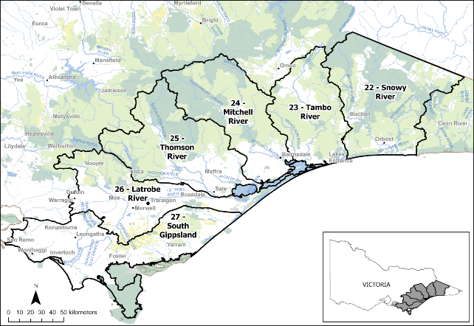
Figure 1. The six coastal river basins forming the project area in eastern Victoria.
Black lines indicate catchment boundaries.
- Methods
The approach used in this project was adapted from Raadik and Lintermans (2022) and Raadik et al. (2025), who developed a framework for identifying potential translocation reaches in small upland streams for the nationally threatened Stocky Galaxias (Galaxias tantangara) in the Snowy Mountains of New South Wales.
This approach comprises two key phases:
- Desktop assessment
Identification and prioritisation of potentially suitable stream reaches based on trout distributions and potential dispersal barriers, followed by selection of representative field sites within each reach for field assessment.
- Initial rapid field survey
Field assessment of trout presence and habitat condition at representative sites, followed by the exclusion filtering of unsuitable sites and the consolidation of sites on the same stream to refine the list of candidate translocation reaches.
The subsequent step described in Raadik and Lintermans (2022) and Raadik et al. (2025), the prioritisation of suitable reaches for translocation implementation, was not part of this project. Accordingly, the potentially suitable reaches identified in this project are referred to as ‘candidate reaches’: stream reaches identified as potentially suitable for translocation through desktop assessment and field screening, pending detailed validation.
  - Desktop stream and site selection
Site selection within the project area (Figure 1) began by refining the stream network to exclude reaches known or likely to contain trout, as well as reaches considered seasonally dry (Figure 2). This was based on existing datasets accessed through the Victorian Biodiversity Atlas (VBA).
For exclusion purposes, all mainstem stream sections downstream of the most-upstream confirmed trout detection were assumed to contain trout. In addition, trout were conservatively assumed to potentially occur a short distance (1–2 km) beyond their last known detection point, including into adjacent tributaries connected to colonised mainstems.
    - Initial barrier identification (map-based assessment)
Potential in-stream barriers (e.g. waterfalls) on the refined stream network were identified using topographic maps and high-resolution aerial imagery. Fine-scale contour mapping was used to identify steep, incised terrain (closely spaced contours crossing streamlines), indicative of abrupt elevational changes (i.e. waterfalls). Abrupt changes in stream channel direction were also used as indirect indicators of resistant bedrock and potential barrier formation.
Aerial imagery was used to visually confirm candidate sites and locate additional sites, with features such as exposed bedrock crossing streamlines, whitewater, and plunge pools used as supporting evidence. However, the process was time-consuming, and dense vegetation cover and variable image resolution often limited interpretations, resulting in few confirmed barriers.
    - Digital elevation model analysis
Given these limitations, a more efficient approach using high-resolution digital elevation models (DEMs) derived from Light Detection And Ranging (LiDAR) data was adopted. This method identifies abrupt changes in elevation along stream profiles that are characteristic of waterfalls and potential trout barriers.
Unlike aerial imagery, LiDAR-derived DEMs are not obstructed by vegetation and can be validated against known waterfall locations. This substantially improved both the efficiency and reliability of potential barrier detection, enabling early exclusion of reaches likely accessible to trout.

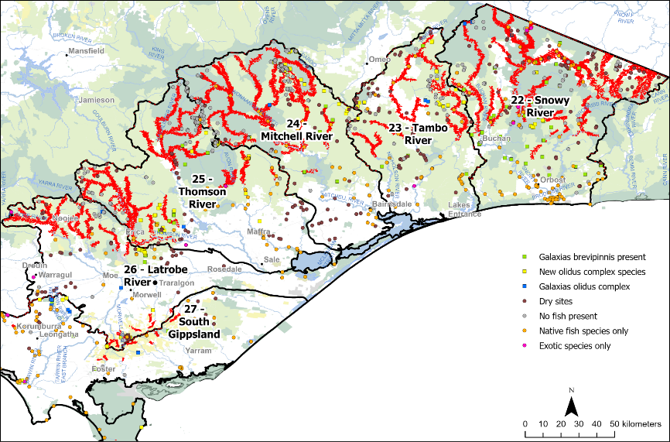
Figure 2. Previous fish survey records, and verified trout streams above 150 m in elevation, across the six river basins in the project area.
Red lines indicate verified trout streams above 150 m in elevation.
The DEM-based method followed Allan et al. (2025) and Raadik et al. (2025) and involved analysing DEM elevation changes in digital stream networks, derived from high-resolution (1-m pixel) LiDAR data, or from an existing 10-m-contour–derived DEM where 1-m DEM data was not available. The DEM approach was implemented using Python (v3.13.3), and DEM processing and stream network extraction used WhiteboxTools (ver. 2.4.0, J. Lindsay, see https://www.whiteboxgeo.com/) (Appendix 1).
DEM processing included:
- Pre-processing data using the FillSingleCellPits
- Correcting elevational anomalies using BreachDepressionsLeastCost functions
- Digital stream network generation using D8Pointer and D8FlowAccumulation rasters, with a flow accumulation threshold of 75,000 m² to define headwaters.
Stream metrics calculated for all pixels included:
- Downstream elevation changes over 2-m (from 1-m DEM) or 10-m (from 10-m DEM) stream segments (in which the appropriate downstream elevation was subtracted from the upstream DEM elevation)
- Available stream habitat as maximum upstream distance (MaxUpsDist)
- Total upstream channel distance (TUCL).
Additional spatial processing and visual validation were undertaken in ArcGIS Pro (v.3.2).
Downstream elevation change was used as the primary proxy for barrier presence. As demonstrated by Allan et al. (2025), stream gradient is a reliable predictor of waterfall occurrence and therefore of potential trout exclusion.
Based on the 1-m DEM, sites with a stream elevation change of <0.53 m over a 2-m stream distance were excluded, based on calibration against known waterfall heights. This comparison demonstrated that waterfalls indicated by elevation changes of less than this height would likely be too small for the purpose of stopping trout movement upstream. The remaining sites were classified as:
- Small barrier: 0.53–0.75 m/2-m stream distance (green circles; Figure 3)
- Medium: barrier 0.75–1.25 m/2-m stream distance (orange circles; Figure 3)
- Large barrier: >1.25 m/2-m stream distance (red circles; Figure 3).
For the 10-m DEM, sites with elevation changes of <2.5 m over a 10-m stream distance were excluded. The remaining sites were classified as:
- Small barrier: 2.5–5.0 m/10-m stream distance
- Medium barrier: 5.0–7.5 m/10-m stream distance
- Large barrier: >7.5 m/10-m stream distance.
It is important to note that DEM-identified potential barriers were considered screening outputs that require field verification. An example of DEM-derived barrier mapping is shown in Figure 3.
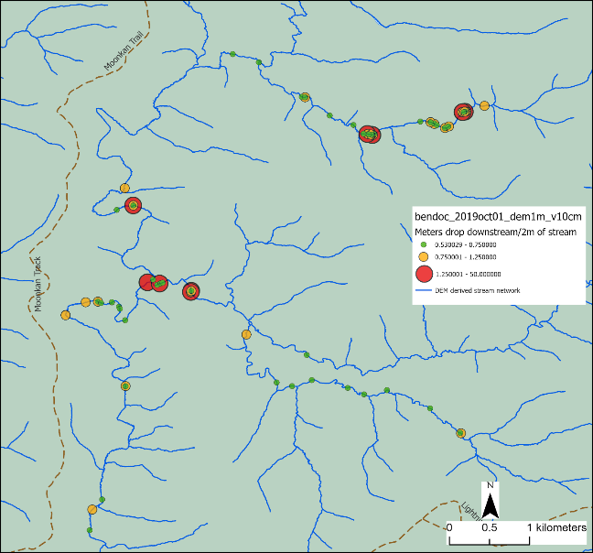
Figure 3. Example output of a 1-m-DEM—based in-stream barrier analysis.
The DEM-derived stream network is delineated as blue lines. Potential in-stream barriers are represented by circles, colour-coded to indicate size class via the calculated stream elevation change over a 2-m downstream distance (green circles = small; orange circles = medium; red circles = large; see above). DEM = digital elevation model.
  - Selection of stream reaches and sites for field assessment
Stream reaches were prioritised for field assessment using a set of ecological and physical criteria adapted from those of Raadik and Lintermans (2022) and Allan et al. (2025). For most target galaxiids, priority was given to reaches upstream of DEM-identified barriers likely to exclude trout. Some criteria were modified for Yalmy Galaxias (see Section 2.2.1) based on the species’ ecology and local knowledge.
    - Species-specific treatment for Yalmy Galaxias
Yalmy Galaxias were assessed separately from the other target galaxiids, because they may persist in warmer downstream reaches where trout occupancy is limited by thermal conditions. Consequently, a downstream physical barrier was considered desirable but not always essential for this species, provided the absence of trout and overall site suitability could be demonstrated.

    - Exclusion criteria
Reaches were excluded if they met any of the following conditions (except where modified for Yalmy Galaxias as described in Section 2.2.1):
- Elevation of <150 m
- Stream order of 1 or >5 (Strahler 1952; 1:25,000 scale)
- Located in cleared agricultural landscapes.
These criteria were used to remove reaches that were:
- Unlikely to support self-sustaining galaxiid populations
- Unsuitable as they were already colonised by trout
- Highly modified by anthropogenic disturbance.
    - Field-assessment prioritisation criteria
The remaining reaches and sites were prioritised based on:
- Barrier presence and size: for most target galaxiids, reaches with larger barriers were prioritised because they were more likely to prevent upstream trout passage (Allan et al. 2025). For Yalmy Galaxias, reaches lacking a downstream barrier were also considered where trout absence and suitable habitat could be demonstrated.
- Multiple barriers: reaches with more than one barrier were prioritised.
- Habitat availability: greater length upstream or habitat length was favoured, due to the likelihood of more abundant habitat supporting a more abundant galaxiid population.
- Accessibility: preference was given to sites accessible by vehicle or which could be reached by vehicle and a manageable hiking distance to optimise the use of time and resources.
A total of 253 sites across 122 stream reaches were selected for assessment (Table 1). The site locations are provided in Appendix 2 and Figure 4–Figure 9.

Table 1. Numbers of streams and survey sites in the project area, grouped by river basin and mainstream catchments.
River basin | Mainstream catchments | Streams | Survey sites
Snowy River | Snowy River  Bonang River  Brodribb River  Buchan River  Deddick River  Ingeegoodbee River  Little River  Murrindal River  Rodger River  Suggan Buggan River  Yalmy River  subtotal | 8  4  1  15  15  4  4  2  1  2  3  59 | 8  7  2  25  30  8  4  4  18  6  12  124
Tambo River | Tambo River  Timbarra River  subtotal | 6  5  11 | 17  6  23
Mitchell River | Mitchell River  Dargo River  Moroka River  Wentworth River  Wonnangatta River  subtotal | 9  2  1  1  1  14 | 17  2  6  1  3  29
Thomson River | Thomson River  Caledonia River  Macalister River  subtotal | 8  1  4  13 | 13  1  7  21
Latrobe River | Latrobe River  Morwell River  Tanjil River  Tyers River  subtotal | 2  2  7  3  14 | 5  5  12  10  32
South Gippsland | Agnes River  Albert River  Bruthen Creek  Franklin River  Little Albert River  Merriman Creek  Tarra River  Tarwin River  subtotal | 1  3  1  1  1  1  1  2  11 | 1  4  2  1  1  3  5  7  24
 | Overall total | 122 | 253

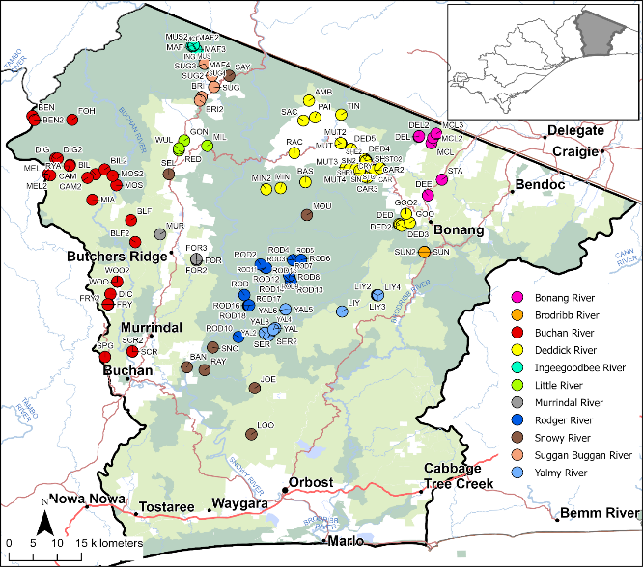
Figure 4. Location of the 124 assessment sites in the Snowy River Basin, including site codes.
The circle colours indicate the mainstream catchment in which each site is located (see legend).
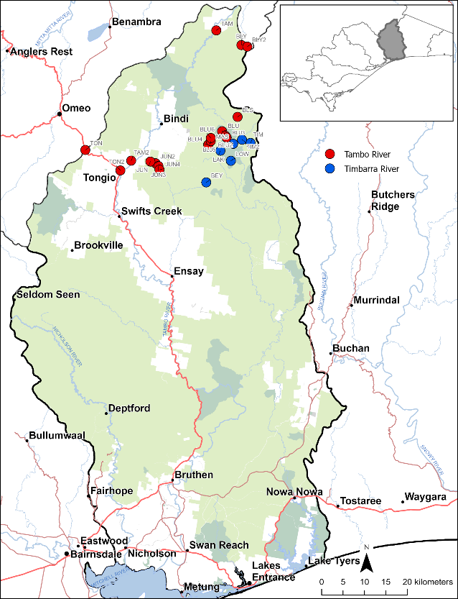
Figure 5. Location of the 23 assessment sites in the Tambo River Basin, including site codes.
The circle colours indicate the mainstream catchment in which each site is located (see legend).
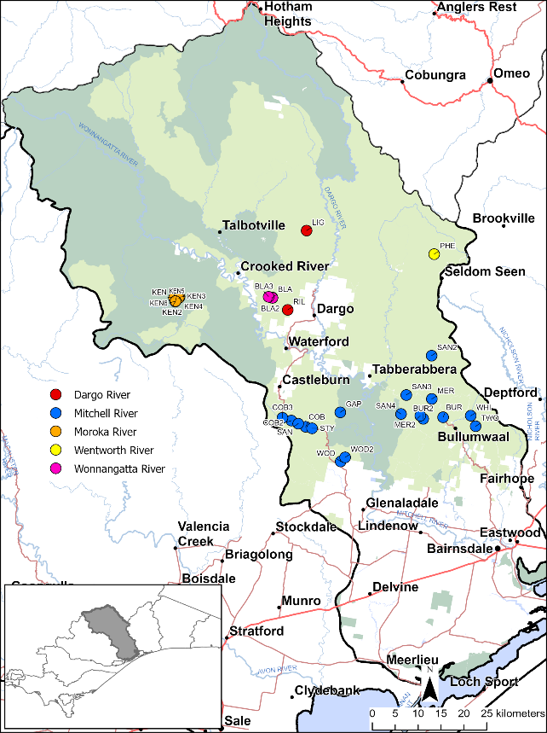
Figure 6. Location of the 29 assessment sites in the Mitchell River Basin, including site codes.
The circle colours indicate the mainstream catchment in which each site is located (see legend).

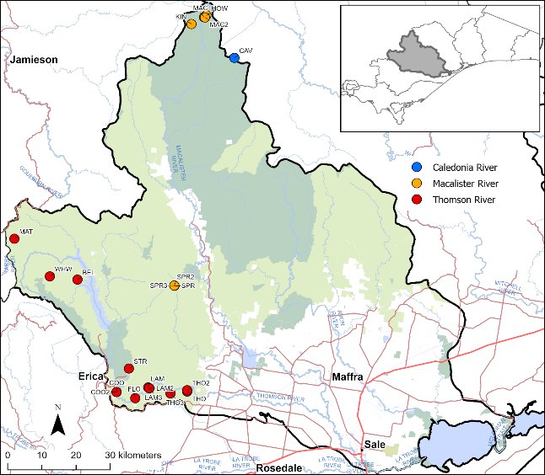
Figure 7. Location of the 21 assessment sites in the Thomson River Basin, including site codes.
The circle colours indicate the mainstream catchment in which each site is located (see legend).
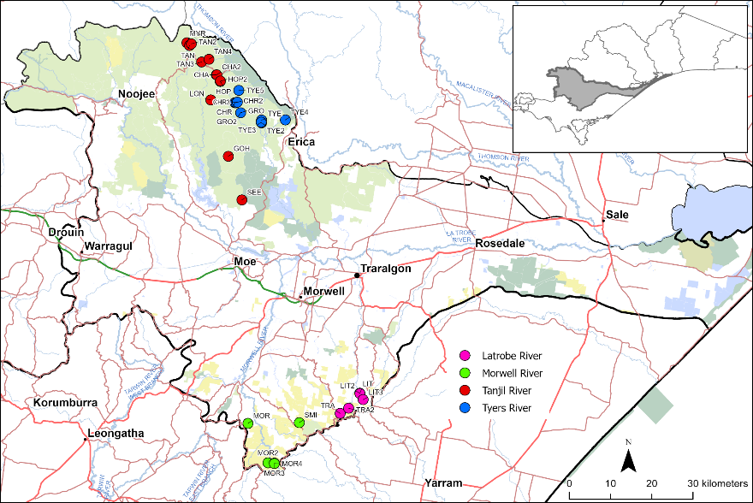
Figure 8. Location of the 32 assessment sites in the Latrobe River Basin, including site codes.
The circle colours indicate the mainstream catchment in which each site is located (see legend).

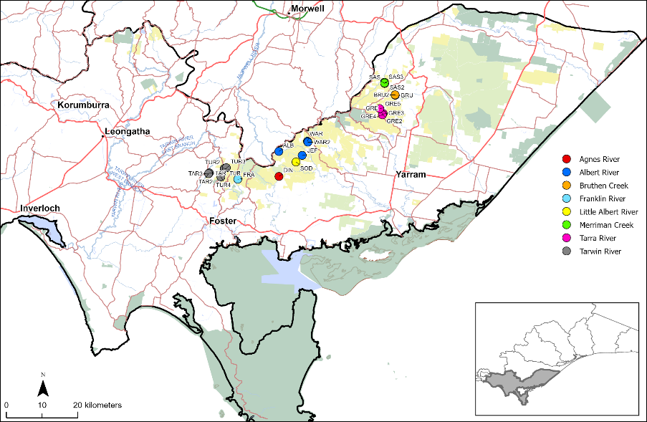
Figure 9. Location of the 24 assessment sites in the South Gippsland Basin, including site codes.
The circle colours indicate the mainstream catchment in which each site is located (see legend).

  - Field site assessment process
Field assessment methods for priority sites followed Raadik and Lintermans (2022), except for environmental DNA sampling, which was excluded due to budget and time constraints.
    - Fish sampling
Sampling was undertaken by two trained operators using a Smith-Root® Model LR-20B backpack electrofisher (triangular anode with soft mesh netting, braided cathode). Output settings ranged from 300 to 990 V (adjusted for water conductivity), 100 Hz frequency, and 20% to 30% duty cycle. Sampling was performed in wadeable stream reaches during daylight hours.
At each site, the team proceeded in an upstream direction, with the operator and the dipnetter conducting a single pass through the designated reach, sampling across all available habitat types. Stunned fish were captured using a large dipnet and transferred to fresh water in a 20-L plastic bucket.
The start and end locations of each sampling reach were georeferenced to calculate the reach length. The start and end times of each sampling event were recorded to determine the sampling duration. Additional data collected included:
- Electrofisher power-on time (s)
- Average channel width (m; visual estimate)
- Average and maximum water depth (m; visual estimate).
The sampling approach was designed to be adaptive, in recognition of the likely variation in site conditions and aquatic fauna. Accordingly, sampling reach length was modified, adjusted at each site based on the fish assemblage detected during sampling, as follows:
- Only trout detected: reach length 30–75 m
- Only native fish detected: minimum reach length 75 m
- No fish detected: minimum reach length 120 m.
These modified reach lengths were implemented to improve time efficiency while maintaining a high level of confidence that a sufficient portion of these upland streams had been sampled to reliably detect species presence, or to confirm their absence.
    - Fish processing
Following electrofishing, captured animals were removed from the 20-L holding bucket using a wet, soft, fine-mesh aquarium dipnet. Fish were identified to species where possible and counted.
For galaxiids, caudal fork length (mm) (using a wetted measuring board) and wet weight (0.1-g precision), were recorded. All handling was undertaken with wet hands to minimise stress. Other aquatic fauna collected were also identified and counted.
After processing, all aquatic fauna were released at the point of capture.
    - Site characteristics and water quality
The following water quality parameters were measured:
- Water temperature (°C)
- Electrical conductivity (µS/cm @ 25°C)
- Dissolved oxygen (mg/L)
- pH
- Water hardness (ppm CaCO₃), when equipment was available.
Turbidity was not measured but was visually assessed and consistently observed to be very low.

Additional habitat variables were visually assessed:
- Presence/absence of surface water
- Presence/absence of flow
- Water volume: categorised as isolated pools, trickle, low, moderate or high
- Water permanency (qualitatively assessed based on hydrology, shading, streambed morphology, and biotic indicators)
- Degree of disturbance (e.g. sedimentation: low, moderate or high).
Site images were also taken to support assessments.
  - Post-assessment site filtering
The post-assessment filtering refined site suitability based on the following:
- Trout presence
- Barrier presence and effectiveness
- Upstream catchment area
- Likely water permanency.
A decision framework adapted from Raadik et al. (2025) is shown in Figure 10. This project did not progress beyond assessment of water permanency (red line in Figure 10), as the later steps were outside the scope of this project.
Catchment area replaced stream length as a prioritisation metric, following Allan et al. (2025), who demonstrated a strong relationship between the two metrics in headwater systems and thus recommended the use of catchment area to improved standardisation. A minimum threshold of 2 km² was applied, with larger catchments being assigned higher priority because they are more likely to support viable galaxiid populations.
Water permanence was inferred from indicators such as stream flow and volume, pool depth, aquatic vegetation, channel morphology, and fish presence, and assessment was intentionally conservative.
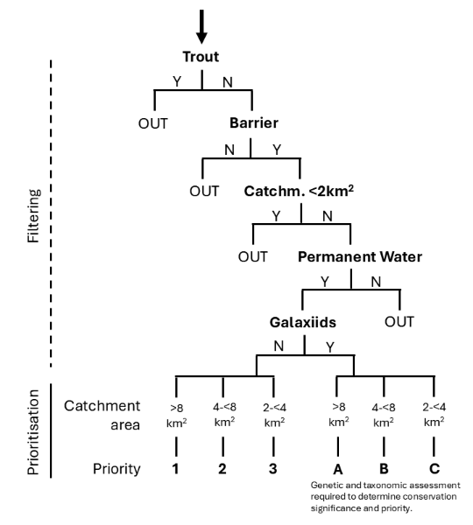
Figure 10. Filtering and prioritisation process used to identify candidate translocation reaches for upland galaxiids following field assessment.
The red line indicates the extent of filtering undertaken in this project. N = no; Y = yes; OUT = filtered out. Adapted from Raadik et al. (2025).

- Results
  - Field assessment
Field assessments at 253 sites selected across eastern Victoria were completed between February 2025 and May 2026. Sites were accessed by vehicle or a combination of vehicle access and hiking. A complete survey dataset has been submitted to the Department of Energy, Environment and Climate Action (DEECA) VBA.
Appendix 3 provides the survey results for each site, including sampling date, species detected, and their abundance. The fauna survey data are summarised in Table 2 and Figure 11–Figure 16. Appendix 4 contains representative site photographs, while Figure 17 illustrates examples of fish and crayfish species recorded during surveys, as well as the backpack electrofishing method used.
Table 2. Number of sites assessed in each river basin grouped by fish community observed (fishless, native fish only, or trout) and by sites that were dry or only trickling at the time of assessment.
River basin | Fishless sites | Native fish only sites | Trout sites | Dry / just trickling sites
Snowy River | 35 | 35 | 23 | 31
Tambo River | 4 | 1 | 1 | 17
Mitchell River | 8 | 10 | 2 | 9
Thomson River | 4 | 6 | 8 | 3
Latrobe River | 13 | 2 | 17 | 0
South Gippsland | 1 | 7 | 15 | 0
Totals | 65 | 62 | 66 | 60
The 253 assessment sites ranged in elevation from 115 m above sea level (Basin Creek, site BAN) to 1515 m (Bentley Creek, site BEN2), representing a broad range of foothill and upland stream environments across the six river basins. Only two sites were situated below 150 m elevation, reflecting the project’s emphasis on sites in foothill and upland habitats, as these are more likely to be trout free.
Eleven fish species were recorded during the surveys, comprising nine native and two introduced species.
The native fauna included Climbing Galaxias (Galaxias brevipinnis), two species in the Mountain Galaxias (Galaxias olidus) species complex as defined by Raadik (2014a) (Yalmy Galaxias—Galaxias sp. nov. ‘Yalmy’ and undescribed taxa—Galaxias spp.), Cox’s Gudgeon (Gobiomorphus coxii), Australian Smelt (Retropinna semoni), River Blackfish (Gadopsis marmoratus complex), Tupong (Pseudaphritis urvillii), Short-finned Eel (Anguilla australis) and Long-finned Eel (A. reinhardtii). The introduced species recorded were Brown Trout and Rainbow Trout .
Eight species of native crayfish were also recorded, comprising Orbost Spiny Crayfish (Euastacus diversus), Gippsland Spiny Crayfish (Euastacus kershawi), South Gippsland Spiny Crayfish (Euastacus neodiversus), Upland Spiny Crayfish (Euastacus sp. 4), Spiny Crayfish (Euastacus sp. 5), Central Highlands Spiny Crayfish (Euastacus woiwuru) , Richards Burrowing Crayfish (Engaeus laevis) and Common Yabby (Cherax destructor).
A notable result was the complete lack of sympatry between introduced trout and galaxiids in the Mountain Galaxias species complex. Throughout the project area, these taxa occupied mutually exclusive distributions, further demonstrating the strong association between trout presence and the absence of upland galaxiids. In comparison, Climbing Galaxias was found occurring at 12 sites with introduced trout (Appendix 3).
The surveys also discovered five previously undocumented populations of taxa in the Mountain Galaxias species complex that potentially represent three distinct species. One taxon, recorded from Wards Creek and Greig Creek (sites WAR2, GRE2 and GRE4) in the South Gippsland Basin, appears to be a previously undescribed species. Detailed genetic and morphological analyses are required to confirm the taxonomic status of all five previously undocumented populations.

Of the 253 sites assessed (Table 2):
- 66 sites (26%) contained trout
- 60 sites (24%) were dry / just trickling
- 62 sites (24%) contained native fish only
- 65 sites (26%) had no fish present.
Together, these results demonstrate that potentially suitable trout-free headwater habitat remains widespread across the Gippsland region of Victoria, although many streams are either seasonally dry or already occupied by introduced trout.
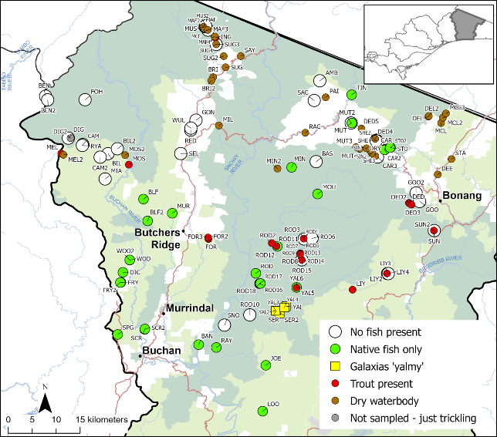
Figure 11. Results of field assessment of sampling sites in the Snowy River Basin.
See text box for explanation of coloured circles.
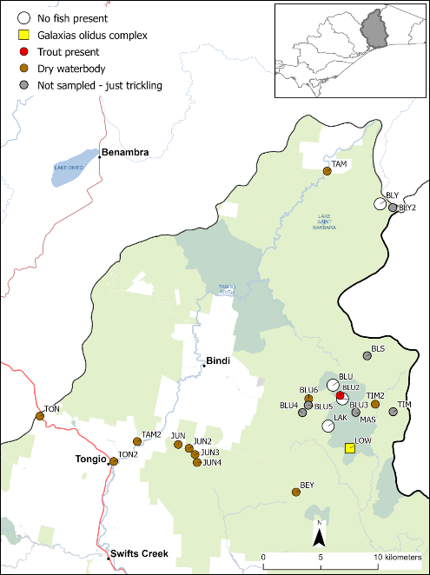
Figure 12. Results of field assessment of sampling sites in the Tambo River Basin.
See text box for explanation of coloured circles.
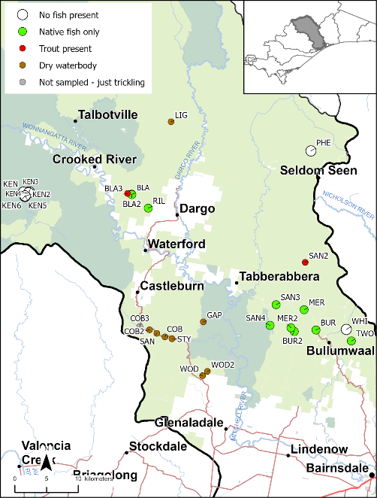
Figure 13. Results of field assessment of sampling sites in the Mitchell River Basin.
See text box for explanation of coloured circles.
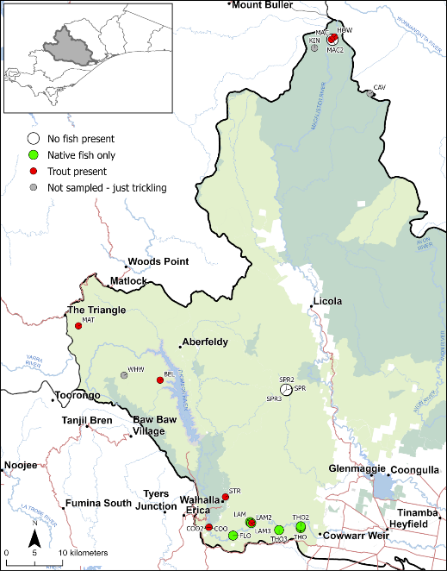
Figure 14. Results of field assessment of sampling sites in the Thomson River Basin.
See text box for explanation of coloured circles.
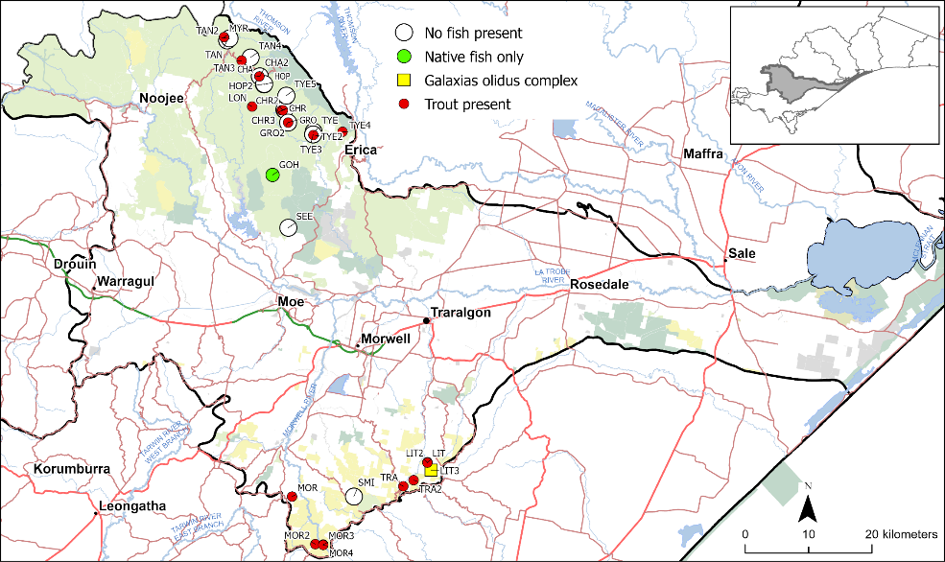
Figure 15. Results of field assessment of sampling sites in the Latrobe River Basin.
See text box for explanation of coloured circles.
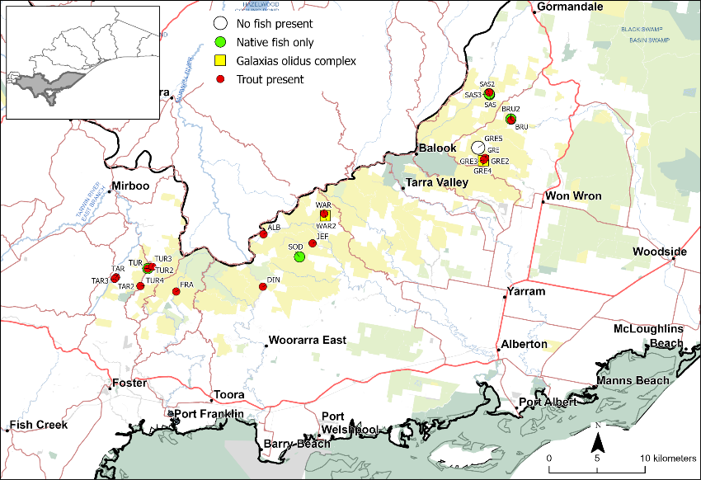
Figure 16. Results of field assessment of sampling sites in the South Gippsland Basin.
See text box for explanation of coloured circles.

Figure 17. Examples of fauna collected during sampling, and of backpack electrofishing.
Clockwise from top left: The native Climbing Galaxias (Galaxias brevipinnis) (TAR); individuals from a new population of Mountain Galaxias (Galaxias olidus) species complex from Greigs Creek (TAR); the introduced Rainbow Trout (Oncorhynchus mykiss) (TAR); a native spiny crayfish (Euastacus sp.) (MDN); backpack electrofishing a pool (MDN); the introduced species Brown Trout (Salmo trutta) (TAR) (image credits: MDN = Michael D. Nicol; TAR = Tarmo A. Raadik).
  - Post-assessment site filtering
Post-assessment filtering followed the prioritisation framework described in Section 2.4, including the species-specific criteria applied for Yalmy Galaxias.
The first post-field assessment filtering stage excluded all sites where trout were present or where streams were dry or reduced to only trickling flow during the survey. This removed 126 sites, comprising 66 trout-inhabited sites and 60 dry or near-dry sites, leaving 127 sites for further assessment (Figure 18–Figure 23).
For the remaining sites, the upstream catchment area was recalculated to represent the extent of catchment located upstream of the downstream-most trout barrier. This approach provides a biologically meaningful estimate of the habitat potentially available for a translocated galaxiid population and is consistent with the prioritisation framework adopted in this project.
In several cases, multiple survey sites occurred within the same continuous trout-free stream reach upstream of the downstream-most trout barrier. These sites were therefore grouped and treated as a single assessment unit (Table 3).
The grouped sites are as follows:
Snowy River Basin:
- Bentley Creek (sites BEN, BEN2)
- Blackfellows Creek (sites BLF, BLF2)
- Carter Creek (sites CAR, CAR2)
- Frying Pan Creek (sites DIC, FRY, FRY2)
- Good Hope Creek (sites GOO, GOO2)
- Goodwin Creek (sites GON, RED, WUL)
- Little Yalmy River (LIY3, LIY4)
- MacFarlane Creek (MCF, MUS, MUS2)
- Moss Bed Creek (sites BIL, BIL2, CAM, CAM2, RYA)
- Mutch Creek (sites MUT, MUT2)
- Reedy Creek (sites DIG, FOH)
- Rodger River tributary 3 (sites ROD16, ROD17, ROD18)
- Rodger River tributary 4 (sites ROD3, ROD6)
- Scrubby Creek (sites SCR, SCR2)
- Sheep Station Creek (SHE, SHE2)
- Woolshed Creek (sites WOO, WOO2)
Mitchell River Basin:
- Black Snake Creek (sites BLA, BLA2)
- Kent Creek (sites KEN, KEN2, KEN3, KEN4, KEN5, KEN6)
- Merrijig Creek (sites MER, MER2)
Thomson River Basin:
- Burnett Creek (sites BUR, BUR2)
- Springs Creek (sites SPR, SPR2, SPR3)
Latrobe River Basin:
- Hope Creek (sites HOP, HOP2)
- Tyers River (sites TYE, TYE3)
South Gippsland Basin:
- Greig Creek (sites GRE2, GRE4)
- Sassafras Creek (sites SAS, SAS3)
The change to a continuous stream reach upstream of a trout barrier in the prioritisation process necessitated a change in location terminology, as assessment locations now contained either a single water body name and site code, or multiple sites with different water body names and site codes (e.g. the grouped sites above). Consequently, each assessment location is hereafter referred to as a ‘reach’. This change more accurately reflects the management unit relevant to conservation translocations.
Where necessary, reach names were updated to correspond to the water body name containing the downstream barrier rather than the individual survey sites (see Table 3 and Table 4).
A second post-field-assessment filtering stage applied three exclusion criteria, in the following order:
- Absence of an effective downstream barrier preventing trout access (except for Yalmy Galaxias candidate reaches assessed under the modified criteria)
- Upstream catchment area <2 km²
- Potential lack of permanent surface water.
Application of these criteria identified a further 29 stream reaches (composed of 34 sites) for exclusion (see Table 3; Figure 18–Figure 23). Several reaches met more than one exclusion criterion. Reaches retained under the modified Yalmy Galaxias criteria were excluded from this filtering step. Of the excluded reaches:
- Nine lacked an effective downstream trout barrier.
- Twenty had potential water permanency concerns.
- Three had both water permanency concerns and potential trout access.
- Two had both trout access and an upstream catchment area smaller than 2 km².
Most reaches excluded because of inadequate trout barriers (5 reaches) or uncertain water permanency (10 reaches) occurred within the Snowy River Basin (Table 3), reflecting both the larger number of sites assessed in that basin and the greater complexity of its headwater stream network.

Table 3. Catchment, waterbody reach name, and site codes for the additional 29 stream reaches (34 sites) identified for exclusion during prioritisation, based on trout access, small upstream catchment area, or water permanency concerns.
The primary exclusion criterion for each reach is indicated in bold text.
River basin | Waterbody reach | Site codes | Trout access | Catchment <2 km² | Water permanency issue
Snowy River | Raymond Creek | RAY | YES
 | Rodger River | ROD | YES
 | Rodger River tributary | ROD10 | YES |  | YES
 | Suggan Buggan River | SUG3 | YES |  | YES
 | Tingaringy Creek | TIN | YES
Tambo River | Bluestone Creek | BLU | YES
 | Bluestone Creek tributary | BLU3 | YES | YES
Mitchell River | Whitburns Creek | WHI | YES |  | YES
Thomson River | Good Hope Creek | GOH | YES
 | Macalister River | MAC2 | YES | YES
 | Serpentine Creek | SEE | YES
 | Thomson River | THO2 | YES
Latrobe River | Tanjil River | TAN | YES
South Gippsland | Tarwin River | TUR2 | YES
Snowy River | Base Camp Creek | BAS |  |  | YES
 | Carter Creek | CAR & CAR2 |  |  | YES
 | Joe Creek | JOE |  |  | YES
 | MacFarlane Creek | MCF, MUS & MUS2 |  |  | YES
 | Mountain Creek | MOU |  |  | YES
 | Sheep Station Creek | SHE & SHE2 |  |  | YES
 | Snowy River | SNO |  |  | YES
 | Stony Creek | STO2 |  |  | YES
Tambo River | Lake Hill | LAK |  |  | YES
Mitchell River | Riley Creek | RIL |  |  | YES
Thomson River | Burnett Creek | BUR & BUR2 |  |  | YES
 | Flour Bag Creek | FLO |  |  | YES
 | Lammers Creek | LAM |  |  | YES
 | Lammers Creek tributary | LAM3 |  |  | YES
 | Two Mile Creek | TWO |  |  | YES

Following completion of the filtering process, 61 stream reaches, represented by 93 survey sites, were identified as potentially suitable future translocation habitats for threatened Galaxias species (Figure 18–Figure 23, white circles or green circles; Table 4–Table 5).
The candidate reaches were distributed across all six river basins:
- Snowy River Basin: 34 reaches
- Tambo River Basin: 2 reaches
- Mitchell River Basin: 6 reaches
- Thomson River Basin: 3 reaches
- Latrobe River Basin: 10 reaches
- South Gippsland Basin: 6 reaches.

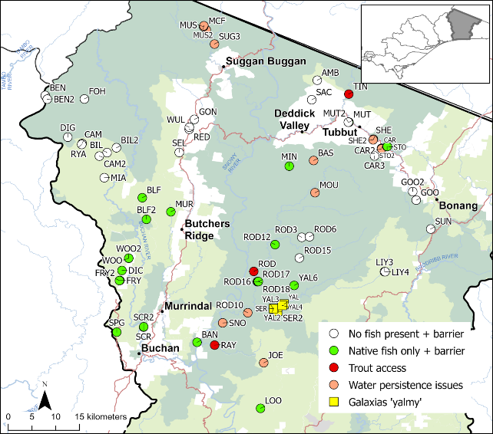
Figure 18. Candidate sites remaining in the Snowy River Basin (green circles, white circles and yellow squares) following removal of trout-inhabited and dry sites, highlighting 17 additional sites identified for exclusion based on trout access (no effective downstream trout barrier; red circles) or potential water permanency issues (orange circles).
See text box for legend.
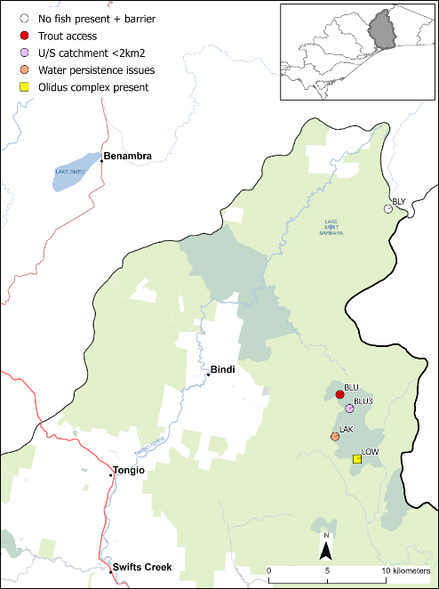
Figure 19. Candidate sites remaining in the Tambo River Basin (white circle, yellow square) following removal of trout-inhabited and dry sites, highlighting three additional sites identified for exclusion based on trout access (no effective downstream trout barrier; red circle), very small upstream (U/S) catchment area (<2 km²; mauve circle), or potential water permanency issues (orange circle).
See text box for legend.
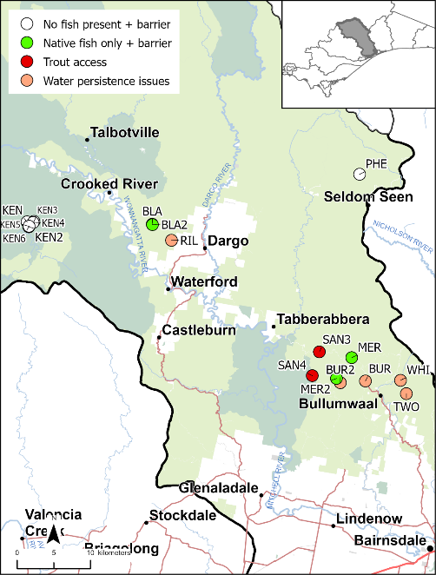
Figure 20. Candidate sites remaining in the Mitchell River Basin (green circles and white circles) following removal of trout-inhabited and dry sites, highlighting seven additional sites identified for exclusion based on trout access (no effective downstream trout barrier; red circles) or potential water permanency issues (orange circles).
See text box for legend.
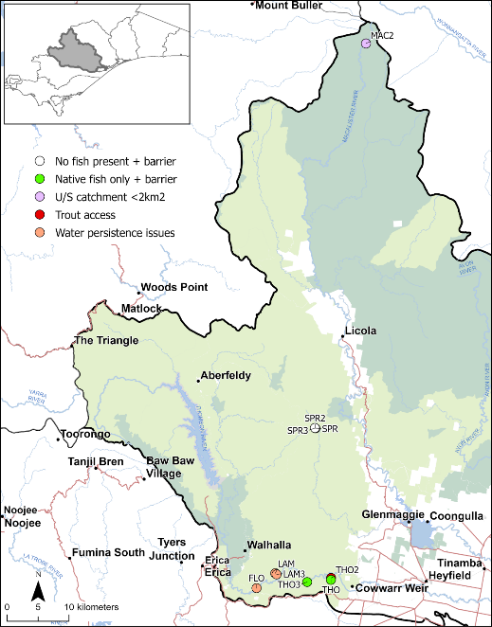
Figure 21. Candidate sites remaining in the Thomson River Basin (green circles and white circles) following removal of trout-inhabited and dry sites, highlighting five additional sites identified for exclusion based on trout access (no effective downstream trout barrier; red circle, very small upstream (U/S) catchment area (<2 km²; mauve circle), or potential water permanency issues (orange circles).
See text box for legend.
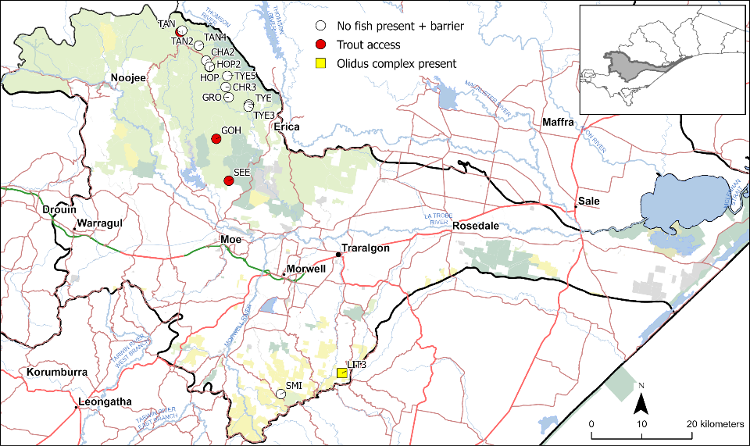
Figure 22. Candidate sites remaining in the Latrobe River Basin (white circles, yellow square) following removal of trout-inhabited and dry sites, highlighting three additional sites identified for exclusion based on trout access (no effective downstream trout barrier; red circles).
See text box for legend.
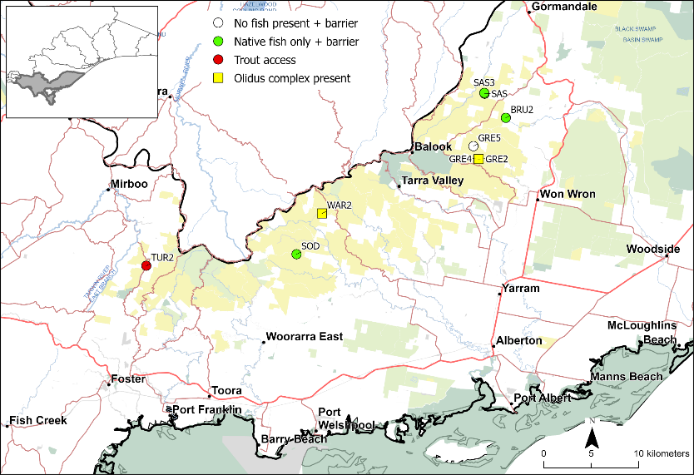
Figure 23. Candidate sites remaining in the South Gippsland Basin (green circles, white circles, yellow squares) following removal of trout-inhabited and dry sites, highlighting one additional site identified for exclusion based on trout access (no effective downstream trout barrier; red circle).
See text box for legend.
Barrier surveys confirmed the presence of effective downstream trout barriers for 27 of these reaches (Table 1).
For a further 26 reaches, LiDAR-derived DEM analysis identified likely downstream waterfalls, and the field survey results strongly suggest these features function as barriers to upstream trout movement. However, these barriers have not yet been field verified and require confirmation before the reaches can be considered suitable for translocation.
The remaining eight reaches were identified as candidate translocation sites for Yalmy Galaxias under the species-specific assessment framework described in Section 2.2. These reaches lack a confirmed downstream barrier but were retained because trout were not detected during field assessment and the habitat conditions were considered suitable. These reaches are listed in Table 4–Table 5 and shown in Figure 24–Figure 29.
Overall, the identified reaches span a broad range of stream sizes and environmental conditions while satisfying the principal ecological requirements for threatened galaxiid translocations. The key characteristics of each reach are presented in Table 4 and include:
- Upstream catchment area
- Galaxiid occurrence
- Presence of surface flow
- Reach-scale parameters (average width, average and maximum water depths).
Water permanency is not included, because all reaches remaining after filtering were assessed as having a high likelihood of maintaining permanent water.
The coordinates and confirmation status of the downstream-most barrier associated with each candidate reach are provided in Table 5. The water quality measurements recorded from these reaches are presented in Table 6 and indicate that all sites fall within ranges considered suitable for the persistence of small upland freshwater fishes.
Table 4. Selection criteria for the 61 candidate reaches (93 site–reach codes) identified in this project.
Reach characteristics: Ave. = average; Catch. = catchment; Galbre = Galaxias brevipinnis; GoliC = Galaxias olidus species complex; Flow categories: vlow (very low), low, mod (moderate), high; * = potential catchment area—DEM analysis indicates a downstream barrier, but the barrier has not yet been field confirmed; DEM = digital elevation model; max. = maximum; ^{YG} = reach intended for Yalmy Galaxias translocation, barrier presence optional if trout are absent from area.
River basin | Water body reach | Reach code(s) | Catch. area (km²) | Galaxiids | Flow | Ave. width (m) | Depth ave./max. (m)
Snowy | Amboyne Creek | AMB | 24.0* |  | low | 0.7 | 0.1/0.4
 | Basin Creek | BAN | 36.5 | Galbre | mod | 1.4 | 0.3/1.2
 | Bentley Creek | BEN & BEN2 | 37.0* |  | vlow | 0.4–4.0 | 0.05–0.3/  0.1–1.5
 | Blackfellows Creek | BLF & BLF2 | 29.0* | Galbre | mod | 3.0 | 0.15/0.4
 | Carter Creek | CAR3 | 7.0* |  | mod | 2.0 | 0.1/0.4
 | Frying Pan Creek | DIC, FRY & FRY2 | 25.0* | Galbre | vlow–low | 2.5–4.0 | 0.1–0.4/  0.4–1.5
 | Good Hope Creek | GOO & GOO2 | 9.0* |  | mod | 1.5–1.9 | 0.1–0.2/0.4
 | Goodwin Creek | GON, RED & WUL | 70.0* |  | vlow | 1.6–2.3 | 0.05–0.9/  0.2–1.4
 | Little Yalmy River^{YG} | LIY3 & LIY4 | 5.7 |  | low | 1.5–2.2 | 0.1/0.3
 | Loongelaat Creek | LOO | 13.0* | Galbre | vlow | 0.9 | 0.4/1.3
 | Mia Mia Creek | MIA | 11.3* |  | mod | 1.6 | 0.15/0.6
 | Minchin Creek | MIN | 18.9* | Galbre | mod | 1.3 | 0.1/0.3
 | Moss Bed Creek | BIL, BIL2, CAM, CAM2 & RYA | 47.0* |  | mod | 0.9–3.5 | 0.05–0.15/  0.1–0.35
 | Murrindal River | MUR | 26.0* | Galbre | mod | 2.0 | 0.1/0.4
 | Mutch Creek | MUT & MUT2 | 11.0 |  | mod | 1.9 | 0.1/0.4–1.50
 | Reedy Creek | DIG & FOH | 77.0* |  | mod | 0.7–1.1 | 0.15–0.35/  0.3–1.2
 | Rodger River tributary | ROD3 & ROD6 | 5.6 |  | low–mod | 0.9–1.4 | 0.1/0.2–0.3
 | Rodger River tributary | ROD12 | 4.0 | Galbre | low | 1.1 | 0.1/0.4
 | Rodger River tributary | ROD15 | 5.2 |  | mod | 1.5 | 0.1/0.4
 | Rodger River tributary | ROD16, ROD17 & ROD18 | 24.4 | Galbre | low | 4.5–6.0 | 0.15–0.2/  0.4–0.7
 | Sandy Creek | SAC | 14.3 |  | vlow | 1.0 | 0.1/0.6
 | Scrubby Creek | SCR & SCR2 | 9.8 | Galbre | mod | 1.9 | 0.1–0.15/  0.5–0.6
 | Seldom Seen Creek | SEL | 45.0* |  | mod | 1.3 | 0.15/1.0
 | Serpentine Creek^{YG} | SER | 50.0 |  | mod | 5.0 | 0.1/0.2
 | Serpentine Creek^{YG} | SER2 | 49.0 |  | mod | 4.5 | 0.1/0.2
 | Spring Creek | SPG | 15.0* | Galbre | mod | 2.5 | 0.1/0.4
 | Stony Creek | STO | 8.3 |  | low | 1.1 | 0.1/0.8
 | Sun Creek | SUN | 7.1 |  | high | 2.0 | 0.1/0.3
 | Woolshed Creek | WOO & WOO2 | 20.9 | Galbre | low | 2.3 | 0.25/0.5–0.6
 | Yalmy River^{YG} | YAL | 160.0 |  | high | 4.0 | 0.45/1.0
 | Yalmy River^{YG} | YAL2 | 162.0 |  | high | 8.0 | 0.1/0.8
 | Yalmy River^{YG} | YAL3 | 162.0 |  | high | 8.0 | 0.15/0.7
 | Yalmy River^{YG} | YAL4 | 161.0 |  | mod | 7.0 | 0.15/0.4
 | Yalmy River^{YG} | YAL6 | 5.9 | Galbre | mod | 1.8 | 0.1/0.3
Tambo | Bluey Creek | BLY | 24.0* |  | vlow | 0.4 | 0.05/0.3
 | Low Plain Creek | LOW | 5.0* | GoliC | mod | 1.1 | 0.2/0.8
Mitchell | Black Snake Creek | BLA & BLA2 | 6.4* | Galbre | low | 1.0 | 0.05–1.0/  0.15–0.6
 | Kent Creek | KEN, KEN2, KEN3, KEN4, KEN5, KEN6 | 10.7* |  | mod | 1.7–3.2 | 0.1/0.3–0.5
 | Merrijig Creek | MER & MER2 | 37.8 | Galbre | mod | 2.0–3.0 | 0.05–0.3/  0.15–1.1
 | Pheasant Creek | PHE | 6.7* |  | mod | 0.8 | 0.05–0.15
 | Sandy Creek^{YG} | SAN3 | 75.2 | Galbre | mod | 3.0 | 0.15/0.5
 | Sandy Creek^{YG} | SAN4 | 152.0 | Galbre | mod | 6.0 | 0.3/1.1
Thomson | Springs Creek | SPR, SPR2 & SPR3 | 6.0 |  | mod | 3.5–4.5 | 0.2/1.0–1.8
 | Thomson River tributary | THO | 5.0 | Galbre | high | 5.0 | 0.2/2.0
 | Thomson River tributary | THO3 | 7.0 | Galbre | mod | 6.0 | 0.25/1.7
Latrobe | Charity Creek | CHA2 | 3.6 |  | mod | 3.5 | 0.25/0.8
 | Christmas Creek | CHR3 | 10.1 |  | high | 4.0 | 0.3/1.2
 | Growler Creek | GRO | 6.5 |  | mod | 3.5 | 0.15/0.4
 | Hope Creek | HOP & HOP2 | 6.5 |  | mod | 4.0–5.0 | 0.2–0.25/  0.6–1.5
 | Little Traralgon Creek | LIT3 | 5.2 | GoliC | mod | 2.5 | 0.2/0.4
 | Smiths Creek | SMI | 6.7* |  | low | 0.8 | 0.1/0.2
 | Tanjil River East Branch | TAN4 | 9.2 |  | high | 5.5 | 0.3/0.5
 | Tanjil River West Branch | TAN2 | 23.1 |  | high | 7.0 | 0.4/1.1
 | Tyers River | TYE & TYE3 | 9.8 |  | mod | 1.5–6.0 | 0.3–1.5/  0.9–3.0
 | Tyers River West Branch | TYE5 | 20.5* |  | high | 17.0 | 0.5/1.2
South Gippsland | Bruthen Creek | BRU2 | 2.94 | Galbre | mod | 2.0 | 0.2/0.7
 | Soda Creek | SOD | 9.7* |  | low | 2.0 | 0.3/1.5
 | Sassafras Creek | SAS & SAS3 | 4.3 | Galbre | mod | 3.0–3.5 | 0.3/1.2–1.5
 | Greig Creek | GRE2 & GRE4 | 4.25 | GoliC | mod | 2.0 | 0.2/0.5–1.0
 | Greig Creek tributary | GRE5 | 4.2* |  | mod | 1.2 | 0.05/0.2
 | Wards Creek | WAR2 | 1.3 | GoliC | high | 3.0 | 0.2/0.75

Table 5. Coordinates of the downstream-most barrier for each of the 61 candidate reaches identified in this project, including barrier confirmation status (confirmed or requiring verification) (see Figure 24–Figure 28).
^{YG} = Reach intended for Yalmy Galaxias translocation; barrier presence optional if trout are absent from area.
River basin | Water body reach | Latitude (most-downstream barrier) | Longitude (most-downstream barrier) | Barrier presence confirmed?
Snowy River | Amboyne Creek | -37.011916 | 148.546974 | No
 | Basin Creek | -37.473344 | 148.276390 | Yes
 | Bentley Creek | -36.979029 or -36.997891 | 148.102377 or 148.048905 | No
 | Blackfellows Creek | -37.244467 | 148.180635 | Upstream Yes, Downstream No
 | Carter Creek | -37.107209 | 148.625341 | No
 | Frying Pan Creek | -37.393793 | 148.149534 | No
 | Good Hope Creek | -37.185976 | 148.683022 | Upstream Yes, Downstream No
 | Goodwin Creek | -37.083223 | 148.311746 | No
 | Little Yalmy River | -37.339806 | 148.630948 | Yes
 | Loongelaat Creek | -37.596079 | 148.362631 | Yes
 | Mia Mia Creek | -37.173331 | 148.117608 | No
 | Minchin Creek | -37.120868 | 148.449189 | No
 | Moss Bed Creek | -37.125412 | 148.130148 | No
 | Murrindal River | -37.262118 | 148.226555 | Upstream Yes, Downstream No
 | Mutch Creek | -37.056799 | 148.563572 | No
 | Reedy Creek | -37.039268 | 148.094474 | Yes
 | Rodger River tributary | -37.288480 | 148.423890 | Yes
 | Rodger River tributary | -37.313920 | 148.469960 | Yes
 | Rodger River tributary | -37.358609 | 148.390339 | Yes
 | Rodger River tributary | -37.274682 | 148.474459 | Yes
 | Sandy Creek | -37.048429 | 148.491644 | Upstream Yes, Downstream No
 | Scrubby Creek | -37.444557 | 148.175204 | Yes
 | Seldom Seen Creek | -37.146567 or -37.141724 | 148.325079 or 148.306642 | No
 | Serpentine Creek^{YG} | -37.410030 | 148.421250 | No barrier required^{YG}
 | Serpentine Creek^{YG} | -37.414610 | 148.428450 | No barrier required^{YG}
 | Spring Creek | -37.499821 | 148.151149 | No
 | Stony Creek | -37.102683 | 148.636289 | Yes
 | Sun Creek | -37.258774 | 148.718219 | Yes
 | Woolshed Creek | -37.314508 | 148.146906 | Yes
 | Yalmy River^{YG} | -37.400990 | 148.440830 | No barrier required^{YG}
 | Yalmy River^{YG} | -37.409220 | 148.421190 | No barrier required^{YG}
 | Yalmy River^{YG} | -37.409670 | 148.420790 | No barrier required^{YG}
 | Yalmy River^{YG} | -37.403518 | 148.437300 | No barrier required^{YG}
 | Yalmy River^{YG} | -37.365680 | 148.459930 | Yes
Tambo River | Bluey Creek | -37.018968 | 147.931995 | No
 | Low Plain Creek | -37.187123 | 147.972836 | No
Mitchell River | Black Snake Creek | -37.434539 | 147.163089 | No
 | Kent Creek | -37.448528 | 146.974078 | No
 | Merrijig Creek | -37.626683 | 147.452458 | No
 | Pheasant Creek | -37.384150 | 147.465230 | No
 | Sandy Creek^{YG} | -37.587323 | 147.433048 | No barrier required^{YG}
 | Sandy Creek^{YG} | -37.616900 | 147.423012 | No barrier required^{YG}
Thomson River | Springs Creek | -37.762547 | 146.580337 | No
 | Thomson River tributary | -37.982207 | 146.610146 | Yes
 | Thomson River tributary | -37.985909 | 146.566592 | Yes
Latrobe River | Charity Creek | -37.852625 | 146.227400 | Yes
 | Christmas Creek | -37.899674 | 146.272394 | Yes
 | Growler Creek | -37.917930 | 146.279380 | Yes
 | Hope Creek | -37.864200 | 146.235225 | Yes
 | Little Traralgon Creek | -38.409730 | 146.546146 | Yes
 | Smiths Creek | -38.429055 | 146.388254 | No
 | Tanjil River East Branch | -37.799357 | 146.172133 | Yes
 | Tanjil River West Branch | -37.826012 | 146.210369 | Yes
 | Tyers River | -37.934372 | 146.324327 | Yes
 | Tyers River West Branch | -37.881758 | 146.268995 | No
South Gippsland | Bruthen Creek | -38.395587 | 146.677920 | Yes
 | Soda Creek | -38.435098 | 146.646072 | Yes
 | Sassafras Creek | -38.425485 | 146.639180 | No
 | Greig Creek | -38.372262 | 146.651456 | Yes
 | Greig Creek tributary | -38.540798 | 146.433585 | No
 | Wards Creek | -38.489132 | 146.458298 | Yes

Table 6. Water quality parameters for the 61 candidate stream reaches identified in this project.
DO = dissolved oxygen; EC = electrical conductivity; Hard = hardness; NTU = Nephelometric Turbidity Units; temp. = temperature; Turb. = turbidity.
Water body / stream reach | Reach code(s) | Water temp.  (ºC) | EC  (µS/cm) | DO  (mg/L) | pH | Hard  (ppm CaC0₃) | Turb.  (NTU)
Amboyne Creek | AMB | 9.9 | 143 |  | 6.0 | 32 | <5
Basin Creek | BAN | 8.0 | 355 |  | 7.7 |  | <5
Bentley Creek | BEN & BEN2 | 9.8 | 102 | 7.7 | 6.6 | 12 | <5
Black Snake Creek | BLA & BLA2 | 13.9 | 191 | 9.4 | 7.4 | 32 | <5
Blackfellows Creek | BLF & BLF2 | 8.6–9.6 | 143–187 | 11.3 | 6.0–6.8 | 30 | <5
Bluey Creek | BLY |  |  |  |  |  | <5
Bruthen Creek | BRU2 | 12.8 | 165 | 10.4 | 7.0 |  | <5
Carter Creek | CAR3 | 7.3 | 56 |  | 6.9 | 16 | <5
Charity Creek | CHA2 | 6.7 | 40 | 10.6 | 6.0 | 8 | <5
Christmas Creek | CHR3 | 7.8 | 24 | 10.7 | 6.3 | 15 | <5
Frying Pan Creek | DIC, FRY & FRY2 | 10.4 | 190 |  | 7.0 |  | <5
Good Hope Creek | GOO & GOO2 | 6.9 | 72 |  | 6.6 | 16 | <5
Goodwin Creek | GON, RED & WUL | 7.4–9.5 | 172–416 | 8.9–10.8 | 6.3–7.0 | 24–28 | 0–30
Greig Creek | GRE2 & GRE4 | 17.5 | 150 |  | 7.0 |  | <5
Greig Creek tributary | GRE5 | 16.2 | 154 | 8.3 | 7.1 |  | <5
Growler Creek | GRO | 8.4 | 58 | 7.8 | 6.6 | 24 | <5
Hope Creek | HOP & HOP2 | 7.5 | 28 | 10.6 | 6.2 | 8 | <5
Kent Creek | KEN, KEN2, KEN3, KEN4, KEN5 & KEN6 | 11.0–11.4 | 84–104 | 9.8 | 6.3–7.0 | 8–12 | <5
Little Traralgon Creek | LIT3 | 11.7 | 170 | 10.5 | 7.2 |  | <5
Little Yalmy River | LIY3 & LIY4 | 8.6 | 85 |  | 7.0 | 16 | <5
Loongelaat Creek | LOO |  |  |  |  |  | 10
Low Plain Creek | LOW | 15.9 | 146 | 8.2 | 7.0 | 20 | <5
Merrijig Creek | MER & MER2 | 14.1–14.6 | 198–208 | 9.7 | 7.1 | 6–16 | <5
Mia Mia Creek | MIA | 9.1 | 120 | 8.7 | 6.6 | 16 | <5
Minchin Creek | MIN | 9.3 | 72 | 11.5 | 7.0 |  | <5
Moss Bed Creek | BIL, BIL2, CAM, CAM2 & RYA | 9.8–10.7 | 50–72 | 8.0–10.0 | 6.0–6.6 | 8–12 | <5
Murrindal River | MUR | 10.2 | 110 | 9.6 | 6.8 | 18 | <5
Mutch Creek | MUT & MUT2 | 6.3 | 978 |  | 7.6 | 484 | <5
Pheasant Creek | PHE | 10.4 | 110 | 9.4 | 7.0 |  | <5
Reedy Creek | DIG & FOH | 9.8–11.5 | 138–208 | 8.5 | 6.3–7.0 | 6–12 | <5
Rodger River tributary | ROD3 & ROD6 | 12.7 | 60 |  | 7.0 | 16 | <5
Rodger River tributary | ROD12 | 12.0 | 92 |  | 7.0 | 28 | <5
Rodger River tributary | ROD15 | 7.9 | 55 |  | 7.0 | 16 | <5
Rodger River tributary | ROD16, ROD17 & ROD18 |  |  |  |  |  | <5
Sandy Creek | SAC | 4.4 | 290 |  | 7.0 | 84 | <5
Sandy Creek | SAN3 | 14.4 | 190 | 8.6 | 7.1 | 20 | <5
Sandy Creek | SAN4 | 13.8 | 191 | 8.4 | 6.9 | 16 | <5
Sassafras Creek | SAS & SAS3 | 14.3 | 187 | 9.3 | 7.3 |  | <5
Scrubby Creek | SCR & SCR2 | 14.9 | 455 |  | 7.8 |  | <5
Seldom Seen Creek | SEL | 7.4 | 59 | 10.3 | 6.6 | 8 | <5
Serpentine Creek | SER | 20.5 | 167 | 7.4 | 6.0 | 44 | <5
Serpentine Creek | SER2 | 20.5 | 167 | 7.4 | 6.0 | 44 | <5
Smiths Creek | SMI |  |  |  |  |  | 20
Soda Creek | SOD | 19.6 | 177 | 9.6 | 7.0 |  | <5
Spring Creek | SPG | 4.9 | 145 |  | 7.0 | 36 | <5
Springs Creek | SPR, SPR2 & SPR3 | 9.6 | 53 | 10.1 | 7.0 |  | <5
Stony Creek | STO | 4.8 | 1210 |  | 7.6 |  | <5
Sun Creek | SUN | 8.0 | 130 |  | 7.0 |  | 10
Tanjil River East Branch | TAN4 | 5.6 | 24 | 11.0 | 6.0 | 6 | <5
Tanjil River West Branch | TAN2 | 7.0 | 32 | 11.2 | 6.2 | 18 | <5
Thomson River tributary | THO | 14.1 | 135 | 8.8 | 6.3 |  | <5
Thomson River tributary | THO3 | 14.7 | 144 | 8.6 | 6.4 |  | <5
Tyers River | TYE & TYE3 | 6.4–8.8 | 38–43 | 9.7 | 6.2 | 8 | 5–10
Tyers River West Branch | TYE5 | 9.6 | 53 | 10.1 | 7.0 |  | <5
Wards Creek | WAR2 | 4.8 | 1210 |  | 7.6 |  | <5
Woolshed Creek | WOO & WOO2 | 8.0 | 130 |  | 7.0 |  | 10
Yalmy River | YAL | 20.1 | 72 | 7.8 | 6.0 | 20 | <5
Yalmy River | YAL2 | 20.1 | 72 | 7.8 | 6.0 | 20 | <5
Yalmy River | YAL3 | 20.1 | 72 | 7.8 | 6.0 | 20 | <5
Yalmy River | YAL4 | 20.1 | 72 | 7.8 | 6.0 | 20 | <5
Yalmy River | YAL6 | 10.8 | 75 |  | 7.0 | 20 | <5

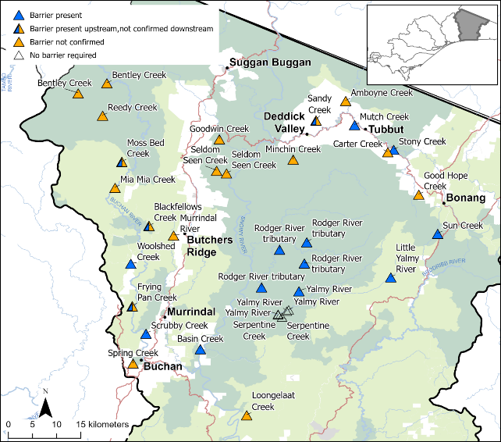
Figure 24. Final 34 candidate reaches, including barrier confirmation status (confirmed or requiring verification), remaining in the Snowy River Basin following additional exclusion filtering.
See text box for explanation of coloured and open triangles.
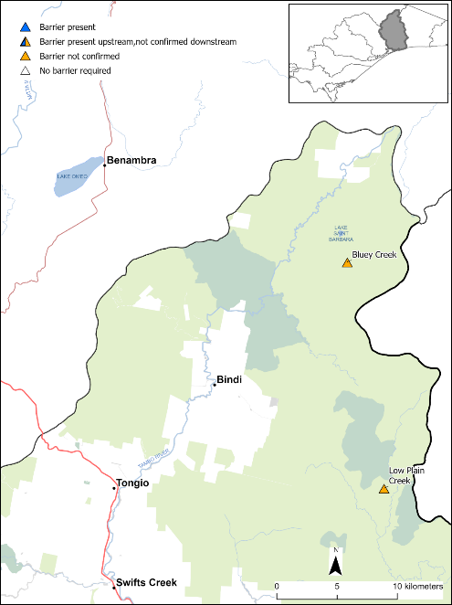
Figure 25. Final two candidate reaches, including barrier confirmation status (confirmed or requiring verification), remaining in the Tambo River Basin following additional exclusion filtering.
See text box for explanation of coloured triangles.
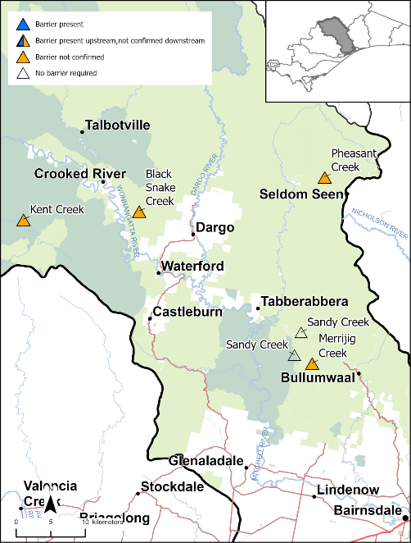
Figure 26. Final six candidate reaches, including barrier confirmation status (confirmed or requiring verification), remaining in the Mitchell River Basin following additional exclusion filtering.
See text box for explanation of coloured and open triangles.
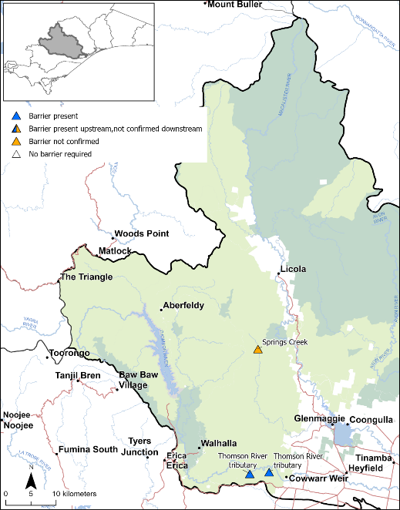
Figure 27. Final three candidate reaches, including barrier confirmation status (confirmed or requiring verification), remaining in the Thomson River Basin following additional exclusion filtering.
See text box for explanation of coloured triangles.

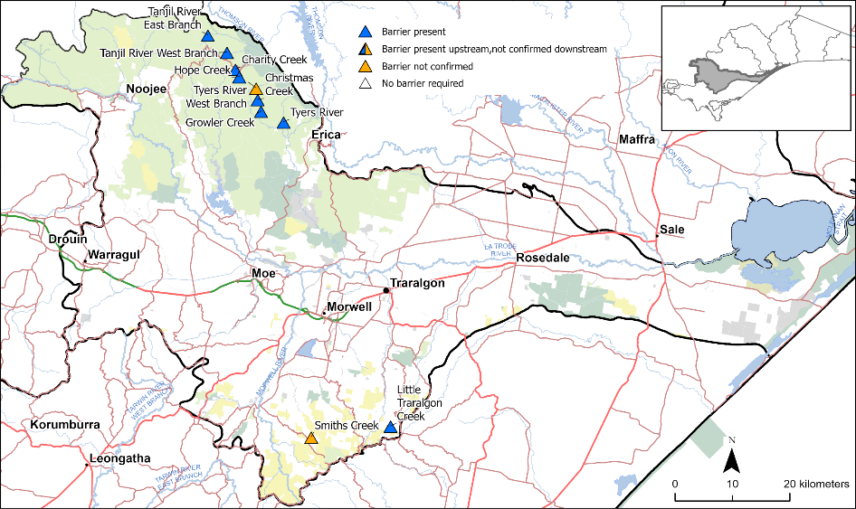
Figure 28. Final 10 candidate reaches, including barrier confirmation status (confirmed or requiring verification), remaining in the Latrobe River Basin following additional exclusion filtering.
See text box for explanation of coloured triangles.
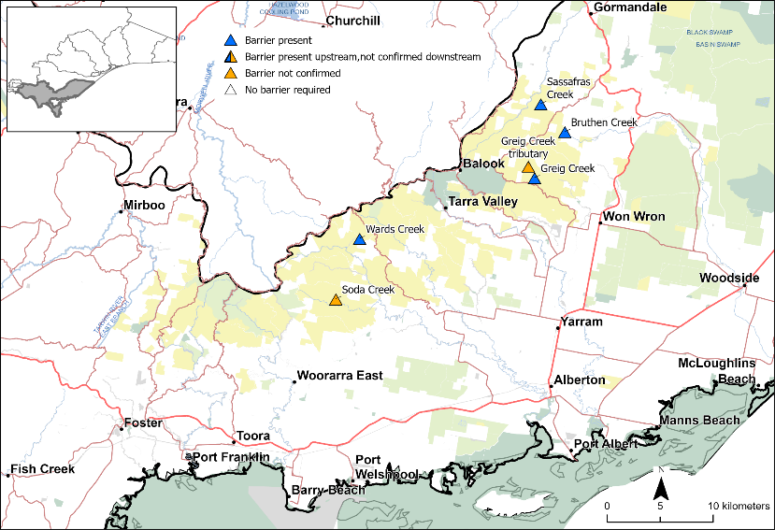
Figure 29. Final six candidate reaches, including barrier confirmation status (confirmed or requiring verification), remaining in the South Gippsland River Basin following additional exclusion filtering.
See text box for explanation of coloured triangles.
- Discussion
This project achieved its primary objective of identifying potential future translocation habitat for five nationally threatened galaxiid species across eastern Victoria. Through a combination of desktop analysis, LiDAR-derived DEM analyses, and targeted field surveys, 61 stream reaches (represented by 93 survey sites) were identified as potentially suitable for future conservation translocations.
Considering the widespread distribution of introduced trout throughout the project area, the identification of the 61 trout-free candidate reaches is a significant outcome. Nearly one-quarter of all surveyed sites contained trout, while a similar portion were dry or reduced to nearly isolated pools with trickling flow during the project period. Consequently, only a small proportion of the surveyed stream network satisfied the minimum ecological requirements for long-term galaxiid persistence. This outcome reinforces the critical role that in-stream barriers, particularly natural waterfalls, play in the long-term persistence of upland galaxiids by providing natural refuges from trout predation.
The candidate stream reaches were distributed across all six river basins, which provides opportunities to establish additional populations over a broad geographic area, particularly if the translocations are considered to be outside known, or suspected, species distributions. This broad spread in distribution is particularly valuable, as it reduces the risk that a single catastrophic event, such as trout invasion, fire, drought or flood, could affect all populations of a species.
Importantly, no new, previously unknown, populations of any of the five target threatened galaxiid species were discovered despite extensive survey in data-deficient areas across 253 sites. This finding reinforces previous evidence that each species remains restricted to a single extant wild population (Raadik 2014a; DCCEEW 2023a, 2023b, 2023c, 2023d, 2023e) and highlights the urgency of establishing additional populations to reduce extinction risk.
  - Conservation significance
The results reinforce the fundamental conservation problem facing the majority of upland galaxiids throughout south-eastern Australia—introduced trout occupy the majority of suitable stream habitat, restricting native galaxiids to isolated refuges upstream of effective in-stream barriers (McDowall 2003; McIntosh et al. 2010; Lintermans 2013a; Raadik 2014a; Jarvis et al. 2024).
The species-specific assessment framework for Yalmy Galaxias identified eight additional candidate reaches that would have been excluded under the barrier-based framework used for the other target species. These reaches demonstrate that, in some systems, absence of trout combined with downstream habitat thermally unsuitable for trout may provide an alternative mechanism for long-term galaxiid persistence where effective downstream barriers are lacking. Whether these reaches provide equivalent long-term security remains uncertain, as seasonal or future changes in trout distribution could increase invasion risk. Consequently, long-term monitoring and management of any upstream trout populations would be particularly important for these sites.
This suggests that Yalmy Galaxias can persist downstream of trout where stream temperatures remain sufficiently warm to limit trout occupancy. The field results support the hypothesis that, if trout are excluded from lower elevation reaches by thermal conditions, the requirement for a downstream barrier to prevent upstream trout colonisation may be less critical for the long-term persistence of Yalmy Galaxias than for other threatened upland galaxiids. This is relevant for the Little Yalmy River, Serpentine Creek and Yalmy River sites in the Snowy River Basin, and for the Sandy Creek sites in the Mitchell River Basin (Table 4; Figure 24–Figure 25). However, effective management of upstream trout populations will remain essential, and barriers may still provide an important safeguard against future changes in trout distribution associated with warmer climatic conditions, altered flow regimes, or other environmental changes.
Throughout the project area, trout and upland galaxiids, excluding Climbing Galaxias, exhibited mutually exclusive distributions. This pattern is consistent with previous studies demonstrating that trout predation and competition largely determine the distribution of non-diadromous galaxiids and confirms the understanding that effective trout exclusion remains the single most important requirement for successful conservation translocations (McDowall 2006; Woodford and McIntosh 2010; Raadik 2014b).
Natural waterfalls continue to provide the principal mechanism by which these species persist in the wild (Jolly et al. 2025). Accordingly, locating, confirming and maintaining effective downstream trout barriers remains critical to long-term recovery of the target species. The large number of candidate reaches identified during this project demonstrates that potentially suitable refuges still occur across Gippsland, although many require additional verification before they can be considered suitable for translocation.
The discovery of five previously unknown populations within the Mountain Galaxias species complex further demonstrates that intensive surveys of remote headwater streams continue to improve understanding of freshwater biodiversity in Victoria, and more broadly in south-eastern Australia. While these were not target species, they contribute valuable information on regional biodiversity patterns and warrant taxonomic investigation.
  - Performance of the reach selection framework
The staged approach used in this project proved to be an efficient and practical method for identifying candidate translocation reaches across a large geographic area.
The initial desktop assessment substantially reduced the number of stream sites requiring field investigation by combining existing fish records with topographic information and DEM-based identification of potential trout barriers. Recent advances in LiDAR-derived DEM analysis proved particularly valuable. Compared with interpretation of aerial imagery and topographic maps alone, DEM analysis provided a faster, more objective, reliable and repeatable method for identifying potential waterfalls, particularly in densely forested catchments, where waterfalls are frequently obscured by vegetation.
Subsequent field assessments provided an effective means of validating desktop predictions while simultaneously collecting ecological information necessary for prioritisation. This staged approach allowed resources to be concentrated on reaches with the highest likelihood of suitability while avoiding unnecessary field assessment of unsuitable streams.
The filtering component of the framework also demonstrated the importance of considering multiple ecological attributes rather than simply the absence of trout. Several apparently suitable trout-free reaches were excluded because of limited upstream catchment area or uncertainty regarding long-term water permanence. The upstream catchment area was given substantial weight in the ranking process, reflecting ecological principles: larger stream reaches are generally more likely to support larger, more resilient fish populations (Fausch et al. 2002; Jackson et al. 2001). Such populations are more likely to persist over the long term and to retain higher evolutionary potential (Hughes et al. 2008; Frankham et al. 2010; Lintermans 2013b; Pavlova et al. 2017; Huey et al. 2019). Collectively, these attributes are fundamental to establishing long-term, viable translocated populations, and they increase confidence that the selected reaches will provide sufficient habitat and environmental resilience to support persistence over time.
  - Limitations and uncertainty
Although the prioritisation framework provides a robust basis for identifying candidate translocation reaches, several sources of uncertainty remain.
First, each stream reach was generally represented by a single assessment site. This approach was necessary, given the scale of the project and the logistical constraints associated with surveying remote headwater catchments. Although upper stream reaches were typically short and relatively homogenous, local variation in habitat condition, water permanence, or fish distribution may not have been fully captured.
Second, several key assessment criteria were based on field-based qualitative evaluations rather than quantitative long-term datasets. For example, water permanence was inferred from indicators, including stream flow and volume, pool depth, aquatic vegetation, channel morphology, and fish presence, rather than from long-term hydrological modelling. To minimise the risk of overestimating habitat suitability, these assessments were deliberately conservative, and reaches were excluded where substantial uncertainty existed. Although these indicators are widely recognised as reliable proxies for perenniality, hydrological conditions may differ during exceptionally dry years, potentially reducing habitat suitability in some reaches.
Third, the effectiveness of many potential trout barriers remains unconfirmed. DEM analyses and field observations strongly indicate that these waterfalls prevent upstream trout movement, but confirmation by detailed barrier assessment is required before translocations can proceed.
The candidate reaches identified for Yalmy Galaxias have even greater uncertainty. Several of these reaches do not have a confirmed downstream trout barrier and were retained because trout were absent during field assessment and the downstream thermal conditions were considered likely to limit trout occupancy. Although this approach substantially increased the number of potential translocation reaches for this species, its effectiveness long term remains uncertain, because trout distribution may vary seasonally or shift in response to climatic or hydrological changes. Consequently, these reaches will require additional monitoring of trout occurrence and stream thermal regimes before translocations are undertaken.
Finally, ecological knowledge of several of the target species remains limited. In particular, the interactions between species of threatened galaxiids and Climbing Galaxias remain poorly understood. Because Climbing Galaxias attain a substantially larger body size and can be aggressive, uncertainty remains regarding the long-term viability of establishing threatened galaxiid populations in reaches already occupied by this species. Until these interactions are better understood, fishless reaches that satisfy all other ecological criteria may represent lower-risk translocation reaches.
Despite these limitations, the framework provides a scientifically defensible method for progressively refining many potential reaches into a manageable number suitable for detailed investigation.
  - Management implications and future work
The identification of candidate translocation reaches represents the completion of the first stage of a broader conservation translocation program rather than the final stage of reach selection.
Before translocations can occur, candidate reaches should undergo detailed prioritisation following the framework developed by Raadik and Lintermans (2022). This should include confirmation that trout remain absent, detailed assessments of downstream barrier effectiveness, refinement of upstream catchment area estimates, and evaluation of additional in-stream barriers that may further increase habitat security.
Further ecological surveys should quantify the abundance and distribution of Climbing Galaxias where present and confirm reach water permanence during different flow conditions. Surveys should also determine the presence of other galaxiid species, particularly undescribed or unconfirmed taxa within the Mountain Galaxias species complex, in large subcatchments identified as potential translocation areas. This is necessary to avoid introducing threatened galaxiids into catchments containing closely related taxa, where hybridisation, genetic swamping, or the displacement of small relict populations could occur.
The Reedy Creek system, a major tributary of the Buchan River in the Snowy River Basin, illustrates this issue. Two sites in this approximately 125-km² subcatchment, Forlorn Hope Creek (site FOH) and Diggers Plain Creek (site DIG), were identified as candidate reaches. However, these are the only two locations surveyed within the subcatchment, and both are situated near its upper boundary. A member of the Mountain Galaxias species complex was last recorded from the upper Buchan River catchment in 1974 but has not been detected since (Raadik 14a). Given its historical occurrence in the upper Buchan catchment, it is plausible that this taxon also occurred, or may still persist, within the Reedy Creek system. Consequently, comprehensive surveys are required to confirm its presence or absence before translocations of other galaxiid species into this catchment are considered.
Barrier confirmation should be regarded as a particularly high priority for the four barrier-dependent target species. Of the 61 candidate reaches identified, barriers have already been confirmed for 27 reaches. For most of the remaining reaches, DEM analyses indicate likely downstream waterfalls that require field verification. Confirming these barriers will substantially reduce uncertainty in the prioritisation process and increase confidence that translocated populations will be protected from future trout invasion.
Candidate reaches identified for Yalmy Galaxias will require additional assessment before translocations are undertaken. Because these reaches do not necessarily rely on downstream physical barriers to exclude trout, repeat surveys should confirm the continued absence of trout under different seasonal conditions. Monitoring of stream thermal regimes would also help determine whether downstream water temperatures are likely to provide a persistent ecological barrier to trout occupancy. These additional assessments would reduce uncertainty and improve confidence in the long-term suitability of these reaches for translocation.
Several trout-free reaches removed during the filtering process, primarily due to small upstream catchment size or potential water security issues, may still hold value for supportive conservation purposes. Some may prove useful as temporary grow-out reaches for hatchery-produced larvae or as short-term holding locations during future recovery activities. These supplementary management roles warrant further consideration.
Ultimately, the successful implementation of conservation translocations will depend not only on identifying suitable habitat but also on maintaining long-term trout exclusion, preserving habitat quality, and establishing genetically resilient populations of galaxiids through ongoing monitoring and adaptive management actions.

- Conclusions and recommendations
This project represents one of the most comprehensive landscape-scale assessments of potential translocation habitat undertaken for threatened upland galaxiids in south-eastern Australia. By combining existing biological information, LiDAR-derived stream channel analyses, and intensive field verification surveys, it identified 61 potential stream reaches across six Gippsland river basins in eastern Victoria. These include eight candidate reaches identified using a modified assessment framework for Yalmy Galaxias, reflecting the differing ecological processes influencing trout occupancy in that species. Overall, the 61 reaches provide the first strategically developed network of potential recipient reaches for establishing additional populations of five nationally Critically Endangered galaxiid species.
The project achieved its objective of identifying potentially suitable habitats for future translocation, addressing a major constraint in the recovery of these species. The combined use of LiDAR-based barrier mapping and field validation proved to be an efficient and transferable approach for locating trout-free habitats, with application to other trout-sensitive freshwater fishes.
Given the continued decline of these species and their restriction to single wild populations, establishing additional self-sustaining populations to reduce extinction risk remains one of the highest priorities for their recovery. The results provide the essential knowledge for this next phase of conservation management.
    - Recommendations
Before undertaking any conservation translocations, the 61 candidate reaches identified as potentially meeting the minimum habitat requirements for the nationally threatened galaxiids should be further assessed and prioritised. The following actions are recommended:
- Confirm trout barriers at candidate stream reaches by field verification.
- Undertake pre-translocation surveys across the broader catchment (not just the stream containing the proposed translocation reach) to identify any resident galaxiid taxa. This will reduce the risk of hybridisation, genetic swamping, or impacts on relict populations.
- Complete the species-specific prioritisation of the 61 candidate reaches based on habitat suitability, barrier integrity, presence of existing galaxiid populations, conservation value, and translocation feasibility.
- Undertake further detailed assessments of the highest-priority candidate reaches, where required.
- Re-survey priority reaches to verify the continued absence of trout and to detect any recent incursions.
- For candidate Yalmy Galaxias reaches lacking downstream barriers, undertake multiseason monitoring of trout occurrence and stream temperature before translocation.
- Implement staged conservation translocations using a combination of hatchery-bred and wild-sourced fish.
- References
Adams, M., Raadik, T.A., Burridge, C.P. and Georges, A. (2014). Global biodiversity assessment and hyper-cryptic species complexes: more than one species of elephant in the room? Systematic Biology 63 (4), 518–533. doi:10.1093/ sysbio/ syu017
Allan, H., Duncan, R.P., Unmack, P.J., White, D. and Lintermans, M. (2025). Developing geospatial tools to identify refuges from alien trout invasion in Australia to assist freshwater conservation. Marine and Freshwater Research 76, MF24221. doi:10.1071/MF24221
Burridge, C., McDowall, R., Craw, D., Wilson, M. and Waters, J. (2012). Marine dispersal as a pre-requisite for Gondwanan vicariance among elements of the galaxiid fish fauna. Journal of Biogeography 39, 306–321. doi:10.2307/ 41440554
Coleman, R.C., Hoffman, A.A. and Raadik, T.A. (2015). A review of Galaxiella pusilla (Mack) (Teleostei: Galaxiidae) in south-eastern Australia with a description of a new species. Zootaxa 4021 (2), 243–281. doi:10.11646/zootaxa.4021.2.2
DCCEEW. (2023a) Conservation advice for Galaxias gunaikurnai (Shaw Galaxias). Department of Climate Change, Energy, the Environment and Water, Canberra, ACT.
DCCEEW. (2023b) Conservation advice for Galaxias lanceolatus (Tapered Galaxias). Department of Climate Change, Energy, the Environment and Water, Canberra, ACT.
DCCEEW. (2023c) Conservation advice for Galaxias longifundus (West Gippsland Galaxias). Department of Climate Change, Energy, the Environment and Water, Canberra, ACT.
DCCEEW. (2023d) Conservation advice for Galaxias mcdowalli (McDowall’s Galaxias). Department of Climate Change, Energy, the Environment and Water, Canberra, ACT.
DCCEEW. (2023e) Conservation advice for Galaxias sp. nov. ‘Yalmy’ (Yalmy Galaxias). Department of Climate Change, Energy, the Environment and Water, Canberra, ACT.
DCCEEW. (2026). Species Profile and Threats Database—EPBC Act List of Threatened Fauna. Department of Climate Change, Energy, the Environment and Water, Canberra, ACT. https://www.environment.gov.au/cgi-bin/sprat/public/publicthreatenedlist.pl?wanted=fauna (accessed 9 July 2026).
Dunn, N.R., Closs, G.P., Crow, S.H., David, B.O., Goodman, J.M., Griffiths, M., Hicks, A.S., Hickford, M.J.H., Jack, D.C., Kitson, J.C., Ling, N., Waters, J.M., Wylie, M.J., Hitchmough, R.A. and Makan, T. (2023). Conservation Status of New Zealand Freshwater Fishes. New Zealand Threat Classification Series 46. Department of Conservation, Wellington, NZ.
Fausch, K.D., Torgersen, C.E., Baxter, C.V. and Li, H.W. (2002). Landscapes to riverscapes: bridging the gap between research and conservation of stream fishes. BioScience 52 (6), 483–498. doi:10.1641/0006-3568(2002)052[0483:LTRBTG]2.0.CO;2
Frankham, R., Ballou, J.D. and Briscoe, D.A. (2010). Introduction to Conservation Genetics. 2nd edn. Cambridge University Press, Cambridge, UK.
Fricke, R., Eschmeyer, W.N. and Van der Laan, R. (Eds). (2026). Eschmeyer’s Catalog of Fishes: Genera, Species, References. http://researcharchive.calacademy.org/research/ichthyology/catalog/fishcatmain.asp (accessed 9 July 2026).
Huey, J.A., Tonkin, Z., Lyon, J.P. and Lintermans, M. (2019). Small-bodied fish show a better response to environmental flows in regulated rivers than large-bodied fish. Journal of Applied Ecology 56 (7), 1724–1734. doi:10.1111/1365-2664.13337
Hughes, J.M., Schmidt, D.J. and Finn, D.S. (2008). Genes in streams: using DNA to understand the movement of freshwater fauna and their riverine habitat. BioScience 58 (6), 499–509. doi:10.1525/bio.2009.59.7
IUCN. (2026). The IUCN Red List of Threatened Species. Version 2025-2. International Union for the Conservation of Nature. https://www.iucnredlist.org (accessed 7 July 2026).
Jackson, D.A., Peres-Neto, P.R. and Olden, J.D. (2001). What controls who is where in freshwater fish communities—the roles of biotic, abiotic, and spatial factors. Canadian Journal of Fisheries and Aquatic Sciences 58 (1), 157–170. doi:10.1139/f00-239
Jarvis, M., Closs, G., Dedual, M., Dorsey, L., Fulton, W., Gabrielsson, R., Lintermans, M. and Trotter, M. (2024). The Introduced Trout and Char of Australia and New Zealand. In: Kershner, J.L., Williams, J.E., Gresswell, R.E. and Lobon-Cervia, J. (Eds) Trout and Char of the World, pp. 573–604. American Fisheries Society, Bethesda. doi:10.47886/9781934874547.ch17
Jense, C., Adams, M., Raadik, T.A., Waters, J.M., Morgan, D.L., Barmuta, L.A., Hardie, S.A., Deagle, B.E. and Burridge, C.P. (2024). Cryptic diversity within two widespread diadromous freshwater fishes (Teleostei: Galaxiidae). Ecology and Evolution, 14 (5), e11201. doi:10.1002/ece3.11201
Jolly, M.E., Warburton, H.J., Bowie, S. and McIntosh, A.R. (2025). Managing isolation: implementing in-stream barriers to exclude introduced trout from fragmented native freshwater fish refuges. River Research and Applications 41 (6), 1347–1361. doi:10.1002/rra.4447
Lintermans, M. (2013a). A review of on-ground recovery actions for threatened freshwater fish in Australia. Marine and Freshwater Research 64, 775–791. doi:10.1071/MF12306
Lintermans, M. (2013b). The rise and fall of a translocated population of the endangered Macquarie perch, Macquaria australasica, in south-eastern Australia. Marine and Freshwater Research 64, 838–850. doi:10.1071/MF12270
Lintermans, M. and Allan, H. (2019). Galaxias tantangara. The IUCN Red List of Threatened Species 2019: e.T122903246A123382161. doi:10.2305/IUCN.UK.2019-3.RLTS.T122903246A123382161.en
Lintermans, M., Geyle, H.M, Beatty, S., Brown, C., Ebner, B., Freeman, R., Hammer, M.P., Humphreys, W.F., Kennard, M.J., Kern, P., Martin, K., Morgan, D., Raadik, T.A., Unmack, P.J., Wager, R., Woinarski, J.C.Z. and Garnett, S.T. (2020). Big trouble for little fish: identifying Australian freshwater fishes in imminent risk of extinction. Pacific Conservation Biology 26 (4), 365–377. doi:10.1071/PC19053
McDowall, R.M. (2003). Impacts of introduced salmonids on native galaxiids in New Zealand upland streams: a new look at an old problem. Transactions of the American Fisheries Society 132, 229–238. doi:10.1577/1548-8659(2003)132<0229:IOISON>2.0.CO;2
McDowall, R.M. (2006). Crying wolf, crying foul, or crying shame: alien salmonids and a biodiversity crisis in the southern cool-temperate galaxioid fishes? Reviews in Fish Biology and Fisheries 16 (3–4), 233–422. doi:10.3897/rio.16.233.242
McIntosh, A.R., McHugh, P.A., Dunn, N.R., Goodman, J.M., Howard, S.W., Jellyman, P.G., O’Brien, L.K., Nystrom, P.A. and Woodford, D.J. (2010). The impact of trout on galaxiid fishes in New Zealand. New Zealand Journal of Ecology 34 (1),195–206.
Pavlova, A., Beheregaray, L.B., Coleman, R., Gilligan, B., Harrison, K.A., Ingram, B.A., Kearns, J., Lamb, A.M., Lintermans, M., Lyon, J., Nguyen, T.T.T., Sasaki, M., Tonkin, Z., Yen, J.D.L. and Sunnucks, P. (2017). Severe consequences of habitat fragmentation on genetic diversity of an endangered Australian freshwater fish: a call for assisted gene flow. Evolutionary Applications 10 (6), 531–550. doi:10.1111/eva.12484
Raadik, T.A. (2012). Fact File: Conserving the threatened Shaw Galaxias. Critical Conservation Actions in the Alpine National Park. Arthur Rylah Institute for Environmental Research, and Parks Victoria, Heidelberg, Victoria.
Raadik, T.A. (2014a). Fifteen from one: a revision of the Galaxias olidus Günther, 1866 complex (Teleostei, Galaxiidae) in south-eastern Australia recognises three previously described taxa and describes 12 new species. Zootaxa 3898, 1–198. doi:10.11646/zootaxa.3898.1.1
Raadik, T.A. (2014b). Twenty years of conservation management of threatened upland galaxiids: blood, sweat, tears … and a little joy. Abstracts, Australian Society for Fish Biology and Australian Society for Limnology Joint Annual Conference, 30 June–3 July 2014, Darwin, Australia.
Raadik, T.A. (2016). Galaxias species complex in eastern Victoria (east of the Hume Highway) – information and advice to the Forest Industry Taskforce. Unpublished Client Report, Arthur Rylah Institute for Environmental Research, Department of Environment, Land, Water and Planning, Heidelberg, Victoria.
Raadik, T.A. (2018). Tamborith–Dingo Hill Track Fire natural values protection: aquatic values in Shaw’s Creek catchment. Report to Parks Victoria. Arthur Rylah Institute for Environmental Research, Department of Environment, Land, Water and Planning, Heidelberg, Victoria.
Raadik, T.A. (2019a). Recovery actions for seven endemic and threatened Victorian galaxiid species. Biodiversity On-ground Actions Regional Partnerships and Targeted Actions Project 2017–18. Published Fact Sheet. Arthur Rylah Institute for Environmental Research, Department of Environment, Land, Water and Planning, Heidelberg, Victoria.
Raadik, T.A. (2019b). Conservation of endemic and threatened Victorian galaxiid species. Biodiversity Response Planning Projects 118, 119, 120 & 121 2018–2020. Published Fact Sheet. Arthur Rylah Institute for Environmental Research, Department of Environment, Land, Water and Planning, Heidelberg, Victoria.
Raadik, T.A. (2025). Progressing the conservation of our threatened Galaxiids. Aquatic Quarterly Update – Influence, May 2025, pp. 1–3. Arthur Rylah Institute for Environmental Research, Department of Energy, Environment and Climate Action, Heidelberg, Victoria.
Raadik, T.A., Allan, H. and Pearce, L. (2025). Stocky Galaxias (Galaxias tantangara) catchment survey 2025: search for relictual populations and potential translocation sites, preliminary report. Report for the New South Wales Department of Primary Industries and Regional Development (DPIRD), Fisheries and Forestry. Arthur Rylah Institute for Environmental Research, Department of Energy, Environment and Climate Action, Heidelberg, Victoria.
Raadik, T.A., Fairbrother, P.S. and Smith, S.J. (2010). National Recovery Plan for the Barred Galaxias Galaxias fuscus. Department of Sustainability and Environment, Melbourne, Victoria.
Raadik, T.A. and Lintermans, M. (2022). Stocky Galaxias – catchment survey, Snowy 2.0. Published client report for Snowy Hydro Ltd, Cooma. Arthur Rylah Institute for Environmental Research, Department of Environment, Land, Water and Planning, Heidelberg, Victoria.
Raadik, T.A. and Nicol, M. D. (2012). Assessment of the post-fire status and distribution of the Dargo Galaxias (Galaxias sp. 6), affected by the White Timber Spur fire, upper Dargo River system. Black Saturday Victoria 2009 – Natural Values Fire Recovery Program. Department of Sustainability and Environment, Heidelberg, Victoria.
Raadik, T.A. and Nicol, M.D. (2013). Searching for threatened upland galaxiids (Teleostei, Galaxiidae) in the Thomson and La Trobe river catchments, West Gippsland, Victoria. Arthur Rylah Institute for Environmental Research Technical Report No. 248. Department of Environment and Natural Resources, Heidelberg, Victoria.
Raadik, T.A. and Nicol, M.D. (2015). Post-fire recovery of McDowall’s Galaxias, and additional aquatic fauna, in East Gippsland 2014–2015. Arthur Rylah Institute for Environmental Research Client Report to Gippsland Region, DELWP. Department of Environment, Land, Water and Planning, Heidelberg, Victoria.
Raadik, T.A., Tonkin, Z. and Johnson, G. (2021). 5.1 Fish, crayfish and mussels. In: Department of Environment, Land, Water and Planning (DELWP). Biodiversity response and recovery supplementary report: bushfire impacts on species in Victoria, pp. 130–152. DELWP, Melbourne, Victoria.
Shelley, J.J., Raadik, T.A. and Lintermans, M. (2021). Summary of the 2019/20 bushfire impacts on freshwater fish and the emergency conservation responses in south-eastern Australia. NESP TSR Hub Project 8.3.6. Arthur Rylah Institute for Environmental Research Technical Report Series No. 330. Department of Environment, Land, Water and Planning, Heidelberg, Victoria.
Stoessel, D.J., Raadik, T.A., Nicol, M.D., Fairbrother, P.S. and Campbell-Beschorner, R. (2020). Captive breeding of two rare non-migratory galaxiids (Teleostei, Galaxiidae) for species conservation. Proceedings of the Royal Society of Victoria 131, 42–48. doi:10.1071/RS20003
Stoessel, D.J., Raadik, T.A. and Shelley, J.J. (2021). Emergency extraction, temporary housing and return of small-bodied aquatic species following the 2019/20 megafire. Report to Biodiversity Division, DELWP. Arthur Rylah Institute for Environmental Research, Department of Environment, Land, Water and Planning, Heidelberg, Victoria.
Strahler, A.N. (1952). Dynamic basis of geomorphology. Bulletin of the Geological Society of America 63 (9), 923–938.
Woodford, D.J. and McIntosh, A.R. (2010). Evidence of source–sink metapopulations in a vulnerable native galaxiid fish driven by introduced trout. Ecological Applications 20 (4), 967–977. doi:10.1890/08-1909.1

Appendices

Appendix 1. Python packages and scripts used for DEM analysis utilising WhiteboxTools
Python script author acknowledgement: Chris Nicol (Groundwater Logic). Note: There are some issues in this version of Script 1, possibly due to some hard coded file location assumptions.

Python Packages
- Fiona
- Geopandas
- Numpy
- Pandas
- Rasterio
- Shapely
- Whitebox
- Whitebox workflows

Script 1 – make sub catchments per DEM raster

import pathlib
import pandas as pd
from shapely.ops import unary_union
import fiona
import rasterio
import geopandas as gp

subcatch = gp.read_file("MyProject.gdb", layer="SDL_CATCH")
footprints = [f for f in fiona.listlayers('MyProject.gdb') if f.find("SDL_CATCH")<0]
print(footprints)
gdfs = [
gp.read_file(
'MyProject.gdb',
driver='FileGDB',
layer=footprint
) for footprint in footprints
]
for gdf,footprint in zip(gdfs,footprints):
print(footprint)
gdf["file"] = footprint.replace("RasterDomain_OutFeatureClass_","")
gdf = gp.GeoDataFrame(pd.concat(gdfs), geometry="geometry")
print(gdf.head())
output_folder = "output_stream_analysis_whitebox"
pathlib.Path(output_folder).mkdir(parents=True, exist_ok=True)
gdf.to_file(f"{output_folder}/footprints.shp")

print("unioning SDLs and footprints...")
union = gdf.overlay(subcatch, how='union')

# drop areas outdie of footprints
union = union.loc[~union.file.isna()].copy()

# remove overlaps based on largest raster intersection of each SDL_CATCH
union["poly_area"] = union.geometry.area
union["max_area"] = union.groupby(by="BASNUM")["poly_area"].transform("max")
clip_mask = union.max_area != union.poly_area
to_clip = union.loc[clip_mask].copy()
union = union.loc[union.max_area == union.poly_area].copy()
to_clip = to_clip.overlay(union, how="difference")
union = gp.GeoDataFrame(pd.concat([union, to_clip]), geometry="geometry")
union["poly_area"] = union.geometry.area

# save
union.to_file("output_stream_analysis_whitebox/footprint_SDL_CATCH_union.shp")

Script 2 – DEM stream processing per sub catchment

import os, glob, pathlib, re
import numpy as np
import pandas as pd
import whitebox
import time
import sys
import rasterio # <--- Added for reading input CRS
from rasterio.warp import calculate_default_transform, reproject, Resampling
from shapely.geometry import Point
import geopandas as gpd # <--- Added for writing vector CRS
from whitebox_workflows import WbEnvironment, download_sample_data, show, WbPalette
"""
************************************************************************
USAGE NOTES
************************************************************************
SEE BOTTOM OF SCRIPT FOR USER INPUTS
(UNDER SECTION LABELLED: '--- USER INPUTS ---')
************************************************************************
"""
# --- Initialize WhiteboxTools ---
try:
wbt = whitebox.WhiteboxTools()
wbe = WbEnvironment()
wbt.start_minimized = True
try:
script_dir = os.path.dirname(os.path.abspath(__file__))
except NameError:
script_dir = os.getcwd()
# print(f"Warning: __file__ not defined. Using current working directory: {script_dir}") # Less verbose
print(f"WhiteboxTools executable directory: {wbt.exe_path}")
if not os.path.isdir(wbt.exe_path):
print("Error: WhiteboxTools directory not found or not set.")
exit()
print(f"WhiteboxTools version: {wbt.version()}")
wbt.verbose = True
except Exception as e:
print(f"Error initializing WhiteboxTools: {e}")
exit()
# ---------------------------------

def reproject_raster(geotiff_in=None, dst_crs='EPSG:28355', geotiff_out=None, return_type="Whitebox"): # gda94 zone 55: 'EPSG:28355'; gda20 zone55: 'EPSG:7855'

if geotiff_in is None or geotiff_out is None:
print(" ! No input/output geotiff provided. Nothing done !")
return None

with rasterio.open(geotiff_in) as src:
transform, width, height = calculate_default_transform(
src.crs, dst_crs, src.width, src.height, *src.bounds)
kwargs = src.meta.copy()
kwargs.update({
'crs': dst_crs,
'transform': transform,
'width': width,
'height': height
})

with rasterio.open(geotiff_out, 'w', **kwargs) as dst:
for i in range(1, src.count + 1):
reproject(
source=rasterio.band(src, i),
destination=rasterio.band(dst, i),
src_transform=src.transform,
src_crs=src.crs,
dst_transform=transform,
dst_crs=dst_crs,
dst_nodata=np.nan,
resampling=Resampling.nearest) #dst_nodata=-1e+16,

if return_type=="Whitebox":
return wbe.read_raster(geotiff_out)
else:
return rasterio.open(geotiff_out)

def interp_raster_to_points(src, points, method='cubic'):

from scipy.interpolate import griddata

band = src.read(1)
x, y = np.meshgrid(np.arange(band.shape[1]), np.arange(band.shape[0]))

# Transform point coordinates to row and column indices
row_col = [src.index(p.x, p.y) for p in points]

# Extract x and y indices separately
rows, cols = zip(*row_col)

# Interpolate values using cubic method
interpolated_values = griddata((x.flatten(), y.flatten()), band.flatten(), (np.array(cols), np.array(rows)), method=method)

return interpolated_values

def get_raster_crs(raster_path):
"""Reads the CRS from a raster file using rasterio."""
try:
with rasterio.open(raster_path) as src:
return src.crs
except Exception as e:
print(f"Warning: Could not read CRS from {raster_path}: {e}")
return None

def rasterio_mask_raster(gdf, raster, out_raster, default_crs, min_dem_elev=-1.0e16):
from rasterio.mask import mask
print(rasterio.__version__)
coords = gdf.geometry.force_2d()
if isinstance(raster, str):
raster = rasterio.open(raster)

out_img, out_transform = mask(dataset=raster, shapes=coords, crop=True)

out_meta = raster.meta.copy()
if 'init' in raster.crs.data.keys():
crs = rasterio.crs.CRS.from_string(raster.crs.data['init'])
else:
crs = rasterio.crs.CRS.from_string(default_crs)
out_meta.update({"driver": "GTiff",
"height": out_img.shape[1],
"width": out_img.shape[2],
"transform": out_transform,
"crs": crs}
)
with rasterio.open(out_raster, "w", **out_meta) as dest:
dest.write(out_img)

# mask out areas below threshold elevation
clipped = rasterio.open(out_raster)
nodata = clipped.nodata
clipped = clipped.read()
clipped[clipped < min_dem_elev] = nodata
with rasterio.open(out_raster, "w", **out_meta) as dest:
dest.write(clipped)
clipped = rasterio.open(out_raster)

return clipped

def wbt_processing(
subcatch_dem, abs_dem_path, perform_fill,
accumulation_threshold, min_stream_length,
abs_output_streams_path):
# continue main whitebox processing steps
base_name = os.path.splitext(os.path.basename(subcatch_dem))[0]
hillshade_path = os.path.join(abs_output_dir, f"{base_name}_hs.tif")
filled_dem_path = os.path.join(abs_output_dir, f"{base_name}_filled.tif")
filled_dem_slope_path = os.path.join(abs_output_dir, f"{base_name}_filled_slope.tif")
pointer_path = os.path.join(abs_output_dir, f"{base_name}_d8ptr.tif")
facc_path = os.path.join(abs_output_dir, f"{base_name}_facc.tif")
streams_raster_path = os.path.join(abs_output_dir, f"{base_name}_stream_raster.tif")
stream_link_raster_path = os.path.join(abs_output_dir, f"{base_name}_stream_link_raster.tif")

current_dem_abs_path = abs_dem_path

"""wbt.multidirectional_hillshade(
abs_dem_path,
hillshade_path,
altitude=45.0)"""

try:
# --- 1. Fill Depressions ---
if perform_fill:
print("Filling depressions...")
wbt.set_nodata_value(current_dem_abs_path, output=current_dem_abs_path, back_value=np.nan)
# Fill missing data
wbt.fill_missing_data(current_dem_abs_path, current_dem_abs_path, 3, 3)
#pathlib.Path.unlink(pathlib.Path(current_dem_abs_path))
#os.rename("temp.tif",current_dem_abs_path)
#pathlib.Path.unlink(pathlib.Path("temp.tif"))
# breach
wbt.breach_depressions_least_cost(
dem=current_dem_abs_path,
output=filled_dem_path,
dist=5000, fill=True) #, min_dist=True, flat_increment=0.01
wbt.conditional_evaluation(
i=filled_dem_path,
output=filled_dem_path,
statement="value > 1.0e+10",
true=np.nan,
false=filled_dem_path,
)
#wbt.set_nodata_value(filled_dem_path, output=filled_dem_path, back_value=np.nan)
if not os.path.exists(filled_dem_path): raise RuntimeError("Filled DEM not created.")
current_dem_abs_path = filled_dem_path
else: print("Skipping sink filling.")

# --- 2. D8 Pointer ---
print("Calculating D8 pointer...")
wbt.d8_pointer(dem=current_dem_abs_path, output=pointer_path )
if not os.path.exists(pointer_path): raise RuntimeError("D8 pointer not created.")

# --- 3. D8 Flow Accumulation ---
print("Calculating D8 flow accumulation...")
d8 = True
if d8:
wbt.d8_flow_accumulation(i=current_dem_abs_path, output=facc_path, out_type='cells')
else:
wbt.qin_flow_accumulation(dem=current_dem_abs_path, output=facc_path, out_type='cells')
if not os.path.exists(facc_path): raise RuntimeError("Flow accumulation not created.")

# --- 4. Extract Streams (Raster) ---
print(f"Extracting streams raster (threshold={accumulation_threshold})...")
wbt.extract_streams(flow_accum=facc_path, output=streams_raster_path, threshold=accumulation_threshold, zero_background=False)
if not os.path.exists(streams_raster_path): raise RuntimeError("Streams raster not created.")

wbt.remove_short_streams(
pointer_path,
streams_raster_path,
streams_raster_path,
min_length=min_stream_length,
)

"""wbt.stream_link_class(
pointer_path,
streams_raster_path,
stream_link_raster_path,
)"""

"""wbt.average_flowpath_slope(
filled_dem_path,
filled_dem_slope_path
)"""

return abs_output_streams_path, streams_raster_path, pointer_path, facc_path, filled_dem_path, hillshade_path

except Exception as e:
print(f"An error occurred during WhiteboxTools processing: {e}")
import traceback
traceback.print_exc()
return [None] * 6

def assign_crs(abs_output_streams_path, input_crs, default_crs, subcatchments, idx):
print("Assigning CRS to output vector file...")
try:
gdf = gpd.read_file(abs_output_streams_path)
gdf["BASNUM"] = subcatchments.loc[idx,"BASNUM"]
if gdf.crs is None:
gdf.crs = default_crs
elif gdf.crs.Name == "unnamed":
gdf.crs = default_crs

if input_crs:
gdf.crs = input_crs
print(f"Assigning CRS: {input_crs}")
# Save back to the same file with the correct CRS
gdf.to_file(abs_output_streams_path)
print(f"Vector file overwritten with correct CRS: {abs_output_streams_path}")
else:
#print("Skipping CRS assignment as input CRS could not be read.")
gdf.crs = default_crs
print(f"!! WARNING !! Assigning default CRS: {default_crs}")
# Save back to the same file with the correct CRS
gdf.to_file(abs_output_streams_path)
out_crs = gdf.crs

return out_crs

except Exception as e_crs:
print(f"Error assigning CRS to vector file: {e_crs}")
print("The vector file was created, but may lack correct projection information.")

def get_stream_gradients(abs_dem_path, abs_output_streams_path, out_crs, subcatchments, sc_idx, dem_res_stream_vertex_factors):
og_dem = rasterio.open(abs_dem_path)
dem_res = sum(og_dem.res) / 2.0
streams = gpd.read_file(abs_output_streams_path)
# densify stream polyline to max separation == twice dem resolution
# (twice because we have diagonals, which seem in places slightly longer then the square res (probably due to the reprojection, or the way whitebox draws lines?)
# In any case, 0.5m grid res is arguably pushing the reliability of the lidar data for stream gradient calcs - its pretty sketchy - lots of satellite tracks evident.
dem_res_stream_vertex_factor = 1.0 # default
min_threshold = 1.0e+16
for d in dem_res_stream_vertex_factors:
if (dem_res < d["dem_res_threshold"]) and (d["dem_res_threshold"] < min_threshold):
dem_res_stream_vertex_factor = d["factor"]
min_threshold = d["dem_res_threshold"]
streams['geometry'] = streams.geometry.segmentize(max_segment_length=dem_res_stream_vertex_factor * dem_res)

# order stream polylines by catchment outlet code, then the tributary id (which seems from mainstem to longest to shortest), then downstream distance to outlet (moving back upstream from shortest to longest)
streams.sort_values(by=["OUTLET","TRIB_ID","DIST2MOUTH"], inplace=True)
# convert polylines to points, but keep ordered attributes from the source lines
dfs = []
keep_cols = [c for c in streams.columns if c != "geometry"]
for idx, row in streams.iterrows():
geoms = [Point(xy[0],xy[1]) for xy in row.geometry.coords]
cols = [row.loc[keep_cols].to_list()] * len(geoms)
dfs.append(pd.DataFrame(data=cols, columns=keep_cols))
dfs[-1]["geometry"] = geoms
stream_verts = gpd.GeoDataFrame(pd.concat(dfs, ignore_index=True), geometry="geometry", crs=out_crs)
stream_verts = stream_verts.dropna(subset="geometry")
# calculate node to node distances, and topographic gradients
stream_segment_group_cols = ["OUTLET","DS_LINK_ID","TRIB_ID"]
stream_verts["geom_adjacent"] = stream_verts.groupby(by=stream_segment_group_cols).geometry.shift(-1)
stream_verts["next_dist"] = stream_verts.geometry.distance(stream_verts.geom_adjacent)
stream_verts.drop(columns=["geom_adjacent"], inplace=True)
# extract og dem RL to stream vertices (not the filled/breached dem)
slow_method = False
if slow_method:
stream_verts['dem_upstr'] = interp_raster_to_points(src=og_dem, points=stream_verts.geometry, method='linear') # linear or cubic
else:
stream_verts['dem_upstr'] = [x[0] for x in og_dem.sample(list(zip(stream_verts.geometry.x, stream_verts.geometry.y)))]
stream_verts["dem_dnstr"] = stream_verts.groupby(by=stream_segment_group_cols).dem_upstr.shift(-1)
stream_verts["mdrop_dnst"] = stream_verts.dem_upstr - stream_verts.dem_dnstr
stream_verts["dsgrad_m_m"] = stream_verts.mdrop_dnst / stream_verts.next_dist

# save the stream vertices
stream_verts.crs = out_crs
stream_verts["BASNUM"] = subcatchments.loc[sc_idx,"BASNUM"]
stream_verts.to_file(f"{abs_output_streams_path[:abs_output_streams_path.rfind('.')]}_vertices{abs_output_streams_path[abs_output_streams_path.rfind('.'):]}")

return stream_verts

def stream_vectors_to_gradient(
streams_raster_path, subcatchments, idx, pointer_path,
abs_output_streams_path, filled_dem_path, abs_dem_path,
input_crs, default_crs, dem_res_stream_vertex_factors
):
#with rasterio.open(filled_dem_slope_path) as src:
skip_this_subcatchment = False
with rasterio.open(streams_raster_path, 'r') as streams:
nodata = streams.nodata
array_data = streams.read()
array_data[array_data==nodata] = np.nan

if np.isnan(array_data).all():
skip_this_subcatchment = True

if skip_this_subcatchment:
print("!!!!!!!!!!!!!!!!!!!!!!!!!!!!!!!!!!!!!!!!!!!!!!!!!!!!!\n WARNING: skipping subcatchment ",subcatchments.loc[idx,"BASNUM"], "\n!!!!!!!!!!!!!!!!!!!!!!!!!!!!!!!!!!!!!!!!!!!!")
subcatchments.loc[idx, "skip_proc"] = "No streams in subcatchment given spec'd flow accumulation threshold"
else:
# --- 5. Vectorize Streams ---
print("Vectorizing stream raster...")

wbt.raster_streams_to_vector(streams=streams_raster_path, d8_pntr=pointer_path, output=abs_output_streams_path)
if not os.path.exists(abs_output_streams_path): raise RuntimeError("Vector streams file not created.")
print(f"Vector streams created by WBT at: {abs_output_streams_path}")

streams_vec = wbe.read_vector(abs_output_streams_path)
dem_no_deps = wbe.read_raster(filled_dem_path)
streams_vec, tmp1, tmp2, tmp3 = wbe.vector_stream_network_analysis(streams_vec, dem_no_deps) # We only want the streams output
wbe.write_vector(streams_vec, abs_output_streams_path)

# --- 6. Assign CRS to Output Vector File --- <--- NEW STEP
out_crs = assign_crs(abs_output_streams_path, input_crs, default_crs,subcatchments, idx)

# --- 7. STREAM VERTICES / GRADIENTS DOWN STREAM ---
stream_verts = get_stream_gradients(abs_dem_path, abs_output_streams_path, out_crs, subcatchments, idx, dem_res_stream_vertex_factors)

return subcatchments

def create_streamlines_whitebox(
dem_path, output_dir, accumulation_threshold,
output_streams_filename="streamlines_wbt.shp",
min_stream_length=100.,
perform_fill=True,
save_intermediate=False,
subcatchments_dict=None,
default_crs=None,
min_dem_elev=-1.0e37,
dem_res_stream_vertex_factors=[]):
"""
Generates streamlines from a DEM TIF file using WhiteboxTools.
Assigns the input DEM's CRS to the output vector file.

Args:
dem_path (str): Path to the input DEM TIF file.
output_dir (str): Directory to save the output files.
accumulation_threshold (float): Minimum flow accumulation value.
output_streams_filename (str): Filename for output vector streamlines.
perform_fill (bool): Whether to fill sinks.
save_intermediate (bool): If True, keeps intermediate rasters.

Returns:
str: Path to the created streamline vector file, or None on failure.
"""
print(f"Processing DEM: {dem_path} using WhiteboxTools")
print(f"Output directory: {output_dir}")
print(f"Accumulation threshold: {accumulation_threshold}")
print(f"Perform sink fill: {perform_fill}")

# --- Get Input CRS ---
input_crs = get_raster_crs(dem_path)
if input_crs:
print(f"Detected Input DEM CRS: {input_crs}")
else:
print(f"Warning: Could not detect CRS from input DEM. Output vector CRS may be incorrect.\n Assigning defaults crs {default_crs}.")
# --------------------

if subcatchments_dict is not None:
subcatchments = gpd.read_file(subcatchments_dict["file"]).dropna(subset=["BASNUM"])
subcatchments["BASNUM"] = subcatchments["BASNUM"].astype(int)
mask = subcatchments.loc[:,subcatchments_dict["raster_field"]].apply(lambda x: dem_path.lower().find(x.lower()) >= 0)
if subcatchments.loc[mask].empty:
mask = subcatchments.loc[:,subcatchments_dict["raster_field"]].apply(lambda x: dem_path.lower().replace('-','_').find(x.lower()) >= 0)
subcatchments = subcatchments.loc[mask]
subcatchments = subcatchments.dissolve(by="BASNUM").reset_index(drop=False)
#subcatchments.to_file(os.path.join(output_dir, "subcatchments.shp"))
else:
print("!!!! TO DO !!!!! \
MAKE A 'SUBCATHCMENT' POLYGON COVERING WHOLE DEM AREA \
")

# print(f"Using absolute input DEM path: {abs_dem_path}") # Less verbose
# print(f"Using absolute output directory: {abs_output_dir}")
# -----------------------------

# !!!!!!!!!!!!!!!!!!!!!!!!!
# OUTER SUBCATCHMENT LOOP
print("!!! DEMPATH !!! ",dem_path)
sub_catch_dfs = []
subcatchments["skip_proc"] = "Processed ok"

for idx, subcatchment in subcatchments.iterrows():

timestamp = time.strftime("%Y%m%d%H%M%S")

print(subcatchment)
print(subcatchment.BASNUM)

try:
# clip raster to this subcatchment
subcatch_dem = f"{dem_path.replace('.tif','')}_SDL_SC{subcatchment.BASNUM}.tif"
dem = rasterio_mask_raster(
gdf=gpd.GeoDataFrame(pd.DataFrame(subcatchment).T, geometry=[subcatchment.geometry]),
raster=dem_path,
out_raster=subcatch_dem,
default_crs=default_crs,
min_dem_elev=min_dem_elev
)
dem.close()
print(os.path.abspath(subcatch_dem))

# update subcatchment streams output file name
extension = f"{output_streams_filename[output_streams_filename.rfind('.'):]}"
subcatch_output_streams_filename = f"{output_streams_filename[:output_streams_filename.rfind('.')]}_SDL_SC{subcatchment.BASNUM}{extension}"
print(subcatch_output_streams_filename)

# --- Create Absolute Paths ---
abs_dem_path = os.path.abspath(subcatch_dem)
abs_output_dir = os.path.abspath(output_dir)
abs_output_streams_path = os.path.join(abs_output_dir, subcatch_output_streams_filename)

if not os.path.exists(abs_dem_path):
print(f"FATAL ERROR: Input DEM not found at absolute path: {abs_dem_path}")
return None

os.makedirs(abs_output_dir, exist_ok=True)

# main Whitebox dem processing (filling pits, flow accumulation etc)
abs_output_streams_path, streams_raster_path, pointer_path, facc_path, filled_dem_path, hillshade_path = wbt_processing(
subcatch_dem, abs_dem_path, perform_fill, accumulation_threshold, min_stream_length, abs_output_streams_path
)

# make vector streams, and process pixel by pixel stream gradients along the network
subcatchments = stream_vectors_to_gradient(
streams_raster_path, subcatchments, idx, pointer_path,
abs_output_streams_path, filled_dem_path, abs_dem_path,
input_crs, default_crs, dem_res_stream_vertex_factors)

sub_catch_dfs.append(subcatchments.loc[[idx],:].copy())

# ---------------------------------------------
# --- 8. Cleanup Intermediate Files ---
if not save_intermediate:
print("Cleaning up intermediate files...")
files_to_remove = [abs_output_streams_path, streams_raster_path, pointer_path, facc_path, hillshade_path, abs_dem_path]
if perform_fill: files_to_remove.append(filled_dem_path)
for f in files_to_remove:
if os.path.exists(f):
try: pathlib.Path(f).unlink() #os.remove(f)
except Exception as e_rem: print(f"Warning: Could not remove {f}: {e_rem}")
except Exception as e:
print(f"An error occurred during WhiteboxTools processing (RAM?): {e}")
import traceback
traceback.print_exc()
subcatchments.loc[idx,"skip_proc"] = "Not processed. Error in Whitebox Tools processing (RAM?)."
sub_catch_dfs.append(subcatchments.loc[[idx],:].copy())
abs_output_streams_path = None
pass # here we plough on to the next subcatchment.

return abs_output_streams_path, sub_catch_dfs

# --- Example Usage ---
if __name__ == "__main__":
# --- USER INPUTS ---

subcatchments_dict = dict(
file="output_stream_analysis_whitebox/footprint_SDL_CATCH_union.shp",
raster_field="file"
)
input_dem_files = [f for f in glob.glob(fr"_1mDEM/vicmap_1mdem/*.tif") if not re.search("SDL|_hs.tif", f)] # and f.find("cobungra") >= 0]
do_reproject = False
output_crs = "EPSG:7855" # GDA2020 zone55
reproject_names = [f"{f.replace('epsg7855.tif','g20vg.tif')}" for f in input_dem_files]
output_directory = "output_stream_analysis_whitebox"
flow_accumulation_threshold = 75000
output_filenames = [f"{os.path.split(f[:-4])[-1]}_stream_network_wbt.shp" for f in reproject_names] # Keep as Shapefile
fill_sinks = True
min_dem_elev = -10 # for removing mine pits etc from the stream network processing. Areas < this elevation are nulled.
dem_res_stream_vertex_factors = [
{'dem_res_threshold': 1.0,
'factor': 2.0},
{'dem_res_threshold': 9999.0,
'factor': 1.0}
]
""" ^ This is used to "densify" stream network vertices for making the output downstream gradient shapefile.
Vertex spacing is dem res times this factor - gradients are calculated over that distance, based on
dem elevations at those upstream and downstream end pixels. I think 2 is good as it skips one to three
pixels downstream, which would minimise noise effects in the gradient calculations. I made it flexible for now
with a factor of 1 on dems of res >=1m, and a factor of 2 for res <1m.
We could get fancier than this, looking at n pixels over a nominal stream length, but it'll do for now."""
save_intermediate_files = False
# --- END USER INPUTS ---

# delete old output first
for f in glob.glob(os.path.join(output_directory,"*vertices.*")):
pathlib.Path(f).unlink()
for f in glob.glob(os.path.join(output_directory,"*stream_network_wbt*.*")):
pathlib.Path(f).unlink()
for f in glob.glob(os.path.join(output_directory,"*.tif")):
pathlib.Path(f).unlink()
files = [f for f in glob.glob(fr"_1mDEM/vicmap_1mdem/*.tif") if f.find("SDL") >= 0]
for f in files:
pathlib.Path(f).unlink()

for (input_dem_file, reproject_name, output_filename) in zip(input_dem_files, reproject_names, output_filenames):
if do_reproject:
dem = reproject_raster(
geotiff_in=input_dem_file,
dst_crs=output_crs,
geotiff_out=reproject_name,
return_type="Rasterio")
input_dem_file = reproject_name

base_dir = os.getcwd()
abs_input_dem = os.path.join(base_dir, input_dem_file)
abs_output_dir = os.path.join(base_dir, output_directory)

if not os.path.exists(abs_input_dem):
if not os.path.exists(input_dem_file):
print(f"Error: Input DEM file not found at '{abs_input_dem}' or '{input_dem_file}'")
exit()
else: abs_input_dem = input_dem_file

wbe.verbose = True
wbe.working_directory = output_directory

result_path, sub_catch_dfs = create_streamlines_whitebox(
dem_path=abs_input_dem,
output_dir=abs_output_dir,
accumulation_threshold=flow_accumulation_threshold,
output_streams_filename=output_filename,
min_stream_length=200.,
perform_fill=fill_sinks,
save_intermediate=save_intermediate_files,
subcatchments_dict=subcatchments_dict,
default_crs=output_crs,
min_dem_elev=min_dem_elev,
dem_res_stream_vertex_factors=dem_res_stream_vertex_factors,
) # gcs: min_stream_length=100. / 111000.,

if result_path:
print(f"\nProcessing Complete. Streams with CRS assigned saved to: {result_path}")
else:
print("\nWhiteboxTools processing failed or generated no output.")

files = [f for f in glob.glob(fr"_1mDEM/vicmap_1mdem/*.tif") if f.find("SDL") >= 0]
for f in files:
pathlib.Path(f).unlink()

print(f"\n \
*******************************************************************")
# MAKE SUBCATCHMENTS POLY WITH A FIELD FLAGGING WHETHER IT WAS PROCESSED OR NOT
print(f"\n** Making aggregate subcatchment polygons with\nskip_proc field flagging those processed or not. **")
sub_catch_df = gpd.GeoDataFrame(pd.concat(sub_catch_dfs, ignore_index=True), geometry="geometry")
basename = os.path.split(subcatchments_dict["file"])[1]
area_cols = [c for c in sub_catch_df.columns if c.lower().find("area") >=0 or c.lower().find("shape_ar") >=0]
sub_catch_df.loc[:,area_cols] /= 1.0e6 # km2
sub_catch_df.to_file(os.path.join(output_directory,"_ALL_CATCHMENTS_stream_network_wbt_subcatchments.shp"))
sub_catch_df.drop(columns=["geometry"]).to_csv(os.path.join(output_directory,"_ALL_CATCHMENTS_stream_network_wbt_subcatchments.csv"), index=False)

# MERGE ALL STREAM GRADIENT POINT FILES
outfile = os.path.join(output_directory,"_ALL_CATCHMENTS_stream_network_wbt_gradient_vertices.shp")
print(f"\n** Making aggregate stream point file across all subcatchments\n({outfile}) **")
shps = [f for f in glob.glob(os.path.join(output_directory,"*vertices.shp"))]
dfs = [gpd.read_file(f) for f in shps]
for idx,df in enumerate(dfs):
dfs[idx].crs = output_crs
gdf = gpd.GeoDataFrame(pd.concat(dfs, ignore_index=True), geometry="geometry")
gdf = gdf[gdf.geometry.type.isin(['Point'])]
dropcols = [c for c in gdf.columns if c.lower().find("shape_ar") >= 0]
gdf.drop(columns=dropcols, inplace=True)
area_cols = [c for c in gdf.columns if c.lower().find("area") >=0]
gdf.loc[:,area_cols] /= 1.0e6 # km2
gdf.to_file(outfile)

# MERGE ALL STREAM NETWORK POLYLINE FILES
outfile = os.path.join(output_directory,"_ALL_CATCHMENTS_stream_network_wbt.shp")
print(f"\n** Making aggregate stream polyline file across all subcatchments\n({outfile}) **")
nw_shps = [f for f in glob.glob(os.path.join(output_directory,"*stream_network_wbt*.shp")) if f not in shps]
nw_dfs = [gpd.read_file(f) for f in nw_shps]
for idx,df in enumerate(nw_dfs):
nw_dfs[idx].crs = output_crs
nw_gdf = gpd.GeoDataFrame(pd.concat(nw_dfs, ignore_index=True), geometry="geometry")
nw_gdf = nw_gdf[~nw_gdf.geometry.type.isin(['Point'])]
dropcols = [c for c in nw_gdf.columns if c.lower().find("shape_ar") >= 0]
nw_gdf.drop(columns=dropcols, inplace=True)
area_cols = [c for c in nw_gdf.columns if c.lower().find("area") >=0]
nw_gdf.loc[:,area_cols] /= 1.0e6 # km2
nw_gdf.to_file(outfile)

print(f"\n \
*******************************************************************\n \
All Processing Complete.\n \
*******************************************************************\n")

Appendix 2. Location data for field assessment sites
Elev. = elevation. See Figure 4–Figure 9 for mapped locations.
River basin | Catchment | Site code | Water body | Tributary of | Site location | Latitude (decimal) | Longitude (decimal) | Elev. (m)
22 | Bonang River | DEE | Deep Creek | Bonang River | At Bonang Road | -37.15359 | 148.72477 | 665
22 | Bonang River | DEL | Dellicknora Creek | Bonang River | 150-m section at ford on Brown Break Track, Alpine National Park | -37.04455 | 148.707658 | 715
22 | Bonang River | DEL2 | Dellicknora Creek | Bonang River | Tributary, ford on Brown Break Track | -37.04361 | 148.70808 | 730
22 | Bonang River | MCL | McLaughlan Creek | Dellicknora Creek | Tributary, culvert on Hobbs Road | -37.056567 | 148.731131 | 660
22 | Bonang River | MCL2 | McLaughlan Creek | Dellicknora Creek | Tributary, culvert on Hobbs Road | -37.0467 | 148.73439 | 690
22 | Bonang River | MCL3 | McLaughlan Creek | Dellicknora Creek | Tributary, culvert on Hobbs Road | -37.038873 | 148.740293 | 705
22 | Bonang River | STA | Strawberry Gully Creek | Bonang River | Tributary, culvert on Bonang Road | -37.124364 | 148.750711 | 745
22 | Brodribb River | SUN | Sun Creek | Goongerah Creek | At falls on Old Bonang Highway to 70 m upstream | -37.258774 | 148.718219 | 450
22 | Brodribb River | SUN2 | Sun Creek | Goongerah Creek | From 2 m falls at Old Bonang Highway to 35 m downstream, over 3 m cascades | -37.25886 | 148.717848 | 450
22 | Buchan River | BEN | Bentley Creek | Buchan River | From 630 m to 780 m downstream on Nunniong Road, Alpine National Park | -37.006115 | 147.988954 | 1446
22 | Buchan River | BEN2 | Bentley Creek | Buchan River | Tributary, from 10 m downstream of fire dam and circumference of fire dam, at end of track off Nunniong Road, Alpine National Park | -37.013183 | 147.99288 | 1515
22 | Buchan River | BIL | Billy Plain Creek | Moss Bed Creek | From culvert on Billies Track to 50 m downstream | -37.114247 | 148.106244 | 1000
22 | Buchan River | BIL2 | Billy Plain Creek | Moss Bed Creek | Tributary, in fire dam on upstream side of Ash Camp Track | -37.105191 | 148.123683 | 1065
22 | Buchan River | BLF | Blackfellows Creek | Buchan River | From 35 m downstream to 5 m upstream of ford on Pink Rocks Road | -37.199626 | 148.172597 | 747
22 | Buchan River | BLF2 | Blackfellows Creek | Buchan River | From 70 m downstream to culvert on Glenmore Road | -37.240628 | 148.180478 | 450
22 | Buchan River | CAM | Campbell Creek | Moss Bed Creek | 105-m section north of Ryan Creek Road | -37.097107 | 148.058797 | 1250
22 | Buchan River | CAM2 | Campbell Creek | Moss Bed Creek | From culvert on Mellick Munjie Road to 145 m downstream | -37.120902 | 148.091466 | 1020
22 | Buchan River | DIC | Dick Creek | Frying Pan Creek | At culvert on Gilling Station Road, pool on downstream side | -37.337342 | 148.134242 | 420
22 | Buchan River | DIG | Diggers Hole Creek | Reedy Creek | 160-m reach off end of track off Brumby Plain Track, Alpine National Park | -37.085191 | 148.031662 | 1480
22 | Buchan River | DIG2 | Diggers Hole Creek | Reedy Creek | Tributary, at end of track off Brumby Point Track, Alpine National Park | -37.084986 | 148.035903 | 1490
22 | Buchan River | FOH | Forlorn Hope Creek | Reedy Creek | 100-m section off Forlorn Hope Track, Alpine National Park | -37.012767 | 148.062961 | 1278
22 | Buchan River | FRY | Frying Pan Creek | Buchan River | 97-m section through bedrock falls/cascades upstream to 10 m downstream of culvert on Gillingal Road | -37.356329 | 148.130425 | 373
22 | Buchan River | FRY2 | Frying Pan Creek | Buchan River | From top of falls downstream of culvert on Gillingal Road to 6 m upstream | -37.356448 | 148.129251 | 383
22 | Buchan River | MEL | Mellick Munjie Creek | Buchan River | 15 m downstream of track off Wheatfields Road | -37.114128 | 148.018357 | 1335
22 | Buchan River | MEL2 | Mellick Munjie Creek | Buchan River | Tributary, at Wheatfields Road | -37.11644 | 148.02235 | 1330
22 | Buchan River | MIA | Mia Mia Creek | Buchan River | From culvert on Eaglehawk Track to 50 m downstream | -37.161789 | 148.100697 | 865
22 | Buchan River | MOS | Moss Bed Creek | Buchan River | 20-m section upstream of ford on Diggers Hole Track | -37.13482 | 148.14532 | 565
22 | Buchan River | MOS2 | Moss Bed Creek | Buchan River | Tributary, off Diggers Hole Track | -37.117116 | 148.138266 | 910
22 | Buchan River | RYA | Ryan Creek | Campbell Creek | 63-m section upstream of junction with Campbell Creek | -37.098673 | 148.057995 | 1238
22 | Buchan River | SCR | Scrubby Creek | Buchan River | Below falls, off Slippery Pinch Road | -37.444557 | 148.175204 | 160
22 | Buchan River | SCR2 | Scrubby Creek | Buchan River | From top of falls to 170 m upstream, off Slippery Pinch Road | -37.443956 | 148.175256 | 166
22 | Buchan River | SPG | Spring Creek | Buchan River | Downstream to upstream of Timbarra Road, upstream of large barriers | -37.454236 | 148.124373 | 390
22 | Buchan River | WOO | Woolshed Creek | Buchan River | 30-m section downstream of artificial barrier off Gillingal Station Road | -37.314508 | 148.146906 | 335
22 | Buchan River | WOO2 | Woolshed Creek | Buchan River | From 20 m upstream of artificial waterfall to 130 m upstream, off Gillingal Road | -37.314117 | 148.146947 | 343
22 | Deddick River | AMB | Amboyne Creek | Deddick River | At Amboyne Track | -36.977381 | 148.503494 | 655
22 | Deddick River | BAS | Base Camp Creek | Accommodation Creek | Above waterfalls to next waterfall, off Bowen Track, Alpine National Park | -37.129258 | 148.496733 | 820
22 | Deddick River | CAR | Carter Creek | Deddick River | Off Clem Track, in gorge, downstream of falls | -37.10624 | 148.62523 | 555
22 | Deddick River | CAR2 | Carter Creek | Deddick River | Off Clem Track, from above falls to 120 m upstream | -37.107211 | 148.625342 | 565
22 | Deddick River | CAR3 | Carter Creek | Deddick River | From 15 m downstream to 120 m upstream of culvert on Boundary Track, Snowy River National Park | -37.120601 | 148.611937 | 680
22 | Deddick River | DED | Deddick River | Snowy River | Off Minchins Track, downstream of bend | -37.206997 | 148.670963 | 712
22 | Deddick River | DED2 | Deddick River | Snowy River | Off Minchins Track, on bend | -37.208183 | 148.672469 | 715
22 | Deddick River | DED3 | Deddick River | Snowy River | Off Minchins Track, upstream of large bend | -37.210241 | 148.675729 | 718
22 | Deddick River | DED4 | Deddick River | Snowy River | Tributary, on McKillops Road | -37.08622 | 148.60761 | 455
22 | Deddick River | DED5 | Deddick River | Snowy River | Tributary, on McKillops Road | -37.06719 | 148.58182 | 445
22 | Deddick River | DRY | Dry Creek | Deddick River | On Boundary Track | -37.11878 | 148.607795 | 700
22 | Deddick River | GOO | Good Hope Creek | Deddick River | From 40 m downstream to 5 m upstream of Sun Track | -37.204343 | 148.690988 | 735
22 | Deddick River | GOO2 | Good Hope Creek | Deddick River | From cascades upstream to unnamed track, private property | -37.18802 | 148.684172 | 675
22 | Deddick River | MIN | Minchin Creek | Fall Creek | From ford on Bowens Track to 120 m upstream, Alpine National Park | -37.140156 | 148.450722 | 850
22 | Deddick River | MIN2 | Minchin Creek | Fall Creek | Tributary, at Bowen Track | -37.14234 | 148.42407 | 980
22 | Deddick River | MUT | Mutch Creek | Deddick River | Off Willis Road, upstream from McKillops Road, downstream of 10-m-high falls | -37.056799 | 148.563572 | 460
22 | Deddick River | MUT2 | Mutch Creek | Deddick River | Upstream of 10-m and 8-m waterfalls, off Willis Road | -37.056635 | 148.562452 | 475
22 | Deddick River | MUT3 | Mutch Creek | Deddick River | Tributary, ford on Boundary Track | -37.102125 | 148.571516 | 710
22 | Deddick River | MUT4 | Mutch Creek | Deddick River | Tributary, ford on Boundary Track | -37.104973 | 148.578226 | 740
22 | Deddick River | PAI | Painters Camp Creek | Deddick River | At Amboyne Road | -37.0082 | 148.514781 | 647
22 | Deddick River | RAC | Racecourse Creek | Deddick River | Bridge on McKillops Road | -37.074773 | 148.476376 | 255
22 | Deddick River | SAC | Sandy Creek | Deddick River | At Amboyne Road | -37.01426 | 148.49313 | 615
22 | Deddick River | SHE | Sheep Station Creek | Deddick River | Section downstream of falls, upstream of McKillops Road | -37.088984 | 148.609913 | 465
22 | Deddick River | SHE2 | Sheep Station Creek | Deddick River | Section upstream of falls, upstream of McKillops Road | -37.090062 | 148.609432 | 480
22 | Deddick River | SHE3 | Sheep Station Creek | Deddick River | Culvert on Boundary Track | -37.113013 | 148.6009 | 660
22 | Deddick River | SIN | Single Hut Creek | Sheep Station Creek | Ford on Boundary Track | -37.104099 | 148.591112 | 620
22 | Deddick River | SIN2 | Single Hut Creek | Sheep Station Creek | Tributary, culvert on Boundary Track | -37.10761 | 148.597578 | 635
22 | Deddick River | STO | Stony Creek | Deddick River | From junction with Deddick River upstream to falls at start of McKillops Road | -37.102683 | 148.636289 | 497
22 | Deddick River | STO2 | Stony Creek | Deddick River | From top of falls upstream of McKillops Road to 120 m upstream | -37.102866 | 148.635715 | 500
22 | Deddick River | TIN | Tingaringy Creek | Deddick River | At Amboyne Boundary Track | -37.003413 | 148.563258 | 460
22 | Ingeegoodbee River | ING | Ingeegoodbee River | Buchan River | From ford on MacFarlane Flat Track to 80 m downstream, Alpine National Park | -36.896457 | 148.307753 | 575
22 | Ingeegoodbee River | MAF | MacFarlane Creek | Ingeegoodbee River | At junction with tributary just off MacFarlane Flat Track | -36.875586 | 148.285384 | 760
22 | Ingeegoodbee River | MAF2 | MacFarlane Creek | Ingeegoodbee River | Tributary, at MacFarlane Flat Track | -36.875646 | 148.285394 | 760
22 | Ingeegoodbee River | MAF3 | MacFarlane Creek | Ingeegoodbee River | Tributary, at MacFarlane Flat Track | -36.88164 | 148.29344 | 685
22 | Ingeegoodbee River | MAF4 | MacFarlane Creek | Ingeegoodbee River | Tributary, at MacFarlane Flat Track | -36.89422 | 148.30635 | 595
22 | Ingeegoodbee River | MCF | MacFarlane Creek | Ingeegoodbee River | 130-m reach off MacFarlane Flat Track, Alpine National Park | -36.88202 | 148.293531 | 690
22 | Ingeegoodbee River | MUS | Musk Creek | MacFarlane Creek | Below set of falls off MacFarlane Flat Track, Alpine National Park | -36.875852 | 148.288423 | 754
22 | Ingeegoodbee River | MUS2 | Musk Creek | MacFarlane Creek | 35-m section upstream of last set of falls off MacFarlane Flat Track, Alpine National Park | -36.874074 | 148.289285 | 810
22 | Little River | GON | Goodwin Creek | Little River | From 95 m downstream to 65 m upstream of Snowy River Road | -37.051421 | 148.271376 | 850
22 | Little River | MIL | Milky Creek | Little River | At McKillops Road | -37.06139 | 148.3144 | 810
22 | Little River | RED | Red Soil Creek | Wulgulmerang Creek | From Snowy River Road to 70 m downstream, isolated pools | -37.070016 | 148.261339 | 845
22 | Little River | WUL | Wulgulmerang Creek | Goodwin Creek | From 35 m downstream to 40 m upstream of Snowy River Road | -37.066277 | 148.261638 | 843
22 | Murrindal River | FOR | Forest Creek | Butcher Creek | At Forest Creek Track | -37.274789 | 148.294395 | 650
22 | Murrindal River | FOR2 | Forest Creek | Butcher Creek | Below large falls, upstream from Forest Creek Track | -37.272276 | 148.293958 | 660
22 | Murrindal River | FOR3 | Forest Creek | Butcher Creek | Upstream from large waterfall, upstream from Forest Creek Track | -37.271981 | 148.294064 | 663
22 | Murrindal River | MUR | Murrindal River | Buchan River | From 65 m downstream to 50 m upstream of culvert on Glenmore Road | -37.226204 | 148.22677 | 692
22 | Rodger River | ROD | Rodger River | Snowy River | Off Moonkan Track, Snowy River National Park | -37.33925 | 148.38348 | 365
22 | Rodger River | ROD10 | Rodger River | Snowy River | Tributary, at culvert on Varneys Track, Snowy River National Park | -37.41739 | 148.37228 | 185
22 | Rodger River | ROD11 | Rodger River | Snowy River | Tributary, section below falls, off Roger River Track, Snowy River National Park | -37.28823 | 148.42249 | 510
22 | Rodger River | ROD12 | Rodger River | Snowy River | Tributary, 90-m reach upstream of 3-m falls, off Roger River Road, Snowy River National Park | -37.28848 | 148.42389 | 515
22 | Rodger River | ROD13 | Rodger River | Snowy River | Tributary, downstream of falls, off Deddick Track, Snowy River National Park | -37.313439 | 148.469365 | 650
22 | Rodger River | ROD14 | Rodger River | Snowy River | Tributary, from top of 1.2-m falls upstream to base of 2.0-m falls, off Deddick Track, Snowy River National Park | -37.313791 | 148.469805 | 652
22 | Rodger River | ROD15 | Rodger River | Snowy River | Tributary, from 2-m vertical falls to 120 m upstream, off Deddick Track, Snowy River National Park | -37.31392 | 148.46996 | 655
22 | Rodger River | ROD16 | Rodger River | Snowy River | Tributary, from above first 7-m waterfall to base of long cascades, off Moonkan Track, Snowy River National Park | -37.358609 | 148.390339 | 310
22 | Rodger River | ROD17 | Rodger River | Snowy River | Tributary, from top of cascades to 50 m upstream, off Moonkan Track, Snowy River National Park | -37.358266 | 148.391061 | 320
22 | Rodger River | ROD18 | Rodger River | Snowy River | Tributary, 270-m section ending just downstream of waterfall, off Moonkan Track, Snowy River National Park | -37.358254 | 148.392081 | 327
22 | Rodger River | ROD2 | Rodger River | Snowy River | At ford on Rodger River Track, Snowy River National Park | -37.282364 | 148.413326 | 470
22 | Rodger River | ROD3 | Rodger River | Snowy River | Tributary, off Deddick Track, upstream of falls and small cascades, Snowy River National Park | -37.274682 | 148.474459 | 620
22 | Rodger River | ROD4 | Rodger River | Snowy River | Tributary, 25-m section below 3-m waterfall, off Deddick Track, Snowy River National Park | -37.273909 | 148.473481 | 615
22 | Rodger River | ROD5 | Rodger River | Snowy River | Tributary, from 3-m falls upstream to cascades, off Deddick Track, Snowy River National Park | -37.274073 | 148.473453 | 615
22 | Rodger River | ROD6 | Rodger River | Snowy River | Tributary, off Deddick Track, Snowy River National Park | -37.273642 | 148.48904 | 715
22 | Rodger River | ROD7 | Rodger River | Snowy River | Tributary, reach below barrier 1, off Deddick Track, Snowy River National Park | -37.301488 | 148.467141 | 600
22 | Rodger River | ROD8 | Rodger River | Snowy River | Tributary, from barrier 1 upstream to barrier 3, off Deddick Track, Snowy River National Park | -37.302703 | 148.46666 | 610
22 | Rodger River | ROD9 | Rodger River | Snowy River | Tributary, from top of 10-m falls to 140 m upstream, off Deddick Track, Snowy River National Park | -37.303277 | 148.466779 | 615
22 | Snowy River | BAN | Basin Creek | Snowy River | From 112 m downstream to 156 m upstream of Old Basin Road, upstream of Basin Creek Falls | -37.473344 | 148.27639 | 115
22 | Snowy River | JOE | Joe Creek | Raymond Creek | Off Yalmy Road | -37.512252 | 148.402335 | 260
22 | Snowy River | LOO | Loongelaat Creek | Loongelaat Creek | South Branch, off Frying Pan Track | -37.59831 | 148.39624 | 150
22 | Snowy River | MOU | Mountain Creek | Snowy River | Tributary, 100-m reach off Waratah Flat Track, Snowy River National Park | -37.19011 | 148.49954 | 485
22 | Snowy River | RAY | Raymond Creek | Snowy River | From below last tier of Raymond falls to large pool upstream | -37.478743 | 148.309375 | 170
22 | Snowy River | SAY | Sandy Creek | Snowy River | At Snowy River Road | -36.931066 | 148.35523 | 555
22 | Snowy River | SEL | Seldom Seen Creek | Boundary Creek | From 35 m downstream to 21 m upstream of Snowy River Road | -37.114088 | 148.242584 | 856
22 | Snowy River | SNO | Snowy River | Bass Strait | Tributary, off West Track, Snowy River National Park | -37.43671 | 148.324657 | 210
22 | Suggan Buggan River | BRI | Bridle Creek | Bridle Creek | Tributary, at Snowy River Road | -36.97043 | 148.30344 | 590
22 | Suggan Buggan River | BRI2 | Bridle Creek | Bridle Creek | Tributary, at Snowy River Road | -36.97682 | 148.30032 | 670
22 | Suggan Buggan River | SUG | Suggan Buggan River | Snowy River | Tributary, at track at Suggan Buggan | -36.95192 | 148.32672 | 400
22 | Suggan Buggan River | SUG2 | Suggan Buggan River | Snowy River | Tributary, off Hollingsworth Road | -36.93102 | 148.323145 | 525
22 | Suggan Buggan River | SUG3 | Suggan Buggan River | Snowy River | Tributary, off track off MacFarlane Flat Track, downstream of 4-m dry falls, Alpine National Park | -36.908781 | 148.30909 | 495
22 | Suggan Buggan River | SUG4 | Suggan Buggan River | Snowy River | Tributary, above 4-m falls, off track | -36.90844 | 148.30929 | 498
22 | Yalmy River | LIY | Little Yalmy River | Yalmy River | Off Little Yalmy Trail | -37.370011 | 148.565022 | 380
22 | Yalmy River | LIY2 | Little Yalmy River | Yalmy River | 75-m section below Little Yalmy Falls 1, off 36 Mile Track | -37.33964 | 148.629662 | 595
22 | Yalmy River | LIY3 | Little Yalmy River | Yalmy River | From top of Little Yalmy Falls 1 to base of Falls 2, off 36 Mile Track | -37.339806 | 148.630948 | 625
22 | Yalmy River | LIY4 | Little Yalmy River | Yalmy River | Upstream of Little Yalmy Falls 5 to base of Falls 6, off 36 Mile Track | -37.339833 | 148.632153 | 650
22 | Yalmy River | SER | Serpentine Creek | Yalmy River | From 45 m to 110 m upstream of junction with Yalmy River | -37.41003 | 148.42125 | 185
22 | Yalmy River | SER2 | Serpentine Creek | Yalmy River | From junction with tributary to 100 m upstream | -37.41461 | 148.42845 | 195
22 | Yalmy River | YAL | Yalmy River | Rodger River | From 75 m downstream of bridge on Yalmy Road to 180 m upstream | -37.40099 | 148.44083 | 200
22 | Yalmy River | YAL2 | Yalmy River | Rodger River | From 55 m upstream of junction with Serpentine Creek | -37.40922 | 148.42119 | 180
22 | Yalmy River | YAL3 | Yalmy River | Rodger River | At junction with Serpentine Creek | -37.40967 | 148.42079 | 180
22 | Yalmy River | YAL4 | Yalmy River | Rodger River | Off Yalmy Road, Snowy River National Park | -37.403518 | 148.4373 | 200
22 | Yalmy River | YAL5 | Yalmy River | Rodger River | Tributary, off Yalmy Road just below falls | -37.366005 | 148.459982 | 360
22 | Yalmy River | YAL6 | Yalmy River | Rodger River | Tributary, from top of falls to 75 m upstream, off Yalmy Road | -37.36568 | 148.45993 | 365
23 | Tambo River | BLS | Blue Shirt Creek | Tambo River | Tributary, off Nunniong Road, Nunniong State Forest | -37.102037 | 147.971315 | 1282
23 | Tambo River | BLU | Bluestone Creek | Tambo River | From 85 m downstream to 80 m upstream of ford on Nunniong Plains Track | -37.126004 | 147.938724 | 1230
23 | Tambo River | BLU2 | Bluestone Creek | Tambo River | Tributary, from pipe culvert on Nunniong Plains Track to 50 m upstream | -37.133974 | 147.94598 | 1190
23 | Tambo River | BLU3 | Bluestone Creek | Tambo River | Tributary, 70-m section off Nunniong Plains Track | -37.136521 | 147.948327 | 1205
23 | Tambo River | BLU4 | Bluestone Creek | Tambo River | Tributary, at Sawpit Road | -37.14826 | 147.90957 | 1350
23 | Tambo River | BLU5 | Bluestone Creek | Tambo River | Tributary, at Sawpit Road | -37.14229 | 147.91498 | 1330
23 | Tambo River | BLU6 | Bluestone Creek | Tambo River | At Sawpit Road | -37.13726 | 147.91526 | 1345
23 | Tambo River | BLY | Bluey Creek | Tambo River | Tributary, from 180 m to 720 m downstream from Nunniong Road | -36.982424 | 147.979489 | 1295
23 | Tambo River | BLY2 | Bluey Creek | Tambo River | Tributary, at Nunniong Road, Tambo State Forest | -36.98493 | 147.991853 | 1436
23 | Tambo River | Jun-02 | Junction Creek | Tambo River | Tributary, at Nunniong Road | -37.17911 | 147.79932 | 410
23 | Tambo River | Jun-03 | Junction Creek | Tambo River | Tributary, at Nunniong Road | -37.18385 | 147.80527 | 445
23 | Tambo River | Jun-04 | Junction Creek | Tambo River | Tributary, at Nunniong Road | -37.18996 | 147.80757 | 480
23 | Tambo River | JUN | Junction Creek | Tambo River | Tributary, at Nunniong Road | -37.17626 | 147.7884 | 390
23 | Tambo River | TAM | Tambo River | Lake King | North Branch, tributary, at McCallums Track | -36.95788 | 147.92654 | 945
23 | Tambo River | TAM2 | Tambo River | Lake King | Tributary, Bindi Road | -37.17487 | 147.74818 | 350
23 | Tambo River | TON | Tongio Creek | Tambo River | At Great Alpine Road | -37.157108 | 147.65184 | 730
23 | Tambo River | TON2 | Tongio Creek | Tambo River | Tributary, Bindi Road | -37.19108 | 147.72553 | 335
23 | Timbarra River | BEY | Bentley Creek | Timbarra River | Tributary, at Nunniong Road | -37.21098 | 147.90569 | 1175
23 | Timbarra River | LAK | Lake Hill | Stoney Creek | Southern end of lake, off Lake Hill Track | -37.158335 | 147.935213 | 1310
23 | Timbarra River | LOW | Low Plain Creek | Timbarra River | 150-m section downstream from old fence off end of Low Plain Track | -37.175125 | 147.957198 | 1155
23 | Timbarra River | MAS | Mason Creek | Stoney Creek | At Nunniong Plains Track, Nunniong Plain Native Features Reserve | -37.146814 | 147.961932 | 1195
23 | Timbarra River | TIM | Timbarra River | Tambo River | Tributary, off Nunnett Road | -37.145398 | 147.998603 | 1220
23 | Timbarra River | TIM2 | Timbarra River | Tambo River | Tributary, at Nunnett Road | -37.13995 | 147.98074 | 1185
24 | Dargo River | LIG | Lightwood Creek | Dargo River | At Mount Puwpun Logging Road | -37.33137 | 147.23757 | 1170
24 | Dargo River | RIL | Riley Creek | Dargo River | North Branch, from 60 m downstream to 25 m upstream of Riley Creek Track | -37.454877 | 147.200486 | 440
24 | Mitchell River | BUR | Burnett Creek | Merrijig Creek | From 45 m downstream to 65 m upstream of dual pipe crossing on Bullumwaal/Tabberabbera Road | -37.621797 | 147.505401 | 353
24 | Mitchell River | BUR2 | Burnett Creek | Merrijig Creek | From ford on Burnett Creek Track to 75 m downstream | -37.624486 | 147.466532 | 246
24 | Mitchell River | COB | Cobbannah Creek | Mitchell River | Tributary, at Bairnsdale/Dargo Road | -37.63689 | 147.23555 | 340
24 | Mitchell River | COB2 | Cobbannah Creek | Mitchell River | Tributary, at Bairnsdale/Dargo Road | -37.62721 | 147.20776 | 375
24 | Mitchell River | COB3 | Cobbannah Creek | Mitchell River | At ford on Reedy Creek Road | -37.6229 | 147.19019 | 400
24 | Mitchell River | GAP | Gap Creek | Cobbannah Creek | At Mitchell River Access Road | -37.61423 | 147.30342 | 375
24 | Mitchell River | MER | Merrijig Creek | Sandy Creek | From 85 m downstream to 35 m upstream of bridge on Bullumwaal/Tabberabbera Road | -37.593489 | 147.483312 | 320
24 | Mitchell River | MER2 | Merrijig Creek | Sandy Creek | From 30 m downstream of Merrijig Track to 25 m upstream | -37.619535 | 147.460529 | 235
24 | Mitchell River | SAN | Sandy Creek | Cobbannah Creek | At Bairnsdale/Dargo Road | -37.63194 | 147.22094 | 355
24 | Mitchell River | SAN2 | Sandy Creek | Mitchell River | From 20 m downstream to 40 m upstream of Koppler Track | -37.526088 | 147.482874 | 382
24 | Mitchell River | SAN3 | Sandy Creek | Mitchell River | 95-m reach off Tabberabbera Road, just downstream of bridge | -37.587323 | 147.433048 | 210
24 | Mitchell River | SAN4 | Sandy Creek | Mitchell River | From 40 m downstream to 45 m upstream of bridge on Sandy Creek Road | -37.6169 | 147.423012 | 150
24 | Mitchell River | STY | Stony Creek | Cobbannah Creek | At Bairnsdale/Dargo Road | -37.63906 | 147.24815 | 330
24 | Mitchell River | TWO | Two Mile Creek | Prospect Creek | From 40 m downstream to 80 m upstream of ford on Two Mile Road | -37.635983 | 147.569195 | 245
24 | Mitchell River | WHI | Whitburns Creek | Prospect Creek | From ford on track off Bulldog Road to 120 m downstream | -37.619634 | 147.559674 | 275
24 | Mitchell River | WOD | Woolshed Creek | Mitchell River | Tributary, at Woolshed Creek Track | -37.69057 | 147.30455 | 265
24 | Mitchell River | WOD2 | Woolshed Creek | Mitchell River | At Woolshed Creek Track | -37.68431 | 147.313 | 250
24 | Moroka River | KEN | Kent Creek | Moroka River | West Branch, at Shanty Hollow Road to 170 m downstream | -37.43611 | 146.977201 | 1125
24 | Moroka River | KEN2 | Kent Creek | Moroka River | 60-m reach, downstream from junction with east and west branches | -37.44189 | 146.980035 | 1053
24 | Moroka River | KEN3 | Kent Creek | Moroka River | East Branch, at old log/dirt crossing on unnamed track, two pools | -37.435304 | 146.987773 | 1115
24 | Moroka River | KEN4 | Kent Creek | Moroka River | East Branch, 25-m section off unnamed track, two pools | -37.436563 | 146.986456 | 1105
24 | Moroka River | KEN5 | Kent Creek | Moroka River | West Branch, 40-m section upstream of junction with Kent Creek east branch | -37.441353 | 146.98014 | 1050
24 | Moroka River | KEN6 | Kent Creek | Moroka River | East Branch, 30-m section upstream of junction with Kent Creek West Branch | -37.441325 | 146.980246 | 1050
24 | Wentworth River | PHE | Pheasant Creek | Wentworth River | Tributary, from 25 m downstream to 35 m upstream of Pheasant Creek Track | -37.36801 | 147.487902 | 830
24 | Wonnangatta River | BLA | Black Snake Creek | Wonnangatta River | 35-m section off Black Snake Creek walking track, off the end of Black Snake Creek Track | -37.43565 | 147.170176 | 437
24 | Wonnangatta River | BLA2 | Black Snake Creek | Wonnangatta River | 45-m section off Black Snake Creek walking track off the end of Black Snake Creek Track | -37.436012 | 147.170617 | 442
24 | Wonnangatta River | BLA3 | Black Snake Creek | Wonnangatta River | Two pools below 4-m falls, downstream of Black Snake Creek walking track off the end of Black Snake Creek Track | -37.434551 | 147.162955 | 370
25 | Caledonia River | CAV | Cave Gate Creek | Caledonia River | Tributary, off Howitt Road | -37.286674 | 146.73425 | 1470
25 | Macalister River | HOW | Howitt Creek | Macalister River | 20-m section, 35 m upstream of junction with Macalister River, off King Billy Track | -37.197429 | 146.660612 | 1150
25 | Macalister River | KIN | King Billy Creek | Macalister River | Tributary, off King Billy Track | -37.215695 | 146.621551 | 1230
25 | Macalister River | MAC | Macalister River | Thomson River | 1200-m reach off King Billy Track to upstream of junction with Howitt Creek | -37.20153 | 146.654847 | 1125
25 | Macalister River | MAC2 | Macalister River | Thomson River | Tributary, 15-m section just off King Billy Track | -37.20182 | 146.657054 | 1160
25 | Macalister River | SPR | Springs Creek | Glenmaggie Creek | Off Glenmaggie Creek Track, Glenmaggie State Forest | -37.762275 | 146.576937 | 655
25 | Macalister River | SPR2 | Springs Creek | Glenmaggie Creek | Off Glenmaggie Creek Track, Glenmaggie State Forest | -37.762024 | 146.576246 | 670
25 | Macalister River | SPR3 | Springs Creek | Glenmaggie Creek | Off Glenmaggie Creek Track, Glenmaggie State Forest | -37.761921 | 146.576118 | 680
25 | Thomson River | BEL | Bell Clear Creek | Thomson River | Ford on Bells Link Track upstream, Thomson River Forest Reserve | -37.749659 | 146.322167 | 530
25 | Thomson River | COO | Coopers Creek | Thomson River | From confluence with the Thomson River upstream ~90 m, downstream of bridge on Coopers Creek Road | -37.98308 | 146.42518 | 205
25 | Thomson River | COO2 | Coopers Creek | Thomson River | From bridge on Coopers Creek Road upstream, Coopers Creek Copper Mine Historic Reserve | -37.98327 | 146.424656 | 205
25 | Thomson River | FLO | Flour Bag Creek | Thomson River | From just upstream of large waterfall off Bruntons Bridge Road to upstream of bridge | -37.995944 | 146.473952 | 200
25 | Thomson River | LAM | Lammers Creek | Thomson River | Off Happy Go Lucky Track, Deep Creek State Forest | -37.97382 | 146.507832 | 230
25 | Thomson River | LAM2 | Lammers Creek | Thomson River | ~400 m downstream of large falls on Lammers Creek at confluence with side tributary, off Happy Go Lucky Track, Deep Creek State Forest | -37.975313 | 146.511127 | 205
25 | Thomson River | LAM3 | Lammers Creek | Thomson River | Tributary, off Happy Go Lucky Track, Deep Creek State Forest | -37.975497 | 146.510292 | 210
25 | Thomson River | MAT | Matlock Creek | Thomson River | Upstream of ford on Pills Track, Thomson River Forest Reserve | -37.66469 | 146.156452 | 710
25 | Thomson River | STR | Stringers Creek | Thomson River | East Branch, off Cricket Ground Track, Walhalla Historic Area | -37.934565 | 146.457246 | 440
25 | Thomson River | THO | Thomson River | Latrobe River | Tributary, off Mitchell Track, Boola Boola State Forest | -37.982207 | 146.610146 | 150
25 | Thomson River | THO2 | Thomson River | Latrobe River | Tributary, from confluence with the Thomson River upstream, off Mitchells Track, Boola Boola State Forest | -37.979366 | 146.610229 | 125
25 | Thomson River | THO3 | Thomson River | Latrobe River | Tributary, off C23-1 Track upstream to falls/trout barrier, Boola Boola State Forest | -37.985909 | 146.566592 | 170
25 | Thomson River | WHW | Whitelaw Creek | Thomson River | Middle branch, tributary, off Walkers Track, Thomson River Forest Reserve | -37.74268 | 146.24952 | 844
26 | Latrobe River | LIT | Little Traralgon Creek | Traralgon Creek | Off Goombala Road | -38.398601 | 146.539193 | 245
26 | Latrobe River | LIT2 | Little Traralgon Creek | Traralgon Creek | Off Goombala Road | -38.399175 | 146.539405 | 210
26 | Latrobe River | LIT3 | Little Traralgon Creek | Traralgon Creek | Off Goombala Road, above upper falls | -38.40973 | 146.546146 | 265
26 | Latrobe River | TRA | Traralgon Creek | Latrobe River | Off Traralgon Creek Road | -38.433264 | 146.496382 | 310
26 | Latrobe River | TRA2 | Traralgon Creek | Latrobe River | Tributary, off Road 57, DELWP Plantation | -38.424364 | 146.514854 | 260
26 | Morwell River | MOR | Morwell River | Latrobe River | Tributary, at Livingstone Road | -38.450341 | 146.295444 | 200
26 | Morwell River | MOR2 | Morwell River | Latrobe River | Tributary, off Gunyah Short Cut Track | -38.517507 | 146.338816 | 263
26 | Morwell River | MOR3 | Morwell River | Latrobe River | Off track off Grey Gum Track, Livingstone Plantation | -38.518079 | 146.353083 | 260
26 | Morwell River | MOR4 | Morwell River | Latrobe River | Off track off Grey Gum Track, Livingstone Plantation | -38.518745 | 146.353106 | 268
26 | Morwell River | SMI | Smiths Creek | Middle Creek | Off Road 29 off Budgeree Road, in plantation south-east of Budgeree East locality | -38.448955 | 146.407229 | 300
26 | Tanjil River | CHA | Charity Creek | Tanjil River | ~60 m off Tanjil Bren Road, downstream of bridge on Tanjil Bren Road, Tanjil State Forest | -37.852789 | 146.226782 | 560
26 | Tanjil River | CHA2 | Charity Creek | Tanjil River | From top of waterfall ~120 m downstream of bridge on Tanjil Bren Road upstream, Tanjil State Forest | -37.852625 | 146.2274 | 570
26 | Tanjil River | GOH | Good Hope Creek | Bull Beef Creek | From 50 m downstream of 1.1-m-high waterfall to 30 m upstream, off Good Hope Creek Track, Tanjil State Forest | -37.992817 | 146.252562 | 300
26 | Tanjil River | HOP | Hope Creek | Charity Creek | Below ~10-m-high falls just downstream of bridge on Tanjil Bren Road, Tanjil State Forest | -37.8642 | 146.235225 | 545
26 | Tanjil River | HOP2 | Hope Creek | Charity Creek | From above ~10-m-high falls just downstream of bridge on Tanjil Bren Road upstream, Tanjil State Forest | -37.863651 | 146.235566 | 575
26 | Tanjil River | LON | Long Creek | Tanjil River | Off Amos Track, north-east of Fumina South, Tanjil State Forest | -37.895953 | 146.214416 | 350
26 | Tanjil River | MYR | Myrrhee Creek | Tanjil River | Off Strahan Track, west of Strahan, Tanjil State Forest | -37.797593 | 146.162629 | 713
26 | Tanjil River | SEE | Serpentine Creek | Tanjil River | From just downstream of ford on S6 Track upstream, Moondarra State Forest, Thalloo | -38.067773 | 146.28221 | 130
26 | Tanjil River | TAN | Tanjil River | Latrobe River | West Branch, off Strahan Track below large falls area, Strahan, Tanjil State Forest | -37.802249 | 146.168085 | 650
26 | Tanjil River | TAN2 | Tanjil River | Latrobe River | West Branch, off Strahan Track above large falls area, Strahan, Tanjil State Forest | -37.799357 | 146.172133 | 705
26 | Tanjil River | TAN3 | Tanjil River | Latrobe River | East branch, upstream of Mount Baw Baw Tourist Road crossing, Tanjil State Forest | -37.830661 | 146.194379 | 500
26 | Tanjil River | TAN4 | Tanjil River | Latrobe River | East branch, ~2.1 km upstream of Mount Baw Baw Tourist Road, Tanjil State Forest | -37.826012 | 146.210369 | 661
26 | Tyers River | CHR | Christmas Creek | Tyers River | Off Christmas Creek Road, Erica State Forest | -37.900791 | 146.266999 | 400
26 | Tyers River | CHR2 | Christmas Creek | Tyers River | Off Christmas Creek Road, Erica State Forest | -37.900577 | 146.269475 | 418
26 | Tyers River | CHR3 | Christmas Creek | Tyers River | Off Christmas Creek Road, Erica State Forest | -37.899674 | 146.272394 | 465
26 | Tyers River | GRO | Growler Creek | Tyers River | Off Spurwood Road, Erica State Forest | -37.91793 | 146.27938 | 402
26 | Tyers River | GRO2 | Growler Creek | Tyers River | Off Spurwood Road, Erica State Forest | -37.917956 | 146.279345 | 400
26 | Tyers River | TYE | Tyers River | Latrobe River | From off Buckles Spur Road, upstream to bridge on Buckles Spur Road | -37.930612 | 146.325012 | 380
26 | Tyers River | TYE2 | Tyers River | Latrobe River | Off Buckles Spur Road upstream for ~70 m to below ~4.5 m waterfall | -37.935325 | 146.32493 | 355
26 | Tyers River | TYE3 | Tyers River | Latrobe River | Off Buckles Spur Road, from just above fish barrier/waterfall upstream ~45 m | -37.934372 | 146.324327 | 360
26 | Tyers River | TYE4 | Tyers River | Latrobe River | East Branch, from 35 m downstream of culvert to 40 m upstream, culvert on South Face Road, Erica State Forest | -37.930187 | 146.377017 | 350
26 | Tyers River | TYE5 | Tyers River | Latrobe River | West Branch, bridge on South Face Road, Erica State Forest | -37.879539 | 146.275386 | 780
27 | Agnes River | DIN | Dingo Creek | Agnes River | Tributary, off Dingo Creek No. 2 Road | -38.556552 | 146.385009 | 237
27 | Albert River | ALB | Albert River | Shallow Inlet | Off Collis Road, Albert Plantation | -38.507359 | 146.384811 | 332
27 | Albert River | JEF | Jeffrey Creek | Albert River | Just off Staircase Track/Jackson Road | -38.515288 | 146.443663 | 150
27 | Albert River | WAR | Wards Creek | Albert River | Bridge on track off Wards Road | -38.487203 | 146.456987 | 280
27 | Albert River | WAR2 | Wards Creek | Albert River | Tributary, downstream of pipe culvert on track off Wards Road | -38.489132 | 146.458298 | 320
27 | Bruthen Creek | BRU | Bruthen Creek | Shallow Inlet | Off waterfall track | -38.396526 | 146.678264 | 336
27 | Bruthen Creek | BRU2 | Bruthen Creek | Shallow Inlet | Off waterfall track | -38.395587 | 146.67792 | 348
27 | Franklin River | FRA | Franklin River | Corner Inlet | Off end of unnamed track off Franklin Road, Wonjip Plantation | -38.562258 | 146.281346 | 260
27 | Little Albert River | SOD | Soda Creek | Little Albert River | Just upstream of culvert on Christies/Albert River Road | -38.528149 | 146.428212 | 310
27 | Merriman Creek | SAS | Sassafras Creek | Merriman Creek | Off Wilson Road, Calignee Plantation | -38.373078 | 146.651823 | 270
27 | Merriman Creek | SAS2 | Sassafras Creek | Merriman Creek | Off Wilson Road, Calignee Plantation | -38.37096 | 146.651442 | 240
27 | Merriman Creek | SAS3 | Sassafras Creek | Merriman Creek | Off Wilson Road, Calignee Plantation | -38.372262 | 146.651456 | 244
27 | Tarra River | GRE | Greig Creek | Tarra River | Tributary, pipe culvert on Greigs Creek Track, Bodman Plantation | -38.43252 | 146.647883 | 203
27 | Tarra River | GRE2 | Greig Creek | Tarra River | Ford on McPhails Track | -38.435098 | 146.646072 | 215
27 | Tarra River | GRE3 | Greig Creek | Tarra River | Downstream of ford on McPhails Track, below large falls set, then below small falls | -38.434327 | 146.646344 | 227
27 | Tarra River | GRE4 | Greig Creek | Tarra River | Ford on McPhails Track | -38.435052 | 146.64607 | 215
27 | Tarra River | GRE5 | Greig Creek | Tarra River | Tributary, at Hickey Road, Bodman Plantation | -38.422926 | 146.6395 | 335
27 | Tarwin River | TAR | Tarwin River | Bass Strait | East branch, private property on Foster/Mirboo Road | -38.549696 | 146.209257 | 190
27 | Tarwin River | TAR2 | Tarwin River | Bass Strait | East branch, tributary, private property on Foster/Mirboo Road | -38.551079 | 146.207796 | 180
27 | Tarwin River | TAR3 | Tarwin River | Bass Strait | East branch, private property on Foster/Mirboo Road | -38.551028 | 146.207671 | 180
27 | Tarwin River | TUR | Turtons Creek | Tarwin River | ~25-m reach downstream of ~3.5 m falls off Turtons Creek Road | -38.541045 | 146.2471 | 205
27 | Tarwin River | TUR2 | Turtons Creek | Tarwin River | From above ~3.5 m falls off Turtons Creek Road upstream ~150 m | -38.541045 | 146.2471 | 205
27 | Tarwin River | TUR3 | Turtons Creek | Tarwin River | Tributary, off Turtons Creek Road | -38.53944 | 146.2525 | 200
27 | Tarwin River | TUR4 | Turtons Creek | Tarwin River | Culvert on Livingstone Creek Road | -38.5576 | 146.238654 | 230

Appendix 3. Results of field sampling at each assessment site, including date of sampling, gear type used, and species names and numbers collected for sampled fauna
DRY = site had no surface water; EF/BP = electrofisher, backpack; No fish (or crayfish) = no fish (or crayfish) were sampled; No. = number; Obs = observation. See Figure 4–Figure 9 for mapped locations.
River basin | Catchment | Site code | Water body | Date sampled | Gear type | Species | No.
Snowy River | Bonang River | DEE | Deep Creek | 19/06/2025 | Obs | Dry
Snowy River | Bonang River | DEL | Dellicknora Creek | 19/06/2025 | EF/BP | Salmo trutta | 1
Snowy River | Bonang River | DEL2 | Dellicknora Creek | 19/06/2025 | Obs | Dry
Snowy River | Bonang River | MCL | McLaughlan Creek | 19/06/2025 | Obs | Dry
Snowy River | Bonang River | MCL2 | McLaughlan Creek | 19/06/2025 | Obs | Dry
Snowy River | Bonang River | MCL3 | McLaughlan Creek | 19/06/2025 | Obs | Dry
Snowy River | Bonang River | STA | Strawberry Gully Creek | 19/06/2025 | Obs | Dry
Snowy River | Brodribb River | SUN | Sun Creek | 16/06/2025 | EF/BP | No fish
Snowy River | Brodribb River | SUN2 | Sun Creek | 16/06/2025 | EF/BP | Anguilla australis  Salmo trutta | 1  8
Snowy River | Buchan River | BEN | Bentley Creek | 28/04/2026 | EF/BP | No fish or crayfish
Snowy River | Buchan River | BEN2 | Bentley Creek | 28/04/2026 | EF/BP | Euastacus sp. | 1
Snowy River | Buchan River | BIL | Billy Plain Creek | 30/04/2026 | EF/BP | No fish or crayfish
Snowy River | Buchan River | BIL2 | Billy Plain Creek | 30/04/2026 | EF/BP | No fish or crayfish
Snowy River | Buchan River | BLF | Blackfellows Creek | 14/05/2026 | EF/BP | Galaxias brevipinnis | 18
Snowy River | Buchan River | BLF2 | Blackfellows Creek | 14/05/2026 | EF/BP | Galaxias brevipinnis | 2
Snowy River | Buchan River | CAM | Campbell Creek | 30/04/2026 | EF/BP | Euastacus sp. 4 | 1
Snowy River | Buchan River | CAM2 | Campbell Creek | 30/04/2026 | EF/BP | Euastacus sp. 4 | 1
Snowy River | Buchan River | DIC | Dick Creek | 11/05/2026 | EF/BP | Anguilla australis | 1
Snowy River | Buchan River | DIG | Diggers Hole Creek | 29/04/2026 | EF/BP | Euastacus sp. 4 | 18
Snowy River | Buchan River | DIG2 | Diggers Hole Creek | 29/04/2026 | Obs | Not sampled—just trickling
Snowy River | Buchan River | FOH | Forlorn Hope Creek | 28/04/2026 | EF/BP | Euastacus sp. 4 | 4
Snowy River | Buchan River | FRY | Frying Pan Creek | 11/05/2026 | EF/BP | Galaxias brevipinnis | 16
Snowy River | Buchan River | FRY2 | Frying Pan Creek | 11/05/2026 | EF/BP | Galaxias brevipinnis | 4
Snowy River | Buchan River | MEL | Mellick Munjie Creek | 29/04/2026 | EF/BP | Oncorhynchus mykiss | 1
Snowy River | Buchan River | MEL2 | Mellick Munjie Creek | 29/04/2026 | Obs | Dry
Snowy River | Buchan River | MIA | Mia Mia Creek | 30/04/2026 | EF/BP | No fish or crayfish
Snowy River | Buchan River | MOS | Moss Bed Creek | 30/04/2026 | EF/BP | Galaxias brevipinnis  Salmo trutta | 1  1
Snowy River | Buchan River | MOS2 | Moss Bed Creek | 30/04/2026 | Obs | Dry
Snowy River | Buchan River | SCR | Scrubby Creek | 1/07/2025 | EF/BP | Anguilla australis  Galaxias brevipinnis  Pseudaphritis urvillii | 14  6  6
Snowy River | Buchan River | SCR2 | Scrubby Creek | 1/07/2025 | EF/BP | Anguilla australis  Galaxias brevipinnis | 1  4
Snowy River | Buchan River | SPG | Spring Creek | 1/07/2025 | EF/BP | Galaxias brevipinnis | 8
Snowy River | Buchan River | WOO | Woolshed Creek | 11/05/2026 | EF/BP | Anguilla australis  Galaxias brevipinnis | 2  5
Snowy River | Buchan River | WOO2 | Woolshed Creek | 11/05/2026 | EF/BP | Galaxias brevipinnis | 12
Snowy River | Deddick River | AMB | Amboyne Creek | 18/06/2025 | EF/BP | No fish or crayfish
Snowy River | Deddick River | BAS | Base Camp Creek | 13/05/2026 | EF/BP | No fish or crayfish
Snowy River | Deddick River | CAR | Carter Creek | 17/06/2025 | EF/BP | Anguilla australis | 1
Snowy River | Deddick River | CAR2 | Carter Creek | 17/06/2025 | EF/BP | Anguilla australis | 1
Snowy River | Deddick River | CAR3 | Carter Creek | 19/06/2025 | EF/BP | No fish
Snowy River | Deddick River | DED | Deddick River | 17/06/2025 | EF/BP | Salmo trutta | 1
Snowy River | Deddick River | DED2 | Deddick River | 17/06/2025 | EF/BP | Salmo trutta | 1
Snowy River | Deddick River | DED3 | Deddick River | 17/06/2025 | EF/BP | Salmo trutta | 1
Snowy River | Deddick River | DED4 | Deddick River | 18/06/2025 | Obs | Dry
Snowy River | Deddick River | DED5 | Deddick River | 18/06/2025 | Obs | Dry
Snowy River | Deddick River | DRY | Dry Creek | 19/06/2025 | Obs | Dry
Snowy River | Deddick River | GOO | Good Hope Creek | 17/06/2025 | EF/BP | No fish
Snowy River | Deddick River | GOO2 | Good Hope Creek | 17/06/2025 | EF/BP | No fish
Snowy River | Deddick River | MIN | Minchin Creek | 13/05/2026 | EF/BP | Galaxias brevipinnis  Euastacus diversus | 9  1
Snowy River | Deddick River | MIN2 | Minchin Creek | 13/05/2026 | Obs | Dry
Snowy River | Deddick River | MUT | Mutch Creek | 19/06/2025 | EF/BP | Anguilla australis  Gobiomorphus coxii | 1  1
Snowy River | Deddick River | MUT2 | Mutch Creek | 19/06/2025 | EF/BP | No fish
Snowy River | Deddick River | MUT3 | Mutch Creek | 19/06/2025 | Obs | Dry
Snowy River | Deddick River | MUT4 | Mutch Creek | 19/06/2025 | Obs | Dry
Snowy River | Deddick River | PAI | Painters Camp Creek | 18/06/2025 | Obs | Dry
Snowy River | Deddick River | RAC | Racecourse Creek | 18/06/2025 | Obs | Dry
Snowy River | Deddick River | SAC | Sandy Creek | 18/06/2025 | EF/BP | Cherax destructor | 4
Snowy River | Deddick River | SHE | Sheep Station Creek | 18/06/2025 | EF/BP | No fish
Snowy River | Deddick River | SHE2 | Sheep Station Creek | 18/06/2025 | EF/BP | No fish
Snowy River | Deddick River | SHE3 | Sheep Station Creek | 19/06/2025 | Obs | Dry
Snowy River | Deddick River | SIN | Single Hut Creek | 19/06/2025 | Obs | Dry
Snowy River | Deddick River | SIN2 | Single Hut Creek | 19/06/2025 | Obs | Dry
Snowy River | Deddick River | STO | Stony Creek | 18/06/2025 | EF/BP | Retropinna semoni | 1
Snowy River | Deddick River | STO2 | Stony Creek | 18/06/2025 | EF/BP | Retropinna semoni | 2
Snowy River | Deddick River | TIN | Tingaringy Creek | 18/06/2025 | EF/BP | Retropinna semoni | 15
Snowy River | Ingeegoodbee River | ING | Ingeegoodbee River | 12/05/2026 | EF/BP | Anguilla australis  Galaxias brevipinnis  Salmo trutta | 1  1  2
Snowy River | Ingeegoodbee River | MAF | MacFarlane Creek | 12/05/2026 | Obs | Dry
Snowy River | Ingeegoodbee River | MAF2 | MacFarlane Creek | 12/05/2026 | Obs | Dry
Snowy River | Ingeegoodbee River | MAF3 | MacFarlane Creek | 12/05/2026 | Obs | Dry
Snowy River | Ingeegoodbee River | MAF4 | MacFarlane Creek | 12/05/2026 | Obs | Dry
Snowy River | Ingeegoodbee River | MCF | MacFarlane Creek | 12/05/2026 | EF/BP | No fish or crayfish
Snowy River | Ingeegoodbee River | MUS | Musk Creek | 12/05/2026 | EF/BP | No fish or crayfish
Snowy River | Ingeegoodbee River | MUS2 | Musk Creek | 12/05/2026 | EF/BP | No fish or crayfish
Snowy River | Little River | GON | Goodwin Creek | 14/05/2026 | EF/BP | Cherax destructor | 46
Snowy River | Little River | MIL | Milky Creek | 13/05/2026 | Obs | Dry
Snowy River | Little River | RED | Red Soil Creek | 14/05/2026 | EF/BP | Cherax destructor | 1
Snowy River | Little River | WUL | Wulgulmerang Creek | 14/05/2026 | EF/BP | Cherax destructor | 21
Snowy River | Murrindal River | FOR | Forest Creek | 1/07/2025 | EF/BP | Salmo trutta | 22
Snowy River | Murrindal River | FOR2 | Forest Creek | 1/07/2025 | EF/BP | Salmo trutta | 1
Snowy River | Murrindal River | FOR3 | Forest Creek | 1/07/2025 | EF/BP | Galaxias brevipinnis  Salmo trutta | 7  1
Snowy River | Murrindal River | MUR | Murrindal River | 14/05/2026 | EF/BP | Galaxias brevipinnis | 3
Snowy River | Rodger River | ROD | Rodger River | 12/02/2025 | EF/BP | Anguilla australis | 1
Snowy River | Rodger River | ROD10 | Rodger River | 30/04/2025 | EF/BP | No fish
Snowy River | Rodger River | ROD11 | Rodger River | 1/05/2025 | EF/BP | Euastacus sp.  Galaxias brevipinnis  Salmo trutta | 1  1  9
Snowy River | Rodger River | ROD12 | Rodger River | 1/05/2025 | EF/BP | Euastacus sp.  Galaxias brevipinnis | 1  1
Snowy River | Rodger River | ROD13 | Rodger River | 13/05/2025 | EF/BP | Euastacus sp.  Salmo trutta | 1  9
Snowy River | Rodger River | ROD14 | Rodger River | 13/05/2025 | EF/BP | Salmo trutta | 9
Snowy River | Rodger River | ROD15 | Rodger River | 13/05/2025 | EF/BP | Euastacus sp. | 1
Snowy River | Rodger River | ROD16 | Rodger River | 27/05/2025 | EF/BP | Galaxias brevipinnis | 1
Snowy River | Rodger River | ROD17 | Rodger River | 27/05/2025 | EF/BP | Anguilla australis | 2
Snowy River | Rodger River | ROD17 | Rodger River | 27/05/2025 | EF/BP | Galaxias brevipinnis | 5
Snowy River | Rodger River | ROD18 | Rodger River | 27/05/2025 | EF/BP | Anguilla australis | 3
Snowy River | Rodger River | ROD18 | Rodger River | 27/05/2025 | EF/BP | Galaxias brevipinnis | 6
Snowy River | Rodger River | ROD2 | Rodger River | 26/03/2025 | EF/BP | Anguilla australis  Anguilla reinhardtii  Salmo trutta | 11  6  4
Snowy River | Rodger River | ROD3 | Rodger River | 29/04/2025 | EF/BP | No fish or crayfish
Snowy River | Rodger River | ROD4 | Rodger River | 29/04/2025 | EF/BP | Salmo trutta | 4
Snowy River | Rodger River | ROD5 | Rodger River | 29/04/2025 | EF/BP | Salmo trutta | 3
Snowy River | Rodger River | ROD6 | Rodger River | 29/04/2025 | EF/BP | Euastacus sp. | 1
Snowy River | Rodger River | ROD7 | Rodger River | 30/04/2025 | EF/BP | Salmo trutta | 12
Snowy River | Rodger River | ROD8 | Rodger River | 30/04/2025 | EF/BP | Anguilla australis  Salmo trutta | 1  8
Snowy River | Rodger River | ROD9 | Rodger River | 30/04/2025 | EF/BP | Euastacus sp.  Salmo trutta | 1  6
Snowy River | Snowy River | BAN | Basin Creek | 30/06/2025 | EF/BP | Galaxias brevipinnis | 3
Snowy River | Snowy River | JOE | Joe Creek | 27/03/2025 | EF/BP | Galaxias brevipinnis | 12
Snowy River | Snowy River | LOO | Loongelaat Creek | 13/05/2025 | EF/BP | Galaxias brevipinnis | 1
Snowy River | Snowy River | MOU | Mountain Creek | 25/03/2025 | EF/BP | Galaxias brevipinnis  Euastacus sp. | 49  3
Snowy River | Snowy River | RAY | Raymond Creek | 13/02/2025 | EF/BP | Anguilla australis  Galaxias brevipinnis | 1  3
Snowy River | Snowy River | SAY | Sandy Creek | 2/10/2025 | Obs | Dry
Snowy River | Snowy River | SEL | Seldom Seen Creek | 14/05/2026 | EF/BP | No fish or crayfish
Snowy River | Snowy River | SNO | Snowy River | 15/05/2025 | EF/BP | No fish
Snowy River | Suggan Buggan River | BRI | Bridle Creek | 2/10/2025 | Obs | Dry
Snowy River | Suggan Buggan River | BRI2 | Bridle Creek | 2/10/2025 | Obs | Dry
Snowy River | Suggan Buggan River | SUG | Suggan Buggan River | 2/10/2025 | Obs | Dry
Snowy River | Suggan Buggan River | SUG2 | Suggan Buggan River | 2/10/2025 | Obs | Dry
Snowy River | Suggan Buggan River | SUG3 | Suggan Buggan River | 12/05/2026 | EF/BP | No fish or crayfish
Snowy River | Suggan Buggan River | SUG4 | Suggan Buggan River | 12/05/2026 | Obs | Dry
Snowy River | Yalmy River | LIY | Little Yalmy River | 27/03/2025 | EF/BP | Anguilla australis  Galaxias brevipinnis  Euastacus sp.  Salmo trutta | 4  2  5  3
Snowy River | Yalmy River | LIY2 | Little Yalmy River | 29/05/2025 | EF/BP | Salmo trutta | 4
Snowy River | Yalmy River | LIY3 | Little Yalmy River | 29/05/2025 | EF/BP | No fish
Snowy River | Yalmy River | LIY4 | Little Yalmy River | 29/05/2025 | EF/BP | Euastacus sp. | 1
Snowy River | Yalmy River | SER | Serpentine Creek | 11/02/2025 | EF/BP | Anguilla reinhardtii  Galaxias sp. nov. ‘Yalmy’ | 3  2
Snowy River | Yalmy River | SER2 | Serpentine Creek | 11/02/2025 | EF/BP | Anguilla reinhardtii  Galaxias brevipinnis  Galaxias sp. nov. ‘Yalmy’ | 8  3  9
Snowy River | Yalmy River | YAL | Yalmy River | 11/02/2025 | EF/BP | Anguilla reinhardtii  Galaxias sp. nov. ‘Yalmy’ | 12  6
Snowy River | Yalmy River | YAL2 | Yalmy River | 11/02/2025 | EF/BP | Galaxias sp. nov. ‘Yalmy’ | 4
Snowy River | Yalmy River | YAL3 | Yalmy River | 11/02/2025 | EF/BP | Anguilla reinhardtii  Galaxias sp. nov. ‘Yalmy’ | 1  1
Snowy River | Yalmy River | YAL4 | Yalmy River | 13/02/2025 | EF/BP | Anguilla australis  Anguilla reinhardtii  Galaxias brevipinnis  Galaxias sp. nov. ‘Yalmy’ | 2  1  5  5
Snowy River | Yalmy River | YAL5 | Yalmy River | 14/05/2025 | EF/BP | Galaxias brevipinnis  Salmo trutta | 1  1
Snowy River | Yalmy River | YAL6 | Yalmy River | 14/05/2025 | EF/BP | Galaxias brevipinnis  Euastacus sp. | 1  21
Tambo River | Tambo River | BLS | Blue Shirt Creek | 29/04/2026 | Obs | Not sampled—just trickling
Tambo River | Tambo River | BLU | Bluestone Creek | 29/04/2026 | EF/BP | No fish or crayfish
Tambo River | Tambo River | BLU2 | Bluestone Creek | 29/04/2026 | EF/BP | Oncorhynchus mykiss | 3
Tambo River | Tambo River | BLU3 | Bluestone Creek | 29/04/2026 | EF/BP | No fish or crayfish
Tambo River | Tambo River | BLU4 | Bluestone Creek | 29/04/2026 | Obs | Not sampled—just trickling
Tambo River | Tambo River | BLU5 | Bluestone Creek | 29/04/2026 | Obs | Not sampled—just trickling
Tambo River | Tambo River | BLU6 | Bluestone Creek | 29/04/2026 | Obs | Dry
Tambo River | Tambo River | BLY | Bluey Creek | 28/04/2026 | EF/BP | Euastacus sp. 4
Tambo River | Tambo River | BLY2 | Bluey Creek | 28/04/2026 | Obs | Not sampled—just trickling
Tambo River | Tambo River | JUN | Junction Creek | 29/04/2026 | Obs | Dry
Tambo River | Tambo River | JUN2 | Junction Creek | 29/04/2026 | Obs | Dry
Tambo River | Tambo River | JUN3 | Junction Creek | 29/04/2026 | Obs | Dry
Tambo River | Tambo River | JUN4 | Junction Creek | 29/04/2026 | Obs | Dry
Tambo River | Tambo River | TAM | Tambo River | 28/04/2026 | Obs | Dry
Tambo River | Tambo River | TAM2 | Tambo River | 29/04/2026 | Obs | Dry
Tambo River | Tambo River | TON | Tongio Creek | 28/04/2026 | Obs | Dry
Tambo River | Tambo River | TON2 | Tongio Creek | 29/04/2026 | Obs | Dry
Tambo River | Timbarra River | BEY | Bentley Creek | 29/04/2026 | Obs | Dry
Tambo River | Timbarra River | LAK | Lake Hill | 29/04/2026 | EF/BP | No fish or crayfish
Tambo River | Timbarra River | LOW | Low Plain Creek | 28/04/2026 | EF/BP | Galaxias olidus complex | 12
Tambo River | Timbarra River | MAS | Mason Creek | 29/04/2026 | Obs | Not sampled—just trickling
Tambo River | Timbarra River | TIM | Timbarra River | 29/04/2026 | Obs | Not sampled—just trickling
Tambo River | Timbarra River | TIM2 | Timbarra River | 29/04/2026 | Obs | Dry
Mitchell River | Dargo River | LIG | Lightwood Creek | 15/04/2026 | Obs | Dry
Mitchell River | Dargo River | RIL | Riley Creek | 14/04/2026 | EF/BP | Galaxias brevipinnis  Euastacus kershawi | 2  3
Mitchell River | Mitchell River | BUR | Burnett Creek | 16/04/2026 | EF/BP | Galaxias brevipinnis | 12
Mitchell River | Mitchell River | BUR2 | Burnett Creek | 16/04/2026 | EF/BP | Anguilla australis  Galaxias brevipinnis | 1  19
Mitchell River | Mitchell River | COB | Cobbannah Creek | 13/04/2026 | Obs | Dry
Mitchell River | Mitchell River | COB2 | Cobbannah Creek | 13/04/2026 | Obs | Dry
Mitchell River | Mitchell River | COB3 | Cobbannah Creek | 13/04/2026 | Obs | Not sampled—just trickling
Mitchell River | Mitchell River | GAP | Gap Creek | 13/04/2026 | Obs | Dry
Mitchell River | Mitchell River | MER | Merrijig Creek | 16/04/2026 | EF/BP | Anguilla australis  Galaxias brevipinnis  Retropinna semoni | 2  3  21
Mitchell River | Mitchell River | MER2 | Merrijig Creek | 16/04/2026 | EF/BP | Anguilla australis  Galaxias brevipinnis | 1  15
Mitchell River | Mitchell River | SAN | Sandy Creek | 13/04/2026 | Obs | Dry
Mitchell River | Mitchell River | SAN2 | Sandy Creek | 15/04/2026 | EF/BP | Anguilla australis  Galaxias brevipinnis  Salmo trutta | 1  6  9
Mitchell River | Mitchell River | SAN3 | Sandy Creek | 16/04/2026 | EF/BP | Galaxias brevipinnis | 1
Mitchell River | Mitchell River | SAN4 | Sandy Creek | 17/04/2026 | EF/BP | Galaxias brevipinnis  Retropinna semoni | 24  14
Mitchell River | Mitchell River | STY | Stony Creek | 13/04/2026 | Obs | Dry
Mitchell River | Mitchell River | TWO | Two Mile Creek | 16/04/2026 | EF/BP | Galaxias brevipinnis | 1
Mitchell River | Mitchell River | WHI | Whitburns Creek | 16/04/2026 | EF/BP | No fish or crayfish
Mitchell River | Mitchell River | WOD | Woolshed Creek | 13/04/2026 | Obs | Dry
Mitchell River | Mitchell River | WOD2 | Woolshed Creek | 13/04/2026 | Obs | Dry
Mitchell River | Moroka River | KEN | Kent Creek | 1/04/2026 | EF/BP | No fish or crayfish
Mitchell River | Moroka River | KEN2 | Kent Creek | 1/04/2026 | EF/BP | No fish or crayfish
Mitchell River | Moroka River | KEN3 | Kent Creek | 1/04/2026 | EF/BP | No fish or crayfish
Mitchell River | Moroka River | KEN4 | Kent Creek | 1/04/2026 | EF/BP | No fish or crayfish
Mitchell River | Moroka River | KEN5 | Kent Creek | 1/04/2026 | EF/BP | No fish or crayfish
Mitchell River | Moroka River | KEN6 | Kent Creek | 1/04/2026 | EF/BP | No fish or crayfish
Mitchell River | Wentworth River | PHE | Pheasant Creek | 15/04/2026 | EF/BP | Euastacus sp. 5 | 1
Mitchell River | Wongarra River | RYA | Ryan Creek | 30/04/2026 | EF/BP | No fish or crayfish
Mitchell River | Wonnangatta River | BLA | Black Snake Creek | 14/04/2026 | EF/BP | Galaxias brevipinnis | 2
Mitchell River | Wonnangatta River | BLA2 | Black Snake Creek | 14/04/2026 | EF/BP | Galaxias brevipinnis | 7
Mitchell River | Wonnangatta River | BLA3 | Black Snake Creek | 14/04/2026 | EF/BP | Salmo trutta | 8
Thomson River | Caledonia River | CAV | Cave Gate Creek | 31/03/2026 | Obs | Not sampled—just trickling
Thomson River | Macalister River | HOW | Howitt Creek | 31/03/2026 | EF/BP | Salmo trutta | 1
Thomson River | Macalister River | KIN | King Billy Creek | 30/03/2026 | Obs | Not sampled—just trickling
Thomson River | Macalister River | MAC | Macalister River | 31/03/2026 | EF/BP | Salmo trutta | 65
Thomson River | Macalister River | MAC2 | Macalister River | 31/03/2026 | EF/BP | No fish or crayfish
Thomson River | Macalister River | SPR | Springs Creek | 27/11/2025 | EF/BP | Euastacus sp. | 1
Thomson River | Macalister River | SPR2 | Springs Creek | 27/11/2025 | EF/BP | Euastacus woiwuru | 1
Thomson River | Macalister River | SPR3 | Springs Creek | 27/11/2025 | EF/BP | No fish or crayfish
Thomson River | Thomson River | BEL | Bell Clear Creek | 14/10/2025 | EF/BP | Salmo trutta | 11
Thomson River | Thomson River | COO | Coopers Creek | 15/10/2025 | EF/BP | Anguilla australis  Salmo trutta | 8  9
Thomson River | Thomson River | COO2 | Coopers Creek | 15/10/2025 | EF/BP | Anguilla australis  Salmo trutta | 2  6
Thomson River | Thomson River | FLO | Flour Bag Creek | 13/10/2025 | EF/BP | Anguilla australis | 5
Thomson River | Thomson River | LAM | Lammers Creek | 16/10/2025 | EF/BP | Anguilla australis  Galaxias brevipinnis | 15  8
Thomson River | Thomson River | LAM2 | Lammers Creek | 28/11/2025 | EF/BP | Anguilla australis  Salmo trutta | 16  21
Thomson River | Thomson River | LAM3 | Lammers Creek | 28/11/2025 | EF/BP | Anguilla australis | 3
Thomson River | Thomson River | MAT | Matlock Creek | 14/10/2025 | EF/BP | Salmo trutta | 1
Thomson River | Thomson River | STR | Stringers Creek | 24/11/2025 | EF/BP | Salmo trutta | 2
Thomson River | Thomson River | THO | Thomson River | 25/11/2025 | EF/BP | Anguilla australis  Galaxias brevipinnis | 2  1
Thomson River | Thomson River | THO2 | Thomson River | 25/11/2025 | EF/BP | Anguilla australis | 2
Thomson River | Thomson River | THO3 | Thomson River | 26/11/2025 | EF/BP | Anguilla australis  Galaxias brevipinnis | 3  1
Thomson River | Thomson River | WHW | Whitelaw Creek | 15/10/2025 | Obs | Not sampled—just trickling
Latrobe River | Latrobe River | LIT | Little Traralgon Creek | 3/02/2026 | EF/BP | Anguilla australis  Gadopsis marmoratus  Euastacus kershawi  Salmo trutta | 12  21  1  1
Latrobe River | Latrobe River | LIT2 | Little Traralgon Creek | 3/02/2026 | EF/BP | Anguilla australis  Salmo trutta | 4  1
Latrobe River | Latrobe River | LIT3 | Little Traralgon Creek | 3/02/2026 | EF/BP | Anguilla australis  Galaxis olidus complex  Euastacus neodiversus | 1  55  2
Latrobe River | Latrobe River | TRA | Traralgon Creek | 22/01/2026 | EF/BP | Salmo trutta | 11
Latrobe River | Latrobe River | TRA2 | Traralgon Creek | 2/02/2026 | EF/BP | Anguilla australis  Gadopsis marmoratus  Euastacus neodiversus  Salmo trutta | 3  1  1  44
Latrobe River | Morwell River | MOR | Morwell River | 19/01/2026 | EF/BP | Anguilla australis  Salmo trutta | 2  2
Latrobe River | Morwell River | MOR2 | Morwell River | 19/01/2026 | EF/BP | Euastacus neodiversus  Salmo trutta | 1  2
Latrobe River | Morwell River | MOR3 | Morwell River | 5/02/2026 | EF/BP | Anguilla australis  Euastacus kershawi  Salmo trutta | 1  9  21
Latrobe River | Morwell River | MOR4 | Morwell River | 5/02/2026 | EF/BP | Euastacus kershawi  Salmo trutta | 12  14
Latrobe River | Morwell River | SMI | Smiths Creek | 5/02/2026 | EF/BP | Euastacus neodiversus | 5
Latrobe River | Tanjil River | CHA | Charity Creek | 18/09/2025 | EF/BP | Salmo trutta | 4
Latrobe River | Tanjil River | CHA2 | Charity Creek | 18/09/2025 | EF/BP | No fish or crayfish
Latrobe River | Tanjil River | GOH | Good Hope Creek | 16/09/2025 | EF/BP | Gadopsis marmoratus  Euastacus kershawi | 2  3
Latrobe River | Tanjil River | HOP | Hope Creek | 18/09/2025 | EF/BP | No fish or crayfish
Latrobe River | Tanjil River | HOP2 | Hope Creek | 18/09/2025 | EF/BP | Euastacus woiwuru | 1
Latrobe River | Tanjil River | LON | Long Creek | 15/09/2025 | EF/BP | Gadopsis marmoratus  Oncorhynchus mykiss  Salmo trutta | 8  2  2
Latrobe River | Tanjil River | MYR | Myrrhee Creek | 2/10/2025 | EF/BP | Oncorhynchus mykiss  Salmo trutta | 1  1
Latrobe River | Tanjil River | SEE | Serpentine Creek | 19/09/2025 | EF/BP | Engaeus laevis | ----
Latrobe River | Tanjil River | TAN | Tanjil River | 17/09/2025 | EF/BP | No fish or crayfish
Latrobe River | Tanjil River | TAN2 | Tanjil River | 17/09/2025 | EF/BP | No fish or crayfish
Latrobe River | Tanjil River | TAN3 | Tanjil River | 1/10/2025 | EF/BP | Euastacus woiwuru  Oncorhynchus mykiss  Salmo trutta | 1  1  65
Latrobe River | Tanjil River | TAN4 | Tanjil River | 1/10/2025 | EF/BP | No fish
Latrobe River | Tyers River | CHR | Christmas Creek | 30/09/2025 | EF/BP | Salmo trutta | 13
Latrobe River | Tyers River | CHR2 | Christmas Creek | 30/09/2025 | EF/BP | Salmo trutta | 2
Latrobe River | Tyers River | CHR3 | Christmas Creek | 30/09/2025 | EF/BP | No fish or crayfish
Latrobe River | Tyers River | GRO | Growler Creek | 30/09/2025 | EF/BP | No fish or crayfish
Latrobe River | Tyers River | GRO2 | Growler Creek | 30/09/2025 | EF/BP | Salmo trutta | 1
Latrobe River | Tyers River | TYE | Tyers River | 28/08/2025 | EF/BP | No fish or crayfish
Latrobe River | Tyers River | TYE2 | Tyers River | 16/09/2025 | EF/BP | Euastacus kershawi  Euastacus woiwuru  Salmo trutta | 1  1  21
Latrobe River | Tyers River | TYE3 | Tyers River | 16/09/2025 | EF/BP | Euastacus kershawi  Euastacus woiwuru | 1  1
Latrobe River | Tyers River | TYE4 | Tyers River | 16/09/2025 | EF/BP | Gadopsis marmoratus  Salmo trutta | 6  4
Latrobe River | Tyers River | TYE5 | Tyers River | 17/09/2025 | EF/BP | Euastacus woiwuru | 3
South Gippsland | Agnes River | DIN | Dingo Creek | 16/12/2025 | EF/BP | Anguilla australis  Galaxias brevipinnis  Euastacus neodiversus  Salmo trutta | 4  4  1  11
South Gippsland | Albert River | ALB | Albert River | 17/12/2025 | EF/BP | Anguilla australis  Galaxias brevipinnis  Euastacus neodiversus  Salmo trutta | 2  2  2  3
South Gippsland | Albert River | JEF | Jeffrey Creek | 18/12/2025 | EF/BP | Anguilla australis  Gadopsis marmoratus  Galaxias brevipinnis  Pseudaphritis urvillii  Salmo trutta | 13  13  1  1  3
South Gippsland | Albert River | WAR | Wards Creek | 17/12/2025 | EF/BP | Anguilla australis  Euastacus neodiversus  Salmo trutta | 3  14  1
South Gippsland | Albert River | WAR2 | Wards Creek | 17/12/2025 | EF/BP | Galaxias olidus complex Euastacus neodiversus | 8  35
South Gippsland | Bruthen Creek | BRU | Bruthen Creek | 22/01/2026 | EF/BP | Anguilla australis  Galaxias brevipinnis  Euastacus neodiversus  Salmo trutta | 3  3  2  1
South Gippsland | Bruthen Creek | BRU2 | Bruthen Creek | 22/01/2026 | EF/BP | Anguilla australis  Euastacus neodiversus  Salmo trutta | 2  21  23
South Gippsland | Franklin River | FRA | Franklin River | 4/02/2026 | EF/BP | Anguilla australis  Galaxias brevipinnis  Euastacus neodiversus  Salmo trutta | 1  2  1  6
South Gippsland | Little Albert River | SOD | Soda Creek | 18/12/2025 | EF/BP | Anguilla australis | 1
South Gippsland | Merriman Creek | SAS | Sassafras Creek | 21/01/2026 | EF/BP | Anguilla australis  Galaxias brevipinnis  Euastacus neodiversus | 3  27  7
South Gippsland | Merriman Creek | SAS2 | Sassafras Creek | 21/01/2026 | EF/BP | Anguilla australis  Salmo trutta | 1  1
South Gippsland | Merriman Creek | SAS3 | Sassafras Creek | 21/01/2026 | EF/BP | Anguilla australis  Galaxias brevipinnis | 3  5
South Gippsland | Tarra River | GRE | Greig Creek | 18/12/2025 | EF/BP | Anguilla australis  Euastacus neodiversus  Salmo trutta | 7  1  4
South Gippsland | Tarra River | GRE2 | Greig Creek | 18/12/2025 | EF/BP | Anguilla australis  Galaxias brevipinnis  Galaxias olidus complex  Euastacus kershawi  Euastacus neodiversus | 18  12  7  2  3
South Gippsland | Tarra River | GRE3 | Greig Creek | 18/12/2025 | EF/BP | Anguilla australis  Euastacus neodiversus  Salmo trutta | 3  1  1
South Gippsland | Tarra River | GRE4 | Greig Creek | 20/01/2026 | EF/BP | Anguilla australis  Galaxias brevipinnis  Galaxias olidus complex  Euastacus neodiversus | Present  Present  17  Present
South Gippsland | Tarra River | GRE5 | Greig Creek | 15/05/2026 | EF/BP | Euastacus neodiversus | 28
South Gippsland | Tarwin River | TAR | Tarwin River | 16/12/2025 | EF/BP | Anguilla australis  Euastacus sp.  Salmo trutta | 3  1  2
South Gippsland | Tarwin River | TAR2 | Tarwin River | 16/12/2025 | EF/BP | Salmo trutta | 2
South Gippsland | Tarwin River | TAR3 | Tarwin River | 16/12/2025 | EF/BP | Anguilla australis  Euastacus sp.  Salmo trutta | 1  1  2
South Gippsland | Tarwin River | TUR | Turtons Creek | 15/12/2025 | EF/BP | Gadopsis marmoratus  Euastacus neodiversus  Salmo trutta | 4  2  3
South Gippsland | Tarwin River | TUR2 | Turtons Creek | 15/12/2025 | EF/BP | Anguilla australis  Gadopsis marmoratus  Galaxias brevipinnis  Euastacus neodiversus | 6  4  4  6
South Gippsland | Tarwin River | TUR3 | Turtons Creek | 15/12/2025 | EF/BP | Galaxias brevipinnis  Salmo trutta | 2  3
South Gippsland | Tarwin River | TUR4 | Turtons Creek | 15/12/2025 | EF/BP | Anguilla australis  Gadopsis marmoratus  Euastacus sp.  Salmo trutta | 1  1  1  4

Appendix 4. Selected site image descriptions (images removed)

Snowy River Basin
Brodribb River catchment

Sun Creek, SUN2, Old Bonang Highway, 16/06/2025 (image credit: Tarmo A. Raadik).
Buchan River catchment

(Left) Spring Creek, SPG, Timbarra Road, 1/07/2025; (Right) Scrubby Creek, SRC, off Slippery Pinch Track, below 3-m-high falls, 1/07/2025 (image credits: Tarmo A. Raadik).

(Left) Forest Creek, 1/07/2025; FOR, Forest Creek Track; (Right) FOR2, upstream of Forest Creek Track (image credits: Tarmo A. Raadik).

(Left) Bentley Creek tributary, BEN2, on-stream fire dam, 28/04/2026; (Right) Forlorn Hope Creek, FOH, off Forlorn Hope Track, 28/04/2026 (image credits: Tarmo A. Raadik). No fish.

Diggers Hole Creek, DIG, off end of track off Brumby Plain Track, 29/04/2026 (image credits: Tarmo A. Raadik).

(Left) Campbell Creek, CAM2, at Mellick Munjie Road, 30/04/2026; (Right) Billy Plain Creek tributary, BIL2, Ash Camp Track, 30/04/2026 (image credits: Tarmo A. Raadik).

(Left) Moss Bed Creek, MOS, Diggers Hole Track, 30/04/2026; (Right) Mia Mia Creek, MIA, Eaglehawk Track, 30/04/2026 (image credits: Tarmo A. Raadik).

(Left) Woolshed Creek, WOO2, off Gillingal Road, 11/05/2026; (Right) Frying Pan Creek, FRY, Gillingal Road, 11/05/2026 (image credits: Tarmo A. Raadik).

(Left) Murrindal River, MUR, Glenmore Road, 14/05/2026; (Right) Dick Creek, DIC, Gilling Station Road, 11/05/2026 (image credits: Tarmo A. Raadik).
.
Blackfellows Creek, 14/05/2026; (Left) BLF, Pink Rocks Road; (Right) BLF2, Glenmore Road (image credits: Tarmo A. Raadik).
Deddick River catchment

Good Hope Creek, 17/06/2025; (Left) GOO, Sun Track; (Right) GOO2, unnamed track off Sun Track (image credits: Tarmo A. Raadik).

Deddick River, 17/06/2025; (Left) DED, off Minchins Track; (Right) DED3, upstream of bend off Minchins Track (image credits: Tarmo A. Raadik).

Stony Creek, 17/06/2025; waterfall, on upstream side of McKillops Road (image credits: Tarmo A. Raadik).

Carter Creek, 17/06/2025; CAR & CAR2, in gorge, off Clem Track (image credits: Tarmo A. Raadik).

Carter Creek, CAR3, 19/06/2025, Boundary Track, Snowy River National Park (image credits: Tarmo A. Raadik).

(Left) Sandy Creek, SAC, Ambyne Road, 18/06/2025; (Right) Amboyne Creek, AMB, Ambyne Track, 18/06/2025 (image credits: Tarmo A. Raadik).

(Left) Tingaringy Creek, TIN, Amboyne Boundary Track 18/06/2025; (Right) Sheep Station Creek, SHE, below SHEEP STATION FALLS, 12-m high, upstream of McKillops Road, 18/06/2025 (image credits: Tarmo A. Raadik).

Dellicknora Creek, 19/06/2025; (Left) DEL, Brown Break Track; (Right) tributary, PLUMMET FALLS, 7-m high, off Brown Break Track (image credits: Tarmo A. Raadik).

Mutch Creek, off Willis Road, MUTCH CREEK FALLS, 19/06/2025: (Left) MUT, below first (10-m-high) falls; (Right) MUT2, second (8-m-high) falls (image credits: Tarmo A. Raadik).
Minchin Creek, MIN, Bowen Track, 16/12/2025 (image credits: Tarmo A. Raadik).

Rodger River catchment

Little Yalmy River, 29/05/2025; (Left) LIY2, below SEQUENCE FALLS, off 36 Mile Track; (Right) SEQUENCE FALLS, fall 1, ~15-m high, 4 tiers (image credits: Tarmo A. Raadik).
Little Yalmy River, 29/05/2025; (Left) falls 2, 2-m high; (Right) falls 3, 10-m high (image credits: Tarmo A. Raadik).

Little Yalmy River, 29/05/2025; (Left) falls 4, ~10-m high; (Right) falls 6, 2.2 -m high (image credits: Tarmo A. Raadik).

(Left) Little Yalmy River, LIY, off Little Yalmy Trail, 30/04/2025; (Right) Rodger River tributary, ROD10, Varneys Track, 30/04/2025 (image credits: Tarmo A. Raadik).

Rodger River, ROD, on bend off Moonkan Track, 12/02/2025 (image credits: Tarmo A. Raadik).

Rodger River, east of Moonkan Track, 27/05/2025; (Left) Rodger River Falls; (Right) upstream of Rodger River Falls (image credits: Tarmo A. Raadik).
.
Rodger River tributary, 27/05/2025; (Left) ROD16, 7-m-high lower falls; (Right) ROD18, SUBTLE FALLS, 7-m high, hidden behind branches (image credit: Tarmo A. Raadik).

Rodger River, ROD2, at Rodger River Track 26/03/2025 (image credits: Tarmo A. Raadik).

Rodger River tributary, off Rodger River Track 1/05/2025; (Left) ROD11, section downstream of falls; (Right) ROD12, LONE FALLS, 3-m high (image credits: Tarmo A. Raadik).

Rodger River tributary, north of Deddick Track, 29/04/2025; (Left) ROD4, downstream of FALSE HOPE FALLS; (Right) ROD5, FALSE HOPE FALLS, 3-m high (image credits: Tarmo A. Raadik).

Rodger River tributary, west off Deddick Track, 30/04/2025; (Left) ROD7, lower 2-m-high rockslide; (Right) ROD8, 1.7-m-high falls (rock chute/slide) (image credits: Tarmo A. Raadik).

Rodger River tributary, west off Deddick Track, 30/04/2025; (Left) ROD8, FAILED FALLS, ~15-m high; (Right) ROD9, upstream of FAILED FALLS (image credits: Tarmo A. Raadik).

Rodger River tributary, upper reaches, west off Deddick Track, SAVIOUR FALLS, 13/05/2025; (Left) ROD14, first fall, 2-m high; (Right) ROD15, second fall 2-m high (image credits: Tarmo A. Raadik).

Serpentine Creek, SER, upstream of junction with Yalmy River, 11/02/2025 (image credits: Tarmo A. Raadik).

Serpentine Creek, 11/02/2025; SER2, at junction with tributary, upstream of Yalmy Road (image credits: Tarmo A. Raadik).

Yalmy River, YAL3, at junction with Serpentine Creek, 11/02/2025; (Left) downstream; (Right) upstream (image credits: Tarmo A. Raadik).

Yalmy River, 10/02/2025; (Left) YAL, upstream of Yalmy Road; (Right) YAL2, upstream of junction with Serpentine Creek (image credits: Tarmo A. Raadik.

Yalmy River tributary, off Yalmy Road, 14/05/2025; (Left) YAL5, downstream of falls; (Right) YAL6, TWO-TIER FALLS, 4-m and ~14-m high (image credits: Tarmo A. Raadik).

Snowy River tributaries

(Left) Basin Creek, BAN, Old Basin Road, 30/06/2025; (Right) Goodwin Creek, GON, Snowy River Road, 14/05/2026 (image credits: Tarmo A. Raadik).

(Left) Mountain Creek tributary, MOU, off Waratah Flat Track, 25/03/2025; (Right) Red Soil Creek, RED, Snowy River Road, 14/05/2026 (image credits: Michael D. Nicol; Tarmo A. Raadik, respectively).

(Left) Seldom Seen Creek, SEL, Snowy River Road, 14/05/2026; (Right) Snowy River tributary, SNO, off West Track, 15/05/2025 (image credits: Tarmo A. Raadik).

Raymond Creek FALLS, RAY, 13/02/2025; (Left) top of falls facing downstream; (Right) pool upstream of falls (image credits: Tarmo A. Raadik).

Wulgulmerang Creek, WUL, Snowy River Road, 14/05/2025 (image credit: Tarmo A. Raadik).
Suggan Buggan River catchment

(Left) MacFarlane Creek, MAF, off MacFarlane Flat Track, 12/05/2026; (Right) Ingeegoodbee River, ING, MacFarlane Flat Track, 12/05/2026 (image credits: Tarmo A. Raadik).

Musk Creek, upstream of MacFarlane Flat Track, 12/05/2026; (Left) MUS; (Right) MUS2 (image credits: Tarmo A. Raadik).

Musk Creek, between MUS & MUS2, upstream of MacFarlane Flat Track, MUSK CREEK FALLS, 12/05/2026; (Left) first large falls (Right) second large fall (image credits: Tarmo A. Raadik).

Tambo River Basin

(Left) Low Plain Creek, LOW, off Low Plain Track, 28/04/2026; (Right) Lake Hill, LAK, off Lake Hill Track, 29/04/2026 (image credits: Tarmo A. Raadik).

Bluestone Creek, 29/04/2026 (Left) tributary, BLU, Nunniong Plains Track; (Right) BLU2, Nunniong Plains Track (image credits: Tarmo A. Raadik).

Mitchell River Basin

Kent Creek, 1/04/2026; (Left) KEN2, downstream of east and west branches; (Right) KEN5, west branch lower (image credits: Tarmo A. Raadik).

(Left) Kent Creek, KEN4, off unnamed track, mid reaches,1/04/2026; (Right) Sandy Creek, SAN2, Koppler Track, 15/04/2026 (image credits: Tarmo A. Raadik).
.
Black Snake Creek, 14/04/2026; (Left) BLA3, 4-m falls off walking track; (Right) BLA2, off Black Snake Creek walking track (image credits: Tarmo A. Raadik).

(Left) Whitburns Creek, WHI, off track off Bulldog Track,16/04/2026; (Right) Burnett Creek, BUR, Bullumwaal–Tabberabbera Road, 16/12/2025 (image credits: Tarmo A. Raadik).

Sandy Creek, SAN3, 16/04/2026, off Tabberabbera Road, downstream of bridge (image credits: Tarmo A. Raadik).

(Left) Sandy Creek, SAN4, Sandy Creek Road,17/04/2026; (Right) Merrijig Creek, MER, Bullamwall–Tabberabbera Road, spring fed,16/04/2026 (image credits: Tarmo A. Raadik).

Thomson River Basin

Bell Clear Creek, BEL, Bells Link Track, 14/10/2025 (image credits: Michael D. Nicol).

(Left) Coopers Creek, COO, upstream of Thomson River, 15/10/2025; (Right) Flour Bag Creek, FLO, off Bruntons Bridge Road, 13/10/2025 (image credits: Michael D. Nicol).

Lammers Creek, off Happy Go Lucky Track; (Left) LAM, 400 m downstream of the 5.5-m high LAMMERS FALLS, 28/11/2025; (Right) LAM, top of falls, 16/10/2025 (image credits: Tarmo A. Raadik: Michael D. Nicol).

Lammers Creek tributary, LAM3, 16/11/2025; (Left) 1.8-m-high falls just upstream of junction; (Right) ~6-m-high falls (image credits: Tarmo A. Raadik).

(Left) Stringers Creek East Branch, STR, off Cricket Ground Track, 24/11/2025; (Right) Springs Creek, SPR3, upstream of ~9-m-high SPRINGS FALLS 2, 27/11/2025 (image credits: Tarmo A. Raadik).

Springs Creek, off Glenmaggie Creek Track, 27/11/2025; (Left) SPR, pool at start of reach; (Right) SPR2, SPRINGS FALLS 2, ~9-m high (image credits: Tarmo A. Raadik).

Thomson River tributary, THO, off Mitchell Track, Boola Boola State Forest, and CHUTE FALLS, ~5-m high (image credits: Tarmo A. Raadik).

Thomson River tributary, THO3, cascades/falls, total height 3 m, 26/11/2025 (image credits: Tarmo A. Raadik).

Latrobe River Basin

(Left) Charity Creek, CHA (below falls) & CHA2 (above falls), CHARITY FALLS, 5-m high, downstream of Tanjil Bren Road, 18/09/2025; (Right) Christmas Creek, CHR, off Christmas Creek Road, 30/09/2025 (image credits: Tarmo A. Raadik; Michael D. Nicol).

Christmas Creek, CHR2, off Christmas Creek Road, 30/09/2025 (image credits: Tarmo A. Raadik).

Christmas Creek, CH3, off Christmas Creek Road, 30/09/2025 (image credits: Tarmo A. Raadik).

(Left) Good Hope Creek, GOH, off Good Hope Creek Track, 16/09 /2025; (Right) Growler Creek, GRO, off Spurwood Road, 30/09/2025 (image credits: Tarmo A. Raadik; Michael D. Nicol).

Hope Creek, HOP, downstream of Tanjil Bren Road, 18/09/2025; (Left) HOPE FALLS 1, 3-m high; (Right) HOPE FALLS 2, 10-m high (image credits: Tarmo A. Raadik).

Morwell River, MOR3, off Grey Gum Road, 5/02/2026 (image credits: Michael D. Nicol).

(Left) Myrrhee Creek, MYR, off Strahan Track, west of Strahan, 2/10/2025; (Right) Serpentine Creek, SEE, S6 Track, Moondarra State Forest, 19/09/2025 (image credits: Michael D. Nicol; Tarmo A. Raadik, respectively).

Tanjil River East Branch, TAN3, upstream of Mt Baw Baw Tourist Road, 1/10/2025 (image credits: Tarmo A. Raadik).

Tanjil River West Branch, off Strahan Track, near Strahan, 17/09/2025; (Left) TAN, below STRAHAN FALLS with multiple drops (~40 m in height); (Right) TAN2, upstream of falls (image credits: Tarmo A. Raadik).

Tyers River, off Buckles Spur Road, 16/09/2025; (Left) TYE2, on downstream side of 4.5-m-high KEY FALLS; (Right) TYE3, upstream of falls (image credits: Tarmo A. Raadik).

(Left) Tyers River East Branch, TYE4, South Face Road, 16/09/2025; (Right) (image credit: Tarmo A. Raadik).

Tyers River West Branch, TYE5, South Face Road, 17/09/2025 (image credits: Tarmo A. Raadik).

Little Traralgon Creek, off Goombala Road, 3/02/2026; (Left) LIT; (Right) LIT3 (image credits: Michael D. Nicol).

South Gippsland River Basin

(Left) Bruthen Creek, BRU, off Waterfall Track, 22/01/2026; (Right) Jeffrey Creek, JEF, off Staircase Track,18/12/2025 (image credits: Michael D. Nicol; Tarmo A. Raadik, respectively).

Greig Creek (Left) GRE2, GREIG FALLS, just off McPhails Track, 18/12/2025; (Right) tributary, GRE5, Hickey Road, Bodman Plantation, 15/05/2026 (image credits: Michael D. Nicol, Tarmo A. Raadik. respectively).

Sassafras Creek, off Wilson Road, 21/01/2026; (Left) SAS, below SASSAFRAS FALLS; (Right) SAS2, upstream of falls (image credits: Michael D. Nicol).
.
(Left) Turtons Creek, TUR, off Turtons Creek Road,15/12/2025; (Right) Tarwin River East Branch, TAR, off Forster–Mirboo Road, 16/12/2025 (image credits: Tarmo A. Raadik).

www.deeca.vic.gov.au

www.ari.vic.gov.au

