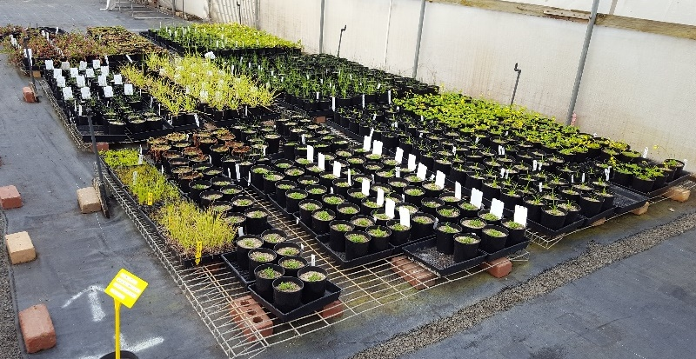
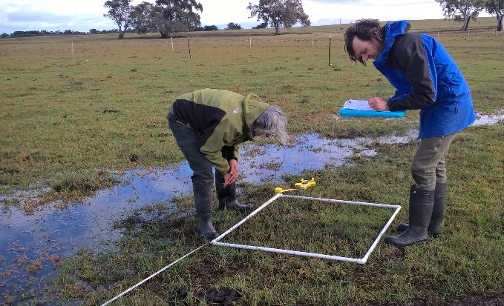
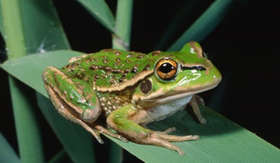
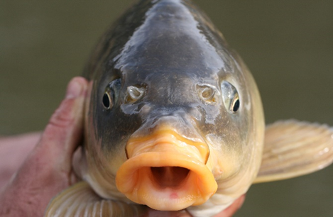
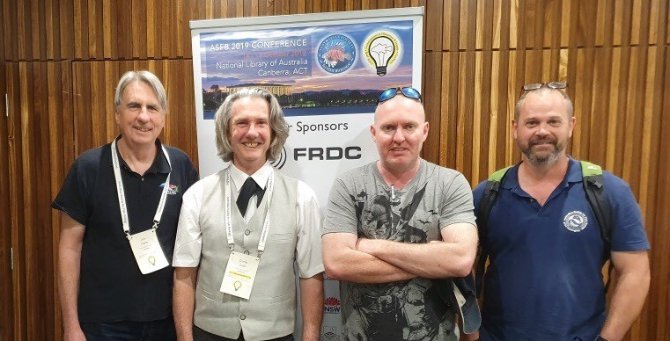
About Us - The Applied Aquatic Ecology group aims to generate and share knowledge, through world-class, applied, ecological research, which supports and guides sustainable ecosystem policy and management to ensure healthy, resilient ecosystems. We work collaboratively with national, state and local agencies, research institutes, universities, interest groups and the community.

Influencing change
- Data from a range of fish monitoring programs is being collated and analysed to assess the survivorship of stocked fish and identify key drivers of survival. This work will generate recommendations to maximise the benefits to fish populations and recreational fishers of native fish stocking in northern Victorian rivers (Victorian Fisheries Authority funded).
- ARI studied Carp movement patterns in the Gunbower Forest to identify entry/exit pathways, floodplain movement patterns and residual accumulations of Carp once wetlands are disconnected. This work clarifies Carp management options at key entry/exit pathways, options to enhance our understanding of movement patterns and refuge sites and builds on current Carp management actions (North Central CMA funded).
- The MDBA is developing a Native Fish Management and Recovery Strategy to protect and restore native fish populations of the Basin over the long-term. ARI is providing input in relation to science, management and communication.
- VEFMAP and WetMAP regularly liaise with CMAs to discuss field monitoring schedules, provide timely feedback after surveys about results and highlights, and provide advice on watering plans. This helps managers by providing evidence to support their existing watering plans and advising where slight changes in components of watering regimes could be beneficial.

Knowledge transfer and engagement
- Australian Society for Fish Biology conference Canberra. Murray Cod in the lower Darling River: environmental flows protect populations (Stuart); Hope and opportunities beyond Carp and fish kills + Fish kills: we’ve been there before, we know what to do, what’s the hold up? (Koehn); Size at onset of maturity is a poor measure for setting Murray crayfish fishing regulations, size at functional reproduction is the gold standard (Todd); Establishing refuge populations of threatened Southern Pygmy Perch in NE Victoria (Raymond). Australia New Guinea Fishes Association Convention, Continuing the passion: Further insights and progress on galaxiid taxonomy in SE Australia (Raadik). ARI seminar Understanding salinity tolerance of Murray Hardyhead to guide environmental watering (Stoessel). Fisheries Research and Development Corporation workshop - Modelling Carp Biomass: Estimates for the Year 2023 (Koehn); DELWP Riparian Forum - Angler Riparian Partnerships Program achievements (Ayres); DELWP & Mallee CMA Victorian Murray Floodplain Restoration Project (Stuart); NSW OEH, CEWO, NSW Parks workshop Opportunities for collaborations in native fish recovery (Stuart & Lyon); Victorian Environmental Water Holder workshop Identification & mapping approaches for aquatic refuges in small, unregulated streams (Raadik).

Highlights
- WIMP (Wetland Intervention Monitoring Program) is studying how different grazing regimes affect the health of 29 wetlands on private land across Victoria, to help identify the best grazing management for different wetland types. The WIMP team has been busy catching up with landholders over the last few months, to understand past grazing regimes on their land, and how landholders view their wetlands.
- VEFMAP (Victorian Environmental Flows Monitoring and Assessment Program) continues to build a suite of collaborative projects. Alanna Main is the third student to begin a project at Burnley with us, investigating the physical tolerances of plants to inundation (Chris Jones ARI and Jo Greet Univ of Melb are co-supervisors).
- WetMAP (Wetland Monitoring and Assessment Program for environmental watering) has launched its frog citizen science project – The frogs are calling. This project is seeking help from citizen scientists to investigate how frogs respond to water for the environment and their preferred water regime and habitat. Participants simply sign up, visit wetlands in northern Victoria, and record frog calls, using the Australian Museum’s award winning FrogID app. It’s a collaboration between DELWP, ARI, Frogs Victoria, the University of Melbourne, the Australian Museum, Goulburn Broken Catchment Management Authority (CMA) and North Central CMA.

Output highlights
- Stuart et al. (2019) From an irrigation system to an ecological asset: adding environmental flows establishes recovery of a threatened fish species. Marine and Freshwater Research 70: 1295-1306.
- Raymond et al. (2019) Differential responses by two closely related native fishes to restoration actions. Restoration Ecology.
- Fact sheets
  - Threatened fish and crayfish in proposed Victorian timber harvesting coupes (DELWP Forest Protection and Survey Program)
  - Improving our knowledge of threatened fish and crayfish in eastern Victoria (DELWP Landscape Scale Survey Project)
  - Conservation of endemic and threatened Victorian galaxiid species; Recovery actions for seven endemic and threatened Victorian galaxiid species; Recovery actions for Glenelg Freshwater Mussel (DELWP Biodiversity Onground Actions)

