|  |
| --- |
| Victorian Environmental Flows Monitoring and Assessment Program (VEFMAP) Stage 6 |
| Project Update – 2019  Northern Victorian Rivers - Fish |

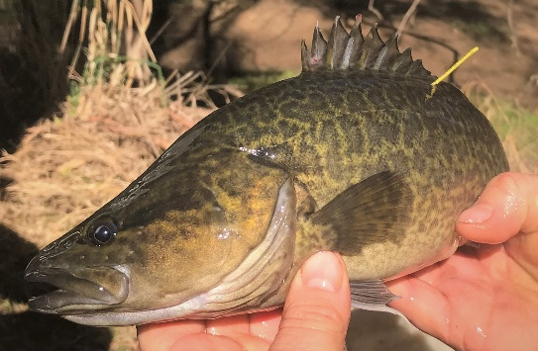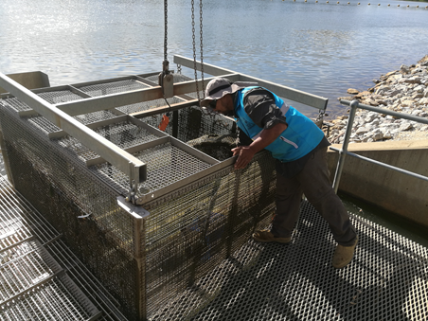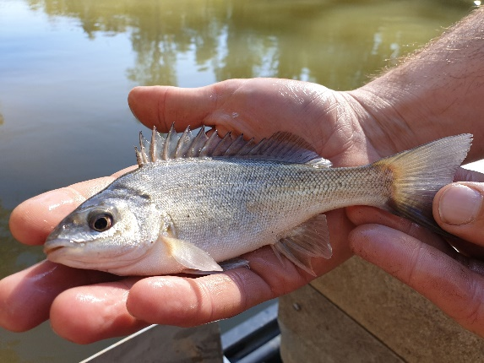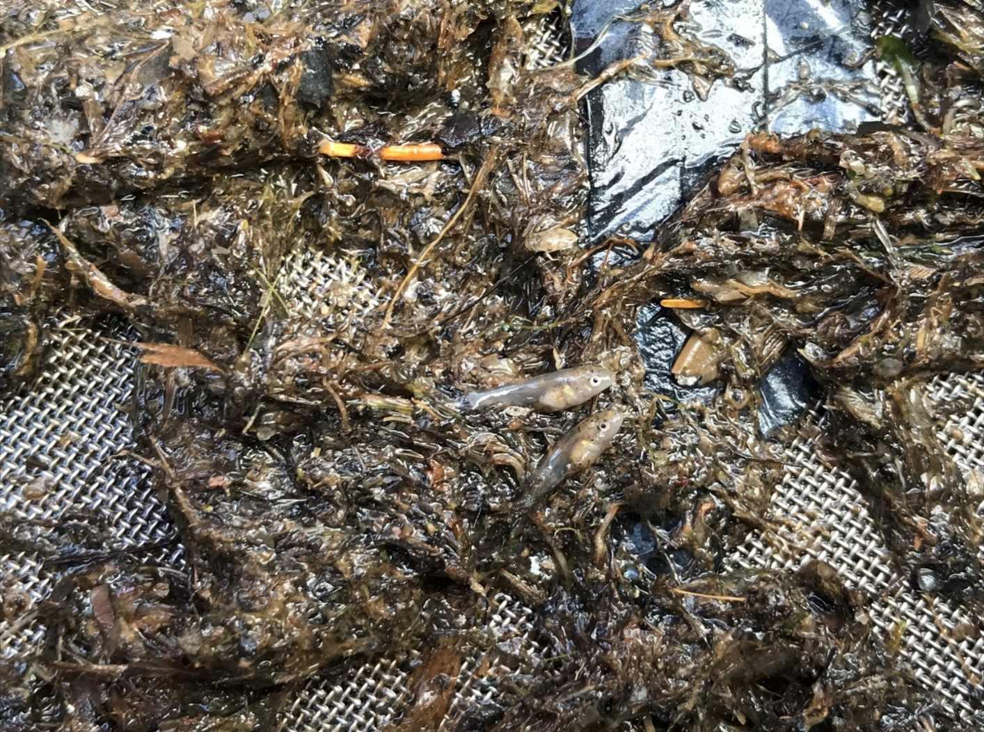

**Background**

The Victorian Environmental Flows Monitoring and Assessment Program (VEFMAP) was established by the Victorian Government in 2005 to monitor and assess ecosystem responses to environmental watering in priority rivers across Victoria. Its results help inform decisions for environmental watering by Victoria’s Catchment Management Authorities (CMAs), Melbourne Water and the Victorian Environmental Water Holder (VEWH). VEFMAP Stage 6 (2016-20) includes a strong focus on “intervention” or “flow event” type questions, for vegetation and fish.

**Fish Monitoring in Northern Victorian Rivers**

The core objective for VEFMAP Stage 6 fish monitoring is to examine the importance of environmental flows in promoting population growth and the rehabilitation of native fish populations via dispersal, colonisation, recruitment and survival. There are two key evaluation questions for fish in northern Victorian rivers, which were developed in collaboration with CMAs.

KEQ 3 Do environmental flows support immigration of native fish into, and dispersal throughout, northern Victorian rivers?

KEQ 4: Does environmental flow management for native fish species enhance: (i) survival (ii) abundance and (iii) distribution?

**2018/19 Survey Sites and Timing**

In 2018/19, surveys were undertaken to investigate KEQ 3 and 4 processes at the following sites:

* ***Immigration*** – Murray River (Torrumbarry Weir fishway), Campaspe and Goulburn rivers.
* ***Dispersal*** – lower Loddon River catchment, acoustic tagging and fishway trapping (The Chute, Kerang Weir, Box Creek fishlock)
* ***Population demography*** – lower Loddon (including Pyramid Creek), Campaspe, Broken and Goulburn rivers.

**Methods**

The survey methods vary for each KEQ and include:

***Immigration***

* *Acoustic telemetry* – fish have been tagged on multiple occasions (Feb 2017–Apr 2019) in the Murray River (Torrumbarry Weir fishway). An acoustic listening station array has been deployed: in the Murray River (Torrumbarry Weir to Yarrawonga Weir); at the entrance of the Campaspe, Goulburn and Edwards rivers, (to detect fish movements in and out of these tributaries); and within the National Channel (to detect fish entering the irrigation system).

***Dispersal***

* *Acoustic telemetry –* Golden Perch *Macquaria ambigua* within the Loddon catchment have been tagged on multiple occasions (Jan 2017–Sept 2018) and listening stations deployed throughout the Loddon River, Pyramid Creek and Washpen Creek.
* *Fishway trapping ­*– occurred at: The Chute fishway (Loddon River near Leaghur); Kerang Weir fishway (Loddon River near Kerang); and Box Creek fishlock (Pyramid Creek at Kow Swamp) (2017-2018).

***Population demographics***

* *Electrofishing* – (boat, bank-mounted or backpack) was undertaken in the Broken, Campaspe, Goulburn rivers, and lower Loddon River (including Pyramid Creek) (2017-2019).
* *Aging and genetics* – collection of otoliths from juvenile Murray Cod *Maccullochella peelii* and genetic analysis to enable assessments of growth, recruitment, survival and natal origin (2017-2019).

**Results and Key Observations**

* 1. ***Environmental flow delivery***

Environmental water was delivered to the Murray, Goulburn and Campaspe rivers in summer/autumn 2017 as within-channel pulses or ‘freshes’ (i.e. small flow events that exceed the baseflow and last up to several weeks). In summer/autumn 2018 and 2019, no environmental water was delivered because flows were elevated due to inter-valley transfers. Environmental water was delivered via freshes, to the downstream end of the Loddon River in autumn 2017, spring 2017, and spring 2018.

* 1. ***Immigration***

There is evidence of movement by Silver Perch and Golden Perch over large spatial scales and between mainstem and tributary habitats. A strong link has been identified between immigration of Silver Perch and elevated summer tributary flows including targeted environmental water delivery. These results, combined with the population demography data, suggest that Silver Perch immigration can be achieved using flow management in Victorian tributaries. Immigration appears important in maintaining tributary populations. The magnitude of metapopulation outcomes within tributaries, however, depends on flow delivery and density of Silver Perch in the mid-Murray River.

* 1. ***Dispersal***

The catch of native fish at fishways in the lower Loddon system, particularly small-bodied species, increased during freshes, both in autumn and spring. The acoustic movement data enhanced our behavioural information on Golden Perch, further supporting the movement patterns identified from fishway trapping. There was a clear upstream movement response for part of the tagged Golden Perch population during rising discharge, often followed by return downstream movements on the descending limb of the hydrograph. Residency within a reach appears linked with stream discharge, with fish preferring flowing habitats of Pyramid Creek over the Loddon River. While results are preliminary, they provide strong support for increased native fish movement during freshes. They also support the hypothesis that freshes improved fish dispersal and population demographic outcomes in some of Victoria’s most flow-stressed rivers, such as the Loddon.

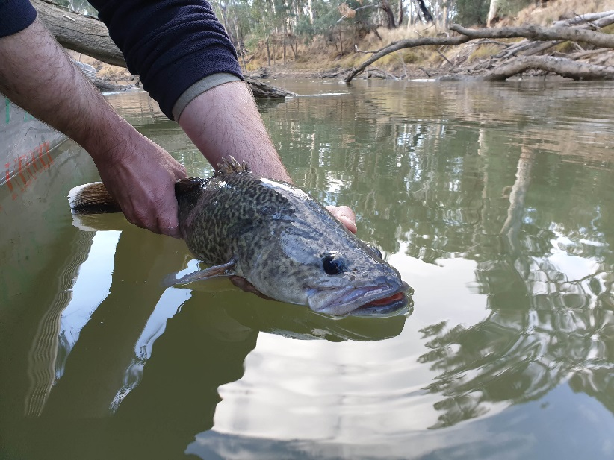 **Figure 1 – Murray Cod (Photo: ARI)**

***Population demography***

* **Murray Cod** – A higher number of YOY Murray Cod were recorded in the Broken River, and to a lesser degree, the Campaspe and Goulburn rivers in 2019 compared to 2018. These results support our hypothesis that large flow events, such as those which occurred in 2017/18, with rapid rates of rise and fall, that occur during the peak larval period may negatively impact YOY survival.
* **Murray River Rainbowfish** - With the exception of the lower Loddon River, this species’ abundance has consistently reduced in the Goulburn River in the past three years and reduced substantially within Reach 3 of the Campaspe River in 2018. This trend maybe a result of lower recruitment success, driven by the increased summer flows (largely Inter Valley Transfer (IVT) water), which reduced water temperatures and/or important habitat availability (e.g. slackwaters) for early life-stages. Much lower volumes of IVT water were delivered through Reach 3 of the Campaspe River in summer 2019 and as hypothesised, catches of Murray River Rainbowfish increased from the 2018 numbers (albeit not to 2017 numbers).
* **Silver Perch** -Lower numbers were captured across the systems (except Broken River) in 2019 compared to 2017, due to a reduced number of juveniles. This suggests that, despite flows still being effective in promoting immigration of these fish into Victorian tributaries, the outcome at a metapopulation level (river scale) depends on the abundance of juveniles in the source Murray River.
* **Large-bodied native fish in the lower Loddon system** - The low abundance of large-bodied native fish in this system highlights the limitations that summer flows can have on shaping a system’s fish community. The abundance of Golden Perch, Murray Cod and Silver Perch, captured in early autumn has consistently been highest in Pyramid Creek, which maintains the highest discharge throughout summer and autumn. Conversely Reaches 4 and 5 of the Loddon River have, over the past three years, been subject to very low water levels, and presumably reduced water quality and quantity of favourable habitat. So, despite all three of these species, particularly Golden Perch and Silver Perch, migrating into and through these reaches, their retention within a system appears to be limited by regulated low flow periods. If metapopulation outcomes for large-bodied species are desired for Reaches 4 and 5 of the Loddon River, a review and modification to the low summer flow recommendations is required.
* **Broad population trends** - At a broad geographic scale, long-term monitoring data show a general increase in distribution, abundance and biomass for most of the priority native species across VEFMAP waterways since 2012. Whilst this pattern likely represents a period of recovery from the Millennium drought and major blackwater events, it also highlights that flow conditions since this time, which include environmental water deliveries, have assisted a broad population recovery trend.
* 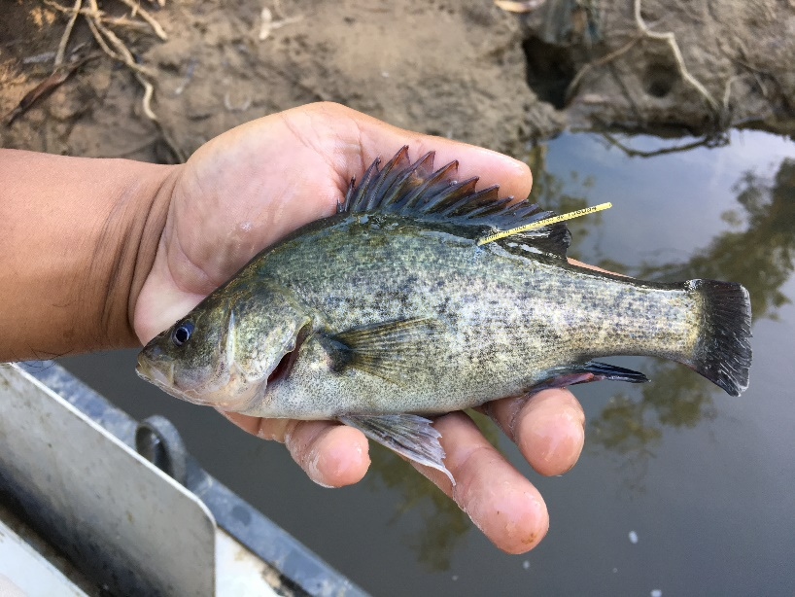**Stocked vs wild recruits of Murray Cod** – analysis of otolith microchemistry was able to distinguish between stocked and wild populations of Murray Cod in the Broken, Goulburn and Mitta Mitta rivers, and Gunbower Creek. While a third year of samples is still being processed, results thus far suggest large variations in abundance of juveniles is driven largely by 1) natural recruitment in the Broken and Goulburn rivers; 2) stocking in the Mitta Mitta River; and 3) similar contributions of stocking and natural recruitment in the Gunbower Creek.

**Flow Recommendations for 2019/20**

* **Murray Cod** - To maximise recruitment of Murray Cod (to YOY), avoid delivery of regulated spring flow pulses that exceed a daily change in discharge of 50% day-1 (rates of rise and fall) from late Oct to mid-Dec (as per the 2016 and 2018 seasons). Spring flow pulses exceeding these rates should be delivered before late October.
* **Murray River Rainbowfish** - To maximise recruitment and survival of Murray River Rainbowfish, avoid long periods of high summer baseflows. If delivery of IVT water is required releases should be in the form of a series of summer and autumn flow pulses that do not exceed daily changes in discharge of 60% day -1 (rates of rise and fall) from Jan-Mar (based on the rates present in the 2016/17 season in the Campaspe River).
* **Loddon system**
  + To maximise the upstream movement response of large- and small-bodied native fish in the Loddon River (Reaches 4 and 5), implement a spring fresh at the Kerang Weir of 700-800 ML day-1 during late October, whilst water temperatures are rising and fish are active, and again during autumn (ideally late Mar–early Apr before the onset of winter).
  + To ensure appropriate water quality, depth and access to habitat for large-bodied species including Golden Perch, implement summer baseflows into Reaches 4 and 5 of the Loddon River at a minimum of 100 ML day-1 and 200 ML day-1 respectively. Golden Perch tend to use these areas during times of high flow but return downstream when water levels recede.
  + **Golden Perch** - To improve the chance of Golden Perch (that have moved into 1st Reedy Lake) returning to the Kerang Weirpool, fully open the regulator leading to 1st Reedy Lake is during lake filling (the gates should not be operated in a regulating position where possible). In the future, consider fish passage for the Reedy Lakes to ensure fish can return to the Loddon/Pyramid/Murray systems.

**Figure 2 – A tagged Golden Perch (Photo: ARI)**

**Science Supporting Management**

The VEFMAP Stage 6 approach to combine both event-based intervention monitoring, and condition monitoring has provided a robust link between patterns in population processes (e.g. migration) and population demographics.

A highlight to date has been the strong collaboration between program managers and waterway managers. Regular and active interactions have been integral to the effective program delivery and the communication of outcomes. This has enabled the inclusion of local advice on the timing and location of monitoring, provided opportunities for input and feedback on the program, and facilitated discussion to modify environmental water management plans.

**What’s Next?**

Monitoring methods tested to date are encouraging, producing several positive results. Based on findings to date and project team discussions, maintaining the long-term population monitoring component of the program is proposed for 2019/20. Collection and interrogation of data will continue to further clarify how flows can be managed to maximise benefits to fish communities.

**Collaborations**

VEFMAP Stage 6 includes many collaborations between DELWP staff, waterway managers, water authorities, universities (Melbourne, La Trobe and Deakin), the Victorian Fisheries Authority, and the Commonwealth Environmental Water Office (both through LTIM, the Long-Term Intervention Monitoring program and EWKR, the Environmental Water Knowledge and Research Project). These include:

* several investigations of fish genomics
* analysis of otoliths to determine natal origin
* an assessment of stocking outcomes and
* development of extended statistical models to explore the effects of flow on fish populations.

**Further Details**

See DELWP (2019) VEFMAP Stage 6: Monitoring fish response to environmental flow delivery in northern Victorian rivers, 2018/19. A client report to Water and Catchments, the Department of Environment, Land, Water and Planning.

**Acknowledgements**

Most of this work was funded by DELWP Water and Catchments, as part of the Victorian Government’s $222 million investment to improve catchment and waterway health across regional Victoria. Goulburn River sites were surveyed as part of the Long-term Intervention Monitoring Program (Commonwealth Environmental Water Office) and Native Fish Report Card monitoring program (DELWP/Victorian Fisheries Authority).

**Contacts:**

Zeb.Tonkin@delwp.vic.gov.au (fish program leader and population demographics), Matthew.Jones@delwp.vic.gov.au (Dispersal), Wayne.Koster@delwp.vic.gov.au (Immigration), Justin.O’Connor@delwp.vic.gov.au (Dispersal)

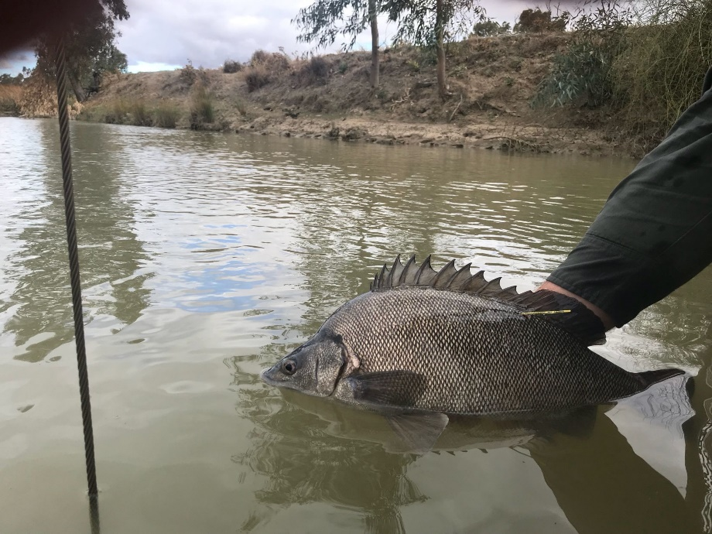

**Figure 3 – A Silver Perch being released (Photo: ARI)**

|  |  |
| --- | --- |
| © The State of Victoria Department of Environment, Land, Water and Planning 2020  LogoThis work is licensed under a Creative Commons Attribution 4.0 International licence. You are free to re-use the work under that licence, on the condition that you credit the State of Victoria as author. The licence does not apply to any images, photographs or branding, including the Victorian Coat of Arms, the Victorian Government logo and the Department of Environment, Land, Water and Planning (DELWP) logo. To view a copy of this licence, visit http://creativecommons.org/licenses/by/4.0/  ISBN 978-1-76077-901-6 (pdf/online)  Disclaimer  This publication may be of assistance to you but the State of Victoria and its employees do not guarantee that the publication is without flaw of any kind or is wholly appropriate for your particular purposes and therefore disclaims all liability for any error, loss or other consequence which may arise from you relying on any information in this publication. | Accessibility  If you would like to receive this publication in an alternative format, please telephone the DELWP Customer Service Centre on 136186, email [customer.service@delwp.vic.gov.au](mailto:customer.service@delwp.vic.gov.au), or via the National Relay Service on 133 677 [www.relayservice.com.au](http://www.relayservice.com.au). This document is also available on the internet at https://www.ari.vic.gov.au/research/rivers-and-estuaries/assessing-benefits-of-environmental-watering |