|  |
| --- |
| WetMAP – Victoria’s Wetland Monitoring and Assessment Program for environmental water |
| Project Update 2019  Vegetation Theme |

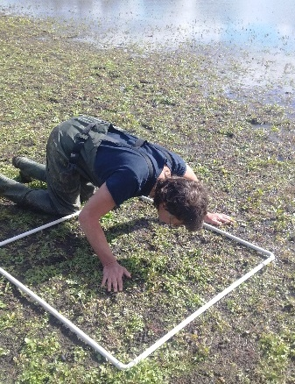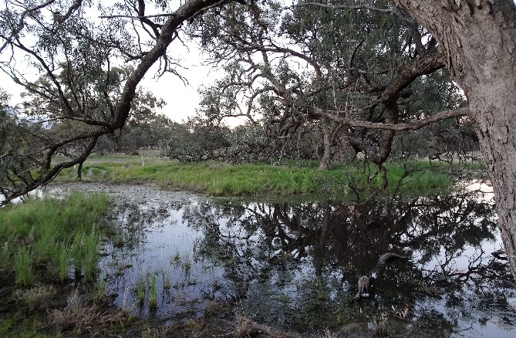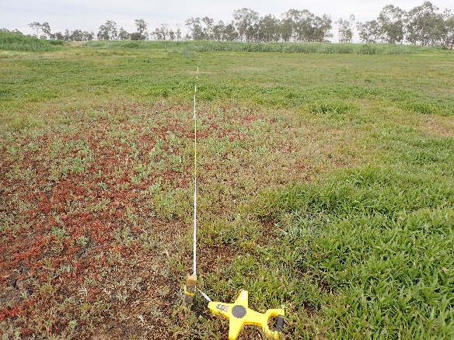

## Background

WetMAP is a state-wide monitoring program designed to assess ecological responses of vegetation, waterbirds, frogs and fish to the delivery of water for the environment in Victorian wetlands. Monitoring for the current stage of WetMAP (2016–2020) is coordinated by Arthur Rylah Institute (ARI) and funded through the Victorian government’s $222 million investment over four years to improve catchment and waterway health.

**Program Objectives**

WetMAP aims to:

* enable DELWP (Department of Environment, Land, Water and Planning) and its water delivery partners to clearly demonstrate ecological outcomes of environmental water management to the community and water industry stakeholders.
* fill knowledge gaps to enable adaptive management – improving planning, delivery and evaluation of environmental water management in rivers and wetlands across Victoria.
* identify ecosystem outcomes from environmental water to help meet Victoria’s obligations under the Murray-Darling Basin Plan.
  1. Ultimately, WetMAP seeks to inform the development of a planning tool for Catchment Management Authorities (CMAs) and the Victorian Environmental Water Holder.
  2. **Program Design**

WetMAP’s design is based on:

* conceptual models of wetland responses to environmental water delivery and natural flooding
* watering objectives defined in state and regional water management plans, and
* Key Evaluation Questions (KEQs) and indicators.

The vegetation experimental design includes wetlands that do and do not receive environmental water. Both types of sites are used to answer the KEQs.

**Factors that influence the response of vegetation to environmental water**

* 1. Key drivers affecting the response of vegetation to water regimes include factors and processes that operate at both the local and landscape scale. Local scale factors include vegetation condition, wetland hydrology, salinity, nutrients, grazing pressure and availability of propagules in the wetland – i.e. seeds, spores, tubers, bulbs and turions. Landscape scale factors include connectivity and the availability of seeds and propagules that disperse into wetlands.
  2. Characteristics of individual plant species (e.g. life history strategy, water regime needs, physiological and genetic fitness) and the seed bank (e.g. size, diversity, longevity, germination and establishment requirements) play a significant role in determining future vegetation composition. So too does a wetland’s disturbance history, which includes factors such as altered water regimes, salinity, nutrient enrichment, the presence and density of Carp *Cyprinus carpio*, and grazing by livestock.
  3. Conceptual models have been developed which identify the drivers and modifiers underpinning vegetation responses to environmental water. These models will help determine an expected response of the wetland vegetation to water management and environmental water.
  4. **Vegetation monitoring**

**Table 2 – Supplementary Questions**

|  |
| --- |
| **SQs** |
| 1. How does the antecedent water regime affect native wetland plant species richness? |
| 1. How does the antecedent water regime affect the cover of native wetland plant species? |
| 1. How does the antecedent water regime affect the cover of terrestrial plant species in wetlands? |
| 1. How does the antecedent water regime affect the condition of Lignum in wetlands? |
| 1. How does the antecedent water regime affect the extent of the native colonists *Typha* and *Phragmites* in wetlands? |

**Table 1 – Key Evaluation Questions and monitoring indicators**

|  |  |
| --- | --- |
| **KEQs** | **Indicator(s)** |
| 1. Do environmental water events increase native wetland species richness? | Number of native wetland species |
| 1. Do environmental water events increase native wetland species cover? | Cover of native wetland species |
| 1. Do environmental water events reduce the cover of terrestrial plant species in wetlands? | Cover of terrestrial species |
| 1. Do environmental water events improve the condition of Lignum in wetlands? | Lignum condition |
| 1. Do environmental water events lead to the growth and flowering of mature wetland tree species? | Magnitude of tip growth and flowering |
| 1. Do environmental water events result in recruitment of wetland tree species? | Number of seedlings and survivorship of saplings |

Six Key Evaluation Questions have been developed to examine whether environmental water led to a change in an indicator (e.g. species richness) (Table 1). Supplementary Questions have been developed to examine how aspects of the environmental water regime (e.g. frequency of inundation) affect an indicator (Table 2).

**Survey methods**

Wetland vegetation assessments were undertaken at 22 wetlands, mostly across northern Victoria. This included:

* wetlands that received environmental water during the survey period
* wetlands that did not, and
* wetlands that received environmental water, which include discrete parts that are not inundated.

Wetland vegetation was assessed within two months of draw-down at wetlands that received environmental water, and in the same period at wetlands that did not receive environmental water.

The timing of vegetation assessments was selected to coincide with the period when there is maximum expression and growth of wetland plants – i.e. aquatic, mudflat, perennial non-woody and perennial woody species.

Vegetation assessment methods have been tailored to suit the different types of vegetation assessed for each KEQ. These include:

* Herbaceous understorey vegetation
* Woody native vegetation
* Tall native herbaceous vegetation: *Typha*, *Phragmites* (Tall Marsh EVC)

Sampling was stratified by vegetation type within each wetland and the following measurements were made:

• Condition and age classes of trees (in 20 x 50 m plots)

• Condition and cover of lignum (in 20 x 50 m plots)

• Cover of understorey vegetation (in 1 x 1 m quadrats, nested in 20 x 50 m plots, replicated in each Ecological Vegetation Class – EVC)

• Extent of tall herbaceous vegetation (measured from aerial imagery)

**Results and Key Observations**

* 1. Given the spatial and temporal variability in the response of wetland vegetation to water management, a minimum of three years’ data is needed to answer the program KEQs (listed above). Therefore, results of detailed analyses will be presented in the final year of this current stage of WetMAP (2016–20). The results presented here are a summary of the vegetation present at the study wetlands – including an assessment of species of conservation significance, species richness, and species composition as they relate to time since inundation.
  2. 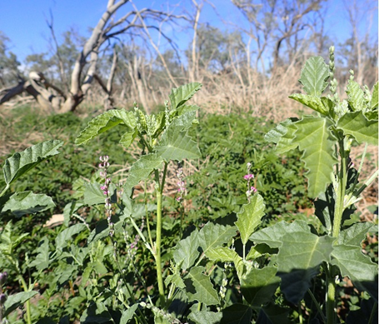A total of 482 species (330 native and 152 introduced) was recorded among all wetlands in 2018–19. This was similar to the previous year (492 species). Of the species recorded in 2018–19, 34 are listed as threatened in Victoria (DEPI 2014) and were distributed among 17 of the wetlands surveyed. Two of these species (*Amphibromus fluitans* and *Maireana cheelii*) are nationally threatened, and one is listed as endangered (Figure 1). The greatest number of species of conservation significance were recorded at Little Lake Heywood (10 species), Margooya Lagoon (10 species) and Neds East Wetland (eight species).

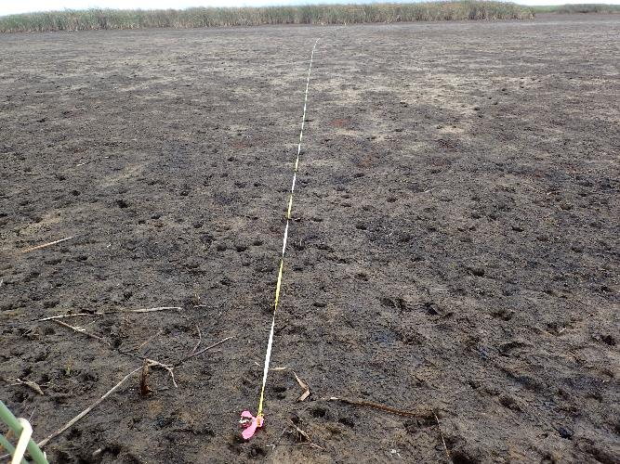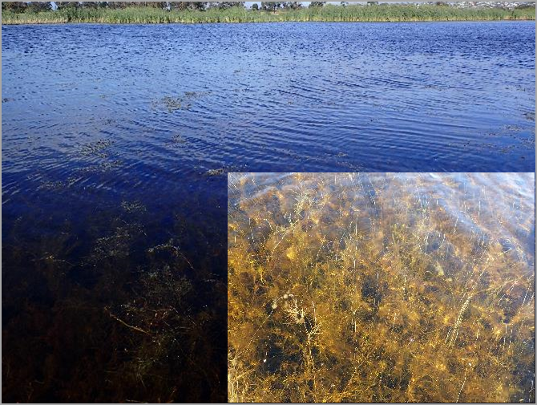

**Fig 1 - Hoary Scurf-pea *Cullen cinereum* (endangered) at Little Lake Heywood (Photo: ARI).**

Multi-dimensional scaling (MDS) analysis was undertaken for three vegetation groups to look for patterns among and within wetlands and EVCs, with respect to time since inundation. Scatter (“ordination”) plots from MDS analysis of species frequency and cover data revealed substantial temporal shifts in vegetation within wetlands in some contexts. There were notable changes in vegetation (species richness, composition, cover and frequency) between surveys in some EVCs at some wetlands, associated with recent inundation and subsequent draw-down and drying.

In the WetMAP vegetation monitoring to date, most of the aquatic herbaceous EVCs appear to be resilient. There was much greater temporal variation in vegetation composition as time since inundation increased for the tree-dominated EVCs than for the other vegetation types, particularly relative to the aquatic herbaceous EVCs. This difference most likely reflects the relative importance of time since inundation to above-ground perennial or biennial species compared with truly ephemeral species dependent on seedbanks, or above-ground ephemeral species reliant on below-ground perennial organs. The difference also reflects the relative responsiveness of these species to watering events or dry periods, and thus their relative resilience to different wet-dry regimes.

**Fig 2 –** **Surveys of brackish aquatic herbs during (top) February 2019 and (bottom) December 2019 show a response to watering (Photo: ARI).**

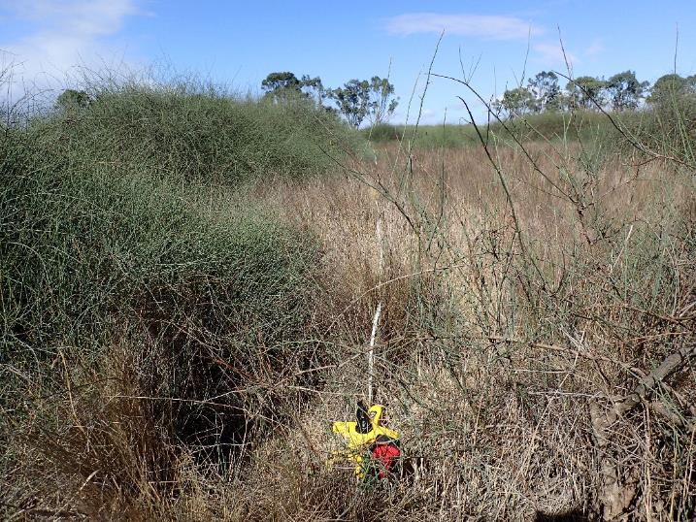**What’s Next?**

Monitoring data collected during 2019-20 will provide the necessary data for an evaluation of the KEQs and SQs around the response of wetland vegetation to environmental watering events and water regime.

**Further information**

See [www.ari.vic.gov.au](http://www.ari.vic.gov.au) for further information on WetMAP

**Contact**

[Phil.Papas@delwp.vic.gov.au](mailto:Phil.Papas@delwp.vic.gov.au) (vegetation monitoring methods),

[Jacqueline.Brooks@delwp.vic.gov.au](mailto:Jacqueline.Brooks@delwp.vic.gov.au) (program leader).

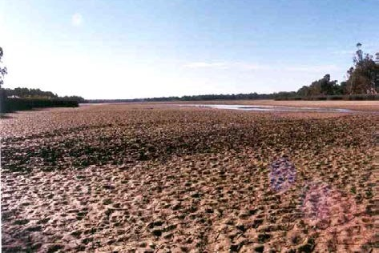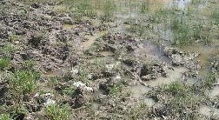

|  |  |
| --- | --- |
| © The State of Victoria Department of Environment, Land, Water and Planning 2020  LogoThis work is licensed under a Creative Commons Attribution 4.0 International licence. You are free to re-use the work under that licence, on the condition that you credit the State of Victoria as author. The licence does not apply to any images, photographs or branding, including the Victorian Coat of Arms, the Victorian Government logo and the Department of Environment, Land, Water and Planning (DELWP) logo. To view a copy of this licence, visit http://creativecommons.org/licenses/by/4.0/  ISBN 978-1-76105-027-5 (pdf/online/MS word)  Disclaimer  This publication may be of assistance to you but the State of Victoria and its employees do not guarantee that the publication is without flaw of any kind or is wholly appropriate for your particular purposes and therefore disclaims all liability for any error, loss or other consequence which may arise from you relying on any information in this publication. | Accessibility  If you would like to receive this publication in an alternative format, please telephone the DELWP Customer Service Centre on 136186, email [customer.service@delwp.vic.gov.au](mailto:customer.service@delwp.vic.gov.au), or via the National Relay Service on 133 677 [www.relayservice.com.au](http://www.relayservice.com.au). This document is also available on the internet at <https://www.ari.vic.gov.au/research/wetlands-and-floodplains/assessing-wetland-response-to-environmental-water> |

**Fig 3 - (top) Effect of carp “mumbling” in Barmah Lake; (bottom) Effect of livestock “pugging” in a wetland in south-west Victoria (Photo: ARI).**

**Fig 4 – The condition of Lignum is being monitored as part of WetMAP (Photo: ARI).**