|  |
| --- |
| Whale Identification Project |
| Using photographs to identify Southern Right Whales |

The South East Australian Southern Right Whale Photo-identification Project is assisting DELWP and other government agencies to improve their understanding of the Southern Right Whale (*Eubalaena australis*) population within south-east Australia.

Collecting and comparing photographs of whale markings helps us to identify individual whales and monitor the population that visits the Victorian coast each winter.

## Why is population assessment important?

Accurate population assessment is essential to

understand the status of the Southern Right Whale in south-east Australia.This helps DELWP evaluate and manage the impacts of human-induced threats such as entanglement, vessel collision and acoustic disturbance.

## How are individual whales identified?

Individual Southern Right Whales can be identified by unique patterns of thickened skin on the head (known as callosities). The callosities used for photo-identification include the bonnet, lip patches, rostral islands, coaming and post-blowhole island (shown in Figure 1).

Identification of individual Southern Right Whales relies on obtaining clear images of the callosity pattern on the rostrum area (upper jaw or snout) on top of the head. The images are most effective when captured from a cliff-top or some other high vantage point on the land such as a lighthouse. Best images from land are of whales breaching (Figure 2) or spyhopping (Figure 3, top). However, multiple images of the same whale taken from different angles can help capture all callosity features required for identification (Figure 3a – 3b)

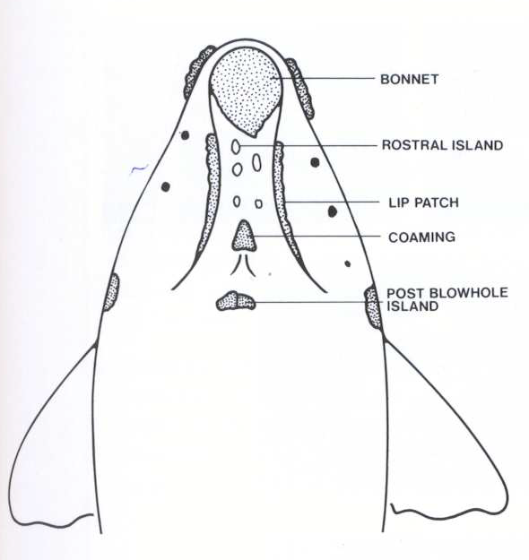

Figure 1: Pattern of callosites on a Southern Right Whale’s head, used to identify individuals. *From Bannister, 1990*

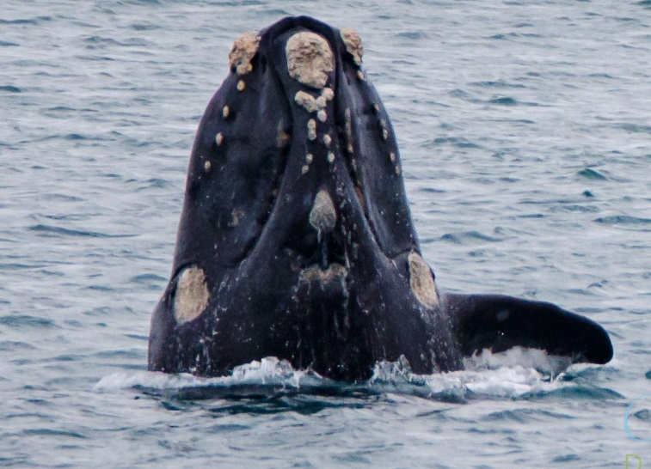

Figure 2: Southern Right Whale Breaching. *Credit: Coralee Askew*

Callosity patterns on the rostrum clearly visible.

## How can I contribute?

DELWP are looking for members of the whale watching community to submit images of Southern Right Whales to the database. Your images will help us track individual whales and monitor the population.

Photos can be uploaded via: http://www.swifft.net.au/whaleface

You will need to register an account to start uploading photos and sighting data. As a registered user you will receive updates about the whales and our research.

As a minimum, please provide the date, time and location of your sighting as well as your best contact details. Other useful information includes: the number of whales in the pod, if a calf was present and any behaviours that you may have noted.

## What happens to the data?

Photographs of whale callosity patterns are stored in a database (SEA SRW PIC). Comparisons between images within this catalogue are made to identify individual movements and breeding patterns and to determine trends in population size and distribution. Summaries of our research findings will be available on the WhaleFace on the SWIFFT website (see link above).

## Want to know more?

|  |
| --- |
| **Contact:**  Mandy Watson (DELWP, BSW region) [Mandy.Watson@delwp.vic.gov.au](mailto:Mandy.Watson@delwp.vic.gov.au) Or  Kasey Stamation (DELWP, Arthur Rylah Institue) [Kasey.Stamation@delwp.vic.gov.au](mailto:Kasey.Stamation@delwp.vic.gov.au) |

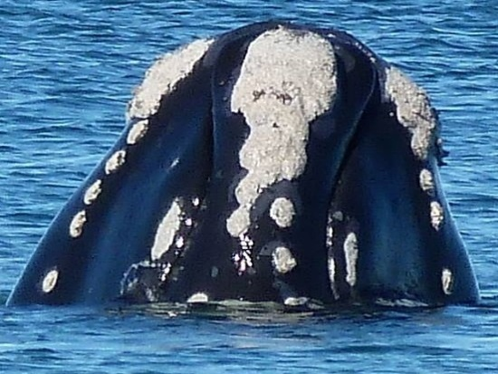

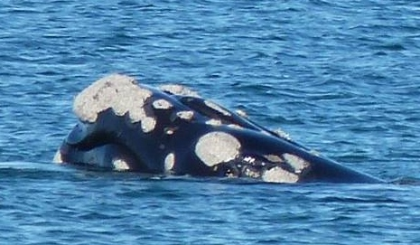

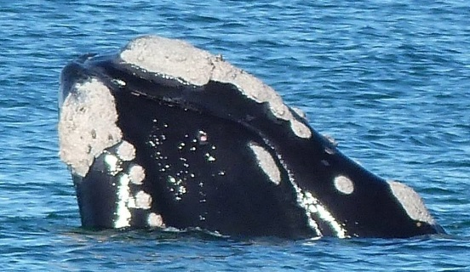

**Figure 3: Southern Rght Whale spyhopping.**

*Credit: Penny Rawlings*

Top image shows bonnet and lips clearly, but some callosities obscured by water; middle image shows right and post blow hole callosities, but left side obscured by water; bottom image shows callosities on left side clearly.

|  |  |
| --- | --- |
| © The State of Victoria Department of Environment, Land, Water and Planning 2021  LogoThis work is licensed under a Creative Commons Attribution 4.0 International licence. You are free to re-use the work under that licence, on the condition that you credit the State of Victoria as author. The licence does not apply to any images, photographs or branding, including the Victorian Coat of Arms, the Victorian Government logo and the Department of Environment, Land, Water and Planning (DELWP) logo. To view a copy of this licence, visit http://creativecommons.org/licenses/by/4.0/  ISBN 978-1-76077-111-9 (print)  ISBN 978-1-76077-112-6 (pdf/online/MS word)  Disclaimer  This publication may be of assistance to you but the State of Victoria and its employees do not guarantee that the publication is without flaw of any kind or is wholly appropriate for your particular purposes and therefore disclaims all liability for any error, loss or other consequence which may arise from you relying on any information in this publication. | Accessibility  If you would like to receive this publication in an alternative format, please telephone the DELWP Customer Service Centre on 136186, email [customer.service@delwp.vic.gov.au](mailto:customer.service@delwp.vic.gov.au) or via the National Relay Service on 133 677 [www.relayservice.com.au](http://www.relayservice.com.au). This document is also available on the internet at [www.delwp.vic.gov.au](http://www.delwp.vic.gov.au). |