**–**

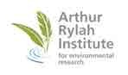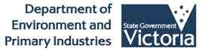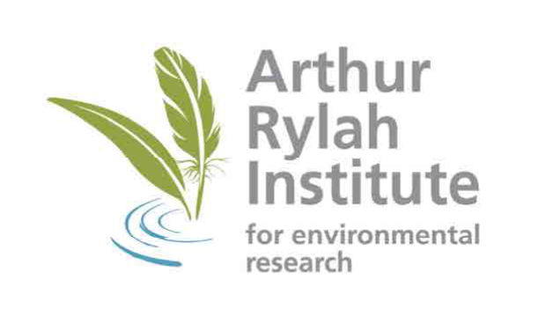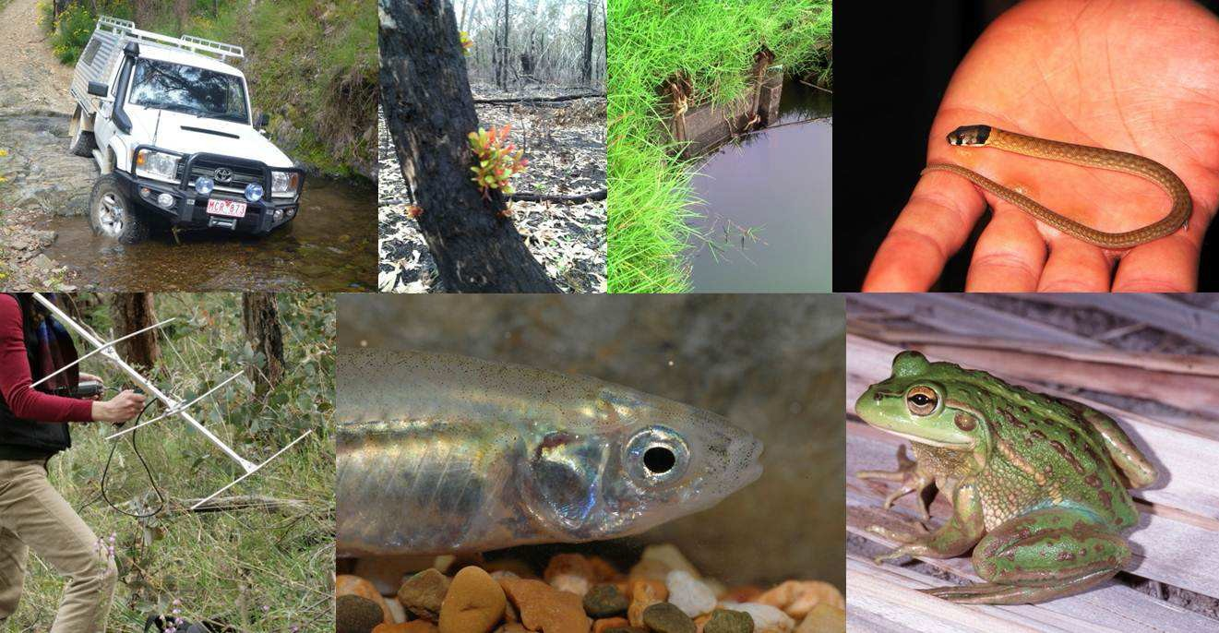

Operational Plan 2014-15



P a g e | ii

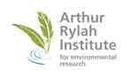

Director’s Foreword

2

About ARI

Strategic Context

Structure & Capability Leadership

Funding

3

4

5

7

2013-14 in Review

Strategic Highlights Science Highlights

8

10

The Year Ahead

2014-15 Budget

Strategic Projects and Continuous Improvement 2014-15 Science Projects

15

16

18

Monitoring Performance

InterPlan©

Client Surveys, Publications & other KPIs

20

21

Significant Published Articles

22

Photograph Acknowledgements

23

P a g e | 1

Contents

**Kim Lowe - Research Director - ARI**

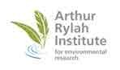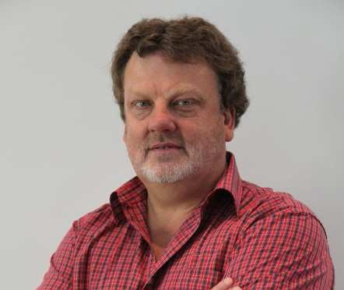

I am proud to present the 2014-15 Operational Plan for ARI.

After a year of growth, delivery, innovation and impact in

2013-14, the Institute is perfectly positioned for a year of great science in 2014-15.

It will be an opportunity to continue to consolidate ARI as

the premier ecological research body in Victoria.

ARI’s highly qualified, resilient and dedicated team of scientists deliver high quality science

across a diverse range of projects. With a focus on improved service, more integrated management information and long term stakeholder relationships, ARI’s work is seen to have impact for decision makers and land managers across the environmental sector.

In 2013-14, we continued to influence biodiversity outcomes by undertaking high quality,

applied, ecological research. Highlights for the year included:

•

The successful delivery of 449 milestones across 196 projects for both the

Department of Environment and Primary Industries (DEPI) and our external clients and collaborators. This was a very significant increase in outputs for the Institute; The publication of 64 journal papers and 61 ARI Technical Series or Client reports; The presentation of 24 ARI Research Snapshot seminars and hosting or presenting numerous other science seminars at ARI to internal and external audiences;

The introduction of client feedback surveys, with excellent satisfaction and impact results;

•

•

•

**“...*an impressively***

***resilient organisation*...**

**...*contributing to high quality, relevant and effective applied research knowledge*…”**

Independent Science Review

(December 2012)

•

The continued implementation of the ARI Science

Strategy including a revised publication tracking system and improvement in Management Information tools. This resulted in a better understanding of our investment mix and project delivery performance.

These great results and improvements, combined with an

increased focus on collaboration, continued leadership development, a refreshed business support team and a

new science leadership arrangement are ensuring that our science staff can continue to do

what they do best – deliver great science.

I look forward the 2014-15 year with great anticipation and excitement.

P a g e | 2

Director’s Foreword



Strategic Context

ARI directly supports all six corporate objectives from DEPI’s 2013-2017 Corporate Plan:

•

•

•

•

Productive and competitive agricultural industries;

Sustainable management of fish, game and forest resources;

The community benefits from effective management of Victoria’s land assets; Effective management of water resources to meet future urban, rural and environmental needs;

Effective environmental and adaptation policy, investment and regulation; Reduced impact of major bushfires and other extreme events on people,

infrastructure and environment.

•

•

The Institute was also active in the formation of the Department’s Science Strategy, which

will guide science for the Department.

At a local level, the Institute will be guided by the five themes that are documented in the ARI Research Strategy 2012-2016:

•

•

Aligning our work to State and Federal Government strategies and priorities;

Understanding our stakeholders’ needs and maximising the value of our work by conducting and bringing together projects of mutual strategic value;

Raising the profile of our research both nationally and internationally; Improving our science leadership and the quality of our science outputs;

Working collaboratively to share knowledge and resources and to support each other and enhance learning.

•

•

•

These themes have driven our operational and strategic planning, and are being supported

by our continued leadership development, ensuring a high performance culture and our focus on improved stakeholder management.

The ARI Research Strategy is underpinned by the principles of Collaboration, Alignment to Government, Responsiveness, Leadership, Influence and Teamwork.

It also clearly defines ARI’s research objective:

“To generate and disseminate knowledge, through world-class, applied, ecological

research, which supports and guides sustainable ecosystem policy and management to ensure healthy, resilient ecosystems in south-eastern Australia”

P a g e | 3

About ARI



Structure & Capability

**Structure**

The Institute operates three Science Sections with two oversight roles relating to Science Leadership & Capability and Collaboration & Communication. A small Business & Administration Services team, supports the Science Sections and Management Committee.

Research Director

Science Leadership

& Capability

Collaboration &

Communication

Business &

Administration Services

Applied Aquatic

Ecology

Community

Ecology

Wildlife Ecology

**Capability**

As at 30th June 2014, ARI had 73 staff (including 7 staff working in conjunction with La Trobe University) which equated to 65.3 FTE employed directly by ARI. Over 50 of those staff operated in science related roles. ARI staff are highly qualified, with over 20 science staff holding Doctorates and the remainder holding Masters or Bachelor degrees.

The workforce is experienced, with an average of 12.7 years’ service and has a median age

of 42.

**Staff Development**

The Institute has a comprehensive staff development program comprising both formal training and experiential development. Science staff are encouraged to participate in forums and conferences, within Australia and abroad, and are coached in presentation skills, leadership and project delivery.

All staff complete formal Safety & Wellbeing training including first aid, 4 wheel drive and

hazardous goods handling where required.

P a g e | 4

About ARI

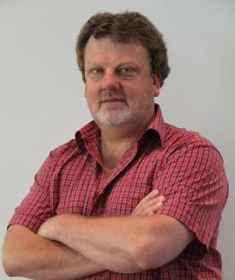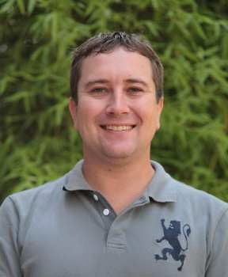

Leadership

ARI is led by an experienced and capable Management Committee. The Committee meets monthly and oversees science, business and strategic decisions. The Committee members average around 20 years’ experience with the Department and a total of 40 years in the private sector. The Management Committee regularly invites Program and Science staff to its monthly meetings. Management Committee members are as follows:

**Research Director - Kim Lowe** BSc (Hons), BSc (Ed), PhD (Zoology)

Kim has worked for the Department of Environment and Primary Industries (and its predecessors) since 1990 in various science-based policy, program and research roles relating to biodiversity conservation and natural resource management. Prior to that he held similar positions with the Commonwealth in what is now called the Department of Environment for 6 years. Kim received a commendation in the Prime Minister’s Award for Public Administration in 2011.

**Principal Research Scientist (Wildlife Ecology) – Lindy Lumsden** BSc, PhD

Lindy began her career at the Museum of Victoria in 1979, and has subsequently worked with DEPI and its predecessors for over 30 years. She has extensive experience in leading large scale fauna surveys and targeted research. She is a recognised expert in bat ecology and was awarded an honorary life member of the Australasian Bat Society in 2012. Most recently the Northern Freetail Bat *Mormopterus lumsdenae* was named in her honour.

**Principal Research Scientist (Applied Aquatic Ecology) – Jarod Lyon** BSc (Hons)

Jarod began his career at the Murray Darling Freshwater Research Centre, before securing a position at ARI. During his 13 years working as a fish ecologist at ARI, Jarod has held a number of positions, including technician and aquarium manager, before being appointed in his current position as Principal Research Scientist in 2013. Jarod has particular skills in the biology and management of large-bodied Murray Darling basin fish species, which allow him to lead and participate in large, multi-disciplinary research projects.

**Science Manager (Community Ecology) – Tim O’Brien** BSc

Tim has worked at ARI since 1984 in various science-based technical, research and management roles. He has represented DEPI and Victoria on several expert technical reference groups, including being a founding member of the MDBA Fish Passage Task Force which oversaw the implementation of the Living Murray Sea to Hume fishway program. Tim managed aquatic research at ARI for 10 years prior to evolving into land based research in 2013.

P a g e | 5

About ARI

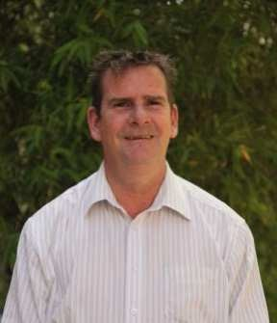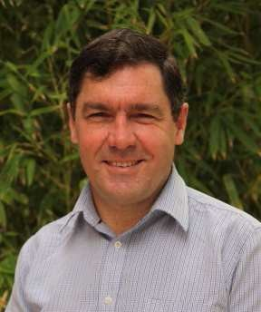

Leadership

**Professor of Ecology (Science Leadership & Capability) – Andrew F Bennett**

Andrew provides and supports the development of scientific leadership through building capability and enhancing the quality of research. Andrew holds BSc (Hons) and PhD (Zoology) degrees and started his career as an ecologist at ARI before spending the last 18 years at Deakin University. He has built an internationally renowned research group working in Landscape Ecology and Conservation Biology. He has worked for extended periods in Canada, England and USA, most recently as a Charles Bullard Fellow at Harvard University in 2012.

**Science Manager (Collaboration & Communication) – Fern Hames** BSc (Hons)

Fern is responsible for supporting effective communication and for building collaboration both within ARI and externally. Fern has extensive experience in both research and engagement and brings a particularly powerful skill set to this role, including 30 years’ experience in project co-ordination, extension, freshwater fish ecology and aquaculture research, policy development and environmental education. Fern holds a B.Sc. (Hons) and Grad Cert in Australian Rural Leadership. She is a Fellow of the Australian Rural Leadership Foundation.

**Manager, Business & Admin Services – Corrinne Wong** LLB (Hons)

Corrinne brings extensive legal, contract and business management experience to the Institute. She has been with the Department since 2010, as Business & Legal Practice Manager, prior to which she was CEO of the Malaysian Bar’s Secretariat, where she oversaw a transformation of that organisation. She has extensive expertise in the field of contract management, leadership and change management and has a track record of building highly effective teams and process improvement.

**Principal Research Scientist (Aquatic) – John Koehn** BSc, PhD (Zoology)

John has established an international reputation as one of Australia’s leading fish biologists in research and management of Australian freshwater fish. This has resulted in more than 200 scientific publications. His applied research has aimed at providing information to improve management. He received the 1997 Gold Banksia and Catchment Management and Inland Waterways Banksia awards and two Rivercare 2000 awards for scientific research.

**Manager, Strategy Planning & Reporting – Steve Werner**

Steve joined the Department in 2006, after 25 years in the private sector and three years in local government. He brings extensive business management experience in strategic planning, process and system improvement, service excellence and change management. He has expertise in client feedback systems and has overseen a number of change management projects in both the private and public sectors.

P a g e | 6

About ARI

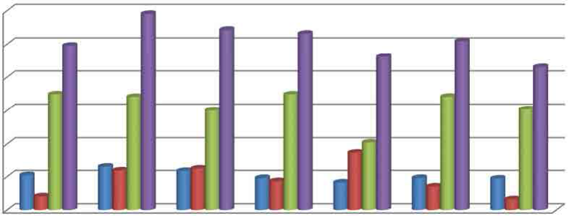

Funding

A small amount of base (State Vote) funding is allocated to the Institute each year. All other funding is secured from within other areas of DEPI (often initiative funding) or externally to the Department. Within DEPI, this model is unique to the Institute.

Total funding declined over the period 2009/10 – 2012/13 (Table 1). This decline was halted

in 2013/14, principally due to an increase in external funding. Projections for 2014/15 are early indications and likely to be exceeded.

**ARI Revenue 2008/9 – 2014/15**

**Table 1 - Total Funding (7 year summary)**

**ARI Revenue ($m)**

12.00

10.00

8.00

6.00

4.00

2.00

0.00

FY 8/09

FY 9/10

FY 10/11

FY 11/12

FY 12/13

FY 13/14 Proj 14/15

State Vote

Initiative

External

Total

In 2014/15, base funding is projected to represent 21% of total revenue, up from 19% in

2013/14. Roughly 2/3 of revenue needs to be sourced externally. This means the Institute must continually take itself to the market to secure additional external funding. This continues to be an area of focus for the Research Director and the Management Committee.

P a g e | 7

**FY 8/09**

**FY 9/10**

**FY 10/11**

**FY 11/12**

**FY 12/13**

**FY 13/14**

**Proj 14/15**

State Vote

2.01

2.61

2.35

1.93

1.65

1.93

1.89

Initiative

0.83

2.38

2.50

1.74

3.48

1.42

0.65

External

6.78

6.83

6.01

6.97

4.10

6.84

6.07

**Total**

**9.91**

**11.81**

**10.86**

**10.64**

**9.23**

**10.18**

**8.61**

About ARI

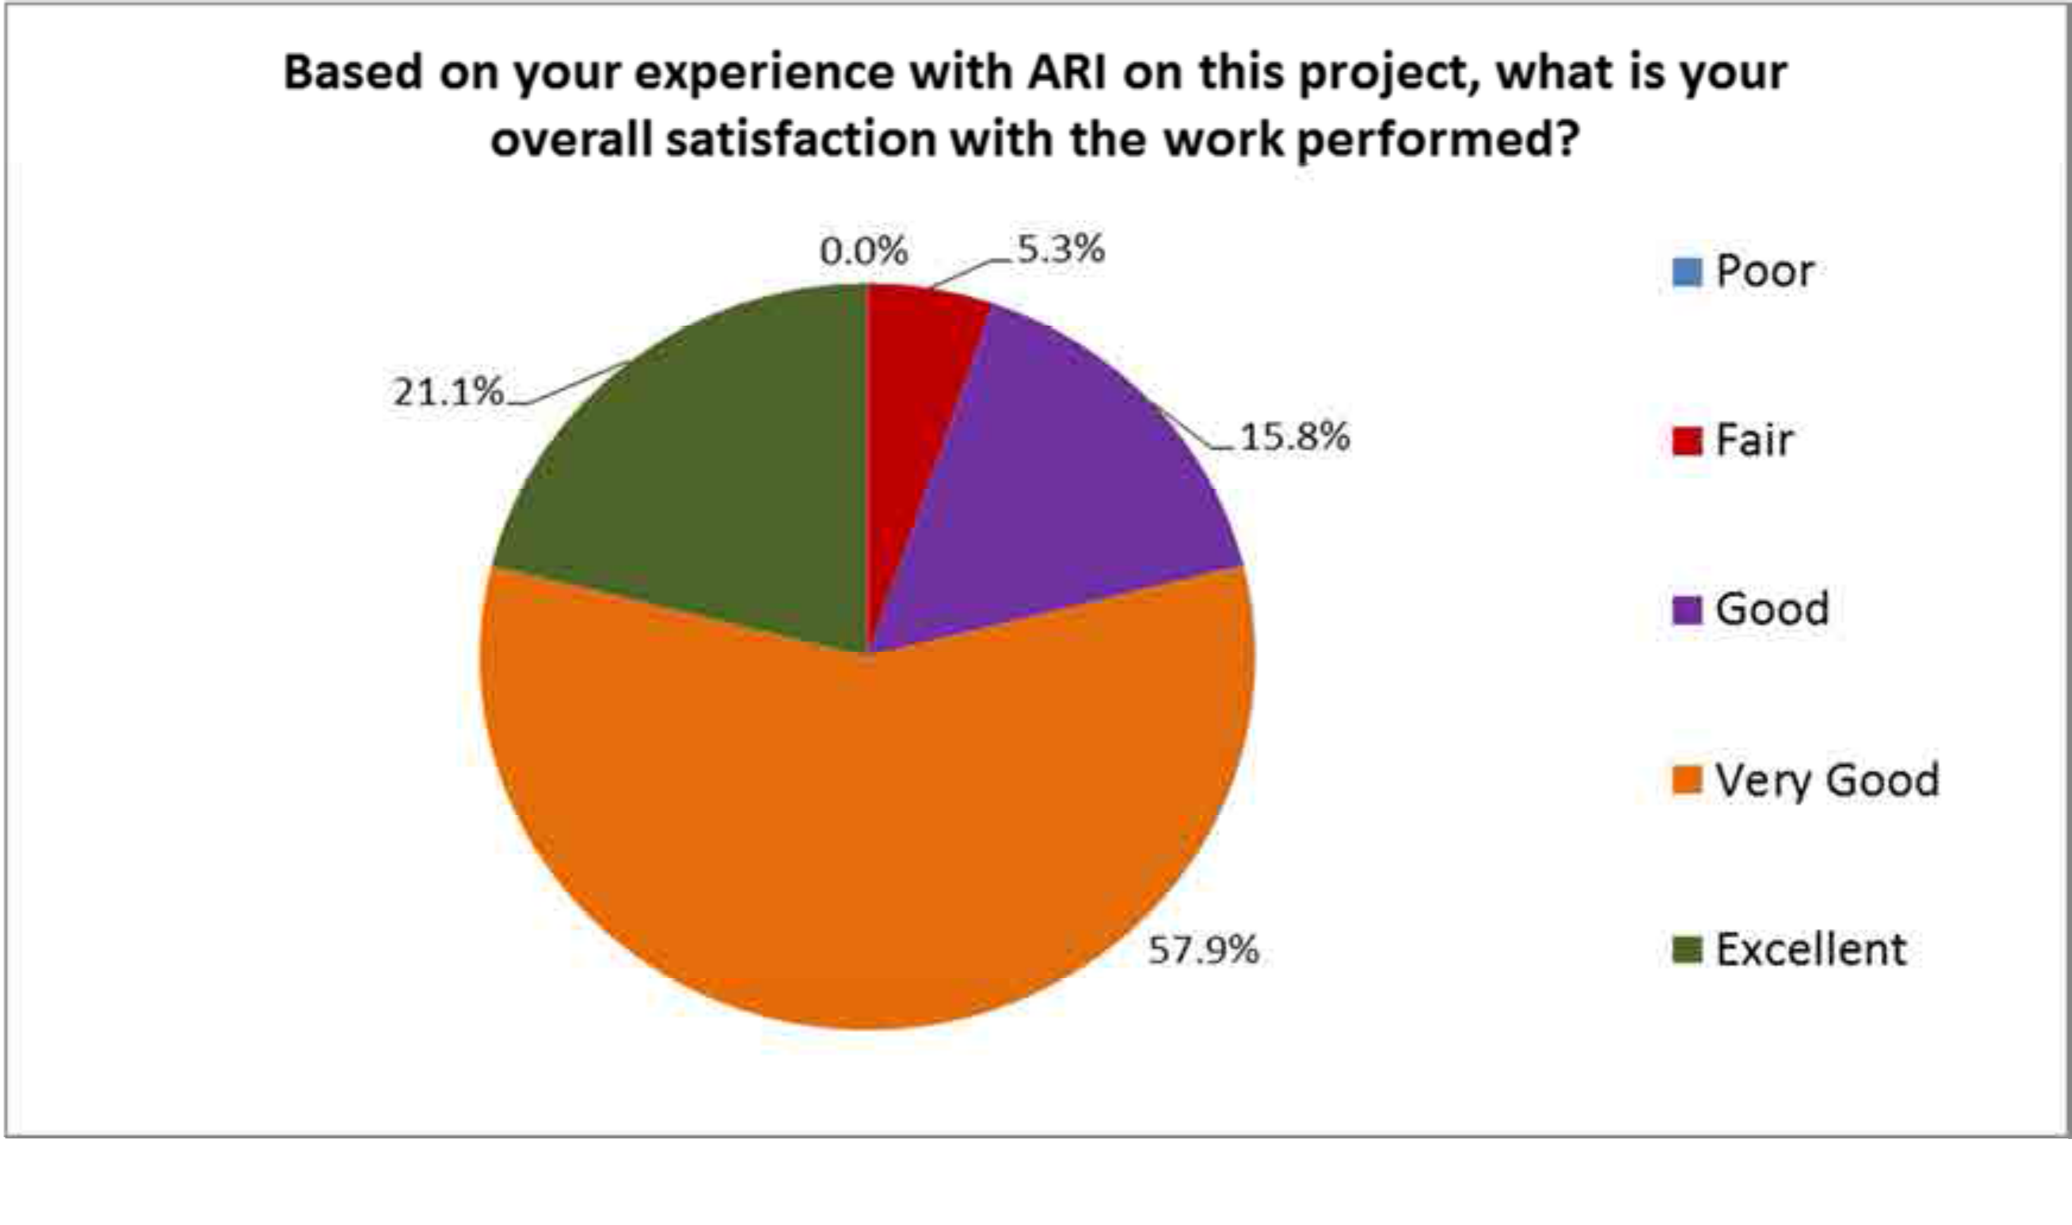

Strategic Highlights

The ARI Management Committee is responsible for the strategic direction of the Institute. A number of initiatives were continued, commenced or introduced in 2013/14.

**Client Survey**

In 2013, the ARI Management Committee identified the need for reliable client feedback to address any specific delivery issues, drive improvement in project delivery and gather information for KPIs. A SurveyMonkey® survey was designed and sent to an initial client list of 42, spread across ELP, other DEPI and external investors.

The survey was designed to capture information regarding satisfaction, relationships with

ARI, types of research required and the impact of research on client decision making, policy development or on ground actions. Performance information was broken down into key areas. The survey will be repeated over September and October 2014.

**Overall Client Satisfaction - Results**

Result highlights included:

•

•

95% of respondents rating their satisfaction as Good or better.

95% of respondents rated the rigour and robustness of the science and thinking used by ARI to develop the project as Good, Very Good or Excellent

94% of respondents indicated ARI’s work had between moderate and Very High Impact

88% of respondents indicated ARI’s work influenced on-ground actions

•

•

P a g e | 8

2013-14 in Review

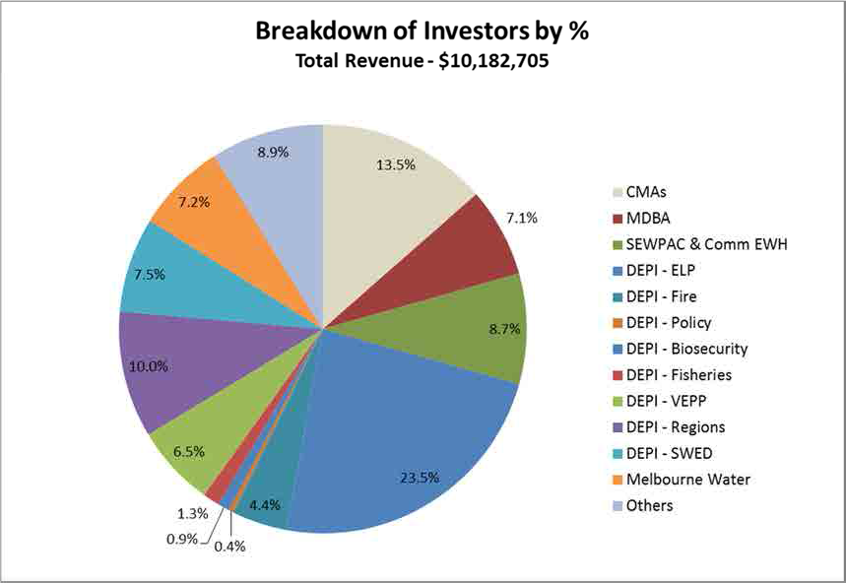

Strategic Highlights

**Improvements in Management Information**

A number of new measurement and reporting processes were introduced in the 2013/14 year. These included detailed FTE reporting (linked to projects) that allowed a snapshot of staff utilisation against annual targets. Analysis of our investment mix was also conducted, setting the direction for strategic discussions on future investment.

**Research Strategy Implementation**

A number of initiatives in the ARI Research Strategy 2012-16 were implemented in 2013/14. An interim research output database was introduced to capture all publication types, publishing details and authors. The database also captures media, popular publications, conference presentations and seminars. This will assist in the State’s annual Budget Paper 3 (BP3) reporting and help facilitate the review process.

A project was completed to standardise science competencies and outputs for inclusion in performance reviews and science based position descriptions for senior and junior science staff. This will help reinforce science standards and provide consistency across ARI.

P a g e | 9

2013-14 in Review



Science Highlights

**Project Delivery**

Our science staff delivered almost 450 milestones across almost 200 projects in 2013/14 (Table 2). Despite field work often being affected by weather or seasonal factors, more than 3/4 of milestones were delivered on or ahead of time and 94% were delivered within 60 days of the target date. There were four projects with 12 milestones delivered jointly across all sections.

**2013/14 Project Summary**

**Table 2 – Project Outputs**

**Publications**

A primary measure of scientific output at the Institute is

publications (Table 3). A database is maintained that recorded all publication activity over the 2013/14 year. Journal articles and published reports are peer reviewed prior to publication. ARI Research Snapshot Seminars are held regularly. These give ARI’s scientists an opportunity to share research findings, which contributes to a greater understanding of the Institute’s work. Other highlights for the year included three ARI produced videos, appearance in children’s television segments, radio interviews and the continued success of eNews, our online newsletter.

**Awards & Nominations**

Three ARI teams were finalists for the 2013/14 David Ashton Environment Awards, namely the ‘Innovative new science guides recommendations for Leadbeater's Possum conservation’ team, ‘The Murray River Resnagging Experiment - demonstrating the benefits of large scale river restoration’ team and the winning ‘Native Fish Strategy' team. ARI staff were also well represented at the Annual Environment and Landscape Performance awards in 2013.

P a g e | 10

**Publication Type**

**Number**

Journal Articles / Papers

64

Presentations & Posters

41

Reports - published

18

Reports - unpublished

44

Media Items

10

Book Chapters

2

Fact Sheets

8

Inform Articles

3

Popular Articles

2

Published Proceedings

4

**Internal Clients**

**External Clients**

**Total ARI**

# of Projects

99

97

**196**

# of Milestones

222

227

**449**

Revenue ($m)

5.90

4.28

**10.18**

% of Milestones delivered on or ahead of time

**77%**

% of Milestones delivered within 30 days of target

**88%**

2013-14 in Review

2013-14 in Review



Science Highlights

Number of 2013/14 Projects – 27

Number of 2013/14 Milestones - 64

In 2013/14, the Wildlife Ecology section continued to undertake a wide range of applied ecological

research projects on threatened and introduced vertebrate species, to underpin evidence-based decision making by governments and communities. Some highlights include:

•

The large *A New Strategic Approach to Biodiversity Management* project was completed this year. This

was a key action from the Victorian Government’s Timber Industry Action Plan. The project provided extensive new data on the status, distribution and habitat use of priority threatened fauna in the forests of eastern Victoria, including the high profile Leadbeater's Possum. This research contributed to the establishment of the ministerially-appointed Leadbeater's Possum Advisory Group, which used the most up-to-date science to inform the development of its recommendations.

The investigation into the interaction between fire and predation by red foxes uses DEPI’s planned burning program and the Glenelg Ark program (sustained fox control over 100,000 ha) to tease out the relative importance of these threats. The findings will help land managers apply fox control to minimise the impact planned fire has on native species at risk from fox predation.

A two-year project along the Werribee River investigated the effects of best-practice rabbit management on the survival and biomass of tree seedlings planted for reforestation. Rabbit control (using a combination of warren ripping and poison baiting) reduced rabbits to around 6% of the density in the untreated sites. Tree seedling survival was highest at low rabbit density and declined with increasing rabbit density for all tree seedling species. However, even low rabbit densities had strong negative effects on the survival of seedlings. These results confirm that rabbits may need to be completely excluded from tree plantings to maximise the benefits of reforestation.

ARI, working with partners from CSIRO, the University of Queensland and the Tasmanian government, has developed new cutting-edge techniques to inform managers of the likely distribution and abundance of foxes that invaded Tasmania over the last 10-15 years. Using sparse information collected from citizen-science data, haphazard sightings and monitoring data, new statistical techniques were used to infer the likely distribution of foxes in Tasmania, which is being used to guide the eradication program.

Recent mortality of freshwater turtles along the Murray River during the ‘millennium’ drought brought together the Yorta Yorta people and scientists from ARI to assess the health and status of the three turtle species inhabiting Barmah-Millewa Forest. This information will help direct future management to protect turtle populations. The project is also focussing on what science can learn from Traditional Owner knowledge and how working collectively can bring these two knowledge systems together to better care for and conserve our wildlife.

•

•

•

•

P a g e | 11

**Wildlife Ecology**

2013-14 in Review



Science Highlights

Number of 2013/14 Projects – 69

Number of 2013/14 Milestones - 158

The Community Ecology Section continued to provide high quality science to strategically inform

policy, and support the needs of our clients. Activities included biological surveys, long-term monitoring programs, targeted ecological research, statistical design, analysis and modelling, spatial mapping and modelling. The outputs of these activities were communicated in various formats (e.g. facts sheets and presentations, through to strategic frameworks and scientific publications).

•

The VEPP Stream 3 *Effectiveness and efficiency - threatened species monitoring, evaluation and*

*reporting* project is testing the assumptions that underlie the relationships between management action, threat mitigation and asset condition. This project will outline and validate a robust approach for monitoring and evaluating the effectiveness of management interventions delivered through native vegetation incentive programs such as VEPP.

Extensive spatial and non-spatial analysis and modelling were applied to several key policy and management programs. For example, the *Forest Biodiversity* project analysed information for selected forest species and a suite of biophysical and remote-sensed data to develop spatial layers that will support a strategic, landscape approach to managing biodiversity values, in particular threatened species in areas proposed for timber harvesting, in the context of the whole forested public land estate.

As part of the *Melbourne Strategic Assessment* program, quantitative goals were developed for several vegetation communities and threatened plant and animal species. A Monitoring and Reporting Framework was developed that guides sampling to assess whether these goals are being met, with the first round of monitoring implemented in Spring 2013. A detailed management model of Natural Temperate Grasslands was also developed, and is being tested and used to guide management decisions.

Fire ecology research, much of which is undertaken in collaboration with partner organisations, investigated the effects of fire on Victoria’s ecosystems (including flora, fauna, carbon and fuel) and provided outputs that support Victoria’s fire management and biodiversity outcomes. A research partnership with University of Melbourne for the *Carbon, Fire and Biodiversity* project was formalised in 2013.

A literature synthesis for native vegetation eco-market monitoring programs was completed to investigate the efficiency of monitoring effort and ultimately to support rigorous cost-effective natural resource management outcomes in relation to Victoria’s native vegetation.

A synthesis report of data from a long-term study (2000-2012) involving comprehensive counts of waterfowl, shorebirds, terns, ibis, and breeding cormorants at Melbourne Water’s Western Treatment Plant was completed. This study monitors the effect on bird numbers of changes to sewage treatment process and is used to inform treatment pond management at the plant.

•

•

•

•

•

P a g e | 12

**Community Ecology**

2013-14 in Review



Science Highlights

Number of 2013/14 Projects – 39

Number of 2013/14 Milestones - 82

**Threatened species recovery**

Six threatened fish were the focus of recovery efforts by ARI during 2013-14 (Barred Galaxias, Shaw Galaxias, Dargo Galaxias, Tapered Galaxias, West Gippsland Galaxias and McDowalls Galaxias.) Recovery actions focussed on predator detection and removal from within galaxiid populations, establishment of additional populations via translocation, locating trout barriers at the downstream limit of some populations, and the artificial breeding of one species (West Gippsland Galaxias) to bolster the population in the wild. These activities improve the long-term status of these threatened species by eliminating predation pressure and expanding populations, and by increasing population abundance. These projects were funded with the support of the Victorian Government under the Victorian Environmental Partnerships Program (VEPP).

The status of threatened Orbost Spiny Crayfish and McDowalls Galaxias were also assessed

following the Orbost Fire Complex which burnt extensive areas of forest in East Gippsland. For both species, post-fire assessment indicated that the species had survived the fires though population impacts were detected. Population recovery assessments are planned for next year.

**Lower Snowy River Monitoring and Assessment Program (for the East Gippsland CMA)**

*Floodplain drainage and infrastructure assessment project* - This recently completed project provided an inventory of the location, type, purpose and current condition of drainage infrastructure in the Lower Snowy River floodplain, including identification of drainages which have a high value in providing connectivity between wetlands and those which are a threat to wetland water regimes and/or extent.

*Priority native fish assessment project -* This project improved knowledge of the status of priority freshwater fish (Australian Bass and Australian Grayling) in the Snowy River system. Outcomes and data collected as part of the project will add to that of the Snowy River Environmental Flow Monitoring and Investigation project (see below).

*Snowy River environmental flow monitoring and investigation project -* This program aims to assess how physical conditions in the Snowy River estuary, and the resilience of key fish species, are influenced by the inter-play between inflows and the constriction of the entrance. Physical monitoring of the estuary (water level, salinity, temperature) will complement the monitoring of Australian Bass to provide a foundation for the development of environmental flow recommendations aimed at improving environmental values.

*Wetland inventory and assessment project -* An inventory of Lower Snowy wetland values, threats and condition with a focus on environmental values has been compiled. This comprises historical data and recent biotic (fish, aquatic invertebrates, amphibians and reptiles) and condition data for the wetlands. The spatial datasets resulting from the inventory in conjunction with wetland connectivity models will guide future management for the Lower Snowy wetlands and surrounding areas.

P a g e | 13

**Aquatic Ecology**

2013-14 in Review



Science Highlights

Number of 2013/14 Projects – 57

Number of 2013/14 Milestones - 133

In the past year, the Waterway Management & Restoration (WMR) section continued its work on a

number of projects to improve habitat, facilitate restoration, enable movement and protect threatened species.

**Linking flows and native fish populations in the mid-Murray River**

Despite significant investment in flow restoration and environmental water delivery for the benefit of fish, there remains a poor understanding of links between flow attributes and native fish populations in temperate Australian floodplain rivers, including the Murray River. This project utilised long term monitoring data to investigate production, recruitment and population responses of native long-lived fish species to flows in the mid-Murray River. Our results demonstrated that flow variability is an important mechanism governing higher trophic order productivity, thus conforming to international river productivity paradigms for which there has been limited evidence in temperate Australian rivers. It also provides much needed support and guidance for the use of environmental water delivery. Nevertheless, our results also demonstrate the highly dynamic and complex patterns of growth, recruitment and population growth of long-lived fish species occupying temperate Australian Rivers. Whilst we demonstrated several components of population dynamics which can be attributed to variations in characteristics of flow regime (e.g. growth), our results highlight the urgent need to further investigate the population dynamics of these long-lived species to better interpret these links.

**Macquarie Perch recovery program**

The project team have continued their research on this threatened species. The work continues the long term monitoring of several important remnant Macquarie Perch populations in the North East, Goulburn Broken and Melbourne Water catchments; research underpinning the population dynamics of the species in both lacustrine and riverine habitats and ultimately; improving management and restoration opportunities for the species across Victoria. The latter includes an intensive effort to re- establish a population in the Ovens River through sustained stocking of hatchery produced fingerlings and translocating sub-adult fish from Lake Dartmouth. Scientists and waterway managers will participate in a workshop linking research outcomes to management within the Goulburn Broken Catchment planned for November 2014.

**Fish and environmental flow allocations in the Murray-Darling Basin**

ARI is currently providing a wide range of technical knowledge and advice to the Murray-Darling Basin Authority in relation to fish and the implementation of the Basin Plan. A series of workshops were held to develop conceptual models, priorities and ecological outcomes for fish in the lower Murray-Darling Basin with the provision of environmental flows. This framework was then transferred to the northern Basin and the Coorong. In a related project, a carp population model was developed, and a series of flow scenarios tested, so that any impact of environmental watering or water management can be quantified.

P a g e | 14

**Waterway Management & Restoration**

2013-14 in Review



2014-15 Budget

**Revenue**

ARI receives funding from three areas - State appropriation, Initiative and External Revenue. In the figures cited, Initiative will include Administered Revenue. In 2014/15, an additional

$1.62m has also been carried forward from the previous year. Typically, work is contracted throughout the year and additional revenue will be received. An additional $4m was still required at the end of June 2014. The breakdown of budgeted revenue sources is in Table 4.

Revenue estimates for 2014/15 are conservative and

are based on agreements in place at the time of writing and known future revenues from contracts. Typically, budgeted revenues are exceeded, primarily from external resources.

**Table 4 - Budgeted Revenue**

**Appropriation Funding ($1.89m)**

20% of ARI’s funding comes from State appropriation. Just under $750,000 pays for the

equivalent of 5 FTE in section and program management. In 2014/15, $680,000 is set aside for NaturePrint and $320,000 for the cost of updating information on Threatened species and the Victorian Biodiversity Atlas.

**Initiative Funding ($0.65m)**

Projected Initiative funding (including administered revenue) is significantly down on prior years and is split between funding for Landscape Mosaic Burning, the Biodiversity Fund and Caring for Our Country (considered initiative for these projections). It is likely that some other initiative funding will be invested in ARI research during the year.

**External Funding ($6.07m)**

Budgeted revenue is slightly down on the prior year, but with a higher than usual amount of External funding contracted at the time of publication, Management Committee is confident this will be well exceeded. There is also deferred funding from the 2013/14 year of $1.6m.

**Expenditure ($10.23m)**

Staff costs account for 72% of budgeted expenditure in 2014/15, consistent with prior years (Table 5). Operating includes all building and vehicle costs. Budgeted expenditure exceeds revenue, but will be offset by funds carried over.

**Table 5 - Budgeted Expenditure**

**($m)**

P a g e | 15

**Proj 14/15**

Staff Related

7.36

Operating

2.38

Internal Trading

0.49

**Total**

**10.23**

**Proj 14/15**

State Vote

1.89

Initiative

0.65

External

6.07

Revenue Carried forward

1.62

**Total**

**10.23**

The Year Ahead

Science Review

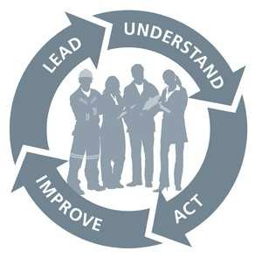

Strategic Projects & Continuous Improvement

**Revised Science Leader role**

ARI has entered into an arrangement with La Trobe University to employ a Research Professor to lead Science at ARI. The role will provide professional leadership in science and conduct internationally recognised research. They will manage processes to advance ARI's research capability; develop strategic alliances and partnerships; be responsible for setting science quality standards and developing strategies to enable staff to consistently achieve excellence in science. This role will lead ecological research that directly influences government policy and management decisions.

**Safety & Wellbeing and Risk Management**

DEPI is required under the *Occupational Health & Safety Act 2004* to provide and maintain, as far as practicable, a work environment that is safe and without risks. Employees also have obligations in relation to their own health and safety and the safety of others under the Act. With large amounts of field and laboratory work, ARI ensures it has systems in place to meet its obligations. In 2014/15 the Institute will undertake significant safety related training for first aid, coxswain training and safety leadership. It will also review its record keeping, to

make training information more accessible to management and staff. The Institute will also continue to manage risks listed in the Department’s Risk Register.

**Improvement to Management Information Systems**

Work will continue on improving information available to management.

•

Enhancements to our FTE tracking systems will be implemented to allow Program

and Section Leaders a snapshot of staff utilisation and coverage;

The Publications database, redesigned in 2013/14, will be further enhanced to ensure all publications, media items and presentations are recorded and reported on accurately. This will further aid BP3 reporting;

A new Training needs database will be implemented;

Regular budget sessions for leaders will be held throughout the year.

•

•

•

P a g e | 16

The Year Ahead

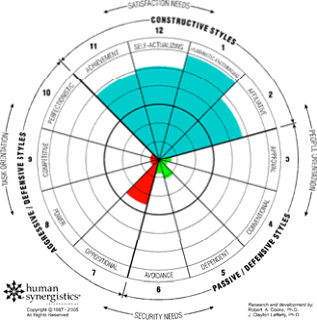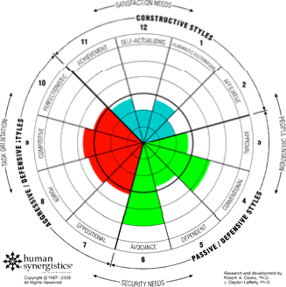

Strategic Projects & Continuous Improvement

**Continued work on the Organisational Cultural Index**

ARI will continue implementing actions that contribute to building ‘constructive’ cultural styles that will move the Institute more towards its desired culture, centred around achievement, affiliation, encouragement and self-worth. Defensive styles such as avoidance, aggression, convention and opposition should reduce. The Management Committee will oversee the implementation of ideas, initiatives and behaviours from all levels of the Institute. The OCI focus will remain throughout 2014/15.

**Current Culture**

**Preferred Culture**

A number of early initiatives have been implemented. These include:

•

A ‘bottom up’ project being undertaken by Science A and Science B staff to further

clarify capabilities, expectations and performance levels. Their findings will feed into performance plans (ePPs) and classification revisions;

The Innovation Café - a regular forum for Science staff to discuss ideas, themes and projects in an unstructured environment.

•

**DEPI Science Strategy & Principles of Outsourcing**

The Institute should also benefit this year from the launch by the DEPI Secretary, Adam Fennessy of the Department’s Science Strategy. Institute staff had input to the strategy, particularly in constructing outsourcing principles, with an emphasis on ensuring our status as a preferred provider of ecological research. As a result, the principle that “DEPI science investors give internal capability priority where it meets the requirements of the investment” is included. ARI is also recognised as a research service provider for 2014/15 under an AusIndustry initiative.

P a g e | 17

The Year Ahead



2014-15 Science Projects

**Internal Clients**

ARI forms part of the Environment & Landscape Performance Division (ELP) of DEPI and receives funding for key projects from ELP. The ‘core funding’ component of this funding ($0.75m) covers biodiversity research management and gives the Department some access to scientists for advice and work on divisional projects. It also includes costs associated with the Animal Ethics Committee, Threatened Species including VBA ($0.32m) and NaturePrint ($0.68m).

**Victorian Environmental Partnership Program (VEPP)**

ARI received funding for research as part of Streams 2 and 3 of the State Government’s Victorian Environmental Partnership Program (VEPP) (Table 6). For 2014/15, a total of

$1.157m (including $0.07m carry over) has been invested for threatened species and native vegetation monitoring research.

**Table 6 - VEPP Projects**

P a g e | 18

**2014-15**

**Stream 2**

**Stream 3**

Heath Skink

$ 31,000

$ 10,000

Plains Wanderer

$ 18,000

$ 10,000

Hooded Scaly-foot

$ 126,000

$ 18,000

Protection of spawning habitat for Australian Whitebait

$ 65,000

Reducing predation and competition pressure on the endangered Trout Cod

$ 7,000

Galaxiid Conservation Projects

$ 170,000

$ 25,000

Fox predation of turtle nests

$ 12,000

$ 7,620

Low Flow Status of Pygmy Perch

$ 53,000

Caladenia Orchid

$ 31,000

Threatened Species - Management & Governance

$ 75,807

Helmeted Honey Eater

$ 12,000

Southern Shepherd's Purse

$ 10,683

Mallee Woodpeckers

$ 10,000

Native Vegetation Monitoring - including Management & Governance

$ 465,000

Total

$ 482,000

$ 675,110

The Year Ahead



2014-15 Science Projects

**External Clients**

The Institute receives funding for projects throughout the year. Traditionally, external funding comes from other State agencies including CMAs, the Commonwealth, other research institutions and the private sector. At the time of writing, over a third of the required external revenue had been secured. Significant contracts are shown in Table 7.

Environment (Federal)

Environmental Water

Associates

**Table 7 - External Projects**

P a g e | 19

**ARI Secured Projects 2014-15**

**Investor**

Helping Victorian recreational fishers habitat

Department of the

Managing fire to protect biodiversity, carbon and build resilient landscapes.

Department of the Environment (Federal)

Response of fish to commonwealth environmental water delivery in Goulburn River and Broken Creek

Commonwealth

Office

Snowy Project - eFlow Monitoring & Assessment Project

CMA East Gippsland

Yarra Bunyip Grayling eFlows Project

Melbourne Water

Snowy Project - Wetland Inventory & Assessment

CMA East Gippsland

Sugarloaf Pipeline Project, Bandicoot crossing Monitoring

Melbourne Water

Foothill Bushfire CRC

Bushfire CRC

Aquatic Health Monitoring Project

Murray Local Land Services

Yarra4Life

CMA Port Phillip & Westernport

Assessment of the Dights Falls Vertical Slot Fishway

Melbourne Water

Golden Perch System Scale Project

Sardi

Gladstone Port UniQuest Shorebirds

UniQuest Pty Ltd

Habitat mapping in the Gunbower Creek

CMA North Central

Mitigating Carp Responses to Environmental Watering

Murray Local Land Services

PIT reader upgrade

MDBA

Anglesea River Fish Response to Habitat Restoration

CMA Corrangamite

Condition Assessment Method for Groundwater Dependent Ecosystem Wetlands

Melbourne Water

Broken River EWP

Peter Cottingham &

Hattah - Kulkyne Ramsar Protection

CMA Mallee

Extinction of Turtles in the Murray River

Parks Victoria

The Year Ahead

**Table 7 - External projects**



InterPlan©

ARI will report progress monthly through InterPlan©, the Department’s business planning reporting system. The Institute has been assigned six actions and 17 tasks in 2014/15 (Table 8). Monthly progress reports will be circulated to the Divisional Executive and copied to ARI Management.

Senior staff are allocated reporting responsibilities, coordinated through the administration

team.

**Table 8 – InterPlan Actions and Tasks**

P a g e | 20

**Action**

**Task**

**5.3.1.5 Deliver the ARI component of the Victorian Environmental Partnerships Program**

ARI Monthly Reporting – Stream 2

ARI Monthly Reporting – Stream 3

**5.4.5.4 Provide biodiversity research management &**

**science support to Environment Landscape and**

**Performance Division**

Deliver ARI’s Operational Plan and Research Strategy

Complete Melbourne Strategic Assessment science tasks

Implement Leadbeater’s Possum Advisory Group science recommendations

Provide expert review of new data added to the Victorian Biodiversity Atlas

Nature Print – Delivery of spatial models

Deliver Biodiversity and Fire scientific services

Completed Action Statements and Bayesian Models for recovering Threatened Species and Communities.

**5.4.5.5 Provide biodiversity research**

**& science support to non-DEPI agencies**

Complete externally funded scientific services on budget and on time

**5.4.5.2 Provide biodiversity research**

**& science support to**

**Water and Natural Resources Group**

Deliver on agreements with the Water and Natural Resources group

**5.4.5.1 Provide biodiversity research**

**& science support to Biosecurity Victoria**

Deliver Deer Distributions Project

Deliver Density of Wild Dogs project

Deliver Strategic Rabbit Management Project

Deliver Dogs and Large Herbivores Project

**5.4.5.3 Provide biodiversity research**

**& science support to Land, Fire and Environment group**

Conduct summer waterfowl count (if funded)

Undertake reassessment of bird and flora surveys at various landscape mosaic burning regions (4 separate agreements)

Monitoring Performance

Performance and KPIs



**Client Surveys 2014/15**

The highly successful client survey introduced in 2013/14 will be repeated in September

2014. A cross section of clients will be surveyed on criteria including relationships with ARI, types of research required, overall satisfaction and the impact of research on client decision making, policy development or on ground actions.

Performance information will be broken down into key areas that cover value for money,

project management, administration, communication and output quality.

Survey results are used to guide improvement, address specific issues and share our

capability.

**Publication and other KPIs**

The Institute’s performance can be measured across a number of parameters relating to science, project delivery, finance and staffing (Table 9). Whilst some are published, most will be used internally.

ARI has one KPI listed in the State’s Budget Paper 3 (BP3) relating to publications. Being a

research institution, this measure is a key indicator of the quality of our science and the way it is received in the academic community.

**Table 9 - 2014/15 KPIs**

Additional KPI’s may be identified throughout the year.

P a g e | 21

**Indicator**

**Measure**

**2014-15 Target**

Presentations made and scientific publications in peer reviewed journals (BP3)

Number

60+

External Funding Secured

$m

6.07

Client Satisfaction – Overall

% Good or better

90

Client Satisfaction – Value for Money

% Good or better

80

Client Satisfaction – Science Quality

% Good or better

90

Project delivery

Milestones met within 30 days (%)

85

Field Trips conducted with up to date Job Safety Plans

%

100

Monitoring Performance



Selected ARI publications in prominent journals from 2013/14

Heard, G.W**., Scroggie, M.P., Clemann, N., Ramsey, D.S.L.** (2014) Wetland characteristics

influence disease risk for an endangered amphibian. Ecological Applications, Volume 24, Issue 4, 650-662.

Pavlova, A., Selwood, P., Harrisson, K.A., Murray, N., Quin, B., **Menkhorst, P.,** Smales, I., Sunnucks, P. (2014) Integrating hylogeography and morphometrics to assess conservation merits and inform conservation strategies for an endangered subspecies of a common bird species. Biological Conservation, Volume 174, 136-146.

Choquenot, D., **Forsyth, D.M.** (2013) Exploitation ecosystems and trophic cascades in non- equilibrium systems: modelling vegetation - red kangaroo - dingo interactions in arid Australia.

Oikos, Volume 122, Issue 9

, 1292-1306.

**Forsyth, D.M., Woodford, L., Moloney, P.D.,** Hampton, J.O., Woolnough, A.P., Tucker, M.

(2014) How Does a Carnivore Guild Utilise a Substantial but Unpredictable Anthropogenic Food Source? Scavenging on Hunter-Shot Ungulate Carcasses by Wild Dogs/ Dingoes, Red Foxes and Feral Cats in South-Eastern Australia Revealed by Camera Traps. PLOS One, Online.

**Koster, W.M. , Dawson, D.R., O'Mahony, D.J., Moloney, P.D., Crook, D.A.** (2014) Timing, frequency and environmental conditions associated with mainstem-tributary movement by a lowland river fish, golden perch (Macquaria ambigua). PLOS One, Volume 9, Issue 5.

**Duncan, D.H.,** Kyle, G., Morries, W.K., Smith, F.P. (2014) Public investment does not crowd out private supply of environmental goods on private land. Journal of environmental management, Volume 136, Issue 1, 94-102.

**Kitchingman, A., Tonkin Z., Lyon J.** (2013) A novel approach to spatially assessing instream woody habitat densities across large areas. Journal of environmental management, Volume 128, 555-460.

Griffiths, S.R., Donato, D.B., **Lumsden, L.F.,** Coulson, G. (2014) Hypersalinity reduces the risk of cyanide toxicosis to insectivorous bats interacting with wastewater impoundments at gold mines. Ecotoxicology and environmental safety, Volume 99, 28-34.

**Beesley, L., King, A.J.,** Gawne, B., **Koehn**, J.D., Price, A., Nielsen, D., **Amtstaetter, F.,** Meredith,

S.N. (2014) Optimising environmental watering of floodplain wetlands for fish. Freshwater Biology, Volume 59, Issue 10, 2024–2037.

Hammer, M., Unmack, P., Adams, M., **Raadik, T.A.,** Johnson, J**.** (2014) A multi-gene molecular assessment of cryptic biodiversity in the iconic freshwater blackfishes (Teleostei: Percichthyidae: Gadopsis) of southeastern Australia. Biological Journal of the Linnean Society, Volume 111, Issue 3, 521-540.

P a g e | 22

Significant Published Articles



Photograph acknowledgements - Cover

P a g e | 23

**Photograph**

**Source**

Traversing the Deep Creek Track near Walhalla, VIC

DEPI File Photo

Post fire re-growth, Hotspur State Forest, VIC

DEPI File Photo

A drop gate regulating structure near Fat Cow Creek, VIC

DEPI File Photo

Juvenile Hooded Scaly-foot (*Pygopus nigriceps*) west of Kerang, VIC

Geoff Brown

Radio-tracking Smoky Mice near Mt Terrible, VIC

Peter Menkhorst

Murray Hardyhead (*Craterocephalus fluviatilis*) near Kerang, VIC

Tarmo A Raadik

Growling Grass Frog (*Litoria raniformis*) near Kerang, VIC

Nick Clemann

Acknowledgements

Photos



P a g e | 24

Published by the Department of Environment and Primary Industries Arthur Rylah Institute for Environmental Research

123 Brown Street Heidelberg VIC 3084

+61 (03) 9450 8600

[www.depi.vic.gov.au/ari](http://www.depi.vic.gov.au/ari)