|  |
| --- |
| Impacts of Pigs in Wetlands |
| Fact Sheet 3 |

## Victorian distribution

Feral Pigs (*Sus scrofa*) have been present in Australia since early settlement. While they occur in all states and territories, they are most abundant in New South Wales and Queensland and are absent from large areas of the arid and semi-arid interior1.

Feral Pigs were likely to have been deliberately released in Victoria, and they have only become an issue in the State since the early 1960s. Pigs, which escape from domestic populations and illegal releases for recreational hunting can also add to feral populations.

Our understanding of the distribution and abundance of feral Pigs in the State is incomplete and under reporting is likely. Isolated populations are known along the Murray River, near Mansfield, Kinglake, the Grampians and Lancefield. The presence of Pigs in particular areas can also be quite transient.

## Biology

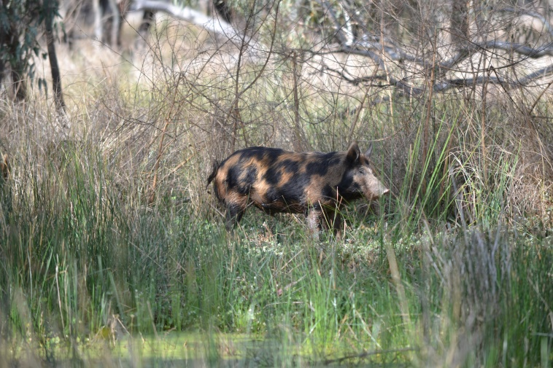Pigs have many characteristics that make them a successful invader; they are highly fertile, tolerant to a range of environmental conditions and have an opportunistic omnivorous diet2.

Feral Pigs vary in size, shape and colour, although they tend to be smaller, leaner and more muscular than domestic Pigs1. Males are typically longer, taller and heavier than females. While size can vary significantly, males usually range up to 115 kg and females up to 75 kg1.

Animals tend to live for less than five years. Mortality of young in the first year is generally high, particularly when conditions are poor. Young Pigs can be vulnerable to predation by Dingos, Wild Dogs and large birds of prey.

Sows make nests of vegetation, usually within 2 km of water. Females can breed by one year of age and litters usually comprise 5-6 Piglets, which are weaned after 2-3 months. If adequate food and water is available, Pigs may breed throughout the year3.

Pigs have a well-developed sense of smell and hearing which can aid in food detection and in predator evasion4.

Feral Pigs may occur in a group (mob), with related females and their young. Bachelor mobs may also form, although by 18 months, males tend to become more solitary, unless they are mating5.

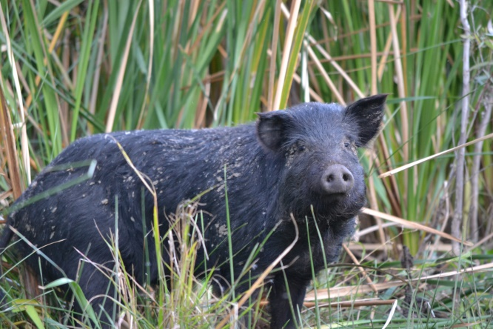

Figure 1: Feral Pigs can cause significant damage to the environment (Photo: Jason Wishart, IACRC).

## Diet

Feral Pigs are opportunistic omnivores, and their diet varies according to the seasonal availability of resources. They show a preference for succulent green vegetation, although they will eat fruit and seeds, foliage and stems, rhizomes, bulbs, tubers and fungi. They also eat a wide range of animal material including invertebrates, fish, frogs, reptiles, birds, eggs, mice, young rabbits, lambs and other small mammals and carrion1. Plant matter comprises the majority of their diet2.

## Habitats

Feral Pigs occur in a wide range of habitats and are considered habitat generalists. Key factors that influence their presence however are their limited tolerance to heat, and associated need for daily water and dense vegetation1. They are restricted largely to watercourses and floodplains in inland or seasonally dry parts of Australia6. They prefer moist areas with reliable and sufficient food supplies, water, shelter and protection from temperature extremes.

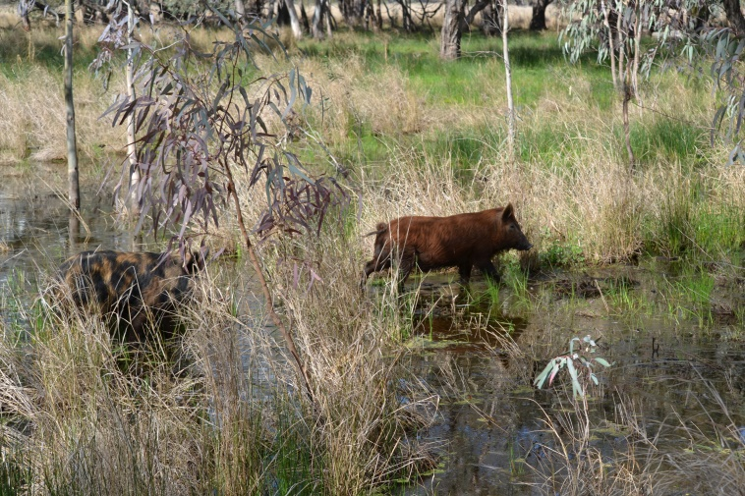Figure 2: Feral Pigs are often found close to water sources (Photo: Jason Wishart, IACRC).

## Home ranges and abundance

Feral Pigs have a defined home range and commonly follow distinct trails between areas they require for shelter, food and water5. The size of home ranges can vary widely, depending on gender, habitat, weather and availability of resources.

Males tend to have larger home ranges than females7. Under typical conditions, a male home range is 10-50 km2, a dry sow 10-20 km2 and a lactating sow >5 km2(5). While animals can migrate significant distances, daily movements are generally quite small.

Population densities can reach at least 10-20/km in wetlands, floodplains and watercourses6.

## Impacts

Feral Pigs can cause significant environmental and economic impacts8,1.

Environmental impacts may occur when feral Pigs:

* modify and degrade habitats and native plants through feeding, trampling, rooting and wallowing activity
* prey upon native animals
* compete with native animals
* spread *Phytophthora cinnamomi* (a soil fungus)
* spread exotic diseases.

Economic impacts may occur when feral Pigs:

* prey on lambs
* eat and damage crops and reduce crop yields
* damage fences and water sources
* compete with stock for feed9.

A recent international review summarised the range of impacts of feral Pigs on ecosystems, including the type of evidence (i.e. descriptive or experimental) and the effect2. This review noted that little is known of the indirect effects of Pigs on ecosystem function, and that further work is needed on ecosystem recovery following feral Pig removal.

A review of the impacts and management of feral Pigs in Australia notes that while the species can have detrimental impacts on biodiversity values, ecosystem functioning and agricultural production, many of these impacts are poorly described, and highly variable8.The tropical north of Australia, and the high country on the south east have been the focus of most research on the impacts of Pigs.

There has been some work to estimate the economic impact of feral Pigs in Australia. One study estimated their total annual impact in Australia to be $106.5 million, although this only estimated the costs through reduced agricultural production, principally in the sheep and cattle industries6. The potential for Pigs to harbour Foot and Mouth disease could result in substantial losses in export revenue (i.e. >$9 billion) 3.

The draft National Threat Abatement Plan for predation, habitat degradation, competition and disease transmission summarises impacts in different regions of Australia1.

## Impacts on wetlands

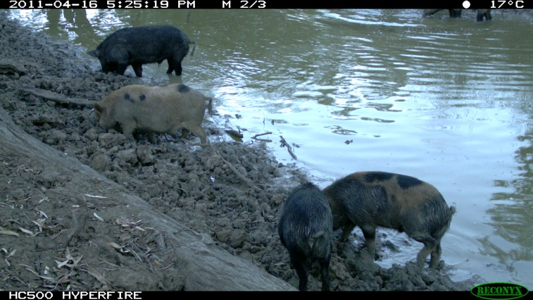Given the preference of Pigs to live in moist areas and dense vegetation, wetlands are particularly vulnerable to damage by Pigs. When wetlands begin to dry out, Pigs can become concentrated around the water source, thus focussing the damage within an even smaller area.

Those species and communities which are wetland specialists, and have restricted distributions, are likely to be particularly vulnerable to localised, significant damage by Pigs. Species which are immobile and have stages in their lifecycle which are undefended may also be at significant risk8.

In Australia, Pigs have been observed to impact many types of wetlands including marshes, swamps, creeklines, floodplain wetlands and drainage lines in tropical and temperate areas and marshes and meadows in alpine and sub-alpine areas1.

It is important to take into account the other disturbances that may be occurring in an ecosystem, when assessing the impacts of Pigs10. For example, climatic conditions (i.e. flooding, drought, rainfall variability) can exacerbate the influence of feral Pigs11.

## Impacts on fauna

Feral Pigs have been identified as a threat to about 40 threatened species listed under the *Environment Protection and Biodiversity Conservation Act* 19991, although few of these occur in Victoria and none are wetland specialist species.

Fauna species which are predominantly ground dwelling, such as frogs and turtles, are particularly vulnerable to damage caused by digging Pigs3. The foraging behaviour of Pigs can degrade aquatic habitats that can subsequently impact associated fauna species.

There are examples of feral Pigs preying upon both freshwater and marine turtle species. Due to Pigs, there was a loss of 96% of Northern Longneck Turtles at a freshwater ephemeral wetland in northern Australia12, and 89.6% loss of nests of three threatened marine turtle species along the coast of Cape York Peninsula13. Pig damage was clustered in a small number of sites where the majority of nests were eaten, by a small number of individuals. These distinct feeding zones adjoined freshwater swamps.

Competition for food resources between Pigs and some native species has been suggested as a potential issue i.e. threatened potoroos and bettongs (subterranean fungi), Brolgas and Magpie Geese (tubers and bulbs), and Cassowaries (fallen rainforest fruit). The significance of competition however is unquantified8.

Figure 3: Feral Pigs can significantly modify and degrade wetlands (Photo: Jason Wishart IACRC).

## Impacts on native plants

Feral Pigs can change the structure and composition of vegetation communities, reduce plant species diversity, reduce recruitment and survival through rooting and trampling and selective feeding, spread weeds and pathogens, and change nutrient cycles2,8. Many of the studies which describe these impacts are however observational8.

Impacts may vary with plant communities, with some communities more resilient to Pig disturbance. Widespread, generalist plant species are less likely to experience significant impacts from ground disturbance, which often occurs in distinct areas8. Conversely, populations of wetland specialists with limited distributions are likely to be impacted.

The impact on particular plant species is not well understood9. Feeding on fruits and seeds may affect the survival of particular species when it leads to mortality of seeds. Some studies have suggested impacts may be greater on species with ﬂeshy roots or corms2. A study of Pig foraging in ephemeral floodplain lagoons on Cape York found that they caused significant damage to aquatic vegetation10,11 through their foraging behaviour.

Disturbance caused by Pigs may also benefit particular plant species2. A recent study in a wet prairie in Florida observed a substantial increase in cover of a perennial plant species which spread by clonal growth and created dense monocultures14.

Feral Pigs have the potential to act as vectors of plant pathogens, including *Phytophthora cinnamomi* (which causes root rot) due to their rooting, wallowing and feeding activities and feeding activity15. Feral Pigs feed on plant material, including wood and underground structures, which are sites of infection with *P.* *cinnamomi.*  A recent study found that Feral Pigs have the ability to transport viable *P. cinnamomi* in their digestive tract15. Another study detected *P. cinnamomi* on Pigs’ hooves16. Since Feral Pigs can travel long distances, this provides significant potential for the pathogen to spread widely.

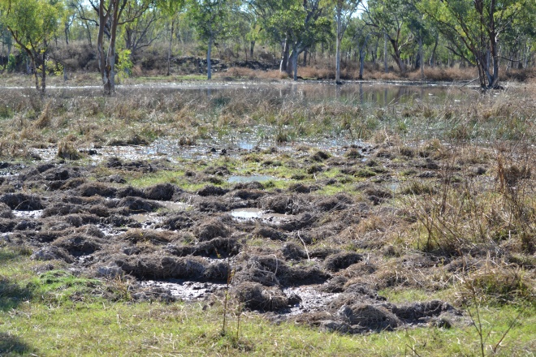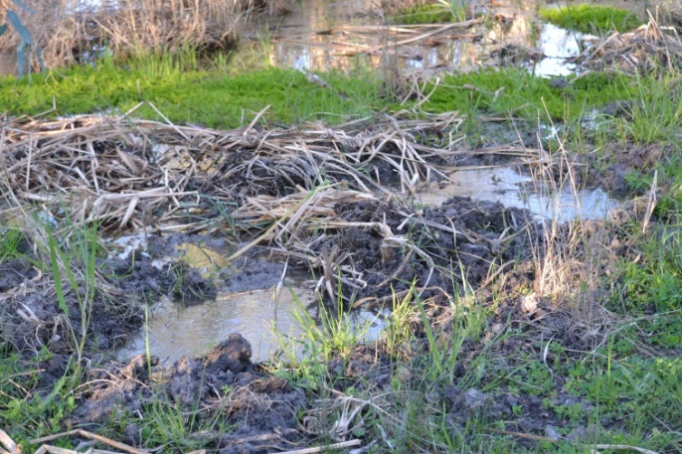

## Impacts on soils and water quality

The rooting behaviour of feral Pigs alters soil structure and processes, although few studies have investigated the inﬂuence on soil properties2. It has been suggested that rooting is comparable to tillage within agricultural activities, which causes increases in nutrient cycling and decomposition rates and increased nutrient loss through leaching2. However, the limited studies show variable results and so no conclusive deductions can be made2.

There are observations that Pigs can increase runoff through the compaction of soils; from wallowing, creation of trails, and trampling of dense vegetation to browse for food and create nests17.

Feral Pigs can foul dams and waterholes through their wallowing and defecation. Few studies have however quantified their impact on water quality. Two studies have compared impacts between fenced and unfenced sites. A study of Pig foraging in an ephemeral floodplain lagoon on Cape York found the destruction of macrophyte communities and disturbance of wetland sediments significantly affected wetland water clarity and caused anaerobic and acidic conditions. The loss of aquatic vegetation and the excretion of Pig waste also resulted in a high level of nutrient enrichment18 which can cause a reduction in plant species richness. An investigation of changes in forested sites in a Hawaiian water catchment showed decreasing soil cover and increasing Total Dissolved Solids in unfenced plots17.

## Disease

Feral Pigs are carriers, either as hosts or vectors, of over 45 different parasites and diseases that may threaten stock, pets, native wildlife and humans3. People may acquire diseases through consumption of pork, or via consumption of water or produce contaminated by feral Pigs1.

Figure 4: Examples of substantial disturbance caused by Pigs within a wetland (Photo: Jason Wishart IACRC).

## Density Thresholds and Impacts

An important component of Integrated Pest Management is managing a species below a predetermined density threshold below which its impacts on environmental values is acceptable19. For some species however, such as Pigs, identifying such a density threshold is problematic. Pig densities can be difficult to estimate and can vary widely across habitats and times of year. The specific impact of Pigs on a different species of fauna may also vary across landscapes and may be influenced by many factors.

The Glovebox Guide for Managing Feral Pigs3 does not recommend the use of Pig numbers as a benchmark for the outcome of control programs, since there is not always a clear correlation between numbers and the extent of damage.

Investigating the particular relationship between Pig density and impacts at a high value site, may be worthwhile if resources are available to undertake comprehensive monitoring. This may identify the minimal level of population control required to maximise impact reduction.

Successful eradication is potentially feasible where populations are isolated, however extensive populations are resilient8.

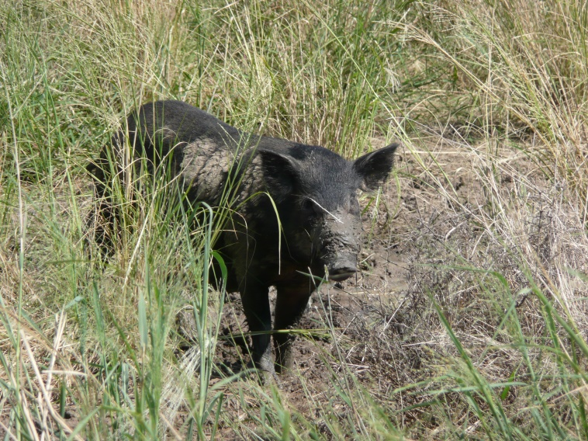

Figure 5: The presence of Pigs is influenced by their limited tolerance to heat, and associated need for daily water and dense vegetation (Photo: Jason Wishart IACRC).

## References

1. Commonwealth of Australia (2015). Draft threat abatement plan for predation, habitat degradation, competition and disease transmission by Feral Pigs (*Sus scrofa*). Commonwealth of Australia 2015.

2. Barrios-Garcia, M. N. and Ballari, S. A. (2012). Impact of wild boar (*Sus scrofa*) in its introduced and native range: A review. *Biological Invasions* **14**, 2283-2300.

3. Koichi K and Halliday D (2015). Glovebox Guide for Managing Feral Pigs. PestSmart Toolkit publication. Invasive Animals Cooperative Research Centre, Canberra, ACT

4. Tisdell, C. A. (1982). Wild Pigs: environmental pest or economic resource? Pergamon Press, Singapore.

5. http://agriculture.vic.gov.au/agriculture/pests-diseases-and-weeds/pest-animals/invasive-animal-management/established-invasive-animals/integrated-feral-Pig-control

6. McLeod, R. (2004). Counting the Cost: Impact of Invasive Animals in Australia 2004. Cooperative Research Centre for Pest Animal Control. Canberra.

7. Dexter, N. (1999). The influence of pasture distribution, temperature and sex on home range size of Feral Pigs in a semi-arid environment. *Wildlife Research* **26**, 755-762.

8. Bengsen, A. J. et al. (2014). Impacts and management of wild Pigs Sus scrofa in Australia. *Mammal Review* **44**, 135-147.

9. Choquenot, D., McIllroy, J. and Korn, T. (1996). Managing vertebrate pests: Feral Pigs. Bureau of Resource Sciences, Canberra, Australia.

10. Mitchell, J. (2010). Experimental research to quantify the environmental impact of feral Pigs within tropical freshwater ecosystems. Final report to the Department of the Environment, Water, Heritage and the Arts, Canberra, Australia.

11. Doupe, R. G. et al. (2010). Efficacy of exclusion fencing to protect ephemeral floodplain lagoon habitats from feral Pigs (*Sus scrofa*). *Wetlands Ecology Management* **18**, 69-78.

12. Fordham D, Georges A, Brook B (2008). Indigenous harvest, exotic Pig predation and local persistence of a long-lived vertebrate: managing a tropical freshwater turtle for sustainability and conservation. *The Journal of Applied Ecology* **45**, 52–62.

13. Whytlaw, P, A. Edwards, W., and Congdon, B. C. (2013). Marine turtle nest depredation by Feral Pigs (*Sus scrofa*) on the Western Cape York Peninsula, Australia: implications for management. *Wildlife Research* **40**, 377-384.

14. Boughton, E. H. and Boughton, R. K. (2014). Modification by an invasive ecosystem engineer shifts a wet prairie to a monotypic stand. *Biological Invasions* **16**, 2105–2114.

15. Li, A. Y. et al. (2014). Potential for dissemination of *Phytophthora cinnamomi* by Feral Pigs via ingestion of infected plant material. *Biological Invasions* **16**, 765-774.

16. Kliejunas, J. T. and Ko, W. H. (1976). Dispersal of *Phytophthora cinnamomi* on the Island of Hawaii. *Phytopathology* **66**, 457-460.

17. Browning, C. A. (2008). A preliminary examination of the effects of Feral Pigs Sus scrofa on water quality and soil loss within a Hawaiian watershed. MSc in Natural Resources and Environment, University of Hawaií.

18 Doupe, R. G. et al. (2009). A description of freshwater turtle habitat destruction by feral Pigs in tropical north-eastern Australia. *Herpetological Conservation and Biology* **4(3),** 331-339.

19, Braysher, M. and Saunders, G. (2003). PESTPLAN – a guide to setting priorities and developing a management plan for pest animals. Bureau of Rural Sciences and the National Heritage Trust, Canberra, ACT.

Websites

Department of Economic Development, Jobs, Transport and Resources - <http://agriculture.vic.gov.au/agriculture/pests-diseases-and-weeds/pest-animals/a-z-of-pest-animals/pig-feral-or-wild>

Invasive Animal CRC -

[http://www.pestsmart.org.au/pest-animal-species/feral-Pig/](http://www.pestsmart.org.au/pest-animal-species/feral-Pig/ )

|  |  |
| --- | --- |
| © The State of Victoria Department of Environment, Land, Water and Planning 2017  LogoThis work is licensed under a Creative Commons Attribution 4.0 International licence. You are free to re-use the work under that licence, on the condition that you credit the State of Victoria as author. The licence does not apply to any images, photographs or branding, including the Victorian Coat of Arms, the Victorian Government logo and the Department of Environment, Land, Water and Planning (DELWP) logo. To view a copy of this licence, visit http://creativecommons.org/licenses/by/4.0/  ISBN 978-1-76047-422-5 (print)  ISBN 978-1-76047-423-2 (pdf)  Disclaimer  This publication may be of assistance to you but the State of Victoria and its employees do not guarantee that the publication is without flaw of any kind or is wholly appropriate for your particular purposes and therefore disclaims all liability for any error, loss or other consequence which may arise from you relying on any information in this publication. | Accessibility  If you would like to receive this publication in an alternative format, please telephone the DELWP Customer Service Centre on 136186, email [customer.service@delwp.vic.gov.au](mailto:customer.service@delwp.vic.gov.au) or via the National Relay Service on 133 677 [www.relayservice.com.au](http://www.relayservice.com.au). This document is also available on the internet at [www.delwp.vic.gov.au](http://www.delwp.vic.gov.au). |