Aquatic Quarterly Update

Summer 2024-25



**About us**

The Arthur Rylah Institute for Environmental Research aims to generate and share knowledge, through world-class, applied, ecological research. This research supports and guides sustainable ecosystem policy and management to ensure healthy, resilient ecosystems. We work collaboratively with national, state and local agencies, research institutes, universities, interest groups and the community.

**Long-term fish data guides water management in our rivers**

As part of a large-scale project to evaluate trends in fish populations, ARI has undertaken the most comprehensive assessment of the long-term changes in fish populations in Victoria. Over 20 years of fish monitoring data across 26 Victorian waterways were combined to identify long-term trends in native fish abundance and recruitment. It focused on 18 native fish species of conservation, cultural and recreational value.

Most species declined in abundance during the 2000-2010 period (Millennium Drought), followed by increasing trends. In coastal Victoria, this trend was most notable for Short- and Long-finned Eels, Common Galaxias, River Blackfish, Tupong and Australian Grayling. In northern rivers, increases were most notable for Murray Cod, Trout Cod, Golden Perch and Macquarie Perch. In contrast, there were mixed trends for Unspecked Hardyhead, Silver Perch, Murray-Darling Rainbowfish and Two-spined Blackfish since 2010, with catch-per-unit-effort (CPUE) estimates in 2023 being similar to, or lower than, those in 2010.

We now have significant insights into the trends in fish populations and the influence of environmental factors, including aspects of flow regimes. Short-term patterns of fish recruitment, survival and distribution were identified, which can be linked to flow events and seasonal flow regimes.

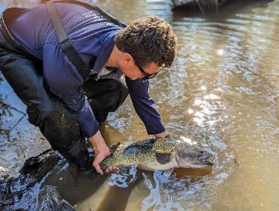This work gives waterway managers information to guide annual and long-term water management planning. Detailed recommendations were developed together with waterway managers for specific river reaches and fish species. For some river systems with Environmental Water Reserves, advice was provided about where current flow recommendations could be maintained and reviewed. Managers also now have the data to track progress in achieving key objectives of maintaining or improving native fish populations within waterway management strategies and Environmental Water Management Plans.

*Releasing a Murray Cod*

The project was funded under the Victorian Environmental Flows Monitoring and Assessment Program ([VEFMAP](https://www.ari.vic.gov.au/research/rivers-and-estuaries/assessing-benefits-of-water-for-the-environment)).

**News**

**New research demonstrates the importance of multiple interventions in restoring degraded floodplain wetlands.**

Just one year after the [Wetland Revival Trust](https://wetlandrevivaltrust.org/) (WRT) began restoring wetlands on farms along the lower Loddon River floodplain, the results have been incredible! The WRT aims to improve drought resilience and create drought refuges for threatened flora and fauna. By delivering water for the environment in combination with revegetation and livestock exclusion, these wetlands have been transformed. Previously in poor condition, these wetlands are now diverse in inundationtolerant native vegetation including several endangered plant species listed under the Flora and Fauna Guarantee Act (1988).

Before restoration began, ARI surveyed four wetland sites in 2023 that were targeted for restoration along with matching ‘control’ (unrestored) sites. This initial monitoring found that the vegetation was degraded at all sites, with limited ground layer vegetation and a dominance of terrestrial plant species.

Surveys repeated one year later found that restoration actions were successful in achieving the following vegetation goals:

1. An improvement in the abundance of native wetland plants

2. An increase in native species diversity.

In contrast, no improvement was found at control sites, despite some natural flooding.

Wetland restoration projects rarely evaluate ecological outcomes, with most reporting only on the delivery of on ground management actions. This project applied a rigorous monitoring design to support adaptive management and learning and help build confidence in restoration programs.

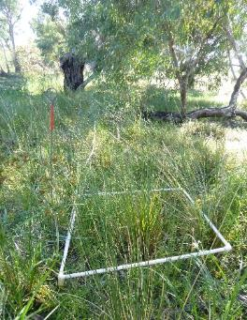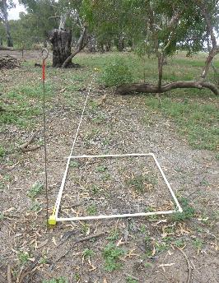

The project was a collaboration between the WRT, local farmers, local Traditional Owners, Deakin University, ARI, the MurrayDarling Wetland Working Group and the North Central Catchment Management Authority. The Australian Government’s Future Drought Fund provided funding.

*River Red Gum dominated Intermittent Swampy Woodland on Canary Island (Before and after).*

**Native Fish Report Cards**

The 2024 [Native Fish Report Cards](https://www.ari.vic.gov.au/research/field-techniques-and-monitoring/native-fish-report-card-program) (NFRC) are available, summarising the results of annual fish surveys of 10 priority rivers. They provide insights on the status of fish populations and inform future management actions. Focusing on target species (i.e. those with high conservation and/or recreational value), they note whether there’s been recent recruitment, and presence of multiple size classes and mature fish in the population. Brief information about the fish community within each river is also provided.

Notable findings this year include:

* Bony Bream detected in the Ovens River for the first time since 2012.
* The nationally threatened Australian Grayling was recorded in the Mitchell, Yarra, Thomson and Macalister rivers again, and in the Gellibrand River for the fourth time by NFRC and the sixth time on record.
* The Victorian threatened Cox’s Gudgeon was recorded in the Mitchell River again.

**Conservation Hatchery – achievements so far**

The 10inTEN program aims to reduce the extinction risk of 10 species in ten years using conservation stockings and translocations, along with other management interventions. So far, the program has facilitated the construction of Victoria’s first conservation facility at the Snobs Creek Hatchery, which opened in May 2024. There is already much to celebrate, including some world-first captive breeding successes. Highlights include:

• Critically endangered Moroka Galaxias and McDowall’s Galaxias have successfully bred at the hatchery and released.

• Vulnerable Flathead Galaxias have successfully bred with a spawning trial in its initial phase.

• Critically endangered West Gippsland Galaxias have been collected and breeding is planned for this year.

• Endangered South Gippsland Spiny Crayfish have moulted and are ready for breeding – plus it was discovered that they fluoresce under UV light!

• Endangered Southern Purplespotted Gudgeon juveniles have been released into ‘surrogacy’ dams.

• River Blackfish – a breeding trial has begun with broodstock collected from the Wimmera catchment in conjunction with Wimmera Catchment Management Authority and the Barengi Gagjin Land Council.

• Critically endangered Glenelg Freshwater Mussels have been collected from the wild and captive breeding is underway in conjunction with Glenelg Hopkins Catchment Management Authority under a program funded by the Australia Government’s Threatened Species Action Plan.

Many other species of threatened freshwater fish, crayfish and mussel could be bred in captivity in the future. This depends on funding support, input from stakeholders and collaboration with agencies involved in broader rehabilitation actions.

For further information, check out this video [10inTen - Recovering Victoria’s Most Threatened Aquatic Species](https://www.youtube.com/watch?v=NKI_tH3k4wY), as well as ARI’s website [10inTen](https://www.ari.vic.gov.au/research/threatened-plants-and-animals/a-conservation-hatchery), and [Conservation Hatchery – VFA](https://vfa.vic.gov.au/education/conservation-hatchery). This work continues to be a collaboration between the VFA and ARI.

*Release of Moroka Galaxias; South Gippsland Spiny Crayfish; Releasing Purple-spotted Gudgeon*

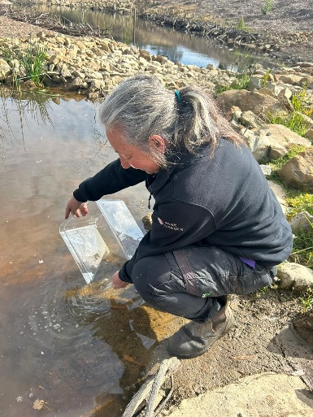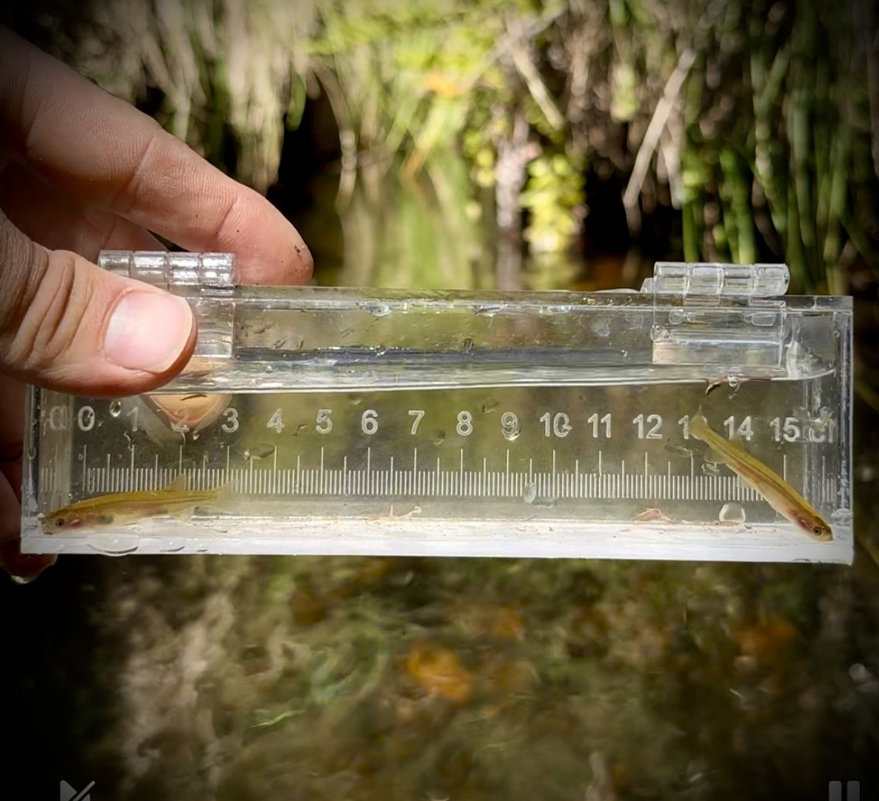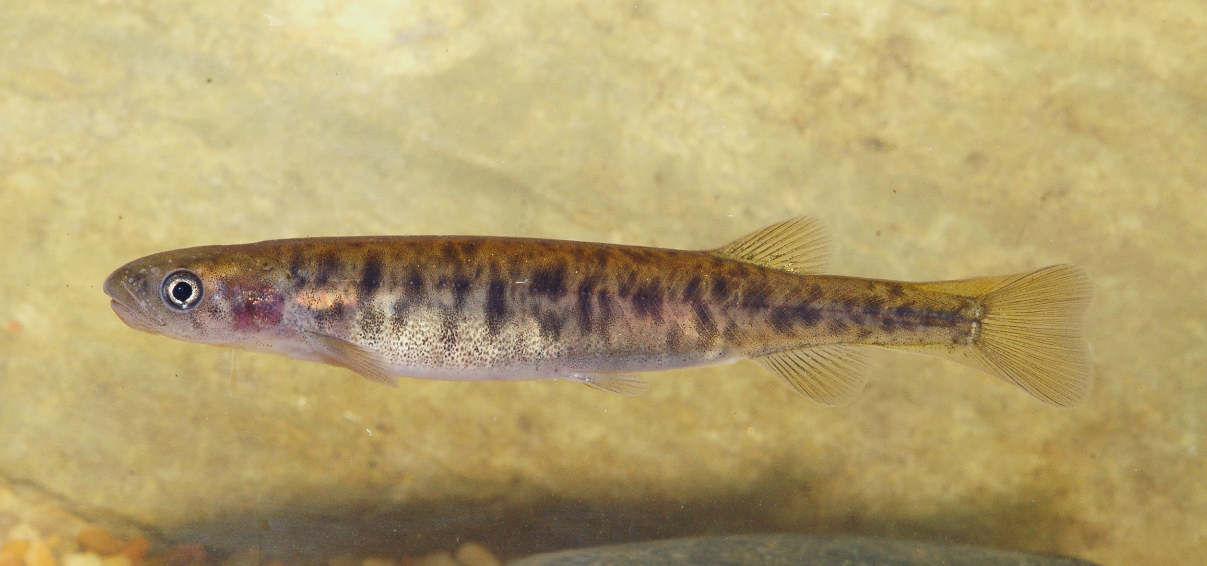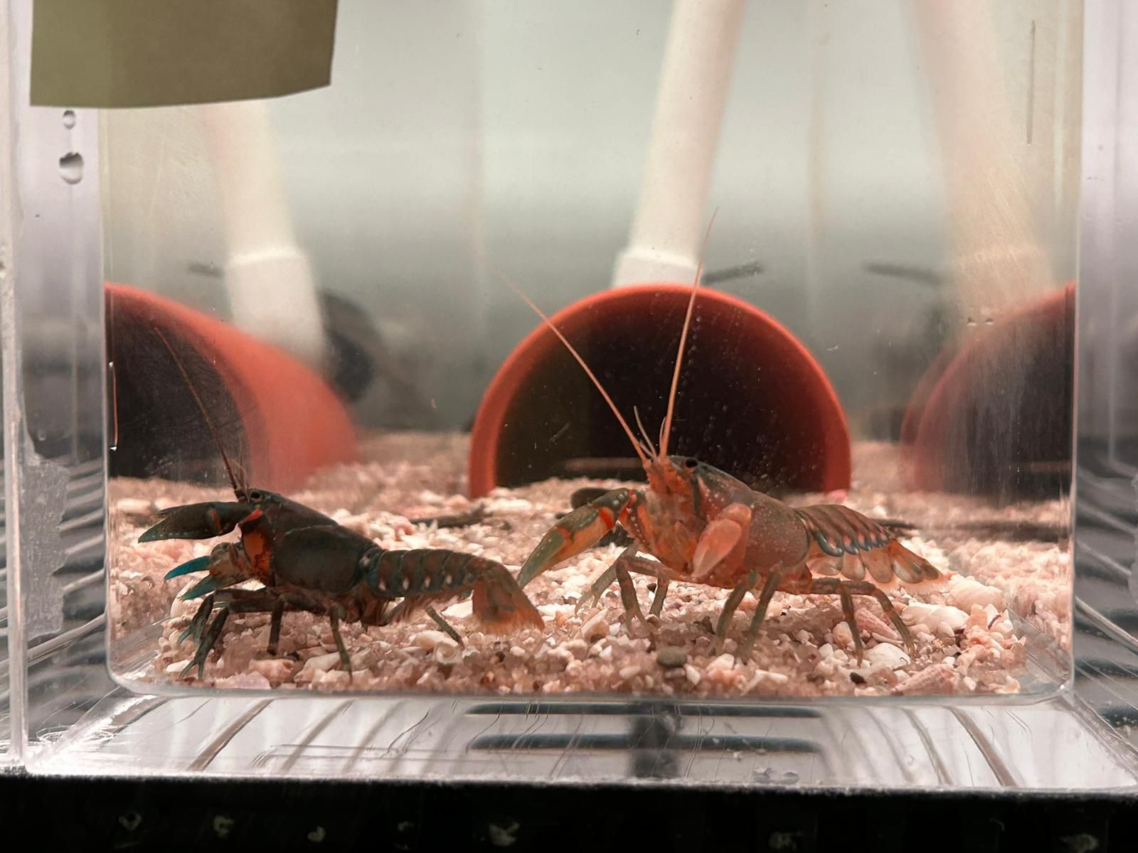

**Flood recovery 18 months on**

Our researchers have assessed the recovery of native fish populations 18 months after the October 2022 flood event in northern Victoria. The flood caused hypoxic water events, causing mass fish kills across multiple waterways. This resulted in declines in the abundance of key native fish species and increases in several non-native species, particularly the invasive Common Carp.

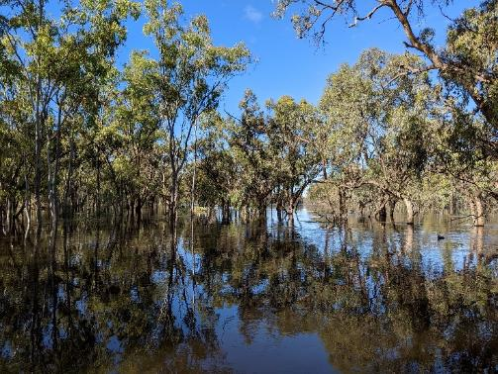We have seen early signs of recovery and resilience of native fish populations. However, the abundances of most species remained below their pre-flood levels and will likely require further management intervention.

If key recovery actions are undertaken, populations are expected to continue recovering over the long term. Recommended targeted management interventions include providing water for the environment, native fish restocking and wider improvements in ecosystem health including Carp removal. Environmental flows can cue fish reproductive processes and promote genetic mixing between populations which helps build resilience in our native fish.

*Flood water on the Murray River near Robinvale*

**Influencing Change**

**A flow in the upper east Moorabool Yaluk (river)**

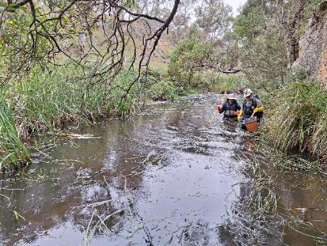In collaboration with Wadawurrung Traditional Owners Aboriginal Corporation (WTOAC) we are looking at the ecological benefits of a Wadawurrung managed flow in the upper east branch of the Moorabool Yaluk (river). This is the first flow for this small catchment. A survey was carried out, focusing on fish, vegetation, frogs, and birds, with WTOAC providing water quality and macroinvertebrate sampling data.

The managed flow event provided significant benefits to water quality and modest short-term benefits to native biota. Continued repeated summer base flows and freshes, particularly in times of drought, will benefit native biota by providing migratory pathways and access to resources. The project has been important to verify the influence of returning flows to the river and to inform future management actions and objectives.

*Survey on the Moorabool Yaluk (river)*

**Waterbird tracking update**

Two more wetland bird species have been successfully captured, tagged and safely released as part of the [waterbird tracking study](https://www.ari.vic.gov.au/__data/assets/pdf_file/0025/612358/WetMAP-Stage-4-Fact-Sheet-Waterbird-tracking.pdf). We are now tracking 35 Sharp-tailed Sandpipers and six Australasian Shovelers.

Tracking these birds will improve our understanding of the links between wetland inundation (by environmental water delivery and natural flooding), waterbird habitats and population outcomes. Priority monitoring questions include the:

• Location of preferred habitats for feeding and breeding at various times of the year

• Timing and main driver of dispersal

• How these patterns vary among individuals.

Managers can use this information to identify and improve valuable habitats to enhance population outcomes for waterbirds. Tagged Brolga continue to provide important movement data to inform watering decisions. Tracks revealed one Brolga nested at Gaynor Swamp and produced two chicks. ARI worked with the Goulburn Broken Catchment Management Authority to ensure prolonged inundation of the wetland and support this exciting breeding event.

This work is part of a wider environmental flow monitoring and assessment program in wetlands, investigating [waterbird habitat requirements](https://www.ari.vic.gov.au/__data/assets/pdf_file/0022/612355/WetMAP-Stage-4-Fact-Sheet-Waterbird-habitat.pdf) and the influence of [seasonality](https://www.ari.vic.gov.au/__data/assets/pdf_file/0024/604752/WetMAP-Stage-4-Fact-Sheet-Seasonality-and-waterbird-abundance.pdf) on waterbirds.

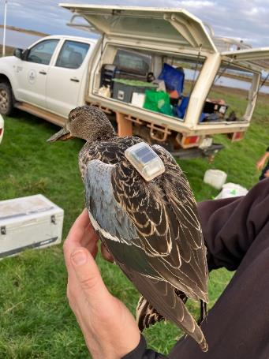

*A tagged Australasian Shoveler; releasing a tagged Sharp-tailed Sandpiper; A tagged Sharp-tailed Sandpiper*

**Publications**

[Booth et al.](https://onlinelibrary.wiley.com/doi/10.1111/mec.17570) (2024) Genomic Vulnerability to Climate Change of an Australian Migratory Freshwater Fish, the Golden Perch (Macquaria ambigua). Molecular Ecology.

[Campbell et al.](https://www.sciencedirect.com/science/article/pii/S1055790324001519?via%3Dihub) (2024) Evolutionary relationships and fine-scale geographic structuring in the temperate percichthyid genus Gadopsis (blackfishes) to support fisheries and conservation management. Molecular Phylogenetics and Evolution.

[Good et al.](https://besjournals.onlinelibrary.wiley.com/doi/10.1111/1365-2664.14718) (2024) A structured approach for building multi-community State and Transition Models to support conservation planning. Journal of Applied Ecology.

[Jense et al.](https://onlinelibrary.wiley.com/doi/10.1002/ece3.11201) (2024) Cryptic diversity within two widespread diadromous freshwater fishes (Teleostei: Galaxiidae). Ecology and Evolution.

[Pavlova et al.](https://www.authorea.com/users/397669/articles/1229900-a-shift-to-metapopulation-genetic-management-for-persistence-of-a-species-threatened-by-fragmentation-the-case-of-an-endangered-australian-freshwater-fish?commit=bfca966dc411176dc8f9569ee3eea3ea8f761af1) (2024) A shift to metapopulation genetic management for persistence of a species threatened by fragmentation: the case of an endangered Australian freshwater fish. Molecular Ecology.

[Raymond et al.](https://onlinelibrary.wiley.com/doi/10.1111/aec.70001) (2024) Farm dams: A valuable interim step in small-bodied threatened fish conservation. Austral Ecology.

[Stuart et al.](https://www.sciencedirect.com/science/article/pii/S0925857424001423) (2024) Rock fishways: Natural designs for an engineered world. Ecological Engineering.

[Todd et al.](https://www.mdpi.com/2410-3888/10/1/22) (2024) A metapopulation model to assess water management impacts on the threatened Australian lungfish, Neoceratodus forsteri. Fishes.

**Knowledge transfer**

**Videos**: [10 in Ten – Recovering Victoria’s most threatened aquatic species](https://www.youtube.com/watch?v=NKI_tH3k4wY&feature=youtu.be); 20 years of [The Living Murray Program in Barmah Forest](https://www.youtube.com/watch?v=NfZUODa_TUA&feature=youtu.be) (GBCMA).

**Presentations**: [ARI seminars](https://www.youtube.com/playlist?list=PLI25liwKHjvW6T26-Y0ITKTsj_madINoj): Listening in: Detecting difficult waterbirds through novel audio analysis techniques (Kulich); Quantifying the ecological impacts of carp in Australia (Fanson); Waterbirds and water for the environment in Victorian wetlands: From local responses to population outcomes (Khwaja).

[UK International Eel Science Symposium](https://ifm.org.uk/wp-content/uploads/2024/04/2nd-Eel-Science-Symp-Programme.pdf): Freshwater and oceanic migrations of Short-finned Eels (*Anguilla australis*) in Australia (Koster). Australian Society for Fish Biology conference: Understanding movement ecology to inform conservation management of freshwater fish (Koster); Setting a trend: Integrating long-term monitoring data to assess trends in riverine fish populations across Victoria (Tonkin); When it rains it pours: Native fish responses to a major flood in a drying climate (Stoios); The 10 in TEN program for recovering our threatened aquatic fauna – an update (Lyon); Basin-scale management of water and fish: Sensitivity analysis to refine a metapopulation model of Golden Perch (Todd).

[Australian Freshwater Sciences Society conference](https://asfb-2023.p.asnevents.com.au/): From Streams to Screens: Mapping threats to platypus to inform management decisions and support population recovery (Hladyz); Changes in wetland vegetation during and after inundation in temporary wetlands: Implications for vegetation monitoring (Vivian).

[Ecological Society of Australia conference](https://kaigi.eventsair.com/QuickEventWebsitePortal/esa2024/esa2024program/Portal/Closed): The future of freshwater fish in the Murray-Darling Basin: Challenges and Opportunities (Lyon); Using near-term forecasts to inform environmental flow deliveries for riverine fish (Yen); From many to one: Aligning vegetarian survey methods within and between major monitoring programs (Jones); From concept to on-ground action: Integrating evolutionary principles into management result in recovery outcomes for an endangered freshwater fish (Tonkin); Resilience of vegetation in long-dry semi-arid floodplains of the southern Murray-Darling Basin and implications for floodplain restoration (Vivian); Optimising water use in a dry country – An analysis of waterbird habitat associations (Kulich); Waterbird seasonality in Victoria (Khwaja); The influence of environmental water and irrigation flows on bank vegetation in a regulated river in south-eastern Australia (Morris).

Community events: [Great Southern Bioblitz](https://www.maroondah.vic.gov.au/Development/Natural-Environment/What-you-can-do-for-Maroondahs-natural-environment/Discovering-nature/The-Great-Southern-Bioblitz/Nature-Discovery-with-a-focus-on-fish) electrofishing demonstration; [Burnanga Indigenous Fishing Club Women’s Fishing Day](https://www.facebook.com/gbcma/posts/pfbid034PGm2wSuaBUpbdf8rvzsvPWfeCA2A1qE2ZPGqC5gj781ZnjeBBiH6m4ubFXDLbBSl) electrofishing demonstration (GBCMA); A selection of work that ARI has been involved in that has also been shared by our collaborators and via news channels: [Conservation Hatchery](https://vfa.vic.gov.au/education/conservation-hatchery), [Australia first for critically endangered Galaxias](https://vfa.vic.gov.au/about/media-releases/australian-first-for-critically-endangered-galaxias), [Talking wild trout](https://vfa.vic.gov.au/about/news/talking-wild-trout-at-free-conference-in-mansfield), [Carp virus](https://www.facebook.com/VictorianFisheries/photos/fishers-asked-for-action-on-carp-were-respondingthe-vfa-is-working-with-the-arth/1040068218162885/) & [South Gippsland Spiny Crayfish](https://www.facebook.com/watch/?v=7883343918420416) (VFA); [Blackfish recovery](https://www.facebook.com/photo/?fbid=1008219094652013&set=a.605986094875317) (WGCMA); [Flatheaded Galaxias recovery](https://www.facebook.com/watch/?v=7883343918420416), [Wetland rehabilitation](https://www.facebook.com/watch/?v=990396382393167) (NCCMA); [Tea Garden Fishway](https://www.facebook.com/northeastcma/posts/pfbid062JcR7TBhWvZrDpUhz5ijLK2LD4pJXZ2eqPzwBaVdRp4Kpt5QLdz6dEkbKpoBeHJl) (NECMA); [Glenelg FW mussels](https://www.facebook.com/watch/?v=8064747963642853) (GHCMA); [Murray Cod](https://www.facebook.com/photo?fbid=966868598810488&set=a.578226367674715) (GBCMA); [Vegetation surveys](https://ccma.vic.gov.au/uncategorized/new-program-monitors-impact-of-environmental-water-releases-on-moorabool-river-vegetation/) (CCMA)

We acknowledge Victorian Traditional Owners and their Elders past and present as the original custodians of Victoria’s land and waters and commit to genuinely partnering with them and Victoria’s Aboriginal community to progress their aspirations.

Logo*© The State of Victoria Department of Energy, Environment and Climate Action 2023. This work is licensed under a Creative Commons Attribution 4.0 International licence. To view a copy of this licence, visit creativecommons.org/licenses/by/4.0/*

*ISSN 2653-8326 - Online (pdf/word)*

Compiled by Lauren Johnson

Further info: research.ari@deeca.vic.gov.au