|  |
| --- |
| Angler scientists helping to measure  how water for the environment benefits fish |
| Program Overview  A Citizen Science project |

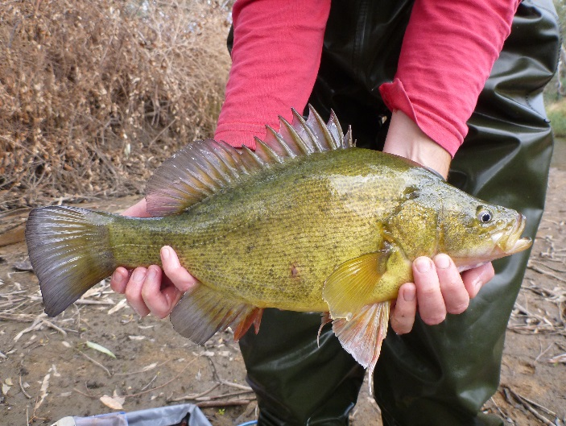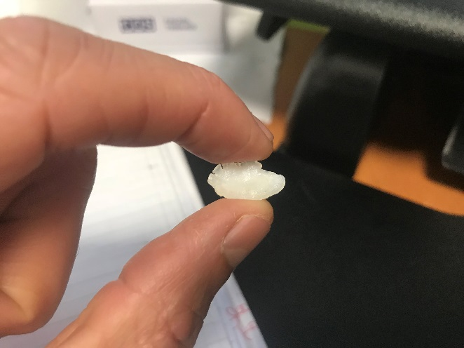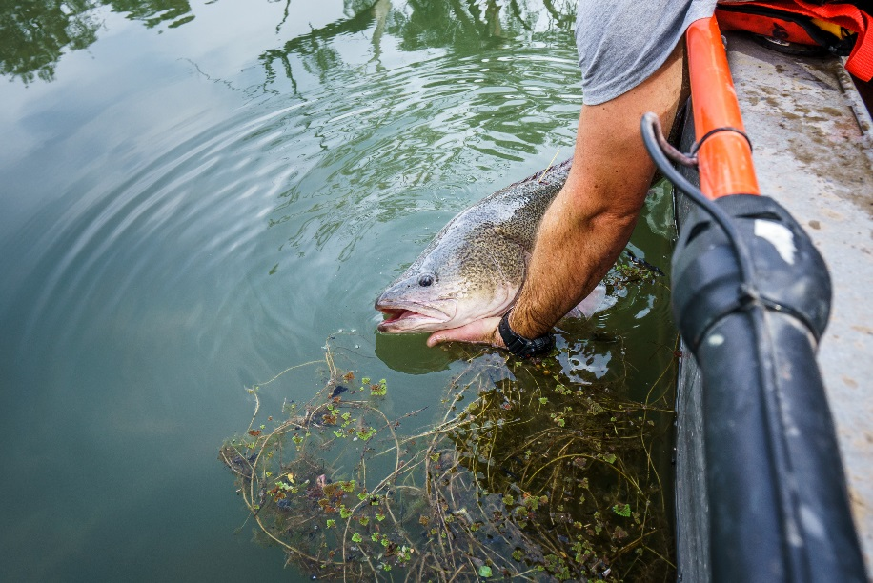

## Managing water for the environment

Many agencies work together to deliver water for the environment (‘environmental water') in Victoria. This is water that is set aside and then released to support rivers and wetlands and their plants and animals. The Department of Environment, Land, Water and Planning (DELWP), the Victorian Environmental Water Holder (VEWH), Catchment Management Authorities (CMAs), water authorities and land managers are all involved in the delivery of environmental water. Water is a scarce resource and the delivery of environmental water is targeted to areas with significant environmental values.

## Demonstrating outcomes from environmental water - VEFMAP

A government program called the [Victorian Environmental Flows Monitoring and Assessment Program](https://www.ari.vic.gov.au/research/rivers-and-estuaries/assessing-benefits-of-environmental-watering) (VEFMAP) is monitoring how fish and vegetation along rivers respond to the delivery of water for the environment. This program aims to help guide government decisions on how to provide water to the environment to get the greatest benefits, demonstrate ecological outcomes to the community and stakeholders, and fill key knowledge gaps to support management.

VEFMAP Stage 6 runs from 2016 to 2020, and fish monitoring is occurring at a range of sites across the State. In northern Victoria, there is a particular focus on delivering water for the environment to improve the movement and breeding of recreationally important species such as Murray Cod and Golden Perch. Sites include the Goulburn, Broken, Loddon, Campaspe and mid-Murray rivers, and Pyramid and Gunbower creeks.

**Water for the environment can help fish**

There have been encouraging signs in recent years regarding how providing water for the environment helps fish.

* There have been some general increases in abundance and distribution of important species such as Silver Perch, Murray Cod and Golden Perch across northern rivers since 2012.
* Golden Perch have responded to even small releases of water in late spring in the Murray and Goulburn rivers; with spawning occurring and eggs and larvae drifting downstream.
* In 2017, many agencies worked together to coordinate an environmental flow over hundreds of kilometres in the Murray, Goulburn and Campaspe rivers – this triggered juvenile Silver Perch to move upstream from the Murray and into tributary rivers. Excitingly, this resulted in a major population outcome for Silver Perch, with about a three-fold increase in the number of fish moving into tributaries.

**A new element for VEFMAP - Scientists and anglers working together**

VEFMAP has recognised that there is an opportunity for scientists and anglers to work together to measure the benefits to fish of providing water for the environment.

A range of methods are currently being used to monitor fish within VEFMAP, including fyke netting, electrofishing, fish tagging and fishways trapping. Fish ear bones (called otoliths) are also being collected to estimate individual ages of fish which are then used to calculate a number of other important measures used for our research. Up to 50 Golden Perch otoliths and 50 Murray Cod otoliths are needed for analysis and we may not collect this many in our surveys.

As part of this citizen science project, we are keen to team up with anglers who are interested in providing the VEFMAP science team with otoliths from Murray Cod and Golden Perch that they intend to keep and eat. The greater the sample size, the better our understanding of fish responses to environmental flows.

**What can an otolith tell you about the benefits of water for the environment?**

Otoliths play a role in fish balance and hearing. Amazingly, looking at an otolith under a microscope and analysing its microchemistry can provide many insights into a fish’s life including:

* its age (by counting the growth rings)
* growth
* which rivers it has been in
* if it is a stocked fish or a natural recruit.

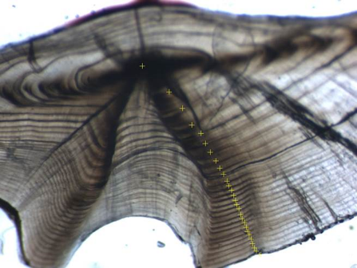Analysing otolith characteristics and flow events in rivers can therefore provide information on fish movement, breeding and survival.

**What are the benefits of scientists and anglers working together?**

There is a growing interest in volunteers participating in scientific research and monitoring by both government and the public. The many potential benefits include:

* scientists and volunteers building strong relationships, leading to an improved understanding of each other’s perspectives and interests
* filling knowledge gaps and advancing our scientific understanding by collection of additional samples
* increasing volunteers’ awareness and interest in scientific programs, and environmental issues more broadly
* promoting particular issues and fostering local stewardship
* building volunteers’ skills and knowledge
* encouraging behaviour change to benefit the environment.

**What’s happening?**

This component of VEFMAP will run from early 2018 until December 2019. We plan to work closely with the North Central CMA, the Goulburn Broken CMA, the Victorian Fisheries Authority and other relevant organisations and groups to identify local anglers who may be interested in participating, and opportunities to share information. We intend to run regional events to meet and train anglers in extracting otoliths (or provide fish frames), and to share information about VEFMAP and the benefits of providing water for the environment. We also plan to assess the project’s success including level of participant satisfaction, the value of the scientific contribution, and changes in the awareness, interest and behaviour of participants.

**Contact**

If you are interested in participating or learning more about the project, please contact [Pam.Clunie@delwp.vic.gov.au](mailto:Pam.Clunie@delwp.vic.gov.au) or Mob 0428 335 706.

**Figure 1 – A Golden Perch otolith**

|  |  |
| --- | --- |
| © The State of Victoria Department of Environment, Land, Water and Planning 2018  LogoThis work is licensed under a Creative Commons Attribution 4.0 International licence. You are free to re-use the work under that licence, on the condition that you credit the State of Victoria as author. The licence does not apply to any images, photographs or branding, including the Victorian Coat of Arms, the Victorian Government logo and the Department of Environment, Land, Water and Planning (DELWP) logo. To view a copy of this licence, visit http://creativecommons.org/licenses/by/4.0/  ISBN 978-1-76077-020-4 (Print) 978-1-76077-021-1 (pdf/online)  Disclaimer  This publication may be of assistance to you but the State of Victoria and its employees do not guarantee that the publication is without flaw of any kind or is wholly appropriate for your particular purposes and therefore disclaims all liability for any error, loss or other consequence which may arise from you relying on any information in this publication. | Accessibility  If you would like to receive this publication in an alternative format, please telephone the DELWP Customer Service Centre on 136186, email [customer.service@delwp.vic.gov.au](mailto:customer.service@delwp.vic.gov.au), or via the National Relay Service on 133 677 [www.relayservice.com.au](http://www.relayservice.com.au). This document is also available on the internet at [www.delwp.vic.gov.au](http://www.delwp.vic.gov.au). |