|  |
| --- |
| Post-fire dynamics of Cool Temperate Rainforest in the O’Shannassy Catchment |
| A. Tolsma, R. Hale,  G. Sutter and M. Kohout |
| July 2019 |

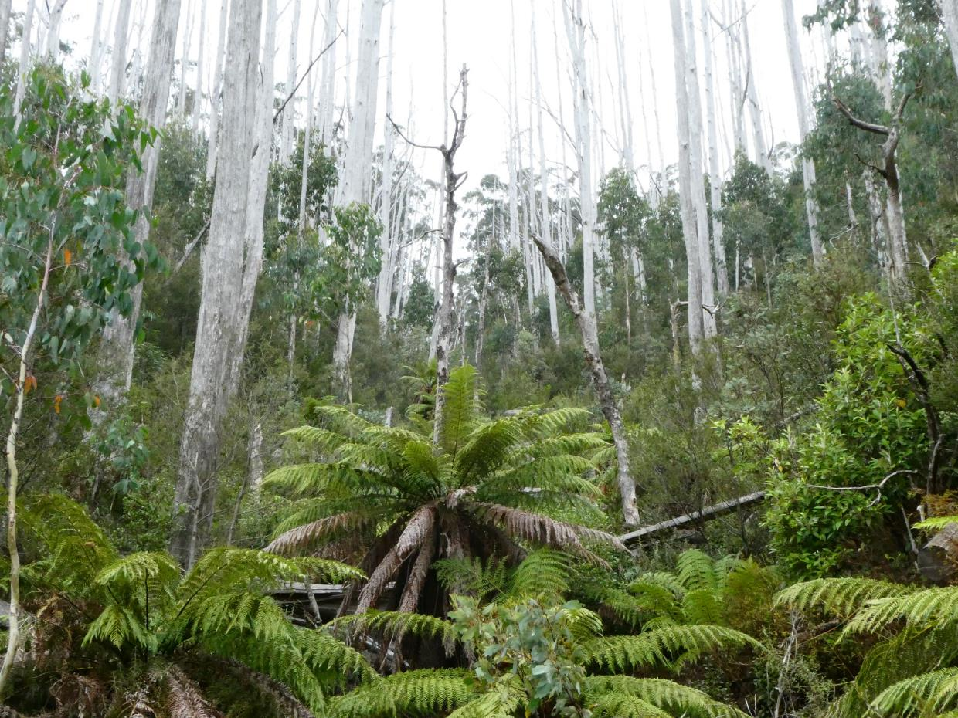

Arthur Rylah Institute for Environmental Research   
Technical Report Series No. 298



|  |
| --- |
| Arthur Rylah Institute for Environmental Research Department of Environment, Land, Water and Planning PO Box 137 Heidelberg, Victoria 3084 Phone (03) 9450 8600 Website: [www.ari.vic.gov.au](http://www.ari.vic.gov.au)  **Citation**: Tolsma, A., Hale, R., Sutter, G. and Kohout, M. (2019). Post-fire dynamics of Cool Temperate Rainforest in the O’Shannassy Catchment. Arthur Rylah Institute for Environmental Research Technical Report Series No. 298. Department of Environment, Land, Water and Planning, Heidelberg, Victoria.  **Front cover photo**: Small stand of Cool Temperate Rainforest grading to Cool Temperate Mixed Forest with fire-killed Mountain Ash, O’Shannassy Catchment, East Central Highlands (Arn Tolsma).  Logo© The State of Victoria Department of Environment, Land, Water and Planning 2019    This work is licensed under a Creative Commons Attribution 3.0 Australia licence. You are free to re-use the work under that licence, on the condition that you credit the State of Victoria as author. The licence does not apply to any images, photographs or branding, including the Victorian Coat of Arms, the Victorian Government logo, the Department of Environment, Land, Water and Planning logo and the Arthur Rylah Institute logo. To view a copy of this licence, visit <http://creativecommons.org/licenses/by/3.0/au/deed.en>  Printed by Melbourne Polytechnic Printroom  ISSN 1835-3827 (Print)  ISSN 1835-3835 (pdf/online/MS word)  ISBN 978-1-76077-589-6 (Print) ISBN 978-1-76077-590-2 (pdf/online/MS word)  **Disclaimer** This publication may be of assistance to you but the State of Victoria and its employees do not guarantee that the publication is without flaw of any kind or is wholly appropriate for your particular purposes and therefore disclaims all liability for any error, loss or other consequence which may arise from you relying on any information in this publication.  Accessibility  If you would like to receive this publication in an alternative format, please telephone the DELWP Customer Service Centre on 136 186, email [customer.service@delwp.vic.gov.au](mailto:customer.service@delwp.vic.gov.au) or contact us via the National Relay Service on 133 677 or [www.relayservice.com.au](http://www.relayservice.com.au). This document is also available on the internet at [www.delwp.vic.gov.au](http://www.delwp.vic.gov.au) |

Post-fire dynamics of Cool Temperate Rainforest in the O’Shannassy Catchment

Arn Tolsma, Rob Hale, Geoff Sutter and Michele Kohout

Date

Arthur Rylah Institute for Environmental Research  
Technical Report Series No. 298

# Acknowledgements

This project was funded by Parks Victoria. Marie Keatley, Dan Nugent, Adam Whitchurch and John Stoner (Parks Victoria) instigated the research and/or provided research direction, information and support.

Tim Sanders and Mario Malovic (Melbourne Water) provided logistical information and facilitated access to the O’Shannassy closed catchment area.

David Cameron (DELWP) provided invaluable comments on the draft report.

Matt White (Arthur Rylah Institute) provided spatial layers for the analysis and sage advice, Ben Fanson and Jim Thomson provided guidance for statistical analyses, and Annette Muir provided comments that improved the final report.

All research on public land was conducted under Permit No. 10008220 (issued by Department of Environment, Land, Water and Planning).

Contents

Acknowledgements ii

Summary 4

1 Introduction 5

2 Methods 8

2.1 Study area 8

2.2 Site selection 8

2.3 Field surveys 11

2.4 Analysis of field survey data 12

2.4.1 Vegetation assemblages 12

2.4.2 Species richness and cover 12

2.4.3 Recruitment of Mountain Ash 12

2.5 Spatial analysis 12

3 Results 14

3.1 Field surveys 14

3.1.1 Do vegetation assemblages differ by fire severity class or forest type? 14

3.1.2 Do species richness and cover differ by fire severity class or forest type? 14

3.1.3 How does recruitment of Mountain Ash relate to seed source? 19

3.2 Spatial analysis 19

3.2.1 Changes in rainforest areal extent 19

3.2.2 Probability of rainforest loss as a function of fire severity 22

3.3 Is deer activity of concern? 23

4 Discussion 24

4.1 Changes in vegetation assemblages and structure from field survey data 24

4.1.1 Floristic composition and richness 24

4.1.2 Floristic structure 25

4.2 Eucalypt invasion and rainforest resilience 28

4.3 Deer activity 31

4.4 Pathogens 31

4.5 Conclusion and recommendations 32

References 33

Appendix 1 – Plot summary 37

Appendix 2 – Supplementary Material 39

# Summary

**Context:**

Cool Temperate Rainforest is an endangered Ecological Vegetation Class generally found in wet, climatically-protected niches where fire has historically been rare. However, since European settlement, there have been substantial changes to land use in surrounding forests and an increase in the frequency of fire. Cool Temperate Rainforest may not be adapted to such perturbations, with implications for post-fire successional processes and long-term recovery and persistence.

**Aims:**

This project aimed to determine the dynamics of post-fire regeneration of Cool Temperate Rainforest in the O’Shannassy Catchment (Victorian East Central Highlands), the influence of pre-fire overstorey composition on structural changes, and the extent to which the rainforest community is likely to persist in its ‘natural’ state.

**Methods:**

Field surveys were undertaken in 24 plots in and around the O’Shannassy Catchment during March/April 2019. These plots were a mix of Cool Temperate Rainforest and Cool Temperate Mixed Forest (a seral stage of rainforest) and were unburnt or burnt at various intensities by bushfire in 2009. Parameters included overstorey and understorey plant composition, ground cover, and post-2009 tree recruitment.

Remotely-sensed data were then used to determine the impacts of fire on the most severely burnt parts of the catchment which could not be safely accessed. Pre- and post-fire data were compared to determine how much rainforest had been lost as a function of fire severity.

**Results:**

Ten years post-fire, burnt plots remained compositionally different to unburnt plots, with burnt plots having higher cover of forbs, grasses and shrubs, but substantially lower tree cover. Only ferns appear to have recovered to the unburnt state. The primary rainforest species Myrtle Beech and Southern Sassafras were resprouting from the bases of top-killed parent trees, and eucalypt and wattle species were regenerating strongly from seed. Encroachment of non-rainforest canopy species into rainforest was related to fire severity. Spatial analysis indicated that non-rainforest tree recruitment in the most severely burnt area of the catchment had been sufficiently high that 96% of primary rainforest mapped pre-fire could no longer be classified as such. Encroachment of eucalypts into plots burnt at moderate severity was more limited, and no recruits were noted in plots burnt at low severity or unburnt. This study suggests that some rainforest stands should persist in the O’Shannassy Catchment, but they will mostly be restricted to the most fire-protected parts of the landscape. Despite some documented resistance to fire, rainforest in the O’Shannassy Catchment could not cope with the highest severity fire.

**Conclusions and implications:**

Severe fire in 2009 has led to the loss of around two thirds of the Cool Temperate Rainforest previously mapped in the O’Shannassy Catchment. Remaining rainforest stands here and elsewhere in Victoria are further threatened by predicted increases in the frequency and intensity of fire due to climate change, and the long-term future of this important vegetation type appears bleak. While little can be done at a local scale to combat direct impacts of climate change, management should aim to protect or buffer remaining rainforest from indirect impacts and other threats.

1. Remaining rainforest needs to be protected as much as possible from fire. Management options are limited within the catchment itself, hence actions need to be undertaken at a much broader landscape scale, preferably using a cross-tenure approach.
2. Infrastructure activity, especially roadworks, near stands of rainforest should be undertaken in a manner that minimises spread of pathogens such as Myrtle Wilt.
3. Deer monitoring and control should continue in the catchment, as population numbers are expected to increase with time-since-fire.
4. Introduction

Rainforests are the remnants of the oldest extant vegetation in Australia which, in the Cretaceous or early Tertiary, dominated most of the continent (Busby 1992; Kershaw 1992). Following the break-up of the super-continent Gondwana, the opening up of rainforest accelerated as rainfall decreased and became more variable, and after around 2.7 million years ago, with a switch from a summer to winter rainfall regime, rainforest became increasingly restricted to locally favourable, moist areas (Kershaw 1992). Further decreases in rainforest extent within the last glacial-interglacial period appeared to correspond with the arrival of aboriginal people and the development of more fire-promoting vegetation (Kershaw 1992). Previous Bioclim analysis suggested that only around 1% of the Australian continent is now climatically suited to rainforest (Busby 1992), and this proportion may already be decreasing.

Cool Temperate Rainforest is an Ecological Vegetation Class (EVC) listed under Victoria’s *Flora and Fauna Guarantee Act 1988* (FFG) (DELWP 2018). In its most mature state (without emergent eucalypts) it is characterised by a more-or-less continuous rainforest tree canopy of variable height, mostly forming narrow linear strips along the margins of streams (DSE 2009). In the Central Highlands, the overstorey is dominated by Myrtle Beech (*Nothofagus cunninghamii*), the mid-storey includes Southern Sassafras (*Atherosperma moschatum*) and Blackwood (*Acacia melanoxylon*), and the understorey is dominated by tree ferns and ground ferns (Cameron and Turner 1996; DSE 2009). The understorey tends to become sparse as the rainforest ages and the canopy closes (Howard 1973).

Cool Temperate Rainforest in the Central Highlands is flanked on most sides by Cool Temperate Mixed Forest, and usually transitions to that community. Mixed forest should be regarded as a seral or successional stage of Cool Temperate Rainforest, reflecting the dynamic nature of the vegetation, with 10-50% cover of emergent eucalypts [usually Mountain Ash (*Eucalyptus regnans*) in the study area] over typical rainforest species (Cameron 1992; Cheal *et al.* 2011; DSE 2009; SAC 2012). Cool Temperate Mixed Forest is also FFG-listed (DELWP 2018; SAC 2012), but has not yet been mapped as a unique entity because it is difficult to reliably identify in aerial photographs (White *et al.* 2019), and is mapped as generic Wet Forest.

Cool Temperate Rainforest is generally found in the wettest, most climatically fire-protected niches, particularly gullies (Ashton 2000; Busby and Brown 1994; Cheal *et al.* 2011; DSE 2009; Leonard *et al.* 2014), where severe fires are historically rare and normally occur only after protracted drought (Ashton 1981; Cheal 2010). Despite being called ‘rainforest’, rain is not the overarching driver of its distribution; rather, fire is the most potent factor that determines its distribution over a broad scale, especially in Victoria, while factors such as climate tend to operate at finer scales (Busby 1992; Cameron 1992). Thus, particular fire regimes may maintain fire-adapted tall eucalypt forests at the expense of fire-sensitive rainforest species (Wood *et al.* 2014).

Cool temperate rainforests may have some resilience or resistance to fire or other disturbance (Baker *et al.* 2012), with the dominant species Myrtle Beech being able to resprout or regenerate profusely by seed after fire (Baker *et al.* 2012; Cameron and Turner 1996; Hill and Read 1984; Howard 1973; Simkin and Baker 2008), and understorey species being able to establish or regenerate in the shade (Cameron 1992). Indeed, some stands of Cool Temperate Rainforest in the Central Highlands appear to have survived both the 1939 and 1851 fires, with Myrtle Beech trees dated at more than 200 years old (Simkin and Baker 2008). Nonetheless, most rainforests in Victoria still show signs of a history of disturbance (Cameron 1992). Survival of rainforest is largely determined by fire dynamics of the margins and ecotones (Baker *et al.* 2012; Busby 1992; Cameron 1992), and the minimum Tolerable Fire Interval for this vegetation type, even for low-intensity fire, is estimated as 80 years (Cheal 2010), reflecting long post-fire recovery times, particularly of the canopy species.

However, the risk of fire is increasing as our climate becomes warmer and drier. Australia’s mean temperature has increased by just over 1°C since 1910, with attendant increases in the frequency of extreme heat events and extreme fire weather, and a lengthening of the fire season (BoM and CSIRO 2018). Autumn and winter rainfall have reduced over south-eastern Australia, particularly in May-July where rainfall has decreased by around 20% since 1970 (BoM and CSIRO 2018).

In addition to increased bushfire, land use change since European settlement may also have altered the susceptibility of rainforests to fire, as adjacent tall Ash forest has often been disturbed and opened up by logging and regeneration fires. It is estimated that only around 1.1% of the entire Mountain Ash forest estate still remains in an old-growth stage (Lindenmayer *et al.* 2011). Logging disturbance in Ash and similar moist forests, usually subject to low frequency, stand-replacing fire, reportedly makes them more prone to fire, particularly in the first few decades after disturbance, by altering attributes such as structure, composition, fuel characteristics and ignition points (Bradstock and Price 2014; DSE 2009; Lindenmayer *et al.* 2011; Lindenmayer *et al.* 2009) [but see Attiwill *et al.* (2014) who argue that logged forests are not more fire-prone]. The impacts of fires on rainforest are most likely to be directed largely at the margins of rainforest stands rather than core zones (Cameron and Turner 1996). Nonetheless, Cool Temperate Rainforest is unlikely to be adapted to persistent changes in fire frequency and increased edge effects, with possible implications for post-fire successional processes and long-term recovery.

The ‘Black Saturday’ fires which started on 7 February 2009 were particularly severe, especially the Kilmore East fire (Cruz *et al.* 2012). That fire eventually joined with the Murrindindi fire and burnt a combined area of over 400,000 ha (Cruz *et al.* 2012) (Figures 1 & 2). Unburnt stands, driven largely by topography, were rare within this fire complex, and comprised less than 1% of the total fire area (Leonard *et al.* 2014). Around 2,600 ha of Cool Temperate Rainforest were burnt in 2009 (Worley 2012), including in the important O’Shannassy Catchment which forms part of the Yarra Ranges National Park (Parks Victoria 2002). Anecdotal evidence suggested that many areas of burnt rainforest, especially around the Deep Creek Reference Area, might now be dominated by regeneration of Ash eucalypts, thereby pushing those rainforests from a mature form to an earlier seral or successional stage, or even a sclerophyll forest type. This phenomenon reflects the importance of fire severity, surrounding vegetation and canopy gaps on survival and post-fire recruitment, and could have important implications for the long-term future of the listed community.

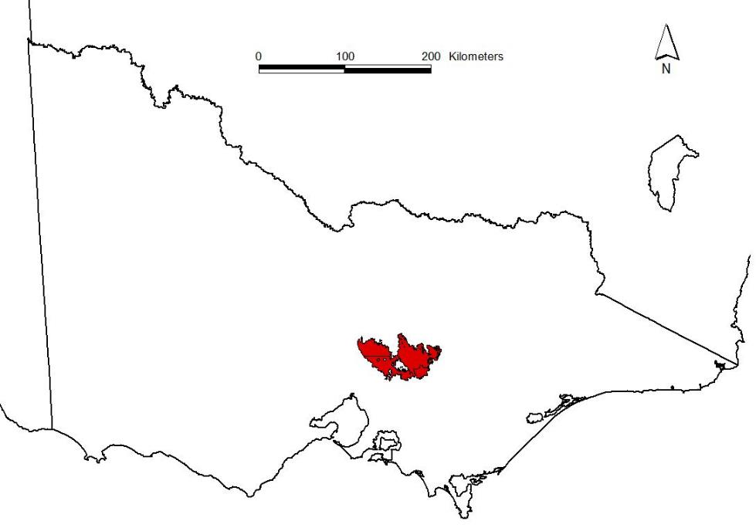

Figure 1. Overview map, Kilmore East – Murrindindi fires, ‘Black Saturday’ 2009.

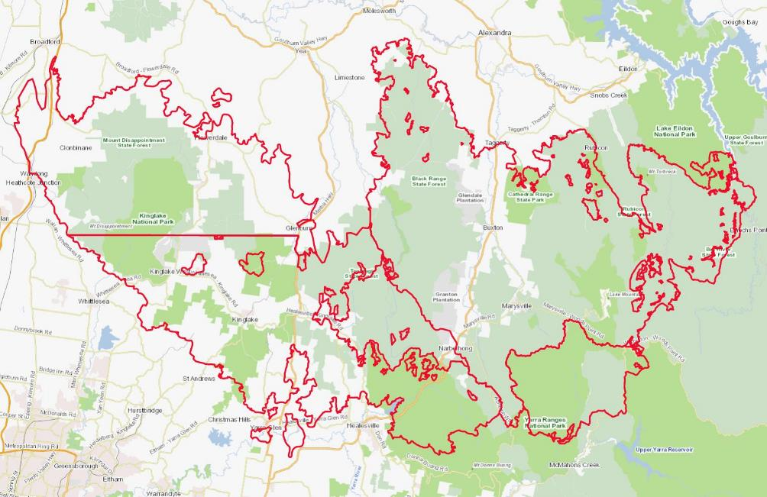Figure 2. Close-up of Kilmore East – Murrindindi fires, ‘Black Saturday’ 2009. Red outline shows extent of fire, and arrow indicates location of the O’Shannassy Catchment. Scale is 1:500,000.

This project examined the dynamics of post-fire regeneration of Cool Temperate Rainforest in and around the O’Shannassy Catchment, and aimed to determine the changes that had occurred in understorey species composition and structure with respect to fire severity. It also aimed to determine the influence of pre-fire overstorey composition on structural changes within Cool Temperate Rainforest, the extent to which rainforest has been lost since the fire, and the extent to which the rainforest community is likely to persist in its ‘pure’ state.

1. Methods
   1. Study area

This study was undertaken in and around the O’Shannassy Catchment (Figures 2 & 3) that is now contained within the Yarra Ranges National Park (Parks Victoria 2002), in the region known as the East Central Highlands (Highlands Southern Falls Bioregion). The majority of the study area is a Designated Water Supply Catchment Area, legislated under the National Parks Act to protect water catchment and resource values (Parks Victoria 2002), and is closed to the general public. The catchment, as expected, contains a range of EVCs typical of high-rainfall regions, including botanically significant representations of Wet Forest (EVC30), Montane Wet Forest (EVC39) and, prior to the fire, around 1500 ha of the FFG-listed Cool Temperate Rainforest (EVC31) (DELWP unpublished data). The protection of these forests within the National Park estate was recommended by the former Land Conservation Council, who recognised their regional importance (Parks Victoria 2002). FFG-listed Cool Temperate Mixed Forest (EVC145), a seral or successional stage of Cool Temperate Rainforest, is also common.

Cool Temperate Rainforest, found in wet sheltered gullies, is dominated in the study area by an overstorey of Myrtle Beech over a midstorey of Southern Sassafras, Blackwood and Silver Wattle (*Acacia dealbata*) and a highly variable understorey and ground layer (Cheal *et al.* 2011; DNRE 1996). The understorey is usually dominated by ferns, especially Soft Tree-fern (*Dicksonia antarctica*), while the ground layer includes variable cover of ground ferns such as Hard Water-fern (*Blechnum wattsii*) and Mother Shield-fern (*Polystichum proliferum*). Cool Temperate Rainforest in the study area is flanked by Cool Temperate Mixed Forest, and the biggest difference between the two rainforest types is the presence of emergent eucalypts in the latter, usually Mountain Ash. The most common species (excluding Mountain Ash) are shared, including Myrtle Beech, Soft Tree-fern, Hard Water-fern and Mother Shield-fern. However, the understorey tends to be denser in the mixed forest, with a greater contribution by shrubs such as Tree Everlasting (*Ozothamnus ferrugineus*), Frosted Wattle (*Acacia frigescens*) and Dusty Daisy-bush (*Olearia phlogopappa*).

Prior to the 2009 fires, much of the Ash forest in the broader Central Highlands was considered to be even-aged regrowth from the 1939 fires (DNRE 1996; Simkin and Baker 2008). However, some stands of Cool Temperate Rainforest in the Central Highlands appear to have survived both the 1939 and 1851 fires, with Myrtle Beech trees dated at more than 200 years old (Simkin and Baker 2008). Some protected areas of the O’Shannassy Catchment area are also likely to be long-unburnt. The southeast edge of the catchment was burnt by fire in 1983, but it is not known if any rainforest stands were affected.

There is a long history of land use in the region, with seasonal use by aboriginal people dating back thousands of years (DNRE 1996), but the catchment has been largely protected from human disturbance since around the turn of the last century (Parks Victoria 2002). Consequently, prior to the 2009 fires, the O’Shannassy and Watts River catchments contained much of the Central Highland’s old-growth Wet Forest (DNRE 1996; Flint and Fagg 2007; Wood *et al.* 2014).

* 1. Site selection

Site selection for this project employed a stratified approach combining pre-fire vegetation type and estimated fire severity.

*A priori* selection of potential sites was undertaken manually to minimise issues associated with localised inaccuracies in both the vegetation mapping and fire intensity modelling. An automated site selection process would have generated a large number of sites that ultimately would have proved unsuitable.

High-resolution aerial photographs taken shortly after the 2009 fire were used in conjunction with fire intensity, road and vegetation layers in GIS to identify potential sites that were:

* mapped as Cool Temperate Rainforest (or appeared to be rainforest in aerial photos)
* sufficiently large that the influence of adjacent eucalypt forest was considered minimal (size of rainforest stand preferably 100 m or more in both of two perpendicular directions)
* one of 3 provisional fire severity classes (unburnt, low-moderate, high), as estimated from post-fire aerial photos in conjunction with the fire severity layer
* no more than 300 m away from an open road or track (because accessing sites further away in dense post-fire regeneration becomes impractical and, given the nature of fire-killed Ash, potentially unsafe)
* in or closely adjacent to the O'Shannassy Catchment
* able to capture a range of topographic positions across the catchment

For convenience and efficiency, each potential site identified during the selection process aimed to capture a pair of plots:

* Cool Temperate Rainforest, hereafter called ‘rainforest’. This was the core area of ‘pure’ rainforest as identified by the site selection process, characterised by high cover of mature Myrtle Beech and, for our purposes, no eucalypt canopy (note that rainforest as mapped may have included up to 10% cover of emergent eucalypts).
* Cool Temperate Mixed Forest, hereafter called ‘mixed’. This was the ecotonal community which usually flanked mature rainforest in the study area, characterised by the presence of emergent eucalypt trees (mostly Mountain Ash) over typical rainforest vegetation. This plot was to be selected during field surveys.

The initial aim was to survey an equal number of plots from each fire-intensity by EVC (forest-type) category. However, despite the careful selection process, this was unachievable for various reasons:

* Many potential sites proved inaccessible because of obstructions or road closures. Indeed, all internal tracks in the northern half of the O’Shannassy Catchment were blocked within two-to-three kilometres of the access point by fallen trees, and some within a few hundred metres.
* Intensely burnt areas in the north of the catchment (around Deep Creek reference Area) were characterised by tall fire-killed Ash trees with the potential to fall or drop branches, as had already occurred in many places. This made it unsafe to attempt to reach distant sites on foot and necessitated the use of remotely-sensed data to examine changes in the most severely burnt areas.
* The size of ‘pure’ rainforest stands was often substantially smaller than mapped, as the GIS layer captured primary rainforest vegetation with up to 10% cover of eucalypts (which we have defined as “mixed forest” for our purposes), and some plots that were accessed proved to be too marginal in terms of vegetation. In some instances, and because of the effort required to reach the potential plot, a mixed forest survey was undertaken with no paired rainforest plot.
* Fire intensity as assessed on-ground differed from that mapped. This did not prevent surveys but made it difficult to balance the fire treatments.
* Estimates of the original fire intensity in rainforest plots were confounded by a decade of post-fire regeneration. It was particularly difficult to distinguish low intensity from unburnt, given strong regeneration of the understorey, hence the low-moderate intensity category needed to be split into the two constituents.
* Paired plots often differed with respect to fire intensity, with mixed forest plots being burnt at a higher intensity than adjacent rainforest plots. For example, six mixed forest plots that were burnt at moderate intensity were paired with rainforest plots that were variously burnt at moderate intensity (3 plots), burnt at low intensity (2 plots) or were unburnt (1 plot). As above, this did not prevent surveys but exacerbated the difficulty in balancing the fire treatment.

A total of 24 plots were eventually surveyed (Table 1, Figure 3), each allocated to one of four fire treatments. Altitude ranged from 400 m to 1200 m, slope ranged from nearly flat to relatively steep (25°), and aspect ranged from 0° to 270° (with no plots having a north-westerly aspect) (Appendix 1).

Table 1. Number of plots by fire treatment and forest type.

|  |  |  |  |
| --- | --- | --- | --- |
| **Fire regime** | **Cool Temperate Rainforest** | **Cool Temperate Mixed Forest** | **TOTAL** |
| **Total Unburnt** | **6** | **5** | **11** |
| Burnt Low Severity | 2 | 0 | **2** |
| Burnt Moderate Severity | 2 | 6 | **8** |
| Burnt High Severity | 1 | 2 | **3** |
| **Total Burnt** | **5** | **8** | **13** |
| **TOTAL PLOTS** | **11** | **13** | **24** |

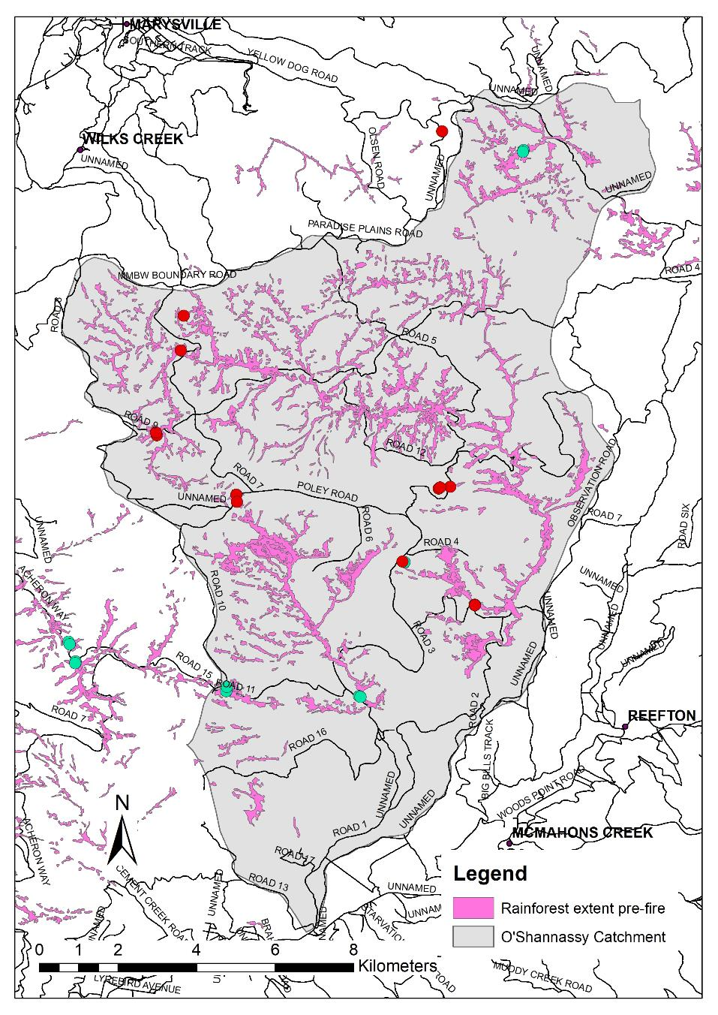

Figure 3. Location of study plots in and around the O’Shannassy Catchment, East Central Highlands.

Green dots are unburnt plots and red dots are burnt plots.

* 1. Field surveys

The parameters for assessment were chosen based on how well they would capture short-medium term changes in floristic composition and structure, and on-ground habitat. Practicality was also a concern, as post-fire regeneration in wet forest, especially a decade after fire, is usually sufficiently dense that visibility is poor, and movement is restricted by both dense vegetation and fallen trees. Methods therefore needed to be relatively simple, would not require accurate delineation of quadrats or transects, but would be sufficiently robust to answer the key questions related to post-fire trajectory.

* Plot establishment. Using maps and pre-loaded GPS waypoints, observers navigated to the target (potential) rainforest plot. The plot was rejected if the vegetation was not ‘pure’ rainforest, or if the plot centre would be less than 20 m from the nearest emergent (mature living or 2009-killed) eucalypt. Ideally this minimum distance would have been greater, however accessible ‘pure’ rainforest stands were often only ~40-50 m wide. If deemed suitable, the assessment plot was established with the centre as close as possible to the centre of the rainforest stand. The plot centre was temporarily marked with flagging tape.
* Plot information. Standard information was recorded for each plot, such as plot number, date assessed, observers, easting and northing of the plot centre (GDA94, Zone 55), slope and aspect.
* Floristic composition. Projected foliage cover (1%, 2% or to nearest 5%) was estimated for each vascular plant species (including canopy and understorey, ferns and epiphytes) rooted in or overhanging (even partially) a standard 20 m x 20 m quadrat, centred around the plot coordinate. These data are compatible with most data in the Victorian Biodiversity Atlas and provide a measure of what species are persisting or regenerating. Resprouting of rainforest species or other interesting observations were recorded in a ‘Comments’ section.
* Ground cover parameters. Percent cover of bryophytes, lichen, litter, Coarse Woody Debris (CWD, >10 cm in each of two perpendicular directions), rocks and bare ground were estimated within the standard 20 m x 20 m quadrat. This provides a measure of changes in the habitat structure that is required by ground-dwelling vertebrate and invertebrate fauna taxa.
* Mature canopy cover. The proportion (percent) of sky obscured by mature canopy was estimated for the two main tree categories, eucalypt and non-eucalypt. For burnt forest, this included coppicing foliage on trunks of mature trees, but not regeneration from lignotubers or roots. This parameter provides a measure of canopy gaps and amount of insolation.
* Pre-fire canopy cover, for both eucalypts and non-eucalypts. For burnt plots, the percent pre-fire canopy cover was estimated based on the structure and density of mature and fire-killed tree trunks in and around the plot. Cover estimates were checked and refined if necessary prior to data analysis using pre-fire aerial photos in GIS. For unburnt plots, pre-fire canopy cover was assumed to be the same as current mature canopy cover.
* Post-fire tree recruits. The number of stems that were assumed to have established post-2009 was counted for each tree species rooted within a 4 m radius of the plot centre (giving an area of 50 m2). This is the same technique used for Victoria’s forest monitoring program (DSE 2010), and provides an indication of future species domination that is not captured by current floristic composition alone.
* Distance to nearest mature eucalypt. Using a rangefinder, the horizontal distance was estimated from the plot centre to the trunk of the nearest mature (living or 2009-fire-killed) eucalypt tree (usually Mountain Ash) that would have had the potential to act as a post-fire seed source. This helps provide an indication of the distance over which the eucalypt canopy has recruited.
* Deer activity. Deer activity was allocated qualitatively to one of four discrete categories:
  + None. No obvious activity noted.
  + Low. Some scats or a faint track indicating a low or intermittent amount of activity.
  + Moderate. Numerous scats or several tracks, indicating regular activity in the area.
  + High. Numerous scats and tracks and understorey disturbance, possibly antler thrashing and/or wallow, indicating extensive and persistent activity.
* Other threats. Notes were made of any other factors that could potentially impact on sites, such as weed invasion or signs of the plant disease Myrtle Wilt.

The Mixed forest plot was selected during field surveys. After completing the rainforest plot, observers moved upslope in a direction perpendicular to that trended by the rainforest gully until they were approximately mid-way between the lower limit of Mountain Ash and the upper limit of Myrtle Beech (i.e., the centre of the ecotone). Thus, in steeper gullies, paired plots were usually closer together than in broader, shallow gullies with a wider ecotone.

* 1. Analysis of field survey data
     1. Vegetation assemblages

We used nonmetric multidimensional scaling (NDMS, in one to four dimensions) to visualise differences between fire severity classes and forest types, incorporating quadrat floristics data. We tested if differences were statistically significant using permutational multivariate analysis of variance (PERMANOVA). This analysis had two factors: forest type and burn severity class. The NDMS and PERMANOVA were conducted using the ‘metaMDS’ and ‘adonis’ functions respectively in the vegan package in R (R Development Core Team 2017). We also used the ‘simper’ function to calculate similarity percentages, which identify the contribution of individual species to differences between groups, for comparisons looking at differences in vegetation between burnt and unburnt plots, and between the two forest types.

* + 1. Species richness and cover

We compared univariate differences between forest type and fire severity classes using generalised linear models (GLM), once again implemented in R (R Development Core Team 2017). The GLM models had fire severity and forest type as two fixed factors, and we evaluated potential differences in: species richness (from quadrat floristics surveys), and percentage cover of the following variables: primary and secondary rainforest species, mature eucalypt and mature non-eucalyptspecies, Myrtle Beech and Southern Sassafras, life forms (ferns, tree ferns, shrubs, trees, forbs, grasses), and ground cover. Primary and secondary rainforest species were classified following Cameron (1992), with primary species being those that can regenerate without disturbance, and secondary species being those that require some level of disturbance to open up canopy gaps. Primary rainforest species were Southern Sassafras, Soft Tree-fern, Tree Lomatia (*Lomatia fraseri*), Myrtle Beech, Banyalla (*Pittosporum bicolor*) and Mountain Pepper (*Tasmannia lanceolata*). Secondary rainforest species were Frosted Wattle, Blackwood (*Acacia melanoxylon*), Mountain Ash, Mountain Tea-tree (*Leptospermum grandifolium*) and Victorian Christmas-bush (*Prostanthera lasianthos* var. *lasianthos*).

Species were classified into life forms following the Department’s Victorian Biodiversity Atlas. Some life forms had only low cover across all plots and were not analysed; for example, average cover of epiphytes across all plots was ~2%. Similarly, some ground cover elements had low cover (for example, mean covers of bare ground and lichen were each less than 2%). Species richness and cover of primary rainforest species were both normally distributed, so GLMs for these variables used a gaussian distribution. For all other variables, a binomial distribution was used. Residual plots were examined to confirm model assumptions were met, and predictions were extracted and plotted to summarise results. While the data were proportional in the binomial models, for ease of interpretation we present results as percent cover.

* + 1. Recruitment of Mountain Ash

We used a generalised additive model to model the relationship between the number of seedlings of Mountain Ashand the nearest mature or 2009 fire-killed adult (that could have acted as a seed source immediately after the fire), or pre-fire Mountain Ash canopy cover. These models were implemented using the gam function in the gamm4 library in R.

* 1. Spatial analysis

The most severely burnt rainforest stands in the northern part of the O’Shannassy Catchment (around the Deep Creek Reference Area) were unable to be safely accessed, hence spatial analysis was used to estimate what changes in the areal extent of rainforest had occurred as a result of the 2009 fires. Pre- and post-fire data were available as follows:

* Pre-fire rainforest data. These data were derived from RAINFOR100_CH, a composite GIS layer (from DELWP’s Corporate Spatial Data Library) that had been compiled in the 1990s for the *Forest Management Plan for the Central Highlands* (DNRE 1998). The polygons relevant to the O’Shannassy Catchment had been mapped by Ian Roberts for the Leadbeaters Possum Project and captured both ‘pure’ rainforest and rainforest where non-rainforest canopy did not exceed 10% cover (considered together as constituting ‘primary rainforest’).
* Post-fire rainforest data. The extent of primary rainforest in Victoria (including rainforest where non-rainforest canopy did not exceed 10% cover) was modelled in 2018 using remotely-sensed data (White *et al.* 2019). Machine learning algorithms were used to model the rainforest using training data from known extant rainforest stands and multi-temporal, multi-spectral satellite imagery (Sentinel 2 and Landsat) (White *et al.* 2019). Locations identified as potential rainforest by the model were checked, edited and augmented as necessary through the interpretation of high-resolution aerial photography. The resultant data were roughly comparable to the pre-fire rainforest data above, albeit with some registration misalignment between the GIS layers.
* Fire severity data. These data, derived from remote-sensing, were sourced from DELWP’s Corporate Spatial Data Library. Each polygon in the layer (within the perimeter of the fire) was allocated to one of five fire severity classes (Table 2).

Table 2. Fire severity classes. Broad severity as per GIS layer metadata. Descriptions are from Worley (2012).

|  |  |  |
| --- | --- | --- |
| **Class** | **Broad severity** | **Description** |
| 1 | High | Crown burnt, understorey burnt |
| 2 | High | Crown scorched, understorey burnt |
| 3 | Medium | Moderate crown scorch, understorey burnt |
| 4 | Low | Light or no crown scorch, understorey burnt |
| 5 | Unburnt | No crown scorch, no understorey burnt, but possibly heat-affected |

Spatial data were analysed both qualitatively and quantitatively. For a coarse measure of areal change, the O’Shannassy Catchment was manually divided into four areas based on clear differences in overall fire severity in conjunction with natural breaks between clusters of rainforest stands. For each area we compared the total amount of rainforest mapped pre-fire with the total amount modelled post-fire.

We then used functions in the raster package in R (R Development Core Team 2017) to examine the spatial layers, and calculated estimates of the probability of rainforest loss as a function of fire severity. All three layers were converted to rasters, and a raster stack created. A small number of cells (around 20 with rainforest) not entirely within the O’Shannassy Catchment were removed, along with those in the unburnt section at the southern end of the catchment (for which fire severity had not been modelled). For the remaining cells, we calculated the mean fire severity score, and recorded if cells contained rainforest either pre-fire or post- fire.

Given the relative misalignment between the pre- and post-fire rainforest layers (up to 100 m), we used the ‘aggregate’ function to create several new layers with lower resolutions (i.e. larger cell sizes) to increase overlap between the two layers. The results were quantitatively the same across the different resolutions, so we present results based on cells that were 194 x 243 m. The mean fire severity scores were not integers, so we grouped these values into five categories: 1 = values up to 1.5, 2 = values 1.5-2.5, 3 = 2.5-3.5 and so on. We then calculated the percentage of cells in each category that had ‘lost’ rainforest after 2009 (i.e. that contained rainforest in the 1990s but not in 2018).

1. Results

It was clear that the results of the field surveys, focussed mostly on plots burnt at low to moderate severity, could not be extrapolated to plots burnt at the highest fire severity (which we were mostly unable to access). Hence, the results in the ‘field survey’ section apply only to plots burnt less severely.

* 1. Field surveys
     1. Do vegetation assemblages differ by fire severity class or forest type?

We found statistically significant differences in vegetation both between forest type (PERMANOVA F1,23 = 2.71, p = 0.01) and fire severity classes (PERMANOVA F3,23 = 3.09, p = 0.03). However, the forest type*fire severity interaction was not significant (PERMANOVA F2,23 = 0.46, p = 0.98). There was a clear differentiation between unburnt plots and any of the plots in the three other burn categories, and the lack of interaction shows that these differences were consistent across the two forest types (Figure 4).

Six species contributed 58% of the difference between burnt and unburnt plots in the simper analysis: Myrtle Beech (19%), Hard Water-fern (15%), Soft Tree-fern (7%), Mother Shield-fern (6%), Southern Sassafras (5%) and Mountain Ash (5%).

These same six species were also the most important causes of differences between forest types, contributing 57%. Relative contributions were Hard Water-fern (16%), Myrtle Beech (14%), Mountain Ash (9%), Soft Tree-fern (6%), Mother Shield-fern (6%) and Southern Sassafras (6%).

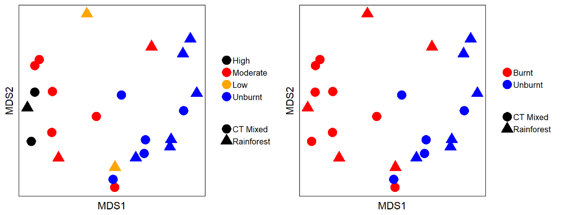

Figure 4. NMDs plots of vegetation communities across burn severity and forest type classes (left) and across burnt status (regardless of severity) and forest type (right). Axes 1 & 2 of the 3-dimensional solution are presented here. Ordination stress = 0.10.

* + 1. Do species richness and cover differ by fire severity class or forest type?

Mean species richness per plot ranged from 8 to 40 species but did not vary significantly between forest types or burn classes [Figure 5a, Table S1 (see Supplementary tables in Appendix 2 for all statistical results)].

Generalised linear modelling predicted the cover of primary rainforest species to be 70% (95% CI: 53-87) for unburnt mixed forest and 92% (95% CI: 77-100) for unburnt rainforest. Cover was lowest at highly burnt plots in both mixed forest (22.5%, 95% CI: 0-49) and rainforest (27%, 95% CI: 0-64) (Figure 5b, Table S2).

In comparison, cover of secondary rainforest species was higher at high burn severity plots for both forest types. Cover at high burn severity plots in mixed forest was predicted to be 52% (95% CI: 45-59) compared to less than 20% for other burn severities, while cover at severely burnt rainforest was18% (95% CI: 12-27) versus <6% for other burn severities. Secondary rainforest cover was also higher at mixed plots (28.5%) than at rainforest plots (8.5%) (Figure 5c, Table S3).

Cover of Myrtle Beech, the main primary rainforest species in the study area, was highest at unburnt plots in both forest types (for mixed mean = 45%, 95% CI: 41-49; for rainforest mean = 57%, 95% CI: 53-61) and was lowest at the most severely burnt plots, where cover was around 5% in both forest types (Figure 5d, Table S4).

Cover of Southern Sassafras was predicted to be highest at the unburnt and moderately burnt rainforest plots (> 15% for both) (Figure 5e, Table S5). In general, cover was also predicted to be higher in rainforest (10%) than mixed forest (2.9%).

No cover of mature eucalypts was observed at any rainforest plots, nor the highly burnt mixed plots, so no significant differences were found (Figure 5f, Table S6).

Cover of mature non-eucalypts was predicted to be highest at unburnt plots in both forest types (for mixed, mean = 75%, 95 CI: 71-78; for rainforest, mean = 45%, 95% CI: 41-50), and cover was less than 5% at the high burn severity in both forest types (Figure 5g, Table S7).

As expected, trends in lifeform cover varied substantially by forest type and burn severity. The cover of ferns was predicted to be higher in rainforest (>40% for all plots) than in mixed forest (<35% for all plots) (Figure 6a, Table S8), but the size of the difference varied with burn severity. Fern cover was lower in mixed forest than rainforest in both unburnt plots (for mixed mean = 34%; for rainforest mean = 57%) and high severity burnt plots (for mixed mean = 14%; for rainforest mean = 41%). However, cover of ferns at moderately burnt plots was not significantly different in mixed forest (mean = 35%, 95% CI: 31-39) and rainforest (mean = 46%, 95% CI: 38-53).

The cover of forbs was comparable between mixed and rainforest types at all fire severities, and lower overall at the unburnt than high fire severity classes (Figure 6b, Table S9). The cover of shrubs was lowest in unburnt plots (Figure 6c, Table S10).

In contrast, the cover of trees was highest in the unburnt plots (Figure 6d, Table S11). We also observed an interaction between forest type and burn severity class for tree cover. At unburnt plots, cover was similar in mixed forest (75%) and rainforest (80%). In comparison, cover was predicted to be significantly higher at high burn severity mixed plots (mean = 55%, 95% CI: 48-62) than high burn severity rainforest plots (mean = 29%, 95% CI: 21-38). A similar trend in tree cover was observed at moderately burnt plots, where cover in mixed forest (95% CI: 41-49%) was higher than in rainforest (95% CI: 28-41%) (Figure 6d, Table S11).

In general, the cover of tree ferns was predicted to be comparable between forest types and burn classes (Figure 6e, Table S12), except at moderately burnt plots, where cover was predicted to be higher at rainforest (29%, 95% CI: 21-41) than at mixed plots (13%, 95% CI: 10-16%).

Cover of tussock grass was predicted to be <1% at all unburnt plots (Figure 6f, Table S13), and increased in response to burn intensity. This effect was most pronounced in the high burn rainforest plots, where cover was predicted to be >30% (Figure 6f).

Only two ground cover parameters had enough data or variation to support analyses: bryophytes and coarse woody debris. The cover of bryophytes was predicted to be generally higher at rainforest plots (7.5-11% cover) than at mixed plots (1-5% cover) (Figure 7a, Table S14). Cover of coarse woody debris was predicted to be higher at moderately burnt mixed forest plots (11.2%, 95% CI: 8.8-14.0) than at moderately burnt rainforest plots (2.5%, 95% CI: 1-6%). Cover was predicted to be comparable between other burn severity and forest type combinations (Figure 7b, Table S15).

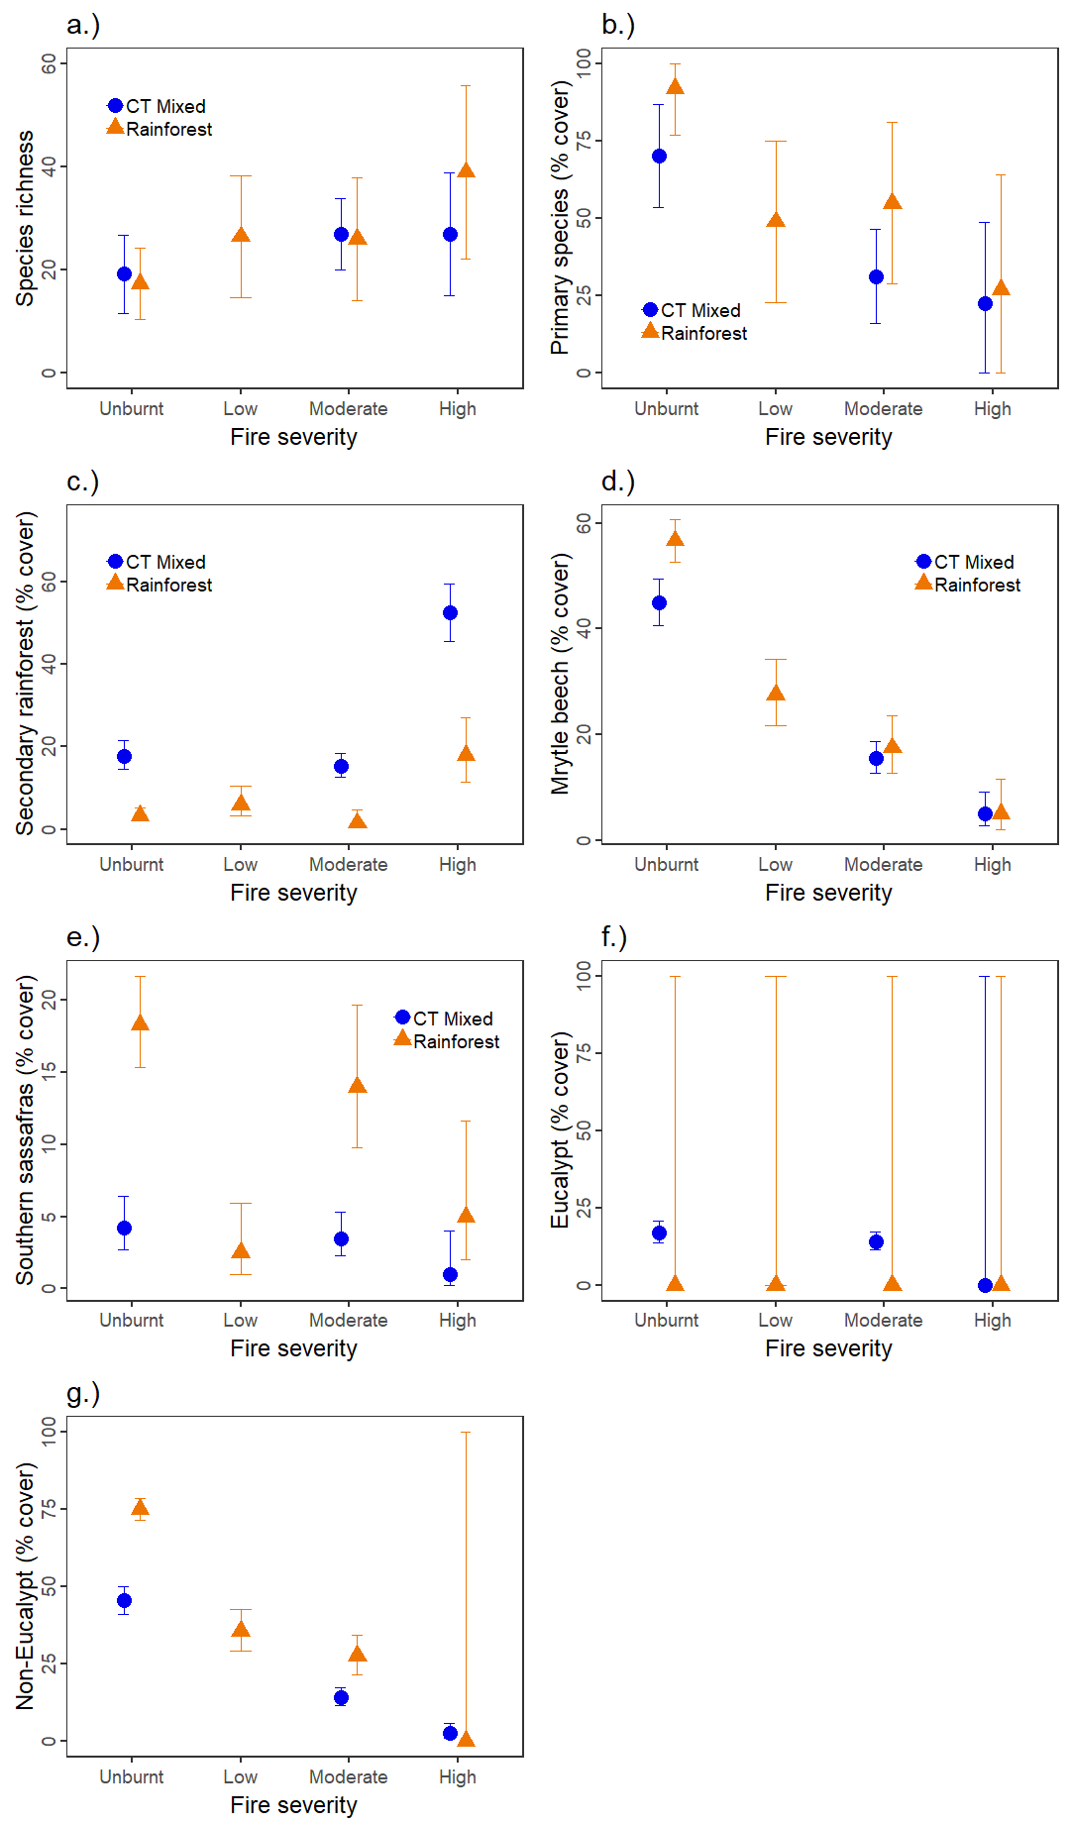

Figure 5. Predictions from generalised linear models examining differences in vegetation between the two forest types (mixed and rainforest) and the four burn severity classes (unburnt, low, moderate, high) for (a) species richness, (b) cover of primary rainforest species, (c) cover of secondary rainforest species, (d) cover of Myrtle Beech, (e) cover of Southern Sassafras, (f) cover of mature eucalypt canopy (zero for all rainforest treatments) and (g) cover of mature non-eucalypt canopy.

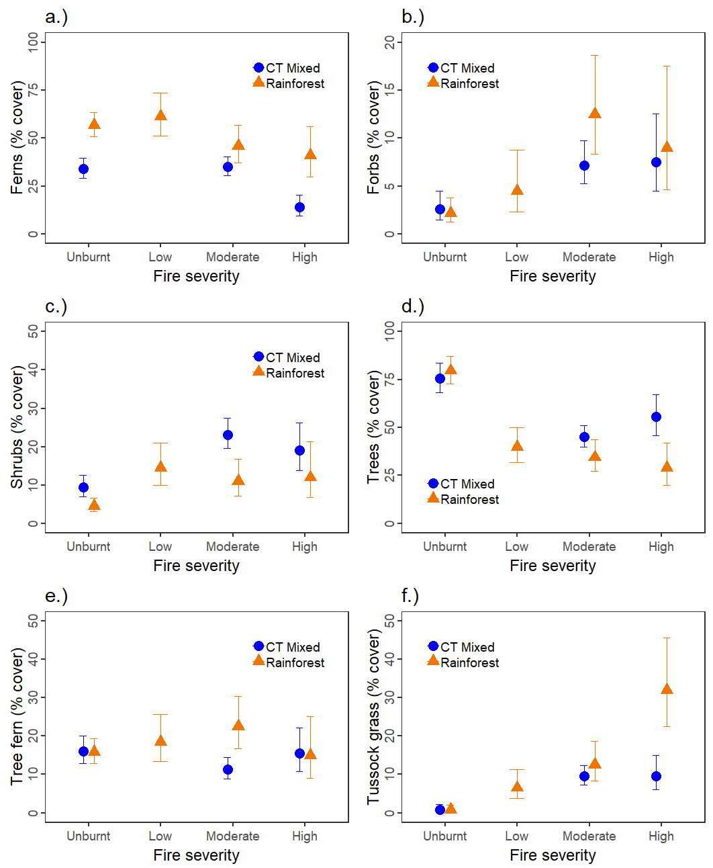

Figure 6. Predictions from generalised linear models examining differences in cover of vegetation life classes between the two forest types (mixed and rainforest) and the four burn severity classes (unburnt, low, moderate, high) for (a) ferns, (b) forbs, (c) shrubs, (d) trees, (e) tree ferns and (f) tussock grasses.

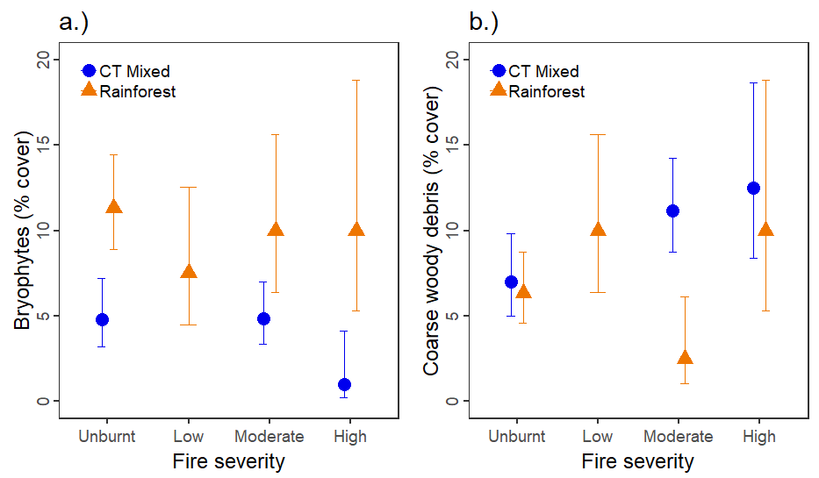

Figure 7. Predictions from generalised linear models examining differences in ground cover between the two forest types (mixed and rainforest) and the four burn severity classes (unburnt, low, moderate, high) for (a) cover of bryophytes, and (b) cover of coarse woody debris.

* + 1. How does recruitment of Mountain Ash relate to seed source?

Data from plots burnt mostly at low-moderate fire intensity suggested that the number of Mountain Ash seedlings was higher at plots with more pre-fire canopy cover (Figure 8a). It is important to note that this relationship is highly variable though, and the model predictions are likely to be unreliable (note large confidence interval, especially above 20% cover on the x-axis). More data are needed to fully explore this relationship. We also found that the number of recruits was higher when the distance to the nearest mature or 2009-fire-killed Mountain Ash (that could have acted as a seed source) was lower (Figure 8b). At locations next to mature plants (i.e. distance = 0 m), the predicted number of recruits was ~10 per 50 m2. In comparison, no recruits were predicted when the distance to the nearest mature plant was >25m. Note again that these data are confounded by a shortage of severely burnt plots in the analysis.

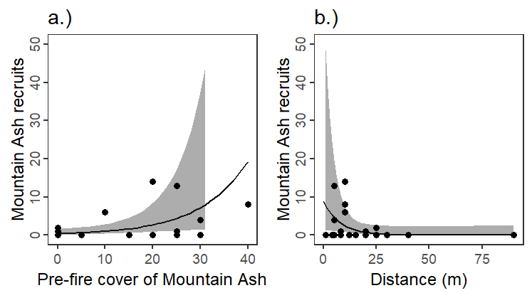

Figure 8. Predictions of generalised additive model relating the number of Mountain Ash recruits to (a) pre-fire cover of Mountain Ash at each plot and (b) distance to the nearest living mature or 2009-fire-killed mature tree (that could have acted as a seed source). Black line shows mean predictions and grey shading shows 95% confidence intervals of prediction. In panel a, the confidence interval is not shown beyond 30 m as it exceeds the y-axis limits. Black points show the raw data.

* 1. Spatial analysis
     1. Changes in rainforest areal extent

Differences between pre-fire mapped rainforest extent and post-fire modelled rainforest extent need to be treated with caution due to different methods used for their derivation [see pre-and post-fire areal values for the unburnt Area A (Table 3)] and relative registration errors between the two GIS shapefiles. However, overall differences were sufficiently stark that useful conclusions could be drawn from the data.

Changes in rainforest extent on a landscape scale were strongly associated with a coarse estimate of overall fire severity. Rainforest in the most northern end of the catchment (Area C) and towards the southern end of the catchment (Area B) generally experienced low-moderate fire severity (Figure 9a), and around 15% of pre-fire rainforest was not captured in post-fire modelling (Figure 9b, Table 3). In contrast, the Deep Creek region (Area D, Figure 9a) experienced the highest fire severities in the catchment, and 96% of the rainforest that had been mapped prior to the fire could no longer be modelled as rainforest (Figure 9b, Table 3). Overall, nearly two thirds of the rainforest previously mapped within the O’Shannassy Catchment could no longer be considered as such.

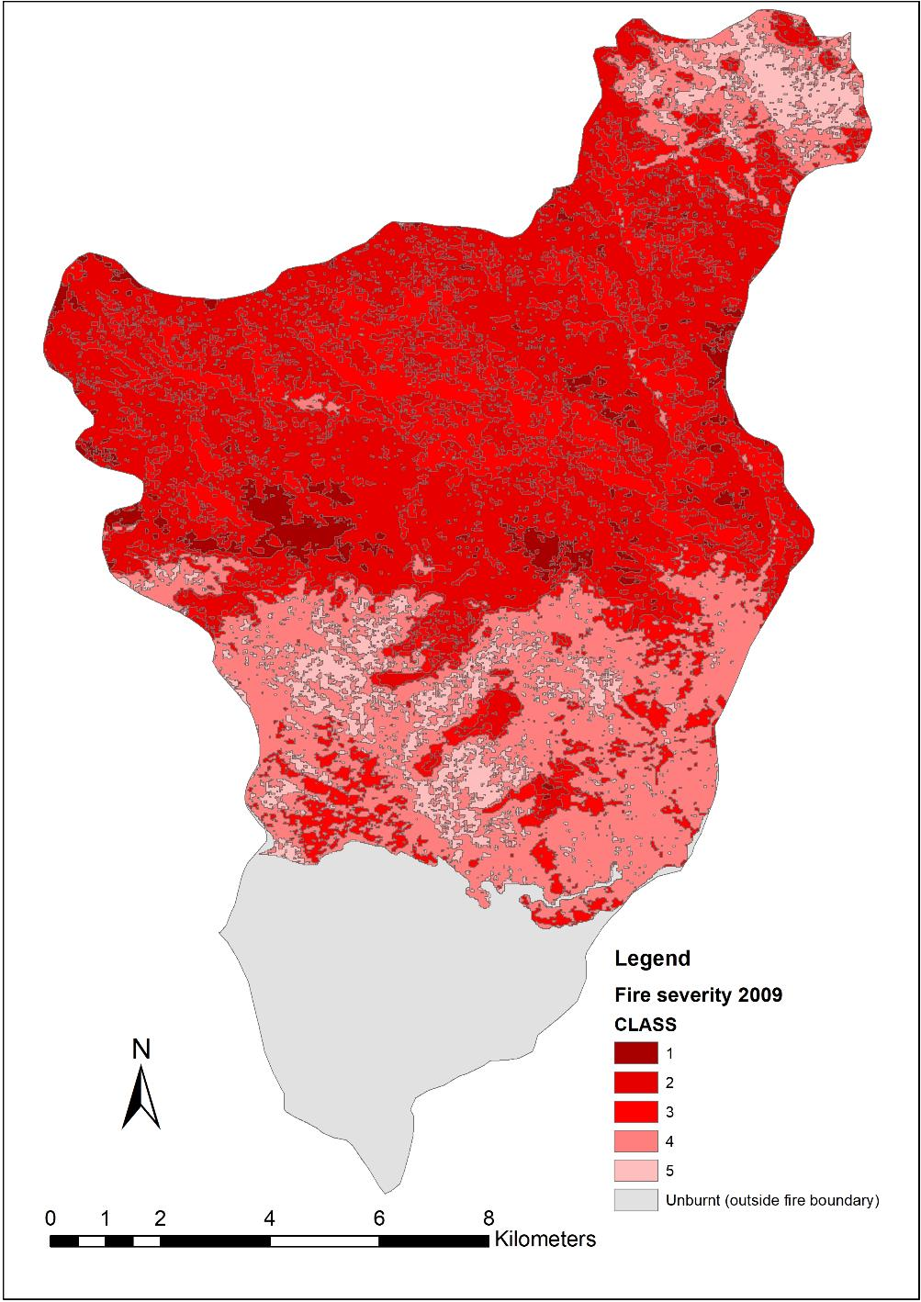

D

B

C

A



Figure 9a. Fire-severity in the O’Shannassy Catchment, 2009. Class 1 is highest severity (see Table 2 for descriptions). A, B, C & D indicate broad areas for calculating pre-and post-fire rainforest extent (see Table 3).

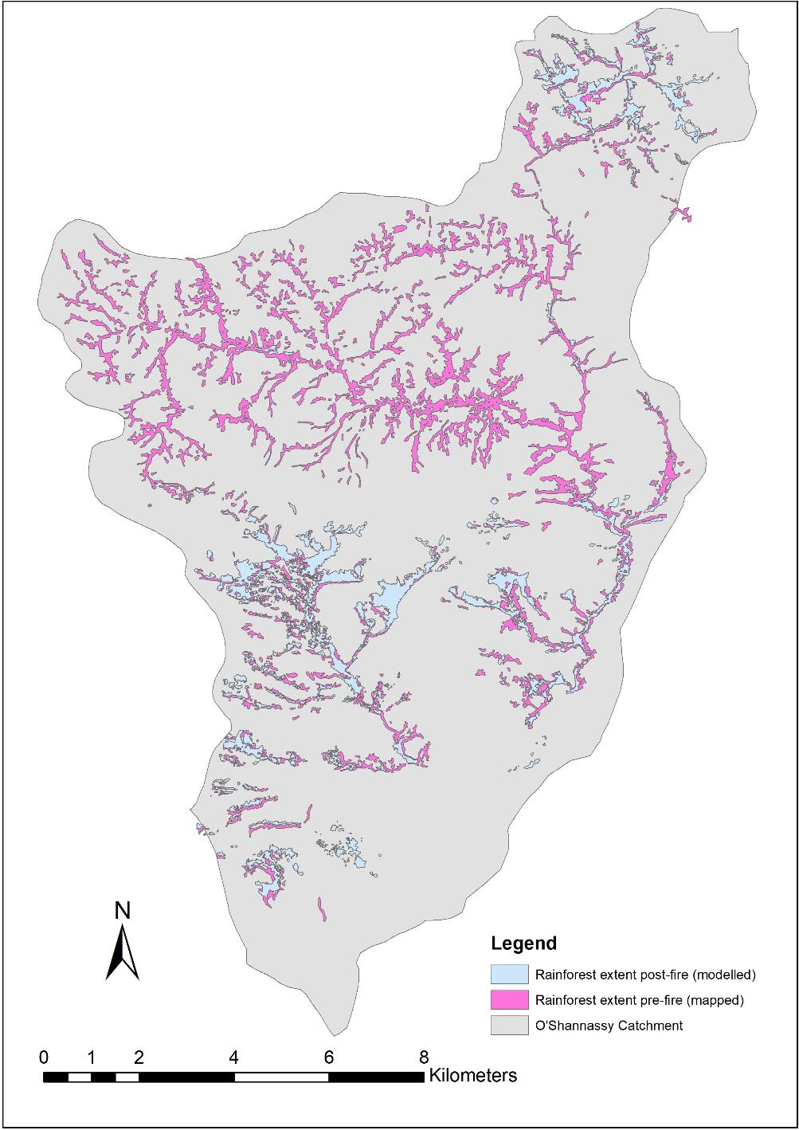

Figure 9b. Extent of primary rainforest in the O’Shannassy Catchment, before and after the 2009 fire. Post-fire (blue) is the top layer so, barring misalignment, visible pre-fire (pink) has now been lost. Arrow indicates the Deep Creek drainage system.

Table 3. Pre-fire (1990s) and post-fire (2018) extent of primary rainforest within the O’Shannassy Catchment. Areas A, B ,C & D as shown in Figure 9a.

|  |  |  |  |  |
| --- | --- | --- | --- | --- |
| **Broad fire severity and area** | **Pre-fire (ha)** | **Post-fire (ha)** | **Post-fire change (ha)** | **Post-fire change (%)** |
| **Unburnt**  **A:** South of Road 15 and Road 1,  to bottom of catchment | 89 | 80 | -9 | -10% |
| **Low-Moderate**  **B:** South from Poley Rd to  Road 15 and Road 1  **C:** Marysville-Woods Point Rd  to around 2.5 km south | 528 | 451 | -77 | -15% |
| **Moderate-High**  **D:** 2.5 km south of Marysville-Woods-  Point Rd down to Poley Rd | 889 | 33 | -856 | -96% |
| **TOTAL** | **1506** | **564** | **-942** | **-63%** |

* + 1. Probability of rainforest loss as a function of fire severity

The analysis showed a strong relationship between mean fire severity class and the probability of losing rainforest. Rainforest was completely lost from cells that were burnt most severely (severity class 1, Figure 10), and almost completely lost from cells in severity class 2. In comparison, less than 20% of cells lost rainforest in the classes describing the least severe burns (fire severity classes 4 and 5, Figure 10). Some of the apparent loss at the lowest fire severity is likely due to inherent differences in the way that the two rainforest GIS layers were created, in combination with their respective registration errors.

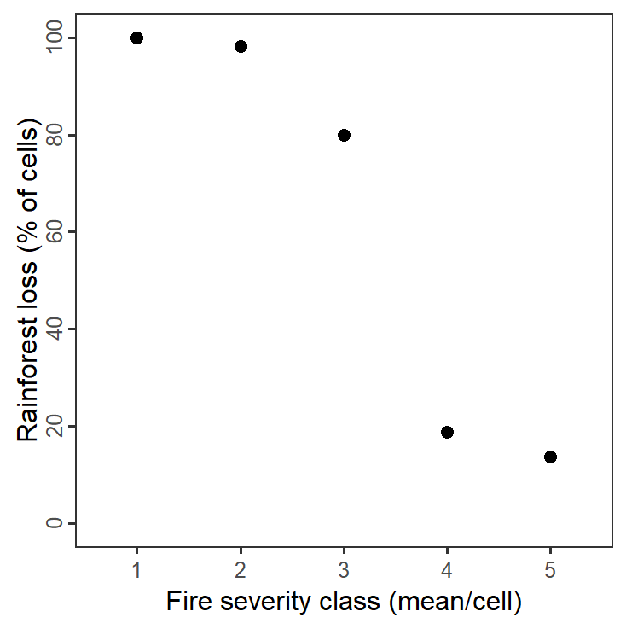

Figure 10. Results of spatial analysis showing rainforest loss after the 2009 fire as a function of fire severity. Mean fire severity scores are grouped, with 1 = values up to 1.5, 2 = values 1.5-2.5 etc. Rainforest loss is the percentage of cells that had rainforest mapped in the 1990s but did not have rainforest modelled in 2018.

* 1. Is deer activity of concern?

Most plots surveyed during this study had no or low deer activity (Table 4). Three plots had a moderate level of deer activity, and no plots had activity levels considered to be high. Deer activity varied little by forest type, with similar levels observed in rainforest and mixed forest. Activity also varied little by fire severity, although the data are likely confounded by the small number of high-severity burnt sites. The most severely burnt areas around the Deep Creek Reference Area could not be safely assessed, and it is possible that activity levels differ there.

Table 4. Estimates of deer activity level at the study plots by fire severity and forest type, with the number of plots in high, low, moderate and no deer activity categories.

|  |  |  |  |  |  |
| --- | --- | --- | --- | --- | --- |
| **Forest type** | **Fire severity** | **High deer activity** | **Moderate deer activity** | **Low deer activity** | **No deer activity** |
| CT mixed | High |  |  | 2 |  |
| CT mixed | Low | NA | NA | NA | NA |
| CT mixed | Moderate |  | 1 | 2 | 3 |
| CT mixed | Unburnt |  |  | 4 | 1 |
| Rainforest | High |  |  | 1 |  |
| Rainforest | Low |  |  | 1 | 1 |
| Rainforest | Moderate |  | 1 | 1 |  |
| Rainforest | Unburnt |  | 1 | 3 | 2 |
| **TOTAL** |  | **0** | **3** | **14** | **7** |

1. Discussion
   1. Changes in vegetation assemblages and structure from field survey data
      1. Floristic composition and richness

The species ordinations showed clear differences as expected between rainforest and mixed forest plots, and between burnt (mostly low-moderate) and unburnt treatments. The same six species were responsible for both the differences between forest type (58% explained) and the differences between burn treatments (57% explained). Three of these species, Myrtle Beech and Southern Sassafras (the dominant primary rainforest species) and Hard Water-fern had higher cover in both rainforest and unburnt plots, as expected. Myrtle Beech, which can form an almost continuous canopy in mature rainforest, was mostly resprouting in the burnt treatments after being top-killed, and foliage cover was still only a fraction of pre-fire cover, as was that for Southern Sassafras. It will be decades before the mature canopy of these species is re-established.

Of the other key species, the mean cover of Mountain Ash was higher in mixed forest plots, as expected, but also had reasonably high cover in some burnt mixed plots because of sapling growth in the ten years since fire and a small amount of regeneration in rainforest plots that were previously eucalypt-free. Cover of Soft Tree-fern was highest in moderately-burnt rainforest plots, while cover of Mother Shield-fern was highest in moderately burnt plots in both forest types.

The impacts of the 2009 fires were still clearly evident on the ordination, with the separation of burnt plots from unburnt plots reflecting increasing fire severity. Similar separation was seen in the ordination by Worley (2012), which was based on rainforest data gathered within a year of the fire. Interestingly, the list of species that contributed the most to differences between burnt treatments after 10 years was very similar to the list of species that contributed to differences within a year of the fire (Worley 2012), including Myrtle Beech, Southern Sassafras, Hard Water-fern, Soft Tree-fern and Mountain Ash. This illustrates that floristic differences are established quickly then persist for a decade or more. The extent to which canopy gaps are opened is related to fire severity, hence the plots burnt at high severity were always expected to show the biggest changes in species composition. Many of these compositional differences will persist until fire-stimulated plants, especially shrubs, begin to senesce and retreat to the soil seed bank, and tree canopy cover is re-established, which may take decades.

Rainforest plots were not as consistently separated from mixed forest plots on the ordination. This was not surprising, because mixed forest in the study area is essentially rainforest overtopped by some taller, emergent eucalypts. Rainforest plots were sometimes well separated from other rainforest plots, even within the same fire treatment, due to site differences. For example, while some rainforest plots were located to the side of drainage lines and had sparse ground cover, others were centred over the drainage line and contained a dense suite of species more suited to saturated conditions, such as sedges. These plots were also characterised by a lower canopy cover because of more pronounced canopy gaps. Mixed forest appeared less affected by topographic differences than rainforest, with less separation of plots on the ordination, with the exception of moderately burnt mixed forest. This is possibly due to greater variation in the amount of canopy that was killed by moderate intensity fire, hence greater variation in post-fire response by the understorey.

No statistically-significant difference in species richness was seen between rainforest and mixed forest plots. This was unexpected, as rainforest plots assessed in the Central Highlands in 2010 generally had low species richness (Worley 2012). In contrast, the mixed forest ecotone ought to share species with both the rainforest and surrounding Ash forest and should logically have higher richness. Similarly, there was no statistically-significant trend for increasing richness with respect to increasing fire severity, which was also surprising given the clear compositional differences seen in the ordination, and the trend by fire severity measured by Worley (2012). Our results are probably an artefact of low sample size and a shortage of severely burnt plots, in combination with substantial differences within both fire severity classes and forest types. For example, species richness was both high (> 30 species) and low (< 15 species) in both burnt and unburnt plots, and in both rainforest and mixed plots. This variation probably explains why our mean species richness in rainforest (around 18-39 species, depending on fire severity) was substantially higher than that measured by Worley (2012) (around 7-17 species). Raw data still suggested an overall trend of increasing richness with increasing burn severity, as expected when large canopy gaps are opened up and a suite of previously-suppressed species are able to germinate. The three plots with highest species richness were all burnt at moderate to high intensity, while the three plots with lowest richness were all unburnt.

Overall, the compositional changes we observed are consistent with immediate removal by fire of above ground plant material, quickly followed by resprouting of ground ferns and tree ferns, rapid establishment from seed of a suite of understorey species, especially shrubs and forbs, from the opening up of canopy gaps, then slow recovery over more than 10 years by canopy species. The underlying trends suggested by the raw data are broadly what would be expected after fire in these forests, and a larger sample size would undoubtedly have improved confidence in the findings.

* + 1. Floristic structure

Primary rainforest species are defined as species that can establish or perpetuate themselves (through seedling regeneration or vegetative resprouting) below an undisturbed canopy, or in small canopy gaps, without requiring fire (Busby and Brown 1994; Cameron 1992). In contrast, secondary rainforest species are defined as those that may regenerate in extensive gaps following fire, and which contribute to, or are emergent over, the immature rainforest component in mixed forest (Cameron 1992).

As expected, the total cover of primary rainforest species was significantly higher in unburnt plots than in burnt plots, with Myrtle Beech making by far the biggest contribution to the difference. Foliage cover of this species can be almost continuous in unburnt forest. In contrast, Myrtle Beech cover was still very low in plots burnt at moderate or high intensity because trees were top-killed (to variable height) and were mostly resprouting from buds at the base (Figure 11). Profuse seedling recruitment as suggested by other researchers for this species was not observed, supporting the findings by Worley (2012). Similarly, Southern Sassafras was also resprouting from top-killed trees and maintained low cover in burnt plots. Such drastic reductions in canopy followed by basal resprouting have been well noted in other rainforest research in the study area (Worley 2012). The total cover of primary rainforest species was not significantly higher in rainforest plots than mixed forest plots. This was also not surprising because, as mentioned above, mixed forest in the study area is essentially a seral stage of rainforest that is overtopped by some taller, emergent eucalypts.

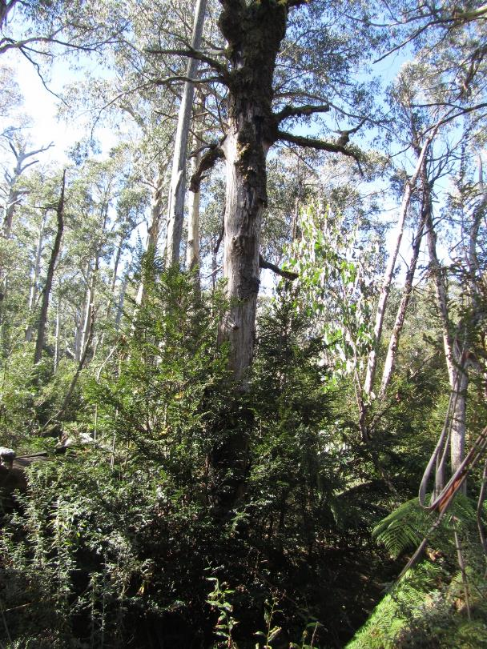

Figure 11. Myrtle Beech resprouting from large, top-killed parent tree in mixed forest burnt at moderate severity.

In contrast to the primary species, the total cover of secondary rainforest species was higher in burnt plots, mostly due to post-fire saplings of Frosted Wattle (there were no recruits of this species in any unburnt plot) and Mountain Ash (Figure 12). Raw data also suggested that mixed forest plots had higher cover of secondary species, as would be expected, but the results were not statistically significant.

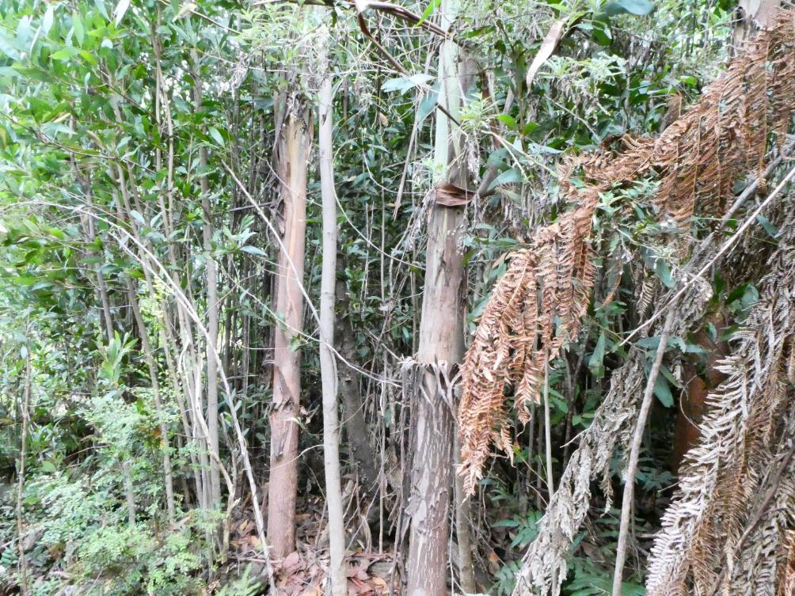

Figure 12. Recruitment of Mountain Ash (thicker stems) and Frosted Wattle in severely burnt mixed forest. Despite fire severity and sapling density, Myrtle Beech is still regenerating at bottom left (arrow).

Fern (excluding tree fern) cover was higher in rainforest than mixed forest in all burn classes, reflecting the gully location of rainforest plots. Hard Water-fern was a major contributor to the difference, with up to 85% cover in some rainforest plots. Ferns declined dramatically in cover immediately after the 2009 fires (Worley 2012), but the absence of any persistent significant fire effects in our study suggests that this lifeform has mostly recovered within 10 years, as also observed in warm temperate rainforest (Chesterfield *et al.* 1990). Similarly, there was little difference in tree fern cover by burn treatment 10 years post-fire, which is not surprising given they are one of the first lifeforms to display prolific vegetative regeneration after fire. There was also little difference in tree fern cover by forest type, with the dominant species, Soft Tree-fern, having similar cover in both rainforest and mixed forest plots (except in moderately burnt plots).

The cover of forbs increased with increasing fire intensity, supporting the results of other rainforest research following the 2009 fires (Worley 2012). Cover of forbs is often low in rainforest vegetation, but is favoured by fire that opens up canopy gaps (Chesterfield *et al.* 1990; Worley 2012). Our data then suggest that these changes persist for at least 10 years after fire. For similar reasons, cover of tussock grasses was higher in burnt plots, especially of Sword Tussock-grass (*Poa ensiformis*) and Tassel Sedge (*Carex fascicularis*). The high cover of tussock grass suggested for rainforest burnt at high severity was driven largely by high cover of Tassel Sedge at one burnt plot, and it may be atypical. Shrub cover was also higher in burnt plots, with fire-stimulated germination of species such as Frosted Wattle, Tree Everlasting and Dusty Daisy-bush. The post-fire response by shrubs can be rapid, because a six-fold increase in shrub cover was detected in these forests within only one year of the 2009 fires (Worley 2012), and such changes are likely to last for as long as the lifespan of the shrubs. Large increases in shrubs are also seen after fire in warm temperate rainforest (Chesterfield *et al.* 1990). In contrast, and not surprisingly, tree cover was lowest in burnt plots, reflecting long recovery times for this lifeform.

As expected, mature eucalypt cover was non-existent in rainforest plots, because they were selected on that basis, and also non-existent in mixed forest plots burnt at high severity, where the overstorey trees were all killed by the fire (Figure 13). Similarly, mature non-eucalypt cover was restricted to rainforest plots (except one plot burnt at high intensity), and unburnt mixed forest. Mature non-eucalypt canopy, including of Myrtle Beech and Southern Sassafras, was sometimes lost in mixed forest even when fire was of moderate intensity and spared some of the higher eucalypt crowns. A year after fire, total tree canopy cover in severely burnt rainforest in the study area was around 10% (Worley 2012). Our research suggested that total canopy cover 10 years post-fire had recovered to around 25% in some plots, but this is still well short of the average 80% cover in unburnt rainforest in this study. Thus, it will still be many years before the canopy closes, and before any top-killed rainforest trees reach a stage where they could be considered ‘mature’.

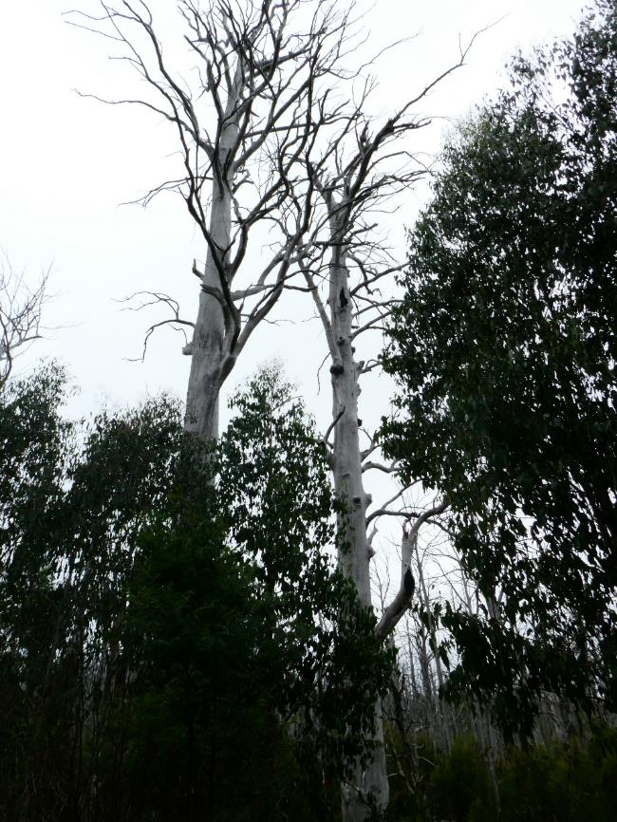

Figure 13. Typical fire-killed Mountain Ash in area of high burn severity.

Epiphytes had very low cover across all plots and were not analysed. Similarly, six ground cover parameters were assessed for this project, but only two (bryophytes and CWD) had enough data or variation to support analyses. Bryophyte cover was consistently higher in rainforest than mixed forest, as expected given that rainforests are mostly restricted to wet, shaded gully locations. Bryophyte cover also reduced slightly with increasing fire intensity, especially in mixed forest. Such reduction was noted in the study area around one year after the 2009 fires (Worley 2012), and our results indicate that bryophytes have still not recovered after 10 years. Recovery of bryophytes and epiphytes may take decades as predicted for warm temperate rainforest (Chesterfield *at al*. 1990). CWD was higher in burnt plots than unburnt plots, and slightly higher in mixed forest than in rainforest, consistent with fire-induced mortality of trees and subsequent dropping of dead branches.

* 1. Eucalypt invasion and rainforest resilience

Cool Temperate Mixed Forest in the study area represents the rainforest ‘ecotone’. This is the transition zone between ‘pure’ rainforest and sclerophyll communities (Cameron 1992), and is defined in this study as the zone between the boundary of emergent eucalypts directly upslope from the rainforest stand, and the disappearance of primary rainforest species further upslope. There are gradients of fire frequency and fire intensity decreasing from sclerophyll forest to rainforest, accompanied by decreasing fuel loads and increasing moisture (Leonard *et al.* 2014), and mixed forest can act as a useful ecological buffer to the mature rainforest (Barker 1992). Indeed, mature, closed rainforest can be reasonably resistant to fire (Baker *et al.* 2012; Barker 1992; Busby and Brown 1994), and in the Central Highlands in 2009, sites within deep gullies that contained rainforest were the least likely to burn (Leonard *et al.* 2014). We also found that rainforest stands were generally burnt less severely than the surrounding Ash forest (at least in the southern part of the study area). Similarly, dendrochronological studies by Simkin and Baker (2008) found that rainforest in the Central Highlands had a significantly higher proportion of trees surviving the 1939 fires than tall forest (where most eucalypts on the upper slopes were killed) [also see review in Baker *et al.* (2012)].

Ecotonal and seral vegetation are therefore essential components of rainforest dynamics in Victoria, with fire maintaining the rainforest-sclerophyll margins in a stable but dynamic equilibrium (Cameron 1992; McMahon 1992). Edge effects are important here, as the narrow, often linear nature of rainforest results in a high circumference to area ratio, potentially exposing it to marginal attrition by sequential fires. Along this edge, the proximity to trees, especially Mountain Ash, is one of the key elements that drives the course of post-fire succession (Cameron 1992). However, rainforests in Australia appear to have some resistance to invasion by eucalypts (Howard 1973), and there is evidence that some core rainforest stands have survived numerous fires (Simkin and Baker 2008). Of course, fire can also prevent expansion of rainforest back into suitable areas, and there is anecdotal evidence that the modern distribution of rainforest may have been limited by fire much more than previously thought (Busby 1992; Hope 1992).

Mountain Ash, as the dominant secondary rainforest species in the study area, does not recruit in the deep shade provided by an intact forest canopy, hence relies on fire to provide the canopy gaps and soil conditions for seedling regeneration (Ashton 1981; Cameron 1992). Seeds of Mountain Ash are predominantly dispersed by wind, and while most seeds fall within a horizontal distance equivalent to less than the height of the parent tree, a small number are dispersed up to around twice the height of the parent tree (Cremer 1966; Flint and Fagg 2007). Dispersal tends to be greater when parent trees are isolated without shelter from the wind (as in a logged coupe), but can be poor from the protected edge of a dense forest (Cremer 1966). Given that Mountain Ash in the study area often exceeds 40 m in height, then potential recruitment of seedlings over 80 m away from fire-killed parents could theoretically lead to the conversion of entire narrow bands of rainforest to mixed forest (an earlier successional stage of rainforest). Any such establishment of eucalypts in the rainforest edge would increase the probability of burning in a future fire (Chesterfield *et al.* 1990; Read 1992).

This study has shown that there has been encroachment of Mountain Ash into burnt rainforest in the study area, but this is strongly related to fire intensity. No Ash saplings were found in the rainforest plots burnt at low intensity. This supports the findings of Worley (2012), who recorded almost no Ash seedlings in quadrats burnt at low intensity within the broader Central Highlands. Other research in the Central Highlands after 2009 also found that eucalypt regeneration in accessible sites was limited to the mixed forest ecotone, and woody seedlings in burnt rainforest were mostly *Acacia* species and not Ash (Pappas 2010, cited in Baker *et a*l. 2012). Similarly, there were only small numbers of eucalypt seedlings in burnt rainforest and mixed forest plots in Tasmania (6 to 18 months after fire), despite the presence of mature trees that provided a potential seed source (Hill and Read 1984).

The existence of unburnt or rapid post-fire growth of plants (including tree ferns, ground ferns, shrubs, and midstorey trees, especially wattles) in low-severity burnt rainforest or mixed forest seems to hinder successful regeneration of eucalypts from seed (Flint and Fagg 2007; Howard 1973). Alpine Ash appears to lack ecological tolerance to shade, and in experiments where Ash seeds were sown under otherwise favourable site conditions, a lack of canopy gaps and vigorous understorey growth, among other factors, ensured that regeneration failed completely after 10-11 years despite initial germination of seedlings (Ashton and Chinner 1999). Regeneration of Mountain Ash can also be hampered by seed harvesting by ants, insect attack, root competition, frost in areas of cold air drainage, and fungal attack (Ashton and Chinner 1999; Flint and Fagg 2007). Fungal attack is more frequent under moist or humid conditions, when light levels are low, and when fire has not been able to create a suitable seedbed (Flint and Fagg 2007). It is clear that the low-intensity burn treatment in our study, even when fire in the surrounding forest may have been of a higher intensity, did not provide conditions suitable for Mountain Ash regeneration, and it is not surprising that surviving recruits were restricted to the moderate and high severity fire treatments.

In moderate intensity burnt plots visited for this study, Ash saplings were found up to around 10 m from a seed source, but in the high intensity plot, saplings were found 25 m away from a seed source, suggesting that the extent of Ash encroachment is closely linked to fire severity. Worley (2012) recorded a mean of 227 Mountain Ash seedlings in 64 m2 rainforest quadrats burnt at high intensity within the broader Central Highlands, and while many of these seedlings may not have survived over the last decade the raw numbers still suggest a concerning level of Ash recruitment. Seedling recruitment was also correlated with fire severity in warm temperate rainforest (Chesterfield *et al.* 1990). Unfortunately, this research was unable to adequately capture the full range of fire intensities in field data, as the most severely burnt rainforest stands in the Deep Creek region of the catchment were inaccessible.

Our study suggests that, in areas subject to low or moderate intensity fire, such as the southern half of the O’Shannassy Catchment or the northern tip, there has not been large-scale conversion of rainforest to mixed forest, and the location of new Ash saplings with respect to the rainforest edge is similar to that of the original mature trees (Figure 14). This may reflect shorter distances of Mountain Ash seed dispersal because of the density of the surrounding forest (Cremer 1966) in combination with competition from surviving or rapidly regenerating rainforest understorey plants (Howard 1973), and a fire severity that was often too low in rainforest cores to produce light conditions suited to Mountain Ash seedling survival.

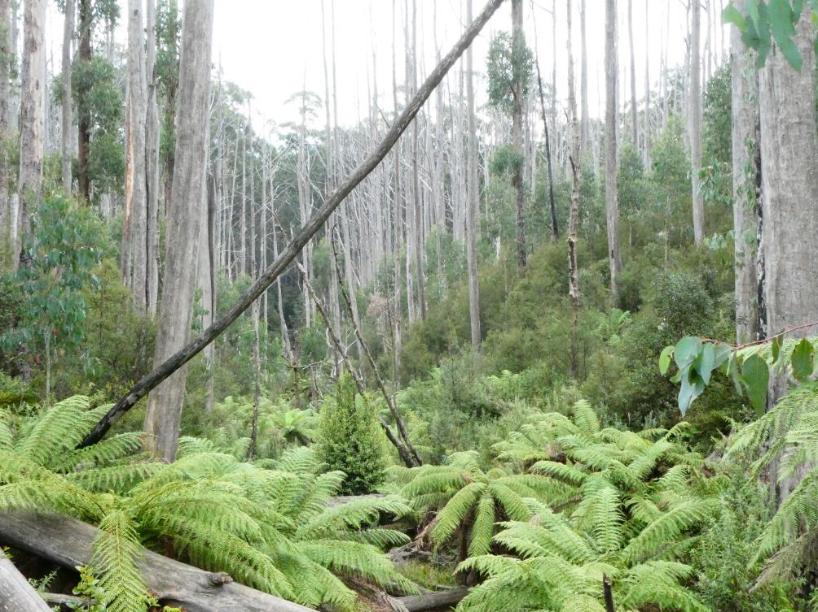

Figure 14. Small rainforest stand in gully, showing the close spatial relationship between new Ash saplings (arrowed) and the original Ash forest edge, when not burnt at high intensity.

Large stands of rainforest in the broader Central Highlands survived fires in 2009 (Baker *et al.* 2012) suggesting that, under certain conditions, rainforest may be relatively resilient to lower-severity fire. Warm-temperate rainforest is also considered relatively resistant to fire (Melick and Ashton 1991), with boundaries between that assemblage and adjacent sclerophyll forest being stable over three decades despite sequential fires (Knox and Clarke 2012). Nonetheless, resistance to fire is not assured, as invasion of eucalypts and wattles in burnt warm temperate rainforest in East Gippsland was probably influenced by changes wrought by previous fires (Chesterfield *et al.* 1990). Even the limited invasion of eucalypts noted in this research in moderately burnt forest, mostly in the rainforest ecotone, means that many stands of ‘pure’ rainforest in moderately burnt areas of the O’Shannassy Catchment are now likely to be smaller than they were before the 2009 fire.

Spatial data for areas of the catchment burnt at lower severity supported the limited incursion of non-rainforest trees as determined by field surveys. Such areas were mostly protected from severe fire by their predominantly southerly aspect and, with generally low-moderate fire severity, 15% of pre-fire rainforest had disappeared. The probability that rainforest was lost from cells with lower mean fire severity (Classes 4 & 5) was less than 20%. In contrast, the Deep Creek area, with broad shallow valleys that transitioned in the south to steep northerly slopes, experienced the highest fire severities in the catchment. Here, 856 ha of rainforest that had been mapped prior to the fire could no longer be modelled as such, and the probability of rainforest loss from cells with the highest mean fire severity (Class 1) was 100%. This suggests that the foliage cover of regenerating non-rainforest species (mostly eucalypts and wattles) was now too high for the vegetation to be seen as rainforest in remotely sensed imagery. Researchers have seen substantial recruitment of eucalypts in the Deep Creek area since 2009, mostly by Mountain Ash, but also Alpine Ash (*Eucalyptus delegatensis*) and Shining Gum (*Eucalyptus denticulata*) (David Cameron, DELWP, pers. comm.). The extent of non-rainforest recruitment appears to be so high that it is possible that many of the most severely burnt stands might now constitute a wet sclerophyll forest type rather than even a mixed forest (rainforest successional) type. A similar transition to sclerophyll forest has been forecast for stands of warm temperate rainforest burnt at high severity in 1983 at Jones Creek, East Gippsland (Chesterfield *et al.* 1990).

Differences between pre-fire mapped rainforest extent and post-fire modelled rainforest extent need to be treated with some caution due to the different methods used for their derivation. For example, post-fire modelling suggested there was around 10% less rainforest in the unburnt area than suggested by pre-fire mapping. Nonetheless, overall differences were sufficiently stark in areas burnt at higher severity that useful conclusions could be drawn from the data.

Much of the rainforest in the Deep Creek area in the northern part of the catchment therefore appears to have been transformed more or less permanently into a different forest type dominated by sclerophyllous (and more fire prone) eucalypt species rather than rainforest species. It is also possible that some rainforest stands here have persisted but are temporarily obscured by wattle species, but this would require ground-validation. Overall, nearly two thirds of rainforest previously mapped in the O’Shannassy Catchment can no longer be mapped as such. Barring another fire in the region that kills the Ash saplings before they reach their viable reproductive maturity [at around 20 years (Flint and Fagg 2007)], this effect could last as long as the 300 to 400 year lifespan of the new trees (Busby and Brown 1994; DNRE 1996; Flint and Fagg 2007).

Even if future fires do not enter the core areas of remaining rainforest, all fires in their vicinity have the potential to damage or destroy the rainforest buffers and margins, increasing the risk of subsequent fires penetrating further into the stand (Cameron 1992; Chesterfield *et al.* 1990; Read 1992). This can set up a self-perpetuating cycle of sclerophyll expansion and rainforest attrition, and place severe limitations on the ability of rainforests to expand to occupy their climatically- and edaphically-determined niches (Cameron 1992; Chesterfield *et al.* 1990), and indeed the ability of rainforests to persist in anywhere near their current (already depleted) extent. Paradoxically, the largest stands of rainforest in the Central Highlands tended to be found in the broader, shallower valleys at lower elevation (such as the Deep Creek area in our study), rather than in the deeply incised gullies upstream, and these larger stands were burnt more extensively in 2009 (Worley 2012). Thus, the stands with the greatest potential to maintain or increase their core size are also the most vulnerable to severe fire, and in many instances no longer exist.

Climate change is of great concern, as fires in surrounding Ash forest are expected to become more severe in line with potentially increased fire frequency. A future fire frequency that maintains Ash forest in a younger age class is likely to be particularly deleterious, and more likely to facilitate the spread of fire into remaining rainforest stands. For example, stands in the Central Highlands aged 7 to 36 years will burn more severely than stands younger than 7 years or older than 40 years, with natural self-thinning creating higher fuel loads (Taylor *et al.* 2014). In contrast, older growth Ash forests with high canopies can develop a luxuriant rainforest understory (Taylor *et al.* 2014) with higher fuel moisture (Cawson *et al.* 2017) and less propensity to burn, but such examples in the Central Highlands are now rare indeed (Lindenmayer *et al.* 2011), and highly unlikely to redevelop.

Climate forecasts give little hope for optimism with respect to the long-term future of Victoria’s Cool Temperate Rainforests, and indeed other rainforest types. Autumn and winter rainfall have reduced over south-eastern Australia, particularly in May-July where rainfall has decreased by around 20% since 1970 (BoM and CSIRO 2018). Australia’s mean temperature has increased by just over 1°C since 1910 with attendant increases in the frequency of extreme heat events and extreme fire weather and a lengthening of the fire season (BoM and CSIRO 2018). These changes are expected to continue, with predicted increases in the frequency of fire (Hennessy *et al.* 2005) and a reduction in climatically-suitable areas for rainforest (Busby 1992). Further encroachment of Ash into already depleted cool temperate rainforest appears almost inevitable, and it requires only one mature tree at the edge of the rainforest to act as a seed source. Similarly, eucalypts are predicted to increase with each successive fire in warm temperate rainforest until they eventually dominate (Chesterfield *et al.* 1990). Thus, while most primary rainforest species have some resistance to fire and should persist as components of mixed forest (a seral stage of rainforest), the occurrence of ‘pure’ rainforest is likely to become increasingly restricted to small stands in the wettest, most protected parts of the landscape.

* 1. Deer activity

Four species of deer have established wild populations in Victoria, of which Sambar Deer (*Cervus unicolor*) is considered to be the most successful (Menkhorst and Knight 2001). This is a large deer to 240 kg (Menkhorst and Knight 2001) that was introduced into Victoria during the 1860s (Peel *et al.* 2005). It now has a large, well-established population throughout the mountain ranges of central to eastern Victoria, including the Yarra Ranges National Park (Forsyth *et al.* 2009; Parks Victoria 2002). It is an agricultural pest, damaging vegetable and cereal crops, orchards and plantations, fouling water and damaging fences (Davis *et al.* 2016; Lindeman and Forsyth 2008). However, Sambar Deer also impact on native ecosystems, particularly rainforests and riparian zones, by thrashing shrubs and small trees, browsing and trampling, creating wallows and interfering with post-fire regeneration (Davis *et al.* 2016; Menkhorst and Knight 2001; Peel *et al.* 2005). Consequently, “Reduction in biodiversity of native vegetation by Sambar (*Cervus unicolor*)” is listed as a threatening process under Victoria’s FFG Act 1988 (DELWP 2016).

Large fires can have a major impact on deer populations. Sambar Deer abundance was greatly reduced by the 2009 fires due to their scale and intensity, and eight months after fire there were no pellets counted along 30 transects in Kinglake National Park (Forsyth *et al.* 2011; 2012). Nearly all burnt habitat was re-occupied 16-24 months later, but faecal pellet counts suggested that deer abundance was still much lower than in the unburnt treatment (Forsyth *et al.* 2011; 2012). It may be many years before populations regain pre-fire levels (Forsyth *et al.* 2011; 2012).

Most plots surveyed during this study had no or low deer activity, with occasional scats, tracks and light browsing. Only three plots had a moderate level of deer activity, with more extensive browsing of shrubs, obvious tracks or trampling, and deer rubbing on shrubs and saplings, including Southern Sassafras. No plots had activity levels considered to be high. These results tend to support the relatively slow post-fire recovery of Sambar Deer numbers.

Deer activity varied little by forest type, with similar levels observed in rainforest and mixed forest. This is not surprising given the close spatial and ecological relationships between the two forest types. Deer activity also varied little by fire severity, although the data may have been confounded by the small number of high-severity burnt sites. Visually, the extent of deer damage appeared to be higher in plots where sparse understorey facilitated easy access to a defined stream. A larger sample size may have helped tease out the factors driving deer activity levels.

* 1. Pathogens

Myrtle Wilt, an often fatal disease caused by the fungal pathogen *Chalara australis*, is widespread in the Central Highlands, and tends to occur more often when the rainforest stand has been disturbed by logging or roading activity (Cameron and Turner 1996; Packham and Kile 1992; Parks Victoria 2002). Canopy gaps created by this disease may also make the regenerating vegetation more susceptible to damage by future fire. Minor evidence of Myrtle Wilt was seen in parts of the study area where roads were in close proximity to rainforest stands, but severely infected Myrtle Beech trees were not observed. It is possible that burning of dead or unhealthy trees by the 2009 fire obscured some previous evidence of infestation. In any event, care should be taken when undertaking any road works to avoid further disturbance to rainforest or mixed forest ecotones, as that could help spread the wilt or make trees more susceptible to infection.

The root-rot fungus *Phytophthora cinnamomi* is also able to attack many rainforest species, but there is little evidence of damage to undisturbed rainforest by this pathogen (Busby and Brown 1994).

* 1. Conclusion and recommendations

Recruitment of non-rainforest canopy species in the most severely burnt part of the O’Shannassy Catchment has been sufficiently high that most rainforest appears to have been converted to mixed forest, if not wet sclerophyll forest. Overall, only around one third of the original rainforest has persisted in the catchment, with surviving stands mostly restricted to protected areas that remained unburnt, or that were burnt at a low to moderate intensity. Despite some documented resistance to fire, rainforest in the catchment could not cope with the highest severity fire.

It is possible that some rainforest stands here have persisted but are temporarily obscured by wattle species rather than eucalypts, but this would require validation. Given safety concerns with respect to field work in the catchment, drone technology or high-resolution aerial photography could be used to examine remote stands of burnt rainforest and determine the permanency of the changes as modelled.

The greatest threat to remaining stands of Cool Temperate Rainforest in Victoria is the predicted increase in the frequency, extent and intensity of fire due to climate change. Mountain Ash and similar species take around 20 years to reach viable reproductive maturity, but once they do so their canopy-stored seed will facilitate further, incremental incursions of eucalypts into the rainforest edges in the event of successive fires. More rainforest will eventually disappear, starting with the smallest stands that may already be marginal, and the long-term future of this important vegetation type appears bleak.

There is little that can be done at a local management level to combat the direct impacts of climate change. However, there are some steps that could be taken in and around the O’Shannassy Catchment (and elsewhere in Victoria) to help protect or buffer rainforests from indirect impacts and other disturbance and maximise the chance that rainforest can persist into the future (refer also to DSE 2009). These steps include:

* Fire fuel management. Rainforests are only burnt when surrounding forests (mostly Mountain Ash in the study area) carry the fire into them, hence conservation of rainforests is largely dependent on protection of the ecotone and its sclerophyll forest buffer (Cameron 1992). Rainforests and wet forests are not suited to fuel reduction burning (either ecologically or in a practical sense), hence protection needs to be undertaken at a much broader landscape scale (Busby 1992; Busby and Brown 1994; Lindenmayer *et al.* 2011). Targeted fuel management in drier sclerophyll forests to the north and west of the O’Shannassy Catchment and increased prioritisation of fire suppression might moderate (to a limited extent) the intensity or propagation of future fire through the catchment. How and to what extent such management would best be undertaken is outside the scope of this report.
* Protection of rainforest outside the catchment. Pre-fire mapping suggested there were 5400 ha of rainforest, relatively evenly distributed between national park and state forest, across the broader Central Highlands, and around three quarter of this is outside the O’Shannassy Catchment. The loss of substantial areas of rainforest after the 2009 fires has increased the ecological value of all remaining stands and makes their protection even more important. This will require a cross-tenure approach. However, recommendations on how to better protect remaining stands of rainforest in state forest subject to timber harvesting activities are outside the scope of this report.
* Prevention of pathogen spread. Myrtle Wilt is widespread in the Central Highlands, and tends to occur more often when the rainforest stand has been disturbed by logging or roading activity (Cameron and Turner 1996). Management should minimise roadwork activity where roads pass through or close to rainforest or mixed forest stands, to help minimise the impacts or spread of Myrtle Wilt and other potential pathogens.
* Deer control. Deer numbers are expected to continue to increase with time-since-fire. Targeted control of deer should continue in the study area, as well as monitoring of long-term changes in plant communities and evaluation of the efficacy of control measures, as these have been identified as priority knowledge gaps (Davis *et al.* 2016).

# References

Ashton D. H. (1981) Fire in tall open-forests (wet sclerophyll forests). In: *Fire and the Australian Biota* (eds A. M. Gill, R. H. Groves and I. R. Noble) pp. 339-66. Australian Academy of Science, Canberra.

Ashton D. H. (2000) The Big Ash forest, Wallaby Creek, Victoria - changes during one lifetime. *Australian Journal of Botany* **48**, 1-26.

Ashton D. H. & Chinner J. H. (1999) Problems of regeneration of the mature *Eucalyptus regnans* F. Muell, (The Big Ash) forest, in the absence of fire at Wallaby Creek, Victoria, Australia. *Australian Forestry* **62**, 265-80.

Attiwill P. M., Ryan M. F., Burrows N., Cheney N. P., McCaw L., Neyland M. & Read S. (2014) Timber harvesting does not increase fire risk and severity in wet eucalypt forests of southern Australia. *Conservation Letters* **7**, 341-54.

Baker P. J., Simkin R., Pappas N., McLeod A. & McKenzie M. (2012) Chapter 18. Fire on the mountain: A multi-scale, multi-proxy assessment of the resilience of cool temperate rainforest to fire in Victoria's Central Highlands. In: *Peopled Landscapes: Archaeological and Biogeographic Approaches to Landscape* (eds S. G. Haberle and B. David). Australian National University E Press, Canberra.

Barker P. C. J. (1992) Fire and the stability of a Victorian cool temperate rainforest. In: *Victoria's Rainforests: Perspectives on Definition, Classification and Management* (eds P. Gell and D. Mercer) pp. 127-31. Monash Publications in Geography No. 41. Monash University, Melbourne.

BoM and CSIRO. (2018) State of the Climate 2018. Bureau of Meteorology and CSIRO, Canberra.

Bradstock R. A. & Price O. F. (2014) Logging and fire in Australian forests: errors by Attiwill et al. (2014). *Conservation Letters* **7**, 419-20.

Busby J. R. (1992) Climatic influences on rainforest distribution. In: *Victoria's Rainforests: Perspectives on Definition, Classification and Management* (eds P. Gell and D. Mercer) pp. 141-4. Monash Publications in Geography No. 41. Monash University, Melbourne.

Busby J. R. & Brown M. J. (1994) Southern rainforests. In: *Australian Vegetation* (ed R. H. Groves). University Press, Cambridge.

Cameron D. (1992) A portrait of Victoria's rainforests: distribution, diversity and definition. In: *Victoria's Rainforests: Perspectives on Definition, Classification and Management* (eds P. Gell and D. Mercer) pp. 13-96. Monash Publications in Geography No. 41. Monash University, Melbourne.

Cameron D. G. & Turner L. A. (1996) Survey and Monitoring of Myrtle Wilt Within Cool Temperate Rainforest in Victoria. Flora and Fauna Technical Report No. 145. Department of Natural Resources and Environment, Melbourne.

Cawson J. G., Duff T. J., Tolhurst K. G., Baillie C. C. & Penman T. D. (2017) Fuel moisture in Mountain Ash forests with contrasting fire histories. *Forest Ecology and Management* **400**, 568-77.

Cheal D. (2010) Growth stages and tolerable fire intervals for Victoria's native vegetation data sets. Fire and Adaptive Management Report No. 84. Department of Sustainability and Environment, East Melbourne, Victoria.

Cheal D., White M., Machunter J. & Kohout M. (2011) The Vegetation of East Gippsland - III. Technical Report Series No. 220. Arthur Rylah Institute for Environmental Research, Heidelberg.

Chesterfield E. A., Taylor S. J. & Molnar C. D. (1990) Recovery After Wildfire: Warm Temperate Rainforest at Jones Creek. Arthur Rylah Institute for Environmental Research, Technical Report Series No. 101. Department of Conservation, Forests and lands - Victoria.

Cremer K. W. (1966) Dissemination of seed from *Eucalyptus regnans*. *Australian Forestry* **30**, 33-7.

Cruz M. G., Sullivan A. L., Gould J. S., Sims N. C., Bannister A. J., Hollis J. J. & Hurley R. J. (2012) Anatomy of a catastrophic wildfire: The Black Saturday Kilmore East fire in Victoria, Australia. *Forest Ecology and Management* **284**, 269-85.

Davis N. E., Bennett A., Forsyth D. M., Bowman D. M. J. S., Lefroy E. C., Wood S. W., Woolnough A. P., West P., Hampton J. O. & Johnson C. N. (2016) A systematic review of the impacts and management of introduced deer (family Cervidae) in Australia. *Wildlife Research* **43**, 515-32.

DELWP. (2016) Flora and Fauna Guarantee Act 1988, Processes List, December 2016. Department of Environment, Land, Water & Planning, East Melbourne.

DELWP. (2018) Flora and Fauna Guarantee Act 1988, Threatened List, April 2018. Department of Environment, Land, Water & Planning, East Melbourne.

DNRE. (1996) Study of Old Growth Forest in Victoria's Central Highlands. Department of Natural Resources and Environment, Victoria.

DNRE. (1998) Forest Management Plan for the Central Highlands. Department of Natural Resources and Environment, Victoria.

DSE. (2009) FFG Action Statement No. 238. Rainforest. Department of Sustainability and Environment, East Melbourne.

DSE. (2010) FM&RIS Guidelines for Ground Plot Measurement, Standard Operating Procedure 14 - Measuring Small Tree Plot (version 1.0). Department of Sustainability and Environment, East Melbourne.

Flint A. W. & Fagg P. C. (2007) Mountain Ash in Victoria’s State Forests. Silviculture Reference Manual No. 1. Department of Sustainability & Environment, Melbourne, Victoria.

Forsyth D. M., Gormley A. M., Woodford L. & Fitzgerald T. (2011) Effects of the Black Saturday fires on Sambar Deer occupancy and abundance. Black Saturday, Victoria 2009 - Natural Values Fire Recovery Program. Department of Sustainability and Environment, Melbourne.

Forsyth D. M., Gormley A. M., Woodford L. & Fitzgerald T. (2012) Effects of large-scale high-severity fire on occupancy and abundances of an invasive large mammal in south-eastern Australia. *Wildlife Research* **39**, 555-64.

Forsyth D. M., McLeod S. R., Scroggie M. P. & White M. D. (2009) Modelling the abundance of wildlife using field surveys and GIS: non-native sambar deer (*Cervus unicolor*) in the Yarra Ranges, south-eastern Australia. *Wildlife Research* **36**, 231-41.

Hennessy K., Lucas C., Nicholls N., Bathols J., Suppiah R. & Ricketts J. (2005) Climate Change Impacts on Fire-Weather in South-East Australia. CSIRO Marine and Atmospheric Research, Bushfire CRC and Australian Bureau of Meteorology.

Hill R. S. & Read J. (1984) Post-fire regeneration of rainforest and mixed forest in western Tasmania. *Australian Journal of Botany* **32**, 481-93.

Hope G. S. (1992) Rainforest in southeastern Australia - the establishment of the modern boundaries. In: *Victoria's Rainforests: Perspectives on Definition, Classification and Management* (eds P. Gell and D. Mercer) pp. 117-21. Monash Publications in Geography No. 41. Monash University, Melbourne.

Howard T. M. (1973) Studies in the ecology of *Nothofagus cunninghamii* Oerst. I. Natural regeneration on the Mt Donna Buang massif, Victoria. *Australian Journal of Botany* **21**, 67-78.

Kershaw A. P. (1992) The development and history of temperate zone rainforests in Australia. In: *Victoria's Rainforests: Perspectives on Definition, Classification and Management* (eds P. Gell and D. Mercer) pp. 107-15. Monash Publications in Geography No. 41. Monash University, Melbourne.

Knox K. J. E. & Clarke P. J. (2012) Fire severity, feedback effects and resilience to alternative community states in forest assemblages. *Forest Ecology and Management* **265**, 47-54.

Leonard S. W. J., Bennett A. F. & Clarke M. F. (2014) Determinants of the occurrence of unburnt forest patches: Potential biotic refuges within a large, intense wildfire in south-eastern Australia. *Forest Ecology and Management* **314**, 85-93.

Lindeman M. J. & Forsyth D. M. (2008) Agricultural Impacts of Wild Deer in Victoria. Arthur Rylah Institute for Environmental Research, Technical Report Series No. 182.

Lindenmayer D. B., Hobbs R. J., Likens G. E., Krebs C. J. & Banks S. C. (2011) Newly discovered landscape traps produce regime shifts in wet forests. *Proceedings of the National Academy of Sciences* **108**, 15887-91.

Lindenmayer D. B., Hunter M. L., Burton P. J. & Gibbons P. (2009) Effects of logging on fire regimes in moist forests. *Conservation Letters* **2**, 271-7.

McMahon A. R. G. (1992) Post-fire succession. In: *Victoria's Rainforests: Perspectives on Definition, Classification and Management* (eds P. Gell and D. Mercer) pp. 123-6. Monash Publications in Geography No. 41. Monash University, Melbourne.

Melick D. R. & Ashton D. H. (1991) The effects of natural disturbances on warm temperate rainforests in south-eastern Australia. *Australian Journal of Botany* **39**, 1-30.

Menkhorst P. & Knight F. (2001) *A Field Guide to the Mammals of Australia*. Oxford University Press, South Melbourne.

Packham J. M. & Kile G. A. (1992) A survey of Myrtle Wilt in the Central Highlands and Strzelecki Ranges of Victoria. In: *Victoria's Rainforests: Perspectives on Definition, Classification and Management* (eds P. Gell and D. Mercer) pp. 147-52. Monash Publications in Geography No. 41. Monash University, Melbourne.

Parks Victoria. (2002) Yarra Ranges National Park Management Plan. Parks Victoria, Melbourne.

Peel B., Bilney R. J. & Bilney R. J. (2005) Observations of the ecological impacts of Sambar *Cervus unicolor* in East Gippsland, Victoria, with reference to destruction of rainforest communities. *The Victorian Naturalist* **122**, 189-200.

R Development Core Team. (2017) R: a language and environment for statistical computing. R Foundation for Statistical Computing, Vienna, Austria.

Read J. (1992) The long-term survivability of *Nothofagus cunninghamii*-dominated rainforest. In: *Victoria's Rainforests: Perspectives on Definition, Classification and Management* (eds P. Gell and D. Mercer) pp. 133-40. Monash Publications in Geography No. 41. Monash University, Melbourne.

SAC. (2012) Nomination No. 825. Final Recommendation on a Nomination for Listing: Cool Temperate Mixed Forest Community. Flora and Fauna Guarantee - Scientific Advisory Committee.

Simkin R. & Baker P. J. (2008) Disturbance history and stand dynamics in tall open forest and riparian rainforest in the Central Highlands of Victoria. *Austral Ecology* **33**, 747-60.

Taylor C., McCarthy M. A. & Lindenmayer D. B. (2014) Nonlinear effects of stand age on fire severity. *Conservation Letters* **7**, 355-70.

White M., Batpurev K., Salkin O. & Newell G. (2019) Primary Rainforest Mapping in Victoria 2018 - Extent and Type. Unpublished report for the Forest, Fire and Regions Group, DELWP. Arthur Rylah Institute for Environmental Research, Department of Environment, Land, Water and Planning, Heidelberg.

Wood S., Bowman D., Prior L., Lindenmayer D., Wardlaw T. & Robinson R. (2014) Tall eucalypt forests. In: *Biodiversity and Environmental Change: Monitoring, Challenges and Direction* (eds D. Lindenmayer, E. Burns, N. Thurgate and A. Lowe) pp. 519-69. CSIRO Publishing, Collingwood.

Worley M. (2012) Impacts of the 2009 Kilmore East-Murrindindi Bushfires on Cool Temperate Rainforest in the Victorian Central Highlands. Black Saturday, Victoria 2009 - Natural Values Fire Recovery Program, Department of Sustainability and Environment, East Melbourne.

# Appendix 1 – Plot summary

|  |  |  |  |  |  |  |  |
| --- | --- | --- | --- | --- | --- | --- | --- |
| **Plot ID** | **Easting Zone 55** | **Northing Zone 55** | **Estimated fire severity** | **Forest type** | **Slope (degrees)** | **Aspect Degrees** | **Altitude (m)** |
| 101M | 395528 | 5844741 | High | CT Mixed | 5 | 270 | 950 |
| 102M | 395803 | 5835719 | Moderate | CT Mixed | 10 | 50 | 960 |
| 10M | 390316 | 5839108 | Moderate | CT Mixed | 1 | 40 | 820 |
| 10R | 390360 | 5839990 | Moderate | Rainforest | 2 | 210 | 880 |
| 2M | 394862 | 5833813 | Moderate | CT Mixed | 8 | 150 | 1100 |
| 2R | 394908 | 5833799 | Unburnt | Rainforest | 3 | 200 | 1100 |
| 32M | 394029 | 5830384 | Unburnt | CT Mixed | 10 | 110 | 400 |
| 32R | 394060 | 5830363 | Unburnt | Rainforest | 5 | 50 | 400 |
| 34M | 396337 | 5832719 | Moderate | CT Mixed | 15 | 30 | 590 |
| 34R | 396342 | 5832735 | Low | Rainforest | 15 | 30 | 590 |
| 37M | 391356 | 5830585 | Unburnt | CT Mixed | 25 | 150 | 900 |
| 37R | 391535 | 5830471 | Unburnt | Rainforest | 2 | 60 | 860 |
| 3M | 389840 | 5837021 | High | CT Mixed | 5 | 130 | 920 |
| 3R | 389859 | 5836952 | High | Rainforest | 1 | 80 | 900 |
| 41M | 397168 | 5844243 | Unburnt | CT Mixed | 5 | 0 | 900 |
| 41R | 397179 | 5844286 | Unburnt | Rainforest | 1 | 45 | 900 |
| 47M | 388286 | 5831142 | Unburnt | CT Mixed | 1 | 220 | 620 |
| 47R | 388295 | 5831191 | Unburnt | Rainforest | 20 | 220 | 620 |
| 4M | 395601 | 5835701 | Moderate | CT Mixed | 2 | 100 | 1010 |
| 4R | 395569 | 5835671 | Moderate | Rainforest | 2 | 100 | 1000 |
| 50M | 388171 | 5831618 | Unburnt | CT Mixed | 15 | 220 | 620 |
| 50R | 388149 | 5831687 | Unburnt | Rainforest | 10 | 200 | 620 |
| 8M | 391486 | 5835463 | Moderate | CT Mixed | 10 | 180 | 1200 |
| 8R | 391501 | 5835284 | Low | Rainforest | 2 | 180 | 1180 |

# Appendix 2 – Supplementary Material

Table S1. Results of generalised linear model testing for differences in species richness between plots in the two forest categories (rainforest, mixed) and the four burn severity categories (unburnt, low, moderate and high). There are no mixed plots with low burn severity, as indicated by ‘NA’ in all the tables below. Standard outputs from GLM models, as presented in all tables below, do not include all statistical terms. Instead, the intercept represents the baseline, which here is mixed forest that has been severely burnt, where 27 species are predicted to be found. Richness is predicted to be 12.5 species lower at the low burn (Fire_severityLow) mixed forest sites (27 – 12. 5 = 14.5). Richness is predicted to be 12 species higher at high burn severity rainforest than high burn severity mixed forest (27 + 12 = 39). The interactions are calculated similarly; i.e. for Fire_severityModerate:Forest_typeRainforest, species richness is Intercept + Fire_severityModerate + Forest_typeRainforest + Fire_severityModerate:Forest_typeRainforest = 27 + 0 + 12 – 13 = 26. In this instance, none of the effects are significantly different from 0 (p values all > 0.05) but this logic applies to all tables. For models with a binomial distribution, estimates need to be converted to the scale of the response using the invert logit transformation.

|  |  |  |  |  |
| --- | --- | --- | --- | --- |
|  | **Estimate** | **SE** | **t value** | **Pr(>|t|)** |
| (Intercept) | 27.00 | 5.94 | 4.55 | <0.001 |
| Fire_severityLow | -12.50 | 10.30 | -1.22 | 0.24 |
| Fire_severityModerate | 0.00 | 6.86 | 0.00 | 1.00 |
| Fire_severityUnburnt | -7.80 | 7.03 | -1.11 | 0.28 |
| Forest_typeRainforest | 12.00 | 10.30 | 1.17 | 0.26 |
| Fire_severityLow:Forest_typeRainforest | NA | NA | NA | NA |
| Fire_severityModerate:Forest_typeRainforest | -13.00 | 12.40 | -1.05 | 0.31 |
| Fire_severityUnburnt:Forest_typeRainforest | -13.90 | 11.50 | -1.21 | 0.24 |

Table S2. Results of generalised linear model testing for differences in cover of Primary Rainforest species between plots in the two forest categories (Rainforest, Mixed) and the four burn severity categories (unburnt, low, moderate and high).

|  |  |  |  |  |
| --- | --- | --- | --- | --- |
|  | **Estimate** | **SE** | **t value** | **Pr(>|t|)** |
| (Intercept) | 22.50 | 13.09 | 1.72 | 0.10 |
| Fire_severityLow | 22.00 | 22.68 | 0.97 | 0.35 |
| Fire_severityModerate | 8.83 | 15.12 | 0.58 | 0.57 |
| Fire_severityUnburnt | 47.70 | 15.49 | 3.08 | <0.01 |
| Forest_typeRainforest | 4.50 | 22.68 | 0.20 | 0.85 |
| Fire_severityLow:Forest_typeRainforest | NA | NA | NA | NA |
| Fire_severityModerate:Forest_typeRainforest | 19.17 | 27.26 | 0.70 | 0.49 |
| Fire_severityUnburnt:Forest_typeRainforest | 17.30 | 25.30 | 0.68 | 0.50 |

Table S3. Results of generalised linear model testing for differences in cover of Secondary Rainforest species between plots in the two forest categories (Rainforest, Mixed) and the four burn severity categories (unburnt, low, moderate and high).

|  |  |  |  |  |
| --- | --- | --- | --- | --- |
|  | **Estimate** | **SE** | **t value** | **Pr(>|t|)** |
| (Intercept) | 0.10 | 0.14 | 0.71 | 0.48 |
| Fire_severityLow | -1.24 | 0.40 | -3.12 | <0.001 |
| Fire_severityModerate | -1.81 | 0.18 | -9.97 | <0.001 |
| Fire_severityUnburnt | -1.63 | 0.18 | -8.88 | <0.001 |
| Rainforest_typeRainforest | -1.62 | 0.30 | -5.46 | <0.001 |
| Fire_severityLow:Rainforest_typeRainforest | NA | NA | NA | NA |
| Fire_severityModerate:Rainforest_typeRainforest | -0.86 | 0.66 | -1.30 | 0.19 |
| Fire_severityUnburnt:Rainforest_typeRainforest | -0.22 | 0.39 | -0.56 | 0.57 |

Table S4. Results of generalised linear model testing for differences in cover of Mrytle Beech between plots in the two forest categories (Rainforest, Mixed) and the four burn severity categories (unburnt, low, moderate and high).

|  |  |  |  |  |
| --- | --- | --- | --- | --- |
|  | **Estimate** | **SE** | **t value** | **Pr(>|t|)** |
| (Intercept) | -2.94 | 0.32 | -9.08 | <0.001 |
| Fire_severityLow | 1.98 | 0.49 | 4.07 | <0.001 |
| Fire_severityModerate | 1.25 | 0.34 | 3.64 | <0.001 |
| Fire_severityUnburnt | 2.74 | 0.34 | 8.15 | <0.001 |
| Rainforest_typeRainforest | 0.00 | 0.56 | 0.00 | 1.00 |
| Fire_severityLow:Rainforest_typeRainforest | NA | NA | NA | NA |
| Fire_severityModerate:Rainforest_typeRainforest | 0.15 | 0.60 | 0.24 | 0.81 |
| Fire_severityUnburnt:Rainforest_typeRainforest | 0.47 | 0.58 | 0.82 | 0.41 |

Table S5. Results of generalised linear model testing for differences in cover of Southern Sassafras between plots in the two forest categories (Rainforest, Mixed) and the four burn severity categories (unburnt, low, moderate and high).

|  |  |  |  |  |
| --- | --- | --- | --- | --- |
|  | **Estimate** | **SE** | **t value** | **Pr(>|t|)** |
| (Intercept) | -4.60 | 0.71 | -6.47 | <0.01 |
| Fire_severityLow | -0.72 | 0.64 | -1.12 | 0.26 |
| Fire_severityModerate | 1.28 | 0.74 | 1.72 | 0.09 |
| Fire_severityUnburnt | 1.47 | 0.74 | 1.97 | 0.05 |
| Rainforest_typeRainforest | 1.65 | 0.85 | 1.95 | 0.05 |
| Fire_severityLow:Rainforest_typeRainforest | NA | NA | NA | NA |
| Fire_severityModerate:Rainforest_typeRainforest | -0.15 | 0.90 | -0.17 | 0.87 |
| Fire_severityUnburnt:Rainforest_typeRainforest | -0.02 | 0.88 | -0.02 | 0.98 |

Table S6. Results of generalised linear model testing for differences in cover of mature Eucalypts between plots in the two forest categories (Rainforest, Mixed) and the four burn severity categories (unburnt, low, moderate and high).

|  |  |  |  |  |
| --- | --- | --- | --- | --- |
|  | **Estimate** | **SE** | **t value** | **Pr(>|t|)** |
| (Intercept) | -22.31 | 3000.00 | -0.01 | 0.99 |
| Fire_severityLow | 0.00 | 5196.00 | 0.00 | 1.00 |
| Fire_severityModerate | 20.51 | 3000.00 | 0.01 | 1.00 |
| Fire_severityUnburnt | 20.73 | 3000.00 | 0.01 | 0.99 |
| Rainforest_typeRainforest | 0.00 | 5196.00 | 0.00 | 1.00 |
| Fire_severityLow:Rainforest_typeRainforest | NA | NA | NA | NA |
| Fire_severityModerate:Rainforest_typeRainforest | -20.51 | 6000.00 | 0.00 | 1.00 |
| Fire_severityUnburnt:Rainforest_typeRainforest | -20.73 | 5478.00 | 0.00 | 1.00 |

Table S7. Results of generalised linear model testing for differences in cover of mature non-Eucalypts between plots in the two forest categories (Rainforest, Mixed) and the four burn severity categories (unburnt, low, moderate and high).

|  |  |  |  |  |
| --- | --- | --- | --- | --- |
|  | **Estimate** | **SE** | **t value** | **Pr(>|t|)** |
| (Intercept) | -3.66 | 0.45 | -8.09 | <0.001 |
| Fire_severityLow | 18.71 | 946.71 | 0.02 | 0.98 |
| Fire_severityModerate | 1.86 | 0.47 | 3.98 | <0.001 |
| Fire_severityUnburnt | 3.48 | 0.46 | 7.54 | <0.001 |
| Rainforest_typeRainforest | -15.65 | 946.71 | -0.02 | 0.99 |
| Fire_severityLow:Rainforest_typeRainforest | NA | NA | NA | NA |
| Fire_severityModerate:Rainforest_typeRainforest | 16.48 | 946.71 | 0.02 | 0.99 |
| Fire_severityUnburnt:Rainforest_typeRainforest | 16.93 | 946.71 | 0.02 | 0.99 |

Table S8. Results of generalised linear model testing for differences in cover of ferns between plots in the two forest categories (Rainforest, Mixed) and the four burn severity categories (unburnt, low, moderate and high).

|  |  |  |  |  |
| --- | --- | --- | --- | --- |
|  | **Estimate** | **SE** | **t value** | **Pr(>|t|)** |
| (Intercept) | -1.82 | 0.20 | -8.91 | <0.001 |
| Fire_severityLow | 0.83 | 0.25 | 3.33 | <0.001 |
| Fire_severityModerate | 1.20 | 0.22 | 5.45 | <0.001 |
| Fire_severityUnburnt | 1.15 | 0.22 | 5.13 | <0.001 |
| Rainforest_typeRainforest | 1.45 | 0.29 | 5.04 | <0.001 |
| Fire_severityLow:Rainforest_typeRainforest | NA | NA | NA | NA |
| Fire_severityModerate:Rainforest_typeRainforest | -1.00 | 0.33 | -3.01 | <0.001 |
| Fire_severityUnburnt:Rainforest_typeRainforest | -0.51 | 0.31 | -1.63 | 0.10 |

Table S9. Results of generalised linear model testing for differences in cover of forbs between plots in the two forest categories (Rainforest, Mixed) and the four burn severity categories (unburnt, low, moderate and high).

|  |  |  |  |  |
| --- | --- | --- | --- | --- |
|  | **Estimate** | **SE** | **t value** | **Pr(>|t|)** |
| (Intercept) | -2.51 | 0.27 | -9.36 | <0.001 |
| Fire_severityLow | -0.74 | 0.49 | -1.52 | 0.13 |
| Fire_severityModerate | -0.05 | 0.31 | -0.16 | 0.87 |
| Fire_severityUnburnt | -1.11 | 0.39 | -2.86 | <0.001 |
| Rainforest_typeRainforest | 0.20 | 0.44 | 0.45 | 0.65 |
| Fire_severityLow:Rainforest_typeRainforest | NA | NA | NA | NA |
| Fire_severityModerate:Rainforest_typeRainforest | 0.42 | 0.51 | 0.81 | 0.42 |
| Fire_severityUnburnt:Rainforest_typeRainforest | -0.39 | 0.59 | -0.65 | 0.52 |

Table S10. Results of generalised linear model testing for differences in cover of shrubs between plots in the two forest categories (Rainforest, Mixed) and the four burn severity categories (unburnt, low, moderate and high).

|  |  |  |  |  |
| --- | --- | --- | --- | --- |
|  | **Estimate** | **SE** | **t value** | **Pr(>|t|)** |
| (Intercept) | -1.45 | 0.18 | -8.05 | <0.001 |
| Fire_severityLow | 0.22 | 0.37 | 0.59 | 0.55 |
| Fire_severityModerate | 0.25 | 0.20 | 1.23 | 0.22 |
| Fire_severityUnburnt | -0.82 | 0.24 | -3.45 | <0.001 |
| Rainforest_typeRainforest | -0.54 | 0.36 | -1.52 | 0.13 |
| Fire_severityLow:Rainforest_typeRainforest | NA | NA | NA | NA |
| Fire_severityModerate:Rainforest_typeRainforest | -0.35 | 0.43 | -0.81 | 0.42 |
| Fire_severityUnburnt:Rainforest_typeRainforest | -0.25 | 0.44 | -0.57 | 0.57 |

Table S11. Results of generalised linear model testing for differences in cover of trees between plots in the two forest categories (Rainforest, Mixed) and the four burn severity categories (unburnt, low, moderate and high).

|  |  |  |  |  |
| --- | --- | --- | --- | --- |
|  | **Estimate** | **SE** | **t value** | **Pr(>|t|)** |
| (Intercept) | 0.22 | 0.14 | 1.55 | 0.12 |
| Fire_severityLow | 0.49 | 0.26 | 1.86 | 0.06 |
| Fire_severityModerate | -0.41 | 0.16 | -2.53 | <0.01 |
| Fire_severityUnburnt | 0.88 | 0.18 | 4.99 | <0.001 |
| Rainforest_typeRainforest | -1.12 | 0.26 | -4.26 | <0.001 |
| Fire_severityLow:Rainforest_typeRainforest | NA | NA | NA | NA |
| Fire_severityModerate:Rainforest_typeRainforest | 0.67 | 0.31 | 2.14 | 0.03 |
| Fire_severityUnburnt:Rainforest_typeRainforest | 1.38 | 0.30 | 4.62 | <0.001 |

Table S12. Results of generalised linear model testing for differences in cover of tree ferns between plots in the two forest categories (Rainforest, Mixed) and the four burn severity categories (unburnt, low, moderate and high).

|  |  |  |  |  |
| --- | --- | --- | --- | --- |
|  | **Estimate** | **SE** | **t value** | **Pr(>|t|)** |
| (Intercept) | -1.70 | 0.20 | -8.68 | <0.001 |
| Fire_severityLow | 0.25 | 0.33 | 0.75 | 0.45 |
| Fire_severityModerate | -0.36 | 0.23 | -1.54 | 0.12 |
| Fire_severityUnburnt | 0.04 | 0.23 | 0.16 | 0.87 |
| Rainforest_typeRainforest | -0.04 | 0.34 | -0.11 | 0.91 |
| Fire_severityLow:Rainforest_typeRainforest | NA | NA | NA | NA |
| Fire_severityModerate:Rainforest_typeRainforest | 0.86 | 0.40 | 2.14 | 0.03 |
| Fire_severityUnburnt:Rainforest_typeRainforest | 0.03 | 0.38 | 0.07 | 0.94 |

Table S13. Results of generalised linear model testing for differences in cover of tussock grasses between plots in the two forest categories (Rainforest, Mixed) and the four burn severity categories (unburnt, low, moderate and high).

|  |  |  |  |  |
| --- | --- | --- | --- | --- |
|  | **Estimate** | **SE** | **t value** | **Pr(>|t|)** |
| (Intercept) | -2.25 | 0.24 | -9.35 | <0.001 |
| Fire_severityLow | -1.91 | 0.36 | -5.34 | <0.001 |
| Fire_severityModerate | 0.00 | 0.28 | 0.00 | 1.00 |
| Fire_severityUnburnt | -2.57 | 0.56 | -4.61 | <0.001 |
| Rainforest_typeRainforest | 1.50 | 0.32 | 4.65 | <0.001 |
| Fire_severityLow:Rainforest_typeRainforest | NA | NA | NA | NA |
| Fire_severityModerate:Rainforest_typeRainforest | -1.19 | 0.41 | -2.90 | <0.01 |
| Fire_severityUnburnt:Rainforest_typeRainforest | -1.46 | 0.75 | -1.95 | 0.05 |

Table S14. Results of generalised linear model testing for differences in cover of bryophytes between plots in the two forest categories (Rainforest, Mixed) and the four burn severity categories (unburnt, low, moderate and high).

|  |  |  |  |  |
| --- | --- | --- | --- | --- |
|  | **Estimate** | **SE** | **t value** | **Pr(>|t|)** |
| (Intercept) | -4.60 | 0.71 | -6.47 | <0.001 |
| Fire_severityLow | -0.32 | 0.43 | -0.74 | 0.46 |
| Fire_severityModerate | 1.62 | 0.74 | 2.20 | 0.03 |
| Fire_severityUnburnt | 1.61 | 0.74 | 2.17 | 0.03 |
| Rainforest_typeRainforest | 2.40 | 0.79 | 3.06 | <0.001 |
| Fire_severityLow:Rainforest_typeRainforest | NA | NA | NA | NA |
| Fire_severityModerate:Rainforest_typeRainforest | -1.62 | 0.84 | -1.92 | 0.05 |
| Fire_severityUnburnt:Rainforest_typeRainforest | -1.47 | 0.82 | -1.78 | 0.07 |

Table S15. Results of generalised linear model testing for differences in cover of coarse woody debris (CWD) between plots in the two forest categories (Rainforest, Mixed) and the four burn severity categories (unburnt, low, moderate and high).

|  |  |  |  |  |
| --- | --- | --- | --- | --- |
|  | **Estimate** | **SE** | **t value** | **Pr(>|t|)** |
| (Intercept) | -1.95 | 0.21 | -9.10 | <0.001 |
| Fire_severityLow | 0.00 | 0.41 | 0.00 | 1.00 |
| Fire_severityModerate | -0.13 | 0.25 | -0.51 | 0.61 |
| Fire_severityUnburnt | -0.64 | 0.28 | -2.32 | 0.02 |
| Rainforest_typeRainforest | -0.25 | 0.40 | -0.64 | 0.53 |
| Fire_severityLow:Rainforest_typeRainforest | NA | NA | NA | NA |
| Fire_severityModerate:Rainforest_typeRainforest | -1.34 | 0.62 | -2.18 | 0.03 |
| Fire_severityUnburnt:Rainforest_typeRainforest | 0.14 | 0.46 | 0.31 | 0.76 |

[www.delwp.vic.gov.au](http://www.delwp.vic.gov.au)

www.ari.vic.gov.au