|  |
| --- |
| Victorian Environmental Flows Monitoring and Assessment Program (VEFMAP) Stage 6 |
| Vegetation Project Update – 2019  Monitoring of Aquatic and River Bank Vegetation: **Campaspe River** |

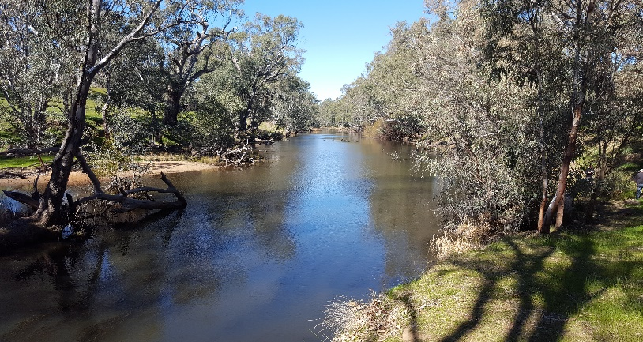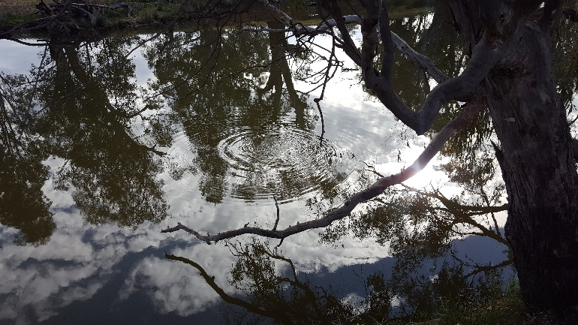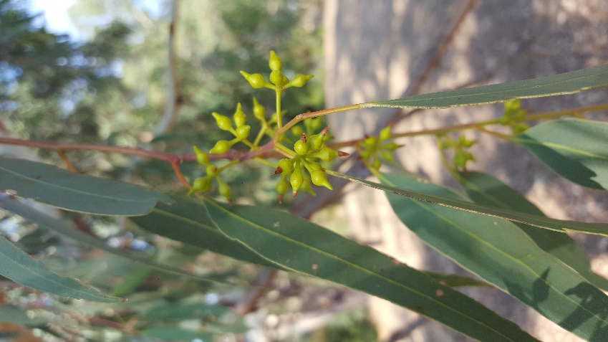

* 1. **VEFMAP Stage 6**

The Victorian Environmental Flows Monitoring and Assessment Program (VEFMAP) is now in its sixth stage of delivery. VEFMAP Stage 6 focusses on ‘intervention’ or ‘event-based’ monitoring of fish and vegetation responses to flows. The program is funded through the Victorian government’s $222 million investment in waterway and catchment health.

## Stage 6 – Vegetation Objectives

Stage 6 vegetation objectives aim to identify vegetation responses to environmental flows. The monitoring approach has been substantially modified from previous stages of the program and is focussed on individual flow events in waterways to detect short-term responses of native and exotic plant species to environmental water delivery. A longer-term understanding will be gained from repeated short-term assessments and by using data from previous stages of VEFMAP to create longer-term datasets. Importantly, these responses will be considered in relation to other factors that may influence flow responses, such as grazing, rainfall, soil properties and season (see program overview for details, DELWP 2017a).

## 2018/19 Monitoring on the Campaspe River

The Campaspe River was the first river to be surveyed as part of Stage 6 vegetation monitoring. Surveys using the updated Stage 6 methods were first conducted in 2016/2017 at six sites that were used for previous stages of VEFMAP. The same six sites were surveyed again in both 2017/18 and 2018/19 to investigate changes through time and in response to different flow events (Figure 1).

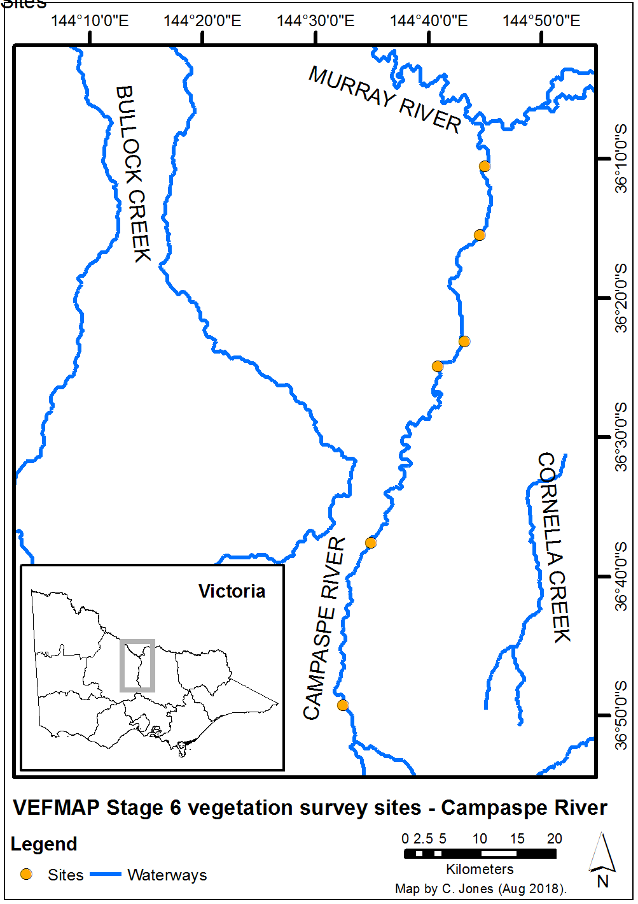

**Figure 1: Map of survey sites on the Campaspe River.**

## Survey timing and hydrology

Timing for the VEFMAP surveys considers rainfall and

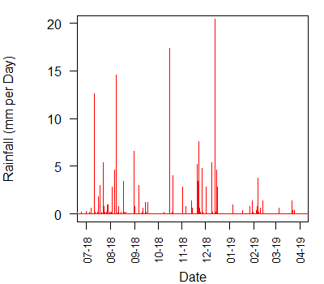managed flow deliveries. The sampling design recommends that surveys occur before a planned flow delivery and two to 12 weeks after the event, depending on the flow regime, to provide adequate time for vegetation to respond and for germinants to emerge. Timing is altered if rainfall increases the flow prior to a planned survey. In 2018/19, rainfall on the Campaspe River, measured near Rochester, did not result in large changes to the river flow outside of the managed flow events (Figure 2).

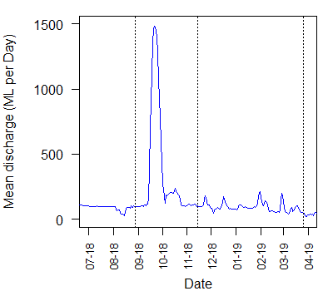**Figure 2: Daily rainfall recorded at Rochester in 2018/19.**

**Figure 3: River flow discharge recorded at Rochester in 2018/19 and VEFMAP vegetation survey timing (dotted lines).**

The first vegetation survey was conducted in August 2018 prior to the environmental flow event in September, followed by a second survey in November. A third survey was done in March 2019 after a series of small summer flow peaks (Figure 3).

The September spring flow peaked at over 1400 ML per day for five days. Irrigation flows and environmental freshes were delivered between late November 2018 and March 2019.

## Methods

Survey methods are outlined in detail in VEFMAP Stage 6 Part B: Monitoring design and sampling methods (DELWP 2017b). The surveys include a wide range of methods: fine-scale vegetation measurements, broad-scale mapping, tree canopy assessments and hydrology assessments.

## Survey observations for 2018-19

**Instream vegetation** continues to flourish in the upper reaches of the Campaspe River but remains absent downstream. The spring fresh in September 2018 encouraged growth of **fringing vegetation** on the bank, including both native and exotic species (Figure 4). Native species observed to benefit most from the spring fresh, and environmental flows more broadly, include species such as *Juncus* spp. (rushes), *Persicaria* spp. (Knotweeds), and various grasses and herbs.

Although the full analysis of vegetation response to inundation will be completed in 2019/20, exploration of species’ abundance data along the bank elevation gradient indicates that repeated spring fresh levels are associated with the distribution of particular species. For example, the native grass *Poa labillardierei* (Common Tussock-grass) appears to prefer conditions provided by environmental flows (Jones and Vivian 2019).

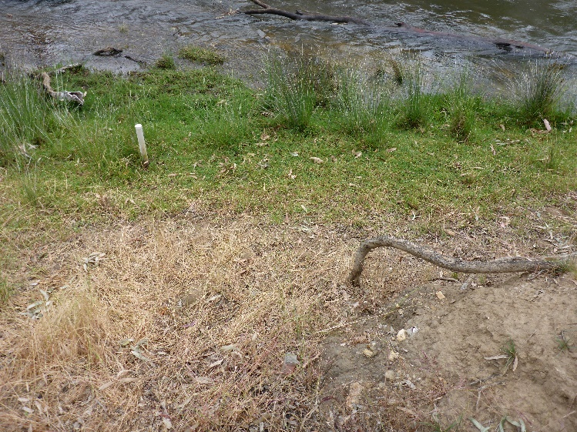The duration of the spring fresh was too brief to negatively impact on exotic inundation-tolerant species, particularly widespread and common species such as *Cynodon dactylon* var. *dactylon* (Couch) and *Panicum coloratum* (Coolah Grass).

**Figure 4: Growth of plants along the lower bank observed during the November 2018 survey, showing a demarcation between vegetation above and below the height of the spring flow.**

**Plant recruitment** was observed towards the end of winter 2018, prior to the spring fresh, with a subsequent recruitment event occurring after the spring fresh. The spring fresh stimulated germination of new propagules alongside those establishing propagules that survived through winter (from recruitment the previous autumn) and the spring fresh inundation. This suggests that spring freshes can not only stimulate a new wave of recruitment, but the large amount of water overtopping young seedlings does not result in the mortality of inundation-tolerant riparian plants that have established earlier in the season (Jones and Vivian 2019).

## Grazing Exclosures

Six grazing exclosure plots have been constructed at three sites grazed by livestock. Each grazing exclosure plot is paired with an adjacent control plot.

The 2018/19 surveys showed that vegetation cover continued to increase within each grazing exclosure compared to the adjacent control. The degree of difference in vegetation cover between exclosures and controls depended on grazing intensity and duration, and on the number and type of livestock involved. For example, the contrast in vegetation cover was particularly strong at the very heavily grazed Strathallan grazing exclosure site (Figure 5).

*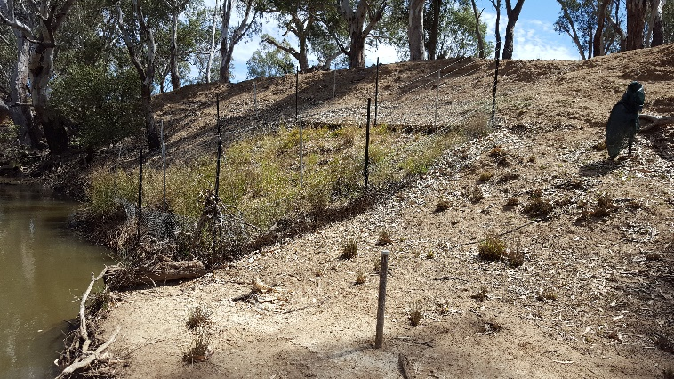***Figure 5: Plant growth inside a grazing exclosure at Strathallan (November 2018).**

Increased recruitment and establishment of native species was also evident within some of the grazing exclosures compared to the adjacent controls. For example, at Doaks Reserve, slower-growing inundation-tolerant perennial species including *Juncus* spp. and *Eucalyptus camaldulensis* (River Red Gum) have become established three years following grazing exclusion (Figure 6).

In order to realise any benefits of environmental water for native vegetation, it will be important to continue to manage the level of grazing at all sites with livestock access throughout the river.

## Soil moisture

Six soil moisture recording probes have been installed on the Campaspe River at three sites. Each probe records soil moisture and temperature at 10 cm intervals along its length, to 85 cm deep (Figure 7). Data are continuously recorded every hour. The results will inform how changes in flow influence the soil moisture in the bank that can be accessed by vegetation.

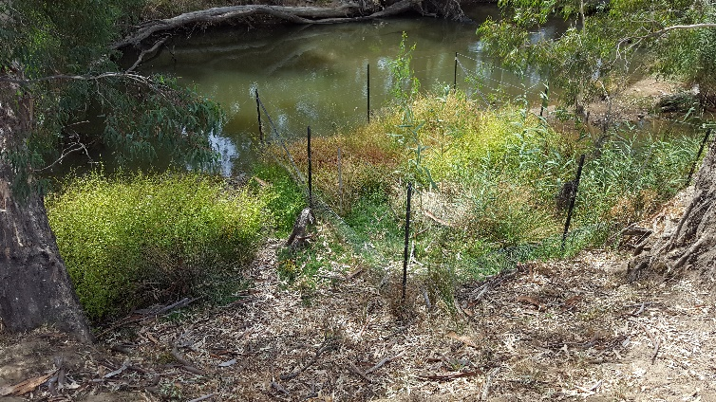

**Figure 6: Establishment of River Red Gums inside a grazing exclosure at Doaks Reserve (March 2019).**

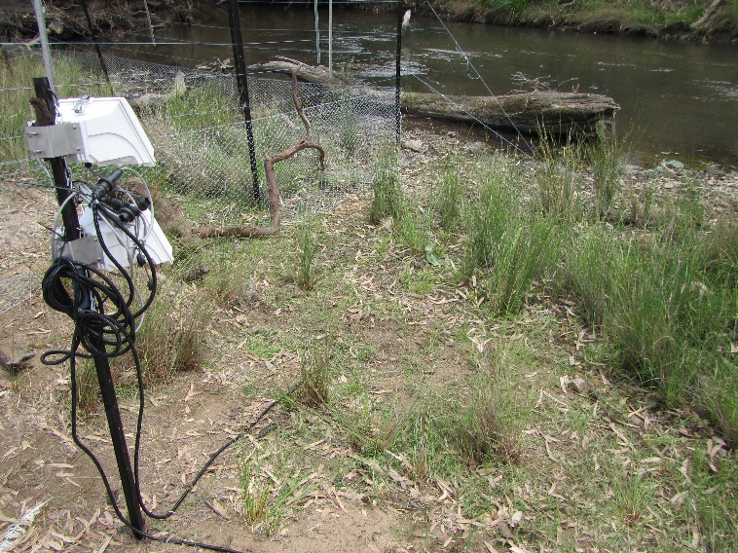**Figure 7: Soil moisture monitoring equipment at Doaks Reserve.**

An example of the monitoring data is shown for autumn to summer 2017/18 at one of the higher elevation probes, where the rate of drying after individual flow events increased with increased seasonal temperatures, i.e. the soil moisture dried out more slowly in autumn than in spring or summer (Figure 8). This figure also shows the large increase in soil moisture that occurred as a result of inter-valley transfer (IVT) water delivery down the Campaspe River over an extended period of more than two months in early 2018. This flow type is delivered for consumptive purposes and the magnitude and duration are not reflective of typical seasonal regimes.

## Summary

Environmental flows are being delivered on the Campaspe River to deliver benefits to vegetation and a wide range of fauna. Waterway managers are working closely with researchers, waterway authorities and a range of other stakeholders to manage flow deliveries as effectively as possible for the environment and other users.

The observations summarised here form part of a larger story relating to vegetation responses to environmental water. Further information on the other systems surveyed and research projects is also available.

## Key Outcomes

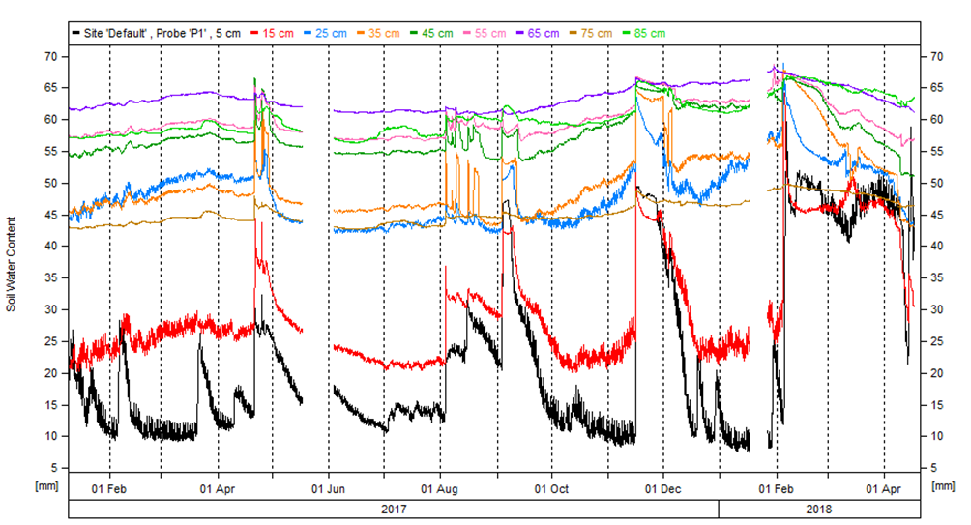

**Figure 8: Soil moisture probe data output from various depths at the Bryant’s Lane site on the Campaspe River. The image shows the data from the probe location on the upper part of the bank (midway up the slope). Arrows indicate increasing steepness of lines, which show faster drying after an inundation flow.**

* Repeated spring fresh levels are associated with the distribution of particular species, which are generally positive responses for riparian natives and negative for many terrestrial exotics.
* Spring freshes can not only stimulate a new wave of recruitment, but the large amount of water overtopping young seedlings does not result in the mortality of inundation-tolerant riparian plants that have established earlier in the season, which is important to have confirmed.
* Instream vegetation cover and diversity was relatively high upstream but declined substantially further downstream. Longer-term monitoring is needed to detect any large spatial or temporal changes in instream vegetation.
* Environmental water is unlikely to benefit native plants in heavily grazed sites. If crash grazing of exotic-dominated riparian zones can be restricted to higher bank elevations (top of bank), this could dramatically reduce the negative impacts of livestock access on native vegetation.

## Next Steps

In the final year of VEFMAP Stage 6 (2019/20), the data collected during the first three years of the program will be processed and analysed, and the findings reported in a series of reports and publications. Some additional targeted data collection will also continue, including additional vegetation surveys and monitoring of the grazing exclosures on the Campaspe River.

## References

DELWP (2017a and b) VEFMAP Stage 6 Part A: Program context and rationale and VEFMAP Stage 6 Part B: Program design and monitoring methods. Reports by Arthur Rylah Institute for Environmental Research and Integrated Water and Catchments Division, Department of Environment, Land, Water and Planning.

Jones C. and Vivian L. 2019. VEFMAP Stage 6: Monitoring vegetation response to environmental flow delivery in Victoria 2018/19. Arthur Rylah Institute report to the Department of Environment, Land, Water and Planning, Melbourne.

## Contact [Chris.Jones@delwp.vic.gov.au](mailto:Chris.Jones@delwp.vic.gov.au)

## Darren.White@nccma.vic.gov.au

|  |  |
| --- | --- |
| © The State of Victoria Department of Environment, Land, Water and Planning 2020  LogoThis work is licensed under a Creative Commons Attribution 4.0 International licence. You are free to re-use the work under that licence, on the condition that you credit the State of Victoria as author. The licence does not apply to any images, photographs or branding, including the Victorian Coat of Arms, the Victorian Government logo and the Department of Environment, Land, Water and Planning (DELWP) logo. To view a copy of this licence, visit http://creativecommons.org/licenses/by/4.0/  ISBN 978-1-76077-161-4 (pdf/online/MS word)  Disclaimer  This publication may be of assistance to you but the State of Victoria and its employees do not guarantee that the publication is without flaw of any kind or is wholly appropriate for your particular purposes and therefore disclaims all liability for any error, loss or other consequence which may arise from you relying on any information in this publication. | Accessibility  If you would like to receive this publication in an alternative format, please telephone the DELWP Customer Service Centre on 136186, email [customer.service@delwp.vic.gov.au](mailto:customer.service@delwp.vic.gov.au), or via the National Relay Service on 133 677 [www.relayservice.com.au](http://www.relayservice.com.au). This document is also available on the internet at https://www.ari.vic.gov.au/research/rivers-and-estuaries/assessing-benefits-of-environmental-watering |