|  |
| --- |
| Demonstrating and predicting plant responses to environmental watering |
| Improving environmental water management to meet ecological objectives |

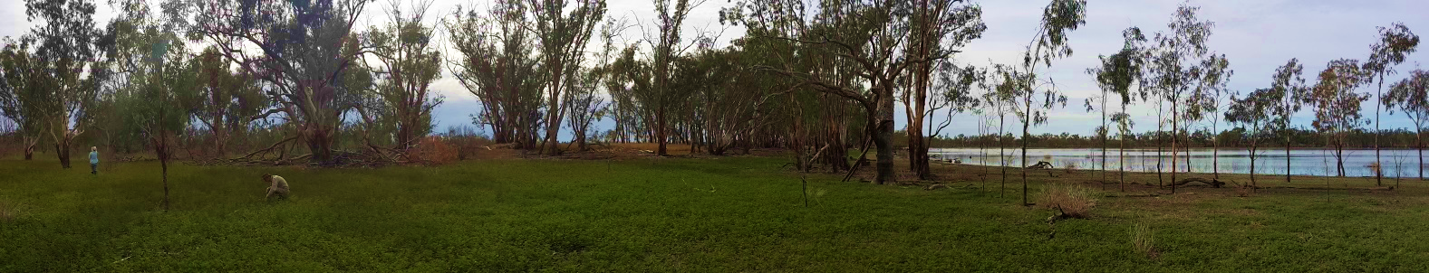

# Key points:

* **A complex statistical approach was developed to determine vegetation responses to environmental water management strategies and aid management decisions.**
* **The anaslysis demonstrated that environmental watering was important for the survival of native water-dependant plants and communities and maintaining semi-arid floodplain ecosystems.**
* **Unique features of the analysis are the ability to:**
* **investigate plant community change at multiple scales in one analysis (plant species level to plant functional groups).**
* **incorporate the influences of rainfall and flooding during different seasons.**
* **investigate the response of the current environmental watering regime and indicate changes in vegetation that are likely to have occurred without environmental water management.**

## Demonstrating environmental watering outcomes

Demonstrating the effectiveness of environmental watering to maintain ecosystem health is becoming increasingly important, particularly in drying climates where there is insufficient rainfall and natural flooding to maintain riparian ecosystems.

**Monitoring is a key component of the water management process as it provides feedback on responses to management actions and evidence for the refinement of management strategies.**

Although monitoring programs can be used to demonstrate ecological outcomes, results are often confounded by:

* climate variability
* ecosystem variability
* lack of long-term data
* lack of unmanaged “control” sites for comparison

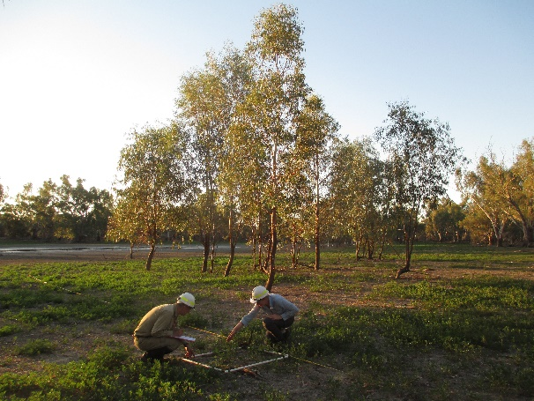These limitations can impede our ability to evaluate the outcomes of water management.

**The development of predictive statistical models might be able to overcome some monitoring design limitations.**

## Complex statistical evaluation to inform environmental watering outcomes

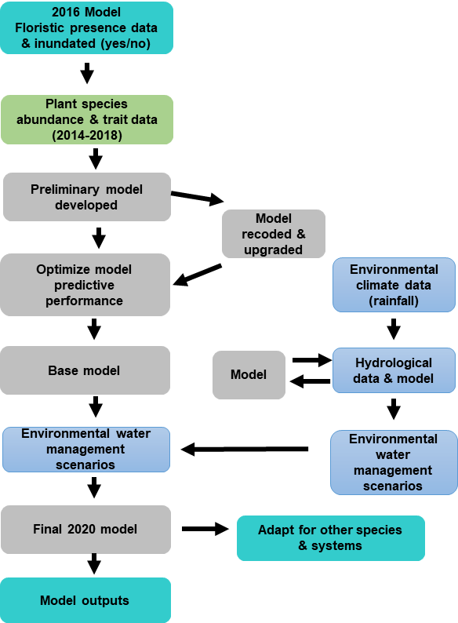

A dynamic joint species distribution analysis approach was developed to determine vegetation responses to environmental water management strategies and aid management decisions.

Utilising long-term data, this model can evaluate the effectiveness of a range of environmental watering strategies.

The unique features of the approach are the ability to:

* investigate plant community change at multiple scales in one analysis: from species level to plant functional groups (e.g. origin, life history or life form groups).
* incorporate effects of rainfall and flooding during different seasons.
* investigate the response of the current environmental watering regime.
* estimate the outcomes if no environmental water was delivered.

**Key analysis stages. Showing the main data (green), model development stages (grey), hydrological and climatic data and modelling (blue), and stastistical outputs (aqua).**

## Implementing the model to evaluate environmental watering at Hattah lakes

The analytical approach was applied to vegetation monitoring data collected at Hattah Lakes Icon Site between 2014 and 2019 to evaluate the extent to which environmental watering met the objective of improving the abundance of native water-dependent plants and communitites.

Because the Hattah Lakes monitoring program does not have access to an appropriate unmanaged control system (that has only natural flooding to compare the effect of environmental water management), comparisons were made using model predictions of the counterfactual case of no water management.

|  |  |  |
| --- | --- | --- |
| **Lake Bed Herbland**  **(frequently flooded)** | **Intermittent Swampy Woodland**  **(intermittently flooded)** | **Riverine Chenopod Woodland**  **(rarely flooded)** |

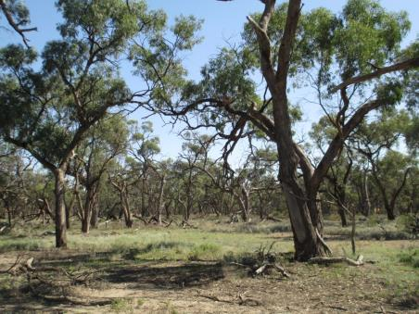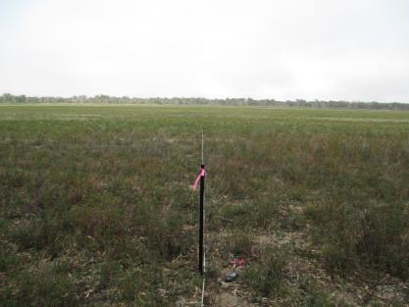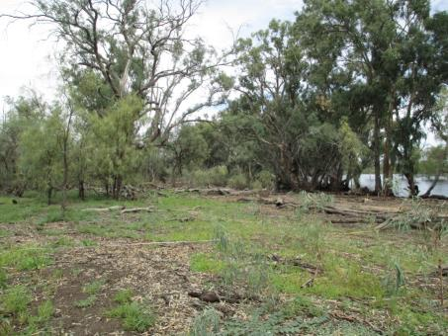

Around the lake system, waterways and floodplains of Hattah Lakes, three main water-dependant plant communities exist in a mosaic reflecting environmental gradients in elevation, soil moisture and flooding regime.

## Results

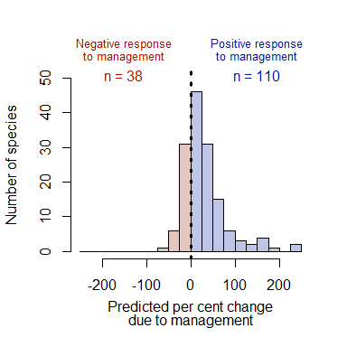The complex statistical approach was highly successful in predicting vegetation responses to the current management of environmental watering and the counterfactual case of no environmental water management.

Water availability (environmental watering and/or rainfall), is a key driver of Hattah Lakes plant community composition.

Key findings include:

* Environmental watering at Hattah Lakes successfully increased the abundance of most riparian plant species.
* Environmental watering increased the abundance of native water-dependent plant species.
* Most plant species and functional groups declined over the monitoring period (2014-2019), but the decline was greater under the scenario of no management. This suggests that further improvements to water management strategies may be necessary to protect the riparian plant assemblage of Hattah Lakes.

Plant species responses to environmental water management.

**Total natives Dryland natives Water-dependent natives**

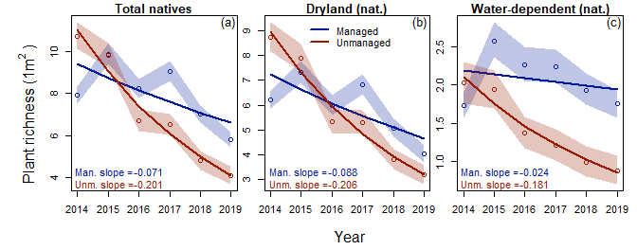

**Plant richness (1 m2)**

Plant richness of native functional groups: all natives, native water-dependent plant and dryland plants. The open circles indicate the plant richness predictions with 95% Bayesian credible intervals, while the lines depict the log-linear trend. Blue indicates the managed condition and red the unmanaged condition.

**Environmental watering is important for the survival of water-dependent plants and the maintainance of this semi-arid floodplain.**

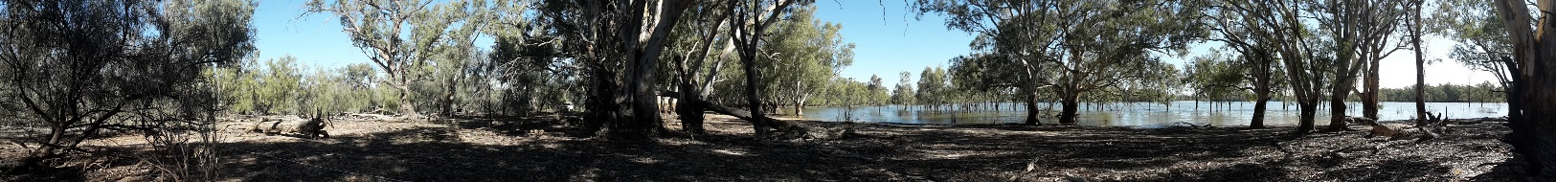

## Knowledge Gaps

Preliminary outcomes that require further investigation include:

* Individual plants species differ in their responses to flooding, which do not necessarily align with current water plant functional groups. This reflects species’ unique water requirements and flood tolerance. Thus, management will need to consider individual species.
* Different environmental watering regimes (timing, duration etc.) can promote different plant assemblages. Highlighting the importance of defining the desired plant community for future management.
* In addition to the flooding regime, season of delivery, climate and rainfall also influence plant responses. Thus, management regimes should consider historical and current water avability.
* 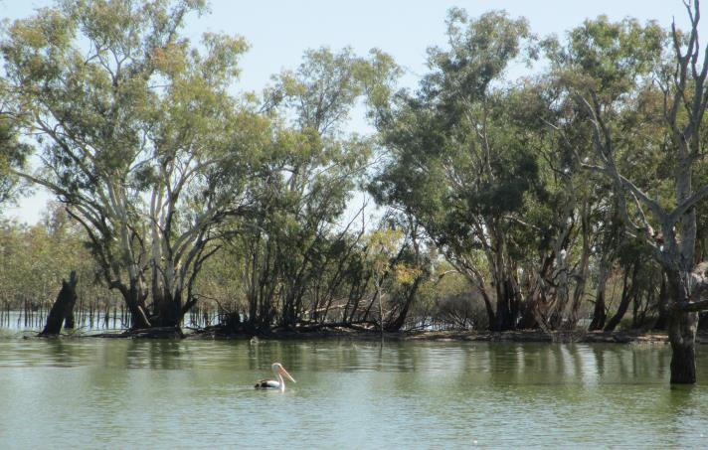Identification of how different water delivery strategies may result in promoting different components of the plant community will allow managers to optimize management strategies to best meet objectives.

**Optimal water management strategies will depend on current and past environmental conditions.**

## Predicting environmental watering outcomes to guide decision making

This analytical approach has been used to provide rigorous scientific evidence of the success and value of environmental water management at Hattah Lakes.

The approach has potential to further refine water management at Hattah Lakes by predicting vegetation responses to a range of hypothetical environmental watering management strategies and under different environmental contexts (e.g. current and past rainfall and flood conditions).

Statistical predictions in response to environmental watering scenarios could be validated with further onground sampling which can then be used to refine the model.

**The analysis approach will allow managers to tailor water deliveries to the current conditions and the most efficient use of environmental water.**

|  |  |
| --- | --- |
| © The State of Victoria Department of Environment, Land, Water and Planning 2021  LogoThis work is licensed under a Creative Commons Attribution 4.0 International licence. You are free to re-use the work under that licence, on the condition that you credit the State of Victoria as author. The licence does not apply to any images, photographs or branding, including the Victorian Coat of Arms, the Victorian Government logo and the Department of Environment, Land, Water and Planning (DELWP) logo. To view a copy of this licence, visit http://creativecommons.org/licenses/by/4.0/  ISBN 978-1-76105-435-8 (pdf/online/MS word)  Disclaimer  This publication may be of assistance to you but the State of Victoria and its employees do not guarantee that the publication is without flaw of any kind or is wholly appropriate for your particular purposes and therefore disclaims all liability for any error, loss or other consequence which may arise from you relying on any information in this publication. | Accessibility  If you would like to receive this publication in an alternative format, please telephone the DELWP Customer Service Centre on 136186, email [customer.service@delwp.vic.gov.au](mailto:customer.service@delwp.vic.gov.au), or via the National Relay Service on 133 677 [www.relayservice.com.au](http://www.relayservice.com.au). This document is also available on the internet at [www.delwp.vic.gov.au](http://www.delwp.vic.gov.au). |

Furthermore, the analysis approach can be applied to other riparian systems and contexts through:

* **Refining plant response groups to aid management** – further develop plant response groups (relative to environmental water management) that can be used across a range of management scenarios and riparian systems.
* **Using species traits to increase statistical resolution, transferability, and understanding of ecosystem function** - refine a set of plant species functional traits to aid interpretation of management outcomes relative to ecosystem functioning and species-level responses that can then be applied across systems.

## Acknowledgements

This project was funded by the DELWP, Victorian Environmental Water Holder, and the Mallee Catchment Management Authority through The Living Murray initiative. The Living Murray is a joint initiative funded by the New South Wales, Victorian, South Australian, Australian Capital Territory and Commonwealth governments, coordinated by the Murray-Darling Basin Authority. The project was implemented by the Arthur Rylah Institute for Environmental Research (DELWP) and Biometric Research.

## Further information

[research.ari@delwp.vic.gov.au](mailto:research.ari@delwp.vic.gov.au)

[ari.vic.gov.au](https://www.ari.vic.gov.au/)