|  |
| --- |
| Environmental Water Benefits Black Box |
| Environmental watering at Hattah Lakes Icon Site improves individual Black Box tree health, flowering and seed production |

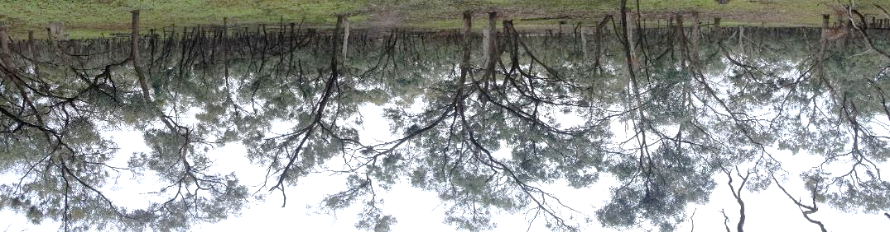

Key Points:

* Environmental watering improves Black Box tree health, flowering and seed production.
* Land managers can be confident that environmental watering at the Hattah Lakes Icon Site can produce sustained improvement in Black Box tree health.

Why apply environmental water?

Floodplain trees across the Murray-Darling Basin are declining in condition. Changed flooding regimes (frequency, duration, extent) due to water regulation and drought, is largely the cause of this decline.

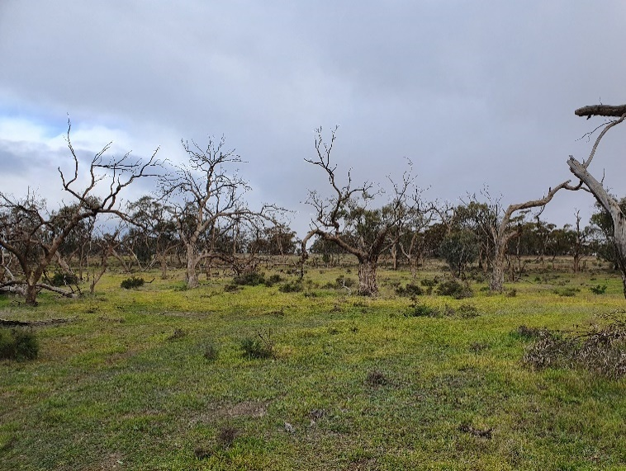

The Living Murray initiative is designed to improve the health of the Murray River and its floodplain through targeted environmental watering events (managed flooding). The Hattah Lakes Icon Site was selected to be part of the program due to its significant cultural, recreational, heritage and ecological values, including floodplain trees.

To effectively deliver environmental water, a clear understanding of how plants, animals and ecosystems respond to watering events is needed. Monitoring can provide this information and be used to refine future watering events and management actions.

Black Box floodplain trees

Black Box (*Eucalyptus largiflorens*) are a long-lived (ca. 250 years) floodplain tree that inhabits the drier parts of the floodplain that are periodically flooded.

Delivering environmental water to improve floodplain tree health requires an understanding of the species key life cycle phases (see figure below). Tree health can be measured from different aspects of the life cycle phases including:

* canopy health
* reproductive output (buds, flowers, fruit and seed)
* seed fall
* seed viability

Black Box trees are important, culturally and ecologically

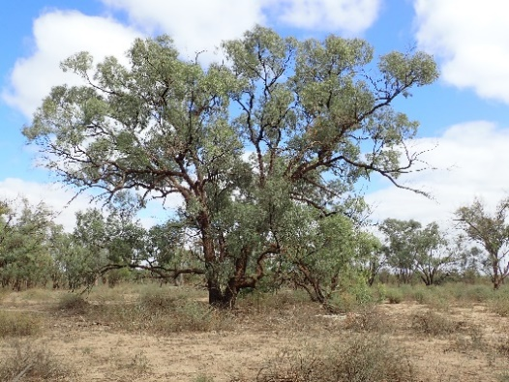

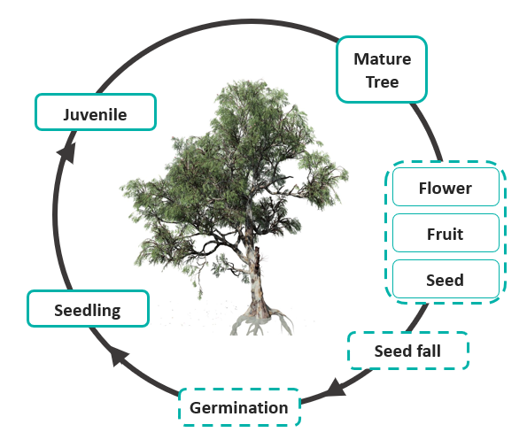Research Program Overview

DELWP’s Arthur Rylah Institute (ARI), in partnership with several organisations, has been undertaking a suite of research projects to evaluate the effectiveness of environmental watering in maintaining or improving Black Box tree health.

This research is helping us evaluate the ecological objective of environmental watering: ‘to restore communities of wetland and terrestrial plant assemblages by maintaining sustainable populations of Black Box communities’.

A range of studies, some highlighted below, are being undertaken that investigate key aspects of the Black Box life cycle and the watering response of canopy health, reproductive output (bud, flower, fruit and seed production), the timing of seed fall and seed viability. Studies were undertaken over a range of years (1-7yrs) and environmental watering events.

**Black Box life cycle phases**

Dotted boxes indicate life cycle phases that the research investigated

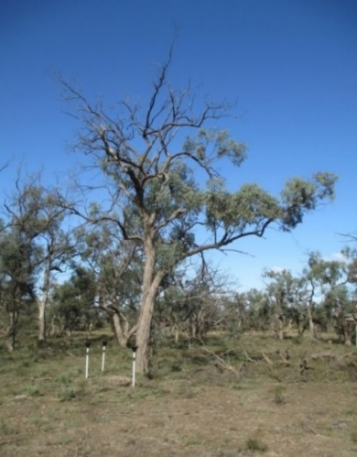Tree Health

Environmental watering at Hattah Lakes has led to improved Black Box tree health and condition. Floodplains that received environmental water had greater canopy cover, crown extent, new tip growth, reproductive output, and Tree Condition Index compared to unwatered floodplains. This response was greater at the lake edge compared to the higher floodplain.

Data demonstrates that environmental watering improves tree health

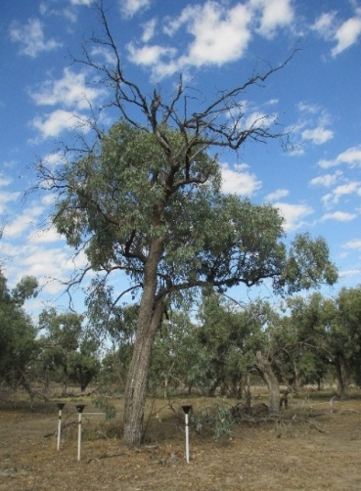

**Improved**

**condition**

**Reduced**

**senescence**

**Improved**

**health**

**Improved**

**seed fall**

**Improved flowering and fruiting**

Tree Canopy Condition Index at unwatered (red) and watered (blue) sites over a seven-year period. Droplets show environmental watering events (blue) and natural flooding (green).

Black Box tree prior to (top) and seven years after (bottom) three environmental watering events.

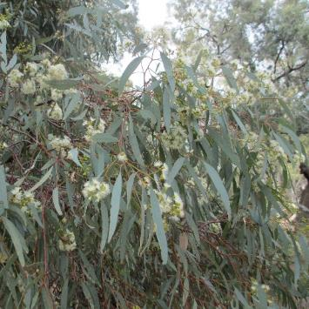**Reproductive Output**

Following environmental watering at Hattah Lakes in 2014, Black Box reproductive output improved until 2018. Trees that received environmental water had greater abundance of buds, flowers, and fruits. Overall, there was a 9-fold increase in reproductive output in watered trees compare to unwatered trees.

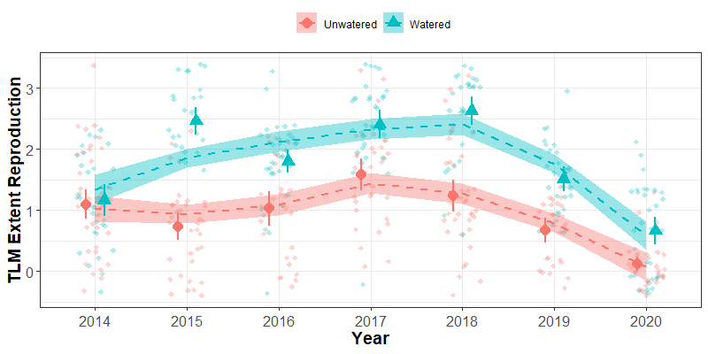

**Reproductive extent**



Reproductive extent at unwatered (red) and watered (blue) sites over a seven-year period. Droplets show environmental watering events (blue) and natural flooding (green).Shading represents the confidence interval.

Environmental watering improved reproductive output

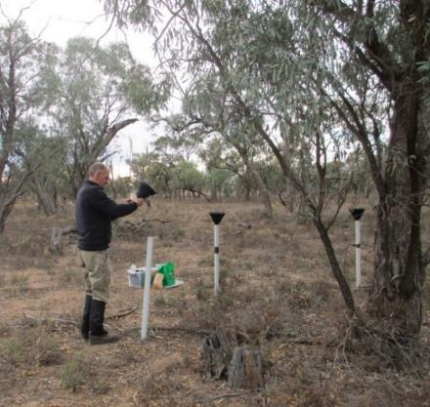

**Seed Fall**

Environmental watering at Hattah Lakes has led to improved Black Box seed production. Experimental sites that received environmental water had greater seed fall (15% greater) and fruit production (20% greater) compared to unwatered sites.

Distinct peaks in seed and fruit production occurred during the spring/summer of the year following a watering event.

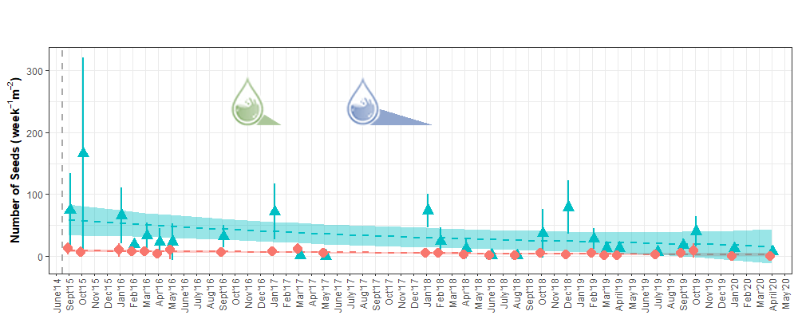



Seed trap monitoring and seed collection (bimonthly).

Average number of seeds for each month sampled at the unwatered (red circles) and watered (teal triangles). Shading indicates confidence intervals. Droplets show environmental watering events (blue) and natural flooding (green). Shading represents the confidence interval.

# Researcher analysing seeds under a microscopeBlack box seedsSeed Viability

Growth cabinet experiments showed that seed viability and germination rates were not influenced by environmental watering.

More than 75% of tested seeds germinated within five days, independent of whether trees had been inundated.

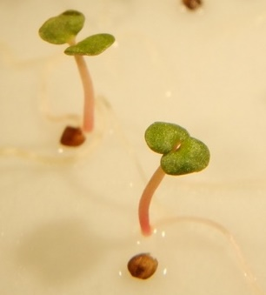

Seed viability is not dependent on environmental watering

# Lessons for Managers

Land managers can be confident that environmental watering at the Hattah Lakes Icon Site can be used to produce a sustained improvement in Black Box tree health, condition, reproduction, recruitment and population structure.

This research highlights the value and effectiveness of using environmental watering to improve floodplain tree condition. Findings provide an evidence-base on which land managers can reliably report management outcomes and refine future decision making.

Key management considerations:

* At unwatered sites tree health, reproduction, seed supply and recruitment are poor. These sites will require active management to improve condition.
* Seedling and sapling surivial rates are unknown.
* Initial tree health will influence recovery time and flooding requirements.
* A single flooding event can improve tree health.
* Additional floods can further improve tree health.
* Trees in poor health may need more than one flood event to improve condition.
* Maintenance of tree condition and recovery trajectories require further investigation.

Seedling and sapling survival are key knowledge gaps in the Black Box life cycle

|  |  |
| --- | --- |
| © The State of Victoria Department of Environment, Land, Water and Planning 2021  LogoThis work is licensed under a Creative Commons Attribution 4.0 International licence. You are free to re-use the work under that licence, on the condition that you credit the State of Victoria as author. The licence does not apply to any images, photographs or branding, including the Victorian Coat of Arms, the Victorian Government logo and the Department of Environment, Land, Water and Planning (DELWP) logo. To view a copy of this licence, visit http://creativecommons.org/licenses/by/4.0/  **ISBN** 978-1-76105-504-1 **(pdf/online/MS word)**  Disclaimer  This publication may be of assistance to you but the State of Victoria and its employees do not guarantee that the publication is without flaw of any kind or is wholly appropriate for your particular purposes and therefore disclaims all liability for any error, loss or other consequence which may arise from you relying on any information in this publication. | Accessibility  If you would like to receive this publication in an alternative format, please telephone the DELWP Customer Service Centre on 136186, email [customer.service@delwp.vic.gov.au](mailto:customer.service@delwp.vic.gov.au) or via the National Relay Service on 133 677 [www.relayservice.com.au](http://www.relayservice.com.au). This document is also available on the internet at [www.delwp.vic.gov.au](http://www.delwp.vic.gov.au). |

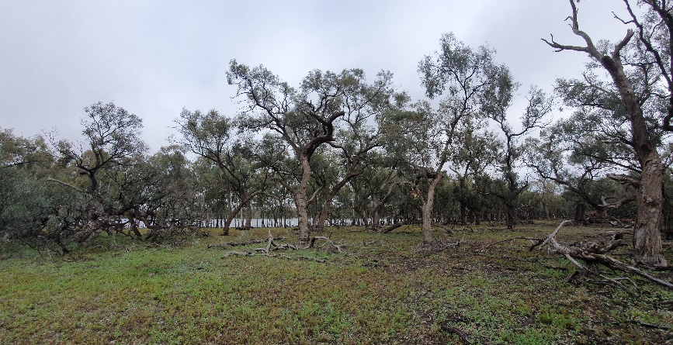

## Acknowledgements

This multi-faceted research program was funded by DELWP, the Mallee Catchment Management Authority through The Living Murray initiative. The Living Murray is a joint initiative funded by the New South Wales, Victorian, South Australian, Australian Capital Territory and Commonwealth governments, coordinated by the Murray-Darling Basin Authority.

## Further information

For more information on this project contact [research.ari@delwp.vic.gov.au](mailto:research.ari@delwp.vic.gov.au)

**Report**: Moxham C., Duncan M., Leevers D. and Farmilo B. (2020) The Living Murray Hattah Lakes Intervention Monitoring: Impact of Environmental Watering on Black Box health, reproduction and recruitment – Final Report 2020. Unpublished Report for the Mallee Catchment Management Authority. Arthur Rylah Institute for Environmental Research, Department of Environment, Land, Water and Planning, Heidelberg, Victoria.