Glenelg River 2021
Glenelg Hopkins region

This report card summarises the 2021 Native Fish Report Card (NFRC) survey in the Glenelg River
Sites 10, GHCMA, Electrofishing

Fish found in Glenelg River for NFRC
Target species
Estuary Perch
Non-target species captured since 2017*
Large-bodied native species
Australian Bass
Australian Grayling
Black Bream
Freshwater Catfish
Golden Perch
River Blackfish
Short-finned Eel
Tupong
Yellow-eye Mullet

Small-bodied native species
Australian Smelt
Carp Gudgeon
Common Galaxias
Flatheaded Gudgeon
Southern Pygmy Perch
Variegated Pygmy Perch

Exotic species
Common Carp
Eastern Gambusia
Goldfish
Rainbow Trout
Redfin
Tench

* These non-target species were incidentally captured during NFRC surveys since 2017 but not measured as for target species

LOGOS – ARI, DELWP

Glenelg River 2021
Fish Community

NFRC target species
The NFRC Program began in 2017, with a focus on targeting the monitoring of population dynamics of key iconic fish species that have high recreational and/or conservation values, in large rivers across Victoria. In the Glenelg River, the target species is Estuary Perch. Surveys occur in February/March each year, at 10 sites from Dartmoor to Yat Nat (between Balmoral and Rocklands Reservoir). The equipment and habitats surveyed are focused on this species, which are measured to determine population structures. Other fish species that are incidentally captured are recorded, but not measured to determine their population structures.

Summary of key health indicators for target species in 2021
Species | Key Health Indicators
 | Recent recruitment | Multiple size classes | Mature fish present
Estuary Perch | No | Yes | Yes

Recent recruitment means young-of-year fish

Estuary Perch are considered an estuarine species, which often moves into lower freshwater reaches of rivers, particularly rivers with elevated baseline salinity levels.

Non-target species
The non-target fish species that have been incidentally recorded in the Glenelg River during NFRC surveys since 2017 are:

Large-bodied native species
Other large-bodied species recorded in surveys are Australian Bass, Australian Grayling, Black Bream, Freshwater Catfish, Golden Perch, River Blackfish, Short-finned Eel, Tupong and Yellow-eye Mullet. A single Australian Grayling was collected in 2019 with another single individual recorded in 2021. This is only the second and third records of this species in the Glenelg River system; the other confirmed record was 124 years ago. Australian Bass, Freshwater Catfish and Golden Perch are considered a translocated species in the Glenelg River. Black Bream and Yellow-eye Mullet are estuarine species that can move upstream into lower freshwater reaches of streams. River Blackfish are a lowland species, generally found at altitudes below 200 metres. This species has suffered a decline in distribution and abundance across the State¹, however, numerous individuals have been detected in the Glenelg River (ARI unpubl data). Short-finned Eel are a diadromous species found throughout coastal Victoria.

Small-bodied native species
Some of the small-bodied species recorded within the Glenelg River, including Australian Smelt and Flatheaded Gudgeon are common across the state. Carp Gudgeon are a lowland species and considered often hard to detect via boat electrofishing. The Common Galaxias and Tupong are diadromous species common across coastal Victoria. Pygmy Perch species are more common in offstream habitats such as billabongs, wetlands and lagoons. Variegated Pygmy Perch have been detected in all five years of NFRC sampling.

Exotic fish species
Common Carp, Eastern Gambusia, Goldfish and Redfin are widely distributed across sampling sites, but the likelihood of their detection and abundances increases as you move upstream. Small (young-of-year) Carp were also detected at most sites in 2019. In 2017, 2018, 2020 and 2021, small Carp have been restricted to the upper sites, indicating the widespread dispersal and spawning of this species during the 2018 spawning season. The presence of small Carp every year at the upper sites also indicates they are spawning in these areas in most, if not all years. Rainbow Trout are restricted in distribution to the Warrock area. Tench have been detected in all five sampling years, albeit in low abundances.

Other native species known from the Glenelg River
Some fish species known to occur in the Glenelg River have never been recorded during NFRC surveys. For example, no Climbing Galaxias, Obscure Galaxias, Spotted Galaxias, Little Galaxias, Pouched Lamprey or Short-headed Lamprey have been detected in the surveys. Both Climbing Galaxias and Spotted Galaxias historically had patchy distributions within the Glenelg River system and are hard to detect using the NFRC sampling methodology. Similarly, both lamprey species had patchy distributions historically, while Obscure Galaxias are hard to detect using the NFRC sampling methodology. Little Galaxias are normally found in lower altitude areas but are found in the Glenelg River upstream Rocklands Reservoir (outside of the NFRC sampling area).

Other notable species
Surveys have also recorded Eastern Long-necked Turtles, Platypus and Yabbies.

LOGOS – ARI, DELWP, NFRC

1. Khan MT, Khan TA, Wilson ME 2004. Habitat use and movement of river blackfish (Gadopsis marmoratus R.) in a highly modified Victorian stream, Australia. Ecology of Freshwater Fish, 13: 285–293.

Glenelg River 2021
Environmental and Management Context

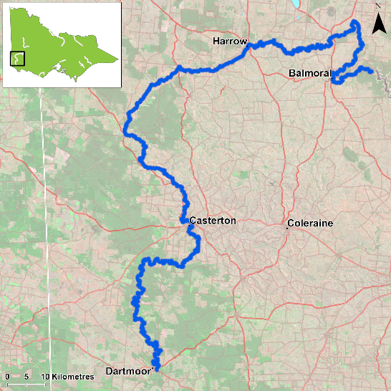
Figure 1. Map showing the section of Glenelg River where NFRC sampling occurs

Environment
Low flow conditions were present in all five sampling seasons.

River rehabilitation efforts in the Glenelg River
Many rehabilitation actions have occurred, and are underway, to improve the health of the Glenelg River. These are informed by the Glenelg Hopkins Waterway Strategy 2014-2-22 and the Glenelg River Restoration Program. Actions include revegetation, weed control and fencing of riparian areas, reintroduction of instream woody habitat, allocations of water for the environment and removal of migration barriers and pest control. There are a range of fish monitoring efforts related to the rehabilitation efforts. These include the Victorian Environmental Flow Monitoring and Assessment Program (VEFMAP). The Glenelg Hopkins Catchment Management Authority, DELWP and VFA support rehabilitation and management of the Glenelg River and its fish community.

PHOTOS
LOGOS – ARI, DELWP, NFRC

Estuary Perch

Glenelg River, South West region

Key Health Indicators
Recent recruitment No
Multiple size classes Yes
Mature fish present Yes

Monitoring Results
Total number of fish caught 38
Fish per 1km of waterway 4.93
Largest fish by length (cm) 42.4
Largest fish by weight (kg) 1.100
% of the catch that is legal size 55.3

Estuary Perch (Macquaria colonorum) are an estuarine species that can push into lower freshwater reaches of streams. Within the Glenelg River, the species pushes further inland than other rivers in Victoria. No Estuary Perch have been detected as far upstream as Balmoral, but sites have been included up this far, as the species seems to be slowly moving further upstream (based on previous surveys). Abundance of Estuary Perch was relatively consistent between all five years, though they may be slightly declining (Figure 2). Multiple size classes including mature and juvenile fish were captured in all years, with young-of-year detected in 2018. This is an indication that conditions in the Glenelg River are supporting spawning and survival of this species throughout its lifecycle and providing good, ongoing angling opportunities. Two main size ranges (15-25 and 30-40 cm) were detected in 2021 (Figure 3).

Stocking
No stocking has occurred.
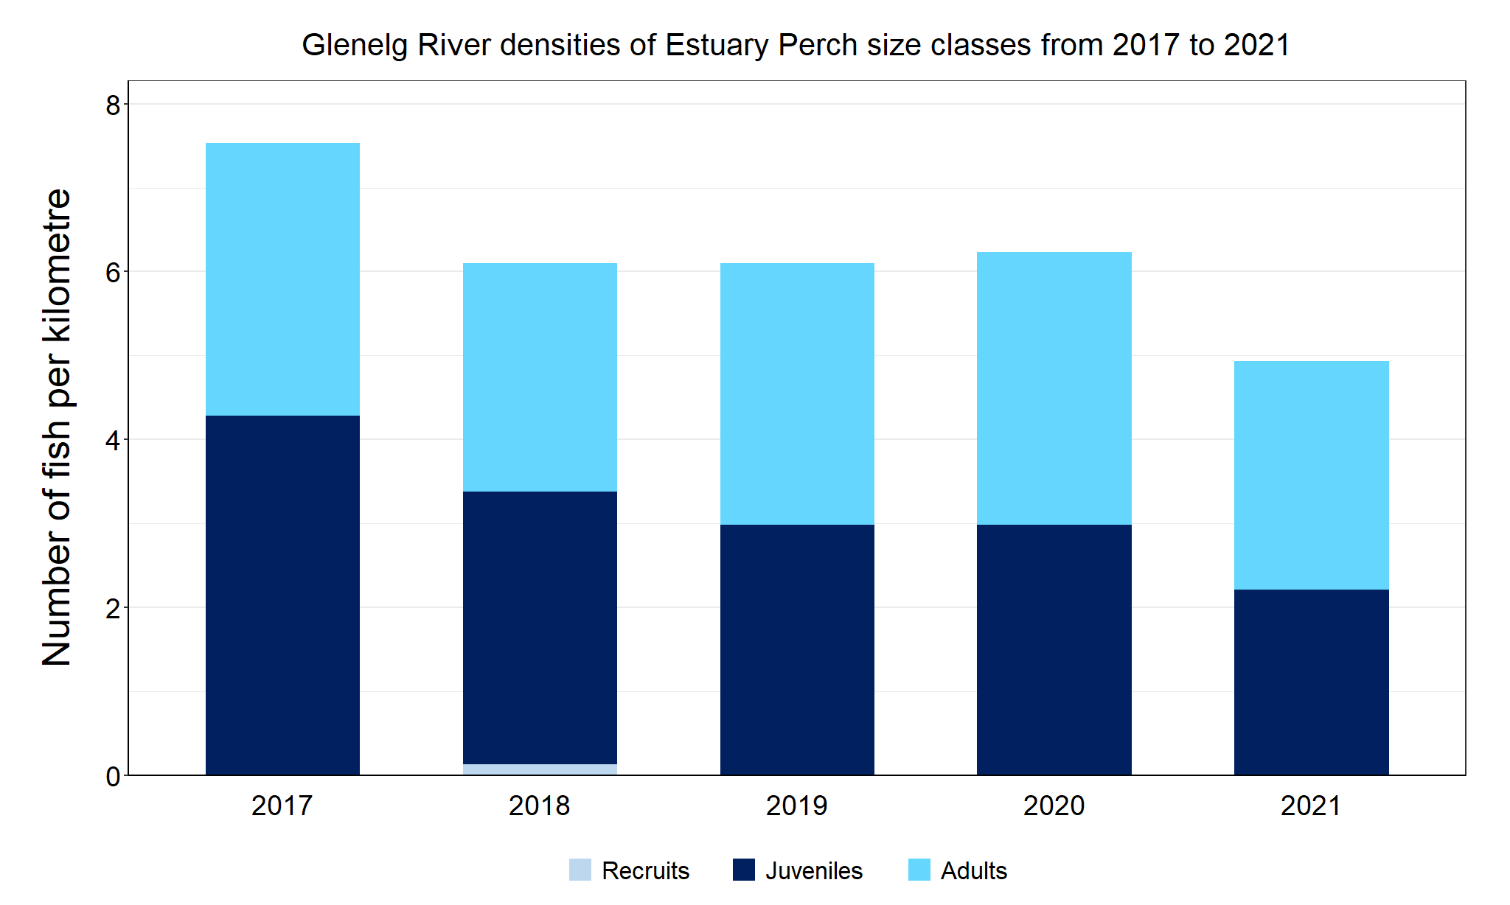
Figure 2. The densities of recruits, juveniles and adult Estuary Perch in the Glenelg River from 2017 to 2021.

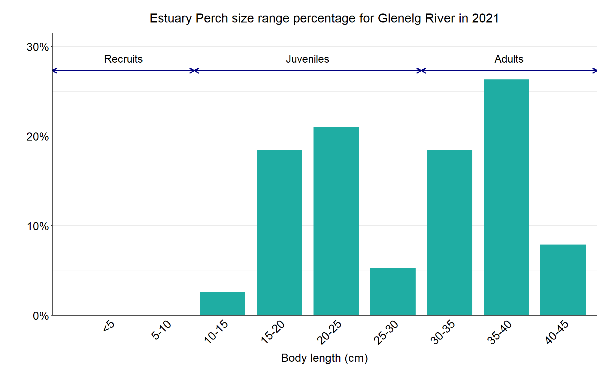
Figure 3. The size range percentage of Estuary Perch in the Glenelg River in 2021.

