|  |
| --- |
| Assessing the abundance of four cockatoo species in Victoria |
| M.P. Scroggie and D.S.L Ramsey |
| September 2021 |

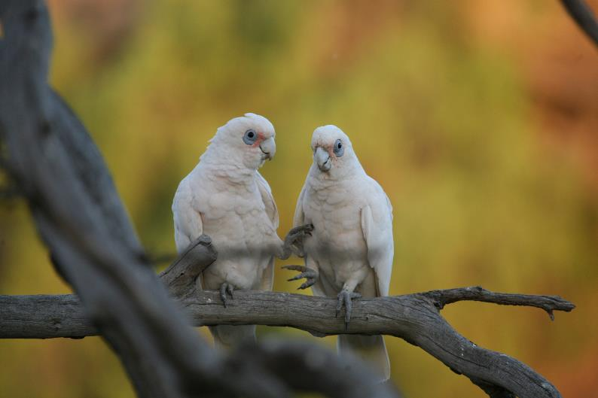

Arthur Rylah Institute for Environmental Research   
Technical Report Series No. 328



|  |  |
| --- | --- |
| |  | | --- | | Acknowledgment  We acknowledge and respect Victorian Traditional Owners as the original custodians of Victoria's land and waters, their unique ability to care for Country and deep spiritual connection to it. We honour Elders past and present whose knowledge and wisdom has ensured the continuation of culture and traditional practices.  We are committed to genuinely partner, and meaningfully engage, with Victoria's Traditional Owners and Aboriginal communities to support the protection of Country, the maintenance of spiritual and cultural practices and their broader aspirations in the 21st century and beyond. |   Arthur Rylah Institute for Environmental Research Department of Environment, Land, Water and Planning PO Box 137 Heidelberg, Victoria 3084 Phone (03) 9450 8600 Website: [www.ari.vic.gov.au](http://www.ari.vic.gov.au)  **Citation**: Scroggie, M.P. and Ramsey, D.S.L (2021). Assessing the abundance of four cockatoo species in Victoria. Arthur Rylah Institute for Environmental Research Technical Report Series No. 328. Department of Environment, Land, Water and Planning, Heidelberg, Victoria.  **Front cover photo**: Little Corellas (Photographer: Ian Temby).  Logo© The State of Victoria Department of Environment, Land, Water and Planning 2021    This work is licensed under a Creative Commons Attribution 3.0 Australia licence. You are free to re-use the work under that licence, on the condition that you credit the State of Victoria as author. The licence does not apply to any images, photographs or branding, including the Victorian Coat of Arms, the Victorian Government logo, the Department of Environment, Land, Water and Planning logo and the Arthur Rylah Institute logo. To view a copy of this licence, visit <http://creativecommons.org/licenses/by/3.0/au/deed.en>  Printed by Melbourne Polytechnic, Preston  Edited by David Meagher  ISSN 1835-3827 (print)  ISSN 1835-3835 (pdf))  ISBN 978-1-76105-777-9 (print) ISBN 978-1-76105-778-6 (pdf/online/MS word)  **Disclaimer** This publication may be of assistance to you but the State of Victoria and its employees do not guarantee that the publication is without flaw of any kind or is wholly appropriate for your particular purposes and therefore disclaims all liability for any error, loss or other consequence which may arise from you relying on any information in this publication.  Accessibility  If you would like to receive this publication in an alternative format, please telephone the DELWP Customer Service Centre on 136 186, email [customer.service@delwp.vic.gov.au](mailto:customer.service@delwp.vic.gov.au) or contact us via the National Relay Service on 133 677 or [www.relayservice.com.au](http://www.relayservice.com.au). This document is also available on the internet at [www.delwp.vic.gov.au](http://www.delwp.vic.gov.au) |

Assessing the abundance of four cockatoo species in Victoria

Michael P. Scroggie and David S.L. Ramsey

Arthur Rylah Institute for Environmental Research   
123 Brown Street, Heidelberg, Victoria 3084

Date

Arthur Rylah Institute for Environmental Research  
Technical Report Series No. 328

# Acknowledgements

The cockatoo count data used in this report were kindly provided by the Birdlife Australia Atlas project. We thank Dr. Andrew Silcocks for his assistance in obtaining the data. We would like to thank Ian Temby, Emma Hickingbotham, Vural Yazgin and Matt White for helpful comments on earlier drafts of this report. Ian Temby also kindly provided the cover image for this report. This work was funded by the Biodiversity Division, DELWP.

Contents

Acknowledgements ii

Summary 4

Context: 4

Aims: 4

Methods: 4

Results: 4

Conclusions and implications: 4

1 Introduction 5

2 Methods 6

Cockatoo census data 6

Environmental covariates 7

Static abundance models 9

Spatiotemporal models of abundance 10

Spatial prediction and estimation of total abundance 11

Model performance 11

3 Results 12

Model performance 12

Responses to the covariates 12

Spatial predictions – static models 16

Abundance estimates for Victoria – static models 18

Spatiotemporal trends in abundance 19

Temporal trends in statewide total abundance 19

4 Discussion 21

Model predictive performance and fit 21

Population estimates, trends and conservation status 21

Caveats and assumptions 21

Implications for lethal control 22

Conclusion 23

References 24

Appendix 26

Result for the boosted regression tree (BRT) models 26

# Summary

### Context:

Four common species of cockatoo (Galah, Sulphur-crested Cockatoo, Little Corella and Long-billed Corella) are well known to cause damage to agricultural crops, as well as damage and nuisance to agricultural and non-agricultural interests in Victoria. All four species are frequently the subject of applications to conduct lethal or non-lethal control under the Authority to Control Wildlife (ATCW) provisions of the *Wildlife Act 1975*. Illegal persecution, including poisoning and shooting, also occurs. As a first step in understanding the ecological risks of these actions, the current population status of the four species must be assessed.

### Aims:

To use existing data to assess the current total population size of all four species, and to assess spatial and temporal trends in density across the state over the last 10 years.

### Methods:

We obtained a large set of bird Atlas data collected from south-eastern Australia between 2010 and 2020 from Birdlife Australia. The data consisted of 20-minute counts of all birds present within 2-hectare plots selected for survey by the data collectors. The counts were related to a set of bioclimatic and land-use variables using Generalised Additive Models. The spatial predictions of densities across the state, conditional on the models, were then used to estimate the total population sizes and the uncertainty in these estimates. Spatiotemporal versions of these models were used to infer temporal trends in total abundance.

### Results:

The modelling procedures identified a number of bioclimatic and land-use variables of value for predicting densities of the four cockatoo species across the study area. Estimates of total abundance with acceptably small coefficients of variation (< 15 %) were obtained for all four species. Estimated total abundances in millions of individuals (and associated 95% confidence intervals) for the four species were as follows: Galah 13.6 (12.7, 14.5), Sulphur-crested Cockatoo 7.7 (6.9, 8.5), Little Corella 2.9 (2.3, 3.6), Long-billed Corella 5.2 (4.3, 6.6). Spatiotemporal modelling revealed that populations of all four species are either stable or increasing, but with substantial variation in the magnitudes and directions of the spatial trends across the state.

### Conclusions and implications:

The combination of Birdlife Australia’s Atlas data and the spatial modelling approach we present in this report provides a useful means of assessing the current abundance of the four cockatoo species in Victoria, as well as temporal trends in abundance. Spatial predictions of density across the study area are broadly congruent with the existing understanding of the species’ habitat associations and geographic distributions in the state.

All four species are found to be widespread and abundant, although total abundances of the two corella species are less that for the Galah and Sulphur-crested Cockatoo. Analysis of temporal trends in abundance showed no evidence of declines; the abundance of each species has been stable or increased over the last decade with only a slight recent decline suggested for Sulphur-crested Cockatoos. The availability of defensible population estimates provides a solid basis for any future work to assess the risks to the populations associated with current or anticipated rates of lethal control.

As data continue to be collected and collated for the Atlas, it would be possible to periodically update these population assessments using the methodology presented here to provide updated trends in abundance. This approach could be extended to other bird species.

1. Introduction

Cockatoos are widespread and familiar birds in Victoria, where nine species occur naturally. These include the threatened Red-tailed Black Cockatoo *(Calyptorhynchus banksia graptogyne*), Major Mitchell’s Cockatoo *(Lophophorea leadbeateri*) and a wet-forest specialist, the Gang-gang Cockatoo *(Callocephalon fimbriatum*). There are also two additional species of black-cockatoos, the Yellow-tailed Black Cockatoo (*Calyptorhyncus funereus)* and Glossy Black Cockatoo (*C. lathami*), which have dietary preferences/specialisation towards the seeds of conifers and native she-oaks *(Allocasuarina* spp.), respectively. These threatened or habitat/dietary specialist species are not considered further in this report.

The four other Victorian species of cockatoos are widespread and abundant in the state and utilise a wide variety of habitats, including extensively modified agricultural and urban landscapes. These are the Sulphur-Crested Cockatoo *(Cacatua galerita*), Little Corella (*Cacatua sanguinea*), Long-billed Corella (*Cacatua tenuirostris*) and Galah *(Eolophus roseicapilla*). These species have more generalised habitat and dietary preferences compared with the previously mentioned species. Their broader habitat and dietary requirements include the ability to feed on (and otherwise damage) agricultural crops, including grains, oilseeds and fruits (Temby and Emison 1986). Furthermore, other kinds of property damage and nuisance, such as damage to buildings and electrical installations, are also commonly reported as being caused by these four species (DELWP 2018). Consequently, all four species are frequently the subject of applications to undertake non-lethal or lethal wildlife control activities under the Authority to Control Wildlife (ATCW) provisions of the Victorian *Wildlife Act* *1975*. Illegal persecution is also known to occur, including cases of shooting, trapping and poisoning (Emison *et al.* 1994; Anonymous 2018).

Due to the number and frequency of ATCW applications and the resulting numbers of individual cockatoos that are either killed or disturbed by non-lethal control operations, it is prudent to carry out a detailed assessment of the current population status of these species in Victoria as a first step towards understanding the likely population-level impacts of current rates of lethal and non-lethal control. To this end, ARI was engaged to undertake an assessment of the population status of all four species in Victoria using currently available data sources.

In this report we use a large body of citizen science and professional ornithologist data (kindly provided by Birdlife Australia) to estimate the abundances of the four cockatoo species across Victoria. The relationships between abundance observed during standardised surveys, and a variety of land-use and climatic variables of likely significance to cockatoos are explored using spatial abundance models. We then extend this modelling approach to estimate spatiotemporal trends in abundance. This approach allowed us to predict average densities and density trends for the four species across the study area and gain an insight into ecological drivers of habitat use and population density for all four species.

1. Methods

Cockatoo census data

Birdlife Australia maintains an extensive database of bird sighting and census data collected by both amateur and professional ornithologists across the entire continent. Much of this data is collected using a standardised methodology in which observers count birds within a 2 hectare plot over 20 minutes. The widespread use of this standardised approach to data collection allows comparisons to be made between times and locations, provided that the counts can be considered close to a complete census of the number of birds present on the 2 ha plot at the given time, or at least that the rate at which birds are under- or over-counted does not vary substantially or systematically in time or space. The implications of this assumption are considered further in the discussion.

Birdlife Australia kindly provided a large amount of 20 min/2 ha count data for the four cockatoo species for inclusion in our analysis. The selected data were limited in spatial and temporal scope to cover the area of interest (Victoria, and adjacent areas of the Australian mainland) for the period 1 January 2010 – 30 April 2021. The spatial limits of the dataset were set to latitudes 32°S to 40°S, and longitudes 140°E to 152°E, encompassing the entirety of Victoria and adjacent areas of South Australia, New South Wales, and the Australian Capital Territory. The raw data for these temporal and spatial limits contained a total of 86,069 census records. Initial plotting of the spatial locations of the records revealed heavy concentrations of records in major urban centres (notably Melbourne, Sydney and Canberra) and larger country towns, no doubt reflecting the concentration of human populations and, by extension, the large numbers of amateur ornithologists resident in or visiting these locations who contribute data to Birdlife Australia’s Atlas project.

To prevent the concentration of data from these urban locations from dominating the analysis of spatial trends in abundance and habitat associations, a spatial thinning process was carried out. First, the entire study area (as delimited by the latitude and longitude limits described above) was subdivided into 5 × 5 km cells. For each cell a random sample of the available count records was selected, with the maximum allowable number of count records in any one cell being set to a maximum of 5. This thinning process reduced the number of records included in the analysis to less than 15,000 and ensured that the data subjected to further analysis was evenly spread over the study area, while also maintaining the majority of records in less thoroughly sampled parts of the study area. The thinned data are mapped in Figure 1.

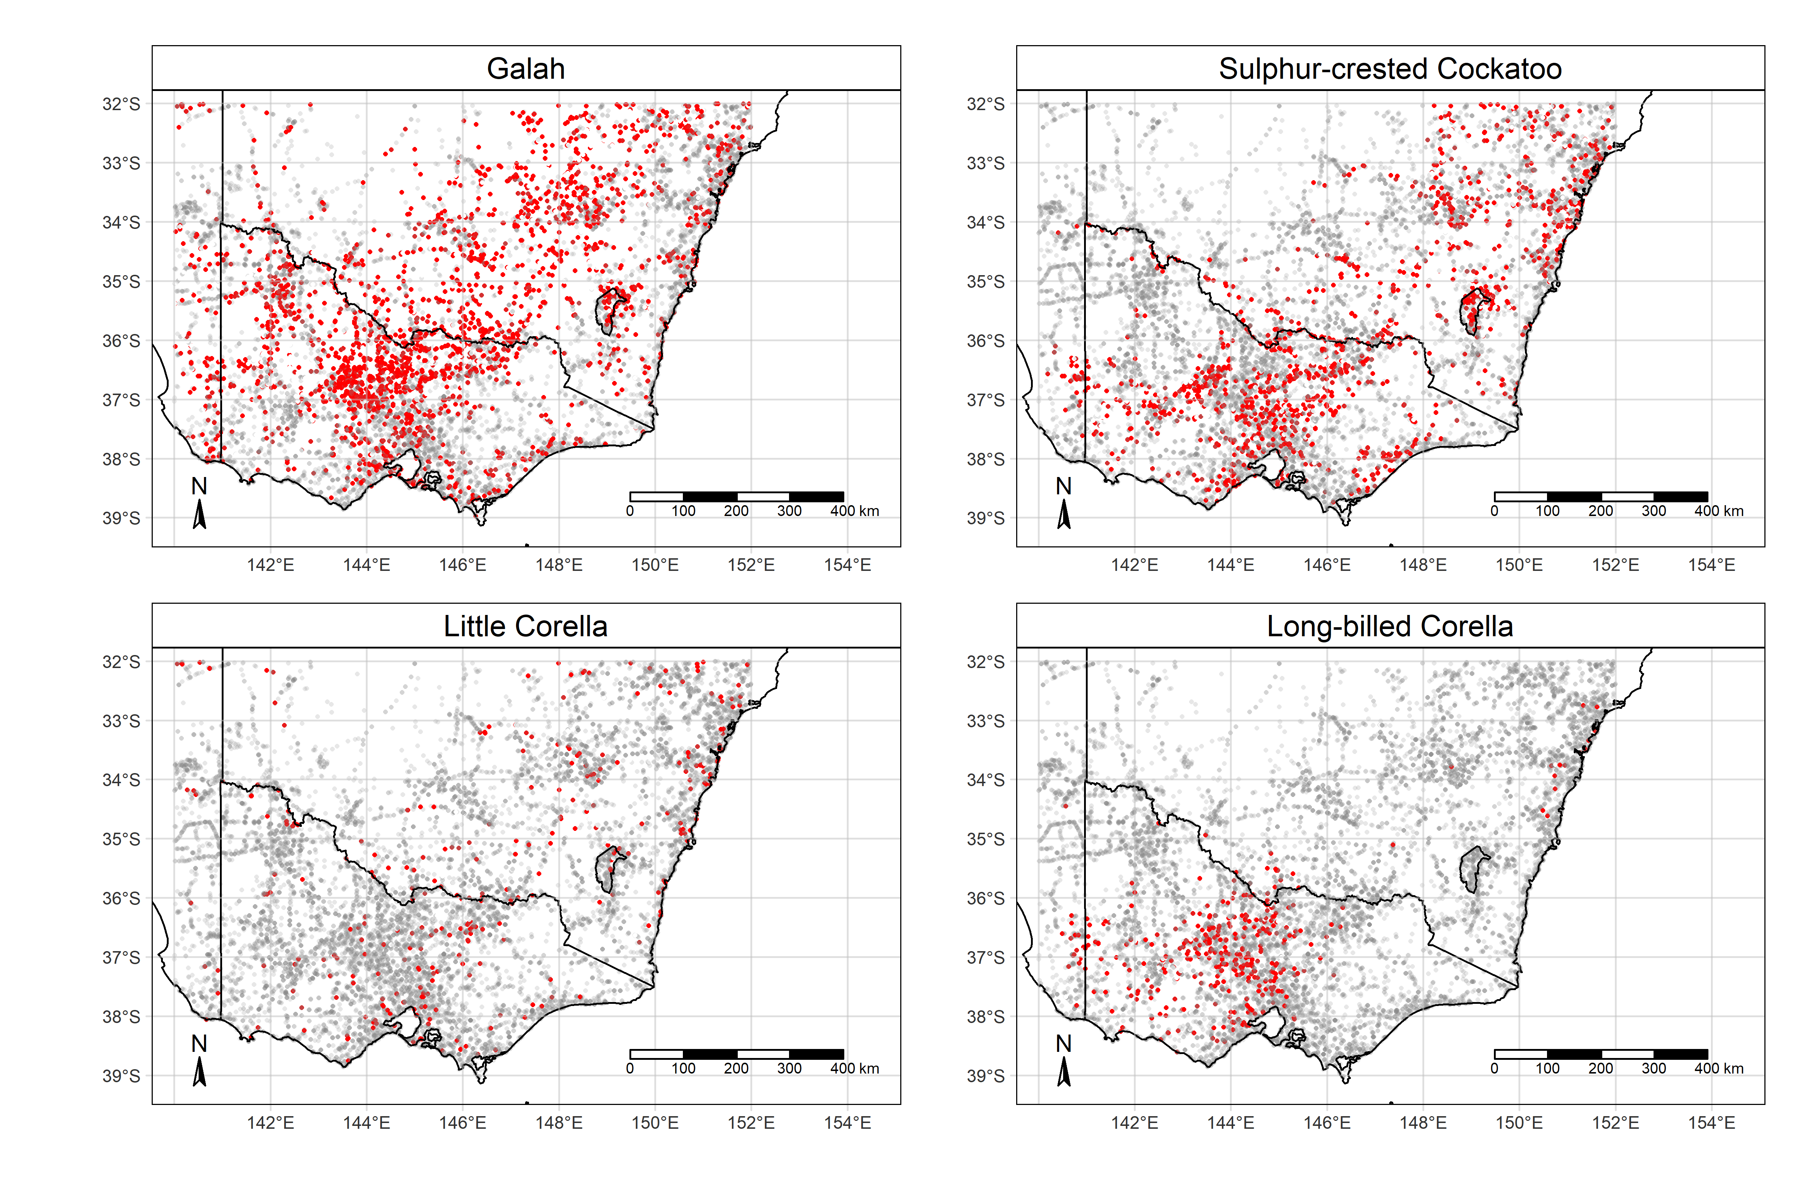

Figure 1. Maps of south-eastern Australia showing the spatially thinned locations of 20 min/2 ha bird counts (grey), and records of the four species of cockatoos (red).

After removing likely erroneous records (e.g., locations in the sea), we were left with a total of 14,910 counts for further analysis.

Of the 14,910 counts (selection described above) included in the analysis, the four species of cockatoos were present in between 2.3 and 22.4% of records (Table 1). The discrepancies between the total number (14,910) and the number of included counts for each species reflect cases where a species was recorded as present, but no count was provided. These records were excluded from the analysis for each species.

Table 1. Prevalence of the four cockatoo species in the subset of data selected for analysis

|  |  |  |  |  |
| --- | --- | --- | --- | --- |
| Species | Total  counts | Counts where  detected | Counts where  not detected | Percentage of counts where detected |
| Galah | 13928 | 3121 | 10801 | 22.4 |
| Sulphur-crested Cockatoo | 14295 | 1691 | 12604 | 11.8 |
| Little Corella | 14673 | 350 | 14413 | 2.4 |
| Long-billed Corella | 14741 | 437 | 14304 | 2.3 |

For each species a random sample of 80% of the available counts was selected from the spatially thinned data to train the statistical models of abundance. The remaining 20% was retained as a hold-out sample for checking the model’s predictive performance using the root mean square error statistic (RMSE).

Environmental covariates

Based on existing knowledge of the ecology of each species, we selected a collection of environmental covariates of likely value for predicting the presence and abundance of the four cockatoo species within the study area. Values of each covariate were obtained in raster format, meaning that they represented predicted or interpolated values for each variable in a fine grid of cells that encompassed the study area. We chose a grid cell resolution of 250 metres, which we considered adequate for wide-ranging and mobile species such as cockatoos.

We initially selected a set of bioclimatic variables which summarise the prevailing, long-term average values for climatic indices across the study area (Table 2). These were obtained from the WorldClim database (Fick and Hijmans 2017), which provides full descriptions and definitions of the variables.

Table 2. Bioclimatic variables obtained in raster form from the WorldClim database

|  |  |  |  |
| --- | --- | --- | --- |
| Code | Description | Code | Description |
| Bio1 | Annual mean precipitation | Bio10 | Mean temperature of warmest quarter |
| Bio2 | Mean diurnal temperature range | Bio11 | Mean temperature of coldest quarter |
| Bio3 | Isothermality | Bio12 | Annual precipitation |
| Bio4 | Temperature seasonality | Bio13 | Precipitation of wettest month |
| Bio5 | Max temperature of warmest quarter | Bio14 | Precipitation of driest month |
| Bio6 | Min temperature of coldest quarter | Bio15 | Precipitation seasonality |
| Bio7 | Temperature annual range | Bio16 | Precipitation of wettest quarter |
| Bio8 | Mean temperature of wettest quarter | Bio17 | Precipitation of driest quarter |
| Bio9 | Mean temperature of driest quarter | Bio18 | Precipitation of warmest quarter |
|  |  | Bio19 | Precipitation of coldest quarter |

Given the apparent association between the four cockatoo species and land use, particularly agriculture, we also used covariates derived from a categorical raster map of land-use categories for Australia (Lymburner *et al.* 2015). The values used are predictions of current land use derived from a machine learning algorithm trained on remote-sensed (satellite) imagery data. The land use classification data are for the year 2015, which is the approximate mid-point of the span of dates of the cockatoo count data used in the analysis.

After eliminating some categories (e.g., sugar cane crops) that are not present in south-eastern Australia and amalgamating several closely related land-use categories derived by Lymburner *et al.* (1983) (see Table 3), a raster map (Figure 2) with land-use categories used in further modelling was defined (Table 3). A binary raster map was prepared for each land-use category, with values of 1 for locations with the specified land-use and 0 otherwise. Because cockatoos can undertake long-range movements and select suitable habitats at large spatial scales (Rowley 1983; Smith and Moore 1992; Blythman and Porter 2020), it was considered advisable to summarise land use proportions at a larger resolution than that selected for the original rasters (250 m). The original binary rasters were therefore converted to measures of the proportion of the relevant land-use category within a radius of 5000 m for each point across the study area.

Table 3. The eight broad land use categories used as predictors of cockatoo abundance in the models

|  |  |  |  |
| --- | --- | --- | --- |
| Category | Categories included | Category | Categories included |
| Crops | Irrigated Cropping, Rainfed Cropping | Wetlands | Lakes and Dams, Salt Lakes, Wetlands |
| Pasture | Irrigated Pasture, Rainfed Pasture | Urban | Urban |
| Grassland | Alpine Meadows, Hummock Grasslands, Tussock Grasslands | Woodland | Woodland, Open Woodland |
| Shrubland | Dense Shrubland, Open Shrubland, Shrubs and Grasses (sparse) | Forest | Closed Forest, Open Forest |

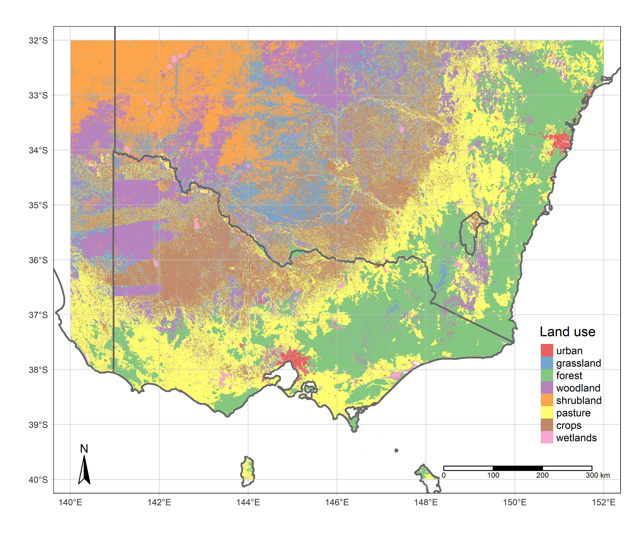

Figure 2. Map of amalgamated land-use categories across the study area.

Static abundance models

We made the simplifying assumption that the counts of cockatoos made during the 20 min/2 ha surveys represented the true number present within the 2 ha plot (i.e. a census). As cockatoos are large and noisy birds and lack cryptic colouration, we considered it reasonable to assume that observers would be likely to detect all (or close to all) of the cockatoos present on the 2 ha plots during typical surveys. It was also assumed that the abundances represented the number of cockatoos present in the plot at a single instant, and that the count was not influenced by individual birds flying in or out of the boundaries of the plot during the course of the 20 minute census. The plausibility of the latter assumption is harder to assess. See Discussion for some exploration of the consequences of any possible violations of these and other assumptions for the resulting population estimates.

An initial screening of the full set of habitat covariates described above was conducted using Poisson boosted regression trees (BRT, Elith *et al.* 2008) relating the full set of covariates to the observed abundances of each species. The boosted regression trees were implemented using the *R* package *dismo* (Hijmans *et al.* 2017). BRTs are very well suited to identifying the set of candidate covariates that are of greatest value from a large set of potential covariates because they are resistant to over-fitting and include procedures for automatically identifying influential and non-influential covariates. BRTs also allow the automatic identification of non-linear relationships, interactions, and other complex relationships between a response variable (in this case observed abundance), and a set of covariate values.

However, we did not use BRT models for the subsequent stages of modelling (prediction of abundance) for three reasons:

* First, the great flexibility of BRTs comes at the expense of interpretability: it can be difficult to understand what the model is saying about the influence of the covariates either individually or collectively.
* Second, available implementations of BRTs are limited in the range of error distributions that are implemented, often including only Bernoulli (applicable to presence/absence data), Gaussian (for normally distributed responses, or Poisson (for simple counts, with errors being Poisson distributed) data. Initial runs of the Birdlife Australia data using Poisson BRTs suggested that the Poisson distribution did not provide a good representation of the variation in observed data, with zero-counts being far more prevalent in the data than the assumed error distribution (Poisson) could accommodate (i.e. zero-inflation, Martin *et al.* 2005). However, the inferences from the Poisson BRT were still considered as being worthwhile for providing insight into the relative importance of the various covariates that were *a priori* considered to be likely influences on abundance of cockatoos. We used the measure of variable importance provided by the BRTs to develop shortlists of covariates that had apparent explanatory power for predicting the abundances of each species of cockatoo in the study area and applied these covariates in an alternative modelling framework which allowed the zero-inflated data to be properly accommodated.
* Third, the estimation of predictive uncertainty for BRTs is not well supported by existing theory or software implementations, meaning that there was no straightforward means of using the fitted models to estimate uncertainty (expressed as a coefficient of variation or a confidence interval) in the predicted abundances of cockatoos.

For these reasons we implemented an alternative, flexible modelling approach using Generalised Additive Models (GAMs, Wood 2017). GAMs are simple extensions of ordinary Generalised Linear Models (GLMs, McCullagh and Nelder 1989), which relax the assumption that covariates and responses are linearly related by allowing each covariate’s effect to adopt a flexible, smooth functional form, with the degree of smoothness determined from the data. Because GAMs are a special case of linear statistical models, methodologies for estimating their prediction uncertainty are well developed and straightforward to implement (see below).

Available software implementations of GAMs such as the *mgcv* package for *R* (Wood 2017) also include a wide range of error distributions that are able to accommodate over-dispersed and/or zero-inflated response data, including the zero-inflated Poisson and the Tweedie distributions.

Trial model fits demonstrated that the Tweedie distribution provided a good basis for modelling variation in counts around the expected means for all four species. The Tweedie distribution is a generalisation of multiple distributions in the exponential family of probability distributions which includes the Gaussian, Poisson and Negative Binomial distributions as special cases.

GAMs with Tweedie-distributed errors were used to model the relationships between the covariates identified using the BRTs and the observed counts of cockatoos during each 2 ha/20 min bird count. The GAM with Tweedie errors can be described by the following equations:

$$C\sim Tweedie\left(λ, p\right)$$

$$\log\left(λ\right)∼x_{0}+s_{1}\left(x_{1}\right)+s_{2}\left(x_{2}\right)+s_{3}\left(x_{3}\right)+...s_{k}(x_{k})+log(A)$$

Where *C* are the counts of cockatoos on each 2 ha plot and *λ* and *p* are the scale and shape parameters of the Tweedie distribution. When *p =* 1 the error distribution is equivalent to the Poisson, with values larger than 1 implying over-dispersed counts with variances greater than the mean. The covariates *x0*– *xk* are the intercept and habitat covariates, and *sk* is a series of smooth functions with smoothing parameters determined from the data. The final term *log(A)* is an offset giving the logarithm of the search area of each cockatoo survey, which was always 2 ha in the present study. The Tweedie Generalised Additive Models were fitted to the data using the *R* package *mgcv* (Wood 2017)*.*

In some cases, covariates identified by the BRT as having predictive value did not prove especially influential when transferred to the GAMs. For simplicity we elected to retain these variables in the GAMs, although refitting with these covariates excluded (or with additional covariates) could be considered. The overall exploration of alternative covariate combinations and model structures was limited in this study, as the main intention was to account for major drivers of spatial variation in abundance as a means of improving the precision of our statewide estimates of abundance. It is possible that a more thorough exploration of model structures could lead to a model with better predictive performance, especially at small spatial scales.

Spatiotemporal models of abundance

During the first stage of modelling, we made the simplifying assumption that the abundances of each species remained constant during the ten years and four months of the data collection period. This allowed an initial exploration of spatial trends in abundance within a simplified framework in which temporal variation in abundance was ignored. Having established basic models for spatial variation in cockatoo abundances over this period, we next sought to understand how abundance had changed over time, by extending the temporally static GAMs to allow for spatiotemporal variation. This approach was intended to estimate the overall temporal trends in the entire Victorian population of cockatoos, as well as to determine how trends in abundance varied in space. Terms were added to the basic, temporally static GAMs fitted at the first modelling step to allow for temporal trends in abundance and spatial variation in the temporal trend, broadly following approaches similar to those described by Marra *et al.* (2012) and Camp *et al.* (2020). Separate spline terms were used to encode for overall temporal trends and for the bivariate (latitude/longitude) space–time interaction.

Spatial prediction and estimation of total abundance

Raster predictions (predicted counts per hectare) from the fitted GAMs (static and spatiotemporal) were generated using the parameters of the fitted models to predict cockatoo densities based on the values of the covariates. Predicted overall abundances for each species in Victoria were estimated by summing predicted abundances for each raster cell of the study area that was contained within the boundaries of the Victorian border. Predictions were generated for both the static GAMs and for the spatiotemporal GAMs. For the latter set of models, predictions were generated for every second year between 2010 and 2020.

Uncertainty in predicted abundance was assessed by generating a sample of 250 replicate raster predictions, each based on a different set of parameter values sampled from a multivariate normal distribution describing the parameter estimates and their estimated variance–covariance matrix (Wood 2017). For each raster cell, the mean of the 250 replicate estimates of density were calculated, and the coefficient of variation (standard error divided by the mean) was computed as a measure of relative uncertainty in the spatial predictions at that location. Uncertainty in the statewide estimates of abundance was assessed by summing the predicted cell-wise abundances associated with each of the 250 replicate prediction layers. The resulting distribution of abundance estimates were then summarised by computing the coefficient of variation and the 2.5% and 97.5% quantiles (i.e., a 95% confidence interval). These summary statistics represent our uncertainty as to the true abundance conditional on the parameters of the fitted models. The same approach was used to generate predicted statewide abundances (and associated measures of uncertainty) from the spatiotemporal models in two-year steps from 2010 to 2020.

For comparative purposes only, spatial prediction maps and estimates of total abundance for each species were also computed using the boosted regression tree models that were used in the first stage of modelling to screen for influential covariates (see the Appendix). As mentioned above, these estimates do not provide associated measures of prediction uncertainty due to a lack of a generally suitable methodology for computing uncertainty around the predictions of boosted regression trees.

Model performance

Model predictive performance was assessed by computing the root mean square error (RMSE) of the predicted counts relative to the observed counts. This was done for both the training data (i.e. the sample of data used to build the models) and the test data (i.e. a further sample of 20% of the observations not used to build the model). The RMSE on the test data can be considered a more meaningful measure of a model’s predictive ability for a new location. Similarly, a test RMSE of much larger magnitude than the training RMSE can be indicative of over-fitting; that is, where the model fits the sample data well but does not generate good predictions on unseen data.

1. Results

Model performance

RMSE for the test data for all static models was in the rage of 4.42 – 6.13 and was, in all cases, smaller than RMSE on the training data. This result suggests that the models were not overfitted to the data (Table 4).

For the dynamic (spatiotemporal models) performance on test data, as measured by RMSE, was generally comparable to performance on training data. RMSE on test data for dynamic models was usually comparable to performance on the same data in the static models, suggesting that the spatiotemporal models were not clearly better at predicting abundances on a small scale when compared to similar static models with no spatiotemporal trends. A notable exception to this was the dynamic model for Long-billed Corellas, which had a test RMSE that was markedly less (2.81 vs 4.94) than that of the static model, suggesting that a dynamic model more closely described the observed data and allowed better prediction at new locations (Table 4). The test data were the 20% holdout sample not used in the fitting of the model, which allow an assessment of out-of-sample model predictive performance.

Table 4. Root mean square error (RMSE) between observed and predicted cockatoo counts from Generalised Additive Models for training and test data sets

**Static models**

|  |  |  |
| --- | --- | --- |
| Category | RMSE (training data) | RMSE (test data) |
| Galah | 6.25 | 4.42 |
| Sulphur-crested Cockatoo | 7.43 | 5.82 |
| Little Corella | 6.17 | 6.13 |
| Long-billed Corella | 10.16 | 4.94 |

**Dynamic (spatiotemporal) models**

|  |  |  |
| --- | --- | --- |
| Category | RMSE (training data) | RMSE (test data) |
| Galah | 5.98 | 5.09 |
| Sulphur-crested Cockatoo | 4.44 | 4.30 |
| Little Corella | 7.30 | 6.27 |
| Long-billed Corella | 2.26 | 2.81 |

Responses to the covariates

Initial screening of covariates using the boosted regression trees revealed several covariates with apparently strong potential predictive ability for the abundance of each cockatoo species. In some cases, covariates identified as being of high predictive value for a given species were highly correlated with other covariates (collinearity). It was not considered desirable to include highly collinear variables in the Generalised Additive Models to be fitted at the second stage of modelling, so in these cases only a single variable among the set of highly collinear variables was retained for further modelling. The resulting set of variables selected for inclusion in the GAMs are listed in Table 5. (See Table 2 for definitions of the bioclimatic variables.)

Table 5. Covariates selected for inclusion in the Generalised Additive Models based on demonstrated predictive performance in the boosted regression trees

|  |  |
| --- | --- |
| Category | Variables included |
| Galah | Crops, pasture, urban, woodland, grassland, forest, bio3, bio5, bio6, bio12 |
| Sulphur-crested Cockatoo | Pasture, urban, woodland, grassland, forest, bio4, bio5, bio6, bio18, bio19 |
| Little Corella | Crops, pasture, urban, wetlands, bio4, bio10, bio12 |
| Long-billed Corella | Crops, pasture, woodland, grassland, wetland, bio8, bio12. |

Fitting of the Tweedie GAMs with the covariates specified in Table 5 led to the identification of habitat covariates with strong effects on the abundance for all cockatoo species at the sites. The resulting partial effect plots, which illustrate the influence of each individual covariate on log-abundance while holding all other covariates at their means, are shown in Figures 3 and 4.

For Galahs, the GAM identified broadly positive effects of cropping and grassland land uses. Woodland and forest were consistently associated with lower abundances. Pasture and urban, despite being identified as having predictive value in the BRTs, had no consistent effect on abundances in the GAM (Figure 3). Complex, non-linear effects of the climatic variables bio3 (Isothermality), bio5 (maximum temperature of warmest quarter), bio6 (quarterly temperature extremes) and bio12 (annual precipitation) on the abundance of Galahs were identified. There were apparent optimal values for these climatic gradients, with lower abundances expected at the extremes. However, in the study area these climatic effects were generally indicative of a preference for warmer, drier conditions by Galahs (Figure 3).

For Sulphur-crested Cockatoos, abundances were negatively associated with crops and shrubland. Intermediate levels of forest cover (around 40%) showed the highest predicted abundances, with much lower abundance predicted at very high or very low levels of forest cover. The relationship with pasture was complex and non-linear, possibly reflecting a structural shortcoming in the model, such as an unmodelled interaction with another land use or bioclimatic covariate (Figure 3).

From a bioclimatic point of view, the partial effects of the GAM revealed that bio4 (isothermality) and bio18 (rainfall in warmest quarter) both had strongly positive effects on the abundance of Sulphur-crested Cockatoos. Similarly, abundances tended to be higher when bio 6 (mean temperature of the warmest quarter) had intermediate or high values. Similarly, when bio19 (precipitation of coldest quarter) was intermediate or high, abundances were higher than when this covariate was low (Figure 3).

The abundance of Little Corellas was highest when pasture was the dominant land-use, or where the proportion of crops in the landscape had an intermediate value. A generally negative association with bio4 (isothermality) and a positive relationship with bio10 (mean temperature of warmest quarter) was also noted, indicating higher abundances of this species in consistently warm climates. An uncertain but somewhat negative effect of annual precipitation (bio12) pointed to reduced abundances in the wettest parts of the study area (Figure 4).

For Long-billed Corellas, abundances were predicted to be highest where proportional cover of pasture was greater than approximately 40%, and abundances consistently reduced where woodland was prevalent. Where the mean temperature of the warmest quarter was high (bio8), abundances were generally lower. The fitted relationship between abundance and total annual rainfall (bio12) was complex and apparently bimodal, reflecting either distinct annual rainfall regimes or the influence of unmodelled interactions between rainfall and other drivers of abundance (Figure 4).

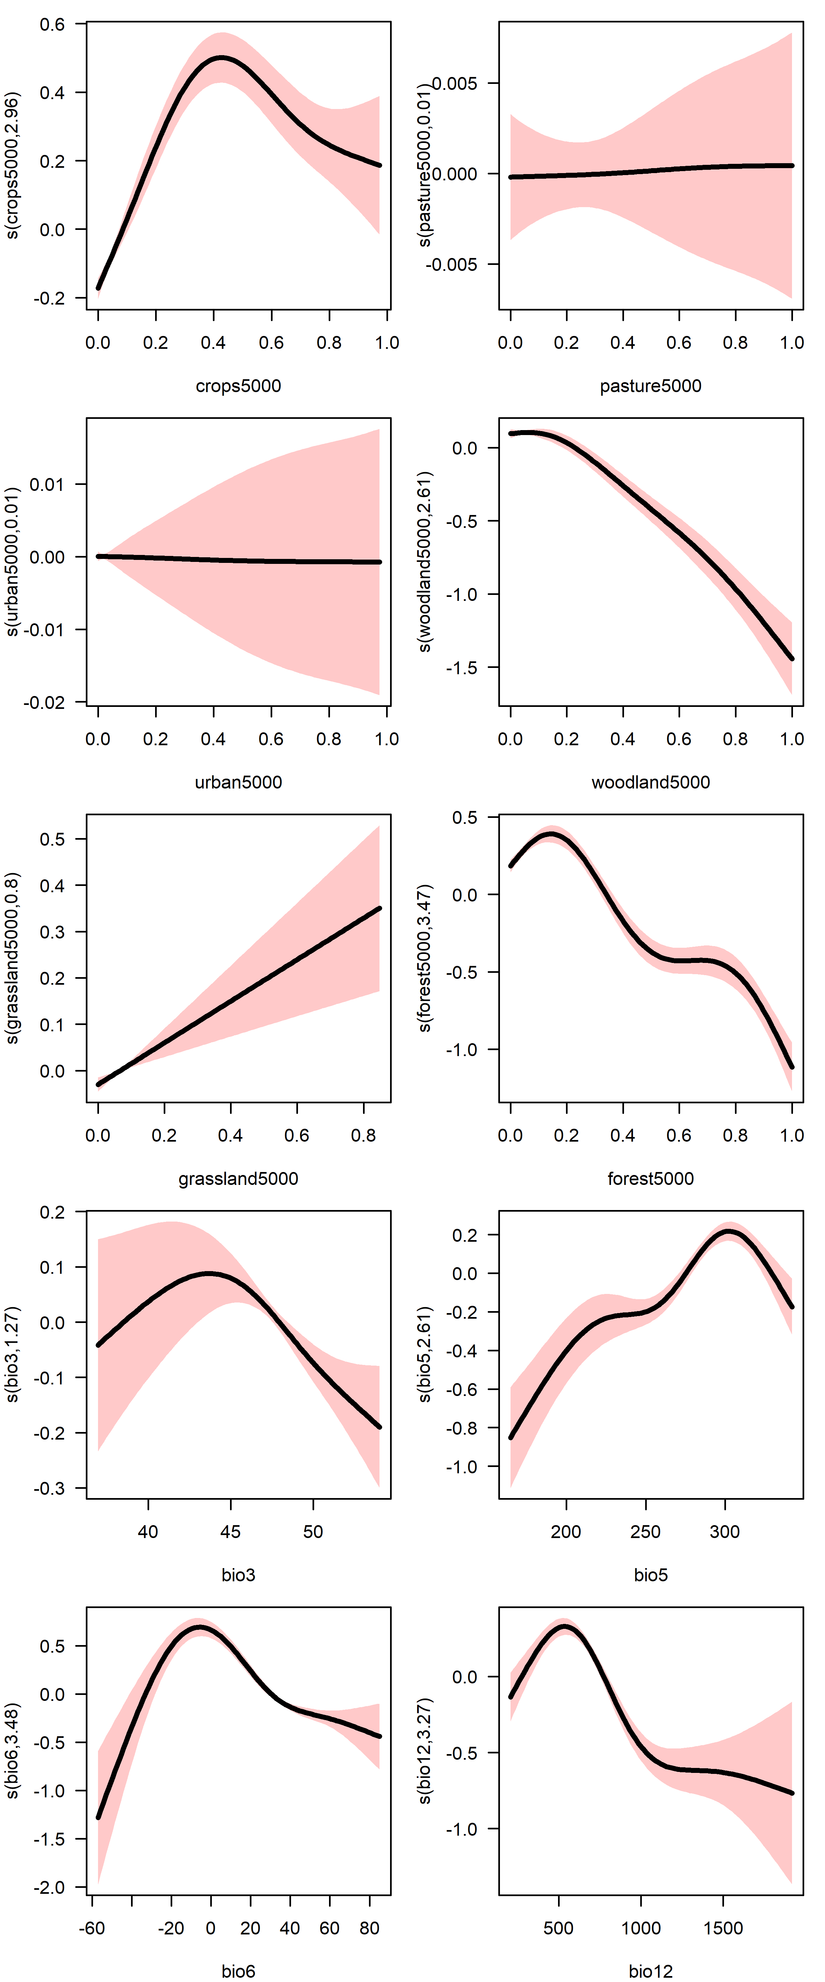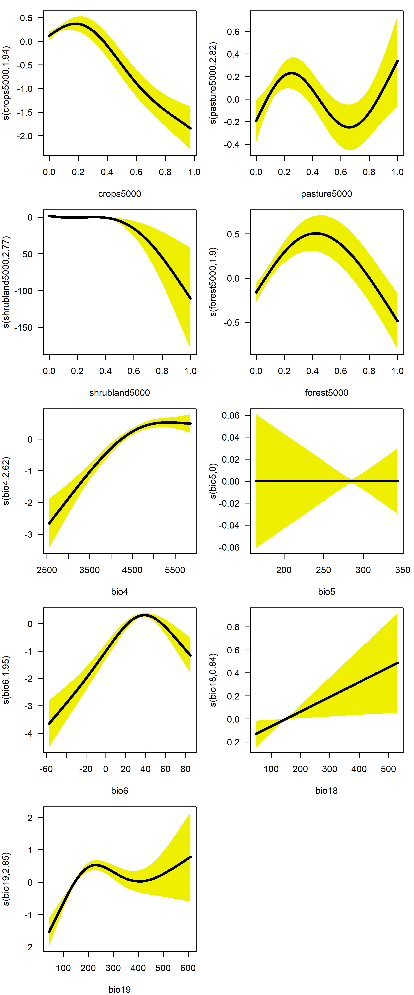

Figure 3. Partial effect of covariates on the log-abundance of Galahs (in pink, at left) and Sulphur-Crested Cockatoos (in yellow, at right) in the study area, as determined by the Generalised Additive Model.

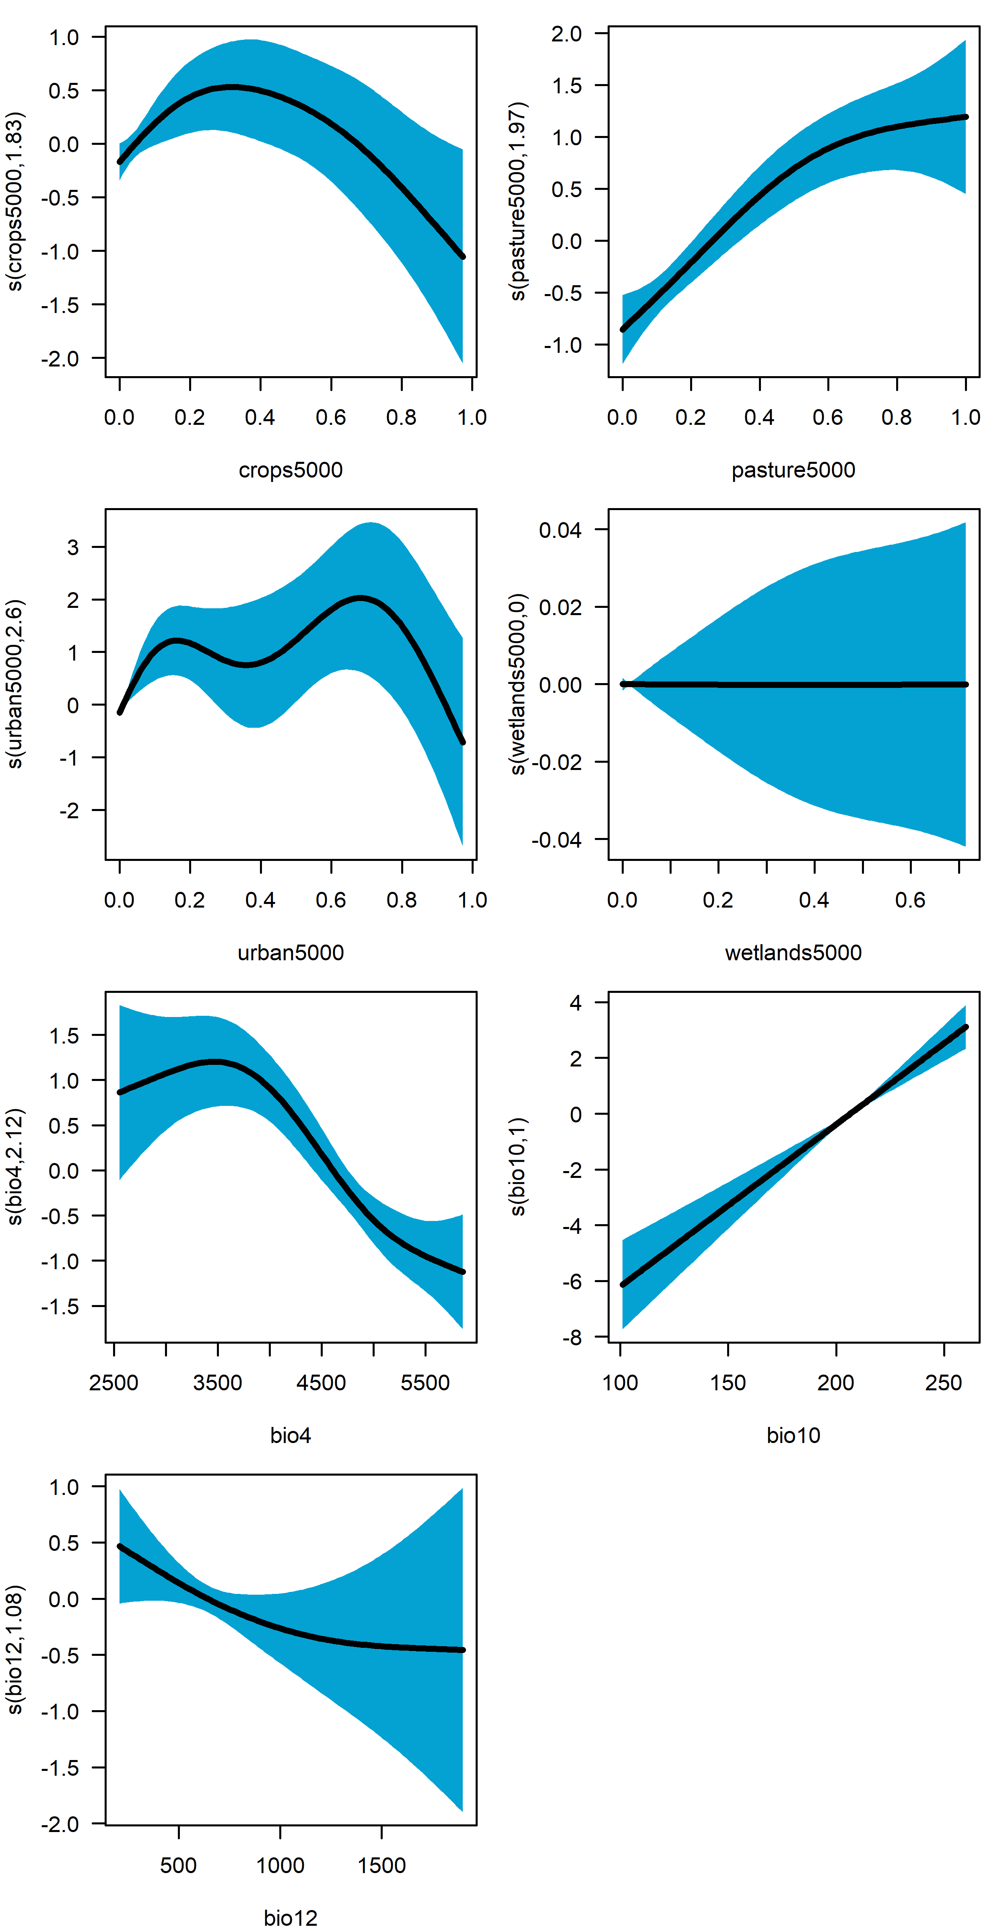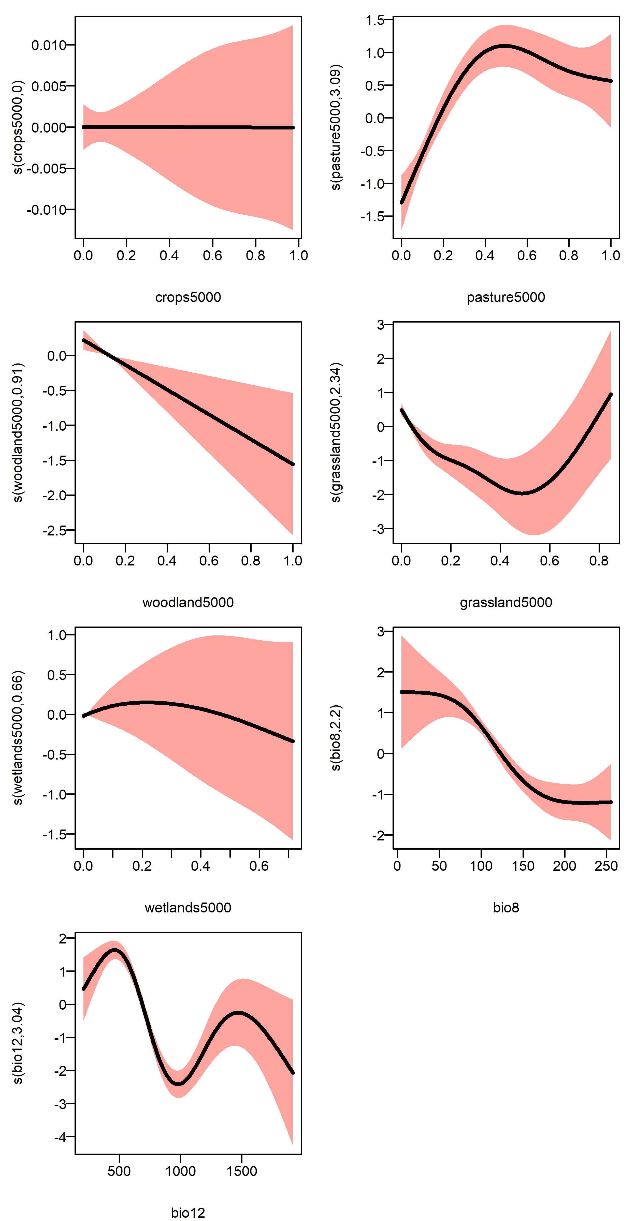

Figure 4. Partial effect of covariates on the log-abundance of Little Corellas (blue, at left) and Long-billed Corellas (pink, at right) as determined from the Generalised Additive Models.

Spatial predictions – static models

The spatial predictions of the static Tweedie GAMs are illustrated in Figure 5, showing areas of the state with high and low predicted densities for each of the four species. For Galahs, predicted abundances were highest on the northern plains, and in the dry north-west of the state. Predicted abundances were lower in forested parts of the Greater Dividing range and the Otway Ranges, reflecting this species’ avoidance of densely forested and wetter locations.

For Sulphur-crested Cockatoos, the highest predicted abundances were observed on the northern plains, in pastoral and agricultural areas, and in the northern slopes of the Great Dividing Range. Abundances were very low at high altitudes in the cool and densely forested parts of the east of the state and were also low in the dry and hot far north-west of the state (Figure 5).

Predicted areas of high abundance for Little Corellas were quite patchy and indicated an association with open country across the agricultural and pastoral districts of the state, consistent with the strongly positive effect of pasture land-use identified in the GAM (Figure 4). Very low abundances of Little Corellas were predicted in the Central Highlands and other high-altitude and/or densely forested parts of the state, such as East Gippsland, the Strzelecki Ranges of south Gippsland and the Otway Ranges,

The spatial predictions for Long-billed Corellas revealed a close relationship with open, pastoral and cropping country in the west of the state (Figure 5). The raw census data shows that this species is rarely found in the east of the state, south of the Great Dividing Range (Figure 1), and this pattern in the observations is born out in the predictions of the spatial model. Long-billed Corellas are similarly predicted to be rare in and around the Otway Ranges, and in the driest extremes of the far northwest of the state.

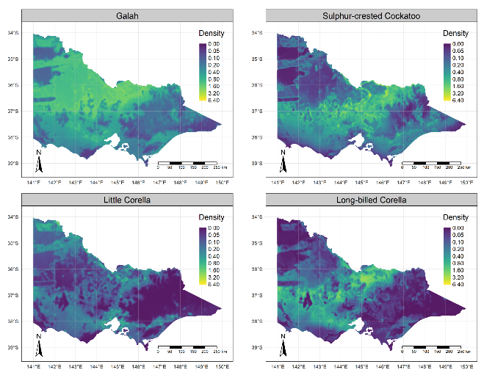

Figure 5. Predicted densities (individuals per hectare) of four species of cockatoos across Victoria based on the static GAMs.

The GAMs also allowed an assessment of spatial variation in the relative uncertainty of the abundance estimates, by computing the cell-wise coefficients of variation (CV) for a sample of abundances predictions derived from the fitted model (see Methods). This spatial variation in predictive uncertainty is illustrated in Figure 6.

For Galahs, uncertainty was consistently low across most of the state, with the exception of some parts of the Great Divide. This part of the state had comparatively few survey points (Figure 1), so there were very few available counts of Galahs on which to inform the model about abundances in this area. Uncertainty in abundance was otherwise low for this species.

A similar pattern was seen in the assessments for Sulphur-crested Cockatoos, with uncertainty being highest in the Central Highlands. There was a similarly high level of uncertainty in parts of the northwest with woodland (mallee) land use, such as the Mallee National Parks (Big Desert, Wyperfeld and Sunset Country) (Figure 6).

Predicted abundances of Little Corellas were perhaps the least certain of the four species considered in this report. In common with the other species, there was high uncertainty regarding abundances in the Great Dividing Range, but uncertainties across the entire state were consistently higher than were the case for the other three species.

For Long-billed Corellas, there was moderate level of uncertainty in abundance across most of their known geographic range, which is largely confined to the west of the state, and to areas north of the Great Dividing Range in the east. The model predicted high uncertainty in the Great Divide, but as the predicted abundance in this area was very low (Figure 5), this simply means the uncertainty has a large relative rather than absolute magnitude.

For all species, areas of large relative uncertainty partly reflect smaller numbers of survey points on which to inform the models about abundances in these areas, but also uncertainties in the fitted relationships between the covariates and the observed counts.

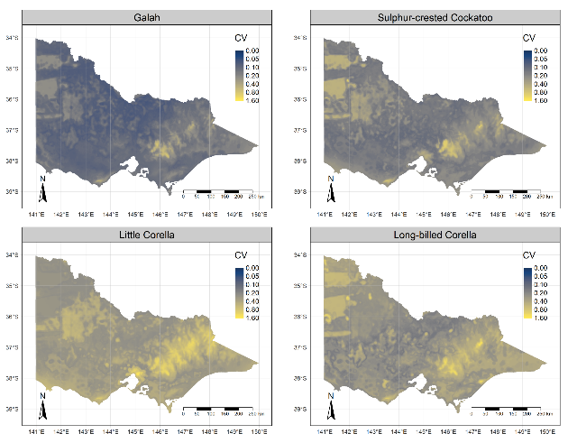

Figure 6. Spatial variation in the coefficient of variation (standard deviation divided by mean) of the predicted density of four species of cockatoos across Victoria. Larger values imply less certain predictions.

Abundance estimates for Victoria – static models

Using the spatial predictions of the static GAMs, predicted total abundances for each species were computed for all cells in Victoria, including estimates of uncertainty derived using the parametric bootstrap procedure (Figure 7). These abundances were derived from 250 simulated estimates from the multivariate normal distribution describing uncertainty in the parameters of the Generalised Additive Models, summed across the entire state. Posterior means and 95% confidence intervals were determined by taking means and quantiles from the empirical distributions.

Mean predicted total abundance for the state ranged between 13.6 million (95% CI 12.7, 14.5) for Galahs, and 2.9 million (95% CI 2.3, 3.6) for Little Corellas. For all four species, the estimates were quite precise, with coefficients of variation ranging between 3.4% for Galahs and 10.2 % for Long-billed Corellas (Figure 7).

As a point of comparison, we also computed the predicted abundances of all four species from the spatial predictions of the boosted regression tree models (Table A2). These predictions were broadly similar for Galah (13.8 million) and Sulphur-crested Cockatoo (7.2 million), with both estimates falling within the 95% confidence limits of the estimates derived from the GAMs (Figure 7). In contrast the estimates for Little Corella (2.1 million) and Long-billed Corella (3.4 million) derived from the BRTs were substantially lower than the estimates derived from the GAMs (Figure 7 & Table A2).

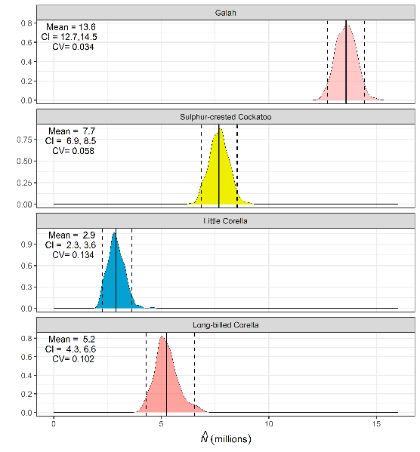

Figure 7. Predicted total abundances (in millions of individuals) for each of four cockatoos in Victoria. Kernel density curves represent the relative plausibility of values across the range of total abundance. Vertical lines are posterior means and 95% confidence intervals.

Spatiotemporal trends in abundance

Estimates of overall changes in abundance between 2010 and 2020 are shown in Figure 8. These allow the visualisation of areas of the state in which the abundance of each species declined or increased during this time. For Galahs, increases were noted across much of the state, with the exception of a large part of the dryland cropping belt of central northern Victoria. Large increases in density were apparent in more westerly parts of the state, including much of the Mallee. For Sulphur-crested Cockatoos, the largest increases in abundance were in central Victoria and on the Gippsland plains. Substantial inferred decreases were limited to a small part of north-central Victoria in the vicinity of the Barmah State Forest. For Little Corellas, there was a predicted increase in density in many parts of western Victoria, notably on the basalt plains in the south-west of the state. For Long-billed Corellas, predicted increases were greatest in north-central Victoria (Figure 8).

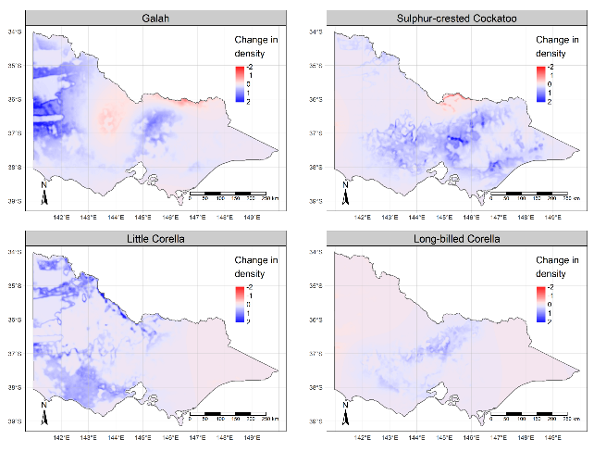

Figure 8. Predicted changes in density of four species of cockatoos across Victoria between 2010 and 2020.

Temporal trends in statewide total abundance

Predicted statewide abundances over time for each of the four species of cockatoos are shown in Figure 9. Between 2010 and 2020 the abundance of all four species increased, with both Sulphur-crested Cockatoos and Little Corellas experiencing the largest proportional increases in abundance during this period. Galahs increased substantially between 2010 and 2014 before declining somewhat in subsequent years. Long-billed Corellas increased slightly in expected abundance, with uncertainty in the estimates (expressed as 95% confidence intervals) meaning that the actual change in abundance was uncertain (Figure 9).

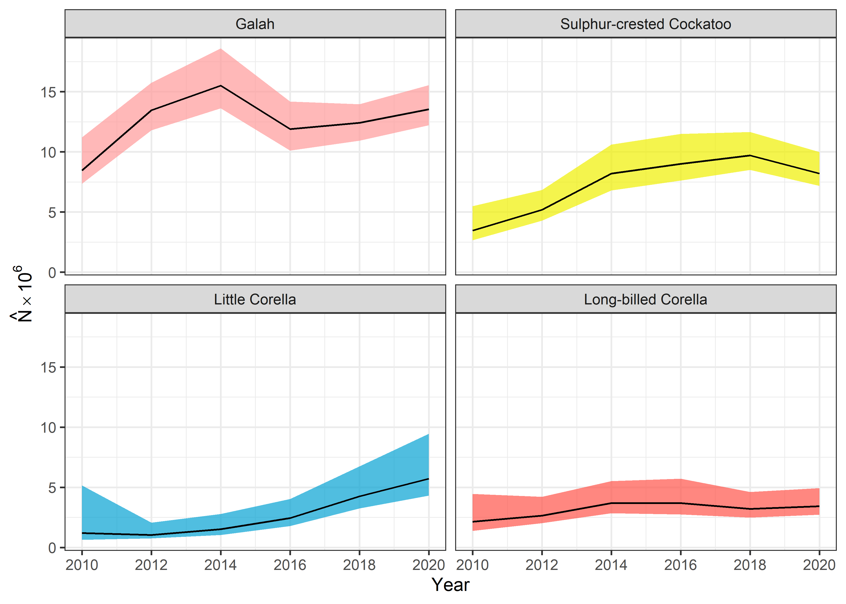

Figure 9. Estimated statewide total abundances (in millions) of four species of cockatoos , 2010–2020. Shaded areas are 95 % confidence intervals on the estimates derived using a parametric bootstrap procedure.

1. Discussion

Model predictive performance and fit

The static and spatiotemporal GAMs fitted to Birdlife Australia’s Atlas data captured important and ecologically meaningful aspects of the habitat associations for all four species, and largely confirmed the existing understanding about areas of high and low abundance for each species across Victoria. Formal measures of model predictive performance (RMSE) suggest that model performance was adequate for the intended purpose, and there was no evidence to suggest that overfitting of the models was leading to poor predictive performance.

The models as presented here are the result of a fairly limited exploration of alternative covariate sets guided by the use of semi-automated machine learning approaches at the initial stages of data exploration. It is likely that a more thorough exploration of alternative covariates could lead to some improvement in model performance and realism, especially if accurate prediction at small spatial scales is desired. For the current purposes for which the models are intended (understanding broad spatial trends and inferring total statewide abundances) the existing models are judged to be adequate.

Population estimates, trends and conservation status

With estimates of abundance in the millions (Figures 7 and 9), the predictions of the models confirm that Victorian populations of all four species are large and not trending downward. The inference is that there is little immediate threat of extinction for any of the four species, and a change to the current official conservation status assessments is not needed. Furthermore, the spatiotemporal models are all indicative of either increasing or stable population sizes for all four species, suggesting that current levels of lethal control are not leading to an overall decline in abundance.

The apparent increase in abundance after 2010 coincides roughly with the end of the historically unprecedented millennium drought in south-eastern Australia (Dijk *et al.* 2013), so it is possible that the observed increases in abundance represent population-level responses of cockatoos to improving environmental conditions after drought, although the present analysis provides no direct evidence for such a mechanism.

The ongoing collection of large volumes of bird count data by the contributors to the Atlas means that data suitable for periodically updating population estimates can be expected to accrue for the foreseeable future. Thus, any updating of abundance estimates can likely be carried out at minimal cost without the need to fund the collection of additional field data.

Caveats and assumptions

The abundance estimates presented here depend implicitly on a number of assumptions, and it is worthwhile to consider the plausibility of these assumptions, as well as the likely effect of any violations.

First, it is assumed that all cockatoos in a 2 ha plot are detected during a survey. As cockatoos are large and conspicuous birds, it seems likely that few individuals would not be observed during the surveys. However, this is essentially an untested assumption of the present analyses. If a portion of the total number are not detected, this will lead to negatively biased estimates of total abundance and could also lead to biases in the fitted relationships between abundance and the habitat covariates (Lahoz-Monfort *et al.* 2014).

Similarly, it is assumed that a count is instantaneous, representing the number of birds present on a plot at a given instant. However, the movement of birds into or out of a plot during the 20-minute census could lead to either positively or negatively biased estimates of abundance. This effect can be further complicated if the presence of the observer causes cockatoos to be attracted or repelled from the plots while the counts are being made. The available data do not provide a basis for testing these assumptions, so the possibility of at least some level of bias being induced by these effects remains unresolved.

The locations which are surveyed for Birdlife Australia’s Atlas are not a random sample of locations in Victoria. Citizen science data are much more likely to accrue at locations close to cities and towns, or in areas that are easily accessible by road. Similarly, citizen scientists often choose to conduct surveys at locations known or believed to have large numbers of birds, or a high diversity of bird species, or rare or migratory species. For all of these reasons, the sample of locations where bird counts are collected are expected to be a biased subset of the total geographic and environmental space in Victoria. Spatial sub-sampling approaches such as the spatial thinning approach used here, along with model-based interpretation of data that use covariates to infer the effects of environmental gradients on abundance can be expected to reduce, but not entirely eliminate the impacts of such sampling biases. In addition, we expect the estimates of abundance to be sensitive to the impacts of any influential environmental covariates which are not actually included in the models (i.e., model misspecification).

An alternative approach to overcoming biased selection of sampling locations would be to collect bird data using a randomised site selection approach such as stratified random sampling, and then to use design-based statistical methods to estimate abundance. Under such an approach to sampling and inference bias in site selection can be eliminated from the data and will not influence the resulting inferences regarding abundance. However, collecting an adequate volume of data to underpin a design-based estimate of abundance would be a challenging process for cockatoos. The majority of 20 min/2 ha surveys would be likely to return zero results, meaning that large numbers of censuses would need to be carried out to obtain adequately precise estimates of abundance on a state or regional scale. For this reason, reliance on model-based estimates using the large volume of available Atlas data from Birdlife Australia, as presented here, remains a much more practicable prospect.

We explored a limited set of covariates and based our GAM-based population estimates on a single model, with the assumption that the model is a reasonable approximation of the factors influencing abundance. The results are conditional on the assumed model (set of covariates, assumed error structure), and different combinations of covariates or model structures could give different results. In particular, failure to include important drivers of abundance in the model (model misspecification) can lead to biases of unknown magnitude. It is encouraging to see that two contrasting modelling approaches (BRTs and GAMs) give broadly similar estimates of abundance, and that uncertainty in total abundance from the GAM-based estimates is small. The two approaches were most divergent for the two least-abundant species (Little Corella and Long-billed Corella), suggesting some unresolved uncertainty regarding the drivers of abundance for these two species. Some degree of caution in interpreting the statewide abundance estimates for these two species is therefore warranted.

Implications for lethal control

It is notable that a large proportion of cockatoo species are currently listed as threatened either in Victoria or nationally. This likely suggests that aspects of the ecology and life-history of cockatoos in general pre-dispose them to high risks of population decline and hence, higher conservation risks. There is little data from Victoria on the population biology of the four cockatoo species considered in this report; see, for example, Emison *et al.* (1994). However, extrapolation from other cockatoo species would suggest that all four species are likely to be slow to mature and long-lived, and to have limited annual reproductive output (e.g. Rowley 1983; Heinsohn *et al.* 2009; Harris *et al.* 2012). All these aspects of the population biology of cockatoos could predispose them to a high risk of extinction if they are exposed to threatening processes such as destruction of breeding sites or widespread and intense lethal control. Similarly, the dependence of cockatoo species on tree hollows as nesting sites exposes them to risk of population decline wherever and whenever the availability of suitable nesting sites is limiting.

Encouragingly however, the spatiotemporal analyses presented here indicate no evidence of recent population declines and were indicative of either increasing trends or stability for all four species. This finding means that we can cautiously conclude that the impacts of present rates of lethal control are not leading to strong declines in cockatoo abundance. However, ongoing vigilance is recommended because of the likely propensity of cockatoo populations to decline where the impact of lethal control, lack of breeding sites or other threatening processes lead to sustained reductions in survival or breeding success.

For all of the above reasons, a conservative and careful approach to population management is warranted. This extends to the processes of permitting either lethal or non-lethal population control, such as via the ATCW system in Victoria. It is important to also recall that illegal persecution and killing is a feature of human interactions with cockatoos in Victoria, and therefore that the actual impacts of lethal control actions will be larger than the legally sanctioned control (via ATCW) might suggest. Ensuring that legal control is conducted in an ecologically sensitive manner, and that non-lethal control options are used wherever possible will help to minimise any consequential ecological risks. Limiting the allowable rate of lethal control to a small proportion of the estimated total population sizes would be especially prudent. However, specifying a recommended maximum culling rate in quantitative terms is difficult without detailed demographic information and associated population modelling.

Conclusion

Using a large volume of currently available bird census data we have developed a means of assessing spatiotemporal variation in the density of four cockatoo species across Victoria. The spatial models allowed us to readily estimate the abundance of all four species on a statewide basis, and trends over time. All four species were found to be abundant and widespread. Galahs had the largest estimated population size (13.6 million) and Little Corellas the smallest (2.9 million). The precision of the estimates (coefficients of variation for all species were less than 15%) was considered adequate for broad-scale population assessments, meaning that the currently available data and analytical techniques are fit for the intended purposes. The abundance of each species was either increasing or stable, with only a slight recent decline suggested for Sulphur-crested Cockatoos.

Periodic updating of the population assessments using newly acquired data from Birdlife Australia’s Atlas should be considered, as this would provide a means of assessing trends in abundance over time and give early warning of a decline in abundance, including a decline that is a consequence of legal or illegal lethal control.

# References

Anonymous (2018). Vic protected cockatoos killed by chemical. *Weekly Times*. Available at: https://www.weeklytimesnow.com.au/news/national/victorian-protected-cockatoos-killed-by-chemical/news-story/05404e7a43f74bde0e19727da1447d30 [accessed 2 July 2021]

Blythman, M., and Porter, G. (2020). Movement of introduced Little Corellas *Cacatua sanguinea* and Long-billed Corellas *C. tenuirostris* in south-western Western Australia. *Australian Field Ornithology*.

Camp, R. J., Miller, D. L., Thomas, L., Buckland, S. T., and Kendall, S. J. (2020). Using density surface models to estimate spatio‐temporal changes in population densities and trend. *Ecography* **43**, 1079–1089. doi:10.1111/ecog.04859

DELWP (2018). Guidelines for Reducing Cockatoo Damage. Available at: https://www.wildlife.vic.gov.au/__data/assets/pdf_file/0022/90661/Guidelines-For-Reducing-Cockatoo-Damage-PDF.pdf

Dijk, A. I. J. M. van, Beck, H. E., Crosbie, R. S., Jeu, R. A. M. de, Liu, Y. Y., Podger, G. M., Timbal, B., and Viney, N. R. (2013). The Millennium Drought in southeast Australia (2001–2009): Natural and human causes and implications for water resources, ecosystems, economy, and society. *Water Resources Research* **49**, 1040–1057. doi:10.1002/wrcr.20123

Elith, J., Leathwick, J. R., and Hastie, T. (2008). A working guide to boosted regression trees. *Journal of Animal Ecology* **77**, 802–813. doi:10.1111/j.1365-2656.2008.01390.x

Emison, W. B., Beardsell, C. M., and Temby, I. D. (1994). The biology and status of the Long-billed Corella in Victoria. *Western Foundation of Vertebrate Zoology* **5**, 211–247.

Fick, S. E., and Hijmans, R. J. (2017). WorldClim 2: new 1-km spatial resolution climate surfaces for global land areas. *International journal of climatology* **37**, 4302–4315.

Harris, J. B. C., Fordham, D. A., Mooney, P. A., Pedler, L. P., Araújo, M. B., Paton, D. C., Stead, M. G., Watts, M. J., Akçakaya, H. R., and Brook, B. W. (2012). Managing the long-term persistence of a rare cockatoo under climate change. *Journal of Applied Ecology* **49**, 785–794. doi:10.1111/j.1365-2664.2012.02163.x

Heinsohn, R., Zeriga, T., Murphy, S., Igag, P., Legge, S., and Mack, A. L. (2009). Do Palm Cockatoos ( *Probosciger aterrimus* ) have long enough lifespans to support their low reproductive success? *Emu - Austral Ornithology* **109**, 183–191. doi:10.1071/MU08053

Hijmans, R. J., Phillips, S., Leathwick, J., and Elith, J. (2017). ‘dismo: Species Distribution Modeling’. Available at: https://CRAN.R-project.org/package=dismo

Lahoz-Monfort, J. J., Guillera-Arroita, G., and Wintle, B. A. (2014). Imperfect detection impacts the performance of species distribution models: Imperfect detection impacts species distribution models. *Global Ecology and Biogeography* **23**, 504–515. doi:10.1111/geb.12138

Lymburner, L., Tan, P., McIntyre, A., Thankappan, M., and Sixsmith, J. (2015). Dynamic Land Cover Dataset, Version 2.1. Available at: http://pid.geoscience.gov.au/dataset/ga/83868

Marra, G., Miller, D. L., and Zanin, L. (2012). Modelling the spatiotemporal distribution of the incidence of resident foreign population: Spatiotemporal smoothing of resident foreign population. *Statistica Neerlandica* **66**, 133–160. doi:10.1111/j.1467-9574.2011.00500.x

Martin, T. G., Wintle, B. A., Rhodes, J. R., Kuhnert, P. M., Field, S. A., Low-Choy, S. J., Tyre, A. J., and Possingham, H. P. (2005). Zero tolerance ecology: improving ecological inference by modelling the source of zero observations. *Ecology Letters* **8**, 1235–1246.

McCullagh, P., and Nelder, J. A. (1989). ‘Generalized linear models' 2nd edition. (London: Chapman & Hall.)

Rowley, I. (1983). Mortality and dispersal of juvenile Galahs, *Cacatua roseicapilla*, in the Western Australian wheatbelt. *Wildlife Research* **10**, 329–342. doi:10.1071/wr9830329

Smith, G. T., and Moore, L. A. (1992). Patterns of movement in the Western Long-billed Corella *Cacatua pastinator* in the south-west of Western Australia. *Emu - Austral Ornithology* **92**, 19–27. doi:10.1071/MU9920019

Temby, I. D., and Emison, W. B. (1986). Foods of the Long-billed Corella. *Wildlife Research* **13**, 57-63. doi:10.1071/WR9860057

Wood, S. N. (2017). ‘Generalized Additive Models: An Introduction with R’. 2nd edition. (New York: Chapman and Hall/CRC)

Appendix

### Result for the boosted regression tree (BRT) models

The boosted regression tree models (BRTs) are described in the methods, and were used as an initial screening tool to identify variables with apparent predictive value for use in the Generalised Additive Models that were used as the primary tool for estimating abundances of the four species of cockatoos across Victoria. For comparative purposes, some basic results of these models are presented here.

Predicted abundances across Victoria from the BRTs are shown in Figure A1, which can be compared with the comparable results for the GAMs given in the main text (Figure 5). These predictions are broadly consistent with those derived from the GAM, predicting largely similar patterns of spatial variation in abundances of all four species to those predicted from the GAMs.

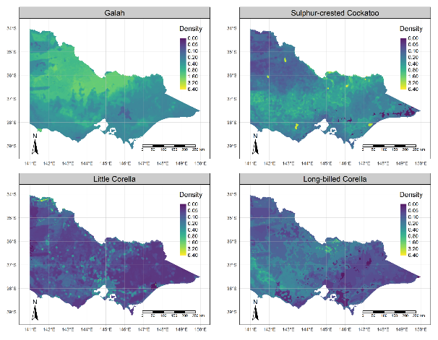

Figure A1. Densities (individuals per hectare) of four cockatoo species in Victoria as predicted using the boosted regression tree models.

Model predictive performance for the BRTs was assessed by calculating root mean square error (RMSE) for both the training data used to build the model, and an independent, 20% holdout sample, which provides a measure of the models’ ability to predict abundance at new sites not used to train the model. These quantitative assessments of model predictive performance were remarkably similar to those for the GAMs, suggesting generally similar predictive performance between the two model types. Performance on unseen (test) data as measured using the RMSE, ranged between 4.41 for Galahs, and 6.59 for Little Corellas (Table A1). In three out of four of the species, performance on test data was somewhat better than on the training data, while for a third species (Little Corella), the RMSE on test data was only slightly worse (larger) than on the training data. Collectively, these results suggest that there was little evidence of overfitting of the models, which would be expected to lead to larger RMSE on test data than training data.

Table A1. Root mean square error (RMSE) of predicted counts of cockatoos for the Boosted Regression Tree Models. The test data are a 20% holdout sample not used in the fitting of the model, and provide an assessment of out-of-sample model predictive performance.

|  |  |  |
| --- | --- | --- |
| Category | RMSE (training data) | RMSE (test data) |
| Galah | 5.97 | 4.41 |
| Sulphur-crested Cockatoo | 6.91 | 5.81 |
| Little Corella | 5.09 | 6.59 |
| Long-billed Corella | 8.89 | 4.94 |

In Table A2 we present the point estimates of total abundance for the four species of cockatoos in Victoria, derived from the spatial predictions of the BRTs shown in Figure A1. These estimates are broadly comparable to the estimates obtained using GAMs, with differences between the two sets of estimates being discussed in the main text.

Table A2. Predicted total abundances of four cockatoo species in Victoria, based on the fitted boosted regression tree models

|  |  |
| --- | --- |
| Species | Predicted total abundance |
| Galah | 13,837,979 |
| Sulphur-crested Cockatoo | 7,219,565 |
| Little Corella | 2,128,704 |
| Long-billed Corella | 3,449,137 |

[www.delwp.vic.gov.au](http://www.delwp.vic.gov.au)

www.ari.vic.gov.au