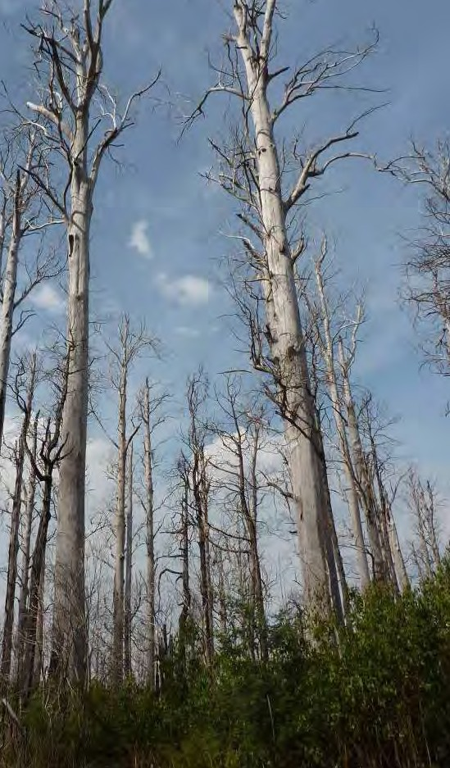
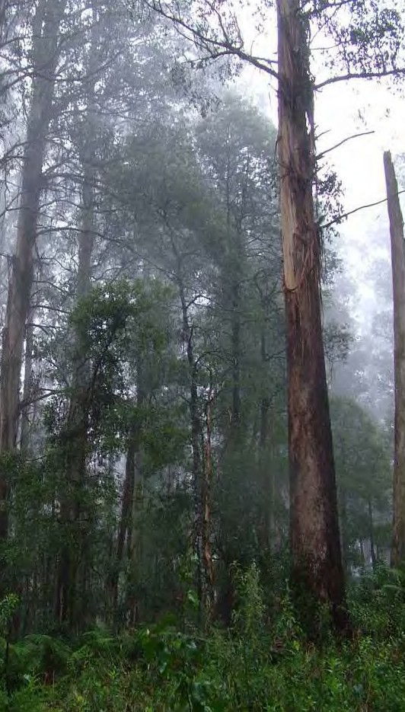
A New Strategic Approach to Biodiversity Management – Research Component

L.F. Lumsden, J.L. Nelson, C.R. Todd, M.P. Scroggie, E.G. McNabb,
T.A. Raadik, S.J. Smith, S. Acevedo, G. Cheers, M.L. Jemison and M.D. Nicol

September 2013

Arthur Rylah Institute for Environmental Research

Report produced by Arthur Rylah Institute for Environmental Research Department of Environment and Primary Industries
PO Box 137
Heidelberg, Victoria 3084

Phone (03) 9450 8600
Website: www.depi.vic.gov.au/ari

© State of Victoria, Department of Environment and Primary Industries 2013

This publication is copyright. Apart from fair dealing for the purposes of private study, research, criticism or review as permitted under the Copyright Act 1968, no part may be reproduced, copied, transmitted in any form or by any means (electronic, mechanical or graphic) without the prior written permission of the State of Victoria,
Department of Environment and Primary Industries. All requests and enquiries should be directed to the Customer Service Centre, 136 186 or email customer.service@dse. vic.gov.au

Citation: Lumsden, L.F., Nelson, J.L., Todd, C.R., Scroggie, M.P., McNabb, E.G., Raadik, T.A., Smith, S.J., Acevedo, S., Cheers, G., Jemison, M.L. and Nicol,
M.D. (2013). A New Strategic Approach to Biodiversity Management - Research Component. Arthur Rylah Institute for Environmental Research Unpublished Client Report for the Department of Environment and Primary Industries, Heidelberg, Victoria.

Disclaimer

This publication may be of assistance to you but the State of Victoria and its employees do not guarantee that the publication is without flaw of any kind or is wholly appropriate for your particular purposes and therefore disclaims all liability for any error, loss or other consequence which may arise from you relying on any information in this publication.

Accessibility

If you would like to receive this publication in an accessible format, such as large print or audio, please telephone 136 186, or through the National Relay Service (NRS) using a modem or textphone/teletypewriter (TTY) by dialling 1800 555 677, or email customer.service@dse.vic.gov.au

This document is also available in PDF format on the internet at www.dse.vic.gov.au

Front cover photo: Mountain Ash forest in Yarra Ranges National Park. The vegetation on the right was burnt in the Black Saturday wildfires in February 2009 (Photographs Steve Smith and Lindy Lumsden).

Contents
List of tables and figures v
Acknowledgements viii
Summary 1
- Background. 6
- Central Highlands project 8
  - Selection of priority species 8
  - Overall survey design 9
  - Data analysis and modelling 9
  - Leadbeater’s Possum 10
    - Leadbeater’s Possum broad scale survey. 10
    - Leadbeater’s Possum fire refuge project 15
    - Leadbeater’s Possum Population Viability Analysis 18
  - Large forest owls and gliders 28
  - Smoky Mouse 35
  - New species of Galaxias 38
- Investigation of Long-footed Potoroo population size and associated habitat requirements in East Gippsland 43
  - Background 43
  - Determine the population size required to sustain a ‘substantial and viable population of Long-footed Potoroos’ in East Gippsland 44
  - Determine the area of suitable habitat required to support a stable population of Long-footed Potoroos 49
  - Clarify the distribution of Long-footed Potoroos in East Gippsland 50
  - Determine the area that is currently reserved within the range of the Long-footed Potoroo in East Gippsland 55
  - Compare the area that is required to support a viable population with the area of Long- footed Potoroo habitat currently reserved 58
  - Assumptions and knowledge gaps 58
- Future directions 61
References 63

List of tables and figures

List of tables
Table 1. Species selected for field sampling within the Central Highlands 8
Table 2. The number of Leadbeater’s Possum survey sites selected in four strata in the Central Highlands RFA 11
Table 3. The area of the Leadbeater’s Possum reserve system unburnt during the 2009 wildfires, and the area of montane ash forest or Snow Gum woodland habitats in parks and reserves additional to areas in the Leadbeater’s Possum reserve. 25
Table 4. The area of predicted currently occupied Leadbeater’s Possum habitat in conservation reserves (parks and reserves and the Leadbeater’s Possum reserve system) and in state forest at two predicted levels of occupancy 25
Table 5. The area of Leadbeater’s Possum habitat required for less than a 5% chance of the population in the Central Highlands falling below 500 adult females in a 200 year time frame, under differing levels of habitat decline. Two additional risk thresholds are included: 2.5% (more risk averse) and 10% (more risk tolerant). 26
Table 6. The impact of future fires on the area (in ha) of Leadbeater’s Possum habitat required for less than a 2.5%, 5% or 10% chance of the population in the Central Highlands falling
below 500 adult females in a 200 year time frame, under differing levels of habitat decline.27
Table 7. The number of large forest owl and glider survey sites selected in four survey strata in the Central Highlands RFA 28
Table 8. The number of Smoky Mouse survey sites selected in four strata in the Central Highlands RFA 35
Table 9. The influence on the required population size of different levels of environmental variability (not factoring in catastrophes) and different levels of risk, using population estimates derived from the long-term trapping data from the Bellbird trapping grid 46
Table 10. Recorded fire size and frequency within the known Long-footed Potoroo distribution over the past 100 years. 46
Table 11. The required population size to support ‘a substantial and viable population’, under differing scenarios at the current survival rate, and if the survival rate could be increased by 10%. 48
Table 12. The area of suitable habitat required under differing population densities and using different extinction risk profiles, based on the required the population size with no catastrophic events and if catastrophic events are incorporated. 49
Table 13. Allocation of survey sites incorporated into the survey design for the Long-footed Potoroo sampling 52
Table 14. Area (ha) of Long-footed Potoroo habitat within conservation reserves, Special Protection Zones, Long-footed Potoroo Special Management Zones, other Special Management Zones and General Management Zones. 57

List of figures
Figure 1. Leadbeater’s Possum (yellow spot above the crosshair) detected using a thermal imaging camera. 12
Figure 2. Leadbeater’s Possum records (yellow circles) obtained during call playback and thermal imaging camera surveys in the Central Highlands, April – August 2012. The black circles indicate sites where the species was not recorded during the surveys. 13
Figure 3. A Leadbeater’s Possum photographed during the surveys (Photo: Tamara Leitch and Claire McCall). 14
Figure 4. Areas most likely to be currently occupied by Leadbeater’s Possum, as predicted using occupancy modelling 15
Figure 5. Unburnt refuge area (red vegetation) revealed by aerial infrared imagery 17
Figure 6. The area burnt during the 2009 wildfires, showing the area of montane ash or Snow Gum habitat (grey shading) that was burnt, and the unburnt refuges (red dots) sampled for Leadbeater’s Possum during this study 17
Figure 7. The Leadbeater’s Possum reserve system and the area burnt during the 2009 wildfires.. 18 Figure 8. The number of adult females within the Leadbeater’s Possum reserve modelled over
time, reflecting: a) the impact of past fires on the population with no increased rate of
habitat decline or future fires; and b) the impact of past fires plus a future 50% habitat decline of hollow-bearing trees. 20
Figure 9. The number of adult females within the Leadbeater’s Possum reserve modelled over time reflecting the impact of past fires, a future 50% decline in hollow-bearing trees and an extensive wildfire burning 50% of the reserve in 2020. 22
Figure 10. The risk curve for the minimum number of adult females over the next 200 years within the Leadbeater’s Possum reserve, reflecting the impact of past fires on the population, with no additional habitat decline or future fires 23
Figure 11. The risk curve for the minimum number of adult females over the next 200 years within the Leadbeater’s Possum reserve, reflecting the impact of past fires on the population (i.e., historical fire regime), plus an additional 12.5%, 25% and 50% habitat decline, plus a fire in 2020 burning 25% and 50% of the reserve in addition to a 50% habitat decline 24
Figure 12. The Leadbeater’s Possum reserve system and other areas of montane ash forest or Snow Gum woodland within the formal parks and reserves system (shown by the overlap of the grey shading on the parks and reserves). 25
Figure 13. Powerful Owl records (yellow circles) obtained during call playback surveys in the Central Highlands, April – July 2012. 29
Figure 14. Sooty Owl records (yellow circles) obtained during call playback surveys in the Central Highlands, April – July 2012. 30
Figure 15. Yellow-bellied Glider records (yellow circles) obtained during call playback surveys in Central Highlands, April – July 2012. Survey sites and records from both the large forest
owl and glider surveys and Leadbeater’s Possum surveys are displayed on this map. 30
Figure 16. Greater Glider records (yellow circles) obtained during call playback surveys in Central Highlands, April – July 2012. Survey sites and records from both the large forest owl and glider surveys and Leadbeater’s Possum surveys are displayed on this map. 31
Figure 17. Areas most likely to be currently occupied by the Powerful Owl, as predicted using occupancy modelling 33

Figure 18. Areas most likely to be currently occupied by the Sooty Owl, as predicted using occupancy modelling 33
Figure 19. Areas most likely to be currently occupied by the Greater Glider, as predicted using occupancy modelling 34
Figure 20. Areas most likely to be currently occupied by the Yellow-bellied Glider, as predicted using occupancy modelling 34
Figure 21. Smoky Mouse records (yellow circles) obtained during camera trap surveys in the Central Highlands, November 2011 – February 2012. 36
Figure 22. Smoky Mouse photographed at a bait station during camera trap surveys in the Central Highlands. 36
Figure 23. Areas most likely to be currently occupied by Smoky Mouse, as predicted using occupancy modelling 37
Figure 24. Close up of the area surveyed for Smoky Mouse within the Central Highlands RFA and the areas most likely to be currently occupied, as predicted by occupancy modelling 38
Figure 25. Location of fish survey sites in 2012 in the Thomson River and La Trobe River catchments (black circles), including sites at which Galaxias sp. 8 and Galaxias sp. 9 were recorded. The grey circles indicate previous sampling locations 39
Figure 26. Galaxias sp. 8 (Stoney). Image of a 75 mm long gravid female 40
Figure 27. Location of collection sites for Galaxias sp. 8 (Stoney) in the Stoney Creek system, Thomson River Catchment 40
Figure 28. Galaxias sp. 9 (Rintoul). Image of a 65 mm long gravid female 41
Figure 29. Location of collection sites for Galaxias sp. 9 (Rintoul) in the Rintoul Creek system, La Trobe River Catchment 42
Figure 30. The extent of wildfires over the past 100 years within the distribution of the Long- footed Potoroo. 47
Figure 31. Fire history within 5 km of the Bellbird trapping grid, showing no record of wildfire at the site, with the most recent nearby wildfire in 1959. More recent fires are shown on top of older fires. The yellow dots represent Long-footed Potoroo records. 47
Figure 32. Long-footed Potoroo Species Distribution Model and all known records of the species at early 2012. 51
Figure 33. Long-footed Potoroo photographed at a bait station during camera trap surveys in East Gippsland, April – August 2012. 53
Figure 34. Long-footed Potoroo records (yellow circles) obtained during camera trap surveys at 170 sites in East Gippsland, April – August 2012. 53
Figure 35. The location of all known records of Long-footed Potoroos in East Gippsland at January 2013, including the results from the sampling of 170 sites during this project 54
Figure 36. Predicted probabilities of occupancy for Long-footed Potoroos in East Gippsland. 55
Figure 37. Polygon enclosing all known Long-footed Potoroo records and most of the habitat predicted to be currently occupied based on the occupancy modelling 57

Acknowledgements

This project was funded by the former Department of Primary Industries (DPI), facilitated by the former Forests and Parks Division of the Department of Sustainability and Environment (DSE). A Project Steering Committee provided oversight and guidance throughout the project. Steering Committee members were: Graham Mitchell (DSE/DPI Chief Scientist), Lee Miezis, Duncan Pendrigh, Gary Howell, Andrew Haywood (all DSE, Forest and Parks Division), Kylie White, Simon Smith (both DSE, Biodiversity & Ecosystems Services Division), Sze Flett, Kim Lowe (both DSE, Arthur Rylah Institute (ARI)), Angela Brierley and Andrew Dolling (both DPI, Forest Industries Policy).

An Industry Reference Group provided valuable input to the project, particularly relating to the study areas and species chosen for field sampling. Industry representatives were: Lisa Marty (Victorian Association of Forest Industries), Daniel Sedunary and Chela Powell (both VicForests).

A large number of people were involved in collecting the survey data underpinning this project. Much of the field work was undertaken through winter in cold, wet and difficult conditions and we are particularly grateful for the hard work and dedication of the field teams involved.

The Leadbeater’s Possum survey team was managed by Steve Smith (ARI) and included Sarah Brown, Kylie Eklom, Simone Harvey, Alex Hodgson and Steve Robertson (all Australian Research Centre for Urban Ecology, facilitated by Rodney van der Ree), Claire McCall, Tamara Leitch, Dave Caldwell, Tim Gentles, Aileen Collyer and Laura Carstairs (all Wildlife Unlimited, Bairnsdale, facilitated by Jim Reside) and Trent Patten (Thermality). Additional field assistance was provided by Linda Grootendorst and Ryan Chick (ARI).

Information relating to Leadbeater’s Possum was provided by David Lindenmayer, Lachlan McBurney, David Blair (all Australian National University) and Dan Harley (Zoos Victoria).

Smoky Mouse surveys were conducted by Jenny Nelson, Micaela Jemison, Ryan Chick, Michael Basson (all ARI), Dave Caldwell and Tim Gentles (Wildlife Unlimited).

Large forest owl and glider surveys were conducted by Ed McNabb (ARI), Garry Cheers (G&B Cheers Flora & Fauna Consultants), Tamara Leitch, Aileen Collyer, Rolf Willig and Jim Reside (all Wildlife Unlimited).

Stephen Henry and Tony Mitchell (DSE, Orbost) provided long-term monitoring data used to develop the Long-footed Potoroo Population Viability Analysis. They also provided insights into the species’ ecology and distribution and, together with Andrew Murray (DSE, Orbost) and Ryan Chick (ARI), assisted with some camera survey photo identifications.

Chela Powell (VicForests), Lucy Clausen (DSE, Orbost), and Alan Robley (ARI) provided survey data that was incorporated into the Long-footed Potoroo occupancy model. Long-footed Potoroo surveys were conducted by Rena Gaborov, Maria Cardoso, Dave Caldwell, Joe Henderson, Tim Gentles, Jim Reside and Laura Carstairs (all Wildlife Unlimited).

Melbourne Water allowed access to closed water catchments and were particularly helpful with logistics relating to track conditions and the deer culling program. Thanks to Mario Malovic, Justin Jemmeson, Neville Rattray and Paul Pearson.

Many regional DSE and Parks Victoria staff also provided information about local conditions and facilitated access to field sites.

GIS support was provided by Silvana Acevedo, Michael Basson and Michael Nicol who produced the maps presented in this report. Michael Basson and Alex Hodgson undertook the infrared aerial photograph interpretation to locate unburnt refuges for the Leadbeater's Possum fire study.

Independent technical and scientific advice was provided to the project team by a Scientific Advisory Panel – Andrew Bennett (Deakin University), Graeme Gillespie (consultant) and Elizabeth Stark (Symbolix). Elizabeth Stark critiqued the field sampling designs for the Long- footed Potoroo, large forest owls and gliders and Leadbeater’s Possum’s surveys.

The research component of this project had strong links with the policy component: thanks to Scott Lawrence, Graeme Newell, David Parkes, Matt White, Peter Menkhorst and Rod Kavanagh for many fruitful discussions.

We thank Kim Lowe, Stuart McConnell, Natasha McLean, Peter Menkhorst, Graham Mitchell and Duncan Pendrigh for reviewing drafts of this report.

Support and guidance throughout the project was also provided by Sze Flett and Kim Lowe (ARI).

Summary

Background

The Timber Industry Action Plan released by the Victorian Government in 2011 aims to provide for a productive, competitive and sustainable Victorian timber industry. In response to this plan, the ‘A New Strategic Approach to Biodiversity Management’ project was established to develop ‘an effective landscape approach to the management of threatened species that provides opportunities for sustainable timber production while managing biodiversity at a species and landscape scale’. This project has both research and policy components. The aim of the research component is to provide extensive new data on the status, distribution and habitat use of priority threatened fauna species in the forests of eastern Victoria to inform the policy development of a new landscape management approach. This report provides a summary of the findings from this research component. The full technical results will be written as a series of peer-reviewed papers to be published in scientific journals.

Sampling rationale

Targeted surveys for nine high priority species were conducted within the Central Highlands Regional Forest Agreement area (Central Highlands RFA). The Central Highlands was seen as a high priority for investigation due to the number of threatened species occurring in the area, the impact of the 2009 fires on both threatened species habitat and the timber resource, the value of the timber resource and the current review of the Forest Management Zoning Scheme for this area. In consultation with the timber industry the following species were selected for field sampling: Leadbeater’s Possum, Smoky Mouse, Greater Glider, Yellow-bellied Glider, Powerful Owl, Sooty Owl, Masked Owl and two newly-described species of galaxias (Galaxias sp. 8 and Galaxias sp. 9). As the entire distribution of Leadbeater’s Possum is within the Central Highlands RFA and the 2009 fire severely affected this species and its habitat, an additional project was undertaken targeting unburnt islands of potential Leadbeater’s Possum habitat within the burnt area. A Population Viability Analysis (PVA) was undertaken to assess the conservation status of Leadbeater’s Possum and the area required to sustain a viable population in the Central Highlands.

A specific project was conducted in East Gippsland to address management issues associated with the uncapped reserve system for the Long-footed Potoroo. This project included a PVA to investigate the number of Long-footed Potoroos required for a substantial and viable population, and a determination of whether the current level of habitat reservation is adequate to support this population. Field surveys for the Long-footed Potoroo were undertaken to address key knowledge gaps relating to the habitat preferences and distribution of the species in East Gippsland.

The sampling strategies used to collect the new data were rigorously designed to complement existing data sources and to provide the maximum information on species’ current distribution and preferred habitat across the public land estate. All survey designs were externally peer-reviewed. The new data was collected using the most efficient and effective survey methods for each of the faunal groups, with new techniques developed for cryptic species. Each survey site was visited on multiple occasions to increase the likelihood of detecting the target species and to allow the modelling to account for imperfect detection. Survey data were used to update current Species Distribution Models (SDMs) predicting the likely occurrence of suitable habitat for each of the target species throughout eastern Victoria. Occupancy models were also developed to represent the current distribution of the key species within the Central Highlands RFA and also of Long-footed Potoroos in East Gippsland. Occupancy models reflect the impact of recent disturbances (e.g., the 2009 wildfires) on current patterns of habitat occupancy, while SDMs reflect patterns of habitat use over a longer time period.

Leadbeater’s Possum surveys and Population Viability Analysis

In the Central Highlands, 180 sites were surveyed for Leadbeater’s Possum during a broad scale survey across the species range, with Leadbeater’s Possum recorded at 16% of these sites. No Leadbeater’s Possums were detected at the 30 sites burnt during the 2009 fires, irrespective of the fire intensity, including locations where the understorey was burnt but the canopy was intact. This result confirms the strong negative impact of the fire on this species. An additional 37 sites were surveyed in unburnt ‘fire refuge’ habitat within the overall area burnt in the 2009 wildfires. These surveys revealed that Leadbeater’s Possums have persisted in some (16%) of these unburnt patches of habitat. It is unknown, however, if these colonies will survive into the future. If they can persist until the surrounding regenerating habitat becomes suitable, then recolonisation can occur from within the fire-affected area as well as from outside. This is likely to be an important factor in the continuing persistence of Leadbeater’s Possum throughout the northern part of its range.

The occupancy modelling revealed that current strongholds for Leadbeater’s Possum include unburnt habitat mainly in the south of its distribution, especially the Baw Baw Plateau and its southern slopes, the Tooronga Plateau south of the Upper Yarra Catchment, state forest in the vicinity of Powelltown, parts of the Toolangi State Forest, and southern parts of the Upper Yarra National Park. Sites most likely to be occupied by Leadbeater’s Possum were generally characterised by lush, unburnt vegetation in gullies in areas that had relatively low summer temperatures and high summer rainfall.

A Leadbeater’s Possum reserve system was established in 2008 as one of the key strategies for the conservation of the species. A PVA was undertaken to evaluate if this reserve system (comprising 30,500 ha of high quality habitat) was sufficient to support the long-term conservation of the species, or if additional strategies were required. The PVA modelled significant fluctuations in population numbers over time due to past fires, especially the extensive fires in 1939 and 2009. There was a severe reduction in the population following the 2009 wildfires and this decline is predicted to continue into the future as habitat deteriorates further due to the collapse of dead nest trees. This will result in areas becoming increasingly unsuitable before 1939 regrowth matures sufficiently to produce suitable hollows during the next 50-120 years. Increased rates of tree fall and future fires will exacerbate this situation, with models predicting the population in the reserve to fall to critically low levels.

To quantify the risk of extinction within the reserve, the probability of the number of adult females falling below 500 within a 200 year time frame was calculated. Typically, once populations decline below these levels, they are more susceptible to loss of genetic variation, population changes due to unfavourable environmental conditions and catastrophic events such as wildfires, leading to a higher risk of extinction. There were no modelled scenarios where there was less than a 5% chance of the number of adult females falling below 500 individuals. For example, under the scenario of the impact of past fires on the future population, without the addition of extra hollow- bearing tree loss or future fires (i.e., the best case scenario) there was a 73% probability of the population falling below 500 adult females within the Leadbeater’s Possum reserve system. All other modelled scenarios (combinations of habitat loss and future fires) had an even higher probability that the population would fall below 500 adult females.

As these models indicate that the Leadbeater’s Possum reserve system alone is insufficient to ensure the long-term conservation of the species, additional areas were factored into the model. Outside of the Leadbeater’s Possum reserve there is an additional approximately 43,000 ha of montane ash forest or Snow Gum woodlands in formal parks and reserves, of which more than 26,000 ha is unburnt. This results in a total of 43,500 ha of unburnt montane ash forest or Snow Gum woodland in conservation reserves that is potential habitat for Leadbeater’s Possum.

However, not all this area is likely to be currently suitable and occupied by Leadbeater’s Possum. Using the occupancy model based on the results of the broad scale survey, it is predicted that there is approximately 15,000 ha of currently occupied habitat (based on areas that are predicted to have at least a 50% likelihood of the species being present now). These figures can then be used to compare with the area required to reduce the risk of extinction of the species.

To assess how much habitat would be required to reduce the extinction risk, the modelling explored the impact of different future fire and habitat loss scenarios across all potential habitat in the Central Highlands (i.e., throughout the whole of the species range). Under the scenario examining the impact of the historical fire regimes with no additional habitat decline or future fires, over 54,000 ha of Leadbeater’s Possum habitat would be required to provide less than a 5% chance of falling below 500 adult females in a 200 year time frame. While not all of this area would necessarily be currently occupied by Leadbeater’s Possum, all of it has the potential to be available when the age and structure of the habitat is suitable. When future fires are included in the model, for example different-sized wildfires occurring in 2020 or 2040, the area of habitat required for less than a 5% chance of falling below 500 adult females in 200 years, ranges from 67,000 to 171,000 ha. The greater the habitat decline and the larger the wildfire, the greater the area required for a viable population. As the amount of unburnt habitat reserved in either formal parks and reserves or the Leadbeater’s Possum reserve (43,500 ha), and estimates of occupied habitat in reserves (15,000 ha), are considerably less than the areas required under all the scenarios above, this indicates that the reserves are currently insufficient to ensure the long-term conservation of the species. Although the above findings do not include the contribution made through habitat protection measures in state forests (e.g., prescriptions in timber harvesting areas, code exclusions) the current analysis indicates that additional management actions (e.g., protection of known colonies in state forest, protection of additional areas of suitable habitat, habitat enhancements, alternative silvicultural practices) need to be considered to reduce the extinction risk of Leadbeater’s Possum throughout its range.

Surveys for other threatened species in the Central Highlands

Large forest owl and glider surveys were conducted at 200 sites across the Central Highlands. Sooty Owl, Powerful Owl and Masked Owl were detected at 25%, 21% and 1% of survey sites respectively. Key areas for Powerful Owl were drier sites on rugged terrain in the south-east and north-east of the Central Highlands RFA. In contrast, wet gullies in the south of the Central Highlands RFA are most likely to be occupied by Sooty Owls. Sites burnt in the 2009 fires were less likely to be occupied by either Powerful Owls or Sooty Owls than unburnt sites. There were too few records of Masked Owl to model their distribution or describe their habitat preferences.

Yellow-bellied Gliders and Greater Gliders were detected at 20% and 16% of sites respectively. Additional owl and glider records were obtained during Leadbeater’s Possum surveys. A striking result of these surveys was the scarcity of the Greater Glider which was, until recently, common across the Central Highlands. Greater Gliders were predicted to be most likely to occur in moist rugged areas with lush vegetation, and areas most likely to be occupied were patchily distributed in the centre and east of the Central Highlands RFA. Yellow-bellied Gliders were more likely to occur in gullies with lush vegetation and high summer rainfall, particularly in the centre and south east of the RFA.

Camera-trap surveys for Smoky Mouse conducted at 120 sites detected the species at 18% of sites with records obtained from several areas from which they had not previously been detected. An occupancy model developed for Smoky Mouse highlighted the sparse and patchy distribution of the species and the importance of dry ridge-top habitats.

No additional populations of two newly-described species of small fish (Galaxias sp. 8 and Galaxias sp. 9) were recorded during field sampling conducted at 121 sites in the upper Thomson and La Trobe River catchments. The only detections were from the streams these species had previously been recorded in, which are both just outside of the Central Highlands RFA boundary. These data, together with data from previous surveys provide a high level of surety that these upland, non-migratory species are extremely rare and occupy only very small areas. The entire distribution of Galaxias sp. 8 is confined to a short section of Stoney Creek and Galaxias sp. 9 to a short section of the east branch of Rintoul Creek. Both these sections of creek flow through state forest.

Investigation of Long-footed Potoroo population size and associated habitat requirements in East Gippsland

Population Viability Analysis was used to investigate the population size needed to provide a substantial and viable population of Long-footed Potoroos in East Gippsland. The results of this analysis indicated that an initial population size of 14,766 individuals would be required to ensure the population had less than a 5% chance of falling below 500 individuals in a 50 year time frame (representing a high risk of extinction), assuming no catastrophic events, such as extensive wildfires. The model predicted a significant increase in risk of extinction when the population experienced catastrophes even under scenarios where such events lead to the loss of a relatively small number of individuals. Under the current level of predator baiting and a wildfire on average every 10 years, the model estimated that an initial population size of 27,640 individuals would be required to meet the definition of a substantial and viable population of Long-footed Potoroos in East Gippsland.

To explore how the risk profile influenced the required population size, the required number of individuals was calculated using a more risk-averse approach of ensuring the population had less than a 2.5% chance of falling below 500 individuals in a 50 year time frame (34,000 individuals), and a more risk-tolerant approach of a 10% chance of falling below 500 individuals in 50 years (22,900 individuals). Based on an average density of 0.28 animals/ha, a population size of 27,640 animals would require 98,714 ha of suitable Long-footed Potoroo habitat (121,429 ha based on the more risk-averse approach of 2.5% chance of a non-viable population, or 81,786 ha if taking a more risk-tolerant approach of 10% chance of a non-viable population).

To clarify the distribution and area of suitable habitat for Long-footed Potoroos, field surveys were conducted at 170 sites in East Gippsland. Long-footed Potoroos were recorded at 41 (24%) of surveyed sites. The majority of records (88%) were within the previously known geographic range, with approximately half in state forest and half in parks and reserves. Only five records of Long- footed Potoroos were from locations outside the previously known range, despite 57% of the sampling being in this area. These results confirm that the species has a very limited distribution within East Gippsland and is not uniformly distributed throughout this range. The occupancy model indicates that the area most likely to be occupied by the species falls within the geographic core of the species’ range. Other important areas include parts of the Snowy River National Park, and state forest north-west of Cann River.

The occupancy model was used to predict the area of occupied Long-footed Potoroo habitat reserved in parks and reserves, Special Protection Zones or the retained habitat component of the Long-footed Potoroo Special Management Zones. Areas of reserved habitat were calculated for three levels of increasing certainty that areas represent suitable habitat for the species (i.e., greater than 40%, 50% and 60%). The areas reserved under all three of these scenarios (69,202 ha, 47,185 ha, and 29,833 ha respectively) were substantially less than the area determined to be required to ensure population viability under the three risk profiles outlined above (i.e., 121,429 ha, 98,714 ha

or 81,786 ha). This indicates that the reserve system alone is insufficient to ensure the long-term conservation of the species, and that consideration of additional conservation strategies will be required.

Implications

The extensive new field data collected during this project has been used to update the Specie Distribution Models for each of the study species. Records obtained during these field surveys of other threatened species, including Long-nosed Potoroo, Southern Brown Bandicoot and White- footed Dunnart, have also been incorporated into updated SDMs. The inclusion of this new data has added significantly to the utility of the SDMs, improving the capacity for these models to accurately predict the distribution of potential habitat for these species throughout the project area.

Occupancy models developed from randomised survey data collected across the public land estate have provided a contemporary view of where these species are most likely to occur in the landscape. This has been especially useful for the Long-footed Potoroo in East Gippsland and to show the distribution of Leadbeater’s Possum post the 2009 fires. These models have been used in conjunction with the SDMs to identify the most important areas for the conservation of these species.

The collection of new data for the nine key species included in the research component of this project has been instrumental in gaining an accurate and up-to-date understanding of the species’ status, distribution and habitat requirements. This information will contribute to the development of a new, strategic approach to the management of threatened fauna species across the public land estate.

There are, however, still many knowledge gaps and areas requiring further information to improve the management and conservation of these and other key species. Many other threatened species do not have comparable, up-to-date distributional data available. The collection of similarly detailed, rigorously collected and analysed data would greatly enhance the ability to inform management decisions intended to improve the conservation status of those species, and allow more reliable assessment of risks and opportunities associated with management of these species.

1 Background

The Timber Industry Action Plan released by the Victorian Government in 2011 aims to provide for a productive, competitive and sustainable Victorian timber industry. In response to this plan, the ‘A New Strategic Approach to Biodiversity Management’ project was established to develop an effective landscape approach to the management of threatened fauna species that provides opportunities for sustainable timber production while managing biodiversity conservation.

The objectives of the project are:
- to improve information about the distribution and habitat use of threatened fauna species in the forest landscapes of eastern Victoria to inform the management of threatened species across the public land estate;
- to develop and document a clear and transparent framework, based on the best knowledge available, that provides for both sustainable timber harvesting and the long-term persistence of species across the public land estate; and
- to reduce high priority risks affecting VicForests’ operations and deliver increased certainty and security to the Victorian native timber industry.
Conservation management of threatened fauna in state forest is currently achieved through the exclusion of timber harvesting from designated zones around detections of species (i.e., site-based records). However, recently, detection-based records of species have often resulted from surveys focused largely in state forest and tend to be biased towards sites that are easily accessible or of particular interest to stakeholder groups. Once a protection zone is established based on an individual detection, little monitoring is undertaken to determine whether the habitat remains suitable through time. There is also a lack of monitoring to determine the effectiveness of the protection measure to maintain and conserve listed species.

The effective management of threatened fauna species in forests subject to timber harvesting may be better achieved by taking a holistic view of the distributions of these species, and incorporating knowledge of the habitats that are most important to them, rather than by an emphasis on reactive responses to individual records. Under the New Strategic Approach to Biodiversity Management project, spatial modelling techniques and new field data are used to proactively identify key areas for selected threatened fauna that occur in timber harvesting areas across the public land estate of eastern Victoria.

This project has research and policy components. The aim of the research component is to provide extensive new data on the distribution and habitat use of priority threatened fauna species in the forests of eastern Victoria, to inform the new landscape management approach developed in the policy component.

The scope of the research component is to:

- conduct surveys to collect new data and to analyse and interpret the data;
- develop population and habitat models for a range of high priority fauna species; and
- provide data to inform the development of a new framework for the management of threatened fauna across the public land estate.

After consultation with the timber industry, through an Industry Reference Group, the research component focused on two key areas of the state. The Central Highlands was seen as a high priority for investigation, due to the number of threatened species that occur in the area, the impact of the 2009 Black Saturday fires on both threatened species habitat and the timber resource, and the current review of the Forest Management Zoning Scheme for this area. In addition, there was a specific project in East Gippsland to address management issues associated with the uncapped

reserve system for the Long-footed Potoroo Potorous longipes. These new data informed a separate project investigating the population size and habitat requirements of Long-footed Potoroos using a Population Viability Analysis (PVA). A PVA was also undertaken for Leadbeater's Possum to assess the current and future predicted status of the species, including the impact of the 2009 fires.

This report provides an overview of the research projects, outlining the approach taken and the key findings. The full technical results will be written as a series of peer-reviewed scientific papers to be prepared for submission to journals during 2013.

Central Highlands project

Under the Central Highlands project, field data were collected for a range of high priority threatened fauna species using rigorous, randomised sampling designs. The overall objective of the surveys undertaken in the Central Highlands was to significantly improve knowledge on the distribution and dynamics of key threatened fauna species in the forested landscapes of the Central Highlands so as to inform the development of an ecosystem-based approach to threatened species conservation.

The study area was defined by the boundaries of the Central Highlands Regional Forest Agreement Area (Central Highlands RFA), incorporating all public land within this area, including state forests, and parks and reserves.

Selection of priority species
A prioritisation process was undertaken to identify the high priority species occurring in forested areas of the Central Highlands. The criteria for prioritising the species included:

  - conservation status of the species;
  - species whose distribution and habitat requirements overlap with timber production areas;
  - species with current prescriptions in Action Statements or Forest Management Plans;
  - species for which the acquisition of new knowledge would have the most impact on refining knowledge of distribution and improving management practices;
  - species where current knowledge predicts potential adverse impacts from timber harvesting; and
  - where multiple species could be sampled concurrently to increase efficiencies in field sampling.

A sub-set of these high priority species was then selected for field sampling with a focus on those species for which the acquisition of new data would have the most impact on refining knowledge of distribution and current management practices (Table 1). For other threatened species it was considered that there was sufficient knowledge to define their distributions (e.g., Spotted Tree Frog Litoria spenceri, Baw Baw Frog Philoria frosti, Alpine Tree Frog Litoria verreauxii alpina, Barred Galaxias Galaxias fuscus), or that surveys would be unlikely to significantly contribute new knowledge (e.g., Spot-tailed Quoll Dasyurus maculatus).

Table 1. Species selected for field sampling within the Central Highlands

Faunal group | Species
Mammals | Leadbeater’s Possum | Gymnobelidus leadbeateri
 | Smoky Mouse | Pseudomys fumeus
 | Greater Glider | Petauroides volans
 | Yellow-bellied Glider | Petaurus australis
Birds | Powerful Owl | Ninox strenua
 | Sooty Owl | Tyto tenebricosa
 | Masked Owl | Tyto novaehollandiae
Fish | New species of galaxias | Galaxias sp. 8 (Stoney)  Galaxias sp. 9 (Rintoul)

Overall survey design
The sampling strategy adopted for each of the target species was designed to complement existing data sources and to provide the maximum information on the current distribution and preferred habitat of each species across the public land estate. Survey sites were spread across the Central Highlands RFA sampling the range of habitats likely to be occupied by each of the target species. The surveys were designed using a rigorous sampling approach, using random stratified selection of survey sites. Due to the high level of scrutiny around this project, all sampling designs were peer reviewed by an external Scientific Advisory Panel consisting of highly respected experts in this field.

Data were collected using the most efficient and effective survey methods for each of the faunal groups, with new techniques developed for cryptic species. Each survey site was visited on multiple occasions to increase the likelihood of detecting the target species and to objectively assess detection probabilities to enable occupancy estimates to be corrected for imperfect detection.

Data analysis and modelling
Survey data for each of the target species were used to update current Species Distribution Models (SDMs) (developed through DSE’s NaturePrint project; Liu et al. 2013) predicting the likely occurrence of suitable habitat for the target species throughout eastern Victoria. These SDMs underpinned the development of a GIS layer used to guide the selection of recommended priority areas for threatened species conservation undertaken in the policy component of this project.

Occupancy models (MacKenzie et al. 2002) were also developed to represent the current distribution of the priority species. Occupancy models use repeated survey data from a sample of sites, to infer the relationships between the probability of presence for a species, and environmental variables. Where spatialised environmental data are available, occupancy models can be used to predict the probability of occupancy across an entire study area, and provide a graded (probability) prediction scale that can be assumed to be indicative of the relative value of different areas of habitat for the species concerned. As the data on which the occupancy models are based reflects a contemporary snapshot of current geographic distribution, rather than a large, historic body of distributional data (as is the case for SDMs), the occupancy models can be interpreted as providing a representation of current species distribution, rather than overall, historic patterns of habitat use. In particular, the occupancy models reflect the impact of recent disturbances (e.g., the 2009 wildfires) on current patterns of habitat occupancy more reliably than the SDMs, which reflect patterns of habitat use over a longer time horizon.

Occupancy models are based on habitat variables available in DSE’s Corporate Spatial Data Library (CSDL) and are constructed from data collected at a randomly-selected, statistical sample of sites across the area of interest, at which repeated surveys for the presence of the species are conducted. The purpose of the repeated surveys is to allow for statistical modelling of both presence/absence of the species at the sites, as well as probabilities of detection. The occupancy models allow explicit prediction of probability of species’ presence for locations across the study area, and can thus be used to infer the overall proportion of occupied habitat in a defined study area. In contrast, SDMs predict the suitability of habitat for a species in a location. In the context of the current project, occupancy models were considered to be particularly useful for objectively assessing the current proportion of area occupied by Leadbeater’s Possum, Powerful Owl, Sooty Owl, Yellow-bellied Glider, Greater Glider and Smoky Mouse in the Central Highlands, and Long-footed Potoroo in East Gippsland.

As the occupancy models are based on data collected from within the Central Highlands RFA for most species, or East Gippsland for Long-footed Potoroos, the capacity of these models to

extrapolate their predictions outside these areas is limited. Accordingly, the predictions of the occupancy models are only considered to be valid within the regions from which the survey sites were selected.

The sampling design and methodology for the collection of the new field data for each of the target species within the Central Highlands and an overview of the results and modelling outputs are outlined in the following sections.

Leadbeater’s Possum
Leadbeater’s Possum is an endangered forest-dependant arboreal marsupial. It has a highly restricted distribution, with all populations occurring in an area of approximately 70 x 80 km within the Central Highlands. Most populations occur in tall, wet montane ash forests that are dominated by Mountain Ash Eucalyptus regnans, Alpine Ash E. delegatensis or Shining Gum E. nitens (Menkhorst and Lumsden 1995). Populations also occur in adjoining sub-alpine woodland dominated by Snow Gum E. pauciflora (Harley 2004), with this habitat type representing 12% of the total area of potential habitat. Leadbeater’s Possum is dependent on hollows in large, old trees in which it shelters and breeds (Smith and Lindenmayer 1988, Lindenmayer et al. 1991) and a dense mid-storey and/or connecting canopy to move through its habitat (Smith and Lindenmayer 1992). There have been several major fires in the Central Highlands over the past 150 years that have significantly influenced the suitability of these forests as habitat for Leadbeater’s Possum (Lindenmayer 2009).

The Black Saturday wildfires in February 2009 burnt 36% of the potential ash forest habitat of Leadbeater’s Possum, including 45% of the Leadbeater’s Possum permanent reserve system (S. Smith, unpublished data, based on all categories of fire severity mapped under the Fire Severity 2009 GIS layer). Post-fire monitoring conducted at the Australian National University’s (ANU) 161 long-term Leadbeater’s Possum monitoring sites has revealed virtually no Leadbeater’s Possums at sites that were burnt in 2009, regardless of fire severity (D. Lindenmayer, pers. comm.).

As the entire distribution of Leadbeater’s Possum is within the Central Highlands RFA and the 2009 fire severely affected this species and its habitat, two approaches were undertaken to survey for Leadbeater’s Possum – a broad scale survey across the distribution of the species, and targeted surveys in unburnt, habitat island ‘refuges’ within the overall area burnt during the 2009 wildfires.

Given the restricted distribution of Leadbeater’s Possum within the Central Highlands, the high impact of the 2009 fire on the species, and the large proportion of the Leadbeater’s Possum permanent reserve burnt in the fire, Population Viability Analysis (PVA) was also undertaken. The PVA examined the impact of historic and more recent wildfires (i.e., fires in 1939, 1983, 1990, 2007 and 2009) on Leadbeater’s Possum populations, the increased rate of loss of hollow-bearing trees reported by Lindenmayer et al. (2012), and potential impacts of future fires.

    - Leadbeater’s Possum broad scale survey
Due to the severe effects of the 2009 wildfire on the distribution and abundance of Leadbeater’s Possum, determining the current population strongholds for the species is a critical step in planning for its management into the future. The aims of the broad scale survey were to sample across all of the species’ range to determine where the species currently occurs and identify population strongholds, and to investigate relationships between environmental variables and probability of occurrence so as to allow prediction of distribution across the entire species’ geographic range.

Sampling design and methodology
Sampling was restricted to forest blocks within the Central Highlands RFA known to contain records and/or potentially suitable habitat for Leadbeater’s Possum. Forest blocks in the west of the RFA containing potentially suitable habitat, but where Leadbeater’s Possum is believed not to occur (notably Wallaby Creek and Dandenong Ranges) were excluded from the sampling.

Sites were selected only from areas containing Ecological Vegetation Classes (EVCs) known to be used by Leadbeater’s Possum: Montane Damp Forest, Montane Riparian Thicket, Montane Wet Forest, Wet Forest, Cool Temperate Rainforest and Sub-alpine Woodland.

Within these EVCs, four survey strata were defined, based on two public land management categories (state forest, and parks and reserves), and 2009 fire status (burnt or unburnt during the 2009 fires).

To minimise duplication of sampling effort within areas covered by the 161 ANU monitoring sites which are broadly distributed across the species’ range, 1 km buffers were set around the ANU sites, and probabilities of selecting sites within these buffers reduced to 30% of their nominal values. This meant that less sites were selected in areas close to the ANU sites than would otherwise be the case.

One hundred and eighty sites were then randomly selected, with allocation of sites to the four survey strata being adjusted from the proportion of the four sampling strata in the study area by down-weighting areas burnt during 2009 by 50%. The burnt areas were down-weighted due to the anticipated low probability of the species being recorded, as revealed by ANU post-fire monitoring. Some sampling in areas burnt in 2009 was undertaken to confirm this finding, however, reducing the number of sites in these strata to less than would have been sampled if sites were allocated in proportion to their availability, enabled more sampling in unburnt areas where the remaining strongholds were considered more likely to occur.

Allocation of sites to state forest and formal parks and reserves was in proportion to the availability of these land management categories. Overall, 32% of sampling was undertaken within parks and reserves, which broadly represents the relative proportion of parks and reserves within the area under consideration. The number of sites selected within each stratum is outlined below.

Table 2. The number of Leadbeater’s Possum survey sites selected in four strata in the Central Highlands RFA.

 | State forest | Parks & reserves | Total
Unburnt 2009 | 104 | 46 | 150
Burnt 2009 | 18 | 12 | 30
Total | 122 | 58 | 180

It was not possible to stratify sampling sites on forest age class (e.g., old growth/1905-26 fire regrowth/1939 regrowth/1983 fire regrowth) as forest age class has only been comprehensively mapped in state forest (SFRI database), and this was completed some time ago. Comparable data are not available for most parks and reserves. Information on age class was collected at each site during the field inspections.

All sites during the broad-scale survey were located adjacent to roads or tracks for ease of access and staff safety, especially at night, and to increase likelihood of detecting Leadbeater’s Possum

due to increased visibility. Sites were located at least 1 km away from each other, to provide coverage of the survey area, to avoid duplication of survey effort and to ensure statistical independence of site data.

Survey method
Two methods were used in combination to survey sites for the presence of Leadbeater’s Possum – call playback and thermal imaging cameras. During call playback, recorded alarm calls of Leadbeater’s Possum and calls of Boobook Owl were played through a megaphone in order to attract any Leadbeater’s Possums present on survey sites. Leadbeater’s Possum is a cryptic, fast- moving species that occurs in dense vegetation where it can be very difficult to locate and see clearly enough to identify even if in close proximity. Thermal imaging cameras detect the heat signature of animals that may be visually obscured by dense vegetation. When an arboreal mammal was detected a laser light was used to pin point the animal’s location, so that a white light spotlight could be accurately directed onto the animal, greatly increasing the ability of observers to identify species present (Figure 1). To further increase the likelihood of detecting Leadbeater’s Possum on sites where they actually occur (i.e., ‘occupied’ sites), all sites were surveyed at least twice. Thermal imaging cameras were not available for use during every survey, however, every site was surveyed using these cameras at least once, and 80% of site visits involved using a thermal camera. Environmental factors that could have affected detectability of Leadbeater’s Possum were recorded during each survey, including temperature, wind velocity and moon phase.

Habitat measurements were taken at each site, including age class, dominant eucalypt species, density and form of hollow-bearing trees, basal area of wattle and extent of connectivity.

Field surveys commenced in April 2012 and were completed by early August. Eight field staff worked almost continually throughout this time to complete the required sampling.

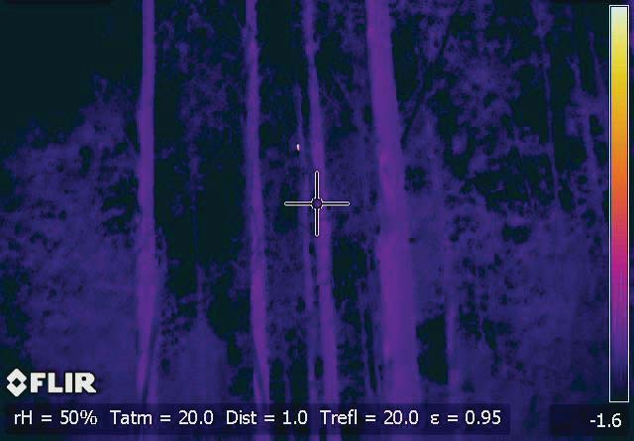
Figure 1. Leadbeater’s Possum (yellow spot above the crosshair) detected using a thermal imaging camera. Once pin pointed using the camera’s laser pointer, the animal’s identity was confirmed using a white light and binoculars.

Results and key findings
Records of Leadbeater’s Possum were obtained from 29 of the 180 sites (16.1%) sampled during the broad-scale survey (Figures 2 & 3). The majority of records were from state forest (22 of the 122 sites sampled in state forest – 18.0%), with seven records from national parks (12.1% of the 58 sites sampled). No Leadbeater’s Possums were detected in any area burnt during the 2009 fires, irrespective of the fire intensity, including sites where the understorey was burnt but the canopy remained intact. These results are consistent with the findings of the post-fire monitoring by ANU that the 2009 fires had a severe impact on Leadbeater’s Possum (D. Lindenmayer pers. comm.).

Leadbeater’s Possums were recorded in areas dominated by ash eucalypts and Snow Gum, with records from 17.4% of the 144 unburnt ash sites, and half of the unburnt Snow Gum sites. As only eight unburnt Snow Gum sites were sampled, further survey work in Snow Gum would be required before conclusions could be made on how widespread the species was through Snow Gum habitats. Within ash forests, Leadbeater’s Possums were detected in sites varied in age and disturbance history and included old growth stands, multi-aged stands, fire regrowth from wildfires in 1939 and 1983, and logging regrowth 10 – 45 years post-harvest. Sites were generally structurally complex with well-developed tall shrub and tree layers including one or more species of wattle (Acacia dealbata, A.frigesens, A. obliquinervia).

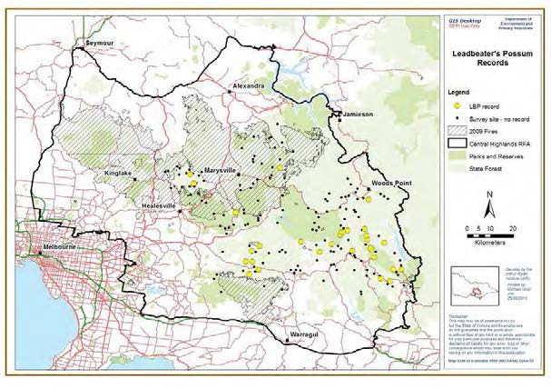
Figure 2. Leadbeater’s Possum records (yellow circles) obtained during call playback and thermal imaging camera surveys in the Central Highlands, April – August 2012. The black circles indicate sites where the species was not recorded during the surveys. The extent of the 2009 fire is represented by the cross-hatching.

Occupancy modelling
The probability of detecting Leadbeater’s Possum on survey sites where it was present, using call playback alone and with thermal imaging cameras, was estimated as part of the occupancy modelling process. Detectability was found to be significantly higher when thermal imaging

cameras were used in conjunction with call playback. The probability of detecting Leadbeater’s Possum on occupied survey sites during a single survey using call playback alone (under still conditions) was 7% (95% confidence interval 1 – 37%). In contrast, the probability of detection when thermal imaging cameras were used in conjunction with call playback was 56% (95% confidence interval 27 – 82%). However, detectability was strongly influenced by wind and dropped substantially as wind strength increased. For example, when wind strength during surveys was rated as moderate (i.e., moves branches), detectability using thermal imaging cameras dropped to 16% (95% confidence interval 4 – 49%). Most sites were surveyed twice during this study which increased the overall probability of detection, using thermal imaging cameras together with call playback, to 80% (95% confidence interval 46 – 97%) when there was no wind. These results indicate that although it was possible that some Leadbeater’s Possums may have been present at survey sites but not detected during surveys, provided there was little wind, the probability of detection after two surveys was relatively high and that therefore, the survey method is reliable.

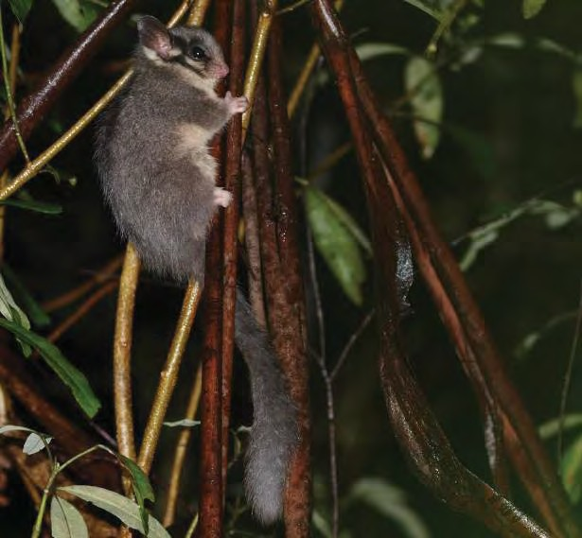
In any case, the modelling process was designed to account for the possibility of non-detection at occupied sites, by use of statistical techniques that jointly model the processes of detection and occupancy, and do not assume that detection at occupied sites is guaranteed (Mackenzie et al. 2002).

Figure 3. A Leadbeater’s Possum photographed during the surveys (Photo: Tamara Leitch and Claire McCall).

The occupancy model developed from the survey data (Figure 4) predicts that current strongholds for Leadbeater’s Possum include unburnt habitat mainly in the south of the Central Highlands including the Baw Baw Plateau and its southern slopes, the Toorongo Plateau south of the Upper Yarra Catchment and state forest in the vicinity of Powelltown, parts of Toolangi State Forest, and southern parts of the Upper Yarra National Park. Sites most likely to be occupied by Leadbeater’s Possum were generally characterised by lush, unburnt vegetation in gullies, located in areas that had relatively low summer temperatures and high summer rainfall.

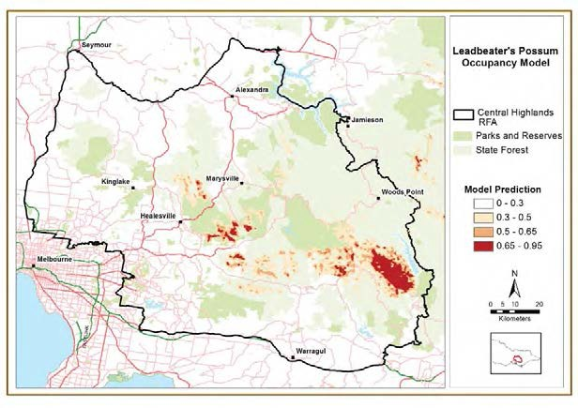
Figure 4. Areas most likely to be currently occupied by Leadbeater’s Possum, as predicted using occupancy modelling.

    - Leadbeater’s Possum fire refuge project
While post-fire monitoring indicated that Leadbeater’s Possum no longer occurred on sites that were burnt in 2009, it was not known if individuals were able to survive the fire and continue to persist within unburnt habitat island ‘refuges’. If Leadbeater’s Possum persisted in these refuges, and continue to survive there, this may greatly facilitate recolonisation of burnt areas once the surrounding habitat becomes suitable. If no populations have survived in unburnt refuges, recolonisation will have to occur from outside the overall fire area, which will take much longer than if internal recolonisation from small, unburnt refugia occurs. Such localised persistence may prove critical to the species’ persistence in, and recolonisation of, the burnt area in future years.

The aim of this component of the project was to determine the extent to which Leadbeater’s Possum may have persisted in unburnt refugia after the 2009 wildfires. The following methods were used to determine if any populations persisted in small patches of unburnt habitat, within the larger burnt area.

- Examination of high resolution, colour infrared, aerial photographs of the area burnt by the Kilmore East-Murrindindi Complex fire, taken a month after the fires, to identify unburnt areas that may act as refuges.

- The State Forest Resource and Inventory (SFRI) database was interrogated to help prioritise areas for ground-truthing by assessing if the areas contained potentially suitable forest type and structure. SFRI data is mostly confined to state forest so was not available for the majority of refuges within parks and reserves.

- The majority of these unburnt refuges were then visited and habitat measurements taken to allow a finer scale assessment of the habitat suitability for Leadbeater’s Possums (e.g., density of hollow-bearing trees, basal area of wattle).

- Surveys were then undertaken in the unburnt refuges, using the technique outlined above for the broad scale survey, to determine if Leadbeater’s Possums were present.

Further data analysis will examine factors which predict persistence of Leadbeater’s Possum in refugia (e.g., landscape, refuge size, proportion of unburnt habitat nearby).

Results and key findings
Forty-seven potential fire refuges were identified from the high resolution aerial photographs (e.g., Figure 5). Examination of the SFRI data, together with ground-truthing, reduced this number to 37 that had intact understory as well as intact canopy cover (Figure 6). Leadbeater’s Possum was detected at six of these sites (16%).

The six refuges in which Leadbeater’s Possum were recorded were all located either in, or close to gullies. The smallest refuge in which the species was recorded was ~ 10 ha. Within these occupied refuges, individuals were detected some distance from the fire edge (i.e. 2.6 km to 9.8 km from the fire edge). There was one record, however, of a Leadbeater’s Possum at one of the broad scale survey sites in an area of unburnt habitat that was within 100 m of the edge of a low severity burn from the 2009 fires. Occupied refuge sites were all structurally complex, with several layers of well-connected vegetation.

The results of this component of the project indicate that Leadbeater’s Possum persists within some unburnt patches of vegetation within a large fire-affected area, 3½ years post-fire. Whether small populations of Leadbeater’s Possum were present in these patches at the time of the fire and have subsequently persisted, or whether they moved into these areas post-fire is unknown. It is possible that some individuals were able to move through lightly burnt areas in which the canopy remained intact but the understorey was burnt, to colonise these sites containing intact suitable habitat, post-fire. The number of sites surveyed within each refuge was not scaled to the size of the refuge so it is also possible that animals may have gone undetected in some of the larger refuges. In addition, several refuges were not surveyed due to access difficulties, so it remains possible that Leadbeater’s Possums may persist in some of these unsurveyed refuges.

The lack of detection of Leadbeater’s Possum in areas that were burnt in 2009 at both ANU’s long-term monitoring sites and at the broad-scale sites surveyed during this project, indicates that the fire has had a major negative impact on the conservation status of this species. As there are likely to be only small numbers of individuals in these occupied unburnt refuges, there is doubt about their capacity to persist, and this requires further investigation. If however, these small
populations do persist in these refuges until the surrounding regenerating habitat becomes suitable,
then recolonisation of regenerating habitat could occur from within the fire-affected area as well as from outside. This is likely to be an important factor in the persistence of Leadbeater’s Possum throughout its range within the Central Highlands. The extent of any such recolonisation, however, may be limited by the small number of refuges, and the risk of extinction of these small, isolated populations during the period between the fire and the surrounding habitat again becoming suitably for occupation.

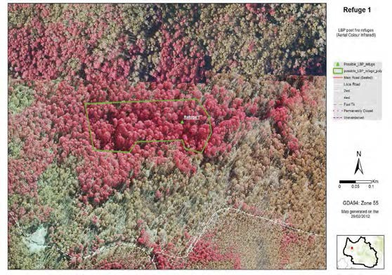
Figure 5. Unburnt refuge area (red vegetation) revealed by aerial infrared imagery.

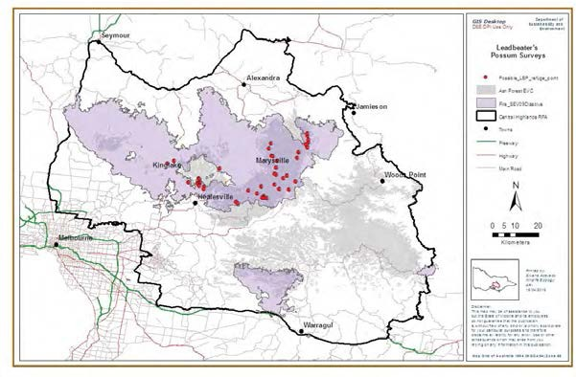
Figure 6. The area burnt during the 2009 wildfires, showing the area of montane ash or Snow Gum habitat (grey shading) that was burnt, and the unburnt refuges (red dots) sampled for Leadbeater’s Possum during this study.

    - Leadbeater’s Possum Population Viability Analysis

Assessing the adequacy of the Leadbeater’s Possum reserve system for long-term conservation of the species

The Leadbeater’s Possum Action Statement (DSE 1995) recommended the establishment of a Leadbeater’s Possum reserve system as a key strategy for the long-term conservation of the species, in addition to prescriptions in timber production areas and the adoption of alternative silvicultural systems. The permanent reserve system was established in the Central Highlands in 2008 to protect priority areas of Leadbeater’s Possum habitat. When this reserve was established it comprised 30,500 ha of high-quality Leadbeater’s Possum habitat, distributed throughout the species’ range from Toolangi in the north-west to Erica in the south-east (Figure 7). A total of 127 patches, greater than 50 ha in size, and containing predominantly old growth ash forest were selected (Smith and Morey 2001). Areas of old growth were primarily selected as these were likely to provide suitable habitat into the future, compared to areas of 1939 regrowth where the dead hollow-bearing trees were collapsing. The patches were spread across the species’ range to reduce the risk of large areas being rendered unsuitable due to wildfire. Areas to be included in the reserve system were assessed tenure blind. The majority of the reserves (85%) were located in areas that were formal parks and reserves or existing Special Protection Zones within state forest (58% in parks and reserves and 27% in Special Protection Zones). Less than 3,000 ha fell within areas available for timber harvesting, reducing to 2,500 ha when unproductive forest was removed. In 2008, these areas were converted to Special Protection Zones which excludes timber harvesting.

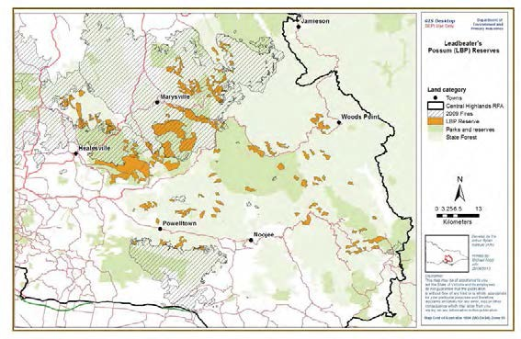
Figure 7. The Leadbeater’s Possum reserve system and the area burnt during the 2009 wildfires.

A Population Viability Analysis (PVA) was undertaken to evaluate if this reserve system was sufficient to support the long-term conservation of the species, or if additional strategies were required. The risk of extinction under different management and disturbance scenarios were investigated. Survival and fecundity rates used in the model were taken from previously developed population models (Lindenmayer et al. 1993; Lindenmayer and Lacy 1995; Lindenmayer and Possingham 1995a, b). Scenarios developed to examine the impact of past wildfires were based

upon fire models by Lindenmayer and Possingham (1995a, b). These models showed major population fluctuations in response to these fires. Of the fires examined (i.e., 1939, 1983, 1990, 2007, 2009), the 1939 and 2009 fires were the most widespread and burnt the greatest area. In 1939, the majority of the Central Highlands was severely affected by fire (The Commonwealth of Australia and Department of Natural Resources and Environment 1997), while in 2009, 36% of ash forests in the Central Highlands was burnt, including 45% of the Leadbeater’s Possum reserve system (S. Smith, unpublished data using all fire severities).

The PVA model predicts changes in the size of the reserve population over time. This is based on the number of adult females, as this species forms colonies where a single adult female breeds. Adult females are therefore critical and are key to the persistence of populations. There is no information on population numbers in the Central Highlands prior to 1939, and so a variety of initial number of adult females were used, with the average being the adult carrying capacity as prescribed by the fire models of Lindenmayer and Possingham (1995a, b). The model was then run 100 times to remove any influence that the initial number of adult females may have on the subsequent population dynamics. As fire has a significant impact on Leadbeater’s Possums and their habitat, the PVA predicts that the population crashed after the extensive 1939 fires, but rebounded as the habitat recovered (Figure 8a). As there were extensive areas of old growth forest prior to the 1939 fires, the large living trees that survived the fire and the large fire-killed dead trees were of sufficient size to provide suitable hollows. Leadbeater’s Possum typically occupy large cavities in which they build large, spherical nests (up to 30 cm in diameter) from strips of bark (Smith and Lindenmayer 1988). Cavities with large internal dimensions typically only form in large diameter trees (Smith and Lindenmayer 1988).

The combination of the availability of tree hollows and the wattle regrowth after the 1939 fire provided ideal habitat in the form of nesting sites and foraging habitat with connectivity facilitating movement through the vegetation. During this period, the model predicts a peak in population numbers during the late 20th century (Figure 8a). The population then begins to decline as the fire-killed 1939 hollow-bearing trees start collapsing and the density of wattles in the understorey declines, reducing the extent and quality of the habitat.

The model reveals a severe decline in population numbers due to the 2009 fires. As no Leadbeater’s Possums have been recorded on burnt sites, it is assumed there was a high level of mortality during the fire, or immediately afterwards if any animals survived, due to the lack of suitable habitat (see photograph on front cover).

The model predicts that the population in the Leadbeater’s Possum reserve will steadily decline in the years after 2009, even in areas not burnt during this fire, as dead nest trees (relics of previous wildfires) continue to collapse (Figure 8a). In contrast to the 1939 fire, it is predicted there will be limited rebound in population numbers after the 2009 fires in response to regenerating habitat. In areas that were 1939 regrowth when burnt in 2009, the majority of the dead stags were lost, and the live trees that were killed are considered unlikely to be large enough to provide suitable hollows. Even if some do provide hollows, it is predicted that these dead trees will remain standing for only a short period of time (Lindenmayer 2009; Lindenmayer et al. 2012).

Even in the absence of future fires or further loss of hollow-bearing trees (Figure 8a), the Leadbeater’s Possum population in the reserve system is predicted to continue to decline until later this century when the areas of 1939 regrowth forest become sufficiently mature to provide adequate tree hollows. Assuming the species persists through this decline, and in the absence of additional large-scale disturbance events such as more large fires, the population in the reserve is predicted to increase and stabilise by the end of next century (Figure 8a).

a)
10000

Average population size
Number of female adults
6000
8000
+1 Standard deviation
-1 Standard deviation Maximum
4000
Minimum
2000

1939 2009 2059 2109 2209
0
Time

b)
1000

Average population size
Number of female adults
6000
8000
+1 Standard deviation
-1 Standard deviation Maximum
4000
Minimum
2000

1939 2009 2059 2109 2209
0
Time

Figure 8. The number of adult females within the Leadbeater’s Possum reserve modelled over time, reflecting: a) the impact of past fires on the population with no increased rate of habitat decline or future fires; and b) the impact of past fires plus a future 50% habitat decline of hollow-bearing trees. The average number of adult females is shown ± 1 standard deviation as well as the maximum and minimum numbers.

However, Figure 8a represents a best-case scenario with no future fires and no higher rate of tree fall above the background level resulting from past fires. In reality neither of these scenarios are likely. Wildfires are an integral part of the Australian landscape, and it is highly likely that wildfires will affect Leadbeater’s Possum habitat sometime in the future. Since 1900 there has been a wildfire within the Central Highlands on average every 10 years, and this frequency is likely to continue. It is unknown when the next major fire may occur or the extent of its impact, but this could happen at any time. For example, had the 2013 Aberfeldy fire started to the west of the Thompson Dam instead of to the east, it could have severely affected one of the remaining strongholds for the species, in the Baw Baw region (see Figure 4). Under climate change scenarios, which predict increased rates of extreme climatic events, the frequency and intensity of wildfires are likely to increase (Mackey et al. 2002).

Hollow-bearing trees are currently being lost from the landscape at a rapid rate. Lindenmayer et al. (2012) reported that 79% of large, old, live hollow-bearing trees and 57-100% of large, dead trees were destroyed on Leadbeater’s Possum long-term monitoring sites that were burnt in 2009. High rates of collapse of dead hollow-bearing trees and high rates of live tree death were also recorded on unburned sites between 1997 and 2011, which were approximately four times higher than during the previous decades. They found that 14% of living, large trees with hollows on unburnt sites died between 1997 and 2011 (Lindenmayer et al. 2012). This is a large proportion in a short time period, which was unexpected as these trees should have remained alive for another 150-200 years. There was also a lack of recruitment of new hollow-bearing trees, with no new hollow- bearing trees recorded on any of the monitoring sites. Ongoing loss of hollow-bearing trees (both alive and dead), and younger trees not yet forming hollows, is expected to lead to a severe shortage of large hollow-bearing trees by the middle of this century that will continue for a number of decades (Lindenmayer et al. 2012). Mountain Ash typically do not start forming hollows until they are 120 years old, with the large cavities preferred by Leadbeater’s Possum typically taking 190 - 220 years to form (Smith and Lindenmayer 1988).

It is unknown whether the observed decline in availability of hollow-bearing trees will continue at the current rate, nor when the decline will cease. To account for this uncertainty, the sensitivity of the reserve population to an increased decline in the abundance of hollow-bearing trees was investigated by examining population viability under scenarios with three levels of hollow-bearing tree loss – 12.5%, 25% and 50%, modelled up until the 1939 regrowth is expected to commence forming hollows (i.e., at 120 years of age, in 2059). Lindenmayer et al. (2012) predict that by 2039, most of the hollow-bearing trees on their long term monitoring sites, particularly those burnt in 2009, will have collapsed. Even on unburnt sites they predict a paucity of standing large trees with cavities by 2039, and that these patterns would be further magnified by 2067. The modelled hollow-bearing tree loss reflects these patterns, and represents a reduction in the carrying capacity of the habitat due to a lack of suitable nest sites. Figure 8b includes a pattern of future decline under a scenario of a 50% reduction in hollow-bearing trees in addition to the impact of the historical fire regime. This reveals a further decline in the number of adult female Leadbeater’s Possums over the next approximately 80 years, with the number of possums in the reserve system falling to critically low levels.

Under the scenario of another large wildfire in the Central Highlands the population is predicted to decline even further. Figure 9 shows an example of the resulting predicted number of adult females if in addition to the 50% habitat decline modelled above, there was an extensive wildfire burning 50% of the Leadbeater’s Possum reserve system in 2020 (i.e., representing a fire roughly equivalent to 2009).

Average population size
Number of female adults
6000
8000
10000
+1 Standard deviation
-1 Standard deviation Maximum
4000
Minimum
2000

1939 2009 2059 2109 2209
0
Time

Figure 9. The number of adult females within the Leadbeater’s Possum reserve modelled over time reflecting the impact of past fires, a future 50% decline in hollow-bearing trees and an extensive wildfire burning 50% of the reserve in 2020. The average number of adult females is shown ± 1 standard deviation as well as the maximum and minimum numbers.

To further examine the risk of extinction of Leadbeater’s Possum in the reserve system, models assessed the probability of the number of adult females falling below 500 individuals within a 200 year time frame. Once population sizes decline below these levels, they are more susceptible to loss of genetic variation, population changes due to unfavourable environmental conditions and catastrophic events such as wildfires (Lacy 2000). A 200 year time frame for examining this risk was selected for two reasons: firstly, this reflects the time for ash trees to develop large hollows suitable for this species (Smith and Lindenmayer 1988); and secondly because 200 years is equivalent to 40 generations of Leadbeater’s Possums, which is a key time frame for assessing threatened species (Schaffer 1981, Reed et al. 2003).

Risk analysis was undertaken by estimating the minimum number of adult females under a range of scenarios and graphing probabilities of minimum numbers as a risk curve. After each step in the model, the minimum number of adult females is recorded in order to produce a frequency distribution known as a quasi-extinction curve (Burgman et al. 1993). This represents the likelihood, or risk, that the modelled population will fall to a given population size during the time period (Burgman et al. 1993; Todd et al. 2005), below which the long-term persistence of a species cannot be ensured. Quasi-extinction risk curves summarize the predicted extreme behaviour of threatened populations and therefore are a useful summary of extinction risk (Burgman et al. 1993; Todd et al. 2001, 2004), where the closer the distribution is to zero the greater the risk that a population will go extinct.

These risk curves can be readily compared in terms of increasing or decreasing risk by a shift to the left or right respectively (Todd et al. 2004, 2005). Calculating the expected value of the minimum number of adult females provides a metric for comparing scenarios. To illustrate how to interpret these risk curves, the basic risk curve showing the impact of historical fires with no additional habitat decline or future fires is shown in Figure 10. There is a 73% chance (shown as

0.73 probability) of the population falling below 500 adult females within a 200 year timeframe (point A on the graph). At the 5% probability level, the predicted population size is well below the required 500 adult females (point B). To have less than a 5% chance of the population not falling below 500 adult females, the curve would need to pass through (or be to the right of) point C on the graph.
1

A
Probability
0.6
0.8

B C
0.05
0.2
0.4

0 100 200 300 400 500 600 700
Minimum number of female adults

Figure 10. The risk curve for the minimum number of adult females over the next 200 years within the Leadbeater’s Possum reserve, reflecting the impact of past fires on the population, with no additional habitat decline or future fires. Point A indicates the probability of the minimum number of adult females being 500 individuals. Point B indicates the minimum number of adult females at 5% probability. Point C indicates where the line should be if there was to be less than a 5% chance of falling below 500 adult females.

When future habitat decline is incorporated, at a 12.5%, 25% and 50% decline in hollow-bearing trees, the risk curves shift to the left showing an increased risk of extinction and lower minimum number of adult females (Figure 11). For example, at the 25% habitat decline level, there is a 99% probability of the population falling below 500 adult females in the next 200 years. Under the 50% habitat decline model the population never reaches 500 adult females, with a 100% probability that the minimum population will not be more than 377 adult females.

Incorporating future fires, for example an extensive fire that burnt 25% or 50% of the reserve in 2020, shifts the risk curve further to the left, and hence closer to extinction. This further reduces the possibility of less than a 5% chance of falling below 500 adult females, with approximately 100 adult females expected at this 5% level (Figure 11).

Overall, the results of the scenarios modelled indicate that, even without further disturbances such as future wildfires and an accelerated loss of hollow-bearing trees, the Leadbeater’s Possum reserve system does not provide the requisite minimum population requirements. The population is highly sensitive to an accelerated loss of hollow-bearing trees and future wildfires. The analysis predicts that the population of Leadbeater’s Possum within the reserve system has a high likelihood of being at a very low population size which imposes on the species a greater risk of extinction, and that the existing reserve is insufficient to ensure the long-term persistence of the species.

1

Historical fire regime (HF) HF + 12.5% Habitat Decline HF + 25% Habitat Decline HF + 50% Habitat Decline
Probability
0.6
0.2
0.4
0.8
HF + 50% HD + 25% Fire in 2020
HF + 50% HD + 50% Fire in 2020
0.05

0 100 200 300 400 500 600 700
Minimum number of female adults

Figure 11. The risk curve for the minimum number of adult females over the next 200 years within the Leadbeater’s Possum reserve, reflecting the impact of past fires on the population (i.e., historical fire regime), plus an additional 12.5%, 25% and 50% habitat decline, plus a fire in 2020 burning 25% and 50% of the reserve in addition to a 50% habitat decline.

Modelling across the whole of the Central Highlands Leadbeater’s Possum habitat

As the PVA modelling shows that the Leadbeater’s Possum reserve alone is not sufficient to ensure the long-term persistence of the species, additional areas of parks and reserves were considered. While a significant proportion of the Leadbeater’s Possum reserve (58%) is contained within formal parks and reserves, there are other areas of montane ash forest and Snow Gum woodlands within the formal parks and reserves that may provide suitable habitat (Figure 12).

There are 43,156 ha of montane ash forest or Snow Gum woodland in formal parks and reserves, outside of the Leadbeater’s Possum reserve, of which 26,157 ha was not burnt during the 2009 fires and hence is currently potential habitat for Leadbeater’s Possum (Table 3). This results in a total of 43,501 ha of unburnt montane ash forest or Snow Gum woodland in conservation reserves (i.e., 17,344 ha in Leadbeater's Possum reserve plus 26,157 ha from elsewhere in parks). When the reserve system was established the highest quality habitat was selected, and hence the areas outside of the Leadbeater’s Possum reserve are currently likely to be less optimal. Therefore, it is probable that not all of this habitat is currently suitable and occupied by the species. The occupancy model (Figure 4) can be used to estimate the proportion of the combined parks and reserve and Leadbeater’s Possum reserve system that is likely to be currently occupied (Table 4). Using a model threshold of 0.5 (i.e., including any areas that have a greater than 50% probability of currently having Leadbeater’s Possums present) there are 15,243 ha within conservation reserves and 20,521 ha in state forest. If a lower threshold of 0.3 is used, the areas increase (Table 4). These figures (i.e., either the total area of unburnt habitat, or the area considered to be currently occupied) that are reserved, can then be used to compare with the area required to reduce the risk of extinction of the species.

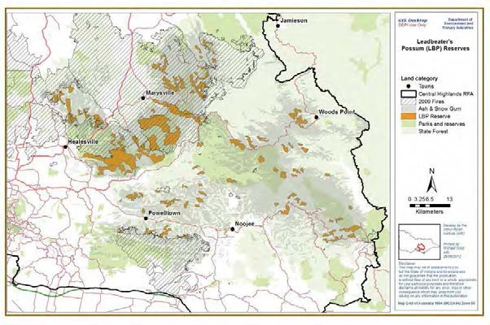
Figure 12. The Leadbeater’s Possum reserve system and other areas of montane ash forest or Snow Gum woodland within the formal parks and reserves system (shown by the overlap of the grey shading on the parks and reserves).

Table 3. The area of the Leadbeater’s Possum reserve system unburnt during the 2009 wildfires, and the area of montane ash forest or Snow Gum woodland habitats in parks and reserves additional to areas in the Leadbeater’s Possum reserve.

Total area (ha)

Area burnt (ha)

Area unburnt (ha)

Leadbeater’s Possum reserve 30,500 13,156 17,344

Ash or Snow Gum in parks and reserves outside of Leadbeater’s Possum reserve

43,156 16,999 26,157

Total Leadbeater’s Possum reserve and ash or Snow Gum in parks

73,656 30,155 43,501

Table 4. The area of predicted currently occupied Leadbeater’s Possum habitat in conservation reserves (parks and reserves and the Leadbeater’s Possum reserve system) and in state forest at two predicted levels of occupancy.

Conservation reserves (ha)

State forest (ha)

Total (ha)

> 50% probability of occupancy 15,243 20,521 35,764

> 30% probability of occupancy 32,582 61,243 93,825

To assess how much habitat would be required to reduce the risk of extinction, the model explored the impact of different future fire and habitat loss scenarios on the area of habitat required. The level of risk adopted for the population to remain viable was to estimate the area required to ensure that there was less than a 5% chance of the population falling below 500 adult females in a 200 year time frame. To explore how alternative risk profiles influenced the required area, we calculated the required area using a more risk-averse approach of less than a 2.5% chance of falling below 500 adult females in a 200 year time frame, or a more risk-tolerant approach of accepting a 10% chance of falling below 500 adult females in 200 years. These figures enable decisions to be made based on levels of risk considered to be tolerable – i.e., if accepting a higher risk of extinction, then a smaller area is required. If a more conservative, risk-averse approach is taken then a larger area is required.

Under the scenario examining the impact of the historical fire regimes with no additional habitat decline or future fires, 54,425 ha of Leadbeater’s Possum habitat would be required to have less than a 5% chance of falling below 500 adult females in a 200 year time frame (Table 5). While not all of this area would be occupied by Leadbeater’s Possum at any one point in time, all of it has the potential to be available when the age and structure of the habitat was suitable. If a more risk- averse approach was taken (i.e., accepting a 2.5% chance) the area required is 74,637 ha, or under a more risk-tolerant approach (10%) the required area is 44,941 ha. When habitat decline is incorporated at 12.5%, 25% and 50% rates, the required area (using 5%) is 58,100, 66,640 and
93,959 ha respectively (Table 5).

When future fires are included in the model, for example a wildfire of differing size (25% and 50% of Leadbeater’s Possum habitat) occurring in 2020, the area required for less than a 5% chance of falling below 500 adult females in 200 years ranges from 67,473 to 171,345 ha (Table 6). The greater the habitat decline and extent of the wildfire, the larger the area required. Fire sizes up to 50% were modelled (representing a fire roughly equivalent to the 2009 fire). If the fire was larger (e.g., equivalent to the 1939 fire), the impact would be even greater. If the fire occurs in 2040 rather than 2020, it makes only a small amount difference to the area required (Table 6). This is because there will have been little improvement in the extent of hollow-bearing trees during this time as the 1939 regrowth would not yet have developed hollows. These modelled scenarios are based on a single fire over the subsequent three decades. If there was more than one fire within this timeframe the risks would be compounded.

Table 5. The area of Leadbeater’s Possum habitat required for less than a 5% chance of the population in the Central Highlands falling below 500 adult females in a 200 year time frame, under differing levels of habitat decline. Two additional risk thresholds are included: 2.5% (more risk averse) and 10% (more risk tolerant).

Probability of | Historical fire | Historical | Historical | Historical
population falling | regime (ha) | fire + 12.5% | fire + 25% | fire + 50%
below 500 adult |  | habitat | habitat | habitat
females |  | decline (ha) | decline (ha) | decline (ha)
2.5% | 74,637 | 75,521 | 83,313 | 113,459
5% | 54,425 | 58,130 | 66,640 | 93,959
10% | 44,941 | 48,752 | 57,097 | 83,605

Table 6. The impact of future fires on the area (in ha) of Leadbeater’s Possum habitat required for less than a 2.5%, 5% or 10% chance of the population in the Central Highlands falling below 500 adult females in a 200 year time frame, under differing levels of habitat decline. The columns show increasing levels of habitat decline (12.5%, 25% and 50%), while the rows show increasing areas of potential habitat burnt during future fires (12.5%, 25% and 50%). The final column shows the difference between if the future fire occurred in 2040 compared to in 2020.

 | Fire year 2020 | Fire year 2020 | Fire year 2020 | Fire year 2040
Probability of population falling below 500 females | Historical fire + 12.5% habitat  decline + 12.5% future fire | Historical fire + 25% habitat  decline + 12.5% future fire | Historical fire + 50% habitat  decline + 12.5% future fire | Historical fire + 50% habitat  decline + 12.5% future fire
2.5% | 79,758 | 86,690 | 120,462 | 119,771
5% | 67,473 | 74,640 | 104,595 | 101,404
10% | 57,793 | 68,440 | 93,161 | 88,649
 | Historical fire + 12.5% habitat  decline + 25%  future fire | Historical fire + 25% habitat  decline + 25%  future fire | Historical fire + 50% habitat  decline + 25%  future fire | Historical fire + 50% habitat  decline + 25%  future fire
2.5% | 87,577 | 100,305 | 159,785 | 156,071
5% | 79,422 | 87,045 | 119,487 | 116,828
10% | 67,367 | 73,240 | 105,746 | 102,557
 | Historical fire + 12.5% habitat  decline + 50% future fire | Historical fire + 25% habitat  decline + 50% future fire | Historical fire + 50% habitat  decline + 50% future fire | Historical fire + 50% habitat  decline + 50% future fire
2.5% | 120,551 | 146,026 | 177,280 | 177,280
5% | 108,166 | 122,855 | 171,345 | 163,463
10% | 89,349 | 111,690 | 156,725 | 148,994

The results of this analysis indicates that more than 67,000 ha of Leadbeater’s Possum habitat is required to have less than a 5% chance of the population falling below 500 adult females in a 200 year time frame, even under the lowest level of future habitat decline or future fires, with other scenarios requiring larger areas. Therefore, the amount of unburnt habitat reserved in either formal parks and reserves or the Leadbeater’s Possum reserve (i.e., 43,500 ha), and estimates of occupied habitat in these reserves (using 50% or 30% threshold probabilities of occupancy: 15,000 and 33,000 ha respectively) are all considerably less than the area that would be required to support a population of Leadbeater’s Possum with a projected extinction risk less than a 2.5%, 5% or 10% chance of falling below 500 adult females in a 200 year time period. Although the above findings do not include the contribution made through habitat protection measures in state forests (e.g., prescriptions in timber harvesting areas or code exclusions) the current analysis indicates that additional management actions (e.g., protection of known colonies in state forest, protection of additional areas of suitable habitat, habitat enhancement, alternative silvicultural practices) need to be considered to reduce the extinction risk of Leadbeater’s Possum throughout its range.

Large forest owls and gliders
Surveys for large forest owls (Powerful Owl, Sooty Owl and Masked Owl) and gliding possums (Greater Glider and Yellow-bellied Glider) were undertaken throughout the study area during autumn 2012. The aim of these surveys was to improve knowledge of the distribution and habitat requirements of large forest owls and gliders in the forested landscapes of the Central Highlands.

Sampling design and methodology
The sampling design for the owls and gliders surveys was similar to that used for Leadbeater’s Possum, although a broader range of vegetation types were included, with all forest or woodland vegetation on public land considered. Previous surveys for large forest owls and gliders undertaken by ARI since 2009 were factored into the design. These surveys were in the Bunyip State Park, Kurth Kiln Regional Park and across the northern parts of the Central Highlands RFA within the Goulburn-Broken Catchment Management Area. These earlier surveys also sampled both state forest and parks and reserves with sites selected using a randomised sampling design. To avoid re-sampling areas covered by these surveys, 2 km buffers were placed around sites previously sampled, and the selection probabilities for areas within these buffers were reduced to 30% of their nominal values. This meant that some sites were still selected within these buffer areas, to conform with the randomised sampling design, but overall representation of locations outside the buffers was higher, producing a more even coverage of overall sampling effort across the study area.

Two hundred sites were randomly selected. Their allocation amongst the four survey strata is shown in Table 7. The number of sites allocated to areas burnt in 2009 was down-weighted by 50% to account for the likely lower occurrence of the target species in burnt areas. To increase knowledge on the contribution of parks and reserves to the conservation of large forest owls and gliders, an additional 10% of sites were allocated to parks and reserves compared to the proportional availability of this land management category. All sites were located adjacent to roads or tracks for ease of access and staff safety at night, and to improve detection of animals during spotlighting surveys. Sites were located at least 1 km from adjacent sites, to improve coverage of the survey area, and to avoid duplication of survey effort.

Table 7. The number of large forest owl and glider survey sites selected in four survey strata in the Central Highlands RFA.

 | State forest | Parks & reserves | Total
Unburnt 2009 | 100 | 65 | 165
Burnt 2009 | 18 | 17 | 35
Total | 118 | 82 | 200

Survey method
Surveys for large forest owls and gliders were undertaken using standard call playback and spotlighting techniques (Loyn et al. 2001). During call playback, recorded calls of each of the target species of owl were played sequentially through a megaphone, with the aim of attracting owls to the observer, or causing them to call in response. Owl calls may also elicit a response from Yellow-bellied Gliders which can be identified by their distinctive vocalisations. On completion of the call playback, visual searches for owls and gliders were conducted along a 100 m spotlight transect. To increase the likelihood of detection during surveys, each site was sampled at least twice. Repeat visits to survey sites also allowed the probability of detection to be estimated from the survey data, and estimates of probabilities of occupancy to be corrected for imperfect detection

probabilities. Large forest owl and glider surveys commenced in April and were completed in early July 2012. Four experienced owl surveyors were in the field almost continually during this time.

Results and key findings
Sooty Owls were detected at 49 sites (25%), Powerful Owls at 42 sites (21%), Masked Owls at 2 sites (1%), Yellow-bellied Gliders at 40 sites (20%) and Greater Gliders at 32 sites (16%) (Figures 13 – 16). All species, except the Masked Owl, were recorded from state forest as well as parks and reserves with proportionally more records of each species from state forests than from parks and reserves. This result highlights the importance of state forest to the conservation of these threatened species across the Central Highlands RFA. Three additional records of Powerful Owl and six records of Sooty Owl were obtained during surveys conducted at Leadbeater’s Possum survey sites. Greater Gliders and Yellow-bellied Gliders were also recorded at 39 and 28 Leadbeater’s Possum survey sites, respectively.

These new data greatly increased our knowledge and understanding of habitats currently occupied by these species following the 2009 fires. A striking result was the scarcity of the Greater Glider as it was, until recently, common across the Central Highlands (Lumsden et al. 1991, Henry 1995). A range of factors may be implicated in this decline, including the recent extended period of low rainfall (Lindenmayer et al. 2011). This decline has been exacerbated by the 2009 fires.

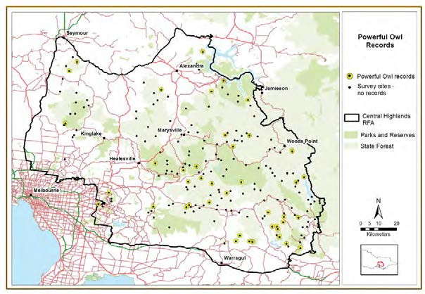
Figure 13. Powerful Owl records (yellow circles) obtained during call playback surveys in the Central Highlands, April – July 2012.

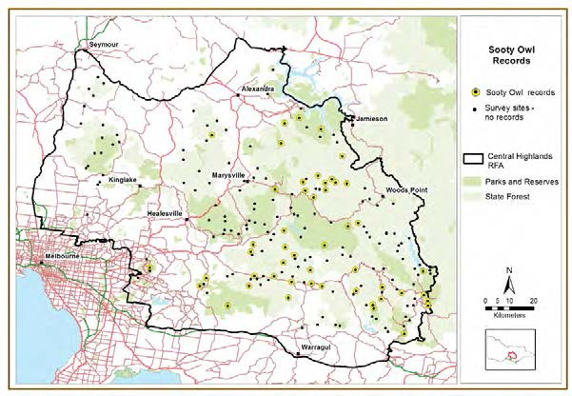
Figure 14. Sooty Owl records (yellow circles) obtained during call playback surveys in the Central Highlands, April – July 2012.
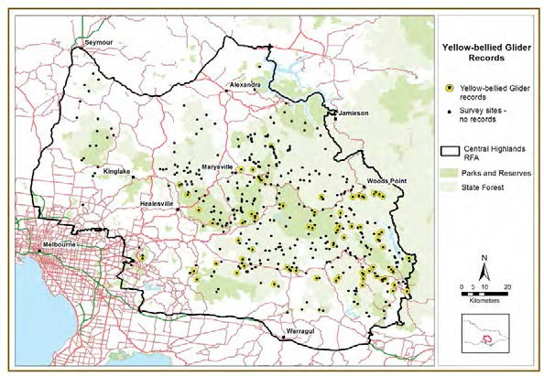

Figure 15. Yellow-bellied Glider records (yellow circles) obtained during call playback surveys in Central Highlands, April – July 2012. Survey sites and records from both the large forest owl and glider surveys and Leadbeater’s Possum surveys are displayed on this map.

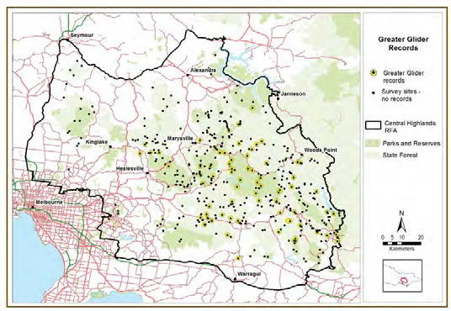
Figure 16. Greater Glider records (yellow circles) obtained during call playback surveys in Central Highlands, April – July 2012. Survey sites and records from both the large forest owl and glider surveys and Leadbeater’s Possum surveys are displayed on this map.

Occupancy modelling
Occupancy models were developed for Powerful Owl, Sooty Owl, Greater Glider and Yellow- bellied Glider from the survey data collected in the Central Highlands during the large forest owl and glider surveys. Masked Owls were recorded at too few sites to construct an occupancy model. This species is sparsely distributed in Victoria, with relatively little known of its ecology and habitat requirements. It is recorded more frequently in coastal and foothill forests (Loyn et al. 2004). The additional owl and glider records obtained during Leadbeater’s Possum surveys were not used in the development of occupancy models due to the different sampling methodologies, habitats sampled and survey techniques used during the two surveys.

The probability of detecting Powerful Owl, Sooty Owl and the two glider species during the surveys (i.e., the likelihood that each species would be detected given that it was present in the area during the survey) was estimated as part of the occupancy modelling process. These analyses also examined environmental factors that could influence detection. The probability of detecting Sooty Owl on an occupied site after a single survey was 39% (95% confidence interval 12 – 74%) under still (no wind) conditions. However, detectability was substantially affected by wind strength and dropped to 1% (95% confidence interval 0 – 31%) when the wind was rated as strong (i.e., moves branches). The probability of detecting Powerful Owl was affected by both wind and topography, with detectability during a single survey of a site located in a gully varying from 5% (95% confidence interval 0 – 27%) in light wind to 0.03% (95% confidence interval 0 – 3%) in strong wind (i.e., moves branches). In contrast, single survey detectability on ridge sites was substantially higher at 84% (95% confidence interval 5 – 96%) in light wind and 2.7% (95% confidence interval 1 – 52%) in strong wind. Most sites were surveyed twice during this study which increased the overall probability of detection substantially. For example, the probability of detecting Sooty Owls in gullies increased from 39% (95% confidence interval 12 – 74%) to 63% (95% confidence interval 23 – 93%) after a second survey. However, in strong wind the probability of detecting either species remained very low.

The probability of detecting Yellow-bellied Gliders at occupied sites during a single survey was higher on ridges at 84% (95% confidence interval 15 – 99%) than in gullies, where detectability was 44% (95% confidence interval 6 – 90%). Detectability was also affected by season and was higher when surveys commenced in April and lower when they were completed in July (i.e., 84% in April/May compared with 37% in July). Although detectablity of Greater Gliders was not affected by topography, in common with Yellow-bellied Gliders, it was affected by season. The single survey probability of detection for Greater Glider was 64% (95% confidence interval 41 – 82%) in April/May and 26% (95% confidence interval 10 – 53%) in July. For both species of glider, surveying sites twice increased the probability of detection substantially. For example, the probability of detecting Greater Gliders in July increased from 26% after a single survey to 44% (95% confidence interval 18 – 78%) after two surveys. Overall, the detectability results for the owl and glider species highlight the degree to which environmental conditions can affect survey results and the importance of surveying sites more than once to increase the accuracy and reliability of the survey data, and to allow for unbiased estimates of site occupancy where detection is not guaranteed.

The occupancy models inferred the effect of major environmental variables related to climate, topography and vegetation, on the distribution of each species. The species’ current distributions in the Central Highlands, predicted by the occupancy models, are shown in Figures 17 – 20 with a brief summary for each species outlined below.

Powerful Owl
The occupancy model predicts that, in the Central Highlands, Powerful Owls are most likely to occur on relatively dry sites in rugged terrain. The 2009 wildfire had a negative influence on occupancy with Powerful Owls less likely to occur on sites burnt in 2009. The areas predicted to most likely be occupied by Powerful Owl are in the south-east of the Central Highlands RFA between the townships of Erica and Neerim South and in the north-east in the vicinity of Eildon (Figure 17). Predicted probabilities of occupancy for Powerful Owls were low for wetter forest types and high-altitude areas.

Sooty Owl
In contrast to the Powerful Owl, Sooty Owl was predicted to be most likely to occur in wet gullies. The 2009 wildfire also had a negative influence on occupancy by this species. The occupancy model predicts that areas most likely to be occupied by Sooty Owls are in the south and east of the Central Highlands RFA (Figure 18).

Greater Glider
Variables with the greatest influence on site occupancy by the Greater Glider were ruggedness, vegetation lushness and terrain wetness, with the species most likely to occur in moist, rugged areas with lush vegetation. Although once widespread and common throughout the Central Highlands (Lumsden et al. 1991, Henry 1995), the occupancy model predicts that areas most likely to be occupied by Greater Gliders are now patchily distributed within an area roughly bounded by the townships of Healesville in the centre of the Central Highlands RFA, Jamieson in the north- east and Erica in the south-east (Figure 19).

Yellow-bellied Glider
The occupancy model predicts that Yellow-bellied Gliders are most likely to occur at sites in gullies with lush vegetation and high summer rainfall. However, high rainfall in winter and terrain wetness had a slightly negative influence on site occupancy, indicating that extremely wet sites are somewhat less likely to be occupied by this species. The areas most likely to be occupied by Yellow-bellied Gliders are in the centre and south-east of the Central Highlands RFA (Figure 20).

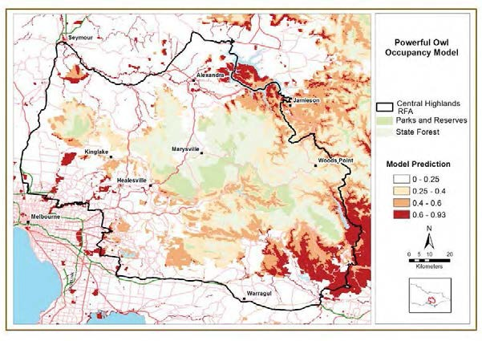
Figure 17. Areas most likely to be currently occupied by the Powerful Owl, as predicted using
occupancy modelling.

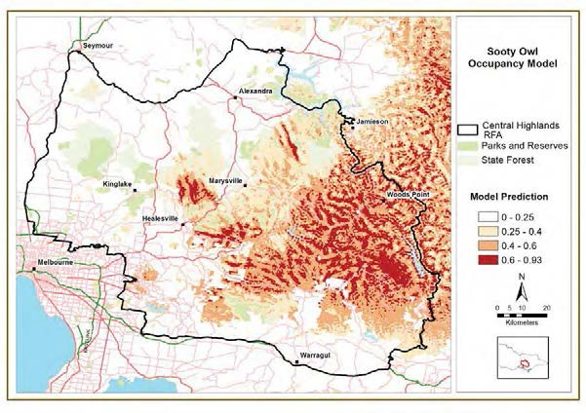

Figure 18. Areas most likely to be currently occupied by the Sooty Owl, as predicted using occupancy modelling.

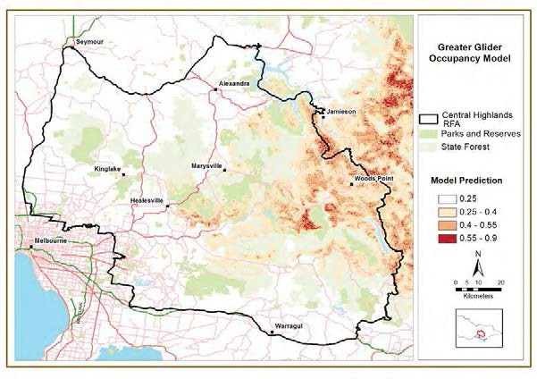
Figure 19. Areas most likely to be currently occupied by the Greater Glider, as predicted using
occupancy modelling.

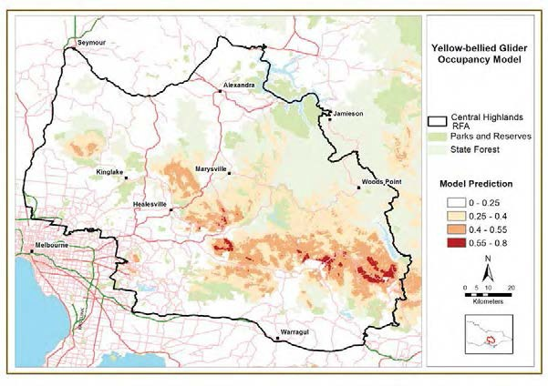
Figure 20. Areas most likely to be currently occupied by the Yellow-bellied Glider, as predicted using occupancy modelling.

Smoky Mouse

Sampling design and methodology
Surveys using automated cameras targeting Smoky Mouse were undertaken at 120 sites in the Central Highlands. Sites were selected within a broad range of EVCs known to constitute good habitat for Smoky Mouse (e.g., Montane Damp Forest, Herb-rich Foothill Forest, Shrubby Dry Forest) as well as vegetation types where there have been few previous records (e.g., Damp Forest, Heathy Dry Forest, Grassy Dry Forest). Large areas of Wet Forest were not sampled as this habitat type is rarely used (Menkhorst and Broome 2008).

Site selection ensured that sites were spread throughout the survey area, including areas burnt in the 2009 wildfires, and areas not burnt in 2009. Sites were randomly selected. The aim was to improve knowledge of the distribution and habitat preferences of the Smoky Mouse, and, as a result, were spread across both state forest (57% of sites) and parks and reserves (43% of sites) (Table 8).

Table 8. The number of Smoky Mouse survey sites selected in four strata in the Central Highlands RFA.

 | State forest | Parks & reserves | Total
Unburnt 2009 | 35 | 31 | 66
Burnt 2009 | 34 | 20 | 54
Total | 69 | 51 | 120

Survey method
At each survey site, two camera traps, each consisting of an automated camera set opposite a bait station, were set 100 m apart for approximately 14 nights. Two models of camera were used, PixController Digital Eye 7.2 (PixController Inc, Pennsylvania, USA) and TrailMAC D435 (Trail Sense Engineering, Delaware, USA). Both camera types had an internal white light flash which greatly facilitated identification of small mammals, particularly Smoky Mouse, which can be difficult to distinguish from other similar-sized small mammals unless images are in colour, and of high quality and resolution (Nelson et al. 2009).

Field surveys commenced in November 2011 and were completed in February 2012.

Results and key findings
Smoky Mice were detected at 21 of the 120 surveyed sites (18% of sites) (Figures 21 & 22). Thirteen of these sites were in state forest and eight were in national parks. Some of the new records of Smoky Mouse obtained during this survey were in areas where the species had not previously been recorded. These new data have significantly increased knowledge of the species’ distribution within the Central Highlands, which is one of the few strongholds for this species (Menkhorst and Broome 2008).

A range of other mammals were also recorded during the camera trap surveys including White- footed Dunnart Sminthopsis leucopus (FFG listed, detected at 10 sites) and Eastern Pygmy Possum Cercartetus nanus (classified as near threatened, detected at 27 sites). Newly obtained records of Smoky Mouse and White-footed Dunnart were incorporated into updated SDMs for the policy component of this project.

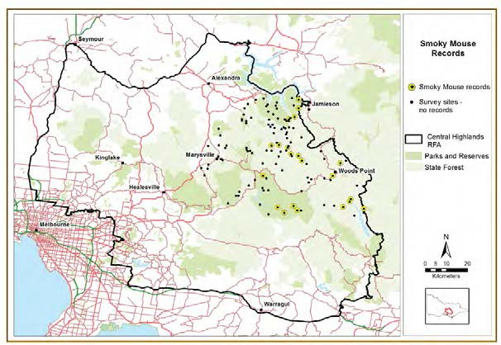

Figure 21. Smoky Mouse records (yellow circles) obtained during camera trap surveys in the Central Highlands, November 2011 – February 2012.

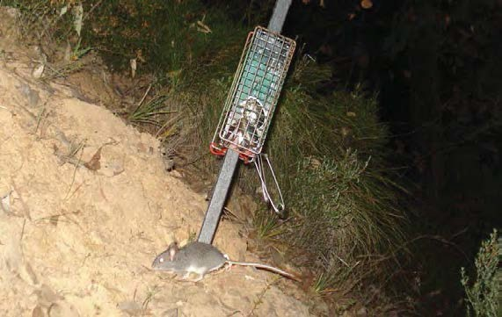
Figure 22. Smoky Mouse photographed at a bait station during camera trap surveys in the Central Highlands.

Occupancy modelling
Analysis of the probability of detecting Smoky Mouse using two cameras at each site found that after two weeks of sampling, detectability was high at 89% for PixController cameras (95% confidence interval 62 – 99%) and 99% for TrailMAC cameras (95% confidence interval 92 – 99%) – i.e., the probability that a Smoky Mouse was present on a survey site but not detected during a survey was very low. Probabilities of detection were somewhat influenced by season, with an increase in detectability for surveys conducted in January, compared to November. Juvenile Smoky Mice were regularly photographed in January and the increase in detectability observed at this time may have been due to the recruitment of juvenile animals into the population post-breeding in late spring and early summer (Menkhorst and Broome 2008) boosting the number of individuals present at sites, and hence the probability of detection at this time. Overall, these results confirm the effectiveness of the survey methodology and the reliability of the survey data.

The occupancy model developed from the survey data predicts that within the Central Highlands RFA, areas most likely to be occupied by Smoky Mouse are sparsely and patchily distribution in the east of the Central Highlands RFA (Figure 23). Within this area the species is most likely to occur on dry ridge-top habitats (Figure 24).

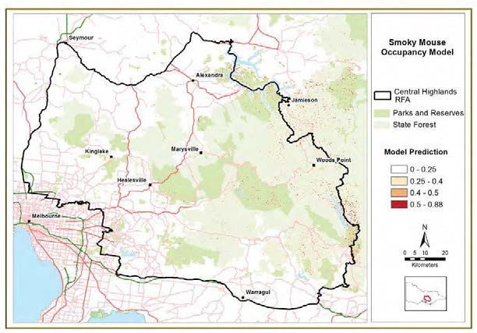
Figure 23. Areas most likely to be currently occupied by Smoky Mouse, as predicted using occupancy modelling.

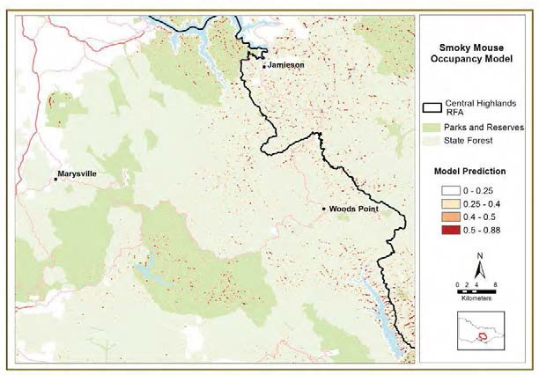

Figure 24. Close up of the area surveyed for Smoky Mouse within the Central Highlands RFA and the areas most likely to be currently occupied, as predicted by occupancy modelling.

New species of Galaxias
Field surveys were undertaken for two species of small, recently discovered native fish in the genus Galaxias (Raadik 2011). Both have been nominated for listing under the FFG Act, and have recently been assessed as being Critically Endangered. Prior to this current project, both of these species were known from only a single location in a single river each: Galaxias sp. 8 (Stoney) in the headwaters of a tributary of the Thompson River (Stoney Creek) and Galaxias sp. 9 (Rintoul) in the headwaters of a tributary of the LaTrobe River (Rintoul Creek). These locations are just outside of the Central Highlands RFA but are in the same river catchments as waterways inside the RFA area. It was therefore considered likely that the two taxa may be present within the Central Highlands RFA. This assumption was further supported by museum specimens indicating that Galaxias sp. 9 (Rintoul) was historically more widespread: a record of an unidentified galaxiid on top of Mount Baw Baw in 1974, and additional anecdotal evidence of the presence of a galaxiid on Mount Baw Baw in 2002 (Greg Hollis, Baw Baw Shire Council, pers. comm. 2002).

Survey design
One hundred and twenty potential sites were selected in the upper Thomson and La Trobe River catchments, spread throughout national park and state forest. These sites were refined by eliminating those with existing fish survey data, those downstream of sites known to be inhabited by trout and giving higher priority to areas above waterfalls or steep stream gradients which may be free of trout. Trout, which are highly predatory, are a key threatening process for upland, non- migratory galaxiids with the galaxiids typically being eliminated from streams as trout invade (McDowall 2006).

Field surveys commenced in February 2012 and were completed by mid-March 2012, with 121 sites sampled (Figure 25) over five field trips. During sampling, the selection of survey sites was further refined as not all sites could be visited due to lack of access, and some additional sites worthy of survey were located.

Results and key findings
No additional populations of these species were located. The only records achieved were from streams from which the two species had previously been recorded (Figure 25). These data, together with data from previous surveys, provide a high level of surety that these upland, non- migratory species are extremely rare and occupy only tiny areas. The entire distribution of Galaxias sp. 8 is confined to a short section of Stoney Creek and Galaxias sp. 9 to a short section of the east branch of Rintoul Creek. Both these sections of creek flow through state forest.

The results from this survey highlight how rare, and therefore significant, the few known Galaxias
populations are, and how significant any additional populations would be if discovered.

Trout can severely fragment galaxiid populations, which usually become confined to very short sections of the headwater reaches of tributary streams, usually upstream of an instream barrier which prevents further upstream colonisation by trout. Currently, the only area within the La Trobe and Thomson catchments of the Central Highlands RFA with potential for the discovery of additional upland galaxiid populations is the Baw Baw Plateau.

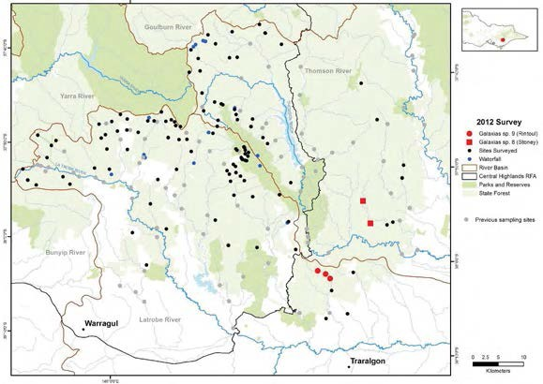
Full details of the results of these surveys is provided in Raadik and Nicol (2013).

Figure 25. Location of fish survey sites in 2012 in the Thomson River and La Trobe River catchments (black circles), including sites at which Galax ias sp. 8 and Galax ias sp. 9 were recorded. The grey circles indicate previous sampling locations.

Galax ias sp. 8 (Stoney)
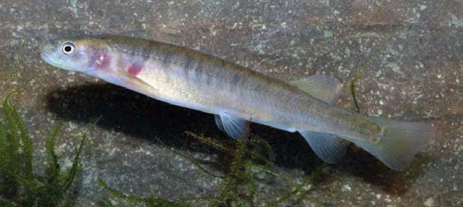
Galaxias sp. 8 (Stoney) (Figure 26) was re-collected from the site where it was originally discovered on Stoney Creek (Stoney No. 5 Track) and was also recorded for the first time at the ford on Stoney No. 4 Track, approximately 5 km further downstream. This second record significantly extends the known distribution of the species, though it is still only known from a single small (~2.0 m average width) and shallow (~0.3 m) stream. The species was not recorded from two additional sites in the same catchment, or from nearby catchments. The distribution of Galaxias sp. 8 (Stoney) will probably extend some distance downstream towards Stoney No. 3 Track, and also further upstream into the headwaters of the catchment above Stoney No. 5 Track. The entire, global distribution of this species is in this short section of Stoney Creek which flows through state forest (Figure 27).

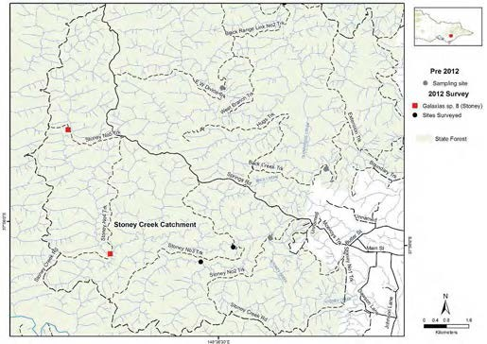
Figure 26. Galax ias sp. 8 (Stoney). Image of a 75 mm long gravid female.

Figure 27. Location of collection sites for Galax ias sp. 8 (Stoney) in the Stoney Creek system, Thomson River Catchment.

Galax ias sp. 9 (Rintoul)
Galaxias sp. 9 (Rintoul) (Figure 28) was re-collected from the site where it was originally discovered, on C12 Track, and from two additional sites, one 1.6 km further downstream (R10 Track) and one 1.8 km further upstream (R7 Track). This extends the known distribution of the species approximately 3.5 km, although it is still only known from a single small (1.5 m average width) and shallow (~ 0.2 m deep) stream. The species was not recorded from two additional sites in the same catchment, or from nearby catchments. The distribution of Galaxias sp. 9 (Rintoul) may extend further downstream from R10 Track, and also further upstream into the headwaters of the catchment above R7 Track, but further surveys would be required to confirm this.

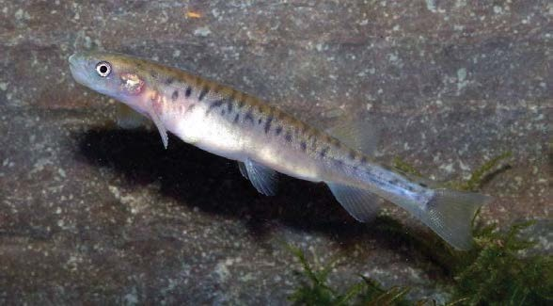
The entire, global distribution of this species is limited to this short section of Rintoul Creek, East Branch, which flows through state forest (Figure 29).

Figure 28. Galax ias sp. 9 (Rintoul). Image of a 65 mm long gravid female.

Records of other species
During the surveys for Galaxias sp. 8 and Galaxias sp. 9, data were also collected incidentally on the distribution of other non-migratory species that may be adversely affected by instream sedimentation.

River Blackfish Gadopsis marmoratus lay eggs on submerged timber and therefore can be susceptible to sedimentation. This species was recorded from just nine of the survey sites (7%) and only in the upper La Trobe River system. Abundances were low at all sites. This result was surprising as it was expected that they would have been widespread and relatively common.

Central Highlands Spiny Crayfish Euastacus woiwuru were found at 39 sites in both catchments and were therefore relatively widespread.

Burrowing crayfish (unknown species) were only captured from a few sites but their presence at additional sites was noted by active ‘chimneys’ of dirt around burrow openings in the riparian zone. Burrowing crayfish, as a whole, were quite widespread, recorded from 59 sites in both catchments, although the distribution of specific species is unknown.

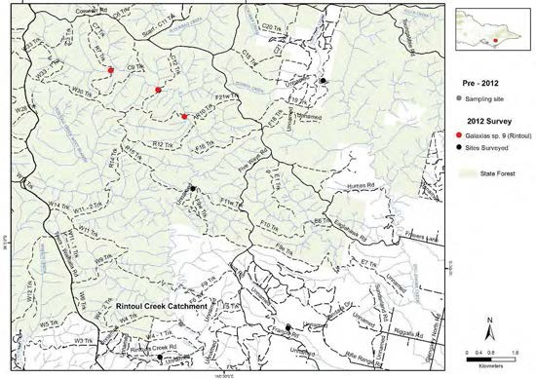
Figure 29. Location of collection sites for Galax ias sp. 9 (Rintoul) in the Rintoul Creek system, La Trobe River Catchment.

Management issues
Twenty-six sites (21%) were found to contain Brown Trout Salmo trutta or Rainbow Trout Oncorhynchus mykiss, the presence of which would render these sites unsuitable for persistence of galaxiids, due to unsustainable predation.

No fish species were detected at 37 sites (31%) but these sites contained crayfish (either spiny crayfish instream or burrowing crayfish along the banks). Neither fish nor crayfish were recorded from 16 sites (13%). Compared to forested catchments elsewhere in Victoria, this is a high proportion of locations lacking these faunal groups.

Many streams in the Thomson and La Trobe catchments have been subject to deposition of coarse sand which smothers the stream substrate and reduces stream depth. In many cases this deposition of sand is associated with previous logging (e.g. Ada River in the Ada River Sawmills Historic Area) or with unsealed forestry roads and tracks where runoff is directed into creeks, carrying sediment with it.

Waterways in the La Trobe River catchment were observed to have been particularly heavily impacted, with stream substrates smothered by sand and often also with silt. Riparian zones at many sites were also smothered, with banks of fine silt underlain by coarse sand. Waterways in the Thomson River catchment were less impacted, though instream and riparian sediment loads were obvious in nearby areas currently undergoing timber harvesting.

In particular, the majority of unsealed forestry tracks in the Rintoul and Stoney Creek catchments showed signs of recent erosion on slopes leading down to the streams, and some are also un-barred on these slopes. These tracks require upgrading so as to minimise erosion and sediment runoff to the streams and their tributaries, during periods of normal rainfall and during intense rainfall events.

Investigation of Long-footed Potoroo population size and associated habitat requirements in East Gippsland

Background
The Native Forestry Taskforce requested an investigation into issues associated with the uncapped reservation system outlined in the Long-footed Potoroo Potorous longipes Action Statement (DSE 2009), where protection measures are applied within state forest around the locations of all new detections.

The first objective in the Long-footed Potoroo Action Statement is ‘to protect populations or habitat from potentially incompatible use’. The targets specified in the Action Statement to achieve this objective are:

- Sufficient habitat identified and protected in both East Gippsland and the Great Dividing Range to provide for a substantial and viable population of Long-footed Potoroos.
- Timber harvesting and other activities managed to protect potoroo habitat at Long-footed Potoroo detection sites outside Core Protected Areas.

In East Gippsland, a network of protected areas containing Long-footed Potoroo ‘primary’ habitat (i.e., EVCs from which most records have come) has been established, comprising conservation reserves and Special Protection Zones (SPZs) in state forest (DSE 2009). Outside these areas, each new Long-footed Potoroo detection leads to the establishment of a Special Management Zone (SMZ) of approximately 150 ha, of which a third (i.e., approximately 50 ha), known as Long- footed Potoroo Retained Habitat, is excluded from timber harvesting.

There has been an increase in new detections of Long-footed Potoroos in recent years due to improved survey methods and greater sampling intensity, including surveys conducted by members of environmental organisations. This has led to a perception by some people that the Long-footed Potoroo is common and widespread in East Gippsland. However, the number of positive records may convey a misleading impression of the true population status of Long-footed Potoroos, as often only positive records have been reported and the number of sites where the species was not recorded is unknown. In addition, recent sampling, especially that undertaken by environment groups, has targeted perceived high-quality Long-footed Potoroo habitat, rather than sampling across the entire forested landscape of East Gippsland, in all tenures and across a range of potential habitats. Thus, the available data may be conveying a biased impression of the true distribution and status of the species in East Gippsland.

The objective of this study was to estimate the area required to sustain ‘a substantial and viable population of Long-footed Potoroos’ (as required by the Action Statement) and compare this area with the area of suitable Long-footed Potoroo habitat currently reserved (both in formal conservation reserves, and via the establishment of SPZs and SMZs in state forest) across East Gippsland. This comparison will enable an evidence-based review of the prescriptions in the Action Statement. The review of the Action Statement is not part of this project but this may be guided by the data and analysis presented here. This study focuses solely on the East Gippsland population and does not include the Great Dividing Range population of Long-footed Potoroos (Lumsden et al. 2012). The Great Dividing Range population is geographically disjunct from the East Gippsland population (DSE 2009). An important underlying assumption is that both populations need to be conserved independently of each other.

The aims of this study were to:

- Analyse existing demographic data to determine the population size required to sustain a ‘substantial and viable population of Long-footed Potoroos’ in East Gippsland by undertaking a Population Viability Analysis (PVA).
- Determine the area of Long-footed Potoroo habitat required to support the population size the PVA identifies as required for a stable population.
- Clarify the distribution of the species in East Gippsland by collecting additional survey data, and modelling the distribution.
- Determine the area of Long-footed Potoroo habitat that is currently reserved within the range of the species in East Gippsland.
- Compare the area that is required to support a viable population with the area of Long-footed Potoroo habitat currently reserved.

Determine the population size required to sustain a ‘substantial and viable population of Long-footed Potoroos’ in East Gippsland
A PVA was undertaken to estimate the number of individuals required for a viable, self-sustaining population. The level of risk adopted for the purposes of this study for the population to have the greatest chance to remain viable was to estimate the number of animals required to ensure that there is less than a 5% chance of the population falling below 500 individuals in 50 years: a time frame appropriate to the life history of the species and its habitat requirements. To explore alternative risk profiles, we also calculated the required population size for less than a 2.5% and a 10% chance of the population falling below 500 individuals in a 50 year time frame.

While some demographic data were available from previous studies (Seebeck 1992, Green and Mitchell 1997), key elements were unknown, especially survival rates. Mark-recapture data from a long-term trapping study (conducted over 26 years) at the 25 ha Bellbird trapping grid in East Gippsland were analysed to provide estimates of survival rates for used in the model. Although this is the only site where such long term trapping data is available, the site is considered to be representative of known Long-footed Potoroo habitats within the species’ geographic range in East Gippsland (S. Henry, pers. comm.). Based on analysis of the mark-recapture data, the long-term average survival rate for adults (i.e. >1 year old) was 0.66 (95% confidence interval 0.55 – 0.76) – i.e., there is a 66% probability that an individual will survive from one year to the next, throughout its life. The recruitment rate (which considers the number of offspring and the probability they will survive to one year of age) was calculated as 0.71.

Analysis of the mark-recapture data also provided an estimate of the population growth rate, used to determine if the population at the Bellbird grid was increasing, stable or decreasing. A growth rate greater than one indicates that the population is increasing in size, while a decreasing population has a growth rate less than one. The long-term average annual growth rate for the Bellbird grid was 0.974 (95% confidence interval 0.918 – 0.992) – i.e., the population size on the grid has marginally decreased over the 26 year period at a rate of approximately 2.5% per year. As the 95% confidence interval does not include one, we can be confident that this reflects a true decline over this 26 year time period.

To investigate temporal variation in population growth rates, the growth rate was calculated for the 1990s and 2000s separately. In the 1990s there was a higher level of predator baiting on the Bellbird trapping grid than was the case during the 2000s (T. Mitchell, pers. comm.). Climatic conditions were also wetter in the 1990s compared to the extended drought period during the 2000s. The estimated population growth rate for the 1991-2000 period was 1.034 (95% confidence

interval 0.901 – 1.167), i.e., the population was most likely to be increasing, however the confidence interval did include one so there is some uncertainty as to whether the population was truly declining or increasing. During the 2001-2011 period, the growth rate was 0.934 (95% confidence interval 0.484 – 0.995). As this 95% confidence intervals did not include one, there is a high degree of confidence that the population was declining during this period, although the extent of this decline is uncertain as the confidence interval was broad. Further analysis using rainfall data showed that the wetter conditions did positively influence the growth rate, however, at this stage the relative contribution of the climatic conditions, predator baiting or other processes cannot be determined. In addition to changes in predator control regimes and climatic conditions, there have been changes to the vegetation structure at the Bellbird trapping grid over the course of the mark recapture study at this site. The site was logged in 1972 and is now 40 year-old regrowth. Over the last decade, the understorey has thinned significantly as the canopy has developed, which has probably been exacerbated by the drought (S. Henry, pers. comm.). These changes in vegetation structure may also have contributed to the changes in population growth rate.

There is likely to be variability in survival and recruitment rates from year to year and in different parts of the species’ range. To account for this spatial and temporal variation in population growth rates, a coefficient of variation (CV) was applied to the mean estimates used in the simulations conducted for the PVA. A range of values for the coefficient of variation were calculated to investigate the influence on the required population size of differing levels of environmental variation (Table 9). A coefficient of variation of 15% was then selected to be used in further simulations based on an examination of the variability in the data and comparison with other similar species where comparable demographic data is available (e.g., Eastern Barred Bandicoot; Todd et al. 2001, 2002). The upper and lower limits of coefficients of variation presented in Table 9 (i.e., 5% and 25%) are highly implausible and are inconsistent with the observed demographic data – for example a 25% coefficient of variation in population growth rates, with a mean value less than one would have resulted in the species declining to extinction over the time period that it has been monitored for. The risk of extinction is less sensitive to changes in the coefficient of variation of the population growth rate than it is to changes in the mean growth rate. Changes in coefficient of variation are only influential when the growth rate is less than one – if the growth rate is more than one the population is more resilient to spatial and temporal variation in demographic processes.

One thousand simulated population trajectories were generated using each scenario of the PVA model to represent variation in the outcomes that would be expected, given the assumed extent of spatial and temporal variation in the population growth rate. The results of these simulations indicate that, under the assumption of a 15% coefficient of variation in population growth rates, an initial population size of 14,766 individuals would be required to ensure the population has less than a 5% chance of falling below 500 individuals over 50 years, assuming no catastrophic events (Table 9). When this figure was tested against the growth rate from the Bellbird grid data it showed a high level of congruence, supporting the assumptions of the model. To explore how alternative risk profiles influenced the required population size, we calculated the required population size using a more risk-averse approach of ensuring the population had less than a 2.5% chance of falling below 500 individuals in 50 years, or a more risk-tolerant approach of accepting a 10% chance of falling below 500 individuals in 50 years (Table 9). Under a 15% coefficient of variation in population growth rate, the required population size is 18,700 individuals under the risk-averse strategy, and 9,900 individuals under the risk-tolerant strategy (Table 9). These figures enable decisions to be made based on levels of risk considered to be tolerable – i.e., if accepting a higher risk of extinction, then a smaller initial population size can be tolerated. If a more conservative, risk-averse approach is taken then a larger initial population size is required.

Potential catastrophes were then added to the model. Catastrophic events are any events where individuals die at a greater rate than the assumed background variability in survival rates, such as large-scale fires, disease or extreme climatic conditions or any other factors that resulted in a large loss of individuals. Data from the Great Dividing Range population indicates that fire has a significant impact on Long-footed Potoroo populations, in the short term at least, with the species rarely detected in areas burnt during the 2006/7 or 2003 fires in the first few years after the fire (Lumsden et al. 2012). Using fire as the example in this analysis, the frequency of fires of different sizes was calculated from the recorded fire histories (DSE Corporate Spatial Data Library) within the known range of the Long-footed Potoroo in East Gippsland (Table 10; Figure 30). Using a representative fire size of 10,000 ha (which equates to approximately 5% of the known distribution of Long-footed Potoroos in East Gippsland), with the likelihood of this occurring one year in ten, the number of individuals in the fire zone likely to be affected (based on the average density of
0.28 individuals/ha – refer section 3.3) is 2,800 individuals.

Table 9. The influence on the required population size of different levels of environmental variability (not factoring in catastrophes) and different levels of risk, using population estimates derived from the long-term trapping data from the Bellbird trapping grid.

Coefficient of variation
Required population size for < 2.5% chance of falling below 500 individuals
Required population size for < 5% chance of falling below 500 individuals
Required population size for < 10% chance of falling below 500 individuals

5% 5,053 4,518 4,140

10% 8,099 6,851 5,970

15% 18,700 14,766 9,900

20% 49,988 33,900 24,498

25% 224,993 118,900 65,442

Table 10. Recorded fire size and frequency within the known Long-footed Potoroo distribution over the past 100 years.

Fire size | Number | Average size | Number per | Average
 |  | (ha) | year | frequency of
 |  |  |  | occurrence
Small (1 – 10,000 ha) | 486 | 635 | 4.86 | 5 per year
Medium (10,000 – 50,000 ha) | 6 | 20,579 | 0.06 | 1 in every 16 yrs
Large (50,000+ ha) | 0 | n/a

There are no records of wildfire at the Bellbird trapping grid (based on the DSE Corporate Spatial Data Library), with wildfire in 1959 burning areas nearby (Figure 31). The area was, however, burnt during a regeneration fire after logging in 1972. The demographic data used in the PVA that was collected over the last 26 years was collected in the absence of fire. The effect of fire therefore needs to be added to the model, but the available evidence for assessing the severity of impact of fires on the population dynamics of Long-footed Potoroos is limited, due to a lack of data concerning population-level responses to fire.

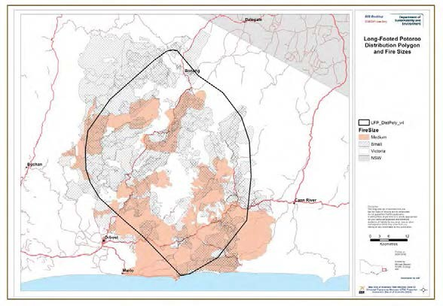
Figure 30. The extent of wildfires over the past 100 years within the distribution of the Long-
footed Potoroo. Small fires (shown as shaded) are classified as 1-10,000 ha in size, and medium (tan colouring) as 10,000 – 50,000 ha in size. There were no ‘large’ fires (> 50,000 ha) recorded. The
distributional polygon is based on the known range of the species in early 2012.
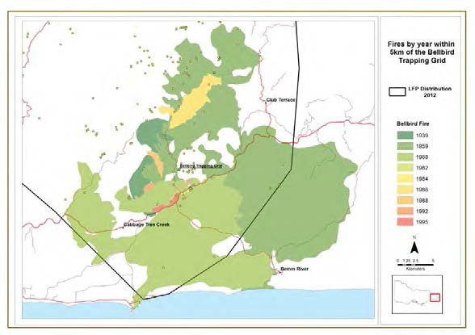
Figure 31. Fire history within 5 km of the Bellbird trapping grid, showing no record of wildfire at the site, with the most recent nearby wildfire in 1959. More recent fires are shown on top of older fires. The yellow dots represent Long-footed Potoroo records.

The PVA predicts significant impacts from catastrophes on probabilities of extinction, even under scenarios involving the loss of a relatively small number of individuals (Table 11). This is because the estimated mean population growth rate of the population is less than one – i.e., the population is in slow decline. In Table 11 (all based on 15% coefficient of variation in growth rate), the figures show the population size required for a substantial and viable population based on the observed population growth rate at the Bellbird trapping grid over the last 26 years. As not all individuals are likely to be killed in a fire, a figure of 500 individuals (of the 2,800 individuals possibly affected in a 10,000 ha wildfire) has been used as an example. Losing even 500 individuals in a given year, at an average frequency of once every 10 years, over a 50 year timeframe (i.e., average total loss of 2,500 over 50 years), results in the required population size for population viability increasing from 14,766 to 27,640. For comparison purposes, if a risk- averse approach is taken by accepting a 2.5% chance of the population falling below 500 individuals in a 50 year time period (Table 9) the required population size, once accounting for the above fire impact, would increase from 18,700 to 34,000 individuals. If a more risk-tolerant approach was taken, accepting a 10% chance of falling below 500 individuals, the required population size would increase from 9,900 to 22,900 individuals. A greater loss of individuals (e.g., a larger or more intense fire or other catastrophic event of similar scale) would mean that an even larger number of individuals is required to ensure a tolerably low risk of extinction.

Table 11. The required population size to support ‘a substantial and viable population’, under differing scenarios at the current survival rate, and if the survival rate could be increased by 10%.

Scenario Population size
at current survival rate
Population size at 10% increased survival rate

No catastrophes 14,766 2,136

10% chance of loss of 500 in any year over 50 years 27,640 3,451

10% chance of loss of 1000 in any year over 50 years 47,798 5,790

20% chance of loss of 1000 in any year over 50 years 79,068 9,120

5% chance of loss of 5000 in any year over 50 years 99,000 13,302

The model is very sensitive to changes in the estimated survival rate (i.e., the probability of survival from year to year for adult potoroos). If the survival rate could be increased by 10% from its current estimated level by active management intervention, this could significantly reduce the number of individuals required to ensure a stable population (Table 11). An increase of 10% would result in a mean population growth rate of 1.05. This is slightly higher than the observed growth rate in the 1990s (1.03) when there was more rainfall, a higher level of predator baiting and a denser understorey at the Bellbird trapping grid. Such an increase is likely to be difficult to achieve in practice at a landscape scale, but the results of simulations under these conditions illustrate how sensitive the model results are to relatively small changes in the survival rate. When the growth rate is less than one, even removing a relatively small number of individuals has a significant impact on the required population size. When the growth rate is greater than one, the population is much more resilient to disturbance and hence a smaller population is adequate for ensuring the population remains viable.

Under the scenario of the current level of predator baiting and a wildfire on average once every 10 years, the model estimates that 27,640 individuals are required to meet the definition of a ‘substantial and viable population’ of Long-footed Potoroos in East Gippsland. This is the figure used for calculating the required area of habitat in the following sections.

3.3 Determine the area of suitable habitat required to support a stable population of Long-footed Potoroos
To determine the area of suitable habitat required to support a stable, viable population, knowledge of the density of animals is required. Density of Long-footed Potoroos will vary spatially across the landscape and through time. Spatial variation may be due to habitat quality, connectivity, disturbance regimes or a range of other factors. The Long-footed Potoroo Action Statement reported density estimates of 0.05 to 0.5 animals per ha, and in calculating the area required to support a viable population, used the conservative estimate of 0.05 animals per ha (DSE 2009). Examination of the Bellbird trapping data, using the number of individuals known to be alive at any point in time, showed comparable densities at this site with the density varying from 0.04 to
0.76 Long-footed Potoroos per ha. The average density of Long-footed Potoroos at the Bellbird
grid was estimated at 0.28 animals per ha.

If an average density of 0.28 animals per ha is adopted as indicative of the average density over the species’ distribution in East Gippsland, a population size of 27,640 animals (based on a 5% chance of falling below 500 individuals over 50 years) would require 98,714 ha of suitable Long-footed Potoroo habitat (Table 12). Under a risk-averse approach of accepting a 2.5% chance of falling below 500 animals over 50 years, the area required is 121,429 ha, and if taking a more risk- tolerant approach of 10% chance of falling below 500 animals over 50 years, the area required is 81,786 ha. To explore the influence of the assumed mean population density on the area of suitable habitat required, the area has been calculated using the minimum, maximum and mean density estimate for the three risk profiles (Table 12). Sensitivity analysis indicates that if management options are available to improve the survival rate of Long-footed Potoroos, such as increased predator baiting, a greater density of animals may be achievable, and consequently a smaller area would be required to ensure a stable, viable population.

Table 12. The area of suitable habitat required under differing population densities and using different extinction risk profiles, based on the required the population size with no catastrophic events and if catastrophic events are incorporated. These figures are based on the range of assumptions outlined in the text and so should be considered indicative only.

No catastrophic events Incorporating catastrophic events

Risk | 2.5% | 5% | 10% | 2.5% | 5% | 10%
Required population size | 18,700 | 14,766 | 9,900 | 34,000 | 27,640 | 22,900
Density estimate
0.04 minimum | 467,500 | 369,150 | 247,500 | 850,000 | 691,000 | 572,500
0.28 mean | 66,786 | 52,736 | 35,357 | 121,429 | 98,714 | 81,786
0.68 maximum | 24,605 | 19,429 | 13,026 | 44,737 | 36,368 | 30,132

  - Clarify the distribution of Long-footed Potoroos in East Gippsland A revised Species Distribution Model (SDM) was developed for the Long-footed Potoroo population in East Gippsland, based on all confirmed records at early 2012. This model predicted
areas of likely high habitat value for the species (Figure 32). The bulk of the predicted high quality
habitat fell within the species’ known range, however, the model also predicted some areas outside the known range to potentially have suitable habitat. These results indicated that further investigation of the distribution and habitat preferences of the Long-footed Potoroo in East Gippsland would be valuable in order to clarify our understanding of the true geographic range of the species.

The objectives of the field sampling and subsequent data analyses were to:

- Improve knowledge of the extent of the distribution of Long-footed Potoroos in East Gippsland to determine if areas outside the known range contribute to the conservation of the species.
- Investigate previously under-sampled areas, including within the park and reserve system.
- Refine knowledge of what constitutes suitable habitat for the Long-footed Potoroo and where this habitat occurs in East Gippsland.
To maximise the information obtained on the distribution and habitat preferences of Long-footed Potoroos within the survey area, sampling was undertaken within four strata:

- Long-footed Potoroo polygon – the polygon encompassing all the then known confirmed records (the known range) for Long-footed Potoroo in East Gippsland, to improve understanding of suitable habitat;
- 5 km buffer – a 5 km buffer surrounding the Long-footed Potoroo polygon, to sample nearby poorly sampled areas that may increase the known range and refine understanding of suitable habitat;
- 10 km buffer – a 10 km buffer surrounding the Long-footed Potoroo polygon, to sample areas further from the known range to assist in clarifying the extent of the distribution and refining understanding of suitable habitat;
- Eastern sector – east of the 10 km buffer and north of the Princes Highway to the New South Wales border, to determine if the species occurs outside the known range and further refine understanding of suitable habitat. This area encompassed a large proportion of potentially suitable habitat identified by the SDM (Figure 32). The area east of Cann River and south of the Princes Highway was not sampled, as it was not predicted to have high quality habitat for Long-footed Potoroos and no animals have been detected in this area, despite a large number of previous mammal surveys in this area (Figure 32).

As there has been considerable survey effort in the past within the Long-footed Potoroo polygon, the number of sites in this area was reduced and the number in the 5 km buffer increased (Table 13). The 5 km buffer surrounding the edge of the species’ known range has been poorly sampled in the past, so additional surveys in this area were likely to provide valuable information about the limits of the species’ distribution and its habitat preferences in different parts of its range. The number of sites allocated to the 10 km buffer and eastern sector were in proportion to the area of public land available for sampling in these areas.

To address the bias in existing survey effort towards state forest, one third less sites were allocated to state forest than the number there would have been if sampling was proportional to area. The number of sites that were planned to be surveyed in state forest and parks and reserves within each stratum are shown in Table 13.

To account for areas that had already been well sampled (i.e., during VicForests surveys, Southern Ark monitoring and various ARI fire projects; Chela Powell, Andrew Murray, Alan Robley and Richard Loyn, pers. comm. respectively), sites sampled during these studies were surrounded by a 2 km buffer and the probability that new sites would fall within these areas was reduced to one- tenth of the probability that would have otherwise applied.

For safety and logistical reasons, all sites were located within 300 m of roads or tracks. To facilitate the spread of sites, a minimum distance of 1 km was permitted between adjacent survey sites. Sites were then randomly selected subject to these constraints.

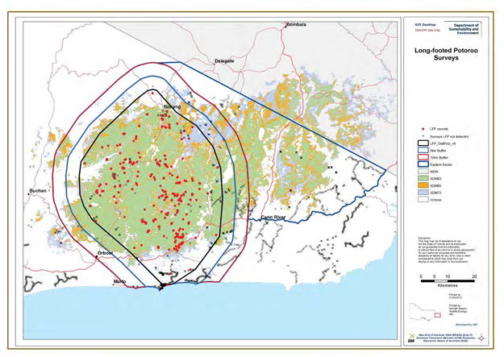
Figure 32. Long-footed Potoroo Species Distribution Model and all known records of the species at early 2012. Surveys that have been undertaken in East Gippsland using techniques suitable for detecting Long-footed Potoroos but at which they were not recorded are indicated by the small crosses. The four strata sampled during the 2012 surveys are also shown.

Due to the high level of scrutiny of this project, the Long-footed Potoroo sampling design was peer reviewed by an external Scientific Advisory Panel which included a biometrician. This review was presented to the Project Steering Committee for consideration with an agreement on the final design.

During the survey period, severe storms limited access to many areas within East Gippsland due to road closures. As a result, 25 of the designated sites were replaced with other randomly selected sites. Where possible, the replacement sites were selected from the same strata and management category as the sites that could not be surveyed. However, this was not always possible, and as a result the final allocation of sites within each category differed slightly from the originally planned allocation (Table 13).

In summary, 71 sites were sampled in state forest and 99 sites in parks and reserves. Parks and reserves represent 33% of the overall study area but received 58% of the sampling. The over- representation of parks and reserves in the study design was intended to increase knowledge of the contribution of parks and reserves to the conservation of the species, while at the same time allowing sufficient sampling in state forests so that the occupancy model (see below) could be reasonably applied across all land tenures.

Table 13. Allocation of survey sites incorporated into the survey design for the Long-footed Potoroo sampling. ‘Adjusted number of sites’ represents number of sites that were planned to be sampled based on adjustment due to stratum and biasing towards parks and reserves. The final column indicates the number of sites that were actually sampled after changes made due to storm damage and access issues.

Stratum Sub-stratum Area (ha) % No. sites if
proportional to area
Adjusted no. of sites
No. sites actually sampled

LFP
polygon

5 km buffer

10 km buffer

Eastern sector
State forest 187,428 74 55 32 29
Parks & reserves 66,689 26 20 33 44
Total 75 65 73
State forest 43,628 50 13 12 12
Parks & reserves 42,983 50 13 23 20
Total 26 35 32
State forest 46,592 55 14 9 9
Parks & reserves 37,421 45 11 16 17
Total 25 25 26
State forest 108,388 71 32 21 21
Parks & reserves 45,019 29 13 24 18
Total 45 45 39

Total sites 170 170 170

Surveys for Long-footed Potoroos using camera trapping commenced in April 2012 using four contract staff. Four rounds of sampling were required to survey all 170 sites, with sampling completed in August 2012. Two automated cameras (Reconyx HC500 trail camera – Reconyx, Wisconsin, USA) were deployed at each site. Each camera was positioned opposite a bait station and left in situ for 3 weeks. This method has been shown to reliably detect Long-footed Potoroos with a probability of detection of more than 90% (Lumsden et al. 2012).

Photographs were downloaded from the cameras at the conclusion of the surveys and each photograph checked thoroughly for the presence of Long-footed Potoroos and other species. During this survey there were over 7,000 nights of camera sampling, which resulted in the examination of approximately 160,000 photographs.

The data were analysed using an occupancy modelling approach (i.e., based on presence/absence data). This facilitated a refinement of our present understanding of what constitutes suitable habitat for the Long-footed Potoroo and enabled its probability of occurrence to be inferred, and mapped, at all locations across the study area. Knowing how much of the survey area is likely to be occupied by Long-footed Potoroos and where the most suitable areas are will inform future conservation zoning for the species and facilitate a landscape-scale approach to management.

Results and key findings
Long-footed Potoroos were recorded at 41 (24%) of the 170 survey sites (Figures 33 & 34). The majority of records (88%) were within the previously known range of the species, with approximately half in state forest and half in parks and reserves. Four records of Long-footed Potoroos were outside the previously known range, but within the 5 km buffer area, and one record was within the 10 km buffer area. This included new records in the Snowy River National Park.

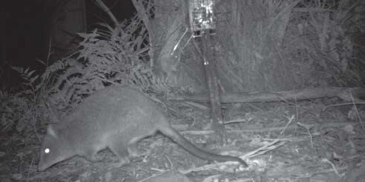

Figure 33. Long-footed Potoroo photographed at a bait station during camera trap surveys in East Gippsland, April – August 2012.

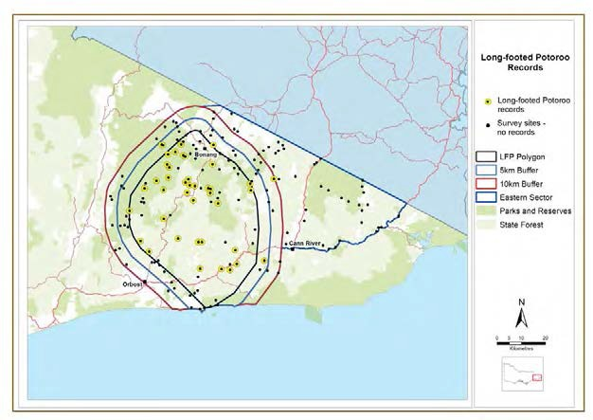

Figure 34. Long-footed Potoroo records (yellow circles) obtained during camera trap surveys at 170 sites in East Gippsland, April – August 2012.

No potoroos were recorded at the other 53 sites located in the buffer zones. In addition, no Long- footed Potoroos were detected at any of the survey sites in the eastern zone. This data confirms that the species has a limited distribution within East Gippsland and is not uniformly distributed throughout this distribution. Within the core of the species’ range it was recorded at a higher percentage of sites indicating that it may be moderately common within this limited area. It is important to note, however, that it was not recorded at all sites within its known range indicating that not all areas within the known range support populations of the species.

Other records of Long-footed Potoroos obtained during other projects conducted in 2011 and 2012 using similar methodology were also incorporated into the modelling process. Camera trap surveys to monitor Spot-tailed Quoll populations within the Gelantipy Community Baiting Program area in the Tulloch Ard State Forest near the township of W Tree recorded Long-footed Potoroos (Lucy Clausen, DSE Orbost, pers. comm.). These records are significant as they are the first records of the species within the Gippsland region that are west of the Snowy River. These are shown on Figure 35 (the furthest west records) and correspond to an area predicted by the SDM to contain suitable habitat for the species (Figure 32). Data from VicForests and ARI fire studies were also incorporated into the modelling.

The occupancy model indicates that the area most likely to be occupied by the species falls within the core of the species’ range (Figure 36). Other important areas include parts of the Snowy River National Park, and state forest north-west of Cann River. Sites more likely to be occupied were characterised by lush vegetation, had relatively high rainfall, particularly in summer, and had warmer summer and winter temperatures.

Knowledge of the distribution of the areas most likely to be occupied by Long-footed Potoroos can be used to estimate the area currently occupied by Long-footed Potoroos across the public land estate within various land management categories.

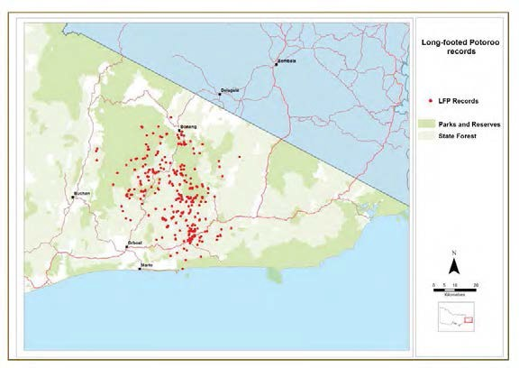
Figure 35. The location of all known records of Long-footed Potoroos in East Gippsland at January 2013, including the results from the sampling of 170 sites during this project.

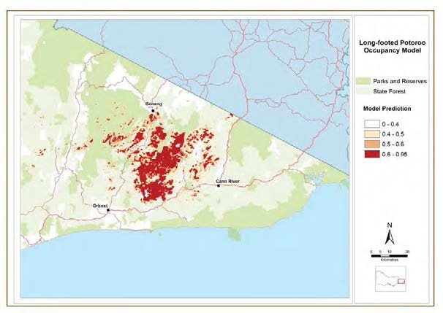
Figure 36. Predicted probabilities of occupancy for Long-footed Potoroos in East Gippsland.

Records of other threatened species recorded during the sampling of 170 sites for this project, included Long-nosed Potoroo Potorous tridactylus (9 sites, 5%), Southern Brown Bandicoot Isoodon obesulus (14 sites, 8%) and White-footed Dunnart (15 sites, 9%). These records have been incorporated into updated SDMs for these species for input into the policy component of this project where a new approach will be developed to guide the selection of priority areas for threatened species conservation throughout eastern Victoria.

Determine the area that is currently reserved within the range of the Long-footed Potoroo in East Gippsland
The survey work conducted during this project has improved our understanding of the extent of the distribution of the Long-footed Potoroo in East Gippsland. Recent records have expanded the known range to a small extent and provide a reasonable level of confidence that the species is unlikely to occur outside this area. Within this new distributional limit it is clear that not all areas provide suitable habitat, with some areas within the polygon that encloses all known records, unlikely to be occupied by Long-footed Potoroos, due to habitat unsuitability.

There are a number of different approaches to determining suitable habitat. In the past, suitable habitat for Long-footed Potoroos has been defined based on EVCs identified in the species’ Action Statement as ‘primary’, ‘secondary’ and ‘other’ habitats . Within the known range of the species in East Gippsland, approximately 95% of the public land is either primary or secondary habitat. It is apparent however that not all primary or secondary habitat is actually occupied by Long-footed Potoroos. This classification therefore is not nuanced enough to accurately define the true distribution with a high degree of certainty.

Long-footed Potoroos were detected at the majority of the sampling sites in some of the core parts of the range suggesting that in some areas most suitable habitat may be occupied. In contrast, on the extremities of the range, Long-footed Potoroos were recorded at a low proportion of sites, suggesting a lower proportion of the habitat is occupied. The camera trapping method used in these surveys is known to have a high detection probability (Lumsden et al. 2012) and hence there was a high probability that, had the species been present, it would have been recorded. Therefore it is likely that not all apparently suitable habitat within the known range is actually occupied at any point in time.

The Long-footed Potoroo Species Distribution Model predicted areas of suitable habitat outside the currently known range (Figure 32). These areas were surveyed extensively during the current project with no Long-footed Potoroos recorded. Therefore, it is considered that while these areas may provide some suitable habitat, there are other, as yet unknown, reasons why the species appears to be absent from this area. It is not unexpected that areas outside the known range were identified as potentially suitable as a similar pattern has been found for other species, and is likely a reflection of limited understanding of what constitutes suitable habitat for each species (P. Menkhorst, pers. comm.). The occupancy model provides some insights as it does not predict Long-footed Potoroos to occupy this area (Figure 36). This model predicted that some high altitude areas are too cool and that others have insufficient summer rainfall to support habitat suitable for occupancy by Long-footed Potoroos.

While each of the above approaches (i.e., primary habitat, SDM and occupancy model) represent alternative views of the distribution and availability of suitable habitat for Long-footed Potoroos in East Gippsland, the occupancy model provides information on the current distribution based on recent survey results. Therefore the occupancy model is used here as the basis for determining the area currently reserved within the range of Long-footed Potoroos in East Gippsland. The occupancy model estimates the probability that each location within the study area will be occupied. Three threshold probabilities are considered, with increasing certainty that areas represent suitable habitat for the species – i.e., > 40%, > 50% and > 60%. As a comparison, the area of reserved public land has also been calculated for the entire polygon enclosing all known records and most of the area predicted to be occupied from the occupancy model, irrespective of whether the occupancy model predicted it to be suitable habitat (Figure 37).

The area of predicted occupied habitat within the distribution of the species was calculated in the following categories:

- conservation reserves – parks and reserves managed by Parks Victoria.
- Special Protection Zones – includes all SPZs irrespective of their values.
- Special Management Zones set aside for Long-footed Potoroos. These SMZs include the 50 ha of Long-footed Potoroo retained habitat and the 100 ha that is available for restricted timber harvesting. Only the SMZs that are currently on DSE’s CSDL have been included.
- Special Management Zones set aside for other values (e.g. apiary sites, road landscape sites).
- General Management Zone – the remainder of public land.

The area of each category within the various versions of the Long-footed Potoroo distribution is provided in Table 14.

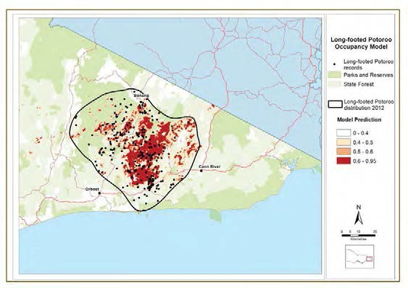

Figure 37. Polygon enclosing all known Long-footed Potoroo records and most of the habitat predicted to be currently occupied based on the occupancy modelling.

Table 14. Area (ha) of Long-footed Potoroo habitat within conservation reserves, Special Protection Zones, Long-footed Potoroo Special Management Zones, other Special Management Zones and General Management Zones. Note that two thirds of the Long-footed Potoroo SMZ (LFP SMZ) areas are available for restricted harvesting. Timber harvesting is permitted in other SMZs with conditions. The ‘Reserved Subtotal’ therefore includes the conservation reserves, SPZs and one third of the area of Long-footed Potoroo SMZs. Note that the polygon enclosing all records and predicted occupied areas incorporates areas that do not provide suitable habitat.

Land tenure | Probability of occupancy  > 60% | Probability of occupancy  > 50% | Probability of occupancy  > 40% | Polygon enclosing all records & predicted occupied areas
Reserved
Conservation | 20,368 | 32,147 | 46,539 | 132,657
SPZ | 9,095 | 14,342 | 21,610 | 36,286
LFP SMZ | 1,110 | 2,089 | 3,158 | 8,850
Subtotal | 29,833 | 47,185 | 69,202 | 171,893
Non-reserved  Other SMZ | 2,425 | 4,678 | 7,964 | 28,237
GMZ | 31,653 | 50,850 | 73,509 | 136,672
Total | 55,556 | 89,764 | 131,170 | 342,702

Compare the area that is required to support a viable population with the area of Long-footed Potoroo habitat currently reserved
Using the figures in Table 14, and specifying a threshold of 60% probability of occupancy, there is currently 29,833 ha of occupied Long-footed Potoroo habitat reserved in conservation reserves, SPZs or the retained habitat component of the Long-footed Potoroo SMZs. If the threshold probability of occupancy is reduced to 50% this area increases to 47,185 ha, and if the threshold is reduced to 40% probability of occupancy, the area is 69,202 ha.

Within the polygon that encloses all records of the species and all habitat that is predicted to be currently occupied (based on the occupancy model), the area currently reserved is 171,893 ha. Some of this area consists of habitats that are clearly unsuitable for the species, such as the dry rainshadow vegetation along the Snowy River. It is apparent however, that other areas within the overall distribution of the species are also unlikely to be occupied. This could be due to the habitat not being suitable, or due to the current successional stage of the forest, with some of this forest likely to be occupied in the past or in the future. As a result, the overall polygon figure will significantly over-estimate the area of potentially suitable Long-footed Potoroo habitat in reserves, and does not provide a realistic view of the actual area of Long-footed Potoroo habitat protected. Instead, this area should be seen as representing a ‘ceiling’ on the possible amount of habitat that could be available given the species geographic range, and that any possible reservation outcomes are going to be less than the estimate provided under this overly-optimistic scenario.

The results of the PVA indicate that 98,714 ha of occupied Long-footed Potoroo habitat are required to support a substantial and viable population under the assumptions outlined earlier in this report, using a 5% chance of the population falling below 500 individuals in a 50 year time frame (or 121,429 ha using 2.5% chance or 81,786 ha if using 10% chance). Therefore, using estimates of the amount of habitat reserved under each of the threshold probabilities of occupancy presented above, the area reserved is considerably less than the area that would be required to support a population of Long-footed Potoroos with a projected extinction risk less than a 2.5%, 5% or 10% chance of falling below 500 individuals in a 50 year time period.

Assumptions and knowledge gaps
There are a number of unknowns and assumptions influencing these calculations, and the inferences drawn from them. Many of these have already been discussed, however, we reiterate them here with the intention of making clear that the estimates are based on extrapolation from restricted data and that the results of the modelling are likely to be sensitive to the many assumptions made in constructing the PVA. The assumptions or limitations of the inferences presented above include:

    - The survival and population growth rate is based entirely on the data from the Bellbird trapping grid, as this is the only location from which such data is available. We have implicitly assumed that these survival and population growth rates are representative of the rates that apply to populations throughout the species range in East Gippsland.

    - The model was very sensitive to the declining growth rate over the past 26 years at the Bellbird trapping grid, and this rate showed some evidence of variation over time, due to environmental variation and other factors. It is difficult to predict what the growth rate is likely to be in the future, or the manner in which it will vary spatially or temporally.

    - The density estimates used in these calculations are based solely on data from the Bellbird trapping grid. It is unknown how uniform Long-footed Potoroo densities are throughout the species’ range and if those observed at Bellbird are representative. If the densities

throughout the range are on average lower than at Bellbird, the figures presented on the area required to support a substantial and viable population will be underestimated. If the densities are higher than at Bellbird, then less area would be required to support a viable population.

    - Assumptions were made about the impact of fire. Results from the Great Dividing Range Long-footed Potoroo population (Lumsden et al. 2012) indicated that fire has a negative effect on the species, however, it is not possible to fully quantify the size of the effect. The size of fire used in this report as an example, is based on past fire history throughout the species East Gippsland range, however, predictions have not been made on future fire patterns. It is also unknown what proportion of the population of an area affected by a wildfire would be killed. In this report we used a mortality rate of approximately 20% (i.e., with 500 killed of a potential pool of 2,800 individuals), and a fire frequency of approximately once every ten years. If these assumptions underestimate rates of mortality due to wildfire, or the frequency with which fire occurs, then the required population size, and hence area required to support it, will also be underestimated.

    - A coefficient of variation of 15% was used in these calculations to represent the impact of environmental variation on the demographic rates of the species. As illustrated in Table 9, assuming different coefficients of variation result in quite different required population sizes. A higher level of variability in population growth rates leads to a requirement for a greater population size to achieve a stable population.

    - The acceptable risk that the Long-footed Potoroo East Gippsland population may fall below the level considered necessary to maintain a substantial and viable population is a policy decision. Presented in this report are figures based on acceptance of a 2.5%, 5% and 10% chance of the population falling below 500 individuals over a 50 year time frame. If alternative levels of risk are used as targets for management, then differing population sizes will be required to satisfy the tolerable risk requirements.

In addition to the above assumptions, the process outlined in this report does not consider the contribution made by areas zoned as GMZ to the overall amount of suitable habitat available for Long-footed Potoroos. There are many records of Long-footed Potoroos from within GMZ areas and some of these areas are known to be currently occupied. Long-footed Potoroos occur in areas that have regenerated after timber harvesting, however, the impact of timber harvesting on Long- footed Potoroo populations is unclear. A study in East Gippsland investigated the short and long term impacts of timber production (Chick et al. 2006), and while there appeared to be some tolerance to disturbance with individuals occurring in a wide range of forest age classes, the study was based on relatively small sample sizes and was inconclusive. The impact of timber harvesting on Long-footed Potoroos therefore requires further investigation. Based on the data collected during this and other recent studies in East Gippsland, an analysis could be undertaken to examine occupancy rates in a range of growth stages and logging histories to infer the effect of timber harvesting. In addition, detailed studies could be undertaken to build on the Chick et al. (2006) study to clarify the impact timber harvesting in a range of areas and habitats.

The PVA was particularly sensitive to the estimated growth rate of the Long-footed Potoroo population. If survival rates could be increased, even marginally, by active management of populations, smaller areas would be required to be reserved to ensure the conservation of the species. A key mechanism that may be expected to improve population growth rates is to reduce predation by introduced predators, which is considered a key threat to this species (DSE 2009). The effectiveness of the current, or differing, levels of predator baiting to improve the conservation of the Long-footed Potoroo is currently unknown. The Southern Ark project

encompasses some of the Long-footed Potoroo distribution, however, there are no Southern Ark monitoring sites within the core of the species’ known range. It is therefore not possible to evaluate the effect of current levels of predator baiting on the conservation of Long-footed Potoroos. The only data available is from the Bellbird trapping grid where survival and recruitment rates can be compared between periods of intensive baiting vs reduced levels of baiting. To investigate the impact of predation fully would require a large study where predator regimes were manipulated with monitoring of the potoroo population responses, including monitoring of control sites where predator densities were not reduced by baiting or other population control measures. Evidence from the Great Dividing Range population of Long-footed Potoroos suggests that rates of habitat occupancy are increased in areas subject to predator control (Lumsden et al. 2012).

The impact of fire is also unknown, with insufficient data to evaluate the effects of wildfire and planned burning on Long-footed Potoroo populations, either in the short or long term. There are a number of studies currently investigating the impact of fire on faunal populations, however these are focusing on foothill forest habitats and are not sampling the wetter habitats preferred by Long- footed Potoroos (R. Loyn, pers. comm.). Catastrophic events such as extensive wildfire had a significant impact on the number of individuals required for a viable population in the PVA, and hence further information on such impacts would be useful.

4 Future directions

The research component of this study focussed on the collection of new data for nine key species. This new information has been instrumental in gaining a current understanding of the species’ status, distribution and habitat requirements, especially in light of recent changes due to the 2009 wildfires. There are, however, still many knowledge gaps and areas requiring further information to improve the management and conservation of these key species. Examples are listed below of further targeted research that could inform management and recovery options for these species.

Leadbeater’s Possum
- Ground truth mapped predictions of the occupancy and species distribution models using habitat assessments and on-ground, stratified surveys to verify and refine the occupancy and species distribution models.
- Conduct surveys to determine the growth stage of ash forests, including the availability of hollow-bearing trees, across all land tenures to refine the PVA, occupancy and species distribution models. While some growth stage information is available from state forest through the SFRI database, this requires updating, and data needs to be collected from parks and reserves so that habitats in these land tenures can be appropriately valued, relative to habitats in state forest.
- Assess long term viability of Leadbeater’s Possum, incorporating new information on availability of hollow-bearing trees across all land tenures.
- Test the assumptions of the PVA modelling, including collecting new data on current population dynamics.
- Determine the short and long-term persistence of Leadbeater’s Possums in unburnt refuges within the 2009 fire area. This would build on the work undertaken during the current project where Leadbeater's Possums were found in some of the fire refuges. The species’ ability to persist in these small unburnt patches is, however, unknown and needs to be assessed over the next decade while surrounding habitat regenerates. Factors influencing which refuges are occupied, now and into the future, would be investigated (such as fire severity, size of refuge, landscape position, distance to other unburnt patches, and density of hollow-bearing trees in and surrounding the fire refuges).
- Undertake a feasibility study on the potential for translocation of individuals from unburnt areas, or reintroduction of captive breed individuals, into areas burnt during the 2009 fires that will have suitable habitat once regenerated sufficiently. This would involve locating areas with suitable habitat attributes, including sufficient hollow-bearing trees to provide nest sites. This approach could fast track the recolonisation of areas as soon as the habitat becomes suitable rather than relying on the slower process of natural recolonisation from occupied habitats, as these may be some distance from any remnant populations in unburnt habitat. Subsequent translocation, and monitoring the success of any re-establishments, could be undertaken subject to the results of the feasibility study.
- Accurately map areas of old growth ash forest, and mature or senescent trees for inclusion in fire and timber harvesting planning processes.
- Investigate potential management actions that could increase the resilience and persistence of populations in Snow Gum woodlands. These areas may provide a reservoir of animals to recolonise ash forests once they have regenerated after timber harvesting or fire.
- Investigate options for artificially promoting hollow development in trees too young to naturally develop hollows. This approach has been used with some success in the USA (e.g., Lewis 1998) and could be trialled in ash forests. If successful it could be used to transform areas, within parks or reserves, that are currently unsuitable as habitat for Leadbeater’s Possum due to a lack of hollow-bearing trees.

- Identify areas and situations where nest boxes may be effective in providing additional hollows. While nest boxes are not a cost-effective option throughout the species range, they may supplement natural hollows in areas that may be currently marginal habitat.
- Investigate options for promoting wattle regrowth in areas with hollow-bearing trees but insufficient foraging opportunities.
- Establish a rigorous scientific monitoring program to evaluate the effectiveness of new management actions, using an adaptive management framework.

Powerful Owl, Sooty Owl and Masked Owl
- Investigate specific nesting, roosting, foraging and dispersal habitat requirements to refine management strategies.
- Investigate different mosaics of regrowth and mature forest to determine the fine scale pattern of habitat use by these species.

Greater Glider
- Determine distribution and abundance in relation to forest vegetation class, age class, and amount of old growth forest in the landscape to understand the pattern of occurrence.
- Investigate the potential causes of the recent decline of this species and monitor the trend of populations.

Long-footed Potoroo
- Investigate the impact of timber harvesting on Long-footed Potoroo populations at a landscape scale.
- Monitor both the East Gippsland and Great Dividing Range populations every 5 years, using the sampling design and protocols developed during this project, to investigate changes in occupancy rates and population status.
- Investigate the impact of differing levels of predator control throughout the species range.
- Investigate the impact of wildfire and planned burning on this species.
- Assess the value of GMZ areas for contributing to the conservation of Long-footed Potoroos, including an investigation of alternative timber harvesting approaches.

Many other threatened species that were not included in the research component of this project do not have up-to-date knowledge on status, distribution and habitat requirements. The collection of similarly detailed, rigorously collected and analysed data would greatly enhance the ability to inform management decisions to improve the conservation status of those species and to more reliably assess risks and opportunities associated with management of these species.

References

Burgman, M.A., Ferson, S. and Akçakaya, H.R. (1993). Risk Assessment in Conservation Biology. Chapman and Hall, London.

Chick, R., Henry, S., Kambouris, P. and Tennant, P. (2006). The effects of timber harvesting on the Long-footed Potoroo (Potorous longipes). Parks and Forests Report Series 06-1. Department of Sustainability and Environment, Victoria.

The Commonwealth of Australia and Department of Natural Resources and Environment (1997). Comprehensive Regional Assessment – Biodiversity. Central Highlands. The Commonwealth of Australia and Department of Natural Resources and Environment, Canberra.

DSE: Department of Sustainability and Environment (1995). Leadbeater's Possum Gymnobelideus leadbeateri . Flora and Fauna Guarantee Action Statement No. 62. Department of Sustainability and Environment, Melbourne

DSE: Department of Sustainability and Environment (2009). Action Statement No. 58 (revised). Long-footed Potoroo Potorous longipes. Victorian Government Department of Sustainability and Environment, Melbourne.

Green, K. and Mitchell, A.T. (1997). Breeding of the Long-footed Potoroo, Potorous longipes, in the wild: behaviour, births and juvenile independence. Australian Mammalogy 20: 1-7.

Harley, D.K.P. (2004). A review of recent records of Leadbeater's Possum (Gymnobelideus leadbeateri). Pp. 330–338 in Goldingay, R. and Jackson, S. (Eds.) The Biology of Australian Possums and Gliding Possums. Surrey Beatty and Sons, Sydney.

Henry, S. (1995). Greater Glider. Pp. 118 - 120 In Menkhorst, P. (ed.) Mammals of Victoria. Oxford University Press, Melbourne.

Lacy, R.C. (2000). Considering threats to the viability of small populations using individual-based models. Ecological Bulletins 48: 39-51.

Lewis, J.C. (1998). Creating snags and wildlife trees in commercial forest landscapes. Western
Journal of Applied Forestry 13: 97-101.

Lindenmayer, D. (2009). Forest pattern and ecological process: A synthesis of 25 years of research. CSIRO Publishing, Melbourne.

Lindenmayer, D.B., Blanchard, W., McBurney, L., Blair, D., Banks, S., Likens, G.E., Franklin, J.F., Laurance, W.F., Stein, J.A.R. and Gibbons, P. (2012). Interacting factors driving a major loss of large trees with cavities in a forest ecosystem. PLoS ONE 7(10): e41864. doi:10.1371/journal.pone.0041864

Lindenmayer, D.B., Clark, T.W., Lacy, R.C. and Thomas, V.C. (1993). Population viability analysis as a tool in wildlife conservation policy: with reference to Australia. Environmental Management 17(6): 745-758.

Lindenmayer, D.B., Cunningham, R.B., Tanton, M.T., Nix, H.A. and Smith, A.P. (1991). The conservation of arboreal marsupials in the montane ash forests of the central highlands of Victoria, south-east Australia: III. The habitat requirements of Leadbeater’s Possum Gymnobelideus leadbeateri and models of the diversity and abundance of arboreal marsupials. Biological Conservation 56: 295–315.

Lindenmayer, D.B. and Lacy, R.C. (1995). Metapopulation viability of arboreal marsupials in fragmented old-growth forests: comparison among species. Ecological Applications 5(1): 183-199.

Lindenmayer, D.B. and Possingham, H.P. (1995a). Modelling the viability of metapopulations of the endangered Leadbeater's possum in southeastern Australia. Biodiversity and Conservation 4: 984-1018.

Lindenmayer, D.B. and Possingham, H.P. (1995b). Modelling the impacts of wildfire on the viability of metapopulations of the endangered Australian species of arboreal marsupial, Leadbeater’s Possum. Forest Ecology and Management 74: 197-222.

Lindenmayer, D.B., Wood, J.T., McBurney, L., MacGregor, C., Youngentob, K. and Banks, S.C. (2011). How to make a common species rare: A case against conservation complacency. Biological Conservation 144: 1663-1672.

Liu, C., White, M., Newell, G. and Griffioen, P. (2013). Species distribution modelling for conservation planning in Victoria, Australia. Ecological Modelling 249: 68-74.

Loyn, R.H., McNabb, E.G., Volodina, L. and Willig, R. (2001). Modelling landscape distributions of large forest owls as applied to managing forests in north-east Victoria, Australia. Biological Conservation 97: 361-376.

Loyn, R., McNabb, E.G., Volodina, L. and Willig, R. (2004). 'Predicting owl distribution: Spatial modelling as a tool for conserving owls in ecologically sustainable forest management in Victoria, Australia'. Spatial Analysis in Raptor Ecology and Conservation. R. Rodriguez-Estrella and L.A. Bojorquez-Tapia. Mexico, Cibnor- Conabio: 111-132.

Lumsden, L.F., Alexander, J.S.A., Hill, F.A.R., Krasna, S.P. and Silveira, C.E. (1991). The vertebrate fauna of the Land Conservation Council Melbourne-2 Study Area. Arthur Rylah Institute for Environmental Research, Technical Report Series 115: 1-125.

Lumsden, L., Chick, R., Scroggie, M., Howard, K., Woodford, L., Douglas, A., Alexander, J. and Pascoe, C. (2012). Assessing management strategies and wildfire impact on Long-footed Potoroos in the Great Dividing Range area of Victoria. 4th Progress Report. Arthur Rylah Institute for Environmental Research Unpublished Report. Department of Sustainability and Environment, Heidelberg, Victoria.

MacKenzie, D.I., Nichols, J.D., Lachman, G.B., Droege, S., Royle, J.A. and Langtimm, C.A. (2002). Estimating site occupancy rates when detection probabilities are less than one. Ecology 83: 2248-2255.

Mackey, B.G., Lindenmayer, D.B., Gill, A.M., McCarthy, M.A. and Lindesay, J.A. (2002). Wildlife, Fire and Future Climate: A forest ecosystem analysis. CSIRO Publishing. Melbourne.

McDowall, R.M. (2006). Crying wolf, crying foul, or crying shame: alien salmonids and a biodiversity crisis in the southern cool-temperate galaxioid fishes? Reviews in Fish Biology and Fisheries 16, 233-422.

Menkhorst, P. and Broome, L. (2008). Background and implementation information for the Smoky Mouse Pseudomys fumeus National Recovery Plan. Department of Sustainability and Environment, Melbourne.

Menkhorst, P. and Lumsden, L. (1995). Leadbeater's Possum. Pp 104–107 in Menkhorst, P. (ed.). Mammals of Victoria: Distribution, Ecology and Conservation. Oxford University Press, Melbourne.

Nelson, J., Menkhorst, P., Howard, K., Chick, R. and Lumsden, L. (2009). The status of Smoky Mouse populations at some historic sites in Victoria, and survey methods for their detection.

Arthur Rylah Institute for Environmental Research Unpublished report number 2009/17. Department of Sustainability and Environment, Heidelberg, Victoria.

Raadik, T.A. (2011). Systematic revision of the Mountain Galaxias, Galaxias olidus Günther, 1866 species complex (Teleostei: Galaxiidae) in eastern Australia. PhD Thesis, University of Canberra, Canberra, ACT.

Raadik, T.A. and Nicol, M.D. (2013). Searching for threatened upland galaxiids (Teleostei, Galaxiidae) in the Thomson and La Trobe river catchments, West Gippsland, Victoria. Arthur Rylah Institute for Environmental Research Technical Report Series No. 248.

Reed, D.H., O’Grady, J.J., Brook, B.W., Ballou, J.D., and Frankham, R. (2003). Estimates of minimum viable population sizes for vertebrates and factors affecting those estimates. Biological Conservation 113: 23–34.

Seebeck, J.H. (1992b). Breeding, growth and development of captive Potorous longipes (Marsupialia: Potoroidae); and a comparison with P. tridactylus. Australian Mammalogy 15: 37- 45.
Shaffer, M.L. (1981). Minimum population sizes for species conservation. Bioscience 31: 131-134. Smith, A.P. and Lindenmayer, D.B. (1988). Tree hollow requirements of Leadbeater's Possum and
other possums and gliders in timber production ash forests of the Victorian Central Highlands.
Australian Wildlife Research 15: 347–362.

Smith, A.P. and Lindenmayer, D.B. (1992). Forest succession and habitat management for Leadbeater’s possum in the state of Victoria, Australia. Forest Ecology and Management 49: 311– 332.

Smith, S. and Morey, J. (2001). Options for a permanent reserve system for the conservation of Leadbeater’s Possum. Central Highlands of Victoria. Flora and Fauna Program, Department of Natural Resources and Environment.

Todd, C.R., Inchausti, P., Jenkins, S., Burgman, M.A. and Pyng Ng, M. (2001). Structural uncertainty in stochastic population models: Delayed development in the eastern barred bandicoot, Perameles gunnii. Ecological Modelling 136: 237-254.

Todd, C.R., Jenkins, S. and Bearlin, A.R. (2002). Lessons about extinction and translocation: Models for eastern barred bandicoots (Perameles gunnii) at Woodlands Historic Park, Victoria, Australia. Biological Conservation 106: 211-223.

Todd, C.R., Nicol, S.J. and Koehn, J.D. (2004). Density-dependence uncertainty in population models for the conservation management of trout cod, Maccullochella macquariensis. Ecological Modelling 171: 359–380.

Todd, C.R., Ryan, T., Nicol, S.J. and Bearlin, A.R. (2005). The impact of cold water releases on the critical period of post-spawning survival and its implications for Murray cod (Maccullochella peelii peelii): a case study of the Mitta Mitta River, in south-eastern Australia. River Research and Applications 21: 1035–1052.

Customer Service Centre 136 186

www.depi.vic.gov.au/ari

