ARI Aquatic Quarterly Update – Influence Autumn 2022

About Us
The Applied Aquatic Ecology section aims to generate and share knowledge, through world-class, applied, ecological research. This research supports and guides sustainable ecosystem policy and management to ensure healthy, resilient ecosystems. We work collaboratively with national, state and local agencies, research institutes, universities, interest groups and the community.
Our focus:
- To undertake high quality, relevant ecological research.
- To interpret research outcomes and communicate these effectively to key stakeholders.
- To guide and support sustainable ecosystem policy and management.

This update provides three examples of projects which help managers.

They provide:
- Important insights into how native vegetation in riparian areas responds to the removal of grazing and some of the factors which may influence management outcomes.
- An assessment of the likely response of Estuary Perch to present and potential environmental flows scenarios in the lower Snowy River, using population modelling. It provides a novel approach that could be tailored to test and guide management actions to benefit similar flow-dependent species in estuaries.
- A demonstration of how flow management can help Murray Cod access critical breeding habitats, including during recovery from disturbance events. Importantly, the work provides an example of how timely research has informed a major intervention program aimed at enhancing ecological outcomes.

www.ari.vic.gov.au Subscribe to any of ARI’s communications at www.tiny.cc/ARIsubscribe
Removal of livestock grazing in riparian areas can benefit native vegetation
Issue: Riparian vegetation and waterway condition is negatively affected by livestock grazing in many ecosystems. Whilst there is significant investment in restoring riparian areas, the long-term impacts of removing grazing on different vegetation life-forms (e.g. herbs, grasses, shrubs etc) is not well documented. In Australia, livestock grazing occurs on many public waterway frontages under long-term licences. There are many barriers to removing or limiting grazing on riparian areas, including concerns that removal of livestock grazing may favour the growth of exotic plants or provide an increased fire risk.

Action: Livestock grazing was removed from many frontages of the Broken, Boosey and Nine Mile Creek system in 2002 as part of the creation of a new reserve system to protect their natural values. We used this rare opportunity to investigate the outcomes of livestock removal on waterway frontages. Vegetation condition at 180 sites was compared along the creeks in northern Victoria in 2009/10, eight years after protection. Some sites had been permanently protected from grazing by the new reserves, while others continued to be grazed, or were not grazed before or after reservation. Comparisons were made between reserved and unreserved frontages as well as between those that were recently grazed or ungrazed in 2009. The sampling design and statistical models used in this study explicitly incorporated the proximity to the waterway to account for water resource and disturbance gradients that are both typically higher closer to the waterway. Vegetation condition surveys of the entire frontage system of the three creeks were conducted in 1994/5, which indicated that there was no difference in the pre-reservation conditions of reserved and unreserved sites.
Results: Reserved sites had more native vegetation cover across a range of different plant life-form types than unreserved sites. Reserved sites also had much less bare ground, and this effect was far greater closer to the water’s edge. Bare ground is bad for frontages because it reduces the vegetation community, reduces the amount of habitat, and increases erosion. Livestock grazing within reserves reduced these benefits of increased native vegetation and decreased bare ground. However, reserved sites also had a higher cover of exotic grasses, but not herbs.
Outcome: This study provides valuable insights into how native vegetation responds to removal of grazing and some of the factors which may influence management outcomes. It also suggests that reservation of stream frontages was beneficial to native vegetation condition within the study sites, even if grazing persisted. Livestock grazing was effective at reducing exotic vegetation cover but at the cost of native vegetation and ground condition. Many factors may influence outcomes and these responses are expected to differ in more productive landscapes or in periods with greater rainfall, and so quantitative monitoring would be beneficial to understand responses in those scenarios. Evaluation of cost-benefit trade-offs for the environment, graziers, and social and cultural objectives will be important to guide decisions on reservation.
Funder: Australian Government through the Commonwealth Environment Research Facilities – Landscape Logic and the National Environmental Research Program-Environmental Decisions.
ARI contact: Dr Chris Jones
Jones et al. (2022). Permanent removal of livestock grazing in riparian systems benefits native vegetation. Global Ecology and Conservation

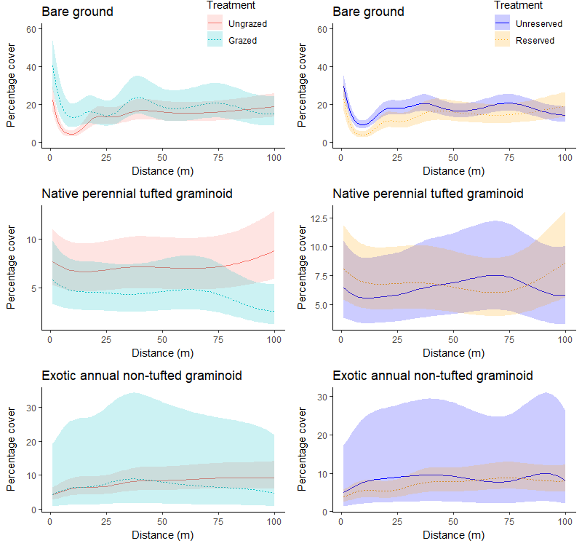

Figure 1. Predictions of percentage cover of different life-forms with increasing distance from the stream edge according to reservation and grazing status.

Using environmental flows to benefit Estuary Perch

Issue: Altered flow regimes are an important threat to estuarine fish populations globally. Estuary Perch (Percalates colonorum) is an estuary-dependent fish native to south-eastern Australia. The species is highly valued by recreational fishers and has declined significantly in abundance in recent decades. Strategies to recover populations include the use of environmental flows.
Action: We explored the likely benefits of present and potential environmental flows scenarios on recruitment and population response of Estuary Perch in the lower Snowy River for a 20-year period. This research used an age-based stochastic matrix population model based on the spawning and recruitment ecology of the species.

Results: The modelling indicated that the present environmental flows produce minimal population response and are of little benefit to recruitment of Estuary Perch. The flow that produced the least risk of further decline of the population was an annual release of 3 × 15,000 ML/day flow events, spaced 30 days apart, the first occurring in late winter.

This study highlights the importance of considering the whole life cycle of a species and identifying the key life history traits that can be influenced to achieve the desired conservation outcome.

Outcome: Although the model was used to test management activities at a single site (and for a single species), it provides a novel approach that could be tailored to test and guide management activities to benefit similar flow-dependent species in estuaries globally.
Funder: East Gippsland CMA
ARI contact: Dan Stoessel
Stoessel et al. (2022) Assessing outcomes of environmental flows for an estuary-dependent fish species using a novel stochastic population model approach. Estuaries and Coasts
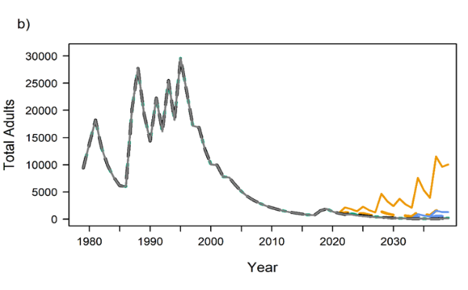
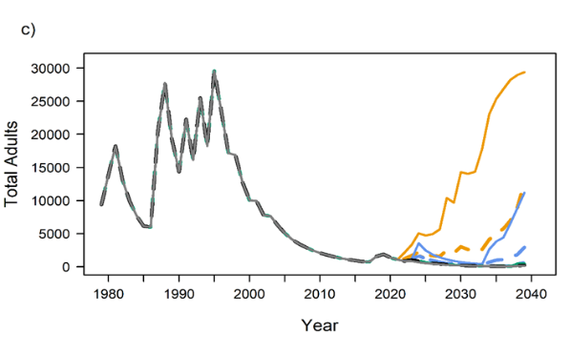
Figure 2. Predicted response of female adult Estuary Perch in the Snowy River when the flow threshold was set to 10,000 ML to environmental flow regimes compared with a 20-year continuation of planned daily releases devised for 2017–2018 as well as pulsed releases: a) every fifth year; b) every third year; and c) every year. Note that pulses of 10,000, 12,500, and 15,000 ML/day are synchronous, in each flow release a), b), and, c).
The movement behaviour of Murray Cod informs environmental flow management
Issue: Movement is a key driver of the distribution and structure of fish populations. Habitat loss and fragmentation can limit movement and contribute to population declines. Our knowledge of habitat use and movement behaviour of fish including Murray Cod (Maccullochella peelii) is limited, particularly in highly modified aquatic environments.

Murray Cod is a threatened freshwater species which has undergone major declines due in part to the infrastructure (barriers) and changes in flow conditions associated with river regulation.

Action: This eight-year project studied the movement behaviour of the Murray Cod within the Lindsay Island anabranch system, a highly modified floodplain ecosystem of the lower Murray River in the southern Murray-Darling Basin. Movement of fish within and between different habitat types in this ecosystem was studied to: (1) identify the key environmental conditions associated with movement to important habitats used for reproduction, (2) examine how a new regulating structure influenced this movement, and (3) examine how flows can be delivered to enhance movement and (4) explore movement mediated response to, and recovery after, a hypoxic blackwater event.

A total of 162 Murray Cod were fitted with radio transmitters and tracked over two periods (71 fish in 2004-06 and 91 fish in 2014-19).

Results: Fish movement within and between an anabranch and main river channel habitats increased during the core spawning period and during elevated discharge in spring. The likelihood of fish moving to an anabranch system from the Murray River declined substantially after a new flow regulating structure (a weir and vertical slot fishway) was constructed.

Flows delivered through the anabranch after regulator construction in accordance with targeted recommendations (time-of-year and magnitude of discharge) increased the movement of adult fish within and between habitats. The hypoxic event also caused high mortality as well as resulted in a high proportion of fish migrating outside of the study reach, before returning to the system over several following years.

Outcome: These results demonstrate how flow management can help a keystone species access critical breeding habitats including during recovery from disturbance events. Importantly, the work provides an example of how timely and robust applied research has informed a major intervention program aimed at enhancing ecological outcomes.

Funder: Murray-Darling Basin Authority, Mallee CMA ARI contact: Dr Zeb Tonkin
Tonkin et al. (2022) Movement behaviour of a threatened native fish informs flow management in a modified floodplain river system. Freshwater Ecology
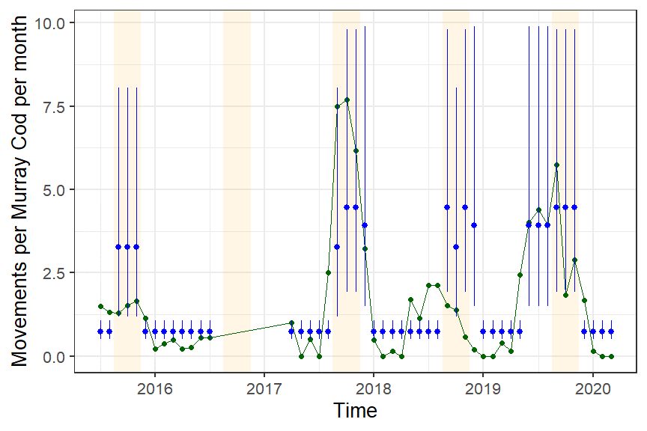
Figure 3. Average number of movements between zones in the anabranch system per adult fish in each month from 2015 to 2020 (period post regulator upgrade). Observed number of movements (green), modelled number of movements (blue). Vertical lines are the 95% credible interval for the model estimates. Months of elevated discharge in spring are shaded in orange. Note 2016 spring blackwater period excluded.

